# Slope seekers

Students calculate angles of elevation and depression, using side measurements of triangles.

## Visible learning

### Learning intention

* To be able to use angles of elevation and depression in trigonometric calculations.

### Success criteria

* I can identify the angle of elevation or depression.
* I can calculate the angle of elevation or depression from lengths in a triangle.
* I can calculate the length of a side in a triangle using the angle of elevation or depression.

### Syllabus outcomes

A student:

* develops understanding and fluency in mathematics through exploring and connecting mathematical concepts, choosing and applying mathematical techniques to solve problems, and communicating their thinking and reasoning coherently and clearly **MAO-WM-01**
* applies trigonometry to solve problems, including bearings and angles of elevation and depression **MA5-TRG-C-02**

[Mathematics K–10 Syllabus](https://curriculum.nsw.edu.au/learning-areas/mathematics/mathematics-k-10-2022/overview) © NSW Education Standards Authority (NESA) for and on behalf of the Crown in right of the State of New South Wales, 2022.

## Activity structure

Please use the associated PowerPoint *Slope seekers* to display images in this lesson.

### Warm up

1. In a Think-Pair-Share ([bit.ly/thinkpairsharestrategy](https://bit.ly/thinkpairsharestrategy)), students are to respond to the following ‘Would you rather’ scenario ([bit.ly/wouldyourathermaths](https://bit.ly/wouldyourathermaths)). This can be found on slide 2 of the PowerPoint *Slope seekers.*

Would you rather use a flight of stairs that:

* has a horizontal length of 3 m and a vertical height of 3.24 m?
* has a slanted height of 5.6 m with a vertical height of 3.24 m?

This activity is designed to revise finding an angle in a right-angled triangle and Pythagoras’ theorem.

1. Initiate a sharing of ideas and reasoning using the Pose-Pause-Pounce-Bounce question strategy (PDF 557 KB) ([bit.ly/posepausepouncebounce](https://bit.ly/posepausepouncebounce)).

### Launch

1. Show students the YouTube clip ‘Newton’s Nation 2017 – Luge Raw Run (1:54)’ ([bit.ly/LugeRawRun](https://bit.ly/LugeRawRun)). This shows a street luge run down Mount Panorama, Bathurst.
2. Explain to students that Mount Panorama is a race circuit near Bathurst where different forms of transport race, including street luge. The circuit is known internationally as being technically challenging due to its steep climbs and descent.
3. Show students slide 4 of the PowerPoint *Slope seekers* which displays Figure 1.

Figure 1: Mount Panorama racetrack

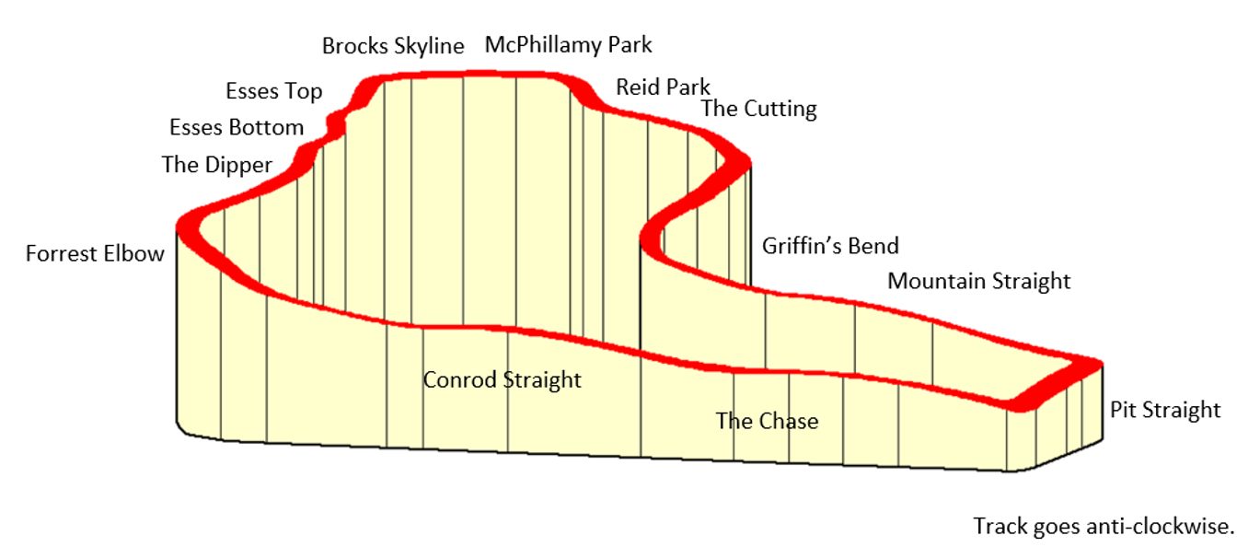Screenshot modified from [Tracks: Bathurst, Mount Panorama](https://www.gdecarli.it/php2/circuit.php?var1=70&var2=2).

1. In a Think-Pair-Share, students are to discuss which section of the track they think is the steepest and how they might determine if they are correct.
2. Use a Pose-Pause-Pounce-Bounce questioning strategy for pairs to share their thoughts and strategies. Prompting questions could include:

* How can we measure slope?
* What things can we easily measure? What tools would we need?
* What mathematical skills could we use?

Students have found the height of trees using trigonometry in Lesson 1 – 45-degree angles of Unit 2 – working with triangles.

### Explore

During this activity, students will be measuring ramps to simulate the different sections of the track at Bathurst.

Alternatively, you can have students go outside and measure the slope of wheelchair ramps around their school.

#### Equipment per group

* Tape measure
* A copy of Appendix A ‘Finding the slope’
* Metre ruler (or a long piece of wood to make a ramp)
* Series of blocks to build up the ramp (base-10 cubes would be suitable, otherwise books, or boxes)

#### Method

1. Display slide 6 from the PowerPoint *Slope seekers* to model the simulation of the mountain slopes.
2. By working in visibly random groups of 3 ([bit.ly/visiblegroups](https://bit.ly/visiblegroups)), students are to create a ramp using blocks or books and measure the height and length of the ramp. This will be repeated 3 more times ensuring that the slope is different each time.
3. Students should use Appendix A ‘Finding the slope’ to record their measurements, working and solutions.
4. Use a Pose-Pause-Pounce-Bounce questioning technique for students to share their strategies and any difficulties they had in calculating the slope. Prompting questions could include the following:

* What made calculating the slope difficult?
* How could we make our answer more accurate?
* What would have happened if the ground wasn’t level?
* Was there a relationship between the angle you found and the slope of the ramp?
* What caused the angle to become steeper?

Students should have been able to apply the sine ratio to calculate the angle that the ramp makes with the ground.

Emphasise to students that the larger the angle, the steeper the slope.

Measurements could be made more accurate by measuring distances multiple times and finding the average.

### Summarise

1. Explain to students that the angle they have been finding to determine the slope is called the ‘angle of elevation’.
2. Show students slides 8 and 9 from the PowerPoint *Slope seekers* to formalise the definitions of the angle of elevation and angle of depression. Emphasise that the angle of elevation is looking up from the horizontal and the angle of depression is looking down from the horizontal.
3. Ask students if they can give an example of where they may have seen or where you might use angles of elevation and depression.

Examples could include looking up at a skyscraper or down over a lookout.

1. Display slide 10 of the PowerPoint *Slope seekers*. State the following scenario to students:

Meagan is standing on top of the building looking down at Gary, and Gary is standing on the ground looking up at Meagan.

1. Ask students what they notice and wonder ([bit.ly/noticewonderstrategy](https://bit.ly/noticewonderstrategy)) about the 2 angles.
2. Display slide 11 of the PowerPoint *Slope seekers* to demonstrate that the angle of depression is equal to the angle of elevation as they are alternate angles in parallel lines.
3. Students complete Appendix B ‘Frayer models’ for angles of elevation and depression.
4. Give each group a copy of Appendix C ‘Mount Panorama measurements’.
5. Students are to work in their groups of 3 to calculate the angle of elevation or depression for several portions of the Bathurst track, showing their calculations on their vertical non-permanent surfaces ([bit.ly/VNPSstrategy](https://bit.ly/VNPSstrategy)).

Emphasise to students that the angle of elevation is the angle with the horizontal as we look up the mountain and the angle of depression is the angle with the horizontal as we look down the mountain.

1. Students are to do a gallery walk ([bit.ly/DLSgallerywalk](https://bit.ly/DLSgallerywalk)) to observe other group’s solutions. Ask them to provide feedback to other groups with two stars and a wish ([bit.ly/2starwish](https://bit.ly/2starwish)).

### Apply

1. Working in new groups of 3 at a vertical non-permanent surface, distribute Appendix D ‘Calculating the height of 2 towers’ to each group. Students are to use trigonometry to calculate the height of the 2buildings.
2. Students do a gallery walk to observe some other solutions.
3. Groups are to create their own problem involving angles of elevation and depression. They should solve their own problem before swapping problems with another group to solve.
4. Solutions should be returned to the original group to correct and provide feedback.

## Assessment and differentiation

### Suggested opportunities for differentiation

**Warm up**

* **Students are supported by working in small groups.**
* **Diagrams of the staircases could be provided to assist students visualise the scenario.**
* **Since there are no correct answers, students should feel comfortable to form an opinion to contribute.**

**Launch**

* **Encourage a variety of methods for measuring and calculating the gradient of the track.**

**Explore**

* Students could also be encouraged to find the gradient of their ramps using $m=\frac{rise}{run}$.
* All students can be involved in measuring the length and height of their ramps.
* Students may benefit from revising the process for calculating an angle in a right-angled triangle from Lessons 3–5 of Unit 2 – working with triangles.
* Explicit teaching of terminology may be necessary to cater to students from EAL/D backgrounds.

**Summarise**

* If students have not completed a Frayer model before, teachers may like to complete ‘angles of elevation’ as a class and then students could complete ‘angles of depression’ on their own or in pairs or their groups of 3.
* Teachers could provide a faded worked example to support students in calculating the slope of the different sections of the Mount Panorama track.
* Teachers could show an example of calculating a missing side from a right-angled triangle using an angle of elevation or depression.
* Students could research which section of the track is the steepest and confirm through calculations.

**Apply**

* Scaffolding of solutions could assist learners.
* Students could be prompted to find the height of the tallest tower first and to display only the information needed for this on a right-angled triangle diagram.
* Students should be challenged to create ‘difficult’ problems for other groups to solve. The level of difficulty will vary from group to group.

### Suggested opportunities for assessment

**Warm up**

* **Teachers can monitor student conversations to determine their level of confidence with Pythagoras’ theorem and trigonometry.**

**Explore**

* Teachers can monitor student conversations while they are measuring and calculating the slope of their ramps to check for understanding.

**Summarise**

* The Frayer models could be reviewed by peers and the teacher for correctness.
* Students could submit their calculations for the steepness of the track at Mount Panorama to check for understanding.

**Apply**

* Student solutions are reviewed by peers during the gallery walk.
* Teachers could create an exit ticket asking students to sketch an example and a non-example of an angle of elevation and depression.
* Students could submit the problem they created and its solution as an exit ticket.

## Appendix A

### Finding the slope

Add measurements onto these triangles and calculate the angle the ramp makes with the ground.

|  |  |
| --- | --- |
| 1. |  |
| 2. |  |
| 3. |  |
| 4. |  |

## Appendix B

### Frayer models

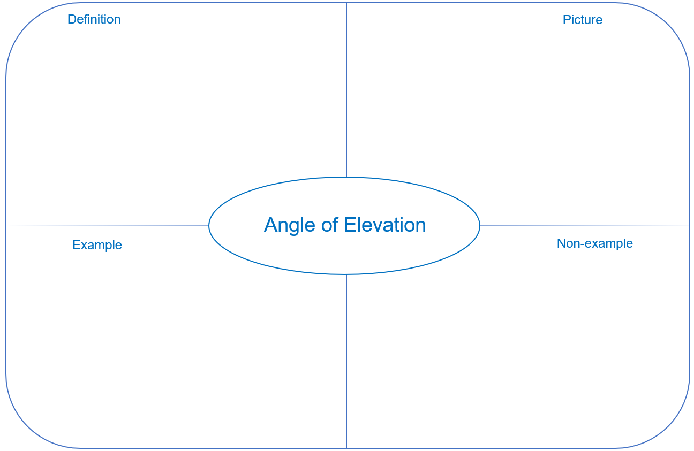

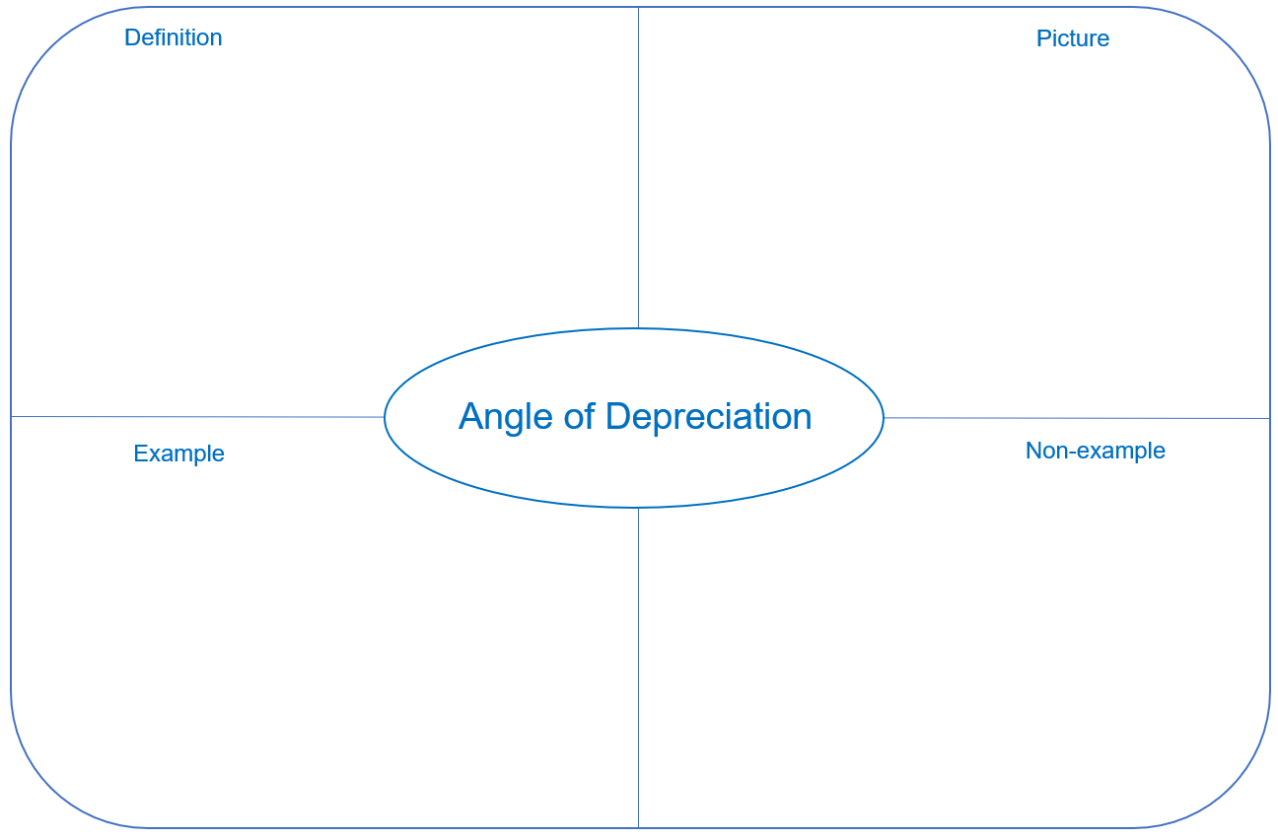

## Appendix C

### Mount Panorama measurements

All measurements provided are approximations.

|  |  |  |  |  |
| --- | --- | --- | --- | --- |
| Section | Elevation height start (metres) | Elevation height finish (metres) | Difference (metres) | Length of road  (metres) |
| Pit Straight | 705 | 718 |  | 400 |
| Mountain Straight | 721 | 773 |  | 1000 |
| Griffin’s Bend | 775 | 789 |  | 100 |
| The Cutting | 816 | 837 |  | 200 |
| Reid Park | 855 | 871 |  | 250 |
| McPhillamy Park | 874 | 876 |  | 250 |
| Brocks Skyline | 876 | 870 |  | 150 |
| Esses Top | 867 | 862 |  | 50 |
| Esses Bottom | 845 | 839 |  | 50 |
| The Dipper | 823 | 812 |  | 200 |
| Forrest Elbow | 799 | 795 |  | 100 |
| Conrod Straight | 795 | 749 |  | 400 |
| The Chase | 717 | 718 |  | 150 |

## Appendix D

### Calculating the height of 2 towers

Baoneng Shenyang Global Financial Centre is a high-rise development under construction in China. It consists of 7 buildings, including 2 office towers. Tower 1 and Tower 2 are the tallest of the towers and are shown below.

The angle of elevation of Tower 1 from the base of Tower 2 is 70 degrees. The angle of depression from the top of Tower 1 to the top of Tower 2 is 16 degrees. Towers 1 and 2 are 132 metres apart.

Calculate the height of both towers.

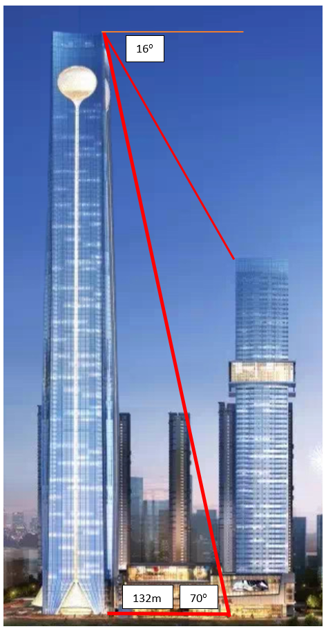

[Image](https://imgur.com/EP6LPP6) by Imgur modified and licensed under [Imgur’s terms of use](https://imgur.com/tos).

## Sample solutions

### Appendix C – Mount Panorama measurements

|  |  |  |  |  |
| --- | --- | --- | --- | --- |
| Section | Elevation height start (metres) | Elevation height finish (metres) | Difference (metres) | Length of road  (metres) |
| Pit Straight | 705 | 718 | 13 | 400 |
| Mountain Straight | 721 | 773 | 52 | 1000 |
| Griffin’s Bend | 775 | 789 | 14 | 100 |
| The Cutting | 816 | 837 | 21 | 200 |
| Reid Park | 855 | 871 | 16 | 250 |
| McPhillamy Park | 874 | 876 | 2 | 250 |
| Brocks Skyline | 876 | 870 | 6 | 150 |
| Esses Top | 867 | 862 | 5 | 50 |
| Esses Bottom | 845 | 839 | 6 | 50 |
| The Dipper | 823 | 812 | 11 | 200 |
| Forrest Elbow | 799 | 795 | 4 | 100 |
| Conrod Straight | 795 | 749 | 46 | 400 |
| The Chase | 717 | 718 | 1 | 150 |

**Pit Straight**

$$\sin{θ}=\frac{13}{400} \\ θ=\sin^{-1}{\frac{13}{400}} \\ ≈2°$$**Mountain Straight**

$$\sin{θ}=\frac{52}{1000} \\ θ=\sin^{-1}{\frac{52}{1000}} \\ ≈3°$$

**Griffin’s Bend**

$$sinθ=\frac{14}{100} \\ θ=\sin^{-1}{\frac{14}{100}} \\ ≈8°$$

**The Cutting**

$$sinθ=\frac{21}{200} \\ θ=\sin^{-1}{\frac{21}{200}} \\ ≈6°$$

**Reid Park**

$$\sin{θ=\frac{16}{250}} \\ θ=\sin^{-1}{\frac{16}{250}} \\ ≈4°$$**McPhillamy Park**

$$sinθ=\frac{2}{250} \\ θ=\sin^{-1}{\frac{2}{250}} \\ ≈0.5°$$**Brocks Skyline**

$$sinθ=\frac{6}{150} \\ θ=\sin^{-1}{\frac{6}{150}} \\ ≈2°$$

**Esses Top**

$$sinθ=\frac{5}{50} \\ θ=\sin^{-1}{\frac{5}{50}} \\ ≈6°$$

**Esses Bottom**

$$sinθ=\frac{6}{50} \\ θ=\sin^{-1}{\frac{6}{50}} \\ ≈7°$$**The Dipper**

$$sinθ=\frac{11}{200} \\ θ=\sin^{-1}{\frac{11}{200}} \\ ≈3°$$**Forrest Elbow**

$$sinθ=\frac{4}{100} \\ θ=\sin^{-1}{\frac{4}{100}} \\ ≈2°$$

**Conrod Straight**

$$sinθ=\frac{46}{400} \\ θ=\sin^{-1}{\frac{46}{400}} \\ ≈7°$$

**The Chase**

$$\sin{θ}=\frac{1}{150} \\ θ=\sin^{-1}{\frac{1}{150}} \\ ≈0.4°$$

### Appendix D – calculating the height of 2 towers

#### Tower 1

Calculate the height.

$$tan70=\frac{h}{132} \\ h=132 ×\tan{70} \\ =362.667… \\ ≈363 m$$

#### Tower 2

Calculate the amount Tower 1 is taller than Tower 2.

$$\tan{16= \frac{h}{132}} \\ h=132 ×tan16 \\ =37.850… \\ ≈38 m$$

Height of tower 2 = Height of tower 1 – difference.

$$= 363 - 38$$ $≈325 m$

## References

This resource contains NSW Curriculum and syllabus content. The NSW Curriculum is developed by the NSW Education Standards Authority. This content is prepared by NESA for and on behalf of the Crown in right of the State of New South Wales. The material is protected by Crown copyright.

Please refer to the NESA Copyright Disclaimer for more information [https://educationstandards.nsw.edu.au/wps/portal/nesa/mini-footer/copyright](https://aus01.safelinks.protection.outlook.com/?url=https%3A%2F%2Feducationstandards.nsw.edu.au%2Fwps%2Fportal%2Fnesa%2Fmini-footer%2Fcopyright&data=05%7C01%7CCaitlin.Pace1%40det.nsw.edu.au%7C9c2c1a9f59c94d2df30708dafa7edb23%7C05a0e69a418a47c19c259387261bf991%7C0%7C0%7C638097720042599463%7CUnknown%7CTWFpbGZsb3d8eyJWIjoiMC4wLjAwMDAiLCJQIjoiV2luMzIiLCJBTiI6Ik1haWwiLCJXVCI6Mn0%3D%7C3000%7C%7C%7C&sdata=BzQh0UsffVZE3eO22b2Xba3p0VMOBZSHfS21FGHXtZM%3D&reserved=0).

NESA holds the only official and up-to-date versions of the NSW Curriculum and syllabus documents. Please visit the NSW Education Standards Authority (NESA) website <https://educationstandards.nsw.edu.au/> and the NSW Curriculum website <https://curriculum.nsw.edu.au/>.

[Mathematics K–10 Syllabus](https://curriculum.nsw.edu.au/learning-areas/mathematics/mathematics-k-10-2022/overview) © NSW Education Standards Authority (NESA) for and on behalf of the Crown in right of the State of New South Wales, 2022.

**© State of New South Wales (Department of Education), 2024**

The copyright material published in this resource is subject to the Copyright Act 1968 (Cth) and is owned by the NSW Department of Education or, where indicated, by a party other than the NSW Department of Education (third-party material).

Copyright material available in this resource and owned by the NSW Department of Education is licensed under a [Creative Commons Attribution 4.0 International (CC BY 4.0) license](https://creativecommons.org/licenses/by/4.0/).

[](https://creativecommons.org/licenses/by/4.0/)

This license allows you to share and adapt the material for any purpose, even commercially.

Attribution should be given to © State of New South Wales (Department of Education), 2024.

Material in this resource not available under a Creative Commons license:

* the NSW Department of Education logo, other logos and trademark-protected material
* material owned by a third party that has been reproduced with permission. You will need to obtain permission from the third party to reuse its material.

**Links to third-party material and websites**

Please note that the provided (reading/viewing material/list/links/texts) are a suggestion only and implies no endorsement, by the New South Wales Department of Education, of any author, publisher, or book title. School principals and teachers are best placed to assess the suitability of resources that would complement the curriculum and reflect the needs and interests of their students.

If you use the links provided in this document to access a third-party's website, you acknowledge that the terms of use, including licence terms set out on the third-party's website apply to the use which may be made of the materials on that third-party website or where permitted by the Copyright Act 1968 (Cth). The department accepts no responsibility for content on third-party websites.