# The Great Pyramid

Students learn how to perform calculations in 3-dimensional space using right-angled triangles.

## Visible learning

This lesson incorporates Path content.

### Learning intention

* To be able to calculate the dimensions of a 3-dimensional object.

### Success criteria

* I can identify right-angled triangles in 3-dimensional shapes.
* I can apply Pythagoras’ theorem to solve problems in 2 and 3 dimensions.
* I can solve problems involving trigonometric ratios in 2 and 3 dimensions.

### Syllabus outcomes

A student:

* develops understanding and fluency in mathematics through exploring and connecting mathematical concepts, choosing and applying mathematical techniques to solve problems, and communicating their thinking and reasoning coherently and clearly **MAO-WM-01**
* applies Pythagoras’ theorem and trigonometry to solve 3-dimensional problems and applies the sine, cosine, and area rules to solve 2-dimensional problems, including bearings   
  **MA5-TRG-P-01**

[Mathematics K–10 Syllabus](https://curriculum.nsw.edu.au/learning-areas/mathematics/mathematics-k-10-2022/overview) © NSW Education Standards Authority (NESA) for and on behalf of the Crown in right of the State of New South Wales, 2022.

## Activity structure

Please use the associated PowerPoint *The Great Pyramid* to display images in this lesson.

### Launch

1. Show students the YouTube video ‘Great Pyramid of Giza’ (2:22) ([bit.ly/GreatPyramidGiza](https://bit.ly/GreatPyramidGiza)).
2. Ask students what they notice and wonder ([bit.ly/noticewonderstrategy](https://bit.ly/noticewonderstrategy)) about the video.

Students may notice:

* it took the Egyptians 20 years to build
* all the pyramids shown have square bases
* the pyramids were made of rectangular blocks
* the pyramids were made from 2.3 million blocks of about 15 tonnes each making the pyramids around 34.5 million tonnes.

Students may wonder:

* How steep is each pyramid?
* What was the angle of elevation on the ramps they used to move the blocks?

### Explore

#### The Great Pyramid

1. Assign students to visibly random groups of 3 ([bit.ly/visiblegroups](https://bit.ly/visiblegroups)) at vertical non-permanent surfaces ([bit.ly/VNPSstrategy](https://bit.ly/VNPSstrategy)).
2. Display slide 3 of the PowerPoint *The Great Pyramid.*
3. Ask students to draw a diagram of the pyramid labelling all important information. Some prompts to help students with their labels include:

* What shape is the base of the pyramid?
* What do we call the length from the corner at the base to the top of the pyramid?
* What would the height from the ground to the apex of the pyramid be called?
* What angle might represent the angle of elevation of the pyramid?

1. Distribute Appendix A ‘Pyramid’ on A3 paper to each group of students.

Teachers are encouraged to display slide 4 from the PowerPoint *The Great Pyramid,* showing Figure 1 for easy reference during this section of the lesson.

Figure 1: The Great Pyramid

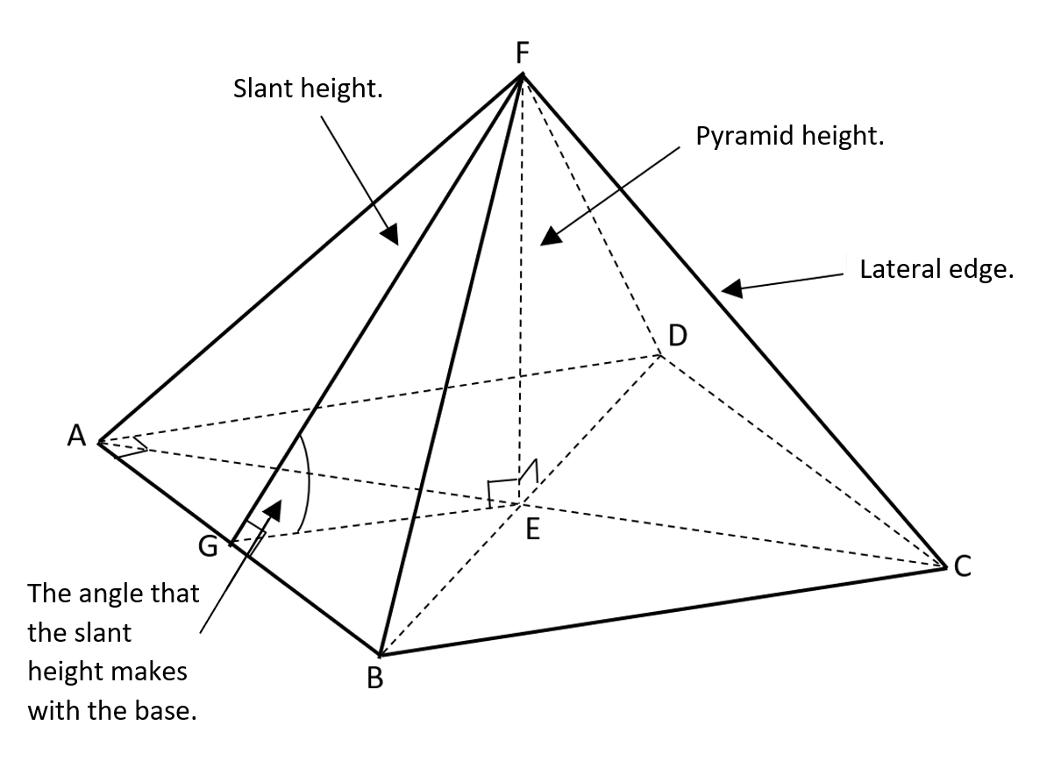

1. Ask students to identify as many right-angled triangles as they can on their pyramid.
2. Students are to do a gallery walk ([bit.ly/DLSgallerywalk](https://bit.ly/DLSgallerywalk)) noting the total number of right-angled triangles that can be found.

There are 15 right-angled triangles in a square pyramid. The right angles in Figure 1 are $∆AGF, ∆BGF, ∆FED, ∆FEA, ∆FEB, ∆FEC, ∆FEG, ∆AEG, ∆BEG, ∆BEA, ∆BEC, ∆CED, ∆DEA, ∆ACD$ and $∆ABC$.

However, there would be more if perpendiculars were drawn from F to the centre of lines AD, CD, and BC.

1. Tell students they have been asked to go to Egypt and measure the Pyramid. Remind students that it is a world heritage site and no climbing is allowed. In their groups of 3, students are to discuss what measurements they might take.
2. As a class discuss each group's proposed measurements and the practicalities, ease and efficiency of making these measurements.
3. Give students the following measurements and ask them to add the measurements to their diagrams.

The base length of the pyramid is 440 cubits or 230.6 m.

The triangular sides make an angle of 51o50’40” with the pyramid's base.

1. Remind students that the video in the Launch indicated that the height of the pyramid was 146.5 m. Working in their groups, ask students to verify this using calculations.

Students may use the slant height or lateral height and half the base length to determine the perpendicular height of the pyramid. Alternatively, they could use the slant height, lateral height, or half the base length and angle of elevation to determine the height of the pyramid.

1. Students are to do a gallery walk to review other groups' calculations using the TAG strategy ([bit.ly/TAGstrategy](https://bit.ly/TAGstrategy)).
2. Students are to return to their group to enact any feedback and add further information.

#### The King’s chamber

1. Students are to remain in their groups of 3 at a vertical non-permanent surface.
2. Display slide 5 from the PowerPoint *The Great Pyramid*, which displays Figure 2.

Figure 2: the King's chamber

A drawing of a rectangular prism with the dimensions 5.8 m x 10.45 m x 5.2 m.



1. Students are to discuss the dimensions of the King's chamber in relation to the Great Pyramid.
2. Distribute Appendix B ‘King’s chamber’ to each group of students, which is also displayed in Figure 2.
3. Ask students to calculate as many angles and diagonal lengths as they can in Appendix B. This is a goal-free problem ([bit.ly/goalfreeproblems](https://bit.ly/goalfreeproblems)).

Students could calculate the length of the diagonal along the floor (floor diagonal), the diagonal length from the top vertex to the opposite vertex on the floor (3D diagonal) and the angle between the 2 diagonals calculated.

1. Students are to do a gallery walk to review other groups' calculations using the TAG strategy ([bit.ly/TAGstrategy](https://bit.ly/TAGstrategy)).
2. Students are to return to their group to enact any feedback and add further information.

### Summarise

1. Use slides 7–14 from *The Great Pyramid* PowerPoint for explicit teaching of 3D calculations using the [worked examples (Your turn) strategy (DOCX 420 KB)](https://education.nsw.gov.au/content/dam/main-education/documents/teaching-and-learning/curriculum/mathematics/mathematics-s4-supporting-strategies-worked-examples-your-turn.docx).
2. Students are to be placed in new visibly random groups of 3 at vertical non-permanent surfaces.
3. In their groups, students are to complete the questions from Appendix C ‘3D consolidation’.
4. Students are to conduct a gallery walk and give peer feedback through the TAG strategy.
5. Distribute Appendix D ‘Four quadrant notes’ to each student and have students complete the table using [four quadrant notes (DOCX 319 KB)](https://education.nsw.gov.au/content/dam/main-education/documents/teaching-and-learning/curriculum/mathematics/mathematics-s4-supporting-strategies-four-quadrant-notes.docx).

### Apply

1. Distribute an A3 copy of Appendix E ‘Roof pitch’ to each group.
2. Ask groups to complete the calculations on the sheet.
3. Allow students time to do a gallery walk.

## Assessment and differentiation

### Suggested opportunities for differentiation

**Launch**

* All students can participate as there are no right answers and everyone can notice and wonder.

**Explore**

* Students can be given a physical pyramid when naming the different measurements.
* Students could be given the different terminology used for different measures of a pyramid to add to their diagram.
* Students could be challenged to verify the perpendicular height in more than one way.
* Most classrooms are rectangular prisms. Students can use this to help them visualise the shapes provided.

**Summarise**

* If a student is struggling to contribute to the task, encourage them to move around the room and find an answer from another group. They should ask that group how they know the length or angle is correct before reporting back to their group.

**Apply**

* To enable students to complete more questions you can provide more sides or separate the questions, so they are focussing on one at a time.
* Students can be challenged to explain why they have different solutions to another group, or what solutions are more accurate.

### Suggested opportunities for assessment

**Explore**

* Students’ working mathematically skills can be assessed when sharing what they notice and wonder.
* Students are providing and receiving peer feedback in the TAG activity.

**Summarise**

* Students are providing and receiving peer feedback in the TAG activity.
* Listen for misconceptions in students’ reasoning as they complete the task.

**Apply**

* Appendix C or D could be collected and analysed as evidence of student learning.
* Students working at vertical non-permanent surfaces means that they can self-assess by comparing their answers to their peers.
* Ask students to justify their answers as you move around the room.

## Appendix A

### Pyramid



## Appendix B

### King’s chamber

In the Great Pyramid, there is a room towards the top which is known as the King’s chamber. The King’s chamber is a room made from pink granite, which measures 10.45 metres by 5.2 metres and 5.8 metres high.

Find all the diagonals and angles you can from this diagram.

A drawing of a rectangular prism with the dimensions 5.8 m x 10.45 m x 5.2 m.



## Appendix C

### 3D consolidation

1. In this rectangular prism, CD = 7 m, BC = 24 m, and FB = 10 m. Find BD, DF and angle FDB.

A rectangular prism with diagonal shown.


1. In the rectangular prism, EF = 32 m, AG = 42 m and Angle GAC = 30o. Find AC, GC, and BC.

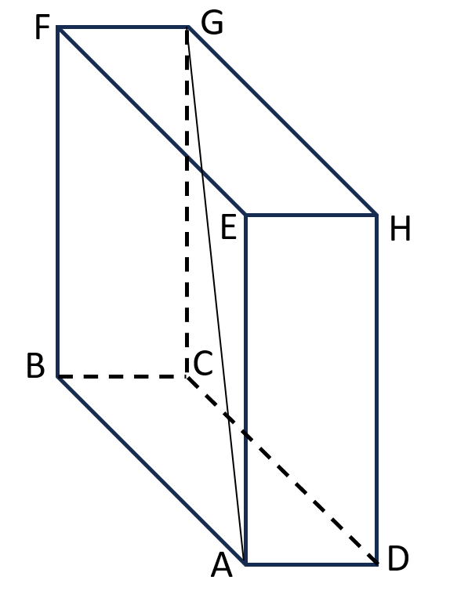

1. In the square pyramid, AE = 41 m, and AB = 12 m. Find Angle EAF and EF.

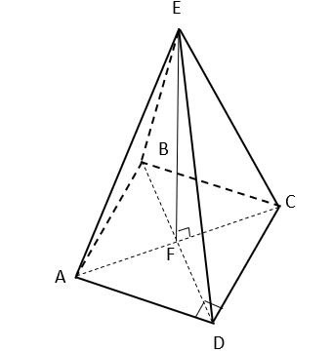

1. In the square-based prism, the height is twice the length and breadth. Find the size of the angle marked.

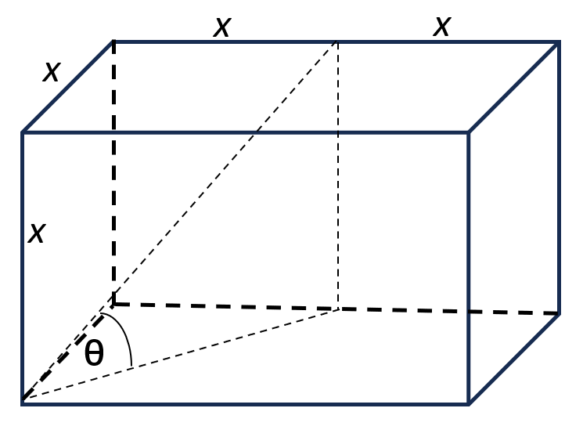

## Appendix D

### Four quadrant notes

|  |  |
| --- | --- |
| **Example 1**  Find the length of the diagonal AH.  Rectangular prism with dimensions 7 m (A)C x 4 m (GH) x 24 m (CG). AH is diagonally drawn. | **Example 2**   Find the size of angle CEG.  Rectangular prism with the dimensions 6 m (EH) x 8 m (GH) x 10 m (CG). EC is diagonally drawn. |
| **Things to remember** | **Example 3** |

## Appendix E

### Roof pitch

Below is a metal-hipped roof from a house. It has the following measurements. AD has a length of 8200 mm, EF has a length of 4653 mm, and EG has a length of 4000 mm.

The owners of the house would like to make use of some of the roof space for storage. The minimum height needed for the owner to comfortably stand up is 1800 mm.

1. By calculating the height of FG, the highest point of the roof, show that the owner would be able to stand up in that space.
2. The optimal pitch for a Colourbond roof is between 20–25o. Does this roof meet the optimal standard for a Colourbond roof? Use mathematical calculations to justify your answer.

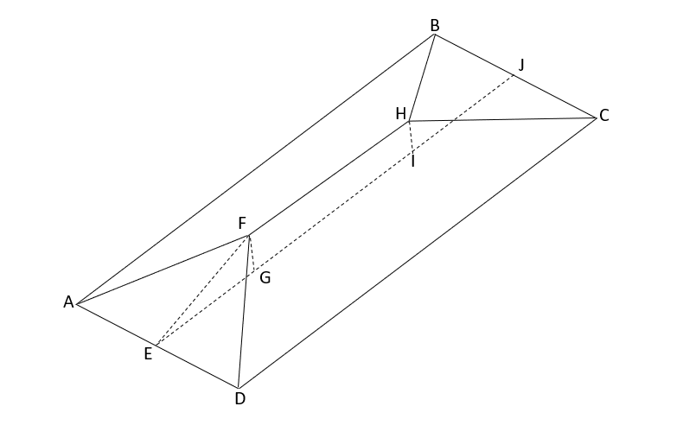

## Sample solutions

### Appendix B – King’s chamber

#### Floor diagonal

$$=\sqrt{{10.45}^{2}+{5.2}^{2}} \\ =\sqrt{136.2425}$$

$$=11.6723…. \\ ≈11.7 m$$

#### 3D diagonal

$$=\sqrt{{5.8}^{2}+{11.6723}^{2}} \\ =\sqrt{169.8825} \\ =13.0339… \\ ≈13 m$$

#### Angle between diagonals

$$\cos{θ}=\frac{11.6723}{13.0339} \\ θ=\cos^{-1}{\frac{11.6723}{13.0339}} \\ =26.4229……… \\ ≈26°$$

### Appendix C – 3D consolidation

1. Rectangular prism.
$$BD=\sqrt{7^{2}+{24}^{2}} \\ =\sqrt{625} \\ =25 m$$

$$DF=\sqrt{{25}^{2}+{10}^{2}} \\ = \sqrt{726} \\ =26.926…. \\ ≈26.9 m$$

$$∠FDB=\tan^{-1}{\frac{10}{25}} \\ =21.8° \\ ≈22°$$

2. Rectangular prism.
$$\cos{30°}=\frac{AC}{42} \\ AC=42×\cos{30°} \\ =36.373…… \\ ≈36 m$$

$$\sin{30°}=\frac{GD}{42} \\ GD=42×\sin{30} \\ =21 m$$

$$BC=\sqrt{{36.373}^{2}-{21}^{2}} \\ =\sqrt{299} \\ ≈17.29 m$$

3. Square pyramid.
$${AF}^{2}+{BF}^{2}={12}^{2} \\ 2{AF}^{2}=144 \\ {AF}^{2}=72 \\ AF=\sqrt{72} \\ ≈8.485 m$$

$$Angle EAF \\ \cos{θ}=\frac{8.485}{41} \\ θ=\cos^{-1}{\frac{8.485}{41}} \\ ≈78°$$

$${41}^{2}={EF}^{2}+{\sqrt{72}}^{2} \\ {EF}^{2}={41}^{2}-{\sqrt{72}}^{2} \\ =1609 \\ EF=\sqrt{1609} \\ =40.1123.. \\ ≈40 m$$

4. Square-based prism.

$$Base diagonal=\sqrt{\left(x^{2}+x^{2}\right)} \\ =\sqrt{2x^{2}} \\ =\sqrt{2}x$$

$$\tan{θ=\frac{x}{\sqrt{2}x}} \\ =\frac{1}{\sqrt{2}} \\ θ=\tan^{-1}{\frac{1}{\sqrt{2}}} \\ =35.26… \\ ≈35°$$

### Appendix D – four quadrant notes

|  |  |
| --- | --- |
| **Example 1**  Find the length of the diagonal AH.    Rectangular prism with the dimensions 7 m (A)C x 4 m (GH) x 24 m (CG). AH is diagonally drawn. | **Example 2**   Find the size of angle CEG.  Rectangular prism with the dimensions 6 m (EH) x 8 m (GH) x 10 m (CG). EC is diagonally drawn. |
| **Things to remember**   * Make sure all the sides are in the right-angled triangle. | **Example 3**  Find the size of angle HAG.  Rectangular prism with the dimensions 12 m (A)C x 5 m (GH) x 13 m (CG). AH is diagonally drawn. |

### Appendix E – roof pitch

$${FG}^{2}={4653}^{2}-{4250}^{2} \\ =3587909 \\ FG =1894.177… \\ ≈1894mm \\ 1894>1800 ∴Person able to stand up$$

$$∠FEG=\cos^{-1}{\frac{4250}{4653}} \\ =24.02.. \\ ≈24° \\ ∠FHG= \tan^{-1}{\frac{1894}{4100}} \\ =24.794… \\ ≈25°$$

Both sides of the roof are optimum as the pitch of both sides is within the bounds $20-25°.$

## References

This resource contains NSW Curriculum and syllabus content. The NSW Curriculum is developed by the NSW Education Standards Authority. This content is prepared by NESA for and on behalf of the Crown in right of the State of New South Wales. The material is protected by Crown copyright.

Please refer to the NESA Copyright Disclaimer for more information <https://educationstandards.nsw.edu.au/wps/portal/nesa/mini-footer/copyright>.

NESA holds the only official and up-to-date versions of the NSW Curriculum and syllabus documents. Please visit the NSW Education Standards Authority (NESA) website <https://educationstandards.nsw.edu.au> and the NSW Curriculum website <https://curriculum.nsw.edu.au>.

[Mathematics K–10 Syllabus](https://curriculum.nsw.edu.au/learning-areas/mathematics/mathematics-k-10-2022/overview) © NSW Education Standards Authority (NESA) for and on behalf of the Crown in right of the State of New South Wales, 2022.

**© State of New South Wales (Department of Education), 2024**

The copyright material published in this resource is subject to the Copyright Act 1968 (Cth) and is owned by the NSW Department of Education or, where indicated, by a party other than the NSW Department of Education (third-party material).

Copyright material available in this resource and owned by the NSW Department of Education is licensed under a [Creative Commons Attribution 4.0 International (CC BY 4.0) license](https://creativecommons.org/licenses/by/4.0/).

[](https://creativecommons.org/licenses/by/4.0/)

This license allows you to share and adapt the material for any purpose, even commercially.

Attribution should be given to © State of New South Wales (Department of Education), 2024.

Material in this resource not available under a Creative Commons license:

* the NSW Department of Education logo, other logos and trademark-protected material
* material owned by a third party that has been reproduced with permission. You will need to obtain permission from the third party to reuse its material.

**Links to third-party material and websites**

Please note that the provided (reading/viewing material/list/links/texts) are a suggestion only and implies no endorsement, by the New South Wales Department of Education, of any author, publisher, or book title. School principals and teachers are best placed to assess the suitability of resources that would complement the curriculum and reflect the needs and interests of their students.

If you use the links provided in this document to access a third-party's website, you acknowledge that the terms of use, including licence terms set out on the third-party's website apply to the use which may be made of the materials on that third-party website or where permitted by the Copyright Act 1968 (Cth). The department accepts no responsibility for content on third-party websites.