Getting my bearings
Students use bearings to navigate their way back to a starting point.
Students will need at least one digital device per pair to interact with Desmos during this lesson.

Visible learning

Learning intention
- To know how to read and use bearings.

Success criteria
- I can convert between compass and true bearings.
- I can use a compass to find a bearing.
- I can use bearings to calculate angles.
- I can explain the importance of words when indicating direction.

Syllabus outcomes
A student:
- develops understanding and fluency in mathematics through exploring and connecting mathematical concepts, choosing and applying mathematical techniques to solve problems, and communicating their thinking and reasoning coherently and clearly MAO-WM-01
- applies trigonometry to solve problems, including bearings and angles of elevation and depression MA5-TRG-C-02
Mathematics K–10 Syllabus © NSW Education Standards Authority (NESA) for and on behalf of the Crown in right of the State of New South Wales, 2022.

Activity structure
Please use the associated PowerPoint Getting my bearings to display images in this lesson.

Launch
- Show students the video ‘Hansel and Gretel | Fairy Tales | Gigglebox’ (10:16) (bit.ly/Hanselfairytale) from 0:32 until 3:00.
- In a Think-Pair-Share (bit.ly/thinkpairsharestrategy), pose the following problems to students.
Hansel and Gretel used pebbles to find their way home. While leaving a trail is a good option to retrace your steps, what other methods can we use to navigate?
How do you navigate when you go somewhere new? For example, exploring a new shopping centre and finding your way back to where you parked the car.
You could use this as an opportunity to engage with your local land council to discover how Indigenous Australians navigate their land and know where to meet up with each other.
- Initiate a sharing of solutions and reasoning using the Pose-Pause-Pounce-Bounce questioning strategy (PDF 557 KB) (bit.ly/pausepouncebounce).

Explore

Reading bearings
- Display the Desmos graph ‘Bearings’ (bit.ly/Desmosbearings) for students.
Figure 1: bearings Desmos graphing calculator
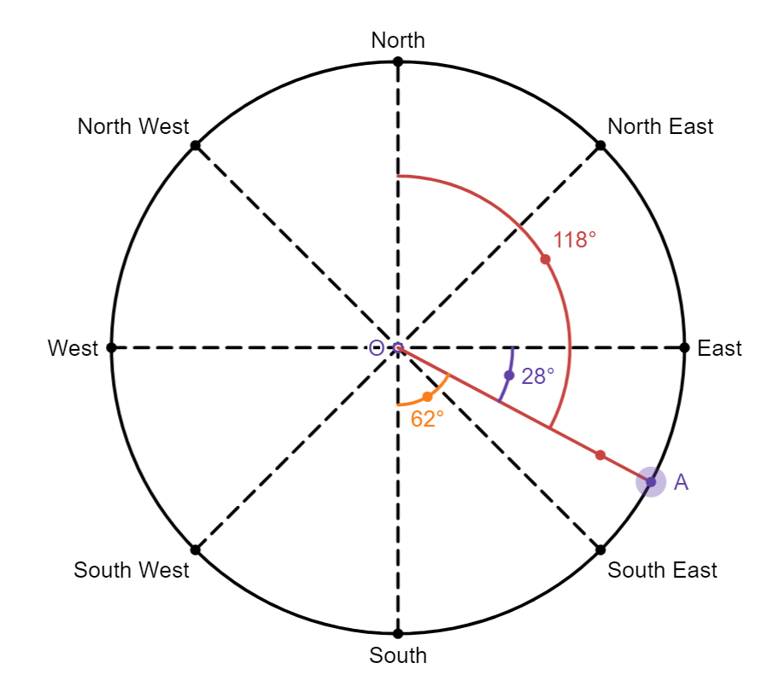
Image created using Desmos and is licensed under the Desmos Terms of Service.
- Select the play button on the angle labelled $a$, on the left-hand side of the webpage, as seen in Figure 2 below.
Figure 2: play button on Desmos graph
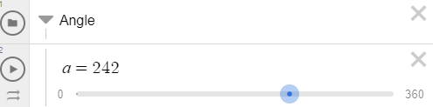
Image created using Desmos and is licensed under the Desmos Terms of Service.
- Ask students to consider what they notice and what they wonder (bit.ly/noticewonderstrategy) as point A moves around the graph in a clockwise direction.
- In a Think-Pair-Share, students are to discuss the following questions:
- What is the difference between the red, purple and orange angles?
- How many ways could students describe or explain directions?
Explain to students how to describe a bearing as both a true bearing and a compass bearing. Advise students that angles below $100°$ should start with a 0 for true bearings, as true bearings are always 3 digits. Desmos cannot display this on their graphing calculator.
In Figure 1, the potential bearings that students could use to reference point A from O are the true bearing 118$°$ and the compass bearing S62$°$E.
Compass bearings always start with north or south and state how many degrees they are towards the east or west of that point. Students may also explain the bearing as E28$°$S but this is not the correct syntax.
- In pairs, ask students to complete Appendix A ‘Reading bearings’ to explore reading true bearings and identifying compass bearings.

Finding my way home
In this activity, students are going to walk to a location and then use their calculations to try to find their way home, just like Hansel and Gretel.

Equipment
- A compass per group
- 5 cones per group
- Appendix B ‘Steps and bearings’ for each group

Method
- Display slide 3 from the PowerPoint Getting my bearings, which shows Figure 3: walking path.
Figure 3: walking path
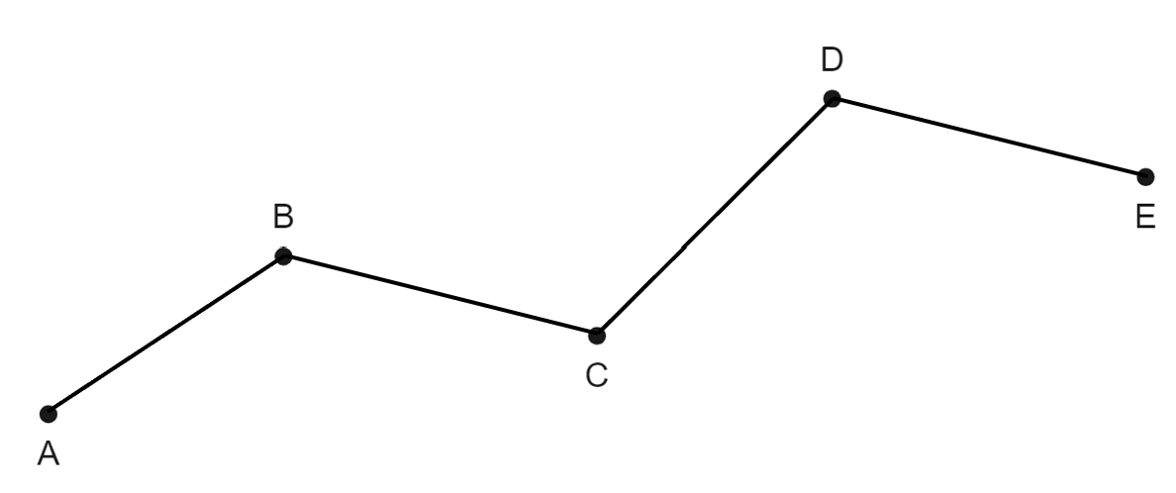
- In visibly random groups of 3 (bit.ly/visiblegroups) hand out a compass and a copy of Appendix B ‘Steps and bearings’ to each group.
- Remind students that a compass works by lining up the arrow to face north.
For instructions on how to read a bearing from a compass, show students the video ‘Taking a compass bearing from a landscape feature (2:10)’ (bit.ly/readingacompass).
- Give groups 5 cones and take them outside to construct the path as shown. The diagram is also shown on the student's handout.
Two groups can be placed together to navigate through a path if there are not enough cones available.
- Students are to complete Table 1 from Appendix B by taking the true bearing and compass bearing from each station to the next one. For example, the bearing of B from A. Students record their bearings and then walk to the next station, counting and recording their steps for each length.
- Students are to complete Table 2 from Appendix B by repeating the process, this time starting from the last cone and moving back to cone A.
- Return to the classroom.
- Display slide 4 from the PowerPoint Getting my bearings. Ask students to identify which statements matches each of the 2 bearings marked on the diagram.
- Display slide 5 from the PowerPoint Getting my bearings, which has the solutions for slide 4. Discuss with students the importance of language when dealing with bearings.
Highlight to students the difference between the bearing of A from B compared to B from A.
When completing their fieldwork, students should have calculated different bearings for the foresight and backsight between the 2 cones. Backsight is looking back at a point you already know, and foresight is looking forward to a point you need to find out.
- Display slides 6–7 from the PowerPoint Getting my bearings and ask students to rephrase each person's statement using either to or from.
- In a Think-Pair-Share, students are to look at the values in their 2 tables and see if there is a way that they could find the values for Table 2 without using a compass to measure.
Students should conclude that you can either add or subtract $180°$ to find the bearing in the opposite direction.
- Students are to create a theory of how to find the back bearing when you have the forward bearing.
- Display the GeoGebra applet ‘Bearings estimation’ (bit.ly/GeoGebrabearings) and demonstrate to students the following steps:
- Estimate the bearing of B from A.
- Select the rectangle B from A to show the bearing.
- Calculate the back bearing (reverse bearing), A from B.
- Select the rectangle A from B to check their calculation.
- Select the rectangle New to get a new question.
- Students should test their theory by using the GeoGebra applet ‘Bearings estimation’.
Highlight that North bearings are parallel lines. Students can prove the conjecture by using either corresponding or co-interior angles in parallel lines.

Summarise
- By continuing to work in their visibly random groups of 3, students are to complete four quadrant notes (DOCX 319 KB) from Appendix C ‘Four quadrant notes’.

Apply
- Assign students to new visibly random groups of 3. Groups are to set out their own course using the cones.
- Provide students with another copy of Appendix B ‘Steps and bearings’.
If there are not enough cones, place 2 groups together to create and navigate their course.
- Students should complete Table 1 from Appendix B ‘Steps and bearings’ to record the bearings and number of steps in the forward direction.
- The teacher should then remove all the cones except the start and end (A and E in Figure 1).
- Students should start at the last cone (E) and then follow their calculated bearings and the number of steps that they recorded to try to find their way home (to A). They can use Table 2 from Appendix B ‘Steps and bearings’ to help record their movements.
- Students should measure how close they are to A when they finish.
- Start a class discussion on how students could increase their accuracy.
Some suggestions for improving accuracy could include using the same person to make all the steps through the course, using a measuring tape, placing the compass on a more level surface such as a clipboard or hardcover book and so on.

Assessment and differentiation

Suggested opportunities for differentiation
Explore
- The Desmos graph ‘Bearings’ can be explored further by asking students to find multiple ways to calculate bearings using common compass bearings. These can be seen using the angles represented in purple and orange.
- Students can be challenged by introducing further compass bearings such as NNE, WSW for students to classify.
- Students requiring support could be restricted to N, S, E, W, and their associated bearings.
- Students could practise reading measurements from tape measures rather than stepping out distances.
- Students who are ready for a challenge could be introduced to formalised proofs to find the back bearing.
- Students can draw the bearing image shown in the GeoGebra applet ‘Bearings estimation’ and then extend the dotted line to better visualise the transversal to see the relationship of the corresponding angle and why we can add or subtract $180°$ to find the other bearing.
Apply
- Students requiring support may create a path with only 3 cones.
- Students requiring a challenge may include cones that take them back toward their starting point before moving forward again.

Suggested opportunities for assessment
Explore
- Students’ ability to read and interpret a compass will have an impact on how they record and calculate their bearings. Teachers can monitor and address students’ understanding of this through their completion of Appendix A ‘Reading bearings’.
Summarise
- Review students’ four quadrant notes to be able to see their understanding of reading bearings and using correct terminology.
Apply
- How close students get back to the beginning point can show how well they can calculate back bearings.
- The teacher could collect Appendix B ‘Steps and bearings’ to check that the forwards and backwards bearings match.

Appendix A

Reading bearings
- Open the Desmos graph ‘Bearings’ (https://bit.ly/Desmosbearings).
- Using the purple point A, complete the table to compare compass bearings and true bearings. The true bearing is the angle measured from North, represented in red.
Table 1: reading bearings
Compass bearing | True bearing
N | 000$°$/360$°$
NE
E
SE
S
SW
W
NW
- Convert the following true bearings to compass bearings. By dragging the purple point A, red represented the true bearing, and either the yellow or purple for the compass bearing.
- 079$°$
- 085$°$
- 251$°$
- 165$°$
- 292$°$
- 344$°$

Appendix B

Steps and bearings
- Stand at cone A.
- Find the bearing of cone B from cone A and record it in Table 1.
- Walk to cone B, counting your steps as you go.
- Record the number of steps to cone B in Table 1.
- Repeat this process until you reach the last cone.
Table 1: forwards
Path | True bearing | Compass bearing | Number of steps
AB
BC
CD
DE
- Stand at cone E.
- Find the bearing of cone D from E and record it in Table 2.
- Walk to cone D, counting your steps as you go.
- Record the number of steps to cone D in Table 2.
- Repeat this process until you work your way back to cone A.
Table 2: backwards
Path | True bearing | Compass bearing | Number of steps
ED
DC
CB
BA

Appendix C

Four quadrant notes
Example 1  Given the bearing of B from A is $125°,$ calculate the bearing of A from B.  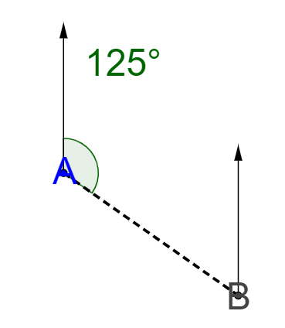  Add $180°$ to the bearing.  $$125°+180°=305°$$  The bearing of A from B is 305$°$. | Example 2  Given the bearing of A from B is $230°,$ calculate the bearing of A to B. 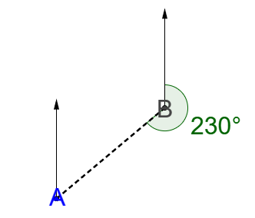
Things to remember | Example 3

Sample solutions

Appendix A – reading bearings
- Using the purple point A, complete the table to compare compass bearings and true bearings. The true bearing is the angle measured from North, represented in red.
Table 1: reading bearings
Compass bearing | True bearing
N | 000$°$/360$°$
NE | 045$°$
E | 090$°$
SE | 135$°$
S | 180$°$
SW | 225$°$
W | 270$°$
NW | 315$°$
- Convert the following true bearings to compass bearings.
- 079$°$ is $N79°E$
- 085$°$ is $N85°E$
- 251$°$ is $S71°W$
- 165$°$ is $S15°E$
- 294$°$ is $N66°W$
- 344$°$ is $N16°W$.

Appendix B – steps and bearings
These are suggested solutions. Your solutions may be slightly different due to the layout of your path.
Table 1: forwards
Path | True bearing | Compass bearing | Number of steps
AB | 169$°$ | $$S11°E$$ | 10
BC | 202$°$ | $$S22°W$$ | 5
CD | 343$°$ | N$17°W$ | 17
DE | 198$°$ | $$S18°W$$ | 9
Table 2: backwards
Path | True bearing | Compass bearing | Number of steps
ED | 349$°$ | $$N11°W$$ | 9
DC | 022$°$ | $$N22°E$$ | 5
CB | 163$°$ | $$S17°E$$ | 16
BA | 018$°$ | $$N18°E$$ | 9

Appendix C – four quadrant notes
Example 1  Given the bearing of B from A is $125°$, calculate the bearing of A from B.  Add $180°$ to the bearing.  $$125°+180°=305°$$  The bearing of A from B is 305$°$. | Example 2  Given the bearing of A from B is $230°$, calculate the bearing of B from A.  Subtract $180°$ from the bearing.  $$230°-180°=50°$$  The bearing of B from A is $050°.$
Things to remember  - Bearings are always 3 numbers, so if they are less than 100 put zeros at the front.  - A bearing A to B means it starts at A and follows around to B.  - A bearing A from B means it starts at B and follows around to A.  - To find the back bearing use corresponding angles in parallel lines. It is easier to extend the time sometimes to see what the corresponding angle will be. | Example 3  Given the bearing of A to B is $042°$, calculate the bearing B to A.  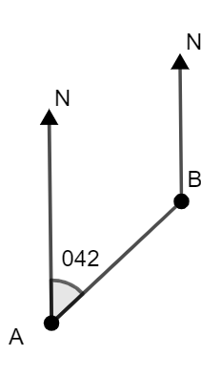  $$42°+180°=222°$$  The bearing of B to A is $222°$.

References
This resource contains NSW Curriculum and syllabus content. The NSW Curriculum is developed by the NSW Education Standards Authority. This content is prepared by NESA for and on behalf of the Crown in right of the State of New South Wales. The material is protected by Crown copyright.
Please refer to the NESA Copyright Disclaimer for more information https://educationstandards.nsw.edu.au/wps/portal/nesa/mini-footer/copyright.
NESA holds the only official and up-to-date versions of the NSW Curriculum and syllabus documents. Please visit the NSW Education Standards Authority (NESA) website https://educationstandards.nsw.edu.au and the NSW Curriculum website https://curriculum.nsw.edu.au.
Mathematics K–10 Syllabus © NSW Education Standards Authority (NESA) for and on behalf of the Crown in right of the State of New South Wales, 2022.

© State of New South Wales (Department of Education), 2024
The copyright material published in this resource is subject to the Copyright Act 1968 (Cth) and is owned by the NSW Department of Education or, where indicated, by a party other than the NSW Department of Education (third-party material).
Copyright material available in this resource and owned by the NSW Department of Education is licensed under a Creative Commons Attribution 4.0 International (CC BY 4.0) license.
This license allows you to share and adapt the material for any purpose, even commercially.
Attribution should be given to © State of New South Wales (Department of Education), 2024.
Material in this resource not available under a Creative Commons license:
- the NSW Department of Education logo, other logos and trademark-protected material
- material owned by a third party that has been reproduced with permission. You will need to obtain permission from the third party to reuse its material.
Links to third-party material and websites
Please note that the provided (reading/viewing material/list/links/texts) are a suggestion only and implies no endorsement, by the New South Wales Department of Education, of any author, publisher, or book title. School principals and teachers are best placed to assess the suitability of resources that would complement the curriculum and reflect the needs and interests of their students.
If you use the links provided in this document to access a third-party's website, you acknowledge that the terms of use, including licence terms set out on the third-party's website apply to the use which may be made of the materials on that third-party website or where permitted by the Copyright Act 1968 (Cth). The department accepts no responsibility for content on third-party websites.

