# Lost in the clouds

Students explore locating places for drone delivery using bearings and distances. Students will use Bathurst as a case study due to its grid-like street layout.

## Visible learning

### Learning intention

* To be able to calculate bearings to and from a point.

### Success criteria

* I can identify directions using compass points.
* I can estimate the value of a bearing from a diagram.
* I can calculate bearings to and from a point.

### Syllabus outcomes

A student:

* develops understanding and fluency in mathematics through exploring and connecting mathematical concepts, choosing and applying mathematical techniques to solve problems, and communicating their thinking and reasoning coherently and clearly **MAO-WM-01**
* applies trigonometry to solve problems, including bearings and angles of elevation and depression **MA5-TRG-C-02**

[Mathematics K–10 Syllabus](https://curriculum.nsw.edu.au/learning-areas/mathematics/mathematics-k-10-2022/overview) © NSW Education Standards Authority (NESA) for and on behalf of the Crown in right of the State of New South Wales, 2022.

## Activity structure

Please use the associated PowerPoint Lost in the clouds to display images in this lesson.

### Launch

1. Show students the video ‘How does Amazon drone delivery work? – BBC News’ (2:58) ([bit.ly/Amazondronedelivery](https://bit.ly/Amazondronedelivery)).
2. Display Figure 1 on slide 3 of the PowerPoint Lost in the clouds, which shows a map of Bathurst town centre*.*

Figure 1: Bathurst town centre

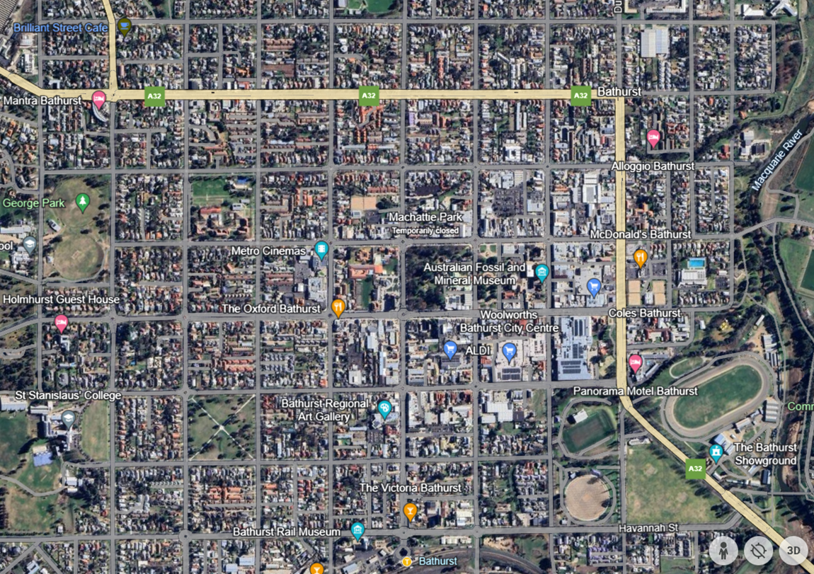

Map data by Google and Airbus

Please note for this task, the original map has been rotated from its northern orientation for content accessibility. Please consider north to be pointing towards the top of the map.

1. Inform students that The Oxford Bathurst restaurant is trialling delivering meals with drones within the Bathurst town centre.
2. In a Think-Pair-Share ([bit.ly/thinkpairsharestrategy](https://bit.ly/thinkpairsharestrategy)), ask students how a drone would know where to go on a delivery, assuming it does not have GPS to help it.

Students may talk about direction and distance using terms such as north, east, north-east or in terms of bearings as seen previously in Lesson 6 – getting my bearings of Unit 9 – surveying.

Student thinking can be extended to include 3D trigonometry as the drone would need to fly vertically up to a certain height and distance or diagonally in a 3D prism.

### Explore

1. Assign students into visibly random groups of 3 ([bit.ly/visiblegroups](https://bit.ly/visiblegroups)).
2. Distribute grid paper printed on A3 paper and placed in a plastic pocket.

Standard grid paper can be found on the Math-Aids website ‘Printable Math Graph Paper’ ([bit.ly/Printablegridpaper](https://bit.ly/Printablegridpaper)).

1. Distribute Appendix A ‘Driving instructions’ on A3 paper which provides students with a map of Bathurst and the different routes a car would drive to reach a location.
2. Tell students they need to turn the instructions for delivery drivers into instructions for the drone. Students will need to consider both the route to and from the destination.

Students will need to move from the map to the grid paper to complete all the routes in the activity as the routes extend beyond the limitations of the map. It is assumed that the map will continue in a grid format.

1. Students are to do a gallery walk ([bit.ly/DLSgallerywalk](https://bit.ly/DLSgallerywalk)) and give peer feedback using the TAG feedback strategy ([bit.ly/TAG-strategy](https://bit.ly/TAG-strategy)).
2. Use the Pose-Pause-Pounce-Bounce questioning strategy (PDF 557 KB) ([bit.ly/posepausepouncebounce](https://bit.ly/posepausepouncebounce)) to ask students what strategies they used to write the drone instructions.

Students could say 2 points on the grid paper, as you can find the distance between them or how far north or south and east or west the original location is from the end location.

### Summarise

1. Distribute Appendix B ‘Variation problems’ to each group. This appendix has a collection of questions that use Variation Theory ([variationtheory.com/introduction/](https://variationtheory.com/introduction/)).
2. Instruct students to find the bearing of B from A and then A from B for each question.
3. Students should compare their answers with other groups. If they have differing solutions, they should work together to find the correct solution.

### Apply

1. Pose the scenario below to students:

We know that a delivery car has travelled a total of 10 km (round trip) and only travelled in the directions north, south, east or west.

Find as many locations as possible for the car by calculating its bearing and distance from its original position.

Some sample solutions have been provided in ‘Apply – scenario solutions’.

1. Use the following [assessing and advancing questions (DOCX 327 KB)](https://education.nsw.gov.au/content/dam/main-education/documents/teaching-and-learning/curriculum/mathematics/mathematics-s4-supporting-strategies-assessing-and-advancing-questions.docx) to further student thinking:

Table 1: assessing and advancing questions

|  |  |
| --- | --- |
| Assessing questions | Advancing questions |
| What is a combination of directions that the car could travel? | Can you draw one path that the car could have driven? |
| How did you calculate the distance and/or bearing of the delivery car? | How could you find all the combinations of lengths in 2 directions you could have? |
| Can you explain how you decided on this route? | Have you noticed a similarity in your distances for when the car travels the same amount of kilometres east or west? What does it change in your solution? |
| Can you tell me what values your bearing should be between? | What do you think would happen to the distances and bearings if the car had only travelled a total of 5 km? |

1. Students are to do a gallery walk and observe the solutions other groups have found.
2. Use the Pose-Pause-Pounce-Bounce question strategy (PDF 557 KB) ([bit.ly/posepausepouncebounce](https://bit.ly/posepausepouncebounce)) to ask students what strategies helped them to find the bearing and distance of each solution they found.

Some students may find that when their route is reflected from travelling in a north-east to north-west direction, the distance stays the same but the bearing differs. Knowing this, they could calculate multiple solutions more efficiently by adding or subtracting from the compass bearings.

## Assessment and differentiation

### Suggested opportunities for differentiation

**Explore**

* The driving routes can be simplified to only include one turn.
* Students can move straight to the use of grid paper to find route bearings.
* Students can be supported by providing the following prompts to help them write their drone instructions:
* draw a triangle that includes how far they have travelled horizontally and how far they have travelled vertically
* calculate the distance from The Oxford Bathurst to the end location
* calculate the bearing from The Oxford Bathurst to the end location
* calculate the bearing from the end location to The Oxford Bathurst.
* Students may benefit from first revising how to find a missing angle using right-angled trigonometry.
* To extend students in the activity in Appendix A ‘Driving instructions’, change the delivery instructions away from the street corner. Have students investigate how this would change the instructions.

**Summarise**

* The teacher can provide more variation problems if students require further practice.

**Apply**

* To extend students, adjust the scenario to include movement in more than 2 directions and with longer distances or encourage them to consider decimal distances, for instance, 2.1 km north and then 2.9 km east.

### Suggested opportunities for assessment

**Explore**

* Students will demonstrate their Working mathematically skills in discussions and justifications while completing Appendix A ‘Driving instructions’ and the scenario.
* The teacher can collect students’ responses from Appendix A ‘Driving instructions’ to check students’ understanding of calculating bearings.

**Summarise**

* Create an exit ticket where students need to calculate the bearing from a given diagram.
* The teacher can collect Appendix B ‘Variation problems’ to check students’ understanding of calculating and finding bearings.

**Apply**

* Students will demonstrate their Working mathematically skills in discussions and justifications while completing the scenario.
* The teacher can collect student responses to the scenario to check students’ understanding of calculating and finding bearings.

## Appendix A

### Driving instructions

Listed below are common driving instructions for delivery drivers from The Oxford Bathurst restaurant. On the map of Bathurst, it is assumed that each block is 100 m and that north is at the top of the page.

You need to turn each of these routes into instructions for a drone to deliver.

1. Route 1:
2. 3 blocks north
3. 4 blocks east.
4. Route 2:
5. 5 blocks west
6. 4 blocks north.
7. Route 3:
8. one block south
9. 6 blocks east
10. 2 blocks south.
11. Route 4:
12. 9 blocks south
13. 3 blocks west
14. 2 blocks north
15. 3 blocks west.

#### Map of Bathurst

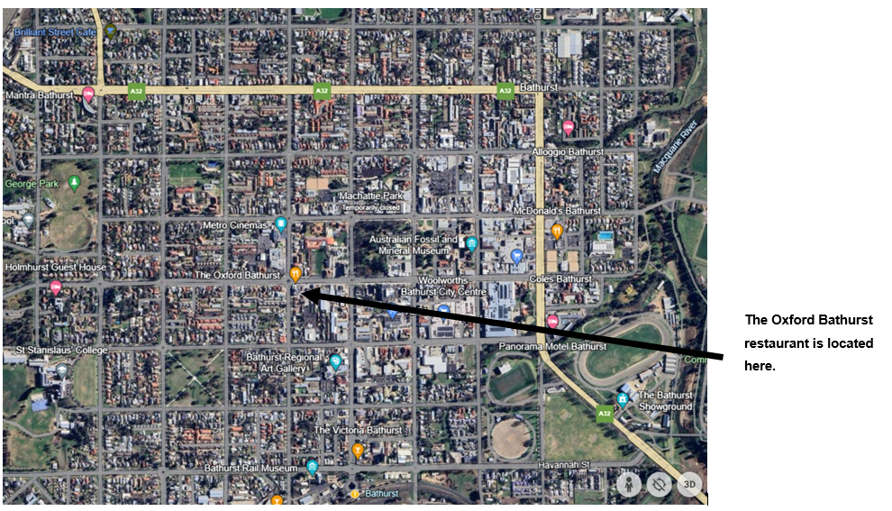

Map data by Google and Airbus.

## Appendix B

### Variation problems

Find the bearing of point B from point A and then point A from point B for each question.

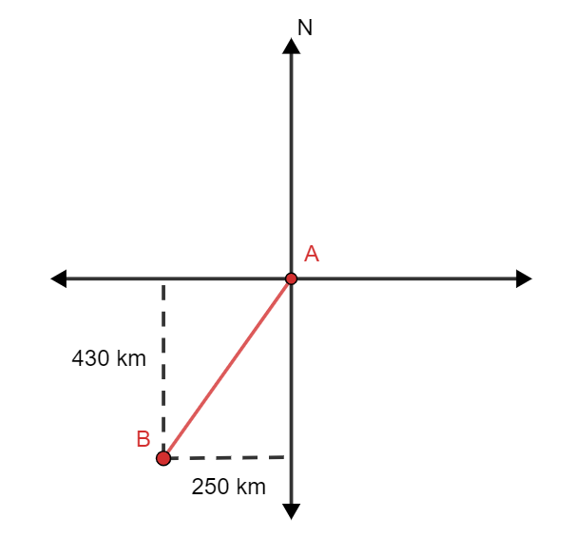

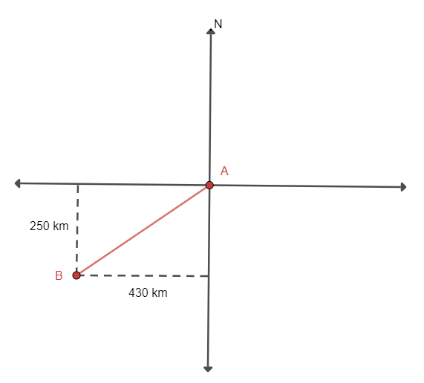

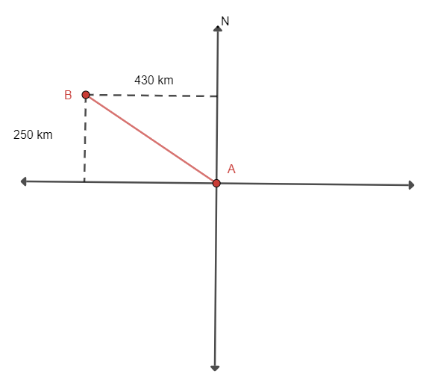

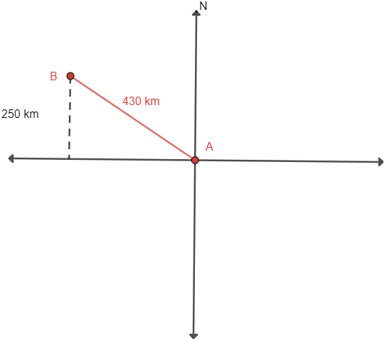

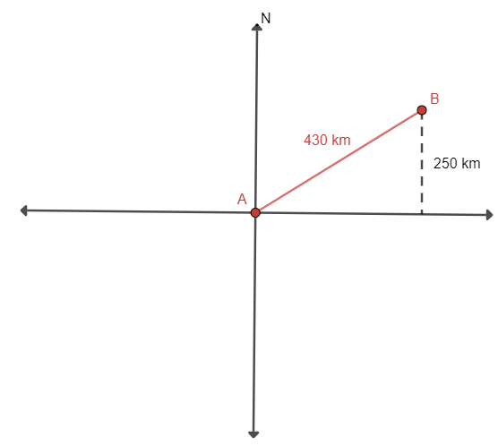

## Sample solutions

### Apply – scenario solutions

|  |  |  |  |  |  |
| --- | --- | --- | --- | --- | --- |
| Directions | Distance | Bearing  NE | Bearing  SE | Bearing  SW | Bearing  SE |
| Travelling N to S 1 km and E to W 9 km | $$d^{2}=1^{2}+9^{2} \\ =82 \\ d=\sqrt{82} \\ d≈9.1 km$$ | $$\tan{θ}=\frac{9}{1} \\ θ=\tan^{-1}{\frac{9}{1}} \\ θ≈84°$$ The bearing is 084 $°$ | $$180-84=96$$ The bearing is 096 $°$ | $$180+84=264$$ The bearing is 264 $°$ | $$360-84=276$$ The bearing is 276 $°$ |
| Travelling N to S 2 km and E to W 8 km | $$d^{2}=2^{2}+8^{2} \\ =68 \\ d=\sqrt{68} \\ d≈8.2 km$$ | $$\tan{θ}=\frac{8}{2} \\ θ=\tan^{-1}{\frac{8}{2}} \\ θ≈76°$$ The bearing is 076 $°$ | $$180-76=104$$ The bearing is 104 $°$ | $$180+76=256$$ The bearing is 256 $°$ | $$360-76=284$$ The bearing is 284 $°$ |
| Travelling N to S 3 km and E to W 7 km | $$d^{2}=3^{2}+7^{2} \\ =58 \\ d=\sqrt{58} \\ d≈7.6 km$$ | $$\tan{θ}=\frac{7}{3} \\ θ=\tan^{-1}{\frac{7}{3}} \\ θ≈67$$ The bearing is 067 $°$ | $$180-67=113$$ The bearing is 113 $°$ | $$180+67=247$$ The bearing is 247 $°$ | $$360-67=293$$ The bearing is 293 $°$ |
| Travelling N to S 4 km and E to W 6 km | $$d^{2}=4^{2}+6^{2} \\ =52 \\ d=\sqrt{52} \\ d≈7.2 km$$ | $$\tan{θ}=\frac{6}{4} \\ θ=\tan^{-1}{\frac{6}{4}} \\ θ≈56$$ The bearing is 056 $°$ | $$180-56=124$$ The bearing is 124 $°$ | $$180+56=236$$ The bearing is 236 $°$ | $$360-56=304$$ The bearing is 304 $°$ |
| Travelling N to S 5 km and E to W 5 km | $$d^{2}=5^{2}+5^{2} \\ =50 \\ d=\sqrt{50} \\ d≈7.1 km$$ | $$\tan{θ}=\frac{5}{5} \\ θ=\tan^{-1}{\frac{5}{5}} \\ θ≈45$$ The bearing is 045 $°$ | $$180-45=135$$ The bearing is 135 $°$ | $$180+45=225$$ The bearing is 225 $°$ | $$360-45=315$$ The bearing is 315 $°$ |
| Travelling N to S 6 km and E to W 4 km | $$d^{2}=6^{2}+4^{2} \\ =52 \\ d=\sqrt{52} \\ d≈7.2 km$$ | $$\tan{θ}=\frac{4}{6} \\ θ=\tan^{-1}{\frac{4}{6}} \\ θ≈34$$ The bearing is 034 $°$ | $$180-34=146$$ The bearing is 146 $°$ | $$180+34=214$$ The bearing is 214 $°$ | $$360-34=326$$ The bearing is 326 $°$ |
| Travelling N to S 7 km and E to W 3 km | $$d^{2}=7^{2}+3^{2} \\ =58 \\ d=\sqrt{58} \\ d≈7.6 km$$ | $$\tan{θ}=\frac{3}{7} \\ θ=\tan^{-1}{\frac{3}{7}} \\ θ≈23$$ The bearing is 023 $°$ | $$180-23=157$$ The bearing is 157 $°$ | $$180+23=203$$ The bearing is 203 $°$ | $$360-23=337$$ The bearing is 337 $°$ |
| Travelling N to S 8 km and E to W 2 km | $$d^{2}=8^{2}+2^{2} \\ =68 \\ d=\sqrt{68} \\ d≈8.2 km$$ | $$\tan{θ}=\frac{2}{8} \\ θ=\tan^{-1}{\frac{2}{8}} \\ θ≈14$$ The bearing is 014 $°$ | $$180-14=166$$ The bearing is 166 $°$ | $$180+14=194$$ The bearing is 194 $°$ | $$360-14=346$$ The bearing is 346 $°$ |
| Travelling N to S 9 km and E to W 1 km | $$d^{2}=9^{2}+1^{2} \\ =82 \\ d=\sqrt{82} \\ d≈9.1 km$$ | $$\tan{θ}=\frac{1}{9} \\ θ=\tan^{-1}{\frac{1}{9}} \\ θ≈6$$ The bearing is 006 $°$ | $$180-6=174$$ The bearing is 174 $°$ | $$180+6=186$$ The bearing is 186 $°$ | $$360-6=354$$ The bearing is 354 $°$ |

### Appendix A – driving instructions

|  |  |  |  |  |
| --- | --- | --- | --- | --- |
| Route | Diagram | Driving distance | Bearing from The Oxford Bathurst to the end location | Bearing from the end location to The Oxford Bathurst |
| 1 | Compass shows a diagonal line between north and east, from point A in the centre of the compass to point B. A horizontal line is drawn from point B to the north line and shows a distance of 400 m. A vertical line is drawn from point A along the north line until it meets the horizontal line from B. A right-angled triangle is created. The vertical line from point A shows a distance of 300 m. |  | The bearing is . | The bearing is |
| 2 | Compass shows a diagonal line between north and west, from point A in the centre of the compass to point B. A vertical line is drawn from point B to the west line and shows a distance of 400 m. A horizontal line is drawn from point A along the west line until it meets the vertical line from B. A right-angled triangle is created. The horizontal line from point A shows a distance of 500 m. |  | The bearing is . | The bearing is |
| 3 | Compass shows a diagonal line between south and east, from point A in the centre of the compass to point B. A vertical line is drawn from point B to the east line and shows a distance of 300 m. A horizontal line is drawn from point A along the east line until it meets the vertical line from B. A right-angled triangle is created. The horizontal line from point A shows a distance of 600 m. |  | The bearing is , | The bearing is |
| 4 | Compass shows a diagonal line between south and west, from point A in the centre of the compass to point B. A vertical line is drawn from point B to the west line and shows a distance of 700 m. A horizontal line is drawn from point A along the west line until it meets the vertical line from B. A right-angled triangle is created. The horizontal line from point A shows a distance of 600 m. |  | The bearing is $221°.$ | $$180°-90°-49°=41°$$ The bearing is $041°.$ |

### Appendix B – variation problems

$$\tan{θ}=\frac{250}{430} \\ θ=\tan^{-1}{\frac{250}{430}} \\ θ≈30°$$

The bearing of point B from point A is $180°+30°=210°.$

The bearing of point A from point B is $030°$ (alternate angles in parallel lines are equal).

$$\tan{θ}=\frac{430}{250} \\ θ=\tan^{-1}{\frac{430}{250}} \\ θ≈60°$$

The bearing of point B from point A is $180°+60°=240°$.

The bearing of point A from point B is $060°$ (alternate angles in parallel lines are equal).

$$\tan{θ}=\frac{250}{430} \\ θ=\tan^{-1}{\frac{250}{430}} \\ θ≈30°$$

The bearing of point B from point A is $270°+30°=300°$.

$$180°-90°-30°=60° \\ 180°-60°=120°$$

The bearing of point A from point B is $120°$.

$$\sin{θ}=\frac{250}{430} \\ θ=\sin^{-1}{\frac{250}{430}} \\ θ≈36°$$

The bearing of point B from point A is 270 $°+36°=306°$.

$$180°-90°-36°=54° \\ 180°-54°=126°$$

The bearing of point A from point B is $126°$.

$$\sin{θ}=\frac{250}{430} \\ θ=\tan^{-1}{\frac{250}{430}} \\ θ≈36°$$

$$90°-36°=54°$$

The bearing of point B from point A is $054°$.

$180°+54°=234°$ (alternate angles of parallel lines are equal, then adding from south).

The bearing of point A from point B is $234°$.

## References

This resource contains NSW Curriculum and syllabus content. The NSW Curriculum is developed by the NSW Education Standards Authority. This content is prepared by NESA for and on behalf of the Crown in right of the State of New South Wales. The material is protected by Crown copyright.

Please refer to the NESA Copyright Disclaimer for more information <https://educationstandards.nsw.edu.au/wps/portal/nesa/mini-footer/copyright>.

NESA holds the only official and up-to-date versions of the NSW Curriculum and syllabus documents. Please visit the NSW Education Standards Authority (NESA) website <https://educationstandards.nsw.edu.au/> and the NSW Curriculum website <https://curriculum.nsw.edu.au/>.

[Mathematics K–10 Syllabus](https://curriculum.nsw.edu.au/learning-areas/mathematics/mathematics-k-10-2022/overview) © NSW Education Standards Authority (NESA) for and on behalf of the Crown in right of the State of New South Wales, 2022.

**© State of New South Wales (Department of Education), 2024**

The copyright material published in this resource is subject to the Copyright Act 1968 (Cth) and is owned by the NSW Department of Education or, where indicated, by a party other than the NSW Department of Education (third-party material).

Copyright material available in this resource and owned by the NSW Department of Education is licensed under a [Creative Commons Attribution 4.0 International (CC BY 4.0) license](https://creativecommons.org/licenses/by/4.0/).

[](https://creativecommons.org/licenses/by/4.0/)

This license allows you to share and adapt the material for any purpose, even commercially.

Attribution should be given to © State of New South Wales (Department of Education), 2024.

Material in this resource not available under a Creative Commons license:

* the NSW Department of Education logo, other logos and trademark-protected material
* material owned by a third party that has been reproduced with permission. You will need to obtain permission from the third party to reuse its material.

**Links to third-party material and websites**

Please note that the provided (reading/viewing material/list/links/texts) are a suggestion only and implies no endorsement, by the New South Wales Department of Education, of any author, publisher, or book title. School principals and teachers are best placed to assess the suitability of resources that would complement the curriculum and reflect the needs and interests of their students.

If you use the links provided in this document to access a third-party's website, you acknowledge that the terms of use, including licence terms set out on the third-party's website apply to the use which may be made of the materials on that third-party website or where permitted by the Copyright Act 1968 (Cth). The department accepts no responsibility for content on third-party websites.