# Bearing it all

Students look at locality sketch plans which provide surveyors with bearings to surveyor markers. Students will use these bearings to find unknown distances.

## Visible learning

### Learning intention

* To be able to calculate distances given a bearing.

### Success criteria

* I can calculate the size of an angle in a right-angled triangle given a bearing.
* I can calculate the length of a side given a bearing and a known distance.
* I can explain the difference between a bearing from and a bearing to.

### Syllabus outcomes

A student:

* develops understanding and fluency in mathematics through exploring and connecting mathematical concepts, choosing and applying mathematical techniques to solve problems, and communicating their thinking and reasoning coherently and clearly **MAO-WM-01**
* applies trigonometry to solve problems, including bearings and angles of elevation and depression **MA5-TRG-C-02**

[Mathematics K–10 Syllabus](https://curriculum.nsw.edu.au/learning-areas/mathematics/mathematics-k-10-2022/overview) © NSW Education Standards Authority (NESA) for and on behalf of the Crown in right of the State of New South Wales, 2022.

## Activity structure

Please use the associated PowerPoint Bearing it all to display images in this lesson.

### Launch

1. Display Figure 1, which can be found on slide 3 of the PowerPoint Bearing it all. This shows a locality sketch plan to help locate a survey marker.

Figure 1: locality sketch plan

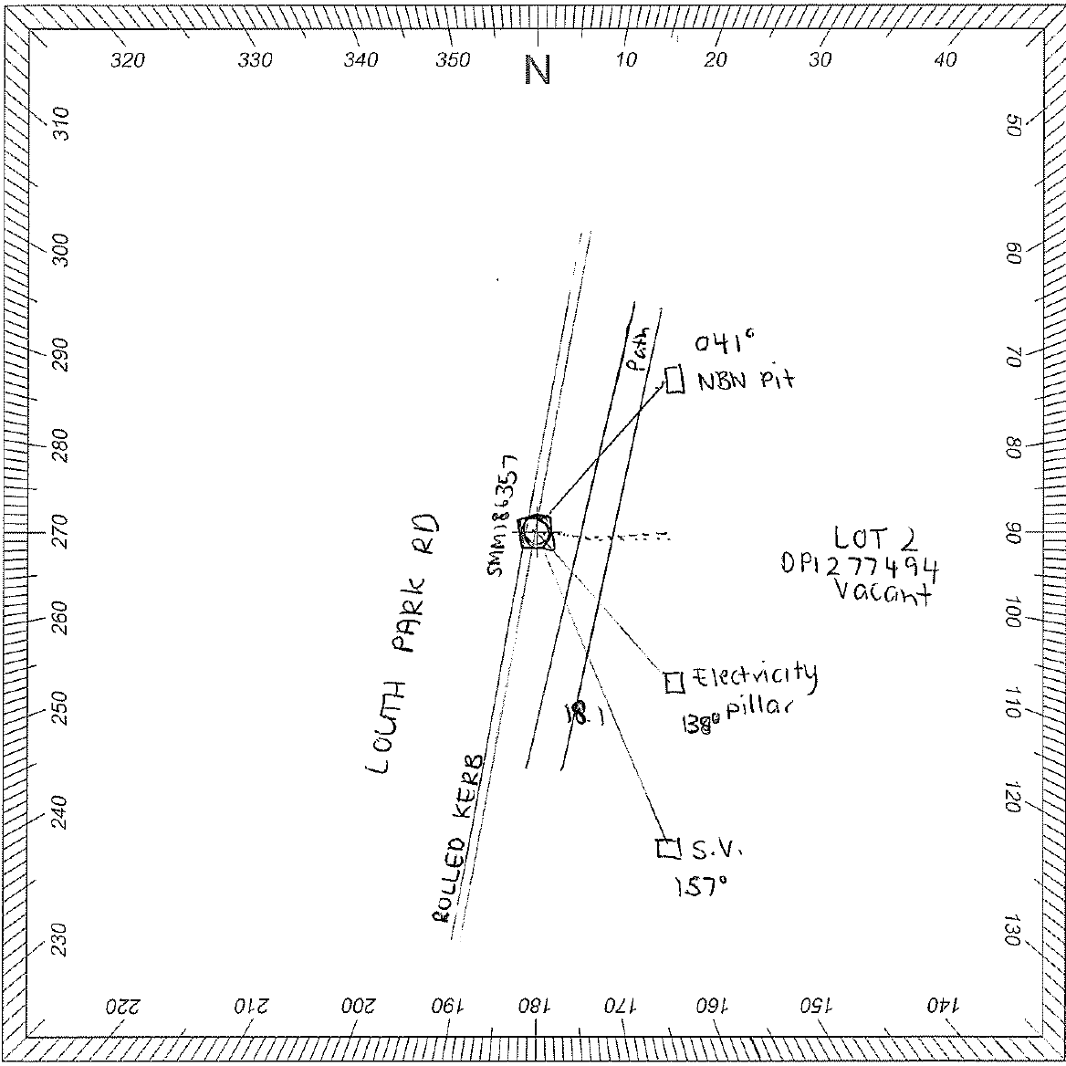

1. Explain to students what a locality sketch plan is and why they are needed.

A locality sketch plan is a small map showing the location of reference survey marks used by surveyors. It helps people locate them easily at a later date, as they are quite small.

Locality sketch plans are required for all permanent survey marks placed in NSW.

They must contain enough information, measured or calculated, to locate the permanent mark from visible and easily identifiable fixed features in the field.

Permanent survey marks are fundamental marks that define the location for surveying, mapping and engineering projects. Uses include housing developments, new road and bridge construction, improving railways and environmental mapping.

Every parcel of land has its boundaries determined from permanent survey marks.

Survey marks are named with the type of mark they are and a number. The one in Figure 1 is SSM186357, which is a state survey mark.

1. Ask students what they notice and wonder ([bit.ly/noticewonderstrategy](https://bit.ly/noticewonderstrategy)) about the locality sketch plan displayed.

Students may notice:

* the survey mark is called SSM186357
* only one distance has been given from the survey mark to the object labelled S.V. (18.1 m)
* the bearings from the survey mark (SSM186357) to the NBN pit ($041°$), the electricity pillar ($138°$) and the object label S.V. ($157°$) have been supplied.

Students may wonder:

* Is there enough information on the plan to locate the position of the reference mark?
* Is there enough information on the plan to find all the other lengths?

### Explore

1. Tell students that for each location a surveyor wants to reference, they need to describe its position from 3 other objects around it so they can easily find it at a later date. They use its bearing from the survey mark they want to reference and its distance, just like the locality sketch plan supplied in Figure 1.
2. Display Figure 2 to students. This can also be found on slide 5 of the Bearing it allPowerPoint.

Figure 2: bearing sketch

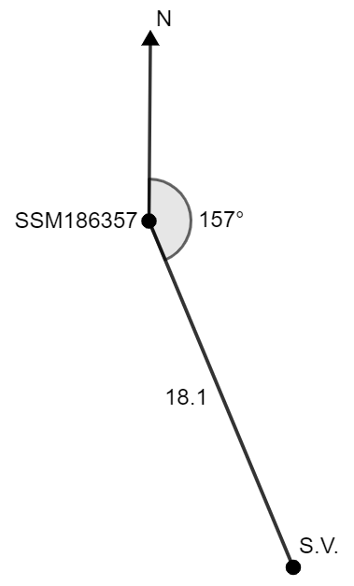

1. Inform students that this is one of the measurements provided on the locality sketch plan in Figure 1. To determine where the survey mark is without a compass, it is much easier to move in the directions of north, south, east or west as we can use the sun to determine these directions.
2. In a Think-Pair-Share ([bit.ly/thinkpairsharestrategy](https://bit.ly/thinkpairsharestrategy)), ask students:

* to determine the compass bearing from the true bearing of S.V. from the survey mark (SSM186357)
* to find the bearing of the survey mark (SSM186357) from S.V.
* how they could find how far the S.V. is south and east from the survey mark (SSM186357).

1. After sharing ideas with the class, ask students to work in pairs to calculate the distance S.V. is south and east of the survey mark (SSM186357).
2. Display slide 6 from the PowerPoint Bearing it all. This shows Emily’s solution for Figure 2. Ask students to read through Emily’s solution in silence.
3. Display slide 7 from the PowerPoint Bearing it all*,* which displays self-explanation prompts for Emily’s solution. In a Think-Pair-Share, ask students to respond to the self-explanation prompts.
4. Repeat steps 6 and 7 with slides 8–9 from the PowerPoint Bearing it all. These show Emily and Erin’s solutions for Figure 2, each using a different angle.

Students could be extended by making connections to complementary angles of trigonometric ratios ($\sin{θ}=\cos{(90-θ)}$) as the 2 angles, $67°$ and $23°$, are complementary.

1. Using the Pose-Pause-Pounce-Bounce questioning strategy (PDF 557 KB) ([bit.ly/posepausepouncebounce](https://bit.ly/posepausepouncebounce)), ask students the following question: Does it matter which angle we use to find distances? Why or why not?
2. Distribute Appendix A ‘Bearing problems’ to pairs of students. These questions use Variation Theory ([variationtheory.com/introduction/](https://variationtheory.com/introduction/)).

You could ask students to verify their solutions by finding 2 (or more) different ways to find the solution. Students could also use the bearing of B from A to find the solution, but this requires extra steps which are redundant.

1. Ask students to check their work with another pair. If they have differing solutions, ask them to work together to find the correct one.
2. Ask students to discuss, while still with another pair, how they decided which angle to use when given a bearing.

Students may suggest using the compass point closest to the value of the angle when given the distance or using the compass point that directly relates to the distance given, if it is north, south, east or west.

1. Ask students to rotate pairs by assigning one person in each pair to move 2 positions to the right around the classroom.
2. Distribute Appendix B ‘Distorted bearing sketch’ to each pair of students and ask them what they notice and wonder.

Students may notice that:

* the diagram has no distances labelled on it but instead, has a bearing to each of the objects
* there is a scale provided only for the vertical length
* there is a disclaimer saying the drawing is not to scale horizontally as it has been warped.

Students may wonder:

* Is there enough information for me to find all the necessary measurements?
* Is the horizontal scale the same?

1. Ask students to find the distances between the location and the objects in the sketch.

Students may require scaffolding to enable them to find the distances which may include:

* drawing each object from the reference point as their own diagram
* using the scale to find the vertical distances, or how far north or south it is from the reference location
* using the bearing to find an angle to use in a right-angled triangle to find the distance.

1. Using the Pose-Pause-Pounce-Bounce questioning strategy, ask students to explain the process they used to find a solution for Appendix B ‘Distorted bearing sketch’.
2. Ask students how the process would change if they were given the horizontal scale instead of the vertical.

### Summarise

1. Students are to create notes to their future forgetful selves ([bit.ly/notestofutureself](https://bit.ly/notestofutureself)) on finding an angle in a right-angled triangle given a bearing and using the triangle to solve problems.

Students should be reminded about the language ‘bearing from’ and ‘bearing to’ explored in Lesson 6 – getting my bearings of Unit 9 – surveying.

1. Instruct students that they are to create their own bearings questions. These must include the question in words and a diagram. These questions should include the language of bearings, from and to the bearing, and a given distance.
2. Collect all student questions and randomly distribute them around the classroom for students to complete. You can repeat this process for the number of questions you would like students to do.
3. Collect at least one solution as an exit ticket ([bit.ly/exitticketstrategy](https://bit.ly/exitticketstrategy)) for the lesson.

### Apply

#### What’s the scale?

1. Distribute Appendix C ‘Finding the scale’ to each student.
2. Allow students time to use the information presented to find the scale of the local sketch plan.
3. Students are to display their work around the room.
4. Students are to do a gallery walk ([bit.ly/DLSgallerywalk](https://bit.ly/DLSgallerywalk)), comparing their scales to each other.
5. In a Think-Pair-Share, ask students why they think their scales may have differed and what made it difficult to determine the scale.

#### Flight paths

1. Show students the Transum website ‘Air Traffic Control’ ([bit.ly/airtrafficctrl](https://bit.ly/airtrafficctrl)).
2. In a Think-Pair-Share, ask students if any of the aircrafts are likely to collide.
3. Select **Run simulation** on the bottom-right corner of the diagram.

**Interesting fact**: runway numbers are determined by rounding the compass bearing of one runway end to the nearest 10 degrees and removing the last digit, meaning runways are numbered from 1 to 36.

1. Returning to a Think-Pair-Share, ask students if they believe you could tell how far apart 2 planes were if they left at the same time going the same speed.
2. In visibly random groups of 3 ([bit.ly/visiblegroups](https://bit.ly/visiblegroups)) at vertical non-permanent surfaces ([bit.ly/VNPSstrategy](https://bit.ly/VNPSstrategy)), distribute Appendix D ‘Flight paths’ to students and ask them to find the solution to the problem.
3. Students are to do a gallery walk and complete peer feedback in the form of Two stars and a wish ([bit.ly/DLSpeerfeedback](https://bit.ly/DLSpeerfeedback)).
4. Individually students are to create their own problem for their group to complete that includes 2 bearings.
5. In a turn and talk ([bit.ly/classroomtalkmoves](https://bit.ly/classroomtalkmoves)) students are to discuss why it was more difficult to create a problem with 2 bearings.

Depending on how they created their questions, they may not be able to be solved without learning about non-right-angled trigonometry.

## Assessment and differentiation

### Suggested opportunities for differentiation

**Launch**

* As this activity has no correct answer and is subject to opinion, all students should be able to participate.

**Explore**

* Students may benefit from first revising the value of bearings at compass points.
* Noticing and wondering is used throughout the discussions in this lesson to allow all students to participate in a risk-free environment.
* Challenge students to explore the complementary relationship between sine and cosine.
* Students could be given the vertical lengths in Appendix B ‘Distorted bearing sketch’ to enable them to complete the task.
* Some students may benefit from scaffolding to assist them to complete the task in Appendix B ‘Distorted bearing sketch’.

**Summarise**

* Students can write their notes to their future forgetful selves in pairs.
* To assist students, allow them to create bearing questions in pairs.

**Apply**

* Some students would benefit from scaffolding to assist them to complete the task in Appendix C ‘Finding the scale’, including drawing each object on its own bearing diagram.
* To enable students, provide a diagram of the problem posed in Appendix D ‘Flight paths’.
* Extend students by considering what happens when we do not create right-angled triangles with bearings.

### Suggested opportunities for assessment

**Explore**

* Students give each other peer feedback, before sharing with the class in a Think-Pair-Share.
* Monitor responses in class discussions to check for student understanding of finding angles in bearings diagrams.

**Summarise**

* Review students’ notes to their future forgetful selves to check their understanding of the wording of bearings questions.
* Students’ questions and solutions to a question are collected as an exit ticket to see how well they understand finding distances with bearings.

**Apply**

* When placed in groups of 3, students provide and receive peer feedback on their understanding.
* Students provide peer feedback using Two stars and a wish.

## Appendix A

### Bearing problems

Complete the following bearing problems.

|  |  |
| --- | --- |
| 1. How far north and east is F from A?   AF, 43 km on a bearing of 018 degrees. | 1. How far north and west is F from A?   AF, 43 km on a bearing of 342 degrees. |
| 1. How far north and west is F from A?   AF, 36 km on a bearing of 342 degrees. | 1. How far is F from A and how far west?   AF, on a bearing of 342 degrees, 36 km north of A. |

|  |  |
| --- | --- |
| 1. How far south and west is F from A?   AF, 36 km, on a bearing of 225 degrees. | 1. How far west and south is F from A?   AF, 26 km, on a bearing of 225 degrees. |
| 1. How far is F from A and how far south?   AF, on a bearing of 225 degrees, 26 km west of A. | 1. How far south and east is F from A?   AF, 26 km, on a bearing of 140 degrees. |

## Appendix B

### Distorted bearing sketch

An apprentice surveyor has accidentally printed the diagram with a distorted horizontal scale. The vertical measurement scale is still intact, showing metres from zero.

Find the true lengths of AB, AC and AD.

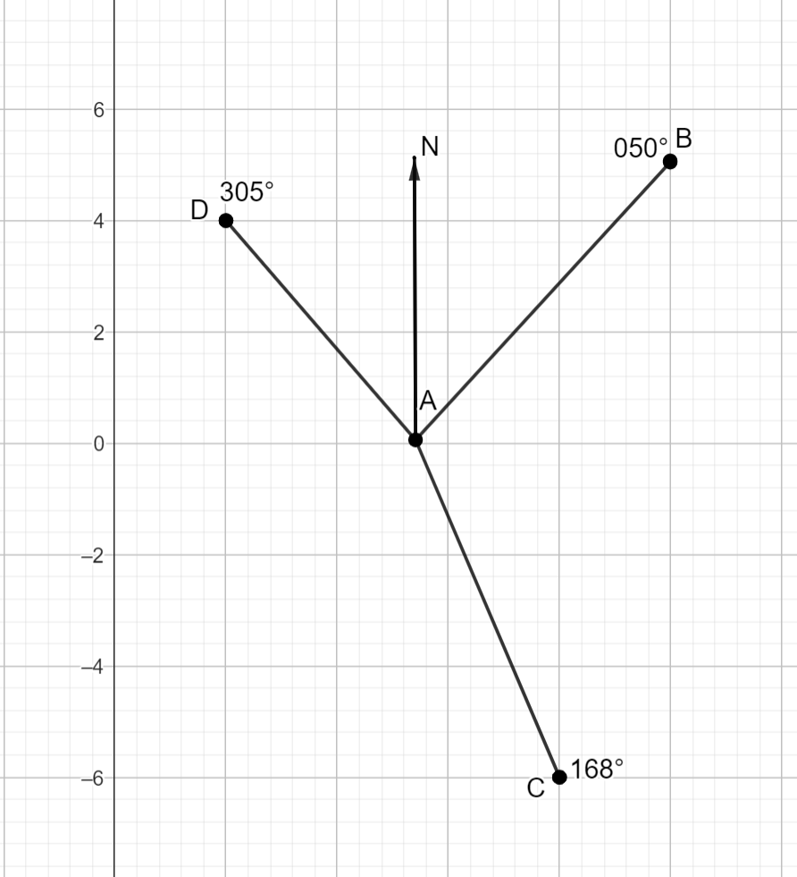

## Appendix C

### Finding the scale

1. Determine the scale for the diagram using the values and bearings below.
2. Find the length of OC.

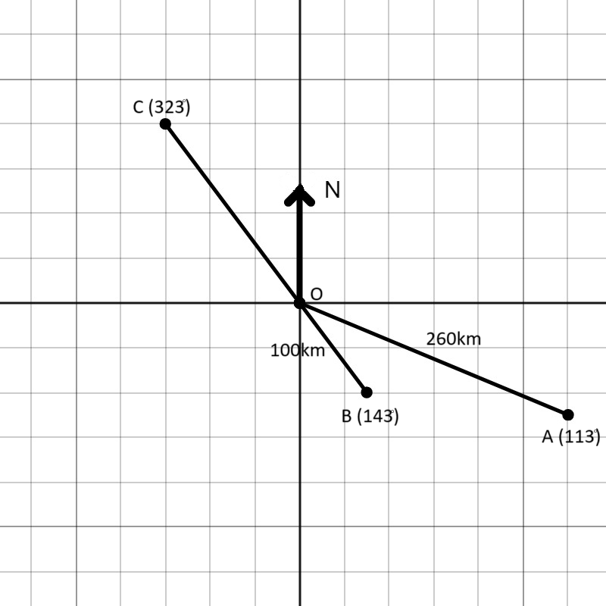

## Appendix D

### Flight paths

Two planes start their flight at the same time. The first plane flies on a course of $030°$ while the second plane flies on a course of $120°$.

1. The first plane flies 300 km until it is due north of the second plane. Find the distance between them.
2. How far has the second plane flown?

## Sample solutions

### Appendix A – bearing problems

|  |  |  |  |
| --- | --- | --- | --- |
| Question | Diagram | Calculation 1 | Calculation 2 |
| 1 | AF, 43 km on a bearing of 018 degrees. | East | North |
| 2 | AF, 43 km on a bearing of 342 degrees. | Angle  North | Angle  West |
| 3 | AF, 36 km on a bearing of 342 degrees. | Angle  North | Angle  West |
| 4 | AF, on a bearing of 342 degrees, 36 km north of A | Angle  West | Angle  AF |
| 5 | AF, 36 km, on a bearing of 225 degrees. | Angle  South $$\sin{45°}=\frac{WF}{36} \\ WF=36×\sin{45°} \\ =25.455… \\ ≈25.5 km$$ | Angle $$270-225=45°$$ $∆WAF$ is isosceles, $∴$ south = west = $25.5 km$ **or**  West |
| 6 | AF, 26 km, on a bearing of 225 degrees. | Angle  South $$\sin{45°}=\frac{WF}{26} \\ WF=26×\sin{45°} \\ =18.384… \\ ≈18.4 km$$ | Angle $$270-225=45°$$ $∆WAF$ is iscoseles, $∴$ south = west = $18.4 km$ **or**  West |
| 7 | AF, on a bearing of 225 degrees, 26 km west of A. | Angle  is iscoseles, $∴$ south = west = $26 km$ **or**  South $$\tan{45°}=\frac{WF}{26} \\ WF=26×\tan{45°} \\ ≈26 km$$ | Angle $$270-225=45°$$ AF  **or** |
| 8 | AF, 26 km, on a bearing of 140 degrees. | Angle  South $$\sin{50}=\frac{JF}{26} \\ JF=26×\sin{50} \\ =19.917… \\ ≈19.9 km$$ | Angle $$140-90=50°$$ East $$\cos{50}=\frac{AJ}{26} \\ AJ=26×\cos{50} \\ =16.712… \\ ≈16.7 km$$ |

### Appendix B – distorted bearing sketch

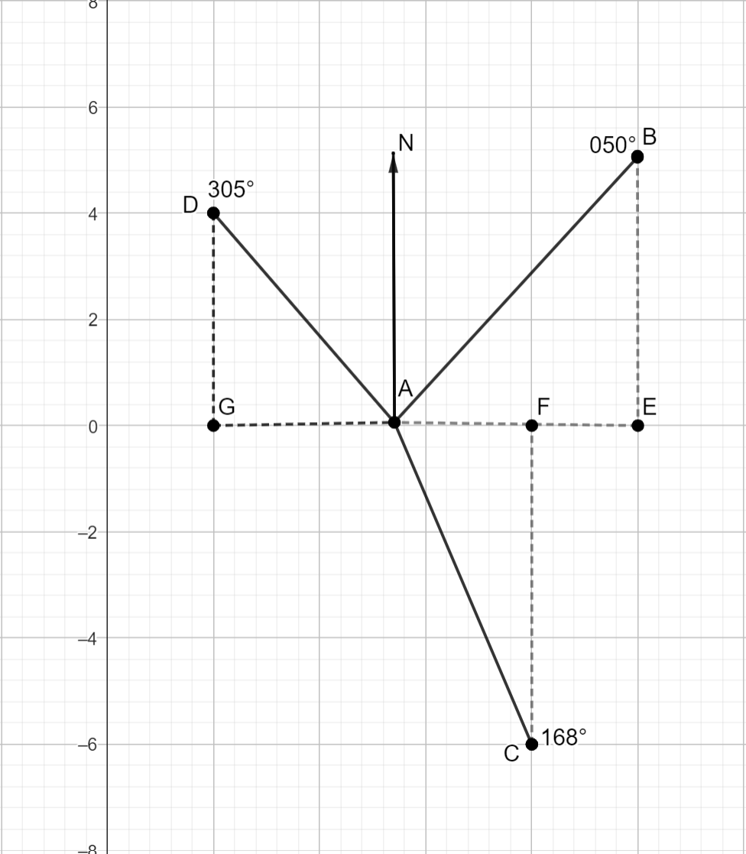

Length AB

$$∠BAE=90-50 \\ =40°$$

Length BE from grid $=5 km$

$$\sin{40°}=\frac{5}{AB} \\ AB= \frac{5}{\sin{40}} \\ =7.778… \\ ≈7.8 km$$

Length AC

$$∠CAF=168-90 \\ =78°$$

Length CF from grid $=6 km$

$$\sin{78°}=\frac{6}{AC} \\ AC=\frac{6}{\sin{78°}} \\ =6.134… \\ ≈6.1 km$$

Length AD

$$∠DAG=305-270 \\ =35°$$

Length DF from grid $=4 km$

$$\sin{35°}=\frac{4}{AD} \\ AD=\frac{4}{\sin{35°}} \\ =6.973… \\ ≈7.0 km$$

### Appendix C – finding the scale

|  |  |  |  |
| --- | --- | --- | --- |
| Bearing from O | Angle | Horizontal | Vertical |
| A | $$113-90=23°$$ | $$\cos{23°}=\frac{x}{260} \\ x=260\cos{23°} \\ ≈239.3 km$$ | $$\sin{23°}=\frac{y}{260} \\ y=260\sin{23°} \\ y≈101.6 km$$ |
| B | $$143-90=53°$$ | $$\cos{53°}=\frac{x}{100} \\ x=100\cos{53°} \\ x≈60.2 km$$ | $$\sin{53°}=\frac{y}{100} \\ y=100\sin{53°} \\ y≈79.8 km$$ |

Finding the length of OC

|  |  |  |  |  |
| --- | --- | --- | --- | --- |
| Number of units on the grid | 1.5 | 2 | 2.5 | 6 |
| Measurement | 60.2 | 79.8 | 101.6 | 239.3 |
| Constant of proportionality | 40.1 | 39.9 | 40.6 | 39.9 |

The scale is approximately 1:40.

1. Three units horizontally implies it is actually 120 km

$$360-323=37° \\ \sin{37°}=\frac{120}{d} \\ d=\frac{120}{\sin{37°}} \\ d≈199.4 km$$

### Appendix D – flight paths

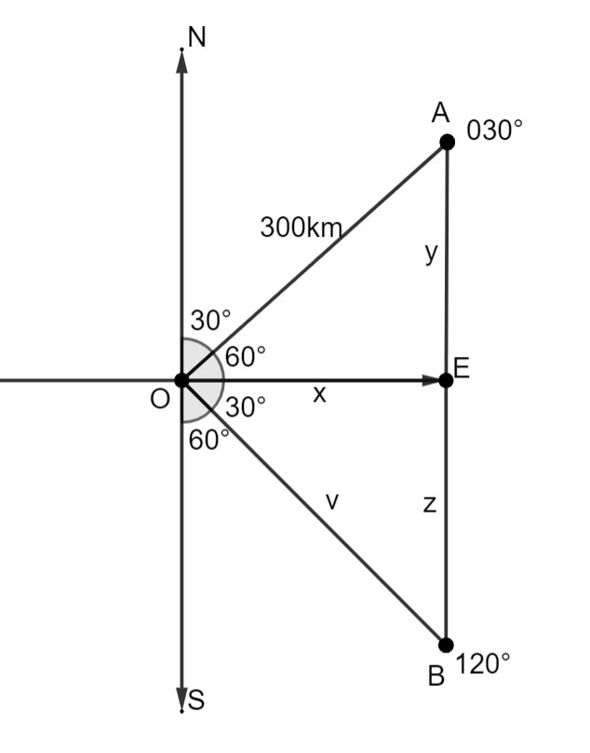

To find AB, we need the length of AE and BE.

To find AE,

$$90-30=60° \\ \sin{60°}=\frac{y}{300} \\ y=300×\sin{60°} \\ ≈260 km$$

AE is 260 km.

To find BE, we first need the value of OE, so we have a value in the $∆$ OEB.

$$\cos{60°}=\frac{x}{300} \\ x=300\cos{60°} \\ =150 km$$

OE is 150 km.

Now that we have the value of OE, we can use that to find BE.

$$120-90=30°$$

$$\tan{30}=\frac{z}{150} \\ z=150×\tan{30°} \\ =86.6025… \\ ≈87 km$$

BE is 87 km.

$$∴AB=AE+BE \\ =259.807+86.602 \\ =346.4095… \\ ≈346 km$$

The distance between the 2 planes is 346 km.

1. OB

$$\cos{30°}=\frac{150}{v} \\ v=\frac{150}{\cos{30°}} \\ =173.205… \\ ≈173 km$$

The second plane has flown 173 km.

## References

This resource contains NSW Curriculum and syllabus content. The NSW Curriculum is developed by the NSW Education Standards Authority. This content is prepared by NESA for and on behalf of the Crown in right of the State of New South Wales. The material is protected by Crown copyright.

Please refer to the NESA Copyright Disclaimer for more information <https://educationstandards.nsw.edu.au/wps/portal/nesa/mini-footer/copyright>.

NESA holds the only official and up-to-date versions of the NSW Curriculum and syllabus documents. Please visit the NSW Education Standards Authority (NESA) website <https://educationstandards.nsw.edu.au> and the NSW Curriculum website <https://curriculum.nsw.edu.au>.

[Mathematics K–10 Syllabus](https://curriculum.nsw.edu.au/learning-areas/mathematics/mathematics-k-10-2022/overview) © NSW Education Standards Authority (NESA) for and on behalf of the Crown in right of the State of New South Wales, 2022.

**© State of New South Wales (Department of Education), 2024**

The copyright material published in this resource is subject to the Copyright Act 1968 (Cth) and is owned by the NSW Department of Education or, where indicated, by a party other than the NSW Department of Education (third-party material).

Copyright material available in this resource and owned by the NSW Department of Education is licensed under a [Creative Commons Attribution 4.0 International (CC BY 4.0) license](https://creativecommons.org/licenses/by/4.0/).

[](https://creativecommons.org/licenses/by/4.0/)

This license allows you to share and adapt the material for any purpose, even commercially.

Attribution should be given to © State of New South Wales (Department of Education), 2024.

Material in this resource not available under a Creative Commons license:

* the NSW Department of Education logo, other logos and trademark-protected material
* material owned by a third party that has been reproduced with permission. You will need to obtain permission from the third party to reuse its material.

**Links to third-party material and websites**

Please note that the provided (reading/viewing material/list/links/texts) are a suggestion only and implies no endorsement, by the New South Wales Department of Education, of any author, publisher, or book title. School principals and teachers are best placed to assess the suitability of resources that would complement the curriculum and reflect the needs and interests of their students.

If you use the links provided in this document to access a third-party's website, you acknowledge that the terms of use, including licence terms set out on the third-party's website apply to the use which may be made of the materials on that third-party website or where permitted by the Copyright Act 1968 (Cth). The department accepts no responsibility for content on third-party websites.