# Going round in circles

Students review Pythagoras’ theorem and use it to derive the equation of a circle.

## Visible learning

This lesson incorporates Path content.

### Learning intention

* To understand the connection between the graph of a circle and its equation.

### Success criteria

* I can find the distance between 2 points.
* I can derive the equation for a circle.
* I can find the radius of a circle from the equation.
* I can graph a circle with centre at the origin.

### Syllabus outcomes

A student:

* develops understanding and fluency in mathematics through exploring and connecting mathematical concepts, choosing and applying mathematical techniques to solve problems, and communicating their thinking and reasoning coherently and clearly **MAO-WM-01**
* interprets and compares non-linear relationships and their transformations, both algebraically and graphically **MA5-NLI-P-01**

[Mathematics K–10 Syllabus](https://curriculum.nsw.edu.au/learning-areas/mathematics/mathematics-k-10-2022/overview) © NSW Education Standards Authority (NESA) for and on behalf of the Crown in right of the State of New South Wales, 2022.

## Activity structure

Please use the associated PowerPoint Going around in circles to display images in this lesson.

### Launch

This activity has been modified from Maths is Fun ‘Activity: A Walk in the Desert 2’ ([mathsisfun.com/activity/walk-in-desert-2.html](https://www.mathsisfun.com/activity/walk-in-desert-2.html)).

1. Assign students to visibly random groups of 3 ([bit.ly/visiblegroups](https://bit.ly/visiblegroups)) on vertical non-permanent surfaces ([bit.ly/VNPSstrategy](https://bit.ly/VNPSstrategy)).
2. Display slide 2 from the PowerPoint Going around in circles, which shows Figure 1.

Figure 1: lost bushwalker

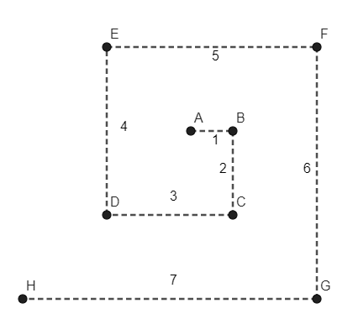

1. State the following scenario to students:

While on a bush walk, Reggie finds a waterhole with clean drinking water. As he stops to fill his drink bottle, Reggie realises he is lost. He has a compass with him.

Reggie has a plan to find his way out of the bush. His plan ensures he always knows how to return to the waterhole to fill his water bottle until he finds a way out.

His plan involves walking 100 metres east, changing direction and walking 200 metres south, then 300 metres west, 400 metres north, 500 metres east, 600 metres south and so on. The diagram provided (see Figure 1) shows how the plan works.

Reggie needs to know how far back it is to the waterhole at each turning point if he decides he needs to return for water. Find the distance between each turning point and the waterhole to help Reggie plan his route to safety.

1. Distribute Appendix A ‘Lost bushwalker’ to each group and ask students to attempt the problem.

Appendix A ‘Lost bushwalker’ contains the walking track and a Cartesian plane with the origin labelled A to aid students with calculations.

1. Ask students [assessing and advancing questions (DOCX 327 KB)](https://education.nsw.gov.au/content/dam/main-education/documents/teaching-and-learning/curriculum/mathematics/mathematics-s4-supporting-strategies-assessing-and-advancing-questions.docx) to further student thinking. Some suggestions are made in Table 1 below:

Table 1: assessing and advancing questions for the Launch scenario

|  |  |
| --- | --- |
| Assessing questions | Advancing questions |
| What information do we know? Can you mark it on the diagram? | Can you tell how far north, south, east or west Reggie is from his start point for each point on his journey? |
| Can you show me the distance you need to find? | How have we found distance using right-angled triangles before? |
| How did you find that distance? | If Reggie started travelling north rather than east to start his journey, what would change in our solutions? |

1. Ask students to do a gallery walk ([bit.ly/DLSgallerywalk](https://bit.ly/DLSgallerywalk)) of the other group’s solutions noting the approaches people took to solve the problem and complete the peer feedback strategy Two stars and a wish ([bit.ly/DLSpeerfeedback](https://bit.ly/DLSpeerfeedback)).
2. Select random students to explain the working from another group and share it with the class.

Attention should highlight how Pythagoras’ theorem or the distance formula could be used to find the distances, in anticipation of drawing on this connection during the lesson.

### Explore

1. Continuing in their visibly random groups of 3, give students the following new scenario and a new Cartesian plane in an A3 plastic sleeve from Appendix A ‘Lost bushwalker’.

Reggie began following his plan, but at one point he decided he needed to return to the waterhole. Once he was at the waterhole, he realised that he couldn’t remember the bearing he came from. However, he knew that he had walked 800 metres to return to the waterhole. Find all the possible points he could have travelled from.

Students may need to be prompted to use a scale on their Cartesian plane, such as 1 unit is equivalent to 100 metres.

1. Ask students assessing and advancing questions to further student thinking. Some suggestions are made in Table 2 below:

Table 2: assessing and advancing questions for the Explore scenario

|  |  |
| --- | --- |
| Assessing questions | Advancing questions |
| Can you explain what the question is asking? | If Reggie was north, south, east or west of the river, where would those points be? |
| What information do we know? | If we knew the $x$ coordinate was 2, how would we find the $y$ coordinate? |
| What information do we need to know to find a bearing? | If we knew the bearing that Reggie travelled was 45 $°$, could we find the $x$ and $y$ coordinates? |
| How did you determine that to be a possible location? | How many different points could Reggie have walked from? |

1. Initiate a sharing of ideas and reasoning of how students found their points using the Pose-Pause-Pounce-Bounce question strategy (PDF 557 KB) ([bit.ly/posepausepouncebounce](https://bit.ly/posepausepouncebounce)).

Students may have found points in different ways that could include fixing an x- or y-value and evaluating for the other coordinate using Pythagoras’ theorem, finding the points on the axis by moving along 8 units, reflecting points to find negative coordinates or assigning an angle and solving using trigonometric ratios.

1. Display the website ‘Desmos graphing calculator’ ([desmos.com/calculator](https://www.desmos.com/calculator)) to students.
2. Groups are to share points they found with the class and the teacher will collate the points by graphing them on the Desmos graphing calculator.
3. Ask students what they notice and wonder ([bit.ly/noticewonderstrategy](https://bit.ly/noticewonderstrategy)).

Students should notice that the points start to make a circle. If students did not find many points, a list of potential points can be found in the sample solutions.

1. In a Think-Pair-Share ([bit.ly/thinkpairsharestrategy](https://bit.ly/thinkpairsharestrategy)), ask students how they think the graph would change if the distance Reggie walked back from the waterhole was 2 km or 10 km.
2. Display the GeoGebra applet ‘Circle Equation Anatomy and Exploration’ ([bit.ly/geogebracircle](https://bit.ly/geogebracircle)).
3. Select the box **Insight?** to display a right-angled triangle.
4. Select the point $\left(x, y\right)$ and drag it around the circle.

To help students make connections, drag the point **($x, y$)** to integer points such as (0,5), (3,4) and (-3,4).

1. Ask students to substitute the values and variables into Pythagoras’ theorem ($a^{2}+b^{2}=c^{2}$) and then share what they notice and wonder.

Students may notice:

* the equation on the screen is the same as when they substituted the values and variables into Pythagoras’ theorem
* no matter the value for x and y, this remains the same
* the radius is the square of the value.

Students may wonder:

* Is Pythagoras’ theorem and the equation of a circle the same thing?
* Do I just change the value for the radius to get a different equation for a circle?

1. In a Think-Pair-Share, ask students what they think the equation of a circle might be for each length: 8 km, 2 km and 10 km.

Students only need to substitute the distance or radius into Pythagoras’ theorem. When doing this, they should get the equations: $x^{2}+y^{2}=64$, $x^{2}+y^{2}=4$ and $x^{2}+y^{2}=100$.

### Summarise

1. Show the equation $x^{2}+y^{2}=r^{2}$, that can be found on slide 3 of the PowerPoint *Going around in circles* and define this to students as the equation of a circle with the centre at the origin with Cartesian coordinates ($x,y$) and radius (r).
2. Students are to write notes to their future forgetful selves ([bit.ly/notestofutureself](https://bit.ly/notestofutureself)) about graphing circles with the centre at the origin.
3. Returning to their groups of 3 at vertical non-permanent surfaces, give students the new scenario:

A search team has found Reggie’s original location (point A) with his plan written down. The plan did not specify what direction he started walking in.

Find all possible locations up to 5 iterations of where Reggie could be in the bush by stating the equation of the circle with the centre at the origin.

1. Have students check their solutions with another group. If they differ have them work together to find the correct solution.

### Apply

1. Distribute and ask students to attempt Appendix B ‘Full circle’. This has students identifying the radius from the equation of a circle, graphing the equation and trying to find where the circle has integer coordinates.
2. Have students check their solutions with a partner. If they differ, have them work together to find the correct solution.

## Assessment and differentiation

### Suggested opportunities for differentiation

**Launch**

* Students may benefit from first plotting points on a Cartesian plane.
* To enable students, provide the diagram in Appendix A ‘Lost bushwalker’ on a Cartesian plane.
* Use assessing and advancing questions to help progress students through the activity.
* If students have learned about simplifying surds, ask them to write their answers as simplified surds.

**Explore**

* To enable students, give them a scale or change the distance from their original location (point A) to 8 km.
* If students have learned about simplifying surds, modify the distances in the Think-Pair-Share activity.
* To extend students, ask them to write the equation of a circle using trigonometric ratios in reference to magnitude and angle. This will lead you to the trigonometric identity of $$\sin^{2}{θ}+\cos^{2}{θ}=1.$$

**Summarise**

* Students can write their notes to their future forgetful selves in pairs.

**Apply**

* To enable students, ask them to graph circles using graphing software such as Desmos.
* To extend students, ask them to complete the extension activity in Appendix B ‘Full circle’. This has students connecting Pythagorean triads to integer coordinates.
* To enable students, return to the GeoGebra applet ‘Circle Equation Anatomy and Exploration’ ([bit.ly/geogebracircle](https://bit.ly/geogebracircle)) to see visually where the circle $x^{2}+y^{2}=25$ has integer solutions.

### Suggested opportunities for assessment

**Launch**

* Students will demonstrate their working mathematically skills in discussions and justifications**.**
* Peer feedback is given through Two stars and a wish.

**Explore**

* When placed in groups of 3, students provide and receive peer feedback on their understanding.
* Monitor responses in class discussions to check for student understanding of finding points on a circle using trigonometric ratios and/or Pythagoras’ theorem.
* Students receive peer feedback in a Think-Pair-Share.

**Summarise**

* Review student's notes to their future forgetful selves.

**Apply**

* Collect Appendix B ‘Full circle’ as evidence of student learning.

## Appendix A

### Lost bushwalker



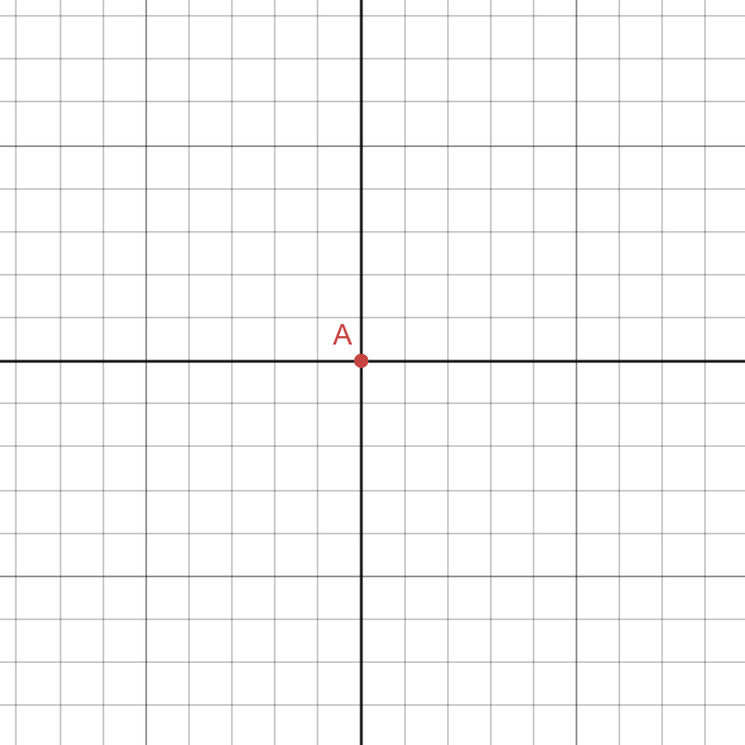

## Appendix B

### Full circle

Given the following equations:

* identify the length of the radius
* sketch the graph.

The equations are given below:

$x^{2}+y^{2}=36$

$x^{2}+y^{2}=6.25$

$x^{2}+y^{2}=25.$

#### Extension task

1. Identify the points on the circle $x^{2}+y^{2}=25$ that have integer values for their coordinates.
2. What other circles would you expect to have integer values for coordinates?

## Sample solutions

### Explore activity

In this sample solution, we have assumed that 1 unit is equivalent to 100 m.

Potential points that are 8 units from the origin include:

* points on the axis (0,8), (0,−8), (8,0) and (−8,0)
* reflection of points in each quadrant.

|  |  |  |  |
| --- | --- | --- | --- |
| First quadrant | Second quadrant | Third quadrant | Fourth quadrant |
| $$(1, \sqrt{63})$$ | $$(-1, \sqrt{63})$$ | $$(-1, -\sqrt{63})$$ | $$(1, -\sqrt{63})$$ |
| $$(2, \sqrt{60})$$ | $$(-2, \sqrt{60})$$ | $$(-2, -\sqrt{60})$$ | $$(2, -\sqrt{60})$$ |
| $$(3, \sqrt{55})$$ | $$(-3, \sqrt{55})$$ | $$(-3, -\sqrt{55})$$ | $$(3, -\sqrt{55})$$ |
| $$(4, \sqrt{48})$$ | $$(-4, \sqrt{48})$$ | $$(-4, -\sqrt{48})$$ | $$(4, -\sqrt{48})$$ |
| $$(5, \sqrt{39})$$ | $$(-5, \sqrt{39})$$ | $$(-5, -\sqrt{39})$$ | $$(5, -\sqrt{39})$$ |
| $$(6, \sqrt{28})$$ | $$(-6, \sqrt{28})$$ | $$(-6, -\sqrt{28})$$ | $$(6, -\sqrt{28})$$ |
| $$(7, \sqrt{15})$$ | $$(-7, \sqrt{15})$$ | $$(-7, -\sqrt{15})$$ | $$(7, -\sqrt{15})$$ |
| $$(\sqrt{63}, 1)$$ | $$(-\sqrt{63}, 1)$$ | $$(-\sqrt{63}, -1)$$ | $$(\sqrt{63}, -1)$$ |
| $$(\sqrt{60}, 2)$$ | $$(-\sqrt{60}, 2)$$ | $$(-\sqrt{60}, -2)$$ | $$(\sqrt{60}, -2)$$ |
| $$(\sqrt{55}, 3)$$ | $$(-\sqrt{55}, 3)$$ | $$(-\sqrt{55}, -3)$$ | $$(\sqrt{55}, -3)$$ |
| $$(\sqrt{48}, 4)$$ | $$(-\sqrt{48}, 4)$$ | $$(-\sqrt{48}, -4)$$ | $$(\sqrt{48}, -4)$$ |
| $$(\sqrt{39}, 5)$$ | $$(-\sqrt{39}, 5)$$ | $$(-\sqrt{39}, -5)$$ | $$(\sqrt{39}, -5)$$ |
| $$(\sqrt{28}, 6)$$ | $$(-\sqrt{28}, 6)$$ | $$(-\sqrt{28}, -6)$$ | $$(\sqrt{28}, -6)$$ |
| $$(\sqrt{15}, 7)$$ | $$(-\sqrt{15}, 7)$$ | $$(-\sqrt{15}, -7)$$ | $$(\sqrt{15}, -7)$$ |

### Summarise activity

|  |  |  |
| --- | --- | --- |
| Point | Radius or distance | Equation of the circle |
| A | 0 | – |
| B | 1 | $$x^{2}+y^{2}=1$$ |
| C | $\sqrt{5}$ | $$x^{2}+y^{2}=5$$ |
| D | $\sqrt{8}$ | $$x^{2}+y^{2}=8$$ |
| E | $\sqrt{8}$ | $$x^{2}+y^{2}=8$$ |
| F | $\sqrt{13}$ | $$x^{2}+y^{2}=13$$ |
| G | 5 | $$x^{2}+y^{2}=25$$ |
| H | $\sqrt{32}$ | $$x^{2}+y^{2}=32$$ |

### Appendix A – lost bushwalker

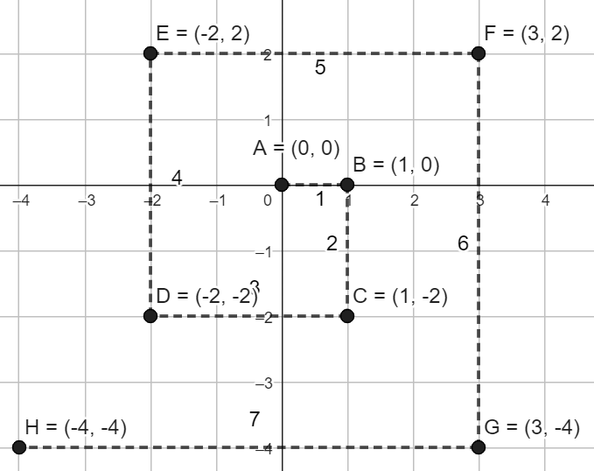

|  |  |  |  |
| --- | --- | --- | --- |
| Point | Using distance formula | Using Pythagoras’ theorem | Distance |
| A | – | – | 0 |
| B | – | – | 1 |
| C | $$\sqrt{1^{2}+{\left(-2\right)}^{2}}$$ | $$1^{2}+2^{2}=5$$ | $$\sqrt{5}$$ |
| D | $$\sqrt{{(-2)}^{2}+{\left(-2\right)}^{2}}$$ | $$2^{2}+2^{2}=8$$ | $$\sqrt{8}$$ |
| E | $$\sqrt{{(-2)}^{2}+2^{2}}$$ | $$2^{2}+2^{2}=8$$ | $$\sqrt{8}$$ |
| F | $$\sqrt{3^{2}+2^{2}}$$ | $$3^{2}+2^{2}=13$$ | $$\sqrt{13}$$ |
| G | $$\sqrt{3^{2}+{\left(-4\right)}^{2}}$$ | $$3^{2}+4^{2}=25$$ | 5 |
| H | $$\sqrt{{(-4)}^{2}+{\left(-4\right)}^{2}}$$ | $$4^{2}+4^{2}=32$$ | $$\sqrt{32}$$ |

### Appendix B – full circle

$x^{2}+y^{2}=36$

Radius = 6

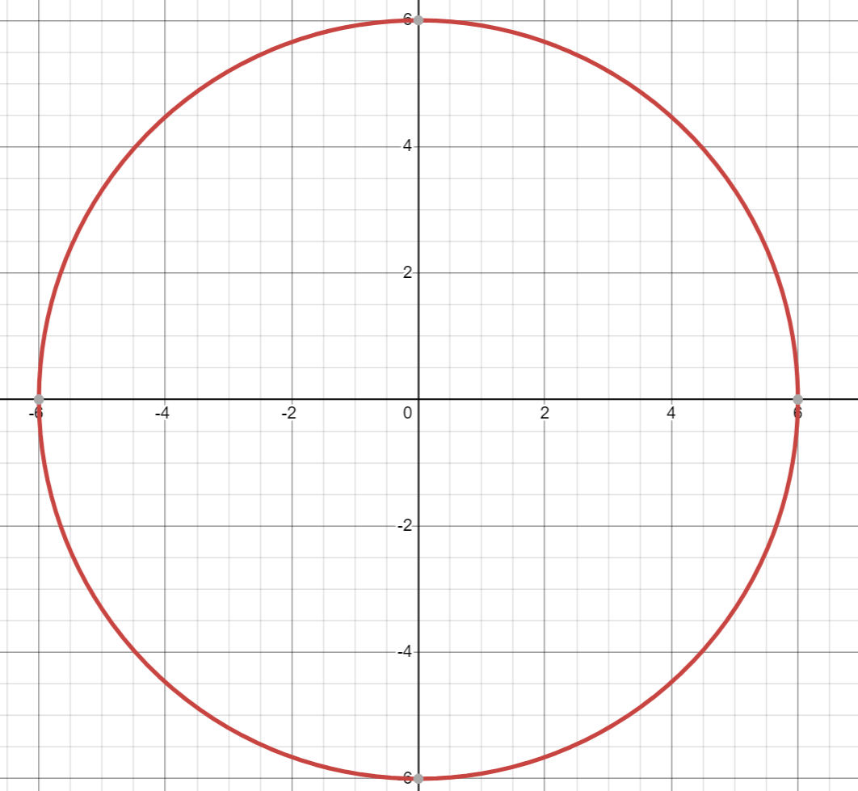

$x^{2}+y^{2}=8$

Radius = $\sqrt{8}=2\sqrt{2}≈2.83$

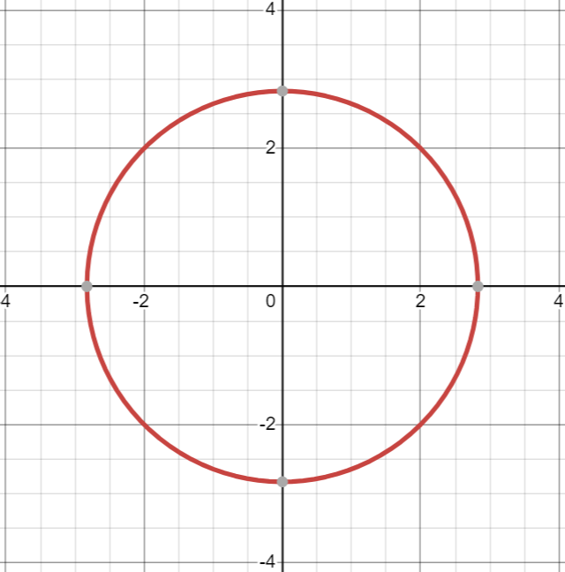

$x^{2}+y^{2}=25$

Radius = 5

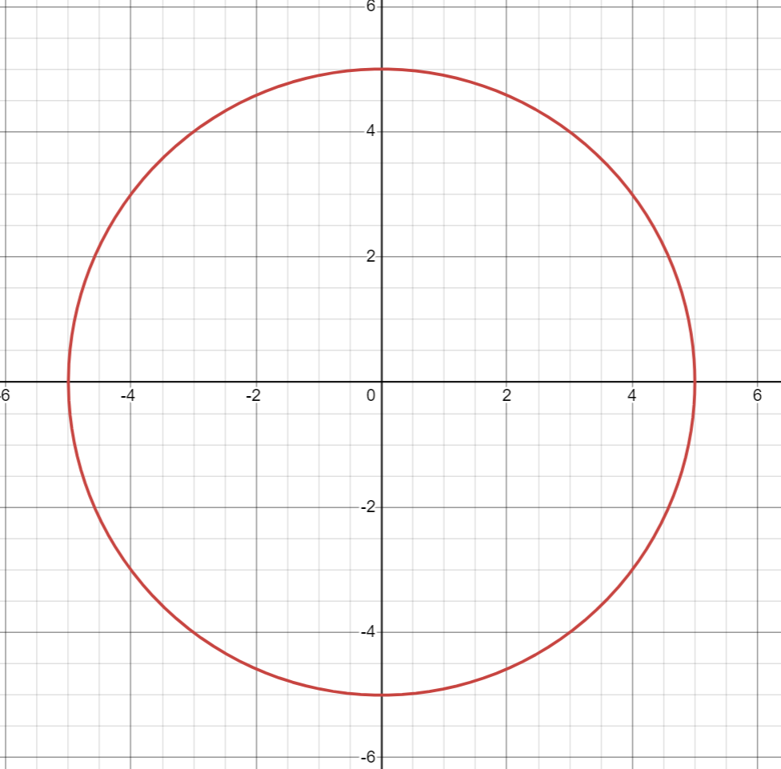

#### Extension task

1. Identify the points on the circle $x^{2}+y^{2}=25$ that have integer values for their coordinates.

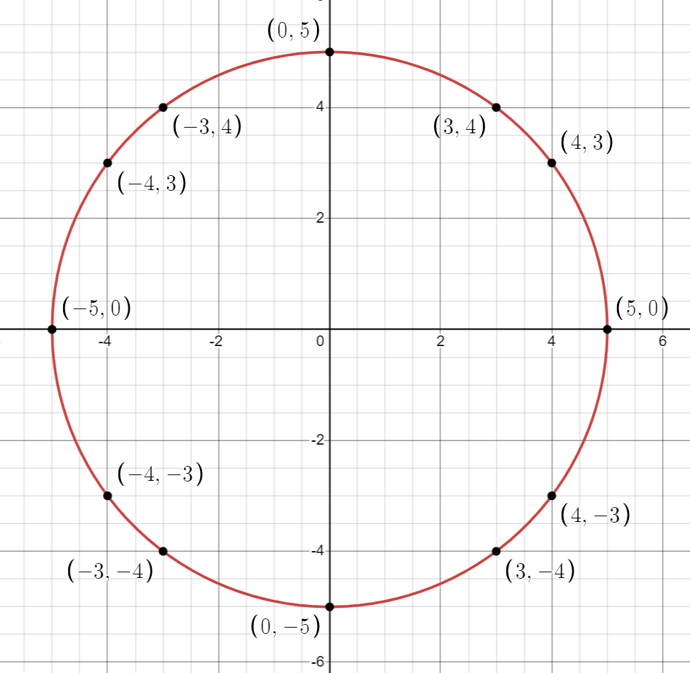

1. What other circles would you expect to have integer values for coordinates?

I expect circles that have a radius that is equal to the largest value, or hypotenuse, in a Pythagorean triad to have integer solutions.

## References

This resource contains NSW Curriculum and syllabus content. The NSW Curriculum is developed by the NSW Education Standards Authority. This content is prepared by NESA for and on behalf of the Crown in right of the State of New South Wales. The material is protected by Crown copyright.

Please refer to the NESA Copyright Disclaimer for more information <https://educationstandards.nsw.edu.au/wps/portal/nesa/mini-footer/copyright>.

NESA holds the only official and up-to-date versions of the NSW Curriculum and syllabus documents. Please visit the NSW Education Standards Authority (NESA) website <https://educationstandards.nsw.edu.au> and the NSW Curriculum website <https://curriculum.nsw.edu.au>.

[Mathematics K–10 Syllabus](https://curriculum.nsw.edu.au/learning-areas/mathematics/mathematics-k-10-2022/overview) © NSW Education Standards Authority (NESA) for and on behalf of the Crown in right of the State of New South Wales, 2022.

**© State of New South Wales (Department of Education), 2024**

The copyright material published in this resource is subject to the Copyright Act 1968 (Cth) and is owned by the NSW Department of Education or, where indicated, by a party other than the NSW Department of Education (third-party material).

Copyright material available in this resource and owned by the NSW Department of Education is licensed under a [Creative Commons Attribution 4.0 International (CC BY 4.0) license](https://creativecommons.org/licenses/by/4.0/).

[](https://creativecommons.org/licenses/by/4.0/)

This license allows you to share and adapt the material for any purpose, even commercially.

Attribution should be given to © State of New South Wales (Department of Education), 2024.

Material in this resource not available under a Creative Commons license:

* the NSW Department of Education logo, other logos and trademark-protected material
* material owned by a third party that has been reproduced with permission. You will need to obtain permission from the third party to reuse its material.

**Links to third-party material and websites**

Please note that the provided (reading/viewing material/list/links/texts) are a suggestion only and implies no endorsement, by the New South Wales Department of Education, of any author, publisher, or book title. School principals and teachers are best placed to assess the suitability of resources that would complement the curriculum and reflect the needs and interests of their students.

If you use the links provided in this document to access a third-party's website, you acknowledge that the terms of use, including licence terms set out on the third-party's website apply to the use which may be made of the materials on that third-party website or where permitted by the Copyright Act 1968 (Cth). The department accepts no responsibility for content on third-party websites.