GPS positioning
Students model trilateration using equations of circles with Desmos and an outdoor activity.
Students will need at least one digital device per pair to interact with Desmos during this lesson.

Visible learning
This lesson incorporates Path content.

Learning intention
- To understand the relationship between the graph and the equation of a circle.

Success criteria
- I can graph circles from an equation.
- I can write the equation of a circle with centre at the origin.
- I can write the equation of a translated circle.
- I can apply the equation of a circle to solve real-world problems.

Syllabus outcomes
A student:
- develops understanding and fluency in mathematics through exploring and connecting mathematical concepts, choosing and applying mathematical techniques to solve problems, and communicating their thinking and reasoning coherently and clearly MAO-WM-01
- interprets and compares non-linear relationships and their transformations, both algebraically and graphically MA5-NLI-P-01
Mathematics K–10 Syllabus © NSW Education Standards Authority (NESA) for and on behalf of the Crown in right of the State of New South Wales, 2022.

Activity structure
Please use the associated PowerPoint GPS positioning to display images in this lesson.

Launch
- Read the following scenario to students.
Amity went on a bush walk. She has plenty of water, her phone, and a map.
She wanders far into the bush and gets distracted. She didn’t realise how late it was and begins to worry that she is lost and starts to panic.
She tries to retrace her steps, but everything looks the same. It’s getting darker and it is harder to see. Amity trips on a tree root and hurts her ankle.
Amity sits under a tree; cold, alone, hungry, and hurt. Her only hope now is her mobile phone.
- Conduct a class discussion by asking students to share any stories they may have about bush rescues. Some prompting questions could include:
- Can anyone relate to this story? What happened?
- When the alarm is raised for someone who is missing, do rescuers just go wandering around in the bush to see what they can find?
- What technologies exist that could assist in finding a missing person? Do you know how they work?

Explore
Students will use the Desmos graphing calculator to model how a global positioning system (GPS) works to accurately locate our position.
- With one device between 2, instruct students that they are going to use the Desmos graphing calculator to model how a global positioning system works to accurately show location.
- Students open Desmos graphing calculator ‘GPS Positioning’ (bit.ly/desmosgps).
- Explain to students that the plotted points A, B and C represent our 3 global positioning system (GPS) base stations.
A base station is a GPS receiver at an accurately known fixed location that helps your mobile phone receive accurate location information. The base stations pick up the distance the mobile phone is from each base station.
- Inform students that point P is our missing person. P sends a signal to A, B, and C. P is
29 km, 25 km, and 13 km from each respectively.
- In a Think-Pair-Share (bit.ly/thinkpairsharestrategy), ask students to investigate the question ‘How can we use this information to find P?’ Students should interact with Desmos to test their ideas by selecting and dragging the point P.
- Display slide 3 of PowerPoint GPS positioning and show students that a circle is the best shape to draw, because it allows the distance from the point to remain constant, as it is the radius of the circle.
Students will remain logged in at their Desmos screen, while the teacher conducts the exploration of the equation of a circle that is not centred at the origin.

Exploration of a circle not centred at the origin
- Display the Desmos graph ‘Circles with centre not at the origin’ (bit.ly/Circlesnotorigin) and ask students to consider what they notice and wonder (bit.ly/noticewonderstrategy) about how the equation of a circle changes as you move the points P and Q.
- Have a student write on the board the equation of the original circle. ${\left(x-0\right)}^{2}+{\left(y-0\right)}^{2}=5^{2}$ and the location of P and the radius.
- Move the circle to different locations and stop so that the student can record the new equation, P and the radius.
Teachers should use multiple demonstrations with different length radii and points P and Q located in different quadrants.
Focus students’ attention on what happens to the sign, for example $(x-5)$ as we translate 5 units to the right. The equation will show $(x-(-5))$ on the screen to become $(x+5)$ in our equation when translated 5 units to the left.
- After 4 or 5 circles, ask students to make some generalisations.
Students should realise that as the centre of the circle moves the equation changes. When moving left to right it changes the value subtracted from x and when moving up and down it changes the value that is subtracted from y. This starts the foundation of the formula ${\left(x-a\right)}^{2}+{\left(y-b\right)}^{2}=r^{2}$.
- Display slide 4 from the PowerPoint GPS positioning, which shows the equation of a circle.
- In a Think-Pair-Share, ask students to explain how the graph of the circle would change if you changed the values of $a$, $b$ and $r$.
- Students will now go back to their Desmos graphing calculator ‘GPS Positioning’ to use the information they have just explored. Instruct students to draw 3 circles with centres A, B, and C with radii 29 km, 25 km, and 13 km respectively.
It is assumed that 1 unit = 1 km.
The equations of the circles will be $x^{2}+y^{2}={29}^{2}$, ${\left(x-36\right)}^{2}+y^{2}={25}^{2}$ and ${\left(x-16\right)}^{2}+{\left(y-32\right)}^{2}={13}^{2}$.
- Initiate a class discussion on the final location of point P, by randomly choosing students to share and explain what they found the coordinates of point P to be.
The final location of P was (21,20).

Outdoor simulation
Teachers can choose to include or exclude the outdoor simulation activity.
This activity is carried out on the school basketball court.

Equipment
- 2 basketballs (to represent missing people)
- Tape measure
- 3 position markers
Alternatively, a teacher could set this up before the lesson using different coloured chalk to label the basketball court, the position markers, and the locations of the missing people. It would also be helpful to complete the measurements and record the coordinates of M and N to have solutions prepared before students complete the activity.

Set up
- Teacher labels the basketball court ABCD.
- Ask a student to place a marker (Q) on the line BC.
- Ask another student to place a marker (P) on the line CD.
- Place the 2 basketballs (M and N) inside the triangle APQ.
Before packing up the equipment, find the coordinates of M and N to verify the solutions.
Figure 1: set up of basketball court
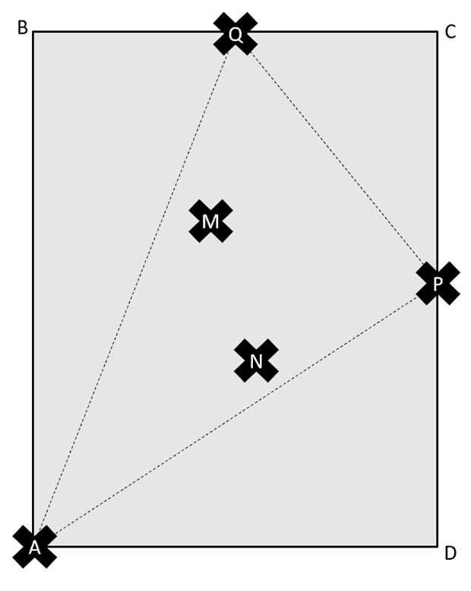

Instructions
- Instruct students to measure the distances indicated in Appendix A ‘GPS trilateration on the basketball court’.
- Once students have completed all measurements, bring them back into the classroom to graph their circle using Desmos and find the coordinates of M and N.

Summarise
- Use slides 6–13 from the PowerPoint GPS positioning for explicit teaching of writing the equation of a circle with the centre not at the origin using the worked examples (Your turn) method (DOCX 420 KB).
- Assign students the Desmos activity ‘Polygraph: Circle Equations’ (bit.ly/CirclesPolygraph) to allow students the opportunity to practise finding radii and centres of circles when presented with equations.
Before doing this activity, you will need to set up a Desmos classroom (https://bit.ly/createdesmosclassroom).
Information on how to play the Polygraph game can be found on the Desmos help page ‘How To Use Polygraphs’ (bit.ly/HowToUsePolygraphs).
- Students are to create notes to their future forgetful self (bit.ly/notestofutureself) on how to write the equations of circles when the centre is not located at the origin.

Apply
- Go back to slide 3 of PowerPoint GPS positioning to display the narrative from the launch.
- In a Think-Pair-Share, ask students to discuss and explain how Amity was found because she had her mobile phone.
A sentence starter could be provided to students to support their response, for example: ‘Amity’s mobile phone could be tracked by’.
Provide hints based on what students have just explored.
- Display the video from Eero website ‘Wi-fi locations (0:09)’ (bit.ly/Wi-filocations) to show the image of the location of 3 wi-fi routers in a home.
- Explain to students that trilateration can be used to maximise wi-fi access and improve the internet speeds on devices around homes.
- By working in visibly random groups of 3 (bit.ly/visiblegroups) on vertical non-permanent surfaces (bit.ly/VNPSstrategy), provide students with an A4 printout of page 13 from the Your home PDF ‘Banksia house’ (PDF 2672 KB) (bit.ly/Banksiaplan).
This image is to scale so care needs to be taken when printing for students.
- Instruct students to determine, using trilateration, where the 3 wi-fi routers should be located to maximise the wi-fi signal in the house. The following parameters apply:
- Each router can emit a signal of up to 5 metres.
- Each router needs to be within 8 metres of another router, so that signals can overlap.
- Students need to write down the equations of their 3 chosen circles.
Students are to use the bottom left-hand corner of the garage as the origin and draw a cartesian plane using the room dimensions to guide their scale.
- Students are to do a gallery walk (bit.ly/DLSgallerywalk) of other groups’ solutions before going back and reviewing their own solutions.
- Initiate a sharing of ideas and reasoning using the Pose-Pause-Pounce-Bounce question strategy (PDF 557 KB) (bit.ly/posepausepouncebounce) for different groups to share their reasoning for the location of the wi-fi routers.
A possible solution for the location of the wi-fi routers is provided in this Desmos graphing calculator link ‘Wi-fi solution’ (bit.ly/Wi-fiSolution)

Assessment and differentiation

Suggested opportunities for differentiation
Explore
- To extend students, they could explore the algebraic method to find the coordinates of P by solving simultaneous equations.
- Once students find the location of the missing person, you could extend students by adjusting the scenario to move the base stations to different locations and instructing students to find the equations of the circles.
- To provide support with writing the equations of circles in Desmos, you can use this alternative version ‘GPS Positioning – circles with sliders’ (bit.ly/Circleswithsliders). This version contains circles already drawn and allows exploration by changing the radius of the circles with sliders and dragging the point P to find the missing person.
- Students could just find the position of one point on the basketball court.
- To extend students, do not allow students to find the distance to M and N on the basketball court. The 2 positions can be solved using simultaneous equations.
Apply
- Students could draw a number plane over the top of the Banksia house plan, using an appropriate scale with the room dimensions provided.

Suggested opportunities for assessment
Explore
- Review Desmos activities to check understanding of equations of a circle.
- Monitor responses in class discussions to check for student understanding of how the equation of a circle changes when you adjust the graph.
Summarise
- Create an exit ticket where students need to write the equation of a circle from its graph.
Apply
- Students will demonstrate their working mathematically skills in discussions and justifications.
- When placed in groups of 3, students provide and receive peer feedback on their understanding. The teacher observes these feedback conversations to check for understanding of the equations of a circle.
- Wi-fi placement solutions could be collected and used as summative assessments for this unit of learning.

Appendix A

GPS trilateration on the basketball court
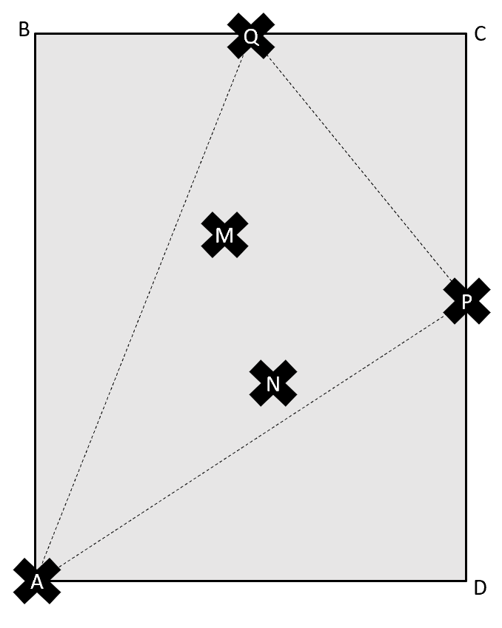
- Let A be the origin (0,0), and measuring the distances from point A, complete Table 1.
Table 1: coordinates of A, Q and P
Label | Coordinate
A | (0,0)
Q
P
- Measure and record the distances in Table 2.
Table 2: distances
Line | Length
AM
PM
QM
AN
PN
QN
- Using the information from Tables 1 and 2, find the equations of the circles needed to find M and N and record in the table below.
Table 3: equation of the circles needed to find M and N
Centre | Coordinate | Radius | (cm) | Equation of the circle
A |  | AM
P |  | PM
Q |  | QM
A |  | AN
P |  | PN
Q |  | QN
- Use the information from Table 3 to create your circles in Desmos and find the coordinates of M and N.
M coordinate is:
N coordinate is:

Sample solutions

Appendix A – GPS trilateration on the basketball court
These sample solutions use the standard size of a basketball court that measures 28 m long and 15 m wide. These coordinates and measurements found the coordinates of M and N using the Desmos graphing calculator ‘GPS positioning outdoor simulation’ (bit.ly/GPSsolutiondesmos).
Note: your measurements will vary based on the positioning of M and N and the size of your basketball court.
Table 1: coordinates of A, Q and P solutions
Label | Coordinate
A | (0,0)
Q | (7,28)
P | (15,14)
Table 2: distances solutions
Line | Length
AM | 20.9 cm
PM | 10.8 cm
QM | 8.1 cm
AN | 13.5 cm
PN | 7.2 cm
QN | 18.1 cm

Table 3: equation of the circles needed to find M and N solutions
Centre | Coordinate | Radius | (cm) | Equation of the circle
A | (0,0) | AM | 20.9 cm | $$x^{2}+y^{2}={20.9}^{2}$$
P | (15,14) | PM | 10.8 cm | $${(x-15)}^{2}+{(y-14)}^{2}={10.8}^{2}$$
Q | (7,28) | QM | 8.1 cm | $${(x-7)}^{2}+{(y-28)}^{2}={8.1}^{2}$$
A | (0,0) | AN | 13.5 cm | $$x^{2}+y^{2}={13.5}^{2}$$
P | (15,14) | PN | 7.2 cm | $${(x-15)}^{2}+{(y-14)}^{2}={7.2}^{2}$$
Q | (7,28) | QN | 18.1 cm | $${(x-7)}^{2}+{(y-28)}^{2}={18.1}^{2}$$
M coordinate is: (6,20)
N coordinate is: (9,10)

References
This resource contains NSW Curriculum and syllabus content. The NSW Curriculum is developed by the NSW Education Standards Authority. This content is prepared by NESA for and on behalf of the Crown in right of the State of New South Wales. The material is protected by Crown copyright.
Please refer to the NESA Copyright Disclaimer for more information https://educationstandards.nsw.edu.au/wps/portal/nesa/mini-footer/copyright.
NESA holds the only official and up-to-date versions of the NSW Curriculum and syllabus documents. Please visit the NSW Education Standards Authority (NESA) website https://educationstandards.nsw.edu.au and the NSW Curriculum website https://curriculum.nsw.edu.au.
Mathematics K–10 Syllabus © NSW Education Standards Authority (NESA) for and on behalf of the Crown in right of the State of New South Wales, 2022.

© State of New South Wales (Department of Education), 2024
The copyright material published in this resource is subject to the Copyright Act 1968 (Cth) and is owned by the NSW Department of Education or, where indicated, by a party other than the NSW Department of Education (third-party material).
Copyright material available in this resource and owned by the NSW Department of Education is licensed under a Creative Commons Attribution 4.0 International (CC BY 4.0) license.
This license allows you to share and adapt the material for any purpose, even commercially.
Attribution should be given to © State of New South Wales (Department of Education), 2024.
Material in this resource not available under a Creative Commons license:
- the NSW Department of Education logo, other logos and trademark-protected material
- material owned by a third party that has been reproduced with permission. You will need to obtain permission from the third party to reuse its material.
Links to third-party material and websites
Please note that the provided (reading/viewing material/list/links/texts) are a suggestion only and implies no endorsement, by the New South Wales Department of Education, of any author, publisher, or book title. School principals and teachers are best placed to assess the suitability of resources that would complement the curriculum and reflect the needs and interests of their students.
If you use the links provided in this document to access a third-party's website, you acknowledge that the terms of use, including licence terms set out on the third-party's website apply to the use which may be made of the materials on that third-party website or where permitted by the Copyright Act 1968 (Cth). The department accepts no responsibility for content on third-party websites.

