# Sine of the apostle

Students discover and use the sine rule to explore how to find the distance between the Twelve Apostles.

## Visible learning

This lesson incorporates Path content.

### Learning intention

* To know how to find the length of a side using the sine rule.

### Success criteria

* I can substitute values into the sine rule.
* I can calculate an unknown side length in a triangle using the sine rule.
* I can deduce the sine rule using trigonometric ratios.

### Syllabus outcomes

A student:

* develops understanding and fluency in mathematics through exploring and connecting mathematical concepts, choosing and applying mathematical techniques to solve problems, and communicating their thinking and reasoning coherently and clearly **MAO-WM-01**
* applies trigonometry to solve problems, including bearings and angles of elevation and depression **MA5-TRG-C-02**
* solves linear equations of more than 3 steps, monic and non-monic quadratic equations, and linear simultaneous equations **MA5-EQU-P-02**

[Mathematics K–10 Syllabus](https://curriculum.nsw.edu.au/learning-areas/mathematics/mathematics-k-10-2022/overview) © NSW Education Standards Authority (NESA) for and on behalf of the Crown in right of the State of New South Wales, 2022.

## Activity structure

Please use the associated PowerPoint *Sine of the apostle* to display images in this lesson.

### Warm up

1. Students are to complete the activity ‘Trigonometry Pile Up!’ (PDF 644 KB) ([bit.ly/trigonometrypileup](https://bit.ly/trigonometrypileup)).

This activity revises the trigonometric ratios for right-angled triangles. This link contains the activity and the solutions.

### Launch

1. Display slide 2 of the PowerPoint *Sine of the apostle*, which displays Figure 1. Ask students if anyone has been to the Twelve Apostles.

Figure 1: Twelve Apostles

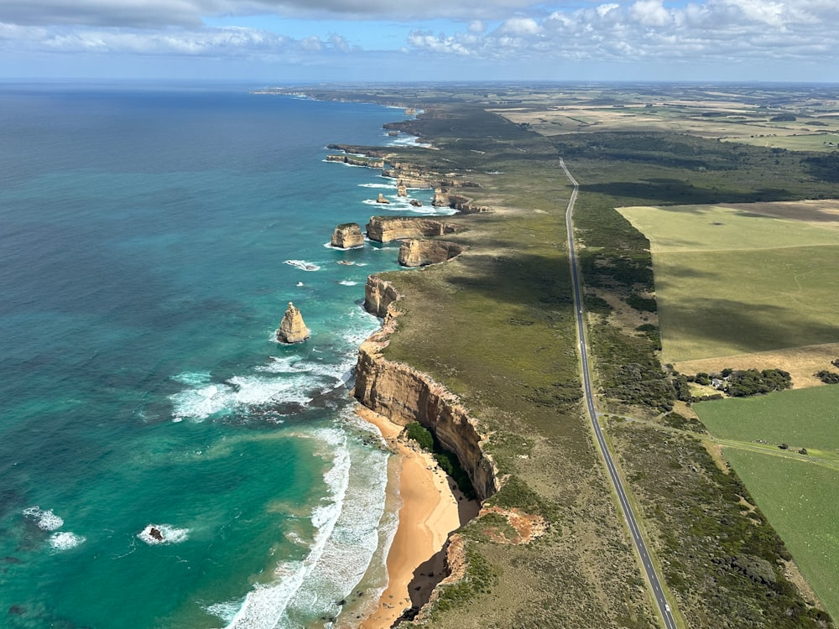

Image licensed under [Unsplash License](https://unsplash.com/license).

1. Ask a random student to point out where the Apostles are in the picture and start a class discussion using the following questions:

* How far apart are the Apostles from the mainland and each other?
* What makes these distances difficult to calculate?
* What mathematics do you think we could use to help us find the answer?

### Explore

1. Assign students to visibly random groups of 3 ([bit.ly/visiblegroups](https://bit.ly/visiblegroups)) on vertical non-permanent surfaces ([bit.ly/VNPSstrategy](https://bit.ly/VNPSstrategy)).
2. Distribute Appendix A ‘Apostles map’ on A3 paper in plastic pockets. This Appendix is a goal-free problem ([bit.ly/goalfreeproblems](https://bit.ly/goalfreeproblems)) that shows the map in Figure 2.

Figure 2: map in Appendix A

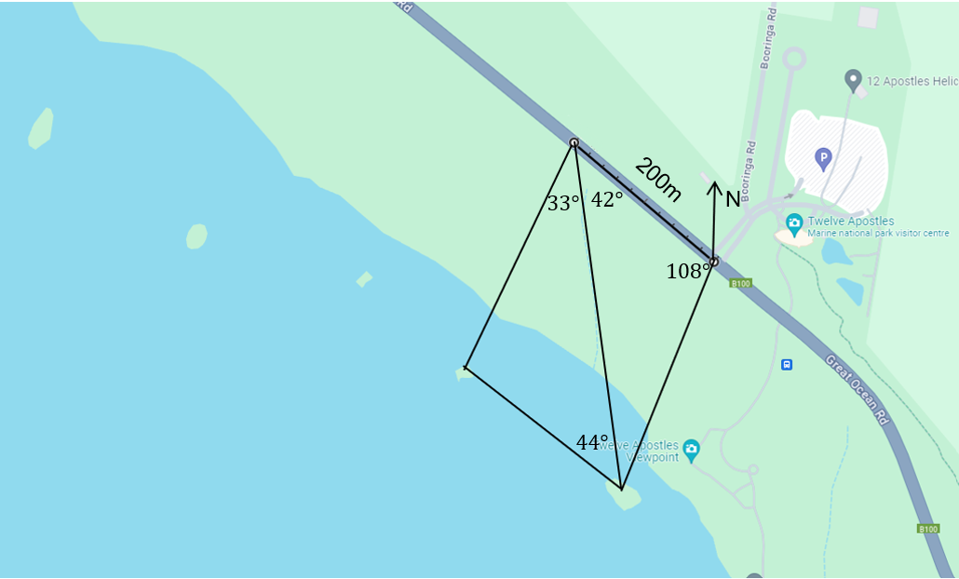

1. Ask students to find as much information as they can from the information in the diagram.
2. In a class discussion, ask students if they could find the length of the other sides, given that 200 m is provided. Ask them to explain their reasoning.

Students should conclude that there is no right angle so they can’t calculate sides.

1. Display the GeoGebra applet ‘Sine Rule’ ([bit.ly/sineruleapplet](https://bit.ly/sineruleapplet)) for the students.
2. Select Point A to drag it around the screen.
3. Ask students what they notice and wonder ([bit.ly/noticewonderstrategy](https://bit.ly/noticewonderstrategy)) about the diagram on the screen. What information changes and what stays the same?

Students should notice that all the ratios are the same, that the opposite side is paired with the opposite angle, and that the angle is always the input for the sine function. If this wasn’t noticed use the following questions to highlight to students:

* + What do you notice about the numbers substituted into the sine function?
  + What do you notice about how the sides and angles are matched?
  + What do you notice about the ratios of each of the pairings of sides and angles substituted into the equation?

To further student understanding Appendix B ‘Law of Sines’ is available for students to explore the proof of the sine rule.

This is an opportunity to explicitly teach rearranging equations by breaking down each step in a scaffolded format to find the sine rule.

### Summarise

1. Display slide 3 from the PowerPoint *Sine of the apostle,* which displays a triangle ABC and the sine rule. Ask students what they notice and wonder.

This activity provides the opportunity to remind students of the naming conventions of triangles. Angles are denoted with capital letters and sides with the lower-case letter of its opposite angle.

Students should notice that each part of the rule has matching opposite sides and angles.

They may wonder if they need all 3 parts of the rule to find missing sides or angles.

1. Use slides 4–5 from the PowerPoint *Sine of the apostle* to go through an example of the sine rule with students.
2. In a Think-Pair-Share ([bit.ly/thinkpairsharestrategy](https://bit.ly/thinkpairsharestrategy)), ask students to answer the self-explanation prompts on slide 5.
3. Distribute Appendix C ‘Faded examples’ for each student to complete individually.

Note that the first example in the Appendix C is the same example from the PowerPoint.  
In the last example, students will need to find the third angle before they can use the sine rule.

1. Students should check their solutions in pairs. If they have different answers, they should work together to find the mistake and resolve it.
2. By returning to their visibly random groups of 3 from the start of the lesson, students are to complete the [four quadrant notes (DOCX 319 KB)](https://education.nsw.gov.au/content/dam/main-education/documents/teaching-and-learning/curriculum/mathematics/mathematics-s4-supporting-strategies-four-quadrant-notes.docx) from Appendix D ‘Four quadrant notes’.
3. Students are to return to Appendix A and find the lengths of all the sides on the map.

If students have already found the distance between the apostles on the map, ask them to find the distance between the next 3 apostles. An alternate map is provided in Appendix E ‘Alternate map’.

1. Explain to students that the process they have been using to find the distances between the Apostles is called trilateration and that surveyors use it to find unknown distances, as it is easy to measure bearings.

### Apply

1. Assign new visibly random groups of 3 on vertical non-permanent surfaces.
2. Distribute Appendix F ‘Running track’. This appendix shows the track of a runner whose watch is broken and has only recorded angles.
3. Students are to find the approximate distance of the running track using the sine rule to find the missing sides.
4. Students are to check their answers with another group. If they have differing solutions, they must debate whose solution is correct and why.

Students could find differences due to mistakes in their calculations, or if a number has been rounded to a different number of decimal places.

## Assessment and differentiation

**Warm up**

* **This activity could be replaced with simple right-angled trigonometry questions.**
* **Teachers can encourage students to draw the triangle they are currently working with, labelling the information they already know.**
* **Students can work in groups of 3 to complete this task.**

**Explore**

* The goal-free problem allows students to work at their level of readiness and to calculate as many pieces of information as they can.
* To enable students, draw arrows that match opposite sides and angles on triangle ABC.
* To extend students, they can complete Appendix B ‘Law of sines’ which leads students through the proof of the sine rule. This could be done in pairs or as a whole class.

**Summarise**

* Students can work in pairs to complete Appendix C ‘Faded examples’.
* To enable students, match sides and angles on Appendix C and Appendix D.
* Students can be restricted to working with angles expressed in whole numbers.

**Apply**

* To support students, teachers could provide the lengths of more sides or separate the questions, so they are focusing on one at a time.
* Students can be challenged to explain why they have different solutions to another group, or which solutions are more accurate.

## Suggested opportunities for assessment

**Warm up**

* **This activity can be used to assess students’ confidence with right-angled trigonometry and their readiness to progress to non-right-angled trigonometry.**

**Explore**

* The goal-free problem can be used to assess students' prior knowledge of concepts such as the angle sum of a triangle or angles in a revolution.
* Students’ algebra knowledge can be assessed when sharing solutions to Appendix C ‘Faded examples’.
* Students’ working mathematically skills can be assessed when sharing what they notice and wonder.

**Apply**

* Student solutions to Appendix F could be collected as evidence of learning.

## Appendix A

### Apostles map

Calculate as much information as possible from the map provided.



## Appendix B

### Law of sines

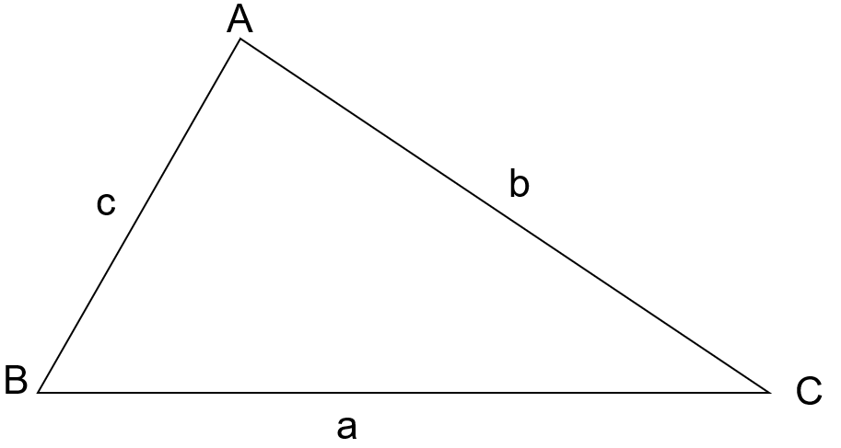

1. Draw a perpendicular line from A to the side a. Label this h.
2. Look at the right-angled triangle formed on the left. Write an equation that expresses the relationship between angle B, the triangle's height (h), and side c.
3. Rewrite this equation so that height (h) is the subject.
4. Now consider the right-angled triangle formed on the right. Write an equation that expresses the relationship between angle C, side b, and the triangle's height (h).
5. Rewrite this equation so that height (h) is the subject.
6. Fill in the blanks by using your answers to questions 3 and 5.

$$\sin{}=h=\sin{} \\ \sin{}=\sin{} \\ =\frac{\sin{}}{\sin{}} \\ \frac{}{\sin{}}=\frac{}{\sin{}}$$

## Appendix C

### Faded examples

|  |  |
| --- | --- |
| 1. Find the length of side d.   A triangle with angle 75 degrees and opposite side 5 cm, and another angle 65 degrees with opposite side d. | 1. Find the length side of *x*.   A triangle with angle 42 degrees and opposite side 3 cm, and another angle 65 degrees with opposite side x. |
| 1. Find the length of side p.   A triangle with angle 42 degrees and opposite side 1.9 cm, and another angle 65 degrees with opposite side p. | 1. Find the length of side f.   A triangle with angle 35 degrees and opposite side 2.2 cm, and another angle 98 degrees with opposite side not labelled and a final side labelled f. |

## Appendix D

### Four quadrant notes

|  |  |
| --- | --- |
| **Example 1**  Find the value of JL.  Triangle JKL with angle JLK = 88 degrees, angle LKJ = 49 degrees and side LK = 4.1. | **Example 2**  Calculate the length of DF.  Triangle DEF with angle DFE = 140 degrees 15 minutes, angle DEF = 24 degrees 50 minutes and side DE = 5. |
| **Things to remember** | **Example 3** |

## Appendix E

### Alternate map

A trilateration map showing a 200 m segment of road. The east end has an angle of 108 degrees to the most eastern Apostle, and west end has an angle of 42 degrees to the western Apostle. The west end of the road also has an angle between the western Apostle and eastern Apostle of 33 degrees and an angle from the western side of the road to the eastern Apostle, back to the western Apostle has an angle of 44 degrees. 
Another apostle has been added with angle from the road of 32 degrees and the angle from the western Apostle 77 degrees.

## Appendix F

### Running track

Renee did her morning run (red line), but her watch broke and it didn’t calculate distances. Given the information provided on the map approximate how far she ran.

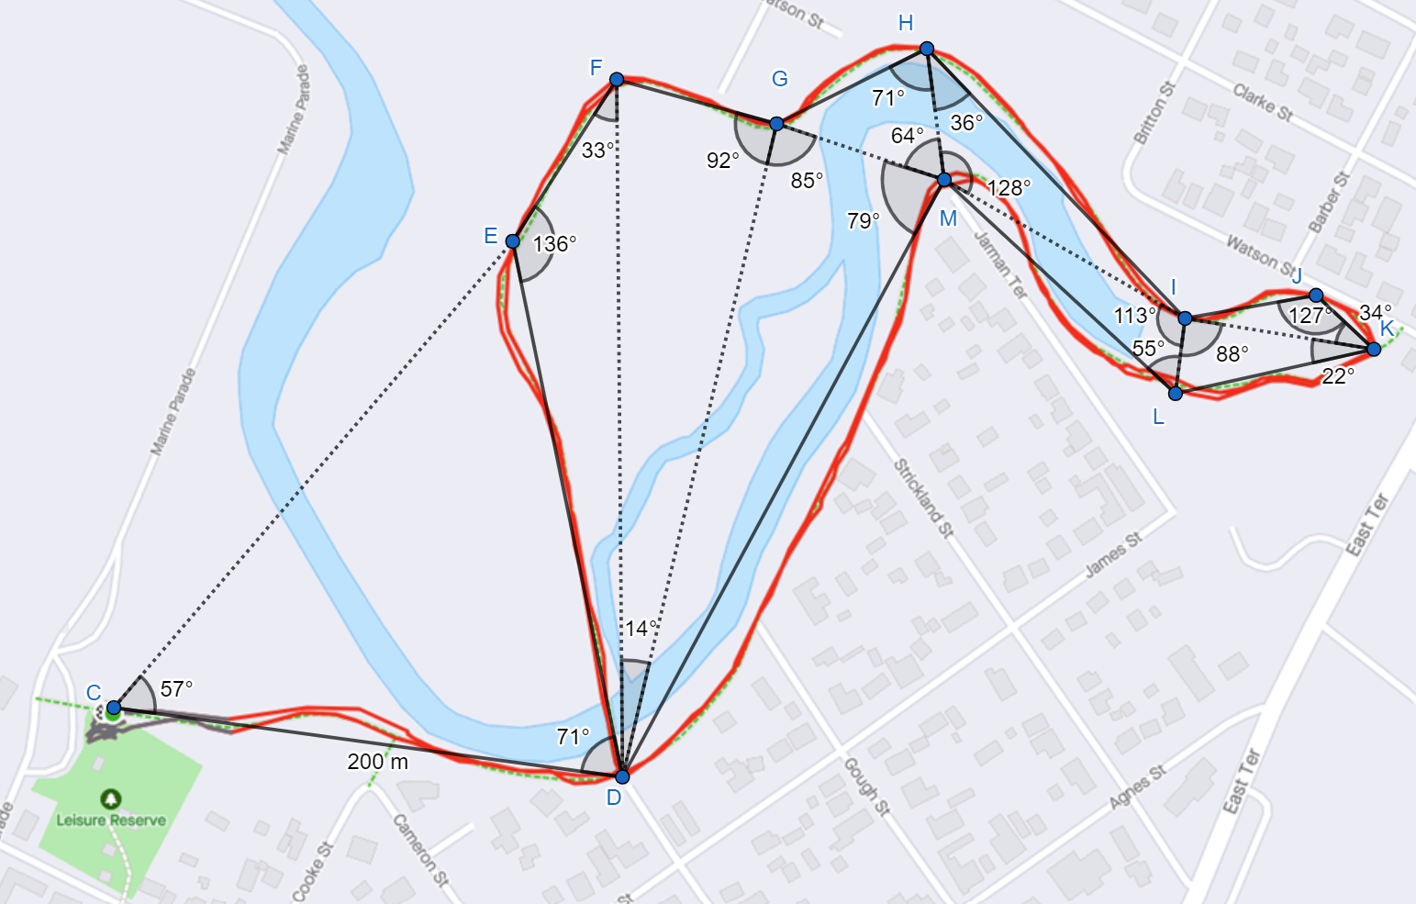

## Sample solutions

### Appendix A – Apostles map

Calculate as much information as possible from the map provided.

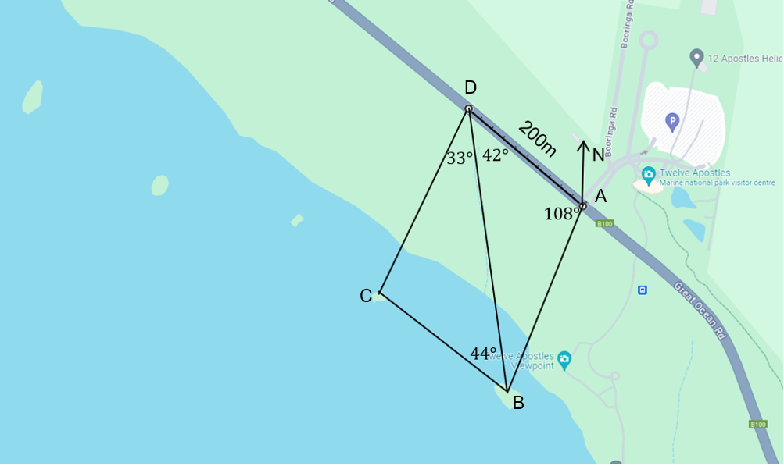

##### Angles

$$∠DBA=180-108-42=30°$$

$$∠DCB=180-33-44=103°$$

##### Sides

Side AB

$$\frac{AB}{\sin{42}}=\frac{200}{\sin{30}} \\ AB=\frac{200\sin{42}}{\sin{30}} \\ AB≈267.7m (1dp)$$

Side BD

$$\frac{BD}{\sin{108}}=\frac{200}{\sin{30}} \\ BD=\frac{200\sin{108}}{\sin{30}} \\ BD≈380.4m \left(1dp\right)$$

Side BC

$$\frac{BC}{\sin{33}}=\frac{308.4}{\sin{103}} \\ BC=\frac{308.4\sin{33}}{\sin{103}} \\ BC≈172.4m (1dp)$$

Side CD

$$\frac{CD}{\sin{44}}=\frac{308.4}{\sin{103}} \\ CD=\frac{308.4\sin{44}}{\sin{103}} \\ CD≈219.9m (1dp)$$

### Appendix B – law of sines

1. Draw a perpendicular line from A to line a. Label this h.

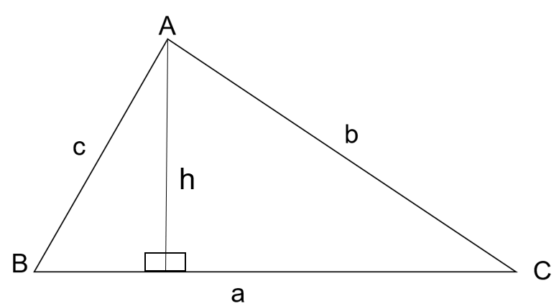

$\sin{B}=\frac{h}{c}$

$c\sin{B}=h$

$\sin{C}=\frac{h}{b}$

$b\sin{C}=h$

$$c\sin{B}=h=b\sin{C}$$

$$c\sin{B}=b\sin{C } \\ c=\frac{bsinC}{sinB} \\ \frac{c}{sinC}=\frac{b}{sinB}$$

### Appendix C – faded examples



$$\frac{a}{\sin{A}}=\frac{b}{\sin{B}} \\ \frac{d}{\sin{65}}=\frac{5}{\sin{75}} \\ d=\frac{5\sin{65}}{\sin{75}} \\ d=4.69139… \\ d≈4.7cm$$

$$\frac{a}{\sin{A}}=\frac{b}{\sin{B}} \\ \frac{x}{\sin{23}}=\frac{3}{\sin{42}} \\ x=\frac{3\sin{23}}{\sin{42}} \\ x=1.7518… \\ x≈1.8 cm$$

$$\frac{a}{\sin{A}}=\frac{b}{\sin{B}} \\ \frac{p}{\sin{65}}=\frac{1.9}{\sin{42}} \\ p=\frac{1.9\sin{65}}{\sin{42}} \\ p=2.5734… \\ p≈2.6cm$$

$180-35-98=47°$ $$\frac{a}{\sin{A}}=\frac{b}{\sin{B}} \\ \frac{f}{\sin{47}}=\frac{2.2}{\sin{35}} \\ f=\frac{2.2\sin{47}}{\sin{35}} \\ f=2.8051… \\ f≈2.8cm$$

### Appendix D – four quadrant notes

|  |  |
| --- | --- |
| **Example 1**  Find the value of JL.  Triangle JKL with angle JLK = 88 degrees, angle LKJ = 49 degrees and side LK = 4.1. | **Example 2**  Calculate the length of DF.  Triangle DEF with angle DFE = 140 degrees 15 minutes, angle DEF = 24 degrees 50 minutes and side DE = 5. |
| **Things to remember**   * Always match the opposite sides to angles so you can correctly substitute into the formula. * If you need to, use the angle sum of a triangle to find the third angle. * Just like an equation, multiply both sides by the numerator. * Make sure your calculator is in degrees mode on the calculator. | **Example 3**  Calculate the side GI.  Triangle GHI with GH =1.44, angle HGI = 77 degrees 19 minutes and angle HIG = 20 degrees 32 minutes. |

### Appendix E – alternate map

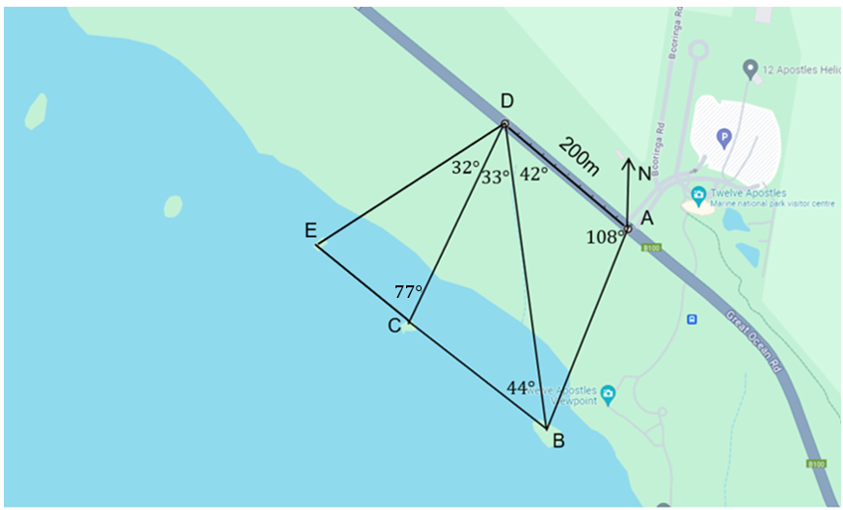From Appendix A sample solutions:

Side CD $=219.9m (1dp)$

Side CE

$$∠CED=180-32-77=71$$

$$\frac{CE}{\sin{32}}=\frac{219.9}{\sin{71}} \\ CE=\frac{219.9\sin{32}}{\sin{71}} \\ CE≈127.5 cm$$

Side DE

$$\frac{DE}{\sin{71}}=\frac{219.9}{\sin{77}} \\ DE=\frac{219.9\sin{71}}{\sin{77}} \\ DE≈209.2 cm$$

### Appendix F – running track

**Side DE**

$$∠CED=180-71-57=52 \\ \frac{DE}{\sin{57}}=\frac{200}{\sin{52}} \\ DE=\frac{200\sin{57}}{\sin{52}} \\ DE≈212.9 m$$

**Side EF**

$$∠EDF=180-136-33=11 \\ \frac{EF}{\sin{11}}=\frac{212.9}{\sin{33}} \\ EF= \frac{212.9\sin{11}}{\sin{33}} \\ EF≈74.9 m$$

**Side FG**

To find side FG we first need to find side FD.

Calculating side FD.

$$\frac{FD}{\sin{136}}=\frac{212.9}{\sin{33}} \\ FD= \frac{212.9\sin{136}}{\sin{33}} \\ FD≈271.5m$$

Now returning to side FG.

$$\frac{FG}{\sin{14}}=\frac{271.5}{\sin{92}} \\ FG=\frac{271.5\sin{14}}{\sin{92}} \\ FG≈65.7 m$$

**Side MD**

To find side MD we first need to find side GD.

Calculating side GD.

$$∠GFD=180-14-92=74 \\ \frac{GD}{\sin{74}}=\frac{271.5}{\sin{92}} \\ GD=\frac{271.5\sin{74}}{\sin{92}} \\ GD≈261.1 m$$

Now returning to side MD.

$$\frac{MD}{\sin{85}}=\frac{261.1}{\sin{74}} \\ MD=\frac{261.1\sin{85}}{\sin{74}} \\ MD≈270.6 m$$

**Side GH**

To find side GH we must first find GM.

$$∠GDM=180-85-79=16 \\ \frac{GM}{\sin{16}}=\frac{261.1}{\sin{74}} \\ GM=\frac{261.1\sin{16}}{\sin{74}} \\ GM≈74.9 m$$

Returning to side GH.

$$\frac{GH}{\sin{64}}=\frac{74.9}{\sin{71}} \\ GH=\frac{74.9\sin{64}}{\sin{71}} \\ GH≈71.2 m$$

**Side HI**

To find side HI we must first find HM.

$$∠HGM=180-64-71=45 \\ \frac{HM}{\sin{45}}=\frac{74.9}{\sin{71}} \\ HM=\frac{74.9\sin{45}}{\sin{71}} \\ HM≈56.0 m$$

Returning to side HI.

$$∠HIM=180-128-36=16 \\ \frac{HI}{\sin{128}}=\frac{56.0}{\sin{16}} \\ HI=\frac{56.0\sin{128}}{\sin{16}} \\ HI≈160.1 m$$

**Side ML**

To find side ML we must first find side MI.

$$\frac{MI}{\sin{36}}=\frac{56.0}{\sin{16}} \\ MI=\frac{56.0\sin{36}}{\sin{16}} \\ MI≈119.4 m$$

Returning to side ML.

$$\frac{ML}{\sin{113}}=\frac{119.4}{\sin{55}} \\ ML=\frac{119.4\sin{113}}{\sin{55}} \\ ML≈134.2 m$$

**Side LK**

To find side LK we must first find side IL.

$$∠LMI=180-113-55=12 \\ \frac{IL}{\sin{12}}=\frac{119.4}{\sin{55}} \\ IL=\frac{119.4\sin{12}}{\sin{55}} \\ IL≈30.3 m$$

Returning to side LK.

$$\frac{LK}{\sin{88}}=\frac{30.3}{\sin{22}} \\ LK=\frac{30.3\sin{88}}{\sin{22}} \\ LK≈80.8 m$$

**Side IJ**

To find side IJ we must first find side IK.

$$∠ILK=180-88-22=70 \\ \frac{IK}{\sin{70}}=\frac{30.3}{\sin{22}} \\ IK=\frac{30.3\sin{70}}{\sin{22}} \\ IK≈76.0 m$$

Returning to side IJ.

$$\frac{IJ}{\sin{34}}=\frac{76.0}{\sin{127}} \\ IJ=\frac{76.0\sin{34}}{\sin{127}} \\ IJ≈53.2 m$$

**Side KJ**

$$∠JIK=180-34-127=19 \\ \frac{KJ}{\sin{19}}=\frac{76.0}{\sin{127}} \\ KJ=\frac{76.0\sin{19}}{\sin{127}} \\ KJ≈31.0 m$$

**Total distance**

$$200+212.9+74.9+65.7+270.6+71.2+160.1+134.2+80.8+53.2+31.0+200=1554.6 m$$

Renee ran approximately $1.55 km$.

## References

This resource contains NSW Curriculum and syllabus content. The NSW Curriculum is developed by the NSW Education Standards Authority. This content is prepared by NESA for and on behalf of the Crown in right of the State of New South Wales. The material is protected by Crown copyright.

Please refer to the NESA Copyright Disclaimer for more information <https://educationstandards.nsw.edu.au/wps/portal/nesa/mini-footer/copyright>.

NESA holds the only official and up-to-date versions of the NSW Curriculum and syllabus documents. Please visit the NSW Education Standards Authority (NESA) website <https://educationstandards.nsw.edu.au> and the NSW Curriculum website <https://curriculum.nsw.edu.au>.

[Mathematics K–10 Syllabus](https://curriculum.nsw.edu.au/learning-areas/mathematics/mathematics-k-10-2022/overview) © NSW Education Standards Authority (NESA) for and on behalf of the Crown in right of the State of New South Wales, 2022.

**© State of New South Wales (Department of Education), 2024**

The copyright material published in this resource is subject to the Copyright Act 1968 (Cth) and is owned by the NSW Department of Education or, where indicated, by a party other than the NSW Department of Education (third-party material).

Copyright material available in this resource and owned by the NSW Department of Education is licensed under a [Creative Commons Attribution 4.0 International (CC BY 4.0) license](https://creativecommons.org/licenses/by/4.0/).

[](https://creativecommons.org/licenses/by/4.0/)

This license allows you to share and adapt the material for any purpose, even commercially.

Attribution should be given to © State of New South Wales (Department of Education), 2024.

Material in this resource not available under a Creative Commons license:

* the NSW Department of Education logo, other logos and trademark-protected material
* material owned by a third party that has been reproduced with permission. You will need to obtain permission from the third party to reuse its material.

**Links to third-party material and websites**

Please note that the provided (reading/viewing material/list/links/texts) are a suggestion only and implies no endorsement, by the New South Wales Department of Education, of any author, publisher, or book title. School principals and teachers are best placed to assess the suitability of resources that would complement the curriculum and reflect the needs and interests of their students.

If you use the links provided in this document to access a third-party's website, you acknowledge that the terms of use, including licence terms set out on the third-party's website apply to the use which may be made of the materials on that third-party website or where permitted by the Copyright Act 1968 (Cth). The department accepts no responsibility for content on third-party websites.