Tracking erosion
Students explore finding an angle using the sine rule by looking at rates of erosion.

Visible learning
This lesson incorporates Path content.

Learning intention
- To be able to find the size of an angle in a non-right-angled triangle when given 2sides and an angle.

Success criteria
- I can correctly substitute values into the sine rule.
- I can explain how to rearrange the sine rule to find an angle.
- I can calculate the size of an angle using the sine rule.

Syllabus outcomes
A student:
- develops understanding and fluency in mathematics through exploring and connecting mathematical concepts, choosing and applying mathematical techniques to solve problems, and communicating their thinking and reasoning coherently and clearly MAO-WM-01
- applies Pythagoras’ theorem and trigonometry to solve 3-dimensional problems and applies the sine, cosine and area rules to solve 2-dimensional problems, including bearings
MA5-TRG-P-01
Mathematics K–10 Syllabus © NSW Education Standards Authority (NESA) for and on behalf of the Crown in right of the State of New South Wales, 2022.

Activity structure
Please use the associated PowerPoint Tracking erosion to display images in this lesson.

Launch
- Show students the video ‘Wamberal Beach erosion solutions progressing but homeowners still vulnerable one year on (1:06)’ (bit.ly/wamberalbeacherosion) on the ABC News webpage.
- Scroll down and display the first image in the article.
- Start a class discussion on what erosion is and how you could track the rate at which the coastline is eroding.
Students should have prior knowledge of erosion as it is explored in the Stage 4 and 5 Geography syllabus.

Explore
- Watch the video ‘Wave forces on a sandy beach (2:00)’ (bit.ly/waveforceexperiment).
It is suggested to change the video to double speed in the settings in the bottom right-hand corner of the video.
- Ask students what they notice and wonder (bit.ly/noticewonderstrategy).
- Distribute Appendix A ‘Eroding beach’, which displays a diagram of the erosion similar to that from the video. This image is also available on slide 2 of the PowerPoint Tracking erosion.
- In a Think-Pair-Share (bit.ly/thinkpairsharestrategy), ask students what variables could be measured if this occurred on an actual beach.
The discussion should lead students to recognise that measurements could include the length of the beach above the shoreline and the slope of the sand above the shoreline. Measurements would need to be conducted at the beginning and end of a period.
- Display slide 3 from the PowerPoint which shows Figure 1 and ask students to record the following measurements on their diagram.
- The original length of the sand on the beach measured 10 cm
- The length of the sand remaining on the beach now measures 9.5 cm
- The angle between the remaining sand on the beach and vertically towards the sky is $100°$.
Figure 1: beach diagram
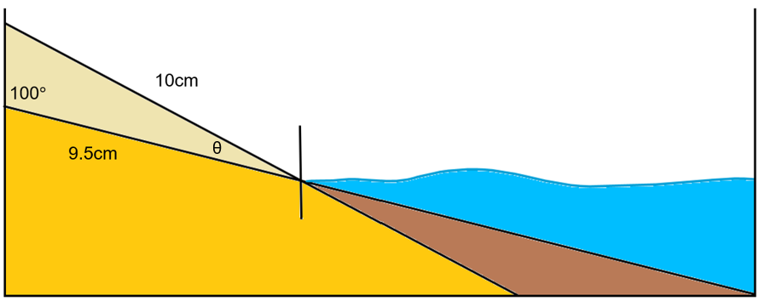
- In a Think-Pair-Share ask students how they could describe the rate of erosion. Have students think about what mathematics they could use to find the angle between the sand that was there originally and the remaining sand.
When sharing answers, ask students to explain their reasoning. If students reference the sine rule it should be because of the information they know and what they need to find.
- Display slide 4 from the PowerPoint Tracking erosion. This slide shows a variety of ratios and their reciprocals. Ask students what they notice and wonder.
Students should notice that the reciprocals of the ratios are still equal.
- Display slide 5 from the PowerPoint Tracking erosion, which displays 2 equations. In a Think-Pair-Share ask students to solve the equations and ask them to explain which was the easiest to solve and why.
Students should notice that both equations have the same solution but when the unknown was in the numerator it was easier to solve.
- Display slide 6 from the PowerPoint Tracking erosion and ask students how we could rewrite the sine rule to make it easier to solve for an angle and why.
Students should rewrite the sine rule as $\frac{\sin{A}}{a}=\frac{\sin{B}}{b}=\frac{\sin{C}}{c}$. This arrangement of the rule makes it easier to solve as the unknown is in the numerator.

Summarise
- Distribute Appendix B ‘Incorrect worked examples’ to each student. This appendix has students responding to incorrect worked solutions (bit.ly/incorrectworkedexamples) before having a turn at a similar question themselves.
- Discuss the solutions as a class, highlighting the common misconceptions in the worked examples and how they could be avoided.
- Assign students to visibly random groups of 3 (bit.ly/visiblegroups), and ask them to complete four quadrant notes (DOCX 319 KB) from Appendix C ‘Four quadrant notes’ on a vertical non-permanent surface (bit.ly/VNPSstrategy).

Apply

Boat rescue
- Assign students into new visibly random groups of 3 at vertical non-permanent surfaces.
- Read the scenario ‘Boat rescue’ to students. This can also be found in Appendix D.
A boat has been lost at sea. The last information received from the tracking system was that it left the port on a bearing of $058°$ for 50 km, then turned and travelled 34 km. The tracking system now shows it is east of the original port.
To provide its location for the rescue team you need to calculate 2 things:
- The angle at which it turned.
- How far east it is from the port.
- Distribute Appendix D ‘Boat rescue’ to each group of students and ask them to work through the problem.
- Use assessing and advancing questions to further student thinking.
Table 1: assessing and advancing questions
Assessing questions | Advancing questions
What information is in the question? | What maths can we use to find angles?
How did you know to label these lengths and angles on your diagram? | What maths can we use to find distances?
Explain how you drew your diagram. | The rescue team travelled out and found the boat a lot closer than expected. Could there be another solution?
What information do we need to find? Explain how you have marked this on your diagram. | What would happen if the bearing at the beginning was incorrect by one degree? How would that change your answers?
- Students are to do a gallery walk (bit.ly/DLSgallerywalk) and give peer feedback using the TAG strategy (bit.ly/TAGstrategy).
- Students are to return to their vertical non-permanent surfaces and try to improve their work from the given feedback.
There are 2 solutions to this problem, one is an acute angle, and the other is the obtuse angle found with the ambiguous sine rule which is beyond the scope of the Stage 5 Mathematics syllabus.

Assessment and differentiation

Suggested opportunities for differentiation
Launch
- Change the location of the erosion to a place within your community.
- There are no correct answers during the launch and all students should be encouraged to participate and share their thoughts and reasoning.
Explore
- A notice and wonder strategy is used where there is no correct answer so that all students can participate in the discussion.
- Students could spend more time investigating the reciprocal of ratios to determine that reciprocal ratios will always be equivalent.
- Students may benefit from first reviewing equations and ratios to check student understanding of rearranging the sine rule.
Summarise
- Students can work in pairs to complete Appendix B.
- Students could create their own incorrect worked examples based on misconceptions they have identified. These could be swapped to allow others to find the mistakes.
- To enable students, add arrows to connect opposite sides and angles.
Apply
- The use of assessing and advancing questions is used to challenge students to progress their thinking.
- To enable students, provide them with the diagram of the scenario.

Suggested opportunities for assessment
Explore
- Monitor responses in class discussions to check for student understanding of using the revised sine rule.
- Students give each other peer feedback, before sharing with the class in a Think-Pair-Share.
Summarise
- Appendix B could be collected and used as a summative assessment.
Apply
- The use of assessing and advancing questions is used to have students show their understanding and Working mathematically skills.
- When placed in groups of 3, students provide and receive peer feedback on their understanding.
- Students are required to give peer feedback using the TAG strategy.

Appendix A

Eroding beach
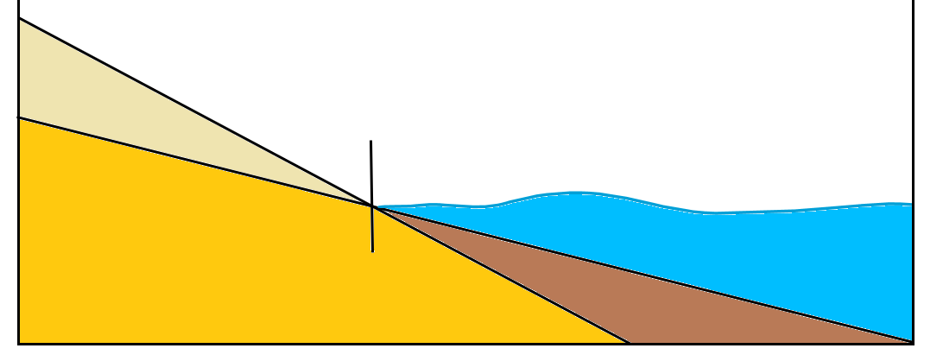

Key
Colour | Description
Yellow | Sand
Beige | Sand position prior to erosion
Brown | Sand position after erosion
Blue | Water

Appendix B

Incorrect worked examples

Example 1
Find the value of the angle ($θ$) in the following triangle. Show your answer to the nearest minute.
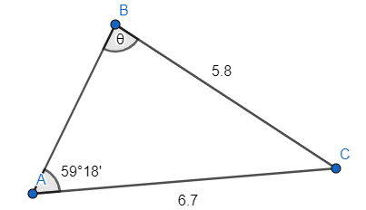
- This is Alan’s solution to Example 1. He incorrectly calculated the angle in $∆ABC$. Explain where Alan made his mistake and provide him with the correct solution.
$$\frac{θ}{\sin{6.7}}=\frac{59°{18}^{'}}{\sin{5.8 }} \\ θ=\frac{59°{18}^{'}\sin{6.7}}{\sin{5.8}} \\ θ=68°28'$$
- Your turn. Find the value of the angle ($θ$) in the following triangle. Show your answer to the nearest minute.
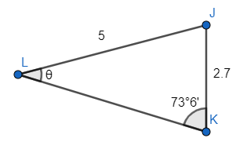

Example 2
Find the value of the angle ($θ$) in the following triangle. Show your answer to the nearest minute.
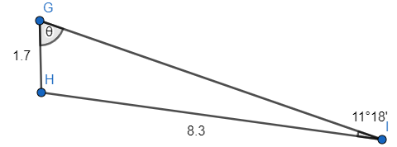
- This is Zoe’s incorrect solution to Example 2:
$$\frac{\sin{θ}}{8.3}=\frac{\sin{11°{18}^{'}}}{1.7} \\ \sin{θ}=\frac{8.3\sin{11°{18}^{'}}}{1.7} \\ θ=0°57'$$
How could Zoe have known that her answer was not reasonable?
- Explain the mistake that Zoe has made and how it can be fixed to get the correct answer.
- Your turn. Find the value of the angle ($θ$) in the following triangle. Show your answer to the nearest minute.
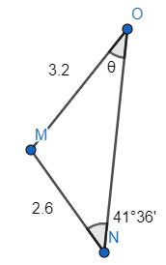

Example 3
Find the value of the angle ($θ$) in the following triangle. Show your answer to the nearest minute.
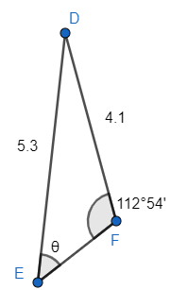
- Rosita incorrectly calculated the angle in $∆DEF$. Explain Rosita’s mistake and provide the correct solution.
$$\frac{\sin{θ}}{5.3}=\frac{\sin{112°{54}^{'}}}{4.1} \\ \sin{θ}=\frac{5.3\sin{112°{54}^{'}}}{4.1} \\ θ=\sin^{-1}\left(\frac{5.3\sin{112°{54}^{'}}}{4.1}\right) \\ θ=\text{MATH ERROR}$$
- Your turn. Find the value of the angle ($θ$) in the following triangle. Show your answer to the nearest minute.
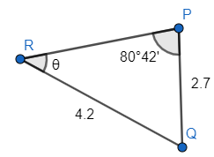

Appendix C

Four quadrant notes
Example 1  Find the value of $∠PRQ$.  $$\frac{\sin{θ}}{}=\frac{\sin{}}{} \\ \sin{θ}=\frac{ \sin{}}{} \\ θ=\sin^{-1}\left(\frac{\sin{}}{}\right) \\ θ≈$$ | Example 2  Calculate the value of $∠ABC$.
Things to remember | Example 3

Appendix D

Boat rescue
A boat has been lost at sea. The last information received from the tracking system was that it left the port on a bearing of $058°$ for 50 km, then turned and travelled 34 km. The tracking system now shows it is east of the original port.
To provide its location for the rescue team you need to calculate 2 things:
- The angle which it turned.
- How far east it is from the port.
Can you find them?

Sample solutions

Appendix B – incorrect worked examples

Example 1
Alan has substituted in sides where he should have substituted in angles, and angles where he has substituted sides. The input of sine is always an angle.
$$\frac{\sin{θ}}{2.7}=\frac{\sin{73°6^{'}}}{5} \\ \sin{θ}=\frac{2.7\sin{73°6^{'}}}{5} \\ {θ=sin}^{1}\left(\frac{2.7\sin{73°6^{'}}}{5}\right) \\ θ≈31°7'$$

Example 2
- Zoe’s answer is too small to be considered a real angle in the triangle, so this makes us believe that she made a mistake. Unless the opposite side was much smaller in ratio, we shouldn’t expect such a small angle.
- To use inverse sine we press shift on our calculator and what should appear is $\sin^{-1}{}$.

$$\frac{\sin{θ}}{2.6}=\frac{\sin{41°{36}^{'}}}{3.2} \\ \sin{θ}=\frac{2.6\sin{41°{36}^{'}}}{3.2} \\ θ=\sin^{-1}\left(\frac{2.6\sin{41°{36}^{'}}}{3.2}\right) \\ θ≈32°39'$$

Example 3
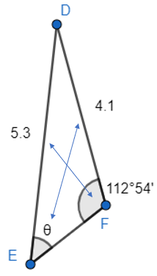
- Rosita has matched the wrong sides and angles. In non-right-angled triangles the angle is always matched with the opposite side.

$$\frac{\sin{θ}}{2.7}=\frac{\sin{80°{42}^{'}}}{4.2} \\ \sin{θ}=\frac{2.7\sin{80°{42}^{'}}}{4.2} \\ θ=\sin^{-1}\left(\frac{2.7\sin{80°{42}^{'}}}{4.2}\right) \\ θ≈39°23'$$

Appendix C – four quadrant notes
Example 1  Find the value of $∠PRQ$.  $$\frac{\sin{θ}}{2.7}=\frac{\sin{80°{42}^{'}}}{4.2} \\ \sin{θ}=\frac{2.7\sin{80°{42}^{'}}}{4.2} \\ θ=\sin^{-1}\left(\frac{2.7\sin{80°{42}^{'}}}{4.2}\right) \\ θ≈39°23'$$ | Example 2  Calculate the value of $∠ABC$.  $$\frac{\sin{θ}}{6.7}=\frac{\sin{59°{18}^{'}}}{5.8} \\ \sin{θ}=\frac{6.7\sin{59°{18}^{'}}}{5.8} \\ θ=\sin^{-1}\left(\frac{6.7\sin{59°{18}^{'}}}{5.8}\right) \\ θ≈83°21'$$
Things to remember  - There is a button to press on the calculator for degrees and minutes and must be pressed after the input of both.  - Match opposite sides and angles.  - Remember it is inverse sign to get the angle.  - Angles are always substituted into trigonometric ratios. | Example 3  $$\frac{\sin{θ}}{2.7}=\frac{\sin{73°6^{'}}}{5} \\ \sin{θ}=\frac{2.7\sin{73°6^{'}}}{5} \\ {θ=sin}^{1}\left(\frac{2.7\sin{73°6^{'}}}{5}\right) \\ θ≈31°7'$$

Appendix D – boat rescue
There are 2 possible solutions, the obtuse angle and the acute angle.

Solution 1
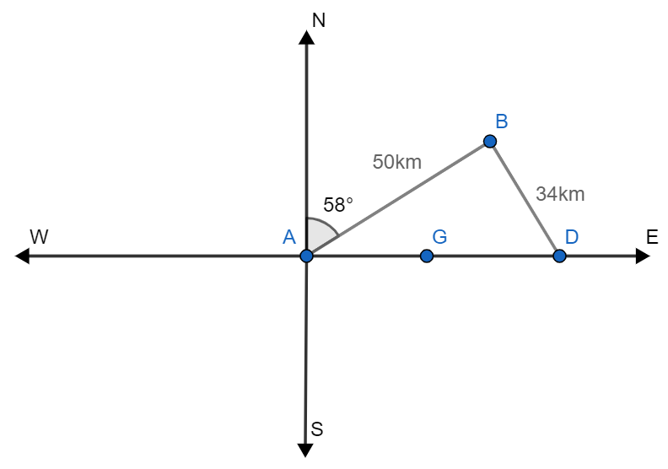

$$∠BAD=90°-58°=32°$$
Let $∠AGB=θ$,
$$\frac{\sin{θ}}{50}=\frac{\sin{32}}{34} \\ \sin{θ}=\frac{50\sin{32}}{34} \\ θ=\sin^{-1}\left(\frac{50\sin{32}}{34}\right) \\ θ≈51°$$
Therefore, $∠ABG=180°-51°-32°=97°$
Therefore, the boat turned to create an angle of $97°$.
Side AD can be found using the sine rule.
$$\frac{AD}{\sin{97}}=\frac{34}{\sin{32}} \\ AD=\frac{34\sin{97}}{\sin{32}} \\ AD≈63.7km$$

Solution 2
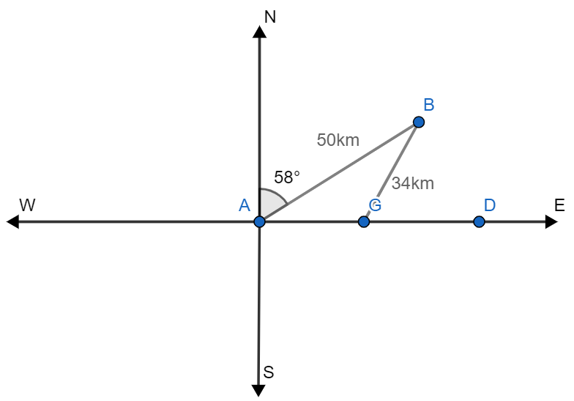
$$∠BAG=90°-58°=32°$$
Let $∠AGB=θ$,
$$\frac{\sin{θ}}{50}=\frac{\sin{32}}{34} \\ \sin{θ}=\frac{50\sin{32}}{34} \\ θ=\sin^{-1}\left(\frac{50\sin{32}}{34}\right) \\ θ≈51°$$
The obtuse angle can be found by $180°-51°=129°$
Therefore, $∠ABG=180°-129°-32°=19°$
Side AD can be found using the sine rule.
$$\frac{AD}{\sin{19}}=\frac{34}{\sin{32}} \\ AD=\frac{34\sin{19}}{\sin{32}} \\ AD≈20.9km$$

References
This resource contains NSW Curriculum and syllabus content. The NSW Curriculum is developed by the NSW Education Standards Authority. This content is prepared by NESA for and on behalf of the Crown in right of the State of New South Wales. The material is protected by Crown copyright.
Please refer to the NESA Copyright Disclaimer for more information https://educationstandards.nsw.edu.au/wps/portal/nesa/mini-footer/copyright.
NESA holds the only official and up-to-date versions of the NSW Curriculum and syllabus documents. Please visit the NSW Education Standards Authority (NESA) website https://educationstandards.nsw.edu.au and the NSW Curriculum website https://curriculum.nsw.edu.au.
Mathematics K–10 Syllabus © NSW Education Standards Authority (NESA) for and on behalf of the Crown in right of the State of New South Wales, 2022.

© State of New South Wales (Department of Education), 2024
The copyright material published in this resource is subject to the Copyright Act 1968 (Cth) and is owned by the NSW Department of Education or, where indicated, by a party other than the NSW Department of Education (third-party material).
Copyright material available in this resource and owned by the NSW Department of Education is licensed under a Creative Commons Attribution 4.0 International (CC BY 4.0) license.
This license allows you to share and adapt the material for any purpose, even commercially.
Attribution should be given to © State of New South Wales (Department of Education), 2024.
Material in this resource not available under a Creative Commons license:
- the NSW Department of Education logo, other logos and trademark-protected material
- material owned by a third party that has been reproduced with permission. You will need to obtain permission from the third party to reuse its material.
Links to third-party material and websites
Please note that the provided (reading/viewing material/list/links/texts) are a suggestion only and implies no endorsement, by the New South Wales Department of Education, of any author, publisher, or book title. School principals and teachers are best placed to assess the suitability of resources that would complement the curriculum and reflect the needs and interests of their students.
If you use the links provided in this document to access a third-party's website, you acknowledge that the terms of use, including licence terms set out on the third-party's website apply to the use which may be made of the materials on that third-party website or where permitted by the Copyright Act 1968 (Cth). The department accepts no responsibility for content on third-party websites.

