# Cos it’s the angle

Students rearrange the cosine rule to make $\cos{C}$ the subject of the equation and then use the rule to find missing angles.

## Visible learning

This lesson incorporates Path content.

### Learning intention

* To know how to find the size of a missing angle using the cosine rule.

### Success criteria

* I can explain the relationship between the longest side in a triangle and the largest angle.
* I can rearrange the cosine rule to make the angle the subject of the equation.
* I can calculate a missing angle using the cosine rule.

### Syllabus outcomes

A student:

* develops understanding and fluency in mathematics through exploring and connecting mathematical concepts, choosing and applying mathematical techniques to solve problems, and communicating their thinking and reasoning coherently and clearly **MAO-WM-01**
* applies Pythagoras’ theorem and trigonometry to solve 3-dimensional problems and applies the sine, cosine and area rules to solve 2-dimensional problems, including bearings   
  **MA5-TRG-P-01**

[Mathematics K–10 Syllabus](https://curriculum.nsw.edu.au/learning-areas/mathematics/mathematics-k-10-2022/overview) © NSW Education Standards Authority (NESA) for and on behalf of the Crown in right of the State of New South Wales, 2022.

## Activity structure

Please use the associated PowerPoint *Cos it’s the angle* to display images in this lesson.

### Launch

1. Display slide 3 of PowerPoint Cos it’s the angle.
2. Ask students to order the distances they can see on the map from longest to shortest.
3. Display slide 4 of PowerPoint Cos it’s the angle.
4. Ask students if knowing the angle means they would change their answer.
5. Display slide 5 of PowerPoint Cos it’s the angle.
6. Ask students to consider what they notice and what they wonder ([bit.ly/noticewonderstrategy](https://bit.ly/noticewonderstrategy)).

Students should notice that the longest side is opposite the largest angle and the shortest side is opposite the smallest angle and may wonder if this is the same for all triangles.

### Explore

1. Place students into visibly random groups of 3 ([bit.ly/visiblegroups](https://bit.ly/visiblegroups)) on vertical non-permanent surfaces ([bit.ly/VNPSstrategy](https://bit.ly/VNPSstrategy)) and provide each group with a ruler.
2. Instruct students to draw 3 triangles, an acute triangle, a right-angled triangle and an obtuse triangle with side lengths of 3 cm and 4 cm either side of the angle. An example can be seen in Figure 1 and on slide 7 of the PowerPoint *Cos it’s the angle*.

Students can use a set square, corner of a piece of paper or their prior knowledge of the Pythagorean triad (3, 4, 5) to draw the right-angled triangle.

1. Ask students to measure the third side, opposite each of the marked angles.

Figure 1: An acute, right-angled and obtuse triangle

Three triangles each called ABC
The left triangle has an acute angle at ACB, AC = 4 and BC = 3
Middle triangle with right angle at ACB, AC =4 and BC = 3
The right triangle has an obtuse angle at ACB, AC = 4 and BC = 3.

1. Ask students to consider what they notice and what they wonder about the length of side c in each of the triangles.

Students should notice that as the angle decreased, the length of the side opposite angle C decreased and as the angle increased, the side opposite increased. Students could wonder if this happens with different length triangles.

1. Have students repeat the process changing the 4 and 3 to lengths of their choice.
2. Have students perform a gallery walk ([bit.ly/DLSgallerywalk](https://bit.ly/DLSgallerywalk)) to observe other groups' triangles to reinforce what they initially noticed.
3. Hand out Appendix A ‘Finding a missing angle’ to each group.
4. Instruct students to use the cosine rule for finding a missing side to try and find the missing angle C.
5. Ask students [assessing and advancing questions (DOCX 327 KB)](https://education.nsw.gov.au/content/dam/main-education/documents/teaching-and-learning/curriculum/mathematics/mathematics-s4-supporting-strategies-assessing-and-advancing-questions.docx) to further student thinking. Some suggestions are made below:

Table 1: assessing and advancing questions

|  |  |
| --- | --- |
| Assessing questions | Advancing questions |
| What is the important information given on the diagram? | How do you know you have substituted the information correctly into the cosine rule formula? |
| How do you match the information on the diagram with the cosine formula? | Have you checked each line of your working out in solving the equation? |
| What steps can you take to make it easier to solve this equation for $\cos{C}$? | Have you completed the correct inverse process? |
| What calculator buttons do you need to use to find a missing angle? | Have you used the correct calculator process to find the value of the missing angle? |

1. Students are to do a gallery walk to look at the steps each group has taken to find the missing angle and their solution. Students are to go back and adjust their working out and solutions if necessary.

Advise students not to erase their work, as they will be returning to it later in the lesson.

1. Ask students to now try and rearrange the cosine rule $c^{2}=a^{2}+b^{2}-2ab\cos{C}$ to make $\cos{C}$ the subject of the equation.

To provide further support, teachers could choose to give students the rearranged formula $\cos{C}=\frac{a^{2}+b^{2}-c^{2}}{2ab}$  
 so they know what they are working towards.

Students may not have been taught how to change the subject of an equation. This could be an opportunity to explicitly teach these skills.

1. Display slide 8 of PowerPoint Cos it’s the angle, which shows the rearrangement of the formula.
2. In a Think-Pair-Share ([bit.ly/thinkpairsharestrategy](https://bit.ly/thinkpairsharestrategy)), students should discuss the self-explanation prompts on rearranging the equation.

### Summarise

1. Use slides 10–13 from the PowerPoint Cos it’s the angle for explicit teaching of finding the missing angle using the cosine rule and the [worked examples (your turn) method (DOCX 420 KB)](https://education.nsw.gov.au/content/dam/main-education/documents/teaching-and-learning/curriculum/mathematics/mathematics-s4-supporting-strategies-worked-examples-your-turn.docx).

If you are putting the entire formula into the calculator, it is suggested that you use brackets around the expression in each denominator and numerator of the formula.

1. Place students back into their visibly random groups of 3 and instruct them to verify their previous solution for Appendix A ‘Finding a missing angle’ by now using the rearranged cosine rule.
2. Using the Pose-Pause-Pounce-Bounce questioning strategy (PDF 557 KB) ([bit.ly/posepausepouncebounce](https://bit.ly/posepausepouncebounce)), ask students which they think is easier, substituting first and solving for C or rearranging the subject of the equation to $\cos{C}$ before substituting and solving and why.
3. Students are to complete [four quadrant notes (DOCX 319 KB)](https://education.nsw.gov.au/content/dam/main-education/documents/teaching-and-learning/curriculum/mathematics/mathematics-s4-supporting-strategies-four-quadrant-notes.docx) from Appendix B ‘Four quadrant notes’.

### Apply

1. Place students into new visibly random groups of 3 and distribute Appendix C ‘Finding my bearings’.
2. Display slide 15 from the PowerPoint Cos it’s the angle and read out the question for students to attempt.

Belinda is going on a day trip to Cook Island (Jungarra Ngarrian) to swim with the sea turtles. Her tour boat leaves the Tweed Heads jetty to reach the river mouth which is on a bearing of 49°42'. The following distances are given on the map:

Tweed Heads jetty to Tweed River mouth – 1.8 km

Tweed River mouth to Cook Island – 3.6 km

Tweed Heads jetty to Cook Island – 3.9 km

Find the bearing the boat needs to take from the Tweed River mouth to Cook Island.

1. Students are to do a gallery walk to analyse other groups’ solutions and then adjust, if necessary, their solutions.

## Assessment and differentiation

### Suggested opportunities for differentiation

**Launch**

* To enable students to culturally connect with the launch, the teacher may wish to replicate this activity with an image from their local area.

**Explore**

* Students can be provided with a protractor for further practice of drawing precise and accurate triangles.
* To enable students, provide them with the triangles already drawn.
* To enable students to rearrange the cosine rule, explicitly teach changing the subject of an equation before students attempt this task.
* Students who are not yet ready to rearrange the cosine rule could conclude the explore after step 6.

**Summarise**

* Encourage students to include an example in their four quadrant notes that has measurements written with decimals and angles rounded off to degrees and minutes.
* Students should check that the triangles they have drawn for their four quadrant notes are possible.
* Students complete further questions on using the cosine rule for finding a missing angle before moving on to the apply section of the lesson.

**Apply**

* To enable students to culturally connect with the scenario, the teacher may wish to replicate this activity with an image from their local area.

### Suggested opportunities for assessment

**Launch**

* Students working mathematically skills can be assessed when sharing what they notice and wonder.

**Explore**

* Teacher can monitor responses to advancing and assessing questions while students complete the activity Appendix A ‘Finding a missing angle’.

**Summarise**

* Monitor student responses in the worked Examples (Your turn) section to check for understanding.
* An exit ticket could be provided to quickly check that students can substitute the correct values into the cosine rule for finding a missing angle.
* Teacher can review students’ four quadrant notes.
* The teacher can collect students’ working out verifying their answer to Appendix A ‘Finding a missing angle’ as evidence of students’ understanding of the learning intention.

**Apply**

* When placed in groups of 3, students provide and receive peer feedback on their understanding.
* Students will demonstrate their working mathematically skills in discussions and justifications.
* The teacher can collect Appendix C ‘Finding my bearings’ as evidence of students’ understanding of the learning intention.

## Appendix A

### Finding a missing angle

Using the cosine rule $c^{2}=a^{2}+b^{2}-2ab\cos{C}$, can you find the size of angle C?

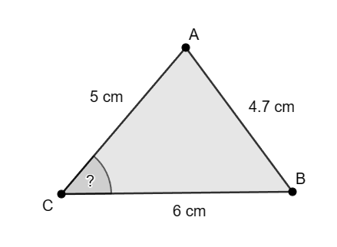

## Appendix B

### Four quadrant notes

|  |  |
| --- | --- |
| Find the value of angle C. A drawing of triangle ABC. AB measuring 9 cm. BC measuring 5 cm. AC measuring 5.4 cm. Find the missing angle C. | **Example 1**  Find the value of angle C.  A drawing of triangle ABC. AB measuring 5 cm. BC measuring 3 cm. AC measuring 7.6 cm. Find the missing angle C. |
| **Things to remember** | **Example 2** |

## Appendix C

### Finding my bearings

Belinda is going out on a day trip to Cook Island (Jungarra Ngarrian) to swim with the sea turtles. Her tour boat leaves the Tweed Heads jetty to reach the river mouth which is on a bearing of $49°42'$. The following distances are given on the map below:

Tweed Heads jetty to Tweed River mouth – 1.8 km

Tweed River mouth to Cook Island – 3.6 km

Tweed Heads jetty to Cook Island – 3.9 km 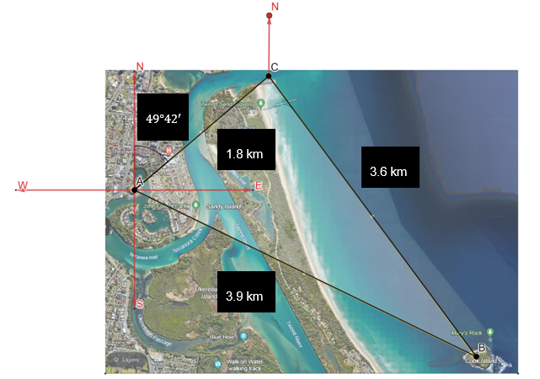

Find the bearing the boat needs to take from the Tweed River mouth to Cook Island.

## Sample solutions

### Appendix A – finding a missing angle



$$c^{2}=a^{2}+b^{2}-2ab\cos{C} \\ {4.7}^{2}=6^{2}+5^{2}-2×6×5×\cos{C} \\ {4.7}^{2}=6^{2}+5^{2}-2×6×5×\cos{C} \\ {4.7}^{2}-6^{2}-5^{2}=-2×6×5×\cos{C} \\ -38.91=-60×\cos{C} \\ \cos{C}=\frac{-38.91}{-60} \\ c=\cos^{-1}\left(\frac{-38.91}{-60}\right) \\ c=0.57139646$$ $c≈49°34'$

Rearrange $c^{2}=a^{2}+b^{2}-2ab\cos{C}$ into $\cos{C}=\frac{a^{2}+b^{2}-c^{2}}{2ab}$

$$c^{2}=a^{2}+b^{2}-2ab\cos{C}$$ $2ab\cos{C}=$ $a^{2}+b^{2}-c^{2}$ $$\frac{2ab\cos{C}}{2ab}=\frac{a^{2}+b^{2}-c^{2}}{2ab}$$ $\cos{C}=\frac{a^{2}+b^{2}-c^{2}}{2ab}$

### Appendix B – four quadrant notes

|  |  |
| --- | --- |
| Find the value of angle C. A drawing of triangle ABC. AB measuring 9 cm. BC measuring 5 cm. AC measuring 5.4 cm. Find the missing angle C. | **Example 1**  Find the value of angle C.  A drawing of triangle ABC. AB measuring 5 cm. BC measuring 3 cm. AC measuring 7.6 cm. Find the missing angle C. $$\cos{C}=\frac{a^{2}+b^{2}-c^{2}}{2ab} \\ \cos{C}=\frac{3^{2}+{7.6}^{2}-5^{2}}{2×3 ×7.6} \\ =\frac{41.76}{45.6} \\ C=\cos^{-1}{\frac{41.76}{45.6}} \\ =23.68190729 \\ C≈23°41'$$ |
| **Things to remember**   * Always match the sides and angles of the triangle with the variables in the formula, so that the numbers are substituted correctly. * Make sure your calculator is in degrees mode. * Make sure to press shift $\cos^{-1}$ on the calculator to find the missing angle. * Make sure to press the degrees, minutes, seconds button to round to the nearest degree and minute. | **Example 2**  Find the missing angle C. A drawing of triangle ABC. AB measuring 4.6 cm. BC measuring 5.8 cm. AC measuring 4.8 cm. Find the missing angle C. $$\cos{C}=\frac{a^{2}+b^{2}-c^{2}}{2ab} \\ \cos{C}=\frac{{5.8}^{2}+{4.8}^{2}-{4.6}^{2}}{2×5.8 ×4.8} \\ =\frac{35.52}{55.68} \\ C=\cos^{-1}{\frac{35.52}{55.68}} \\ =50.36228561 \\ C≈50°22'$$ |

### Appendix C – finding my bearings

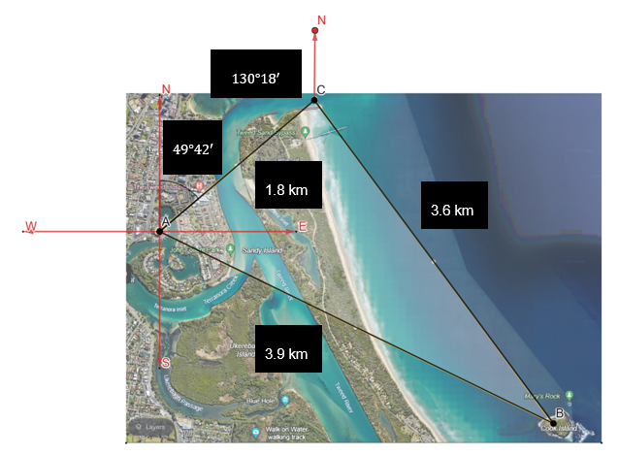

1. Find angle C using cosine rule formula.
$$\cos{C}=\frac{a^{2}+b^{2}-c^{2}}{2ab} \\ \cos{C}=\frac{{3.6}^{2}+{1.8}^{2}-{3.9}^{2}}{2×3.6 ×1.8} \\ =\frac{0.99}{12.96} \\ C=\cos^{-1}{\frac{0.99}{12.96}} \\ =85.61897126 \\ C≈85°37'$$

2. Use co-interior angles of parallel lines to find the angle between the distance from the jetty to Tweed River mouth and North.
$$180°-85°{37}^{'}=130°18'$$

3. Use angles at a point to find the bearing from the Tweed River mouth to Cook Island.

$$360°-85°{37}^{'}-130°{18}^{'}=144°5'$$

Therefore, the bearing the boat needs to take from the Tweed River mouth to Cook Island is $144°5^{'}.$

## References

This resource contains NSW Curriculum and syllabus content. The NSW Curriculum is developed by the NSW Education Standards Authority. This content is prepared by NESA for and on behalf of the Crown in right of the State of New South Wales. The material is protected by Crown copyright.

Please refer to the NESA Copyright Disclaimer for more information <https://educationstandards.nsw.edu.au/wps/portal/nesa/mini-footer/copyright>.

NESA holds the only official and up-to-date versions of the NSW Curriculum and syllabus documents. Please visit the NSW Education Standards Authority (NESA) website <https://educationstandards.nsw.edu.au> and the NSW Curriculum website <https://curriculum.nsw.edu.au>.

[Mathematics K–10 Syllabus](https://curriculum.nsw.edu.au/learning-areas/mathematics/mathematics-k-10-2022/overview) © NSW Education Standards Authority (NESA) for and on behalf of the Crown in right of the State of New South Wales, 2022.

**© State of New South Wales (Department of Education), 2024**

The copyright material published in this resource is subject to the Copyright Act 1968 (Cth) and is owned by the NSW Department of Education or, where indicated, by a party other than the NSW Department of Education (third-party material).

Copyright material available in this resource and owned by the NSW Department of Education is licensed under a [Creative Commons Attribution 4.0 International (CC BY 4.0) license](https://creativecommons.org/licenses/by/4.0/).

[](https://creativecommons.org/licenses/by/4.0/)

This license allows you to share and adapt the material for any purpose, even commercially.

Attribution should be given to © State of New South Wales (Department of Education), 2024.

Material in this resource not available under a Creative Commons license:

* the NSW Department of Education logo, other logos and trademark-protected material
* material owned by a third party that has been reproduced with permission. You will need to obtain permission from the third party to reuse its material.

**Links to third-party material and websites**

Please note that the provided (reading/viewing material/list/links/texts) are a suggestion only and implies no endorsement, by the New South Wales Department of Education, of any author, publisher, or book title. School principals and teachers are best placed to assess the suitability of resources that would complement the curriculum and reflect the needs and interests of their students.

If you use the links provided in this document to access a third-party's website, you acknowledge that the terms of use, including licence terms set out on the third-party's website apply to the use which may be made of the materials on that third-party website or where permitted by the Copyright Act 1968 (Cth). The department accepts no responsibility for content on third-party websites.