# Radial survey

Students will conduct a radial survey to calculate the area of an irregular polygon by finding the areas of non-right-angled triangles.

## Visible learning

This lesson incorporates Path content.

### Learning intention

* To be able to find the area of non-right-angled triangles.

### Success criteria

* I can use bearings to find the angle between 2 sides.
* I can substitute values into the area of a triangle formula.
* I can find the area of an irregular shape by breaking it into known shapes.

### Syllabus outcomes

A student:

* develops understanding and fluency in mathematics through exploring and connecting mathematical concepts, choosing and applying mathematical techniques to solve problems, and communicating their thinking and reasoning coherently and clearly **MAO-WM-01**
* applies Pythagoras’ theorem and trigonometry to solve 3-dimensional problems and applies the sine, cosine, and area rules to solve 2-dimensional problems, including bearings   
  **MA5-TRG-P-01**

[Mathematics K–10 Syllabus](https://curriculum.nsw.edu.au/learning-areas/mathematics/mathematics-k-10-2022/overview) © NSW Education Standards Authority (NESA) for and on behalf of the Crown in right of the State of New South Wales, 2022.

## Activity structure

Please use the associated PowerPoint *Radial survey* to display images in this lesson.

### Launch

1. Show students the YouTube clip ‘Coral bleaching on the Great Barrier Reef’ (2:42). ([bit.ly/CoralbleachinginGBF](https://bit.ly/CoralbleachinginGBF)).
2. Start a class discussion about climate change and coral bleaching and why this is an important issue. Questions for students to consider could include:

* What is your definition of climate change?
* What is coral bleaching?
* How extensive is the problem?
* Why is this destruction so concerning?
* What impact do these coral bleaching events have on the country as a whole?
* Why do we care so much about this issue and climate change as a whole?

1. Show students slide 3 from the PowerPoint *Radial survey* to show a satellite image of a section of the Great Barrier Reef.
2. In a Think-Pair-Share ([bit.ly/thinkpairsharestrategy](https://bit.ly/thinkpairsharestrategy)), ask students the following questions:

* How would you work out the area of the reef?
* How would you work out what percentage of the area was affected by bleaching?
* How might you make measurements of the reef to work out the area?

### Explore

1. Display slide 5 from the PowerPoint *Radial survey* which shows Figure 1 and give students the following definition.

A radial survey is a survey that uses compass bearings to determine the angle from the centre to each corner of an irregularly shaped area.

Figure 1: radial survey

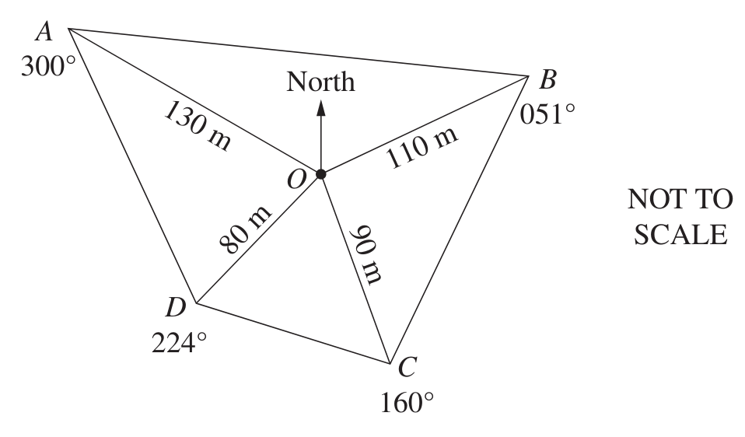

1. Assign students to visibly random groups of 3 ([bit.ly/visiblegroups](https://bit.ly/visiblegroups)) and tell them they are going to conduct a radial survey to simulate the coral reef’s area.

#### Equipment

* 6 witches’ hats, cones, or markers (per group)
* Compass (per group)
* Tape measure or electronic length measuring tool (per group)
* A copy of Appendix A ‘My survey’ (per student).

#### Method

1. Distribute the equipment to each group.
2. Ask students to set up and survey their area using the instructions provided in Appendix A ‘My survey’.
3. Return to the classroom and ask each group to reproduce their survey on a vertical non-permanent surface ([bit.ly/VNPSstrategy](https://bit.ly/VNPSstrategy)).
4. Students are to turn and talk ([bit.ly/classroomtalkmoves](https://bit.ly/classroomtalkmoves)) to discuss in their groups of 3, how the angle of each corner can be found. Students should then label these on their survey.
5. Select non-volunteer students who have successfully completed the task to explain how they found the angle.

To enable students to focus on the area of a triangle, teachers could use slide 6 from the PowerPoint *Radial survey* to demonstrate the calculation.

1. Remind students that to work out the area of a right-angled triangle we use the lengths of 2 sides adjacent to the right angle. To work out the area of a non-right-angled triangle there is an adjustment which considers the different angles.
2. Show students slide 8 from the PowerPoint *Radial survey*.

Teachers should remind students of the naming of angles with a capital letter and the opposite side with the corresponding lowercase letter.

1. In a Think-Pair-Share, students are to explain to each other where the formula comes from.

Emphasise with the students that it doesn’t matter which 2 sides of a triangle you have or the orientation of the triangle, you need the angle between the 2 sides to calculate the area of the triangle. This is called the inclusive angle.

Teachers could show students that the formula also works for right-angled triangles, as $\sin{90°}=1$.

### Summarise

1. Use slides 9–16 from the *Radial survey* PowerPoint for explicit teaching of finding areas of non-right-angled triangles using the [Worked examples (Your turn) method (DOC 420 KB)](https://education.nsw.gov.au/content/dam/main-education/documents/teaching-and-learning/curriculum/mathematics/mathematics-s4-supporting-strategies-worked-examples-your-turn.docx).
2. Students are to return to their groups of 3 at vertical non-permanent surfaces.
3. Distribute Appendix B ‘Area of a triangle’ to each group. Students are to work together to solve the questions. This activity uses Variation Theory ([variationtheory.com/introduction/](https://variationtheory.com/introduction/)) to introduce small changes as students solve problems using the area of a triangle formula.
4. Students then do a gallery walk ([bit.ly/DLSgallerywalk](https://bit.ly/DLSgallerywalk)) and give peer feedback in the form of 2 stars and a wish ([bit.ly/2starwish](https://bit.ly/2starwish)) to evaluate other groups' work.
5. By continuing to work in their same visibly random groups of 3, students are to complete [four quadrant notes (DOCX 319 KB)](https://education.nsw.gov.au/content/dam/main-education/documents/teaching-and-learning/curriculum/mathematics/mathematics-s4-supporting-strategies-four-quadrant-notes.docx) from Appendix C ‘Four quadrant notes’.

### Apply

#### My survey

1. Continuing in their group of 3 on vertical non-permanent surfaces, students are to use the measurements that they recorded on Appendix A ‘My survey’ to calculate their area.
2. Students then do a gallery walk and give peer feedback in the form of 2 stars and a wish to evaluate other groups' work.

#### Coral reefs

1. In a new visibly random group of 3 on a vertical non-permanent surface, give each group a copy of Appendix D ‘Coral catastrophes’ and ask students to attempt the problem.
2. Students are to then do a gallery walk with 2 stars and a wish to evaluate other groups’ work.

#### Herbicides

1. Continuing in their visibly random group of 3 on a vertical non-permanent surface, give each group a copy of Appendix E ’How much herbicide is needed?’.
2. State to students that they need to calculate how much herbicide is needed to spray the paddock.
3. Students are to then do a gallery walk with 2 stars and a wish to evaluate other groups’ work.

## Assessment and differentiation

### Suggested opportunities for differentiation

**Launch**

* All students can participate as there are no right answers and everyone can notice and wonder.

**Explore**

* Students requiring support could be limited to simple compass bearings (for example, E – 90o, S – 180o, SE – 135o, NW – 315o) or be given the internal angle.
* Students requiring support may create an area with only 3 or 4 outer cones.
* Students can be challenged to measure as accurately as possible, using the smallest unit of precision they have access to.
* Students could further increase their accuracy by conducting multiple measurements and finding the average.

**Summarise**

* Students who are ready for a challenge could be introduced to solving for a missing angle, bearing, or side, given the remaining information and the area.
* If a student is struggling to contribute to the task, encourage them to move around the room and find an answer from another group. They should ask that group how they know that area is correct before reporting back to their group.

**Apply**

* Students could do a traverse survey of the same field and find the area using right-angled triangles.
* Students struggling with the rate application could be given a simpler rate that doesn’t require unit conversions.

### Suggested opportunities for assessment

**Launch**

* Students’ reasoning may reveal misconceptions about area which should be addressed before continuing with the lesson.

**Explore**

* Students give each other peer feedback, before sharing with the class in a Think-Pair-Share.

**Summarise**

* Review students’ four quadrant notes to their future forgetful selves for understanding of the area of a triangle.
* Listen for misconceptions in students’ reasoning as they complete the task.
* Appendix A could be collected and analysed as evidence of student learning.
* The teacher could collect Appendix B to check understanding.

**Apply**

* Students working at vertical non-permanent surfaces means that they can self-assess by comparing their answers to their peers.
* Ask students to justify their answers as you move around the room.

## Appendix A

### My survey

#### Instructions

1. Select an area to survey.
2. Place one marker in the approximate centre and the remaining 5 around the outside, similar to the diagram below.

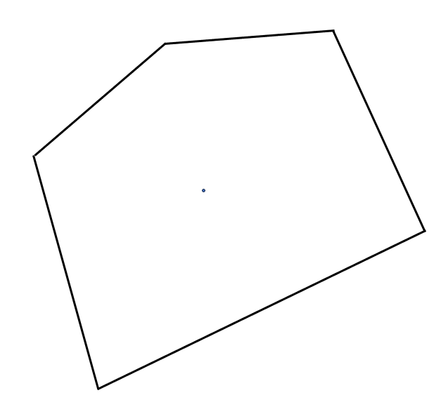

1. Sketch your area on the next page in the space provided.
2. Stand at the centre marker and measure the bearings, with the compass, from the centre to each vertex. Record this information on your diagram.
3. Measure the distance from the centre to each vertex and record the distance on your diagram.

#### Survey

Sketch your survey, adding all measurements.

## Appendix B

### Area of a triangle

Find the area of the following triangles.

|  |  |
| --- | --- |
| Triangle, with 2 sides 7 metres and 8 metres with an angle of 50 degrees between them. |  |
| Triangle, with 2 sides 7 metres and 12 metres with an angle of 50 degrees between them. |  |
| Triangle, with 2 sides 7 metres and 12 metres with an angle of 60 degrees between them. An angle of 80 degrees is made with the side of length 7 m and the unknown side. |  |

|  |  |
| --- | --- |
| Triangle sides 152 m on a bearing of 045 and 87 m on a bearing of 100. |  |
| Triangle sides 152 m on a bearing of 300 and 87 m on a bearing of 220. |  |
| Triangle sides 152 m on a bearing of 330 and 87 m on a bearing of 045. |  |
| Triangle, with three sides 40 metres, 44 metres and 39 metres with an angle of 65 degrees between 39 metres and 44 metres. |  |
| Triangle, with 2 sides 44 metres and 39 metres with an angle of 65 degrees opposite the 44 metres and an angle of 53 degrees opposite the 39 metres. |  |
| Triangle, with angles of 62 degrees, 53 degrees, and 65 degrees. A side of 44 metres is opposite the 62 degrees. |  |

## Appendix C

### Four quadrant notes

|  |  |
| --- | --- |
| **Example 1**  Find the area of triangle ABC.  An obtuse-angled triangle labelled with vertices A, B, and C. Length of side AC is 5 cm. The length of side BC is 3 cm. The angle at C is 110 degrees. | **Example 2**  Find the area of triangle ABC.An obtuse-angled triangle labelled with vertices A, B, and C. Length of side AC is 7.2 cm. The length of side BC is 2.9 cm. The angle at C is 111 degrees 30 minutes. |
| **Things to remember** | **Example 3** |

## Appendix D

### Coral catastrophes

Continual and frequent episodes of coral bleaching can lead to the long-term destruction of a reef as it doesn’t have the time to recover between bleaching events.

Below are 2 pictures of the approximate area of a reef around an atoll (a type of enclosed reef). The blue area is the reef in 2010 and the pink is the reef in 2023.

Calculate the size of the reef in 2010 and 2023.

By first calculating the size of the reef loss, calculate the percentage loss (decline) of the reef over time.

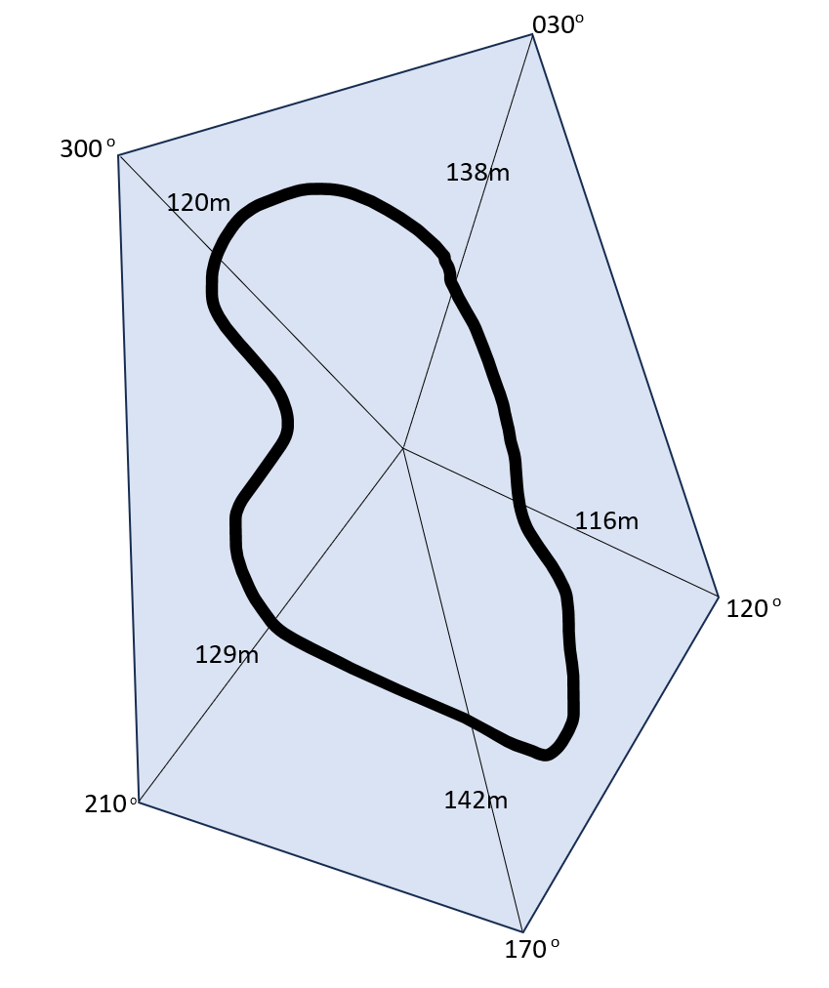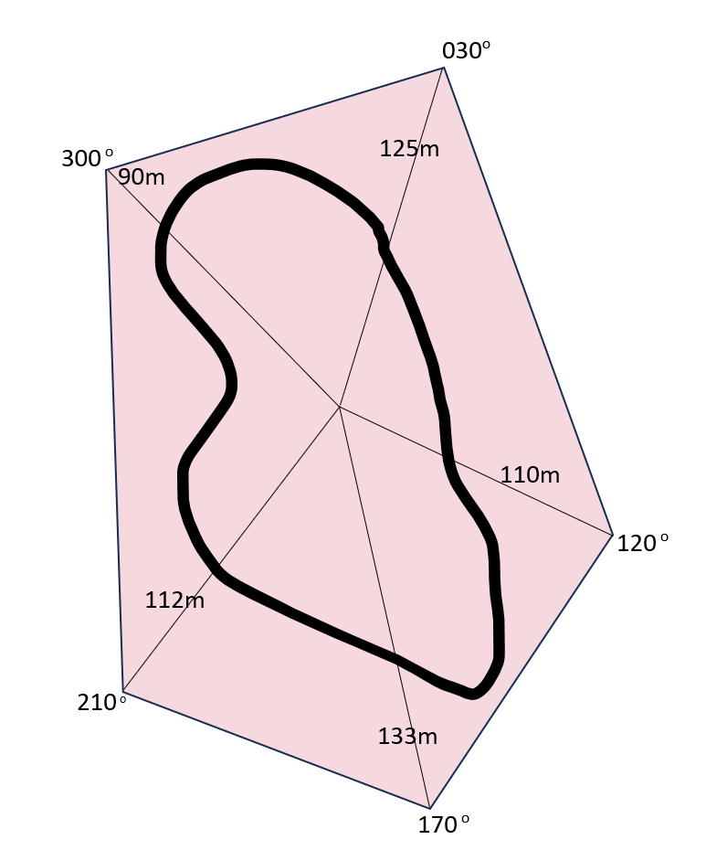

## Appendix E

### How much herbicide is needed?

6.5 L of herbicide in 250 L of water per hectare (10 000 m2).

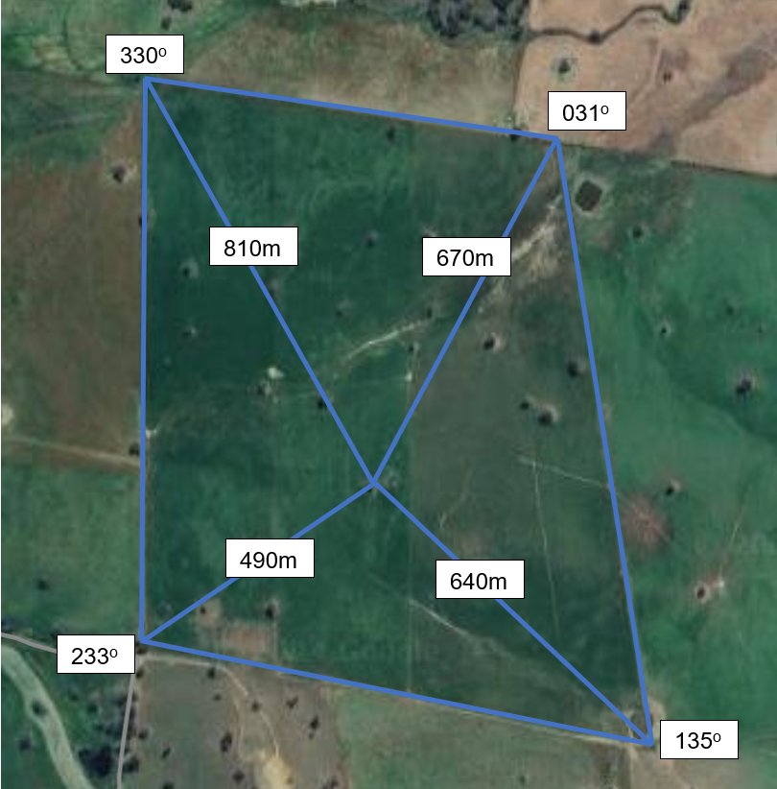

Not to scale

## Sample solutions

### Appendix B – area of a triangle

|  |  |
| --- | --- |
| Triangle, with 2 sides 7 metres and 8 metres with an angle of 50 degrees between them. | Answer |
| Triangle with 2 sides 7 metres and 12 metres with an angle of 50 degrees between them. | Answer |
| Triangle with 2 sides 7 metres and 12 metres with an angle of 60 degrees between them. An angle of 80 degrees is made with the side of length 7 m and an unknown side. | Answer |

|  |  |
| --- | --- |
| Triangle with sides 152 m on a bearing of 045 degrees and 87 m on a bearing of 100 degrees. | Answer |
| Triangle sides 152 m on a bearing of 300 degrees and 87 m on a bearing of 220 degrees. | Answer |
| Triangle sides 152 m on a bearing of 330 and 87 m on a bearing of 045 degrees. | Answer |
| Triangle with 3 sides 40 metres, 44 metres and 39 metres with an angle of 65 degrees between 39 metres and 44 metres. | Answer |
| Triangle with 2 sides 44 metres and 39 metres with an angle of 65 degrees opposite the 44 metres and an angle of 53 degrees opposite the 39 metres. | Answer |
| Triangle with angles of 62 degrees, 53 degrees, and 65 degrees. A side of 44 metres is opposite the 62 degrees. | Answer $$\frac{a}{\sin{53}}=\frac{44}{\sin{62}} \\ a=\frac{44×\sin{53}}{\sin{62}} \\ a=39.798….. \\ a≈40 m \\ A=\frac{1}{2}×44×39.798×\sin{65} \\ =793.532….. \\ ≈794 m^{2}$$ |

### Appendix C – four quadrant notes

|  |  |
| --- | --- |
| **Example 1**  Find the area of triangle ABC.  An obtuse-angled triangle labelled with vertices A, B, and C. Length of side AC is 5 cm. The length of side BC is 3 cm. The angle at C is 110 degrees. | **Example 2**  Find the area of triangle ABC.  An obtuse-angled triangle labelled with vertices A, B, and C. Length of side AC is 7.2 cm. The length of side BC is 2.9 cm. The angle at C is 111 degrees 30 minutes. |
| **Things to remember**   * Need 2 sides and an angle to work out the area. * The angle must be between the 2 sides given. * Units must be squared as it is an area. * If the angle is a right angle, the formula is the same as the formula for a right-angled triangle. | **Example 3**  Find the area of triangle DEF.  A triangle labelled D, E, and F. DF has a length of 5.3 cm. EF has a length of 3.8 cm. Angle F measures 30 degrees. |

### Appendix D – coral catastrophes

|  |  |
| --- | --- |
| Reef area in 2010 | Reef area in 2023 |
| Angle $$120-30=90$$ Area $$A_{1}=\frac{1}{2}×138×116×\sin{90} \\ A_{1}=8004$$ | Angle $$120-30=90$$ Area $$A_{1}=\frac{1}{2}×125×110×\sin{90} \\ A_{1}=6875$$ |
| Angle $$170-120=50$$ Area $$A_{2}=\frac{1}{2}×142×116×\sin{50} \\ A_{2}=6309.14$$ | Angle $$170-120=50$$ Area $$A_{2}=\frac{1}{2}×110×133×\sin{50} \\ A_{2}=5603.62$$ |
| Angle $$210-170=40$$ Area $$A_{3}=\frac{1}{2}×142×129×\sin{40} \\ A_{3}=5887.29$$ | Angle $$210-170=40$$ Area $$A_{3}=\frac{1}{2}×112×133×\sin{40} \\ A_{3}=4787.48$$ |
| Angle $$300-210=90$$ Area $$A_{4}=\frac{1}{2}×129×120×\sin{90} \\ A_{4}=7740$$ | Angle $$300-210=90$$ Area |

|  |  |
| --- | --- |
| Reef area in 2010 | Reef area in 2023 |
| Angle $$120-30=90$$ Area $$A_{5}=\frac{1}{2}×138×120×\sin{90} \\ A_{5}=8280$$ | Angle $$120-30=90$$ Area $$A_{5}=\frac{1}{2}×90×125×\sin{90} \\ A_{5}=5625$$ |
| Area total $$A_{T}=8004+6309.14+5887.29+7740+8280 \\ A_{T}=36220.43m^{2}$$ | Area total $$A_{T}=6875+5603.62+4787.48+5040+5625 \\ A_{T}=27931.1m^{2}$$ |
| Area decrease $$A=36220.43-27931.1 \\ A=8289.33$$ | Percentage decrease $$r=\frac{8289.33}{36220.43}×100 \\ =22.8857… \\ =23\%$$ |

### Appendix E – How much herbicide is needed?

|  |  |
| --- | --- |
| **Area 1**  Angle $$135-031={34}^{o}$$ Area $$A=\frac{1}{2}ab\sin{C} \\ =\frac{1}{2}×670×640×\sin{34} \\ =119890.9585….. \\ ≈119891 m^{2}$$ | **Area 3**  Angle $$330-233={97}^{o}$$ Area $$A=\frac{1}{2}ab\sin{C} \\ =\frac{1}{2}×490×810×\sin{97} \\ =196970.7838… \\ ≈196971 m^{2}$$ |
| **Area 2**  Angle $$233-135={98}^{o}$$ Area $$A=\frac{1}{2}ab\sin{C} \\ =\frac{1}{2}×640×490×\sin{98} \\ =155274.0332… \\ ≈155274 m^{2}$$ | **Area 4**  Angle $$\left(360-330\right)+31={61}^{o}$$ Area $$A=\frac{1}{2}ab\sin{C} \\ =\frac{1}{2}×810×670×\sin{61} \\ =237328.0575… \\ ≈237328 m^{2}$$ |

**Area total**

$$A=119891+155274+196971+237328 \\ =709464 m^{2}$$

**Area total in hectares $$A=709464÷10000 \\ =70.9464 ha$$**

**Herbicide $$6.5×70.9464=461.1516 L$$**

**Water $250×70.9464=17736.6 L$**

### References

This resource contains NSW Curriculum and syllabus content. The NSW Curriculum is developed by the NSW Education Standards Authority. This content is prepared by NESA for and on behalf of the Crown in right of the State of New South Wales. The material is protected by Crown copyright.

Please refer to the NESA Copyright Disclaimer for more information <https://educationstandards.nsw.edu.au/wps/portal/nesa/mini-footer/copyright>.

NESA holds the only official and up-to-date versions of the NSW Curriculum and syllabus documents. Please visit the NSW Education Standards Authority (NESA) website <https://educationstandards.nsw.edu.au> and the NSW Curriculum website <https://curriculum.nsw.edu.au>.

[Mathematics K–10 Syllabus](https://curriculum.nsw.edu.au/learning-areas/mathematics/mathematics-k-10-2022/overview) © NSW Education Standards Authority (NESA) for and on behalf of the Crown in right of the State of New South Wales, 2022.

**© State of New South Wales (Department of Education), 2024**

The copyright material published in this resource is subject to the Copyright Act 1968 (Cth) and is owned by the NSW Department of Education or, where indicated, by a party other than the NSW Department of Education (third-party material).

Copyright material available in this resource and owned by the NSW Department of Education is licensed under a [Creative Commons Attribution 4.0 International (CC BY 4.0) license](https://creativecommons.org/licenses/by/4.0/).

[](https://creativecommons.org/licenses/by/4.0/)

This license allows you to share and adapt the material for any purpose, even commercially.

Attribution should be given to © State of New South Wales (Department of Education), 2024.

Material in this resource not available under a Creative Commons license:

* the NSW Department of Education logo, other logos and trademark-protected material
* material owned by a third party that has been reproduced with permission. You will need to obtain permission from the third party to reuse its material.

**Links to third-party material and websites**

Please note that the provided (reading/viewing material/list/links/texts) are a suggestion only and implies no endorsement, by the New South Wales Department of Education, of any author, publisher, or book title. School principals and teachers are best placed to assess the suitability of resources that would complement the curriculum and reflect the needs and interests of their students.

If you use the links provided in this document to access a third-party's website, you acknowledge that the terms of use, including licence terms set out on the third-party's website apply to the use which may be made of the materials on that third-party website or where permitted by the Copyright Act 1968 (Cth). The department accepts no responsibility for content on third-party websites.