Divide and conquer
Students explore how to divide fractions using bar models and progress into algebraic fractions, proving why we multiply by the reciprocal.

Visible learning
This lesson incorporates Path content.

Learning intention
- To be able to simplify expressions that involve the division of algebraic fractions.

Success criteria
- I can divide fractions using bar models.
- I can demonstrate why multiplying by the reciprocal works when dividing fractions.
- I can divide algebraic fractions.

Syllabus outcomes
A student:
- develops understanding and fluency in mathematics through exploring and connecting mathematical concepts, choosing and applying mathematical techniques to solve problems, and communicating their thinking and reasoning coherently and clearly MAO-WM-01
- simplifies algebraic fractions with numerical denominators and expands algebraic expressions MA5-ALG-C-01
- simplifies algebraic fractions involving indices, and expands and factorises algebraic expressions MA5-ALG-P-01
Mathematics K–10 Syllabus © NSW Education Standards Authority (NESA) for and on behalf of the Crown in right of the State of New South Wales, 2022.
Table 1: lesson summary
Section | Summary of activity | Teaching strategy | Teaching points
Launch | Students explore a scenario of how many $\frac{1}{8}$ sized slices of cake are left in half a cake.  Use slide 3 and 4 of the PowerPoint Divide and conquer to remind students how to divide numerical fractions using bar models. | Think-Pair-Share  Visibly random groups of 3  Vertical non-permanent surfaces | This section aims to remind students that when a value is being divided, the aim is to determine how many of the divisor fits into the quantity.
Explore | Students practice dividing numeric fractions (Appendix A) and try to transfer this knowledge to an algebraic fraction.  Optional: students discuss dividing by 1 (slide 6) and where students can see the value of 1 (slides 7–8) and how this can be used to divide fractions. Students practise faded examples (Appendix B) and discuss the generalisation for dividing fractions.  Students try and generalise using the division $\frac{a}{b}÷\frac{x}{y}$ (slides 9–10). | Pose-Pause-Pounce-Bounce  Vertical non-permanent surfaces  Faded examples  Gallery walk | Students explore 2 options for dividing fractions.
Summarise | Slides 12–15 explicitly teach dividing fractions.  Students practise using slide 16. | Explicit teaching (Your turn) | Students can choose their own questions from slide 16.
Apply | Students attempt to find the lie in Two truths and a lie (slide 18 and 19).  Students create their own Two truths and a lie to swap with a friend. | Think-Pair-Share | There are 2 options for the Two truths and a lie. Slide 18 has the Core option and slide 19 has the Path option.

Activity structure
Please use the associated PowerPoint Divide and conquer to display images in this lesson.

Launch
- Read the following scenario to students:
James had half of their birthday cake left. It was originally cut into 8 pieces. How many pieces are left?
- Using a Think-Pair-Share (bit.ly/thinkpairsharestrategy) ask students to write a mathematical sentence and draw a diagram to represent this scenario.
- Use a Pose-Pause-Pounce-Bounce questioning strategy (PDF 557 KB) (bit.ly/posepausepouncebounce) to allow students to share their sentences and diagrams. Focus on student sentences that represent the scenario as a division.
- Display slide 3 of the PowerPoint Divide and conquer, demonstrating using bar models to divide fractions. Allow students time to silently read through the example.
- Display slide 4 and have students answer the self-explanation questions in their pairs.
Students should read the expression $\frac{1}{2}÷\frac{1}{8}$ as how many $\frac{1}{8}\text{'s}$ go into a $\frac{1}{2}$. Students should recognise that this differs from $\frac{1}{2}$ of an $\frac{1}{8}$ which is $\frac{1}{2}×\frac{1}{8}$ .
Students were introduced to dividing numerical fractions in Lesson 10 – a shopping plan, of Stage 4 – Unit 5 – multiplicative thinking.
- Inform students that during this lesson they will explore how to divide fractions involving algebra.

Explore
- By working in visibly random groups of 3 (bit.ly/visiblegroups) on vertical non-permanent surfaces (bit.ly/VNPSstrategy), ask students to complete Appendix A ‘Dividing bar graphs’.
The aim of revisiting this work is to help students remember that when you divide values you are seeing how many of the divisor fits into the quantity. For this reason, we can multiply by the reciprocal rather than performing the division.
For example, if we know that there will always be 10 tenths in a whole, then instead of asking $\frac{1}{2}÷\frac{1}{10}$ we can ask $\frac{1}{2}×10.$
- Ask students to consider the last question of Appendix A ‘Dividing bar graphs’.
- After some time, have students share their thoughts about how to answer the last question.
The aim of this question is for students to struggle to visualise and calculate. Students may not be able to answer this question yet.

Additional explore for students ready to consider Path content
This explore section is designed for students studying the Path content. Students who are only doing the Core outcomes could move to the summarise section of the lesson.
- Pose the question ‘What happens if we divide something by one?’. Use the Pose-Pause-Pounce-Bounce questioning strategy to highlight that dividing by 1 does not change the number.
Slide 6 of the PowerPoint Divide and conquer contains 2 visual representations for students if required.
- Display slide 7 of the PowerPoint Divide and conquer. Have students consider how many ways you can find a value equivalent to one.
- Ask students to show, using their hands, how many ways they can find the value of one (using a closed fist for none, holding up one finger for one way, 2 fingers for 2 ways and so on).
- By asking students who found one value first and then bouncing to the 2 value students, get students to identify where they found their ones.
- Display slide 8 of the PowerPoint Divide and conquer, demonstrating the 4 values equivalent to one. As a class discuss the self-explanation questions.
- Back in their groups at vertical non-permanent surfaces, distribute Appendix B ‘Dividing by 1, multiplying by 1’ on A3 paper in A3 plastic sleeves. Ask students to complete the faded examples (bit.ly/fadedexamplesstrategy).
- Have students do a gallery walk (bit.ly/DLSgallerywalk) to view others' work and consider why the heading of the task is ‘Dividing by 1, multiplying by 1’.
- Using the questioning strategy of Pose-Pause-Pounce-Bounce to discuss the task heading. Prompting questions could include:
- Can you see where each step occurs?
- Would you get the same result if you only did one of the steps?
- Can you summarise the heading into a shorter set of instructions?
The heading is dividing by 1, multiplying by 1 as this is the process used to calculate the division of fractions. This is the full working behind multiplying by the reciprocal.
- Display slide 9 of the PowerPoint Divide and conquer which has 2 algebraic fractions to divide.
- Ask groups to attempt this question and then allow groups to do a gallery walk to clarify their own thinking.
Slide 10 of the PowerPoint Divide and conquer contains the solution for teachers to display.

Summarise
- Display slides 12–15 from the PowerPoint Divide and conquer for explicit teaching of dividing algebraic fractions, using the worked examples (Your turn) method (DOCX 420 KB).
- Display slide 16 of the PowerPoint Divide and conquer and have students individually complete the questions.
There are 2 versions provided, one set for each of the Core and Path content. It is suggested that students choose their own questions.

Apply
- Display slide 18 or 19 of the PowerPoint Divide and conquer which displays Two truths and one lie.
There are 2 versions provided, one slide for each of the Core and Path content. It is suggested that you only use one version.
In each slide, the second expression is incorrectly simplified.
- In a Think-Pair-Share, students are to identify the lie and justify their choice.
- Students are to create their own Two truths and a lie, which includes dividing algebraic fractions, and then swap with a partner.

Assessment and differentiation

Suggested opportunities for differentiation
Launch
- Students may benefit from revisiting dividing fractions found in Lesson 10 – a shopping plan of Stage 4 – Unit 5 – multiplicative thinking.
- To assist students, the teacher may need to add sections to the bar graphs in Appendix A.
- To extend students, the teacher may provide examples that do not have common factors.
Explore
- Revision of how 1 can be expressed using fractions may be required.
- Challenge students by introducing fractions that involve factors that are in brackets.
- If students find it difficult to simplify fractions mentally, allow the use of a calculator.
- Challenge students by asking them how it differs if we divide by a whole number or a mixed numeral.
Summarise
- Challenge students to write their own questions.
- Enable students to justify their answer using the dividing by 1, multiplying by 1 method used in the explore.
Apply
- When discussing with students about their Two truths and a lie, teachers can encourage students to think about and justify their decisions.

Suggested opportunities for assessment
Launch
- Monitor responses in class discussions to check for student understanding of fractions.
Explore
- When placed in groups of 3, students provide and receive peer feedback on their understanding.
- The teacher could monitor student engagement and contribution to group work activities to check understanding.
- Students will demonstrate their working mathematically skills in discussions and justifications.
Summarise
- Monitor student responses in the ‘Your turn’ section to check for understanding.
- Teachers could monitor students' answers to the questions from slide 16 of the PowerPoint for understanding of both multiplying and dividing fractions.
Apply
- Collect the students’ Two truths and a lie as an exit ticket.

Appendix A

Dividing bar graphs
Calculation | Representation | Solution
$$\frac{1}{2}÷\frac{1}{4}$$
$$\frac{3}{2}÷\frac{1}{4}$$
$$\frac{3}{2}÷\frac{1}{6}$$
$$\frac{3}{2}÷\frac{1}{12}$$
$$\frac{3}{2}÷\frac{1}{10}$$
$$\frac{16}{20}÷\frac{1}{10}$$
$$\frac{16}{20}÷\frac{2}{5}$$
$$\frac{x}{2}÷\frac{1}{4}$$

Appendix B

Dividing by 1, multiplying by 1
Question 1 | Question 2 | Question 3 | Question 4 | Question 5
$$\frac{2}{3}÷\frac{1}{6}$$  $$=\frac{\frac{2}{3}}{\frac{1}{6}}$$  $$=\frac{\frac{2}{3}×\frac{6}{1}}{\frac{1}{6}×\frac{6}{1}}$$  $$=\frac{\frac{2}{3}×\frac{6}{1}}{\frac{1}{6}×\frac{6}{1}}$$  $$=\frac{2}{3}×\frac{6}{1}$$  $$=\frac{12}{3}$$  $$=4$$ | $$\frac{16}{20}÷\frac{1}{5}$$  $$=\frac{\frac{16}{20}}{\frac{1}{5}}$$  $$=\frac{\frac{16}{20}×\frac{5}{1}}{\frac{1}{5}×\frac{5}{1}}$$  $$=\frac{\frac{16}{20}×\frac{5}{1}}{\frac{1}{5}×\frac{5}{1}}$$  $$=\frac{16}{20}×\frac{}{}$$  $$=$$ | $$\frac{6}{5}÷\frac{1}{3}$$  $$=\frac{\frac{6}{5}}{\frac{1}{3}}$$  $$=\frac{\frac{6}{5}×\frac{}{}}{\frac{1}{3}×\frac{3}{1}}$$  $$=\frac{\frac{6}{5}×\frac{3}{1}}{\frac{1}{3}×\frac{3}{1}}$$  $$=\frac{}{}×\frac{}{}$$  $$=\frac{}{}$$ | $$\frac{16}{20}÷\frac{2}{5}$$  $$=\frac{\frac{16}{20}}{\frac{2}{5}}$$  $$=\frac{\frac{16}{20}×\frac{}{}}{\frac{2}{5}×\frac{}{}}$$  $$=\frac{\frac{16}{20}×\frac{}{}}{\frac{2}{5}×\frac{}{}}$$  $$=\frac{}{}×\frac{}{}$$  $$=$$ | $$\frac{x}{2}÷\frac{1}{4}$$  $$=\frac{\frac{x}{2}}{\frac{1}{4}}$$  $$=\frac{\frac{x}{2}×\frac{}{}}{\frac{1}{4}×\frac{}{}}$$  $$=\frac{\frac{x}{2}×\frac{}{}}{\frac{1}{4}×\frac{}{}}$$  $$=\frac{}{}×\frac{}{}$$  $$=2x$$

Sample solutions

Summarise – practice questions

Core
- $\frac{3m}{5}÷\frac{m}{4}$$$=\frac{3m}{5}×\frac{4}{m} \\ =\frac{12}{5}$$
- $\frac{3m}{5}÷\frac{4m}{5}$$$=\frac{3m}{5}×\frac{5}{4m} \\ =\frac{3}{4}$$
- $\frac{6m}{5}÷\frac{4m}{15}$$$=\frac{6m}{5}×\frac{15}{4m} \\ =\frac{9}{2}$$
- $\frac{6m^{2}}{5}÷\frac{4m}{15}$$$=\frac{6m^{2}}{5}×\frac{15}{4m} \\ =\frac{9m}{2}$$
- $\frac{6m^{2}}{5}÷\frac{4}{15m}$$$=\frac{6m^{2}}{5}×\frac{15m}{4} \\ =\frac{9m^{3}}{2}$$

Path
- $\frac{4m^{8}}{6n^{5}}÷\frac{2m^{4}}{3n^{3}}$$$=\frac{4m^{8}}{6n^{5}}×\frac{3n^{3}}{2m^{4}}$$$=\frac{m^{4}}{n^{2}}$
- $\frac{m^{5}}{12n^{2}}÷\frac{3m^{4}}{2n^{2}}$$$=\frac{m^{5}}{12n^{2}}×\frac{2n^{2}}{3m^{4}} \\ =\frac{m}{18}$$
- $\frac{3x^{7}}{5y^{5}w}÷\frac{10x^{4}y^{2}}{6w^{3}}$$$=\frac{3x^{7}}{5y^{5}w}×\frac{6w^{3}}{10x^{4}y^{2}} \\ =\frac{9x^{3}w^{2}}{25y^{7}}$$
- $\frac{{\left(a+b\right)}^{4}}{x^{11}}÷\frac{{\left(a+b\right)}^{2}}{2x^{7}}$$$=\frac{{\left(a+b\right)}^{4}}{x^{11}}×\frac{2x^{7}}{{\left(a+b\right)}^{2}} \\ =\frac{2{\left(a+b\right)}^{2}}{x^{4}}$$
- $\frac{m^{6}{\left(m+5\right)}^{3}}{n^{5}}÷\frac{m^{7}{\left(m+5\right)}^{2}}{n^{3}{\left(m-5\right)}^{2}}$
$$=\frac{m^{6}{\left(m+5\right)}^{3}}{n^{5}}×\frac{n^{3}{\left(m-5\right)}^{2}}{m^{7}{\left(m+5\right)}^{2}} \\ =\frac{\left(m+5\right){\left(m-5\right)}^{2}}{n^{2}m}$$

Appendix A – dividing bar graphs
Calculation | Representation | Solution
$$\frac{1}{2}÷\frac{1}{4}$$ | 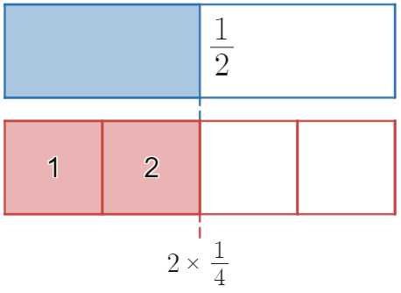 | $$2$$
$$\frac{3}{2}÷\frac{1}{4}$$ | 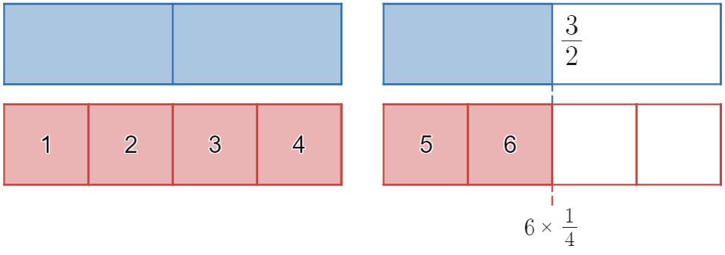 | $$6$$
$$\frac{3}{2}÷\frac{1}{6}$$ | 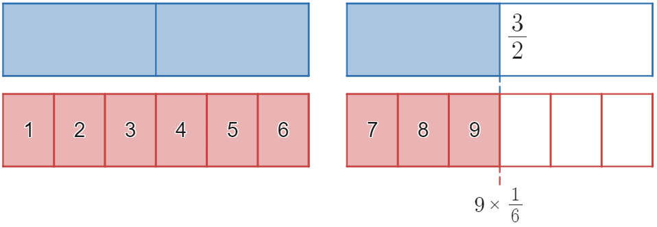 | $$9$$
$$\frac{3}{2}÷\frac{1}{12}$$ | 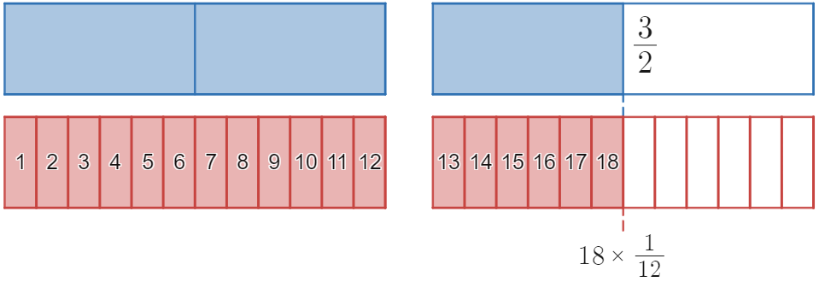 | $$18$$
$$\frac{3}{2}÷\frac{1}{10}$$ | 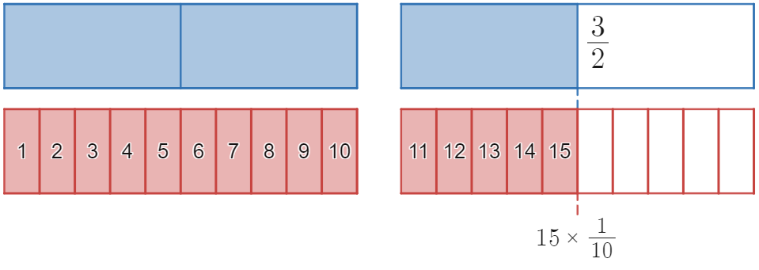 | $$15$$
$$\frac{16}{20}÷\frac{1}{10}$$ | 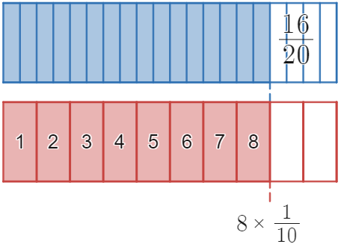 | $$8$$
$$\frac{16}{20}÷\frac{2}{5}$$ | 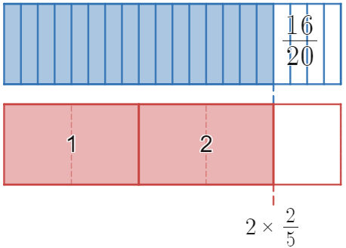 | $$2$$
$$\frac{x}{2}÷\frac{1}{4}$$ | If there are $x$ lots of $\frac{1}{2}$ and two $\frac{1}{4}$’s fit in each $\frac{1}{2}$ then 2 lots of $x$ will fit in $\frac{x}{2}$ | 2x

Appendix B – dividing by 1, multiplying by 1
Question 1 | Question 2 | Question 3 | Question 4 | Question 5
$$\frac{2}{3}÷\frac{1}{6}$$  $$=\frac{\frac{2}{3}}{\frac{1}{6}}$$  $$=\frac{\frac{2}{3}×\frac{6}{1}}{\frac{1}{6}×\frac{6}{1}}$$  $$=\frac{\frac{2}{3}×\frac{6}{1}}{\frac{1}{6}×\frac{6}{1}}$$  $$=\frac{2}{3}×\frac{6}{1}$$  $$=\frac{12}{3}$$  $$=4$$ | $$\frac{16}{20}÷\frac{1}{5}$$  $$=\frac{\frac{16}{20}}{\frac{1}{5}}$$  $$=\frac{\frac{16}{20}×\frac{5}{1}}{\frac{1}{5}×\frac{5}{1}}$$  $$=\frac{\frac{16}{20}×\frac{5}{1}}{\frac{1}{5}×\frac{5}{1}}$$  $$=\frac{16}{20}×\frac{5}{1}$$  $$=4$$ | $$\frac{6}{5}÷\frac{1}{3}$$  $$=\frac{\frac{6}{5}}{\frac{1}{3}}$$  $$=\frac{\frac{6}{5}×\frac{3}{1}}{\frac{1}{3}×\frac{3}{1}}$$  $$=\frac{\frac{6}{5}×\frac{3}{1}}{\frac{1}{3}×\frac{3}{1}}$$  $$=\frac{6}{5}×\frac{3}{1}$$  $$=\frac{18}{5}$$ | $$\frac{16}{20}÷\frac{2}{5}$$  $$=\frac{\frac{16}{20}}{\frac{2}{5}}$$  $$=\frac{\frac{16}{20}×\frac{5}{2}}{\frac{2}{5}×\frac{5}{2}}$$  $$=\frac{\frac{16}{20}×\frac{5}{2}}{\frac{2}{5}×\frac{5}{2}}$$  $$=\frac{16}{20}×\frac{5}{2}$$  $$=2$$ | $$\frac{x}{2}÷\frac{1}{4}$$  $$=\frac{\frac{x}{2}}{\frac{1}{4}}$$  $$=\frac{\frac{x}{2}×\frac{4}{1}}{\frac{1}{4}×\frac{4}{1}}$$  $$=\frac{\frac{x}{2}×\frac{4}{1}}{\frac{1}{4}×\frac{4}{1}}$$  $$=\frac{x}{2}×\frac{4}{1}$$  $$=2x$$

References
This resource contains NSW Curriculum and syllabus content. The NSW Curriculum is developed by the NSW Education Standards Authority. This content is prepared by NESA for and on behalf of the Crown in right of the State of New South Wales. The material is protected by Crown copyright.
Please refer to the NESA Copyright Disclaimer for more information https://educationstandards.nsw.edu.au/wps/portal/nesa/mini-footer/copyright.
NESA holds the only official and up-to-date versions of the NSW Curriculum and syllabus documents. Please visit the NSW Education Standards Authority (NESA) website https://educationstandards.nsw.edu.au/ and the NSW Curriculum website https://curriculum.nsw.edu.au/.
Mathematics K–10 Syllabus © NSW Education Standards Authority (NESA) for and on behalf of the Crown in right of the State of New South Wales, 2022.

© State of New South Wales (Department of Education), 2024
The copyright material published in this resource is subject to the Copyright Act 1968 (Cth) and is owned by the NSW Department of Education or, where indicated, by a party other than the NSW Department of Education (third-party material).
Copyright material available in this resource and owned by the NSW Department of Education is licensed under a Creative Commons Attribution 4.0 International (CC BY 4.0) license.
This license allows you to share and adapt the material for any purpose, even commercially.
Attribution should be given to © State of New South Wales (Department of Education), 2024.
Material in this resource not available under a Creative Commons license:
- the NSW Department of Education logo, other logos and trademark-protected material
- material owned by a third party that has been reproduced with permission. You will need to obtain permission from the third party to reuse its material.
Links to third-party material and websites
Please note that the provided (reading/viewing material/list/links/texts) are a suggestion only and implies no endorsement, by the New South Wales Department of Education, of any author, publisher, or book title. School principals and teachers are best placed to assess the suitability of resources that would complement the curriculum and reflect the needs and interests of their students.
If you use the links provided in this document to access a third-party's website, you acknowledge that the terms of use, including licence terms set out on the third-party's website apply to the use which may be made of the materials on that third-party website or where permitted by the Copyright Act 1968 (Cth). The department accepts no responsibility for content on third-party websites.

