Expand your mind
Students expand and simplify algebraic expressions by interacting with visual representations of expressions.
Students need at least one digital device per pair if choosing to interact with Polypad during this lesson.

Visible learning

Learning intentions
- To be able to expand and simplify algebraic expressions using the distributive law.

Success criteria
- I can use visual representations to show how to expand expressions.
- I can collect like terms to simplify an expression.
- I can expand expressions with negative coefficients.
- I can expand expressions with algebraic coefficients.

Syllabus outcomes
A student:
- develops understanding and fluency in mathematics through exploring and connecting mathematical concepts, choosing and applying mathematical techniques to solve problems, and communicating their thinking and reasoning coherently and clearly MAO-WM-01
- simplifies algebraic fractions with numerical denominators and expands algebraic expressions MA5-ALG-C-01
Mathematics K–10 Syllabus © NSW Education Standards Authority (NESA) for and on behalf of the Crown in right of the State of New South Wales, 2022.

Table 1: lesson summary
Section | Summary of activity | Teaching strategy | Teaching points
Warm up | Students work through the starfish activity from Appendix A. | Working in pairs | Reviewing expansion from Stage 4 Unit 5 – multiplicative thinking.
Launch | Students consider how they would solve 23 × 7 before visually representing a factorised expression on slide 4 of the PowerPoint Expand your mind. | Think-Pair-Share  Mini whiteboards | Introduction of a negative or a variable outside the brackets.
Explore | Students complete questions in Appendix B.  Show slide12 of the PowerPoint to show expansion with a variable outside the brackets using the area model. | Think-Pair-Share  Notice and wonder  Visibly random groups of 3  Vertical non-permanent surfaces | Students visually represent the expansion and simplification of expressions using the area model.
Summarise | Show slides 14–21 for explicit teaching of expanding brackets in expressions and simplifying the results.  Students complete Appendix C and Appendix D. | Visibly random groups of 3  Vertical non-permanent surfaces  Four quadrant notes | Focuses on formal working out for expansions and simplification of expressions.
Apply | Students complete Appendix E and then complete an exit ticket from Appendix F. | Working in pairs

Activity structure
Please use the associated PowerPoint Expand your mind to display images in this lesson.

Warm up
- Issue each student with a copy of Appendix A ‘Starfish’. Students work in pairs to fill in the blank spaces using the given operations.

Launch
- Using a Think-Pair-Share (bit.ly/thinkpairsharestrategy) and mini whiteboards (bit.ly/miniwhiteboards), ask students how many different ways they can solve 23 × 7.
- Initiate a sharing of strategies, highlighting any strategies that use the area model. Slide 3 from the PowerPoint Expand your mind can be used to show one example of an area model.
- In their pairs, ask students to consider the expression $2×\left(x+3\right)$. Challenge them to consider what an area model might look like for this expression and what the answer might look like.
- Show students slide 4 from the PowerPoint Expand your mind and explain that in this lesson, we will be exploring how to expand algebraic expressions.

Explore
- By working in visibly random groups of 3 (bit.ly/visiblegroups) on vertical non-permanent surfaces (bit.ly/VNPSstrategy), distribute an A3 copy of Appendix B ‘Show the expansion’ to each group.
- Students are to draw visual representations on the vertical non-permanent surfaces to model what is happening in the questions and show the expanded, simplified answer.

Students could use Polypad (polypad.amplify.com/p) to create their diagrams. Students could also use magnetic algebra tiles (from coloured magnetic strips or laminated coloured strips with magnets) rather than drawing the tiles.
Alternatively, teachers could access Polypad on an interactive whiteboard to model to students what is happening.
- Use slides 6–11 from the PowerPoint Expand your mind to highlight and discuss the different types of questions that students have experienced in Appendix B ‘Show the expansion’.
- While still at their vertical non-permanent surfaces, challenge students to draw a representation for $x(x+3)$ and work out its expansion. A solution can be found on slide 12 of the PowerPoint Expand your mind.

Summarise
- Use slides 13–20 from the PowerPoint Expand your mind for explicit teaching of expanding algebraic expressions using the worked examples (Your turn) method (DOCX 420 KB).
- Assign students into new visibly random groups of 3. Distribute a copy of Appendix C ’Variation task’ to each group. Students are to complete the task which uses Variation Theory (variationtheory.com/introduction/) on their vertical non-permanent surface.
- By continuing to work in visibly random groups of 3, have students complete four quadrant notes (DOCX 319 KB) to their future forgetful self from Appendix D ‘Four quadrant notes.’ After reviewing other groups’ four quadrant notes, students should then write their version of four quadrant notes in their workbook.

Apply
These tasks have been modified from Don Steward’s blog ‘Median’ (bit.ly/medianexpanding).
- Distribute a copy of Appendix E ’Six expressions’ to each student.
- Working in pairs, students are to use the 6 expressions listed to answer the questions.
- Students are to complete an exit ticket (bit.ly/exitticketstrategy) by responding to the task, Appendix F ‘One incorrect simplification’. There are 3 different versions of the task, increasing in difficulty. Students complete the level of difficulty they choose.

Assessment and differentiation

Suggested opportunities for differentiation
Launch
- Students may benefit from studying more numeric examples before moving onto algebraic examples.
Explore
- Students could use Polypad to assist them in constructing the models of expressions.
Summarise
- The activities in Appendix C are based on variation theory and have been designed for students to notice the difference between one question and the next and to predict how this change will affect the answer. As a minimum, students should consider whether the answer will be higher or lower than their previous answer.
- After completing Appendix C, students could create their own questions which explore variances of questions for peers or themselves.
- Students work in pairs, as well as in groups of 3 at vertical non-permanent surfaces. They have opportunities in these situations to observe other students’ work and thinking processes to assist them in theirs.
Apply
- Students can choose the level of exit ticket they complete. There are 3 levels and students can show understanding at multiple levels during this activity.

Suggested opportunities for assessment
Warm up and Launch
- During the Warm up and Launch activities, students could show their previous knowledge and understanding of the topic.
Explore
- Discussions by students at their vertical non-permanent surface can provide formative assessment opportunities for teachers.
- Appendix B can be collected by teachers as evidence of learning.
Summarise
- Appendix C ‘Variation task’ can be used as evidence of learning.
- Four quadrant notes can be used as evidence of learning for students.
Apply
- Exit ticket collected can be used as evidence of learning.

Appendix A

Starfish
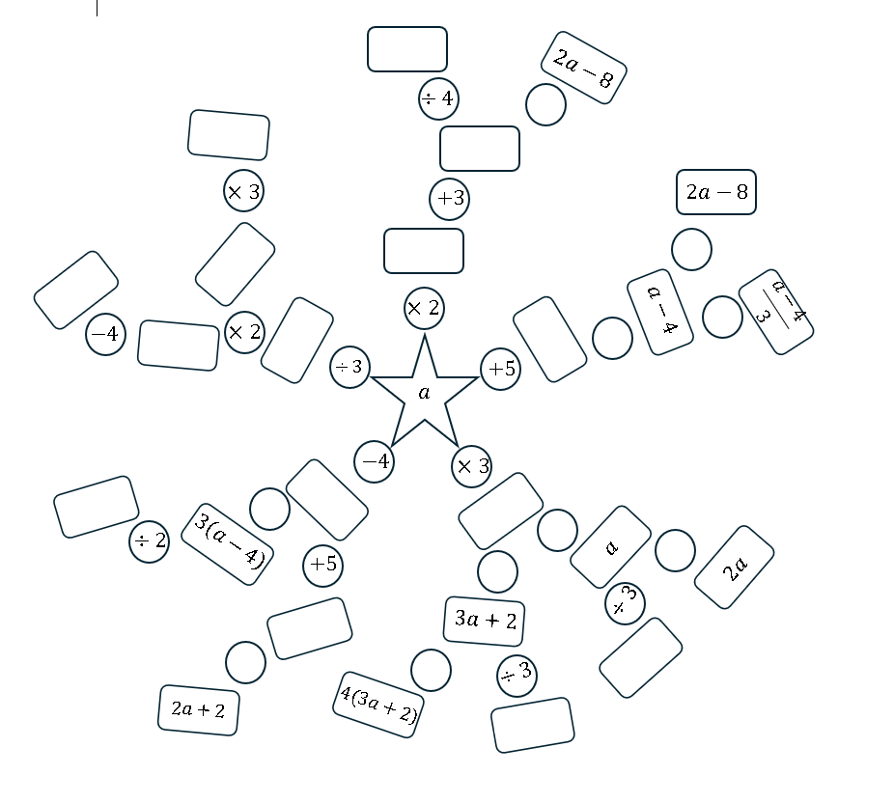
This image has been adapted from Starfish from Median by Don Steward.

Appendix B

Show the expansion
Expression | Expanded and simplified expression
$$5(x+6)$$ | $$5×x+5×6 \\ 5x+30$$  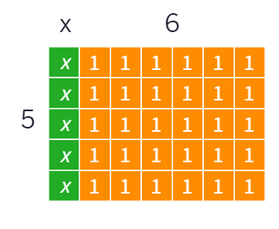
$$5(x-2)$$
$$3(x+6)$$
$$-3\left(x+6\right)$$
$$2(6-x)$$
$$-2(6-x)$$

Appendix C

Variation task
Question | Solution
$$4(a+3)$$
$$4a(a+3)$$
$$-4a(a+3)$$
$$-4a(2a+3)$$
$$-4a(-2a-3)$$
$$-4a\left(-2a+3\right)+6$$

Appendix D

Four quadrant notes
Example 1  Expand and simplify.  $$2\left(a-4\right)+3a+9$$  $$=2×☐-☐×☐+3a+9$$  $$=☐-☐+3a+9$$  $$=☐+☐$$ | Example 2  Expand and simplify.  $$3\left(a+7\right)+8+4a$$
Things to remember | Example 3

Appendix E

Six expressions
$$-3(4a+2b)$$
$$-2(5a-3b)$$
$$-(2a+5b)$$
$$(3b-2a)$$
$$-6\left(b+2a\right)$$
$$3(3a-2b)$$
- Which 2 expressions have a sum of $7a-11b$?
- Which 2 expressions add to $-12a+9b$ ?
- Which 2 expressions have a difference of zero?
- Which 2 expressions have a sum of $-a$?
- Which 2 expressions have a difference of $-2a-12b$?

Appendix F

One incorrect simplification
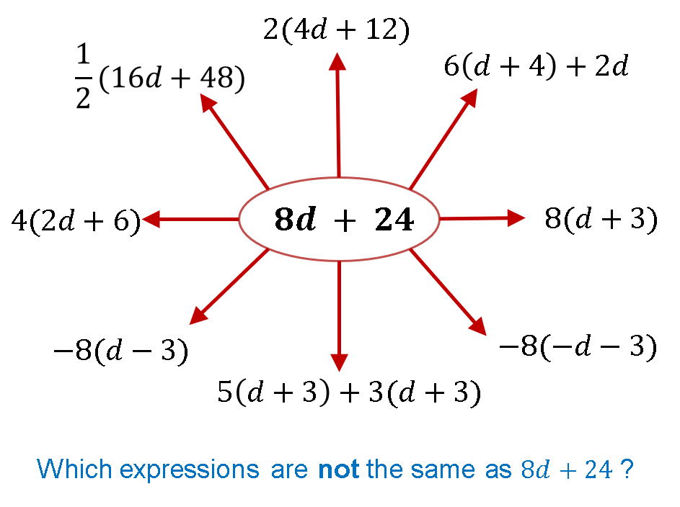
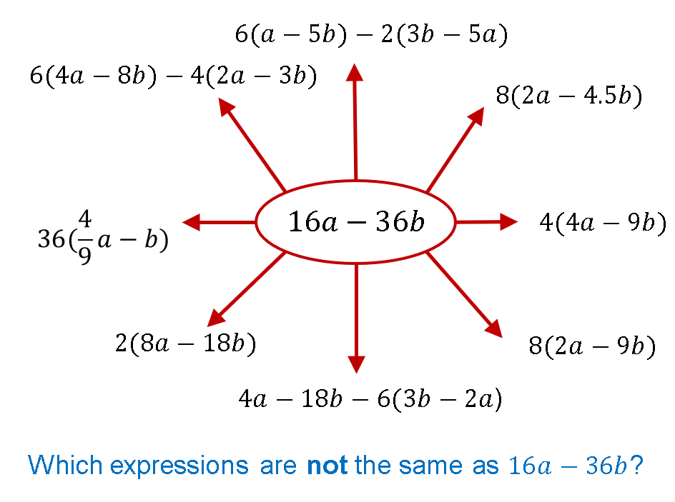
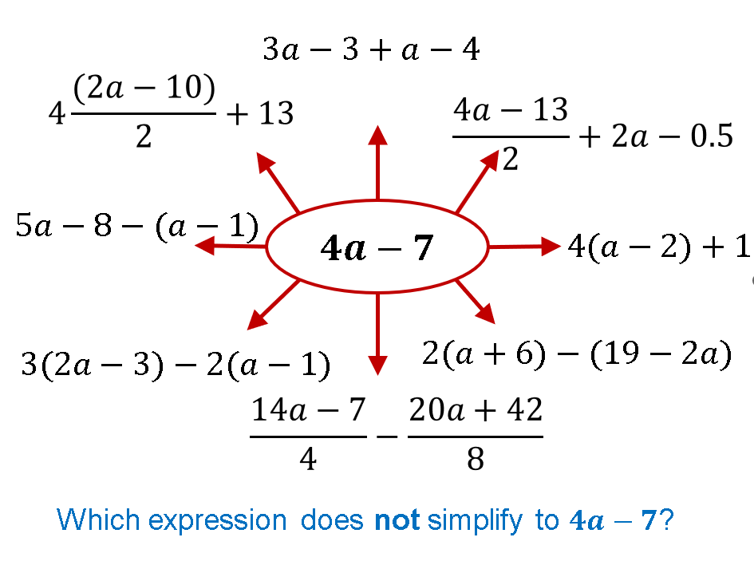

Sample solutions

Appendix A – starfish
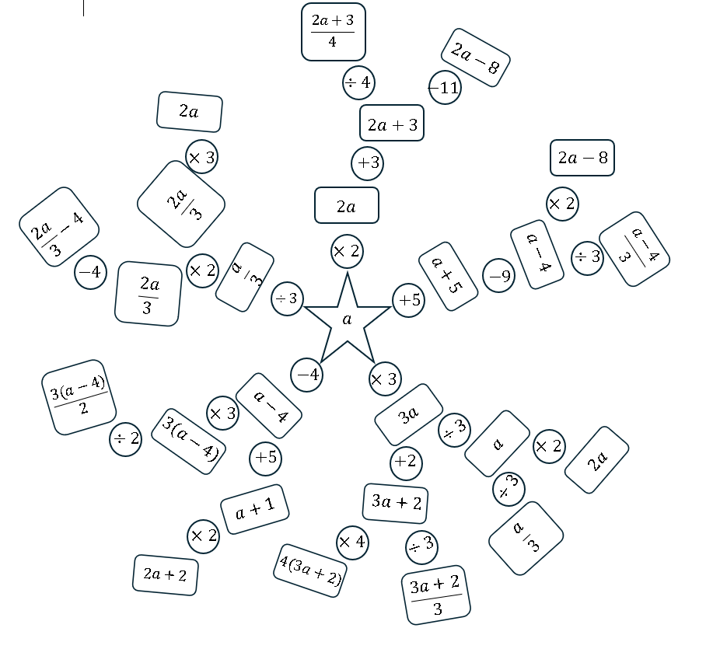

Appendix B – show the expansion!
Expression | Expanded and simplified expression
$$5(x+6)$$ | $$5×x+5×6 \\ 5x+30$$
$$5(x-2)$$ | $$5×x-5×2 \\ 5x-10$$  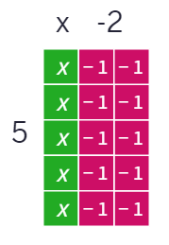
$$3(x+6)$$ | $$3×x+3×6 \\ 3x+18$$  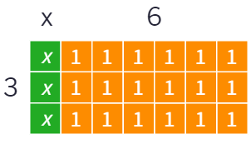
$$-3\left(x+6\right)$$ | $$-3×x-3×6 \\ -3x-18$$  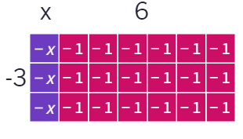
$$2(6-x)$$ | $$2×6-2×x \\ 12-2x$$  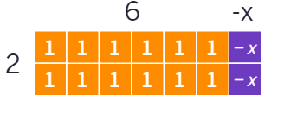
$$-2(6-x)$$ | $$-2×6-2×-x \\ -12+2x$$  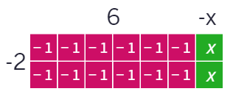

Appendix C – variation task
Question | Solution
$$4(a+3)$$ | $$4×a+4×3 \\ 4a+12$$
$$4a(a+3)$$ | $$4a×a+4a×3 \\ {4a}^{2}+12a$$
$$-4a(a+3)$$ | $$-4a×a-4a×3 \\ -4a^{2}-12a$$
$$-4a(2a+3)$$ | $$-4a×2a-4a×3 \\ -8a^{2}-12a$$
$$-4a(-2a-3)$$ | $$-4a×-2a-4a×-3 \\ 8a^{2}+12$$
$$-4a\left(-2a+3\right)+6$$ | $$-4a×-2a-4a×3+6 \\ 8a^{2}-12a+6$$

Appendix D – four quadrant notes
Example 1  Expand and simplify.  $2(a-4)$+$3a+9$  $$=2×a-2×-4+3a+9$$  $$=2a+8+3a+9$$  $$=5a+17$$ | Example 2  Expand and simplify.  $$3\left(a+7\right)+8+4a$$  $$=3×a+3×7+8+4a$$  $$=3a+21+8+4a$$  $$=7a+29$$
Things to remember  - Be careful of multiplying by negative numbers as you expand out brackets. | Example 3  Expand and simplify.  $$12a+17-2(3a-5)$$  $$=12a+17-2×3a-2×-5$$  $$=12a+17-6a+10$$  $$=6a+27$$

Appendix E – six expressions
- $-\left(2a+5b\right)+3\left(3a-2b\right)$
$$-2a-5b+9a-6b$$
$$7a-11b$$
- $-2\left(5a-3b\right)+\left(3b-2a\right)$$$-10a+6b+3b-2a \\ -12a+9b$$
- $-3\left(4a+2b\right)--6\left(b+2a\right)$$$-12a-6b+6b+12a \\ 0$$
- $-2\left(5a-3b\right)+3\left(3a-2b\right)$$$-10a+6b+9a-6b \\ -a$$
- $-6\left(b+2a\right)--2\left(5a-3b\right)$$$-6b-12a+10a-6b \\ -2a-12b$$

Appendix F – one incorrect simplification
- $8d+24≠-8\left(d-3\right)$ $\left[-8d+24\right]$
- $16a-36b≠8(2a-9b)$ [$16a-72b]$
- $4a-7≠\frac{14a-7}{4}-\frac{20a+42}{8}$ $\left[a-7\right]$

References
This resource contains NSW Curriculum and syllabus content. The NSW Curriculum is developed by the NSW Education Standards Authority. This content is prepared by NESA for and on behalf of the Crown in right of the State of New South Wales. The material is protected by Crown copyright.
Please refer to the NESA Copyright Disclaimer for more information https://educationstandards.nsw.edu.au/wps/portal/nesa/mini-footer/copyright.
NESA holds the only official and up-to-date versions of the NSW Curriculum and syllabus documents. Please visit the NSW Education Standards Authority (NESA) website https://educationstandards.nsw.edu.au and the NSW Curriculum website https://curriculum.nsw.edu.au.
Mathematics K–10 Syllabus © NSW Education Standards Authority (NESA) for and on behalf of the Crown in right of the State of New South Wales, 2022.

© State of New South Wales (Department of Education), 2024
The copyright material published in this resource is subject to the Copyright Act 1968 (Cth) and is owned by the NSW Department of Education or, where indicated, by a party other than the NSW Department of Education (third-party material).
Copyright material available in this resource and owned by the NSW Department of Education is licensed under a Creative Commons Attribution 4.0 International (CC BY 4.0) license.
This license allows you to share and adapt the material for any purpose, even commercially.
Attribution should be given to © State of New South Wales (Department of Education), 2024.
Material in this resource not available under a Creative Commons license:
- the NSW Department of Education logo, other logos and trademark-protected material
- material owned by a third party that has been reproduced with permission. You will need to obtain permission from the third party to reuse its material.
Links to third-party material and websites
Please note that the provided (reading/viewing material/list/links/texts) are a suggestion only and implies no endorsement, by the New South Wales Department of Education, of any author, publisher, or book title. School principals and teachers are best placed to assess the suitability of resources that would complement the curriculum and reflect the needs and interests of their students.
If you use the links provided in this document to access a third-party's website, you acknowledge that the terms of use, including licence terms set out on the third-party's website apply to the use which may be made of the materials on that third-party website or where permitted by the Copyright Act 1968 (Cth). The department accepts no responsibility for content on third-party websites.

