# Age-old question

Students use real-life contexts to look at solving equations with fractions, including those with an unknown in the denominator.

## Visible learning

### Learning intentions

* To be able to solve equations with a fraction as a constant.
* To be able to solve equations with a pronumeral in the denominator.

### Success criteria

* I can recognise the inverse operations needed to solve an equation.
* I can apply operations to move the pronumeral from the denominator to the numerator.
* I can apply the correct operations to solve an equation.

### Syllabus outcomes

A student:

* develops understanding and fluency in mathematics through exploring and connecting mathematical concepts, choosing and applying mathematical techniques to solve problems, and communicating their thinking and reasoning coherently and clearly **MAO-WM-01**
* solves linear equations of up to 3 steps, limited to one algebraic fraction **MA5-EQU-C-01**

[Mathematics K–10 Syllabus](https://curriculum.nsw.edu.au/learning-areas/mathematics/mathematics-k-10-2022/overview) © NSW Education Standards Authority (NESA) for and on behalf of the Crown in right of the State of New South Wales, 2022.

Table 1: lesson summary

|  |  |  |  |
| --- | --- | --- | --- |
| Section | Summary of activity | Teaching strategy | Teaching points |
| ****Launch**** | Introduce students to Fried’s and Young’s rule and the 2 scenarios presented in Appendix A.  Introduce questions with a pronumeral in the denominator. | Think-Pair-Share  Pose-Pause-Pounce-Bounce | Revision of substitution into a formula. |
| ****Explore**** | Students use backtracking to complete Appendix B. The last 2 rows on Appendix B are available for students to write their own questions and swap with a friend. | Think-Pair-Share | Develop an understanding of the order in which operations have occurred. |
| ****Summarise**** | Use slides 5–12 of the PowerPoint Age-old question for explicit teaching of solving equations with an unknown as the denominator.  Students complete Appendix C.  Students complete variation problems in Appendix D and find the error in Appendix E. | Vertical non-permanent surfaces  Visibly random groups of 3  Two stars and a wish | Worked examples and practice of how to solve equations with unknowns in the denominator. |
| ****Apply**** | Interleave trigonometry examples of solving equations with unknowns in the denominator using slides 14–17 from the PowerPoint.  Complete the dosage questions using the rules from the launch and discuss why they give a variety of solutions to the same scenario. | Think-Pair-Share  Gallery walk | Application of skills in solving real-life formulas. |

## Activity structure

Please use the associated PowerPoint Age-old questionto display images in this lesson.

### Launch

1. Distribute Appendix A ‘Correct dosage’ showing 2 rules. Explain to students that these rules are used for dosage calculations for children from an adult dosage.
2. Using a Think-Pair-Share ([bit.ly/thinkpairsharestrategy](https://bit.ly/thinkpairsharestrategy)), have students complete Scenario 1 using both rules.
3. Initiate a discussion around problems encountered when finding the solution to Scenario 1 using the Pose-Pause-Pounce-Bounce question strategy (PDF 557 KB) ([bit.ly/posepausepouncebounce](https://bit.ly/posepausepouncebounce)).

As this is a simple substitution, students do not have to manipulate the formula to find the answer. One difficulty students may encounter is converting months to years for Young’s rule.

1. Allow students time to consider Scenario 2 as a Think-Pair-Share.

It is okay if students do not answer Scenario 2. The question is designed to allow them to engage in productive struggle and to see a need for solving equations where the unknown is part of a fraction.

### Explore

1. Draw or display Figure 1 using slide 3 from the PowerPoint Age-old question for students to see.

Figure 1: backtracking diagram

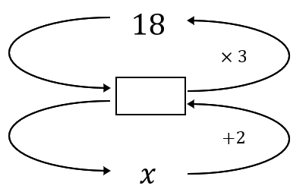

1. Students discuss in a Think-Pair-Share, how they could use the backtracking diagram to find the value of $x$. Encourage discussion of how the diagram could be translated into an equation and how students can read the equation aloud.
2. Distribute Appendix B ‘Working backwards’ to each student.
3. Students use the backtracking diagrams to find the value of $x$ for each set of operations. Students then compare answers with a partner, discussing how the variation in the order of expressions changes the value of $x$.
4. Students complete the second column of the table by translating from the backtracking diagrams to writing algebraic equations. Students compare equations with a partner.
5. The bottom 2 rows are empty so that students can write 2 equations of their own, involving algebraic fractions. They should swap with their partner to draw a backtracking diagram for each other’s equations.

The purpose of the activity is to develop students’ understanding of the order in which operations have occurred in an equation.

### Summarise

1. Use slides 5–12 from the PowerPoint Age-old question for explicit teaching of solving equations with algebraic fractions using the [worked examples (Your turn) method (DOCX 420 KB)](https://education.nsw.gov.au/content/dam/main-education/documents/teaching-and-learning/curriculum/mathematics/mathematics-s4-supporting-strategies-worked-examples-your-turn.docx).
2. Assign students to visibly random groups of 3 ([bit.ly/visiblegroups](https://bit.ly/visiblegroups)) and ask them to complete [four quadrant notes (DOCX 319 KB)](https://education.nsw.gov.au/content/dam/main-education/documents/teaching-and-learning/curriculum/mathematics/mathematics-s4-supporting-strategies-four-quadrant-notes.docx) to their future forgetful self from Appendix C ‘Four quadrant notes’. After reviewing other groups’ four quadrant notes, students should then write their own version of four quadrant notes in their workbook.
3. Issue each student with a copy of Appendix D ‘Variation Theory questions’. ([variationtheory.com/introduction/](https://variationtheory.com/introduction/))
4. Continuing in their random groups of 3 at a vertical non-permanent surface, students are to work through the questions. Students fill in the solution column on their worksheet once the group has determined the solution. Students move around the classroom as they complete questions to check their solutions against other groups.
5. Continuing in their groups of 3 at vertical non-permanent surfaces, issue each student with a copy of Appendix E ‘Correct the error’ and an A3 copy for the vertical non-permanent surface. Have students complete the activity before conducting a gallery walk ([bit.ly/DLSgallerywalk](https://bit.ly/DLSgallerywalk)) and using Two stars and a wish ([bit.ly/DLSpeerfeedback](https://bit.ly/DLSpeerfeedback)) to provide feedback to other groups.

### Apply

1. Display slide 14 of the PowerPoint Age-old question. Ask students to work in their groups of 3 to find the unknown value.
2. Students are to do a gallery walk to see how other groups have approached the solution.
3. Show the correct working on slide 15 of the PowerPoint Age-old question*.*
4. Display slide 16 of the PowerPoint Age-old question and ask the groups to find the unknown.
5. Students conduct a gallery walk again to see how other groups have approached the problem. Select a group that has come up with the correct approach to the solution, otherwise show students the correct solution on slide 17 of the PowerPoint Age-old question.
6. When groups are finished, issue each student with a copy of Appendix F ‘Correct dosage questions’ for students to complete. In their groups of 3, students are to discuss the differences between the rules and discuss why they may differ in solutions or have limitations.

After the sharing part of the discussion, teachers could tell students that the 3 rules have the following limitations:

* Fried’s rule is for children 1–2 years old
* Young’s rule is for children 1–12 years old
* Clark’s rule is a general rule for all children.

## Assessment and differentiation

### Suggested opportunities for differentiation

**Launch**

* Students can discuss how they may solve these equations, enabling them to seek clarification or advice from their peers regarding how to approach the solution.
* Students may need support in converting between months and years with the use of these rules.

**Explore**

* Students could be challenged to solve the equations in Appendix B, showing their working in a more traditional style.
* Students could use Graspable Math’s digital whiteboard([activities.graspablemath.com/whiteboards/new](https://activities.graspablemath.com/whiteboards/new)) to compare the different solutions by changing the order in which to solve an equation.

**Summarise**

* Students could look at other group's responses to create their four quadrant notes, as well as look at the class’s solutions during a gallery walk if they are having difficulty trying to understand how to approach a problem.
* Students could use Graspable Math’s digital whiteboard to assist in solving equations on the Variation Theory sheet.
* Students could use Graspable Math’s digital whiteboard to assist in solving more challenging questions that students develop (for example, questions with more than 3 steps or more than one fraction).

**Apply**

* Students can discuss what the error is in that task so students can seek clarification from their peers.

### Suggested opportunities for assessment

**Launch**

* Students could demonstrate their prior knowledge in the Launch activity.
* Appendix A ‘Correct dosage’ could be collected for evidence of learning.

**Explore**

* Discussions from the Think-Pair-Share activities can provide assessment opportunities for teachers.

**Summarise**

* Students provide peer feedback when on gallery walks using Two stars and a wish.
* Discussions that are conducted by students at the vertical non-permanent surfaces give teachers an opportunity to assess students’ knowledge.
* Appendix D ‘Variation Theory questions’ could be collected for assessment purposes.

**Apply**

* Discussions that are conducted by students at the vertical non-permanent surfaces give teachers an opportunity to assess students’ knowledge.
* Appendix F ‘Correct dosage questions’ could be used as an exit ticket.

## Appendix A

### Correct dosage

|  |  |
| --- | --- |
| Fried’s rule | $$Child dosage=\frac{age in months}{150}×adult dosage$$ |
| Young’s rule | $$Child dosage=\frac{age in years}{age in years+12}×adult dosage$$ |

#### Scenario 1

Manuel is 15 months old. How much medicine should he receive if the adult dose is 25 mg? Solve using both rules.

|  |
| --- |
|  |

#### Scenario 2

How old is the child if the given dosage is 16 mg when an adult dosage is 40 mg?

|  |
| --- |
|  |

## Appendix B

### Working backwards

|  |  |
| --- | --- |
| Operations | Equation |
| Backtracking diagram where x is divided by 2 and 3 is added to get 8. |  |
| Backtracking diagram where x plus 3 is divided by 2 to get 8. |  |
| Backtracking diagram where 3 is divided by x and 2 is added to get 8. |  |
| Backtracking diagram where 3 plus 2 is divided by x to get 8. |  |
| Backtracking diagram where x is multiplied by 2, then 1 is subtracted and then it is divided by 3 to get 8. |  |
| Backtracking diagram where x minus 1 is multiplied by 2 and then divided by 3 to get 8. |  |
| Backtracking diagram where x is divided by 3, then 1 is subtracted and then it is multiplied by 2 to get 8. |  |
| Backtracking diagram where x is divided by 3, then it is multiplied by 2 and then 1 is subtracted to get 8. |  |
| Backtracking diagram where 3 is divided by 2x , then 1 is subtracted to get 8. |  |
| Backtracking diagram where 3 minus 1 is divided by 2x to get 8. |  |
|  |  |
|  |  |

## Appendix C

### Four quadrant notes

|  |  |
| --- | --- |
| **Example 1 $$\frac{5x}{6}-3=12 \\ =+3 \\ \frac{5x}{6}= \\ ×=× \\ 5x=90 \\ ÷5= \\ x=$$** | **Example 2 $$\frac{11-4x}{3}=9 \\ = \\ -= \\ = \\ -= \\ = \\ x=$$** |
| **Things to remember** | **Example 3** |

## Appendix D

### Variation Theory questions

|  |  |
| --- | --- |
| Question | Solution |
| $$\frac{x}{5}+1=4$$ |  |
| $$\frac{x+1}{5}=4$$ |  |
| $$\frac{x+1}{5}-3=4$$ |  |
| $$3-\frac{x+1}{5}=4$$ |  |
| $$\frac{3x-1}{5}=4$$ |  |
| $$\frac{x+1}{5}=4x$$ |  |
| $$\frac{5}{x}+1=4$$ |  |
| $$\frac{5}{x+1}=4$$ |  |
| $$\frac{5}{3x-1}=4$$ |  |

## Appendix E

### Correct the error

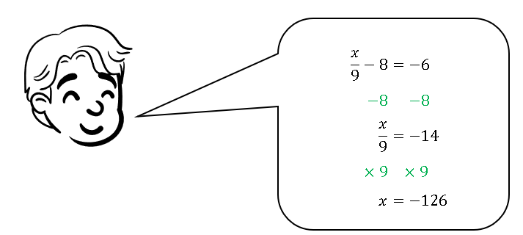

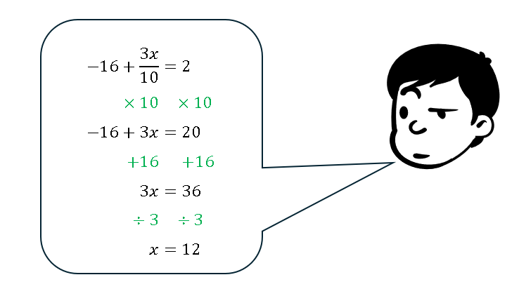

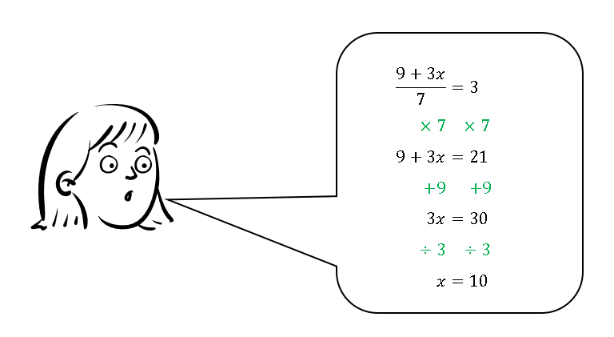

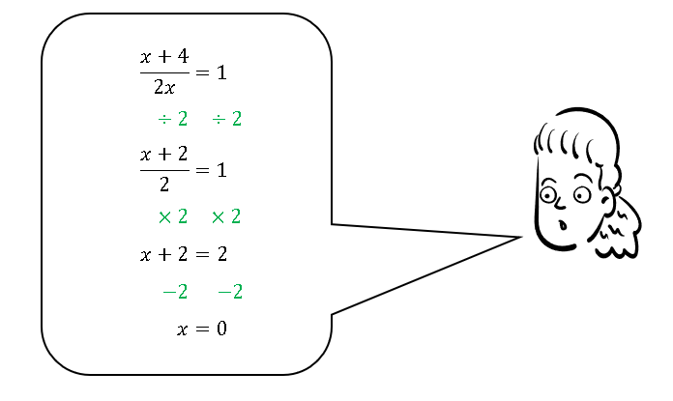

## Appendix F

### Correct dosage questions

|  |  |  |
| --- | --- | --- |
| Fried’s Rule | Young’s Rule | Clark’s Rule |
| Dosage $=\frac{y×A}{150}$ where: $y$ = age of infant in months $A$ = adult dose of medication | Dosage $=\frac{y×A}{y+12}$ where: $y$ = age of child in years $A$ = adult dose of medication | Dosage $=\frac{w×A}{70}$ where: $w$ = weight in kilograms $A$ = adult dose of medication |

1. The pharmacist has told Rae that the dosage for a medication for her child is 15 mL and the adult dosage is 30 mL. By using Clark’s rule, calculate the weight of the child that the dosage is designed for.
2. Jack buys a bottle of cough mixture. The recommended dosage for a 2-year-old is 8 mL. What is the adult dosage of this medication using Fried’s Rule?
3. William has been given instructions to give his child a dosage of 10 mL of medication. The adult dosage is 40 mL. Using Young’s rule, calculate how old the child is that this medication is recommended for.

## Sample solutions

### Appendix A – correct dosage

**Scenario 1**

$$Dosage= \frac{age in months×adult dosage}{150} \\ =\frac{15×25}{150} \\ =2.5 mg$$

$$Dosage=\frac{age in years×adult dosage}{age in years+12} \\ =\frac{1.25×25}{1.25+12} \\ =2.358…… \\ ≈2.4 mg$$

**Scenario 2**

$$Dosage=\frac{age in months×adult dosage}{150} \\ 16=\frac{y×40}{150} \\ ×150=×150 \\ 2400=40y \\ ÷40=÷40 \\ y=60 months$$

$$Dosage= \frac{age in years×adult dosage}{age in years+12} \\ 16=\frac{y×40}{y+12} \\ 16=\frac{40y}{y+12} \\ ×\left(y+12\right)=×\left(y+12\right) \\ 16×\left(y+12\right)=40y \\ 16y+192=40y \\ -16y=-16y \\ 192=24y \\ ÷24=÷24 \\ y=8$$

### Appendix B – working backwards

|  |  |
| --- | --- |
| Operations | Equation |
| Operations for the equation, x over 2 plus 3 equals 8. |  |
| Operations for the equation, x plus 3, all over 2,  equals 8. |  |
| Operations for the equation, 3 over x plus 2 equals 8. |  |
| Operations for the equation, 3 plus 2, all over x, equals 8. |  |
| Operations for the equation, 2x minus 1, all over 3, equals 8. |  |
| Operations for the equation, 2(x minus 1), all over 3, equals 8. |  |
| Operations for the equation, 2(x over 3 minus 1) equals 8. |  |
| Operations for the equation, 2 (x over 3) minus 1  equals 8. |  |
| Operations for the equation, 3 over 2x minus 1 equals 8. |  |
| Operations for the equation, 3 minus 1, all over 2x, equals 8. |  |

### Appendix C – four quadrant notes

|  |  |
| --- | --- |
| **Example 1 $$\frac{5x}{6}-3=12 \\ +3=+3 \\ \frac{5x}{6}=15 \\ ×6=×6 \\ 5x=90 \\ ÷5=÷5 \\ x=18$$** | **Example 2 $$\frac{11-4x}{3}=9 \\ ×3=×3 \\ 11-4x=27 \\ -11=-11 \\ -4x=16 \\ ÷-4=÷-4 \\ x=-4$$** |
| **Things to remember**   * Reverse order of operation. | **Example 3 $$\frac{x-2}{5}+8=11 \\ -8=-8 \\ \frac{x-2}{5}=3 \\ ×5=×5 \\ x-2=15 \\ +2=+2 \\ x=17$$** |

### Appendix D – Variation Theory questions

|  |  |
| --- | --- |
| Question | Solution |
|  |  |
|  |  |
|  |  |
|  |  |

|  |  |
| --- | --- |
| Question | Solution |
|  |  |
|  |  |
|  |  |

|  |  |
| --- | --- |
| Question | Solution |
| $$\frac{5}{x+1}=4$$ | $$\frac{5}{x+1}=4 \\ ×\left(x+1\right)=×\left(x+1\right) \\ 5=4×\left(x+1\right) \\ 5=4x+4 \\ -4=-4 \\ 1=4x \\ ÷4=÷4 \\ x=\frac{1}{4}$$ |
| $$\frac{5}{3x-1}=4$$ | $$\frac{5}{3x-1}=4 \\ ×\left(3x-1\right)=×\left(3x-1\right) \\ 5=4×\left(3x-1\right) \\ 5=12x-4 \\ +4=+4 \\ 9=12x \\ ÷12=÷12 \\ x=\frac{9}{12} \\ x=\frac{3}{4}$$ |

### Appendix E – correct the error

$\frac{x}{9}-8=-6$ $$+8=+8 \\ \frac{x}{9}=2 \\ ×9=×9 \\ x=18$$

Error – subtracting the 8 instead of adding the 8 to both sides.

$$-16+\frac{3x}{10}=2 \\ +16=+16 \\ \frac{3x}{10}=18 \\ ×10=×10 \\ 3x=180 \\ ÷3=÷3 \\ x=60$$

Error – multiplied the right-hand side by 10 but should have added 16 to both sides first or multiplied the -16 by 10 as well in the first step.

$$\frac{9+3x}{7}=3 \\ ×7=×7 \\ 9+3x=21 \\ -9=-9 \\ 3x=12 \\ ÷3=÷3 \\ x=4$$ Error – added the 9 rather than subtracting it.

$$\frac{x+4}{2x}=1 \\ ×2x=×2x \\ x+4=2x \\ -x=-x \\ x=4$$

Error – divided by 2 instead of multiplying by $2x$.

### Appendix F – correct dosage questions

$$Dosage= \frac{w×A}{70} \\ 15=\frac{y×30}{70} \\ ×70=×70 \\ 1050=y×30 \\ ÷30=÷30 \\ y=35kg$$

$$Dosage= \frac{y×A}{150} \\ 8=\frac{24×A}{150} \\ ×150=×150 \\ 1200=24×A \\ ÷24=÷24 \\ A=50mL$$

$$Dosage=\frac{y×A}{y+12} \\ 10=\frac{y×40}{y+12} \\ ×\left(y+12\right)=×\left(y+12\right) \\ 10×\left(y+12\right)=y×40 \\ 10y+120=40y \\ -10y=-10y \\ 120=30y \\ ÷30=÷30 \\ y=4 years old.$$

## References

This resource contains NSW Curriculum and syllabus content. The NSW Curriculum is developed by the NSW Education Standards Authority. This content is prepared by NESA for and on behalf of the Crown in right of the State of New South Wales. The material is protected by Crown copyright.

Please refer to the NESA Copyright Disclaimer for more information <https://educationstandards.nsw.edu.au/wps/portal/nesa/mini-footer/copyright>.

NESA holds the only official and up-to-date versions of the NSW Curriculum and syllabus documents. Please visit the NSW Education Standards Authority (NESA) website <https://educationstandards.nsw.edu.au> and the NSW Curriculum website <https://curriculum.nsw.edu.au>.

[Mathematics K–10 Syllabus](https://curriculum.nsw.edu.au/learning-areas/mathematics/mathematics-k-10-2022/overview) © NSW Education Standards Authority (NESA) for and on behalf of the Crown in right of the State of New South Wales, 2022.

**© State of New South Wales (Department of Education), 2024**

The copyright material published in this resource is subject to the Copyright Act 1968 (Cth) and is owned by the NSW Department of Education or, where indicated, by a party other than the NSW Department of Education (third-party material).

Copyright material available in this resource and owned by the NSW Department of Education is licensed under a [Creative Commons Attribution 4.0 International (CC BY 4.0) license](https://creativecommons.org/licenses/by/4.0/).

[](https://creativecommons.org/licenses/by/4.0/)

This license allows you to share and adapt the material for any purpose, even commercially.

Attribution should be given to © State of New South Wales (Department of Education), 2024.

Material in this resource not available under a Creative Commons license:

* the NSW Department of Education logo, other logos and trademark-protected material
* material owned by a third party that has been reproduced with permission. You will need to obtain permission from the third party to reuse its material.

**Links to third-party material and websites**

Please note that the provided (reading/viewing material/list/links/texts) are a suggestion only and implies no endorsement, by the New South Wales Department of Education, of any author, publisher, or book title. School principals and teachers are best placed to assess the suitability of resources that would complement the curriculum and reflect the needs and interests of their students.

If you use the links provided in this document to access a third-party's website, you acknowledge that the terms of use, including licence terms set out on the third-party's website apply to the use which may be made of the materials on that third-party website or where permitted by the Copyright Act 1968 (Cth). The department accepts no responsibility for content on third-party websites.