Packing then unpacking
Students build their own equations working backward from the solutions. They explore a visual representation of equations and formalise working out for solving equations with 3 or more steps.

Visible learning
This lesson incorporates Path content.

Learning intentions
- To be able to construct equations from a solution.
- To understand the connection between building and solving equations.

Success criteria
- I can construct equations with 3 or more steps.
- I can express an equation using a visual representation.
- I can solve equations with 3 or more steps.
- I can check solutions through substitution.

Syllabus outcomes
A student:
- develops understanding and fluency in mathematics through exploring and connecting mathematical concepts, choosing and applying mathematical techniques to solve problems, and communicating their thinking and reasoning coherently and clearly MAO-WM-01
- solves linear equations of up to 3 steps, limited to one algebraic fraction MA5-EQU-C-01
- solves linear equations of more than 3 steps, monic and non-monic quadratic equations, and linear simultaneous equations MA5-EQU-P-02
Mathematics K–10 Syllabus © NSW Education Standards Authority (NESA) for and on behalf of the Crown in right of the State of New South Wales, 2022.

Table 1: lesson summary
Section | Summary of activity | Teaching strategy | Teaching points
Launch | Use slide 3 from the PowerPoint Packing then unpacking for students to choose which equation does not belong.  Create another equation to make 4 equations that belong. | Think-Pair-Share  Which one doesn’t belong? | The aim is to remind students how to solve equations and how to create an equation.
Explore | Students build equations starting at the solution using a mind map (Appendix A) and visual representations (Appendix B). An example of a visual representation is on slide 5 of the PowerPoint.  Appendix C allows students to take building equations a step further but reversing the operations.  Students discuss where they would start when solving 3-step equations. | Notice and wonder  Visibly random groups of 3  Vertical non-permanent surfaces  Gallery walk  Mind map  Think-Pair-Share  Class discussion | After each activity, groups join with other groups to clarify thinking and provide feedback.  The aim is to build students' confidence in knowing where to start solving a complex equation. This should be established in a class discussion before moving on.
Summarise | Use slides 9–12 of the PowerPoint to explicitly teach solving equations. Students then practise their setting out using Appendix D. | Worked examples (Your turn)  Faded examples | The teacher can vary these tasks depending on the readiness of their students.
Apply | Students use the template provided in Appendix E to create equations for a partner to solve. | Working in pairs | Students can choose which 10 questions they do depending on readiness.

Activity structure
Please use the associated PowerPoint Packing then unpacking to display images in this lesson.

Launch
- Display slide 3 of the PowerPoint Packing then unpacking and allow students to choose which one of the 4 equations below does not belong (bit.ly/wodb).
Table 2: Which one doesn't belong?
$$4x+4=24$$ | $$4x-3=17$$
$$4x+8=20$$ | $$\frac{4x+1}{3}=7$$
- In a Think-Pair-Share (bit.ly/thinkpairsharestrategy), have students share the reasoning behind their choice.
Students may provide different reasoning for which equation does not belong. Only one equation contains a fraction, only one contains subtraction, 3 equations all solve to $x=5$.
- Ask students to write another equation that could belong to make 4 equations that all belong.

Explore
- Display the 2 equations $x = 3$ and $x+7=10$ and in a Think-Pair-Share, ask students to discuss what they notice and wonder (bit.ly/noticewonderstrategy).
Students should notice that the 2 equations have the same solution, but the second equation has 7 added to each side.
- Assign students to visibly random groups of 3 (bit.ly/visiblegroups) at vertical non-permanent surfaces (bit.ly/VNPSstrategy).
- Distribute an A3 copy of Appendix A ‘Mind map’ and have students create equations for each box. Each box has an operation which students will use to modify the original equation. Students can choose their own numbers but must use the operations provided.
- Students are to do a gallery walk (bit.ly/DLSgallerywalk) of other groups’ equations. While viewing, students are to check that $x$still equals 3.
- As a class, discuss how students know that the equation’s solution has not changed.
Students should be able to check that the same process has been done to both sides of the equation or substitute in the answer $x=3$ to verify that it is still the solution.
- Display slide 5 of the PowerPoint Packing then unpacking displaying a visual representation of creating an equation.
- Have students discuss the answers to the self-explanation prompts in their groups, then clarify thinking in a whole-class discussion.
- Still in their groups, distribute an A3 copy of Appendix B ‘Equations visually’ and have students write equations for each visual representation.
- Once students complete the 2 examples, they will pair with the group next to them and share their work. If they differ, they must work together to explain the correct solution.
Slides 6 and 7 of the PowerPoint Packing then unpacking contain the solutions to Appendix B.
- Distribute an A3 copy of Appendix C ‘Unpacking equations’ to each group. Have students work from the bottom up, creating the steps to build each equation and then unpacking each step to get to the solution again.
- Students are to pair with another group and compare their work. Differences should be discussed, and groups must work together to develop the correct answer.
- Pose the question: How would you teach a friend where to start solving an equation with multiple steps? Have students return to their desks and conduct a Think-Pair-Share.
This is an important discussion as it is the most common barrier for students to solve equations. Students should understand that they are to start with the digit the furthest from the unknown.

Summarise
- Use slides 9–12 from the PowerPoint Packing then unpacking for explicit teaching of solving equations using the worked examples (Your turn) method (DOCX 420 KB).
- Distribute Appendix D ‘Faded examples’ (bit.ly/fadedexamplesstrategy) to each student and have them work through the 5 questions.
- After each question have students check their solutions using substitution.
- Students should pair up and compare their work. Differences need to be discussed and pairs must work together to develop the correct answer.

Apply
- Distribute Appendix E ‘Packing then unpacking equations’ to each student. Students will work in pairs to complete this activity.
- In pairs, starting with the card on the left, each student will write a solution of their choice at the top of the card and work down to build an equation. The students will then write the finished equation at the top of the card on the right.
- Students either cut their page in 2, or fold the page in half, and swap with a partner for them to solve.

Assessment and differentiation

Suggested opportunities for differentiation
Launch
- The launch has no correct answer so that all students can participate in the discussion.
- Equations in the launch could be adjusted to suit students’ level of readiness.
Explore
- Students may need to be assigned more practice of solving 3-step equations.
- Students can be challenged to progress beyond 4-step equations.
- Teachers could allow students time to create visual representations for the equations in Appendix C using Amplify’s Polypad.
- Appendix C could be modified by eliminating some operations to make the equations simpler.
- Appendix C could be modified by asking more capable students to create another step above the final equation.
Summarise
- Students could be encouraged to add another step to the faded example questions to increase the difficulty of the equation, showing all working.
- Students who are not ready for the Path content of more than 3-step equations could have the faded examples modified to reflect only 3 steps or less.
Apply
- By building their own equations in Appendix E, students can choose their own challenge level by including as many steps as they wish.

Suggested opportunities for assessment
Launch
- The teacher could monitor students' responses to the launch to determine students’ understanding of 2-step equations.
Explore
- Students should be encouraged to regularly self-assess by substituting their solution back into the original equation.
Summarise
- The teacher could use an example from Appendix D as an exit ticket.
Apply
- The teacher should monitor pairs when writing and solving equations to check for understanding, working out and misconceptions.
- The teacher could collect Appendix E to check students’ overall ability to solve equations.

Appendix A

Mind map
Fill in each box using the operation provided. The light blue boxes are one-step equations and the white boxes are 2-step equations. An example has been provided. You can choose your own numbers; the only restriction is the operation.

Appendix B

Equations visually
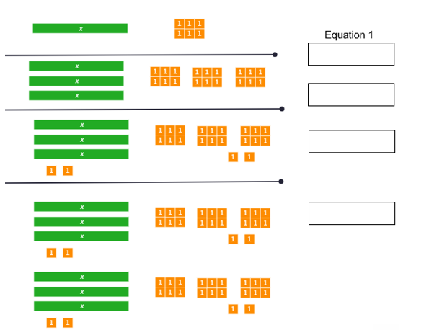
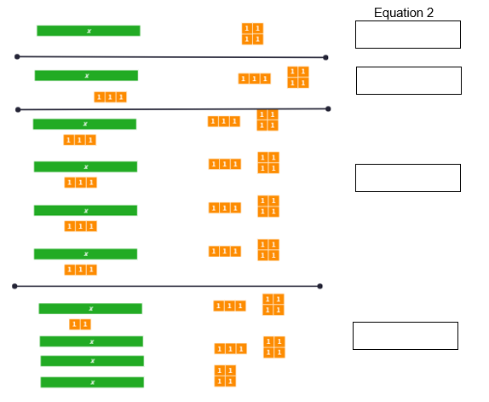

Appendix C

Unpacking equations
The following questions have been built. Can you show the steps required to unbuild or solve the equation?
Question 1 | Question 2
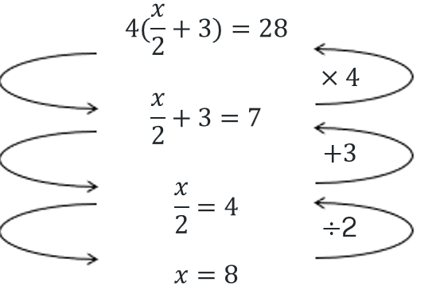 | 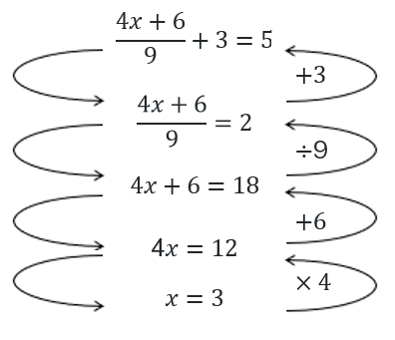
Question 3 | Question 4
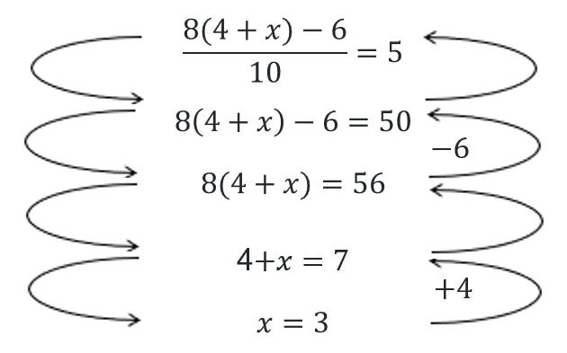 | 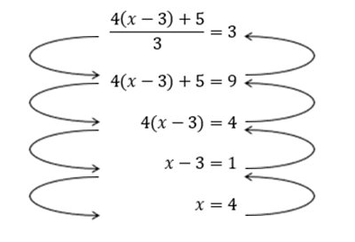

Appendix D

Faded examples
1 | 2 | 3 | 4 | 5
$$4\left(\frac{7x}{3}+1\right)=32 \\ ÷4=÷4 \\ \frac{7x}{3}+1=8 \\ -☐=-☐ \\ \frac{7x}{3}=7 \\ ×☐=×☐ \\ 7x=21 \\ ÷☐=÷☐ \\ x=☐$$ | $$4\left(\frac{8x+2}{3}\right)=24 \\ ☐=☐ \\ \frac{8x+2}{3}=6 \\ ☐=☐ \\ 8x+2=18 \\ ☐=☐ \\ 8x=16 \\ ☐=☐ \\ x=☐$$ | $$\frac{2x-7}{5}+11=18 \\ -11=-11 \\ \frac{2x-7}{5}=7 \\ ×☐=×☐ \\ 2x-7=35 \\ +7=+7 \\ 2x=☐ \\ ☐=☐ \\ x=☐$$ | $$\frac{3x-12}{6}+5=7 \\ ☐=☐ \\ \frac{3x-12}{6}=☐ \\ ☐=☐ \\ 3x-12=☐ \\ ☐=☐ \\ 3x=24 \\ ÷☐=÷☐ \\ x=☐$$ | $$\frac{4x+3}{7}+4=9$$

Appendix E

Packing then unpacking equations
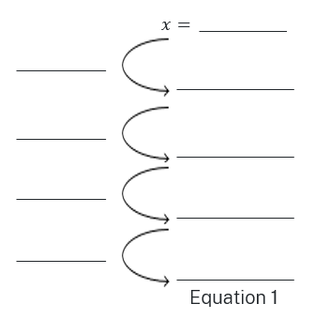 | 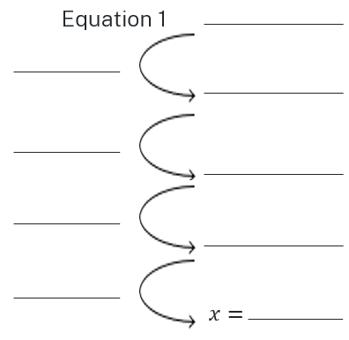

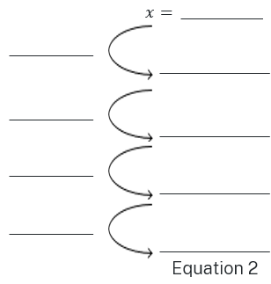 | 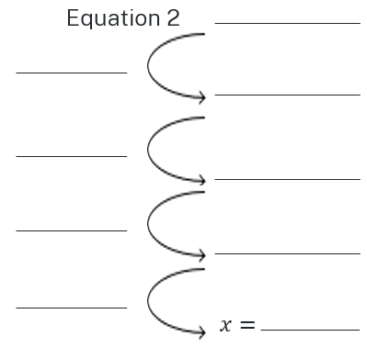

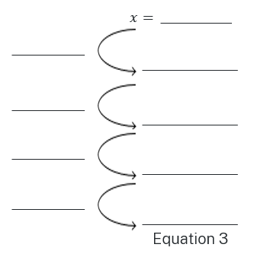 | 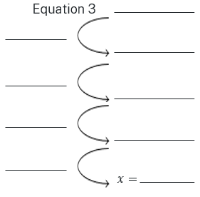

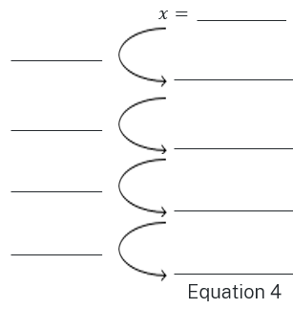 | 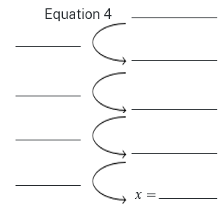

Sample solutions

Appendix A – mind map
This is only a sample and every student should have different equations as they will have chosen different numbers.
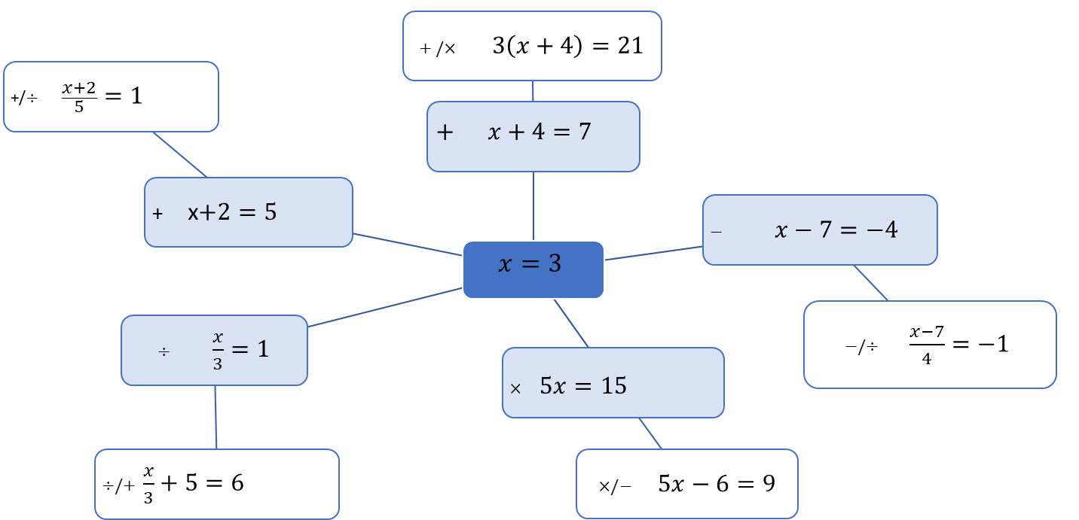

Appendix B – equations visually
Equation 1 | Equation 2
$$x=6 \\ 3x=18 \\ 3x+2=20 \\ 2\left(3x+2\right)=40$$ | $$x=4 \\ x+3=7 \\ 4\left(x+3\right)=28$$  $$4\left(x+3\right)-10=18$$

Appendix C – unpacking equations
Question 1 | Question 2
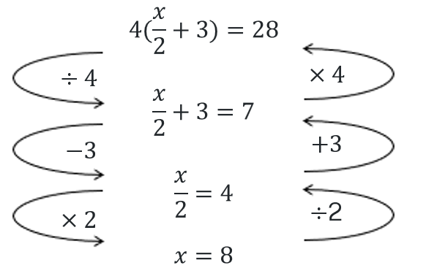 | 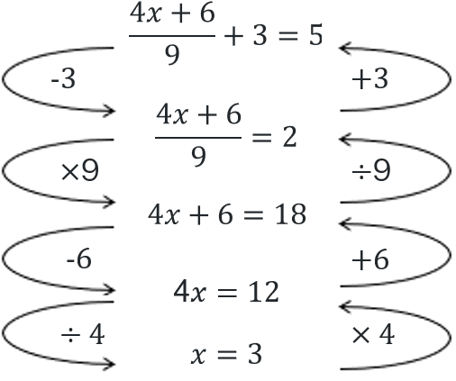
Question 3 | Question 4
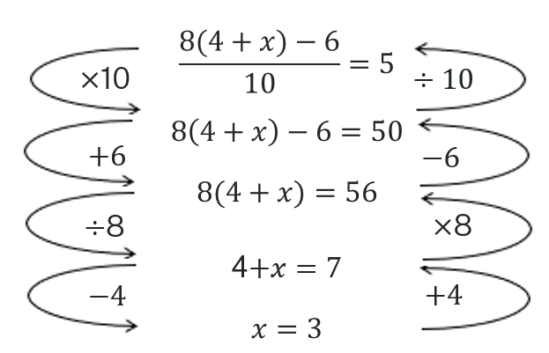 | 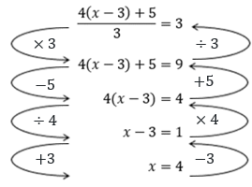

Appendix D – faded examples
1 | 2 | 3 | 4 | 5
$$4\left(\frac{7x}{3}+1\right)=32 \\ ÷4=÷4 \\ \frac{7x}{3}+1=8 \\ -1=-1 \\ \frac{7x}{3}=7 \\ ×3=×3 \\ 7x=21 \\ ÷7=÷7 \\ x=3$$ | $$4\left(\frac{8x+2}{3}\right)=24 \\ ÷4=÷4 \\ \frac{8x+2}{3}=6 \\ ×3=×3 \\ 8x+2=18 \\ -2=-2 \\ 8x=16 \\ ÷8=÷8 \\ x=2$$ | $$\frac{2x-7}{5}+11=18 \\ -11=-11 \\ \frac{2x-7}{5}=7 \\ ×5=×5 \\ 2x-7=35 \\ +7=+7 \\ 2x=42 \\ ÷2=÷2 \\ x=21$$ | $$\frac{3x-12}{6}+5=7 \\ -5=-5 \\ \frac{3x-12}{6}=2 \\ ×6=×6 \\ 3x-12=12 \\ +12=+12 \\ 3x=24 \\ ÷3=÷3 \\ x=8$$ | $$\frac{4x+3}{7}+4=9 \\ -4=-4 \\ \frac{4x+3}{7}=5 \\ ×7=×7 \\ 4x+3=35 \\ -3=-3 \\ 4x=32 \\ ÷4=÷4 \\ x=8$$

References
This resource contains NSW Curriculum and syllabus content. The NSW Curriculum is developed by the NSW Education Standards Authority. This content is prepared by NESA for and on behalf of the Crown in right of the State of New South Wales. The material is protected by Crown copyright.
Please refer to the NESA Copyright Disclaimer for more information https://educationstandards.nsw.edu.au/wps/portal/nesa/mini-footer/copyright.
NESA holds the only official and up-to-date versions of the NSW Curriculum and syllabus documents. Please visit the NSW Education Standards Authority (NESA) website https://educationstandards.nsw.edu.au/ and the NSW Curriculum website https://curriculum.nsw.edu.au/.
Mathematics K–10 Syllabus © NSW Education Standards Authority (NESA) for and on behalf of the Crown in right of the State of New South Wales, 2022.

© State of New South Wales (Department of Education), 2024
The copyright material published in this resource is subject to the Copyright Act 1968 (Cth) and is owned by the NSW Department of Education or, where indicated, by a party other than the NSW Department of Education (third-party material).
Copyright material available in this resource and owned by the NSW Department of Education is licensed under a Creative Commons Attribution 4.0 International (CC BY 4.0) license.
This license allows you to share and adapt the material for any purpose, even commercially.
Attribution should be given to © State of New South Wales (Department of Education), 2024.
Material in this resource not available under a Creative Commons license:
- the NSW Department of Education logo, other logos and trademark-protected material
- material owned by a third party that has been reproduced with permission. You will need to obtain permission from the third party to reuse its material.
Links to third-party material and websites
Please note that the provided (reading/viewing material/list/links/texts) are a suggestion only and implies no endorsement, by the New South Wales Department of Education, of any author, publisher, or book title. School principals and teachers are best placed to assess the suitability of resources that would complement the curriculum and reflect the needs and interests of their students.
If you use the links provided in this document to access a third-party's website, you acknowledge that the terms of use, including licence terms set out on the third-party's website apply to the use which may be made of the materials on that third-party website or where permitted by the Copyright Act 1968 (Cth). The department accepts no responsibility for content on third-party websites.

