Mathematics Stage 5   
(Year 10) – assessment task sample solutions

The rule of 72 investigation

Contents

Part 1 2

Part 2 3

Part 3 5

Part 4 8

Part 5 9

Marking guidelines 13

Evidence base 17

# Part 1

A bank has a bonus saver at 5.25% p.a.

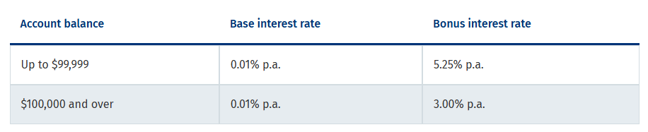

Figure 1 – graph of $10 000 compounding at 5.25% p.a.

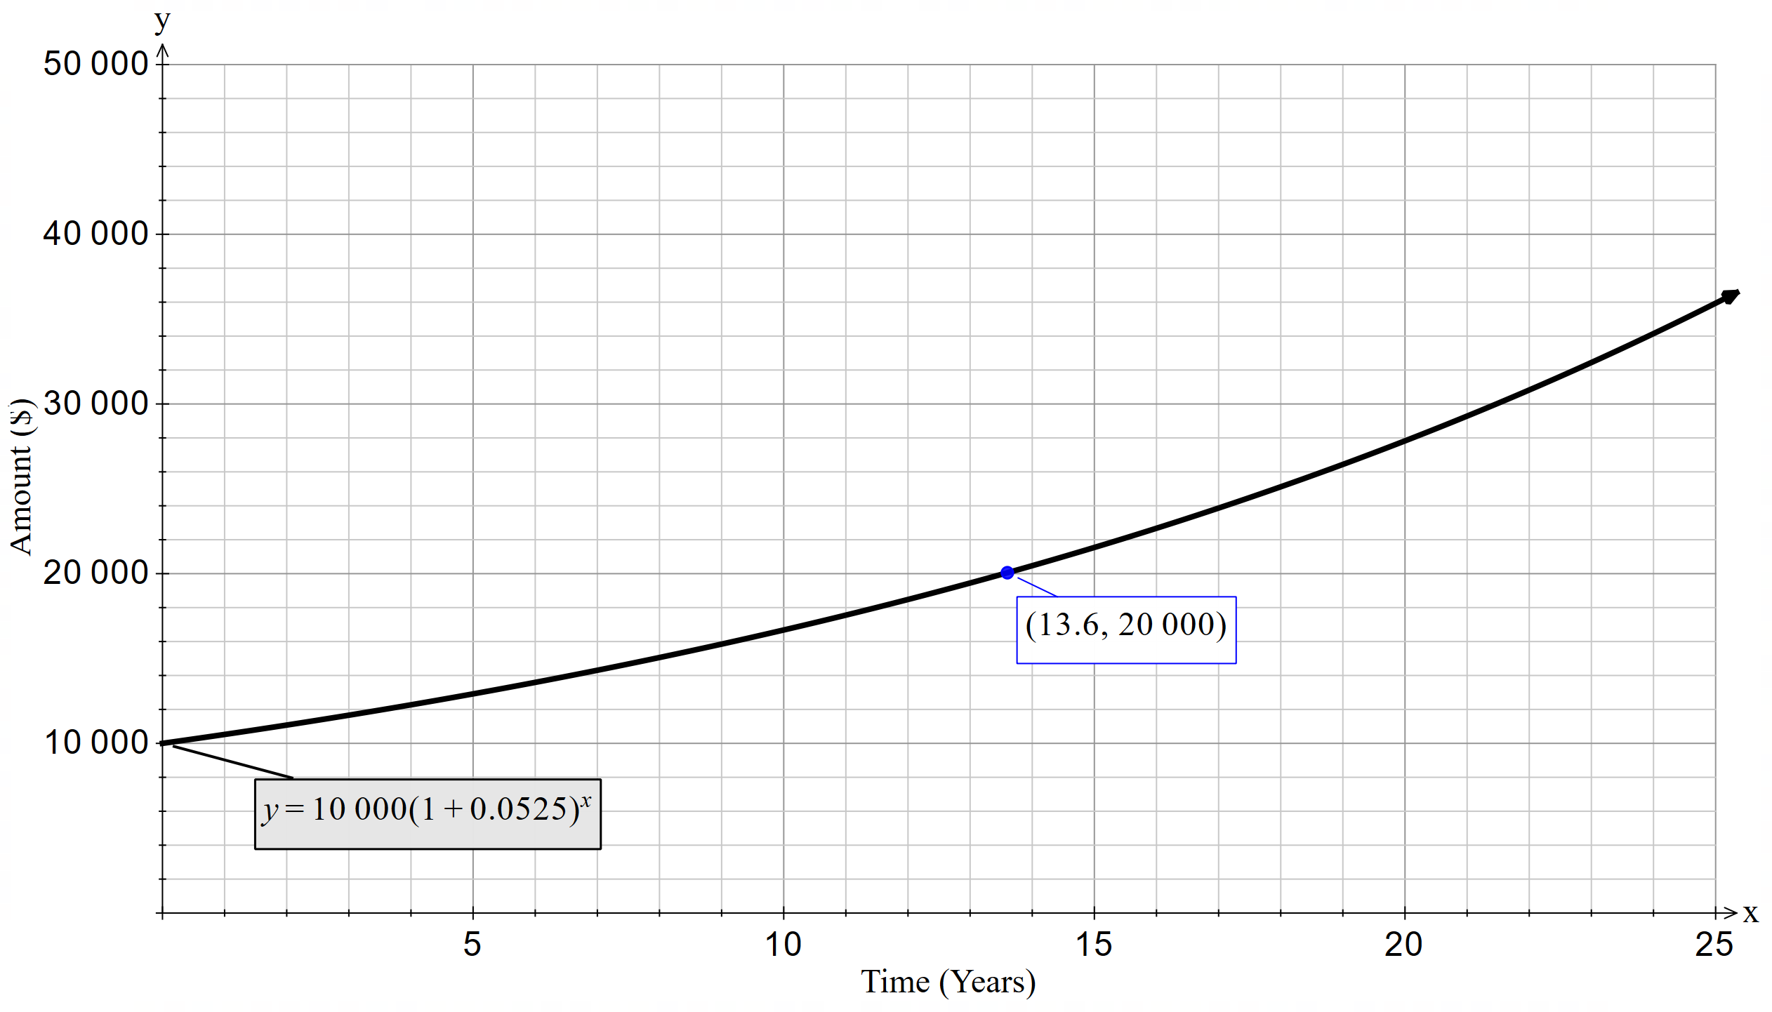

The investment doubles at around 13.6 years.

# Part 2

$Years to double=\frac{72}{5.25}=13.7 (1.d.p.)$

$FV=PV{\left(1+r\right)}^{n}$ $$FV=1{0 000\left(1.0525\right)}^{13.7} \\ FV=\$20157.79$$

1. I would trust the rule of 72 to predict when my investment of $10 000 would double at 5.25% p.a. The compound interest formula using this rate showed that my investment did double in this time. The number was also very close to the value I read off my graph to indicate how long it takes to double.

A range of rates have been tested in the following table.

|  |  |  |
| --- | --- | --- |
| Interest rate ($r$) | Rule of 72 | Compound interest |
| 5% | $$=\frac{72}{5} \\ =14.4$$ | $$PV=FV{\left(1+r\right)}^{n} \\ =10 0{00\left(1.05\right)}^{14.4} \\ =20189.52$$ |
| 6% | $$=\frac{72}{6} \\ =12$$ | $$PV=FV{\left(1+r\right)}^{n} \\ =1{0 000\left(1.06\right)}^{12} \\ =20121.96$$ |
| 7% | $$=\frac{72}{7} \\ =10\frac{2}{7}$$ | $$PV=FV{\left(1+r\right)}^{n} \\ =1{0 000\left(1.07\right)}^{10\frac{2}{7}} \\ =20055.48$$ |
| 8% | $$=\frac{72}{8} \\ =9$$ | $$PV=FV{\left(1+r\right)}^{n} \\ =1{0 000\left(1.08\right)}^{9} \\ =19990.05$$ |
| 9% | $$=\frac{72}{9} \\ =8$$ | $$PV=FV{\left(1+r\right)}^{n} \\ =1{0 000\left(1.09\right)}^{8} \\ =19925.63$$ |
| 10% | $$=\frac{72}{10} \\ =7.2$$ | $$PV=FV{\left(1+r\right)}^{n} \\ =10 000{\left(1.1\right)}^{7.2} \\ =19862.20$$ |

The table contains calculations using the compound interest formula for an initial investment of $10 000 and interest rates from 5% to 10%.

An investment at 5% compounded annually will take approximately 14.4 years to double. The percentages from 5−10% showed that the value does double in this time confirming that the rule of 72 is accurate enough to base decisions on.

Figure 2 – graph of $10 000 compounding at various interest rates

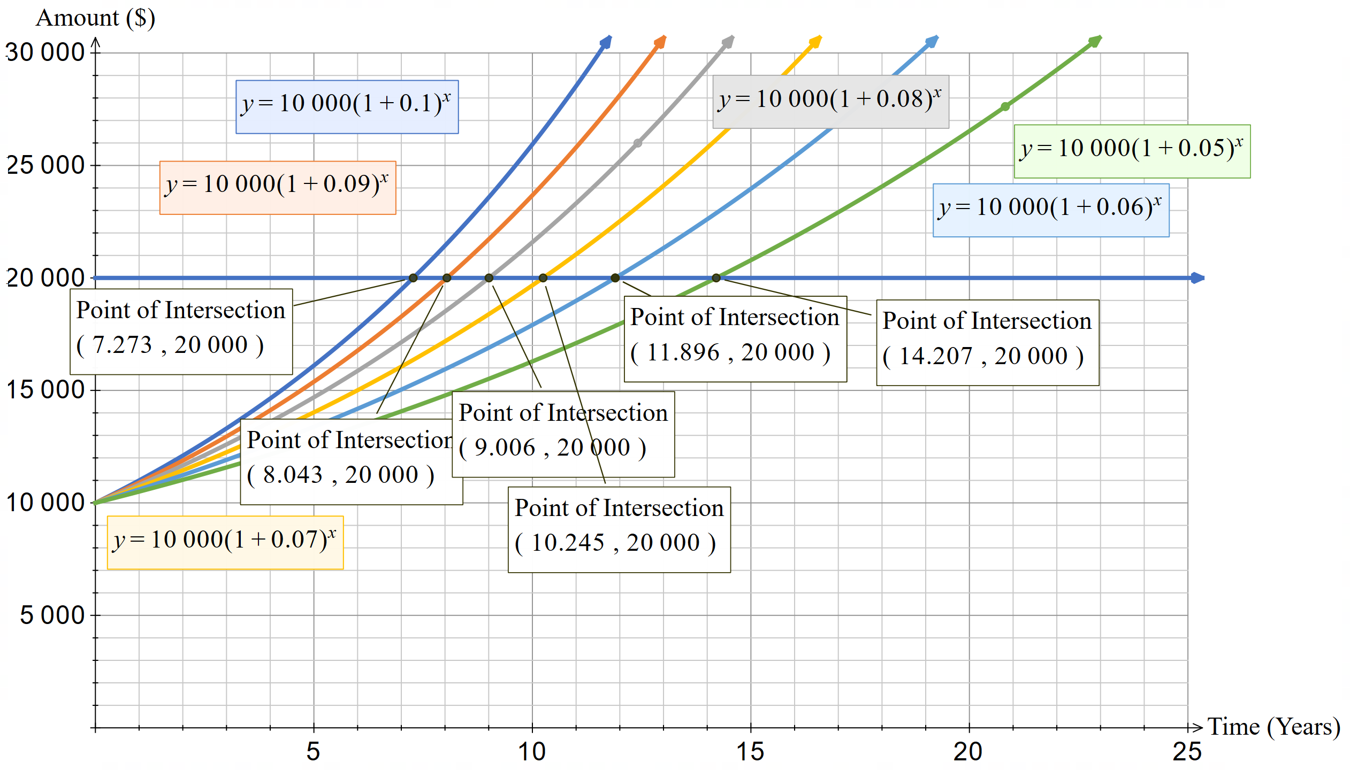

I have graphed the investments to show where each compound interest formula intersects with the value of $20 000. I found you could use the rule of 72 for each of these interest rates but as I got higher interest rates, I noted that the amount was not quite double.

# Part 3

|  |  |  |  |
| --- | --- | --- | --- |
| Rule of 72 | Monthly rate | Time periods | Compound interest |
| $$Years to double$$ $$=\frac{72}{5} \\ =14.4$$ | $$r=\frac{0.05}{12}$$ | $$14.4×12=172.8$$ | $$PV=FV{\left(1+r\right)}^{n} \\ =10 000{\left(1+\frac{0.05}{12}\right)}^{172.8} \\ =20513.62$$ |

There is a difference of $513.62 for when it doubles, because this is monthly I’d want it to be closer than that.

Figure 3 – graph of $10 000 compounding monthly

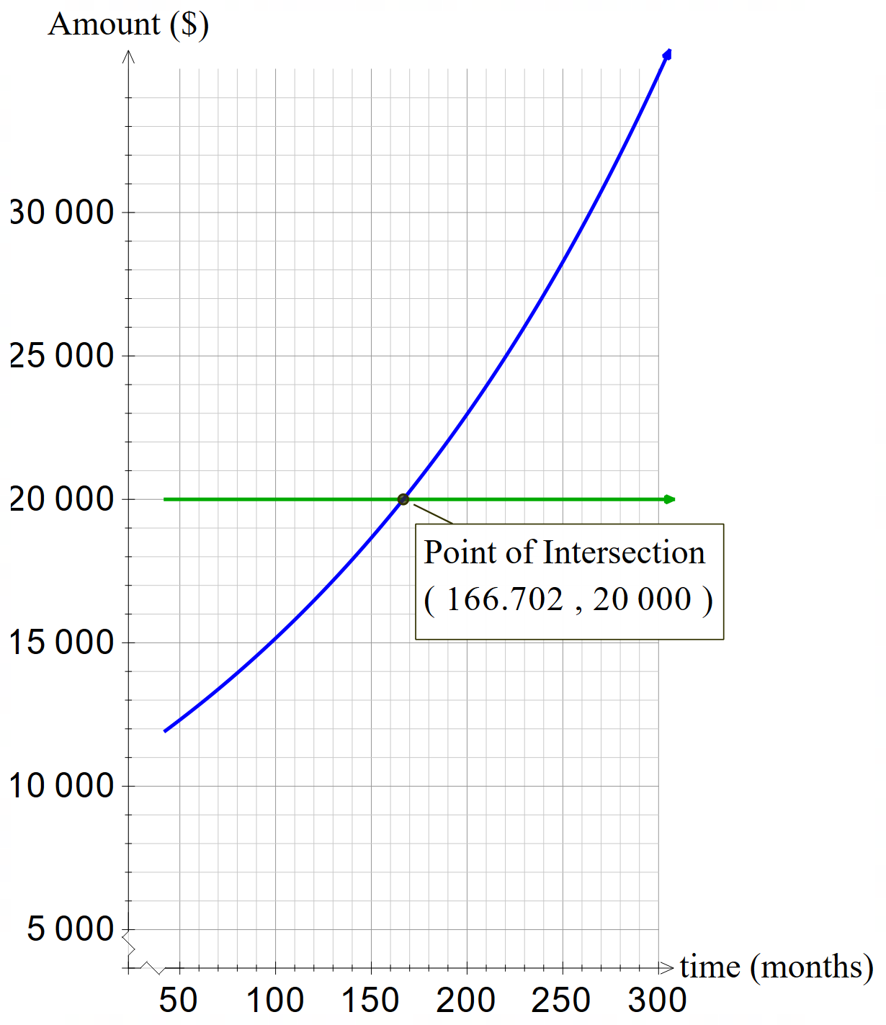

As seen on the graph, it actually doubles at 166.7 months which is about 13.9 years. Using the rule of 72 makes me keep my investment for nearly an extra 6 months.

|  |  |  |  |
| --- | --- | --- | --- |
| Rule of 72 | Weekly rate | Time periods | Compound interest |
| $$Years to double=\frac{72}{5} \\ =14.4$$ | $$r=\frac{0.05}{52}$$ | $$14.4×52=748.8$$ | $$PV=FV{\left(1+r\right)}^{n} \\ =10 000{\left(1+\frac{0.05}{52}\right)}^{748.8} \\ =20537.23$$ |

There is a difference of $537 for when it doubles, because this is weekly I’d want it to be closer than that.

Figure 4 – graph of $10 000 compounding weekly

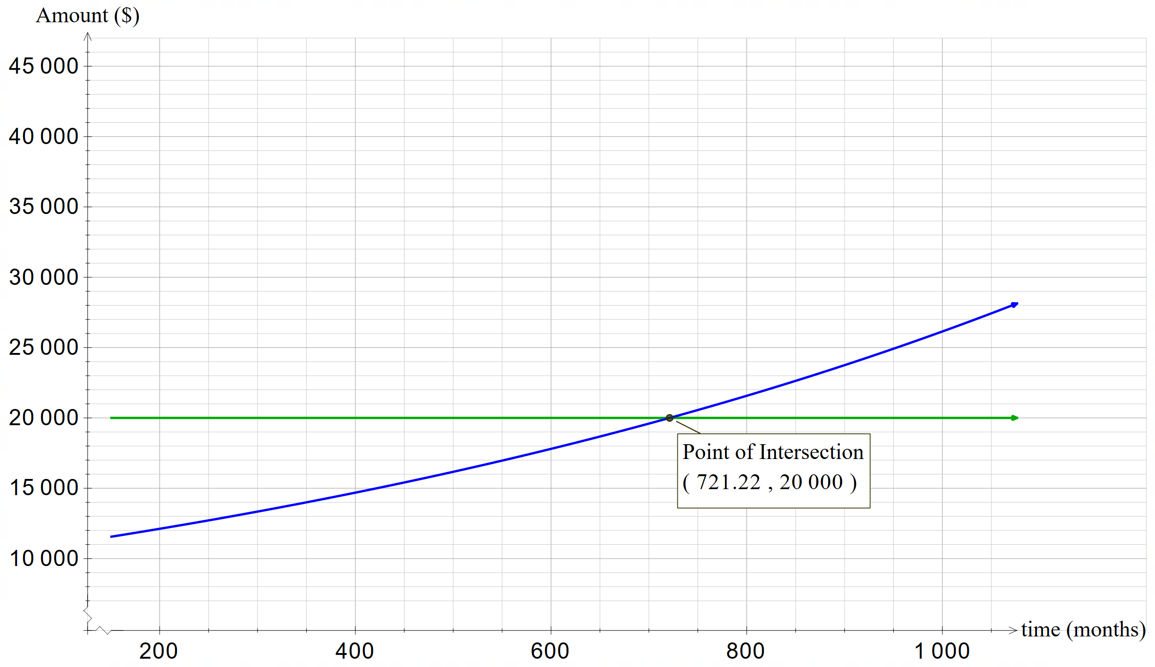

The graph shows my investment doubles at 721.22 months which is about 13.8 years, making me leave my money in there for half a year longer than I need to.

I am now going to test if the rule of 72 works for different compounding periods. I will test the interest rate of 7.85% which was found to be the most accurate for the rule of 72. I will divide the compounding periods in 2 for bi-annually, 12 for monthly and 365 for daily.

|  |  |  |
| --- | --- | --- |
| 5% | Rule of 72 | Compound interest test |
| Annually $$r=5$$ | $$=\frac{72}{5} \\ =14.4$$ | $$PV=FV{\left(1+r\right)}^{n} \\ =10 000{\left(1.05\right)}^{14.4} \\ =20189.52$$ |
| Bi-annually $$r=\frac{5}{2}$$ | $$=\frac{72}{\left(\frac{5}{2}\right)} \\ =28.8$$ | $$PV=FV{\left(1+r\right)}^{n} \\ =1{0 000\left(1+\frac{0.05}{2}\right)}^{28.8} \\ =20363.26$$ |
| Monthly $$r=\frac{7.85}{2}$$ | $$=\frac{72}{\left(\frac{5}{12}\right)} \\ =172.8$$ | $$PV=FV{\left(1+r\right)}^{n} \\ =10 000{\left(1+\frac{0.05}{12}\right)}^{172.8} \\ =20513.62$$ |
| Weekly $$r=\frac{5}{52}$$ | $$=\frac{72}{\left(\frac{5}{52}\right)} \\ =748.8$$ | $$PV=FV{\left(1+r\right)}^{n} \\ =10 000{\left(1+\frac{0.05}{52}\right)}^{748.8} \\ =20537.23$$ |
| Daily $$r=\frac{5}{365}$$ | $$=\frac{72}{\left(\frac{5}{365}\right)} \\ =5256$$ | $$PV=FV{\left(1+r\right)}^{n} \\ =1{0 000\left(1+\frac{0.05}{365}\right)}^{5256} \\ =20543.32$$ |

My calculations indicate that 72 is less accurate as the compounding period increases. I think this is because more interest is added more regularly.

# Part 4

1. I calculated the rule of 72 to find the time an asset would halve and used the depreciation formula to find the amount it would be at that time. I found that it was close to half. I don’t think close to is accurate enough, so I don’t think the rule of 72 works for values halving.

|  |  |  |
| --- | --- | --- |
| Interest rate ($r$) | Rule of 72 | Depreciation |
| 5% | $$=\frac{72}{5} \\ =14.4$$ | $$S=V_{0}{\left(1-r\right)}^{n} \\ =10 000{\left(1-0.05\right)}^{14.4} \\ =4777.71$$ |
| 6% | $$=\frac{72}{6} \\ =12$$ | $$S=V_{0}{\left(1-r\right)}^{n} \\ =1{0 000\left(1-0.06\right)}^{12} \\ =4759.20$$ |
| 7% | $$=\frac{72}{7} \\ =10\frac{2}{7}$$ | $$S=V_{0}{\left(1-r\right)}^{n} \\ =10 000{\left(1-0.07\right)}^{10\frac{2}{7}} \\ =4740.51$$ |
| 8% | $$=\frac{72}{8} \\ =9$$ | $$S=V_{0}{\left(1-r\right)}^{n} \\ =10 000{\left(1-0.08\right)}^{9} \\ =4721.61$$ |
| 9% | $$=\frac{72}{9} \\ =8$$ | $$S=V_{0}{\left(1-r\right)}^{n} \\ =10 000{\left(1-0.09\right)}^{8} \\ =4702.53$$ |
| 10% | $$=\frac{72}{10} \\ =7.2$$ | $$S=V_{0}{\left(1-r\right)}^{n} \\ =10 000{\left(1-0.1\right)}^{7.2} \\ =4683.24$$ |

1. I have graphed the depreciation using a number of different rates. The $y$-intercept for each graph remains the same at 10 000. This is because the $x$-value is zero and any rate to the power of zero is one. The graph for depreciation goes down rather than up and will get closer and closer to zero as $x$ gets bigger, as shown by the asymptote that would be created at $y=0$. This is because of the minus sign in the equation. This makes the bracket that is raised to a power less than one, meaning that the decimal or fraction becomes smaller with each power.

Figure 5 – graph of $10 000 depreciated at different interest rates

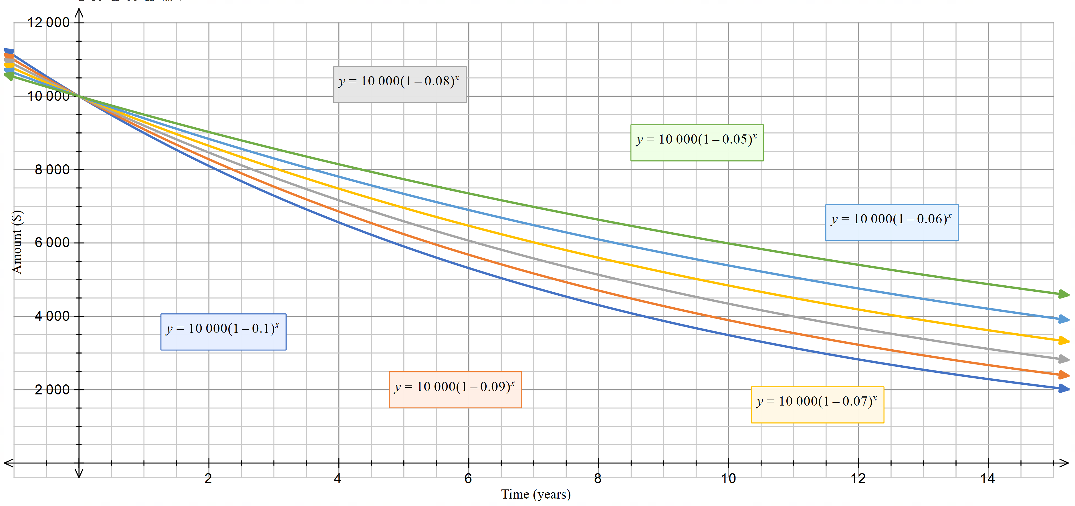In the context of money, any values of the graph less than zero do not make sense. Also, depending on the asset they could eventually increase again, such as a vintage trading card or vintage car. It also doesn’t cater for breaking of the asset or wear and tear which may make it worth less value.

# Part 5

I used the graph that I made in part 2 to see when an investment of $10 000 would triple to $30 000.

Figure 6 – graph of $10 000 compounded at various interest rates and y = 30 000

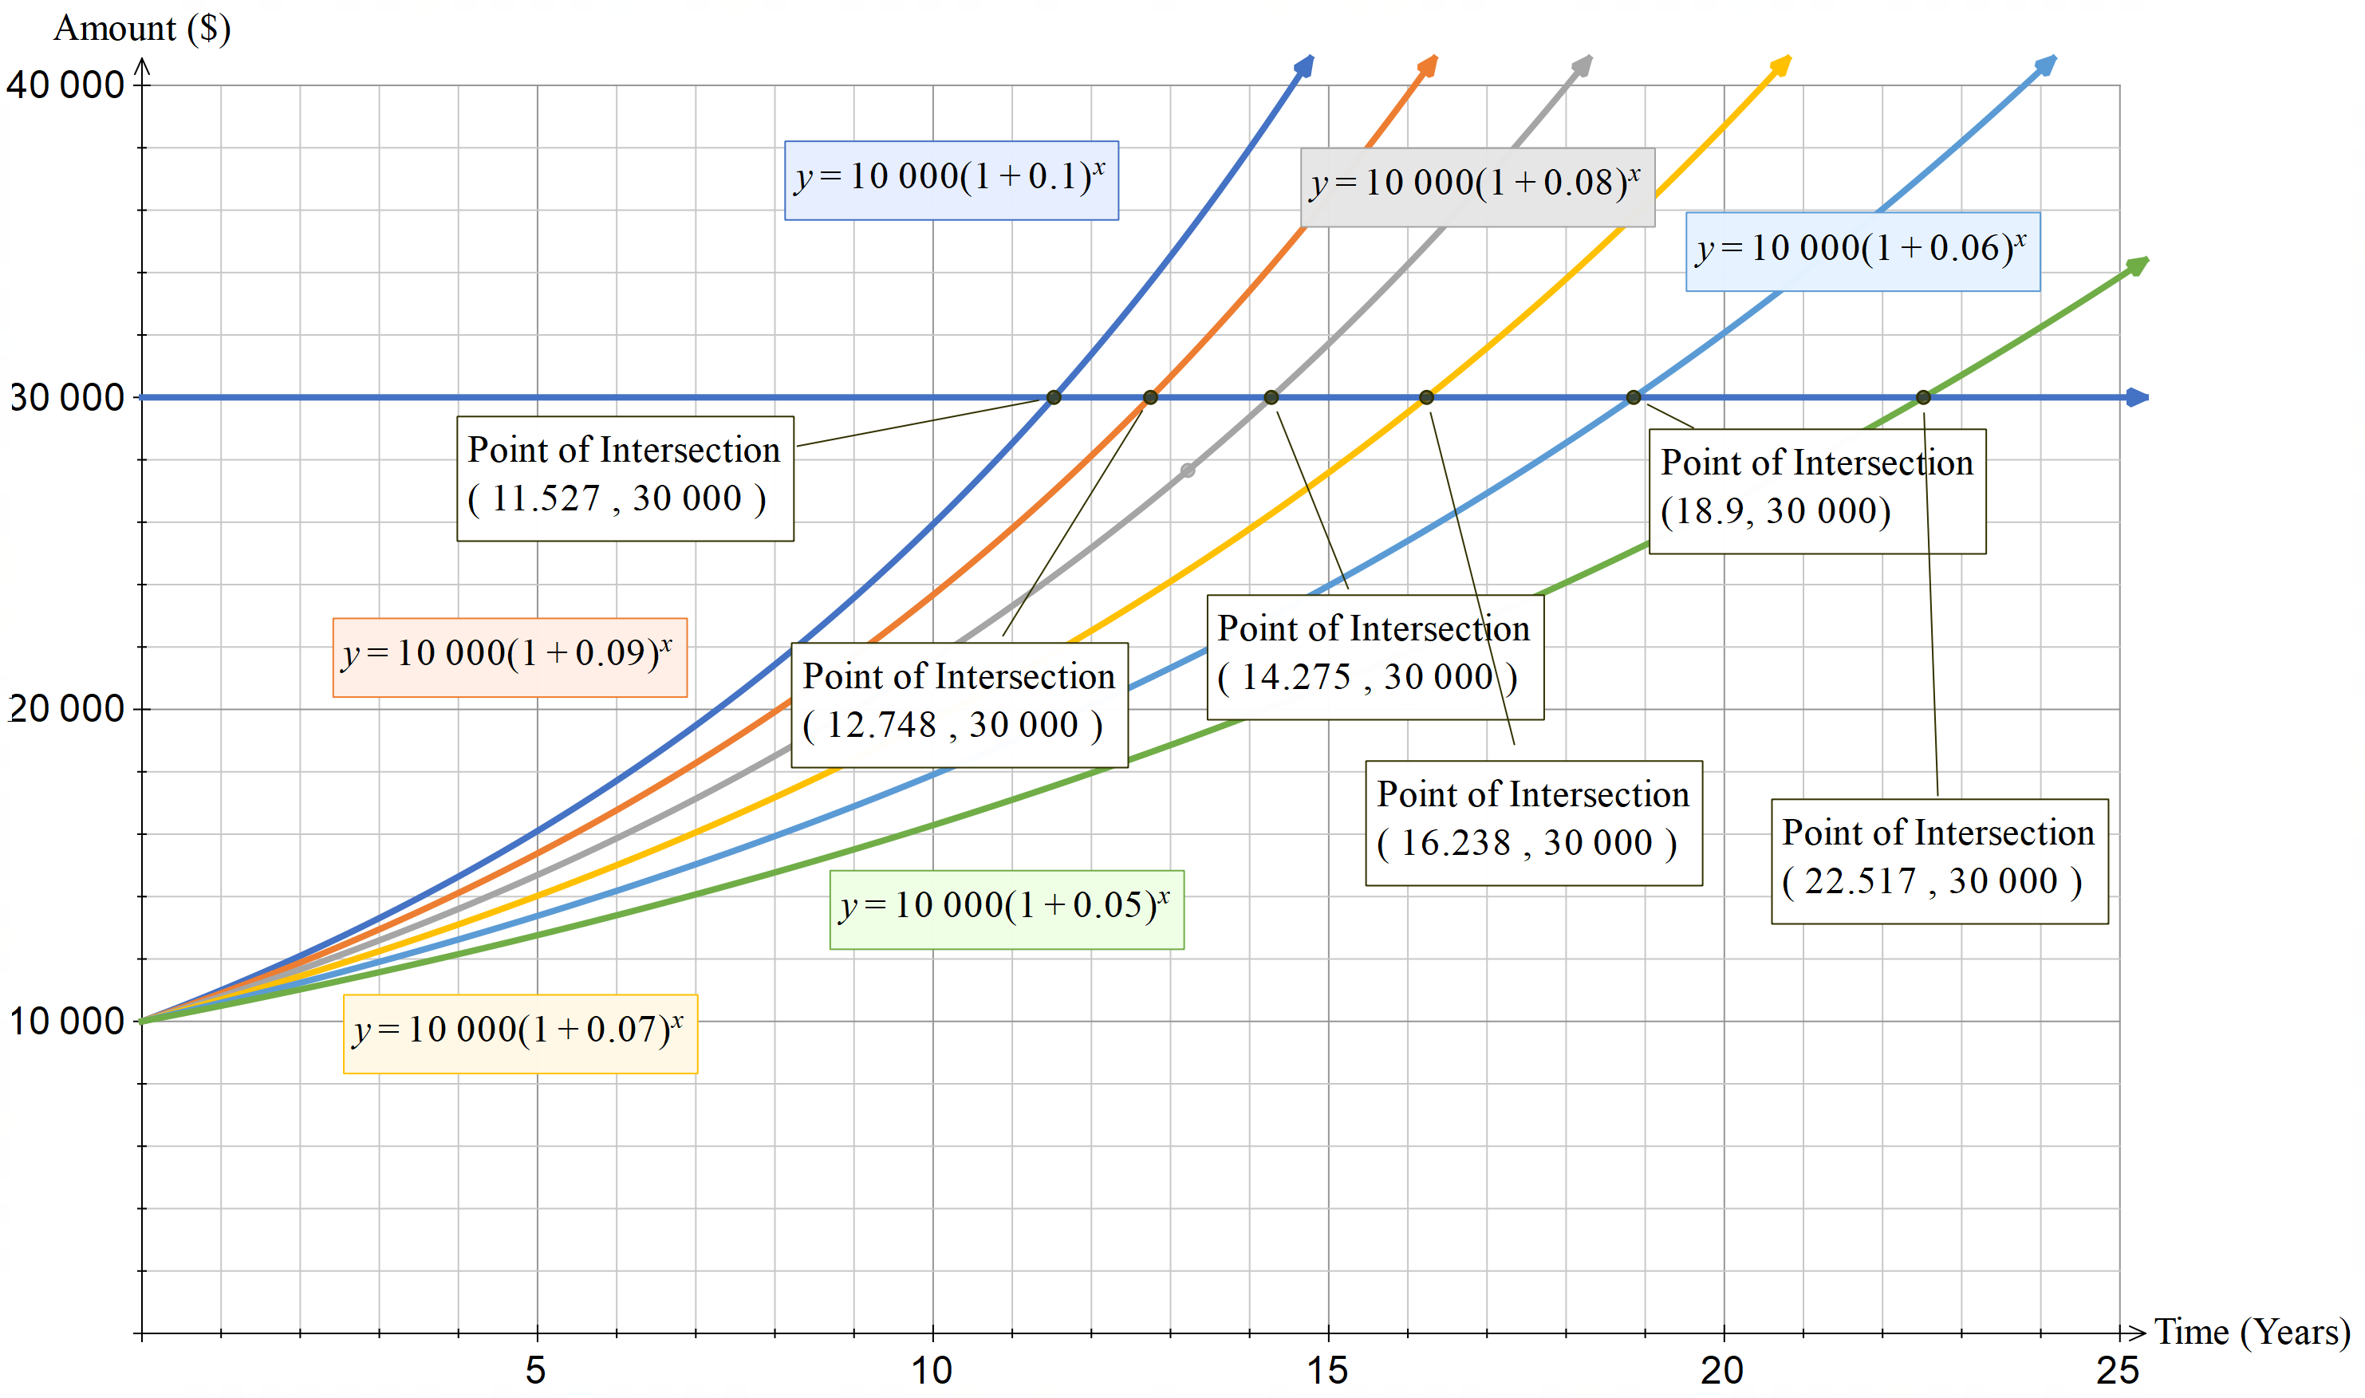

The values were as shown in the table below:

|  |  |  |  |  |  |  |
| --- | --- | --- | --- | --- | --- | --- |
| **Interest rate ($r$)** | 5% | 6% | 7% | 8% | 9% | 10% |
| **Years taken to triple ($t$)** | 22.5 | 18.9 | 16.2 | 14.3 | 12.7 | 11.5 |

I multiplied each of the rates by the number of years to see if I got similar numbers.

|  |  |  |  |  |  |  |
| --- | --- | --- | --- | --- | --- | --- |
| **Interest rate ($r$)** | 5% | 6% | 7% | 8% | 9% | 10% |
| **Years taken to triple ($t$)** | 22.5 | 18.9 | 16.2 | 14.3 | 12.7 | 11.5 |
| $$r×t$$ | 112.5 | 113.4 | 113.4 | 114.4 | 114.3 | 115 |

All of these numbers were between 112.5 and 115 so I will use 114 for my rule.

**Rule of 114:** Time taken to triple $=\frac{114}{t}$

This would work between 5% and 10% very accurately.

As you can see from the table, for the values of 5% and 10% this number seems to vary more to be too high or too low. When we put it in the compound interest formula we find:

$$FV=10 000{\left(1+0.05\right)}^{22.8} \\ FV=\$30416.97$$

$$FV=10 000{\left(1+0.1\right)}^{11.5} \\ FV=\$29923.74$$

Each of these give us values that still pretty much triple and are out by less than $1000.

Because of this I created the following table that shows the rule of 114 for rates is less than 5% and greater than 10% using Microsoft Excel.

I decided the barrier when the amount is inaccurate is over $500 as this is 5% of the original amount invested.

|  |  |  |
| --- | --- | --- |
| Rate | Rule of 114 | Future value |
| 4 | 28.5 | 30580.89 |
| 4.1 | 27.804878 | 30564.36 |
| 4.2 | 27.1428571 | 30547.87 |
| 4.3 | 26.5116279 | 30531.40 |
| 4.4 | 25.9090909 | 30514.96 |
| 4.5 | 25.3333333 | 30498.56 |
| 4.6 | 24.7826087 | 30482.18 |
| 4.7 | 24.2553191 | 30465.83 |
| 4.8 | 23.75 | 30449.52 |
| 4.9 | 23.2653061 | 30433.23 |
| 5 | 22.8 | 30416.97 |

For the lower bound it is 4.5% before it reaches an amount that is more than $500 off the tripling amount.

|  |  |  |
| --- | --- | --- |
| Rate | Rule of 114 | Future value |
| 10 | 11.4 | 29639.89 |
| 10.1 | 11.2871287 | 29625.03 |
| 10.2 | 11.1764706 | 29610.20 |
| 10.3 | 11.0679612 | 29595.39 |
| 10.4 | 10.9615385 | 29580.61 |
| 10.5 | 10.8571429 | 29565.85 |
| 10.6 | 10.754717 | 29551.12 |
| 10.7 | 10.6542056 | 29536.41 |
| 10.8 | 10.5555556 | 29521.73 |
| 10.9 | 10.4587156 | 29507.08 |
| 11 | 10.3636364 | 29492.45 |

For the higher bound we could use the rule of 114 up until 10.9% to get within $500 of when it triples.

This rule should work for different investment amounts as when you change the number of the initial value it should still triple at the same time, as the 10 000 is just a value out the front and not affected by the power. The only limits are in the rates themselves as they are affected by the power. This again would also change if there were compounding periods, as the rate for the compounding period would be lower, as explained in Part 3. If that was the case we would have to use a different rule.

# Marking guidelines

Table 1 – assessment marking guidelines

|  |  |  |  |  |  |
| --- | --- | --- | --- | --- | --- |
| Outcomes | Working towards developing | Developing | Developed | Well developed | Justification |
| Financial mathematics |  |  |  |  |  |
| MAO-WM-01 MA5-FIN-C-02 Parts 2 and 4 | Substitutes **some correct** values into a formula. | Substitutes correctly into the formulas to **justify at least one** interest rate. | Substitutes correctly into the formulas to **justify a variety** of interest rates. |  | The student correctly substituted into the compound interest formula, depreciation formula and rule of 72 for multiple rates. |
| MAO-WM-01 MA5-FIN-C-02 Part 3 | Changes the interest rate **or** time period to test changing compounding periods. | Changes the interest rate **and** time period to test changing compounding periods. | **Explains** the effects that changing the compounding period has on the future value of an investment. | **Justifies** the accuracy of the rule of 72 when compounding periods are changed. | The student changed the rate and time period and stated they think interest is added more regularly but failed to explain the effect that had on the future value. |
| Non-linear relationships |  |  |  |  |  |
| MAO-WM-01 MA5-NLI-C-01 MA5-NLI-C-02  Parts 1−4 | Creates a graph of an investment with or without technology. | Creates a graph of an investment **and uses the graph** to identify when an investment would double, or an asset would halve in value. |  |  | Student showed their ability to create an exponential graph and interpret it. |
| MAO-WM-01 MA5-NLI-C-01 MA5-NLI-C-02 Part 4 | Describes **one feature** of an exponential graph. | Describes **all the relevant features** of an exponential graph. | Describes all relevant features of an exponential graph **and explains the limitations** of the graphs. | Describes all relevant features of an exponential graph, limitations **and links the shape of the graph to the equation** to justify changes. | Student listed all relevant features of the graphs provided. They highlighted limitations in context and explained how the minus in the equation led to a decimal which would make the graph decrease rather than increase. |
| Working mathematically |  |  |  |  |  |
| MAO-WM-01 Parts 1−5 | Attempts to use informal mathematical reasoning and **very limited mathematical language** to communicate and explain solutions. | Uses informal mathematical reasoning and **limited mathematical language** to communicate and explain solutions. | Uses appropriate **formal and informal** **mathematical language** to communicate reasoning and explain solutions and justify results. | Uses appropriate **formal mathematical language** to communicate reasoning, explain solutions and justify results. | The student uses formal mathematical language including asymptote and salvage value. |
| MAO-WM-01 Part 5 | Uses a graph or calculation to find when an asset would triple in value. | **Provides a rule** to accurately predict when an asset would triple in value, with **reasoning based on calculations and related graphs**. | Provides a rule to accurately predict when an asset would triple in value, with reasoning based on calculations and related graphs.  **Explains how the rule was developed.** | Provides a rule to accurately predict when an asset would triple in value, **for a specified range of interest rates**, with reasoning based on calculations and related graphs.  Explains how the rule was developed and **discusses the limitations of the rule**. | The student provides a rule for a range of interest rates, showing their reasoning and providing graphs and calculations to explain how the rule was developed. They also state limitations saying that it would not work for compounding periods. |

**Feedback:** the student has demonstrated fluency when correctly using formulas to find the future value of investments and the salvage value of depreciated items. They could improve by communicating conceptually the effects of changing the compound period on an investment and justifying why that changes the accuracy of the rule of 72 in this context.

The student has shown they can graph exponential relationships and interpret the graph to find results. They have also shown their conceptual understanding of exponential relationships by relating their equation to the shape of the graph and what influences it, particularly when comparing exponentials that are increasing to those that are decreasing.

The student has shown competency in using mathematical language to communicate effectively throughout this assessment. They have also demonstrated their problem solving and reasoning skills when providing a rule for when an investment triples, which would be transferable to other tasks.

# Evidence base

This resource contains NSW Curriculum and syllabus content. The NSW Curriculum is developed by the NSW Education Standards Authority. This content is prepared by NESA for and on behalf of the Crown in right of the State of New South Wales. The material is protected by Crown copyright.

Please refer to the NESA Copyright Disclaimer for more information [https://educationstandards.nsw.edu.au/wps/portal/nesa/mini-footer/copyright](https://aus01.safelinks.protection.outlook.com/?url=https%3A%2F%2Feducationstandards.nsw.edu.au%2Fwps%2Fportal%2Fnesa%2Fmini-footer%2Fcopyright&data=05%7C01%7CCaitlin.Pace1%40det.nsw.edu.au%7C9c2c1a9f59c94d2df30708dafa7edb23%7C05a0e69a418a47c19c259387261bf991%7C0%7C0%7C638097720042599463%7CUnknown%7CTWFpbGZsb3d8eyJWIjoiMC4wLjAwMDAiLCJQIjoiV2luMzIiLCJBTiI6Ik1haWwiLCJXVCI6Mn0%3D%7C3000%7C%7C%7C&sdata=BzQh0UsffVZE3eO22b2Xba3p0VMOBZSHfS21FGHXtZM%3D&reserved=0).

NESA holds the only official and up-to-date versions of the NSW Curriculum and syllabus documents. Please visit the NSW Education Standards Authority (NESA) website [https://educationstandards.nsw.edu.au](https://educationstandards.nsw.edu.au/)/ and the NSW Curriculum website [https://curriculum.nsw.edu.au](https://curriculum.nsw.edu.au/).

[Mathematics K**–**10 Syllabus](https://curriculum.nsw.edu.au/learning-areas/mathematics/mathematics-k-10-2022/overview) © NSW Education Standards Authority (NESA) for and on behalf of the Crown in right of the State of New South Wales, 2022.

Brookhart SM (2018) ‘[Appropriate Criteria: Key to Effective Rubrics](https://www.frontiersin.org/articles/10.3389/feduc.2018.00022/full)’, Frontiers in Education, volume 3(22):1–12, doi:10.3389/feduc.2018.00022, accessed 21 November 2024.

CESE (Centre for Education Statistics and Evaluation) (2020) [*What works best: 2020 update*](https://education.nsw.gov.au/about-us/educational-data/cese/publications/research-reports/what-works-best-2020-update), NSW Department of Education, accessed 21 November 2024.

CESE (2020) [*What works best in practice*](https://education.nsw.gov.au/about-us/educational-data/cese/publications/practical-guides-for-educators-/what-works-best-in-practice), NSW Department of Education, accessed 21 November 2024.

CESE (2021) [*Growth goal setting – what works best in practice*](https://education.nsw.gov.au/about-us/educational-data/cese/publications/practical-guides-for-educators/growth-goal-setting), NSW Department of Education, accessed 21 November 2024.

Fisher D and Frey N (1 November 2009) ‘[Feed Up, Back, Forward](https://www.ascd.org/el/articles/feed-up-back-forward)’, ASCD (Association for Supervision and Curriculum Development): Educational Leadership magazine, 67(3), accessed 21 November 2024.

Griffin P (2017) Assessment for Teaching, Cambridge University Press, Port Melbourne, Victoria.

Hattie J and Timperley H (2007) ‘The Power of Feedback’, Review of Educational Research, 77(1): 81–112, doi:10.3102/003465430298487.

Panadero E and Jonsson A (2013) ‘[The use of scoring rubrics for formative assessment purposes revisited: A review](https://www.sciencedirect.com/science/article/abs/pii/S1747938X13000109?via%3Dihub)’, Educational Research Review, 9:129–144, doi:10.1016/j.edurev.2013.01.002, accessed 21 November 2024.

Sherrington T (2019) Rosenshine’s Principles in Action, John Catt Educational Limited, Melton, Woodbridge.

Wiliam D (2017) Embedded Formative Assessment, 2nd edn, Solution Tree Press, Bloomington, IN.

**© State of New South Wales (Department of Education), 2024**

The copyright material published in this resource is subject to the Copyright Act 1968 (Cth) and is owned by the NSW Department of Education or, where indicated, by a party other than the NSW Department of Education (third-party material).

Copyright material available in this resource and owned by the NSW Department of Education is licensed under a [Creative Commons Attribution 4.0 International (CC BY 4.0) license](https://creativecommons.org/licenses/by/4.0/).

[](https://creativecommons.org/licenses/by/4.0/)

This license allows you to share and adapt the material for any purpose, even commercially.

Attribution should be given to © State of New South Wales (Department of Education), 2024.

Material in this resource not available under a Creative Commons license:

* the NSW Department of Education logo, other logos and trademark-protected material
* material owned by a third party that has been reproduced with permission. You will need to obtain permission from the third party to reuse its material.

**Links to third-party material and websites**

Please note that the provided (reading/viewing material/list/links/texts) are a suggestion only and implies no endorsement, by the New South Wales Department of Education, of any author, publisher, or book title. School principals and teachers are best placed to assess the suitability of resources that would complement the curriculum and reflect the needs and interests of their students.

If you use the links provided in this document to access a third-party's website, you acknowledge that the terms of use, including licence terms set out on the third-party's website apply to the use which may be made of the materials on that third-party website or where permitted by the Copyright Act 1968 (Cth). The department accepts no responsibility for content on third-party websites.