# Invasive species

Students explore the growth rate of invasive species to Australia, creating exponential equations and exploring exponential graphs.

One digital device per group of 3 is optional if choosing to complete Appendix D ‘Caffeine’ in this learning episode.

## Visible learning

### Learning intention

* To understand the relationship between exponential equations and their graphs.

### Success criteria

* I can determine the equation for an exponential pattern.
* I can explain how the equation of an exponential affects the graph.

### Syllabus outcomes

A student:

* develops understanding and fluency in mathematics through exploring and connecting mathematical concepts, choosing and applying mathematical techniques to solve problems, and communicating their thinking and reasoning coherently and clearly **MAO-WM-01**
* identifies connections between algebraic and graphical representations of quadratic and exponential relationships in various contexts **MA5-NLI-C-01**
* identifies and compares features of parabolas and exponential curves in various contexts **MA5-NLI-C-02**
* interprets and compares non-linear relationships and their transformations, both algebraically and graphically **MA5-NLI-P-01**

[Mathematics K–10 Syllabus](https://curriculum.nsw.edu.au/learning-areas/mathematics/mathematics-k-10-2022/overview) © NSW Education Standards Authority (NESA) for and on behalf of the Crown in right of the State of New South Wales, 2022.

Table 1: lesson summary

|  |  |  |  |
| --- | --- | --- | --- |
| Section | Summary of activity | Teaching strategy | Teaching points |
| Warm up | Read the scenario to students to discuss which investment they would rather.  ‘Would you rather receive 1 cent, doubled every year for 50 years or receive $1 invested at 50% per annum, compounded annually for 50 years?’ | Think-Pair-Share  Would you rather? | Link to prior learning of compound interest. |
| Launch | Display slide 3 of the PowerPoint for students to discuss which one doesn’t belong. | Which one doesn’t belong  Pose-Pause-Pounce-Bounce  Think-Pair-Share | Students identify that all 4 species are invasive to Australia. |
| Explore | Use the PowerPoint to model constructing an equation for an exponential pattern.  Pairs complete Appendix A to determine the equations for fire ants and feral pigs.  Display slide 15 to discuss the graphs of bridal creeper and rabbits’ growth.  Pairs complete Appendix B, drawing the graphs of fire ants and feral pigs’ growth. | Think-Pair-Share  Pose-Pause-Pounce-Bounce  Notice and wonder | Students develop connection between exponential growth rates and the exponential equation. |
| Summarise | Students complete Appendix C to compare the graphs of $y=a^{x}, y={(\frac{1}{a})}^{x}$ and $y=ka^{x}.$ | Variation theory  Pose-Pause-Pounce-Bounce | Students connect exponential equations to their graphs. |
| Apply | The teacher models the half-life of caffeine using the half-life calculator ([bit.ly/halflifecalculator](https://bit.ly/halflifecalculator)). Students use the website and Appendix D to explore caffeine in the body. | Visibly random groups of 3  Vertical non-permanent surfaces | Students explore exponential equations with fractional bases. |

## Activity structure

Please use the associated PowerPoint *Invasive species* to display images in this lesson.

### Warm up

1. Pose the following would you rather scenario to students:

Would you rather receive 1 cent, doubled every year for 50 years or receive $1 invested at 50% per annum, compounded annually for 50 years?

1. In a Think-Pair-Share ([bit.ly/thinkpairsharestrategy](https://bit.ly/thinkpairsharestrategy)) ask students which option they would prefer and why.

Students may recognise this problem is comparing $0.01({2)}^{x}$ and $1{\left(1.5\right)}^{x}$. These 2 graphs intersect when $x=16$.

### Launch

1. Display Figure 1 on slide 3 of the PowerPoint *Invasive* species.

Figure 1: Which one doesn't belong?

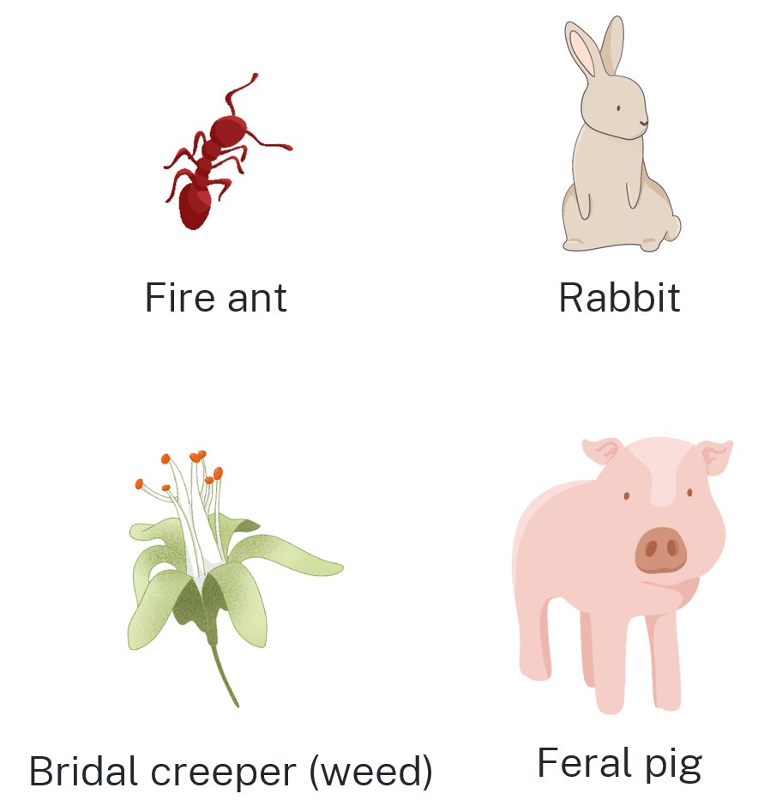

1. In a Think-Pair-Share, ask ‘Which one doesn’t belong?’ ([bit.ly/wodb](https://bit.ly/wodb)).

In a ‘Which one doesn’t belong?’ activity, students could argue that any of the species don’t belong.

1. State to students that all the species are invasive to Australia.
2. Use a questioning strategy such as Pose-Pause-Pouce-Bounce (PDF 557 KB) ([bit.ly/posepausepouncebounce](https://bit.ly/posepausepouncebounce)) to facilitate a class discussion on invasive species. The following prompts could be used:

* What makes a species ‘invasive’?
* Why are invasive species a problem?
* Why is it difficult to stop the spread of invasive species?

Invasive species are animals, plants or parasites that establish outside their natural range and become pests. If possible, share information about invasive species to your school’s local environment.

In Australia, invasive species cause immense damage to our soils, native plants and animals, and annual production losses worth millions of dollars.

More information can be found in the flyer ‘Invasive species in Australia’ by the Australian Government Department of the Environment and Heritage ([bit.ly/invasivespeciesaus](https://bit.ly/invasivespeciesaus)).

1. Explain to students that in this lesson, they will explore invasive species' growth rates.

### Explore

1. Display slide 5 of the PowerPoint to discuss the negative impacts of the bridal creeper weed.

Additional information can be found on the NSW Weedwise website ([bit.ly/bridalcreeper](https://bit.ly/bridalcreeper)).

1. Display slides 6–8 of the PowerPoint to show how the weed grows over 2 weeks.

Explain to students that each week represents a sample from a small area. This allows for simple exponential equations starting with an initial value of (0,1).

1. Display slide 9 of the PowerPoint to show how this information can be displayed in a table of values. In a Think-Pair-Share students to identify the relationship and an equation for the table of values.
2. Display slide 10 of the PowerPoint which reveals the equation. Have students discuss the prompts in a Think-Pair-Share.

* Students may suggest that the 3 represents the growth rate of the bridal creeper weed or that is the number that $y$ values are being multiplied by each week.
* Students can verify that the equation is correct by substituting in an $x$ value to ensure that the $y$ value obtained is correct.

1. Display slide 11 of the PowerPoint, to teach the components of an exponential equation.
2. In a Think-Pair-Share, have students explain what each variable represents in relation to the weeds example.

* 𝑦 is the number of weeds after each week.
* 𝑎 is the rate the weeds are growing.
* 𝑥 is the number of weeks.

1. Display slide 12 of the PowerPoint and have students work in pairs to determine the base of the exponential equation.
2. Display slide 13 of the PowerPoint and have students discuss the prompts in a Think-Pair-Share.

* There will be 216 rabbits in Week 3 ($6^{3}=216$).
* There will be approximately $2.91×{10}^{40}$ rabbits in 1 year ( $6^{52}=2.91×{10}^{40}$).

1. Display slide 14 of the PowerPoint and distribute Appendix A ‘Fire ants and feral pigs’ to pairs of students. Students work in pairs to determine the exponential equation for each species and use the equation to answer the prompts:

* How many fire ants after 5 weeks?
* How many weeks for there to be 64 feral pigs?
* How many weeks for there to be 1 000 feral pigs?
* There will be 100 000 fire ants after 5 weeks (${10}^{5}=100 000$).
* It will take 3 weeks for there to be 64 feral pigs ($4^{3}=64$).
* It will take between 4 and 5 weeks for there to be 1 000 feral pigs ($4^{4}=256$, $4^{5}=1024$).

1. Use slide 15 of the PowerPoint to display the graphs of bridal creeper ($y=3^{x}$) and rabbits ($y=6^{x}$).
2. In a Think-Pair-Share, students discuss what they notice and wonder ([bit.ly/noticewonderstrategy](https://bit.ly/noticewonderstrategy)) about the graphs. Use the below prompts if required:

* How does the base of an exponential equation affect its graph?
* Does the base of an exponential equation affect the y-intercept?
* How many rabbits would there be at ‘Week $-1$’? Use your answer to explain the behaviour of the graph for $x$ values less than zero.
* Use the equations $y=3^{x}$ and $y=6^{x}$ to explain why an exponential graph does not have an x-intercept.
* Students might notice that the graphs both have a $y$ intercept of 1 or that $6^{x}$ grows more quickly than $3^{x}$.
* Students might wonder why the graphs extend in the negative direction beyond zero or what the red line represents.

1. Use students’ observations to define the key features of exponential graphs.

Key features students should recognise include:

* exponential graphs have a y-intercept at the point (0,1)
* exponential graphs have an asymptote at $y=0$. An asymptote is a line whose distance from a curve approaches zero as $x$ gets infinitely large or infinitely small
* the greater the base of an exponential equation the steeper the graph.

1. Distribute Appendix B ‘Exponential graphs’ to pairs of students.
2. Students are to use the equation and table of values to graph each growth rate.

Ensure students label the y-intercept, draw and label the equation of the asymptote, and label at least one other point.

1. Use a questioning strategy such as Pose-Pause-Pounce-Bounce to facilitate a class discussion comparing the graphs of bridal creeper and rabbits from slide 15 of the PowerPoint with the graphs of fire ants and feral pigs from Appendix B. Prompts could include the following questions:

* What do exponential graphs in the form $y=a^{x}$ have in common?
* What might the graph of $y={100}^{x}$ look like?
* What might the graph of $y=2^{-x}$ look like?

#### Summarise

1. Distribute Appendix C ‘Variation of exponential equations’ to pairs of students.
2. Pairs are to compare each set of graphs, writing a brief description under each.

Example descriptions could include statements such as:

$y={\left(2\right)}^{-x}$ is a horizontal reflection of ${y=2}^{x}$, y approaches 0 as $x$ gets larger.

1. Use a questioning strategy such as Pose-Pause-Pounce-Bounce to facilitate a class discussion to draw out comparisons between $y=a^{x}, y={\left(a\right)}^{-x}, y=ka^{x}$.

### Apply

1. Model the energy drink example as outlined in Appendix D ‘Caffeine’ using the Caffeine half-life calculator ([bit.ly/halflifecalculator](https://bit.ly/halflifecalculator)), using the sample solution as a guide.
2. Assign visibly random groups of 3 ([bit.ly/visiblegroups](https://bit.ly/visiblegroups)) and position groups at vertical non-permanent surfaces ([bit.ly/VNPSstrategy](https://bit.ly/VNPSstrategy)), with 1 digital device per group.
3. Distribute Appendix D with 2 scenarios for groups to complete on their vertical non-permanent surfaces.

If digital devices aren’t available, the table of values produced via the Caffeine half-life calculator ([bit.ly/halflifecalculator](https://bit.ly/halflifecalculator)) for the 2 scenarios, could be printed and provided to students alongside Appendix D.

1. Encourage groups to move about the room, observing how other groups set out their thinking and the equations constructed.

Students should notice that all equations have the base 0.89. Challenge students to consider what this means and if the rate of decay of 0.89 is consistent with all doses of caffeine.

## Assessment and differentiation

### Suggested opportunities for differentiation

**Warm up**

* Challenge students to use a visual representation such as graphs to help justify their argument.

**Launch**

* ‘Which one doesn't belong?’ has no correct answers, which allows all students to share their reasoning.
* Allow students to share their stories and prior understanding of invasive species to build strong connections with this learning episode.

**Explore**

* Students could explore authentic data for each species to determine an appropriate exponential model.
* Throughout the Explore, challenge students to consider cases where they are required to use an equation to determine the number of weeks to reach a specific number of each species.
* Manipulatives such as counters could be used to model the growth rate of each species.
* Students could be challenged to draw or use technology to graph the equations to answer the questions in step 9, as opposed to them being displayed on slide 15.
* Appendix A requires students to determine the number of weeks for a given number of species, students could solve this using equations, graphs or by guess and check as is shown in the sample solutions.
* For Appendix B, low-readiness students could plot the y-intercept and draw a sketch of the approximate graph shape. High-readiness students should be challenged to include all significant features with a focus on accuracy.

**Summarise**

* Students could use technology to graph each function as a table of values.

**Apply**

* Students could use technology to graph further exponential functions to test their assumptions.
* Students could be provided exponential graphs and challenged to identify a possible equation from a graph and verify using graphing applications (Path).
* Challenge students to describe the rate of change for each equation. For example, $y=2^{x}$ is increasing at an increasing rate whereas $y=2^{-x}$ is decreasing at a decreasing rate.
* Students could attempt to construct an equation to model 2 consumptions of caffeine, for example a coffee at 7 am and a coffee at 12 pm.
* Students should be challenged to check their calculated value against the value from the half-life calculator and explain why the values are not exactly the same.

### Suggested opportunities for assessment

**Warm up**

* Use the Warm up activity as an opportunity to assess students' prior knowledge of exponential equations. If students can confidently use exponential equations to explain their reasoning, they will likely need extending throughout this learning episode.

**Explore**

* Observe student responses in the Think-Pair-Share discussions to assess students' understanding of how the exponential equation relates to the growth rate of each species.
* Students could be asked to make predictions throughout the Explore, either in class discussions or using a tool such as mini whiteboards, to assess their understanding.
* If students are not confident using the equation to predict future values, additional support may be required before commencing with the learning episode.

**Summarise**

* Observe what students notice and wonder to determine their level of understanding of how the exponential equation relates to the graph.
* Appendix B could be collected as evidence that students can draw the graph of an exponential equation.

**Apply**

* **Appendix D could be collected as evidence of students’ understanding of exponential graphs.**

## Appendix A

### Fire ants and feral pigs

|  |  |  |
| --- | --- | --- |
| Week 0 | Week 1 | Week 2 |
| 1 fire ant. | 10 fire ants. | 100 fire ants. |
| 1 fire ant | 10 fire ants | 100 fire ants |

|  |  |  |
| --- | --- | --- |
| Week 0 | Week 1 | Week 2 |
| 1 feral pig. | 4 feral pigs. | 16 feral pigs. |
| 1 feral pig | 4 feral pigs | 16 feral pigs |

1. Determine the exponential equation that represents the growth of fire ants.
2. Determine the exponential equation that represents the growth of feral pigs.
3. Use your equations to answer the following questions:

* How many fire ants after 5 weeks?
* How many weeks for there to be 64 feral pigs?
* How many weeks for there to be 1 000 feral pigs?

## Appendix B

### Exponential graphs

$$y={10}^{x}$$

|  |  |  |
| --- | --- | --- |
| Week 0 | Week 1 | Week 2 |
| 1 fire ant. | 10 fire ants. | 100 fire ants. |
| 1 fire ant | 10 fire ants | 100 fire ants |

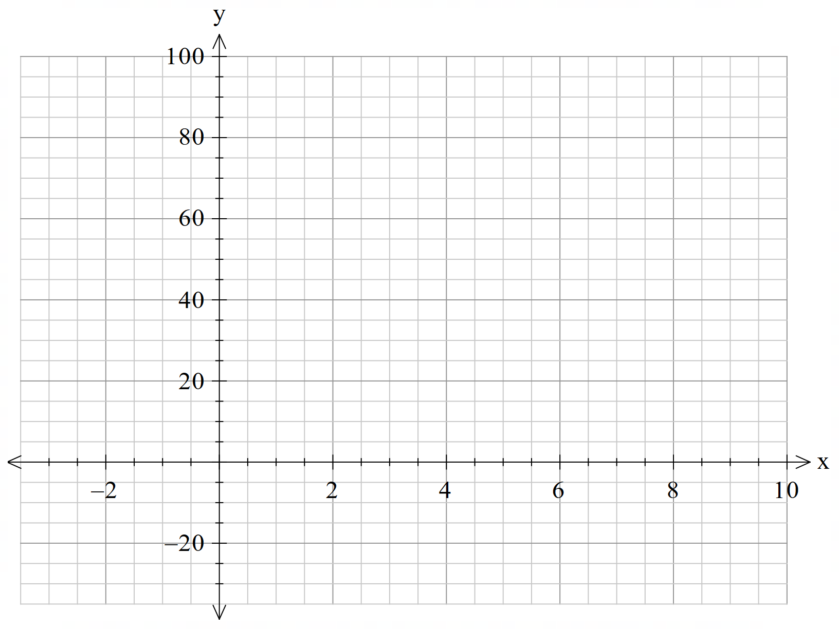

|  |  |  |
| --- | --- | --- |
| Week 0 | Week 1 | Week 2 |
| 1 feral pig. | 4 feral pigs. | 16 feral pigs. |
| 1 feral pig | 4 feral pigs | 16 feral pigs |



## Appendix C

### Variation of exponential equations

|  |  |  |  |
| --- | --- | --- | --- |
|  |  |  |  |
| Graph of y=2^x. | Graph of y=2^(-x). | Graph of y=4^x. | Graph of y=5^x. |
| Describe the graph of . | Describe the graph of . | Describe the graph of . | Describe the graph of . |

|  |  |  |  |
| --- | --- | --- | --- |
|  |  |  |  |
| Graph of y=5^(-x). | Graph of y=10^(-x). | Graph of y=10^x. | Graph of y=2(5)^x. |
| Describe the graph of $y={(5)}^{-x}$. | Describe the graph of $y={(10)}^{-x}.$ | Describe the graph of $y={10}^{x}$. | Describe the graph of $y={2(5)}^{x}$. |

## Appendix D

### Caffeine

* Navigate to the website ‘Caffeine half-life calculator’ ([bit.ly/halflifecalculator](https://bit.ly/halflifecalculator)).
* Enter time in 24-hour format and caffeine in milligrams. For example, an energy drink with 200 mg of caffeine at 12 pm would be **12:00 200**.
* Record the caffeine remaining after 1, 2, and 3 hours, using the graph or the table below the graph for each scenario.

|  |  |
| --- | --- |
| Hours since consumption | Caffeine (mg) |
| $$1$$ |  |
| $$2$$ |  |
| $$3$$ |  |

* Let $C=$ mg of caffeine remaining in the body, $C_{0}=$ initial caffeine consumed, $r=$ rate of decay, and $t=$ hours since consumption.  
  Construct an equation $C=C_{0}{\left(r\right)}^{t}$.
* Use your equation to calculate the amount of caffeine in the body 8 hours since consumption.
* Complete each scenario in your groups:
* **Scenario 1:** A person starts the day by drinking an espresso with 150 mg of caffeine at 6:00 am.
* **Scenario 2:** A person drinks a can of soft drink with 37.5 mg of caffeine at 8:00 pm.

## Sample solutions

### Appendix A – fire ants and feral pigs

|  |  |  |
| --- | --- | --- |
| Week 0 | Week 1 | Week 2 |
| 1 fireant | 10 fireants | 100 fireants |
| 1 fire ant | 10 fire ants | 100 fire ants |

|  |  |  |
| --- | --- | --- |
| Week 0 | Week 1 | Week 2 |
| 1 feral pig | 4 feral pigs | 16 feral pigs |
| 1 feral pig | 4 feral pigs | 16 feral pigs |

1. Determine the exponential equation that represents the growth of fire ants.
2. Determine the exponential equation that represents the growth of feral pigs. $$y=4^{x}$$
3. Use your equations to answer the following questions:

* How many fire ants after 5 weeks? There will be 100 000 fire ants after 5 weeks (${10}^{5}=100 000$).
* How many weeks for there to be 64 feral pigs? It will take 3 weeks for there to be 64 feral pigs ($4^{3}=64$).
* How many weeks for there to be 1 000 feral pigs? It will take between 4 and 5 weeks for there to be 1 000 feral pigs ($4^{4}=256$, $4^{5}=1024$).

### Appendix B – exponential graphs

$$y={10}^{x}$$

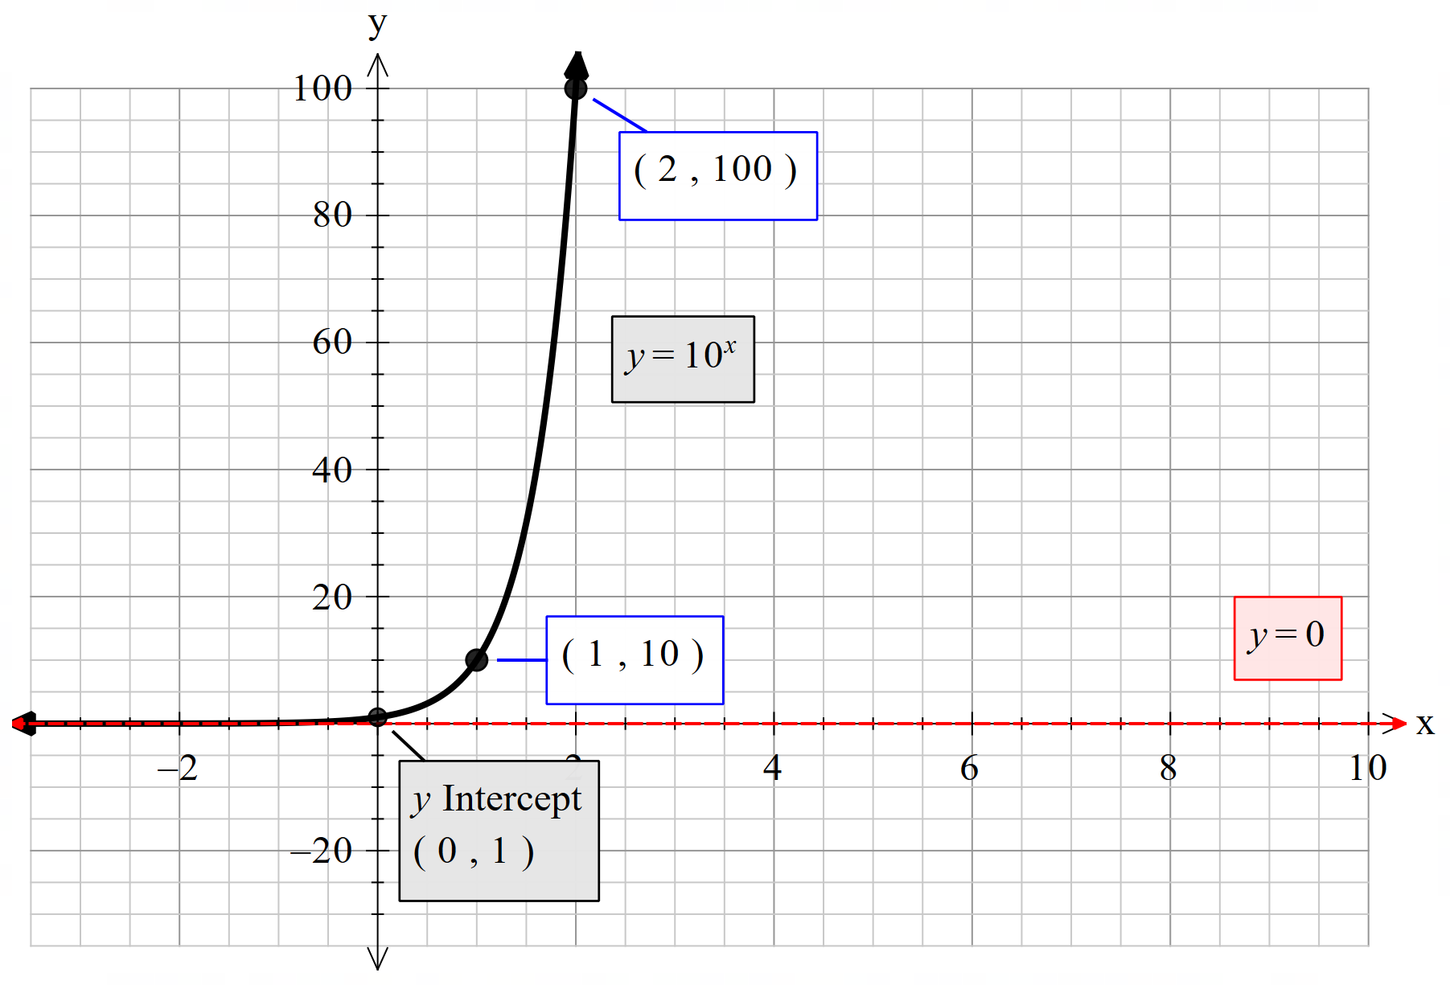

$$y=4^{x}$$

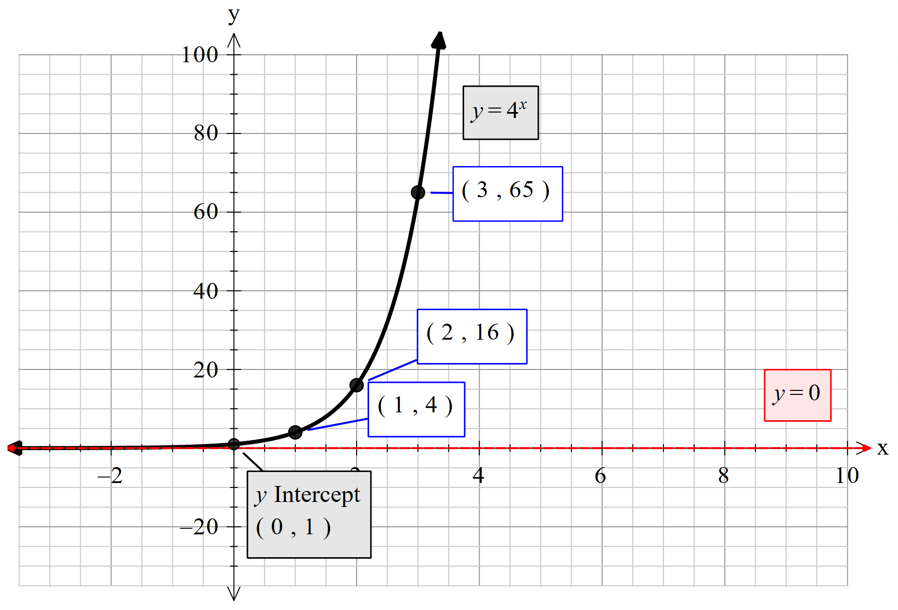

### Appendix C – variation of exponential equations

|  |  |  |  |
| --- | --- | --- | --- |
|  |  |  |  |
| graph of y=2^x | graph of y=2^(-x) | graph of y=4^x | graph of y=5^x |
| Describe the graph of $y=2^{x}$. $y=2^{x}$ has an asymptote at y=0, a y intercept at (0,1), and passes through the point (1,2). | Describe the graph of $y=2^{-x}$. $y=2^{-x}$ has an asymptote at y=0, a y intercept at (0,1), and passes through the point (1, $\frac{1}{2}$).  It is a horizontal reflection of $y=2^{x}.$ | Describe the graph of $y=4^{x}$. $y=4^{x}$ has an asymptote at y=0, a y intercept at (0,1), and passes through the point (1,4).  It grows quicker than $y=2^{x}$. | Describe the graph of $y=5^{x}$. $y=5^{x}$ has an asymptote at y=0, a y intercept at (0,1), and passes through the point (1,5).  It grows quicker than . |

|  |  |  |  |
| --- | --- | --- | --- |
|  |  |  |  |
| graph of y=5^(-x) | graph of y=10^(-x) | graph of y=10^x | Graph of y=2(5)^x |
| Describe the graph of .  has an asymptote at y=0, a y intercept at (0,1), and passes through the point (1,).  It is a horizontal reflection of $y=5^{x}.$ | Describe the graph of $y={10}^{-x}$. $y={10}^{-x}$ has an asymptote at y=0, a y intercept at (0,1), and passes through the point (1, $\frac{1}{10}$).  It grows slower than $y=5^{-x}$ or in other words, it decays faster than $y=5^{-x}.$ | Describe the graph of $y={10}^{x}$. $y={10}^{x}$ has an asymptote at y=0, a y intercept at (0,1), and passes through the point (1,10).  It is a horizontal reflection of $y={10}^{-x}.$ | Describe the graph of $y=2({5)}^{x}$. $y=2({5)}^{x}$ has an asymptote at y=0, a y intercept at (0,2), and passes through the point (1,10).  It grows twice as fast as $y=5^{x}$. |

### Appendix D – caffeine

1. For each scenario:

* Navigate to Caffeine half-life calculator ([bit.ly/halflifecalculator](https://bit.ly/halflifecalculator)).
* Enter time in 24-hour format and caffeine in milligrams. For example, an energy drink with 200 mg of caffeine at 12 pm would be **12:00 200**.
* Record the caffeine remaining after 1, 2, and 3 hours, using the graph or the table below the graph.

|  |  |
| --- | --- |
| Hours since consumption | Caffeine (mg) |
| $$1$$ | $$177.10$$ |
| $$2$$ | $$156.82$$ |
| $$3$$ | $$138.87$$ |

* Let $C=mg$ of caffeine remaining in the body, $C_{0}=$ initial caffeine consumed, $r=$ rate of decay, and $t=$ hours since consumption.  
  Construct an equation $C=C_{0}{\left(r\right)}^{t}$.
$$r=\frac{156.82}{177.10} \\ r=0.89 mg/hr \\ C=200{\left(0.89\right)}^{t}$$

* Use your equation to calculate the amount of caffeine in the body 8 hours since consumption.

$$C=200{\left(0.89\right)}^{8} \\ =78.73 mg$$

1. **Scenario 1:** A person starts the day by drinking an espresso with 150 mg of caffeine at 6:00 am.

|  |  |
| --- | --- |
| Hours since consumption | Caffeine (mg) |
| $$1$$ | 132.82 |
| $$2$$ | 117.62 |
| $$3$$ | 104.15 |

$r=\frac{117.62}{132.82}$ $$r=0.89 mg/hr \\ C=150{\left(0.89\right)}^{t}$$

$C=150{\left(0.89\right)}^{8}$ $$=59.05 mg$$

1. **Scenario 2:** A person drinks a can of soft drink with 37.5 mg of caffeine at 8:00 pm.

|  |  |
| --- | --- |
| Hours since consumption | Caffeine (mg) |
| $$1$$ | 32.76 |
| $$2$$ | 29.01 |
| $$3$$ | 25.69 |

$r=\frac{29.01}{32.76}$ $$r=0.89 mg/hr \\ C=37.5{\left(0.89\right)}^{t}$$

$C=37.5{\left(0.89\right)}^{8}$ $$=14.76 mg$$

## References

This resource contains NSW Curriculum and syllabus content. The NSW Curriculum is developed by the NSW Education Standards Authority. This content is prepared by NESA for and on behalf of the Crown in right of the State of New South Wales. The material is protected by Crown copyright.

Please refer to the NESA Copyright Disclaimer for more information [https://educationstandards.nsw.edu.au/wps/portal/nesa/mini-footer/copyright](https://aus01.safelinks.protection.outlook.com/?url=https%3A%2F%2Feducationstandards.nsw.edu.au%2Fwps%2Fportal%2Fnesa%2Fmini-footer%2Fcopyright&data=05%7C01%7CCaitlin.Pace1%40det.nsw.edu.au%7C9c2c1a9f59c94d2df30708dafa7edb23%7C05a0e69a418a47c19c259387261bf991%7C0%7C0%7C638097720042599463%7CUnknown%7CTWFpbGZsb3d8eyJWIjoiMC4wLjAwMDAiLCJQIjoiV2luMzIiLCJBTiI6Ik1haWwiLCJXVCI6Mn0%3D%7C3000%7C%7C%7C&sdata=BzQh0UsffVZE3eO22b2Xba3p0VMOBZSHfS21FGHXtZM%3D&reserved=0).

NESA holds the only official and up-to-date versions of the NSW Curriculum and syllabus documents. Please visit the NSW Education Standards Authority (NESA) website <https://educationstandards.nsw.edu.au/> and the NSW Curriculum website <https://curriculum.nsw.edu.au/>.

[Mathematics K–10 Syllabus](https://curriculum.nsw.edu.au/learning-areas/mathematics/mathematics-k-10-2022/overview) © NSW Education Standards Authority (NESA) for and on behalf of the Crown in right of the State of New South Wales, 2022.

**© State of New South Wales (Department of Education), 2024**

The copyright material published in this resource is subject to the Copyright Act 1968 (Cth) and is owned by the NSW Department of Education or, where indicated, by a party other than the NSW Department of Education (third-party material).

Copyright material available in this resource and owned by the NSW Department of Education is licensed under a [Creative Commons Attribution 4.0 International (CC BY 4.0) license](https://creativecommons.org/licenses/by/4.0/).

[](https://creativecommons.org/licenses/by/4.0/)

This license allows you to share and adapt the material for any purpose, even commercially.

Attribution should be given to © State of New South Wales (Department of Education), 2024.

Material in this resource not available under a Creative Commons license:

* the NSW Department of Education logo, other logos and trademark-protected material
* material owned by a third party that has been reproduced with permission. You will need to obtain permission from the third party to reuse its material.

**Links to third-party material and websites**

Please note that the provided (reading/viewing material/list/links/texts) are a suggestion only and implies no endorsement, by the New South Wales Department of Education, of any author, publisher, or book title. School principals and teachers are best placed to assess the suitability of resources that would complement the curriculum and reflect the needs and interests of their students.

If you use the links provided in this document to access a third-party's website, you acknowledge that the terms of use, including licence terms set out on the third-party's website apply to the use which may be made of the materials on that third-party website or where permitted by the Copyright Act 1968 (Cth). The department accepts no responsibility for content on third-party websites.