# Population clock

Students use the population clock to explore the limitations of exponential relationships when used to model everyday occurrences. Students then interpret information from different models and identify any limitations.

## Visible learning

This lesson incorporates Path content.

### Learning intention

* To understand when exponential graphs are a good model to represent real-life scenarios.

### Success criteria

* I can use an exponential model to predict future values.
* I can identify limitations of models that use exponential relationships.
* I can interpret information from an exponential graph.

### Syllabus outcomes

A student:

* develops understanding and fluency in mathematics through exploring and connecting mathematical concepts, choosing and applying mathematical techniques to solve problems, and communicating their thinking and reasoning coherently and clearly **MAO-WM-01**
* identifies connections between algebraic and graphical representations of quadratic and exponential relationships in various contexts **MA5-NLI-C-01**
* identifies and compares features of parabolas and exponential curves in various contexts **MA5-NLI-C-02**

[Mathematics K–10 Syllabus](https://curriculum.nsw.edu.au/learning-areas/mathematics/mathematics-k-10-2022/overview) © NSW Education Standards Authority (NESA) for and on behalf of the Crown in right of the State of New South Wales, 2022.

Table 1: lesson summary

|  |  |  |  |
| --- | --- | --- | --- |
| Section | Summary of activity | Teaching strategy | Teaching points |
| Launch | Display the current population using the population clock website ([worldometers.info/world-population/](https://www.worldometers.info/world-population/)).  Students examine the world population, past, present and future and consider if the population will continue to grow exponentially. | Notice and wonder | The website is accurate within 2%. |
| Explore | Students use various countries’ populations from the year 2000 and growth rates (Appendix A) to calculate future values. This is modelled using world population on slide 3–4 of the PowerPoint *Population clock*.  Students discuss as a class the results of their calculations versus the exponential model. | Think-Pair-Share  Visibly random groups of 3  Vertical non-permanent surfaces  Gallery walk | Students should recognise that the population changes and does not grow at the same rate each year in each country. |
| Summarise | Students compare the actual world population versus the exponential graph (slide 6) and identify the model from the real data.  Students complete a PMI table reflecting on the use of an exponential curve as a model. | Think-Pair-Share  PMI table (plus, minus, interesting)  Worked examples (Your turn) | The purpose of this section is for students to compare the actual data to the model and discuss the differences. |
| Apply | Students examine 4 different exponential models in Appendix B and question the limitations of each model. |  | The purpose of this section is for students to examine different exponential models and question their limitations. |

## Activity structure

Please use the associated PowerPoint *Population clock* to display images in this lesson.

### Launch

1. Ask students if anyone knows what a population clock is.
2. Inform students that it is a model created from data such as births and deaths and is used to estimate the population of countries and the world.
3. Navigate to the website ‘Worldometer’ ([worldometers.info/world-population](https://www.worldometers.info/world-population/)) and display the current population clock. Ask students what they notice and wonder ([bit.ly/noticewonderstrategy](https://bit.ly/noticewonderstrategy)). Randomly select students to share their thinking.

Students may wonder what the reliability or accuracy of the data is. This website has a margin of error of 2%. This could provide a good opportunity to revise errors in measurement.

1. Scroll down the website to the graph labelled **World Population: Past, Present, and Future** and ask students what type of graph best describes the world population at any given time.

The graph is approximately exponential.

1. Inform students that exponential graphs are often used to describe population growth.
2. Pose the question for students to consider: Do you expect the world population to continue increasing exponentially? Why or why not?

Students might notice that the graph does not continue to grow exponentially. Some reasons for not growing exponentially could include a lack of resources, land or a natural disaster.

### Explore

1. Display slide 3 of the PowerPoint *Population clock*, which shows data for the year 2000 and the percentage growth at this time. It also shows the population in 2023. In a Think-Pair-Share ([bit.ly/thinkpairsharestrategy](https://bit.ly/thinkpairsharestrategy)), ask students:

* Where have we seen this formula before?
* Why can we use it in this scenario?
* What values represent each variable?
* How do each of the variables affect the graph?

Students have explored compound interest in Lessons 1–3 and transformations of exponential graphs in Lesson 5 – exponential marble slides of Unit 11 – applying exponentials. The data from the year 2023 would be the calculated number if the population had grown exponentially at the same rate since 2000.

1. Display slide 4 of the PowerPoint. Give students a moment to look at the worked solution provided.
2. Display slide 5 of the PowerPoint and in a Think-Pair-Share have students answer the self-explanation prompts.

Students should notice that the future value is different than the one provided for the year 2023 and may use their answers in the Launch to provide a reason why they are different.

The time period is 24 as it is inclusive of the years 2000–2023.

1. During this section, students will work in visibly random groups of 3 ([bit.ly/visiblegroups](https://bit.ly/visiblegroups)) on vertical non-permanent surfaces ([bit.ly/VNPSstrategy](https://bit.ly/VNPSstrategy)).
2. Distribute Appendix A ‘Countries data’ and ask students to calculate the future value of 4 different countries’ populations.
3. Have groups write the actual number next to the predicted number so it is easier for students to compare.
4. Students are to do a gallery walk ([bit.ly/DLSgallerywalk](https://bit.ly/DLSgallerywalk)) of the calculations observing the calculated population compared to the actual population.
5. Bring students back together and discuss the results. Prompting questions could include:

* What did you notice from your calculations?
* Did any calculations match the actual value? Why might this be the case?
* If the population was growing exponentially from the year 2000, what would we expect from your calculations?
* Which countries’ populations were more than predicted? Why might this be the case?
* Which countries’ populations were less than predicted? Why might this be the case?

1. Revisit the launch question: Do you expect the world population to continue increasing exponentially? Why or why not?

Students should recognise that the population changes and does not grow at the same rate each year in each country. The teacher could lead a discussion on some reasons for this. This could be tailored to students’ interests and experiences.

### Summarise

1. Display slide 7 of the PowerPoint which graphs the actual population versus the modelled population.
2. In a Think-Pair-Share, have students distinguish between the modelled population and the actual population.

Students should recognise that the modelled population is the green line as it is more consistent. Real population growth has many variables.

1. Display slide 8 of the PowerPoint and ask pairs to complete the Plus, Minus, Interesting (PMI) table ([bit.ly/PMI_plusminusintersting](https://bit.ly/PMI_plusminusintersting)). Students reflect on using exponential graphs to model population growth by writing down and completing the PMI table before discussing what they wrote in a Think-Pair-Share.
2. Use slides 9–12 from the PowerPoint for explicit teaching of interpreting exponential graphs using the Worked examples (Your turn) method ([bit.ly/supportingstrategies](https://bit.ly/supportingstrategies)).

Suggested reasons for limitations to the model are the effect of lockdown, the effect of vaccination or the effects of major events such as cruise ships or concerts. The model also indicates that there is never a time where there are zero cases.

### Apply

1. Distribute Appendix B ‘Modelling everyday situations’ to students and have them complete the questions. Students will read information from the graphs and question the model for limitations.
2. Bring students back together and discuss some of the reasoning for each scenario’s final question.

## Assessment and differentiation

### Suggested opportunities for differentiation

**Launch**

* Students can be provided with multiple choice options on which types of graphs might suit the world population graph.
* After posing the question: Do you expect the world population to continue increasing exponentially? Why or why not?, teachers may want to place students into a Think-Pair-Share to allow time for students to discuss with each other before sharing with the class.

**Explore**

* The teacher may choose to round population numbers to the nearest billion for students who require further support.
* The number of countries students need to calculate in Appendix A can be adjusted.
* Students can work in pairs for Appendix A.
* Some of the discussion-prompt questions can be given to students before they complete their gallery walk to provide students with a focus for their observations.

**Summarise**

* The teacher may need to highlight points of difference between the graphs on slide 7 of the PowerPoint Population clock to support students in their discussions.
* The PMI can be completed through a whole class discussion.

**Apply**

* Appendix B could be set up as a jigsaw task ([bit.ly/jigsawgroupstrategy](https://bit.ly/jigsawgroupstrategy)) with 4 stations for each of the scenarios.
* Students could be placed in pairs for peer support to complete Appendix B.

### Suggested opportunities for assessment

**Launch**

* Check for students’ understanding of different types of graphs from their responses to the notice and wonder.

**Explore**

* An opportunity for the teacher to assess students’ recall of the future value formula.
* A Think-Pair-Share provides students with the opportunity to reflect on their understanding.
* When placed in groups of 3, students provide and receive peer feedback on their understanding.
* Monitor responses in class discussions to check for student understanding and reasoning between calculations and predicted values.

**Summarise**

* The teacher can collect PMIs as evidence of students’ understanding of the limitations of using exponential models.

**Apply**

* Student responses to Appendix B can be collected as evidence of interpreting exponential graphs.
* One of the scenarios from Appendix B could be collected as an exit ticket.

## Appendix A

### Countries data

|  |  |  |  |
| --- | --- | --- | --- |
| Country | 2000 population | Yearly % change | 2023 population |
| India | 1 059 633 675 | 1.90% | 1 441 719 852 |
| China | 1 264 099 069 | 0.74% | 1 425 178 782 |
| USA | 282 398 554 | 1.23% | 341 814 420 |
| Indonesia | 214 072 421 | 1.56% | 279 798 049 |
| Pakistan | 154 369 924 | 3.01% | 245 209 815 |
| Nigeria | 122 851 984 | 2.57% | 229 152 217 |
| Brazil | 175 873 720 | 1.47% | 217 637 297 |
| Bangladesh | 129 193 327 | 1.86% | 174 701 211 |
| Russia | 146 844 839 | -0.23% | 143 987 079 |
| Mexico | 97 873 442 | 1.70% | 129 388 467 |
| Ethiopia | 67 031 867 | 3.12% | 129 719 719 |
| Japan | 126 803 861 | 0.22% | 122 631 432 |
| Philippines | 77 958 223 | 2.40% | 119 106 224 |
| Germany | 81 551 677 | 0.11% | 86 252 474 |
| Australia | 19 017 963 | 1.10% | 26 699 482 |
| Lebanon | 4 320 642 | 1.76% | 5 219 044 |

## Appendix B

### Modelling everyday situations

#### Scenario 1

Scenario 1 models the decay of a radioactive substance.

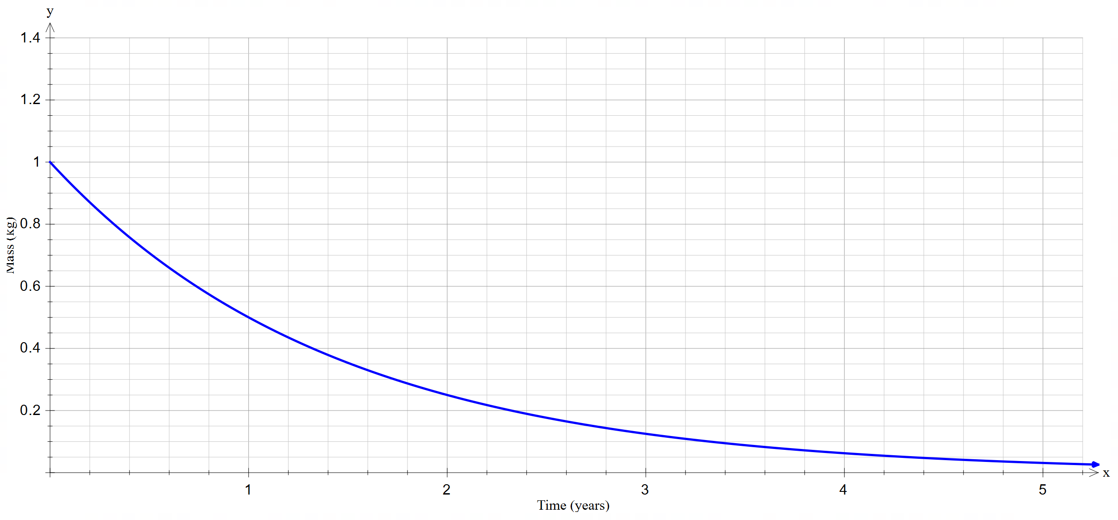

1. Use the graph to determine the mass of the radioactive substance when:
2. t = 0
3. t = 2.4
4. t = 4.2
5. What is the mass of the radioactive substance at the beginning of the experiment? How do you know?
6. What is the horizontal asymptote and what does this indicate about the radioactive substance?
7. Is this model realistic for the decay of a radioactive substance? Why or why not?

#### Scenario 2

Scenario 2 models the mass of a baby orangutan over time.

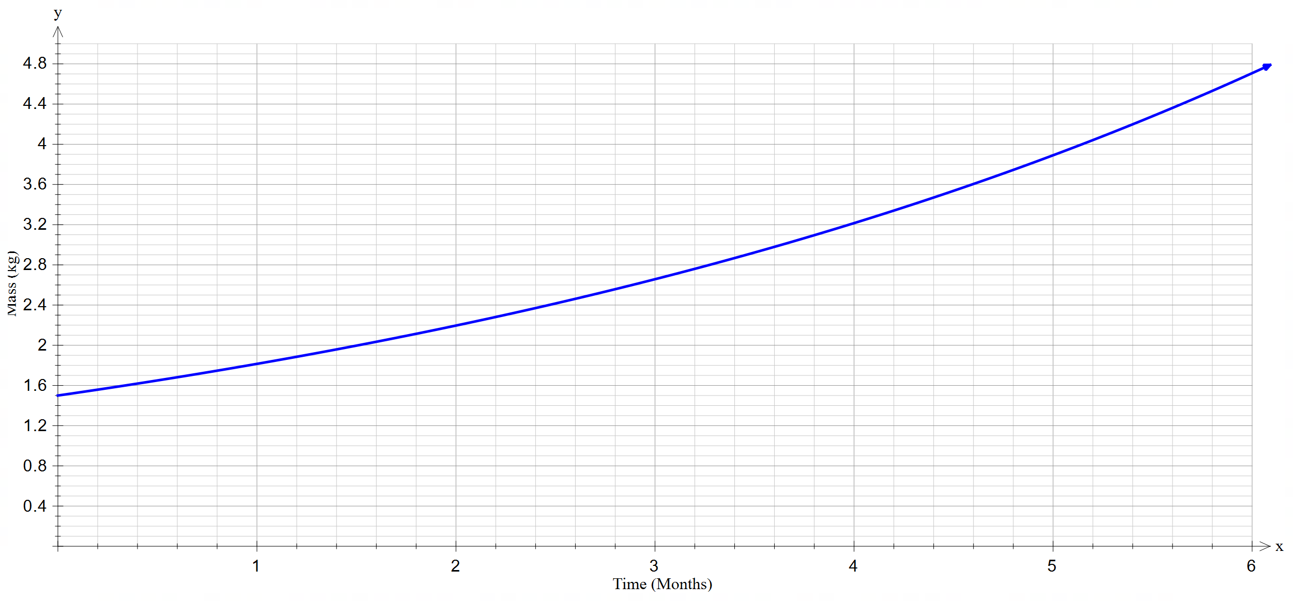

1. Determine the mass of the orangutan at birth.
2. Determine the mass of the orangutan at 3 months old.
3. How old was the orangutan when it weighed 3.6 kilograms.
4. What does the value of the M intercept tell us?
5. Do you think this model can be used for all baby orangutans? Why or why not?
6. Do you think this graph would be relevant past the 6 months shown? Justify your reasoning.

#### Scenario 3

Scenario 3 models deer population over time.

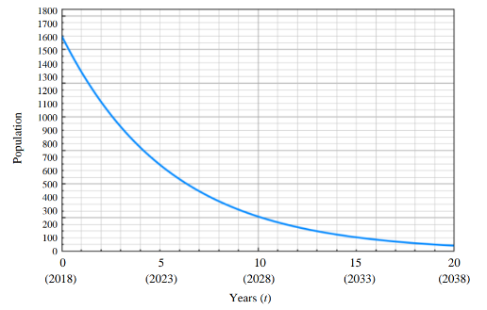

1. What was the initial deer population?
2. What was the expected deer population in 2020?
3. In which year did the deer population reach 500?
4. How long did it take for the deer population to halve?
5. Using this model, will the deer population ever become extinct? Provide reasoning to support your answer.
6. What limitations are there to this model? Explain your thinking.

#### Scenario 4

Scenario 4 models superannuation balance over time.

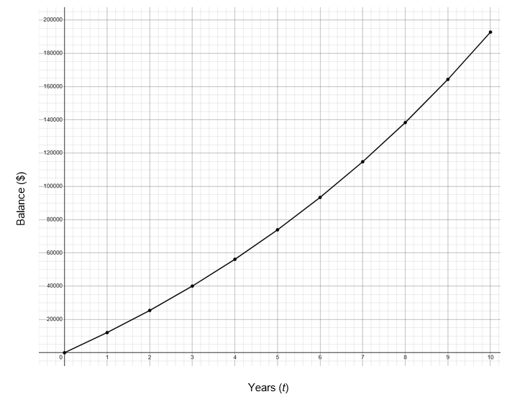

1. What was the initial balance?
2. What was the expected superannuation balance after 3 years?
3. How many years does it take to get to a balance of $100 000?
4. How long will it take to get to a balance of $200 000?
5. Do you think this model is a good representation of all superannuation funds? Provide reasoning to support your answer.
6. What limitations are there to this model? Explain your thinking.

## Sample solutions

### Appendix A – countries data

|  |  |
| --- | --- |
| India | China |
| USA | Indonesia |
| Pakistan | Nigeria |
| Brazil | Bangladesh |
| Russia | Mexico |

|  |  |
| --- | --- |
| Ethiopia | Japan |
| Philippines | Germany |
| Australia | Lebanon |

### Appendix B – modelling everyday situations

#### Scenario 1

1. 1.0 g
2. 0.2 g
3. 0.05 g
4. 1.0 because t = 0
5. M = 0. This means that the mass will never reach zero or the radioactive substance will never fully disappear.
6. Yes, this is a good model because when you continue to divide a number it gets smaller but never decreases. This is the same with radioactive decay.

#### Scenario 2

1. 1.5 kg
2. 2.6 kg
3. 4.8 months old.
4. Initial weight.
5. No, not all orangutans will have the same food, water, care or the same growth rate.
6. No, all animals grow quickly and then slow down. The orangutan will also have to stop growing at some stage.

#### Scenario 3

1. 1600 deer.
2. 1100 deer.
3. 2024
4. 4 years.
5. The deer will continue to decrease but will never reach zero according to this model. This is because an exponential graph approaches zero but never reaches zero.
6. The problems with the model include:

* you can’t have half a deer
* to successfully breed you need at least 2 deer (a male and a female).

#### Scenario 4

1. $0
2. Approximately $40 000
3. Between 6 and 7 years.
4. Just over 10 years.
5. No, not all superannuation funds will have the same investment returns and each individual person will contribute different amounts into their fund.
6. The problems with the model include:

* assumes the rate of return is consistent, doesn’t consider fluctuations or negative returns
* assumes the amount of money contributed into superannuation stays the same, where in reality the amount fluctuates in line with income earnings and personal contributions can also be added.

## References

This resource contains NSW Curriculum and syllabus content. The NSW Curriculum is developed by the NSW Education Standards Authority. This content is prepared by NESA for and on behalf of the Crown in right of the State of New South Wales. The material is protected by Crown copyright.

Please refer to the NESA Copyright Disclaimer for more information <https://educationstandards.nsw.edu.au/wps/portal/nesa/mini-footer/copyright>.

NESA holds the only official and up-to-date versions of the NSW Curriculum and syllabus documents. Please visit the NSW Education Standards Authority (NESA) website <https://educationstandards.nsw.edu.au/> and the NSW Curriculum website <https://curriculum.nsw.edu.au/>.

[Mathematics K–10 Syllabus](https://curriculum.nsw.edu.au/learning-areas/mathematics/mathematics-k-10-2022/overview) © NSW Education Standards Authority (NESA) for and on behalf of the Crown in right of the State of New South Wales, 2022.

**© State of New South Wales (Department of Education), 2024**

The copyright material published in this resource is subject to the *Copyright Act 1968* (Cth) and is owned by the NSW Department of Education or, where indicated, by a party other than the NSW Department of Education (third-party material).

Copyright material available in this resource and owned by the NSW Department of Education is licensed under a [Creative Commons Attribution 4.0 International (CC BY 4.0) license](https://creativecommons.org/licenses/by/4.0/).

[](https://creativecommons.org/licenses/by/4.0/)

This license allows you to share and adapt the material for any purpose, even commercially.

Attribution should be given to © State of New South Wales (Department of Education), 2024.

Material in this resource not available under a Creative Commons license:

* the NSW Department of Education logo, other logos and trademark-protected material
* material owned by a third party that has been reproduced with permission. You will need to obtain permission from the third party to reuse its material.

**Links to third-party material and websites**

Please note that the provided (reading/viewing material/list/links/texts) are a suggestion only and implies no endorsement, by the New South Wales Department of Education, of any author, publisher, or book title. School principals and teachers are best placed to assess the suitability of resources that would complement the curriculum and reflect the needs and interests of their students.

If you use the links provided in this document to access a third-party's website, you acknowledge that the terms of use, including licence terms set out on the third-party's website apply to the use which may be made of the materials on that third-party website or where permitted by the *Copyright Act 1968* (Cth). The department accepts no responsibility for content on third-party websites.