# Features of a parabola

Students are introduced to the features and terminology of parabolas through the context of a vehicle’s braking distance.

Students will need at least one digital device per pair to interact with activities in this lesson.

## Visible learning

### Learning intention

* To be able to identify the features of a parabola.

### Success criteria

* I can identify and name the vertex and axis of symmetry of a parabola.
* I can identify the intercepts of a parabola.
* I can identify the concavity of a parabola.
* I can use quadratic relationships to model real-world scenarios.

Table 1: lesson summary

|  |  |  |  |
| --- | --- | --- | --- |
| Section | Summary of activity | Teaching strategies | Teaching points |
| Launch | Students watch the video ‘500km/h in Dragster!! (0:47)’ ([bit.ly/dragster500](https://bit.ly/dragster500)).  Students sketch what they believe the relationship between speed and stopping distance might be. | Think-Pair-Share  Pose-Pause-Pounce-Bounce  Gallery walk | Identifying quadratic relationships and which parts of the graph are relevant to a real-life context. |
| Explore | Students use the website ‘It’s a drag’ ([bit.ly/its_a_drag](https://bit.ly/its_a_drag)) and the Desmos file ‘It’s a drag’ ([bit.ly/Its_a_drag_desmos](https://bit.ly/Its_a_drag_desmos)) to investigate the relationship between speed and stopping distance of cars under various conditions.  Teachers assign each student a scenario from Appendix A. | Pose-Pause-Pounce-Bounce | Comparing graphs of parabolas and identifying the common features. |
| Summarise | Students play the activity ‘Polygraph: Parabolas’ ([bit.ly/Polygraph_Parabolas](https://bit.ly/Polygraph_Parabolas)) to practise identifying the features of a parabola. Teachers introduce correct terminology and definitions for vertex, intercepts, concavity and axis of symmetry using slides 3–6 of the PowerPoint *Features of a parabola.* Students complete the Desmos activity ‘Polygraph: Parabolas, Part 2’ ([bit.ly/Polygraph_Parabolas2](https://bit.ly/Polygraph_Parabolas2)) to practise using their new terminology. |  | Introducing the need for common terminology to refer to the features of a parabola. |
| Apply | Students identify the features of the graphs they drew from their ‘It’s a drag’ data.  Students make up a story to explain the graph in Appendix B. They should include all the important features of the graph in their story. |  | Applying their knowledge of terminology to write a real-life context for a graph. |

### Syllabus outcomes

A student:

* develops understanding and fluency in mathematics through exploring and connecting mathematical concepts, choosing and applying mathematical techniques to solve problems, and communicating their thinking and reasoning coherently and clearly **MAO-WM-01**
* identifies connections between algebraic and graphical representations of quadratic and exponential relationships in various contexts  
  **MA5-NLI-C-01**
* identifies and compares features of parabolas and exponential curves in various contexts **MA5-NLI-C-02**

[Mathematics K–10 Syllabus](https://curriculum.nsw.edu.au/learning-areas/mathematics/mathematics-k-10-2022/overview) © NSW Education Standards Authority (NESA) for and on behalf of the Crown in right of the State of New South Wales, 2022.

## Activity structure

Please use the associated PowerPoint *Features of a parabola* (FOAP PPT) to display images in this lesson.

### Launch

1. Show students the video ‘500km/h in Dragster!! (0:47)’ ([bit.ly/dragster500](https://bit.ly/dragster500)).
2. In a Think-Pair-Share ([bit.ly/thinkpairsharestrategy](https://bit.ly/thinkpairsharestrategy)), ask students to discuss:

* Why do the cars use parachutes?
* How long would it take to stop the car without a parachute?
* If I was travelling at 100 km/h, how long do you think it would take my car to stop? What about 60 km/h?
* What things might affect how long it takes a car to stop?

1. Show students the video ‘Stopping Distance (1:01)’ ([bit.ly/Stopping_Distance](https://bit.ly/Stopping_Distance)).
2. In a Think-Pair-Share, ask students to draw a sketch to show the relationship between speed and stopping distance.
3. Ask students to do a gallery walk ([bit.ly/DLSgallerywalk](https://bit.ly/DLSgallerywalk)) to observe other pair’s sketches. They should consider what is similar and different to their own.
4. Use the Pose-Pause-Pounce-Bounce questioning strategy (PDF 557 KB) ([bit.ly/posepausepouncebounce](https://bit.ly/posepausepouncebounce)) for students to share what they noticed during their gallery walk and to justify their chosen relationship.

Most students will likely show a linear relationship. Prompt students to use their knowledge of television campaigns and other messaging to consider if they believe the braking distance at 40 km/h is really half that of a car travelling at 80 km/h, as would occur in a linear relationship.

Students have compared graphs of straight lines, exponentials and parabolas in Lesson 1 – What’s that graph? of Unit 12 – investigating parabolas.

### Explore

1. Ask students to navigate to the website ‘It’s a drag’ ([bit.ly/its_a_drag](https://bit.ly/its_a_drag)) and to open the Desmos graph ‘It’s a drag’ ([bit.ly/dragdesmostemplate](https://bit.ly/dragdesmostemplate)).
2. Assign each pair of students one of the scenarios listed in Appendix A ‘It’s a drag scenarios’.

There are 27 scenarios provided, each involving cars. Teachers could choose to provide students with other scenarios involving other types of vehicles.

1. Students will adjust the variables in the ‘It’s a drag’ website to match those provided to them by the teacher.
2. Students will start their car travelling at 10 km/h and record the total stopping distance at this speed on the Desmos graph’s table of values. They will continue to increase their speed and record the distance in the table of values in Desmos until they reach 100 km/h.

Instructions for using the interactive are shown when students first navigate to the website. Teachers can choose to read through these with students or to demonstrate how to use the interactive.

1. Ask students to consider:

* What type of graph has been created from the data?
* How could we describe this graph to another person? What features can you see?
* How could you use the graph to determine how long it would take a drag car to stop if it was travelling at 500km/h?

Use students’ prior knowledge to build on their knowledge of features of graphs.

Students have seen $x$-intercepts and $y$-intercepts in Lesson 6 and 9 of Unit 6 – constant rates of change, in relation to linear graphs and in Unit 11 – exponentials in relation to exponential graphs.

Encourage students to zoom in on their graph to be able to see features more clearly.

1. Ask students to compare the graph they drew from their scenario, with the pairs on either side of them. Ask them to consider what is similar about their graphs and what is different.

Students should notice that their graphs are the same shape – parabolas, but that the intercepts and the vertex of the parabolas are in slightly different places.

Students may not know the correct terminology for the features of the graphs. It is ok for them to be using common language. This activity is designed to highlight what would be considered the important features of the graph, and the need for terminology to describe them.

1. Use the Pose-Pause-Pounce-Bounce questioning strategy for students to share the type of graphs they drew for their different scenarios. Prompt students to consider whether the graph makes sense for the context. For example, can we have a negative distance? Can we have negative speed?
2. Ask students to keep their graphs on their screens as they will return to them later in the lesson.

### Summarise

1. Assign the Desmos Polygraph activity ‘Polygraph: Parabolas’. ([bit.ly/Polygraph_Parabolas](https://bit.ly/Polygraph_Parabolas)).

This activity highlights the need for common terminology when referring to parabolas.

Before doing this activity, you will need to set up a Desmos classroom ([bit.ly/managingdesmosclassroom](https://bit.ly/managingdesmosclassroom)). More information on using Polygraph with your class can be found at the Amplify website ‘Polygraph’ ([bit.ly/UsingPolygraph](https://bit.ly/UsingPolygraph)).

1. Use slides 3–6 of the PowerPoint (FOAP PPT) to explicitly teach the following terminology:

* vertex
* $x$-intercepts
* $y$-intercepts
* axis of symmetry
* concavity.

1. Assign the Desmos activity ‘Polygraph: Parabolas, Part 2’ ([bit.ly/Polygraph_Parabolas2](https://bit.ly/Polygraph_Parabolas2)).
2. Working in their original pair, students return to the graphs they drew from their ‘It’s a drag’ data. They should describe their graph by identifying all its important features, using the correct terminology.

### Apply

1. Assign each pair of students to one of the graphs from Appendix B ‘Parabola stories’.
2. Working in their pairs, students make up a story to explain their graph. They should include all the important features of the graph in their story.

Although units have been included on the graphs, students should be free to change the units to fit in with their story.

## Assessment and differentiation

### Suggested opportunities for differentiation

**Launch**

* There are no correct answers in this activity. Students should be encouraged to participate and to practise sharing their reasoning.
* Student participation is supported by working in pairs and testing ideas with a partner.

**Explore**

* Students could be challenged to compare reaction distance with braking distance for each of the speeds. What is the relationship between these 2 variables?
* The Desmos file will automatically draw a graph from the data that students have entered in the table of values. Teachers could choose to enhance students’ Desmos skills by asking them to create a table of values and graph from scratch.
* The number of data points could be decreased. For instance, just measuring the braking distance at common speeds such as 10, 50, 60, 80 and 100 km/h.
* All students will be able to participate in this activity but will describe the graphs with different levels of detail.

**Apply**

* Students can verbally state their story, instead of providing it in written form.
* Teachers could provide students with a story scaffold for them to fill in the blanks with details from their given parabola.
* Students could be challenged to consider how their story would change if the parabola were translated or dilated in various ways.

### Suggested opportunities for assessment

**Launch**

* Teachers should monitor student discussions to listen for correct terminology of linear, exponential and quadratic relationships.
* Teachers can assess student understanding of increasing relationships. For instance, that as the speed increases, the stopping distance will also increase.

**Explore**

* Teachers should monitor student responses during class discussions to check for their understanding of what a quadratic relationship looks like and for their interpretation of the graph in relation to the real-life context.

**Summarise**

* Teachers can monitor students' responses to the Desmos activities through the Desmos teacher dashboard. Teachers can monitor for correct terminology and whether students can identify the important features of a parabola.

**Apply**

* Teachers could collect student’s stories as evidence of their understanding of the features of a parabola and their ability to interpret a graph.

## Appendix A

### It’s a drag scenarios

|  |  |  |  |
| --- | --- | --- | --- |
| Vehicle | Tyres | Road surface | Weather |
| Car | Treaded | Bitumen | Dry |
| Car | Treaded | Bitumen | Wet |
| Car | Treaded | Bitumen | Icy |
| Car | Treaded | Dirt | Dry |
| Car | Treaded | Dirt | Wet |
| Car | Treaded | Dirt | Icy |
| Car | Treaded | Gravel | Dry |
| Car | Treaded | Gravel | Wet |
| Car | Treaded | Gravel | Icy |
| Car | Bald | Bitumen | Dry |
| Car | Bald | Bitumen | Wet |
| Car | Bald | Bitumen | Icy |
| Car | Bald | Dirt | Dry |
| Car | Bald | Dirt | Wet |
| Car | Bald | Dirt | Icy |
| Car | Bald | Gravel | Dry |
| Car | Bald | Gravel | Wet |
| Car | Bald | Gravel | Icy |
| Car | Slick | Bitumen | Wet |
| Car | Slick | Bitumen | Icy |
| Car | Slick | Dirt | Dry |
| Car | Slick | Dirt | Wet |
| Car | Slick | Dirt | Icy |
| Car | Slick | Gravel | Dry |
| Car | Slick | Gravel | Wet |
| Car | Slick | Gravel | Icy |

## Appendix B

### Parabola stories

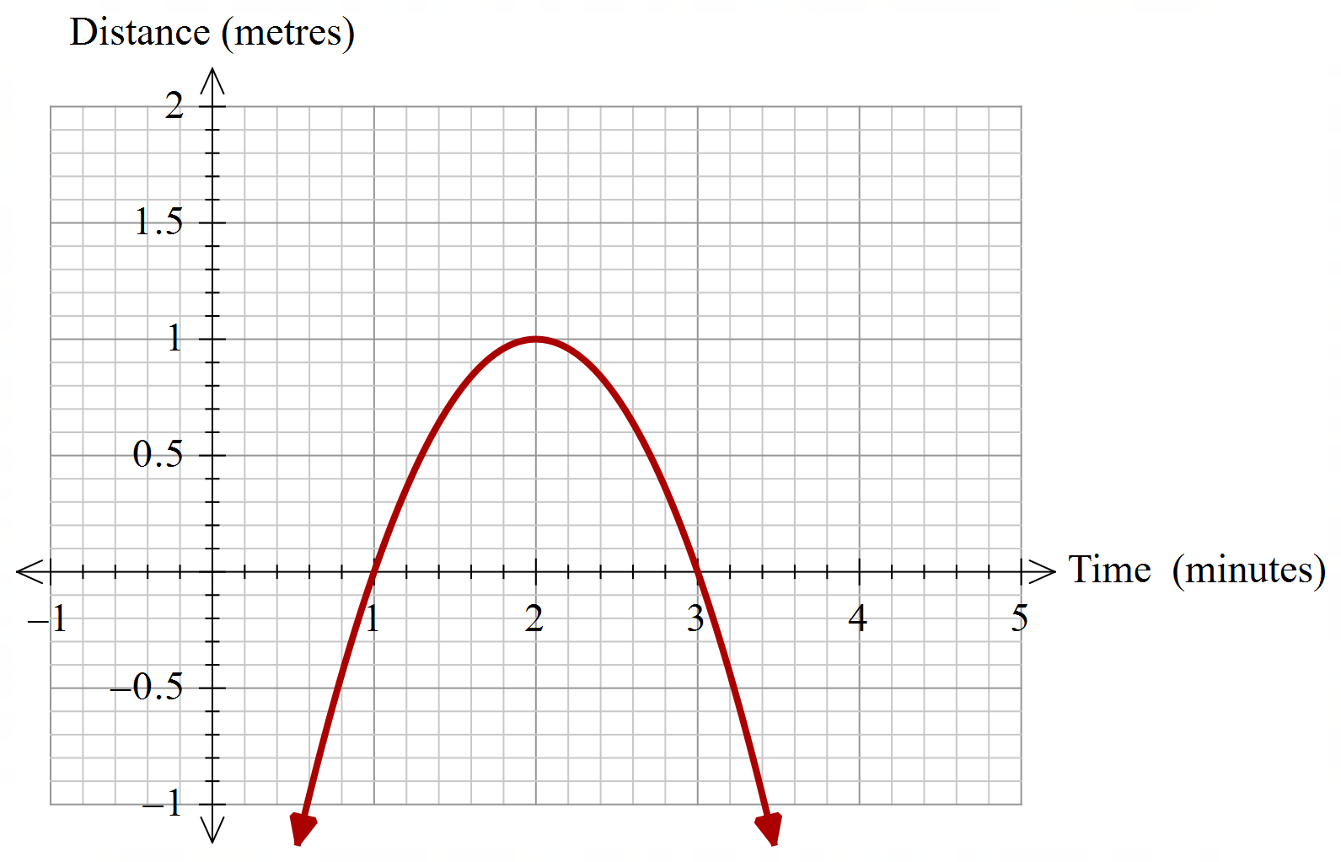

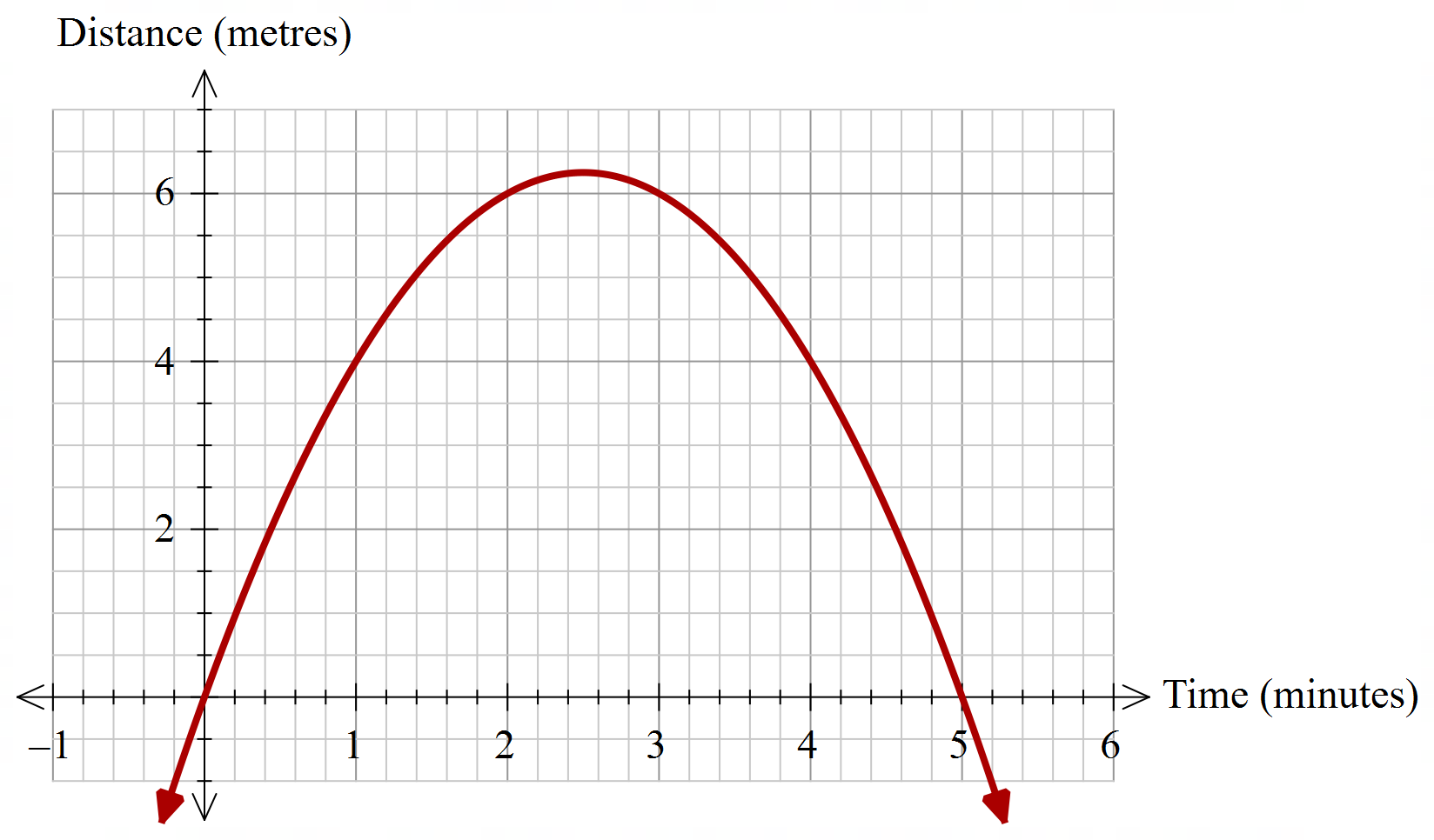

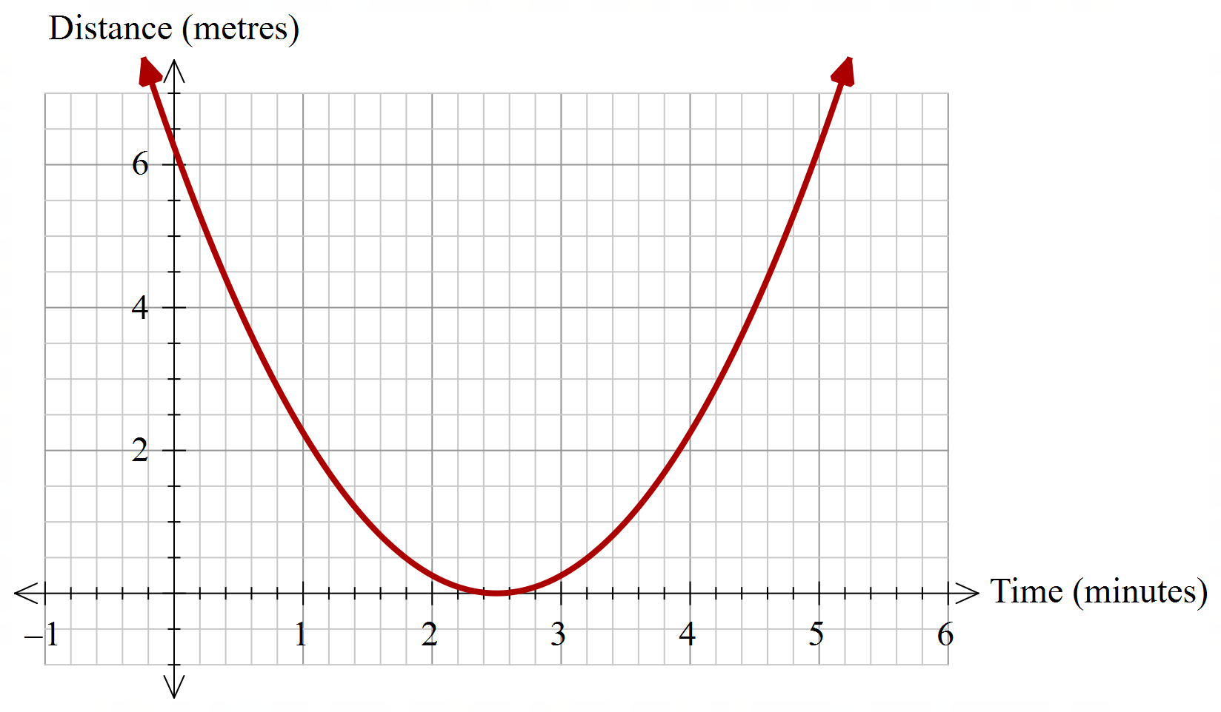

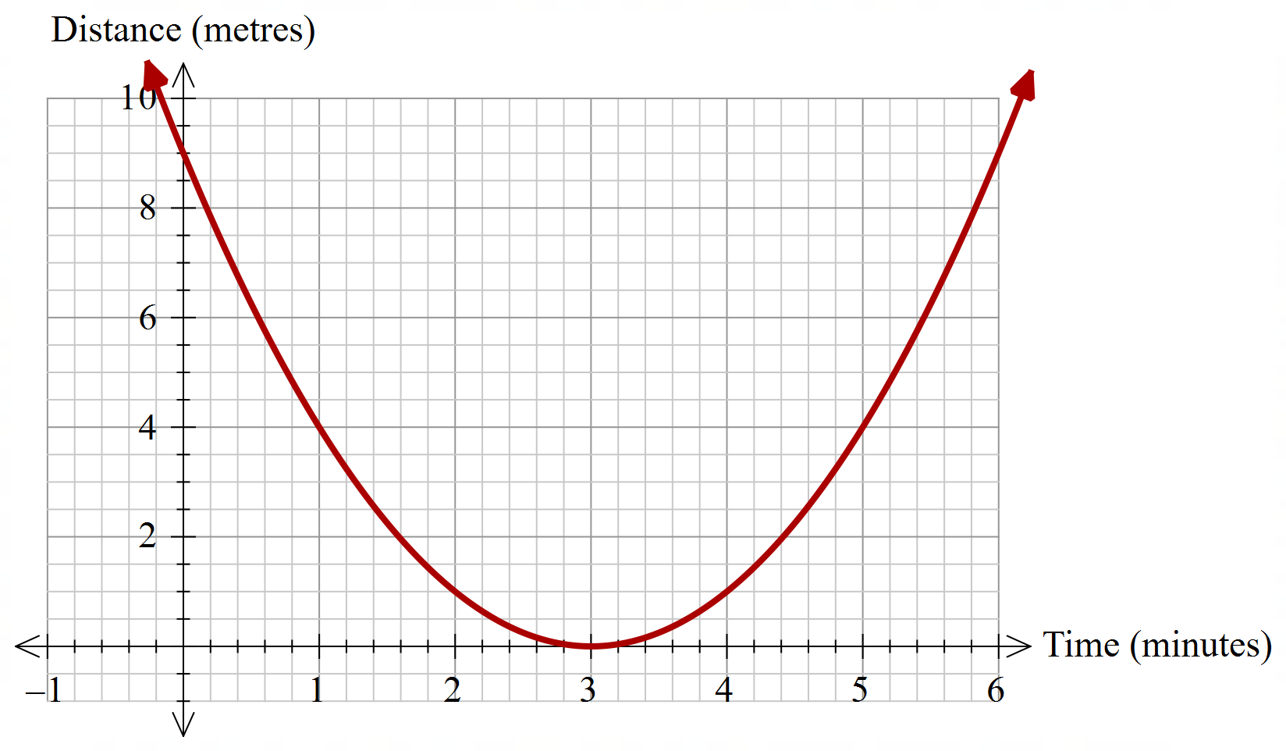

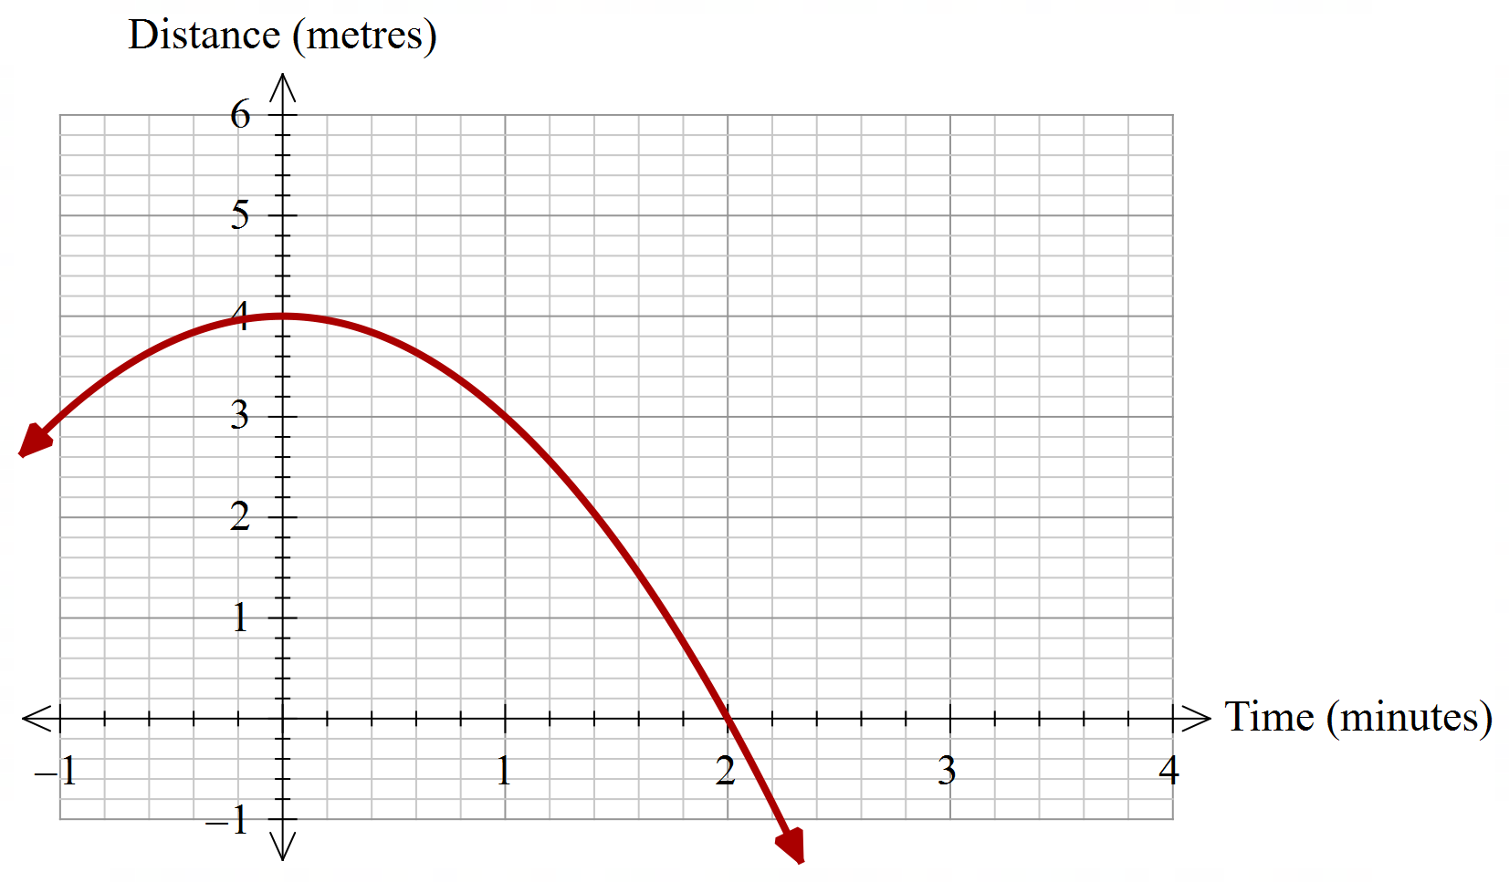

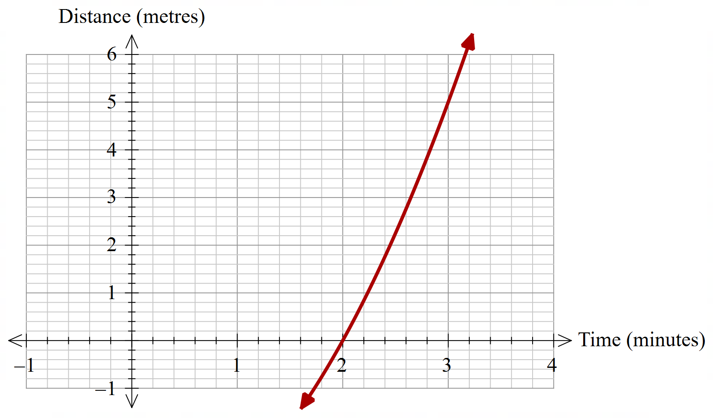

## References

This resource contains NSW Curriculum and syllabus content. The NSW Curriculum is developed by the NSW Education Standards Authority. This content is prepared by NESA for and on behalf of the Crown in right of the State of New South Wales. The material is protected by Crown copyright.

Please refer to the NESA Copyright Disclaimer for more information [https://educationstandards.nsw.edu.au/wps/portal/nesa/mini-footer/copyright](https://aus01.safelinks.protection.outlook.com/?url=https%3A%2F%2Feducationstandards.nsw.edu.au%2Fwps%2Fportal%2Fnesa%2Fmini-footer%2Fcopyright&data=05%7C01%7CCaitlin.Pace1%40det.nsw.edu.au%7C9c2c1a9f59c94d2df30708dafa7edb23%7C05a0e69a418a47c19c259387261bf991%7C0%7C0%7C638097720042599463%7CUnknown%7CTWFpbGZsb3d8eyJWIjoiMC4wLjAwMDAiLCJQIjoiV2luMzIiLCJBTiI6Ik1haWwiLCJXVCI6Mn0%3D%7C3000%7C%7C%7C&sdata=BzQh0UsffVZE3eO22b2Xba3p0VMOBZSHfS21FGHXtZM%3D&reserved=0).

NESA holds the only official and up-to-date versions of the NSW Curriculum and syllabus documents. Please visit the NSW Education Standards Authority (NESA) website <https://educationstandards.nsw.edu.au/> and the NSW Curriculum website <https://curriculum.nsw.edu.au/>.

[Mathematics K–10 Syllabus](https://curriculum.nsw.edu.au/learning-areas/mathematics/mathematics-k-10-2022/overview) © NSW Education Standards Authority (NESA) for and on behalf of the Crown in right of the State of New South Wales, 2022.

**© State of New South Wales (Department of Education), 2024**

The copyright material published in this resource is subject to the *Copyright Act 1968* (Cth) and is owned by the NSW Department of Education or, where indicated, by a party other than the NSW Department of Education (third-party material).

Copyright material available in this resource and owned by the NSW Department of Education is licensed under a [Creative Commons Attribution 4.0 International (CC BY 4.0) license](https://creativecommons.org/licenses/by/4.0/).

[](https://creativecommons.org/licenses/by/4.0/)

This license allows you to share and adapt the material for any purpose, even commercially.

Attribution should be given to © State of New South Wales (Department of Education), 2024.

Material in this resource not available under a Creative Commons license:

* the NSW Department of Education logo, other logos and trademark-protected material
* material owned by a third party that has been reproduced with permission. You will need to obtain permission from the third party to reuse its material.

**Links to third-party material and websites**

Please note that the provided (reading/viewing material/list/links/texts) are a suggestion only and implies no endorsement, by the New South Wales Department of Education, of any author, publisher, or book title. School principals and teachers are best placed to assess the suitability of resources that would complement the curriculum and reflect the needs and interests of their students.

If you use the links provided in this document to access a third-party's website, you acknowledge that the terms of use, including licence terms set out on the third-party's website apply to the use which may be made of the materials on that third-party website or where permitted by the *Copyright Act 1968* (Cth). The department accepts no responsibility for content on third-party websites.