Mathematics Stage 5   
(Year 10) – teacher information

Investigating parabolas

Contents

About this resource 2

Part 1 – teacher information 2

Part 2 – student notification 2

Part 3 – sample solutions 2

Outcomes 3

Core 3

Path 3

Task description 4

Purpose of task components 4

When and how to use 5

Preparing for the task 5

Managing the task 6

Issuing the student assessment notification 6

Materials list 6

Core 6

Path 6

Conducting the task 7

Option A – task to be completed in one lesson 7

Option B – task to be completed over 2 lessons 8

Suggestions for differentiation 9

Marking guidelines 9

Appendix A – Core mind map 10

Appendix B – Core non-routine problem 11

Appendix C – Path mind map 12

Appendix D – Path non-routine problem 13

References 18

# About this resource

This document is Part 1 of an assessment package designed to assess the outcomes from Unit 12 – investigating parabolas of the Department of Education’s [Stage 5 Year 10 sample scope and sequence](https://education.nsw.gov.au/teaching-and-learning/curriculum/mathematics/planning-programming-and-assessing-mathematics-7-10#Scope1).

## Part 1 – teacher information

The ‘Teacher information’ document contains:

* a task description
* the task, contained in Appendices A, B, C and D
* teacher support notes that outline relevant information about the task.

## Part 2 – student notification

The ‘Student assessment task notification’ document contains:

* information for students about the task
* marking guidelines.

## Part 3 – sample solutions

The ‘Sample solutions’ document contains:

* a set of sample solutions for both the Core and Path content
* an example of how the marking guidelines could be used to determine a grade
* a list of possible solutions for the Core and Path non-routine problems.

# Outcomes

## Core

A student:

* develops understanding and fluency in mathematics through exploring and connecting mathematical concepts, choosing and applying mathematical techniques to solve problems, and communicating their thinking and reasoning coherently and clearly **MAO-WM-01**
* simplifies algebraic fractions with numerical denominators and expands algebraic expressions **MA5-ALG-C-01**
* identifies connections between algebraic and graphical representations of quadratic and exponential relationships in various contexts **MA5-NLI-C-01**
* identifies and compares features of parabolas and exponential curves in various contexts **MA5-NLI-C-02**

## Path

* interprets and compares non-linear relationships and their transformations, both algebraically and graphically **MA5-NLI-P-01**
* simplifies algebraic fractions involving indices, and expands and factorises algebraic expressions **MA5-ALG-P-01**
* selects and applies appropriate algebraic techniques to operate with algebraic fractions, and expands, factorises and simplifies algebraic expressions **MA5-ALG-P-02**
* solves monic quadratic equations, linear inequalities and cubic equations of the form $ax^{3} = k$**MA5-EQU-P-01**
* solves linear equations of more than 3 steps, monic and non-monic quadratic equations, and linear simultaneous equations **MA5-EQU-P-02**

[Mathematics K**–**10 Syllabus](https://curriculum.nsw.edu.au/learning-areas/mathematics/mathematics-k-10-2022/overview) © NSW Education Standards Authority (NESA) for and on behalf of the Crown in right of the State of New South Wales, 2022.

# Task description

**Type of task**: In-class task

The task provides students with opportunities to demonstrate their knowledge, critical thinking and problem-solving skills. It has 2 parts:

1. Students will create a mind map. A diagram of a set of parabolas will be provided as a starting point.
2. Students will attempt a non-routine problem.

There are 2 versions of the task:

* one for students who have studied only Core outcomes of the syllabus
* one for students who have studied both Core and Path outcomes of the syllabus.

The task may need to be modified to reflect the Path outcomes covered by the students.

Teachers are advised to consider the assessment and reporting requirements of their school when determining which version to use.

## Purpose of task components

* A visual stimulus for the mind map has been provided as a starting point for all students. Students should be encouraged to annotate the diagrams and add further knowledge about parabolas and quadratics to the mind map.
* The aim of the non-routine problem in the Core version is to draw out student understanding of the relationship between parabolas and quadratic relationships.
* The aim of the non-routine problem in the Path version is to draw out student understanding of quadratic expressions and how to factorise them.
* The non-routine problem can be adjusted to meet the assessment goals of the teacher.

## When and how to use

The task should be assigned once Unit 12 – investigating parabolas has been completed.

The recommended time allocated for the task is one hour. There are 2 recommended options for completing the task. Adjustments may be needed to suit individual schools.

Table 1 – task options

|  |  |
| --- | --- |
| Task options | Timing recommendation |
| Option A – students complete the task in one lesson | * Approximately 20 minutes to create the mind map * Approximately 20 minutes to attempt the non-routine problem * Approximately 20 minutes to refine the mind map and complete the non-routine problem |
| Option B – students complete the task over 2 lessons | * Approximately 30 minutes to create the mind map, in the first lesson * Approximately 30 minutes to respond to the non-routine problem in the second lesson |

## Preparing for the task

* Teachers should offer students an opportunity to practise and seek feedback on creating mind maps, before the day of the task.
* The non-routine problem for the Path task is an Open Middle problem. Students should have an opportunity to become familiar with Open Middle problems before completing the task. Other Open Middle problems can be found on the [Open Middle](https://www.openmiddle.com/) website.

## Managing the task

### Issuing the student assessment notification

Provide the following information to students when issuing the student assessment notification.

* The time allocated for the task will be one hour. Depending on the option chosen, students will have either one hour in one lesson or over 2 lessons. This may need to be amended on the student assessment task notification for students.
* The timing within the task will be managed by the teacher.
* During the task, students will create a mind map based on some diagrams of parabolas, which will be supplied.
* The task requires students to create a mind map and respond to a non-routine problem.
* The student assessment task notification includes dot points from Unit 12 – investigating parabolas which can be used for revision and to practise creating a mind map.

## Materials list

### Core

* Appendix A ‘Core mind map’ – class set, printed on A3
* Appendix B ‘Core non-routine problem’ – class set, printed on A4
* Blank paper

### Path

* Appendix C ‘Path mind map’ – class set, printed on A3
* Appendix D ‘Path non-routine problem’ – class set, printed on A4

## Conducting the task

### Option A – task to be completed in one lesson

Students should be provided with Appendix A (Core) or Appendix C (Path) which contain the parabola diagrams for the mind map to begin the task.

It is recommended that teachers distribute Appendix B (Core) or Appendix D (Path) which contain the non-routine problem to students after the first 20 minutes.

The following text is a script of how you could introduce the task on the day students are completing it.

I have provided you with a picture of some parabolas to use to create a mind map. You can write and draw on and around the diagrams, telling me everything you know about parabolas and quadratics.

After 20 minutes, I will distribute a non-routine problem for you to attempt. You should spend 20 minutes focusing on solving it, making sure you explain your mathematical thinking when completing the task.

I will let you know when the 20 minutes is finished.

You will then have 20 minutes to work on both your mind map and your solution to the non-routine problem.

### Option B – task to be completed over 2 lessons

The following text is a script of how you could introduce the task on the days on which students are completing the task.

#### Lesson 1 – mind map

I have provided you with a picture of some parabolas to use to create a mind map.

You can write and draw on and around the diagrams, telling me everything you know about parabolas and quadratics.

You will have 30 minutes to create your mind map.

#### Lesson 2 – non-routine problem

I have provided you with a non-routine problem for you to respond to.

You should focus on solving the problem, making sure you explain your mathematical thinking as you solve the problem.

You will have 30 minutes to complete the non-routine problem.

# Suggestions for differentiation

* Support students to create a glossary of terms from the Unit 12 – investigating parabolas to prepare for the task.
* Students who require additional support could have further scaffolding, such as key points marked with dots on the graphs and sentence starters for the mind map.
* The outcomes assessed in this task should be adapted to fit the school context.
* The teacher should demonstrate the process of creating a mind map during a lesson before the assessment. An example of a mind map is provided in the student assessment task notification.
* Teachers may decide to provide space for additional attempts of the non-routine problem to give students further opportunities to explain their thinking and reasoning. However, it is recommended that no more than 5 attempts be provided to ensure students focus on strategy, rather than guess and check.
* Teachers could use an alternative non-routine problem for Path content by changing the expressions to quadratic equations and asking students to find solutions with $x$-intercepts that are integers.

# Marking guidelines

The marking guidelines provide an opportunity to give feedback on the assessment. Teachers will use this table to assign an overall grade and to provide feedback on what was done well and how improvements could be made.

The marking guidelines contain 5 criteria. The first 3 criteria are for all students, the final 2 criteria apply to students studying either Core or Path outcomes and align to the corresponding non-routine problem provided in the teacher information. Teachers will need to amend the table to display only the appropriate criteria, before issuing the task to students.

# Appendix A – Core mind map

Three graphs of parabolas. Each of the graphs has a parabola with a dashed line that begins in the top left quadrant, goes down and turns at the origin and continues up into the top right quadrant. The first graph also has a parabola with a solid line that starts in the top left quadrant, has a turning point at the point (0,-2) and continues up into the top right quadrant.
The second graph has a parabola with a solid line that starts in the bottom left quadrant, goes up to a turning point at the origin and continues down into the bottom right quadrant. The third graph has a parabola with a solid line that starts in the top left quadrant, goes down to a turning point at (0,2) and then continues up into the top right quadrant.

# Appendix B – Core non-routine problem

**Problem:** Galileo was a mathematician and astronomer in the 1600s. After studying quadratic equations, he incorrectly assumed that a hanging rope or chain followed the path of a quadratic curve. Instead, the shape is a catenary.

The following graph and table of approximate values represent a catenary.

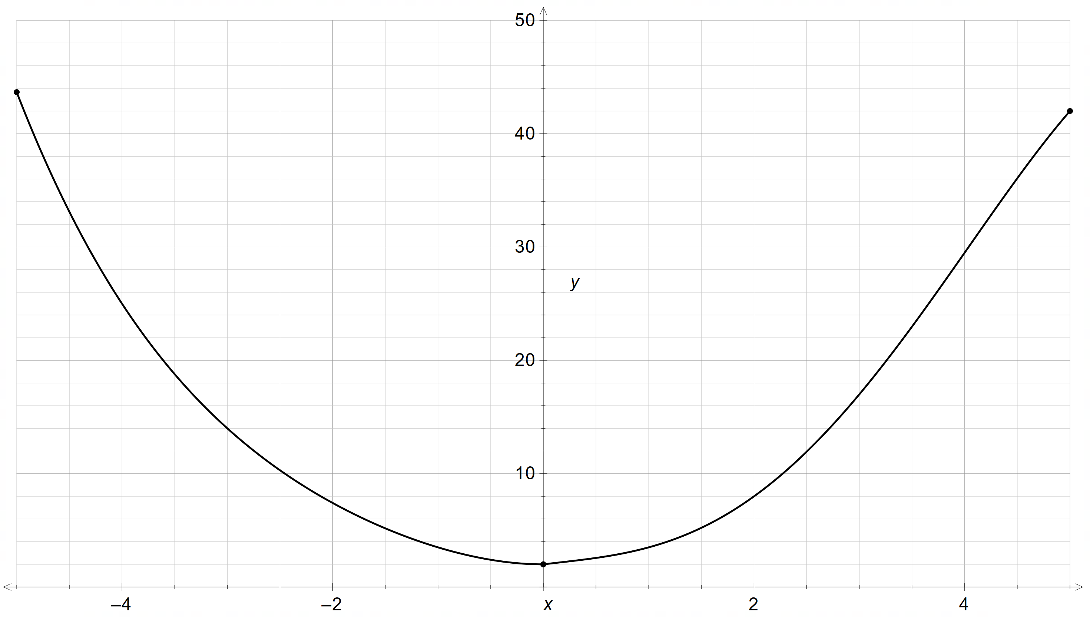

Table 1 – partially completed table of approximate values of the catenary

|  |  |  |  |  |  |  |  |  |  |  |  |
| --- | --- | --- | --- | --- | --- | --- | --- | --- | --- | --- | --- |
| $$x$$ | $$-5$$ | $$-4$$ | $$-3$$ | $$-2$$ | $$-1$$ | $$0$$ | $$1$$ | $$2$$ | $$3$$ | $$4$$ | $$5$$ |
| $$y$$ |  | $$25$$ | $$14$$ |  | $$3.5$$ | $$2$$ | $$3.5$$ | $$8$$ | $$17$$ |  | $$42$$ |

Use different methods to show that an equation of the form $y=ax^{2}+c$**cannot** be used to model this data well.

When considering how you might do this, you might think about the features of a parabola and different representations of a quadratic relationship.

You may find that some methods do not work. If this happens, you should explain why.

# Appendix C – Path mind map

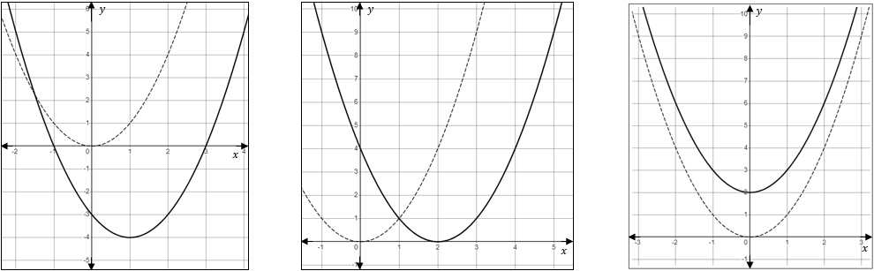

# Appendix D – Path non-routine problem

**Instructions**

Attempt to solve the following non-routine problem and answer the questions below it.

If you find one solution, then attempt to find another unique solution. If you can’t find another unique solution, explain why.

**Problem**

Using the digits 1–9 no more than one time each, place a digit in each box to create 4 different quadratic expressions that can be factorised as a binomial product.

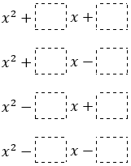

**First attempt**



Is your solution valid? How do you know?

What did you learn from this attempt?

How will your strategy change on your next attempt?

**Second attempt**



Is your solution valid? How do you know?

What did you learn from this attempt?

How will your strategy change on your next attempt?

**Third attempt**



Is your solution valid? How do you know?

What did you learn from this attempt?

How will your strategy change on your next attempt?

**Fourth attempt**



Is your solution valid? How do you know?

What did you learn from this attempt?

# References

This resource contains NSW Curriculum and syllabus content. The NSW Curriculum is developed by the NSW Education Standards Authority. This content is prepared by NESA for and on behalf of the Crown in right of the State of New South Wales. The material is protected by Crown copyright.

Please refer to the NESA Copyright Disclaimer for more information [https://educationstandards.nsw.edu.au/wps/portal/nesa/mini-footer/copyright](https://aus01.safelinks.protection.outlook.com/?url=https%3A%2F%2Feducationstandards.nsw.edu.au%2Fwps%2Fportal%2Fnesa%2Fmini-footer%2Fcopyright&data=05%7C01%7CCaitlin.Pace1%40det.nsw.edu.au%7C9c2c1a9f59c94d2df30708dafa7edb23%7C05a0e69a418a47c19c259387261bf991%7C0%7C0%7C638097720042599463%7CUnknown%7CTWFpbGZsb3d8eyJWIjoiMC4wLjAwMDAiLCJQIjoiV2luMzIiLCJBTiI6Ik1haWwiLCJXVCI6Mn0%3D%7C3000%7C%7C%7C&sdata=BzQh0UsffVZE3eO22b2Xba3p0VMOBZSHfS21FGHXtZM%3D&reserved=0).

NESA holds the only official and up-to-date versions of the NSW Curriculum and syllabus documents. Please visit the NSW Education Standards Authority (NESA) website <https://educationstandards.nsw.edu.au/> and the NSW Curriculum website [https://curriculum.nsw.edu.au](https://curriculum.nsw.edu.au/).

[Mathematics K–10 Syllabus](https://curriculum.nsw.edu.au/learning-areas/mathematics/mathematics-k-10-2022/overview) © NSW Education Standards Authority (NESA) for and on behalf of the Crown in right of the State of New South Wales, 2022.

**© State of New South Wales (Department of Education), 2025**

The copyright material published in this resource is subject to the *Copyright Act 1968* (Cth) and is owned by the NSW Department of Education or, where indicated, by a party other than the NSW Department of Education (third-party material).

Copyright material available in this resource and owned by the NSW Department of Education is licensed under a [Creative Commons Attribution 4.0 International (CC BY 4.0) license](https://creativecommons.org/licenses/by/4.0/).

[](https://creativecommons.org/licenses/by/4.0/)

This license allows you to share and adapt the material for any purpose, even commercially.

Attribution should be given to © State of New South Wales (Department of Education), 2025.

Material in this resource not available under a Creative Commons license:

* the NSW Department of Education logo, other logos and trademark-protected material
* material owned by a third party that has been reproduced with permission. You will need to obtain permission from the third party to reuse its material.

**Links to third-party material and websites**

Please note that the provided (reading/viewing material/list/links/texts) are a suggestion only and implies no endorsement, by the New South Wales Department of Education, of any author, publisher, or book title. School principals and teachers are best placed to assess the suitability of resources that would complement the curriculum and reflect the needs and interests of their students.

If you use the links provided in this document to access a third-party's website, you acknowledge that the terms of use, including licence terms set out on the third-party's website apply to the use which may be made of the materials on that third-party website or where permitted by the *Copyright Act 1968* (Cth). The department accepts no responsibility for content on third-party websites.