# Flame versus time

Students will predict when a candle burns out by looking at data on the height of the candle and the time the candle has been burning.

## Visible learning

Learning intentions and success criteria should be shared with students later in the learning episode, towards the end of the Explore.

### Learning intentions

* To understand the relationship between independent and dependent variables.
* To be able to describe the association between 2 variables.

### Success criteria

* I can determine which variable is the independent variable.
* I can plot bivariate data on a scatter plot.
* I can describe the strength of the association between 2 variables using the terms ‘weak’, ‘moderate’ and ‘strong’.
* I can describe the direction of the association between 2 variables using the terms ‘positive’ and ‘negative’.

### Syllabus outcomes

A student:

* develops understanding and fluency in mathematics through exploring and connecting mathematical concepts, choosing and applying mathematical techniques to solve problems, and communicating their thinking and reasoning coherently and clearly **MAO-WM-01**
* displays and interprets datasets involving bivariate data **MA5-DAT-C-02**

[Mathematics K–10 Syllabus](https://curriculum.nsw.edu.au/learning-areas/mathematics/mathematics-k-10-2022/overview) © NSW Education Standards Authority (NESA) for and on behalf of the Crown in right of the State of New South Wales, 2022.

Table 1: lesson summary

|  |  |  |  |
| --- | --- | --- | --- |
| Section | Summary of activity | Teaching strategies | Teaching points |
| Launch | Watch the video ‘Candle burning’ [(bit.ly/candle_burning](https://bit.ly/candle_burning)) from the Making Math Moments lesson under the ‘Spark Curiosity’ headingand discuss what students notice and wonder. | Think-Pair-Share | Students use existing data to predict how long it will take for a candle to extinguish. |
| Explore | Watch more of the clip. Students are to estimate the time it takes for the candle to burn out. Groups should consider other groups' responses. Consider data from the clip and have students plot points. Students review other groups' models and consider why they may vary. Define independent and dependent variables. Students review the Flame versus time PowerPoint slides 3–5. Students consider the relationship between the 2, and whether there is an association and whether it is strong/moderate/weak or positive/negative. | Visibly random groups of 3  Vertical non-permanent surfaces  Gallery walk  Pose-Pause-Pounce-Bounce | Students take the data from the clip and plot the points on a scatter plot before considering a model. They then look at ways to describe the association between the 2 variables. |
| Summarise | Students complete Appendix A as a group before reviewing their peers’ responses. Students then do the card sorting activity from Appendix B before ordering the cards from strongest negative association through to strongest positive association. | Visibly random groups of 3  Vertical non-permanent surfaces  Gallery walk | Students consolidate the words strong/moderate/weak and negative /positive with different examples |
| Apply | Students then do an Open Middle problem that is shown on slide 7 of the PowerPoint. Students then complete Appendix C ‘Polygraph’ activity. | Pose-Pause-Pounce-Bounce  Think-Pair-Share | Apply knowledge to activities. |

## Activity structure

Please use the associated PowerPoint *Flame versus time* (FVT PPT) to display images in this lesson.

### Launch

This lesson has been modified from the Making Math Moments that matter lesson ‘Candle Burning’ [(bit.ly/candle_burning](https://bit.ly/candle_burning)).

1. Navigate to the Making Math Moments webpage ‘Candle burning’ [(bit.ly/candle_burning](https://bit.ly/candle_burning)).
2. Show students the video under the **Spark Curiosity** heading which shows a candle being lit and starting to burn (1:00).
3. Ask students what they notice and wonder ([bit.ly/noticewonderstrategy](https://bit.ly/noticewonderstrategy)). Students may write down in their books what they notice and wonder.

Students might notice:

* that the candle was tall
* that the candle was narrow
* that the candle was cylindrical
* what the candle was being held by.

Students might wonder:

* How long will the candle burn?
* Why do we burn candles?
* How long would it take for the candle to burn out?
* Would the shape of the candle affect the time taken to burn out?
* Would the height or width of the candle affect the time taken to burn out?

1. In a Think-Pair-Share ([bit.ly/thinkpairsharestrategy](https://bit.ly/thinkpairsharestrategy)), ask students to estimate how long it will take before the candle burns out. Students should record their estimate in their workbooks.
2. Ask students to indicate their confidence in their estimate with a finger vote, with 5 being very confident.

### Explore

1. Watch the video under the **Fuel Sense-making** heading from the Making Math Moments webpage ‘Candle burning’ (1:00) [(bit.ly/candle_burning](https://bit.ly/candle_burning)).
2. Assign students to visibly random groups of 3 ([bit.ly/visiblegroups](https://bit.ly/visiblegroups)) at vertical non-permanent surfaces ([bit.ly/VNPSstrategy](https://bit.ly/VNPSstrategy)).
3. Have students record the time and height table data from the video on their vertical non-permanent surface.
4. Ask students to review their estimate from the Launch and form a new estimate as a group based on the given video data and their own experiences. Students should record this new estimate on their vertical non-permanent surface along with the group's reasoning for the estimate.
5. Ask groups to indicate their confidence in their estimate with a finger vote, with 5 being very confident.

Students should be encouraged to use some type of mathematical model; however, teachers should be careful not to funnel students towards a specific approach.

1. Students perform a gallery walk ([bit.ly/DLSgallerywalk](https://bit.ly/DLSgallerywalk)) to review other group's estimates and reasoning.

Some approaches that students might take include:

* Doubling the time it took to burn half of the candle.
* Approximating the rate that the candle burns, for example, 0.1 cm/minute.
* Extending the table using rate or ratio reasoning.
* Sketching a scatter plot and constructing a line of best fit.

1. Use the Pose-Pause-Pounce-Bounce questioning strategy (PDF 557 KB) ([bit.ly/posepausepouncebounce](https://bit.ly/posepausepouncebounce)) to ask students what strategies they saw during the gallery walk and which they liked best.
2. Show students the video ‘Reveal’ (0:46) under the **Next Moves** heading, pressing pause at (0:20).
3. Distribute an A3 sheet of graph paper ([bit.ly/Graph_paper_mathlinks](https://bit.ly/Graph_paper_mathlinks)) in a plastic sleeve with adhesive putty to each group of 3. Ask students to plot the data on graph paper at their vertical non-permanent surface.

Teachers can access printable graph paper of various sizes from ([bit.ly/Graph_paper_mathlinks](https://bit.ly/Graph_paper_mathlinks)).

If students drew a scatter plot to assist with their previous estimate, ask them to consider how this more accurate plot will affect their estimate.

Students are not required to draw the line of best fit. Students learn about lines of best fit in Lesson 3 – lines of best fit.

1. Ask students to use their plotted data to re-evaluate their estimate for how long it will take for the candle to burn out.
2. Ask groups to indicate their confidence in their solution with a finger vote, with 5 being very confident. Have groups consider how their confidence has changed since their initial, individual estimate.
3. Have groups write their latest estimate on the teacher’s board.
4. Using the Pose-Pause-Pounce-Bounce questioning strategy, ask students why different group’s estimates differ from each other.

Teachers can inform students that the use of the mathematical model to predict what would happen outside of the range of the original data is called ‘extrapolation’. This will be addressed in the next lesson.

1. Show students the rest of the video ‘Reveal’ (0:46) under the **Next Moves** heading.
2. Use the Pose-Pause-Pounce-Bounce questioning strategy to ask students:

* What do the terms ‘independent’ and ‘dependent’ refer to in the table?
* Why does the height of the candle depend on time, rather than time depending on the height of the candle?

Answers could include:

* One variable’s value depends on the other.

Inform students that the syllabus glossary defines independent and dependent variable as follows: An independent variable is used to represent the input values of a function and is generally represented on the horizontal axis of a graph whilst the dependent variable is used to represent the output values of a function. It is generally represented on the vertical axis of a graph (NESA 2022).

1. Use the Pose-Pause-Pounce-Bounce questioning strategy to ask students if there is a relationship between the height of the candle and the time it takes to burn.

The longer the candle burned, the shorter the candle became.

1. Inform students that this relationship between the height of the candle and time it takes to burn is called an association. Ask students to describe the association between time and height in their own words.

Students may answer that the data has a negative, decreasing or downhill trend. Emphasise that the data having a negative trend is referred to as having a negative association, and a positive trend would be referred to as having a positive association.

1. Display slide 3 and then slide 4 from the PowerPoint (FVT PPT).
2. Use the Pose-Pause-Pounce-Bounce questioning strategy to ask students to share how they would describe the associations shown on slides 3 and 4.

Slide 3 – both plots show a strong association. The first one is positive and the second one is negative.

Slide 4 – both plots show a weak association. The first one is positive and the second one is negative.

1. Display slide 5 of the PowerPoint (FVT PPT) and ask students to describe the association.

There appears to be no association.

1. Explain to students that we can describe an association, in addition to the terms positive/negative, as weak, moderate, or strong. It should also be noted that if no relationship is visible between 2 variables, like in slide 5, they are said to have no association.
2. Reveal to students the learning intentions and success criteria for the lesson.

### Summarise

1. Distribute Appendix A ‘Terminology’ to each group of 3. Have students work in groups to complete the information presented in the table on the vertical non-permanent surfaces.
2. Students are to perform a gallery walk and see what other groups have written.
3. Students return to their groups and update the information in their tables, if necessary.

Independent variable: a variable used to represent values in the domain (input values) of a function. Generally represented on the horizontal axis of a graph.

Dependent variable: the variable used to represent the output values of a function. A dependent variable is generally represented on the vertical axis of a graph.

Association: association is any relationship between two variables, including linear and non-linear.

1. Students copy the finalised terminology into their workbook, or each student could be given a copy of Appendix A to complete.
2. In pairs, students are to complete the card matching activity from Appendix B ‘Card sorting activity’. Students are to group the cards into 2 groups: positive association and negative association.

Teachers may find that having these cards precut into sets is easier for lesson implementation.

1. Students are to take all the cards that have a positive association and arrange them from the weakest positive to the strongest positive association. Repeat for the negative associations.

### Apply

#### Open Middle

1. Display slide 7 of the PowerPoint (FVT PPT), which shows an Open Middle problem.
2. Continuing to work in groups of 3 at vertical non-permanent surfaces, students are to use only the numbers from −9 to 9, at most one time each, to find a data set of 6 points that have a positive association.
3. Students do a gallery walk to observe other student's solutions.
4. Repeat the activity, but have students find a data set of 6 points that have a negative association.

#### Polygraph

1. Distribute a copy of Appendix C ‘Polygraph’ to each pair. The graph shows a sample of 30-year-old men's resting heart rate vs systolic blood pressure.

Blood pressure is recorded as 2 numbers written as an improper, unsimplified fraction, such as 120/80. The first number is the systolic blood pressure and is a measure of the pressure in the arteries as the heart pumps blood out. The other number is the diastolic blood pressure and measures the pressure as the heart relaxes before the next beat.

1. In a Think-Pair-Share ask students to consider whether there appears to be any association between the resting heart rate and blood pressure and if so to describe it.
2. Ask students, in pairs, to plot the data from the 5 people listed and then consider whether their data has the same association as shown by the other participants.
3. Use the Pose-Pause-Pounce-Bounce questioning strategy to ask the class whether this is an accurate measure of whether a person could be telling a lie.

## Assessment and differentiation

### Suggested opportunities for differentiation

**Launch**

* A notice and wonder strategy is used where there is no correct answer, so that all students can participate in the discussion.

**Explore**

* Students are predicting the time that it will take the candle to burn out. There is no correct answer so all students can participate. Students could review other group’s responses before refining their own responses.
* If the teacher notices a group with a misconception on how to predict the time, they can temporarily combine 2 groups, telling the groups to justify their approaches.

**Summarise**

* The card sorting activity is completed in pairs and allows for discussion about what each term means in the association.
* Sentence starters can be provided for students who may be struggling to describe the associations in their own words.

**Apply**

* **Challenge students to find the strongest possible positive and negative association when completing the Open Middle problem.**

### Suggested opportunities for assessment

**Launch**

* The teacher could facilitate class discussions and observe students’ reasoning in response to the notice and wonder activity.

**Explore**

* Teachers can assess a student’s ability to construct a scatter plot by using the data provided.
* **Students working at vertical non-permanent surfaces allows the teacher to assess student progress and provide support where appropriate.**
* **Teachers can use the finger vote results as an indication of student confidence and understanding.**

**Summarise**

* The card sorting activity and discussion can be observed by the teacher and used as formative assessment of student understanding of strength and direction of an association.

**Apply**

* During the Open Middle activity, the development of the 6 points can be used as evidence of learning and understanding about the strength and direction of the association.
* Teachers could use Appendix C ‘Polygraph’ as evidence of understanding how to plot points and describe an association.
* Students give each other peer feedback, before sharing with the class in a Think-Pair-Share.

## Appendix A

### Terminology

|  |  |  |  |
| --- | --- | --- | --- |
| Name | Definition | Facts and characteristics | Examples |
| Dependent variable |  | . |  |
| Independent variable |  |  |  |
| Association |  |  |  |

## Appendix B

### Card sorting activity

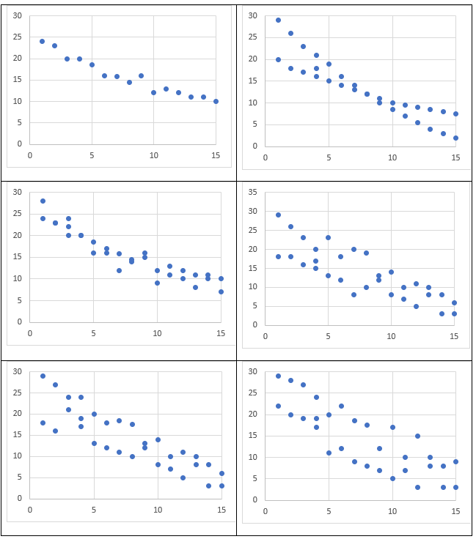

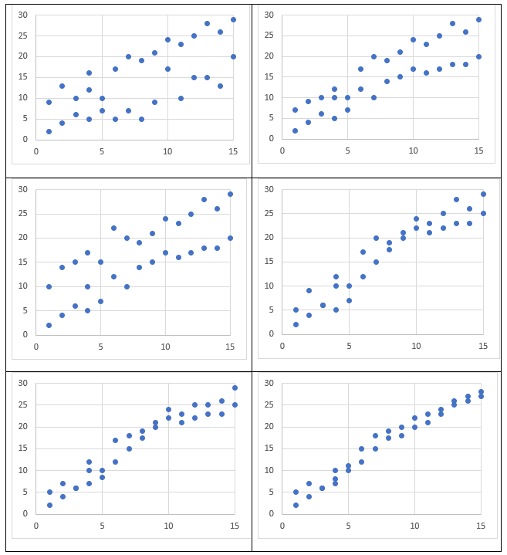

## Appendix C

### Polygraph

Polygraphs or ‘Lie detectors’ measure a person’s heart rate, blood pressure, respiration and electrodermal response (how well the skin conducts electricity). Studies have shown that people who are being deceptive can experience a change to their resting heart rate, blood pressure, respiration and electrodermal responses that would be different to what they experience when not being deceptive.

A random selection of sixty 30-year-old men had their resting heart rate and systolic (top number in blood pressure) blood pressure measured and the data was displayed in the scatter plot below.

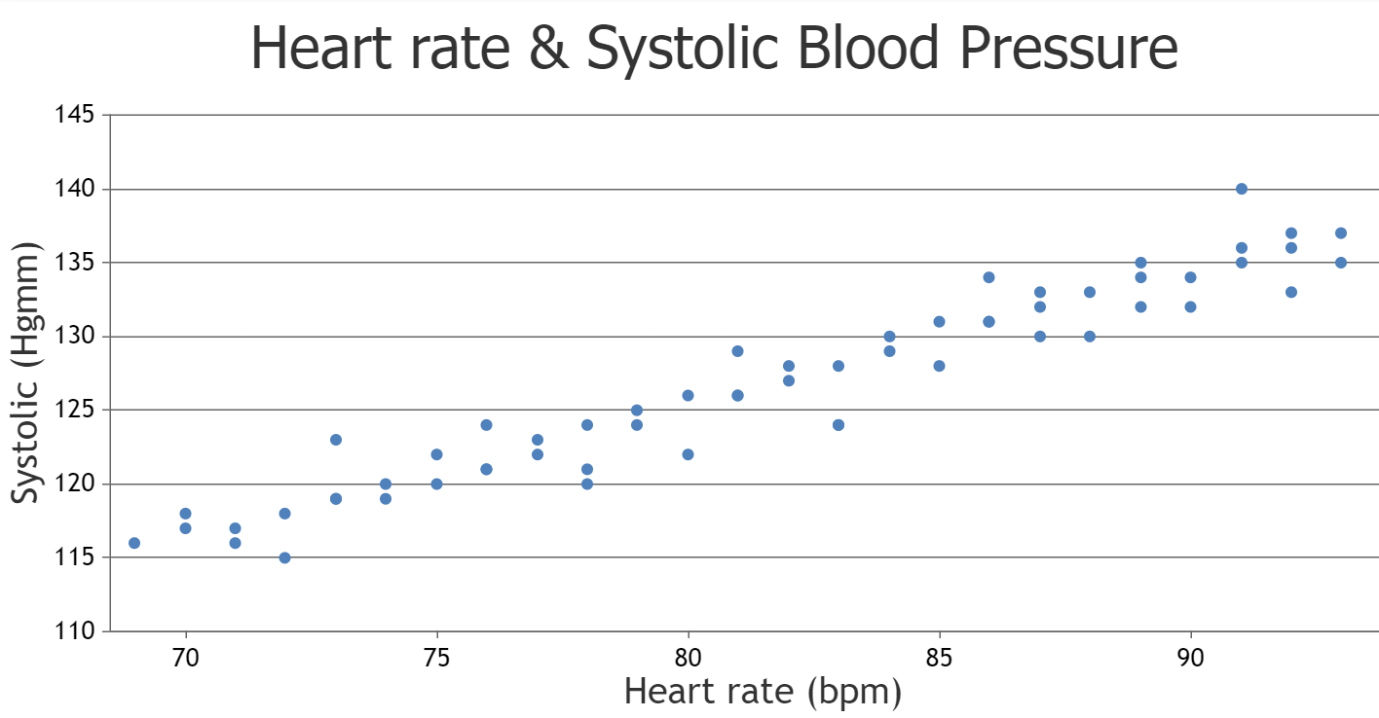

Each dot represents a person.

1. Does there appear to be any association between the resting heart rate and systolic blood pressure of the 30-year-old men, and if so, describe it?
2. Plot the data of the 5 men in the table below, onto the graph.

|  |  |  |
| --- | --- | --- |
| Name | Resting heart rate (bpm) | Systolic (mm Hg) |
| Albert | 86 | 135 |
| Boris | 80 | 142 |
| Calvin | 89 | 130 |
| Doug | 74 | 119 |
| Ernie | 90 | 122 |

1. Using the information provided, make a judgment about who may ‘fail’ the polygraph test.

## Sample solutions

### Open Middle question answer examples

Positive: (−9, −8), (−7, −6), (−5, −4), (−3, −2), (−1, 0), (1, 2)

Negative: (−9, 8), (−8, 6), (−7, 4), (−6, 1), (−5, 0), (−4, −3)

### Appendix A – terminology

|  |  |  |  |
| --- | --- | --- | --- |
| Name | Definition | Facts and characteristics | Examples |
| Dependent variable | The variable used to represent the output values of a function. | A dependent variable is generally represented on the vertical axis of a graph. | The amount of money (dependent) earned is dependent on the hours (independent) a person works. |
| Independent variable | A variable used to represent values in the domain (input values) of a function. | Usually represented on the horizontal axis of a graph. | The amount of coffee you consume (independent) affects the hours you stay awake (dependent). |
| Association | Association refers to any relationship between two variables, including linear and non-linear. | It can be viewed using a scatterplot. | There is an association between the amount of study a student does for a test and the student’s result in the test. |

### Appendix C – polygraph

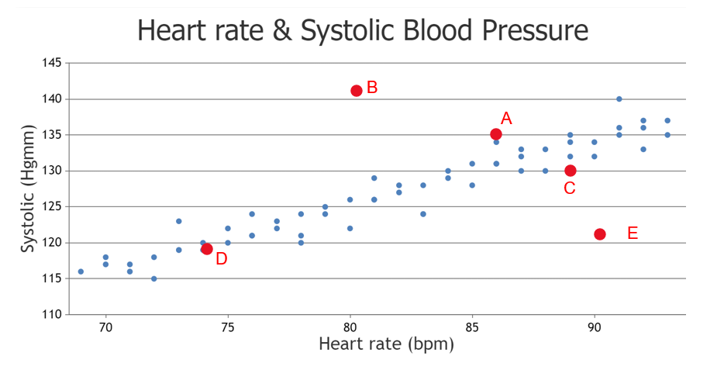

The 2 results that stand out as not following the trends and could be considered to have failed the polygraph are Boris and Ernie.

Boris’s systolic measure is significantly higher compared to other 30-year-olds with similar resting heart rates.

Ernie’s heart rate is elevated compared to others with similar blood pressure.

## References

This resource contains NSW Curriculum and syllabus content. The NSW Curriculum is developed by the NSW Education Standards Authority. This content is prepared by NESA for and on behalf of the Crown in right of the State of New South Wales. The material is protected by Crown copyright.

Please refer to the NESA Copyright Disclaimer for more information [https://educationstandards.nsw.edu.au/wps/portal/nesa/mini-footer/copyright](https://aus01.safelinks.protection.outlook.com/?url=https%3A%2F%2Feducationstandards.nsw.edu.au%2Fwps%2Fportal%2Fnesa%2Fmini-footer%2Fcopyright&data=05%7C01%7CCaitlin.Pace1%40det.nsw.edu.au%7C9c2c1a9f59c94d2df30708dafa7edb23%7C05a0e69a418a47c19c259387261bf991%7C0%7C0%7C638097720042599463%7CUnknown%7CTWFpbGZsb3d8eyJWIjoiMC4wLjAwMDAiLCJQIjoiV2luMzIiLCJBTiI6Ik1haWwiLCJXVCI6Mn0%3D%7C3000%7C%7C%7C&sdata=BzQh0UsffVZE3eO22b2Xba3p0VMOBZSHfS21FGHXtZM%3D&reserved=0).

NESA holds the only official and up-to-date versions of the NSW Curriculum and syllabus documents. Please visit the NSW Education Standards Authority (NESA) website <https://educationstandards.nsw.edu.au/> and the NSW Curriculum website <https://curriculum.nsw.edu.au/>.

[Mathematics K–10 Syllabus](https://curriculum.nsw.edu.au/learning-areas/mathematics/mathematics-k-10-2022/overview) © NSW Education Standards Authority (NESA) for and on behalf of the Crown in right of the State of New South Wales, 2022.

NESA (NSW Education Standards Authority (2022) [‘Glossary’](https://curriculum.nsw.edu.au/learning-areas/mathematics/mathematics-k-10-2022/glossary), Mathematics K–10, NESA website, accessed 6 November 2024.

**© State of New South Wales (Department of Education), 2024**

The copyright material published in this resource is subject to the *Copyright Act 1968* (Cth) and is owned by the NSW Department of Education or, where indicated, by a party other than the NSW Department of Education (third-party material).

Copyright material available in this resource and owned by the NSW Department of Education is licensed under a [Creative Commons Attribution 4.0 International (CC BY 4.0) license](https://creativecommons.org/licenses/by/4.0/).

[](https://creativecommons.org/licenses/by/4.0/)

This license allows you to share and adapt the material for any purpose, even commercially.

Attribution should be given to © State of New South Wales (Department of Education), 2024.

Material in this resource not available under a Creative Commons license:

* the NSW Department of Education logo, other logos and trademark-protected material
* material owned by a third party that has been reproduced with permission. You will need to obtain permission from the third party to reuse its material.

**Links to third-party material and websites**

Please note that the provided (reading/viewing material/list/links/texts) are a suggestion only and implies no endorsement, by the New South Wales Department of Education, of any author, publisher, or book title. School principals and teachers are best placed to assess the suitability of resources that would complement the curriculum and reflect the needs and interests of their students.

If you use the links provided in this document to access a third-party's website, you acknowledge that the terms of use, including licence terms set out on the third-party's website apply to the use which may be made of the materials on that third-party website or where permitted by the *Copyright Act 1968* (Cth). The department accepts no responsibility for content on third-party websites.