# Lines of best fit

Students develop the idea of placing a line of best fit by eye on a scatter plot to make more accurate predictions and use the terminology of ‘interpolation’ and ‘extrapolation’.

Students will need at least one digital device per pair to interact with Desmos during this lesson.

## Visible learning

### Learning intention

* To be able to draw, interpret, and make predictions using a line of best fit by eye.

### Success criteria

* I can draw a line of best fit by eye.
* I can explain what the gradient and $y$-intercept of a line of best fit represent.
* I can define interpolation and extrapolation.
* I can use a line of best fit to interpolate and extrapolate information.

### Syllabus outcomes

A student:

* develops understanding and fluency in mathematics through exploring and connecting mathematical concepts, choosing and applying mathematical techniques to solve problems, and communicating their thinking and reasoning coherently and clearly **MAO-WM-01**
* displays and interprets datasets involving bivariate data **MA5-DAT-C-02**
* graphs and interprets linear relationships using the gradient/slope-intercept form   
  **MA5-LIN-C-02**

[Mathematics K–10 Syllabus](https://curriculum.nsw.edu.au/learning-areas/mathematics/mathematics-k-10-2022/overview) © NSW Education Standards Authority (NESA) for and on behalf of the Crown in right of the State of New South Wales, 2022.

Table 1: lesson summary

|  |  |  |  |
| --- | --- | --- | --- |
| Section | Summary of activity | Teaching strategies | Teaching points |
| Warm up | Students use the Desmos Polygraph activity ‘Polygraph: Linear Functions Revision’ ([bit.ly/LinearRevision](https://bit.ly/LinearRevision)) to revise the features of linear graphs. Discuss the questions students found useful to help guess the graphs. | Pose-Pause-Pounce-Bounce | Activate prior knowledge of linear relationships.  Emphasise terminology like gradient, slope, and $y$-intercept. |
| Launch | Students use the Desmos classroom activity ‘Scatter Plot Capture’ ([bit.ly/ScatterPlotCapture](https://bit.ly/ScatterPlotCapture)) to make predictions based on a trend. | Think-Pair-Share  Desmos pacing | This section aims for students to see that it is easier to make predictions when the points closely follow a linear relationship. |
| Explore | Discuss students’ strategies for capturing the dot in the last activity. Explain how fitting a straight line to the data can help us to make predictions. Students complete the Desmos classroom activity ‘Fit Fights’ ([bit.ly/Fitfight](https://bit.ly/Fitfight)). | Pose-Pause-Pounce-Bounce  Desmos pacing | Demonstrate fitting a straight line to data. Encourage visualising trends and fitting lines. |
| Summarise | Discuss the scoring system in the 'Fit Fights' activity and list features of a line of best fit. Use the PowerPoint *Line of best fit* for students to practice identifying appropriate lines of best fit. | Pose-Pause-Pounce-Bounce  Variation Theory  Notes to future forgetful selves | Features of a line of best fit include: gradient following data trend, equal number of points above and below the line. |
| Apply | Distribute Appendix A 'Candle burning' for students to draw a line of best fit and make predictions. Distribute Appendix B 'Heart rate and systolic blood pressure' for students to draw a line of best fit and make predictions. | Pose-Pause-Pounce-Bounce | Practise drawing lines of best fit and making predictions. Understand interpolation and extrapolation in predictions. Discuss the meaning of ‘ $y$-intercept’ and ‘gradient’ in the context of data. Use the line of best fit for estimating values and identifying outliers. |

## Activity structure

Please use the associated PowerPoint *Lines of best fit* (LOBF PPT) to display images in this lesson.

### Warm up

1. Assign students to pairs and distribute a device to each pair.
2. Instruct students to access the Desmos Polygraph ([bit.ly/HowToUsePolygraphs](https://bit.ly/HowToUsePolygraphs)) activity ‘Polygraph: Linear Functions Revision’ ([bit.ly/LinearRevision](https://bit.ly/LinearRevision)) and complete one round.

Students previously learned about linear relationships in Unit 6 – constant rates of change. This is an opportunity to activate prior knowledge and encourage students to use the terminology of ‘gradient’, ‘slope’, and ‘ $y$-intercept’.

1. Use the Pose-Pause-Pounce-Bounce questioning strategy (PDF 557 KB) ([bit.ly/posepausepouncebounce](https://bit.ly/posepausepouncebounce)) for students to share the questions they found useful. Teachers should highlight and remind students of the correct terminology to describe linear graphs.
2. Instruct students to complete a second round of the ‘Polygraph: Linear Functions Revision’ activity using the correct terminology.

### Launch

1. Continue with students in pairs on devices.
2. Instruct students to access the Desmos classroom activity ‘Scatter Plot Capture’ ([bit.ly/ScatterPlotCapture](https://bit.ly/ScatterPlotCapture)).

Before using this activity, you will need to set up a Desmos classroom ([bit.ly/createdesmosclassroom](https://bit.ly/createdesmosclassroom)) and use the pacing feature to restrict the students to screen 2.

1. Allow students time to explore screen 2 before discussing as a class how the scoring works for this activity. The teacher could highlight a few responses on the teacher dashboard before using the pacing feature to allow students to attempt screens 3 to 8.
2. Use a Think-Pair-Share ([bit.ly/thinkpairsharestrategy](https://bit.ly/thinkpairsharestrategy)) and display screen 8 so students can discuss the reflection question ‘For which scatterplot would it be easier to make an accurate prediction?’

Students should notice that it is easier to make an accurate prediction on scatter plot A as there is a stronger association.

1. Use the pacing feature to allow students to attempt screens 9 to 11.
2. Display screen 11 and highlight some student responses to conduct a class discussion on why it was challenging to make a prediction.

Students should notice that it was challenging to predict due to the weak association.

1. Use the pacing feature to allow students to attempt screens 12 to 15.
2. Initiate a sharing of ideas and reasoning for the dispute on screen 15 using the Pose-Pause-Pounce-Bounce questioning strategy.

Students should conclude that both claims are correct.

### Explore

1. Use the Pose-Pause-Pounce-Bounce questioning technique to discuss students’ strategies for capturing the dot in the last activity.

Highlight strategies that involve visualising the trend continuing or a line through the dots.

1. Explain to students that we can fit a straight line to data to help us to describe the data and make predictions from it.
2. Continuing with students in pairs on devices, instruct students to access the Desmos classroom activity ‘Fit Fights’ ([bit.ly/Fitfight](https://bit.ly/Fitfight)).

Before using this activity, you will need to assign the activity to your class ([bit.ly/createdesmosclassroom](https://bit.ly/createdesmosclassroom)). Use the pacing feature to restrict the students to screens 2 and 3.

1. Use the Pose-Pause-Bounce-Bounce questioning strategy to discuss the methods students used to fit their lines.
2. Allow students to continue to work through screens 4 to 6.

Screen 6 allows students to create their own challenge for someone in their class to solve. Encourage students to complete other student’s challenges but also encourage them to review responses to their own.

### Summarise

1. Use the Pose-Pause-Pounce-Bounce questioning strategy to discuss how the scoring system worked in the ‘Fit Fights’. Use this discussion to make a list on the board of the features of a line of best fit.

A line of best fit should have a gradient that follows the trend of the data and has approximately the same number of points above and below the line.

1. Use slides 3 to 4 of the PowerPoint (LOBF PPT) for students to practice identifying appropriate lines of best fit. Students should stand, and for each graph, they should place their hands on their heads if their answer is ‘yes’, and hands on their hips if their answer is ‘no’.

This activity has been adapted from Variation Theory’s Rule activity ‘Identifying an appropriate line of best fit’ ([variationtheory.com/2020/06/05/identifying-an-appropriate-line-of-best-fit/](https://variationtheory.com/2020/06/05/identifying-an-appropriate-line-of-best-fit/)).

1. Students should write notes to their future forgetful selves ([bit.ly/notestofutureself](https://bit.ly/notestofutureself)) on how to draw a line of best fit.

### Apply

1. Distribute Appendix A ‘Candle burning’ to each student. The appendix shows the scatter plot from Lesson 2 – flame vs time which shows the height of the candle as time passes.
2. Ask students to fit a line of best fit to the data and to use their line to estimate the time for the candle to burn out, as well as the candle’s height after 30 minutes, one hour and 2 hours.

Clear, plastic rulers work best when creating lines of best fit as students can see the number of points above and below their lines.

1. Explain to students that extrapolation occurs when a line of best fit is used to make predictions using values that are outside the range of the original data. Interpolation is used to describe making predictions between known data values.
2. Use the Pose-Pause-Pounce-Bounce questioning strategy to discuss what the $y$-intercept and gradient of the line of best fit would represent in this context.

The $y$-intercept tells us how tall the candle was initially, and the gradient tells us about the rate at which the candle is burning or is getting shorter.

1. Distribute Appendix B ‘Heart rate and systolic blood pressure’ to each student.
2. Ask students to draw a line of best fit through the data.
3. Students are to determine what the $y$-intercept and gradient would mean in this context and the limitations of this model.
4. Students should use their line of best fit to determine what the systolic blood pressure should be for each person in the table. Students should use the information to highlight anyone who is potentially lying.

## Assessment and differentiation

### Suggested opportunities for differentiation

**Warm up**

* **Students may benefit from revising equations of straight lines.**

**Launch and Explore**

* **Students will be able to make predictions will varying levels of accuracy.**
* **Use the Desmos teacher dashboard to monitor student progress and provide support where necessary.**
* **Students complete the activity in pairs so they can discuss and explain their reasoning throughout the activity.**

**Summarise**

* Teachers could use a Think-Pair-Share for students to discuss whether each line is an appropriate line of best fit. The decision then belongs to the pair, rather than an individual student.
* Teachers could ask students to create their own line of best fit examples for other pairs to discuss the correctness of the line of best fit.
* Students could create a Frayer model with examples and non-examples of lines of best fit.

**Apply**

* Teachers could provide graphs with the line of best fit already drawn so that students can practise interpolating and extrapolating information.
* Teachers could adjust the questions to ask for values that are easy to read from the scales on the graphs.

### Suggested opportunities for assessment

**Warm up**

* Teachers can use the Desmos teacher dashboard to monitor student interactions and questions whilst playing the Polygraph game.
* By playing in pairs, students will learn suitable questions from each other.

**Launch and Explore**

* Teachers can use the Desmos teacher dashboard to monitor student responses to questions and activities in Desmos.
* While working in pairs, students will need to explain and justify their reasoning to each other, receiving peer-feedback on their thoughts and ideas.

**Summarise**

* Teachers receive formative assessment information on student understanding of lines of best fit, during the ‘Lines of best fit, heads or tails’ activity.
* Teachers could collect students’ notes to their future forgetful selves to check for their understanding of how to draw a line of best fit.

**Apply**

* Teachers could collect student work samples from Appendix A and Appendix B to check for their understanding of drawing a line of best fit and using it to interpolate and extrapolate data.
* Teachers could create an exit ticket where students need to interpolate and extrapolate information from a given line of best fit.

## Appendix A

### Candle burning

1. Draw a line of best fit through the data.

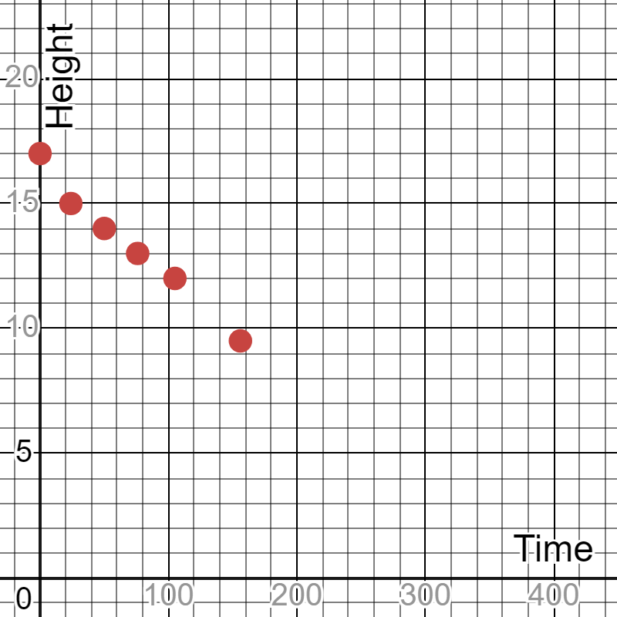

1. Use your line of best fit to predict when the candle will burn out.
2. What does the $y$-intercept of your line of best fit represent? What does the gradient represent in this context?
3. Use your line of best fit to predict the candle’s height after:
4. 30 minutes
5. 1 hour
6. 2 hours.

## Appendix B

### Heart rate and systolic blood pressure

Polygraphs or ‘Lie detectors’ measure a person’s heart rate, blood pressure, respiration and electrodermal response (how well the skin conducts electricity). Studies have shown that people who are being deceptive can experience a change in their resting heart rate, blood pressure, respiration and electrodermal responses that would be different from what they experience when not being deceptive.

A random selection of fifty-four 30-year-old men had their resting heart rate and systolic (top number in blood pressure) blood pressure measured, and the data was displayed in the scatter plot below.

1. Draw a line of best fit through the data.

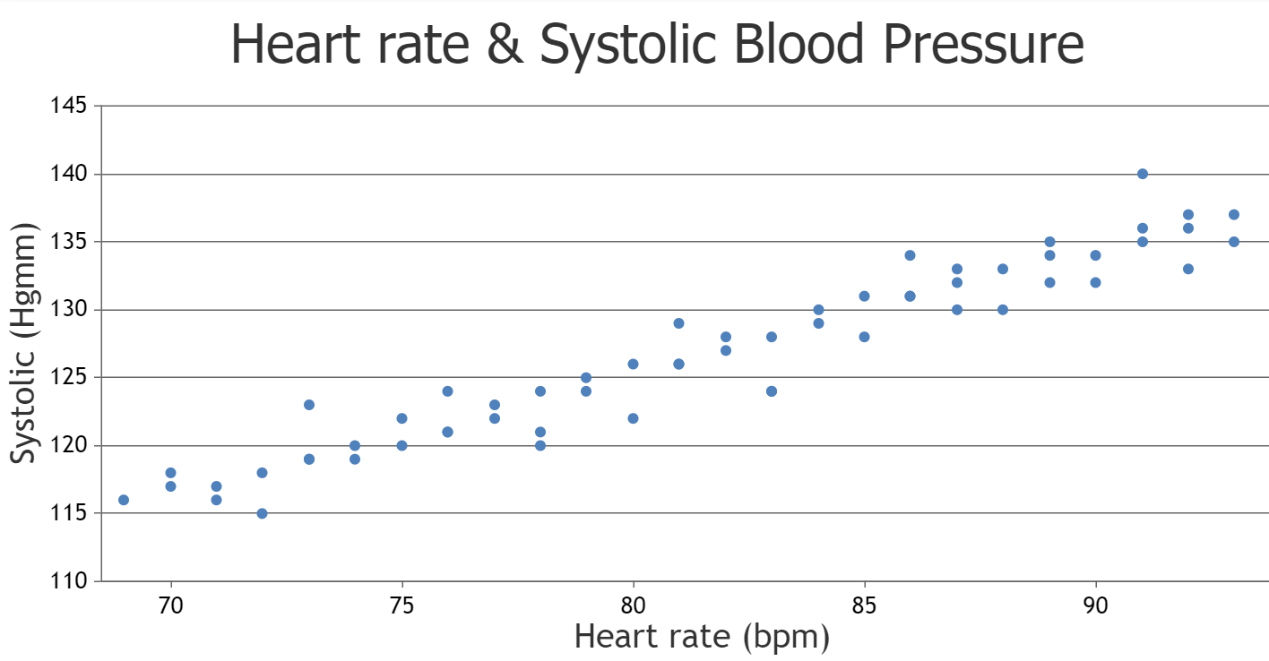

1. Looking at the axes on the scatter plot, can you explain why the $y$-intercept isn’t 115 Hgmm?
2. Explain what the $y$-intercept and gradient represent in this context.
3. Outline any limitations of the model.
4. Determine what each person’s systolic reading should be according to your line of best fit.

|  |  |  |
| --- | --- | --- |
| Name | Resting heart rate (bpm) | Systolic (Hgmm) |
| Albert | 86 | 135 |
| Boris | 80 | 142 |
| Calvin | 89 | 130 |
| Doug | 74 | 119 |
| Ernie | 90 | 122 |

1. Highlight anyone who is likely to fail the polygraph test.

## Sample solutions

### Candle burning

1. Draw a line of best fit through the data.



1. Use your line of best fit to predict when the candle will burn out.

After approximately 350 minutes.

1. What does the $y$-intercept of your line of best fit represent? What does the gradient represent in this context?

The $y$-intercept shows that the candle started at a height of 17 cm. The gradient tells us that the candle is losing approximately 1 cm every 20 minutes.

1. Use your line of best fit to predict the candle’s height after:
2. 30 minutes: 15.5 cm
3. 1 hour: 14 cm
4. 2 hours: 11 cm.

### Heart rate and systolic blood pressure

1. Draw a line of best fit through the data.



1. Looking at the axes on the scatter plot, can you explain why the $y$-intercept isn’t 115 Hgmm?

The heart rate scale doesn’t start at zero on the scatter plot. The 115 Hgmm would represent the blood pressure of a heart rate between 65 bpm and 70 bpm.

1. Explain what the $y$-intercept and gradient represent in this context.

The $y$-intercept would represent the systolic blood pressure when the heart rate was zero. The gradient shows how a rise in heart rate results in a rise in blood pressure. From the line of best fit, it looks like a rise of 1 bpm results in a rise of 1 Hgmm.

1. Outline any limitations of the model.

It is illogical to have a heart rate of zero and it is equally illogical to assume that a heart rate can continue increasing indefinitely.

1. Determine what each person’s systolic reading should be according to your line of best fit.

|  |  |  |  |
| --- | --- | --- | --- |
| Name | Resting heart rate (bpm) | Systolic (mm Hg) | Systolic from graph |
| Albert | 86 | 135 | 130 |
| Boris | 80 | 142 | 125 |
| Calvin | 89 | 130 | 134 |
| Doug | 74 | 119 | 121 |
| Ernie | 90 | 122 | 134 |

1. Highlight anyone who is likely to fail the polygraph test.

Boris and Ernie have both recorded blood pressure that is significantly different from what the line of best fit shows they should. Therefore, they could both be being deceptive.

## References

This resource contains NSW Curriculum and syllabus content. The NSW Curriculum is developed by the NSW Education Standards Authority. This content is prepared by NESA for and on behalf of the Crown in right of the State of New South Wales. The material is protected by Crown copyright.

Please refer to the NESA Copyright Disclaimer for more information [https://educationstandards.nsw.edu.au/wps/portal/nesa/mini-footer/copyright](https://aus01.safelinks.protection.outlook.com/?url=https%3A%2F%2Feducationstandards.nsw.edu.au%2Fwps%2Fportal%2Fnesa%2Fmini-footer%2Fcopyright&data=05%7C01%7CCaitlin.Pace1%40det.nsw.edu.au%7C9c2c1a9f59c94d2df30708dafa7edb23%7C05a0e69a418a47c19c259387261bf991%7C0%7C0%7C638097720042599463%7CUnknown%7CTWFpbGZsb3d8eyJWIjoiMC4wLjAwMDAiLCJQIjoiV2luMzIiLCJBTiI6Ik1haWwiLCJXVCI6Mn0%3D%7C3000%7C%7C%7C&sdata=BzQh0UsffVZE3eO22b2Xba3p0VMOBZSHfS21FGHXtZM%3D&reserved=0).

NESA holds the only official and up-to-date versions of the NSW Curriculum and syllabus documents. Please visit the NSW Education Standards Authority (NESA) website <https://educationstandards.nsw.edu.au/> and the NSW Curriculum website <https://curriculum.nsw.edu.au/>.

[Mathematics K–10 Syllabus](https://curriculum.nsw.edu.au/learning-areas/mathematics/mathematics-k-10-2022/overview) © NSW Education Standards Authority (NESA) for and on behalf of the Crown in right of the State of New South Wales, 2022.

Barton C (5 June 2020) ‘[Identifying an appropriate line of best fit](https://variationtheory.com/2020/06/05/identifying-an-appropriate-line-of-best-fit/)’, *Variation Theory*, accessed 7 November 2024.

**© State of New South Wales (Department of Education), 2024**

The copyright material published in this resource is subject to the *Copyright Act 1968* (Cth) and is owned by the NSW Department of Education or, where indicated, by a party other than the NSW Department of Education (third-party material).

Copyright material available in this resource and owned by the NSW Department of Education is licensed under a [Creative Commons Attribution 4.0 International (CC BY 4.0) license](https://creativecommons.org/licenses/by/4.0/).

[](https://creativecommons.org/licenses/by/4.0/)

This license allows you to share and adapt the material for any purpose, even commercially.

Attribution should be given to © State of New South Wales (Department of Education), 2024.

Material in this resource not available under a Creative Commons license:

* the NSW Department of Education logo, other logos and trademark-protected material
* material owned by a third party that has been reproduced with permission. You will need to obtain permission from the third party to reuse its material.

**Links to third-party material and websites**

Please note that the provided (reading/viewing material/list/links/texts) are a suggestion only and implies no endorsement, by the New South Wales Department of Education, of any author, publisher, or book title. School principals and teachers are best placed to assess the suitability of resources that would complement the curriculum and reflect the needs and interests of their students.

If you use the links provided in this document to access a third-party's website, you acknowledge that the terms of use, including licence terms set out on the third-party's website apply to the use which may be made of the materials on that third-party website or where permitted by the *Copyright Act 1968* (Cth). The department accepts no responsibility for content on third-party websites.