# Causation

Students will investigate a series of associations to develop an understanding that association does not imply causation. Through this investigation, students will develop their ability to explain the difference between association and causation.

Students will need at least one digital device per pair.

## Visible learning

Learning intentions and success criteria should be shared with students later in the learning episode.

### Learning intention

* To know the difference between association and causation.

### Success criteria

* I can define the terms ‘association’ and ‘causation’.
* I can explain why association does not imply causation.
* I can give reasons why an association is not causal.

### Syllabus outcomes

A student:

* develops understanding and fluency in mathematics through exploring and connecting mathematical concepts, choosing and applying mathematical techniques to solve problems, and communicating their thinking and reasoning coherently and clearly **MAO-WM-01**
* displays and interprets datasets involving bivariate data **MA5-DAT-C-02**

[Mathematics K–10 Syllabus](https://curriculum.nsw.edu.au/learning-areas/mathematics/mathematics-k-10-2022/overview) © NSW Education Standards Authority (NESA) for and on behalf of the Crown in right of the State of New South Wales, 2022.

Table 1: lesson summary

|  |  |  |  |
| --- | --- | --- | --- |
| Section | Summary of activity | Teaching strategies | Teaching points |
| Launch | Students use the question prompts from slides 3 to 7 of the PowerPoint Causation to discuss the association between 2 variables. | Think-Pair-Share  Slow reveal graphs | To build initial curiosity about the association between 2 variables and discover that at times, association may occur when there is no obvious cause. |
| Explore | Students consider a scenario that compares 2 different, related associations from slide 9 of the PowerPoint before engaging with a card sort from Appendix A to determine which associations have causation and discuss what considerations need to be made when looking at association and causation. | Think-Pair-Share  Visibly random groups of 3  Vertical non-permanent surfaces  Pose-Pause-Pounce-Bounce  Gallery walk  Two stars and a wish | The purpose of this section is to explore more deeply what factors influence a graph and make 2 associated variables appear to be related. |
| Summarise | Students reflect on their learning by completing a Frayer diagram in Appendix B and annotating the scatter plot in Appendix C. | Frayer diagram  Think-Pair-Share  Two stars and a wish | The purpose of this section is to consolidate understanding of causation and what features to look for when investigating scatter plots. |
| Apply | Students view a comic on slide 11 of the PowerPoint as a stimulus to create a comic about association not implying causation. | Think-Pair-Share | Students creatively interpret association without causation. |

## Activity structure

Please use the associated PowerPoint *Causation* (C PPT)to display images in this lesson.

### Launch

1. Use slides 3 to 7 of the PowerPoint (C PPT) to show the slow reveal graph ([slowrevealgraphs.com](https://slowrevealgraphs.com/)). Initiate a Think-Pair-Share ([bit.ly/thinkpairsharestrategy](https://bit.ly/thinkpairsharestrategy)) using the question prompts from each slide. Ensure the sharing occurs before revealing each new information piece by navigating to the next slide.

Teachers should ensure students use the correct metalanguage associated with concepts such as the relationship's strength, the association's direction and the coordinate axes.

* Slide 3: students should notice a strong, positive association. They might wonder what data is being represented. Students may also notice and wonder about the ‘zigzag’ or ‘squiggle’ acting as an axis break. If students are unfamiliar with these displays, this would be an opportunity to teach what the break means explicitly.
* Slide 4: students should identify that the horizontal axis now has a scale. Students may recognise that the graph is related to the price of something.
* Slide 5: students should identify that the vertical axis now has a scale.
* Slide 6: the horizontal axis now has a label, ‘The independent variable is the price of eggs.’ Students could expect the vertical axis to represent cartons sold.
* Slide 7: the vertical axis has a label and the graph's title has been revealed. Students may suggest that the 2 variables are unrelated.

1. Reveal the learning intentions and success criteria of the lesson.

### Explore

1. Read aloud the following text while viewing the scatter plots on slide 9 of the PowerPoint (C PPT).

A local frozen yoghurt shop owner collected data for 8 days to compare sales of ice cream at a nearby ice cream shop with the number of people who are sunburnt at the nearby beach. He believes that in the interests of public safety the ice cream store should be closed.

1. Initiate a Think-Pair-Share where students discuss aspects of the graph. Some suggested prompts include:

* Do you think one of these variables happening is dependent on the other variable?
* What do you notice about each data set? What do you wonder about each data set?

Students could notice that the ice cream sales data has a line of best fit with a positive gradient, and the frozen yoghurt sales graph has a line of best fit with a negative gradient. Some students may notice the difference in the values on the horizontal axis. Some students may wonder if there is bias in the yoghurt shop owner’s motivations.

The concept of which variable is independent and dependent is covered in Lesson 2 – flame versus time. If you have not completed this activity, this may be an opportunity to reflect on this knowledge.

1. Define a causal relationship using the following definition:

A causal relationship is one where there are 2 variables with a relationship that indicates that one event is the result of the occurrence of the other event (NESA 2022).

1. Assign students into visibly random groups of 3 ([bit.ly/visiblegroups](https://bit.ly/visiblegroups)) at vertical non-permanent surfaces ([bit.ly/VNPSstrategy](https://bit.ly/VNPSstrategy)).
2. Distribute Appendix A ‘Card sort’, cut into cards and adhesive putty.

Cards are not in order, so students could be provided with scissors to cut the cards.

1. Ask students to divide their vertical non-permanent surface into 2 sections and label the sections ‘Potential causal’ and ‘Not causal’.
2. Using adhesive putty on the back of each card, place the cards in the appropriate section, under one of the headings.

Students should end up with 6 cards with associations that could potentially have a causal relationship, and 3 cards with associations that do not have a causal relationship.

1. Ask students to focus on the group of scatter plots below the heading ‘Not causal’. Initiate a sharing of ideas and reasoning using the Pose-Pause-Pounce-Bounce questioning strategy (PDF 557 KB) ([bit.ly/posepausepouncebounce](https://bit.ly/posepausepouncebounce)) to highlight what features of the graphs might lead them to think the association is not causal.

Students may suggest that the variables have nothing to do with each other, that the only relationship between the data is time passing in years, that insufficient data has been collected or that adjustments to the axis have created a misleading representation of the data.

1. Ask the groups to look at each graph that doesn’t show a causal relationship. For each of these graphs, have them write down at least one reason why the association doesn’t seem to be causal.
2. Students conduct a gallery walk ([bit.ly/DLSgallerywalk](https://bit.ly/DLSgallerywalk)) of the graphs and complete peer feedback in the form of Two stars and a wish ([bit.ly/DLSpeerfeedback](https://bit.ly/DLSpeerfeedback)).
3. Initiate a second sharing of ideas and reasoning using the Pose-Pause-Pounce-Bounce questioning strategy to highlight students' notice and wonder about the graphs.

Students may notice that when 2 variables seem related but don’t have a true cause-and-effect connection, it’s often because the data set is small or the graph’s scale makes the relationship look stronger than it is. Students may wonder if time passing is the only related third variable or whether there could have been other variables influencing the change.

### Summarise

1. Ask students to return to their desks.
2. Distribute Appendix B ‘Frayer diagram’ to each student and ask them to complete the Frayer diagram ([bit.ly/frayerdiagram](https://bit.ly/frayerdiagram)) provided.
3. Students are to swap Frayer diagrams and complete peer feedback in the form of Two stars and a wish.
4. Students then respond to the feedback to improve their Frayer diagrams.

Prompt students to use correct terminology on their Frayer diagrams, such as association, causation and variable. Rather than supply feedback, the teacher could display terminology used in the lesson, such as ‘association’, ‘causation’ and ‘variable’ to assist students in completing their Frayer diagram.

1. Distribute Appendix C ‘Cracking the numbers’ and ask students to work in pairs to annotate the scatter plot to identify the features of the graph that suggest why the association occurs and is not a causal relationship.

Two versions of this task are provided in Appendix C. One version includes prompts as conversation starters and the other does not.

### Apply

1. Use slide 11 of the PowerPoint (C PPT) to initiate a Think-Pair-Share about the comic and how that demonstrates an association where there is an association but not causation.
2. Distribute one device between each pair.
3. Students create a comic representing a situation where there is association without causation.

Students could draw a comic by hand if devices are not available. Students could use scenarios from the lesson or could be guided toward the spurious correlations website ([www.tylervigen.com/spurious-correlations](https://www.tylervigen.com/spurious-correlations)).

## Assessment and differentiation

### Suggested opportunities for differentiation

##### ****Explore****

* Word prompts could be provided on the board, such as independent and dependent variables, to support student discussion.
* A glossary of terms could be co-created throughout the topic to support the use of appropriate language.
* If the teacher notices a misconception, they can temporarily combine 2 groups, telling the groups that at least one of them is incorrect. The teacher then walks away, leaving students to explain and justify their solution.
* Students could be challenged to find equations of each line in the card sort and to state what each equation would mean in context.

##### Summarise

* Sentence starters or a glossary could be provided to assist with the Frayer model.
* Appendix C has been provided in 2 versions if sentence starters are required.

### Suggested opportunities for assessment

##### ****Launch****

* The teacher could facilitate class discussions and observe students’ reasoning and justification in response to the provided prompts.

##### Explore

* Students have opportunities to contribute to and hear from pair and class discussions, these act as opportunities for self- and peer-reflection.
* Monitor responses in class discussions to check for student understanding of the terms ‘association’ and ‘causation’.

##### Summarise

* When placed in groups of 3, students provide and receive peer-feedback on their understanding.
* Students working at vertical non-permanent surfaces means the teacher can assess student progress and provide support where appropriate.
* The teacher could take copies of Appendix B ‘Frayer diagram’ to verify student’s understanding of terminology.
* The teacher could take a copy of Appendix C ‘Cracking the numbers’ to verify whether students can identify possible reasons for association without causation.

##### Apply

* Monitor responses in class interactions to check for student understanding of association and causation.

## Appendix A

### Card sort

|  |  |
| --- | --- |
| A scatter plot graph titled 'New evidence for Theory of the Stork', comparing the number of stork pairs and out of hospital births in Germany.  Source: Adapted from Blackwell Publishing Ltd (2004) | A scatter plot graph titled 'Comparing shoe size and foot length'. |
| A scatter plot graph titled 'Exercise and cardio health' comparing minutes of cardio exercise per day and resting heart rate. | A scatter plot titled 'Cage versus climate', comparing temperature in Sydney to the number of films starring Nicholas Cage.  Source: Adapted from Vigen T (n.d.a.) |
| A scatter plot titled 'Hours of study compared to marks' comparing the number of marks with the hours of study of different students. | A scatter plot titled 'Teenage sleep time compared to screen time' comparing sleep time and screen usage among teenagers. |
| A scatter plot titled 'Swifty Stolen Moments' comparing motor vehicle theft and Taylor Swift Google searches.  Source: Adapted from Vigen T (n.d.b.) | A scatter plot titled 'Supply and demand of bananas' showing the supply and demand of bananas. |
| A scatter plot titled 'Chocolate block consumption' comparing size of chocolate stash to number of chocolate blocks eaten. |  |

## Appendix B

### Frayer diagram

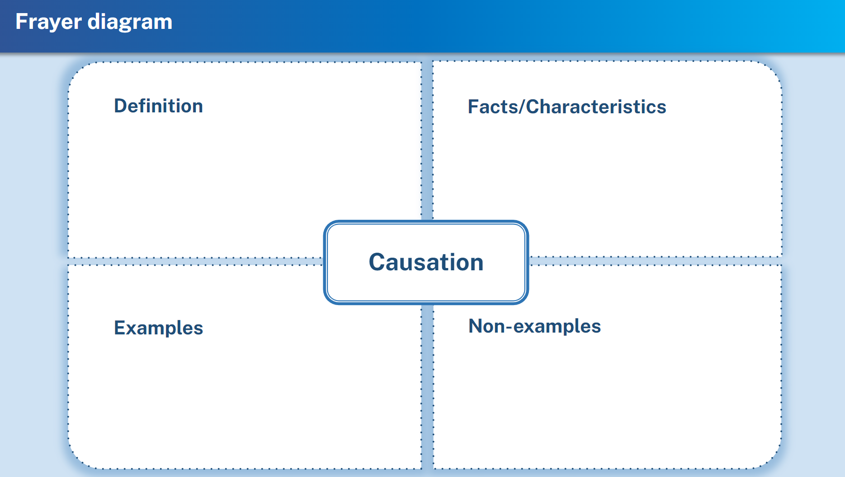

## Appendix C

### Cracking the numbers

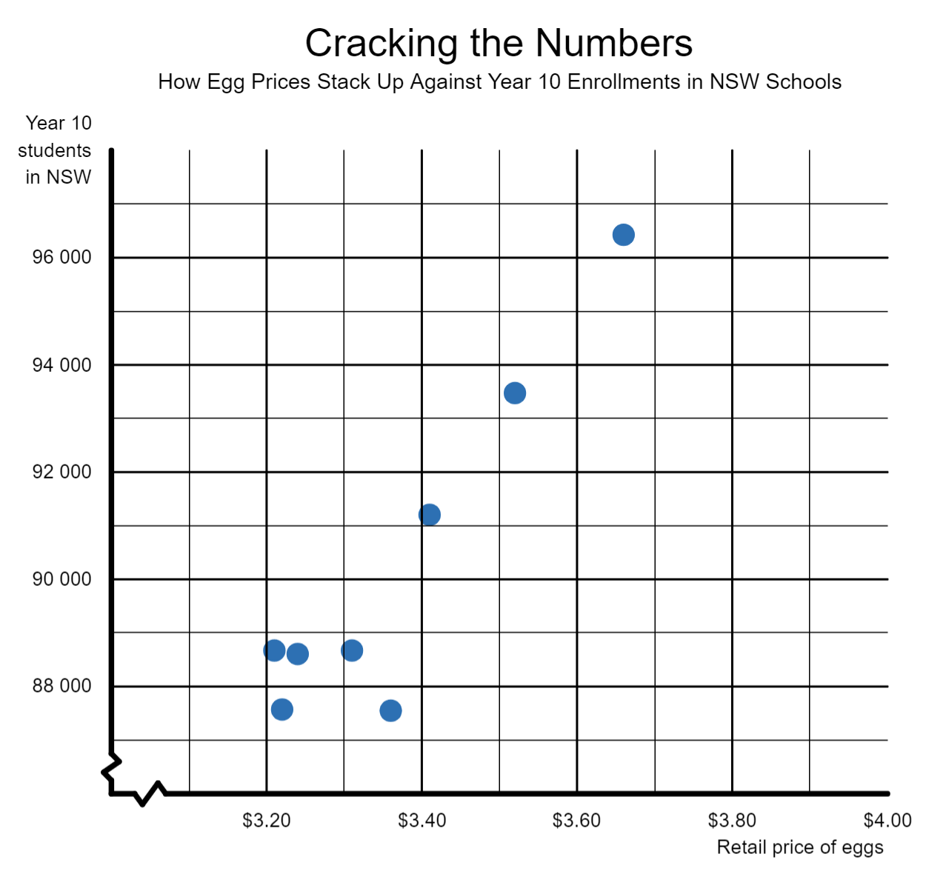

Source: Adapted from NSW Government (n.d.) and Australian Bureau of Statistics (2023)

### Cracking the numbers (including conversation starters)

A scatter plot graph titled 'Cracking the numbers' showing a positive correlation between the retail price of eggs and the number of students enrolled in school in NSW. The x-axis it titled 'Retail price of eggs' with the range $3.10 up to $4.00. The y-axis is titled 'Year 10 students in NSW' with the range from 87 000 to 96 000.
There are conversation starters for the activity around the graph including:
What does each minor axis represent?
Where does each axis start?
Does one of these variables cause the other?
Is there be a third variable that could influence these variables?
How much data is being compared?

Source: Adapted from NSW Government (n.d.) and Australian Bureau of Statistics (2023)

## Sample solutions

### Appendix A – card sort

#### No causal

|  |  |
| --- | --- |
| A scatter plot graph titled 'New evidence for Theory of the Stork', comparing the number of stork pairs and out of hospital births in Germany.  Source: Adapted from Blackwell Publishing Ltd (2004) | A scatter plot titled 'Cage versus climate', comparing temperature in Sydney to the number of films starring Nicholas Cage.  Source: Adapted from Vigen T (n.d.) |
| A scatter plot titled 'Swifty Stolen Moments' comparing motor vehicle theft and Taylor Swift Google searches.  Source: Adapted from Vigen T (n.d.) |  |

#### Causal

|  |  |
| --- | --- |
| A scatter plot titled 'Chocolate block consumption' comparing size of chocolate stash to number of chocolate blocks eaten. | A scatter plot titled 'Teenage sleep time compared to screen time' comparing sleep time and screen usage among teenagers. |
| A scatter plot titled 'Hours of study compared to marks' comparing the number of marks with the hours of study of different students. | A scatter plot titled 'Supply and demand of bananas' showing the supply and demand of bananas. |
| A scatter plot graph titled 'Exercise and cardio health' comparing minutes of cardio exercise per day and resting heart rate. | A scatter plot graph titled 'Comparing shoe size and foot length'. |

### Appendix B – Frayer diagram

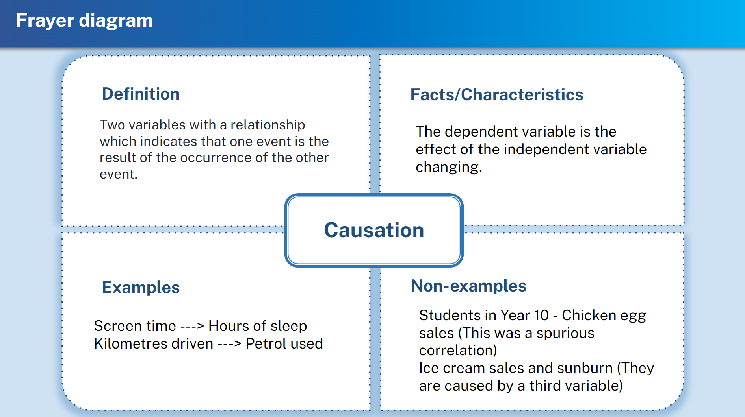

### Appendix C – cracking the numbers

An annotated graph from Appendix C titled 'Cracking the Numbers'. The answers to the prompting questions include:
What does each minor axis represent? Each box on the horizontal axis represents $0.10. Each box on the vertical axis represents 1000 students.
Where does each axis start? The horizontal axis starts at $3.10. The vertical axis starts at 87 000.
Does one of these variables cause the other? These variables would have no causal relationship.
Is there be a third variable that could influence these variables? The third variable influencing this data could be time (years).
How much data is being compared? There are only 8 pieces of data.
  Source: Adapted from NSW Government (n.d.) and Australian Bureau of Statistics (2023)

## References

This resource contains NSW Curriculum and syllabus content. The NSW Curriculum is developed by the NSW Education Standards Authority. This content is prepared by NESA for and on behalf of the Crown in right of the State of New South Wales. The material is protected by Crown copyright.

Please refer to the NESA Copyright Disclaimer for more information [https://educationstandards.nsw.edu.au/wps/portal/nesa/mini-footer/copyright](https://aus01.safelinks.protection.outlook.com/?url=https%3A%2F%2Feducationstandards.nsw.edu.au%2Fwps%2Fportal%2Fnesa%2Fmini-footer%2Fcopyright&data=05%7C01%7CCaitlin.Pace1%40det.nsw.edu.au%7C9c2c1a9f59c94d2df30708dafa7edb23%7C05a0e69a418a47c19c259387261bf991%7C0%7C0%7C638097720042599463%7CUnknown%7CTWFpbGZsb3d8eyJWIjoiMC4wLjAwMDAiLCJQIjoiV2luMzIiLCJBTiI6Ik1haWwiLCJXVCI6Mn0%3D%7C3000%7C%7C%7C&sdata=BzQh0UsffVZE3eO22b2Xba3p0VMOBZSHfS21FGHXtZM%3D&reserved=0).

NESA holds the only official and up-to-date versions of the NSW Curriculum and syllabus documents. Please visit the NSW Education Standards Authority (NESA) website <https://educationstandards.nsw.edu.au/> and the NSW Curriculum website <https://curriculum.nsw.edu.au/>.

[Mathematics K–10 Syllabus](https://curriculum.nsw.edu.au/learning-areas/mathematics/mathematics-k-10-2022/overview) © NSW Education Standards Authority (NESA) for and on behalf of the Crown in right of the State of New South Wales, 2022.

Australian Bureau of Statistics (2023) [*Schools*](https://www.abs.gov.au/statistics/people/education/schools/latest-release), ABS Website, accessed 8 November 2024.

Blackwell Publishing Ltd (2004) [*New evidence for the Theory of the Stork*](https://web.stanford.edu/class/hrp259/2007/regression/storke.pdf) [PDF 101 KB], accessed 8 November 2024.

NESA (NSW Education Standards Authority (2022) [‘Glossary’](https://curriculum.nsw.edu.au/learning-areas/mathematics/mathematics-k-10-2022/glossary), Mathematics K–10, NESA website, accessed 6 November 2024.

NSW Government (n.d.) ‘[Eggs](https://www.dpi.nsw.gov.au/about-us/publications/pdi/2023/eggs)’, Livestock, Department of Primary Industries and Regional Development website, accessed 8 November 2024.

Vigen T (n.d.a.) [*Spurious correlation #9,886*](https://www.tylervigen.com/spurious/correlation/9886_the-number-of-movies-nicolas-cage-appeared-in_correlates-with_average-temperature-in-sydney), Tyler Vigen website, accessed 8 November 2024.

Vigen T (n.d.b.) [*Spurious correlation #15,241*](https://tylervigen.com/spurious/correlation/15241_google-searches-for-taylor-swift_correlates-with_motor-vehicle-thefts-in-tennessee), Tyler Vigen website, accessed 8 November 2024.

**© State of New South Wales (Department of Education), 2024**

The copyright material published in this resource is subject to the *Copyright Act 1968* (Cth) and is owned by the NSW Department of Education or, where indicated, by a party other than the NSW Department of Education (third-party material).

Copyright material available in this resource and owned by the NSW Department of Education is licensed under a [Creative Commons Attribution 4.0 International (CC BY 4.0) license](https://creativecommons.org/licenses/by/4.0/).

[](https://creativecommons.org/licenses/by/4.0/)

This license allows you to share and adapt the material for any purpose, even commercially.

Attribution should be given to © State of New South Wales (Department of Education), 2024.

Material in this resource not available under a Creative Commons license:

* the NSW Department of Education logo, other logos and trademark-protected material
* material owned by a third party that has been reproduced with permission. You will need to obtain permission from the third party to reuse its material.

**Links to third-party material and websites**

Please note that the provided (reading/viewing material/list/links/texts) are a suggestion only and implies no endorsement, by the New South Wales Department of Education, of any author, publisher, or book title. School principals and teachers are best placed to assess the suitability of resources that would complement the curriculum and reflect the needs and interests of their students.

If you use the links provided in this document to access a third-party's website, you acknowledge that the terms of use, including licence terms set out on the third-party's website apply to the use which may be made of the materials on that third-party website or where permitted by the *Copyright Act 1968* (Cth). The department accepts no responsibility for content on third-party websites.