Mathematics Advanced Stage 6

Sample scope and sequence

Contents

Purpose of resource 2

Mathematics Advanced Year 11 scope and sequence 3

Mathematics Advanced Year 11 scope and sequence overview 6

Mathematics Advanced Year 12 scope and sequence 7

Mathematics Advanced Year 12 scope and sequence overview 11

Support and alignment 12

Evidence base 13

# Purpose of resource

This resource has been designed to support teachers by providing an approach to organising syllabus content and can be modified to suit individual school contexts and procedures as required.

High quality formative and summative assessment should form an integral part of all teaching and learning programs. For more information, please visit [NESA’s Advice on assessment](https://educationstandards.nsw.edu.au/wps/portal/nesa/k-10/understanding-the-curriculum/assessment) page.

# Mathematics Advanced Year 11 scope and sequence

Table 1 – Mathematics Advanced Term 1 scope and sequence

|  |  |  |  |
| --- | --- | --- | --- |
| Unit | Probability and data  Weeks 1–4 | Introduction to functions  Weeks 5–7 | Working with linear and quadratic functions  Weeks 8–10 |
| Outcomes | **MAO-WM-01, MAV-11-09,  MAV-11-10** | **MAO-WM-01, MAV-11-01,  MAV-11-02, MAV-11-08** | **MAO-WM-01, MAV-11-01,  MAV-11-02** |
| Description | This unit focuses on concepts such as set notation, probability rules and data representation. Students will learn how to define and calculate probabilities using Venn and tree diagrams, analyse conditional probability and organise datasets. | This unit introduces functions and relations and the basic graphs within the scope of the Mathematics Advanced course. Students will learn how to use the vertical line test, find the domain and range, and intercepts whilst connecting equations to their corresponding graphs. | This unit provides an exploration of linear and quadratic functions, their graphs and their applications to model practical problems. Students will refine their algebraic skills while learning and applying appropriate methods for graphing quadratic functions. |

Table 2 – Mathematics Advanced Term 2 scope and sequence

|  |  |  |  |
| --- | --- | --- | --- |
| Unit | Graph transformations  Weeks 1–4 | Foundations of differentiation  Weeks 5–7 | Differentiation techniques and applications  Weeks 8–10 |
| Outcomes | **MAO-WM-01, MAV-11-01, MAV-11-02, MAV-11-03** | **MAO-WM-01, MAV-11-01,  MAV-11-02, MAV-11-06** | **MAO-WM-01, MAV-11-06** |
| Description | This unit explores graphical transformations of functions, including reflections, translations and dilations. Students will investigate how changes to equations affect graphs within the scope of the Mathematics Advanced course and determine key features such as domain, range, intercepts and asymptotes. Students then apply this knowledge to solve a range of problems including those involving direct and inverse variation. | This unit explores the gradient of straight lines, its connection to calculus and the fundamentals of differentiation. Students will revise key algebraic techniques, including index laws and simplifying expressions, to support their understanding of rates of change, estimation of the gradient of a curve and differentiation from first principles. | This unit explores key differentiation techniques, including the product, quotient and chain rules, to analyse functions and their rates of change. Students will apply these concepts to find tangents and normals, identify stationary points, interpret velocity and acceleration and use derivative graphs to describe physical phenomena. |

Table 3 – Mathematics Advanced Term 3 scope and sequence

|  |  |  |
| --- | --- | --- |
| Unit | Trigonometry  Weeks 1–6 | Exponential and logarithmic functions  Weeks 7–10 |
| Outcomes | **MAO-WM-01, MAV-11-04, MAV-11-05** | **MAO-WM-01, MAV-11-07, MAV-11-08** |
| Description | This unit focuses on trigonometry, examining both measures of angles and trigonometric identities. This unit covers concepts such as the relationships between angles and sides, applications of trigonometric functions and the use of radians and degrees in angle measurement. Students will also investigate trigonometric identities, solve equations involving trigonometric ratios and apply these concepts to problems. | This unit focuses on exponential and logarithmic functions, exploring their properties, behaviours and interrelationships. Students will graph exponential functions, identify their characteristics, learn about Euler’s number and apply logarithmic laws to solve equations, ultimately understanding the reflection between exponential and logarithmic graphs. |

## Mathematics Advanced Year 11 scope and sequence overview

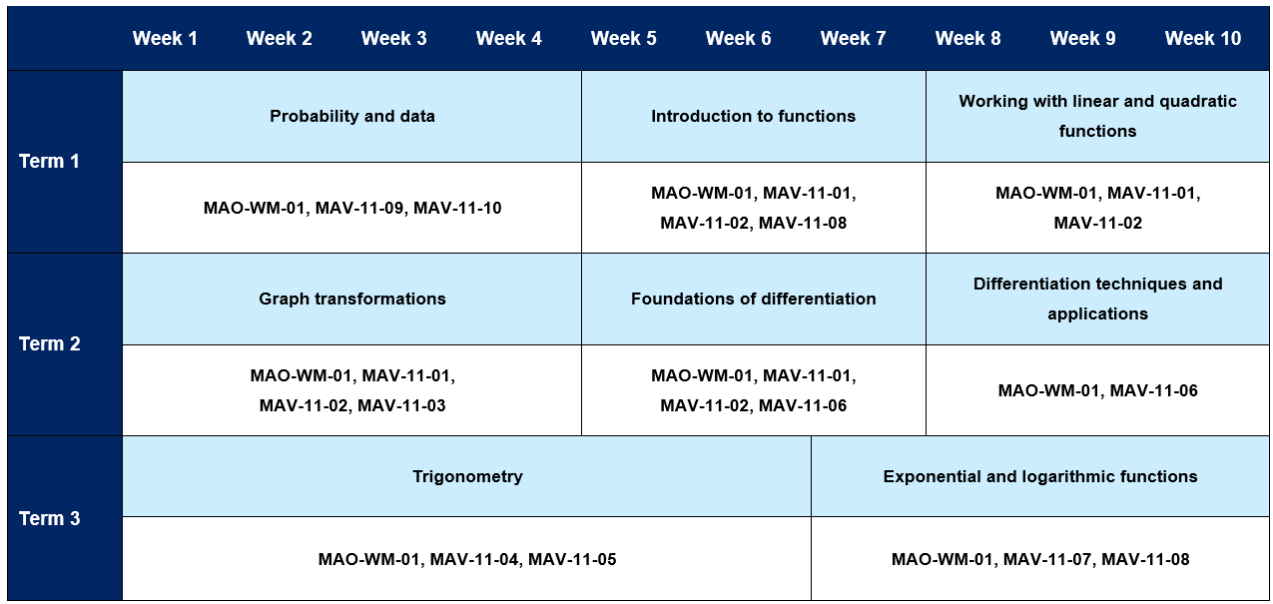

# Mathematics Advanced Year 12 scope and sequence

Table 4 – Mathematics Advanced Term 4 scope and sequence

|  |  |  |
| --- | --- | --- |
| Unit | Further differentiation, modelling and graphing  Weeks 1–5 | Differentiation applications  Weeks 6–10 |
| Outcomes | **MAO-WM-01, MAV-12-01, MAV-12-02,  MAV-12-04** | **MAO-WM-01, MAV-12-06** |
| Description | This unit covers transformations of trigonometric functions, exploring their reflections, translations and dilations using graphing applications. Students will model and solve practical problems with periodic phenomena, apply differentiation techniques to exponential, logarithmic and trigonometric functions, and use derivatives to analyse tangents and normals of the functions within the scope of the Mathematics Advanced course. | This unit explores the concepts of turning points, inflections and curve-sketching, focusing on the analysis of functions through their derivatives. Additionally, students will learn to classify points using first and second derivatives, apply these concepts to optimisation problems and effectively graph functions by considering their behaviour across various intervals and under different conditions. |

Table 5 – Mathematics Advanced Term 1 scope and sequence

|  |  |  |
| --- | --- | --- |
| Unit | Integration  Weeks 1–6 | Rates of change  Weeks 7–10 |
| Outcomes | **MAO-WM-01, MAV-12-05** | **MAO-WM-01, MAV-12-06** |
| Description | This unit focuses on the concept of primitive functions and their relationship to differentiation, emphasising how to find primitives for various functions, including polynomials, exponentials and trigonometric functions. Additionally, students will explore definite integrals, the Fundamental Theorem of Calculus and techniques for calculating areas under curves, using both exact algebraic methods and numerical approximations. | This unit focuses on understanding rates of change through differentiation and integration, emphasising their applications in real-world scenarios where a quantity varies with time. Students will learn to model exponential growth and decay, interpret the relationships between displacement, velocity and acceleration of moving particles, and effectively model practical problems using graphing techniques and calculus. |

Table 6 – Mathematics Advanced Term 2 scope and sequence

|  |  |  |
| --- | --- | --- |
| Unit | Random variables  Weeks 1–6 | Sequences and series  Weeks 7–10 |
| Outcomes | **MAO-WM-01, MAV-12-07** | **MAO-WM-01, MAV-12-03** |
| Description | This unit explores discrete and continuous random variables, focusing on their probability distributions, expected values and variances, and applying these concepts to model real-world phenomena. Students will also investigate the normal distribution, including its properties, applications and the use of z-scores for comparing and interpreting data in the context of this distribution. | This unit focuses on sequences and series, distinguishing between finite and infinite sequences, and explores arithmetic and geometric progressions. Students will develop and apply formulas for the nth term and partial sums, using these concepts to model and solve real-world problems, including applications involving growth and decay. |

Table 7 – Mathematics Advanced Term 3 scope and sequence

|  |  |  |
| --- | --- | --- |
| Unit | Financial mathematics  Weeks 1–4 | HSC focus  Weeks 5–10 |
| Outcomes | **MAO-WM-01, MAV-12-08** | **MAO-WM-01** |
| Description | This unit explores reducing balance loans and annuities, focusing on the algebraic representation of loans as compound interest with periodic repayments and the impact of interest rates and repayment amounts on loan duration and total cost. Students will also learn to model the future value of annuities, explore factors influencing investment growth and apply geometric sequence formulas to solve financial problems. | This unit allows a focus on non-routine questions across a wide range of contexts. |

## Mathematics Advanced Year 12 scope and sequence overview

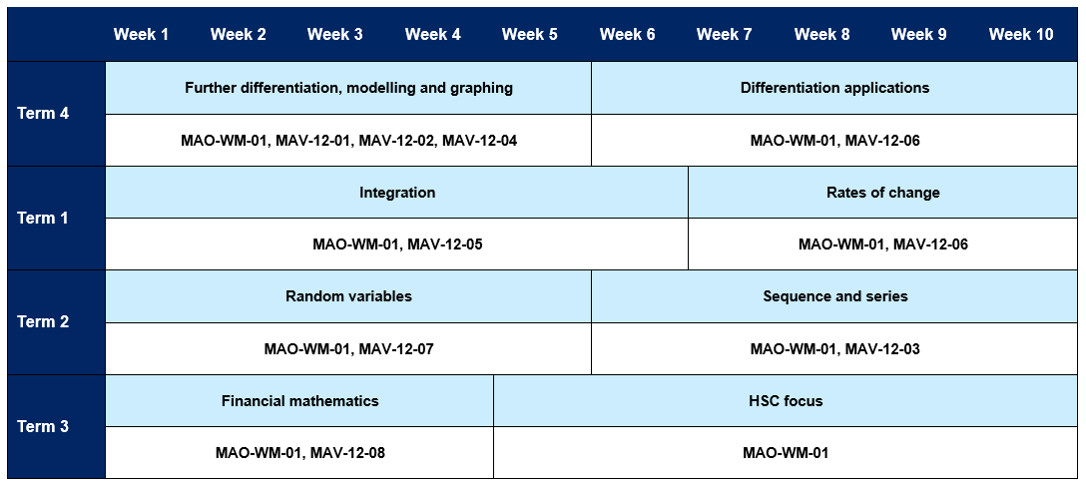

# Support and alignment

**Resource evaluation and support**: all curriculum resources are prepared through a rigorous process. Resources are periodically reviewed as part of our ongoing evaluation plan to ensure currency, relevance and effectiveness. For additional support or advice, or to provide feedback, contact the Mathematics Curriculum team by emailing [mathematics7-12@det.nsw.edu.au](mailto:mathematics7-12@det.nsw.edu.au)

**Differentiation:** further advice to support Aboriginal and Torres Strait Islander students, English as an additional language or dialect (EALD) students, students with a disability and/or additional needs and high potential and gifted students can be found on the [Planning programming and assessing 7–12](https://education.nsw.gov.au/teaching-and-learning/curriculum/planning-programming-and-assessing-k-12/planning-programming-and-assessing-7-12) webpage. This includes the [Inclusion and differentiation 7–10 advice](https://education.nsw.gov.au/teaching-and-learning/curriculum/planning-programming-and-assessing-k-12/planning-programming-and-assessing-7-12/inclusion-and-differentiation-advice-7-10) webpage.

**Assessment**: further advice to support formative assessment is available on the [Planning programming and assessing 7–12](https://education.nsw.gov.au/teaching-and-learning/curriculum/planning-programming-and-assessing-k-12/planning-programming-and-assessing-7-12) webpage. This includes the [Classroom assessment advice 7–10](https://education.nsw.gov.au/teaching-and-learning/curriculum/planning-programming-and-assessing-k-12/planning-programming-and-assessing-7-12/classroom-assessment-advice-7-10-). For summative assessment tasks, the [Assessment task advice 7–10](https://education.nsw.gov.au/teaching-and-learning/curriculum/planning-programming-and-assessing-k-12/planning-programming-and-assessing-7-12/assessment-task-advice-7-10) webpage is available.

**Explicit teaching:** further advice to support explicit teaching is available on the [Explicit teaching](https://education.nsw.gov.au/teaching-and-learning/curriculum/explicit-teaching) webpage. This includes the CESE [Explicit teaching – Driving learning and engagement](https://education.nsw.gov.au/about-us/education-data-and-research/cese/publications/research-reports/what-works-best-2020-update/explicit-teaching-driving-learning-and-engagement) webpage.

**Alignment to system priorities and/or needs**: [School Excellence Policy](https://education.nsw.gov.au/policy-library/policies/pd-2016-0468), [Our Plan for NSW Public Education](https://education.nsw.gov.au/about-us/strategies-and-reports/plan-for-nsw-public-education)

**Alignment to the School Excellence Framework**: this resource supports the [School Excellence Framework](https://education.nsw.gov.au/policy-library/policies/pd-2016-0468) elements of curriculum (curriculum provision) and effective classroom practice (lesson planning, explicit teaching).

**Alignment to the Australian Professional Standards for Teachers**: this resource supports teachers to address [Proficient Teacher Standard Descriptors](https://educationstandards.nsw.edu.au/wps/portal/nesa/teacher-accreditation/meeting-requirements/the-standards/proficient-teacher) 3.2.2, 3.3.2.

# Evidence base

This resource contains NSW Curriculum and syllabus content. The NSW Curriculum is developed by the NSW Education Standards Authority. This content is prepared by NESA for and on behalf of the Crown in right of the State of New South Wales. The material is protected by Crown copyright.

Please refer to the NESA Copyright Disclaimer for more information [https://educationstandards.nsw.edu.au/wps/portal/nesa/mini-footer/copyright](https://aus01.safelinks.protection.outlook.com/?url=https%3A%2F%2Feducationstandards.nsw.edu.au%2Fwps%2Fportal%2Fnesa%2Fmini-footer%2Fcopyright&data=05%7C01%7CCaitlin.Pace1%40det.nsw.edu.au%7C9c2c1a9f59c94d2df30708dafa7edb23%7C05a0e69a418a47c19c259387261bf991%7C0%7C0%7C638097720042599463%7CUnknown%7CTWFpbGZsb3d8eyJWIjoiMC4wLjAwMDAiLCJQIjoiV2luMzIiLCJBTiI6Ik1haWwiLCJXVCI6Mn0%3D%7C3000%7C%7C%7C&sdata=BzQh0UsffVZE3eO22b2Xba3p0VMOBZSHfS21FGHXtZM%3D&reserved=0).

NESA holds the only official and up-to-date versions of the NSW Curriculum and syllabus documents. Please visit the NSW Education Standards Authority (NESA) website [https://educationstandards.nsw.edu.au](https://educationstandards.nsw.edu.au/) and the NSW Curriculum website [https://curriculum.nsw.edu.au](https://curriculum.nsw.edu.au/).

[Mathematics Advanced 11–12 Syllabus](https://curriculum.nsw.edu.au/learning-areas/mathematics/mathematics-advanced-11-12-2024/overview) © NSW Education Standards Authority (NESA) for and on behalf of the Crown in right of the State of New South Wales, 2024.

NESA (NSW Education Standards Authority) (2024) ‘[Advice on scope and sequences](https://www.educationstandards.nsw.edu.au/wps/portal/nesa/k-10/understanding-the-curriculum/programming/advice-on-scope-and-sequences)’, Programming, NESA website, accessed 26 February 2025.

**© State of New South Wales (Department of Education), 2025**

The copyright material published in this resource is subject to the *Copyright Act 1968* (Cth) and is owned by the NSW Department of Education or, where indicated, by a party other than the NSW Department of Education (third-party material).

Copyright material available in this resource and owned by the NSW Department of Education is licensed under a [Creative Commons Attribution 4.0 International (CC BY 4.0) license](https://creativecommons.org/licenses/by/4.0/).

[](https://creativecommons.org/licenses/by/4.0/)

This license allows you to share and adapt the material for any purpose, even commercially.

Attribution should be given to © State of New South Wales (Department of Education), 2025.

Material in this resource not available under a Creative Commons license:

* the NSW Department of Education logo, other logos and trademark-protected material
* material owned by a third party that has been reproduced with permission. You will need to obtain permission from the third party to reuse its material.

**Links to third-party material and websites**

Please note that the provided (reading/viewing material/list/links/texts) are a suggestion only and implies no endorsement, by the New South Wales Department of Education, of any author, publisher, or book title. School principals and teachers are best placed to assess the suitability of resources that would complement the curriculum and reflect the needs and interests of their students.

If you use the links provided in this document to access a third-party's website, you acknowledge that the terms of use, including licence terms set out on the third-party's website apply to the use which may be made of the materials on that third-party website or where permitted by the *Copyright Act 1968* (Cth). The department accepts no responsibility for content on third-party websites.