Mathematics Extension 1 Stage 6

Sample scope and sequence

Contents

Purpose of resource 2

Mathematics Extension 1 Year 11 scope and sequence 3

Mathematics Extension 1 Year 11 scope and sequence overview 6

Mathematics Extension 1 Year 12 scope and sequence 7

Mathematics Extension 1 Year 12 scope and sequence overview 11

Support and alignment 12

Evidence base 13

# Purpose of resource

This resource has been designed to support teachers by providing an approach to organising syllabus content and can be modified to suit individual school contexts and procedures as required.

High quality formative and summative assessment should form an integral part of all teaching and learning programs. For more information, please visit [NESA’s Advice on assessment](https://educationstandards.nsw.edu.au/wps/portal/nesa/k-10/understanding-the-curriculum/assessment) page.

# Mathematics Extension 1 Year 11 scope and sequence

Table 1 – Mathematics Extension 1 Term 1 scope and sequence

|  |  |  |
| --- | --- | --- |
| Unit | Permutations and combinations  Weeks 1–6 | The binomial theorem  Weeks 7–10 |
| ****Outcomes**** | **MAO-WM-01, ME1-11-04** | **MAO-WM-01, ME1-11-05** |
| Description | This unit introduces permutations and combinations, which are then explored to solve more complex counting and probability problems. | This unit introduces the binomial theorem, exploring the expansion of binomial expressions, the identification of specific coefficients and the application of these techniques to mathematical and real-world problems. |

Table 2 – Mathematics Extension 1 Term 2 scope and sequence

|  |  |  |  |
| --- | --- | --- | --- |
| Unit | Polynomials  Weeks 1–6 | Inequalities  Weeks 7–8 | Parametric form  Weeks 9–10 |
| ****Outcomes**** | **MAO-WM-01, ME1-11-02** | **MAO-WM-01, ME1-11-01** | **MAO-WM-01, ME1-11-01** |
| Description | This unit examines the language and graphs of polynomials, applying the remainder and factor theorems and explores the sums and products of zeroes of polynomials. | This unit explores algebraic and graphical techniques to solve inequalities including cubic equations, absolute value inequalities and rational inequalities with variables in the denominator. | This unit explores the parametric form of linear and quadratic functions and circles. |

Table 3 – Mathematics Extension 1 Term 3 scope and sequence

|  |  |  |
| --- | --- | --- |
| Unit | Further work with functions  Weeks 1–5 | Further trigonometry  Weeks 6–10 |
| ****Outcomes**** | **MAO-WM-01, ME1-11-01** | **MAO-WM-01, ME1-11-03** |
| Description | This unit extends the study of functions by exploring graphical transformations, reciprocal functions and inverse functions, focusing on their properties, relationships and problem-solving applications. | This unit explores trigonometry in three dimensions and introduces more complex trigonometric identities and equationsincluding sum and difference expansions, double angle formulas and their applications. |

## Mathematics Extension 1 Year 11 scope and sequence overview

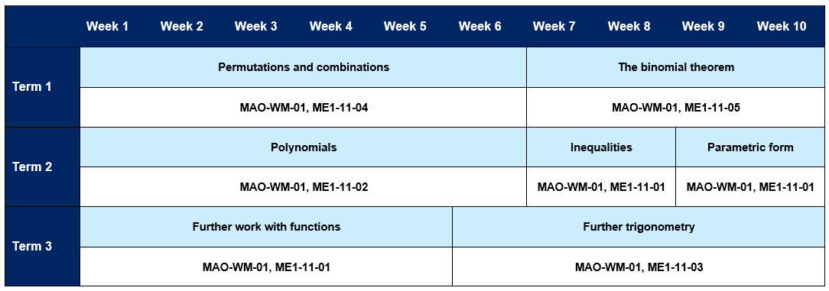

# Mathematics Extension 1 Year 12 scope and sequence

Table 4 – Mathematics Extension 1 Term 4 scope and sequence

|  |  |  |
| --- | --- | --- |
| Unit | Vectors  Weeks 1–7 | Inverse trigonometric functions  Weeks 8–10 |
| ****Outcomes**** | **MAO-WM-01, ME1-12-02** | **MAO-WM-01, ME1-12-03** |
| Description | This unit introduces vector representation and notation for both two-dimensional and three-dimensional vectors and develops into operating with vectors. | In this unit inverse trigonometric functions are defined and students learn to graph them, explore their properties and apply transformations. |

Table 5 – Mathematics Extension 1 Term 1 scope and sequence

|  |  |  |  |
| --- | --- | --- | --- |
| Unit | Proof by mathematical induction  Weeks 1–3 | Further calculus skills  Weeks 4–8 | Polynomial functions  Weeks 9–10 |
| ****Outcomes**** | **MAO-WM-01, ME1-12-01** | **MAO-WM-01, ME1-12-04** | **MAO-WM-01, ME1-12-05** |
| Description | In this unit, mathematical induction is explored, including its structure and applications. | This unit extends students’ calculus skills through differentiating inverse functions and various integration techniques, including integration by substitution. | This unit explores the multiplicity of zeroes of polynomial functions using calculus. |

Table 6 – Mathematics Extension 1 Term 3 scope and sequence

|  |  |  |
| --- | --- | --- |
| Unit | Further applications of calculus  Weeks 1–6 | Vectors and motion  Weeks 7–10 |
| Outcomes | **MAO-WM-01, ME1-12-05** | **MAO-WM-01, ME1-12-02** |
| Description | This unit applies calculus to rates of change, areas between curves and volumes of solids of revolution and also explores differential equations. | This unit explores the application of vectors to describe motion in two dimensions and analyses projectile motion. |

Table 7 – Mathematics Extension 1 Year 12 Term 4 scope and sequence

|  |  |  |
| --- | --- | --- |
| Unit | The binomial distribution and the sampling distribution of the mean  Weeks 1–6 | HSC focus  Weeks 7–10 |
| Outcomes | **MAO-WM-01, ME1-12-06** | **MAO-WM-01** |
| Description | This unit explores Bernoulli distributions, binomial distributions, sampling distribution of the mean and the central limit theorem. | This unit allows a focus on non-routine questions across a wide range of contexts. |

## Mathematics Extension 1 Year 12 scope and sequence overview

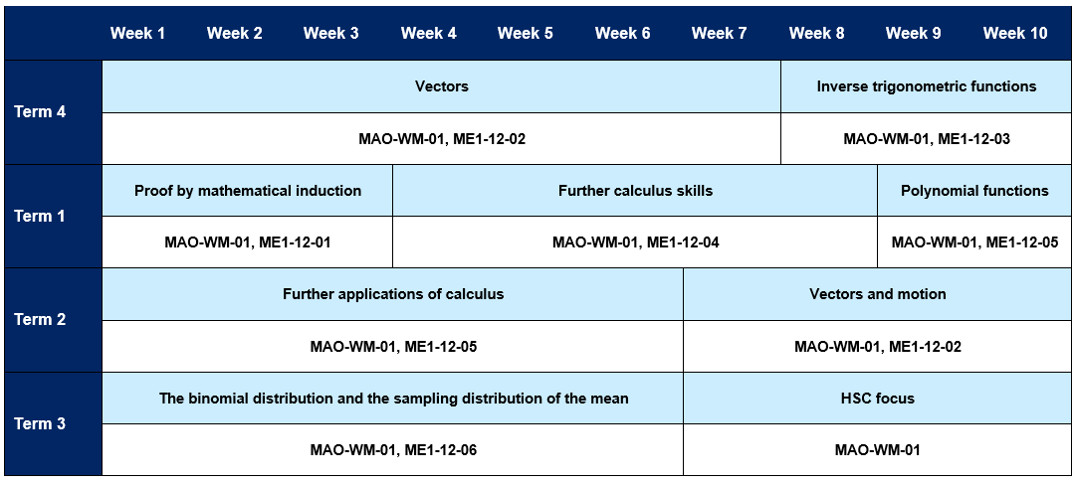

# Support and alignment

**Resource evaluation and support**: all curriculum resources are prepared through a rigorous process. Resources are periodically reviewed as part of our ongoing evaluation plan to ensure currency, relevance and effectiveness. For additional support or advice, or to provide feedback, contact the Mathematics Curriculum team by emailing [mathematics7-12@det.nsw.edu.au](mailto:mathematics7-12@det.nsw.edu.au)

**Differentiation:** further advice to support Aboriginal and Torres Strait Islander students, English as an additional language or dialect (EALD) students, students with a disability and/or additional needs and High Potential and gifted students can be found on the [Planning programming and assessing 7–12](https://education.nsw.gov.au/teaching-and-learning/curriculum/planning-programming-and-assessing-k-12/planning-programming-and-assessing-7-12) webpage. This includes the [Inclusion and differentiation 7–10 advice](https://education.nsw.gov.au/teaching-and-learning/curriculum/planning-programming-and-assessing-k-12/planning-programming-and-assessing-7-12/inclusion-and-differentiation-advice-7-10) webpage.

**Assessment**: further advice to support formative assessment is available on the [Planning programming and assessing 7–12](https://education.nsw.gov.au/teaching-and-learning/curriculum/planning-programming-and-assessing-k-12/planning-programming-and-assessing-7-12) webpage. This includes the [Classroom assessment advice 7–10](https://education.nsw.gov.au/teaching-and-learning/curriculum/planning-programming-and-assessing-k-12/planning-programming-and-assessing-7-12/classroom-assessment-advice-7-10-). For summative assessment tasks, the [Assessment task advice 7–10](https://education.nsw.gov.au/teaching-and-learning/curriculum/planning-programming-and-assessing-k-12/planning-programming-and-assessing-7-12/assessment-task-advice-7-10) webpage is available.

**Explicit teaching:** further advice to support explicit teaching is available on the [Explicit teaching](https://education.nsw.gov.au/teaching-and-learning/curriculum/explicit-teaching) webpage. This includes the CESE [Explicit teaching – Driving learning and engagement](https://education.nsw.gov.au/about-us/education-data-and-research/cese/publications/research-reports/what-works-best-2020-update/explicit-teaching-driving-learning-and-engagement) webpage.

**Alignment to system priorities and/or needs**: [School Excellence Policy](https://education.nsw.gov.au/policy-library/policies/pd-2016-0468), [Our Plan for NSW Public Education](https://education.nsw.gov.au/about-us/strategies-and-reports/plan-for-nsw-public-education)

**Alignment to the School Excellence Framework**: this resource supports the [School Excellence Framework](https://education.nsw.gov.au/policy-library/policies/pd-2016-0468) elements of curriculum (curriculum provision) and effective classroom practice (lesson planning, explicit teaching).

**Alignment to the Australian Professional Standards for Teachers**: this resource supports teachers to address [Proficient Teacher Standard Descriptors](https://educationstandards.nsw.edu.au/wps/portal/nesa/teacher-accreditation/meeting-requirements/the-standards/proficient-teacher) 3.2.2, 3.3.2.

# Evidence base

This resource contains NSW Curriculum and syllabus content. The NSW Curriculum is developed by the NSW Education Standards Authority. This content is prepared by NESA for and on behalf of the Crown in right of the State of New South Wales. The material is protected by Crown copyright.

Please refer to the NESA Copyright Disclaimer for more information [https://educationstandards.nsw.edu.au/wps/portal/nesa/mini-footer/copyright](https://aus01.safelinks.protection.outlook.com/?url=https%3A%2F%2Feducationstandards.nsw.edu.au%2Fwps%2Fportal%2Fnesa%2Fmini-footer%2Fcopyright&data=05%7C01%7CCaitlin.Pace1%40det.nsw.edu.au%7C9c2c1a9f59c94d2df30708dafa7edb23%7C05a0e69a418a47c19c259387261bf991%7C0%7C0%7C638097720042599463%7CUnknown%7CTWFpbGZsb3d8eyJWIjoiMC4wLjAwMDAiLCJQIjoiV2luMzIiLCJBTiI6Ik1haWwiLCJXVCI6Mn0%3D%7C3000%7C%7C%7C&sdata=BzQh0UsffVZE3eO22b2Xba3p0VMOBZSHfS21FGHXtZM%3D&reserved=0).

NESA holds the only official and up-to-date versions of the NSW Curriculum and syllabus documents. Please visit the NSW Education Standards Authority (NESA) website [https://educationstandards.nsw.edu.au](https://educationstandards.nsw.edu.au/) and the NSW Curriculum website [https://curriculum.nsw.edu.au](https://curriculum.nsw.edu.au/).

[Mathematics Extension 1 Stage 6 Syllabus](https://curriculum.nsw.edu.au/learning-areas/mathematics/mathematics-extension-1-11-12-2024/overview) © NSW Education Standards Authority (NESA) for and on behalf of the Crown in right of the State of New South Wales, 2024.

NESA (NSW Education Standards Authority) (2021) ‘[Advice on scope and sequences](https://www.educationstandards.nsw.edu.au/wps/portal/nesa/k-10/understanding-the-curriculum/programming/advice-on-scope-and-sequences)’, Programming, NESA website, accessed 26 February 2025.

**© State of New South Wales (Department of Education), 2025**

The copyright material published in this resource is subject to the *Copyright Act 1968* (Cth) and is owned by the NSW Department of Education or, where indicated, by a party other than the NSW Department of Education (third-party material).

Copyright material available in this resource and owned by the NSW Department of Education is licensed under a [Creative Commons Attribution 4.0 International (CC BY 4.0) license](https://creativecommons.org/licenses/by/4.0/).

[](https://creativecommons.org/licenses/by/4.0/)

This license allows you to share and adapt the material for any purpose, even commercially.

Attribution should be given to © State of New South Wales (Department of Education), 2025.

Material in this resource not available under a Creative Commons license:

* the NSW Department of Education logo, other logos and trademark-protected material
* material owned by a third party that has been reproduced with permission. You will need to obtain permission from the third party to reuse its material.

**Links to third-party material and websites**

Please note that the provided (reading/viewing material/list/links/texts) are a suggestion only and implies no endorsement, by the New South Wales Department of Education, of any author, publisher, or book title. School principals and teachers are best placed to assess the suitability of resources that would complement the curriculum and reflect the needs and interests of their students.

If you use the links provided in this document to access a third-party's website, you acknowledge that the terms of use, including licence terms set out on the third-party's website apply to the use which may be made of the materials on that third-party website or where permitted by the *Copyright Act 1968* (Cth). The department accepts no responsibility for content on third-party websites.