Mathematics Extension 2 Stage 6

Sample scope and sequence

Contents

Purpose of resource 2

Mathematics Extension 2 Year 12 scope and sequence 3

Mathematics Extension 2 Year 12 scope and sequence overview 7

Support and alignment 8

Evidence base 9

# Purpose of resource

This resource has been designed to support teachers by providing an approach to organising syllabus content and can be modified to suit individual school contexts and procedures as required.

High quality formative and summative assessment should form an integral part of all teaching and learning programs. For more information, please visit [NESA’s Advice on assessment](https://educationstandards.nsw.edu.au/wps/portal/nesa/k-10/understanding-the-curriculum/assessment) page.

# Mathematics Extension 2 Year 12 scope and sequence

Table 1 – Mathematics Extension 2 Term 4 scope and sequence

|  |  |  |
| --- | --- | --- |
| Unit | Introducing complex numbers  Weeks 1–6 | Vector equations of lines and curves  Weeks 7–10 |
| Outcomes | **MAO-WM-01, ME2-12-03** | **MAO-WM-01, ME2-12-02** |
| Description | This unit explores the arithmetic, algebraic properties and geometric representation of complex numbers. Complex numbers are examined in Cartesian and polar forms, with operations, equations and identities applied to solve problems and prove results. | This unit explores vector equations of lines and curves in two and three dimensions. Vector methods are examined and applied to determine intersections, collinearity, skew lines and the equations of circles and spheres. |

Table 2 – Mathematics Extension 2 Term 1 scope and sequence

|  |  |  |
| --- | --- | --- |
| Unit | The nature of proof  Weeks 1–6 | Further complex numbers  Weeks 7–10 |
| Outcomes | **MAO-WM-01, ME2-12-01** | **MAO-WM-01, ME2-12-03** |
| Description | This unit explores the language and notation of mathematical proof. Proof techniques such as proof by contradiction, counterexamples, inequalities and mathematical induction are examined and applied to problems involving algebra, geometry and calculus. | This unit explores powers and roots of complex numbers, including de Moivre’s theorem and its applications in trigonometry and geometry. Complex numbers are examined as vectors, with their operations used to describe transformations, solve equations and graph lines, curves and regions on the complex plane. |

Table 3 – Mathematics Extension 2 Term 2 scope and sequence

|  |  |  |  |
| --- | --- | --- | --- |
| Unit | Vectors and geometry  Weeks 1–2 | Further integration  Weeks 3–8 | Forces and motion in a straight line  Weeks 9–10 |
| Outcomes | **MAO-WM-01, ME2-12-02** | **MAO-WM-01, ME2-12-04** | **MAO-WM-01, ME2-12-05** |
| Description | Vector methods are examined and applied to prove geometric results, including inequalities and properties of triangles, in two and three dimensions. | This unit explores trigonometric identities, equations and integrals, including product-to-sum formulas and their applications. Advanced integration techniques such as substitution, partial fractions, completing the square and integration by parts are examined and applied to solve theoretical and practical problems. | This unit explores forces and motion in a straight line, using Newton’s laws and vector methods to analyse acceleration and resolve forces in two and three dimensions. |

Table 4 – Mathematics Extension 2 Term 3 scope and sequence

|  |  |  |
| --- | --- | --- |
| Unit | Applications of calculus to mechanics  Weeks 1–6 | HSC focus  Weeks 7–10 |
| Outcomes | **MAO-WM-01, ME2-12-05** | **MAO-WM-01** |
| Description | This unit explores simple harmonic motion, resisted motion and projectile motion under various conditions. Key concepts include acceleration, velocity, displacement, forces and resistance, with applications to oscillations, inclined planes, pulleys and terminal velocity. | This unit allows a focus on non-routine questions across a wide range of contexts. |

## Mathematics Extension 2 Year 12 scope and sequence overview

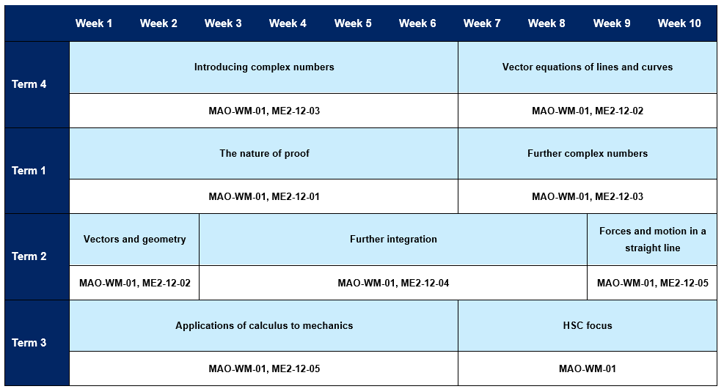

# Support and alignment

**Resource evaluation and support**: all curriculum resources are prepared through a rigorous process. Resources are periodically reviewed as part of our ongoing evaluation plan to ensure currency, relevance and effectiveness. For additional support or advice, or to provide feedback, contact the Mathematics Curriculum team by emailing [mathematics7-12@det.nsw.edu.au](mailto:mathematics7-12@det.nsw.edu.au)

**Differentiation:** further advice to support Aboriginal and Torres Strait Islander students, English as an additional language or dialect (EALD) students, students with a disability and/or additional needs and High Potential and gifted students can be found on the [Planning programming and assessing 7–12](https://education.nsw.gov.au/teaching-and-learning/curriculum/planning-programming-and-assessing-k-12/planning-programming-and-assessing-7-12) webpage. This includes the [Inclusion and differentiation 7–10 advice](https://education.nsw.gov.au/teaching-and-learning/curriculum/planning-programming-and-assessing-k-12/planning-programming-and-assessing-7-12/inclusion-and-differentiation-advice-7-10) webpage.

**Assessment**: further advice to support formative assessment is available on the [Planning programming and assessing 7–12](https://education.nsw.gov.au/teaching-and-learning/curriculum/planning-programming-and-assessing-k-12/planning-programming-and-assessing-7-12) webpage. This includes the [Classroom assessment advice 7–10](https://education.nsw.gov.au/teaching-and-learning/curriculum/planning-programming-and-assessing-k-12/planning-programming-and-assessing-7-12/classroom-assessment-advice-7-10-). For summative assessment tasks, the [Assessment task advice 7–10](https://education.nsw.gov.au/teaching-and-learning/curriculum/planning-programming-and-assessing-k-12/planning-programming-and-assessing-7-12/assessment-task-advice-7-10) webpage is available.

**Explicit teaching:** further advice to support explicit teaching is available on the [Explicit teaching](https://education.nsw.gov.au/teaching-and-learning/curriculum/explicit-teaching) webpage. This includes the CESE [Explicit teaching – Driving learning and engagement](https://education.nsw.gov.au/about-us/education-data-and-research/cese/publications/research-reports/what-works-best-2020-update/explicit-teaching-driving-learning-and-engagement) webpage.

**Alignment to system priorities and/or needs**: [School Excellence Policy](https://education.nsw.gov.au/policy-library/policies/pd-2016-0468), [Our Plan for NSW Public Education](https://education.nsw.gov.au/about-us/strategies-and-reports/plan-for-nsw-public-education)

**Alignment to the School Excellence Framework**: this resource supports the [School Excellence Framework](https://education.nsw.gov.au/policy-library/policies/pd-2016-0468) elements of curriculum (curriculum provision) and effective classroom practice (lesson planning, explicit teaching).

**Alignment to the Australian Professional Standards for Teachers**: this resource supports teachers to address [Proficient Teacher Standard Descriptors](https://educationstandards.nsw.edu.au/wps/portal/nesa/teacher-accreditation/meeting-requirements/the-standards/proficient-teacher) 3.2.2, 3.3.2.

# Evidence base

This resource contains NSW Curriculum and syllabus content. The NSW Curriculum is developed by the NSW Education Standards Authority. This content is prepared by NESA for and on behalf of the Crown in right of the State of New South Wales. The material is protected by Crown copyright.

Please refer to the NESA Copyright Disclaimer for more information [https://educationstandards.nsw.edu.au/wps/portal/nesa/mini-footer/copyright](https://aus01.safelinks.protection.outlook.com/?url=https%3A%2F%2Feducationstandards.nsw.edu.au%2Fwps%2Fportal%2Fnesa%2Fmini-footer%2Fcopyright&data=05%7C01%7CCaitlin.Pace1%40det.nsw.edu.au%7C9c2c1a9f59c94d2df30708dafa7edb23%7C05a0e69a418a47c19c259387261bf991%7C0%7C0%7C638097720042599463%7CUnknown%7CTWFpbGZsb3d8eyJWIjoiMC4wLjAwMDAiLCJQIjoiV2luMzIiLCJBTiI6Ik1haWwiLCJXVCI6Mn0%3D%7C3000%7C%7C%7C&sdata=BzQh0UsffVZE3eO22b2Xba3p0VMOBZSHfS21FGHXtZM%3D&reserved=0).

NESA holds the only official and up-to-date versions of the NSW Curriculum and syllabus documents. Please visit the NSW Education Standards Authority (NESA) website [https://educationstandards.nsw.edu.au](https://educationstandards.nsw.edu.au/) and the NSW Curriculum website [https://curriculum.nsw.edu.au](https://curriculum.nsw.edu.au/).

[Mathematics Extension 2 Stage 6 Syllabus](https://curriculum.nsw.edu.au/learning-areas/mathematics/mathematics-extension-2-11-12-2024/overview) © NSW Education Standards Authority (NESA) for and on behalf of the Crown in right of the State of New South Wales, 2024.

NESA (NSW Education Standards Authority) (2021) ‘[Advice on scope and sequences](https://www.educationstandards.nsw.edu.au/wps/portal/nesa/k-10/understanding-the-curriculum/programming/advice-on-scope-and-sequences)’, Programming, NESA website, accessed 26 February 2025.

**© State of New South Wales (Department of Education), 2025**

The copyright material published in this resource is subject to the *Copyright Act 1968* (Cth) and is owned by the NSW Department of Education or, where indicated, by a party other than the NSW Department of Education (third-party material).

Copyright material available in this resource and owned by the NSW Department of Education is licensed under a [Creative Commons Attribution 4.0 International (CC BY 4.0) license](https://creativecommons.org/licenses/by/4.0/).

[](https://creativecommons.org/licenses/by/4.0/)

This license allows you to share and adapt the material for any purpose, even commercially.

Attribution should be given to © State of New South Wales (Department of Education), 2025.

Material in this resource not available under a Creative Commons license:

* the NSW Department of Education logo, other logos and trademark-protected material
* material owned by a third party that has been reproduced with permission. You will need to obtain permission from the third party to reuse its material.

**Links to third-party material and websites**

Please note that the provided (reading/viewing material/list/links/texts) are a suggestion only and implies no endorsement, by the New South Wales Department of Education, of any author, publisher, or book title. School principals and teachers are best placed to assess the suitability of resources that would complement the curriculum and reflect the needs and interests of their students.

If you use the links provided in this document to access a third-party's website, you acknowledge that the terms of use, including licence terms set out on the third-party's website apply to the use which may be made of the materials on that third-party website or where permitted by the *Copyright Act 1968* (Cth). The department accepts no responsibility for content on third-party websites.