Mathematics Standard Stage 6

Sample scope and sequence

Contents

Purpose of resource 2

Mathematics Standard Year 11 scope and sequence 3

Mathematics Standard Year 11 scope and sequence overview 7

Mathematics Standard 2 Year 12 scope and sequence 8

Mathematics Standard 2 Year 12 scope and sequence overview 12

Mathematics Standard 1 Year 12 scope and sequence 13

Mathematics Standard 1 Year 12 scope and sequence overview 17

Support and alignment 18

Evidence base 19

# Purpose of resource

This resource has been designed to support teachers by providing an approach to organising syllabus content and can be modified to suit individual school contexts and procedures as required.

High quality formative and summative assessment should form an integral part of all teaching and learning programs. For more information, please visit [NESA’s Advice on assessment](https://educationstandards.nsw.edu.au/wps/portal/nesa/k-10/understanding-the-curriculum/assessment) page.

# Mathematics Standard Year 11 scope and sequence

Table 1 – Mathematics Standard Term 1 scope and sequence

|  |  |  |
| --- | --- | --- |
| Unit | Getting healthy  Weeks 1–5 | Show me the money  Weeks 6–10 |
| ****Outcomes**** | **MAO-WM-01, MST-11-01, MST-11-08** | **MAO-WM-01, MST-11-01, MST-11-02, MST-11-03, MST-11-04** |
| Related Life Skills outcomes | MA-LS-01, MA-LS-02, MA-LS-03, MA-LS-04, MA-LS-13,  MA-LS-14, MA-LS-15, MA-LS-16 | MA-LS-01, MA-LS-02, MA-LS-03, MA-LS-04, MA-LS-05,  MA-LS-06, MA-LS-07, MA-LS-16 |
| Description | This unit examines the connection between mathematics and health through a statistical investigation process. Students will design effective surveys, gather statistical information and analyse datasets. Students will apply algebraic concepts to various formulas related to health fields. | This unit provides students with essential financial literacy and algebra skills, focusing on earning, spending, managing and understanding money. Students will construct linear financial models to solve real-world problems. |

Table 2 – Mathematics Standard Term 2 scope and sequence

|  |  |  |
| --- | --- | --- |
| Unit | Making things  Weeks 1–8 | Driving safely  Weeks 9–10 (continues into Term 3) |
| ****Outcomes**** | **MAO-WM-01, MST-11-01, MST-11-02, MST-11-04, MST-11-05** | **MAO-WM-01, MST-11-01, MST-11-04, MST-11-05, MST-11-08** |
| Related Life Skills outcomes | MA-LS-01, MA-LS-02, MA-LS-03, MA-LS-04, MA-LS-05, MA-LS-06, MA-LS-07, MA-LS-08, MA-LS-09, MA-LS-10, MA-LS-16 | MA-LS-01, MA-LS-02, MA-LS-03, MA-LS-04, MA-LS-05, MA-LS-06, MA-LS-07, MA-LS-08, MA-LS-09, MA-LS-10,  MA-LS-11, MA-LS-12, MA-LS-13, MA-LS-14, MA-LS-16 |
| Description | This unit focuses on the practical aspects of creating and producing, whether in trades, gardening, construction, cooking or farming. Students will calculate business costs and quantities of materials, incorporating skills in algebra, linear models, financial literacy and measurement. | In this unit, students will explore mathematical concepts related to road safety and vehicle operation, including road statistics, insurance costs and vehicle ownership expenses. Students will use formulas for calculating metrics like distance, speed, stopping distances and blood alcohol content (BAC). |

Table 3 – Mathematics Standard Term 3 scope and sequence

|  |  |  |
| --- | --- | --- |
| Unit | Driving safely  Weeks 1–6 | Going places  Weeks 7–10 (continues into Term 4) |
| ****Outcomes**** | **MAO-WM-01, MST-11-01, MST-11-04, MST-11-05, MST-11-08** | **MAO-WM-01, MST-11-06, MST-11-07** |
| Related Life Skills outcomes | MA-LS-01, MA-LS-02, MA-LS-03, MA-LS-04, MA-LS-05,  MA-LS-06, MA-LS-07, MA-LS-08, MA-LS-09, MA-LS-10,  MA-LS-11, MA-LS-12, MA-LS-13, MA-LS-14, MA-LS-16 | MA-LS-01, MA-LS-02, MA-LS-04, MA-LS-07, MA-LS-08,  MA-LS-09, MA-LS-11, MA-LS-12, MA-LS-16 |
| Description | Additionally, this unit emphasises data organisation and representation, using spreadsheets to create and interpret graphs and tables and analyse graphical representations and their features. Students will convert units of volume, capacity and mass and will calculate both initial purchase costs and ongoing expenses of vehicle ownership. | In this unit, students will perform time calculations and conversions and study network diagrams, vital for understanding both geographical and theoretical concepts. |

Table 4 – Mathematics Standard Term 4 scope and sequence

|  |  |  |
| --- | --- | --- |
| Unit | Going places  Weeks 1–3 | Year 12 content |
| ****Outcomes**** | **MAO-WM-01, MST-11-06, MST-11-07** |  |
| Related Life Skill outcomes | MA-LS-01, MA-LS-02, MA-LS-04, MA-LS-07, MA-LS-08,  MA-LS-09, MA-LS-11, MA-LS-12, MA-LS-16 |  |
| Description | Students will describe and construct network diagrams to plan aspects of a journey while learning key network terminology and applications. |  |

## Mathematics Standard Year 11 scope and sequence overview

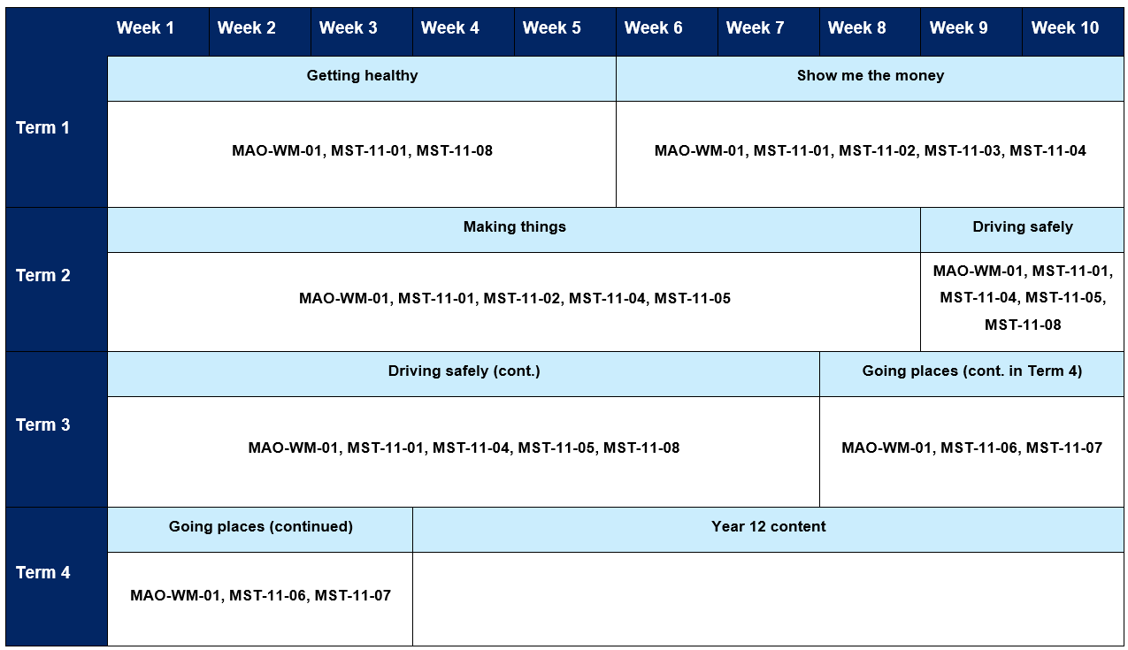

# Mathematics Standard 2 Year 12 scope and sequence

Table 5 – Mathematics Standard 2 Term 4 scope and sequence

|  |  |  |  |
| --- | --- | --- | --- |
| Unit | Year 11 content  Weeks 1–3 | Correlation  Weeks 4–7 | Managing events (continues into Term 2)  Weeks 8–10 |
| ****Outcomes**** |  | **MAO-WM-01, MST-12-S2-08** | **MAO-WM-01, MST-12-S2-01, MST-12-S2-05, MST-12-S2-06, MST-12-S2-07** |
| Related Life Skills outcomes |  | MA-LS-01, MA-LS-03, MA-LS-10, MA-LS-11,  MA-LS-12, MA-LS-13, MA-LS-14, MA-LS-16 | MA-LS-01, MA-LS-02, MA-LS-04, MA-LS-05,  MA-LS-06, MA-LS-07, MA-LS-08, MA-LS-09,  MA-LS-10, MA-LS-11, MA-LS-12, MA-LS-16 |
| Description |  | This unit explores bivariate datasets, focusing on the distinction between one-variable and bivariate data and on the relationship between independent and dependent variables. Students will learn to identify correlation versus causation, represent data with scatterplots and create lines of best fit. | This unit focuses on using mathematics in event planning and major works. Students will learn how simultaneous equations model break-even problems and apply rates to compare best buys and solve speed-distance-time problems. |

Table 6 – Mathematics Standard 2 Term 1 scope and sequence

|  |  |  |  |
| --- | --- | --- | --- |
| Unit | Managing events  Weeks 1–4 | Money in  Weeks 5–8 | Graphs in the real world  Weeks 9–10 |
| ****Outcomes**** | **MAO-WM-01, MST-12-S2-01,  MST-12-S2-05, MST-12-S2-06,  MST-12-S2-07** | **MAO-WM-01, MST-12-S2-01,  MST-12-S2-02, MST-12-S2-03,  MST-12-S2-05** | **MAO-WM-01, MST-12-S2-01,  MST-12-S2-05** |
| Related Life Skills outcomes | MA-LS-01, MA-LS-02, MA-LS-04,  MA-LS-05, MA-LS-06, MA-LS-07,  MA-LS-08, MA-LS-09, MA-LS-10,  MA-LS-11, MA-LS-12, MA-LS-16 | MA-LS-01, MA-LS-02, MA-LS-04,  MA-LS-05, MA-LS-06, MA-LS-07,  MA-LS-16 | MA-LS-01, MA-LS-02, MA-LS-04,  MA-LS-05, MA-LS-06, MA-LS-07,  MA-LS-16 |
| Description | Additionally, in this unit, students will learn project management concepts like flow capacity, critical paths and Gantt charts for effective decision making and planning. | This unit focuses on the growth of money through savings, investments and annuities, covering simple and compound interest, shares and property. The unit also introduces exponential growth through the concept of compound interest. | This unit explores exponential relationships and their applications, including growth and decay problems. |

Table 7 – Mathematics Standard 2 Term 3 scope and sequence

|  |  |  |
| --- | --- | --- |
| Unit | Money out  Weeks 1–3 | Under construction  Weeks 4–10 |
| ****Outcomes**** | **MAO-WM-01, MST-12-S2-02, MST-12-S2-03** | **MAO-WM-01, MST-12-S2-01, MST-12-S2-04, MST-12-S2-05** |
| Related Life Skills outcomes | MA-LS-01, MA-LS-02, MA-LS-03, MA-LS-04, MA-LS-05,  MA-LS-06, MA-LS-07, MA-LS-16 | MA-LS-01, MA-LS-02, MA-LS-03, MA-LS-04, MA-LS-08,  MA-LS-09, MA-LS-10, MA-LS-11, MA-LS-16 |
| Description | This unit focuses on financial management, covering credit cards, loans and annuities. The unit also addresses financial decisions regarding superannuation, savings and loans and helps students compare credit options to manage short-term, medium-term and long-term goals. | This unit extends the Year 11 ‘Making things’ unit by applying mathematical concepts such as ratios, rates, sine and cosine rules, quadratic relationships and reciprocal relationships specifically to the construction industry and other practical contexts. |

Table 8 – Mathematics Standard 2 Term 4 scope and sequence

|  |  |  |
| --- | --- | --- |
| Unit | What are the chances?  Weeks 1–6 | HSC focus  Weeks 7–10 |
| ****Outcomes**** | **MAO-WM-01, MST-12-S2-05, MST-12-S2-09, MST-12-S2-10** | **MAO-WM-01** |
| Related Life Skills outcomes | MA-LS-01, MA-LS-02, MA-LS-03, MA-LS-04, MA-LS-08,  MA-LS-09, MA-LS-10, MA-LS-13, MA-LS-14, MA-LS-15,  MA-LS-16 |  |
| Description | This unit connects probability, normal distribution and rates to real-world risk management decisions, such as insurance costs and assessing natural disaster risks. | This unit allows a focus on non-routine questions across a wide range of contexts. |

## Mathematics Standard 2 Year 12 scope and sequence overview

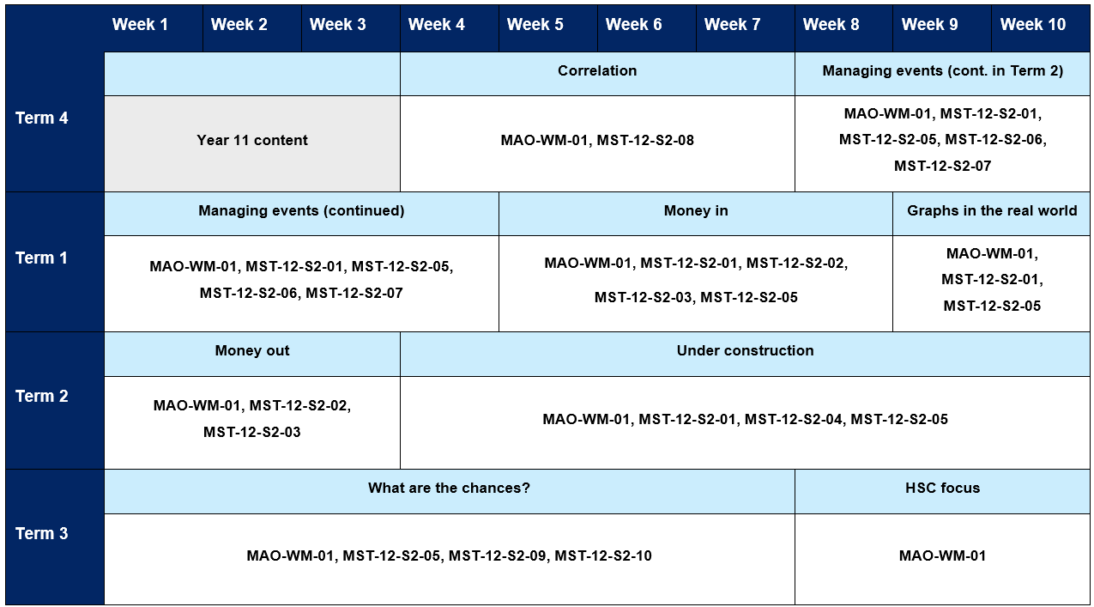

# Mathematics Standard 1 Year 12 scope and sequence

Table 9 – Mathematics Standard 1 Term 4 scope and sequence

|  |  |  |  |
| --- | --- | --- | --- |
| Unit | Year 11 content  Weeks 1–3 | Correlation  Weeks 4–7 | Managing events (continues in Term 2)  Weeks 8–10 |
| ****Outcomes**** |  | **MAO-WM-01, MST-12-S1-06** | **MAO-WM-01, MST-12-S1-01, MST-12-S1-05** |
| Related Life Skills outcomes |  | MA-LS-01, MA-LS-03, MA-LS-10, MA-LS-11,  MA-LS-12, MA-LS-13, MA-LS-14, MA-LS-16 | MA-LS-01, MA-LS-02, MA-LS-04, MA-LS-05,  MA-LS-06, MA-LS-07, MA-LS-08, MA-LS-09,  MA-LS-16 |
| Description |  | This unit explores the concepts of bivariate datasets, focusing on the distinction between one-variable and bivariate data and on understanding the relationship between independent and dependent variables. Students will learn to identify correlation versus causal relationships, represent data with scatterplots and create lines of best fit using both visual and digital tools. | This unit focuses on the use of mathematics in event planning. Students will learn how simultaneous equations model break-even problems and apply rates to compare best buys and solve speed-distance-time problems. |

Table 10 – Mathematics Standard 1 Term 1 scope and sequence

|  |  |  |  |
| --- | --- | --- | --- |
| Unit | Managing events  Weeks 1–4 | Money in  Weeks 5–8 | Graphs in the real world  Weeks 9–10 |
| ****Outcomes**** | **MAO-WM-01, MST-12-S1-01,  MST-12-S1-05** | **MAO-WM-01, MST-12-S1-01,  MST-12-S1-02, MST-12-S1-05** | **MAO-WM-01, MST-12-S1-01** |
| Related Life Skills outcomes | MA-LS-01, MA-LS-02, MA-LS-04,  MA-LS-05, MA-LS-06, MA-LS-07,  MA-LS-08, MA-LS-09, MA-LS-10,  MA-LS-11, MA-LS-12, MA-LS-16 | MA-LS-01, MA-LS-02, MA-LS-04,  MA-LS-05, MA-LS-06, MA-LS-07,  MA-LS-16 | MA-LS-01, MA-LS-02, MA-LS-04,  MA-LS-05, MA-LS-06, MA-LS-07,  MA-LS-16 |
| Description | This unit focuses on the use of mathematics in event planning. Students will learn how simultaneous equations model break-even problems and apply rates to compare best buys and solve speed-distance-time problems. | This unit focuses on the growth of money through savings, investments and annuities, covering simple and compound interest, shares and property. The unit also introduces exponential growth through the concept of compound interest. | This teaching unit focuses on exponential relationships and their applications in various contexts such as growth and decay problems. |

Table 11 – Mathematics Standard 1 Term 3 scope and sequence

|  |  |  |
| --- | --- | --- |
| Unit | Money out  Weeks 1–5 | Under construction  Weeks 6–10 |
| ****Outcomes**** | **MAO-WM-01, MST-12-S1-01, MST-12-S1-03** | **MAO-WM-01, MST-12-S1-04, MST-12-S1-05** |
| Related Life Skills outcomes | MA-LS-01, MA-LS-02, MA-LS-03, MA-LS-04, MA-LS-05,  MA-LS-06, MA-LS-07, MA-LS-16 | MA-LS-01, MA-LS-02, MA-LS-03, MA-LS-04, MA-LS-08,  MA-LS-09, MA-LS-10, MA-LS-11, MA-LS-16 |
| Description | This unit explores real-world financial applications, including modelling depreciation, loans and credit card usage. Students will construct linear or exponential graphs to make predictions and compare straight-line and declining balance depreciation methods. They will analyse loans and credit cards, exploring interest rates, fees and the implications of minimum payments to make informed financial decisions. | This unit focuses on applying mathematical concepts to the context of construction and design. Students will use Pythagoras' theorem and trigonometric ratios to solve problems involving calculating unknown sides and angles. They will study ratios in the context of map scales, building plans and construction measurements and work with rates to compare fuel consumption. |

Table 12 – Mathematics Standard 1 Term 4 scope and sequence

|  |  |  |
| --- | --- | --- |
| Unit | What are the chances?  Weeks 1–6 | HSC focus  Weeks 7–10 |
| ****Outcomes**** | **MAO-WM-01, MST-12-S1-07** | **MAO-WM-01** |
| Related Life Skills outcomes | MA-LS-01, MA-LS-02, MA-LS-03, MA-LS-04, MA-LS-13,  MA-LS-14, MA-LS-15, MA-LS-16 |  |
| Description | This unit explores the application of probability and relative frequency in making risk management decisions like evaluating natural disaster risks, insurance costs and car insurance pricing based on postcodes. Students will learn how statistical analysis and probability play a crucial role in decision-making for businesses and governments. | This unit allows a focus on non-routine questions across a wide range of contexts. |

## Mathematics Standard 1 Year 12 scope and sequence overview

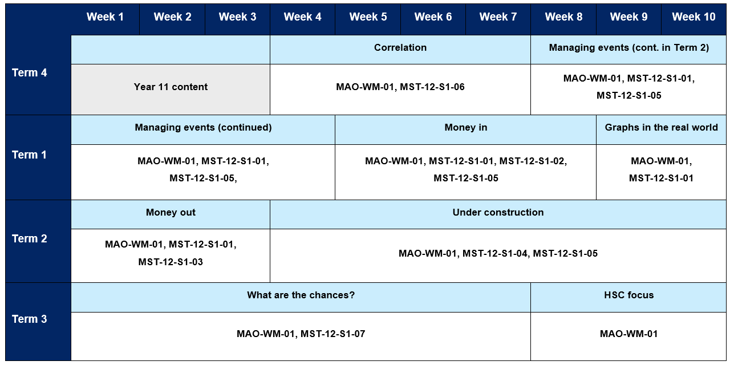

# Support and alignment

**Resource evaluation and support**: all curriculum resources are prepared through a rigorous process. Resources are periodically reviewed as part of our ongoing evaluation plan to ensure currency, relevance and effectiveness. For additional support or advice, or to provide feedback, contact the Mathematics Curriculum team by emailing [mathematics7-12@det.nsw.edu.au](mailto:mathematics7-12@det.nsw.edu.au)

**Differentiation:** further advice to support Aboriginal and Torres Strait Islander students, English as an additional language or dialect (EALD) students, students with a disability and/or additional needs and high potential and gifted students can be found on the [Planning programming and assessing 7–12](https://education.nsw.gov.au/teaching-and-learning/curriculum/planning-programming-and-assessing-k-12/planning-programming-and-assessing-7-12) webpage. This includes the [Inclusion and differentiation 7–10 advice](https://education.nsw.gov.au/teaching-and-learning/curriculum/planning-programming-and-assessing-k-12/planning-programming-and-assessing-7-12/inclusion-and-differentiation-advice-7-10) webpage.

**Assessment**: further advice to support formative assessment is available on the [Planning programming and assessing 7–12](https://education.nsw.gov.au/teaching-and-learning/curriculum/planning-programming-and-assessing-k-12/planning-programming-and-assessing-7-12) webpage. This includes the [Classroom assessment advice 7–10](https://education.nsw.gov.au/teaching-and-learning/curriculum/planning-programming-and-assessing-k-12/planning-programming-and-assessing-7-12/classroom-assessment-advice-7-10-). For summative assessment tasks, the [Assessment task advice 7–10](https://education.nsw.gov.au/teaching-and-learning/curriculum/planning-programming-and-assessing-k-12/planning-programming-and-assessing-7-12/assessment-task-advice-7-10) webpage is available.

**Explicit teaching:** further advice to support explicit teaching is available on the [Explicit teaching](https://education.nsw.gov.au/teaching-and-learning/curriculum/explicit-teaching) webpage. This includes the CESE [Explicit teaching – Driving learning and engagement](https://education.nsw.gov.au/about-us/education-data-and-research/cese/publications/research-reports/what-works-best-2020-update/explicit-teaching-driving-learning-and-engagement) webpage.

**Alignment to system priorities and/or needs**: [School Excellence Policy](https://education.nsw.gov.au/policy-library/policies/pd-2016-0468), [Our Plan for NSW Public Education](https://education.nsw.gov.au/about-us/strategies-and-reports/plan-for-nsw-public-education)

**Alignment to the School Excellence Framework**: this resource supports the [School Excellence Framework](https://education.nsw.gov.au/policy-library/policies/pd-2016-0468) elements of curriculum (curriculum provision) and effective classroom practice (lesson planning, explicit teaching).

**Alignment to the Australian Professional Standards for Teachers**: this resource supports teachers to address [Proficient Teacher Standard Descriptors](https://educationstandards.nsw.edu.au/wps/portal/nesa/teacher-accreditation/meeting-requirements/the-standards/proficient-teacher) 3.2.2, 3.3.2.

# Evidence base

This resource contains NSW Curriculum and syllabus content. The NSW Curriculum is developed by the NSW Education Standards Authority. This content is prepared by NESA for and on behalf of the Crown in right of the State of New South Wales. The material is protected by Crown copyright.

Please refer to the NESA Copyright Disclaimer for more information [https://educationstandards.nsw.edu.au/wps/portal/nesa/mini-footer/copyright](https://aus01.safelinks.protection.outlook.com/?url=https%3A%2F%2Feducationstandards.nsw.edu.au%2Fwps%2Fportal%2Fnesa%2Fmini-footer%2Fcopyright&data=05%7C01%7CCaitlin.Pace1%40det.nsw.edu.au%7C9c2c1a9f59c94d2df30708dafa7edb23%7C05a0e69a418a47c19c259387261bf991%7C0%7C0%7C638097720042599463%7CUnknown%7CTWFpbGZsb3d8eyJWIjoiMC4wLjAwMDAiLCJQIjoiV2luMzIiLCJBTiI6Ik1haWwiLCJXVCI6Mn0%3D%7C3000%7C%7C%7C&sdata=BzQh0UsffVZE3eO22b2Xba3p0VMOBZSHfS21FGHXtZM%3D&reserved=0).

NESA holds the only official and up-to-date versions of the NSW Curriculum and syllabus documents. Please visit the NSW Education Standards Authority (NESA) website [https://educationstandards.nsw.edu.au](https://educationstandards.nsw.edu.au/) and the NSW Curriculum website [https://curriculum.nsw.edu.au](https://curriculum.nsw.edu.au/).

[Mathematics Standard Stage 6 Syllabus](https://curriculum.nsw.edu.au/learning-areas/mathematics/mathematics-standard-11-12-2024/overview) © NSW Education Standards Authority (NESA) for and on behalf of the Crown in right of the State of New South Wales, 2024.

NESA (NSW Education Standards Authority) (2024) ‘[Advice on scope and sequences](https://www.educationstandards.nsw.edu.au/wps/portal/nesa/k-10/understanding-the-curriculum/programming/advice-on-scope-and-sequences)’, Programming, NESA website, accessed 26 February 2025.

**© State of New South Wales (Department of Education), 2025**

The copyright material published in this resource is subject to the *Copyright Act 1968* (Cth) and is owned by the NSW Department of Education or, where indicated, by a party other than the NSW Department of Education (third-party material).

Copyright material available in this resource and owned by the NSW Department of Education is licensed under a [Creative Commons Attribution 4.0 International (CC BY 4.0) license](https://creativecommons.org/licenses/by/4.0/).

[](https://creativecommons.org/licenses/by/4.0/)

This license allows you to share and adapt the material for any purpose, even commercially.

Attribution should be given to © State of New South Wales (Department of Education), 2025.

Material in this resource not available under a Creative Commons license:

* the NSW Department of Education logo, other logos and trademark-protected material
* material owned by a third party that has been reproduced with permission. You will need to obtain permission from the third party to reuse its material.

**Links to third-party material and websites**

Please note that the provided (reading/viewing material/list/links/texts) are a suggestion only and implies no endorsement, by the New South Wales Department of Education, of any author, publisher, or book title. School principals and teachers are best placed to assess the suitability of resources that would complement the curriculum and reflect the needs and interests of their students.

If you use the links provided in this document to access a third-party's website, you acknowledge that the terms of use, including licence terms set out on the third-party's website apply to the use which may be made of the materials on that third-party website or where permitted by the *Copyright Act 1968* (Cth). The department accepts no responsibility for content on third-party websites.