Health and movement science Stage 6 (Year 11)
Teaching a collaborative investigation – technology and young people
Contents
Overview 4
Prior learning 4
Purpose 5
Modelled, guided and independent approach to program delivery 6
Extension options 8
Syllabus 11
Outcomes 11
Content 11
Applying the collaborative investigation process 13
Step 1 – forming a group 13
Modelled approach 13
Guided or independent approach 14
Step 2 – identifying areas of interest 16
Guided or independent approach 17
Modelled approach 18
Guided or independent approach 19
Step 3 – collecting, analysing and recording secondary data 19
Modelled approach 19
Guided or independent approach 20
Modelled approach 20
Guided or independent approach 21
Reflection 22
Step 4 – developing a research question 22
Modelled approach 23
RAFTER model 25
Guided or independent approach 39
Step 5 – selecting research methods 40
Modelled approach 40
Guided or independent approach 42
Step 6 – creating methodologies to collect data 44
Modelled approach 44
Guided or independent approach 46
Step 7 – applying research methods to collect data 47
Modelled approach 47
Guided or independent approach 48
Step 8 – interpreting and analysing research to determine findings 48
Modelled approach 49
Group data analysis 53
Modelled approach 53
Guided or independent approach 53
Step 9 – drawing conclusions from the research 55
Modelled approach 55
Guided or independent approach 55
Step 10 – presenting findings to the class or a panel of experts 57
Modelled approach 58
Guided or independent approach 58
Extension option 59
Resource 1 – group-forming activities 60
Resource 2 – sample group contract 61
Resource 3 – sample roles and responsibilities table for group contract 64
Resource 4 – sample tracking sheet group 65
Resource 5 – sample tracking sheet individual 66
Goals 66
Tasks 67
Next steps 67
Resource 6 – giving and receiving feedback 68
Resource 7 – designing a research question 70
Resource 8 – the RAFTER model 72
Resource 9 – formulating a question – sample questions teacher resource 75
Example questions 75
Resource 10 – application of research data collection methods 77
Interviews 77
Questionnaires 78
Experiments 81
Observations 82
Focus groups 83
Literature reviews 83
Further reading 85
Additional information 86
Support and alignment 86
References 88
This resource has been developed to assist teachers in NSW Department of Education schools to create learning that is contextualised to their classroom. It can be used as a basis for the teacher’s own program, assessment, or scope and sequence, or be used as an example of how the new curriculum could be implemented. The resource has suggested timeframes that may need to be adjusted by the teacher to meet the needs of their students.

Overview
This collaborative investigation is intended to be completed in Year 11 as part of Focus area 1 – Health for individuals and communities. The following collaborative investigation is provided as a guide using the syllabus content which models the process of investigation.
Teachers are advised that:
- this is not the only way a collaborative investigation could be completed
- the research question identified is not the only example suitable for this content
- adaptations will be required to suit the context of each school, including access to resources, equipment, number of classes and number of students.
Duration: ten hours have been allocated to this collaborative investigation. This learning sequence is not designed to count towards the 20 indicative hours for collaborative investigation.

Prior learning
A sound understanding of the following syllabus content will assist students to undertake this collaborative investigation:
- the principles of conducting an investigation
- methods to collect, present and analyse data
- how to present and analyse data
- meanings of health, using various sources, including the World Health Organisation’s (WHO) definition
- why people give different meanings to health
- the dynamic nature of health and how an individual’s circumstances affect their health
- the range of determinants that influence the health and wellbeing of Australians.
Opportunities for reflection and adjustments can be made depending on student interest.
Access the Principles of conducting an investigation learning program if students have not previously engaged in learning associated with the principles of conducting an investigation.
Access the Young people’s meanings of health – Focus area 1 learning program if students have not previously engaged in the following syllabus content:
- Explore across generations aspects of young people’s lives that make them similar and different to the young people of previous generations
Example(s)
Developmental stages.
Influence of family, peers culture, technology and global events.

Purpose
This program of learning is designed to support the whole process from Step 1 – forming a group to Step 10 – presenting findings to the class or a panel of experts (see Figure 1). Opportunities for student collaboration have been embedded in the investigation activities as a guide. Teachers determine the most suitable teaching strategies to deliver this content.
Figure 1 – collaborative investigation 10-step process
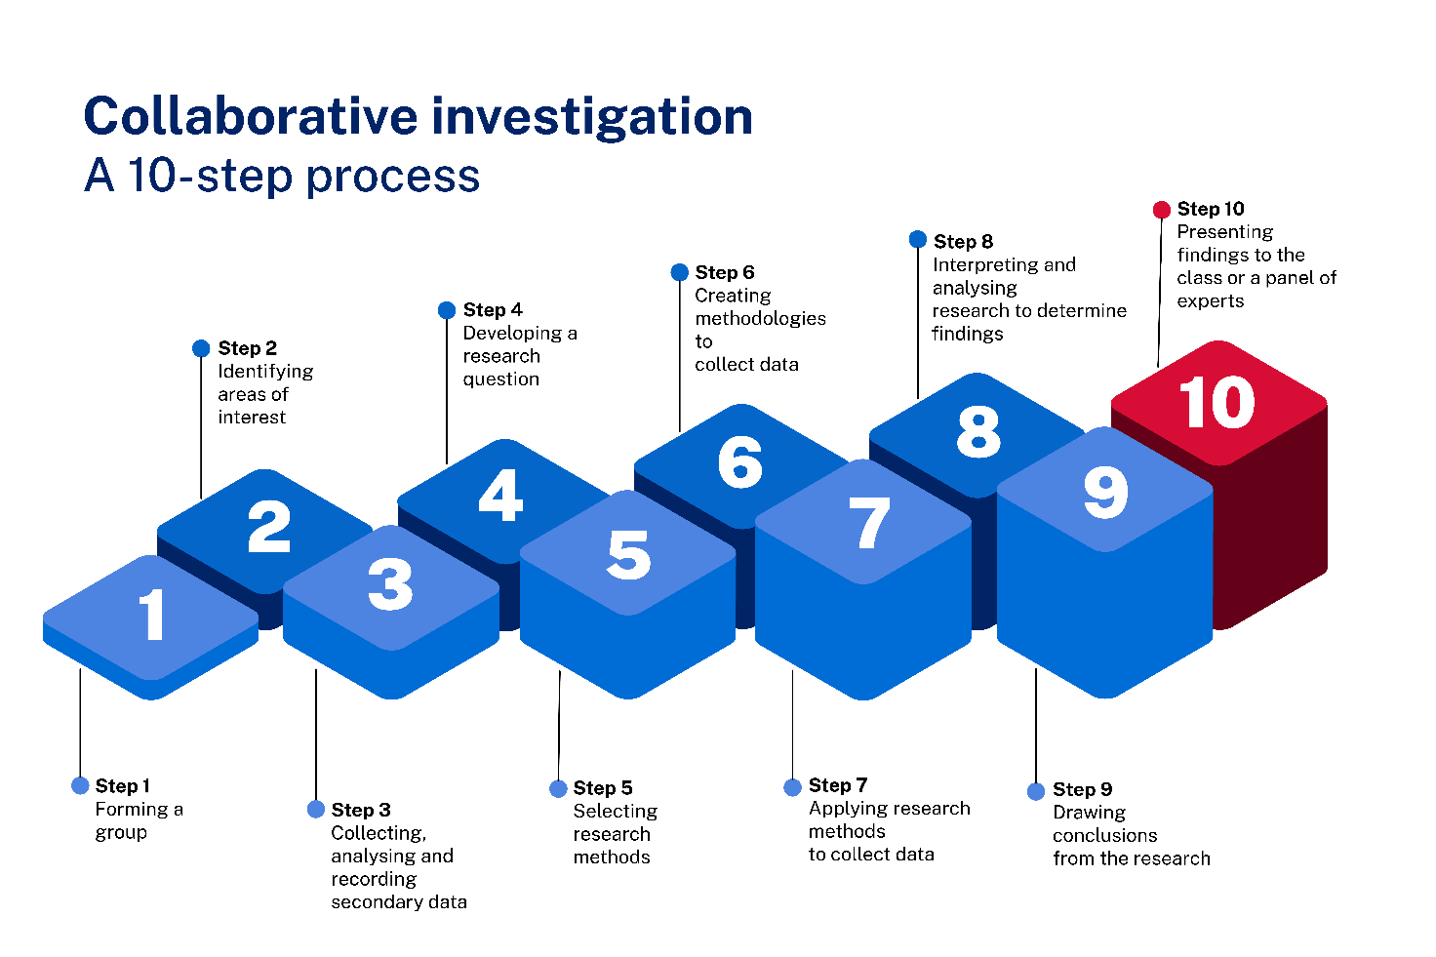
Students will deepen their understanding of syllabus content, alongside applying the principles of research.

Modelled, guided and independent approach to program delivery
A modelled, guided and independent approach has been used throughout this collaborative investigation program of learning. Teachers can make decisions on the most appropriate model of delivery for their students.
For this program of learning, the areas of interest are pre-determined by the section of syllabus content being studied. Through previous syllabus content, students have looked at the aspects of young people’s lives that make them similar and different to the young people of previous generations. These aspects are used as the areas of interest for this program of learning.
Throughout the program of learning, technology has been selected as the area of interest used as the modelled approach to the collaborative investigation. The technology example has been applied to each step of the collaborative investigation process.
Teachers can choose to use either of the following options.
- Option 1 – use the modelled approach (technology) to deliver the program to the whole class. This approach ensures the process of investigation is clearly understood and collaboration is a focus of the work, alongside the content. It suits teachers who have not engaged their students in a collaborative investigation prior to this point in their program.
- Option 2 – use the guided and independent approach activities with groups who can access the steps of investigation with confidence and competence. Use the modelled approach (technology) with a group of students who need additional assistance.
Where teachers are using a guided and independent approach, the remaining aspects of young people’s lives which make them similar and different to the young people of previous generations could be used for other groups as their area of interest (see Figure 2).
Figure 2 – overview of implementation options
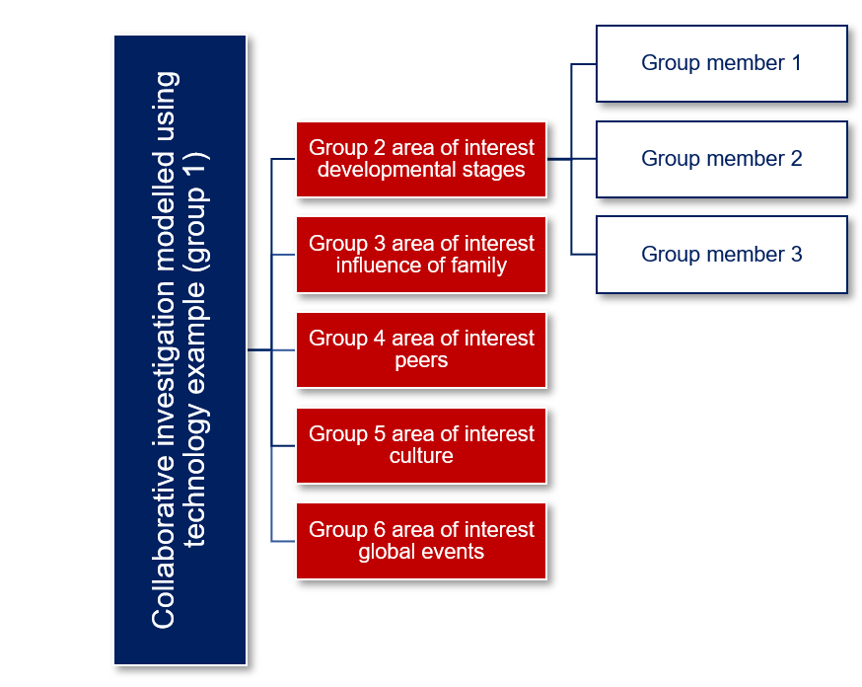

Extension options
Each area of interest could be investigated using established groups. Students remain in their groups for the duration of the program of learning. Instructions are embedded in the program of learning for how groups can be formed.
Groups apply the 10 steps of the collaborative process to undertake their investigation.
Each group would present their findings to the class or panel of experts. Collectively, these areas of interest would contribute to students individually or collaboratively answering an overarching inquiry question: What has the greatest influence on young people’s meanings of health?
The submission to the inquiry question could be formatively assessed to collect evidence of understanding and application of the syllabus content.
The following is an example of the model (see Figure 3).
- Group 1 – modelled approach (working with teacher) – technology
- Group 2 – developmental stages
- Group 3 – influence of family
- Group 4 – peers
- Group 5 – culture
- Group 6 – global events
Figure 3 – delivery approach to provide assessment options for option 2
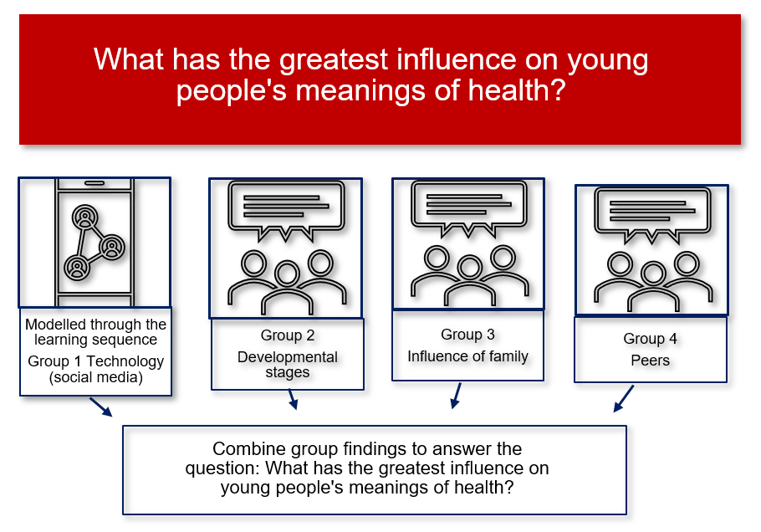
Access the department’s support materials to learn more about teaching and assessing collaboration and undertaking research as part of the collaborative investigation process.
- Collaboration in our classrooms
- The collaborative investigation process
- Support – a framework for assessing collaboration
- Investigation and research support booklet
- HMS logbook student guide
- HMS logbook teacher guide
Collaboration involves:
- positive interactions with others to solve problems, reach agreements and work towards outcomes or goals
- equal contribution by group members to plan and complete the tasks as part of the investigation
- building and sharing perspectives for deeper understanding of concepts.
Meaningful collaboration as part of the Health and Movement Science 11–12 Syllabus and the process of collaborative investigation can promote the building of peer relationships and foster positive peer interactions. By involving students in different discussions, it enables them to understand different perspectives, and to give and receive feedback. Through collaboration, students not only become more skilled at working with their peers, but also working with other adults. Collaboration can occur online and offline.
Through this collaborative investigation learning program, students will:
- apply the principles of conducting an investigation
- demonstrate strategies to positively interact with others
- work together to formulate a research question
- develop methods to collect data
- present and analyse data
- apply collaborative skills and strategies to build shared understanding of health concepts
- draw conclusions on young people and their meanings of health
- present findings.
A range of resources are available to support the process of investigation and collaboration. These can be accessed on the Planning, programming and assessing PDHPE 11–12 curriculum webpage.

Syllabus
The following syllabus outcomes and content is addressed if all the teaching activities are completed. Teachers are to use their professional judgement to ensure that the suggested syllabus content is addressed.

Outcomes
A student:
- interprets meanings, measures and patterns of health experienced by Australians HM-11-01
- Collaboration: demonstrates strategies to positively interact with others to develop an understanding of health and movement concepts HM-11-05
- Communication: communicates health and movement concepts to audiences and contexts, using a variety of modes HM-11-07
- Research: analyses a range of sources to make conclusions about health and movement concepts HM-11-10
Health and Movement Science 11–12 Syllabus © NSW Education Standards Authority (NESA) for and on behalf of the Crown in right of the State of New South Wales, 2023.

Content
Focus area 1
What are young people’s meanings of health?
- Explore across generations aspects of young people’s lives that make them similar and different to the young people of previous generations
Example(s):
Developmental stages.
Influence of family, peers culture, technology and global events.
- Investigate the meanings of health for young people
Including:
- creating a research question
- developing a method(s) to collect data
- considering how the determinants of health impact on a young person’s meaning of health
- analysing the different ways young people define what is important to their own health
- discussing ethical considerations
- discussing validity, reliability and credibility of data collection
- presenting findings and drawing conclusions
- identifying further research questions that could be explored
Example(s):
Developing a method(s) to collect data:
Survey.
Interview questions.
Focus groups.

Applying the collaborative investigation process
In this section, students will apply the steps of the collaborative investigation process. This will prepare students ahead of conducting their own collaborative investigation in the preliminary year.
Opportunities for student collaboration have been embedded in the activities as a guide. Teachers determine the most suitable teaching strategies to deliver this content. Opportunities for reflection and adjustments can be made depending on student interest.
A modelled, guided and independent approach has been used throughout this collaborative investigation program of learning. Teachers should make decisions on the most appropriate model of delivery for their students.

Step 1 – forming a group
The purpose of this step is for group members to become oriented with each other and to establish group norms, boundaries, processes and expectations.

Modelled approach
Use Resource 1 – group-forming activities. Choose a range of group forming activities to encourage students to introduce themselves, communicate effectively and feel confident interacting with others.
As a class, discuss group contracts or agreements.
- What are they?
- Why would a group use a contract?
- What are the benefits?
- What are some components of a group contract? What might it include?
A group contract is an agreement developed by a group to create the most effective environment or conditions for all members to operate or work in. A group contract can bring people together and ensure everyone fully understands what is expected and accepted as a member of the team. It should be created immediately upon formation of the group.
All members should come to consensus when developing the contract and need to agree to all terms of the contract. As collaboration develops throughout the course of the collaborative investigation, students might want to revise the contract to reflect more accurately what the collaboration looks like or to re-evaluate some decisions that could be negatively influencing the group’s collaboration as they work towards their goals.
In small groups, allocate one aspect of a group contract from the list below. Groups discuss and record responses for their heading. What might this aspect look like? What should a group discuss and consider?
Aspects of agreement
- Group goals
- Decision making
- Conflict resolution
- Communication
- Attendance
- Sharing work
- Agreed roles and responsibilities
As a class, use Resource 2 – sample group contract. Ask each group to share their discussions and record these into the sample group contract for use later.

Guided or independent approach
Divide the class into their Focus area 1 collaborative investigation groups.
Each group shares their discussions and records them in Resource 2 – sample group contract for later use.
Accountability
- In pairs, discuss the term ‘accountability’. What is it? How do we make each person accountable when we work collaboratively or in groups?
- Share ideas as a class and create a list of what strategies could be used in a future collaborative task.
Accountability is a practice that will contribute to success in collaboration. Accountability grows a sense of ownership for tasks, roles, goals and outcomes across a group.
A range of strategies can be put in place to increase accountability within groups during a collaborative investigation.
Table 1 – overview of sample strategies, activities and resources to increase accountability among students
Strategy description | Suggested activity
Use a group contract.  Understand clearly what the group is to do.  Support students to be accountable for themselves.  Support students to have discussions with team members about roles. | Create a group contract.  Refer to the group contract during group dysfunction.  Resource 3 – sample roles and responsibilities table for group contract.
Use a tracking system.  Monitor group goals and individual responsibilities. | Create a tracking sheet:  - Resource 4 – sample tracking sheet group  - Resource 5 – sample tracking sheet individual  Use the tracking sheet to record and monitor tasks, roles and completions.
Keep a logbook.  A personal journal which records contributions to the work of the group. | Develop a logbook.
Engage in review and feedback.  Regularly review work to maintain consistency and performance expectations.  All done at regular, pre-determined time periods throughout the collaborative investigation. | Use Resource 6 – giving and receiving feedback to engage in:  - peer feedback  - self-feedback  - teacher feedback.
Students and teachers communicate frequently. | Schedule regular check-ins.
Formative assessment opportunity: outcome (HM-11-05) checkpoint – use a logbook, or alternate method of self or peer assessment to encourage students to reflect on their collaboration. Access the HMS logbook teacher guide and the HMS logbook student guide on the Planning, programming and assessing PDHPE 11–12 webpage for more support.
In addition, collect a group contract, created and signed by group members, as documented evidence of the group’s collaborative work and process.
Points for check in have been identified throughout this collaborative investigation using the above pink box.
Access the Collaboration in our classrooms resource for suggestions, strategies and examples to increase accountability of group members during the collaborative investigation process.

Step 2 – identifying areas of interest
The purpose of this step is for group members to review the syllabus content and identify areas of interest across the Focus area content which they would be interested in investigating further. Collectively, the group shares ideas and narrows down to a group-based area of interest.
To develop an investigation, a major step is to identify a specific area of interest, ponder some relevant questions or describe a possible problem in relation to this area of interest.
Doing this individually, allows students to consider their strengths, their goals, areas of vocation or future careers or study which match the syllabus content. The topic should be narrow enough to investigate or research within the relevant context, but also broad enough to have practical or theoretical merit.
Explain to students that when they do their own collaborative investigation, they must link the group research question to a concept taught in Health for individuals and communities or The body and mind in motion in Year 11. Therefore, they will identify an area of interest relevant to them and the syllabus content.
For this learning program, the areas of interest are pre-determined by the section of syllabus content being studied. Access the information provided in the Modelled, guided and independent approach to program delivery section, to understand the process of forming groups and identifying areas of interest for each group.

Guided or independent approach
Students work in their already established Focus area 1 collaborative investigation groups. Individually, students identify which aspect is of most interest to them and record a justification for their preference.
If groups have not been formed for the collaborative investigation, then they could be formed at this step. To do this:
- use a voting method, such as Google form or sticky notes. Students rank the 5 remaining aspects of young people’s lives in order of preference to investigate. Allocate students to groups based on their preferences. This is now their Focus area 1 collaborative investigation group
- developmental stages
- influence of family
- peers
- culture
- global events
- students form small groups by choice. Groups discuss their areas of interest using the aspects of young people’s lives for their discussions and justifications. The group comes to a consensus on one aspect that interests them to explore more deeply. This is now their Focus area 1 collaborative investigation group.

Modelled approach
As a class, use a table to:
- brainstorm components of their area of interest – technology
- record the type of data that could be collected for their area of interest.
Table 2 provides an example of how the table could be used to support the modelled approach.
Table 2 – most suitable types of data for the areas of interest
Areas of interest | Qualitative or quantitative | Primary data, secondary data or both
How many young people use TikTok on a daily basis? And do young people get health messages? Are they obvious health messages? Is our definition of health reliant on the algorithm within TikTok?
Why do people use technology? Are there health benefits? Are people who use technology for exercise healthier?
How does social media change our views of information and image accuracy?
Do all generations use social media? Can social media impact on people’s health? Does it change our definition of health?
Are there ratings on social media reels? How do young people know that the reels are created by people with credibility? Should there be ratings like TV shows or movies?

Guided or independent approach
In their Focus area 1 collaborative investigation group, students brainstorm components of their area of interest.
- Use a table to record the type of data that could be collected for their area of interest.

Step 3 – collecting, analysing and recording secondary data
The purpose of this step is for group members to identify and review secondary sources to further refine their area of interest for investigation. Collaboratively reviewing, recording and discussing information from secondary sources will build a shared understanding of the existing findings and gaps, before moving into creating a group research question or selecting methods for collecting primary data.

Modelled approach
As a class, share ideas on how to share and store work so that everyone can access it.
- Discuss the term ‘integrity’. How does this term relate to secondary data and sources?
Students should have completed the NSW Education Standards Authority (NESA) HSC: All My Own Work program. This provides foundational understanding of plagiarism, referencing and crediting the work of others.

Guided or independent approach
In their groups:
- create a shared document or way of storing and referencing sources of secondary data to ensure integrity
- identify reliable and credible sources of primary and secondary data relevant to their investigation issue or focus.
Collecting, analysing and recording secondary data as an early step of the overall process, supports students to gain a deeper understanding of the area of interest. It can give clues for the next steps, decide if the area of interest has already been previously explored and support the development of a research question or hypothesis. Collaboratively reviewing, recording and discussing information from secondary sources will build a shared understanding of the existing findings and gaps, before moving into creating a group research question or identifying methods for collecting primary data.
When researching and recording reliable sources to return to, identify what data would be needed to answer a research question in the area of interest, give clues to identifying possible resources, gaps in the current research or methodologies, and time frames. There is no set method or process to researching an area of interest, however, establishing key words as a group will be important. Accessing the school library and the librarian, or becoming a member of the NSW State Library and using the eBook collection, can support this.

Modelled approach
As a class, discuss and record some questions or considerations when deciding on the sources.
Some questions or considerations when deciding on the sources are in Table 3.
Table 3 – considerations for accessing secondary sources of data
Source | Questions or considerations
Print or  electronic | - How credible is the author?  - How current is the content?  - Are they selling a product or an idea?  - Who is the audience?  - When was it written, published or last edited?  - Is the intention of the information to entertain, inform, educate or perhaps sell an idea or product?

Guided or independent approach
In their Focus area 1 collaborative investigation group, students discuss and allocate roles and responsibilities to access agreed secondary sources, for example, healthcare data, newspaper articles, and images or information in a published report and collect secondary data.
Each student in the group should access 2 agreed secondary sources.
Students complete a Plus, Minus, Interesting (PMI) chart on both of their secondary sources and answer the questions that follow:
- What did you find in your research?
- What were some interesting things you found?
- Were there problems or gaps you found in the research that you could potentially look at?
- What potential research questions could you create from exploring and gathering your research?
- What type of data, if any, is being presented in the 2 sources you found? Justify and provide examples, such as qualitative or quantitative data.
- Do the sources provide some suggestions or spark ideas for the types of data or collection methods your group could collect?
Information can be collated in the group’s agreed shared document. In this document, record the website or books using the HSC: All My Own Work – Acknowledging Sources guidelines.
Each student reports back to the group and shares their PMI chart to establish common themes, findings or gaps across the sources.
This research might spark further questions, give some data collection ideas and potentially allow groups to branch off in a different area or narrow focus of their investigation.

Reflection
Students reflect on the process they undertook when collecting secondary data by answering the following questions.
- What were the benefits of this type of research? For example, a wide variety of credible research, quality of research, larger samples for data collection, ability to access experts in the field.
- What are the limitations of this type of research? For example, not finding what you wanted, narrowing your search, too much research, research had a different purpose, bias, location of the research, date of research.
- Is further secondary research required?

Step 4 – developing a research question
The purpose of this step is for group members to negotiate their final topic or issues based on the review of secondary sources. They then develop a research question for investigation. Using an evaluative process, they interrogate their question to ensure it meets their investigation needs.

Modelled approach
Explain to students that as part of a collaborative investigation, they are required to collaborate to design their research question. Collaboration is most effective and observable when all members of a group are working towards the group’s outcomes or goals. Like the setting of goals, the collaborative investigation is a research goal that your group will work towards.
Students use Resource 7 – designing a research question to unpack a research question and the characteristics of a strong research question.
What is a research question?
The research question is a question that the collaborative investigation sets out to answer. A research question:
- gives clear direction, focus and purpose to the investigation
- guides the path through the investigation, research and writing process
- can take the form of a hypothesis or question.
What is a research hypothesis?
The statement or a prediction the research study sets out to prove or disprove. Usually expressed as a precise and unambiguous statement that can be supported or refuted by investigation.
Characteristics of strong research questions
- Relevant to your chosen interest, collaborative investigation process and specific syllabus content.
- Is of interest to you or fills a gap that needs exploring.
- Answerable using primary data or creditable secondary sources, using qualitative and quantitative data.
- Focused on a specific population, age or characteristic.
- Multiple variables in the question to help promote authentic collaboration.
- Allows all group members to make authentic contributions.
- Enough time and resources to conduct research and to answer the question.
- Allows you to access the data you require to answer the question.
- Specific and well-defined concepts – words within the question are clear and have a specific meaning.
- Focus on delving deeper and narrower rather than broader.
- Can be measurable by collecting data or asking questions.

Differentiation: some students might find answering a research question difficult as the answer is not defined. The pathway to answer the question will rely on students’ ability to identify themes in the data or set predetermined themes to help with the analysis. This can be especially difficult when the data is qualitative in nature and broad responses are given. A research question allows for a wide range of outcomes, meaning resources such as time and analytical skills are essential.
Using a research hypothesis will follow the same research or investigation process, however, to answer the hypothesis, students are seeking to either prove or disprove the statement, therefore, the pathway to analyse the data is simplified. It therefore does not allow for a wide range of outcomes, simplifying the analysis and drawing conclusions steps of the investigation process.
A hypothesis can still allow for authentic collaboration.

RAFTER model
One way to formulate and evaluate a research question or hypothesis is to use the Relevant, Answerable, Focused, Timed, Ethical, Resourced (RAFTER) model.
A ‘rafter’ is a series of structural pieces used to support and frame a roof. We can look to use the RAFTER model to help support and frame a research question. This model will assist in making a research question more specific, allowing a clear direction to be taken.
This provides an authentic collaboration opportunity as the basis for this discussion will be based on the students’ previous secondary data readings.
Explain to students that when completing the process, the question might change as considerations are made as part of the RAFTER model.
Students should use their secondary data findings to contribute to the discussions and collaborate with their group to build shared understanding and work towards a group goal.
This process will take time and spark many discussions. As a result, students might find themselves:
- going back and forth through the steps of the RAFTER model
- exploring some secondary research to check possibilities
- searching data collection options.
Does technology have an effect on people’s health?
Students use the question above to identify the variables in the question.
A variable is a factor that can be changed, maintained or measured through an investigation, For example, time, distance, intensity, amount, temperature, type of behaviour, age of participants, type of training, location, person, place, thing or phenomenon that you are trying to measure in some way. Some factors can be easily measured, some will need expert qualifications to measure, and others will need more resources and equipment to measure. The number of variables creates areas to provide comparisons or to identify relationships between ideas.
Within this question there are 3 variables.
Does technology have an effect on people’s health?
- technology – social media, personal apps, health technology (for example, in vitro fertilisation [IVF]), electric bikes or electric scooters, food technology (for example, genetically modified foods)
- people – age, gender, athletes, living arrangements, location of a demographic, year group or a school’s house groups
- health – physical, social, mental, emotional, spiritual.
Use the questions below to explore the overarching question, and relate back to the syllabus content.
- How do people view health?
- How does technology impact on a person’s health?
- How does technology impact on a person’s meaning of health?
- Is technology a determinant of health? Consider a person’s physical, social, mental, emotional and spiritual health.
- How would the research change if the question focused on an aspect of technology, such as social media use?
As a class, use Resource 8 – the RAFTER model to improve the following question. A modelled example has been done for reference.
Does technology have an effect on people’s health?
Note: in the following table, some potential amendments have been provided as a guide for the research question ‘Does technology have an effect on people’s health?’. While the RAFTER model offers a range of considerations at each step, not every consideration is applicable to all research questions. Their purpose is to guide and help refine thinking.
Table 4 – the RAFTER model applied to research question – a modelled example
Part of model | Definition | Considerations | Amendments
R – relevant | Relevant to an area of syllabus content  Relevant to your chosen interest  Relevant to the collaborative investigation process | Is there a direct link to the Health and Movement Science 11–12 Syllabus content?  Does this question link to specific content from Focus area 1 or Focus area 2?  Has the group selected something linked to content that sparks their interest?  Does the question allow for genuine collaboration in the group and input from each group member? | Directly links to syllabus content.  What are young people’s meanings of health?  Explore across generations aspects of young people’s lives that make them similar and different to the young people of previous generations.  Example(s): developmental stages, influence of family, peers, culture, technology and global events.  Technology is an example of an environmental factor or determinant of health. Technology has a positive and negative impact on people’s health. Use and access to different types of technology across different generations could be a focus which directly links with the relevant syllabus content.  Screen time or screen use is an example of health behaviour and is a determinant of health.  Social media is associated with technology and its use, regulation, users and popularity has multiple forms, based on the platform. These different platforms (for example, Facebook, TikTok, Snapchat, Instagram) can potentially be divided among group members when conducting the investigation. This would promote collaboration through valued contribution and input from all members, each bringing a part of the whole answer.
A – answerable | Answerable by collecting quantitative and/or qualitative data in a valid and reliable way  Answerable by reading credible secondary sources on the topic | Can this research question be measured and answered?  Do the variables in the question allow for data collection and analysis in a valid and reliable way?  Can primary and secondary data (qualitative or quantitative) used to answer this question be accessed and collected?  Does the question need to be narrowed further to make it easier to collect data?  Is this research question going to accurately test or measure what it is intended to test or measure (validity)?  Would a group get similar results if they repeated the process under the same conditions (reliability?) | Original question is too broad, making it difficult for it to be measured and answered with the resources and time allowed.  Yes, I can collect data on people’s social media or screen time through screen time apps, surveys on screen time – quantitative data.  Difficulty measuring all aspects of health.  What does this look like? How do I measure some of the aspects, such as emotional health? Is emotional health too sensitive a topic area? Psychologists and counsellors analyse emotional health data. I am not qualified. Could I access this through secondary data if needed? Do I have the resources to continue with this aspect of health?  Social health. I can collect data on social health. However, if I want to find out about people’s social health through technology use, I am limited to finding out how long they are on social media and being social with people. Will that answer social health or just how long they use social media? This will not test what I want to test (not valid).  I can measure and analyse physical activity as an aspect of the physical health dimension.  Ways forward – modify the question to narrow the focus on a specific dimension of health, for example, physical.
F – focused | Focused on a particular population, age or characteristic  Focused on specific concepts rather than general or broad areas | Is the research question or focus specific, for example, age, gender or characteristic?  Does the question have a variable?  Do the variables in the question promote focus and specificity?  Are terms within the question focused with a clear meaning?  Do the variables in the question allow for data collection and analysis in a collaborative way within the group? | ‘People’ as a term is too broad. It needs a particular focus on a population group to allow access to data. The sample we have access to is the students in the classroom, which means we could specify to students in Year 11 at ‘x’ high school.  Concepts in the original question are too broad. The term ‘social media’ is ok as it allows each group member to investigate a type of social media such as TikTok, Instagram and Facebook and contribute to the overall research question.  Physical health is still too broad, including diet and nutrition, sleep, illness or disease, hygiene, relaxation.  Narrow to physical activity to potentially generate a hypothesis to prove or disprove.  By narrowing to physical activity, primary data can be more reliably gathered, for example, fitness trackers or diary. Secondary data is also an option to potentially look at physical activity rates over years when social media took off.  Ways forward – the question needs to be narrowed further through changing some of the variables. ‘Health’ could be made more focused or specific to physical health, and even further down to physical activity or even organised physical activity. This makes it easier to collect data. Potentially, physical activity could be broken into awareness of physical activity and the benefits for health, types of physical activity people are aware of or participate in, levels and intensity of physical activity. Any of these aspects of physical activity could act as variables in the research.  A focus on a more specific population, for example,16 to 18 years.  Amended questions:  - Research question – What role does social media play in 16- to 18-year-olds’ involvement in physical activity?  - Hypothesis – social media is taking time away from 16- to 18-year-olds’ opportunities to participate in physical activity.  - The variable for this question is social media. There are many platforms for social media, with different features, chats, reels or maps. Is social media’s bad reputation warranted? Are there positive aspects to it for the physical health of young people, specifically related to physical activity?  - Health is a variable. By narrowing health down, there is a clear focus. Age is also a variable. This investigation could change variables, by identifying TikTok and physical activity but using age or time as a variable such as across generations or age groups.
T – timed | Time to complete the data collection and research required  Time frames and periods align to complete research | Is there enough time to collaboratively conduct the research required to answer the question?  Does the research require a specific time frame or period, for example, sporting season, start of school year, holiday period?  Is the data and resources accessible within the allocated timeframe?  Does the question need to be narrowed further or changed if the required time and resources to answer the question are difficult to access? | The time frame would need a minimum of one week of primary data collection by the participants, pending the data collection method chosen. For example, a diary to log or check screen time which will be more accurate but not all devices have this or people know how to do it.  Ways forward – time to conduct the experiment and collect primary data.  By limiting the variables and narrowing focus for this research, time can be saved. By accessing a sample group that I have access to, such as 16 to 18-year-olds, data collection can be simplified to within school time such as roll call or a year group meeting.  Timing will be important. Having a large group together can mean that the instructions are not taken seriously which could impact the data collected. All instructions can be given at once, which means conditions are kept the same for each member of the sample group, increasing reliability.  If accessing a professional to clarify data or access further data through an interview, will impact time. Online Microsoft Teams or Zoom interviews are more common after COVID lockdowns. Planning is important for this option.
E – ethical | Nature of the research focus requires further consideration around ethical behaviours, for example, informed consent, integrity, privacy and respect | Does the research question or focus have components of sensitivity, for example, the content, the focus group, the application of the process?  Are there aspects of safety which need to be considered and planned for before finalising the research question?  How will informed consent from participants be collected? Will this impact completion of the research in the time frame?  Could the way the group conducts their research and reports on their findings be questioned? | This topic area on face value doesn’t seem controversial. Acting ethically through the collection of data is important, ensuring that as researchers we act with integrity, maintain their privacy and gain informed consent.  The data collected should be de-identified.  Using the physical health dimension is seemingly less sensitive.  Instruction will need to be given to not use names or identifying characteristics. Psychological safety is important for this investigation, rather than physical safety. Instruction and a disclaimer about privacy and support for psychological safety needs to be provided.
R – resourced | Required resources available and accessible to answer the question | Is the type and number of resources needed to collect and analyse primary and secondary data to answer the question accessible?  Is all required specialist equipment or software accessible to complete the research and answer the question?  Can reliable and credible primary and secondary sources be accessed to answer this question? | Resources to collect data around screen time could be screentime apps, as most people have a mobile phone.  Secondary sources around physical activity levels and screen usage can be accessed online.
At the completion of the RAFTER model, the following are more refined examples of the original technology research question for further investigation in their groups.
Research question: what role does social media play in 16- to 18-year-olds’ involvement in physical activity?
Hypothesis: social media is taking time away from 16- to 18-year-olds’ opportunities to participate in physical activity.

Review questions
- How did the original area of research question change from the start of the RAFTER model to the end?
Sample answer: the variable of the question is technology. The health dimension and age were specified into manageable areas. Social media is still a variable, as is physical health. Physical health has been further refined to physical activity. One variable has been kept broader to allow for authentic collaboration.
- If the research question was kept with broad variables, what will likely happen within the process of the investigation?
Sample answer: it could lose direction, it could require more time, it could require more primary data to be able to answer it. It will require changing roles and changing demands on the process.
- What will influence if a research question created for the collaborative investigation process can be answered?
Sample answer: whether the question is time manageable and answerable because students have the qualifications.
- How will time and resources influence the question?
Sample answer: time to collect data and people to analyse the data.
- What are the options for the research question if the question needs data that students are not qualified to analyse?
Sample answer: to access the data through a professional, through primary methods such as an interview or through a secondary method of collecting the data such as a literature review.
- What would be the benefit of completing a hypothesis compared to a research question?
Sample answer: the data collected needs to be analysed to prove or disprove the statement.

Guided or independent approach

Formulating a question
In their Focus area 1 collaborative investigation group, students complete a Think-Pair-Share activity. Resource 9 – formulating a question – sample questions teacher resource can be used to guide student thinking.
- Individually, students think of 2 questions for their area of interest.
- Students form pairs and apply their questions to the RAFTER model to see whether it is a valid question for a collaborative investigation.
- Pairs should report back to their Focus area 1 collaborative investigation group to discuss the pros and cons of each research question or hypothesis established after the RAFTER model.
- Students work collaboratively in their Focus area 1 collaborative investigation group to reach a consensus on a research question based on their chosen area of interest. This might involve
- discussing their questions with the purpose of narrowing down to one question
- discussing each question and resolving differences in opinion
- establishing a consensus and agreeing on the final research question.
Students might wish to vote on a question, merge or modify the question and reapply the RAFTER model.
Groups share the question with their teacher. Once groups have a question formulated, the next step is for them to consider how they will collect the data to help answer the question.
Formative assessment opportunity: outcome (HM-11-05) checkpoint – use a logbook, or method of self or peer assessment to encourage students to reflect on their collaboration.
Access the HMS logbook teacher guide and the HMS logbook student guide on the Planning, programming and assessing PDHPE 11–12 webpage for more support.

Step 5 – selecting research methods
The purpose of this step is for group members to identify and select the most suitable research methods for their investigation and their question.
Through previous learning programs, students will have learned that the type of data needed will influence the research method used to collect the data. The research question or hypothesis created will dictate the data needed.

Modelled approach
Students watch the video Research Design: Choosing your Data Collection Methods | Scribbr (5:16). Complete a PMI chart for each of the following data collection methods.
- Interviews
- Questionnaires
- Experiments
- Observations
- Focus groups
- Literature reviews
- Content analysis
- Case studies
In their groups, students use their PMI chart to discuss the data collection methods. Collaboratively evaluate and determine the most suitable data collection methods for this hypothesis.
For further information on data collection methods, please see the Investigation and research support booklet which you can find on the Planning, programming and assessing PDHPE 11–12 webpage.
Hypothesis: social media is taking time away from 16- to 18-year-olds’ opportunities to participate in physical activity.
Allocate one data collection method for each group. Groups brainstorm the type of data their collection method could gather for the hypothesis.
Share with the whole class how the allocated data collection method will collect data to prove or disprove the hypothesis. This allows students to visualise the role each data collection method will play.
For the hypothesis to be proven or disproven, each group is reliant on other groups bringing the data collected from their method (see Figure 4). This means collaboration is required to collectively pool data and build a shared understanding across each group on the area of interest.
Figure 4 – overview of group structure for data collection
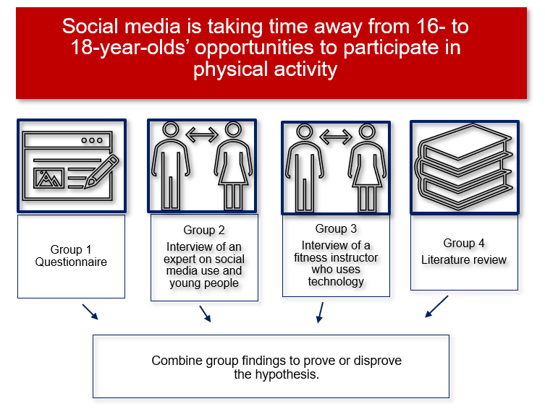
Each of the data collection methods are explained in detail in Resource 10 – application of research data collection methods using the hypothesis developed at the completion of the RAFTER model. For further information on data collection methods, please see the Investigation and research support booklet which you can find on the Planning, programming and assessing PDHPE 11–12 webpage.
Collecting primary sources of data includes collecting data from individuals and groups. It is the researcher’s responsibility to ensure that these groups feel a level of comfort and safety, resulting in them offering truthful responses or full commitment physically to experiments or observations. This ensures that the data collected is reliable.

Guided or independent approach
In their Focus area 1 collaborative investigation group, students collaboratively discuss and record the following.
- The most suitable data collection method to answer the group’s formulated research question and justify why.
- Ethical considerations for each research method and how the group will apply each throughout the investigation, for example, informed consent, integrity, privacy and respect.
- Any safety considerations or risks to be managed in conducting the research.
- How the group will ensure reliability, validity and credibility of their research and data.
Use the following questions as a guide.
Table 5 – considerations and questions for accessing primary data ethically
Source | Questions and considerations
Individuals and groups | - What data do I need to collect to answer the research question or hypothesis?  - How will I collect that data?  - What types of questions or observations will I use to collect that data?  - Who is the target sample group and how will I access them?  - What time of day or what conditions are needed to make sure the data collected is not impacted?  - How will the sample group know they can trust the process of data collection?  - How will the sample group know I will keep their data confidential?  - What types of communication is needed for the sample group to feel safe to give honest responses?  - What instructions will need to be given when collecting the data?  - How will I store the data to increase participant confidence in the process?  - What if the data I collect is not what is expected?
Formative assessment opportunity: outcome (HM-11-05) – this activity provides another authentic opportunity for collaboration. Use a logbook, or method of self or peer assessment to encourage students to reflect on their collaboration. Within their Focus area 1 collaborative investigation group, students should demonstrate some of the following collaboration strategies and markers:
- apply their own strengths to participate in the group
- actively listen to understand others
- tailor explanations for different group members
- discuss differences of opinion or perspective
- come to an agreement where opinions differ, or conflict arises
- negotiate the most effective approach to completing the task for the greater good of the group
- make quality and relevant contributions
- perform responsibilities assigned by the collective group
- access assistance or feedback where required.
Access the collaboration support materials on the Planning, programming and assessing PDHPE 11–12 webpage for more support.

Step 6 – creating methodologies to collect data
The purpose of this step is for group members to develop their plan for conducting the investigation. Groups will establish, create and test the processes, tools and methods to ensure reliability, validity and credibility.
At this point in the sequence, students have:
- created a research question
- developed an understanding of the types of data they need to collect
- chosen an appropriate data collection method.

Modelled approach
Watch the video Research Design: Planning your Data Collection Procedures | Scribbr (4:04) and answer the following questions.
- How will you define and measure your variables?
- How will you ensure your measurements are reliable and valid?
- How will you select and contact your sample?
- How will you plan for how ethical considerations, safety considerations and risks will be managed?
- How will you establish a process and system to record, including a way to de-identify the sample group, share results and data between group members.
In their groups, students collaboratively create the instructions and protocols for the method identified in Step 5 (see Figure 4).
Each of the data collection methods are explained in detail in Resource 10 – application of research data collection methods using the hypothesis developed at the completion of the RAFTER model.
Formative assessment opportunity: outcome (HM-11-05) – the following activities centre around creating methods to collect primary data. These activities provide more authentic opportunities for student collaboration. Use a logbook, or method of self or peer assessment to encourage students to reflect on their collaboration.
Within their Focus area 1 collaborative investigation group, students should demonstrate some of the following collaboration markers:
- identify and evaluate different options and pathways towards the common goal
- negotiate the most effective approach to completing the task for the greater good of the group
- discuss differences of opinion or perspective
- discuss individual and group responsibilities
- share responsibility for the tasks to reach the common goal
- share roles between group members
- match responsibilities with expertise where possible
- perform responsibilities assigned by the collective group
- comprehend others’ understanding
- access assistance or feedback where required.
Access the collaboration support materials on the Planning, programming and assessing PDHPE 11–12 webpage for more support.

Guided or independent approach
In their Focus area 1 collaborative investigation group, students collaboratively develop the plan for conducting the research.
Suggestions include:
- developing each research method, instruction and protocols, for example
- questionnaire
- practical application or lab protocol and recording sheet
- observation sheet and markers their group is looking for
- interview questions – writing and piloting the questions to test whether the responses produced are what was intended (reliability)
- data collection procedures – instructions, equipment environment
- determining who and how many participants are needed for a reliable collection of data, and how they will avoid bias and ensure a representative sample
- unpacking and breaking down key terms within the research question to help guide questions for their questionnaire, interview or focus group questions to collect appropriate data
- planning for how ethical considerations, safety considerations and risks will be managed
- contacting their sample group, for example, online, phone or in person to ensure a representative sample
- discussing the effectiveness of the pilot questionnaire
- establishing a process and system to record, including a way to de-identify the sample group, share results and data between group members.
Formative assessment opportunity: outcome (HM-11-05) checkpoint – use a logbook, or method of self or peer assessment to encourage students to reflect on their collaboration. Access the Planning, programming and assessing PDHPE 11–12 webpages for more support.
Additionally, collect their plan for research as evidence of the collaborative group work.

Step 7 – applying research methods to collect data
The purpose of this step is for group members to apply their processes, tools and methods to collect data, and ensure reliability, validity and credibility.
Access the Investigation and research support booklet which you can find on the Planning, programming and assessing PDHPE 11–12 webpage for more information on collecting, analysing and presenting data.

Modelled approach
Hypothesis: social media is taking time away from 16- to 18-year-olds’ opportunities to participate in physical activity.
When accessing a group of 16- to 18-year-old young people, the most obvious target sample group would be the students available within the school environment. Consider the characteristics of the sample group to guide how and when to apply the method. Considerations include:
- who should deliver the instructions of the purpose, confidentiality and how to reliably respond to a questionnaire without identifying characteristics
- what time and where students should respond to the questionnaire
- whether all students complete the questionnaire at the same time as a whole group, in small groups, in year group assemblies or house groups
- how students will respond, for example, pen and paper or using technology.
These considerations can create a mood or feeling of safety for participants to answer honestly, indicate how seriously to take the questionnaire and support the quality of the data collected. These considerations can increase the reliability of the data collected.
In their groups, students apply their method to collect primary data.
- Allocate roles and responsibilities to access and collect primary data in their group.
- Identify, source and test resources for testing and recording.
- Seek informed consent from research participants where required.
- Implement the research method to collect and record data.
- Use an established process and system to record and share results and data between group members.

Guided or independent approach
In their Focus area 1 collaborative investigation group, students apply one or multiple methods to collect primary data.
- Allocate roles and responsibilities to access and collect primary data in their group.
- Identify, source and test resources for testing and recording.
- Organise access to the target or population group where possible or use members of the class as a test.
- Seek informed consent from research participants where required.
- Implement the research methods to collect and record data.
- Use an established process and system to record and share results and data between group members.

Step 8 – interpreting and analysing research to determine findings
The purpose of this step is for group members to simplify, decode and extract meaning from the data they have collected. This involves presenting data in a variety of ways to enable group members to interpret the data, identify trends and construct meanings to draw conclusions. As students share findings as a group, they should analyse and discuss any primary data findings in relation to their research question and secondary data findings.
Access the Investigation and research support booklet on the Planning, programming and assessing PDHPE 11–12 webpage for more information on collecting, analysing and presenting data.
It can be complicated to extract useful content from raw data. The purpose of this step is for group members to simplify, decode and extract meaning from the data they have collected. This involves presenting data in a variety of ways, such as tables, charts, graphs, maps, pictographs or be transcribed to enable group members to interpret the data to identify trends, construct meanings and draw conclusions.
As students share findings as a group, they should analyse and have discussions in relation to their research question and secondary data findings.
The following activities will support students in understanding the best possible ways to present their groups’ data. The graphs and table examples used in the following activities are a guide and not specific findings found as part of the research question modelled throughout.

Modelled approach
As a class, review the variety of ways data can be presented. Identify whether the mode of presentation works best for quantitative data, qualitative data or both.
Now that students have applied their allocated method to collect their data, groups discuss and negotiate the most effective way to present their findings.
- The data collected from each group’s method will bring a viewpoint to prove or disprove the hypothesis.
- Each group will need to be able to form a point of view by interpreting, speculating, critiquing, analysing and constructing meanings that allow conclusions to be drawn.
To be able to do this well for their own data collected, students could practise this through the following activities. Alternatively, students could create their own graphs, tables and charts, and use the guiding questions in the following activities to analyse and draw conclusions on their findings.
Programs such as Microsoft Excel allow students to create visualisations of data sets, for example, graphs and tables. Students can enter the raw data into the cells of Excel, highlight the set of data and ask Excel to recommend a chart. It will provide students with several types of charts and provide recommendations on the most appropriate, based on their raw data.
Graphs
The following graph shows potential results collected from one question as part of a questionnaire to answer the hypothesis:
Social media is taking time away from 16- to 18-year-olds’ opportunities to participate in physical activity.
It displays the number of hours of physical activity that participants do per week. The questionnaire was given to 68 students from a small local context.
Figure 5 – hours of physical activity per week
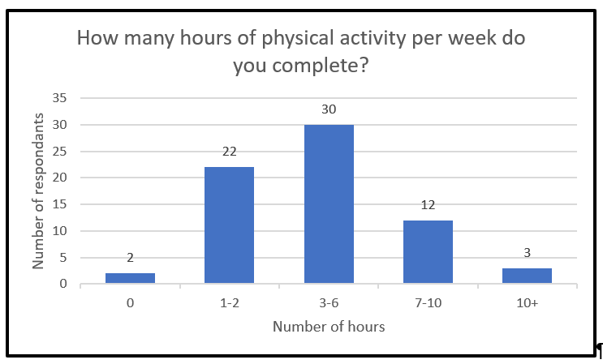
Data reflection questions
- What do you see?
- Are there any trends in the data?
- Were these results expected?
- Are there any outlying results? Can these be accounted for?
- What conclusions can be drawn from these results?
- Is this data enough to answer the question or hypothesis, or would secondary sources (for example, physical activity rates from the Australian Institute of Health and Welfare) or more primary data be needed?
- Compare these primary results to secondary sources of information. How do the results reflect, differ or extend on the area of interest, issue or focus.
- Are there limitations with this graph or the data?
- Could you suggest any improvements, for example, type of graph, labelling, larger sample size?
- Is this the best way to present the results? Why or why not? What are some other ways this data can be potentially presented?
Table
The following table displays results collected as part of the research question:
To what extent is children’s screen time associated with their participation in extracurricular activities in early adolescence?
It displays boys’ and girls’ weekday time spent on screen time compared to their regular participation in selected extracurricular activities at 12 to 13 years.
Figure 6 – table of Australian children’s screen time and participation in extracurricular activities
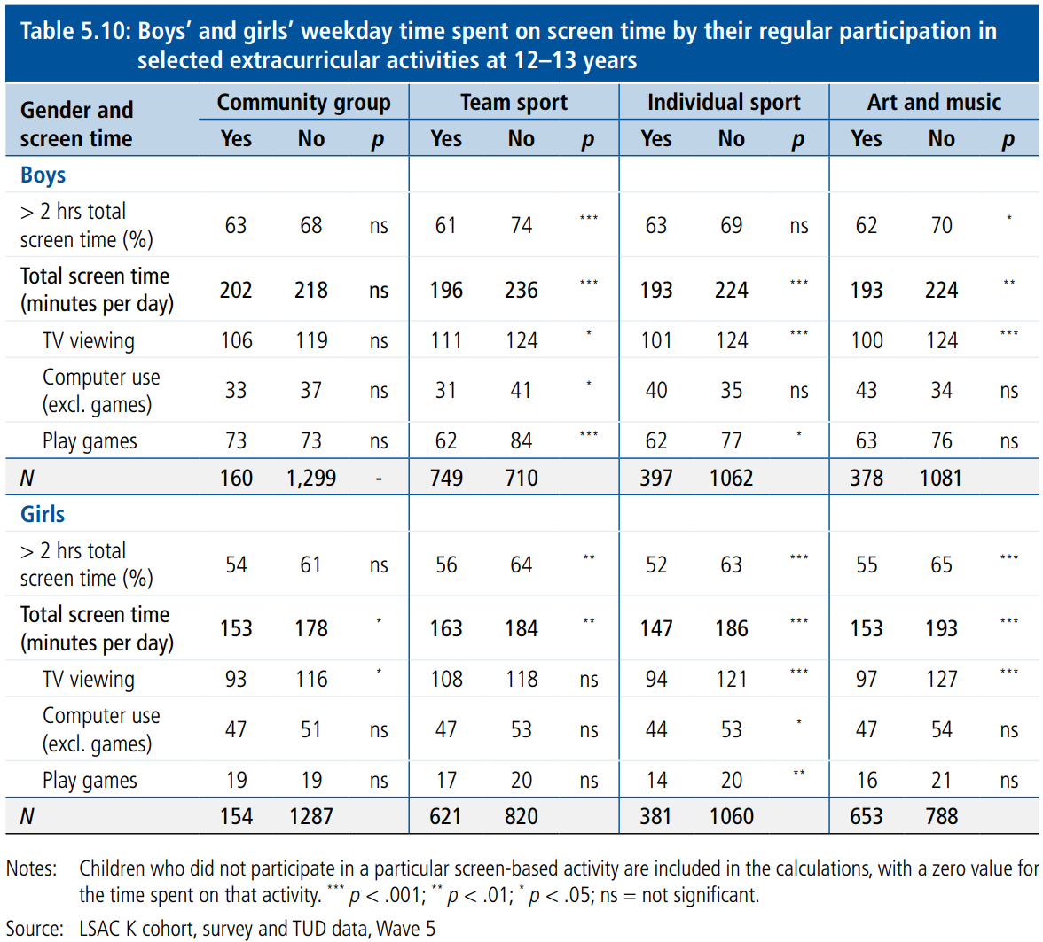
‘The Longitudinal Study of Australian Children Annual Statistical Report 2015’ by the Australian Institute of Family Studies is licensed under CC BY 4.0.
Data reflection questions
- What do you see?
- Are there any trends in the data?
- Were these results expected?
- Are there any outlying results? Can these be accounted for?
- What conclusions can be drawn from these results?
- These results are for 12- to 13-year-olds. Could you predict what you think might happen for students aged 16 to 18 years old?
- Is this data enough to answer the question or hypothesis, or would secondary sources, for example, AusPlay – National Sport and Physical Activity Participation Report or more primary data be needed?
- Compare these primary results to secondary sources of information. How do the results reflect, differ and or extend on the area of interest, issue or focus?
- Are there limitations with this graph or the data?
- Could you suggest any improvements, for example, type of graph, labelling, larger sample size?
- Is this the best way to present the results? Why or why not? What are some other ways this data can be potentially presented?

Group data analysis
Once students have collected and presented their data, they will need to be able to form a point of view by creating relationships, interpreting, speculating, critiquing, analysing and constructing meanings that allow conclusions to be drawn.
Quantitative analysis is focused on combining information across a group or multiple groups of people, factors, things or themes and using this to draw out wider trends.
Before analysing the results, students must interpret the data.

Modelled approach
In their group, students discuss their findings using the interpretation questions.

Guided or independent approach
In their Focus area 1 collaborative investigation group, students divide up the data and present their findings in graphs or tables.
The following reflective questions can be used as a guide to interpret the data, determine reasons for the data and compare the data. They can assist in creating relationships with qualitative data.
Interpretation questions
- Explain the graph or table in words. This should be presented using percentages of the whole sample to create a narrative for the reader.
- What was the most common response?
- Were the results expected?
- Are there any trends in the data?
- Are there any outlying results? Can these outliers be accounted for?
- Were there differences or similarities between the age groups, gender or cultural groups in my sample?
Analysis and interpretation of qualitative data coming from open-ended questionnaire questions, interviews, observations or focus groups requires judgement and care to identify key themes and ‘decode’ meaning in what people have said. Analysis of qualitative data should identify the main themes (in students’ own words) and illustrate these with quotes (in the words of respondents or observed facts). The analysis should also identify ‘outlier’ positions – perspectives that are equally valid and important, but less common.
The nature of qualitative data is that it is time consuming to gather and interpret. It can also be overwhelming for the researcher to make sense of. Working with a large volume of qualitative data might require ‘coding’. Coding is a useful strategy when working with a large volume of qualitative data.
The first step is to create some categories. Start by reading the first few pages of comments and identifying consistent themes.
When coding open-ended responses in a spreadsheet, start with each comment in its own row. Each theme then gets its own column. Ensure there is an ‘other’ column.
For each comment, put a ‘1’ in each of the columns where that theme is identified.
If there is a need to clarify, expand or split a theme during coding, pause at that point to check comments that had previously been tagged in that theme and reapply the new code-frame.
At the end, review the comments coded ‘other’ and ensure that they are genuine outliers.
Once qualitative data has been coded, the data should behave like a multiple response quantitative question, allowing greater comparison and additional analysis to be undertaken. The coding and identifying themes in qualitative data will support stronger links to the quantitative data.
Formative assessment opportunity: outcome (HM-11-05) checkpoint – use a logbook, or method of self or peer assessment to encourage students to reflect on their collaboration.
Access the Planning, programming and assessing PDHPE 11–12 webpages for more support.

Step 9 – drawing conclusions from the research
The purpose of this step is for group members to answer their research questions by drawing conclusions from the research findings.
Following the interpretation of the data, the group should be asking ‘why’.

Modelled approach
In their group, students collaboratively identify one of the trends, patterns or relationships found through their research method.
- Are the results similar or consistent with other studies or knowledge about this topic?
- What evidence from secondary data do they have to support or challenge the findings?
- Do the results reflect, differ or extend on the area of interest, issue or focus?
- What conclusions can be drawn from these results?

Guided or independent approach
In their Focus area 1 collaborative investigation group, students collaboratively identify one of the trends, patterns or relationships found through their research. Using the trend, pattern or relationship, groups:
- identify possible reasons for the trend, pattern or relationship found
- make inferences and predictions from graphs and justify.
The reasons, inferences and predictions need an evidence base and is the result of deep reading and understanding the topic. This can support, clarify or use qualitative data or secondary data. The qualitative or secondary data might even challenge the quantitative data.
In their Focus area 1 collaborative investigation group, students discuss the following.
- Are the results similar or consistent with other studies or knowledge about this topic?
- What evidence from secondary data do they have to support or challenge the findings?
- Do the results reflect, differ or extend on the area of interest, issue or focus?
- What conclusions can be drawn from these results?
As a group, students:
- Draw conclusions from their findings to answer the research question (or prove or disprove their hypothesis). Drawing a conclusion which shows the reader how the pieces of research fit together and work to support the research question, leaves the audience with the sense that a valid argument has been presented and supported by relevant research.
- Identify, share and discuss any relationships across the findings and compare to secondary data.
- Discuss and develop arguments and justifications for the data and findings.
Analysing and writing the discussion section of a research project can be challenging for students. The following sentence starters might support and help summarise their key findings, give interpretations, describe the relationships of their question, problem statement or hypothesis, discuss implications, acknowledge limitations and provide recommendations for further research questions.
- The graph shows …
- The results indicate …
- Based on the patterns in the data, we can see that …
- A trend that exists in the data is …
- The study demonstrates a correlation between …
- The data suggests that …
- In line with the hypothesis, …
- Contrary to the hypothesis, …
- The results disagree with Author (YEAR) who suggests that …
- The data shows a clearer understanding of …
- These results do not fit with the hypothesis …
- These results build on existing research which suggests that …
- Due to the sample size, results might …
- Due to the lack of data on [X], the results cannot confirm …
- Due to the way the data was collected, …
- The reliability of this data is impacted by …
- Further research into [X] would …
- Further research questions that could be explored are …

Step 10 – presenting findings to the class or a panel of experts
The purpose of this step is for students to present what they have concluded and found through their investigation. This could be presented individually or as a group.
There are several ways to present the findings of research. Some examples might include a written report, oral presentation, video, podcast, multimodal text such as an infographic and an explanation.

Modelled approach
Each group will present their findings.
Figure 7 – overview of group structure for data presentation
For the hypothesis to be proven or disproven, each group is reliant on other groups bringing the data collected from their method (see Figure 7). This means collaboration is required to collectively pool data and build a shared understanding across each group on the area of interest.

Guided or independent approach
In their Focus area 1 collaborative investigation group, students negotiate a presentation mode of choice with group members, ensuring that the chosen mode includes:
- a summary of the research question and methodologies undertaken
- findings and conclusions of the research with supporting evidence
- suggestions of further opportunities for research
- acknowledgement of sources.
The teacher, in negotiation with the class, determines the presentation format. This might include a live or recorded presentation to the class or a panel of experts. It might also include a visual or written submission, such as a report, slide deck, infographic or multimodal submission.
Each group will present their findings.
Formative assessment opportunity: outcome (HM-11-05) checkpoint – use a logbook, or method of self or peer assessment to encourage students to reflect on their collaboration.
Access the Planning, programming and assessing PDHPE 11–12 webpages for more support.

Extension option
Where Option 2 was selected and used as the approach to program delivery, the following extension option provides an opportunity for assessment and collection of evidence.
For this learning program, the areas of interest were pre-determined by the section of the syllabus content being studied.
Each area of interest was investigated, and findings have been presented to the class. Collectively, these areas of interest, or aspects of young people’s lives, will contribute to answer the inquiry question: What has the greatest influence on young people’s meanings of health?
Extension: students individually draw conclusions to answer the following inquiry question: What has the greatest influence on young people’s meanings of health?
Submit as a formative assessment to show levels of understanding and achievement of the knowledge and understanding of outcomes.

Resource 1 – group-forming activities
Two truths and a lie
Each person must make 3 statements about themselves, one of which isn't true.
For example: I have 2 brothers, I was born in Australia, I have a motorcycle.
Allow the group some time to think of their statements and write them down if they need.
Once one person makes their statements, the rest of the group must guess, or vote on, which statement is the lie.
Tangled chain or knots
Students huddle in a group of 5 to 6 in the middle of the room and join each hand with someone across the circle. Once everyone has joined hands, their task is to untangle themselves.
Remember everything
In groups of 6 to 8, students partner up. Each person must find out 3 things about that partner. After a minute, everyone in the group of 6 to 8 reports back to the group about the person that they got to know.
Each person finds a new partner and discovers 3 new things about that person. After a minute, everyone in the group of 6 to 8 reports back to the group about the person that they got to know.
Then, maybe get a couple of students in the group to try to remember all 6 facts about both students they’ve interacted with.
You can keep going with a third or fourth round. Get people to try to report all the facts back without making a mistake.
This activity has been adapted from Youth Group Games from Remember Everything.

Resource 2 – sample group contract
Use the headings and the questions below to create a group contract or agreement for a collaborative investigation.
These agreements should also reflect the expectations of the classroom and school community.
Note: teachers can delete the sample questions to supply a blank table for students to complete.
Table 6 – sample group agreement
Aspect of agreement | Group details and sample questions
Group | Insert members’ names and contact details.
Group goals | What are some specific, measurable, achievable, realistic and timely (SMART) goals for the collaborative investigation? List them below.
Decision making | How will the group make decisions? For example, consensus, majority rules.
Conflict resolution | How will the group deal with conflict? For example, talk it out, bring in a facilitator.
Communication | How will the group communicate? For example, respectful conversations, sharing of time to speak, active listening, group check-ins, text, email.
Attendance | What is the policy for people who are absent?  How many days can a person miss before there are consequences?
Sharing work | How will the group get work to one another?
Agreed roles and responsibilities | Identify the roles a collaborative investigation requires.  List below what their responsibilities will be.  Identify what the consequences will be if a group member can’t finish a deliverable on time.
Agreement | Signature of group members and date.

Resource 3 – sample roles and responsibilities table for group contract
Use the table to list the roles, responsibilities and students allocated for tasks.
Table 7 – sample roles and responsibilities table for a group contract
Role | Responsibility | Name

Resource 4 – sample tracking sheet group
Use the sample tracking sheet to monitor work progress and completion.
Collaborative investigation tracking sheet – group tasks
Project name:
Group members:
Table 8 – sample collaborative investigation tracking sheet for group tasks
Task | Who is responsible? | Due date | Status | Done

Resource 5 – sample tracking sheet individual
Use the sample tracking sheets below to monitor work progress and completion.
Project name:
Group members:
Date:

Goals
During this time, I had the following goals for project work:
Table 9 – sample collaborative investigation tracking sheet for goals and progress
Goal | Details of progress

Tasks
During this time, I accomplished the following:
Table 10 – sample collaborative investigation tracking sheet for tasks and progress
Task | Details of progress

Next steps
What I will do next:
Table 11 – sample collaborative investigation tracking sheet for next steps
Step | Details
Outline any concerns or questions you have.

Resource 6 – giving and receiving feedback
Feedback helps us improve our future work and ourselves. It offers us an opportunity to see our work through others’ eyes, to help us recognise our achievement and see past our own blind spots.
Using The Tuning Protocol: A Framework for Personalized Professional Development will promote effective feedback.
Effective feedback should be constructive. Asking questions to clarify and explore options could help to better understand the work. It involves detailed analysis and assessment with the aim of improving the work. It’s important to be open, honest and kind when providing feedback.
This feedback is provided by:
This feedback is provided for:
Table 12 – sample feedback form for peer assessment
Feedback form | Comment
What I like about your work and why.
What I think could be better about your work and how.
Questions to make a difference.
Prompts for giving feedback
- A strength of this work that I really like is ...
- The presenter has paid close attention to ...
- I think it will be helpful for teachers that the annotations ...
- I think it is worth considering ...
- I wonder if ...
- One way to improve this might be ...
When we seek feedback, we are sometimes looking for affirmation rather than information, which makes feedback hard to receive. Particularly if we have trouble separating the value of our work from how we value ourselves.
Receiving feedback is most effective when we can join our reviewers in looking at our work critically rather than defensively. When everyone involved can share honest viewpoints about the work, we can see the value in what has been done and potential for what could be done.
Tips for receiving feedback
- Remove the personal attachment and emotion from the feedback and the work. Consider that the work is what you did, not who you are.
- Recognise that the work is the best you could do with your time, knowledge and ability.
- Extract the useful information from the feedback, whatever form it might take.
- Focus on receiving feedback as suggestions for how you can do better in the future.

Resource 7 – designing a research question
Developing a research question in a group will involve initial pre-research, negotiation and collaboration.
A research question:
- gives clear direction, focus and purpose to an investigation
- guides the path through the investigation, research and writing process
- can take the form of a problem statement, hypothesis or question.
Question: asks whether a relationship exists between variables in a particular population. Including variables will promote authentic collaboration in the group. A variable is any condition that can vary or change in quantity (for example, dosage, intensity, level, amount, size) or quality (for example, type of training, health behaviour, initiative or strategy, age).
Problem statement: presents the idea, issue or situation that the researcher intends to examine in their study.
Hypothesis: a statement made to reflect the relationship between 2 variables and usually written as a prediction for the research study to prove or disprove. A good hypothesis puts the question into a form that can be observable and tested. For example: Young people are engaging more with technology when accessing health information rather than seeking help from a medical professional.
Review the sample research questions below. Identify the characteristics of a strong research question for a collaborative investigation.
Examples of sample research questions
- What effect does social media have on the mental health of young people?
- What are young people’s meanings of health?
- What effect does the daily use of TikTok have on the attention span of people in the age group of 16 to 20 years?
- Is being active on social media good for maintaining relationships among young people?
- What effect do restrictions on alcohol limits have on the injury rates of young people aged 17 to 25?
- What effect does social media have on the attention span of 16 year olds at your local high school?
- Does technology affect the mental health of young people today?
- Does technology affect the physical health of young people today?
- Does technology affect the social health of young people today?
- Does social media have a positive impact on a young person’s mental health?
- How has young people’s participation rates in physical activity changed over the past 3 years of the pandemic?
- Do young people have a greater say over their health at a younger age than in the past?
- Do entertainment technologies have an impact on the physical health of youth?
- How does using technology close to sleep time impact adolescents’ sleep patterns?
Pick 2 questions from the list provided above.
In pairs, discuss whether the selected questions are strong research questions and what changes you would make to improve the quality of the question.

Resource 8 – the RAFTER model
Use the considerations provided for each part of the model below to develop, evaluate and change your research question.
Table 13 – the RAFTER model overview
Part of model | Definition | Considerations
R – relevant | Relevant to an area of syllabus content  Relevant to your chosen interest  Relevant to the collaborative investigation process | Is there a direct link to the Health and Movement Science 11–12 Syllabus content?  Does this question link to specific content from Focus area 1 or Focus area 2?  Has the group selected something linked to content that sparks their interests?  Does the question allow for genuine collaboration in the group and input from each group member?
A – answerable | Answerable by collecting quantitative and/or qualitative data in a valid and reliable way  Answerable by reading credible secondary sources on the topic | Can this research question be measured and answered?  Do the variables in the question allow for data collection and analysis in a valid and reliable way?  Can primary and secondary data (qualitative or quantitative) used to answer this question be accessed and collected?  Does the question need to be narrowed further to make it easier to collect data?  Do the variables in the question allow for data collection and analysis in a collaborative way within the group?  Is this research question going to accurately test or measure what it is intended to test or measure (validity)?  Would a group get similar results if they repeated the process under the same conditions (reliability)?
F – focused | Focused on a particular population, age or characteristic  Focused on specific concepts rather than general or broad areas | Is the research question or focus specific, for example, age, gender or characteristic?  Does the question have a variable?  Do the variables in the question promote focus and specificity?  Are terms within the question focused with a clear meaning?
T– timed | Time to complete the data collection and research required  Time frames and periods align to complete research | Is there enough time to collaboratively conduct the research required to answer the question?  Does the research require a specific time frame or period, for example, sporting season, start of school year, holiday period?  Is the data and resources accessible within the allocated time frame?  Does the question need to be narrowed further or changed if the required time and resources to answer the question are difficult to access?
E – ethical | Nature of the research focus requires further consideration around ethical behaviours, for example, informed consent, integrity, privacy and respect | Does the research question or focus have components of sensitivity, for example, the content, the focus group, the application of the process?  Are there aspects of safety which need to be considered and planned for before finalising the research question?  How will informed consent from participants be collected? Will this impact completion of the research in the time frame?  Could the way the group conducts their research and reports on their findings be questioned?
R – resourced | Required resources available and accessible to answer the question | Is the type and number of resources needed to collect and analyse primary and secondary data to answer the question accessible?  Is all required specialist equipment or software accessible to complete the research and answer the question?  Can reliable and credible primary and secondary sources be accessed to answer this question?

Resource 9 – formulating a question – sample questions teacher resource
Individually, students formulate 2 questions for their group’s chosen area of interest.

Example questions
Developmental stages
- Has the developmental stage of young people influenced their meanings of health?
- How have young people’s meanings of health changed over time?
- Do older people have a different meanings of health to young people?
Influence of family
- Can the geographical location of a young person influence their meanings of health?
- Does family play a large role in young people’s involvement in physical activity?
Peers
- What are the main factors influencing young people’s decisions to post on social media?
Culture
- Does culture influence our decisions to access health services?
Technology
- Do the large amounts of health data coming from technology impact on young people’s meanings of health?
- Does access to technology influence meanings of health for young people?
- Does technology such as health apps (period tracker apps, sleep cycle, MyFitnessPal, Headspace, Smiling Minds), TikTok, electric bikes, Fitbit and googling health symptoms help young people to actively make informed decisions about health?
- What effect does the daily use of social media have on a 16-year-old’s involvement in physical activity?
- Does technology, specifically social media, affect young people’s ability to communicate?
- Can using entertainment technologies every day have a negative impact on young people’s ability to concentrate?
- Does technology today positively affect the mental health of young people much more than the technology previous generations had access to?
- Is social media taking time away from 16- to 18-year-olds’ opportunities to participate in physical activity?
Global events
- Do global events such as COVID-19 influence how young people view health?

Resource 10 – application of research data collection methods
Each of the data collection methods are explained below using the hypothesis developed at the completion of the RAFTER model.
Hypothesis: social media is taking time away from 16- to 18-year-olds’ opportunities to participate in physical activity.

Interviews
The researcher asks a series of questions to participants about a particular topic. More common in qualitative research, it allows the researcher to collect people’s ideas, opinions, values and beliefs on a topic. They allow participants to answer questions in their own words and then use follow-up questions to explore ideas in more depth. They can be structured (set questions) or unstructured (planned areas of discussion).
Table 14 – advantages and disadvantages of interviews
Advantages | Disadvantages
Depth of responses | Time consuming to conduct and organise
Flexibility of face-to-face or over the phone interview | Small number of people interviewed due to data analysis
Able to ask follow-up questions to gain depth of understanding | Might not reflect the views of the wider population
Collect large amounts of data, rich in context and stories | Open to subjectivity
Can read non-verbal cues | Responses vary, so results are difficult to compare
When completed online or recorded in online spaces, an automatic transcript can be created | The subject must feel safe enough to respond honestly and is the responsibility of the researcher
 | The quality of the questions and how the questions are composed can limit the quality of the interview
Technology example
In this case, an interview can be used to offer different information which could reinforce or refute some of the findings from the questionnaire. For example, interview a gym owner to see gym habits of young people, interview an expert from e-safety on their understanding of social media use and its effects on young people. Interviewing these people might help better understand the data collected by either confirming or validating the findings or highlighting that it is not similar and therefore help draw out reasons why. Combining data methods helps to make a reliable conclusion.

Questionnaires
Questionnaires involve gathering information and data from people using a series of either open-ended or closed questions. They are used to find out opinions, characteristics or behaviours of a population by studying a representative sample group. Questionnaires are more common in quantitative research where closed questions with multiple choice answers or rating scales are used. This allows you to collect consistent data and analyse responses statistically.
Table 15 – advantages and disadvantages of questionnaires
Advantages | Disadvantages
Easy to access a large sample size | Response rates can be low
Inexpensive | Cannot investigate responses further
It is relatively quick and easy to collect | Meaning of a question can’t be clarified part way through the survey
Interpreting the data can be straightforward | If the sample is small or unrepresentative, interpretations of data can be unreliable
Easily made private and confidential, data is more likely to be honest and free of bias | No ability to see non-verbal cues or body language
Deeper analysis of data can occur when comparing demographic populations within the sample group to data collected
Technology example
A questionnaire could be created to collect responses from many students to answer the hypothesis: social media is taking time away from 16- to 18-year-olds’ opportunities to participate in physical activity. It can be easy to access a large sample size of high school students. Questions can start broad and narrow in and be centred around young people’s social media and physical activity habits. Questions can be both open and closed to collect both quantitative and qualitative data in a short period of time. Defining main terms within the question, for example, social media and physical activity is important to provide clarity for the respondent and makes the response valid.
Questionnaires can be created in an online program such as SurveyMonkey. Programs like this can be time efficient, offer templates for different question types and increase the professionalism of the questionnaire. However, using a program like this, that presents the raw data into graphs and tables, can reduce the opportunity for application of this learning.
Sample questionnaire
- What is your age? 16, 17 or 18?
- How much time do you spend on social media in a typical week? Use screen time data from your phone (instructions need to be given).
- How much time do you spend at school or work in a typical week?
- How much time do you spend sleeping in a typical week?
- How much time do you spend on physical activity in a typical week? Circle one of the following: 0, 1 to 2, 3 to 6, 7 to 10, 10+ hours.
- How much time do you spend on other activities in a typical week? For example, movies, hobbies that are not physical activity, socialising that is not on social media.
- How much time do you spend on entertainment technologies other than social media in a typical week? For example, TV, podcasts, reading news.
- Rate the following categories in order of importance with one being the most important and 5 being the least important. Social media, school or work, sleeping, socialisation, physical activity.
- Do you wish you participated in more physical activity? If yes, how many more hours would you like to spend? If no, continue to question 11.
- What are the barriers stopping you from participating in more physical activity? For example, social media, entertainment technologies, sleep, work and school, socialisation.
- If you’ve answered ‘yes’ to a barrier, rate that barrier in order of influence, that is, one being the greatest influence and 5 being the least.
- What type of social media do you use? For example, Facebook, TikTok, Instagram, Snapchat.
- How many hours would you use social media in an average week? Use the screen time app to record the hours spent on the different social media platforms.
- Do you find yourself being distracted by any device when doing physical activity?
- Do you believe your screen time affects your ability to be physically active?
- Do you find that screen time supports your physical activity?
For the future success of this questionnaire, at Step 8 – interpreting and analysing research to determine findings, ensure that for the closed-ended questions (the questions with a defined answer), that participants are offered an opportunity to explain their response or there are open-ended questions for participants to clarify their thoughts on the topic.
It is always a good idea to offer a final question ‘Do you have anything further to add?’

Experiments
Experiments are designed to test hypotheses under controlled conditions. The research attempts to understand cause and effect by manipulating the variables so they can create an environment where they can test their hypotheses. It can look at how a change in one variable results in a change on another over time. They can remove or control other factors by narrowing their focus on a small number of variables. A control group might be required to allow comparisons to be made.
Table 16 – advantages and disadvantages of conducting experiments
Advantages | Disadvantages
Strongest way to test cause and effect relationships | Can be expensive and difficult to implement
Researchers can isolate specific variables | Can require expensive equipment
Researchers can gain a high level of control | Can be affected by user errors
Experimental research can be easily duplicated | There might be ethical or practical problems depending upon the variables manipulated
Technology example
An experiment for the hypothesis: ‘social media is taking time away from 16- to 18-year-olds’ opportunities to participate in physical activity’, wouldn’t be the most effective way to answer the research hypothesis. However, an example of an experiment might be taking away a young person’s use of social media for a period of time (1 to 2 weeks) and having them record the activities they took part in.
Other examples might include:
- Testing the difference in heart rate depending on the different types of aerobic training.
- Sleep tracking and its effect on concentration.

Observations
Observations involve watching and recording what is seen and heard. It is by watching behaviours, interactions, events or noting characteristics of participants in their natural setting. It is done by looking and listening for things in a systematic and meaningful way. Observations can be used to collect quantitative or qualitative data. It is usually collected in tables and tallies. The success of observations involves very clear planning of what is to be observed and how the data is to be collected, organised and analysed.
Table 17 – advantages and disadvantages of observations
Advantages | Disadvantages
Occurs in the natural setting | Can be time consuming
Simple to conduct | Results can be subjective
Can see firsthand what people do rather than what they say they do | Bias in the recording of events viewed
Not reliant on people providing information | Presence of observer might influence the behaviour being observed
Other data can be observed outside the original parameters of the research | No historical data is collected only what is observed at the time
Technology example
This method would not give enough data to answer the hypothesis: social media is taking time away from 16- to 18-year-olds’ opportunities to participate in physical activity.
Observation would be more suited to Focus area 2 content by which students could observe, for example, the skill level of students in executing movements to understand the different stages of skill acquisition that is in the cognitive, associative or autonomous stage, observing responses to feedback and whether participants respond to it, observing body language, ventilation or sweat.

Focus groups
A group interview whereby the person conducting the focus group acts as a facilitator who encourages discussion and interaction between participants. Facilitators enable participants to feel comfortable within the group to allow them to express their opinions, describe their own experiences, attitudes, motivations and behaviours. They are used to collect more qualitative research where transcripts are created from focus groups and meaning is drawn to help the research question.
Table 18 – advantages and disadvantages of focus groups
Advantages | Disadvantages
Understand experiences and personal perspectives | Participants might not want to ‘say the wrong thing’ (social desirability bias)
Allows follow-up questions or clarification | Interviewer might influence responses (researcher bias)
Helps explore complex issues and experiences | Time consuming to collect and analyse all data
Participants might be more confident in talking about their experiences | Participants might be influenced by the answers of other group members
Can be time effective | Require large amounts of planning and organisation time
Technology example
Facilitate a focus group to investigate why young people are engaging more in social media. Facilitators can explore some of the reasons why young people are engaging less in physical activity and what some of the barriers are contributing to this.

Literature reviews
A literature review is a search and evaluation of the available literature in your given subject or chosen topic area. It provides an overview of previously published works on a topic. It is summarised in a logical and methodical way.
Table 19 – advantages and disadvantages of literature reviews
Advantages | Disadvantages
Large amount of research available |  | Might not find information which is specific enough to the topic
Identifies current knowledge or gaps in a research area |  | Time consuming
Helps to evaluate trends within a research topic |  | Not providing new information on the subject
Determines methodologies in past studies of similar topics |  | Might not be credible or academic sources
Technology example
Students might look at current research on young people’s social media or screen time use and its impact on extra-curricular activities such as physical activity. Alternatively, research looking at the impact of social media on the health and physical activity levels of children and young people could be reviewed. Notes can be made on the arguments made by authors, and the themes and ideas established.

Further reading
CESE (Centre for Education Statistics and Evaluation) (2020a) What works best: 2020 update, NSW Department of Education, accessed 24 August 2023.
CESE (Centre for Education Statistics and Evaluation) (2020b) What works best in practice, NSW Department of Education, accessed 24 August 2023.

Additional information
The information below can be used to support teachers when using this teaching resource for health and movement science.

Support and alignment
Resource evaluation and support: all curriculum resources are prepared through a rigorous process. Resources are periodically reviewed as part of our ongoing evaluation plan to ensure currency, relevance and effectiveness. For additional support or advice contact the PDHPE Curriculum team by emailing PDHPEcurriculum@det.nsw.edu.au.
Alignment to system priorities and/or needs: School Excellence Policy
Alignment to the School Excellence Framework: this resource supports the School Excellence Framework elements of curriculum (curriculum provision) and effective classroom practice (lesson planning, explicit teaching).
Alignment to Australian Professional Teaching Standards: this resource supports teachers to address Australian Professional Teaching Standards 3.2.2, 3.3.2.
Consulted with: Curriculum and Reform and subject matter experts
NSW syllabus: Health and Movement Science 11–12 Syllabus
Syllabus outcomes: HM-11-01, HM-11-05, HM-11-07, HM-11-10
Author: PDHPE Curriculum Team
Publisher: State of NSW, Department of Education
Resource: Collaborative Investigation Learning program
Related resources: further resources to support health and movement science Stage 6 can be found on the Planning, programming and assessing PDHPE 11–12 curriculum webpage and the HSC hub.
Professional learning: relevant professional learning is available through the PDHPE Statewide staffroom.
Creation date: 8 March 2024
Rights: © State of New South Wales, Department of Education.

References
This resource contains NSW Curriculum and syllabus content. The NSW Curriculum is developed by the NSW Education Standards Authority. This content is prepared by NESA for and on behalf of the Crown in right of the State of New South Wales. The material is protected by Crown copyright.
Please refer to the NESA Copyright Disclaimer for more information https://educationstandards.nsw.edu.au/wps/portal/nesa/mini-footer/copyright.
NESA holds the only official and up-to-date versions of the NSW Curriculum and syllabus documents. Please visit the NSW Education Standards Authority (NESA) website https://educationstandards.nsw.edu.au and the NSW Curriculum website https://curriculum.nsw.edu.au.
Health and Movement Science 11–12 Syllabus © NSW Education Standards Authority (NESA) for and on behalf of the Crown in right of the State of New South Wales, 2023.
Hughes J (2016) The Tuning Protocol: A Framework for Personalized Professional Development, Edutopia website, accessed 8 March 2024.
NESA (NSW Education Standards Authority) (2021) ‘Proficient Teacher: Standard descriptors’, The Standards, NESA website, accessed 20 March 2024.
Youth Group Games (2011) Remember Everything, Youth Group Games website, accessed 20 March 2024.

© State of New South Wales (Department of Education), 2024
The copyright material published in this resource is subject to the Copyright Act 1968 (Cth) and is owned by the NSW Department of Education or, where indicated, by a party other than the NSW Department of Education (third-party material).
Copyright material available in this resource and owned by the NSW Department of Education is licensed under a Creative Commons Attribution 4.0 International (CC BY 4.0) license.
This license allows you to share and adapt the material for any purpose, even commercially.
Attribution should be given to © State of New South Wales (Department of Education), 2024.
Material in this resource not available under a Creative Commons license:
- the NSW Department of Education logo, other logos and trademark-protected material
- material owned by a third party that has been reproduced with permission. You will need to obtain permission from the third party to reuse its material.
Links to third-party material and websites
Please note that the provided (reading/viewing material/list/links/texts) are a suggestion only and implies no endorsement, by the New South Wales Department of Education, of any author, publisher, or book title. School principals and teachers are best placed to assess the suitability of resources that would complement the curriculum and reflect the needs and interests of their students.
If you use the links provided in this document to access a third-party's website, you acknowledge that the terms of use, including licence terms set out on the third-party's website apply to the use which may be made of the materials on that third-party website or where permitted by the Copyright Act 1968 (Cth). The department accepts no responsibility for content on third-party websites.

