Science Stage 4 (Year 7) – sample assessment task

Forces

**Creation date:** 12 August 2024.

Contents

About this assessment task 2

Purpose of the resource 2

When and how to use 2

Assessment task notification 9

Task description 9

Marking rubric 10

Student resource – ancient and modern simple machines 12

Part 1 – identifying the problem 12

Part 2 – a solution to the problem 17

Part 3 – Modern machines 22

Evidence base 28

# About this assessment task

## Purpose of the resource

This assessment task is linked to the learning in the Forces teaching and learning program for Year 7 students. It is designed as a depth study to assess students' understanding of forces in simple machines and skills in processing and analysing data and problem solving.

## When and how to use

This depth study should be delivered over approximately 5 hours, divided into planning, conducting and processing data. Students work in groups of 3 to 4 to plan and conduct the investigations in Part 1 and Part 2 (planning steps only – Steps A and B). Students then individually complete Part 2, Steps C and D, and all of Part 3.

An overview of the teaching and learning for each step in Parts A, B and C is provided in Table 1,

Table 2 and Table 3 respectively. The Student resource – ancient and modern simple machines is provided as a scaffold for the task. The student response boxes may require modification if the document is printed for students to complete.

Table 1 – overview of steps in Part 1 of the depth study

|  |  |
| --- | --- |
| Step | Teacher guide |
| A | Guide a discussion of the historical context of how the pyramids were built using the student support material in Part 1 – identifying the problem.  Students calculate the weight force for the real stone blocks and record this in the table provided.  Students use an appropriate spring balance scale (or force meter) to raise the block and measure the weight force. Figure 1 shows how the equipment can be set up to collect the data. |
| B | Display the video from TED-Ed [How did they build the Great Pyramid of Giza? - Soraya Field Fiorio (5:32)](https://www.youtube.com/watch?v=fJBlEPOj4Fk).  Students describe the possible techniques for constructing the Great Pyramid of Giza in Step 1, Part B of the student resource. |
| C | Guide students in planning an investigation to test a range of ramp angles to determine the relationship between the ramp angle and the force required to pull the block.  Students can simply slide the ramp along the desk to change the ramp angle. This will reduce the distance up the ramp to the selected lift height. Figure 2 shows an example of how the equipment could be set up. A protractor should be used to measure the angle of the ramp. |
| D | Students conduct the investigation planned in Step C. Instruct students to repeat the trials for each ramp angle until they get values very close to each other (students need to drag the block consistently to ensure an accurate reading on the spring balance). Students calculate the mean force required to drag the block at each angle. |
| E | Students work through the questions to compare the force required to raise the block using the ramp at different angles. Prompt students to use the words ‘effort’, ‘load’, ‘distance’, ‘simple machine’, ‘inclined plane’ and ‘weight’ when giving a reason.  Students draw a conclusion. Remind them to state whether their prediction was correct or wrong and why (a Claim-Evidence-Reasoning scaffold may be useful for this). Students should refer to the independent and dependent variables in their conclusion. |

|  |  |
| --- | --- |
| Figure 1 – Part 1, Step A – lifting the block  Picture of spring balance measuring force of a block of wood. | Figure 2 – Part 1, Steps B, C and D – using a ramp to lift the block  Picture of a spring balance measuring force of a block of wood up a ramp. |

Table 2 – overview of steps in Part 2 of the depth study

|  |  |
| --- | --- |
| Step | Teacher guide |
| A | Outline Part 2 of the depth study for the students. Students must investigate another simple machine that can be used in combination with the ramp to decrease the effort required to raise the block to their defined height. An example is provided in Figure 3.  Provide the students with a range of simple machines or objects that can be used as simple machines, such as pulleys, wheels and axles.  Explain that in this investigation, the ramp angle will be kept constant so that they can test their new variable. |
| B | In groups, students:   * identify the independent and controlled variables for the Part 2 investigation * write a prediction for the investigation. |
| C | In groups, students:   * conduct the investigation.   Individually, students:   * record the results in their table * calculate the mean for each variation of the independent variable. |
| D | Individually, students respond to questions about the data collected and draw a conclusion.  Define the validity of their investigation and the reliability of the collected data. Prompt students to judge their investigation's effectiveness in reducing the effort needed to lift the load in Part 2. |

Figure 3 – an example of how students could add an additional simple machine to move the block with less effort

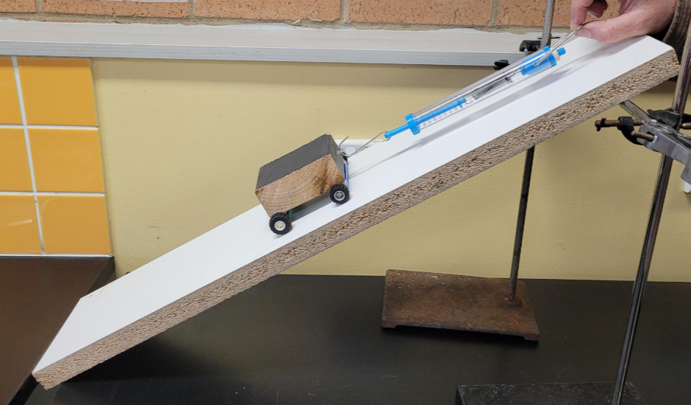

Table 3 – overview of steps in Part 3 of the depth study

|  |  |
| --- | --- |
| Step | Teacher guide |
| A | **Note:** students will need access to computers for this activity.  Review the images in Part 3, Step A, in the student resource and discuss the simple machines that make up the complex machine.  Instruct the students to identify the simple machines in the picture of a bicycle and then outline the role of the simple machines identified.  Students then find a modern machine that makes a task easier and outline its properties using the table in the student resource. |
| B | Review a selection of introductory videos with students. While watching the following videos, students should think about how a selection of simple machines can be used to automate a complex task.   * [Flubber - The Breakfast Machine | (Contraption Review) (01:46)](https://www.youtube.com/watch?v=YMyF2tlAAzs) * [The Snoozatron - Cracking Contraptions - Wallace and Gromit (02:06)](https://www.youtube.com/watch?v=vGxRUglFFME) * [Casper Ghost Ride Contraptions | Chain Reaction Reacts (03:40)](https://www.youtube.com/watch?v=Nsv8YbwAgLk)   Brainstorm with the class the types of chores or tasks that they have to do at home, which could be made easier with a system of simple machines.  Students select a chore to design a system using simple and or complex machines to reduce the effort required to do the task. |

The [Common Grade Scale](https://educationstandards.nsw.edu.au/wps/portal/nesa/k-10/understanding-the-curriculum/awarding-grades/common-grade-scale) can be used to report student achievement in both primary and junior secondary years in all NSW schools.

When grading students’ level of achievement in Stage 5, refer to the [course performance descriptors](https://curriculum.nsw.edu.au/learning-areas/science/science-7-10-2023/assessment#course-performance-descriptors-science_7_10_2023). Course performance descriptors provide holistic descriptions of typical achievement at different grade levels in a specific course.

### Equipment requirements

To complete this task, student groups will require the following equipment:

* A board, approximately one meter long and 10 centimetres wide, to act as a ramp or lever
* A solid wooden or plastic block with an attachment hook to act as a load. Alternatively, a container that can be loaded with a consistent mass.
* Scales to measure the mass of the block
* Spring balances of various scales
* Protractor and ruler
* A selection of simple machines – pulleys and string, wheels of different diameters, axles of different diameters, levers of different lengths
* Materials to act as a fulcrum if needed. For example, a drink bottle or glue stick.
* **Optional:** if available, digital data collection tools, such as data loggers and force sensors, could be considered for this task.

**Investigations**: this depth study includes primary investigations. In the student resource, students may record planning information, record measurements, perform calculations and perform other tasks associated with conducting scientific inquiry. However, if teachers would like their students to publish their investigations in the form of traditional practical reports, they should modify the student resource accordingly.

**Differentiation**: this task does not assess **SC4-WS-04** Working scientifically outcome, Conducting investigations. However, as part of the scientific inquiry process, students will define the variables of the investigations in this depth study. Some parts of this resource, such as Part 1 Step C, provide information about the experimental variables. Teachers may delete that information from the student resource if they want their students to determine those variables themselves.

# Assessment task notification

**Name of task**: Ancient and modern simple machines.

**Type of task: Depth study**

**Weighting**: [the weight of the assessment task is a school-based decision].

**Submission details:** [schools complete this section – include any important details about submission, the format of the task, word limits, and submission procedures].

**Outcomes being assessed**:

* describes the effects of forces in everyday contexts **SC4-FOR-01**
* uses a variety of ways to process and represent data **SC4-WS-05 (Processing data and information)**
* uses data to identify trends, patterns and relationships, and draw conclusions **SC4-WS-06 (Analysing data and information)**
* identifies problem-solving strategies and proposes solutions **SC4-WS-07 (Problem-solving)**

[Science 7–10 Syllabus](https://curriculum.nsw.edu.au/learning-areas/science/science-7-10-2023/overview) © NSW Education Standards Authority (NESA) for and on behalf of the Crown in right of the State of New South Wales, 2023.

## Task description

You will conduct a depth study in class to explore how simple machines were used to build the Great Pyramids of Egypt and how they are used in the modern world. The task is divided into 3 parts.

**Part A** – you will investigate how ramp angle affects the effort (force) required to move a block and compare this to how the Egyptians may have moved the heavy sandstone blocks to build the pyramids.

**Part B** – you will expand on the investigation in Part A to include another simple machine to try and reduce the effort (force) required to move the block.

**Part C** – you will explore modern-day complex machines – often made up of many simple machines. You will identify a problem and design a machine to make a task easier.

## Marking rubric

|  |  |  |  |  |  |
| --- | --- | --- | --- | --- | --- |
| Criteria | Level 1 | Level 2 | Level 3 | Level 4 | Level 5 |
| Apply scientific ideas to describe and explain the operation of machines.  **SC4-FOR-01**  Relevant sections:  Part 1, Steps B, C and E,  Part 2, Steps A, B and D,  Part 3, Steps A–B). | Demonstrated a limited understanding of load and effort in the various simple and complex machine scenarios.  Explanations are vague or entirely incorrect. | Demonstrated a basic understanding of load and effort in the various simple and complex machine scenarios.  Explanations are incomplete or partially incorrect. | Demonstrated a sound knowledge and understanding of the concepts of forces in simple and complex machine scenarios.  Explanations are mostly correct but lack depth. | Demonstrated a thorough knowledge and understanding of the concept of forces in simple and complex machine scenarios.  Explanations are clear and mostly thorough, with minor gaps. | Demonstrated a deep knowledge and understanding of the concept of forces in simple and complex machine scenarios.  The descriptions include multiple concepts that explain the relevant phenomena by establishing cause-and-effect relationships. Explanations are clear, detailed and fully accurate. |
| Perform calculations relating to load and effort in the operation of simple machines.  Tabulate data and/or construct graphs using accepted conventions.  Draws diagrams to represent information.  **SC4-WS-05**  Relevant sections:  Part 1 Steps A, C and D  Part 2 Steps A and C  Part 3 Steps A and B | Data in tables is incomplete.  Diagrams, if included, lack labels. | Data is recorded in tables. Labels and units may be missing.  Diagrams are included, and most labels are present. | Correctly recorded data in tables. Some labels and units are correct.  Diagrams are included and contain labels. | Correctly recorded data in tables. Most labels and units are correct. Summary data (mean) is calculated but may not exclude erroneous data.  Diagrams are neatly drawn. Diagrams contain labels and annotations where required. | Correctly recorded data in tables. All appropriate labels and units are correct. Summary data (mean) is calculated correctly after appropriately excluding erroneous data.  Diagrams are neatly drawn and scientifically accurate. Diagrams contain detailed labels and annotations where required. |
| Interpret the relationship between load and effort based on data representations.  Evaluates predictions based on collected data.  Evaluates the quality of information collected from investigations (reliability and validity). **SC4-WS-06**  Relevant sections:  Part 1 Step E  Part 2 Step D | Demonstrates a limited understanding of the relationship between variables.  Does not evaluate the prediction.  Makes a judgement about validity or reliability but does not support it with reasoning. | Demonstrates a basic understanding of the relationship between variables.  Indicates whether the experimental prediction is supported or not. No reasoning is provided  Makes a judgement about validity and reliability but may not support it with reasoning. | Demonstrates a sound understanding of the relationship between variables.  Indicates whether the experimental prediction is supported or not. The reasoning is vague.  Makes an appropriate judgement about the reliability and validity of the investigation supported with reasoning. | Examines data to draw evidence-based scientific conclusions about the relationship between variables.  Indicates whether the experimental prediction is supported or not. Limited reasoning is provided  Provides an evaluation of the validity and reliability of the investigation. | Analyses data and synthesises information to draw evidence-based scientific conclusions about the relationship between variables.  Indicates whether the experimental prediction is supported and provides evidence-based arguments.  Provides a well-reasoned evaluation of the validity and reliability of the investigation. |
| Describes the improved efficiency of using machines (in terms of the reduced effort).  Describes the development of complex machines and systems from simple machines.  **SC4-WS-07**  Relevant section:  Part 3 Step A and B. | Uses strategies to make observations about a scientific problem. | Uses strategies to identify a solution to a scientific problem. | Selects and uses problem-solving strategies and identifies proposed solutions to a scientific problem. | Selects and applies a suitable problem-solving strategy and compares proposed solutions to the scientific problem. | Selects and applies suitable problem-solving strategies and evaluates and compares proposed solutions to the scientific problem. |

# Student resource – ancient and modern simple machines

## Part 1 – identifying the problem

The Great Pyramid of Giza was built in 2600 BC by quarrying approximately 2.3 million large stone blocks. It stands 139 meters high and has a square base of approximately 230 meters on each side. Some of the blocks have a mass of up to 80,000 kilograms each. The pyramid has a total mass of around 6 billion kilograms.

Figure 4 – the Great Pyramid of Giza in Egypt

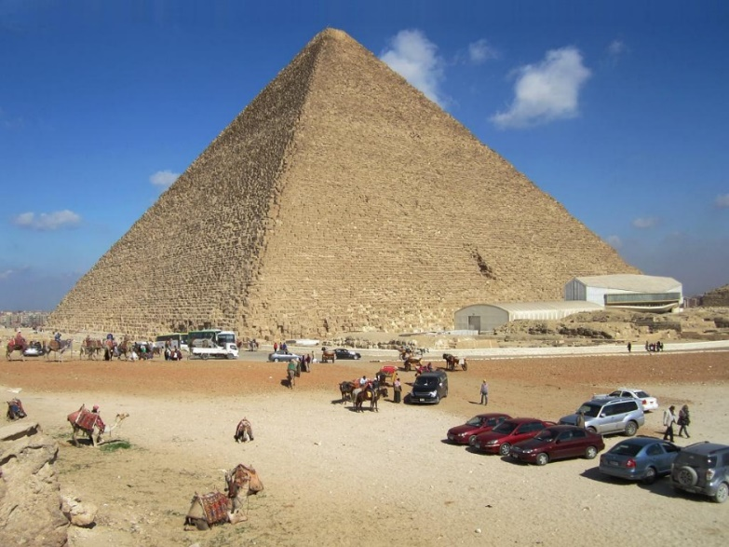

‘[Great Pyramid of Giza](https://www.worldhistory.org/image/6190/great-pyramid-of-giza/)’ by Stanley D is licensed under [CC BY 2.0](https://creativecommons.org/licenses/by/2.0/).

**Step A**

How much force (**effort**) would be required to lift one of these stone blocks (**load**) vertically? Calculate the force required using the following formula:

$$Force=mass×acceleration due to gravity$$

**Assumptions:**

* The average mass of the stone blocks of the pyramids was 80,000 kilograms.
* The acceleration due to gravity at the Earth’s surface is 9.8 ms-2.

|  |
| --- |
| Force required to lift a pyramid stone block = |

You will use a block (**load**) to model the stone blocks in the Great Giza Pyramid. First, you must calculate **baseline data** on the force required to lift the block.

Calculate the force (**effort**) required to lift your block vertically (**load**) using an appropriate spring balance.

|  |
| --- |
| **Baseline data**  Force required to lift your block = |

**Note:** you will use the results of your calculations to answer questions in other activities in this task.

**Step B**

Although the exact methods used to construct the pyramids are still subject to extensive debate, the currently accepted theory is that a combination of simple machine technologies was used to move the large blocks into place.

Research the currently accepted theory of how the pyramids were constructed.

Describe the possible techniques for constructing the Great Pyramid of Giza. In your answer, identify the types of simple machines that may have been used.

|  |
| --- |
|  |

**Step C**

In this investigation, you will model using a ramp to lift the blocks (**load**) to a selected height. You are to measure the effort required to lift the blocks with the ramp at different angles. To change the ramp angle, slide the ramp along the desk.

**Independent variable:** ramp angle.

**Dependent variable:** force (**effort**) required to move the block (**load**) to the selected lift height. Measured in Newtons.

Complete the planning information in Table 1 with your group. The response to ‘simple machine used’ has been added for you.

Table 1 – planning information for the ramp angle investigation

|  |  |
| --- | --- |
| Planning information | Student response |
| Group members |  |
| Simple machine used | Ramp |
| Load mass (g) |  |
| Lift height (cm) |  |
| Size of spring balance used (N) |  |
| Labelled diagram |  |

Write a prediction for your investigation as an ‘if-then-because’ statement:

|  |  |  |
| --- | --- | --- |
| Step | Description | Your response |
| If … | How will you change the independent variable? |  |
| Then … | Predicted change to the dependent variable. |  |
| Because … | A logical reason for the change.to the dependent variable. |  |

**Step D**

Test your ramp at least 3 different angles and record the force (**effort**) data in Table 2. Complete repeated trials for each angle until you obtain at least 3 similar results. Then, calculate the mean for these 3 results in Table 3.

Table 2 – raw data for the effect of ramp angle on the effort required to raise a block

|  |  |  |  |  |  |
| --- | --- | --- | --- | --- | --- |
| Ramp angle (°) | Effort required to raise the block (N) | | | | |
|  | Trial 1 | Trial 2 | Trial 3 | Trial 4 | Trial 5 |
|  |  |  |  |  |  |
|  |  |  |  |  |  |
|  |  |  |  |  |  |

Identify any trial measurements that may be high or low due to errors in data collection. For example, if the block was not moved at a constant speed, it could cause measurement errors. Place an * (asterisk) next to the data, and do not include it when calculating the mean effort for that ramp angle (check with your teacher).

Calculate the mean effort required to move the block up the ramp at each angle in Table 3.

Table 3 – summary data for the effect of ramp angle on the effort required to raise a block

|  |  |
| --- | --- |
| Ramp angle (°) | Mean effort (N) |
|  |  |
|  |  |
|  |  |

**Step E**

Answer and complete the following questions:

1. Compare the force (effort) required to raise the block (load) using the ramp at different angles to the baseline data collected in Part 1 Step A. Give a possible reason for this difference in effort required to raise the blocks. **Hint:** use key terms such as ‘effort’, ‘load’, ‘distance’, ‘simple machine’, ‘ramp’ and ‘weight’ in your response.

|  |  |
| --- | --- |
| Comparison | Reason |
|  |  |

1. Write a conclusion indicating whether your prediction was supported or not. Remember to refer to the independent and dependent variables in your conclusion.

|  |
| --- |
|  |

## Part 2 – a solution to the problem

As a scientist, you will use modelling and experimentation to improve on the solution to a problem.

**Step A**

First, your group will explore another simple machine to be used with the ramp. Your aim is to determine if the machine and ramp can lift the **load** to the **same height** with **less effort** than that recorded in Part 1.Your teacher will provide you with a range of simple machines to choose from. Pick one that your group would like to investigate.

In the following table, draw a simple labelled diagram showing your plan to use the combination of simple machines to lift the load used in Part 1 to the selected lift height. Set and maintain the ramp at a 45o angle. Record the simple machine used, block mass, lift height, and size of the spring balance used (for example, 10N or 100N):

Table 4 – planning information for Part 2, Step A, the multiple simple machines investigation

|  |  |
| --- | --- |
| Planning information | Student response |
| Group members |  |
| Additional simple machine used |  |
| Load mass (g) |  |
| Lift height (cm) |  |
| Size of spring balance used (N) |  |
| Ramp angle (degrees) |  |
| Labelled diagram |  |

**Step B**

Identify a way to modify your added simple machine so you can investigate the effect of this change on the effort required to move the load. This is the independent variable. The dependent variable is given to you.

|  |  |
| --- | --- |
| **Independent variable:** |  |
| **Dependant variable:** | The **effort** required to move the load to the lift height you have identified. Measured in Newtons. |

Identify 3 **controlled variables** for your investigation. These variables are to be kept the same throughout the Part 2 investigation.

|  |
| --- |
|  |

Write a prediction for your investigation as an ‘if-then-because’ statement.

|  |  |  |
| --- | --- | --- |
| Step | Description | Your response |
| If … | How will you change the independent variable? |  |
| Then … | Predicted change to the dependent variable. |  |
| Because … | A logical reason for the change. |  |

**Step C**

Build your model and collect the effort data for Table 5. Insert your independent variable into the first column. Complete repeated trials for your independent variable until you obtain at least 3 similar results.

Table 5 – raw data for the effect of ________________________ on the effort required to raise a block

|  |  |  |  |  |  |
| --- | --- | --- | --- | --- | --- |
|  | Effort required to raise the block (N) | | | | |
|  | Trial 1 | Trial 2 | Trial 3 | Trial 4 | Trial 5 |
|  |  |  |  |  |  |
|  |  |  |  |  |  |
|  |  |  |  |  |  |

Identify any trial results that may be high or low due to an error in data collection. For example, if the block was not moved at a constant speed, it could cause measurement errors. Place an * (asterisk) next to the data, and do not include it when calculating the mean effort for that ramp angle (check with your teacher).

**The following steps must be completed individually.**

Summarise the raw data in Table 5 into a summary data table. In the first column, enter your independent variable treatments.

Table 6 – summary data for the effect of _________________________ on the effort required to raise a block.

|  |  |
| --- | --- |
|  | Mean effort (N) |
|  |  |
|  |  |
|  |  |

**Step D**

Answer and complete the following questions independently.

1. Compare the effort required to raise the load to the lift height of the ramp used in Part 1 to your combination of simple machines used in Part 2. Give possible reasons for this:

|  |  |
| --- | --- |
| Comparison | Reasons |
|  |  |

1. Write a conclusion indicating whether your prediction was supported or not. Remember to refer to the independent and dependent variables in your conclusion.

|  |
| --- |
|  |

**Validity:** The extent to which the processes and resultant data measure what was intended.

**Reliability:** An extent to which repeated measurements taken under identical circumstances will yield similar results.

(NESA 2024)

1. Using **validity** and **reliability** as criteria, make a judgement on the effectiveness of your investigation to reduce the effort needed to lift the load in Part 2. Give 2 reasons why you made this judgement.

|  |  |
| --- | --- |
| **Judgement:** |  |
| **Reasons:** |  |

## Part 3 – Modern machines

**Step A**

Think about the simple machines around us. Simple machines are sometimes combined to form more complex machines. Review and discuss the images in Figure 5 for modern applications of simple machines in complex machines. List the simple machines that you can see in each image.

Figure 5 – complex machine examples. What simple machines are used in them?

|  |  |
| --- | --- |
| Bulldozer  [’File:CatD9T.jpg](https://commons.wikimedia.org/wiki/File:CatD9T.jpg)’ by Shaun Greiner is licensed under [CC BY-SA 2.0](https://creativecommons.org/licenses/by-sa/2.0/deed.en). | A bulldozer is a complex machine that contains: |
| Tower crane  ‘[Crane photo](https://commons.wikimedia.org/wiki/File:%D0%9A%D1%80%D0%B0%D0%BD_%D1%81_%D0%BC%D0%B0%D1%85%D0%BE%D0%B2%D0%BE%D0%B9_%D1%81%D1%82%D1%80%D0%B5%D0%BB%D0%BE%D0%B9.jpg)’ by Monoklon is licensed under [CC0 1.0](https://creativecommons.org/publicdomain/zero/1.0/deed.en). | A tower crane is a complex machine that contains: |
| A pink sports car  ‘[Motor car](https://commons.wikimedia.org/wiki/File:Z%C3%BCrich_(Schweiz),_Auto_in_der_Bahnhofstrasse_--_2011_--_1425.jpg)’ by Dietmar Rabich is licensed under [CC BY-SA 4.0](https://creativecommons.org/licenses/by-sa/4.0/deed). | A car is a complex machine that contains: |
| Steam locomotive  ‘[Steam train](https://commons.wikimedia.org/wiki/File:Lok_99_222_im_Bahnhof_Wernigerode.jpg)’ by Richard Bartz is licensed under [CC BY-SA 3.0](https://creativecommons.org/licenses/by-sa/3.0/deed.en). | A steam train is a complex machine that contains: |

Label the simple machines on the bicycle in Figure 3.

Figure 3 – a bicycle contains multiple simple machines

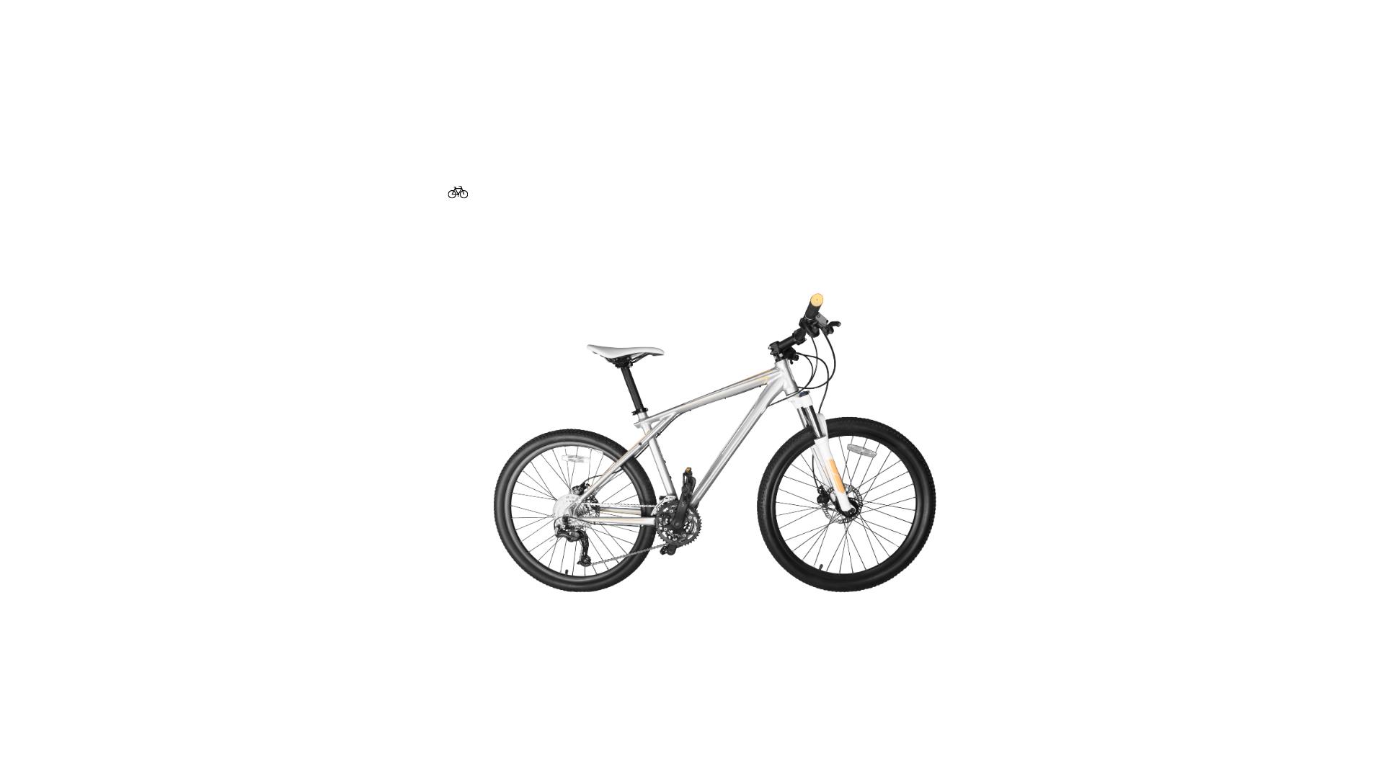

Outline the role of the simple machines you have identified on the bicycle in Table 7.

Table 7 – the role of simple machines in a bicycle

|  |  |
| --- | --- |
| Simple machine | What is the role of this simple machine? |
|  |  |
|  |  |
|  |  |

Research a modern complex machine. Summarise information to explain how the simple machines in your chosen complex machine reduce the effort when shifting a load. Record your response in Table 8.

Table 8 – description of a complex machine used to solve a problem

|  |  |
| --- | --- |
| Prompt | Response |
| **Machine** |  |
| **Task it performs** |  |
| **Simple machines used** |  |
| **Explanation of process** How is effort reduced? |  |
| **Labelled diagram**  Annotate the diagram to indicate the simple machines within the complex machine. |  |

**Step B**

Review a selection of the introductory videos and consider how a selection of simple machines can be used to automate a complex task:

* [Flubber - The Breakfast Machine | (Contraption Review) (01:46)](https://www.youtube.com/watch?v=YMyF2tlAAzs)
* [The Snoozatron - Cracking Contraptions - Wallace and Gromit (02:06)](https://www.youtube.com/watch?v=vGxRUglFFME)
* [Casper Ghost Ride Contraptions | Chain Reaction Reacts (03:40)](https://www.youtube.com/watch?v=Nsv8YbwAgLk)

**Note:** a Rube Goldberg machine consists of sequentially activated stages, some of which may use simple machines. In this task, you do not need to consider the staged activation of steps; only one or more simple machines are used at some point during the process.

Think about what chores you must complete at home, such as taking out the rubbish bin on collection day.

Design a system and create a labelled diagram to illustrate how to use a selection of simple and/or complex machines to simplify or automate your complex task at home. For example, create a timer set for 5 am on the rubbish collection day each week to operate a remote-control car that transports the bin along a pre-determined path from the side of the house to the street position. Your system should include multiple simple machines and consider how the effort required to do the task can be reduced.

Table 9 – simplifying a chore with a system of machines

|  |  |
| --- | --- |
| Prompt | Response |
| **Chore** |  |
| **Simple machines used** |  |
| **Complex machines used** |  |
| **Explanation of the process** How is effort reduced? |  |
| **Labelled diagram**  Annotate the diagram to identify the combination of simple and/or complex machines used. |  |

# Evidence base

This resource contains NSW Curriculum and syllabus content. The NSW Curriculum is developed by the NSW Education Standards Authority. This content is prepared by NESA for and on behalf of the Crown in right of the State of New South Wales. The material is protected by Crown copyright.

Please refer to the NESA Copyright Disclaimer for more information <https://educationstandards.nsw.edu.au/wps/portal/nesa/mini-footer/copyright>.

NESA holds the only official and up-to-date versions of the NSW Curriculum and syllabus documents. Please visit the NSW Education Standards Authority (NESA) website <https://educationstandards.nsw.edu.au> and the NSW Curriculum website <https://curriculum.nsw.edu.au>.

[Science 7–10 Syllabus](https://curriculum.nsw.edu.au/learning-areas/science/science-7-10-2023/overview) © NSW Education Standards Authority (NESA) for and on behalf of the Crown in right of the State of New South Wales, 2023.

Brookhart SM (2018) ‘[Appropriate Criteria: Key to Effective Rubrics](https://www.frontiersin.org/articles/10.3389/feduc.2018.00022/full)’, *Frontiers in Education*, volume 3(22):1–12, doi:10.3389/feduc.2018.00022, accessed 2 August 2024.

CESE (Centre for Education Statistics and Evaluation) (2020) [*What works best in practice*](https://education.nsw.gov.au/about-us/educational-data/cese/publications/practical-guides-for-educators-/what-works-best-in-practice), NSW Department of Education, accessed 2 August 2024.

—— (2021) [*Growth goal setting – what works best in practice*](https://education.nsw.gov.au/about-us/educational-data/cese/publications/practical-guides-for-educators/growth-goal-setting), NSW Department of Education, accessed 2 August 2024.

—— (2020) [*What works best: 2020 update*](https://education.nsw.gov.au/about-us/educational-data/cese/publications/research-reports/what-works-best-2020-update), NSW Department of Education, accessed 2 August 2024.

Fisher D and Frey N (1 November 2009) ‘[Feed Up, Back, Forward](https://www.ascd.org/el/articles/feed-up-back-forward)’, *ASCD (Association for Supervision and Curriculum Development): Educational Leadership magazine*, 67(3), accessed 2 August 2024.

Griffin P (2017) *Assessment for Teaching*, Cambridge University Press, Port Melbourne, Victoria.

Handwerk B (21 December 2024) ‘[The Pyramids at Giza were built to endure an eternity—but how?](https://www.nationalgeographic.com/history/article/giza-pyramids), *National Geographic*, accessed 2 August 2024.

Hattie J and Timperley H (2007) [‘The Power of Feedback’](https://journals.sagepub.com/doi/abs/10.3102/003465430298487), Review of Educational Research, 77(1): 81–112, doi:10.3102/003465430298487, accessed 15 July 2024.

Kraft S and Poynor L (2004) ‘[Was the Great Pyramid Built with Simple Machines?](https://eric.ed.gov/?id=EJ722146)’, *Science and Children*, 42(2):46–48, accessed 2 August 2024.

Panadero E and Jonsson A (2013) ‘[The use of scoring rubrics for formative assessment purposes revisited: A review](https://www.sciencedirect.com/science/article/abs/pii/S1747938X13000109?via%3Dihub)’, *Educational Research Review*, 9:129–144, doi:10.1016/j.edurev.2013.01.002, accessed 2 August 2024.

Sherrington T (2019) *Rosenshine’s Principles in Action*, John Catt Educational Limited, Melton, Woodbridge.

TeachEngineering (2019) [*Evolutionary Engineering: Simple Machines—Pyramids to Skyscrapers*](https://www.teachengineering.org/curricularunits/view/cub_simple_curricularunit), TeachEngineering website, accessed 2 August 2024.

TeachEngineering (2020) [*How to Use a Wedge, Science and Children*](https://www.teachengineering.org/lessons/view/cub_simple_lesson02), TeachEngineering website, accessed 2 August 2024.

Wallace & Gromit (30 April 2015) ['The Snoozatron - Cracking Contraptions - Wallace and Gromit' [video]](https://www.youtube.com/watch?v=vGxRUglFFME), *Wallance & Gromit*, YouTube, accessed 2 August 2024.

Wiliam D (2017) *Embedded Formative Assessment*, 2nd edn, Solution Tree Press, Bloomington, IN.

Zach's Contraptions (11 September 2023) ['Flubber - The Breakfast Machine | (Contraption Review)' [video]](https://www.youtube.com/watch?v=YMyF2tlAAzs), *Zach’s Contraptions*, YouTube, accessed 2 August 2024.

Zach's Contraptions (6 December 2023) ['Casper Ghost Ride Contraptions | Chain Reaction Reacts' [video]](https://www.youtube.com/watch?v=Nsv8YbwAgLk), *Zach’s Contraptions*, YouTube, accessed 2 August 2024.

**© State of New South Wales (Department of Education), 2024**

The copyright material published in this resource is subject to the Copyright Act 1968 (Cth) and is owned by the NSW Department of Education or, where indicated, by a party other than the NSW Department of Education (third-party material).

Copyright material available in this resource and owned by the NSW Department of Education is licensed under a [Creative Commons Attribution 4.0 International (CC BY 4.0) license](https://creativecommons.org/licenses/by/4.0/).

[](https://creativecommons.org/licenses/by/4.0/)

This license allows you to share and adapt the material for any purpose, even commercially.

Attribution should be given to © State of New South Wales (Department of Education), 2024.

Material in this resource not available under a Creative Commons license:

* the NSW Department of Education logo, other logos and trademark-protected material
* material owned by a third party that has been reproduced with permission. You will need to obtain permission from the third party to reuse its material.

**Links to third-party material and websites**

Please note that the provided (reading/viewing material/list/links/texts) are a suggestion only and implies no endorsement, by the New South Wales Department of Education, of any author, publisher, or book title. School principals and teachers are best placed to assess the suitability of resources that would complement the curriculum and reflect the needs and interests of their students.

If you use the links provided in this document to access a third-party's website, you acknowledge that the terms of use, including licence terms set out on the third-party's website apply to the use which may be made of the materials on that third-party website or where permitted by the Copyright Act 1968 (Cth). The department accepts no responsibility for content on third-party websites.