Science Stage 5 (Year 9) – Disease

Teacher resource book 1 of 3 (TRB1)

**How and why does the body respond to a changing environment?**

**Creation date:** 6 September 2024

Contents

Overview 2

Tier 3 vocabulary glossary 2

1.1 What do you know? – write the room 6

What do you know? 6

1.2 Maintaining a balance 10

Modelling homeostasis – practical investigation 10

1.3 Response to stimuli 23

Reliability and validity of investigations 23

Investigate the heart’s response to a stimulus (practical investigation) 27

Interpreting data about sweating and temperature 34

1.4 Feedback mechanisms 39

The role of feedback loops 39

1.5 Coordinating the response to stimuli 45

Structure and function of the endocrine system (secondary-source investigation) 45

Observing the body’s response to stimuli (practical investigation) 48

Structure and function of the nervous system (secondary-source investigation) 55

1.6 Comparing the endocrine and nervous systems 67

Preparing to write a response 67

Evidence base 75

# Overview

**Stage and learning area:** Stage 5 Science

**Description:** this resource complements the Disease program of learning. It aims to serve as a teacher reference, offering practical strategies and ideas to enrich teaching practices and create engaging learning environments. The activities should be adapted to suit students’ needs.

**Duration:** while timing will vary based on the mode of delivery, differentiation strategies employed and the class or school context, this series of activities should take approximately 11 hours.

**Risk management:** teachers are advised to undertake a risk assessment before conducting any classroom investigation or experiment. For more information on developing risk assessments see [Risk Assessment – a pre-requisite for risk control](https://education.nsw.gov.au/inside-the-department/facilities-assets-and-equipment/school-infrastructure-nsw/knowledge/directorates/operations/technical-services/compliance-and-environment/chemical-safety-in-schools/section-1--general-information-for-all-staff/1-7-risk-assessment---a-pre-requisite-for-risk-control).

This resource book elaborates on many of the activities in the Disease sample learning program. Some activities also reference the Disease slide deck (identified as **DIS PPT** throughout this document).

## Tier 3 vocabulary glossary

Tier 3 words are those that are relevant for subject-specific content. More information is provided in the ‘Vocabulary in context’ document found at the [Stage 5 reading strategies page](https://education.nsw.gov.au/teaching-and-learning/curriculum/literacy-and-numeracy/teaching-and-learning-resources/literacy/teaching-strategies/stage-5/reading/stage-5-vocabulary-in-context). A glossary containing Tier 3 vocabulary related to the essential question ‘How and why does the body respond to a changing environment?’ has been provided below. The [Guide for planning and implementing explicit vocabulary instruction](https://resources.education.nsw.gov.au/detail/V-19) can be used by teachers across all curriculum areas.

|  |  |
| --- | --- |
| Term | Definition |
| **Accuracy** | The extent to which measurements are considered to be close to the true value (NESA 2023). |
| **Blood glucose (blood sugar)** | The main sugar found in blood. It is the human body’s primary source of energy. |
| **Control centre** | The brain is the control centre of the body. The brain controls all our actions and functions, both voluntary and involuntary. |
| **Disease** | an illness or condition of the body affecting the way an organism, or parts of an organism, or its organs, function (NESA 2023). |
| **Effector** | **a body part or cell that reacts to a stimulus in a particular way.** |
| **Electrical impulses** | an electrical charge that travels along the neuron, allowing transmission of messages from one part of the body to another. |
| **Endocrine system** | a system in the human body made up of glands that release special chemicals called hormones into the blood. |
| **External environment** | the environment surrounding the organism on the outside of the body. |
| **Feedback loops** | reactions in response to environmental change (NESA 2023). |
| **Glucagon** | a hormone that raises blood sugar when it is low. |
| **Glycogen** | the stored form of glucose that's made up of many connected glucose molecules. |
| **Homeostasis** | the ability of an organism to maintain stable internal conditions despite external changes (NESA 2023). |
| **Hormones** | chemical messages sent to specific parts of the body to tell them what to do. For example, insulin is a hormone that helps control blood sugar levels. |
| **Hypothalamus** | an area of the brain that produces hormones that control a range of processes such as body temperature, heart rate, hunger and mood. |
| **Insulin** | a hormone that lowers the level of glucose (a type of sugar) in the blood. |
| **Internal environment** | the environment in which cells are found, inside the body. |
| **Mean** | the sum of values in a data set divided by the total number of values in the data set. Also called the average (NESA 2023). |
| **Negative feedback loop** | this acts to oppose the stimulus that triggers it. For example, if body temperature is too high, a negative feedback loop will act to bring the temperature back down towards the set point. |
| **Nerves** | a bundle of fibres that carry electrical impulses between the brain and the rest of the body. |
| **Nervous system** | a network of nerves and cells that carry messages to and from the brain and spinal cord to various parts of the body. |
| **Neuron** | the type of cell that makes up the nervous system. |
| **Positive feedback loop** | this acts to intensify a response. For example, when a wound causes bleeding, the body responds with a positive feedback loop to clot the blood and stop blood loss. |
| **Precision** | the extent to which repeated measurements of the same item are close to each other (NESA 2023). |
| **Receptor** | a group of cells that detect a change in a particular component of the internal environment. |
| **Reflex arc** | a pathway that controls the reflex reaction of the body. |
| **Reliability** | the extent to which repeated observations and/or measurements taken under identical circumstances will yield similar results (NESA 2023). |
| **Response** | actions of the body triggered by a stimulus. |
| **Stimulus** | a change in the internal or external environment of the body that triggers a response in the organism. |
| **Stimulus-response model** | a model that shows how living organisms respond to changes in their environment. |
| **Target** | a cell, tissue or organ on which a hormone acts. |
| **Thermoregulation** | the process which maintains a body’s internal temperature. |
| **Validity** | the extent to which the processes and resultant data measure what was intended (NESA 2023). |

# 1.1 What do you know? – write the room

Table 1 – learning intention and success criteria for 1.1 What do you know? – write the room

|  |  |
| --- | --- |
| Learning intention | Success criteria |
| We are:   * **revising Stage 4 content from the focus areas Cells and classification and Living systems.** | I can:   * identify bacteria and fungi as living things * identify organs and their functions * outline the function of a range of specialised cells * describe the role of specialised cells in multicellular organisms * explain how organ systems work together to carry out their functions. |

## What do you know?

### Teacher information

In this activity, students recall content from Cells and classification, Living systems and Data science 1 (modelling) in Stage 4 relevant to the Disease focus area. This activity is designed to determine students' prior knowledge of Stage 4 content required to understand the Disease focus area. This will inform teacher planning to ensure students have the required prerequisite knowledge to successfully complete the Disease focus area.

**Note:** the Overview in the Disease sample program of learning outlines the prior learning from both the Science and Technology K–6 Syllabus and Stage 4 in the Science 7–10 Syllabus. This is useful pre-reading so that you have an understanding of the learning students should have before commencing this program of learning.

Order the following for the class:

* Markers (one per student)
* 5 × butcher’s paper with headings as outlined in point 1 below.

1. **Write the following headings in the centre of each butcher’s paper, one per paper:**

* Single-celled organisms
* Specialised cells in multicellular organisms
* Body systems and their interrelated functions
* Organs and their functions
* Scientific models.

1. **Hang each sheet of butcher’s paper in different locations around the room.**
2. **Model how to complete the activity by writing example responses on sticky notes and adding them to the relevant butcher’s paper. For example:**

* Respiratory system (added to the Body systems and their interrelated functions butcher’s paper)
* The human body systems work together to meet the needs of multicellular organisms (added to the Body systems and their interrelated functions butcher’s paper)
* Models are used to represent scientific concepts (added to the Scientific models butcher’s paper)
* Single-celled **organism: an organism that is made up of one cell (added to the Single-celled organisms butcher’s paper)**

1. **Give each student sticky notes and ask them to move around the classroom to each butcher’s paper and demonstrate what they know about each area written on it by adding keywords, sentences, definitions and/or diagrams. Images to prompt student thinking are** **provided in slide ‘1.1 What do you know about living things and disease?’ in the DIS PPT. Speaker notes are included to unpack the concepts depicted on the slide.**
2. **As students are writing their sticky notes and adding them to the relevant butcher’s paper, walk around to identify** **any alternative conceptions, misconceptions or gaps in knowledge using** Table 2**.**
3. **Lead a discussion about the contents of each butcher’s paper to clarify student understanding, including identifying any alternative conceptions, misconceptions or gaps in knowledge.**

Table 2 – alternative conceptions and their corresponding accepted conception

|  |  |
| --- | --- |
| ****Alternative conceptions**** | ****Accepted conceptions**** |
| The particles in an animal are living. | Particles do not reproduce or need water to ‘survive’. Cells are the smallest living thing. |
| The human body contains cells. | The human body is made up of cells. |
| There are only 2 types of cells: plant cells and animal cells. Therefore, only plants and animals are made up of cells. | All living things are made up of cells. This includes single-celled organisms such as bacteria. |
| Living things grow because their cells get bigger. | Living things grow because the cells reproduce. |
| All living things have a brain. | Plants are living things and do not have a functioning brain. |
| All living things need oxygen to survive. | Many microorganisms grow in environments that do not have oxygen. They will exchange other gases. |
| All bacteria make you sick. | While some bacteria can cause illness, we rely on many types of bacteria to help us digest food and fight disease. |
| The only gas we breathe out is carbon dioxide. | The air we breathe is 21% oxygen, 78% nitrogen (and small amounts of carbon dioxide). We use approximately 3% of the oxygen we breathe in. This is why CPR works (18% oxygen in each breath out). |
| The heart produces, stores, filters or cleans the blood. | The heart pumps blood around the body. |

Sources: [Biological science conceptions](https://primaryconnections.org.au/pedagogical-tools/deep-connected-learning-tools/biological-science-conceptions?tabIndex=4) and [Chemical science conceptions](https://primaryconnections.org.au/pedagogical-tools/deep-connected-learning-tools/chemical-science-conceptions?tabIndex=1) by Primary Connections, licensed under [CC BY-NC-SA-4.0](https://primaryconnections.org.au/credits) and [Big idea: The cellular basis of life](https://www.stem.org.uk/secondary/resources/collections/science/best-evidence-science-teaching/cellular-basis-of-life) by Best Evidence Science Teaching (BEST) licensed under [CC BY-NC 4.0](https://creativecommons.org/licenses/by-nc/4.0/).

1. If necessary, to review some of the identified concepts, use the [Interactive Human Body activity](https://www.labxchange.org/library/items/lb:LabXchange:e40b2431:lx_simulation:1?fullscreen=true), BEST’s [The cellular basis of life](https://www.stem.org.uk/secondary/resources/collections/science/best-evidence-science-teaching/cellular-basis-of-life) response activities, and the speaker notes on the slide ‘1.1 What do you know about living things and disease?’ in the **DIS PPT**.
2. **Ask students to move around the room again and shift or amend the sticky notes, and add additional information to their own and others’ contributions.**

**Note:** this activity could be run digitally as an alternative to using butcher’s paper, for example, a group Microsoft PowerPoint, Google Slides, or Microsoft Whiteboard.

# 1.2 Maintaining a balance

Table 3 – learning intentions and success criteria for 1.2 Maintaining a balance

|  |  |
| --- | --- |
| Learning intentions | Success criteria |
| We are learning:   * about the importance of maintaining stable internal conditions in the human body to function optimally | I can:   * define homeostasis * identify that the body keeps factors such as temperature within a certain range * outline how the human body responds to changes in external temperatures to maintain a constant body temperature |
| * to understand how scientific models can represent and explain concepts. | * explain how a model demonstrates the concept of homeostasis * identify the limitations of a model. |

## Modelling homeostasis – practical investigation

### Teacher information

In this activity, students will model the concept of homeostasis before being introduced to additional scientific terminology (such as feedback loops). This allows students to grasp the concept without being overloaded with new terminology at the start of the activity. Throughout the subsequent lessons, refer to the model to consolidate students' understanding of homeostasis.

The model includes both the apparatus shown in Figure 1 and the students completing the actions. It models the concept of homeostasis by simulating the continuous adjustments an organism makes to maintain its internal environment within certain parameters. The cup represents the organism’s internal environment, and the lines drawn on it symbolise the narrow range of conditions required for optimum function (see Figure 2). The student adding water plays a critical role in the scientific model, representing feedback mechanisms that detect and respond to changes. By actively monitoring and adjusting the variables, students represent how organisms strive to maintain equilibrium despite external fluctuations. Table 4 outlines some comparisons of the homeostasis model to the human body function or feature it represents.

Table 4 – comparison of the model to the representation in the human body and an explanation of the process in the human body

|  |  |  |
| --- | --- | --- |
| Homeostasis model | Human body function or feature | Explanation |
| Water temperature | Body temperature | The hypothalamus acts as the body’s thermostat. It detects changes in the body’s temperature and triggers an appropriate response.  When the body is cold, it generates heat through shivering (muscle contractions) and increases metabolic activities.  When the body is hot, it loses heat through sweating and vasodilation (expansion of the blood vessels) to increase heat dissipation. |
| Water volume | Hydration – body water levels | The body regulates water balance to prevent dehydration or overhydration. The kidneys play a major role in this.  We gain water through drinking and eating.  We lose water:   * through our skin as sweat (perspiration) in hot weather due to the body regulating its temperature * when we exhale * in urine. When we are dehydrated our urine is dark yellow because the waste products are concentrated. Our body reabsorbs as much water as possible, which concentrates the waste in our urine. |
| Temperature probe | Receptor | The temperature probe in the model acts as a receptor to identify the changes in the temperature. This sends a message to the control centre (the student) to initiate a response (the student adding hot or cold water). |
| Student completing the actions (adding water and dye) | Control centre and effector  Also, the receptor for volume change | For temperature the student is the control centre and the effector, responding to the change in temperature identified by the temperature probe (receptor).  The student represents the receptor, control centre and effector for the water volume and water colour. |

#### Equipment requirements

Order the following equipment for each group of students:

* 1 × retort stand
* 1 × boss head and clamp (to hold the temperature probe or thermometer)
* 1 × tripod (to hold cup)
* 1 × clear plastic cup with a small hole in the bottom (approximately 1 mm), with 2 permanent lines drawn 0.5 cm apart and approximately 3 cm from the top (see Figure 2)
* 3 × Pasteur pipettes
* 2 × 500 mL beakers (for hot and cold water)
* 2 × 250 mL beaker (for wastewater)
* 1 × temperature probe (or thermometer if a temperature probe is unavailable)
* 1 × device to show the live temperature from the temperature probe.

|  |  |
| --- | --- |
| Figure 1 – homeostasis model equipment setup (DIS PPT) Diagram of the homeostasis model for a practical investigation.  This work has been generated using [Chemix.org](https://chemix.org/). | Figure 2 – cup with lines drawn on it  Diagram of the cup used for the homeostasis model showing 2 lines drawn around it.  This work has been generated using [BioRender.com](https://www.biorender.com/). Any copyright subsisting in this work is owned by © State of New South Wales (Department of Education) 2024. |

#### Lesson instructions

Before conducting the practical activity, ask the students what normal body temperature is. Most students will know that the human body temperature is between 36°C–37°C. Ask the students what would happen if they went outside on a hot day. Students should suggest that their body temperature would not change much, but they would sweat.

Display **DIS PPT slide ‘1.2 Defining homeostasis’** and ask students to define homeostasis in question 1 in the Student resource – homeostasis model.

Show the students the unlabelled diagram of the equipment setup in the **DIS PPT** slide ‘**1.2 Modelling homeostasis’**. Instruct students to label the apparatus in question 2 (answers have been provided in the **DIS PPT** and inFigure 1).

Demonstrate the model to students as outlined below:

1. Tell students that the cup with the drawn lines represents the internal environment of an organism that requires the following conditions for life:

* a constant body temperature of 37°C
* a constant volume of water.

1. Fill the cup with water at a temperature of 37°C and a known volume (this will depend on the size of the cup). Point out that the water volume is immediately going down as water is leaving through the bottom of the cup. Show students that the temperature reading from the data logger is reducing as heat is lost to the environment.
2. Tell the students they need to work together in their group for 10 minutes to:

* maintain the temperature of the water in the cup (37°C) using the Pasteur pipettes to transfer hot and cool water from the beakers on their bench to the cup/bottle while keeping an eye on the temperature on the data logger screen
* maintain the water volume between the 2 lines on the cup
* swap the waste beaker as it fills up. The students should have a spare beaker to replace the waste beaker to minimise spills.

1. Demonstrate how to maintain the volume and temperature by transferring hot and cool water to the cup using Pasteur pipettes.
2. Explain to students that if their cup deviates too far from the parameters set, their model organism will fall ill and potentially not survive.
3. Fill the students’ cups and instruct them to maintain the variables for 10 minutes.

**Note:** where possible, a temperature probe should be used to monitor the temperature of the water. The data logger should be set to collect the temperature every 15 seconds for 10 minutes. The output could be a graph and a table of the data. An example of the data logger output has been provided in Figure 3.

If a thermometer is used instead, the students will have to manually record the temperature at regular intervals. A table must be added to the student resource to facilitate this data collection. Students can then graph and analyse the fluctuations in the temperature once the practical component is completed.

#### Analysing the homeostasis model

Instruct students to complete questions 3–5 in the Student resource – homeostasis model.

* The students should have observed that the water volume fluctuated over the 10 minutes. The water volume decreased because there was a hole in the cup, which was counteracted by the students adding water.
* In their responses, students should be able to identify that the temperature fluctuated and that it was quite difficult to maintain the temperature at the specified value. Tell students that our bodies are much better at maintaining a constant internal temperature, which usually does not deviate from 36.5°C to 37.4°C.

Figure 3 shows sample temperature data collected using the model. Using a temperature probe allows students to observe the fluctuations in temperature as they add hot and cold water to their cups. Use the students' graphs to introduce the concept of homeostasis – the ability of an organism to maintain stable internal conditions despite external changes. Outline that the decrease or increase in temperature was counteracted by adding warm or cool water.

Figure 3 – sample temperature data for the homeostasis model

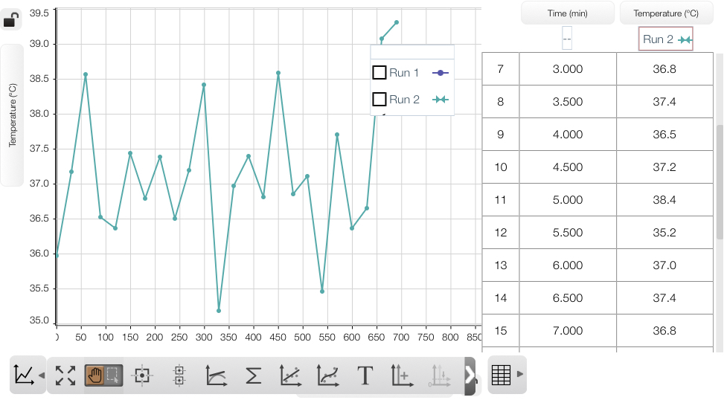

Prompt the students to think about how much harder they would have to work to maintain the temperature of the cup if it was a very cold day (this relates to question 6). The cup would lose heat to the external environment, and they would have to add more hot water than cold water. Relate this to functions within the human body:

* The hairs on our skin raise to trap a layer of air, which acts as an insulating layer, helping to keep us warm.
* Our muscles contract and relax, causing us to shiver. This produces heat and helps to increase the body’s temperature.
* In extreme cold, our circulatory system keeps vital organs warm and stops blood pumping to the extremities to conserve heat.

Show the students slide ‘1.2 Thermoregulation in humans’ in the **DIS PPT** and explain how body temperature is kept in balance through a range of actions triggered by the body. Speaker notes are included on the slide. Students complete question 7 as thermoregulation is explained.

Before students complete question 8, ask them what other variables in the human body are controlled by the body to stay within a certain range. This is an opportunity to identify if students have any prior understanding of homeostasis in the body. Provide students with a brief overview of the other factors maintained in the body by homeostasis. Refer to Table 4.

Students complete the table (in question 8 of the student resource) to relate the components of the homeostasis model to the related process in the human body.

**Note:** address any misconceptions as they arise. For example, students may think that the water leaving through the hole in the cup represents urination. Although this is one way the body maintains water balance, the body also has other mechanisms for losing water, such as sweating.

Students are asked to identify one strength and one limitation of the homeostasis model. Students will have varying degrees of understanding of models based on the learning in Data science 1 in Year 8.

**Note: at this point, introduce the term ‘feedback loop’ as a reaction to environmental change. Link this to the model and slide ‘1.2 Thermoregulation in humans’ (DIS PPT).**

Unpack the strengths and limitations using the information below, and then students complete question 9 in the student resource to evaluate the model.

**Strengths and limitations of the homeostasis model**

Some examples of strengths include:

* The model helps highlight how a feedback loop maintains a stable internal environment in the body. For example, temperature regulation.
* It demonstrates how the body maintains a ‘set point’ like optimal temperature range.
* It simplifies the concept of homeostasis.

Some examples of limitations of the homeostasis model include:

* Real biological systems are more complex, involving multiple organs and regulatory pathways. The model simplifies these processes to basic actions like adding water to adjust the temperature.
* In biological systems, homeostasis is maintained through internal processes without conscious thought. In the model, students must consciously add water and monitor and adjust the temperature.
* The model only focuses on 2 variables (temperature and volume) having to be kept in homeostasis. The body must manage many more things at once, such as oxygen levels, blood glucose, blood pH, salt levels and so on.

**Checkpoint: hinge question – exit ticket**

**What happens to your body’s internal temperature if you are exposed to a cold environment for an extended period?**

1. Your body temperature drops rapidly to match the outside temperature.
2. Your body maintains a stable internal temperature by shivering and constricting blood vessels near the skin.
3. Your body temperature increases to compensate for the cold environment.
4. Your body stops regulating temperature.

This exit ticket could be set up digitally to analyse student responses quickly. The form could also be set up to give the students instant feedback. The ‘1.2 Hinge question – exit ticket’ slide in the **DIS PPT** also includes the hinge question.

Table 5 – explanation of students' understanding and misconceptions based on their response to the hinge question

|  |  |
| --- | --- |
| Response | Explanation |
| A | The student may think the body cannot regulate its temperature effectively and will simply conform to the external environment. This indicates a lack of understanding of the body’s mechanisms for maintaining homeostasis, such as thermoregulation through physiological responses. |
| B | This is the correct answer. |
| C | Students might believe the body will respond to the cold by increasing the internal temperature. This shows a misunderstanding of homeostasis, as the body’s response to cold typically involves conserving heat (through vasoconstriction and hairs standing on their end to trap a layer of air around the skin) rather than generating excess heat. Note that shivering is a response to increased body temperature, but it will not cause body temperature to increase higher than it should. |
| D | Students have not understood that the body regulates temperature in response to environmental changes. |

The information gathered from this hinge question should inform teaching for future student understanding. The same question could be used to check for understanding after 1.4 Feedback mechanisms.

### Student resource – homeostasis model

1. What is homeostasis?

|  |
| --- |
|  |

1. Label the equipment in the homeostasis model.

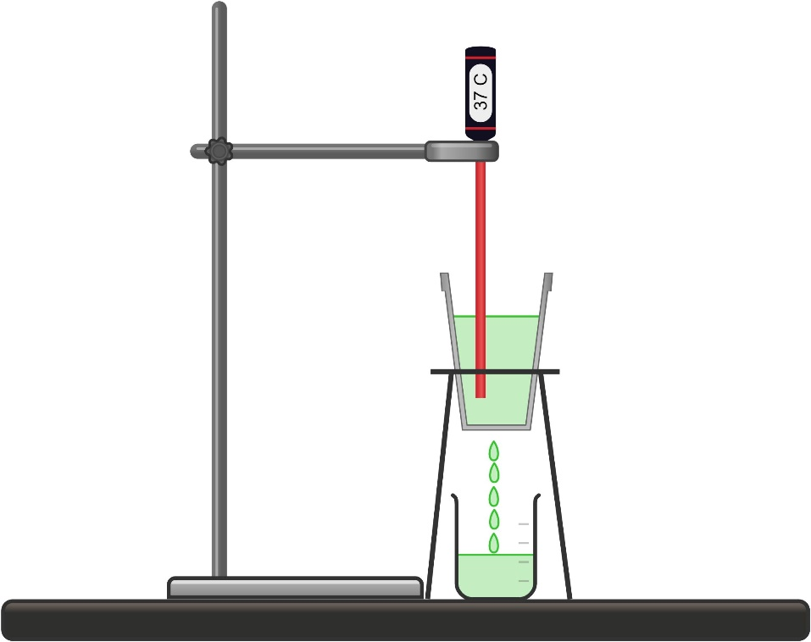

This work has been generated using [Chemix.org](https://chemix.org/).

1. Describe what happened to the volume of water in the cup over 10 minutes.

|  |
| --- |
|  |

1. You collected temperature data using a temperature probe. Sketch the graph showing how the water temperature changed over 10 minutes.
2. Describe what happened to the water temperature in the cup over time.

|  |
| --- |
|  |

1. How might this change if there was a change to the external environment, for example, if it was a cold winter’s day?

|  |
| --- |
|  |

1. Use the PowerPoint slide shown by your teacher to complete the missing words in Figure 1.

Figure 1 – human body temperature regulation

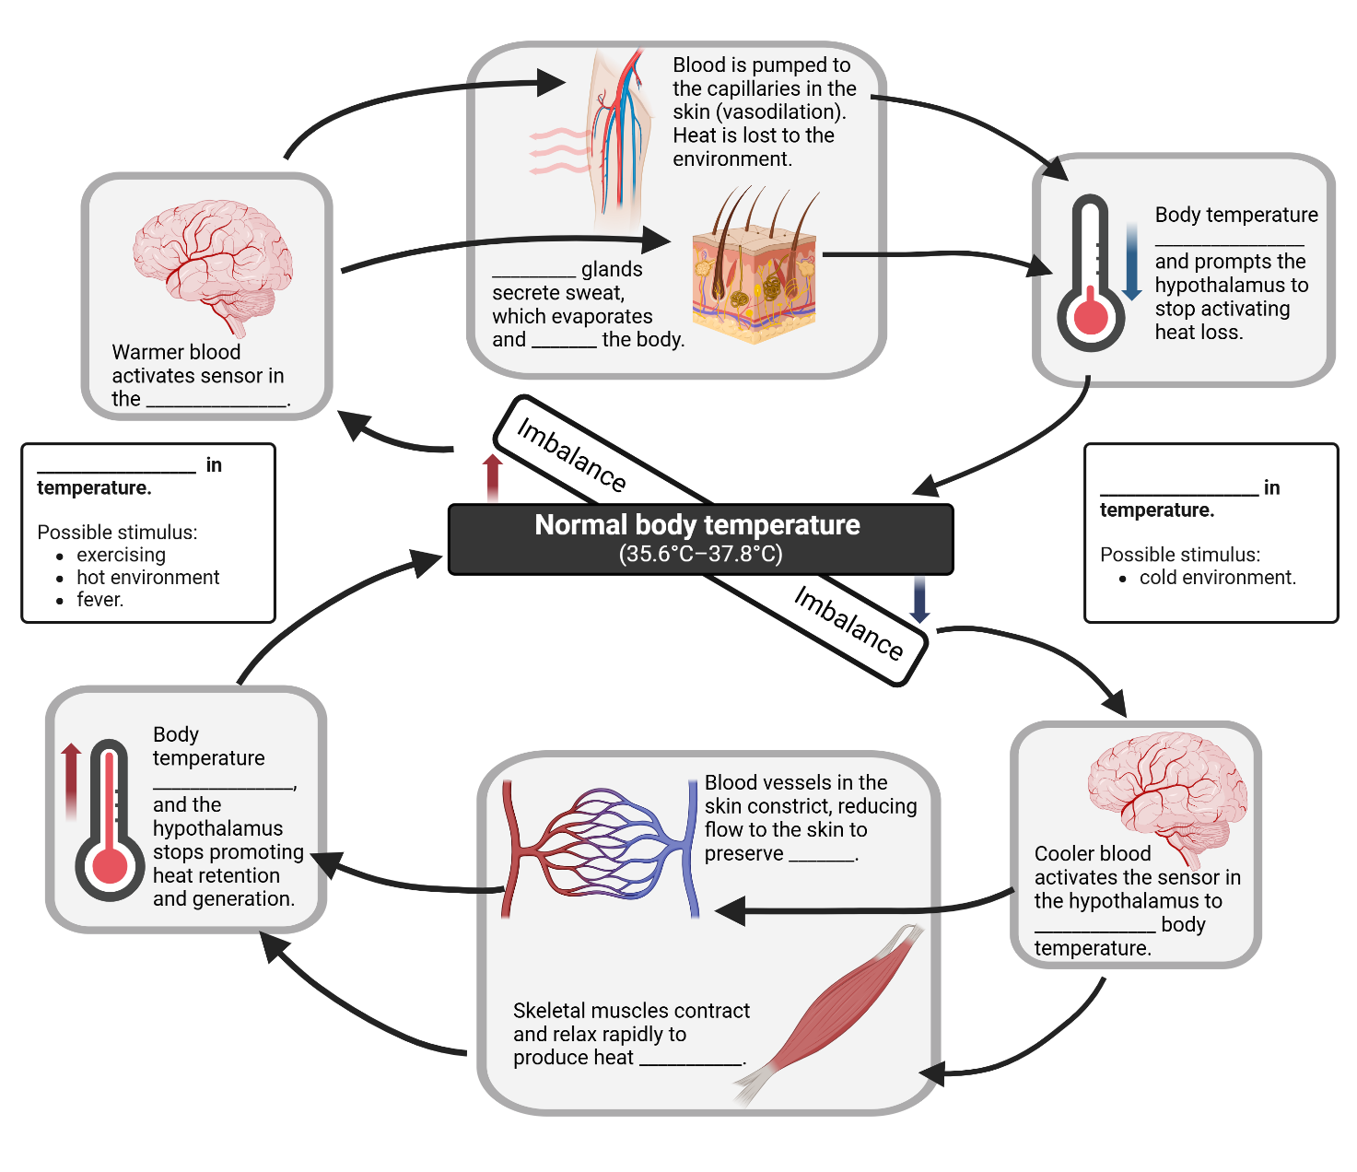

This work has been generated using [BioRender.com](https://www.biorender.com/). Any copyright subsisting in this work is owned by © State of New South Wales (Department of Education) 2024.

1. Complete the table below to relate the homeostasis model to processes that occur in the human body.

Table 1 – comparing the homeostasis model to processes in the human body

|  |  |
| --- | --- |
| Homeostasis model | Related processes in the human body |
| Water temperature |  |
| Water volume |  |

1. A model can be used to help explain a concept or an idea. Give one example of how the homeostasis model is a good representation of homeostasis. Give another example showing a limitation of this model.

|  |
| --- |
|  |

### 

# 1.3 Response to stimuli

Table 6 – learning intentions and success criteria for 1.3 Response to stimuli.

|  |  |
| --- | --- |
| Learning intentions | Success criteria |
| We are learning:   * to describe human responses to stimuli | I can:   * define stimulus * describe how humans respond to given stimuli |
| * to assess the reliability and validity of practical data | * define reliability and validity for primary data * outline criteria that make a practical investigation reliable and valid * assess the reliability and validity of practical investigations |
| * to use various methods like tables and graphs to organise and visualise data. | * identify the quality criteria for a table and column graph * construct a suitable table and graph for the investigation. |

## Reliability and validity of investigations

### Teacher information

1. Teach students what validity and reliability are in practical investigations using the information in the Student resource – reliability and validity text.
2. Teach students how to make a judgement using slide ‘1.3 Example 1: Is it reliable? Is it valid?’ in the **DIS PPT**,by determining if it is valid and reliable. Provide reasons to support the judgement, including information from the investigation. Ask students if the remaining examples in the **DIS PPT** are reliable and valid. In the notes section of these slides, there are questions to support students in attaining information to make their judgement.

**Note:** tell students the procedures for the experiments (examples 1–3) in the **DIS PPT** have not been provided. However, this information is required to determine if the experiment is valid. Assume that the procedures used in the examples were appropriate to the given aim. The focus will also be on precision (internal reliability).

**Differentiation:** advanced students may be introduced to statistical measures of variability, such as range and standard deviation, using the examples 1–3 Is it reliable? is it valid? in the **DIS PPT**.

### Student resource – reliability and validity text

|  |
| --- |
| **Reliability** is all about how consistent and repeatable measurements are when doing experiments. Reliable measurements are those that are similar in value over multiple experiments (conducted under similar conditions). This means the data is reliable because it is consistent.  Reliability is a key part of the scientific process. When scientists publish their research, they need to share all the details about their experiments (such as the materials they used, the methods they followed, and the procedures they applied) so that other scientists can repeat the experiments and check if they get the same results. This helps confirm that the findings are reliable.  There are 2 types of reliability:  **Internal reliability**: this is about the consistency of measurements within a single experiment. This is otherwise known as **precision**.  **External reliability:** this is about the consistency of measurements across different, independent experiments. Doing the same experiment multiple times and getting similar results each time shows strong external reliability. Imagine plotting the results of 2 or more identical experiments on a graph; you should see a strong correlation between the data points.  In science, when we talk about reliability, we usually mean external reliability.  The **validity** of an investigation refers to whether the method accurately measures what was intended to be measured. Accuracy, precision and reliability are essential to the validity of scientific findings.  Validity refers to the extent to which the experiment method measures what it was designed to test. For an experiment to be valid, it must satisfy the following criteria:   * All variables (dependent, independent and controlled) are identified. A well-designed experiment can establish the relationship between the dependent and independent variables because all other variables are controlled. * The correct instruments and procedures are used in an experiment to make the measurements relevant to the aim. * The findings of the investigation stem from the independent variable. In other words, there are no other possible reasons for the results other than the change in the independent variable. * The experiment is reliable.   Figure 1 – targets showing reliability and validity of data  Targets showing reliability and validity.  ‘[Reliability and validity](https://commons.wikimedia.org/wiki/File:Reliability_and_validity.svg)’ by Nevit Dilmen from [Wikimedia Commons](https://commons.wikimedia.org/wiki/Main_Page) is licensed under [CC BY-SA 4.0](https://creativecommons.org/licenses/by-sa/4.0/deed.en).   * Looking at Figure 1 above, the bullseye represents the experiment's aim/target. * The dots represent the data collected. * The more tightly grouped the data is, the more reliable they are. If the data are scattered (as shown in a and b), then they are not reliable. * The targets (a, b and c) that show data points far from the centre demonstrate that the measurements do not measure what has been intended, making the experiment invalid. |

## Investigate the heart’s response to a stimulus (practical investigation)

### Teacher information

Students will need one stopwatch each to conduct the practical activity.

**Note:** a data logger with a heart rate monitor will measure accurate and precise data for this activity compared to a stopwatch, where the measurements will be impacted by errors such as human reaction time. However, the method is based on students manually measuring their carotid pulse.

Students need access to a safe outdoor space to walk, jog and run to conduct this activity. Use an alternate safe indoor space if no safe outdoor space is available.

**Adjustment – consider student mobility:** this activity specifies walking, jogging and running and should be modified to accommodate students who do not have this level of mobility.

1. Provide students with a copy of the Student resource – investigating the impact of exercise on heart rate. Read through the equipment list and procedure with students. Describe to students how to measure heart rate by locating their carotid pulse, counting the number of beats in 15 seconds, and multiplying it by 4. It is helpful if one student uses the stopwatch and tells the other students when to stop and start counting.
2. Read through the sample risk assessment with students and check student health plans in preparation for conducting the practical investigation.
3. Recall how to construct a quality table with students using slide ’1.3 Annotated example of a table’ in the **DIS PPT**.
4. Unpack slide ‘1.3 Annotated example of a table’ with sample data in the **DIS PPT.** Use the testable question below to guide discussion on the placement of the table components.

**Testable question**: How does the amount of salt impact the boiling point of water?

1. Students construct their own table to collect data for the investigation into the effect of exercise on heart rate. Students use slide ‘1.3 Quality criteria – Table’ in the **DIS PPT** to provide peer feedback on the quality of the student-constructed table using a strategy such as [guided feedback chat](https://app.education.nsw.gov.au/digital-learning-selector/LearningActivity/Card/549?clearCache=a8c3ff71-86dc-e65e-3aa2-188e6c52930) (slide ‘1.3 Guided feedback chat’ in the **DIS PPT** can facilitate the peer feedback discussion).

**Differentiation:** varied levels of scaffolding have been provided in the **DIS PPT** to support students in drawing tables (see slides ‘1.3 Table scaffold 1’ and ‘1.3 Table scaffold 2’). Scaffolding should be removed once students have grasped this skill so they can practise constructing suitable tables independently.

1. Show students slide ‘1.3 Table for investigation (annotated)’ in the **DIS PPT**. Students should compare it to their table and make any refinements.
2. Inform students they are only conducting the practical investigation once; they will collate data from 4 other students to complete their table after the practical activity.

**Note:** this activity focuses students on observing the heart rate response to the exercise stimulus to recognise a stimulus and a response. Students do not focus on data analysis where they observe similarities and differences between trial data collected. However, discussion questions may be added at the teacher’s discretion to focus more on data analysis.

1. Students collect resting heart rate data in the classroom. After that, take the students outside to a safe space and supervise them conducting the exercise components of the practical investigation. When returning to the classroom, remind students to collate data from 4 other students at their table. Recall how to calculate the mean/average. Model calculating the mean for students who may not recall how to calculate the mean (**DIS PPT** slide ‘1.3 Calculating the mean’).
2. Students construct an appropriate graph on the grid paper in the student resource. Slide ‘1.3 From table to graph’ in the **DIS PPT** shows students how to use the table's structure to draw a graph. Show slide ‘1.3 Quality criteria for a column graph’ in the **DIS PPT,** and students provide peer feedback using a strategy like [guided feedback chat](https://app.education.nsw.gov.au/digital-learning-selector/LearningActivity/Card/549?clearCache=a8c3ff71-86dc-e65e-3aa2-188e6c52930). An annotated sample column graph has also been provided in the **DIS PPT** (slide ‘1.3 Annotated sample graph’) to unpack the quality components of a column graph.

**Differentiation (slides ‘1.3 Graph scaffold 1–2’ in the DIS PPT):** varied levels of scaffolding can be provided to students to support them in drawing the graph.

1. Using slide ‘1.3 Table for investigation: reliability and validity’ in the **(DIS PPT)**, collate the student data.
2. As a class, discuss the reliability and validity of the experiment.

**Note:** to assess the reliability and validity, make an individual judgement about each and then provide reasons to support the judgement.

This investigation will concentrate on internal reliability (precision) and validity.

1. As a class, co-construct responses to the discussion questions in the Student resource – investigating the impact of exercise on heart rate. Sample responses are provided in the **DIS PPT** to be displayed for students (see slides ‘1.3 Discussion question 1: Frayer diagram’ and ‘1.3 Discussion questions’).

**Differentiation:** support students in defining stimulus by providing keywords or a fill-in-the-blank sentence (see slide ‘1.3 Discussion questions scaffold’ in the **DIS PPT**).

1. Review homeostasis with students, emphasising how the body maintains a stable internal environment. Focus on key concepts from this practical investigation, such as oxygen uptake, carbon dioxide removal, heart rate and breathing rate.
2. Use the flow chart on slide ‘1.3 The body’s response during exercise’ in the **DIS PPT** to discuss the effects of exercise on the body.

* Explain that oxygen is used very quickly when exercising to provide muscles with the energy needed to move.
* Reiterate that, when exercising, muscles work harder. The body uses more oxygen and produces more carbon dioxide, which is a waste product. To deal with this extra demand, the breathing rate increases to absorb more oxygen from the air and remove the carbon dioxide. The heart rate increases to improve blood circulation, thus increasing the amount of oxygen delivered to muscles and the amount of carbon dioxide removed.

### Student resource – investigating the impact of exercise on heart rate

**Aim:** to determine how exercise type impacts heart rate in humans.

**Procedure**

1. Sit in a quiet environment for 5 minutes.
2. Measure your heart rate (as shown by your teacher) manually by finding the pulse on the neck and counting for 15 seconds.
3. Multiply the number by 4 and record this value in a table as beats per minute (bpm).
4. Perform the chosen exercise (for example, walking) for 3 minutes.
5. Repeat steps 2 and 3.
6. Wait until the heart rate has returned to the resting heart rate.
7. Repeat steps 4–6 for other exercises, including jogging and running.
8. Collate data from other groups to attain data for 5 trials.

Table 1 – sample risk assessment

|  |  |  |
| --- | --- | --- |
| Hazard | Risk | Controls/precautions |
| Slips and falls | Cuts and grazes to the skin | Ensure the area you are running in is not slippery due to wet weather. If the outdoor area is not safe, find an alternative indoor area. |
| Insects | Stings or bites | Students leave shoes on. People with allergies have appropriate medications available. For example, EpiPen. |

**Results**

Construct a suitable table to record the results of your investigation in the space below.

[Students insert a table here]

Construct a suitable graph to represent the mean heart rate for each exercise.

**Discussion questions**

1. **Define the word ‘stimulus’, using the heart rate activity as an example to support your definition.**

Figure 1 – Frayer diagram

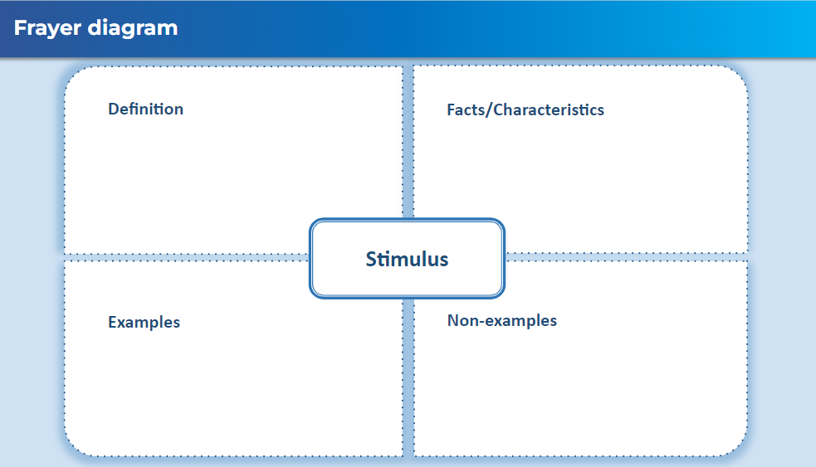

1. Identify **the observable response of your body to the exercise** stimulus**.**

|  |
| --- |
|  |

1. What changes do you observe in heart rate as exercise intensity increases? Explain why this happens.

|  |
| --- |
|  |

1. Relate the observed responses to exercise to homeostasis in the body.

|  |
| --- |
|  |

## Interpreting data about sweating and temperature

### Teacher information

This activity uses a slow reveal graph to engage students in interpreting information in graphical representations. It releases information one step at a time so the students can interpret the new information each time.

When using slow reveal graphs, focus on:

* What type of data does the graph show?
* What new information is shown in each step?
* How does the additional information revealed sequentially help us understand the data?

More information on slow reveal graphs can be found at [Slow Reveal Graphs](https://slowrevealgraphs.com/introduction/).

1. Display the ‘1.3 Slow reveal graph’ slide in the **DIS PPT**. Use the speaker notes to unpack each reveal individually with the class. Sample questions and answers have been included in the notes section of the slides.
2. Provide the students with the Student resource – interpreting data about sweating and temperature.
3. Students use their understanding of the graph to respond to the questions in the student resource. Work with students to draw relationships between the results of the 3 variables (internal body temperature, skin temperature and rate of sweating) and explain the result with reference to information about the room temperature, drinking the iced water at the 25-minute mark (indicated by the vertical dotted line) and homeostasis.
4. Discuss the responses as a class. Sample responses have been provided below.

**Sample responses for the student resource – interpreting data about sweating and temperature**

1. Describe the experiment's results, using the evidence from the data in the graph to support your response. Refer to each variable in your response.

|  |
| --- |
| The graph depicts changes in internal body temperature, skin temperature and sweat rate over time. The internal body temperature was initially stable at around 37.6°C, the skin temperature was stable at the lower temperature of 36.8°C, and the sweating rate was stable at 4 arbitrary units. The 3 variables changed within 5 minutes of drinking the iced water. Over 10 minutes, the internal body temperature and rate of sweating dropped by 0.6°C and 2.4 arbitrary units, respectively. On the other hand, the skin temperature rose by 0.8°C over a slightly longer period. Between 15 and 20 minutes after the person drank the water, the internal body temperature, sweating rate and skin temperature returned to their levels before the cold drink. |

1. Describe the impact of drinking a large amount of iced water on the variables represented in the graph.

|  |
| --- |
| The internal body temperature and rate of sweating both decreased after drinking the water, whereas the skin temperature increased. |

1. Using your understanding of homeostasis, explain why the rate of sweating reduced after drinking the iced water.

|  |
| --- |
| Drinking ice-cold water lowered the internal body temperature of the person. Sweating is the body’s response to lower the body’s temperature. Since the ice-cold water cooled the body, sweating was no longer required, so the rate of sweating decreased. |

1. Why do the 3 variables return to their original stable conditions?

|  |
| --- |
| The body must maintain its internal temperature within a certain range to survive. Due to homeostasis, the body’s internal temperature quickly returned to normal (from 37°C to 37.6°C) after the cold drink. Once the core body temperature was restored, sweating resumed. This is because the man continued to stay in the hot room, and sweating helped the body to keep the core body temperature stable. Also, as a result of the sweating, the skin temperature returned to its normal level (36.8oC). |

**Checkpoint (DIS PPT):** ask students the following questions and discuss them as a class.

* + - 1. Distinguish between stimulus and response.
      2. Outline the importance of an organism responding to stimuli in both its internal and external environment.

**Sample response:**

A stimulus is a change in an organism's internal or external environment that triggers a response, while a response is the organism’s reaction to the stimulus. The stimulus is the incoming information that an organism detects, such as changes in temperature. The response is the outgoing action the organism does in response to the stimulus, such as changing heart rate.

* + - 1. An organism's ability to respond to stimuli is important for survival because it helps organisms maintain balance in changing conditions such as temperature and light. It also allows them to respond to stimuli such as the presence of a predator to avoid danger.

### Student resource – interpreting data about sweating and temperature

This graph shows the results of an experiment to investigate temperature control in the human body. In this experiment, a person stayed in a room kept at a steady 45°C. After 25 minutes in the room, the subject drank a large amount of iced water. Scientists tracked the internal body temperature, skin temperature, and rate of sweating of the person, and the results can be seen in the graph.

Figure 1 – change in body temperature, rate of sweating and skin temperature over time

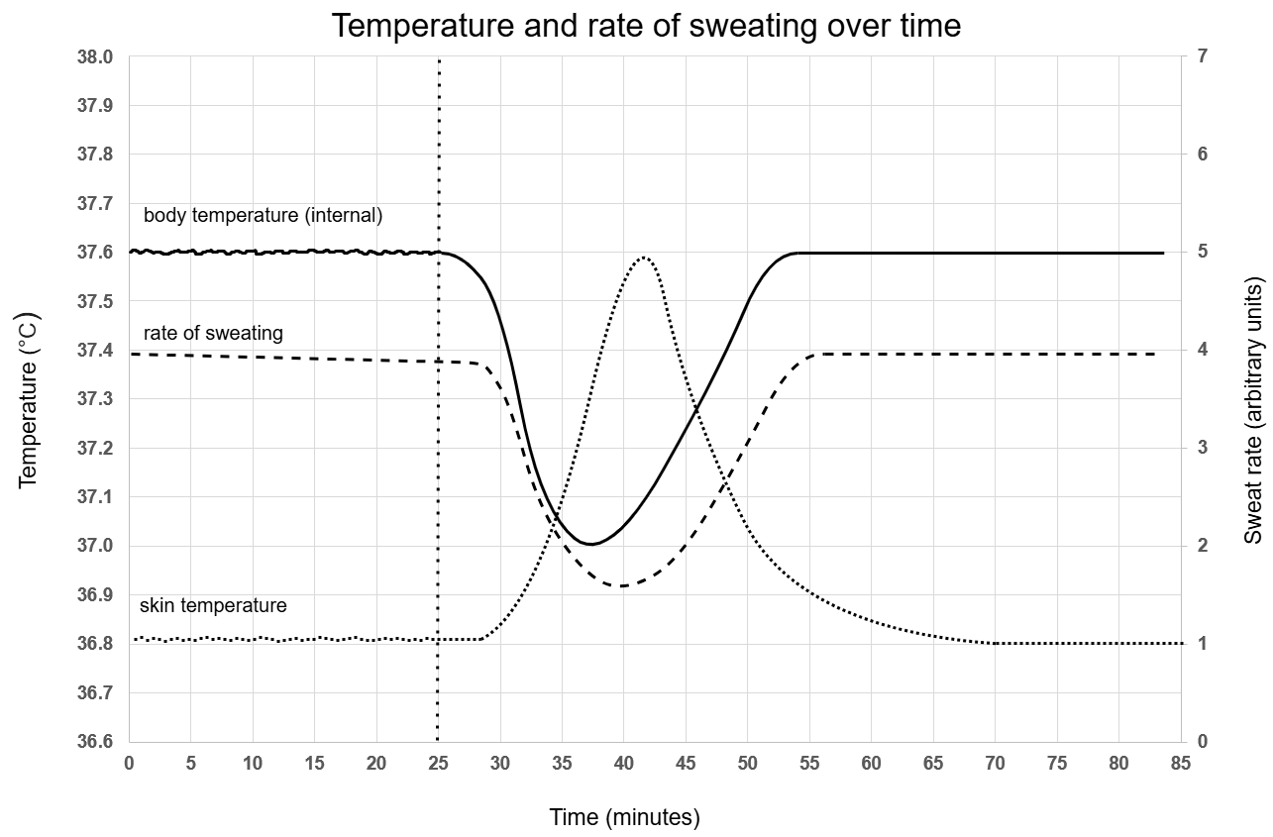

Created by author using Microsoft Excel and draw.io. Adapted from [Practical Biology](https://practicalbiology.org/control-and-communication/homeostasis/interpreting-information-about-sweating-and-temperature) and reproduced with permission of the Royal Society of Biology and the Nuffield Foundation.

1. Describe the experiment's results, using the evidence from the data in the graph to support your response. Refer to each variable in your response.

|  |
| --- |
|  |

1. Describe the impact of drinking a large amount of iced water on the variables represented in the graph.

|  |
| --- |
|  |

1. Using your understanding of homeostasis, explain why the rate of sweating reduced after drinking the iced water.

|  |
| --- |
|  |

1. Why do the 3 variables return to their original stable conditions?

|  |
| --- |
|  |

# 1.4 Feedback mechanisms

Table 7 – learning intentions and success criteria for 1.4 feedback mechanisms

|  |  |
| --- | --- |
| Learning intentions | Success criteria |
| **We are learning:**   * **about the role of negative feedback loops in maintaining homeostasis.** | I can:   * define negative and positive feedback loops * outline examples of negative and positive feedback loops * describe how negative and positive feedback loops relate to homeostasis |
| * **to synthesise data and information to form an evidence-based argument.** | * combine data from the heart rate activity and information from the video to establish evidence-based reasoning for regulating internal body temperature as a negative feedback loop. |

## The role of feedback loops

### Teacher information

Display slide ‘1.4 The role of feedback loops’ in the **DIS PPT**. Read through the questions that students will respond to and then watch [Homeostasis and Negative/Positive feedback (6:23)](https://www.youtube.com/watch?v=Iz0Q9nTZCw4). Students will extract and summarise key points to answer the questions on the slide. Sample answers to these questions are provided.

Display slide ‘1.4 What makes you say that?’ in the **DIS PPT**. Using information collected from the video activity, identify whether the regulation of internal body temperature in the heart rate activity would be classified as a negative or positive feedback loop. Using the ['What Makes You Say That?’ thinking routine](https://pz.harvard.edu/sites/default/files/What%20Makes%20You%20Say%20That_2.pdf), establish evidence-based reasoning for student thinking as a class.

Show students slide ‘1.4 Body temperature feedback loop’ in the **DIS PPT**. Ask them to use this information to further support their reasoning for why internal body temperature regulation is a negative feedback loop.

**Differentiation**: to extend students, ask them to construct a negative feedback loop for changes in internal body temperature if they were above and below the normal internal body temperature range.

**Sample answers**

1. Identify factors in the body that are maintained within a certain range.

|  |
| --- |
| The body regulates many things, including blood pH, blood glucose, and internal body temperature. |

1. Define negative feedback and provide an example.

|  |
| --- |
| Negative feedback counteracts the effect of a stimulus to return the variable to a set point. For example, the body’s thermoreceptors act as sensors detecting increased heat, which will send a signal to the brain. The brain then sends signals to counteract the increase in temperature: Sweat glands start to release sweat; the blood vessels dilate to help remove heat from the body. These responses allow the body to cool back to the set point.  **Note**: the example used may vary as the video provides multiple examples. |

1. Define positive feedback and provide an example.

|  |
| --- |
| Positive feedback occurs when a stimulus amplifies the response (‘More, more, more’ in the video). For example, during childbirth, pressure on the cervix by the baby causes the release of hormones which cause contractions. This increases the pressure, which in turn triggers the release of more hormones and contractions until the baby is born. |

1. Describe how positive and negative feedback loops relate to homeostasis.

|  |
| --- |
| Negative feedback loops are critical for maintaining homeostasis as they work to stabilise variables such as internal body temperature, blood pH, and blood glucose.  Positive feedback loops are not directly related to homeostasis, but do play important roles in various processes in the human body, |

**Checkpoint:** provide the Student resource – feedback loop checkpoint to students. Students independently interpret the feedback loop and answer the questions. Facilitate a class discussion for students to check their responses and make any adjustments. The feedback loop used in the checkpoint has been added to the **DIS PPT** to support teachers in facilitating class discussions.

**Checkpoint sample response**

1. **Identify whether this is a positive or negative feedback loop. Give a reason to support your answer.**

|  |
| --- |
| This is a negative feedback loop. When blood glucose levels rise, insulin is released to lower them, and when blood glucose levels fall, glucagon is released to raise them. The loop restores balance by counteracting changes in blood sugar levels, returning them to a stable state. |

1. **Outline the role of this feedback loop in maintaining homeostasis in relation to blood sugar (glucose) levels.**

|  |
| --- |
| This feedback loop plays an important role in keeping blood sugar levels stable, or in homeostasis. When blood sugar rises, such as after eating, the pancreas releases insulin into the bloodstream. As the circulatory system distributes insulin throughout the body, the liver and body cells absorb sugar, thereby reducing blood sugar levels. Conversely, when blood sugar drops, glucagon is released, which tells the liver to release stored glucose, bringing blood levels back up. This cycle ensures that glucose levels stay balanced around a set point to maintain homeostasis. |

1. **Describe the role of negative and positive feedback loops in maintaining homeostasis.**

|  |
| --- |
| Negative feedback loops are crucial for maintaining homeostasis as they work to counteract changes in conditions within optimal ranges. They detect variations from a set point and trigger a response that returns the condition to normal. Homeostatic processes in the body, such as temperature regulation, blood pressure control, and blood glucose, rely on negative feedback.  Positive feedback loops are not homeostatic because they amplify the initial stimulus rather than reversing it, which can lead to an intensified response. Positive feedback loops are important for life, such as blood clotting and childbirth. In blood clotting, when a blood vessel is injured, chemicals are released that attract parts of your blood to form a clot. This quick, intensified response prevents excessive blood loss, which is crucial for maintaining internal balance. Once the clot forms, the process stops. |

**Note:** homeostasis is related to maintaining stable internal conditions despite external changes. Since the positive feedback loop’s purpose is not to restore balance but to accelerate a process to completion, it is not considered to be a homeostatic process.

### Student resource – feedback loop checkpoint

Interpret the feedback loop in Figure 1 and answer the questions below.

Figure 1 – a feedback loop for blood glucose

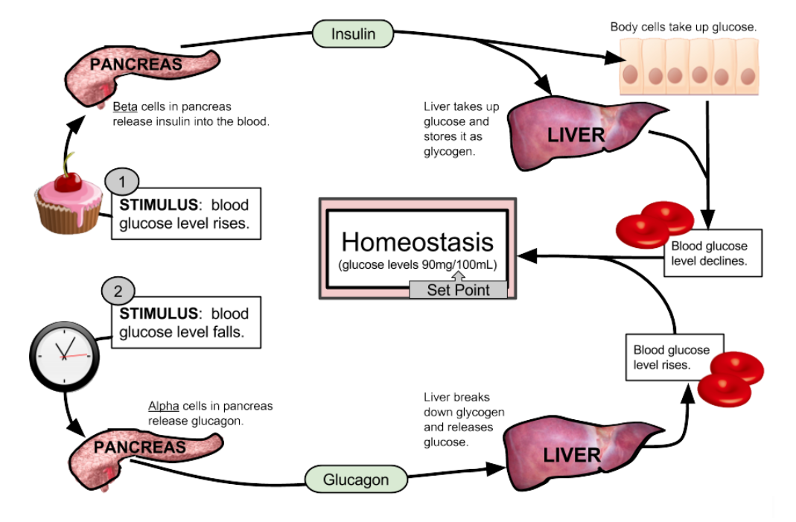

[Feedback loop for blood sugar](https://bio.libretexts.org/Learning_Objects/Worksheets/Book%3A_The_Biology_Corner_(Worksheets)/Anatomy_Worksheets/Feedback_Loops%3A_Glucose_and_Glucagon) by Shannon Muskopf from [LibreTexts Biology](https://bio.libretexts.org/) is licensed under [CC BY-NC-SA 4.0](https://creativecommons.org/licenses/by-nc-sa/4.0/).

**Vocabulary**

**Glucagon:** a chemical messenger that raises blood sugar when it is low.

**Glucose:** the main type of sugar in the blood.

**Glycogen:** the stored form of glucose that is made up of many connected glucose molecules.

1. Identify whether this is a positive or negative feedback loop. Give a reason to support your answer.

|  |
| --- |
|  |

1. Outline the role of this feedback loop in maintaining homeostasis in relation to blood sugar (glucose) levels.

|  |
| --- |
|  |

1. Describe the role of negative and positive feedback loops in maintaining homeostasis.

|  |
| --- |
|  |

# 1.5 Coordinating the response to stimuli

Table 8 – learning intentions and success criteria for 1.5 Coordinating the response to stimuli

|  |  |
| --- | --- |
| Learning intentions | Success criteria |
| **We are learning:**   * **to describe how the response to stimuli in the body is coordinated so that we can explain how it responds to changes and maintains homeostasis** | I can:   * identify that the human body’s responses are coordinated by the nervous and endocrine systems * describe how the nervous and endocrine systems coordinate responses to stimuli |
| * **how to process information from secondary sources** | * identify key points in a text using given questions * summarise key points in my own words to answer questions |
| * **to create written texts to communicate findings from a scientific investigation.** | * construct a discussion for the experiment using guiding questions * construct an evidence-based conclusion for the experiment using claim-evidence-reasoning. |

## Structure and function of the endocrine system (secondary-source investigation)

### Teacher information

**Teacher background information** that may be useful pre-reading to facilitate this activity includes [Stage 5 Reading – Literal comprehension](https://education.nsw.gov.au/teaching-and-learning/curriculum/literacy-and-numeracy/teaching-and-learning-resources/literacy/teaching-strategies/stage-5/reading/stage-5-literal-comprehension) and [Comprehension -Summarising (PDF 83 KB)](https://cer.schools.nsw.gov.au/content/dam/doe/sws/schools/c/cer/localcontent/summarising_.pdf).

1. Determine students' prior knowledge with a class brainstorming activity about hormones (**DIS PPT** slide ‘1.5 Brainstorm’).
2. Tell students the importance of engaging with written texts to extract relevant information in a range of contexts and then summarising this information into their own words. This activity will focus on extracting key points from the [Endocrine System text](https://my.clevelandclinic.org/health/body/21201-endocrine-system) using [literal comprehension](https://education.nsw.gov.au/teaching-and-learning/curriculum/literacy-and-numeracy/teaching-and-learning-resources/literacy/teaching-strategies/stage-5/reading/stage-5-literal-comprehension).
3. Show slide ‘1.5 Extracting key points’ (**DIS PPT**). Ask students the questions in the **DIS PPT** about extracting key points. Sample answers and prompts are provided in the speaker notes.

**Note**: this will show whether students understand a key point and how to identify key points in a text.

1. Show slide ‘1.5 Endocrine system’ **(DIS PPT)**. Students write the endocrine system questions in their book.
2. Provide the [Endocrine System text](https://my.clevelandclinic.org/health/body/21201-endocrine-system) to students and explicitly teach them how to scan a text. Model identifying keywords with a highlighter and how to locate and interpret information by navigating the text using graphics, headings and subheadings for the first question in the **DIS PPT** (slide 1.5 Endocrine system ‘(a) Define endocrine system’).
3. Explicitly teach students how to summarise, using the identified key points to respond to the first question and define the endocrine system in their own words. Sample answers have been provided in slide speaker notes.

**Differentiation:** give students a cloze passage with a word bank to support them in constructing responses using the summarised information from the text (**DIS PPT** slide ‘1.5 Endocrine system cloze passage’).

1. As a class, employ the scanning method to highlight specific information and keywords in the text to answer the second question, which is to define ‘hormone’. Emphasise that information needs to be summarised in their own words, not copied word for word from the text.
2. Students should attempt to independently complete the same process for the last question, outlining the endocrine system's function. If students are not confident, this may need to be completed as a class.
3. Slide ‘1.5 Endocrine cloze passage’ (**DIS PPT**) can be used as sample answers for the questions.

**Note:** inform students that when summarising key points from a text, interpretations of what the text is saying should not be made. Do not add details that are not in the text.

**Checkpoint: hinge question (DIS PPT)**

**Which of the following correctly describes the primary role of the endocrine system?**

1. It uses electrical signals to control body processes.
2. It uses hormones to regulate processes such as growth, metabolism and mood.
3. It helps the body respond to stimuli with quick reactions.

The checkpoint question would be best set up in a digital form so that the student responses can be analysed quickly. The form could also be set up to give students instant feedback. The question has also been provided on slide 1.5 Checkpoint: hinge question in the **DIS PPT**.

Table 9 – explanation of the understanding and misconceptions students may have based on their response to the hinge question

|  |  |
| --- | --- |
| Response | Explanation |
| A | The student may have the endocrine system confused with the nervous system, which is also a regulatory system. However, although they both function in regulation, the endocrine system uses chemical signalling (hormones produced by glands) while the nervous system uses electrical impulses. |
| B | This is the correct answer. |
| C | The student may have the endocrine system confused with the nervous system, which is also a regulatory system. However, although they both function in regulation, signal transmission in the endocrine system is slower than in the nervous system. This is because hormones must travel through the bloodstream, but the responses tend to last longer. The nervous system is faster due to the interconnected neurons eliciting much quicker responses. |

## Observing the body’s response to stimuli (practical investigation)

### Teacher information

Order the following equipment for each pair of students for this activity:

* 1 × 30 cm ruler
* 1 × blindfold (or anything that can be used as a blindfold)
* 1 × laptop (to graph their data on Microsoft Excel)

1. Read through the inquiry question, aim, equipment list and procedure with students (in the Student resource – the body’s response to stimuli). An image of the experiment setup is provided in the **DIS PPT** slide ‘1.5 Observing the body’s response to stimuli experiment set up’. Discuss any potential risks and control measures.
2. Recall how to construct a quality table. Students construct a table to collect their data and then provide peer feedback using the quality criteria to improve it (slide ‘1.5 Quality criteria: Drawing a table’ **DIS PPT**). The **DIS PPT** has an annotated version of the completed table (slide ‘1.5 Table for stimulus investigation’).

**Differentiation:** varied levels of scaffolding can be provided to students to support them in drawing tables (**DIS PPT** slide ‘1.5 Table scaffold 1–3’).

1. Inform students that they will only conduct the practical investigation once in pairs. They will collate data from other students to complete their table after the practical activity.
2. Students conduct the experiment in the Student resource – the body’s response to stimuli and record all data in the table.
3. Work with students to identify any potential errors indicated by inconsistencies in the data collected from this experiment. As a class, discuss errors that may have occurred. Possible reasons could be:

* The participant may have been distracted during trials, leading to delayed reaction times.
* The participant may have misjudged the timing or position of the ruler due to coordination or not paying attention.
* A change in lighting or background noise may have affected the person’s ability to react quickly.
* The way the ruler was dropped (for example, slight differences in initial positioning or release method) can influence the reaction.
* There may have been errors in measuring the catch mark.
* There may be variability in hand-eye coordination.

1. Teach students to graph in Microsoft Excel using instructions in slide ‘1.5 Graphing in Excel’ **(DIS PPT)**. Students should do this activity along with the teacher. Students paste the graph into their report (Student resource – the body’s response to stimuli).
2. Teach students how to write a discussion that addresses the following points:

* Discuss the comparative speed of reaction as measured by the catch mark for each stimulus. Outline causes for the differences in reaction time between different types of stimuli.
* Discuss the reliability of the results and suggest relevant improvements.
* Consider the validity of the experiment and suggest any relevant improvements.
* Propose any further experiments or research that could build on your findings.

1. To address the inquiry question by drawing an evidence-based conclusion, use [Claim-Evidence-Reasoning](https://app.education.nsw.gov.au/digital-learning-selector/LearningActivity/Card/664?clearCache=58d820c9-8a63-cc6b-9335-254f9ebe8453) (C-E-R) to teach students how to draw conclusions using evidence explicitly. The scaffold for C-E-R has also been provided in the **DIS PPT** slide ‘1.5 Drawing a conclusion: C-E-R’)and is intended to be worked through as a class. Language resources to support students in creating a conclusion using C-E-R can be seen below.

The Claim-Evidence-Reasoning (C-E-R) model can be used to develop a conclusion.

Use the language resources in Table 10 to teach students how to express cause and effect, showing students how this language assists students to express causal relationships in the discussion and conclusion. Demonstrate using some of these language resources in sample sentences so students can apply the learning in their own discussion. Further information to assist in teaching this can be found at [Connecting ideas](https://education.nsw.gov.au/teaching-and-learning/curriculum/literacy-and-numeracy/teaching-and-learning-resources/literacy/teaching-strategies/stage-5/reading/stage-5-connecting-ideas).

Table 10 – language resources for expressing causal relationships

|  |  |
| --- | --- |
| Language resources | Examples |
| Causal conjunctions | Conjunctions that join clauses to make sentences: because, so, since, as, since, hence, consequently …  Conjunctions that join sentences and paragraphs: Therefore, Thus, As a result, As a consequence … |
| Causal processes | results in, leads to, causes, produces, resulting in … |
| Causal prepositions | because of, due to … |
| Causal nominals | cause, reason, factor effect, consequence, outcome, product … |

1. Use the completed C-E-R scaffold in the **DIS PPT** to teach students to write a conclusion. A sample conclusion has been provided in the **DIS PPT** slide ‘1.5 From C-E-R scaffold to a conclusion’). Go through the sample conclusion and identify language that indicates causal relationships using Table 10.
2. Teach students that the nervous system coordinates the response to the different stimuli, resulting in a quick and precise response. Outline that the nervous system works quickly and efficiently to coordinate the body’s response to stimuli, allowing precise actions like catching a ruler. Whether the stimulus is something that can be seen (visual), heard (auditory), or felt (tactile), the body’s goal is the same: to react quickly to catch the ruler. The speed at which the nervous system processes these signals is remarkable.

**Sample student response for scientific report components**

The **DIS PPT** slide ‘1.5 Table for stimulus investigation (annotated)’ provides a sample results table for the investigation. A sample graph of the mean result for the investigation can be found in the **DIS PPT** slide ‘1.5 Graphing in Excel Step 5’.

|  |
| --- |
| Based on the data collected, it was observed that the average reaction time indicated by the catch mark varied significantly across the 3 types of stimuli. The tactile stimulus consistently resulted in the shortest catch distance, with an average of 10 cm, indicating the fastest reaction time. In comparison, the auditory stimulus led to a slightly slower reaction, with an average catch distance of 12 cm. In contrast, the visual stimulus produced the slowest reaction, with an average catch distance of 16 cm.  The differences in catch marks and, thus, reaction time could be due to how the brain processes information from different types of stimuli. Tactile (touch) stimuli are processed very quickly because when you feel something, the sensors in your skin send signals directly to your muscles, allowing you to react almost instantly. This is why the reaction to touch is usually the fastest. Auditory stimuli require the brain to process sound before telling your muscles to respond. This extra step of processing the sound takes more time, so reactions to sound are generally slower than reactions to touch. Visual stimuli involve even more processing as the brain interprets the visual signal before coordinating a motor response. This explains why the visual stimulus resulted in the slowest reaction time.  The results were reliable (precise), as the experiment was repeated 5 times for each stimulus type, with similar data collected. For example, the variation between trial data was only 0.1 cm on average. Improvements in internal reliability could include using a larger sample size of participants to account for individual differences. The experiment did not achieve external reliability. While the data within the sample group was consistent, the results may not represent the broad population. Factors such as individual differences in reaction times, age or distractions could vary significantly between different groups of participants. Although the method is detailed enough to be followed by other people, to achieve external reliability the experiment would need to be repeated in different settings, with different participants using the same experiment procedures to attain similar or the same outcomes.  The experiment was valid as the independent variable (type of stimulus: tactile, auditory or visual) and the dependent variable (distance caught on the ruler to indicate reaction speed) were directly relevant to the aim of determining how stimulus type affects reaction speed. Using a ruler to measure the distance caught provided a simple and appropriate way to assess reaction time, aligning the measurements with the aim of the study. Although the experiment involved different participants, each trial used the same procedure to ensure consistency. Variables, such as the environment the investigation was conducted in, the type of ruler, the starting point on the ruler, and how the ruler was held were controlled. However, controlling environmental factors such as distractions could further enhance validity.  Further research could explore additional variables, such as the effect of fatigue or age on reaction time, or compare the reaction speed to more complex stimuli, like combining visual and auditory cues. This would build on the findings of the current experiment and offer more insights into the factors influencing human reaction speed. |

A sample conclusion has been provided in the **DIS PPT** slide ‘1.5 Drawing a conclusion: C-E-R scaffold’, and slide ‘1.5 from C-E-R scaffold to a conclusion’.

### Student resource – the body’s response to stimuli

**Inquiry question**: How does the stimulus type affect the reaction speed, measured by the distance caught on a ruler?

|  |  |
| --- | --- |
| **Aim:** to determine the impact of stimulus type (tactile, auditory or visual) on the distance caught on a ruler.  **Equipment:**   * **1 × 30 cm ruler** * **1 × blindfold** | Figure 1 – ruler setup  A hand holding a ruler over the edge of a table.  **Source:** This work has been generated using [BioRender.com](https://www.biorender.com/). Any copyright subsisting in this work is owned by © State of New South Wales (Department of Education) 2024. |

**Procedure**

**Part 1 – visual stimulus**

1. **Have a partner sit at a table with their dominant hand over the edge, as shown in Figure 1.**
2. Hold the ruler at the 30 cm mark so the 0 cm end is at your partner's index finger. Your partner should put their hand at the bottom of the ruler and be ready to grab the ruler (however, they should not be touching it).
3. Inform your partner that they must grab the ruler as quickly as possible once it has been released.
4. Without making any sounds or gestures, you will drop the ruler so your partner can respond to the visual stimulus of seeing the ruler being released.
5. Record the centimetre mark in the table, then swap partners to repeat the experiment.

**Part 2 – auditory stimulus**

1. **Have a partner sit at a table with their dominant hand over the edge, as shown in Figure 1. Place a blindfold over their eyes.**
2. **Hold the ruler at the 30 cm mark so that the 0 cm end is at your partner's index finger.**
3. **Tell your partner that you will say the word ‘drop’ as you release the ruler, and they need to grab it as quickly as possible.**
4. **Record the centimetre mark in the table, then swap partners to repeat the experiment.**

**Part 3 – tactile stimulus**

1. **Have a partner sit at a table with their dominant hand over the edge, as shown in Figure 1. Place a blindfold over their eyes.**
2. **Hold the ruler at the 30 cm mark so the 0 cm end is at your partner's index finger.**
3. **Tell your partner that you will tap the shoulder connected to their non-dominant hand to indicate that you will release the ruler, and they need to grab it as quickly as possible.**
4. **Record the centimetre mark in the table, then swap partners to repeat the experiment.**

**Results**

Construct a suitable table to record the results of the investigation.

Paste a copy of your graph from Excel.

**Discussion**

|  |
| --- |
|  |

**Conclusion**

|  |
| --- |
|  |

## Structure and function of the nervous system (secondary-source investigation)

### Teacher information

**Note:** this activity applies skills learned in the earlier activity on the endocrine system ‘Structure and function of the endocrine system (secondary-source investigation)’. Use principles of [gradual release of responsibility](https://education.nsw.gov.au/teaching-and-learning/curriculum/explicit-teaching/explicit-teaching-strategies/gradual-release-of-responsibility) to determine the best mode of delivery for this lesson.

1. Show the **DIS PPT** slide ‘1.5 The nervous system’. Define the nervous system and describe the general structure of the nervous system.
2. To complete the [jigsaw activity](https://app.education.nsw.gov.au/digital-learning-selector/LearningActivity/Card/546?clearCache=32984b90-e263-ce03-ed9d-6263a4cb4758), randomly put students into groups of 4 (this is their home group). Slide ‘1.5 Jigsaw: home group organisation’ (**DIS PPT) contains a slide to facilitate grouping (this is based on a class of 28 students, so adjust the number of expert groups according to the class size).** Each group selects a presentation style, such as an A4 poster or a 4-slide presentation. One student in each group is allocated one of the sections outlined in slide ‘1.5 Jigsaw: expert group organisation’ (**DIS PPT).**
3. Students move to expert groups (one student from each home group will be in each expert group.
4. Hand out the Student resource – jigsaw text, 2 per expert group.

**Note**: all the information is provided in one handout. The purpose of this is for students to practise skills learned about literal comprehension from the previous activity Structure and function of the endocrine system (secondary-source investigation), such as scanning to extract the required information.

1. Students are to work with their expert group to extract and summarise information for their component of the activity. The individual student should then structure the information according to the home group's agreed presentation style. Students should use relevant images to support the explanation of their component. Inform students that there will be some overlap of information in some areas. They must bring it all together when they complete the ‘jigsaw’.

**Note:** the text provided contains more information than each group requires. This may be a good opportunity to see how well students can use their allocated component to select, extract and summarise relevant information from a text.

1. **Once students have completed their component and product in their presentation style, they join the home groups they started in.**
2. In home groups, students take turns to share their knowledge with their peers. If students have completed the work digitally, they should combine the sections and embed it in their digital workbook.
3. Ask students probing questions to clarify their thinking and ascertain how well students understand the concepts. Sample student responses are outlined below. Re-teach any concepts that students may not have understood.

**Sample probing questions and sample responses**

|  |
| --- |
| **What are the 2 main parts of the nervous system? What are they composed of?**   * The nervous system is structured into 2 main parts: the central nervous system (CNS) and the peripheral nervous system (PNS). * The CNS is made up of the brain and spinal cord. * The brain, located in the skull, is the body's control centre, responsible for processing information and making decisions. * The spinal cord extends from the brainstem down the back, serving as a pathway for signals between the brain and the rest of the body and managing some reflexes directly. * The PNS comprises all the nerves that branch out from the CNS to various parts of the body. * The PNS includes sensory neurons that carry signals from sensory receptors to the CNS and motor neurons that transmit commands from the CNS to muscles and glands.   **What is the function of the central nervous system?**   * **Central nervous system (CNS):** the central nervous system is the primary control centre of the body. * The brain processes and interprets sensory information, makes decisions, and coordinates functions such as thinking, memory and emotional responses. * The brain manages essential involuntary functions like breathing and heart rate through the brainstem. * The spinal cord acts as a communication highway, relaying signals between the brain and the rest of the body. * The spinal cord transmits sensory information from the body to the brain and motor commands from the brain to muscles and glands. * Additionally, the spinal cord can manage some reflexes independently of the brain, allowing quicker responses.   **What is the function of the peripheral nervous system?**   * **Peripheral Nervous System (PNS):** the peripheral nervous system encompasses all the nerves outside the central nervous system and includes both sensory and motor neurons. * Sensory neurons detect external stimuli, such as touch and light, and internal conditions, like pain and temperature, sending this information to the CNS for processing. * Motor neurons carry commands from the CNS to muscles and glands, resulting in voluntary and involuntary movements. * The PNS also includes the autonomic nervous system, which regulates automatic functions like digestion and heart rate. * The autonomic nervous system is divided into the sympathetic nervous system, which prepares the body for stress or emergency responses, and the parasympathetic nervous system, which promotes relaxation and maintenance functions.   **What is a stimulus-response pathway? Use the ruler drop and heart rate experiments as an example.**   * **The** **stimulus-response pathway outlines how the nervous system processes and responds to external stimuli.** * In this pathway, sensory receptors (for example, in the skin) detect a stimulus, such as a ruler falling. * These receptors send electrical impulses to the central nervous system (CNS) through sensory neurons. * The CNS processes this information and formulates a response. * In the catching a ruler activity, the CNS quickly interprets the visual and tactile stimuli of the ruler falling and sends a motor command through motor neurons to the muscles in the hand to catch the ruler. * In the heart rate activity, receptors in the body detect a stimulus such as physical exertion from exercise. The CNS processes this information and adjusts the heart rate by sending messages to the heart via motor neurons to increase or decrease the rate as needed.   **Why is a reflex arc important?**   * It is very fast because it only transmits the signal through the spine instead of the brain. * This pathway ensures that the body can respond appropriately to varying stimuli, maintaining effective and timely reactions.   **How does the nervous system coordinate the body’s response to stimuli?**   * **The nervous system coordinates the body’s response to stimuli using the reflex arc and the stimulus-response model.** * **In the stimulus-response model, sensory receptors detect a stimulus and send signals to the central nervous system (CNS), which processes the information and sends messages to effectors to respond.** * **The reflex arc provides a rapid, automatic response; for example, sensory neurons quickly send signals to the spinal cord, which then immediately instructs effectors to respond, bypassing the brain for a faster reaction.** * **These mechanisms ensure both controlled and swift responses to various stimuli.** |

1. Show slide ‘1.5 Structure and function of the nervous system’ in the **DIS PPT**. Jointly construct a response to the question using the information about the nervous system.

**Sample response**

|  |
| --- |
| **Using examples, describe how the nervous system coordinates the body’s response to different stimuli. Your response should refer to both the stimulus-response model and the reflex arc.**  The nervous system coordinates the body’s response to different stimuli through both the reflex arc and the stimulus-response model.  In the reflex arc, when you touch something hot, receptors in your skin detect the stimulus and send electrical impulses through neurons in the peripheral nervous system (PNS) to the spinal cord, which acts as a control centre. The spinal cord then immediately sends a message via motor neurons, also part of the PNS, to the muscles (effectors) to move your hand, bypassing the brain for a quick response, which is crucial for avoiding injury.  The stimulus-response model involves the central nervous system (CNS), including the brain and spinal cord, and the PNS. For example, if you engage in physical exercise, sensory receptors detect the increased demand and send signals through nerves in the PNS to the brain. The brain processes this information and sends commands through motor neurons in the PNS to the heart, adjusting the heart rate to meet the body’s needs. This model allows for more controlled and complex responses than quick reflex actions. |

**Differentiation:** provide students with key concepts and terms to include in the response to the final question (slide ‘1.5 Structure and function of the nervous system’ in the **DIS PPT**)

### Student resource – jigsaw text

#### The structure of the nervous system

The nervous system is the body’s control centre and communication network. It helps your body respond to the world around you and controls essential processes like movement, breathing and thinking. The nervous system is divided into 2 main parts:

1. **Central Nervous System (CNS)**: the brain and spinal cord process information and decide on a response.
2. **Peripheral Nervous System (PNS)**: sensory neurons detect stimuli (for example, heat and light) and send information to the CNS. Motor neurons then carry instructions from the CNS to muscles or glands.

Some responses, like pulling your hand away from a hot object, do not require the brain’s input. These are called reflexes and are controlled by the spinal cord for speed. Messages in the nervous system are electrical signals that travel along neurons. This makes the nervous system incredibly fast, often reacting in milliseconds.

Figure 1 – the major components of the nervous system

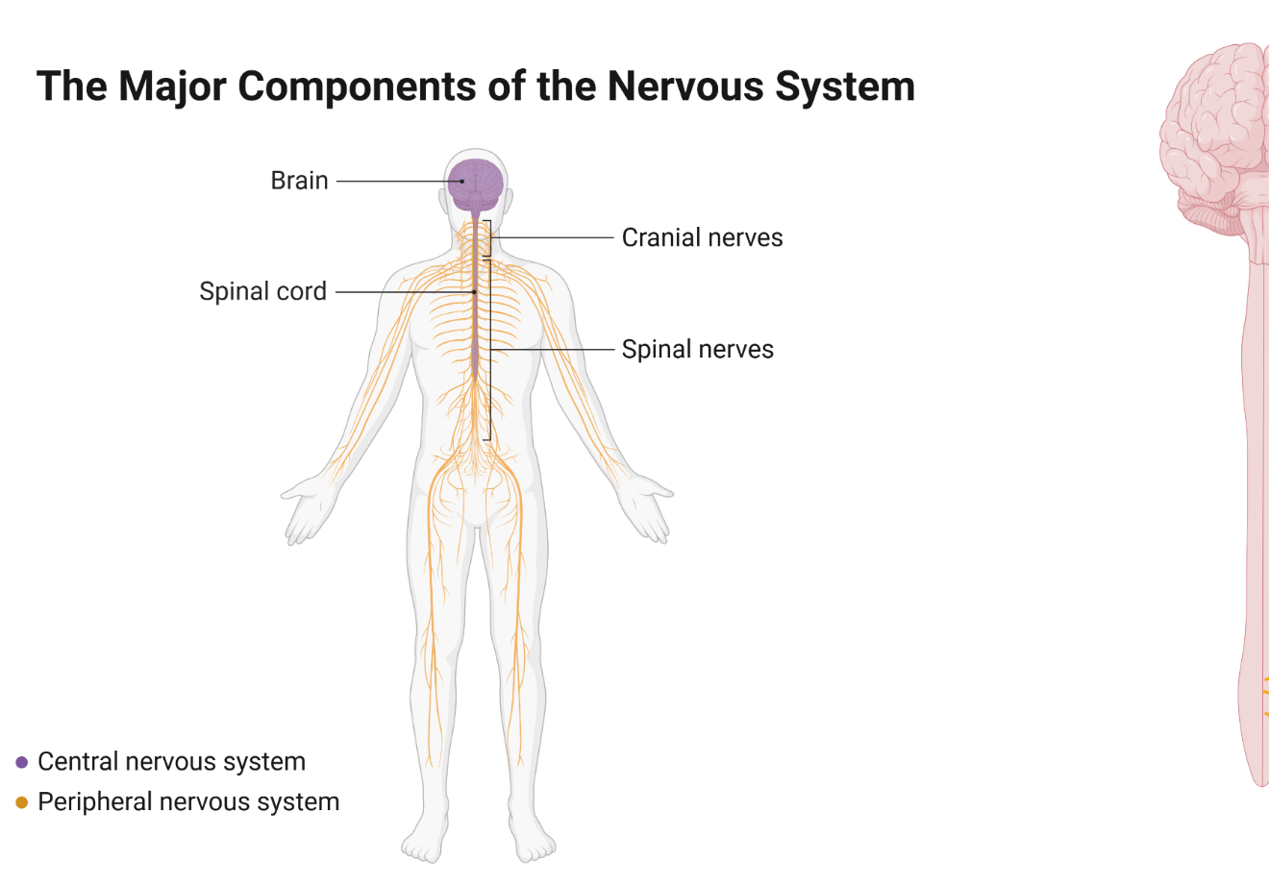

This work has been generated using [BioRender.com](https://www.biorender.com/). Any copyright subsisting in this work is owned by © State of New South Wales (Department of Education) 2024.

##### The central nervous system (CNS)

The CNS is like the ‘command centre’ of your body. It processes information and sends instructions. It consists of the following:

* **Brain**
* Cerebrum: the largest part of the brain. It controls thinking, memory, senses, and voluntary actions like walking or running.
* Cerebellum: located under the cerebrum, it helps with balance, coordination and fine motor skills.
* Brainstem: connects the brain to the spinal cord and controls automatic functions like breathing, heart rate and digestion.
* **Spinal cord**
* This is a long bundle of nerves running down your back.
* It connects the brain to the rest of your body and allows messages to travel back and forth.
* It controls reflexes which are quick automatic actions, like pulling your hand away from a hot surface.

##### The peripheral nervous system (PNS)

The PNS acts like the ‘messenger’ of the nervous system. It connects the CNS to the rest of the body and is made up of nerves. The PNS can be divided into 2 additional parts:

* Somatic Nervous System (SNS)
* Controls voluntary actions, like moving your arms or legs
* Sends sensory information (like touch, pain or temperature) from your body to the CNS
* Autonomic Nervous System (ANS)
* Controls involuntary actions, like your heartbeat, breathing and digestion
* Divided into
* Sympathetic Nervous System: prepares your body for ‘fight or flight’ during stress (for example, increased heart rate)
* Parasympathetic Nervous System: helps your body ‘rest and digest’ by slowing down processes when you relax.

#### Stimulus-response pathway

The stimulus-response pathway is vital in enabling the body to detect and respond to internal and external environmental changes, ensuring appropriate and timely reactions. It serves as a framework for how the nervous system processes stimuli and coordinates responses through a series of well-defined steps.

Figure 2 – the stimulus-response pathway

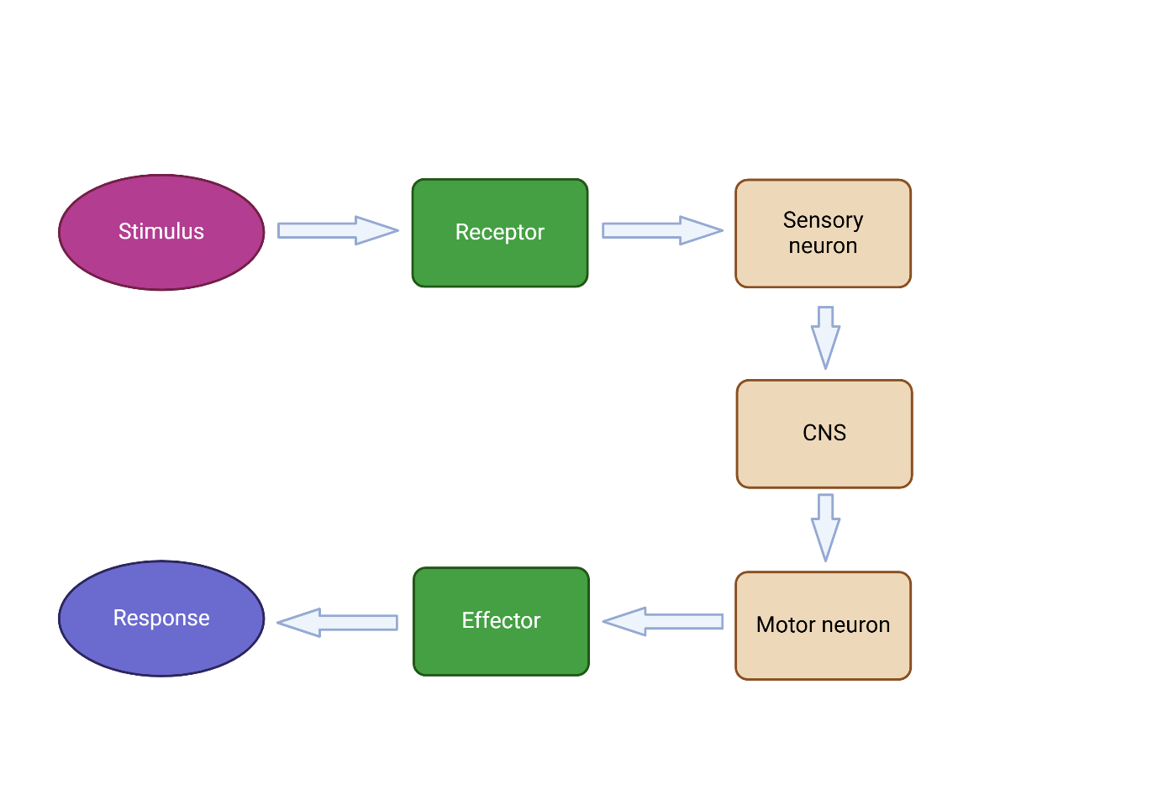

This work has been generated using [BioRender.com](https://www.biorender.com/). Any copyright subsisting in this work is owned by © State of New South Wales (Department of Education) 2024.

##### Receptors

Receptors are specialised cells or structures that detect specific stimuli. They are found in sensory organs and tissues throughout the body.

Table 1 – examples of receptors and the stimulus that they detect

|  |  |  |
| --- | --- | --- |
| Receptor | Stimulus detected | Location |
| Photoreceptors | Light | The retina of the eye |
| Mechanoreceptors | Pressure, vibration, touch, stretch, sound waves | Skin, inner ear, joints and muscles |
| Thermoreceptors | Temperature changes | Skin and hypothalamus |
| Chemoreceptors | Chemicals (smell, taste, blood pH) | Nose, tongue and carotid bodies |

##### Neurons

Neurons, also known as nerve cells, are the fundamental building blocks of the nervous system. They are specialised cells designed to transmit information throughout the body.

Figure 3 – the anatomy of a neuron (nerve cell)

A diagram of a neuron. The diagram identifies dendrites, soma, nucleus, Axon (including Node of Ranvier, Schwann cell, Myelin sheath, and Axon terminals.
An arrow beneath the neuron shows direction of impulse.

This work has been generated using [BioRender.com](https://www.biorender.com/). Any copyright subsisting in this work is owned by © State of New South Wales (Department of Education) 2024.

There are 3 types of neurons:

* **Sensory neurons**: carry information from sensory receptors to the central nervous system (CNS)
* **Motor neurons**: transmit signals from the CNS to the muscles or glands, enabling movement or responses
* **Interneurons**: found withing the CNS, they process information and relay signals between the sensory and motor neurons.

##### Effectors

Effectors are structures that bring about a response to a stimulus.

* **Muscles** contract to produce movement, for example
* skeletal muscles such as biceps
* cardiac muscle in the heart
* smooth muscle in the intestines.
* **Glands** secrete hormones, enzymes or other substances. For example
* salivary glands secrete saliva
* adrenal glands secrete adrenaline
* sweat glands secrete sweat.

##### Reflex arc

A reflex arc is the pathway through which a reflex action occurs. Reflex actions are automatic and rapid responses to stimuli, designed to protect the body from harm. The reflex arc involves only a few components, enabling it to bypass the brain for quicker responses.

Figure 4 – basic spinal reflex arc

A diagram of a basic spinal reflex arc. A person touches a hot cup which triggers the response of pulling the hand away.
Text reads:
1. Receptors: Respond to a stimulus (e.g. a hot cup) HOT!!!
2. Sensory neuron: Transmits a signal from the receptors in skin to an interneuron in the spine.
3. Interneuron: Transmits the signal from the sensory neuron to the motor neuron.
4. Motor neuron: Sends an electrical impulse to an effector.
5. Effectors: Produces a response (muscle contracts to move hand away).

This work has been generated using [BioRender.com](https://www.biorender.com/). Any copyright subsisting in this work is owned by © State of New South Wales (Department of Education) 2024.

#### The nervous system and homeostasis

Homeostasis is the body's ability to maintain a stable internal environment despite changes in external conditions. The nervous system plays a crucial role in homeostasis by detecting changes, processing information, and coordinating responses to keep the body’s conditions within a narrow, optimal range.

**The nervous system maintains homeostasis through a stimulus-response mechanism**

* Detection of change: sensory receptors in the body detect deviations from normal conditions (stimuli), such as changes in temperature, pH, or blood pressure.
* Signal transmission: sensory neurons send this information to the central nervous system (CNS), which processes the data.
* Processing and decision making: the CNS (brain or spinal cord) integrates the sensory input and determines the appropriate response.
* Response coordination: motor neurons carry commands from the CNS to effectors (muscles or glands) to enact the response.

**Regulating body temperature (thermoregulation)**

**Detection**: thermoreceptors in the skin and brain detect changes in body temperature.

**Processing**: the hypothalamus in the brain processes this information.

**Response**:

* If the body is too hot, motor nerves signal
* sweat glands to release sweat for cooling
* blood vessels to dilate (vasodilation), increasing heat loss.
* if the body is too cold, motor nerves signal
* muscles to shiver, generating heat
* blood vessels to constrict (vasoconstriction), conserving heat.

# 1.6 Comparing the endocrine and nervous systems

Table 11 – learning intentions and success criteria for 1.6 Comparing the endocrine and nervous systems

|  |  |
| --- | --- |
| Learning intentions | Success criteria |
| We are learning:   * to compare and contrast how the human nervous and endocrine systems respond to stimuli so we can understand their role in responding to stimuli | I can:   * identify the responses of the nervous and endocrine system to a stimulus * outline similarities and differences in the responses of the nervous and endocrine systems |
| * to create written texts to communicate scientific understanding to different audiences. | * construct a written response to an examination-style question to communicate understanding using correct and precise scientific terminology * use connectives/cohesive devices to create cohesion. |

## Preparing to write a response

### Teacher information

In this activity, students are taught how to break down a question using the Verb-Content-Focus-Singular (V-C-F-S) strategy (see slide ‘1.6 Unpacking the V-C-F-S strategy’ in the **DIS PPT**. An example of this strategy and how it is used to deconstruct a question has been provided on slide ‘1.6 Annotated example of V-C-F-S’ in the **DIS PPT**. This strategy helps students to plan their responses.

**Suggested activity structure**

1. Provide students with a copy of the Student resource – deconstructing a question.
2. Introduce students to the table in their handout, which outlines the V-C-F-S strategy for deconstructing exam-style questions and planning a response. Supporting information is provided on the slide ‘1.6 Unpacking the V-C-F-S strategy’ in the **DIS PPT.**
3. Use the V-C-F-S strategy and slide ‘1.6 Annotated example of V-C-F-S’ to model for students if and how the provided example has been appropriately deconstructed.

**Note:** tell students that when they write a response to a compare and contrast question, they should compare features that are ‘like-for-like’. An example of this is when comparing 2 people, features compared may be height (tall versus short) or hair colour (brown versus blonde). Another example is when comparing and contrasting infectious and non-infectious diseases; the features discussed could be the mode of transmission and the causes of the diseases.

1. Project the compare and contrast question on the board **(DIS PPT)**. Students should then use the V-C-F-S strategy to unpack the question in their student resource. If students require further practice, deconstruct it as a class.
2. Discuss the deconstruction of the question using V-C-F-S. Use the points below to plan a response.

* First, look at the verb(s). [Compare](https://www.nsw.gov.au/education-and-training/nesa/hsc/student-guide/glossary#C) means to show how things are similar or different. Contrast means to show how things are different or opposite, so our response needs to focus on similarities and differences.
* The content addressed in the question is about the nervous and endocrine systems, responses and stimuli. This means we will need to make statements looking at how similar and different the nervous and endocrine systems respond to stimuli.
* The focus of the question is on humans. This means we are looking at the responses of the nervous and endocrine systems to stimuli in humans.
* The question uses plural words. For example, the use of ‘and’ between nervous and endocrine and the use of an ‘s’ after systems indicate we need to talk about both types of systems in the response. The question also specifies to provide 2 similarities and 2 differences.

1. Model how to plan to write the response, considering the points above.

* Identify features of responses that can be compared in how the nervous and endocrine system respond to stimuli.
* Determine if they are similar or different (2 similarities and 2 differences are required as specified in the question).
* Write a statement for each that outlines the similarity/difference in the feature, ensuring it is linked to humans. Remember, students are comparing and contrasting ‘like-for-like’.

1. Deconstruct Sample response 1 as a class against the marking criteria (in the student resource and on the slide ‘1.6 Sample response 1’ in the **DIS PPT**), annotating how the response does and does not meet the criteria. Highlight where connectives (cohesive words) have been used to indicate similarity or difference and annotate correct and precise scientific terminology in a different colour (the teacher-annotated sample response is on the slide ‘1.6 Sample response 1 annotated’ in the **DIS PPT**).
2. Deconstruct Sample response 2 as a class against the marking criteria (in the student resource and on the slide ‘1.6 Sample response 2’ in the **DIS PPT**), annotating how the response does and does not meet the criteria. Highlight where cohesive words have been used to indicate similarity or difference. Annotate the use of correct and precise scientific terminology in a different colour (the teacher-annotated sample response is on the slide ‘1.6 Sample response 2 annotated’ in the **DIS PPT**).
3. Provide students with a list of connectives (cohesive words) for comparing and contrasting (slide ‘1.6 Comparing and contrasting cohesive words’ in the **DIS PPT**) that can be used in compare and contrast responses to highlight a similarity or difference.
4. [Jointly construct](https://schoolsnsw.sharepoint.com/sites/WiSresourcehub/SitePages/Joint-Construction.aspx) an improved response based on the feedback annotated on Sample response 2. This should be like Sample response 1 and Sample response 3 (level-up activity). Highlight where connectives (cohesive words) and correct and precise scientific terminology have been used.

**Differentiation:** level-up activity –students improve on using correct and precise scientific terminology by completing the activity outlined below.

1. Instruct students to deconstruct and annotate Sample response 3 (in the student resource and on the slide ‘1.6 Level up activity: Sample response 3’ in the **DIS PPT**) in pairs using the marking criteria. Students also annotate where they can see cohesive words that highlight similarities or differences in the responses to stimuli and highlight examples of the use of correct and precise scientific terminology. The correct and precise scientific terminology has been written in blue in the annotated response on the slide ‘1.6 Level up activity: Sample response 3 annotated’ in the **DIS PPT**.
2. Project sample response 3 on the board without the highlighted words. Ask each pair of students to come up to the board and add an annotation related to how the response meets the marking guidelines, feedback for improvement, cohesive words that indicate similarity or difference or an example of correct and precise terminology being used.
3. Ask students to compare correct and precise terminology to Sample response 1 and their constructed response. Facilitate discussion about the fact that Sample responses 1 and 3 achieve full marks. However, Sample response 3 has been ‘levelled up’ from Sample response 1 by incorporating more correct and precise scientific terminology and adding relevant examples such as growth and metabolism, demonstrating depth and specificity of understanding.

### Student resource – deconstructing a question

Deconstruct the question below using Table 1.

|  |
| --- |
| Compare and contrast how the human nervous and endocrine systems respond to stimuli. In your response, provide 2 similarities and 2 differences that highlight key features of the systems. |

Table 1 – requirements for deconstructing a question using V-C-F-S requirements for deconstructing a question using V-C-F-S

|  |  |
| --- | --- |
| Component | Criteria |
| Verb | Identify the verb(s) and the requirements of the verb.   * This helps to determine the requirements of the response. For example, is a judgment needed? (if a judgement is needed, you need to identify points for and/or against). |
| Content | * Identify the content – circle and annotate keywords that relate to what you have learned. |
| Focus | Outline the focus of the question:   * Is it related to a particular context or a stimulus? * Does the question contain a how or a why? This means you need to draw relationships between ideas. |
| Singular | Identify if words in the question are singular or plural.   * Are there words that indicate the response needs to refer to 2 or more ideas? * If the question states to give ‘examples’, the ‘s’ at the end of example indicates more than one. |

#### Planning your response

As a class, plan a response to the deconstructed question.

|  |
| --- |
|  |

#### Sample student responses to the question

Engage with the marking criteria below for the question: Compare and contrast how the human nervous and endocrine systems respond to stimuli. In your response, provide 2 similarities and 2 differences that highlight key features of the systems.

You will use it to assess sample responses and improve a sample response.

Table 2 – marking criteria for the question

|  |  |
| --- | --- |
| Marks | Criteria |
| 4 | Compares and contrasts the response of the nervous and endocrine systems to stimuli in humans by providing similarities and differences.  Constructs a cohesive written response that effectively uses connectives/cohesive words to illustrate comparison and contrast.  Effective use of correct and precise scientific terminology to provide detail and show understanding of the contribution of each system to homeostasis. |
| 3 | Compares and contrasts the response of the nervous and endocrine systems to stimuli in humans by providing a similarity and difference(s).  Constructs a written response that effectively uses connectives/cohesive words to illustrate comparison and contrast.  Use of correct scientific terminology to provide detail. |
| 2 | Compares the nervous and endocrine system responses by providing a similarity or difference OR outlines responses of the endocrine and/or nervous system in humans. |
| 1 | Outlines a response of the endocrine and/or nervous system in humans. |

Deconstruct and annotate the response below.

|  |  |
| --- | --- |
| Sample response 1 | Annotations |
| The nervous and endocrine systems receive stimuli, transmit messages, and elicit responses. They are also both systems in the human body that help maintain homeostasis. However, they do so in a different way. The nervous system sends messages as electrical impulses, resulting in a fast response, unlike the endocrine system, which uses hormones to send messages, resulting in a slower response. Responses coordinated by the nervous system are typically localised, affecting a particular part of the body. Conversely, responses coordinated by the endocrine system typically have a more widespread effect. |  |

|  |  |
| --- | --- |
| Sample response 2 | Annotations |
| The nervous system acts fast, and its response affects a particular part of the body. Both the nervous and endocrine systems respond to help keep a balance in the body. The endocrine system uses chemical messengers and has a slow response. |  |

Engage with writing skills to re-create Sample response 2 in the box below, addressing the feedback you annotated in class.

Compare and contrast how the human nervous and endocrine systems respond to stimuli. In your response, provide 2 similarities and 2 differences that highlight key features of the systems.

|  |
| --- |
|  |

#### Level-up activity

Deconstruct and annotate the response below using the marking criteria. Annotate where you can see joining words that highlight similarities or differences in the responses to stimuli. Highlight examples of the use of correct and precise scientific terminology.

|  |  |
| --- | --- |
| **Sample response 3:**  The nervous and endocrine systems are both important for how our bodies respond to stimuli, but they work in different ways. The nervous system sends electrical impulses through connected neurons, allowing us to react quickly, such as pulling our hands away from a hot surface. In contrast, the endocrine system responds more slowly by releasing hormones into the bloodstream, which take longer to reach target organs but have longer effects. The nervous system's responses are fast and specific, affecting particular parts of the body for a short time. In contrast, the endocrine system, which uses hormones to regulate processes like growth and metabolism, can influence multiple parts of the body at the same time. Both systems are essential for maintaining homeostasis and often interact to effectively coordinate the body's functions. | **Annotations:** |

# Evidence base

This resource contains NSW Curriculum and syllabus content. The NSW Curriculum is developed by the NSW Education Standards Authority. This content is prepared by NESA for and on behalf of the Crown in right of the State of New South Wales. The material is protected by Crown copyright.

Please refer to the NESA Copyright Disclaimer for more information <https://educationstandards.nsw.edu.au/wps/portal/nesa/mini-footer/copyright>.

NESA holds the only official and up-to-date versions of the NSW Curriculum and syllabus documents. Please visit the NSW Education Standards Authority (NESA) website <https://educationstandards.nsw.edu.au> and the NSW Curriculum website <https://curriculum.nsw.edu.au>.

[Science 7–10 Syllabus](https://curriculum.nsw.edu.au/learning-areas/science/science-7-10-2023/overview) © NSW Education Standards Authority (NESA) for and on behalf of the Crown in right of the State of New South Wales, 2023.

Backyard Brains (n.d.) [*Reaction Times: Clock the Inner Workings of the Brain*](https://backyardbrains.com/experiments/reactiontime), Backyard Brains website, accessed 2 June 2024.

Brookhart SM (2018) ‘[Appropriate Criteria: Key to Effective Rubrics](https://www.frontiersin.org/articles/10.3389/feduc.2018.00022/full)’, Frontiers in Education, volume 3(22):1–12, doi:10.3389/feduc.2018.00022, accessed 5 August 2024.

CESE (Centre for Education Statistics and Evaluation) (2020) [*What works best: 2020 update*](https://education.nsw.gov.au/about-us/educational-data/cese/publications/research-reports/what-works-best-2020-update), NSW Department of Education, accessed 5 August 2024.

——(2020) [*What works best in practice*](https://education.nsw.gov.au/about-us/educational-data/cese/publications/practical-guides-for-educators-/what-works-best-in-practice), NSW Department of Education, accessed 5 August 2024.

——(2021) [*Growth goal setting – what works best in practice*](https://education.nsw.gov.au/about-us/educational-data/cese/publications/practical-guides-for-educators/growth-goal-setting), NSW Department of Education, accessed 5 August 2024.

Eisenhart C (1968) Expression of the Uncertainties of Final Result, Science, 160(3833), 1201–1204.

Elasy TA and Gaddy G (1998) Measuring subjective outcomes: Rethinking reliability and validity, Journal of General Internal Medicine, 13(11), 757–761.

Fisher D and Frey N (1 November 2009) ‘[Feed Up, Back, Forward](https://www.ascd.org/el/articles/feed-up-back-forward)’, ASCD (Association for Supervision and Curriculum Development): Educational Leadership magazine, 67(3), accessed 31 July 2024.

Griffin P (2017) Assessment for Teaching, Cambridge University Press, Port Melbourne, Victoria.

Hattie J and Timperley H (2007) ‘The Power of Feedback’, Review of Educational Research, 77(1): 81–112, doi:10.3102/003465430298487.

Houser J (2009) ‘Precision, reliability and validity: essential elements of measurement in nursing research’, Journal for Specialists in Pediatric Nursing, 13(4), 297–299.

launchSCIENCE (29 January 2020) ['LS1 5 Homeostasis simulation lab WIS' [video]](https://www.youtube.com/watch?v=xIG3li1k2ZM), *launchSCIENCE*, YouTube, accessed 03 July 2024.

Muskopf S (n.d.) [*Feedback Loops: Glucose and Glucagon*](https://bio.libretexts.org/Learning_Objects/Worksheets/Book%3A_The_Biology_Corner_(Worksheets)/Anatomy_Worksheets/Feedback_Loops%3A_Glucose_and_Glucagon), LibreTexts Biology, accessed 4 August 2024.

NSW Centre for Effective Reading (CER) (n.d.) [*Middle years*](https://cer.schools.nsw.gov.au/professional-learning/middle-years.html), NSW Department of Education, accessed 1 July 2024

Rice University (n.d.) [Homeostasis](https://openstax.org/books/biology/pages/33-3-homeostasis), Openstax, accessed 3 July 2024.

Royal Society of Biology and Nuffield Foundation (2019) [*Interpreting information about sweating and temperature*](https://practicalbiology.org/control-and-communication/homeostasis/interpreting-information-about-sweating-and-temperature), Practical Biology website, accessed 6 February 2025.

Panadero E and Jonsson A (2013) ‘[The use of scoring rubrics for formative assessment purposes revisited: A review](https://www.sciencedirect.com/science/article/abs/pii/S1747938X13000109?via%3Dihub)’, Educational Research Review, 9:129–144, doi:10.1016/j.edurev.2013.01.002, accessed 5 August 2024.

Sherrington T (2019) Rosenshine’s Principles in Action, John Catt Educational Limited, Melton, Woodbridge.

Stallings WM and Gillmore GM (1971) A note on “accuracy” and "precision, The Journal of Educational Measurement, 8(2):127–129.

State of New South Wales (Department of Education [DoE]) (n.d.) ‘[Stage 5 reading- Connecting ideas](https://education.nsw.gov.au/teaching-and-learning/curriculum/literacy-and-numeracy/teaching-and-learning-resources/literacy/teaching-strategies/stage-5/reading/stage-5-connecting-ideas)’, *Literacy and Numeracy*, NSW Department of Education website, accessed 4 July 2024.

Streiner DL and Norman GR (2006) ‘“Precision” and “accuracy”: Two terms that are neither’, Journal of Clinical Epidemiology, 59(4), 327–330.

Thatcher RW (2010) ‘Validity and Reliability of Quantitative Electroencephalography’, Journal of Neurotherapy, 14(2), 122–152.

The Writing Center (n.d.) [Comparing and Contrasting](https://writingcenter.unc.edu/tips-and-tools/comparing-and-contrasting/), University of North Carolina, accessed 4 June 2024.

Wiliam D (2017) Embedded Formative Assessment, 2nd edn, Solution Tree Press, Bloomington, IN.

**© State of New South Wales (Department of Education), 2025**

The copyright material published in this resource is subject to the Copyright Act 1968 (Cth) and is owned by the NSW Department of Education or, where indicated, by a party other than the NSW Department of Education (third-party material).

Copyright material available in this resource and owned by the NSW Department of Education is licensed under a [Creative Commons Attribution 4.0 International (CC BY 4.0) license](https://creativecommons.org/licenses/by/4.0/).

[](https://creativecommons.org/licenses/by/4.0/)

This license allows you to share and adapt the material for any purpose, even commercially.

Attribution should be given to © State of New South Wales (Department of Education), 2025.

Material in this resource not available under a Creative Commons license:

* the NSW Department of Education logo, other logos and trademark-protected material
* material owned by a third party that has been reproduced with permission. You will need to obtain permission from the third party to reuse its material.

**Links to third-party material and websites**

Please note that the provided (reading/viewing material/list/links/texts) are a suggestion only and implies no endorsement, by the New South Wales Department of Education, of any author, publisher, or book title. School principals and teachers are best placed to assess the suitability of resources that would complement the curriculum and reflect the needs and interests of their students.

If you use the links provided in this document to access a third-party's website, you acknowledge that the terms of use, including licence terms set out on the third-party's website apply to the use which may be made of the materials on that third-party website or where permitted by the Copyright Act 1968 (Cth). The department accepts no responsibility for content on third-party websites.