Science Stage 5 (Year 9) – Disease

Teacher resource book 3 of 3 (TRB3)

**How do we effectively prevent and manage non-infectious diseases?**

**Creation date:** 6 September 2024

Contents

Overview 3

Tier 3 vocabulary glossary 3

3.1 What is a non-infectious disease? 5

Disease concept map 5

Causes of non-infectious diseases 19

Distinguish between infectious and non-infectious diseases 21

3.2 Non-infectious diseases in Australia 25

Investigating the leading causes of death in Australia (secondary-source investigation) 26

Investigating Australian non-infectious disease data (secondary-source investigation) 33

3.3 Reducing the incidence of non-infectious diseases 39

Strategies to reduce the incidence of non-infectious diseases 39

3.4 Australia’s medical technology 46

Australian technologies to improve health 46

3.5 Consolidating the disease concept map 52

Teacher information 52

Evidence base 19

# Overview

**Stage and learning area:** Stage 5 Science

**Description:** this resource complements the Disease program of learning. It aims to serve as a teacher reference, offering practical strategies and ideas to enrich teaching practices and create engaging learning environments. The activities should be adapted to suit students' needs.

**Duration:** while the timing will vary depending on the mode of delivery, differentiation strategies employed and the class or school context, this series of activities should take approximately 7 hours.

**Risk management:** teachers are advised to undertake a risk assessment before conducting any classroom investigation or experiment. For more information on developing risk assessments see [Risk Assessment – a pre-requisite for risk control](https://education.nsw.gov.au/inside-the-department/facilities-assets-and-equipment/school-infrastructure-nsw/knowledge/directorates/operations/technical-services/compliance-and-environment/chemical-safety-in-schools/section-1--general-information-for-all-staff/1-7-risk-assessment---a-pre-requisite-for-risk-control).

This resource book elaborates on many of the activities in the [Disease sample learning program](https://education.nsw.gov.au/teaching-and-learning/curriculum/science/science-curriculum-resources-k-12/science-7-10-curriculum-resources/science-s5-disease). Some activities also reference the Disease slide deck (identified as **DIS PPT** throughout this document).

## Tier 3 vocabulary glossary

Tier 3 words are those that are relevant for subject-specific content. Read more about this in the ‘Vocabulary in context’ document found at the [Stage 5 reading strategies](https://education.nsw.gov.au/teaching-and-learning/curriculum/literacy-and-numeracy/teaching-and-learning-resources/literacy/teaching-strategies/stage-5/reading/stage-5-vocabulary-in-context) page. A glossary containing Tier 3 vocabulary related to the essential question ‘How do we effectively prevent and manage non-infectious diseases?’ has been provided below. The [Guide for planning and implementing explicit vocabulary instruction](https://resources.education.nsw.gov.au/detail/V-19) can be used by teachers across all curriculum areas.

|  |  |
| --- | --- |
| Term | Definition |
| **Disorder** | A disturbance of physical, mental or genetic health (NESA 2023). |
| **Incidence** | The number of newly diagnosed cases of a disease occurring in a specified population during a defined period. Often expressed as a rate, such as cases per 1000 people per year. |
| **Non-infectious (disease)** | A medical condition that cannot be transmitted from one person to another. Genetic factors, lifestyle choices, environmental factors, or a combination of these factors typically cause these diseases. Examples include heart disease, cancer and asthma (NESA 2023). |
| **Prevalence** | The total number of existing cases of a disease or condition in the population. |
| **Technology** | Applying scientific knowledge for practical purposes or applications. |

# 3.1 What is a non-infectious disease?

Table 1 – learning intention and success criteria for 3.1 What is a non-infectious disease?

|  |  |
| --- | --- |
| Learning intention | Success criteria |
| We are learning:   * to differentiate between infectious and non-infectious diseases | I can:   * define non-infectious disease * identify causes of non-infectious diseases * identify ways to prevent some non-infectious diseases * distinguish between infectious and non-infectious diseases. |

## Disease concept map

### Teacher information

Students constructed a concept map at the beginning of Part 2 of the Disease program of learning. Students should refine their concept map by including information about infectious diseases and make space to add information about non-infectious diseases. The concept map will be finalised after the Disease lesson sequence.

Constructing the concept map on a digital platform can make it easier to move items around to make changes. Canva has a range of templates that may be used:

* [Concept Map Planning Whiteboard](https://www.canva.com/templates/EAFb0foF57I-concept-map-planning-whiteboard/)
* [Concept Mapping Whiteboard in Orange Purple Basic Style](https://www.canva.com/templates/EAFDvsfuHcQ-concept-mapping-whiteboard-in-orange-purple-basic-style/)

Show students the **DIS PPT** slide ‘3.1 Defining non-infectious disease’ and ask them to add the information to their concept map.

**Note:** students will revisit this concept map at the end of the Disease lesson sequence. A completed sample concept map with edit access is available in 3.5 Consolidating the disease concept map.

Figure 1 – a sample concept map showing only the infectious disease learning

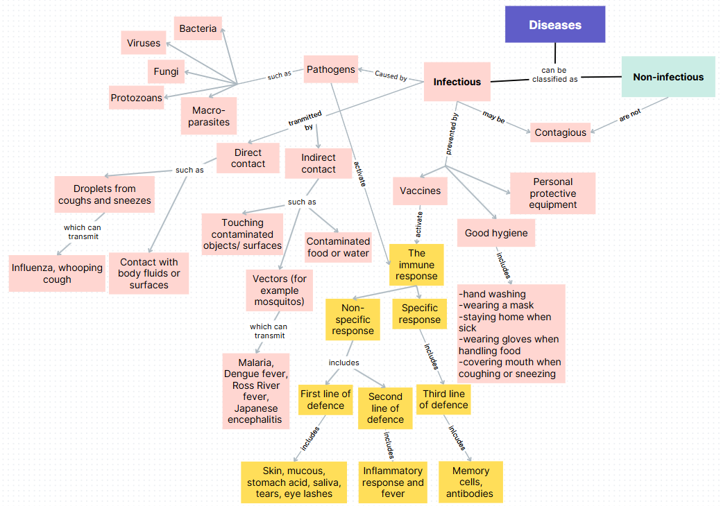

## Causes of non-infectious diseases

### Teacher information

**Note:** in this activity, students will work collaboratively on a slide deck to outline the symptoms, causes and treatment of a range of non-infectious diseases. It is recommended that a collaborative slide deck is set up before the lesson with copies of the **DIS PPT** slide ‘1.3 Non-infectious disease summary slide template’.

1. Inform students that we generally classify causes for non-infectious disease into the categories of genetic, environmental and lifestyle choices.

* Display the **DIS PPT** slide ‘3.1 Classifying causes of non-infectious disease’. Define each of the categories. Speaker notes have been included on the slide to unpack examples of each category. Students can record the definitions in their workbooks.
* Ask students to construct a table with 3 columns: one for genetic causes, environmental causes and lifestyle causes.
* Display the **DIS PPT** slide ‘3.1 Causes of non-infectious disease’. Students categorise the risk factors under the headings of genetic, environmental and lifestyle in their books.
* Call upon students to contribute their answers. Display the **DIS PPT** slide ‘3.1 Causes of non-infectious disease (answers)’. Instruct students to correct their tables where required.

1. Determine students' prior understanding of diabetes (they may recall hearing about it during the homeostasis lessons). Identify that there are 2 types of diabetes. The focus of this activity is on Type 2 Diabetes.

* Read the information in the **DIS PPT** slide ‘3.1 Type 2 diabetes’ and ask students to make note of any risk factors.

1. Show students the **DIS PPT** slide ‘3.1 Type 2 diabetes summary’ and unpack the information with the class. Tell the students they will complete a similar slide on another non-infectious disease in groups.

**Note:** extract slide ‘3.1 Non-infectious disease summary slide template’ from the **DIS PPT** and save it as a separate presentation. Duplicate the slide so that there is one for each group of students. The presentation can be shared with students through a slide deck platform so the class can work on their slides simultaneously.

1. Students work in small groups to conduct research and complete their slides.
2. Display each group’s work to the class and allow each group to outline their disease to the class.

**Checkpoint: DIS PPT (3.1 Checkpoint: Disease).** Students use mini whiteboards to respond to statements about the causes of disease and identify if they are examples of infectious or non-infectious diseases. Students should provide their reasoning with each response.

## Distinguish between infectious and non-infectious diseases

### Teacher information

Provide students with a copy of the Student resource – deconstructing a question. Recall how to deconstruct a question using V-C-F-S (verb, content, focus and singular). A table that summarises how to do this is in the **DIS PPT slide ‘3.1 V-C-F-S strategy’.** More information on the strategy can be found in **TRB1** 1.6 Comparing the endocrine and nervous systems ‘writing a response’ activity).

As a class, deconstruct the question **‘**Using examples, distinguish between infectious and non-infectious diseases’**,** using the V-C-F-S strategy.

Show the **DIS PPT** slide ‘3.1 Marking criteria’ slide to the students. Deconstruct it as a class. Use the deconstructed criteria and questions to formulate the plan.

Discuss the deconstruction of the question using V-C-F-S. Link the points below to plan a response:

* First, look at the verb(s). Distinguish means
* to recognise or note/indicate as being distinct or different from, OR
* to note differences between.
* The content identified is infectious and non-infectious diseases. This means we must state the differences between infectious and non-infectious diseases.
* The focus has been identified as ‘between’ and indicates the need for examples. This means we are looking at how infectious and non-infectious diseases are different to each other.
* Words given are plural. It asks for examples, so students should use more than one example.

As a class, discuss the steps to take to write a response.

* Identify differences between infectious and non-infectious diseases. Identify relevant examples.
* Write a statement for each that outlines the difference between infectious and non-infectious diseases, incorporating relevant examples. Remember to distinguish ‘like-for-like’ features.

Show students the **DIS PPT slide** ‘3.1 Distinguishing cohesive devices’ to assist in distinguishing between infectious and non-infectious diseases.

Students construct a response using the plan, marking guidelines and cohesive words. A sample has been given in the **DIS PPT** ‘3.1 Sample response with word bank’ slide. Students reflect on the response using the marking criteria.

**Differentiation:** provide students with the response with a word bank and words missing **DIS PPT** ‘3.1 Sample response with word bank’. Students can then identify the parts of the response that meet the marking criteria.

### Student resource – deconstructing a question

Deconstruct the question below using V-C-F-S.

|  |
| --- |
| Using examples, distinguish between infectious and non-infectious diseases. |

Table 1 – quality criteria for deconstructing a question using V-C-F-S

|  |  |
| --- | --- |
| Component | Criteria |
| Verb | Identify the verb(s) and the requirements of the verb   * This helps to determine the requirements of the response. For example, is a judgment needed? (If a judgment is required, identify points for and/or against it.) |
| Content | Identify the content by circling and annotating keywords that relate to what you have learned. |
| Focus | Outline the focus of the question   * Is it related to a particular context or a stimulus? * Does the question contain a how or a why? This means you need to draw relationships between ideas. |
| Singular | Identify if words in the question are singular or plural.   * Are there words that indicate the response needs to refer to 2 or more ideas? * If the question states to give examples, the ‘s’ at the end of the example indicates more than one. |

Table 2 – the marking criteria for the question

|  |  |
| --- | --- |
| Marks | Criteria |
| 3 | Distinguishes between infectious and non-infectious diseases by providing relevant differences and specific examples.  Use of correct and precise scientific terminology to construct a cohesive response. |
| 2 | Distinguishes between infectious and non-infectious diseases by providing a relevant difference and a specific example.  OR  Distinguishes between infectious and non-infectious diseases by providing relevant differences.  AND  Uses correct and precise scientific terminology. |
| 1 | Outlines features of infectious and/or non-infectious diseases.  OR  Provides a distinct difference between infectious and non-infectious diseases.  OR  Provides an example of an infectious and/or non-infectious disease. |

#### Writing your response

Using examples, distinguish between infectious and non-infectious diseases. (3 marks)

|  |
| --- |
|  |

# 3.2 Non-infectious diseases in Australia

Table 2 – learning intentions and success criteria for 3.2 Non-infectious diseases in Australia

|  |  |
| --- | --- |
| Learning intentions | Success criteria |
| We are learning:   * to analyse data to draw conclusions about common non-infectious diseases in Australia | I can:   * identify common non-infectious diseases in Australia * describe factors contributing to the incidence of a non-infectious disease in Australia * compare the incidence data of the non-infectious disease in different sexes and age groups |
| * to explain our scientific ideas clearly to the intended audience using evidence to support our arguments. | * create a presentation to communicate scientific understanding to a specific audience * identify scientific evidence from secondary sources to support communicated ideas. |

## Investigating the leading causes of death in Australia (secondary-source investigation)

**Note:** this activity aims to establish context around some common non-infectious diseases in Australia. It is to get students to understand that the leading causes of death in Australia are mostly from non-infectious diseases. Although some risk factors, such as genetics, are non-modifiable, other factors, such as lifestyle, are modifiable. Bringing awareness to these diseases and the risk factors that cause them is essential to reduce the incidence of these diseases.

### Teacher information

1. Provide students with the ‘leading underlying causes of death in Australia’ graphic in the Student resource – causes of death in Australia and project **DIS PPT** ‘3.2 Leading causes of death in Australia’.

Current information on infectious diseases affecting Australians today should be used. At the time of writing, 2022 data was the most recent published data.

1. Describe some of the information in the graphic to the students:

* The numbers represent the deaths in Australia for males and females in 2022.
* Coronary heart disease involves blockages in the arteries of the heart.
* Dementia is an umbrella term that describes diseases that affect memory, thinking and the ability to perform daily activities. Alzheimer’s disease is the most common form of dementia.
* In 2022, COVID-19 was still a major cause of death. In 2024 and beyond COVID-19, it is unlikely to feature in the top 5 underlying causes of death due to significant interventions such as vaccination programs.
* Unpack the term ‘cerebrovascular’. ‘Cerebro’ refers to the large part of the brain and vascular means arteries and veins, so cerebrovascular diseases are any disorders of the blood vessels supplying the brain and its covering membranes. An example of cerebrovascular disease is stroke. A stroke is a sudden blockage to an artery supplying blood to the brain or a ruptured artery, causing a bleed.

1. Instruct the students to answer the questions while referring to the graphic. Pause at points to discuss the responses with students. The sample responses and teaching prompts on the next page can be used to facilitate this.
2. Show students the website from which the ‘leading underlying causes of death in Australia’ graphic was taken – [Australian Institute of Health and Welfare, Deaths in Australia](https://www.aihw.gov.au/reports/life-expectancy-deaths/deaths-in-australia/contents/leading-causes-of-death). Recall what makes a secondary source reliable.

**Note: more information about the reliability of secondary sources can be found in ‘2.1 Causes of infectious disease’ in this program and TRB1 and the DIS PPT.**

1. Ask students to answer the questions below:

* **Locate the source of the data on the webpage. Is the website a reliable source? Justify the response.**
* **Co-construct a reference for this secondary source. An APA example has been given; however, any recognised method to reference secondary sources may be used.**

**APA example:** Australian Institute of Health and Welfare. (2024).Deaths in Australia.Retrieved from https://www.aihw.gov.au/reports/life-expectancy-deaths/deaths-in-australia

1. **Explain to students the importance of using reputable data sources and the need to verify information.**

##### Sample responses and question prompts: student resource – causes of death in Australia

1. Identify the non-infectious diseases by circling them on the graphic above.

|  |
| --- |
| The non-infectious diseases that should have been circled on the graphic are coronary heart disease, dementia including Alzheimer’s disease, lung cancer and cerebrovascular disease. |

1. Calculate the percentage of non-infectious diseases in Australia's top 5 leading causes of death. Consider why this might be.

|  |
| --- |
| $$\% of deaths from non infectious disease in top 5 = \left(\frac{Male+Female non infectious disease deaths}{Total people who died in lead causes of death }\right)x 100$$ $$= \left(\frac{26894 +27332}{64485 }\right)x 100= 84\%$$ The high proportion of non-infectious diseases as the leading causes of death in Australia might be due to several reasons outlined below:   * Lifestyle factors: leading an inactive lifestyle, poor diet, smoking and alcohol consumption contribute to conditions like cardiovascular disease, diabetes and cancer. * Aging population and longer life expectancy: as people live longer, they are more likely to develop ongoing non-infectious diseases. This includes Australia's aging population. * Healthcare improvements: better control of infectious diseases through vaccination and hygiene practices has shifted the disease burden towards non-infectious diseases. |

1. Identify the leading cause of death for both males and females.

|  |
| --- |
| The leading cause of death for males is coronary heart disease. 11,303 males died due to this disease in 2022. The leading cause of death for females is dementia, including Alzheimer’s disease. 10,976 females died due to this disease in 2022. |

1. Compare the leading causes of death from non-infectious diseases in females and males. Justify why the differences may exist.

**Teaching prompts to assist students with this question**

The leading cause of death for males is coronary heart disease and the leading cause for women is dementia. Prompt students to think about the factors that could contribute to these differences, emphasising that the presence of a relationship does not necessarily mean one factor causes the other. For example:

* Life expectancy and dementia prevalence – women generally have a higher life expectancy than men. Since the risk of developing dementia increases with age, dementia is more commonly observed in women. This is correlation and does not imply that simply living longer causes dementia. Biological factors and social determinants may also play a role in this trend.
* Lifestyle and coronary heart disease risk – men are more likely to engage in behaviours such as smoking and excessive alcohol consumption, which are well-documented risk factors for coronary heart disease (Australian Bureau of Statistics 2022). This correlation suggests that these behaviours are associated with an increased risk of heart disease, but it does not mean all men who engage in these behaviours will develop heart disease. Other factors such as genetic predispositions and other lifestyle factors may also contribute to this trend.
* Health care utilisation – women tend to be more proactive in seeking medical care, leading to earlier detection and management of certain conditions.

|  |
| --- |
| The leading cause of death for males is coronary heart disease, while for females, it is dementia, including Alzheimer’s disease. There are a range of factors which may contribute to the leading cause of death for males and females including, life expectancy, lifestyle and willingness to access health care.  Dementia, including Alzheimer’s disease and coronary heart disease affect both men and women as shown in the data.  Deaths in women due to dementia, including Alzheimer’s, was 10,976 compared to 6,130 in men. Women have a higher life expectancy than men. Dementia is more prevalent with age, so it is possible that more women have dementia for this reason.  Men were more likely than women to die from coronary heart disease (11,303 men compared to 7,340 women in 2022). Additionally, men are more likely to engage in behaviours such as smoking and heavy alcohol consumption. These are risk factors for coronary heart disease and may contribute to the higher risk of coronary heart disease being the leading cause of death in men. |

**Differentiation:** students may require a worked example to remind them how to calculate an average. For questions 5 and 6, students must add the male and female numbers together before determining the average. You could guide them through question 5 before they attempt question 6 independently.

1. According to the Australian Bureau of Statistics, 190,939 people died in Australia in 2022. Calculate the percentage of people in Australia who died from coronary heart disease in 2022. Show your working.

|  |
| --- |
| $$\left(\frac{Male+Female coronary heart disease}{People who died in 2022}\right)×100=\% of deaths from coronary heart disease$$ $$\left(\frac{11,303+10,976}{190,393}\right)×100=9.79\%$$ Therefore, 9.8% of deaths in Australia in 2022 occurred due to coronary heart disease. |

1. Calculate the percentage of those who died from lung cancer in Australia in 2022.

|  |
| --- |
| $$\left(\frac{Male+Female deaths from lung cancer}{People who died in 2022}\right)×100=\% of deaths from lung cancer$$ $$\left(\frac{5,145+3,903}{190,393}\right)×100=4.75\%$$ |

### Student resource – causes of death in Australia

Look at the data below and then answer the questions.

[Leading underlying causes of death](https://www.aihw.gov.au/reports/life-expectancy-deaths/deaths-in-australia/contents/leading-causes-of-death) in Australia, by sex, 2022

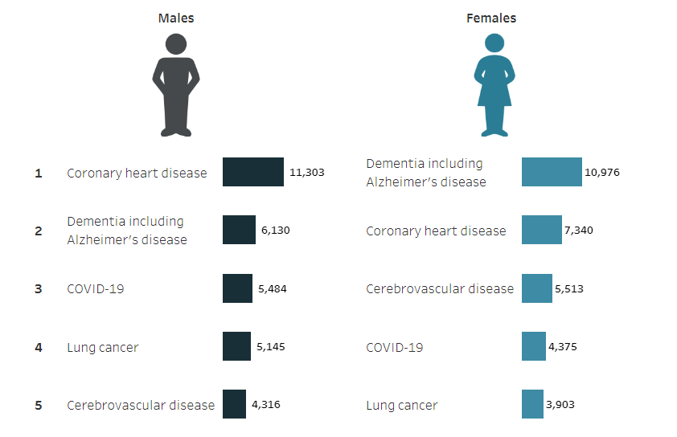

[‘Leading underlying causes of death in Australia, by sex, 2022’](https://www.aihw.gov.au/reports/life-expectancy-deaths/deaths-in-australia/contents/leading-causes-of-death#:~:text=Figure%203.1%3A%20Leading%20underlying%20causes%20of%20death%20in%20Australia%2C%20by%20sex%2C%202022) from AIHW National Mortality Database; Table S3.1 is licensed under [CC BY 4.0](https://creativecommons.org/licenses/by/4.0/deed.en).

1. Identify the non-infectious diseases by circling them on the graphic above.
2. Calculate the percentage of non-infectious diseases in Australia's top 5 leading causes of death. Consider why this might be.

|  |
| --- |
|  |

1. Identify the leading cause of death for both males and females.

|  |
| --- |
|  |

1. Compare the leading causes of death from non-infectious diseases in females and males. Justify why the differences may exist.

|  |
| --- |
|  |

**According to the Australian Bureau of Statistics, 190,939 people died in Australia in 2022.**

1. Calculate the percentage of people in Australia who died from coronary heart disease in 2022. Show your working.

|  |
| --- |
|  |

1. Calculate the percentage of those who died from lung cancer in Australia in 2022.

|  |
| --- |
|  |

## Investigating Australian non-infectious disease data (secondary-source investigation)

### Teacher information

Students will need access to laptops or computers to complete this activity.

1. Working in pairs, students select a non-infectious disease prevalent in Australia from the list below, preferably not the same as any other pair.

**Note:** the non-infectious diseases below were part of the [top 20 leading causes of death for males and/or females in Australia in 2023](https://www.abs.gov.au/statistics/health/causes-death/causes-death-australia/2023). This list should be updated as new information is made available.

|  |  |
| --- | --- |
| * Coronary heart disease | * Prostate cancer |
| * Lung cancer | * Type 1 diabetes |
| * Dementia, including Alzheimer’s disease | * Type 2 diabetes |
| * Cerebrovascular disease | * Pancreatic cancer |
| * Chronic obstructive pulmonary disease (COPD) | * Breast cancer |
| * Cardiac arrhythmias |  |

1. Revise how to conduct a secondary-source investigation with the students, ensuring reliable and valid sources of information are used. Unpack what makes a quality presentation (in the Student resource – presenting about non-infectious disease and the **DIS PPT** slide‘3.2 What makes a quality presentation?’.
2. Provide students with a copy of the Student resource – presenting about non-infectious disease. This resource contains guided questions to help students collect the relevant information for their presentation.
3. Students present their work to the class.
4. Ask the students to make note of strategies used to reduce the incidence of non-infectious diseases, as this is needed in the next learning sequence.
5. Allow time for students to ask questions after each presentation.

### Student resource – presenting about non-infectious disease

#### What makes a quality presentation?

|  |
| --- |
| **Presentation component**   * Ensure your content is well-researched, reliable and summarised in your own words. * The flow of your presentation should be logical, with a clear introduction, body and conclusion. * All information presented should be relevant to the topic. * Use images that support your explanation of concepts. These could be graphs as well. * Provide the main points on the slide and verbally elaborate on these to avoid cluttering on slides. * Maintain a consistent design and layout throughout your presentation. * Use clear and legible fonts and colours.   **Delivery component**   * Have a backup plan in case of technical difficulties (for example, handouts, backup presentation online). * Ensure you have rehearsed for smooth delivery and timing. * Engage with the audience through eye contact. * Speak clearly and at a moderate pace so people can follow what you are saying. * Be prepared to answer questions at the end of your presentation. |

#### Investigating data on a common non-infectious disease in Australia

You will need to answer the questions below to create your presentation for the class.

**Non-infectious disease investigated:** ___________________________________

1. Provide a brief description of the non-infectious disease.

|  |
| --- |
|  |

1. Find data that compares the incidence of the chosen non-infectious disease to other diseases in Australia.
2. Compare the incidence of the non-infectious disease to the other non-infectious diseases. Give reasons for this (consider reasons such as risk factors and education).

|  |
| --- |
|  |

1. Find data that compares the incidences of the chosen non-infectious disease in different age groups in Australia.
2. Describe any patterns in the data (if applicable).

|  |
| --- |
|  |

1. Compare the incidence of the disease in each age group. If there are differences in incidence in age groups, give reasons why this might be.

|  |
| --- |
|  |

1. Find data that compares the incidences of the chosen non-infectious disease between males and females in Australia.
2. Describe any patterns in the data (if applicable).

|  |
| --- |
|  |

1. Compare the incidence of the disease in each gender. If there are differences in incidence in gender, give reasons for this.

|  |
| --- |
|  |

1. Find data that compares the incidences of the chosen non-infectious disease in different socio-economic groups in Australia.
2. Describe any patterns in the data (if applicable).

|  |
| --- |
|  |

1. Compare the incidence of the disease in groups of people with different socio-economic status. If there are differences in incidence, give reasons why this might be.

|  |
| --- |
|  |

1. Describe some strategies that have been put in place to reduce the incidence of the non-infectious disease you are investigating.

|  |
| --- |
|  |

1. Using data to support your response, how effective have the combined strategies been in reducing the incidence of the non-infectious disease in Australia?

|  |
| --- |
|  |

# 3.3 Reducing the incidence of non-infectious diseases

Table 3 – learning intention and success criteria for 3.3 Reducing the incidence of non-infectious diseases

|  |  |
| --- | --- |
| Learning intention | Success criteria |
| **We are learning:**   * **to** describe **strategies used in Australia to prevent non-infectious diseases so that we understand what it takes to be healthy** | I can:   * identify a range of non-infectious diseases based on the strategies used to prevent them * describe different strategies that have been implemented to reduce the incidence of non-infectious diseases * compare the strategies used to reduce the incidence of infectious and non-infectious diseases. |

## Strategies to reduce the incidence of non-infectious diseases

### Teacher information

**Note:** some of the content in this activity may be familiar to students, based on the previous activity 3.2 Non-infectious diseases in Australia, Investigating Australian non-infectious disease data. However, some strategies described in this section may be new to students.

Students will need mini whiteboards (one per group of 3–4 students) and whiteboard markers to complete this activity.

1. Inform students that reducing the incidence of non-infectious diseases is quite complex as it requires a multifaceted approach that may involve lifestyle changes and public health initiatives, including education and health programs, policy and medical advancements.
2. Show students a range of strategies to reduce the incidence of a non-infectious disease they may be familiar with from the previous activity, 3.2 Non-infectious diseases in Australia, Investigating Australian non-infectious disease data. Students are to engage, discuss in groups and then identify which non-infectious disease the strategies are used for.
3. Slowly reveal strategies for each disease in the **DIS PPT** slides ‘3.3 Disease 1–3’, one at a time. Provide students time to think and discuss in their groups, then ask for their answers. Give them the correct answer; this is animated in the **DIS PPT**. Discuss any points of difference to clarify for students. After each disease, ask students for any other strategies they know to reduce the incidence of this disease. There are 3 diseases in total that students have to consider for this activity.
4. Students complete a Think-Pair-Share to answer the following questions (some discussion prompts have been provided):

* Outline what you noticed about the strategies used for reducing the incidence of non-infectious diseases.
* What types of strategies did you observe (for example, lifestyle, education, government initiatives)?
* Are most of the strategies preventative or reactive? Why might that be?
* Did any strategies surprise you? Which ones and why?
* What is one of the main messages for reducing the likelihood of getting a non-infectious disease?
* Why is prevention so important for non-infectious diseases?
* How does individual behaviour (for example, diet, exercise, avoiding harmful substances) reduce risk?
* What role does early detection play in managing non-infectious diseases?
* How can schools contribute to reducing the incidence of non-infectious diseases?
* What programs or activities can schools implement to encourage healthy habits?
* How can schools educate students about the causes of non-infectious diseases?
* Are there examples of healthy behaviours that schools already encourage? How can these be improved?
* How can physical education, mental health programs and nutrition initiatives reduce the risk of non-infectious diseases?
* Identify strategies that are the same in reducing the incidence of infectious and non-infectious diseases. Why are they able to be the same?
* Why do healthy lifestyles minimise the chances of developing diseases, regardless of their cause?
* How does general education about health and wellbeing reduce disease incidence overall?
* Identify strategies for reducing the incidence of infectious and non-infectious diseases. Why are they different?
* How are vaccines and treatments important for infectious diseases but not as relevant for non-infectious diseases?
* Why are lifestyle choices (for example, smoking, diet) more significant in preventing non-infectious diseases?
* How are genetic factors or environmental conditions more significant in non-infectious disease prevention?
* What makes the spread of infectious diseases fundamentally different from the causes of non-infectious diseases?

1. Discuss the share component as a class.

**Differentiation**: students create a public health campaign to promote strategies that reduce the incidence of a chosen non-infectious disease in their school. Students can select a sample of students from the school and ask them to complete a survey (Microsoft form) that identifies their knowledge of the non-infectious disease and how it can be prevented. This should be done before and after the school health campaign. Students analyse the data and then make changes to their campaign based on the feedback.

**Checkpoint:** provide students with the Student resource – non-infectious disease stimulus question. Students respond individually. Collect the student responses in hard copy or digitally to check their understanding and provide feedback.

**Checkpoint sample response**

1. Based on the data, describe the number of Australians per 100,000 who have type 2 diabetes from 2010 to 2020. Suggest 2 reasons for this.

|  |
| --- |
| **The data shows a decreasing trend in the number of Australians per 100,000 with type 2 diabetes between 2010 and 2020. In 2010, the rate was 295 per 100,000; by 2020, it had decreased to 184 per 100,000. This means that the incidence of type 2 diabetes has steadily declined over this period.**  Two possible reasons could be increased public awareness and education about healthy living, including a balanced diet and exercise, which help reduce the risk of developing type 2 diabetes. Another reason could be health campaigns supporting early diagnosis and better management of type 2 diabetes. |

1. Calculate the percentage difference in the number of Australians with type 2 diabetes between 2010 and 2020.

|  |
| --- |
| $$Percentage difference=\frac{Old value-Recent value}{Old value} × 100$$ $$=\frac{295-184}{295} ×100$$ There was approximately a 37.63% decrease in the number of Australians per 100,000 with type 2 diabetes between 2010 and 2020. |

1. Type 2 diabetes is a non-infectious disease often linked to lifestyle factors. Describe 2 ways to reduce the incidence of type 2 diabetes in Australia.

|  |
| --- |
| One way could be to promote and educate people about healthy eating habits, including a balanced diet and reducing the intake of sugary and processed foods. Another way could be to educate people about the benefits of exercise and encourage a lifestyle including regular exercise. Exercise helps people maintain a healthy weight and can reduce the risk of type 2 diabetes. The third way could be to support government policies and initiatives that make healthy choices more accessible, such as implementing taxes on sugary drinks, improving access to fresh fruits and vegetables and creating more opportunities for physical activity through community programs and infrastructure like walking paths and sports facilities. |

### Student resource – non-infectious disease stimulus question

The table below shows the number of Australians per 100,000 who lived with type 2 diabetes from 2010 to 2020.

|  |  |
| --- | --- |
| Year | Number of Australians with type 2 diabetes (per 100,000) |
| 2010 | 295 |
| 2012 | 267 |
| 2014 | 237 |
| 2016 | 201 |
| 2018 | 193 |
| 2020 | 184 |

1. **Based on the data, describe the number of Australians per 100,000 who have type 2 diabetes from 2010 to 2020. Suggest 2 reasons for this.**

|  |
| --- |
|  |

1. Calculate the percentage difference in the number of Australians with type 2 diabetes between 2010 and 2020.

|  |
| --- |
|  |

1. Type 2 diabetes is a non-infectious disease often linked to lifestyle factors. Describe 2 ways to reduce the incidence of type 2 diabetes in Australia.

|  |
| --- |
|  |

# 3.4 Australia’s medical technology

Table 4 – learning intention and success criteria for 3.4 Australia’s medical technology

|  |  |
| --- | --- |
| Learning intention | Success criteria |
| **We** are **learning:**   * **to explain Australian technologies that have advanced medicine so that we can appreciate the contributions of Australian innovation to global medical advancements.** | I can:   * identify technological advances made by Australians in medicine * explain how the technologies work * outline the importance of these technologies for society. |

## Australian technologies to improve health

### Teacher information

Engage students in medical technologies by showing them the following:

* [Catalyst: Affordable prosthetics made with 3D printing (8:21)](https://www.abc.net.au/education/catalyst-affordable-prosthetics-made-with-3d-printing/13959878).
* [Meet Professor Fiona Wood AM – inventor of spray-on skin cells (2:22)](https://www.youtube.com/watch?v=-TQIaGvk8JU).

**Note:** students will require access to a computer to complete this activity.

1. Inform students that they will be working in groups.
2. Allocate one example from the list in the **DIS PPT** slide ‘3.4 Australian technologies to improve health’ to each student. Students working on the same medical technology will work together later to produce an infographic.
3. Revise with students how to conduct a secondary source investigation, if required.
4. Provide students with Student resource – Australian technological advances to support them in collecting the relevant information. Provide students with a time frame for collecting the information. Students conduct research to gather relevant information.
5. Instruct students to form groups based on the allocated technology. Show students the ‘Tips for making an infographic’ section on the [Creating an infographic](https://www.monash.edu/student-academic-success/excel-at-writing/how-to-write/infographic) webpage.
6. Students work as a group to turn their research into an infographic.
7. Each group displays their infographic and provides an overview of the technology for the class.
8. Show the **DIS PPT** slide ‘3.4 Australian medical technology discussion’ and allow time for students to think about the questions. Facilitate class discussion for the questions using the discussion points below:

* Outline the diversity and innovation in Australian healthcare technologies.
* Wide range of health issues addressed: technologies include solutions for trauma (spray-on skin), sensory impairments (bionic eye, cochlear implant) and respiratory conditions (sleep apnoea machine).
* Advanced and new methods: for example, Spray-on skin (Fiona Wood) revolutionised burn treatment by rapidly regenerating skin cells.
* Bionic eye and cochlear implant (Monash Vision Group and Graeme Clark) showcase cutting-edge biomedical devices that restore senses.
* 3D-printed prosthetics (Matt Bowtell) have made affordable assistive devices widely accessible.
* Cross-disciplinary expertise: includes medicine, engineering and digital technology. Collaboration between researchers, clinicians and engineers is a hallmark of Australian innovation.
* Describe how these technologies improve quality of life.
* Improvements in physical recovery: for example, spray-on skin accelerates healing for burn victims, reducing scarring and recovery times and 3D-printed prosthetics provide cost-effective solutions for amputees, improving mobility and independence.
* Restoring senses such as sight and hearing: for example, the bionic eye restores vision, while the cochlear implant enables sound perception in deaf individuals. Both these technologies improve social inclusion and communication.
* Improved sleeping and breathing: for example, the sleep apnoea machine enhances sleep quality, reduces fatigue and lowers health risks (for example, cardiovascular disease).
* Improved patient care: for example, the heart recovery app supports patients post-heart attack by monitoring progress, reducing hospital readmissions and providing guidance.
* Discuss the implications of the technology for health care and society.
* Accessibility to healthcare and equity: innovations like 3D-printed prosthetics and digital health apps make treatment affordable and available to more people. However, technologies like the bionic eye raise questions about equitable access and affordability.
* Improved healthcare outcomes: technologies reduce recovery times, improve patient survival rates and enable people to live more productive, independent lives.
* Economic benefits: reducing hospital stays and costs through vaccines, advanced therapies and remote health tools can relieve pressure on healthcare systems.
* Social impact: restoring functions like vision, hearing or movement allows individuals to contribute actively to their communities, improving social cohesion. Restoring senses (vision or hearing) and mobility reduces isolation, depression and stress, positively impacting mental health.
* Longer life expectancy and healthier aging: innovations that manage chronic diseases (for example, sleep apnoea machine) and improve trauma recovery enhance the quality of life, supporting longer, healthier lives.
* Outline the importance of continued research and development of technologies in healthcare.
* Addressing emerging health challenges: ongoing research is vital for combating new diseases (for example, pandemics) and improving treatments for chronic conditions.
* Reducing healthcare costs: continued innovation leads to cost-effective alternatives, such as 3D-printed prosthetics, which make treatments more accessible and affordable. Preventive tools, such as recovery apps, like recovery apps help avoid expensive hospitalisations and long-term care.
* Supporting preventive healthcare: Advances in monitoring tools (for example, apps and wearable devices) provide real-time data, helping people manage conditions before they escalate. Preventive healthcare reduces disease incidence, resulting in healthier populations.
* Improving treatment effectiveness: ongoing research allows refinement of existing technologies (for example, improving cochlear implants or bionic eye precision) to enhance outcomes. Treatments become safer, more efficient and tailored to individual patients, maximising their success rates.
* Future-proofing healthcare: innovations like AI, apps and biotechnology will enhance predicting, preventing and treating diseases.

### Student resource – Australian technological advances

Use the questions below to gather the required information for your infographic. Include relevant images that support the explanation of concepts.

1. Name the technology.

|  |
| --- |
|  |

1. Identify the disease, disorder or trauma it addresses.

|  |
| --- |
|  |

1. Identify the person/people who developed it, including how and why they developed it.

|  |
| --- |
|  |

1. Explain how the technology works.

|  |
| --- |
|  |

1. Outline the impact it had on the lives of patients.

|  |
| --- |
|  |

1. Is there any future research that was instigated as a result of this technology? What was it?

|  |
| --- |
|  |

References

|  |
| --- |
|  |

# 3.5 Consolidating the disease concept map

Table 5 – learning intention and success criteria for 3.5 Consolidating the disease concept map

|  |  |
| --- | --- |
| Learning intention | Success criteria |
| **We are learning:**   * **to summarise information about infectious and non-infectious diseases.** | I can:   * distinguish between infectious and non-infectious diseases * represent relationships between concepts in a concept map * summarise the information logically. |

## Teacher information

Students have worked on a concept map throughout the learning on infectious and non-infectious diseases. This is an opportunity to consolidate and refine the concept map so students can demonstrate their understanding of the relationships between interrelated concepts. Concept maps support students in learning and remembering new knowledge by integrating it with and connecting it to existing knowledge.

**Differentiation:** the [Y9 Disease concept map](https://www.canva.com/design/DAGZh6qu0sU/CxJ7994xYr70KBN4Aw-BZQ/edit?utm_content=DAGZh6qu0sU&utm_campaign=designshare&utm_medium=link2&utm_source=sharebutton) can be accessed and modified on CANVA. To make your own copy of the concept map, go to **FILE > Make a copy**. Providing the concept map with the connecting words or some key information removed may be a useful strategy to support some students.

Figure 2 – sample disease concept map

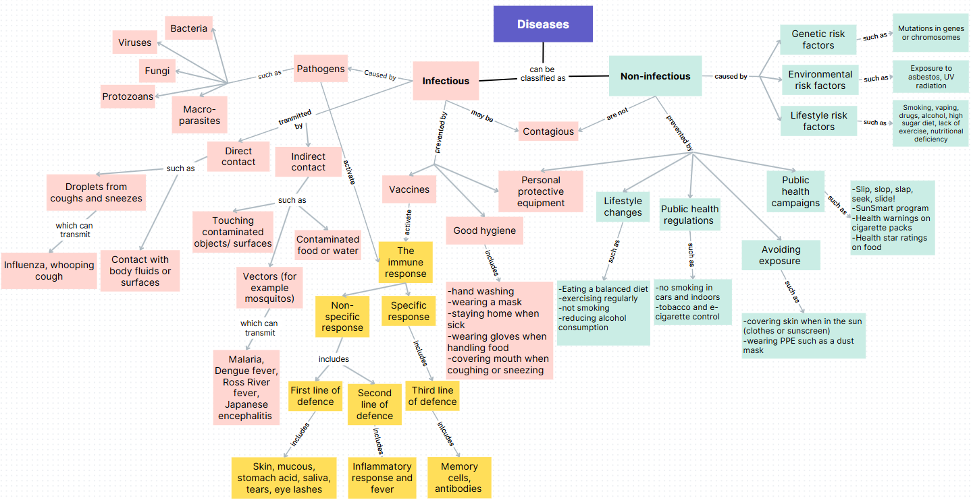

# Evidence base

This resource contains NSW Curriculum and syllabus content. The NSW Curriculum is developed by the NSW Education Standards Authority. This content is prepared by NESA for and on behalf of the Crown in right of the State of New South Wales. The material is protected by Crown copyright.

Please refer to the NESA Copyright Disclaimer for more information <https://educationstandards.nsw.edu.au/wps/portal/nesa/mini-footer/copyright>.

NESA holds the only official and up-to-date versions of the NSW Curriculum and syllabus documents. Please visit the NSW Education Standards Authority (NESA) website <https://educationstandards.nsw.edu.au> and the NSW Curriculum website <https://curriculum.nsw.edu.au>.

[Science 7–10 Syllabus](https://curriculum.nsw.edu.au/learning-areas/science/science-7-10-2023/overview) © NSW Education Standards Authority (NESA) for and on behalf of the Crown in right of the State of New South Wales, 2023.

AIHW (Australian Institute of Health and Welfare) (2024) [*Deaths in Australia*](https://www.aihw.gov.au/reports/life-expectancy-deaths/deaths-in-australia/contents/leading-causes-of-death), AIHW website, accessed 11 July 2024.

AIHW (2024) [*Diabetes: Australian facts Type 2 diabetes*](https://www.aihw.gov.au/reports/diabetes/diabetes/contents/how-common-is-diabetes/type-2-diabetes#_Toc97889422), AIHW website, accessed 4 August 2024.

Australian Bureau of Statistics (2022) [*Alcohol consumption*](https://www.abs.gov.au/statistics/health/health-conditions-and-risks/alcohol-consumption/2022#cite-window2), ABS Website, accessed 21 July 2024.

Australian Bureau of Statistics (2022) [*Smoking and vaping*](https://www.abs.gov.au/statistics/health/health-conditions-and-risks/smoking-and-vaping/2022), ABS Website, accessed 21 July 2024.

Brookhart SM (2018) ‘[Appropriate Criteria: Key to Effective Rubrics](https://www.frontiersin.org/articles/10.3389/feduc.2018.00022/full)’, Frontiers in Education, volume 3(22):1–12, doi:10.3389/feduc.2018.00022, accessed 5 August 2024.

CESE (Centre for Education Statistics and Evaluation) (2020) [*What works best: 2020 update*](https://education.nsw.gov.au/about-us/educational-data/cese/publications/research-reports/what-works-best-2020-update), NSW Department of Education, accessed 17 May 2024.

—— (2020) [*What works best in practice*](https://education.nsw.gov.au/about-us/educational-data/cese/publications/practical-guides-for-educators-/what-works-best-in-practice), NSW Department of Education, accessed 11 July 2024.

—— (2021) [*Growth goal setting – what works best in practice*](https://education.nsw.gov.au/about-us/educational-data/cese/publications/practical-guides-for-educators/growth-goal-setting), NSW Department of Education, accessed 11 July 2024.

Fisher D and Frey N (1 November 2009) [Feed Up, Back, Forward](https://www.ascd.org/el/articles/feed-up-back-forward), ASCD (Association for Supervision and Curriculum Development): Educational Leadership magazine, 67(3), accessed 11 July 2024.

Griffin P (2017) Assessment for Teaching, Cambridge University Press, Port Melbourne, Victoria.

Hattie J and Timperley H (2007) ‘The Power of Feedback’, Review of Educational Research, 77(1): 81–112, doi:10.3102/003465430298487.

Panadero E and Jonsson A (2013) ‘[The use of scoring rubrics for formative assessment purposes revisited: A review](https://www.sciencedirect.com/science/article/abs/pii/S1747938X13000109?via%3Dihub)’, Educational Research Review, 9:129–144, doi:10.1016/j.edurev.2013.01.002, accessed 5 August 2024.

Sherrington T (2019) Rosenshine’s Principles in Action, John Catt Educational Limited, Melton, Woodbridge.

Waraburra Nura (2024) [*Plants*](https://waraburranura.com/plants/), Waraburra Nura website, accessed 12 July 2024.

Wiliam D (2017) Embedded Formative Assessment, 2nd edn, Solution Tree Press, Bloomington, IN.

**© State of New South Wales (Department of Education), 2025**

The copyright material published in this resource is subject to the Copyright Act 1968 (Cth) and is owned by the NSW Department of Education or, where indicated, by a party other than the NSW Department of Education (third-party material).

Copyright material available in this resource and owned by the NSW Department of Education is licensed under a [Creative Commons Attribution 4.0 International (CC BY 4.0) license](https://creativecommons.org/licenses/by/4.0/).

[](https://creativecommons.org/licenses/by/4.0/)

This license allows you to share and adapt the material for any purpose, even commercially.

Attribution should be given to © State of New South Wales (Department of Education), 2025.

Material in this resource not available under a Creative Commons license:

* the NSW Department of Education logo, other logos and trademark-protected material
* material owned by a third party that has been reproduced with permission. You will need to obtain permission from the third party to reuse its material.

**Links to third-party material and websites**

Please note that the provided (reading/viewing material/list/links/texts) are a suggestion only and implies no endorsement, by the New South Wales Department of Education, of any author, publisher, or book title. School principals and teachers are best placed to assess the suitability of resources that would complement the curriculum and reflect the needs and interests of their students.

If you use the links provided in this document to access a third-party's website, you acknowledge that the terms of use, including licence terms set out on the third-party's website apply to the use which may be made of the materials on that third-party website or where permitted by the Copyright Act 1968 (Cth). The department accepts no responsibility for content on third-party websites.