Action research resource

### High potential and gifted education

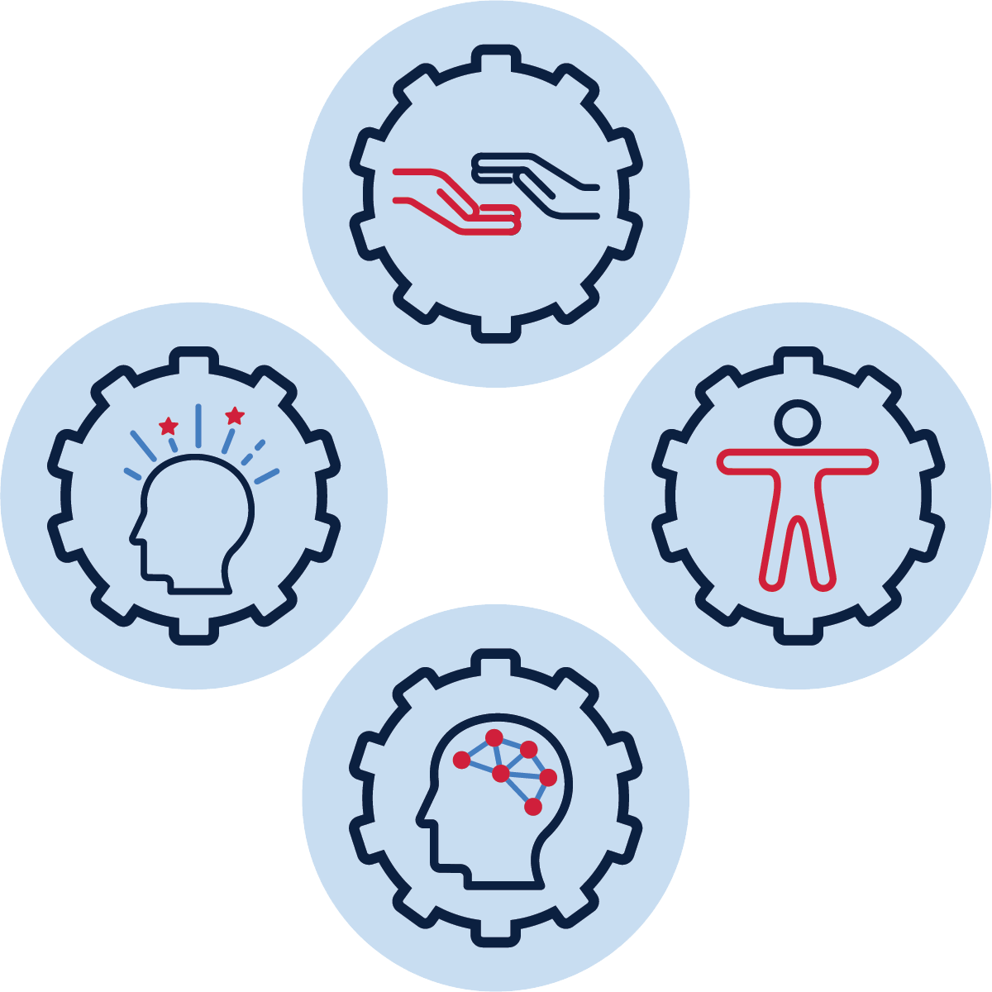

# Table of contents

Purpose 2

Action research cycle 2

Where do I start? 4

Planning - identify, inform, organise 4

Identifying the focus of your action research 4

Analysing what is happening in your context 7

Action research focus 17

Acting - trial, question, collect 17

Observing - analyse, report, share 21

Reflecting - evaluate, implement, revisit 23

Where to next? 25

References 25

 Tip: Hover over a heading in the table of contents to move straight to the relevant section of the document

Purpose

Action research is a deliberate approach for investigating questions and finding solutions to authentic problems. It is a reflective approach that drives decision-making and critical reflection to support improvement of student learning outcomes. It is often used by school leaders and teachers to trial and evaluate the effectiveness of evidence-informed strategies in their unique contexts and individual classrooms.

This resource has been designed to scaffold school leaders and teachers through the action research process to support schools to build towards excellence in the implementation of the [High potential and gifted education policy](https://education.nsw.gov.au/policy-library/policies/pd-2004-0051). Its use will aid schools in acting upon particular HPGE Policy statements such as those identified in the completion of the evaluation section of [the HPGE Evaluation and Planning Tool (EP Tool)](https://education.nsw.gov.au/teaching-and-learning/high-potential-and-gifted-education/supporting-educators/evaluate#High1).

Firstly, the action research cycle is described, then each stage of the cycle is unpacked. Reflective questions are used throughout, targeting procedures, programs and practices, to prompt school leaders and teachers to engage with each stage of the cycle, considering high potential and gifted education in their individual context or setting, supporting school improvement progress measures and monitoring.

# Action research cycle

Research is about generating credible knowledge. Action research creates contextualised knowledge based on enquiries conducted within specific and often practical contexts. The purpose of action research is to learn through action and reflection that then leads to personal or professional development.

The process of action research is both reflexive and progressive, the researcher is both an outsider and an insider, and the outcome is both general and specific (Ollila, 2020). It is participatory in nature which led Kemmis and McTaggart (2000) to describe it as participatory research. The authors state that action research involves a spiral of self-reflective cycles of:

* planning a change / setting a goal
* acting and observing the process and consequences of the change
* reflecting on these processes and consequences and then replanning
* acting and observing
* reflecting
* and so on, working towards excellence.

It is recommended that action research is conducted in a flexible manner. The process may not be as neat as the spiral of self-contained cycles of planning, acting, and observing, and reflecting suggests. These stages will overlap, and initial plans will quickly become obsolete in the light of learning from experience. The process is likely to be more fluid, open, and responsive to findings. What is important is to analyse the principles involved in the model which, in turn should lead to a deeper understanding of the processes involved in action research.

Action researchers should always adopt a model which suits their purpose best (Koshy, 2010). As a result, schools should be looking at their own unique context when undertaking action research and decision-making, bearing in mind that successful implementation in each school and classroom will be different.

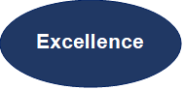

identify

inform

organise



revisit

implement

evaluate

report

share

analyse

trial

collect

question

repeat cycle as needed



 Tip: Hover the mouse over the red box and press ‘control + click’ to move straight to the relevant section

# Where do I start?

This resource can be utilised to guide you through the action research cycle at any point in the implementation of the HPGE Policy. A school-based team may use this resource in full, or in part, to action school-wide research, inquiry and change. It can be used by stage/faculty teams or an individual who has chosen to focus on their HPGE procedures, programs and practices.

An action research inquiry may be a short or long-term process and can take place over the course of a term, a year, or longer. This will be dependent on a school or individual’s context, progression of their HPGE journey, scale and depth of the research. Flexibility is key, however using the HPGE Evaluation and Planning (EP) Tool to support initial evaluation of what focus area or domain of potential to begin, is a recommended place to start. Each section of the action research process is supported by videos. The first step is to start planning.

# Planning - identify, inform, organise

### Identifying the focus of your action research

Action research starts with identifying what you are going to focus in on. Your focus for this project will be determined by your current [School Excellence Plan (SEP)](https://education.nsw.gov.au/about-us/strategies-and-reports/school-excellence-and-accountability/school-excellence-in-action/strategic-improvement-plan), and information from the completed self-evaluation of the HPGE Evaluation and Planning Tool.

To assist with refining your focus consider the [Revisiting Gifted Education literature review](https://education.nsw.gov.au/content/dam/main-education/about-us/educational-data/cese/revisiting-gifted-education-literature-review.pdf), High potential and gifted education policy and the [5 key actions](https://education.nsw.gov.au/teaching-and-learning/high-potential-and-gifted-education/supporting-educators) developed to provide a framework for schools to support implementation of the policy. All 5 key actions apply within an action research framework, however, evaluation, collaboration and building capability are particularly relevant. It is also essential that all 4 domains of potential are considered throughout the project.

 **Tip:** Use the self-evaluation process in the [HPGE Evaluation and Planning Tool](https://forms.office.com/Pages/ResponsePage.aspx?id=muagBYpBwUecJZOHJhv5kc7f1Skk8ElJjQgFTkwP6nRUQVJMNFpYU0tXNFE3OE45RjMzWVVGMThZQy4u) to reflect on the needs of your school context. Also consider which [HPGE key action](https://education.nsw.gov.au/teaching-and-learning/high-potential-and-gifted-education/supporting-educators) would be most beneficial to HPGE practice in your school context.

**5 key actions**

 [**Evaluate**](https://education.nsw.gov.au/teaching-and-learning/high-potential-and-gifted-education/supporting-educators/evaluate) school procedures, programs and practices, and analyse student growth and achievement data to inform school planning and policy implementation.

[**Assess and identify**](https://education.nsw.gov.au/teaching-and-learning/high-potential-and-gifted-education/supporting-educators/assess-and-identify) the specific learning needs of all high potential, gifted and highly gifted students.

[**Implement**](https://education.nsw.gov.au/teaching-and-learning/high-potential-and-gifted-education/supporting-educators/implement) evidence-informed procedures, programs and practices that meet the learning and wellbeing needs of all high potential and gifted students and facilitate talent development.

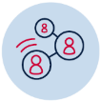[**Collaborate**](https://education.nsw.gov.au/teaching-and-learning/high-potential-and-gifted-education/supporting-educators/collaborate) with families, school communities and the wider community to enhance growth and achievement for all high potential and gifted students.

[**Build teacher and leadership capability**](https://education.nsw.gov.au/teaching-and-learning/high-potential-and-gifted-education/supporting-educators/build-capacity) through engagement with quality research and ongoing professional learning on effective practices to improve growth and achievement for all high potential and gifted students.

Domains of potential

**Intellectual** domain of potential refers to natural abilities to process, learn, understand, reason and apply/transfer thinking.

**Creative** domain of potential refers to natural abilities in imagination, invention and originality.



**Social-emotional** domain of potential refers to natural abilities in self-management and relating to and interacting with others.

**Physical** domain of potential refers to natural abilities in muscular movement and motor control.



 Tip: To streamline your action research you may choose to cross reference your action research with a concurrent process, e.g., a whole school audit assessment could be built into collection of data for the action research

Table 1: Identifying the focus of your action research

|  |  |
| --- | --- |
| **Reflective questions** | **Answers** |
| Which HPGE Policy statement point have you identified as the focus of this action research project?  1.1.1 high expectations  1.2 assessment and data  1.3 diversity  1.4 evidence-informed strategies for  talent development  1.5 learning environments  1.6 professional learning and  networks  1.7 growth and achievement |  |
| Why have you chosen this focus?  Are you delivering, sustaining & growing, or excelling in this area? |  |
| State your action research question.  Use School Excellence Framework domains and the relevant ‘excelling’ statements in the EP Tool to frame your question.  Example Starters  How could we improve…?  What procedures, programs and/or practices can we implement to demonstrate…?  How do we know our impact …?  Example question for policy 1.5 using SEF domain Reporting: Parent engagement and EP Tool:  *What procedures, programs and/or practices can we implement to engage in strong collaborations between the school, parents/carers, students and the community and how is this used to inform and support social-emotional development and wellbeing of high potential and gifted students?* |  |

### Analysing what is happening in your context

Research requires devising methods of collecting information to get a broad picture of what is happening and why. Refining your focus requires analysis of current procedures, programs and practices in your school context or setting and consideration of:

* the priorities of all stakeholders in your school situational analysis
* [current research](https://education.nsw.gov.au/teaching-and-learning/high-potential-and-gifted-education/HPGE-research) in high potential and gifted education
* Evidence-informed practices including critical reflection, meaningful engagement and solutions that can be embedded.

**TASK:** Using the reflective question prompts below, critically reflect and consider the positions of stakeholders (executive, teaching and support staff, students, families) in your school context. Note your reflections in the table below.

Table 2a: Current Context - considering stakeholder priorities, equity, and inclusion

Consider the following when answering these questions: School Excellence Plan, School Excellence Framework, [Implementation and Progress Monitoring](https://education.nsw.gov.au/inside-the-department/directory-a-z/strategic-school-improvement/school-excellence-in-action-support/implementation-and-progress-monitoring-support), HPGE policy and the 5 key actions.

|  |  |  |
| --- | --- | --- |
| **Reflective questions** | **What does this look like in your context?** | **How will you collect and analyse information to inform your understanding?** |
| What research and evidence-informed practice currently drives executive decision-making in relation to high potential and gifted education in your context? |  |  |
| What are the current professional learning priorities for your staff? |  |  |
| How do your current procedures, programs and practices support growth and achievement for your high potential and gifted students (HPGS)? |  |  |
| How can you find out the priorities of your HPGS families?  How would families like to engage in their children’s learning? |  |  |
| Are all four domains of potential included in school procedures, programs, assessments, and teaching & learning practices? |  |  |
| Do HPGS from diverse backgrounds have access to quality learning opportunities that meet their needs and aspirations? |  |  |
| How do you support and make reasonable adjustments for HPGS with disability? |  |  |

Table 2b: Planning – considering best practice in your chosen policy focus area

Check chosen policy focus area and **only answer** the relevant questions.

|  |  |  |  |
| --- | --- | --- | --- |
| **Policy statement** | **Reflective questions** | **What does this currently look like in your context?** | **How will you collect and analyse information to inform your understanding?** |
| 1.1.1 | How will you know the impact of the HPGE Policy on establishing a culture of high expectations, and the pursuit of excellence, in your school and community? |  |  |
| How will you know which evidence-informed teaching strategies effectively support your students to feel challenged and engaged? |  |  |
| How will you implement effective learning partnerships to motivate HPGS to achieve personal excellence and to continually improve? |  |  |
| 1.2 | How will you flexibly use assessments to inform learning and teaching across all domains of potential? |  |  |
| How do staff find high potential and recognise the specific learning needs of HPGS across 4 domains? |  |  |
| How will trends in HPGS progress, achievement data and contextual information be analysed to inform teaching and learning? |  |  |
| How will you ensure that parents and HPGS understand assessment approaches and their benefits for learning? |  |  |
| How will feedback from HPGS on their learning, be used to inform teaching and learning? |  |  |
| 1.3 | How will you know that the HPGE Policy has ensured access to quality learning opportunities for HPGSs from all backgrounds that meet their needs and aspirations? |  |  |
| How will you implement tailored resourcing and support that is responsive to the diversity of your HPGS? |  |  |
| How will you ensure that progress and achievement of HPGSs from equity groups is equivalent to the progress and achievement of other HPGSs in the school? |  |  |
| 1.4 | How will you know that all teaching and learning programs evidence dynamic revisions and adjustments based on reliable data? |  |  |
| How will you know how effective HPGE evidence-informed differentiation adjustment strategies have challenged students’ current level of mastery? |  |  |
| How will you know if feedback to students is effective and is being used to inform next steps to promote growth? |  |  |

|  |  |  |  |  |  |
| --- | --- | --- | --- | --- | --- |
| **Policy statement** | | **Reflective questions** | | **What does this currently look like in your context?** | **How will you collect and analyse information to inform your understanding?** |
| 1.5 | | How can strong collaborations between parents, students and the school community be developed to inform learning success? How is this collective responsibility measured and evaluated? |  |  |
| How can advanced learning pathways be flexibly implemented so that all learning outcomes are enhanced? |  |  |
| How will you demonstrate that positive, safe and respectful relationships are evident schoolwide and wellbeing and optimal learning conditions for HPGS is promoted? How will you measure this? |  |  |
| 1.6 | | How can professional learning, across both the school and wider community build teacher and leadership capability to effectively support HPGS? |  |  |
| Do teachers have the needed skills in analysing and interpreting data to inform their planning for the specific needs of their HPGS across 4 domains? |  |  |
| How do you know whether teachers have the capability to support all 4 domains of potential at appropriate levels for HPGS? |  |  |

|  |  |  |  |  |  |  |
| --- | --- | --- | --- | --- | --- | --- |
| **Policy statement** | | **Reflective questions** | | **What does this currently look like in your context?** | | **How will you collect and analyse information to inform your understanding?** |
| 1.7 | | How will you use the analysis of internal and external student achievement data to inform and monitor the progress of individual learning goals for HPGS across 4 domains? | |  |  |
| Can you identify which procedures, programs and practices are effectively extending and supporting HPGS in all 4 domains? | |  |  |

### Action research focus

Now that you have collected information, reflected on multiple positions and analysed your context, you have a broad and deep understanding of your school’s current practices.

Revisit your identified focus area/s for action research that you noted previously in Table 1. In light of your context analysis, review and fine tune your focus area to ensure you are targeting what you intended. Your focus area is not set in stone and may continue to develop and change throughout the process as you discuss and analyse data from your research.

After finalising your focus, develop a plan related to your specific school context.

Tip: Invite colleagues to support your action research through a facilitated approach, for example principal, learning and support team and colleagues, including those with training/experience in gifted education.

# Acting - trial, question, collect

As the title suggests, acting is action oriented. Actions are initiated and trialled following your plan over a selected period. Both qualitative and quantitative data is collected and compiled. All four domains of potential should be considered when collecting data.

Data collection tools applicable to all four domains of potential might include, but are not limited to, any of the following examples:

* student voice, and or student/parent surveys
* interviews and focus groups
* individual learning plans for HPGE students / smart goal monitoring
* [advanced learning pathways and acceleration](https://education.nsw.gov.au/teaching-and-learning/high-potential-and-gifted-education/supporting-educators/implement#Advanced8) opportunities for HPGE students in all domains
* teaching and learning programs showing [evidence-informed differentiation and assessment](https://education.nsw.gov.au/teaching-and-learning/high-potential-and-gifted-education/supporting-educators/implement#Differentiation4)
* attendance & engagement data
* whole-school [evaluation](https://education.nsw.gov.au/teaching-and-learning/high-potential-and-gifted-education/supporting-educators/evaluate#Evaluate3) and analysis of [assessment](https://education.nsw.gov.au/teaching-and-learning/high-potential-and-gifted-education/supporting-educators/assess-and-identify#Assessment1) data
* Best Start Kindergarten, Best Start Year 7, NAPLAN, VALID, HSC, check in assessments
* [talent development](https://education.nsw.gov.au/teaching-and-learning/high-potential-and-gifted-education/supporting-educators/implement#Talent2) supported through collaboration with other schools, organisations, parents/carers, and [wider community](https://education.nsw.gov.au/teaching-and-learning/high-potential-and-gifted-education/supporting-educators/collaborate)
* student work samples or artefacts evidencing individualised [effective feedback](https://education.nsw.gov.au/teaching-and-learning/curriculum/explicit-teaching/explicit-teaching-strategies/using-effective-feedback).

In addition to the above data collection tools, domain-specific examples may include:

**Intellectual domain**:

* advanced learning pathways and acceleration data and monitoring (subject, program or whole year)
* OC and SHS data (school assessment data, placement test results, offers/reserves)
* NCCD Data and disability adjustments.

**Physical domain**:

* formative and summative assessment
* school or external sports carnival participation and performance data
* department programs and representative [sporting programs and teams](https://education.nsw.gov.au/teaching-and-learning/curriculum/learning-across-the-curriculum/school-sport)

**Creative domain**:

* external examinations and performance (e.g. Australian Music Examination Board)
* teaching and learning programs across all KLAs show evidence of critical and creative thinking and problem-solving opportunities
* school involvement and identification in department programs through the Arts Unit

**Social-emotional domain:**

* nomination, participation and selection data in competitions and programs, for example [Premier’s Debating Challenge](https://artsunit.nsw.edu.au/program/premiers-debating-challenge), [Public Speaking](https://artsunit.nsw.edu.au/literature-and-language-arts/public-speaking)
* evidence-informed student mentor and peer support program data
* leadership and participation in school, family, and inclusive community programs

Further examples of sources of evidence for all HPGE policystatements across all four domains can be accessed in the HPGE Evaluation and Planning Tool.

**TASK:** Using the question prompts below, reflect on what and how you will trial practices and collect data, and who will be involved. Note your reflections in the table provided.

Table 3: Acting

During this stage you will also be questioning the process and making changes as required. Try to consider what research and evidence-informed strategies could be applied creatively in your school context to meet the HPGE goals of the School Excellence Framework and School Excellence Plan?

|  |  |
| --- | --- |
| **Reflective questions** | **Answers** |
| What procedures, processes and/or practices are you going to trial? Will you focus on just one domain of potential or more? |  |
| What is your first step to implementing your trial? |  |
| What information will you collect and how will you collect it? |  |
| How will you analyse and question the information collected? |  |
| Who will be engaged in this process? Will people involved provide a variety of perspectives? |  |
| What time and energy will you (and others) commit to this action research? |  |
| What are your agreed standards/guidelines to support everyone engaging with the action research? |  |

 **Tip 1: Collect and document as you go and reflect throughout your journey - don’t leave this until the end.**

 **Tip 2: If in the past, you completed the HPGE Tier 1 Leaders course, it may be useful to use the Attitudes and Teaching Practices Survey (ATPS) to guide your planning and reflections.**

# Observing - analyse, report, share

When you no longer learn anything new or identify new themes or patterns, it is time to stop collecting and start analysing.

Collate your data by reading and sorting systematically then set aside any data that does not directly relate to your research question/s.

**TASK:** Using the question prompts below, reflect on the data you collected and your analysis to summarise any answers to your research question. Note your reflections in the table provided.

Table 4: Observing – analyse, report and share

|  |  |
| --- | --- |
| **Reflective questions** | **Answers** |
| What have you observed/found? |  |
| What worked, what didn’t? How do you know? |  |
| What are your thoughts on the information you have collected? |  |
| What is the data NOT telling you?  What other information is needed to complete a valid analysis? |  |
| How will you report and share your findings? |  |
| Who will you share your findings with?  This may include the principal, DEL, P&C, school social media |  |

Tip: Create categories according to shared characteristics to sort and analyse data. Watch the [CESE Evaluative Thinking film](https://vimeo.com/212678863) to support your evaluation and analysis process.

# Reflecting - evaluate, implement, revisit

After analysing your data, assess the effects of your actions to determine if improvement has occurred. Evaluate your first cycle of this process and implement the finding or new strategy. Maintain openness to possible revisions, redirections and new problems and assumptions. Ensure equitable and just solutions and consequences for all participants.

**TASK:** Using the question prompts below, reflect on what you have learnt from your action research cycle and what you will do as a result. Note your reflections in the table provided. **Openness and honesty are key. Be willing to share your work, its successes and the challenges.**

Table 5: Reflecting

|  |  |
| --- | --- |
| **Reflective questions** | **Answers** |
| What have you learned from this cycle of action research? What haven’t you learnt that you were expecting to? Were there any surprises? |  |
| Are you now delivering, sustaining & growing, or excelling in this area? |  |
| Do you need to adjust any of the procedures, programs or practices that you trialled? Do you need to trial something new or different? |  |
| Has your data collection/ documentation provided you enough information to analyse and make informed decisions? |  |
| What aspects will you keep the same and what will you do differently during the next action research cycle? |  |
| What are your current thoughts about the focus of your action research? |  |
| Based on your findings, do you need to revisit, refine, or change your focus? |  |
| What equity/inclusion issues are arising from the research? |  |

# Where to next?

Action research is directed towards both understanding and improving. The purpose of this action research is to positively affect school procedures, programs and processes, and support schools to excel in their implementation of the High potential and gifted education policy.

Now that you have completed your first cycle of action research, decide what steps, if any, need to be taken to alter or further improve practice.

Action research often leads to new questions to examine. Revisit the process to forge new forms of understanding and deeper insights to practice.

You may use this template to repeat the cycle as many times as needed.

## References

ACER Teacher Magazine (24 June 2015). [Tips for conducting school-based research](https://www.teachermagazine.com.au/articles/tips-for-conducting-school-based-research)

Australian Institute for Teaching and School Leadership (AITSL) – [Action Research for professional learning](https://www.aitsl.edu.au/tools-resources/resource/action-research-for-professional-learning-illustration-of-practice)

[Action Research in Qualitative Research Chapter 9 (PDF 630.55KB)](https://people.wou.edu/~girodm/library/ch9.pdf)

Burns, A. (2010). The Cambridge Guide to Research in Language Teaching and Learning, [Chapter 11 Action Research](https://www.researchgate.net/publication/282199978_Action_research)

Ferrance, E (2000). Northeast and Islands Regional Education Laboratory at Brown University [Action Research (PDF 215.43KB)](https://repository.library.brown.edu/studio/item/bdr:qbjs2293/)

Kemmis, S., & McTaggart, R. (2000). Participatory action research. In N. Denzin & Y. Lincoln (Eds.), *Handbook of qualitative research* (2nd ed., pp. 567–605). Thousand Oaks, CA: Sage

Koshy, V (2010). Action Research for Improving Educational Practice: A step-by-step guide, Chapter 1: What is action research? Sage Publication

McGlinn Manfra, M (2019). [Review of Action Research in Education](https://doi.org/10.3102%2F0091732X18821132), American Education Research Association; 43(1): 163–196

Nugent, G; Malik, S and Hollingsworth, S (2012). [A Practical Guide to Action Research for Literacy Educators (PDF 2.62MB)](https://www.literacyworldwide.org/docs/default-source/resource-documents/a-practical-guide-to-action-research-for-literacy-educators.pdf?sfvrsn=4)

Ollila, S and Ystrom, A (2020). [Action research for innovation management: three benefits, three challenges, and three spaces](https://doi.org/10.1111/radm.12407)

Sagor, R (2000). [Guiding School Improvement with Action Research](http://www.ascd.org/publications/books/100047/chapters/What-Is-Action-Research%C2%A2.aspx)