English Stage 4 (Year 7) – assessment task –

multimodal report – seeing through a text
This document contains a sample assessment notification and a student work sample. This accompanies the teaching and learning program ‘Seeing through a text’.
Contents
About this resource 3
Purpose of resource 3
Target audience 3
When and how to use 4
Opportunities for collaboration 4
Seeing through a text – multimodal report 5
Task overview 5
Task description 8
The context of the task 8
What is the teacher looking for in this assessment task? 10
Steps to success 10
Marking guidelines 13
Marking criteria 13
Student-facing rubric 16
Assessment policy 21
Student support materials 21
Knowledge and skills 22
Student work sample 23
Multimodal report 23
Humans help people in developing countries 25
Annotated student work sample 27
The English curriculum 7-12 team 34
Share your experiences 34
Support and alignment 34
References 36

Updating the table of contents
Want to update the table? Have you added content to the document and noticed the page numbers have changed? As you add content to this report, you can update the table of contents to accurately reflect the page numbers within the resource. To update the table:
- Right click on the table and select ‘Update table of contents’ (in the browser version) or ‘Update field’ (in the desktop app). In the browser version, it will automatically update the entire table.
- In the desktop app, you will then need to select ‘Update entire table’. Your table numbers should then update to reflect your changes.

About this resource
This sample assessment notification has been developed to assist teachers in NSW Department of Education schools to create and deliver assessment practices that are contextualised to their classroom. It is designed as an example of how the English K–10 Syllabus (NESA 2022) could be implemented.

Purpose of resource
This assessment task notification is not a standalone resource. It has been designed for use by teachers in connection to the program ‘Seeing through a text’ and the accompanying resources. The sample notification and student work sample are intended to support teachers to develop a consistent approach to formal assessment notifications, guide interpretation of the syllabus and provide a model of syllabus aligned assessment practice.
It is acknowledged that many schools have their own assessment templates. The content from the heading ‘Seeing through a text – multimodal report’ to the heading ‘Student support materials’ is student facing and could be copied and pasted into the school’s assessment template.
The text in the blue feature boxes are instructions for the classroom teacher engaging with the resource. This is to be deleted by the teacher before issuing the assessment to students.

Target audience
A combination of teacher and student information is contained in this resource. The content intended for teachers is educative. This is intended to support the teacher and their practice as they design formal assessment task notifications. Teachers must ensure that they omit or delete information that is not relevant to students prior to distribution. Instructions have been provided throughout this template to indicate where this may be necessary.

When and how to use
This assessment notification has been designed for Term 2 of Year 7. It builds on the knowledge and skills developed in the first Year 7 assessment task. Students are supported to transition from developing a writing voice into expressing responses to texts. Students will develop analytical responses to texts and concepts with an awareness of their own and others’ perspectives.
The resource should be used with timeframes that are created by the teacher to meet the overall assessment schedule.

Opportunities for collaboration
The following is an outline of some of the ways this sample assessment notification can be used with colleagues and students:
- The task and student samples provide an opportunity for modelled and guided co-construction. Use the student response as examples and models and make modifications to reflect contextual needs. This can take place prior to students beginning their own compositional process and as a feedback opportunity to refine compositions.
- Examine the sample assessment and student samples (in this document and within the resource booklet) during faculty meetings and/or planning days and collaboratively refine them based on faculty or school goals.
- Examine the annotated work samples and use these to support discussion around ways to support and guide consistent teacher judgement.
- Examine the materials during faculty meetings or planning days and collaboratively plan opportunities for team teaching, collaborative resource development, mentoring, lesson observation and/or the sharing of student samples.
- Use the examples as inspiration for designing student-specific tasks.
- Use the assessment practices and/or syllabus planning as an opportunity to backward map Years 10–7.

Seeing through a text – multimodal report
In this program, you will have the opportunity to explore and engage with a range of visual texts such as film, news media reports, websites, advertising, music videos and picture books. By examining and experimenting with the codes and conventions of these forms, you will develop your understanding of visual literacy. You will also practise writing about images, explaining your personal and informed responses. You will have the chance to deepen your understanding of the ways in which visual texts are purposefully constructed to represent ideas, experiences and values.
Change the tense of these instructions if you are issuing the assessment later in the program when students have engaged in this learning. The types of texts listed above should also be updated based on school decisions.

Task overview
The annotations column has been provided to assist assessment design. This column is for the teacher only and would be deleted prior to distributing the assessment notification to students.
The task overview provides a concise description of key information about the assessment.
Table 1 – overview of the assessment task
Year 7 – English | Task details | Annotations
Task number | 2 | [Task number – ensure this reflects the chronological order outlined within the scope and sequence and the assessment schedule.]
Issue date | [Type text here] | [Issue and date – state the day and date the assessment is issued.]  [Draft submissions day and date]
Due date | [Type text here] | [Due date – state the day and date the assessment is due. The timing should be time efficient and manageable for teachers and students. Issue the task early in the program so students can make connections and seek clarification as they progress through their learning. At a minimum, students should be provided with 2 full weeks after the date of issue. The NESA Developing formal school-based assessment programs in Stage 6 information provides useful guidance for schools implementing formal assessment procedures in Stage 4 and 5.]
Outcomes being assessed | EN4-URA-01: representation; code and convention; connotation, imagery and symbol  EN4-URB-01: theme  EN4-ECA-01: representing; text features: informative and analytical | [Ensure details align with the scope and sequence, assessment schedule and any details that have been provided to students in the school’s assessment handbook. The outcome codes and key content groups being assessed are included in this outline.]
Weighting | 25% (indicative only) | [Where applicable, ensure details align with the scope and sequence, assessment schedule and any details that have been provided to students in the school’s assessment handbook.]
Submission details | Multimodal report  [Instructions to be adjusted for context] | [Be specific about the process for submission and parameters for the task. This may include:  - the format of the task submission  - where the task will be submitted  - word/time limits  - any additional information in accordance with school assessment policy.]

Task description
Provide a short description of the task. This description should be written in plain English. It should include a clear outline of the audience, purpose and context of the task. This helps students understand appropriate style, form and the necessary language, forms and features required.
Supplementary information can be provided later in the document. This reduces the cognitive load experienced while using the notification. The assessment should align with NESA’s Assessment principles and provide clear opportunities for teachers to gather evidence about student achievement in relation to syllabus outcomes. This advice can be customised at a school level.
Task modification options: provide a different task context, provide a glossary, modify the language of the task to meet student needs and or refine or reduce the task requirements. Phase 6 activities and resources, as well as Phase 2, resource 8 – introducing the fictional task context, provide teachers with suggestions for ways to introduce and support student understanding of the requirements for this task.

The context of the task
The following is a fictional scenario intended to provide students with an authentic audience and purpose for composing. Students are provided with a specific context for the selection and discussion of visual texts, and a rationale for the creation of a multimodal text.
Anahit is the most powerful planet in the Galaxy. The Ministers in the government of Anahit have been watching Earth for many years and are deeply concerned. They have noticed that Earth’s environment is being destroyed and the inhabitants are suffering. The Ministers have decided that the best solution is to destroy planet Earth and start again.
Your boss, the Minister for Other Planets, believes that Earth should be saved. They have one final chance to convince the other Ministers at their next meeting.
The Minister for Other Planets is going to deliver a speech and has asked you, the Senior Advisor, to provide evidence that can be used to support the argument that Earth is worth saving.
You know that visuals are a very effective type of evidence, and you have decided to select 3 powerful and engaging visual texts about Earth. You will create a multimodal report presenting and analysing the visuals. You will include captions to help your boss understand the content and context of the visuals. In addition, you will write the accompanying informative text.
Remember, your job is not to convince anyone. You job is to gather, select and analyse the evidence and write an informative report to support your boss’ argument that Earth should be saved.
Your task – multimodal report
Create a multimodal report your boss can use to support their argument that Earth is worth saving from destruction.
To complete this multimodal report, you must:
- Decide why Earth is worth saving: this will be your thesis.
- Research and select the 3 visual texts that you think will best support the argument that Earth is worth saving (for example: images, paintings, photographs or extracts from media texts or picture books).
- Write a one sentence caption for each visual stating: what the visual is, who it is by, where it is from and what it shows. The captions are not included in your final word limit.
- Compose a multimodal report of 300–500 words (excluding captions, headings and other multimodal report features) analysing the 3 visual texts. Explain what they communicate about planet Earth (your thesis). In your analysis, focus on the content, construction and contextual information (where relevant), that will help your boss convince the Anahit government that Earth should be saved.
This task may be submitted in a variety of ways and these should be adjusted to suit the school context. The task has been designed as an informative and analytical report that includes the visual texts chosen by students. Students may be instructed to:
Submit a document in class or online: the content would be assessed based on how effectively text and visual features are utilised by the student to support the task’s context.
Submit a poster or digital display of the report: the content would be assessed as a class ‘gallery walk’ (traditional A3 poster or a digital presentation in an app such as Sway, or similar). Note that an oral ‘presentation’ of the report may be added as an assessed requirement or conducted as an optional formative assessment task after formal submission.

What is the teacher looking for in this assessment task?
Use the criteria points from the marking guidelines to articulate the skills and knowledge required to meet the requirements of this task (what is expected of the response).
The teacher is looking to see how well you:
- Use the codes and conventions (visual and written) of a multimodal report and create a clear and engaging reader journey (EN4-URA-01 – multimodal report).
- Use appropriate metalanguage to analyse how the codes and conventions within the 3 visual texts communicates ideas and issues (EN4-URA-01 – visual analysis).
- Provide accurate and effective contextual and textual evidence to support the thematic ideas (EN4-URB-01 – thesis explanation and ideas).
- Write a sustained report using language and structure accurately and with purpose supporting a clear thesis (EN4-ECA-01 – overall cohesion and report structure).

Steps to success
This schedule is designed to support students to successfully complete the task and to support teachers in their monitoring of student progress. This schedule is not for the purposes of compliance and students should not be penalised for not meeting interim times. The second column should be determined by the teacher and could be:
used to feed forward
co-constructed with students.
Implementing the steps to success will support you to demonstrate your knowledge, skills and understanding, and prompt you to seek support as it is needed. These steps also provide you with opportunities to receive feedback throughout the drafting and refining process.
Table 2 – assessment preparation schedule
Steps | What I need to do and when I need to do it | Have I completed this step? Yes or no
Prepare your thesis | Decide on a clear thesis for why earth should be saved. You do not need to convince your boss, but you need a specific ‘angle’.
Select 3 visual texts | Select 3 visual texts that strongly support your thesis.
Create captions for your visual texts | Summarise each visual text with captions that state:  - the content of the image  - the type of visual text, where it is from and who created it  - any other information your boss may need to know  - the connection to your thesis.
Prepare your analysis | To help prepare your analysis you should engage in the activity of annotation. Annotate each visual text identifying its emotional power, the visual language, the codes and conventions and how they are used, important or useful contextual detail, and explain how your visual texts support your thesis.
Refine your use of evidence | To organise your ideas, make choices from your annotations and brainstorm to create a judicious, informed, cohesive text that supports your thesis.
Compose a multimodal report | Compose a report with an introduction, a series of body paragraphs and a conclusion using the evidence you recorded within your annotations. Use the codes and conventions of a multimodal report. Strategically place your visuals throughout the multimodal report to create a clear and engaging reader journey.
Seek feedback and continue refining your response | Seek regular feedback from your teacher and peers and refine your work throughout the assessment process.

Marking guidelines
The structure of the marking criteria depends on the requirements of the assessment task. Two marking criteria templates have been provided. This demonstrates the various approaches to marking criteria. It is not expected that teachers would use both marking criteria.
The following table contains sample language that may be useful in the composition of criteria for each grade. Each criterion would need to be refined to reflect the requirements of the outcomes. The language is reflective of the K–10 Common Grade Scale and Stage 4 syllabus outcomes and content points.
The K–10 Common Grade Scale can be used to report student achievement in both primary and junior secondary years in all NSW schools. Teachers may find the language helpful when composing their own marking criteria.

Marking criteria
Table 3 – assessment marking criteria
Grade | Marking guideline descriptors
A | - Effectively uses the codes and conventions (visual and written) of a multimodal report creating a clear and engaging reader journey (EN4-URA-01 – multimodality)  - Effectively analyses how the codes and conventions of visual texts communicate ideas about issues and uses appropriate metalanguage (EN4-URA-01 – visual analysis)  - Effectively supports the thesis and ideas with accurate and effective use of contextual information and textual evidence (EN4-URB-01 – explanation of the evidence used to support argument)  - Develops a sustained report using language and structure with accuracy and purpose supporting a clear thesis (EN4-ECA-01 – overall structure)
B | - Accurately uses the codes and conventions (visual and written) of a multimodal report creating a clear reader journey (EN4-URA-01 – multimodality)  - Analyses how the codes and conventions of visual texts communicate ideas about issues, and uses appropriate metalanguage (EN4-URA-01 – visual analysis)  - Supports the thesis and ideas in a well-reasoned way using accurate contextual information and textual evidence (EN4-URB-01 – explanation of the evidence used to support argument)  - Develops a clear report using language and structure and purpose supporting a thesis (EN4-ECA-01 – overall structure)
C | - Sound use of codes and conventions (visual and written) of a multimodal report creating a reader journey with some clarity (EN4-URA-01 – multimodality)  - Adequately analyses how some codes and conventions of visual texts communicate ideas about issues, and uses some appropriate metalanguage (EN4-URA-01 – visual analysis)  - Supports the thesis and ideas with some contextual information and textual evidence (EN4-URB-01 – explanation of the evidence used to support argument)  - Develops a report using language and structure with some accuracy and purpose supporting a thesis (EN4-ECA-01 – overall structure)
D | - Uses some codes and conventions (visual and written) of a multimodal report and tries to engage the reader (EN4-URA-01 – multimodality)  - Describes codes and conventions of visual texts with basic reference to how they communicate ideas about issues, and attempts to accurately use metalanguage (EN4-URA-01 – visual analysis)  - Uses basic contextual information and textual evidence (EN4-URB-01 – explanation of the evidence used to support argument)  - Develops a basic report attempting to use language and structure to support a thesis (EN4-ECA-01 – overall structure)
E | - Limited use of codes and conventions (visual and written) of a multimodal report (EN4-URA-01 – multimodality)  - Describes visual texts with limited use of metalanguage to explain how they communicate ideas (EN4-URA-01 – visual analysis)  - Limited support of ideas (EN4-URB-01 – explanation of the evidence used to support argument)  - Attempts to develop a report with elementary use of language and structure and limited support of a thesis. (EN4-ECA-01 – overall structure).

Student-facing rubric
The student-facing rubric is designed to provide context specific explanations of the assessment marking criteria. The rubric uses student-friendly language and unpacks the specific knowledge, skill and understanding required when composing each component of the assessment. This can be modified to reflect the texts chosen by the teacher and the language forms, features and structures that have been a focus of the learning. When teachers are providing feedback they may make comments on the specific knowledge, skill or understanding that was demonstrated effectively, needs further development and methods for improvement.
Table 4 – rubric for assessment
Criteria | Extensive | Thorough | Sound | Basic | Elementary
Multimodal report (EN4-URA-01)  Your multimodal report should:  - use the codes and conventions (visual and written) of a multimodal report  - create a clear and engaging reader journey throughout the multimodal report | You have effectively used a range of visual and written codes and conventions of a multimodal report in your report such as subheadings, positioning, pull quotes and captions to create a clear and highly engaging report for the reader. | You have used a range of visual and written codes and conventions of a multimodal report such as subheadings, positioning, pull quotes and captions to create a clear and engaging report for the reader. | You have used visual and written codes and conventions of a multimodal report such as subheadings, positioning, pull quotes and captions to create a report with some clarity for the reader. | You have attempted to use some visual and written codes and conventions of a multimodal report and have tried to engage the reader. | You have shown a limited use of visual and written codes and conventions of a multimodal report in your response.
Visual analysis (EN4-URA-01)  Your visual analysis should:  - use appropriate metalanguage (visual devices)  - analyse how each visual text has used the codes and conventions of their form to communicate ideas and issues | You have effectively used a range of appropriate metalanguage such as symbolism, colour, juxtaposition and vector throughout your report. You have thoughtfully analysed the use of codes and conventions in visual texts, and have clearly explained how they communicate ideas and issues relating to your thesis. | You have used appropriate metalanguage such as symbolism, colour, juxtaposition and vector throughout your report. You have analysed the use of codes and conventions in visual texts and have explained how they communicate ideas and issues relating to your thesis. | You have used metalanguage such as symbolism, colour, juxtaposition and vector in parts of your report. You have analysed the use of some codes and conventions in visual texts and have satisfactorily explained how they communicate ideas and issues relating to your thesis. | You have used basic metalanguage throughout your report. You have described some codes and conventions in visual texts and have made some reference to how they communicate your ideas and thesis. | You have shown a limited use of metalanguage in your report. You have described visual texts with limited reference to how codes and conventions communicate your ideas and thesis.
Thesis and ideas (EN4-URB-01)  Your thesis should:  - be supported with accurate and effective textual evidence  - be supported with accurate and well-selected contextual evidence | You have developed and embedded an articulate thesis throughout your entire report. You have used well-selected and accurate contextual information to clearly express your ideas and have effectively used evidence from visual texts to support and enhance your thesis. | You have developed and embedded a thoughtful thesis throughout your report. You have used accurate contextual information to express your ideas and have used evidence from visual texts to support your thesis. | You have developed a sound thesis that is reflected in your report. You have used contextual information and evidence from visual texts in your report to express your ideas and support parts of your thesis. | You have developed a basic thesis reflected in your report. You have used some contextual information and evidence from visual texts and have attempted to support your ideas and thesis. | You have tried to develop a thesis for your report. You have used limited contextual information and have attempted to support some of your ideas using evidence from visual texts.
Report structure (EN4-ECA-01)  Your report should:  - explore ideas related to the thesis  - use correct spelling, punctuation and grammar  - use a clear report style structure presenting one idea at a time including a clear introduction and conclusion  - use appropriate language to achieve the intended purpose for the specific audience | Your response contains accurate stylistic features of a report: a clear introduction and conclusion and presents each idea in a separate paragraph. You have shown effective control over your spelling, punctuation and grammar which has made your report easy to read. Your appropriate and effective choice of language has allowed you to explore and support ideas relating to your clearly structured thesis. You have successfully achieved your intended purpose. | Your response contains stylistic features of a report. Your report has an introduction and conclusion and presents each idea in a separate paragraph. You have shown control over your spelling, punctuation and grammar through most of your report which has made your response easy to read. Your appropriate choice of language has allowed you to explore and support ideas relating to your thesis to achieve your intended purpose. | You have satisfactorily included stylistic features of a report in your response. Your report has a sound introduction and conclusion, and some body paragraphs are structured to present one idea at a time. Your adequate control of spelling, punctuation and grammar has made some parts of your report easy to read/follow. Your choice of language has allowed you to explore and support some ideas relating to your thesis to achieve some of your intended purpose. | Your response includes some stylistic features of a report. Your report has a basic introduction, conclusion and some body paragraphs that may present one idea at a time. You have shown basic control of spelling, punctuation and grammar making the flow of your response variable. Your basic language choices have allowed you to explore some ideas with some reference to your thesis to achieve your intended purpose. | You have attempted to include some stylistic features of a report in your response. Your report includes a basic introduction and or conclusion and simple paragraphs with a brief discussion of ideas. Your limited control of spelling, punctuation and grammar and choice of language interrupts the flow of your response and vaguely supports your thesis and or purpose.

Assessment policy
Assessment notifications should contain a reference to the school’s assessment policy and the relevant information or support. Schools may wish to include specific reminders on the assessment notification itself. Some relevant reminders are suggested below.
Ensure all students understand the assessment policy and understand what makes a task invalid or unreliable. Dedicate time to helping students understand what malpractice is and how to avoid this issue. The Core formative tasks are designed to support students with recursive writing and develop their planning, monitoring and revising skills.
Schools may provide the administrative procedures associated with the following:
absence from an assessment task or non-attempts
late submission of tasks due to illness or misadventure
malpractice
invalid or unreliable tasks
student appeals.

Student support materials
This list would be adjusted by the teacher and reflect the resources and materials provided to the class. The list below reflects the resources, activities and core formative tasks from the resource booklet that has been provided to support students as they refine their assessment submission.
You should refer to the following resources and activities to help you refine your response:
- Student work sample and the annotated student work sample (see ‘Student work sample’ at the end of this document).
- Template for selecting appropriate and effective visual texts (see ‘Phase 6, activity 2 – gathering and selecting texts’).
- Activities and resources on the key features of multimodal texts (see ‘Phase 6, resource 3 – informative report for government minister of Anahit’, ‘Phase 6, activity 3 – supporting the thesis’ and ‘Phase 6, activity 4 – features of an informative report jigsaw’, the language and textual features of captions ‘Phase 3, resource 1 – descriptive caption’ and ‘Phase 5, resource 1 – the features of multimodal texts’).
- Core formative task 6 – ‘checklist for analytical paragraph’ (Phase 6).

Knowledge and skills
The table below is designed to help teachers plan and prepare for the specific knowledge and skills students need to complete this assessment. Specific knowledge and skills are identified and where they are developed and supported within the program is outlined. This table can be used as a tool to inform pre-assessment, program planning and the creation of specific resources and formative assessments. It is a guide and suggestion only.
Table 5 – identifying and planning for the assessed knowledge and skills
Skill area | Specific skills (location in program)
Text features of information reports and multimodal text | - orient and guide reader (phase 5)  - sustain ideas in paragraphs (phase 5)  - develop ideas logically (phase 5)  - combine modes (phase 5)
Sentence-level grammar and punctuation | - sentence structures – passive and active (phase 2)  - sentence structures – cause and effect (phase 4)  - sentence structures – embedding evidence (phases 3 and 6)  - punctuation for elaborating ideas (phase 5)  - cohesive devices to link concepts and express cause and effect (phases 3 and 4)
Word-level language | - nouns and noun groups for summarising conceptual information (phase 5)  - adjectives for accurate description (phase 5)  - metalanguage to add detail and authority (phases 1, 2 and 3)  - the timeless present for analysis (phase 3)

Student work sample
The following annotated work sample is designed to provide one example of a completed version of this assessment task. It is not designed to be an exemplar and is reflective of an average C grade student response. This can be used as a sample with students and as part of a modelled, guided and independent compositional process.
This should be removed from the assessment notification if the assessment is issued early in the program. It should be explored with students.
Type of text – informative and analytical multimodal report
This is a complete copy of the student response.
- Read through the response in its entirety prior to reading the annotations.

Multimodal report
Dear Boss,
I think you could convince the other Ministers by telling them how amazing Earth is and that it is home to many living creatures.
They work together in strong communities and live together peacefully. The visual texts in this report show that humans are good at accepting different people, helping others and they love the land. These visual texts are powerful because they show how strong communities have been built on Earth to help them live. This means they will be able to fix their problems. And they need another chance.

Humans accept difference
All humans are different and they come from different backgrounds. Humans speak different languages and believe in different things and act differently. But they all accept each other which helps them build strong communities. Picture 1 is from a short film named Visible. In this picture there are visual features such as salience, long shot and symbolism.
Picture 1 – the short film called ‘Visible’ shows humans accepting difference and living in peace.
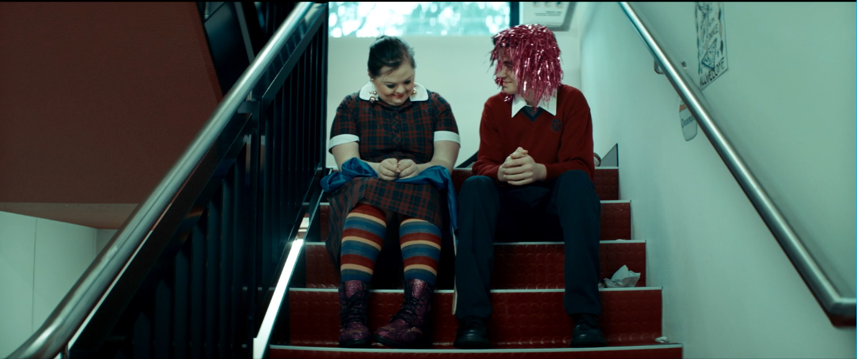
In the picture there are 2 friends sitting together on the school staircase. The first thing you see is the salient feature. The salient feature is the girl’s rainbow socks. The different colours in her socks symbolises the different people that are on Earth. It shows us that different people can live together peacefully, like the colours next to each other in her socks. In the long shot, the audience sees the students sitting together on the same step. It shows that all humans are different but they are equal. There is a lot of colour red used in this picture and this symbolises love. Humans love each other even if they are different. All the visual features in this picture are powerful because they show that humans accept difference, which helps them build strong communities.

Humans help people in developing countries
Picture 2 – a photograph (from a news report) of humans helping people living in developing countries.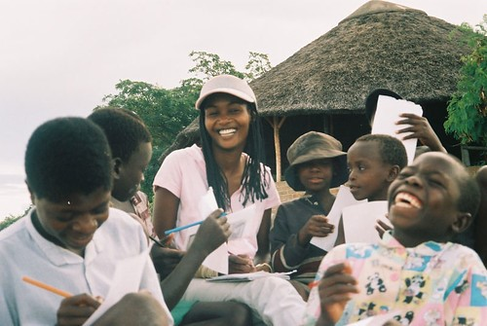
Humans work together in strong communities to help people living in developing countries. Some humans do not have the things as others such as food, clean water, medicine and schools.
Picture 2 shows humans in strong communities because it has juxtaposition and mid shot. The hut in the background is juxtaposed with the children using modern technology and learning in the foreground. This shows that some humans live in traditional ways and this is shown in this example. They are working together to give others a chance to go to school. The mid shot shows humans smiling because they are learning together. This shows that humans are happy when they work together.

They love the land
Picture 3 is from an Aboriginal picture book and shows the connection between the Earth and living creatures. The person who drew this used extreme long shot, imagery and colour. The image is created with layers of nature and animals over the land, water and houses. There is also imagery used in the text. There are houses in groups across the land which shows that humans are living together. The colour orange and yellow is used. To show happiness and joy humans feel.

Conclusion
The Earth is an amazing planet. The Earth and all living things are connected in strong communities because they accept difference, help each other and love the land. The visual texts I included in this report use a lot of powerful visual features to show that humans live in strong communities. This is why you should convince the ministers to save the Earth; so that humans can live peaceful lives.
Picture 3 – this page is from an Aboriginal picture book. It shows the land and all living things on Earth.
.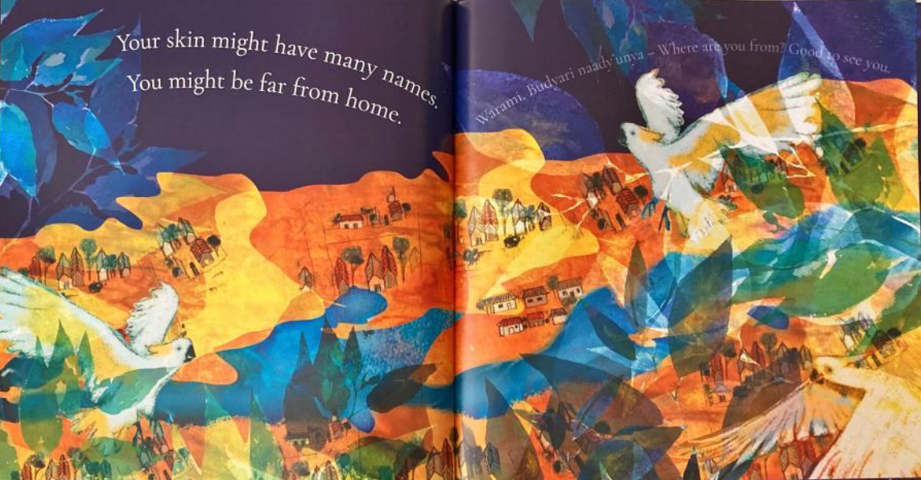

Annotated student work sample
- Read through each paragraph of the student’s response and the corresponding annotations.
Table 6 – annotated student work sample
Student work sample | Annotations | Features of writing used to shape meaning
Dear Boss,  I think you could convince the other Ministers by telling them how amazing Earth is and that it is home to many living creatures. | Uses the conventions of a letter rather than a formal report.  Could have written:  To: The Minister for Other Planets. | Uses conjunctives ‘and’ to form compound sentences to support the purpose of the report: ‘… telling them how amazing Earth is and that it is home to many living creatures.’  Use of first person pronoun ‘I’ makes the response read like a persuasive piece. Using third person pronoun would be more appropriate in addressing the informative purpose of the report.
They work together in strong communities and live together peacefully. The visual texts in this report show that humans are good at accepting different people, helping others and they love the land. These visual texts are powerful because they show how strong communities have been built on Earth to help them live. This means they will be able to fix their problems. And they need another chance. | Re: The planned destruction of the planet known as earth.  Introduction.  Addresses the purpose of the report.  Writer has developed a thoughtful thesis to support the purpose: ‘(Humans) … work together in strong communities and live together peacefully’. | Uses punctuation accurately to list ideas discussed in the report ‘… humans are good at accepting different people, helping others and they love the land.’  Some inaccuracies with punctuation: ‘… they will be able to fix their problems. And they need another …’  Use of conjunctive ‘and’ to begin sentences impacts sentence fluency.
Humans accept difference  All humans are different and they come from different backgrounds. Humans speak different languages and believe in different things and act differently. But they all accept each other which helps them build strong communities. Picture 1 is from a short film named Visible. In this picture there are visual features such as salience, long shot and symbolism. | Uses stylistic features of a multimodal report: subheading ‘Humans accept difference’. Clear use of active voice in subheading orients and informs the reader about the ideas discussed.  Attempts to use ‘but’ as cohesive device to connect ideas to thesis. Using ‘however’ would have improved sentence fluency. | Repetition of conjunction ‘and’ to connect ideas. Writer could have improved sentence cohesion using commas.  Writer uses appropriate metalanguage ‘… salience, long shot and symbolism.’
Picture 1 – the short film called ‘Visible’ shows humans accepting difference and living in peace.  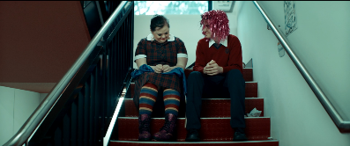 | Captions used as a multimodal feature. Captions include mostly accurate information about the visual text, however, some details are missing. For example – the creator of the text. | Grammatical error in the caption using the word ‘called’. A more appropriate word choice would have been ‘named’.
In the picture there are 2 friends sitting together on the school staircase. The first thing you see is the salient feature. The salient feature is the girl’s rainbow socks. The different colours in her socks symbolises the different people that are on Earth. It shows us that different people can live together peacefully, like the colours next to each other in her socks. In the long shot, the audience sees the students sitting together on the same step. It shows that all humans are different but they are equal. There is a lot of colour red used in this picture and this symbolises love. Humans love each other even if they are different. All the visual features in this picture are powerful because they show that humans accept difference, which helps them build strong communities. | Sound analysis and explanation of textual evidence such as salience, long shot and symbolism. Analysis of visual features are satisfactorily linked to ideas discussed in the body paragraph and support thesis.  Sound use of passive voice ‘There is a lot of colour red used in this picture …’ to emphasise the power of visual codes and convention in communicating ideas, rather than placing emphasis on the composer. | Thoughtful use of cohesive devices such as ‘like’ to support thesis by making connections between ideas and visual features: ‘It shows us that different people can live together peacefully, like the colours next to each other in her socks.’  Use of adjective ‘powerful’ to describe visual features shows the writers understanding of the effectiveness of visual texts in supporting their ideas and thesis.
Humans help people in developing countries  Picture 2 – a photograph (from a news report) of humans helping people living in developing countries.  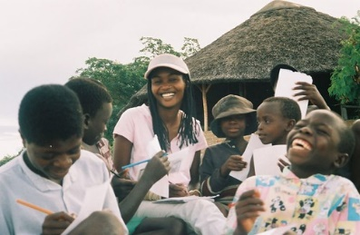 | Sound alignment of visual and written text. Creates reader engagement through a clear reading journey. | Sound summary of visual text in captions using noun groups ‘Photograph … of humans …’.
Humans work together in strong communities to help people living in developing countries. Some humans do not have the things as others such as food, clean water, medicine and schools. | There is an attempt to use contextual evidence to build on the idea they are discussing: ‘Some humans do not have the things as others such as food, clean water, medicine and schools.’ This could be strengthened by including a statistic or a clear reference to the country represented in the picture. | Grammatical error in sentence: ‘Some humans do not have the things as others such as …’.  Inconsistent paragraph structure. Separates paragraphs discussing one idea into short and extended paragraphs. This impacts the reading pathway through the report.
Picture 2 shows humans in strong communities because it has juxtaposition and mid shot. The hut in the background is juxtaposed with the children using modern technology and learning in the foreground. This shows that some humans live in traditional ways and this is shown in this example. They are working together to give others a chance to go to school. The mid shot shows humans smiling because they are learning together. This shows that humans are happy when they work together. | There is some attempt to analyse and explain textual evidence such as ‘juxtaposition’ and 'mid shot’. There is relevant contextual and textual evidence used, however, the expression of the idea lacks clarity due to the grammatical errors.  Sound use of cause and effect sentence: ‘The mid shot shows humans smiling because they are learning together.’, to support ideas discussed in the paragraph. | Grammatical error in sentences: ‘Picture 2 shows humans in strong communities because it has juxtaposition and mid shot.’ and ‘This shows that some humans live in traditional ways and this is shown in this example.’ These errors impact the reader’s understanding of contextual and textual evidence used to support ideas and thesis.
They love the land  Picture 3 is from an Aboriginal picture book and shows the connection between the Earth and living creatures. The person who drew this used extreme long shot, imagery and colour. The image is created with layers of nature and animals over the land, water and houses. There is also imagery used in the text. There are houses in groups across the land which shows that humans are living together. The colour orange and yellow is used. To show happiness and joy humans feel. | Use of active voice in the sentence: ‘The person who drew this used …’ highlights power of the composer, rather than the power of visual devices. Composing this sentence using passive voice would have been effective in showing the power of visual devices. For example: ‘Extreme long shot, imagery and colour are used in this illustration.’  Depth of analysis and explanation of visual evidence is inconsistent with previous paragraphs. The writer has incorporated and analysed some textual evidence: ‘The colour orange and yellow is used. To show happiness …’,but has not explained how it supports the idea or thesis. | Use of third person pronoun ‘They’ to compose subheading is unclear about the topic of the subheading. The writer could have used the noun ‘Humans’ to clarify the topic of the paragraph.  Use of simple sentences: ‘There is also imagery used in the text.’  Paragraph includes some incomplete sentences: ‘The colour orange and yellow is used.’
Conclusion  The Earth is an amazing planet. The Earth and all living things are connected in strong communities because they accept difference, help each other and love the land. The visual texts I included in this report use a lot of powerful visual features to show that humans live in strong communities. This is why you should convince the ministers to save the Earth; so that humans can live peaceful lives. | Use of cause-and-effect sentences to support the purpose of the report: ‘This is why you should convince the ministers to save the Earth; so that humans can live peaceful lives.’ | Accurate use of punctuation (semicolon) connecting clauses.  Writer displays inconsistent choice of language. Language choice changes between first ‘I’, second ‘you’ and third ‘they’ person pronouns impacting the clarity of the conclusion.
Picture 3 – this page is from an Aboriginal picture book. It shows the land and all living things on Earth.  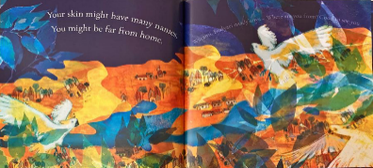 | Placement of the visual text is unclear and impacts the flow of the report. Positioning the visual text with the aligning body paragraph would have provided a clearer reading pathway.  The caption should identify the name of the text and the author. | Uses captions incorporating nouns and noun groups to summarise conceptual information: ‘… land and all living things on Earth.’

Feedback comment
This response presents a sound example of a multimodal report. There is a clear attempt to engage the reader through a range of visual and written codes and conventions such as subheadings, visual texts and written captions. The use of other multimodal features, such as pull quotes could have made it more engaging for the reader and have aided the composer in highlighting essential information to supports the reports' overall purpose.
The response has been composed using a thesis, ideas are supported by some relevant contextual and textual evidence, this helps to achieve the overall purpose. The report includes an introduction, body paragraphs and conclusion. The response is over the assigned word limit, and sentence structure and grammatical expression are not always sustained. Analysis and explanation of visual codes and conventions are varied throughout the text. Some parts demonstrate a thoughtful analysis and interpretation of codes and convention, and these are used to support the thesis.

The English curriculum 7-12 team
The English curriculum 7–12 team provides support for the delivery of the English curriculum 7–12 in NSW Department of Education high schools.

Share your experiences
If you use the sample assessment in your faculty and school context, reach out to the English curriculum team. We would love English teams form across NSW to share snapshots of their practice and how this resource has been used in their unique context as part of our ‘Voices from the Classroom’ section of the English 7–12 newsletter. Send submissions to english.curriculum@det.nsw.edu.au

Support and alignment
If you have any questions regarding the use of material available or would like additional support, please contact the English curriculum team by emailing English.curriculum@det.nsw.edu.au.
Alignment to system priorities and/or needs: School Excellence Policy, School Success Model.
Alignment to the School Excellence Framework: this resource supports the School Excellence Framework element of assessment (formative assessment, summative assessment, student engagement).
Alignment to Australian Professional Teaching Standards: this resource supports teachers to address Australian Professional Teaching Standards 5.1.2, 5.4.2.
Consulted with: subject matter experts within: Curriculum and Reform; Strategic Delivery; Literacy and Numeracy teams; Aboriginal Outcomes and Partnerships and Multicultural Education.
NSW Syllabus: English K–10 Syllabus © NSW Education Standards Authority (NESA) for and on behalf of the Crown in right of the State of New South Wales, 2022.
Syllabus outcomes: EN4-URA-01, EN4-URB-01 and EN4-ECA-01
Author: English curriculum 7–12 team
Resource: assessment task notification
Related resources: further resources to support Stage 4 English can be found on the English K–12 curriculum page. The Planning, programming and assessing 7–12 page provides an outline of essential and useful support materials for the design, delivery and evaluation of assessment practices. You might also wish to consult the Assessment principles section of the NESA website for advice, strategies and samples.
Creation date: 16 June 2023
Review date: 16 June 2024

References
This resource contains NSW Curriculum and syllabus content. The NSW Curriculum is developed by the NSW Education Standards Authority. This content is prepared by NESA for and on behalf of the Crown in right of the State of New South Wales. The material is protected by Crown copyright.
Please refer to the NESA Copyright Disclaimer for more information https://educationstandards.nsw.edu.au/wps/portal/nesa/mini-footer/copyright.
NESA holds the only official and up-to-date versions of the NSW Curriculum and syllabus documents. Please visit the NSW Education Standards Authority (NESA) website https://educationstandards.nsw.edu.au/ and the NSW Curriculum website https://curriculum.nsw.edu.au/home.
English K–10 Syllabus © NSW Education Standards Authority (NESA) for and on behalf of the Crown in right of the State of New South Wales, 2022.
Brookhart S (2018) ‘Appropriate Criteria: Key to Effective Rubrics’, Frontiers in Education, volume 3(22):1–12, doi:10.3389/feduc.2018.00022, accessed 16 February 2023.
CESE (Centre for Education Statistics and Evaluation) (2020) What works best in practice, NSW Department of Education, accessed 16 February 2023.
CESE (2020) What works best 2020 update, NSW Department of Education, accessed 16 February 2023.
Clay-Smith G (2022) ‘Visible’ [video], CApture, NSW Department of Education, accessed 16 June 2023.
Fisher D and Frey N (1 November 2009) ‘Feed Up, Back, Forward’, ASCD, 67(3) accessed 16 February 2023.
Jose_ugs (2008), Odette Krempin Charity Works [photograph] flickr website, accessed 16 June 2023.
Manuel J (2021) ‘Enabling students’ writing lives: a response to McGraw and Mason’s key paper’, in Literacy Learning: the Middle Years, 29:3, accessed October 2021.
McGraw A and Mason M (2021) ‘The formulaic essay and its power to de-fuse reading responses’, in Literacy Learning: the Middle Years, 29:3, accessed October 2021.
Seymour J (2022) Open Your Heart to Country, Magabala Books, Australia. Only reproduced as extracts and made available for copying and communication by NSW Department of Education for its educational purposes. This has been made possible as permission has been granted by Jasmine Seymour. This resource is licensed up until May 2026.

© State of New South Wales (Department of Education), 2023
The copyright material published in this resource is subject to the Copyright Act 1968 (Cth) and is owned by the NSW Department of Education or, where indicated, by a party other than the NSW Department of Education (third-party material).
Copyright material available in this resource and owned by the NSW Department of Education is licensed under a Creative Commons Attribution 4.0 International (CC BY 4.0) licence.
This licence allows you to share and adapt the material for any purpose, even commercially.
Attribution should be given to © State of New South Wales (Department of Education), 2023.
Material in this resource not available under a Creative Commons licence:
- the NSW Department of Education logo, other logos and trademark-protected material
- material owned by a third party that has been reproduced with permission. You will need to obtain permission from the third party to reuse its material.
Links to third-party material and websites
Please note that the provided (reading/viewing material/list/links/texts) are a suggestion only and implies no endorsement, by the New South Wales Department of Education, of any author, publisher, or book title. School principals and teachers are best placed to assess the suitability of resources that would complement the curriculum and reflect the needs and interests of their students.
If you use the links provided in this document to access a third-party's website, you acknowledge that the terms of use, including licence terms set out on the third-party's website apply to the use which may be made of the materials on that third-party website or where permitted by the Copyright Act 1968 (Cth). The department accepts no responsibility for content on third-party websites.

