English Stage 4 (Year 7) – core texts booklet
Seeing through a text
This document contains the core texts associated with the Year 7 teaching and learning program, ‘Seeing through a text’.
Contents
Overview of program 2 – seeing through a text 2
Rationale 2
Texts and resources 2
Core text 1 – Mirror by Jeannie Baker 4
Core text 2 – ‘Hermidale reaps a tonne of learning with crop’s harvest’ 14
Core text 3a – ‘Eurydice and the Tawny Frogmouth’ by Robert Adamson 16
Core text 3b – ‘Eurydice and the Tawny Frogmouth’ Paul Kelly 17
Core text 4 – Open Your Heart to Country by Jasmine Seymour 21
Core text 5 – Visible by Genevieve Clay-Smith 29
References 30

Updating the table of contents
Want to update the table? Have you added content to the document and noticed the page numbers have changed? As you add content to this report, you can update the table of contents to accurately reflect the page numbers within the resource. To update the table:
- Right click on the table and select ‘Update table of contents’ (in the browser version) or ‘Update field’ (in the desktop app). In the browser version, it will automatically update the entire table.
- In the desktop app, you will then need to select ‘Update entire table’. Your table numbers should then update to reflect your changes.

Overview of program 2 – seeing through a text
In this program, students explore how visual texts are constructed to position the reader. They investigate how the codes and conventions of visual texts are used to communicate ideas, issues and experiences. Students respond analytically and creatively to a range of visual forms, exploring and experimenting with the unique suggestive power of visual forms.

Rationale
This core texts resource booklet is created as a teacher resource. It provides the full version of core texts or the full excerpts that are licenced and explored in the Year 7 ‘Seeing through a text’ program. It is not a standalone resource. It has been designed for use by teachers in connection to Year 7 resources designed by the English curriculum team for the NSW English K–10 Syllabus (NESA 2022). Links contained within this resource were correct as of 20 June 2023.

Texts and resources
A succinct overview of the core texts provided in this booklet are outlined in the table below. This brief overview provides the name and details of each text and points of note about each text.
Table 1 – texts selected and their alignment to the text requirements
Text | Annotation or overview
Baker J (2010) Mirror, Walker Books, London, ISBN: 9781406309140 | This picture book uses exclusively visual language to explore the lives of 2 families – one living in Australia and one living in Morocco. There are interesting reading pathways to explore in this text and it includes different cultural perspectives. Through the study of this text, students will analyse how meaning is created and create personal, creative and critical texts for a range of audiences.
Jones V (19 December 2022) ‘Hermidale reaps a tonne of learning with crop’s harvest’, NSW Department of Education. | This news media report is a non-fiction digital text by an Australian composer that deals with youth and environmental themes. The text deals with primary school students learning about and actively participating in farming practices Throughout the study of this text, students will use a range of strategies to read texts and analyse how meaning is created.
Adamson R (2009) ‘Eurydice and the Tawny Frogmouth’ [poem].  Kelly P (2021) ‘Eurydice and the Tawny Frogmouth’ [song] [Music video directed by Sian Darling]. | This poem is created and performed by an Australian poet and artist. It explores nature and environment themes, with layered meanings about love, and includes a female protagonist. Themes are adapted for the music and visual forms with the intertextuality leading to interesting new meanings. Students will undertake activities to demonstrate their understanding of the text and how it communicates ideas, experiences and values to its audience.
Seymour J (2022) Open Your Heart to Country, Magabala Books, Broome, ISBN: 9781922613769 | This text is written from a Dharug perspective. It examines the deep relationship that Aboriginal and/or Torres Strait Islander peoples have with nature and the land. The accompanying book features striking visuals of the natural world and is told through a combination of Dharug and English languages, with several reading options available. Students will employ a variety of techniques to read and analyse text, while gaining insights into how meaning is crafted. Students will also showcase their comprehension on how the text represents concepts, encounters, and the values of Aboriginal and/or Torres Strait Islander cultures.  Teacher note: the teaching and learning program uses the spelling ‘Dharug’ as this is the spelling used in this picture book.
Clay-Smith G (2022) Visible, NSW Department of Education, CApture, Australia, accessed 19 June 2023. | This short film follows the storyline of a female student’s longing to belong and feel accepted by her peers. The various codes and conventions used in the text allows the audience to understand the student’s feeling of loneliness due to her diverse background. She strives to belong through changing her identity just so she can be visible and acknowledged by her peers. Through this text students will examine how visual and multimodal texts represent ideas, experiences and values of people with diverse backgrounds.

Core text 1 – Mirror by Jeannie Baker
Teacher note: one of the most interesting and unique aspects of this picture book is that it tells 2 different stories using dual reading paths. Extracts are provided here to illustrate and for use as part of analysis activities.
Jeannie Baker (2010). Mirror. Reproduced and made available for copying and communication by NSW Department of Education for its educational purposes, used with permission. This resource is licensed up until May 2027.

Figure 1 – Mirror double page extract
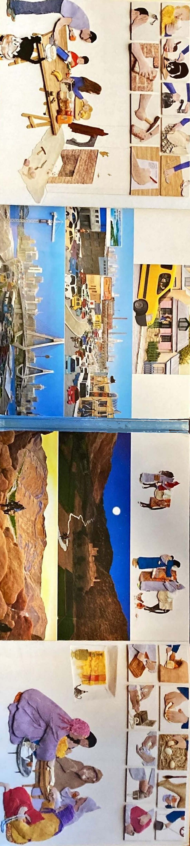
Figure 2 – Mirror extract 1(a)
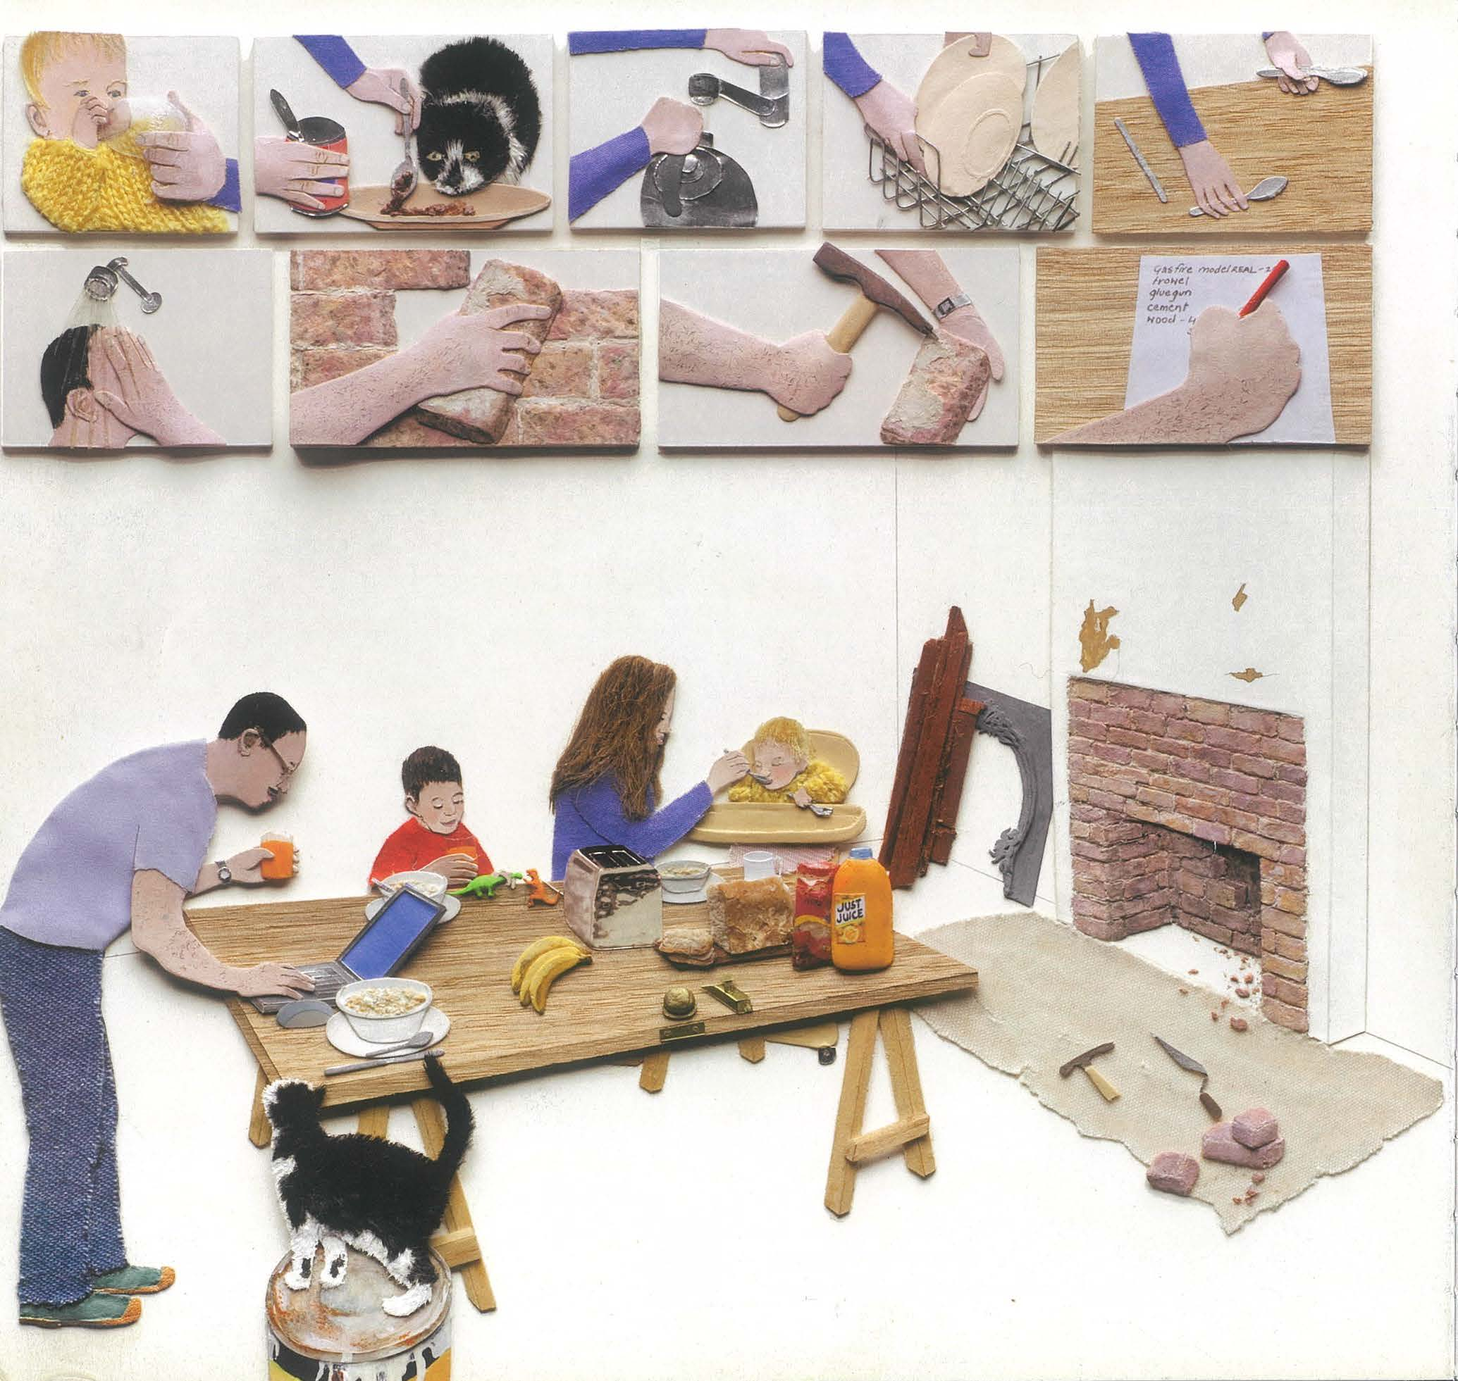

Figure 3 – Mirror extract 1(b)
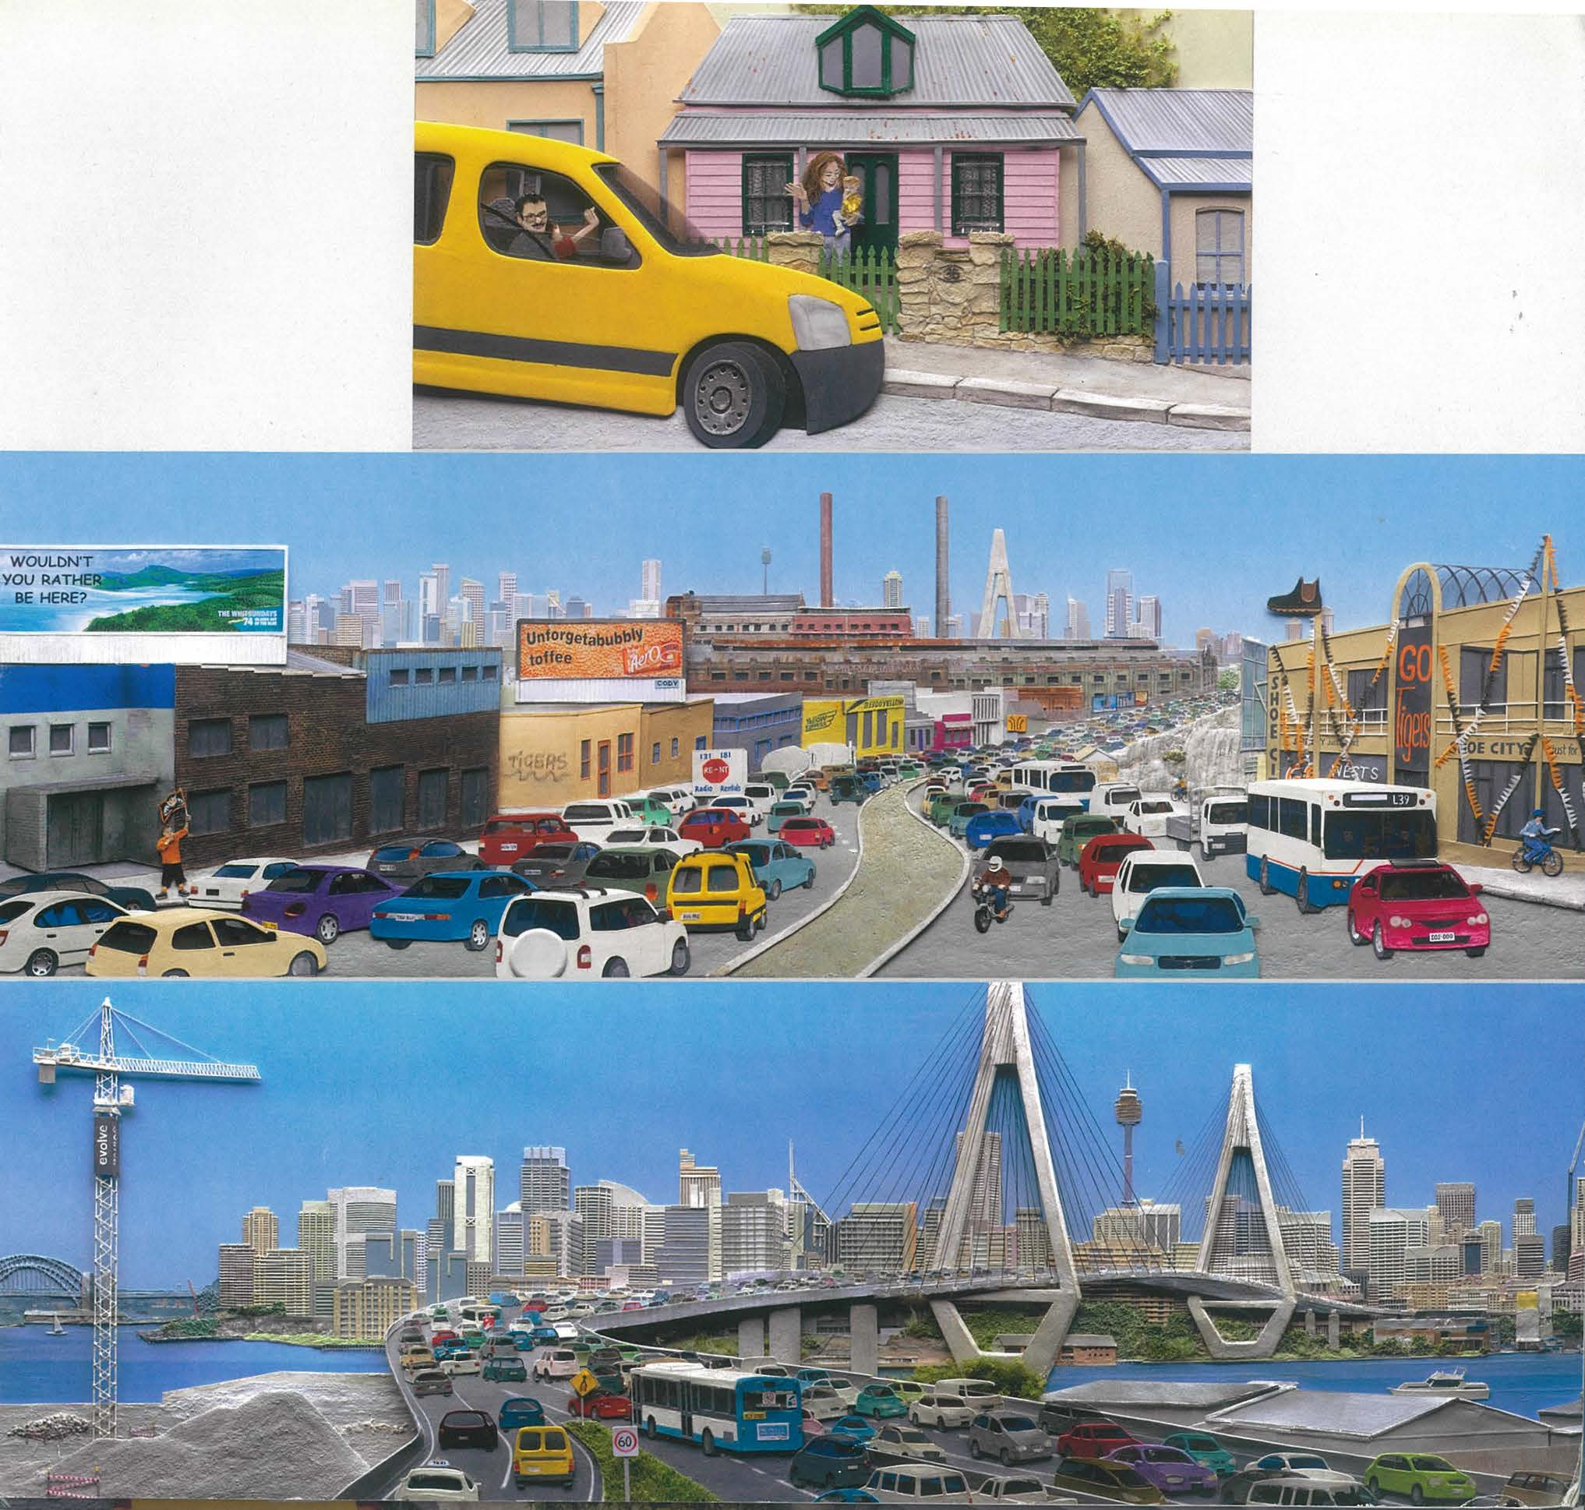
Figure 4 – Mirror extract 1(c)
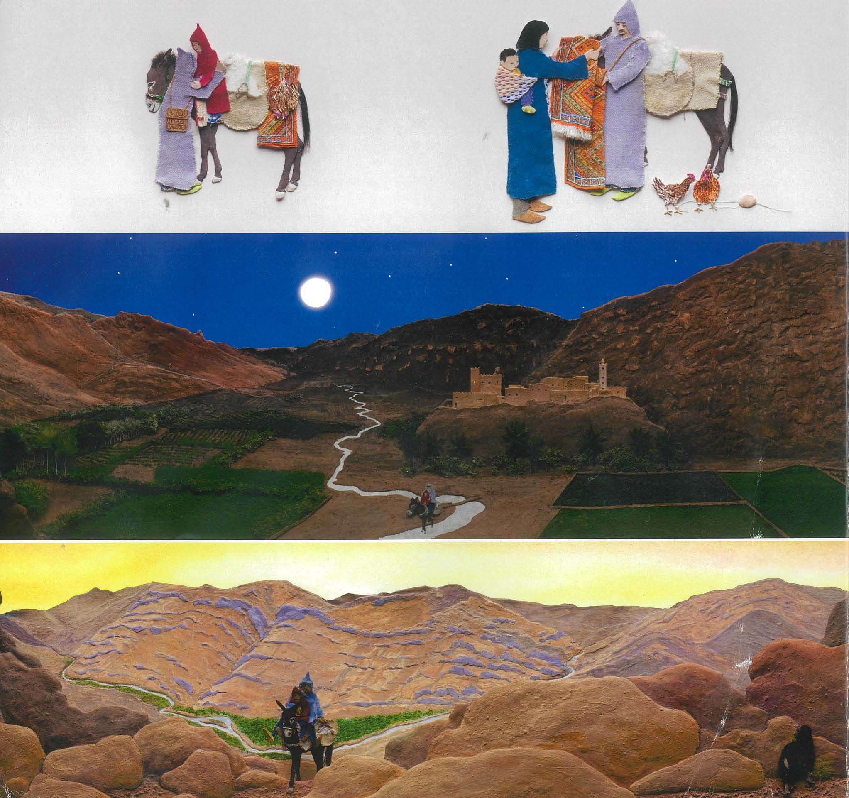
Figure 5 – Mirror extract 1(d)
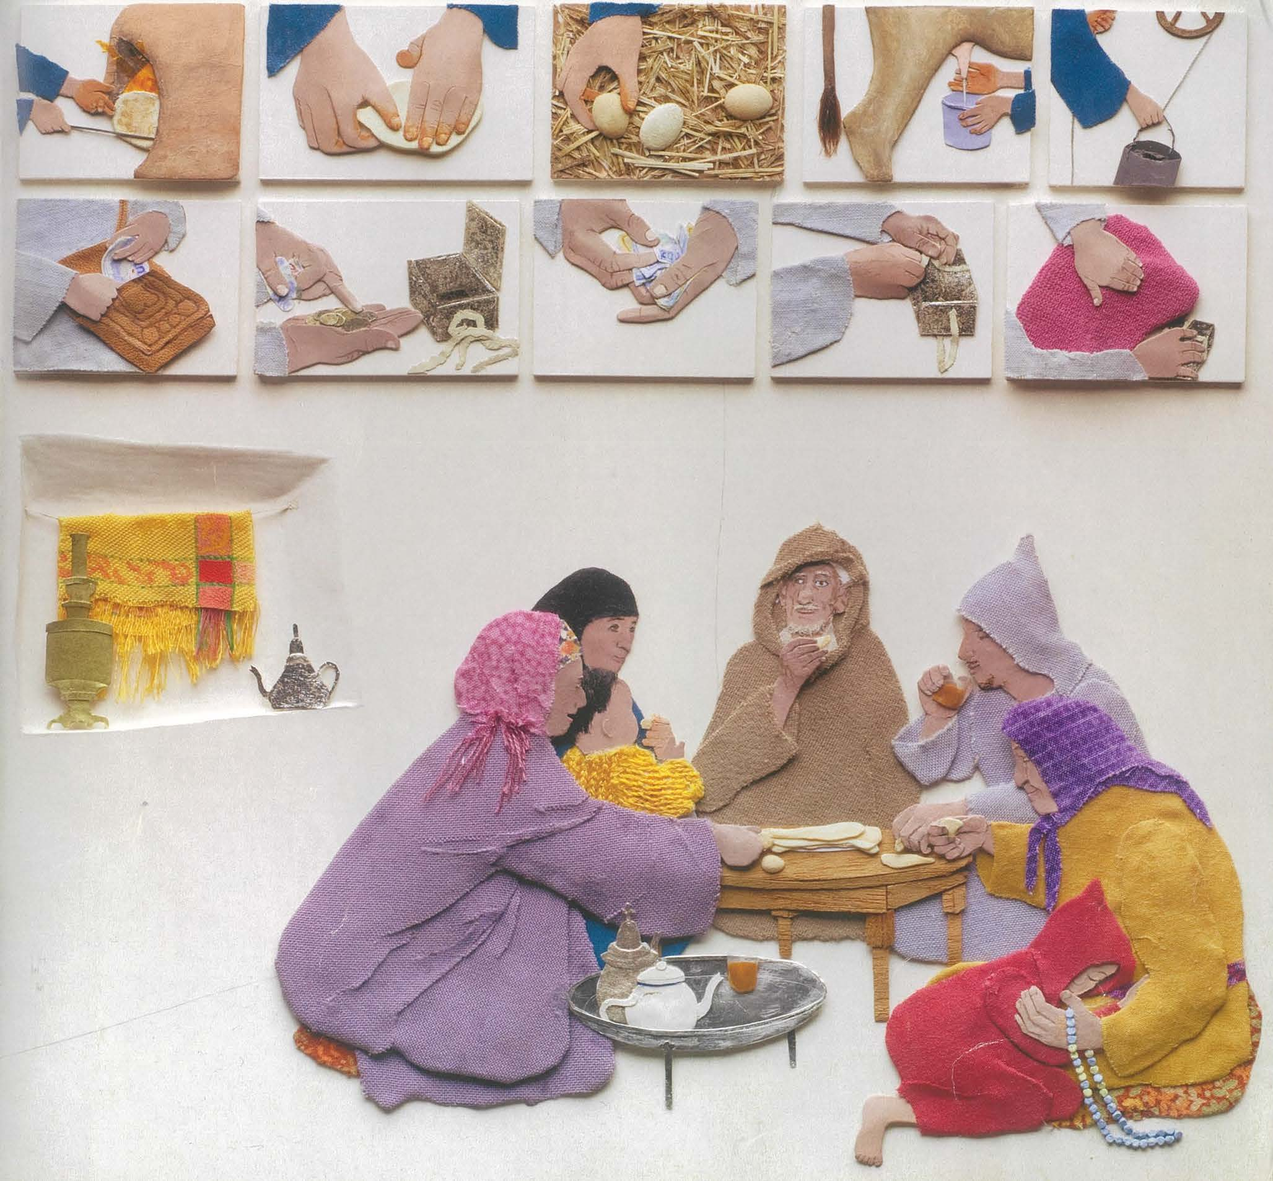
Figure 6 – Mirror extract 2(a)
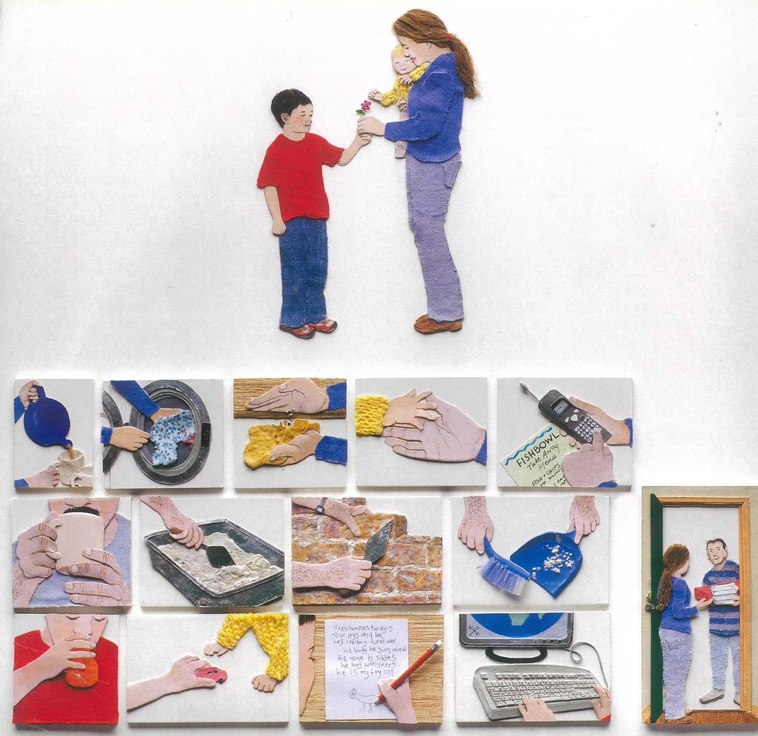
Figure 7 – Mirror extract 2(b)
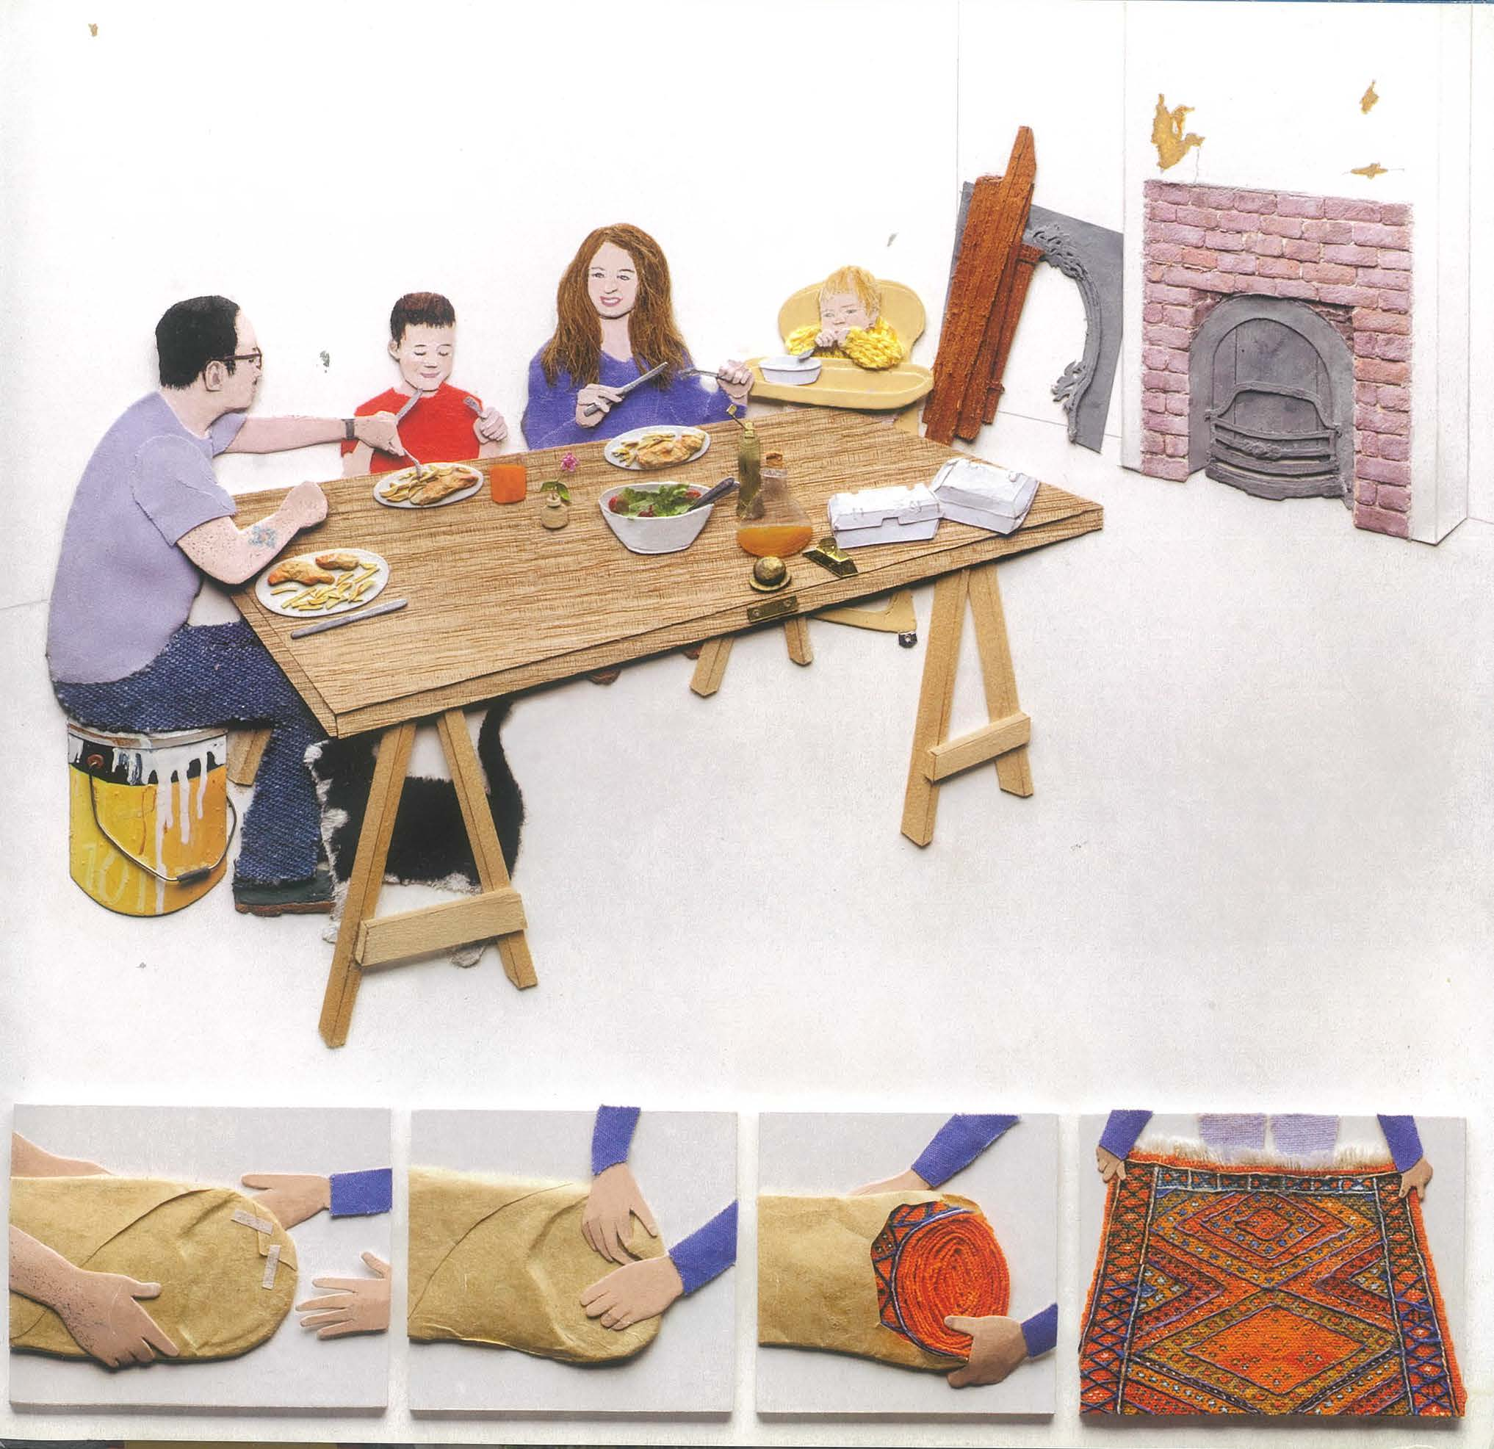
Figure 8 – Mirror extract 2(c)
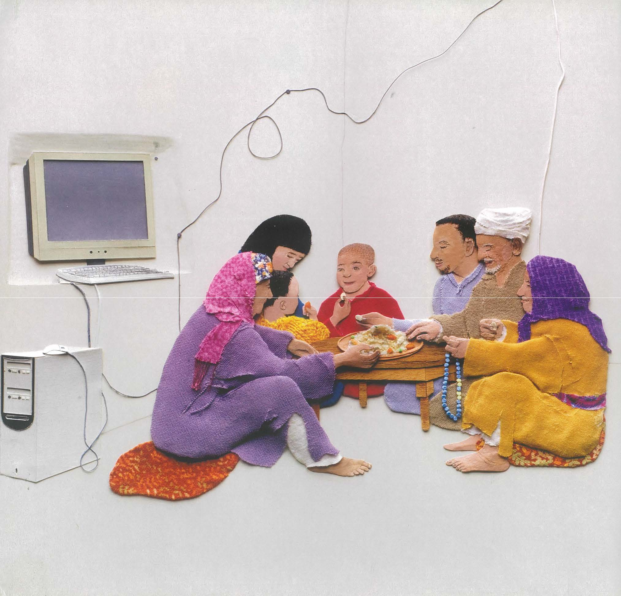
Figure 9 – Mirror extract 2(d)
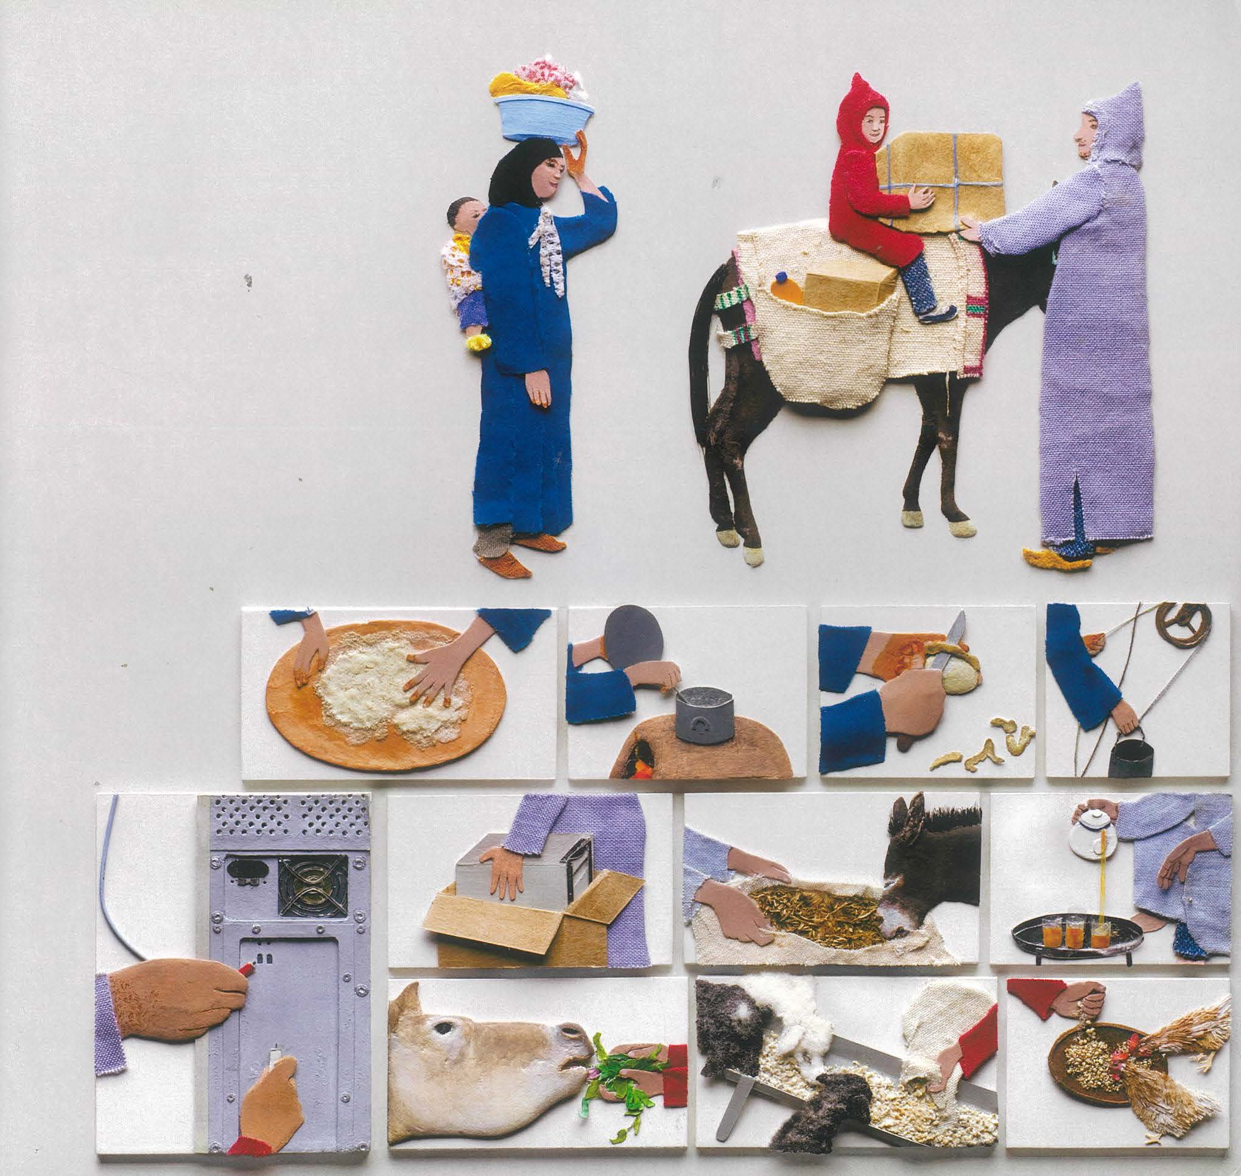

Core text 2 – ‘Hermidale reaps a tonne of learning with crop’s harvest’
Hermidale reaps a tonne of learning with crop’s harvest (Jones 2022)
The tiny school with the big plan to harvest 170 tonnes of wheat has reached its goal but isn’t stopping there. Vivienne Jones reports.
19 December 2022
From seed, to wheat, to flour, to pizza.
Ten students at the tiny school in the central west of the state have seen their crop come full circle in a future-farming project that has gone from strength to strength this year.
The Hermidale Future Farmers project finally reached its goal last month when its 85-hectare wheat crop was harvested and just a week later, they were watching their harvest turn into flour.
Principal Skye Dedman said the school could have never imagined the community interest in the project when they started in Term 1.
“You couldn’t predict the depth of knowledge the students were going to achieve when we started this,” she said.
“They have really taken ownership of the project and of their learning and you can see it coming through when they are talking to people about what they do at school.
“They are so proud of their efforts and so they should be.”
The group travelled two hours away to Dubbo recently with a tonne of wheat in tow after an invitation from Ben Furney Flour Mill.
“It was great to see the wheat being milled in a local mill and transformed into flour for us to use in this weekend’s cut-out party with pizza and bruschetta and pasta,” Mrs Dedman said.
“For the kids to see the whole process was really beneficial and they were excited to see it come out as 700 kilograms of flour.”
Harvest was a long-awaited day for not only the students, but also the staff and community members involved.
“We had about a week and a half of good, dry weather in the lead-up to harvest, so we were thrilled when one of our dads brought his whole harvest team to strip the crop,” Mrs Dedman said.
“There were two headers, two trucks and chaser bins and while the students couldn’t operate the machines, they enjoyed standing back and watching a couple of runs of the header.
“We then went to the grain receival site and they saw our grain being tested and then unloaded into the trucks.”
The innovative, cropping immersion project, which has been brewing in the school community for a few years, came to life at the beginning of the school year with the paddock being donated by a former student and local farmer.
“The kids have been really engaged in following the process from paddock to buyer and we will head to the port in Newcastle sometime in February to see our wheat being loaded for export,” Mrs Dedman said.
“The lovely thing about wheat is that it is a 10-month process.
“It has given us time to really engage in the scientific learning about the process, but also grow with the project as well.
“There has been a focus on the pre-learning, then to see it all happen and now we will go back into the paddock and put those learnings into practice with weed solutions and maintaining the moisture profile.
“The students’ work and learning doesn’t stop once the crop is harvested.
“It is a unique project, and we are seeing so much love and support from all over the country, including letters and messages from people who have seen the stories or heard about the project.
“We are really keen to go deeper into investigative projects and continue that learning into next year and beyond.”
The school has also been invited to visit Tanja Public School on the South Coast for a week next year as another excursion.
Jones V (2022). ‘Hermidale reaps a tonne of learning with crop’s harvest’, NSW Department of Education. Reproduced and made available for copying and communication by NSW Department of Education for its educational purposes, used with permission.

Core text 3a – ‘Eurydice and the Tawny Frogmouth’ by Robert Adamson
Eurydice and the Tawny Frogmouth (Adamson 2009)
On the low arch
above our gate,
he looks out
through a fringe
of feathers,
hunting,
then places one
foot on black
cast iron and ruffles
his head. His other
foot is clenched
in the night air,
held out
in an atmosphere
of waiting – then
unclenched.
Those nights
flying with you
weighed no more
or less than
this.
Robert Adamson (2009). ‘Eurydice and the Tawny Frogmouth’ in The Kingfisher’s Soul (p. 50). Bloodaxe Books. Reproduced and made available for copying and communication by NSW Department of Education for its educational purposes. This has been made possible as permission has been granted by Juno Gemes. This resource is licensed up until May 2026.

Core text 3b – ‘Eurydice and the Tawny Frogmouth’ Paul Kelly
The images included here are stills taken from the music video film clip. They are representative of the visual devices employed by the director to represent ideas in the original poem and audio version.
Figure 10 – still 1, close up
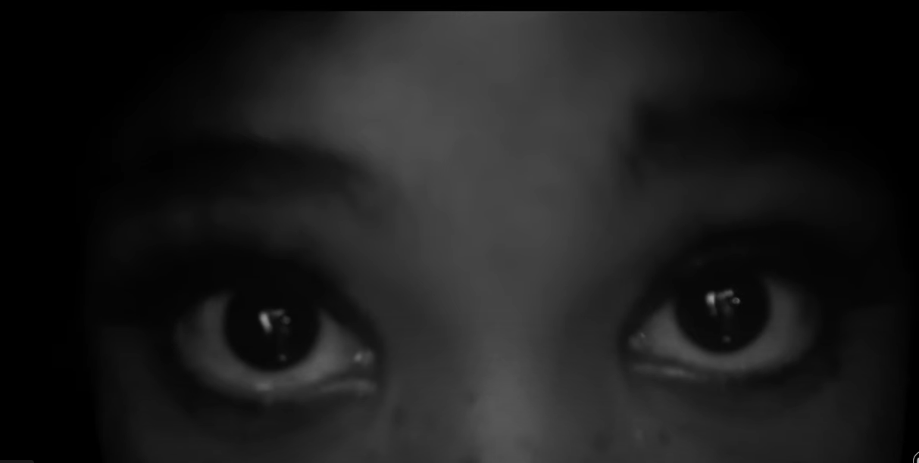
Figure 11 – still 2, long shot
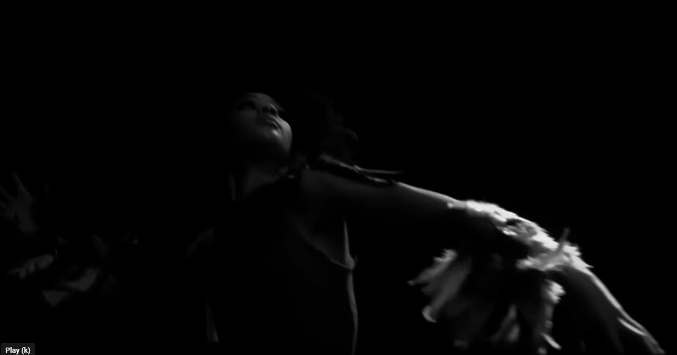
Figure 12 – still 3, close up of hand
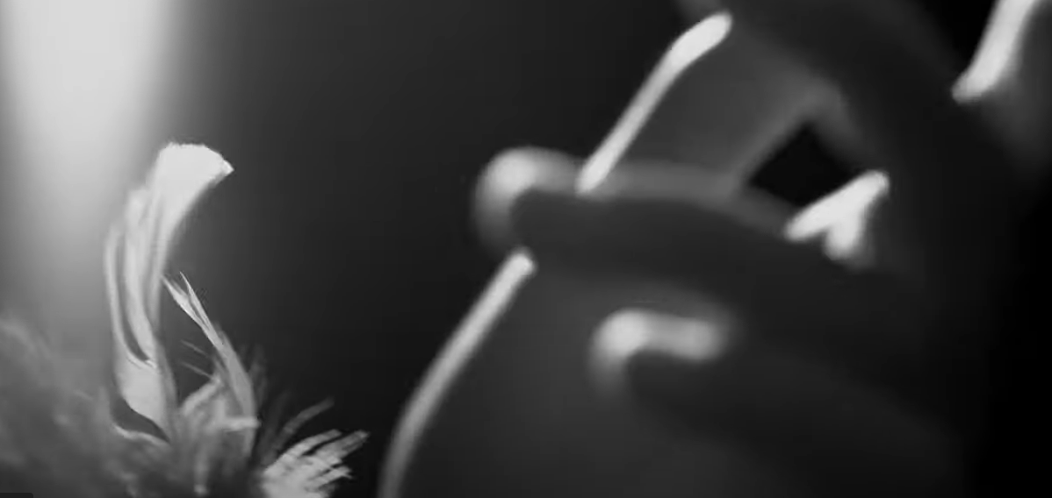
Figure 13 – still 4, close up of eyes with light from the rear.
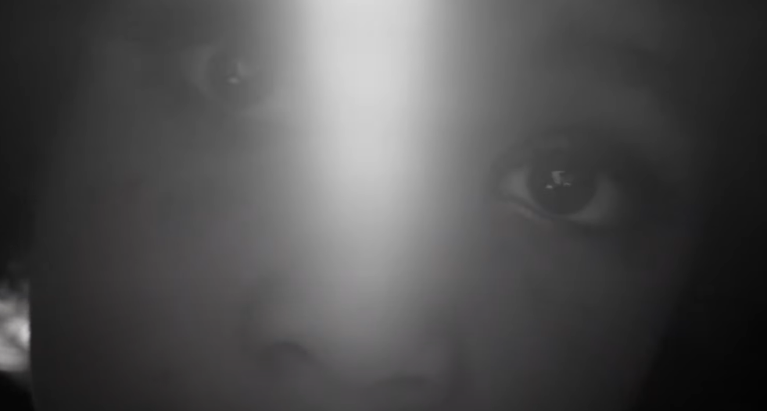
Figure 14 – still 5, gesture with hand.
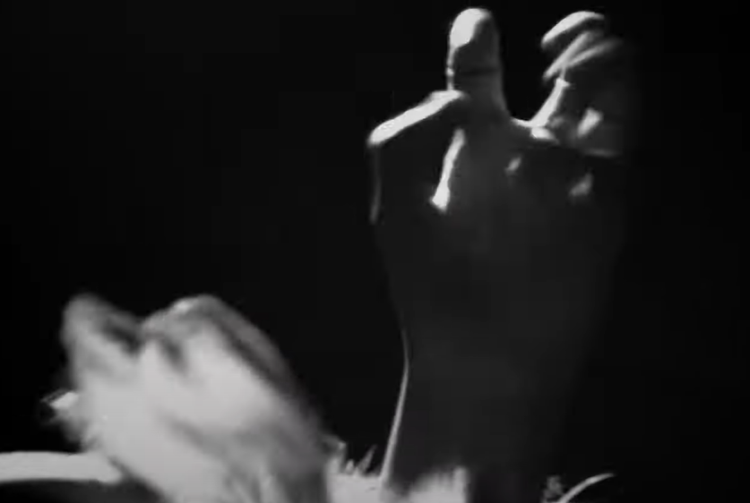
Figure 15 – still 6, zoom to close up and out of focus shot
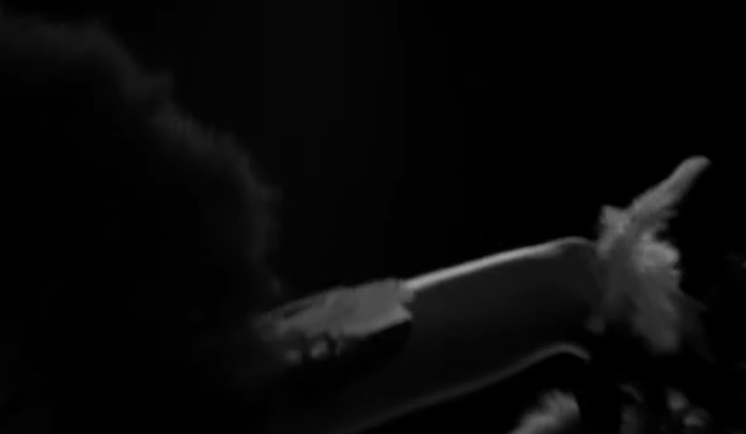
Figure 16 – still 7, light and shade in mid shot.
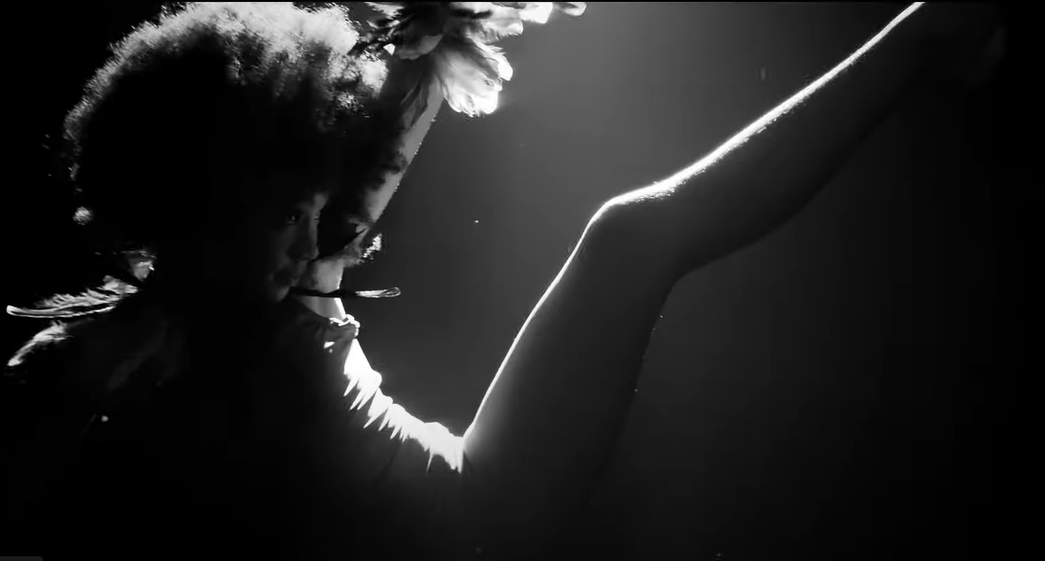
Figure 17 – still 8, framing and editing
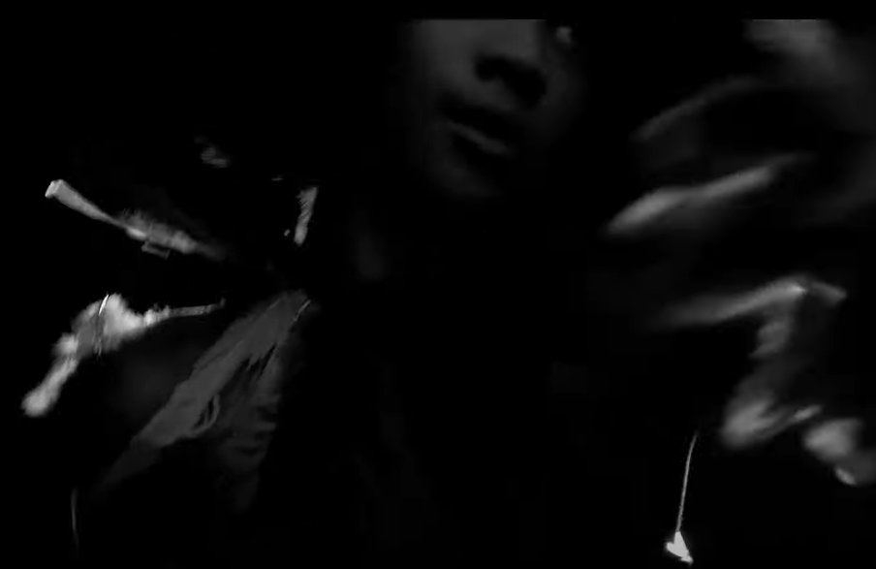
All images in this sequence – Paul Kelly (2022). ‘Eurydice and the Tawny Frogmouth’, stills from YouTube video (dir, Sian Darling). Sony Music Publishing/Golvan Arts Management. Reproduced and made available for copying and communication by NSW Department of Education for its educational purposes with the permission of One Louder on behalf of Paul Kelly. This resource is licensed up until May 2026.

Core text 4 – Open Your Heart to Country by Jasmine Seymour
Figure 18 – Open Your Heart to Country extract 1(a)
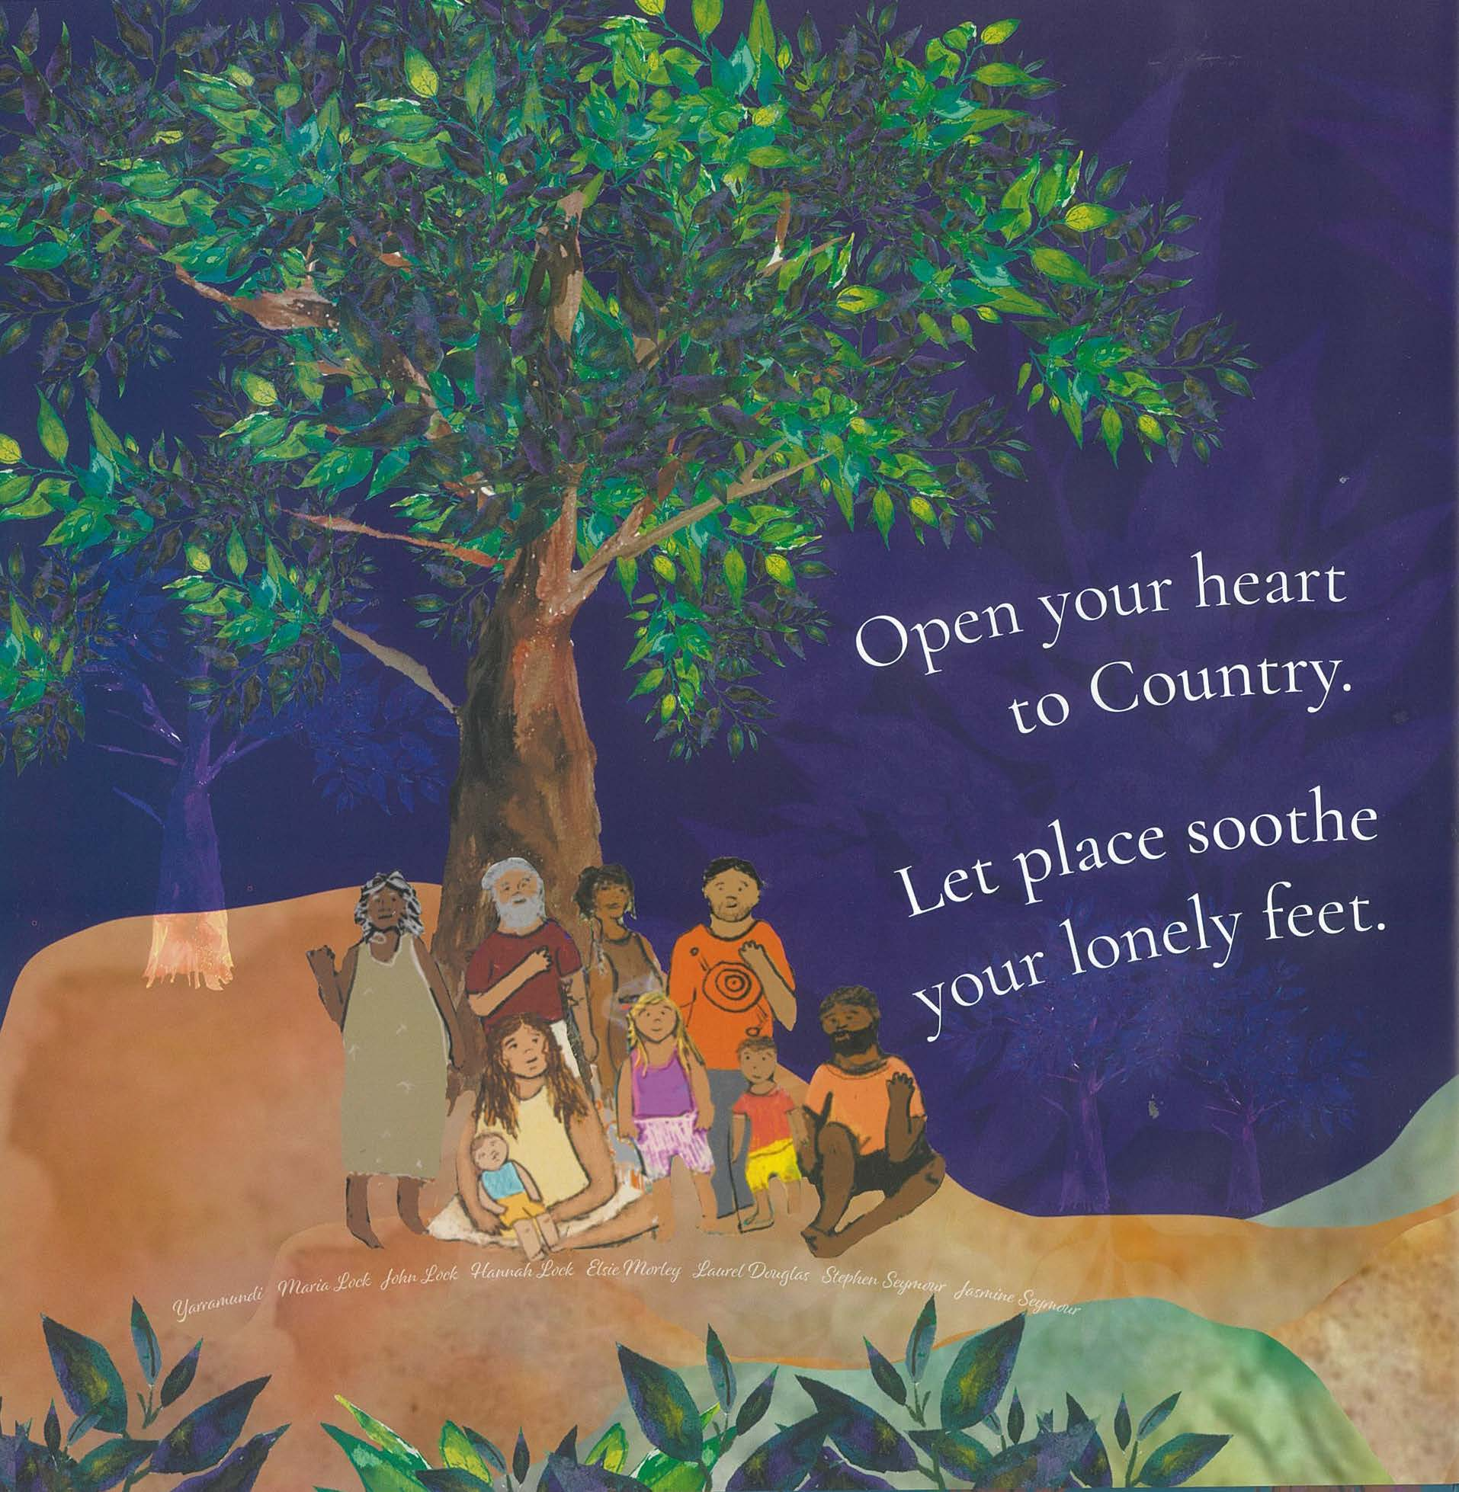

Figure 19 – Open Your Heart to Country extract 1(b)
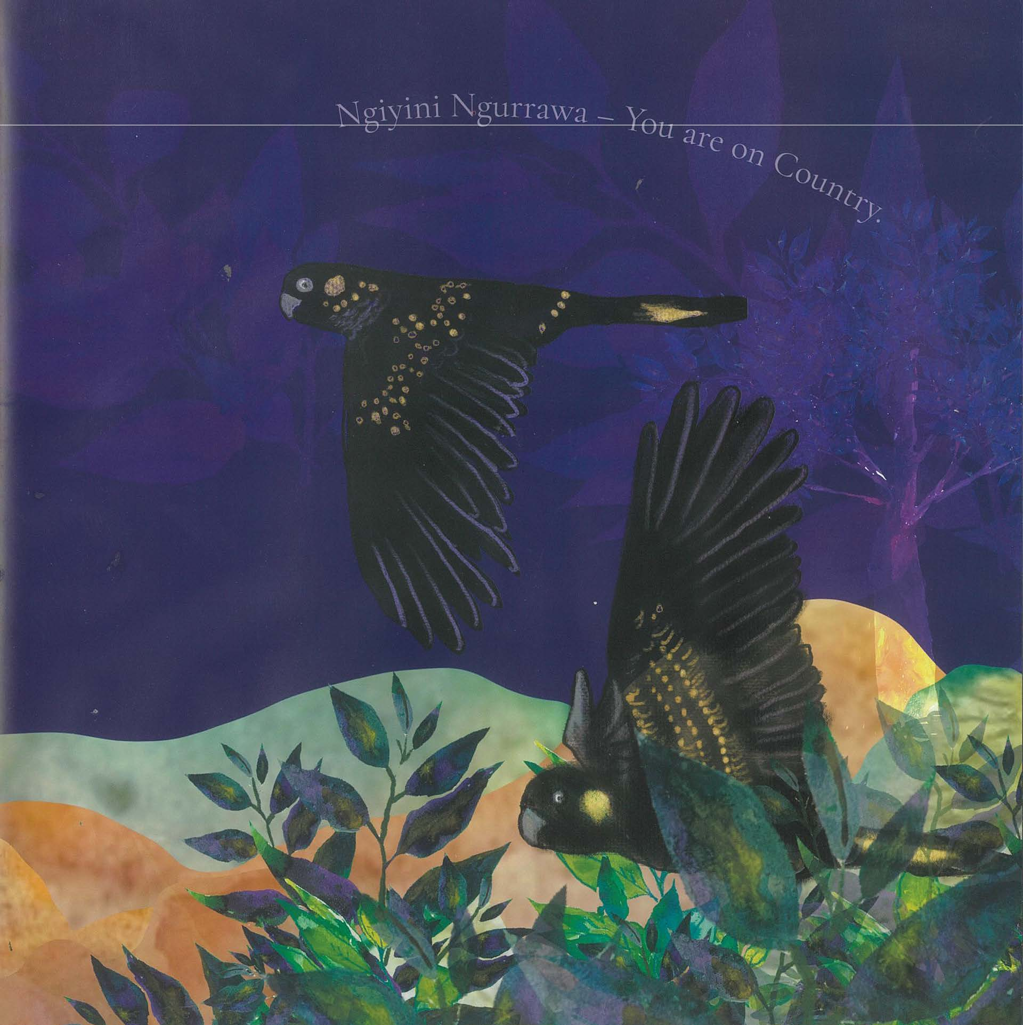
Figure 20 – Open Your Heart to Country extract 2(a)
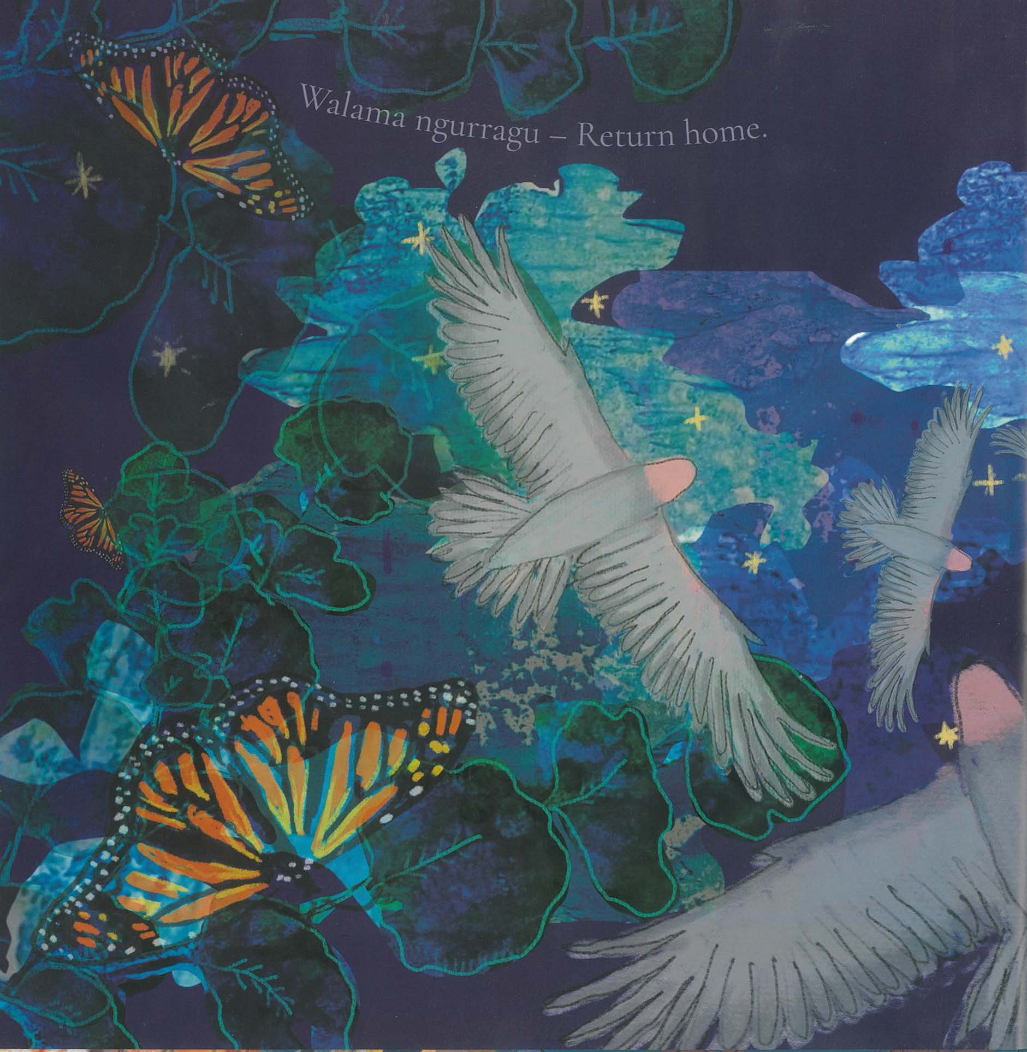
Figure 21 – Open Your Heart to Country extract 2(b)
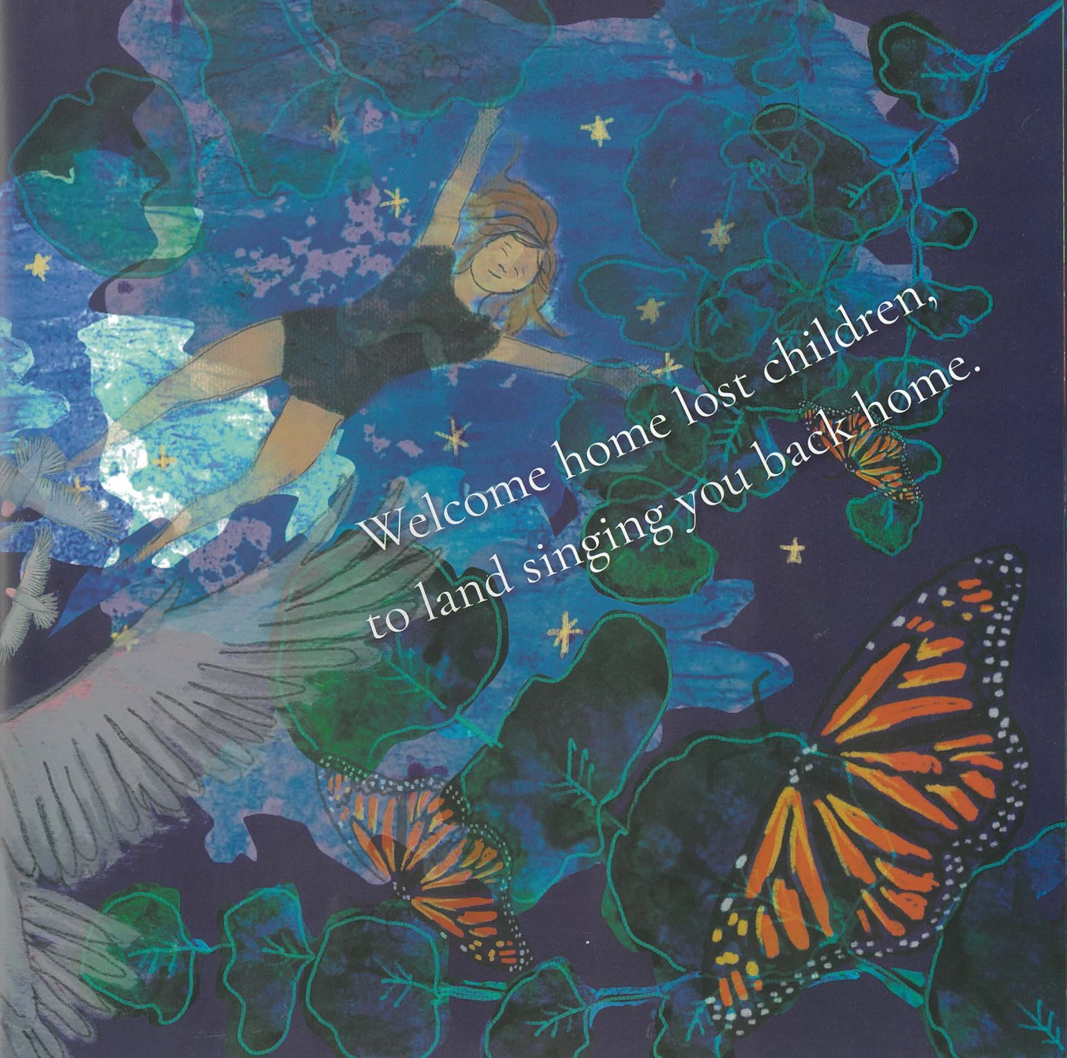
Figure 22 – Open Your Heart to Country extract 3(a)
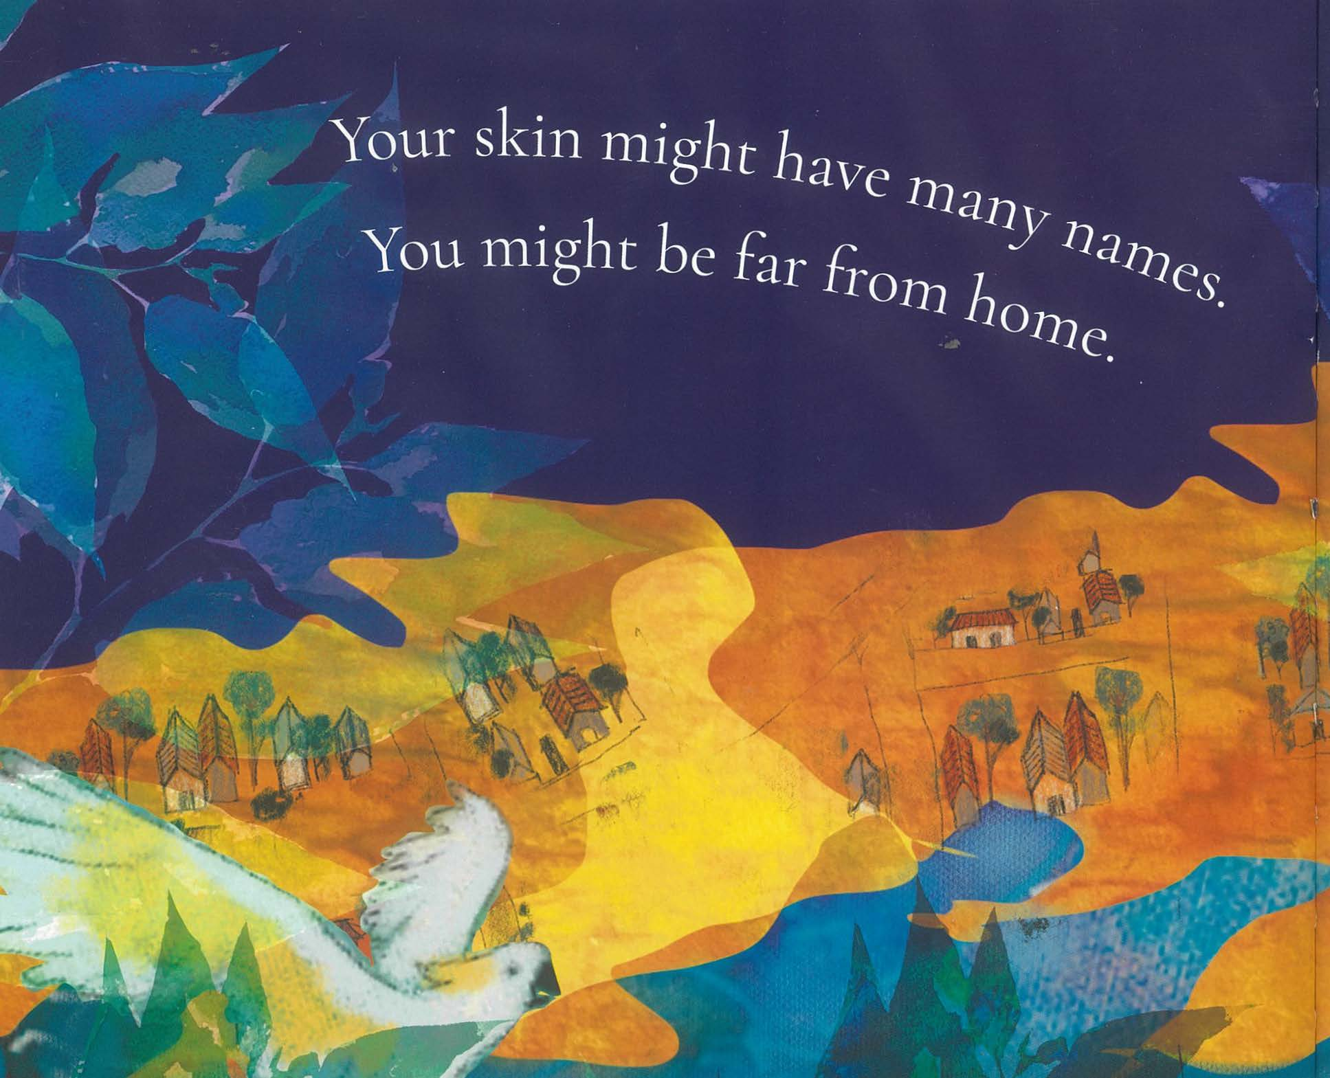
Figure 23 – Open Your Heart to Country extract 3(b)
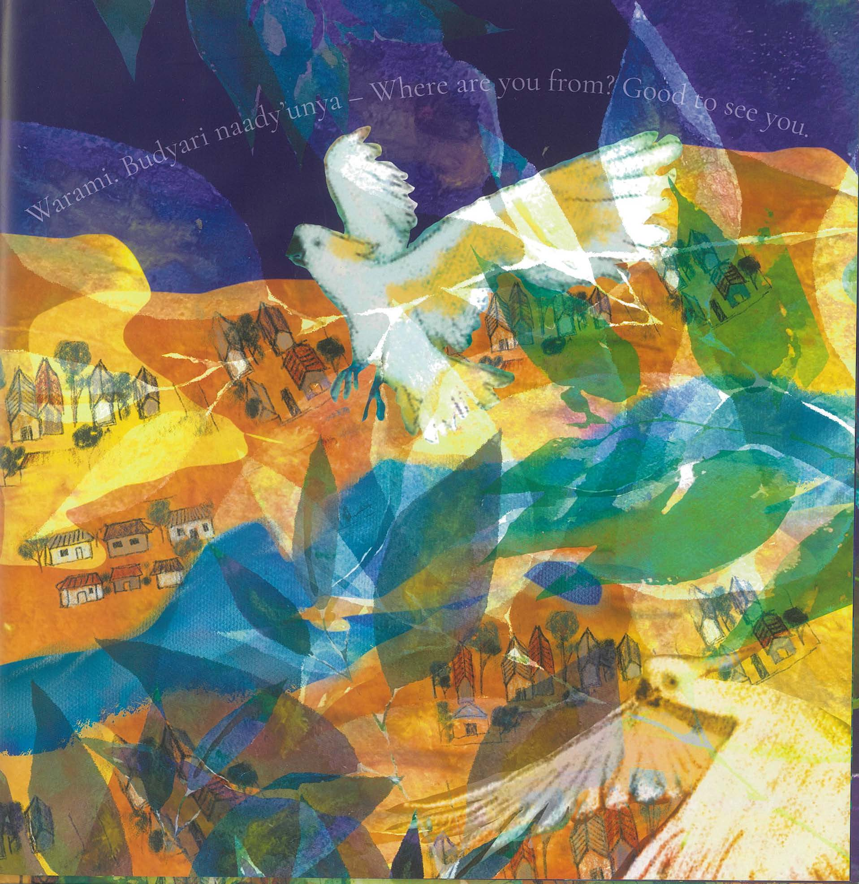
Figure 24 – Open Your Heart to Country extract 4(a)
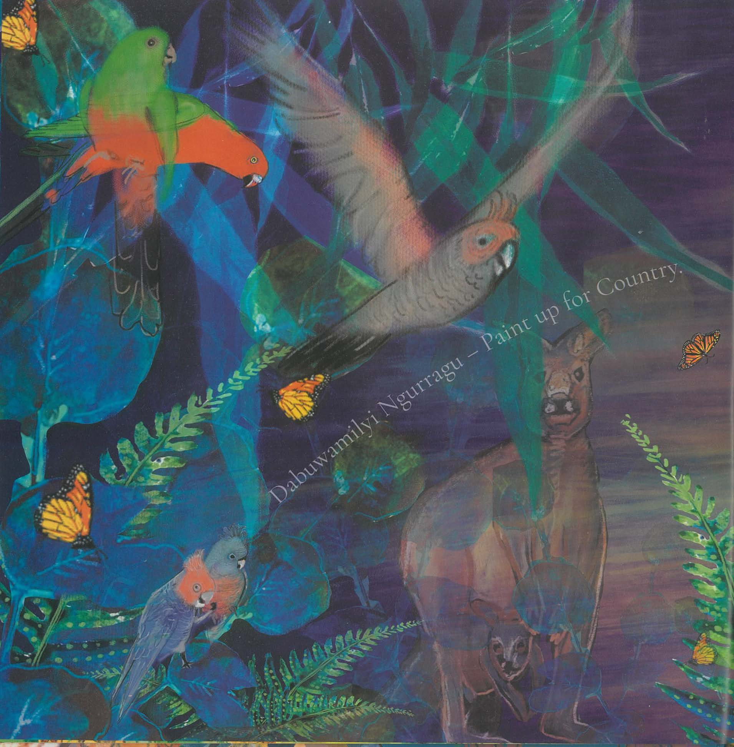
Figure 25 – Open Your Heart to Country extract 4(b)
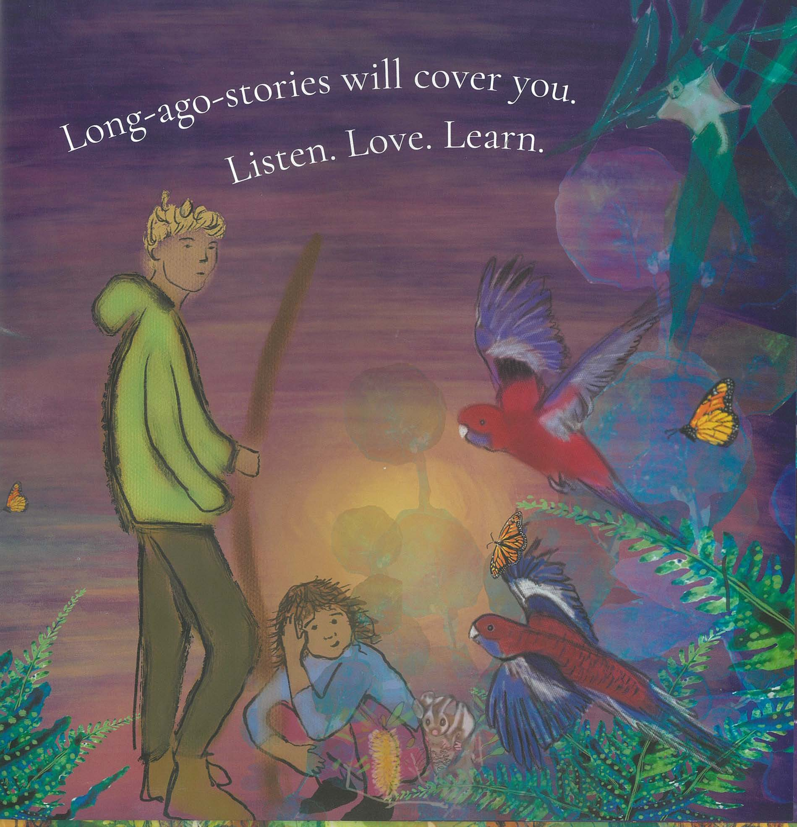
Jasmine Seymour (2022). ‘Open Your Heart to Country’. Only reproduced as extracts and made available for copying and communication by NSW Department of Education for its educational purposes, used with permission. This resource is licensed up until May 2026.

Core text 5 – Visible by Genevieve Clay-Smith
Visible can be accessed on the department’s website.
Genevieve Clay-Smith (2022). ‘Visible’ (short film), NSW Department of Education, CApture, accessed 19 June 2023. Reproduced and made available for copying and communication by NSW Department of Education for its educational purposes. This has been made possible as permission has been granted by CApture. This resource is licensed up until May 2026.

References
Adamson R (2009) ‘Eurydice and the tawny Frogmouth’, in The Kingfisher’s Soul, Bloodaxe Books, UK.
Baker J (2010) Mirror, Walker Books, Australia.
Clay-Smith G (director) (2022) Visible [short film], CApture, NSW Department of Education website, accessed 19 June 2023.
Jones V (19 December 2022) ‘Hermidale reaps a tonne of learning with crop’s harvest’, NSW Department of Education, accessed 13 March 2023.
Kelly P (30 July 2021) 'Paul Kelly with James Ledger, Alice Keath, Seraphim Trio - Eurydice and the Tawny Frogmouth' [video], Paul Kelly, YouTube, accessed 17 June 2023.
Seymour J (2020) Open Your Heart to Country, Magabala books, Australia.

© State of New South Wales (Department of Education), 2023
The copyright material published in this resource is subject to the Copyright Act 1968 (Cth) and is owned by the NSW Department of Education or, where indicated, by a party other than the NSW Department of Education (third-party material).
Copyright material available in this resource and owned by the NSW Department of Education is licensed under a Creative Commons Attribution 4.0 International (CC BY 4.0) license.
This license allows you to share and adapt the material for any purpose, even commercially.
Attribution should be given to © State of New South Wales (Department of Education), 2023.
Material in this resource not available under a Creative Commons license:
- the NSW Department of Education logo, other logos and trademark-protected material
- material owned by a third party that has been reproduced with permission. You will need to obtain permission from the third party to reuse its material.
Links to third-party material and websites
Please note that the provided (reading/viewing material/list/links/texts) are a suggestion only and implies no endorsement, by the New South Wales Department of Education, of any author, publisher, or book title. School principals and teachers are best placed to assess the suitability of resources that would complement the curriculum and reflect the needs and interests of their students.
If you use the links provided in this document to access a third-party's website, you acknowledge that the terms of use, including licence terms set out on the third-party's website apply to the use which may be made of the materials on that third-party website or where permitted by the Copyright Act 1968 (Cth). The department accepts no responsibility for content on third-party websites.

