English Stage 4 (Year 7) – resource booklet – Seeing through a text
This document contains the teaching and learning resources and activities that accompany the Year 7 teaching and learning program, ‘Seeing through a text’.
Contents
Key 4
About this resource 5
Purpose of resource 5
Target audience 5
When and how to use 5
Texts and resources 6
Phase 1 – engaging with the unit and the learning community 11
Phase 1, activity 1a – visual communication timeline 11
Phase 1, activity 1b – visual communication timeline 14
Phase 1, activity 2 – reflection questions 25
Phase 1, resource 1 – codes and conventions 25
Phase 1, resource 2 – digitally altered photographs 28
Phase 1, activity 3 – questions for consideration 28
Phase 1, resource 3 – metalanguage of visual texts 29
Core text 1 – Mirror by Jeannie Baker 34
Phase 1, resource 4 – sentence structure revision 34
Phase 1, resource 5 – review of Mirror by Jeannie Baker 35
Phase 1, activity 4 – complex sentences in action 35
Phase 1, resource 6 – complex sentences in action answers 37
Phase 1, activity 5 – exploring etymology 39
Phase 1, resource 7 – sample email to Jeannie Baker 44
Core formative task 1 – exploring how visual texts impact the way we tell and receive stories 44
Phase 2 – unpacking and engaging with the conceptual focus 48
Phase 2, resource 1 – teaching approaches 49
Core text 2 – news article from website 50
Phase 2, activity 1a – teacher facing adjusted activities 50
Phase 2, activity 1b – student facing adjusted activities 51
Phase 2, activity 2 – extension and independent analysis 53
Phase 2, resource 2 – news websites 55
Phase 2, resource 3 – passive and active voice 55
Phase 2, resource 4 – critical and creative thinking strategies 56
Phase 2, resource 5 – advertising campaigns, social media and websites 57
Phase 2, resource 6 – codes and conventions of persuasive visual texts 59
Phase 2, resource 7 – best practice in assessment procedures 60
Phase 2, activity 3 – exploring the assessment notification 61
Phase 2, resource 8 – introducing the fictional task context 63
Core formative task 2 – writing in response to stimulus 63
Phase 2, resource 9 – process writing 64
Phase 3 – discovering and engaging analytically with core texts 66
Phase 3, resource 1 – descriptive caption 66
Phase 3, activity 1a – teacher facing adjusted activities 68
Phase 3, activity 1b – student facing adjusted activities 69
Phase 3, activity 2 – sketch to stretch 70
Core text 3a – ‘Eurydice and the Tawny Frogmouth’ by Robert Adamson 74
Phase 3, resource 2 – allusion to Eurydice 74
Phase 3, activity 3 – parts of speech 74
Phase 3, activity 4 – analytical writing 76
Phase 3, activity 5 – visual imagery and emotions 78
Core text 3b – Phase 3, activity 6 – visual devices in the music video 79
Phase 3, activity 7 – critical and creative thinking 82
Core formative task 3 – informative writing: explain how you will make a music video 85
Phase 4 – deepening connections between texts and concepts 86
Phase 4, activity 1 – scaffolding peer discussion 87
Phase 4, activity 2 – audience and purpose quadrant analysis 87
Phase 4, resource 1 – Aboriginal iconography: glossary 89
Phase 4, resource 2 – Aboriginal iconography: informative text 89
Phase 4, activity 3 – cause and effect sentences 90
Phase 4, resource 3 – protocols for teaching Aboriginal and/or Torres Strait Islander texts 92
Core text 4 – Open Your Heart to Country by Jasmine Seymour 95
Phase 4, activity 4 – exploring vocabulary 95
Phase 4, activity 5 – exploring word meaning of ‘values’ 96
Phase 4, activity 6 – Aboriginal and/or Torres Strait Islander languages 97
Phase 4, activity 7 – figurative language in the core text 98
Phase 4, resource 4 – figurative language responses 99
Phase 4, resource 5 – annotated extracts from the core text 101
Core text 5 – Visible by Genevieve Clay-Smith 102
Phase 4, activity 8 – three level guide for Visible 102
Phase 4, activity 9 – film metalanguage information gap activity 103
Phase 4, resource 6 – film metalanguage information gap answers 106
Phase 4, activity 10 – theme or plot? 109
Phase 4, activity 11 – connecting texts thematically 109
Core formative task 4 – writing analytically about theme 110
Phase 5 – engaging critically with model texts 112
Phase 5, activity 1 – guided exploration of a multimodal text 113
Phase 5, resource 1 – the features of multimodal texts 114
Phase 5, resource 2 – model multimodal text 2 115
Phase 5, activity 2 – layout of a multimodal text 116
Phase 5, resource 3 – elaboration and description within accompanying written text to an image 117
Phase 5, activity 3 – analysing and experimenting 122
Core formative task 5 – informative accompanying text 123
Phase 6 – preparing the assessment task 125
Phase 6, resource 1a – assessment notification glossary 125
Phase 6, activity 1a – crafting a thesis 129
Phase 6, resource 1b – annotating a text 131
Phase 6, activity 1b – critical thinking for analytical writing 132
Phase 6, activity 1c – Seldon method: bubble theory 132
Phase 6, activity 2 – gathering and selecting texts 135
Phase 6, resource 2 – assessment task scaffold 138
Phase 6, activity 3 – supporting the thesis 142
Core formative task 6 – improving student sample response 149
Phase 6, resource 3 – informative report for government ministers of Anahit 149
Sample response – Earth: time to start over 150
Introduction 150
Environmental challenges 150
Phase 6, activity 4 – features of an informative report jigsaw 153
Core formative task 7 – analytical paragraph 155
References 157

Updating the table of contents
Want to update the table? Have you added content to the document and noticed the page numbers have changed? As you add content to this report, you can update the table of contents to accurately reflect the page numbers within the resource. To update the table:
- Right click on the table and select ‘Update table of contents’ (in the browser version) or ‘Update field’ (in the desktop app). In the browser version, it will automatically update the entire table.
- In the desktop app, you will then need to select ‘Update entire table’. Your table numbers should then update to reflect your changes.

Key
Understanding this document:
Text in blue feature boxes – additional information related to the research background for strategies aimed at the classroom teacher engaging with the resource. This may be deleted or adjusted by the teacher as needed.
Text in pink feature boxes – instructions directed as a student note. Teachers may adjust these based on their students’ interests, needs and abilities.
Resources provide additional information or support for teachers to be able to implement strategies. This may include explanations of key principles and terminology used in the program.
Activities provide examples, scaffolds and instructions to support teaching and learning activities in the program.

About this resource

Purpose of resource
This resource booklet is not a standalone resource. It has been designed for use by teachers in connection to Year 7 resources designed by the English curriculum team for the English K–10 Syllabus (NESA 2022). These include the Year 7 scope and sequence, Stage 4 syllabus planner, Year 7 ‘Seeing through a text’ program and the Year 7 Term 2 sample assessment task, which includes a student work sample.
The content in this resource booklet has been prepared by the English curriculum team, unless otherwise credited. Some of the information is collated from relevant NESA and department documentation. It is important that all users re-read and cross-reference the relevant syllabus, assessment and reporting information hyperlinked throughout. This ensures the content is an accurate reflection of the most up to date syllabus content. Links contained within this resource were correct as of 15 June 2023.

Target audience
These samples are intended to support teachers as they develop contextually appropriate teaching and learning resources for their students’ needs. The program and associated resources are not intended to be taught exactly as is presented in their current format. There are instructions for the teacher and instructions for the student throughout the resources and activities. Teachers using this resource booklet should edit and refine these to suit their students’ needs, interests, abilities and the texts selected.

When and how to use
This teaching and learning resource booklet is designed for Term 2 of Year 7. It provides opportunities for students to learn about how and why visual texts are constructed to impact a responder. The resources can be used as an example and adapted for the teacher’s own design of resources. The booklet also serves as an example of how resources and activities can be designed for the English K–10 Syllabus (NESA 2022). The resources should be used with timeframes that are created by the teacher to meet the faculty and school assessment schedules.

Texts and resources
A succinct overview of the texts required for the teaching and learning program are outlined in the table below. This brief overview provides the name and details of each text, the syllabus requirement being addressed and points of note.
Table 1 – core texts and their alignment to the text requirements
Text | Text requirement | Annotation or overview
Baker J (2010) Mirror [picture book] (2010), Walker Books, London ISBN: 9781406309140. | This picture book is a moderately complex text as per the National Literacy and Numeracy Learning Progressions (NLLP) (V3) in that it requires students to reflect on the concepts of connotation, imagery and symbolism, word-level language and code and convention. EN4-RVL-01 requires students to read texts that are complex in their ideas and construction. The text helps meet the Text requirements for English 7–10: engage meaningfully with visual texts by a prominent Australian children’s author and artist, and explores a range of cultural and social perspectives. | This picture book uses exclusively visual language to explore the lives of 2 families – one living in Australia and one living in Morocco. There are interesting reading pathways to explore in this text and it includes different cultural perspectives.  Through the study of this text, students will analyse how meaning is created and create personal, creative and critical texts for a range of audiences.
Jones V (19 December 2022) ‘Hermidale reaps a tonne of learning with crop’s harvest’ NSW Department of Education [article on a website]. | This news media report is a moderately complex text as per the NLLP (V3) in that it requires students to reflect on the concepts of representation and code and convention. EN4-RVL-01 requires students to read texts that are complex in their ideas and construction. The text helps meet the Text requirements for English 7–10: engage meaningfully with a range of types of texts inclusive of multimodal and digital texts and gives students experiences of a range of fiction and non-fiction texts. | This news media report is a non-fiction digital text by an Australian composer that deals with primary school students learning about and actively participating in farming practices.  Through the study of this text, students will use a range of strategies to read texts and analyse how meaning is created.
Adamson, R ‘Eurydice and the Tawny Frogmouth’ [poem].  Kelly P (2021) ‘Eurydice and the Tawny Frogmouth’ [Song] [Music video directed by Sian Darling]. | This poem is a complex text as per the NLLP (V3) in that it requires students to reflect on the concepts of theme and connotation, imagery and symbolism. EN4-RVL-01 requires students to read texts that are complex in their ideas and construction.  The poem helps meet the Text requirements for English 7–10: engage meaningfully with quality literature by Australian authors and explore types of texts inclusive of short prose, visual, spoken, multimodal and digital texts. The song and music video version are both composed by Australian artists. | This poem is by an Australian poet. It explores themes about the environment and nature with an inferred representation of love. These themes are adapted in the song and visual forms with the intertextuality creating new meanings.  Students will undertake activities to demonstrate their understanding of the text and how it communicates ideas, experiences and values to its audience.
Seymour J (2022) Open Your Heart to Country (picture book), Magabala Books, Broome, ISBN: 9781922613769. | This picture book is a moderately complex text as per the NLLP (V3) in that it requires students to reflect on the concepts of perspective, representation and connotation, imagery and symbol. EN4-RVL-01 requires students to read texts that are complex in their ideas and construction.  This book helps meet the Text requirements for English 7–10: engage meaningfully with visual texts by Aboriginal and Torres Strait Islander authors. | This text is written from a Dharug perspective. It examines the deep relationship that Aboriginal and/or Torres Strait Islander peoples have with nature and the land. The accompanying book features striking visuals of the natural world and is told through a combination of Dharug and English languages, with several reading options available. Students will employ a variety of techniques to read and analyse text, while gaining insights into how meaning is crafted. Students will also showcase their comprehension on how text represents concepts, encounters, and the values of Aboriginal and/or Torres Strait Islander cultures.  Teacher note: the teaching and learning program uses the spelling ‘Dharug’ as this is the spelling used in this picture book.
Clay-Smith G (2022) Visible [short film], NSW Department of Education, CApture, Australia, accessed 19 June 2023. | This short film is a complex text as per the NLLP (VS) in that it uses structural features to enhance meaning and it contains unique structural elements that may disrupt meaning for novice readers. The text requires students to reflect on complex and abstract ideas and the concepts of theme and codes and conventions. EN4-RVL-01 requires students to read texts that are complex in their ideas and construction; on balance, this film mostly meets the criteria for a complex text.  The short film helps meet the Text requirements for English 7–10: engage meaningfully with multimodal and digital texts that demonstrate diverse experiences. | This short film follows the storyline of a female student’s longing to belong and feel accepted by her peers. The various codes and conventions used in the text allows the audience to understand the student’s feeling of loneliness due to her diverse background. She strives to belong through changing her identity just so she can be visible and acknowledged by her peers.  Through this text, students will examine how visual and multimodal texts represent ideas, experiences and values of people with diverse backgrounds.
Jeannie Baker (2010). Mirror. Reproduced and made available for copying and communication by NSW Department of Education for its educational purposes, used with permission. This resource is licensed up until May 2027.
Vivienne Jones (2022). ‘Hermidale reaps a tonne of learning with crop’s harvest’, NSW Department of Education. Reproduced and made available for copying and communication by NSW Department of Education for its educational purposes, used with permission.
Robert Adamson (2009). ‘Eurydice and the Tawny Frogmouth’ in The Kingfisher’s Soul (p. 50). Bloodaxe Books. Reproduced and made available for copying and communication by NSW Department of Education for its educational purposes. This has been made possible as permission has been granted by Juno Gemes. This resource is licensed up until May 2026.
Paul Kelly (2022). ‘Eurydice and the Tawny Frogmouth’, stills from YouTube video (dir, Sian Darling). Sony Music Publishing/Golvan Arts Management. Reproduced and made available for copying and communication by NSW Department of Education for its educational purposes with the permission of One Louder on behalf of Paul Kelly. This resource is licensed up until May 2026.
Jasmine Seymour (2022). Open Your Heart to Country. Only reproduced as extracts and made available for copying and communication by NSW Department of Education for its educational purposes, used with permission. This resource is licensed up until May 2026.
Genevieve Clay-Smith (2022). ‘Visible’ (short film), NSW Department of Education, CApture, accessed 19 June 2023. Reproduced and made available for copying and communication by NSW Department of Education for its educational purposes. This has been made possible as permission has been granted by CApture. This resource is licensed up until May 2026.

Phase 1 – engaging with the unit and the learning community
The focus of this phase is for students to engage personally with a range of model visual texts to create interest and enthusiasm for the program. Students engage with visual texts to consider how they convey stories, explore ideas, and evoke emotional responses. They consider multiple ways of ‘reading’ a visual text and how and why varied interpretations of the same text can arise. Students begin to explore how visual texts can be constructed to position the responder. They develop an awareness of and appreciation for the ways in which visual language is used across contexts. Students are introduced to the codes and conventions of visual texts. They begin building knowledge of the metalanguage essential for discussing the texts they are exploring. Literacy activities are embedded throughout the phase to support students to develop and refine their informative writing skills.
The teacher draws upon students’ prior experiences with visual texts in their everyday lives such as film, video games and social media to begin building an understanding of the significance of visual texts and popular culture.

Phase 1, activity 1a – visual communication timeline
- Arrange the following images in a timeline to represent the evolution of visual communication. Provide a short justification explaining your choice for each image.
Teacher note: in preparation for this activity, the visual texts should be printed separately with the citations removed so that students must rely on engaging with the visuals to complete the timeline.
Table 2 – visual communication timeline
Cut – paste and annotate | Cut – paste and annotate
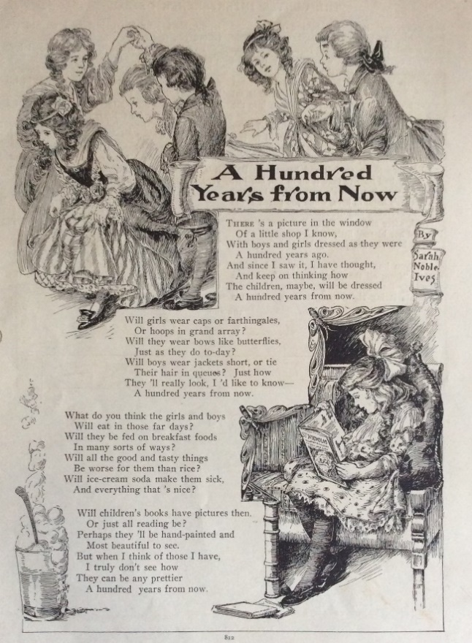  ‘Vintage illustration Saint Nicholas magazine 1905’ by Me Amelia is licensed under CC BY-NC-ND 2.0. | 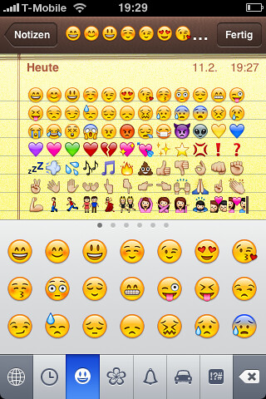  ‘iPhone: Emoji Keyboard enabled’ by schoschie is licensed under CC BY-SA 2.0.
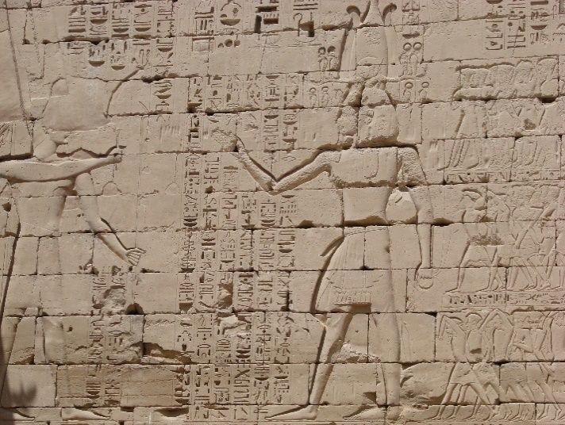  ‘Hieroglyphics at Luxor’ by watchsmart is licensed under CC BY 2.0. | 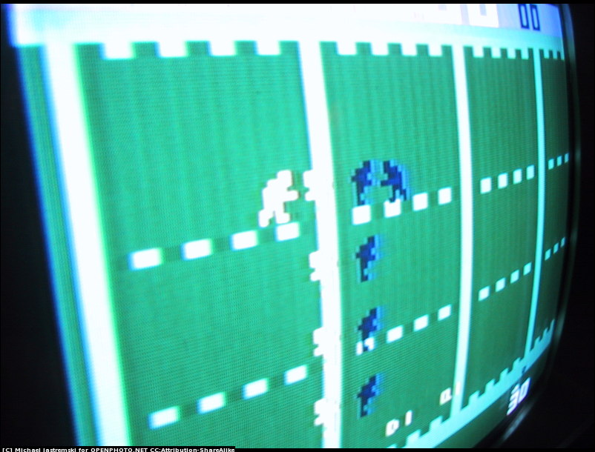  ‘2600’ by Michael Jastremski is licensed under CC BY-SA 3.0.
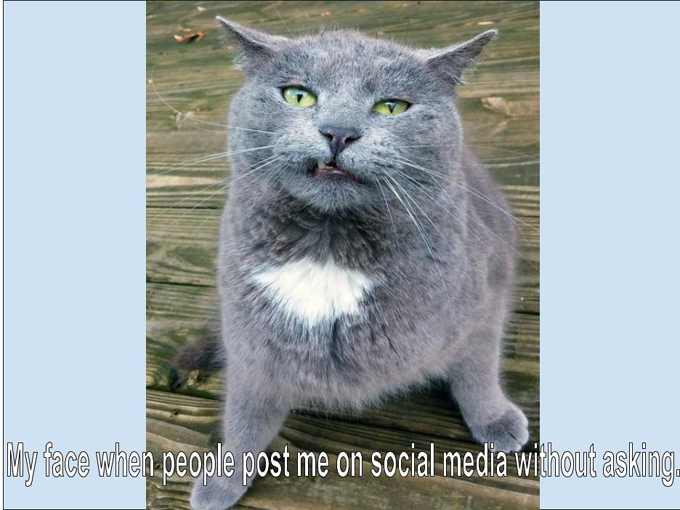  ‘Meme’ by Dianna Geers is licensed under CC0 1.0. | 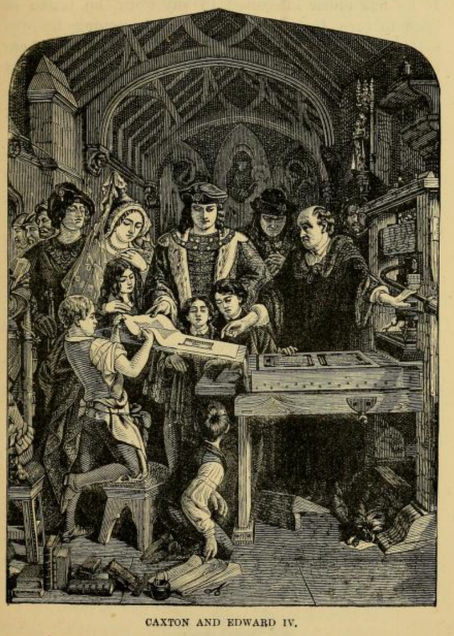  ‘Renaissance – Caxton’s Printing Press’ by Patrick Gray is licensed under Public Domain Mark 1.0.
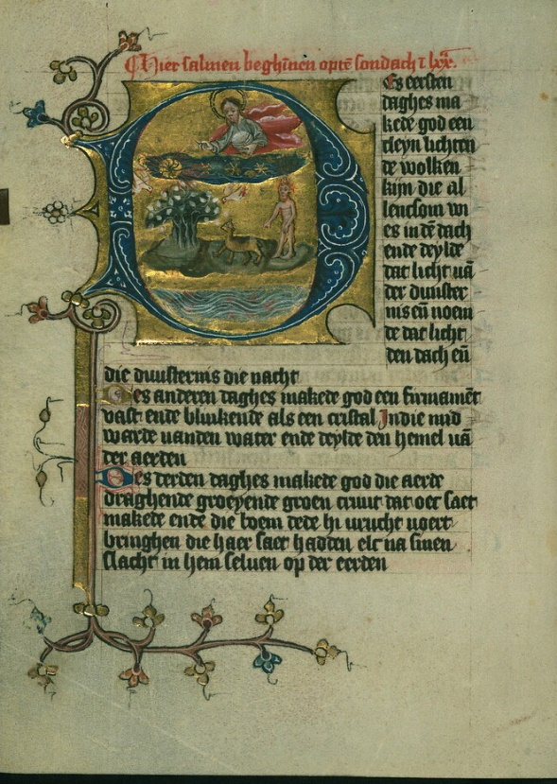  ‘Illuminated Manuscript, Duke Albrecht's Table of Christian Faith (Winter Part), The Six Days of Creation, Walters Art Museum Ms. W.171, fol. 5v’ by Walters Art Museum Illuminated Manuscripts is licensed under CC0 1.0. | 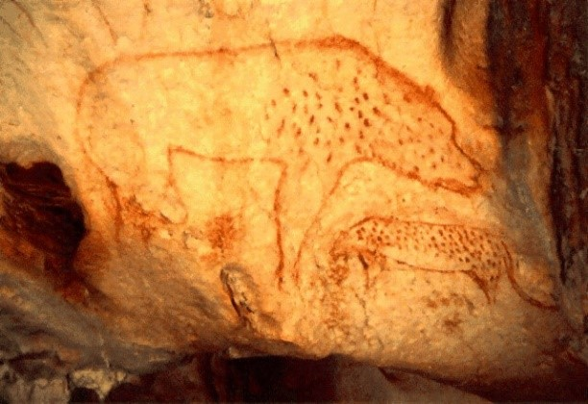  ‘20,000 Year Old Cave Paintings: Hyena’ by Carla216 is licensed under CC BY-SA 2.0.

Phase 1, activity 1b – visual communication timeline
Teacher note: the aim of a dictogloss is for students to recreate a text they have listened to by collaborating with their peers, sharing their knowledge and understanding and reconstructing the text in written form. Australian Institute for Teaching and School Leadership (AITSL) highlights the ways this can be used to support English as an additional language or dialect (EAL/D) learners (Dictogloss for EAL/D students). The discussion students engage in during the reconstruction of the texts supports their developing understanding of text type and organisation, grammar, tense, topic specific vocabulary and content (Gibbons 2015). A demonstration of this strategy is available on the AITSL website.
Steps for completing the dictogloss activity:
- Your teacher will read you a text explaining how visual language has changed over time.
- The first time your teacher reads the text, you should listen to understand the overall meaning.
- Your teacher will read the text again during which you should take notes about how visual language has changed over time.
- You will then share your notes in a small group, adding any details that you may have missed.
- You will repeat steps 3 and 4.
- You will use your notes to recreate the text as accurately as possible.
- You will compare your completed text about the evolution of visual communication with the timeline you created to see if they align.
Teacher note: it may be appropriate for your context to adapt the text, provide a glossary of challenging vocabulary or read the text more times. The following table could be completed and distributed to students or used to create a spaghetti match activity or information gap activity. Students could use a dictionary to complete the table.
Table 3 – glossary
Vocabulary | Definition
modes | [student response]
prehistoric | [student response]
ancestors | [student response]
ritual | [student response]
ancient | [student response]
civilisation | [student response]
convey | [student response]
hieroglyphics | [student response]
medieval | [student response]
moral | [student response]
Renaissance | A historical period that saw development of a culture that valued art, literature, science and philosophy.
accessible | [student response]
masterpieces | [student response]
depicted | [student response]
Industrial Revolution | An important period in history when new technology in areas such as transport, farming and manufacturing changed the way that people worked and lived.
distribute | [student response]
interactive | [student response]
evolve | [student response]

Option 1 – the evolution of visual communication
Since the beginning of time, human beings have developed ways to communicate with each other. The purpose, message and modes of communication have changed over time, but the need for humans to express themselves has not.
The use of visual language can be traced back to prehistoric times when our ancestors communicated through cave paintings and rock art. These visual representations were a way to tell stories about their daily lives, often showing hunting scenes and religious rituals.
Ancient civilisations communicated through a system of symbols to convey complex ideas and practical information; you may be familiar with the hieroglyphics of Ancient Egypt.
In Europe in the medieval period, religious and moral messages were communicated through the imagery used to illustrate documents. Religious texts would be beautifully decorated to communicate religious teachings to a population who generally could not read or write.
In the Renaissance period, the printing press was invented and illustrated books were produced on a larger scale. Books became more accessible to the general population. The emphasis on Renaissance art was on realism with artists such as Leonardo da Vinci, Sandro Botticelli and Michelangelo creating masterpieces that depicted reality.
The Industrial Revolution of the 18th and 19th century led to the rise of mass media such as newspapers, posters and magazines. Effective visual communication was essential to capture attention and quickly communicate a message. Visual texts became a powerful way to shape public opinion and distribute information.
In the 20th century, technological developments have led to an increase in the possibilities for visual language. Cinema, television and digital media such as video games have led to the creation of multimodal texts with movement, sound and interactive elements being added to visual texts.
Visual language continues to evolve today. We live in what is called ‘the digital age’ where technology such as the internet, social media, virtual reality and access to mobile devices have created new ways for humans to communicate using visual language such as emojis, memes and gifs.
Although visual communication has changed over time, it is clear that it has always been used and will continue to be used as an effective and sometimes powerful mode of communication.

Option 2 – 7 strips – teacher preparation
Teacher note: the aim of ‘7 Strips’ is for students to recreate the key points and main ideas of a text they have or will listen to by collaborating with their peers, sharing their knowledge and understanding and reconstructing the text in written form. This strategy is particularly useful for EAL/D learners. It is a good idea to strategically pair students. For EAL/D students, pair with a student for whom English is a first language. This activity is more successful the more often it is completed. Students need practise using the process. In turn, it becomes quicker. The first time this is completed, it should be with a shorter text (no more than half a page). A glossary or visual prompts is essential when there are Tier 2 or Tier 3 words that may pose a challenge. The words or phrases bolded in the text may need vocabulary support.
Teacher preparation
- Select the length and difficulty of a text depending on your class. You may need to edit existing texts by removing sections and changing certain terms.
- The ‘7’ in the title is just a guide. This can be more or less depending on your class and chosen text. When completing for the first time, try for ‘5 Strips’.
- The ‘Strips’ can take different forms:
- literal strips of paper provided to each student
- a page that is divided into sections
- large sticky notes
Make sure you have spares ready to use for any of the above.
- If you have a class with the majority of students at the ‘Emerging’ or ‘Developing’ EAL/D Phase, it is a good idea to have images and key words for reference on the whiteboard or in a glossary:
- visuals related to key aspects of the text
- key words (with synonyms, antonyms and definitions)
Allow students some time to take this information in before beginning the activity. Use this to guide a verbal prediction activity to stimulate prior knowledge where students guess what the text will be about.
Activity instructions
- Project the name of the text, the images, key words and/or the glossary on the board and allow students time to read or view the information related to the chosen text. Clarify where necessary and engage in a short verbal prediction task: ‘What do you think you are about to read?’
- Explain to students that you will read a text to them, and they are to note down the key pieces of information on pieces of paper that you will give them.
- Discuss what ‘key’ information might be and give examples and explain what would not be considered key information.
- Point out to students that the information on the board might help them.
- Depending on the class, demonstrate this using information from a previous lesson or provide a student with a paragraph of text that they read to you and you note down the key information on the board.
- Before issuing the strips, read the text once to students and ask them to listen and look at the information on the board.
- For EAL/D students, consider the pace at which you read and your pronunciation. Try to emphasise key information as you read.
- Issue the strips. Ask students to number the strips 1 to 5 (for the first use of this activity or 1 to 7 if the activity is familiar to students and the text is longer or more complex). Allow students time to think about what they have heard and the most important pieces of information.
- Read the text again and give students time to write down the key points on the strips.
- Each strip should have a new piece of information.
- Remind students not to stress about spelling at this stage and to use the information on the board to assist their note making.
- Read the text again to the students. Slow your pace and pause at the end of each paragraph or chunk of information. Give students time to finish their notes.
- Ask students to swap their strips with a peer. This will be their partner. Remind students to check that their strips are in order and numbered. Give students time to read what has been written.
- Tell students you are going to read the text again. Ask students to select a different coloured pen or pencil. This time, they are going to add to or edit their partner’s strips. Read students the text again.
- Students use a different coloured pen to add notes or edit to ensure new additions stand out.
- Again, allow students some time to finalise their notes. Students sit with their partner and put their strips together. They read through them and then use their combined strips to recreate the key ideas from the text read to them in their exercise books.
- Students could complete the joint construction together.
- Students could complete the joint construction individually using both sets of strips.
- Encourage students to use the information on the board to help the recreation.
- Provide time for different pairs to read each other’s final versions.
- Discuss with the class the main points that everyone identified and why they thought this was key information. This will help develop future note taking stills.

Original text – the evolution of visual communication
Since the beginning of time, human beings have developed ways to communicate with each other. The purpose, message and modes of communication have changed over time, but the need for humans to express themselves has not.
The use of visual language can be traced back to prehistoric times when our ancestors communicated through cave paintings and rock art. These visual representations were a way to tell stories about their daily lives, often showing hunting scenes and religious rituals.
Ancient civilisations communicated through a system of symbols to convey complex ideas and practical information; you may be familiar with the hieroglyphics of Ancient Egypt.
In Europe in the medieval period, religious and moral messages were communicated through the imagery used to illustrate documents. Religious texts would be beautifully decorated to communicate religious teachings to a population who generally could not read or write.
In the Renaissance period, the printing press was invented and illustrated books were produced on a larger scale. Books became more accessible to the general population. The emphasis on renaissance art was on realism with artists such as Leonardo da Vinci, Sandro Botticelli and Michelangelo creating masterpieces that depicted reality.
The Industrial Revolution of the 18th and 19th century led to the rise of mass media such as newspapers, posters and magazines. Effective visual communication was essential to capture attention and quickly communicate a message. Visual texts became a powerful way to shape public opinion and distribute information.
In the 20th century, technological developments have led to an increase in the possibilities for visual language. Cinema, television and digital media such as video games have led to the creation of multimodal texts with movement, sound and interactive elements being added to visual texts.
Visual language continues to evolve today. We live in what is called ‘the digital age’ where technology such as the internet, social media, virtual reality and access to mobile devices have created new ways for humans to communicate using visual language such as emojis, memes and gifs.
Although visual communication has changed over time, it is clear that it has always been used and will continue to be used as an effective and sometimes powerful mode of communication.

Slightly modified text – the evolution of visual communication
Since the beginning of time, humans have found different ways to communicate with each other. The purpose, message and ways we communicate have changed over time, but the need for humans to express themselves has not.
The use of visual language goes all the way back to prehistoric times when our ancestors communicated through cave paintings and rock art. These visual representations were a way to tell stories about their daily lives, showing hunting scenes and religious rituals.
Ancient civilisations communicated through a system of symbols to share ideas and practical information; an example of this are the hieroglyphics of Ancient Egypt.
In Europe in the medieval period, religious and moral messages were shared through the imagery used to illustrate documents. Religious texts would be beautifully decorated to communicate religious teachings to the many people who could not read or write.
In the Renaissance period, the printing press was invented and many illustrated books were made. This meant that more people could get these books. Many of these books shared images of real life through renaissance art from famous artists.
Media such as newspapers, posters and magazines were everywhere during the Industrial Revolution of the 18th and 19th century. Communicating through visuals was very important to get people’s attention quickly. Visual texts became a powerful way to change how people thought about things and shared information.
In the 20th century, technology has meant that there are so many ways to use visual language. Cinema, television and digital media such as video games have led to the creation of multimodal texts with movement, sound and interactive elements being added to visual texts.
Visual language continues to grow and change today. We live in what is called ‘the digital age’ where technology such as the internet, social media, virtual reality and access to mobile devices have created new ways for humans to communicate using visual language like emojis, memes and gifs.
Even though visual communication has changed over time, it is clear that it has always been used and will continue to be used as an effective and sometimes powerful mode of communication.

Highly modified text – the evolution of visual communication
Since the beginning of time, humans have found different ways to communicate with each other. The purpose, message and ways we communicate have changed over time.
The use of visual language goes all the way back to prehistoric times when our ancestors communicated through cave paintings and rock art. These visual representations were a way to tell stories about their daily lives, showing hunting scenes and religious rituals.
Ancient civilisations communicated through a system of symbols to share ideas and practical information; an example of this are the hieroglyphics of Ancient Egypt.
In Europe in the medieval period, religious and moral messages were shared through religious texts that would be beautifully decorated to communicate religious teachings to the many people who could not read or write.
In the Renaissance period, the printing press was invented and many illustrated books were made. Many of these books shared images of real life through renaissance art from famous artists.
Media such as newspapers, posters and magazines were everywhere during the Industrial Revolution of the 18th and 19th century. Visual texts became a powerful way to change how people thought about things and shared information.
In the 20th century, technology has meant that there are so many ways to use visual language. Cinema, television and digital media such as video games have led to the creation of multimodal texts with movement, sound and interactive elements being added to visual texts.
Visual language continues to grow and change today. We live in what is called ‘the digital age’ where technology such as the internet, social media, virtual reality and mobile devices have given humans new ways to communicate using visual language like emojis, memes and gifs.
Table 4 – 7 strips vocabulary support
Term or phrase | Definition | Image or synonym
Modes | [Provide the necessary information for the class] | [Provide the necessary information for the class]
Traced | [Provide the necessary information for the class] | [Provide the necessary information for the class]
Prehistoric | [Provide the necessary information for the class] | [Provide the necessary information for the class]
Ancestor | [Provide the necessary information for the class] | [Provide the necessary information for the class]
Ritual | [Provide the necessary information for the class] | [Provide the necessary information for the class]
Ancient Civilisation | [Provide the necessary information for the class] | [Provide the necessary information for the class]
Hieroglyphics | [Provide the necessary information for the class] | [Provide the necessary information for the class]
Medieval Period | [Provide the necessary information for the class] | [Provide the necessary information for the class]
Moral | [Provide the necessary information for the class] | [Provide the necessary information for the class]
Illustrate | [Provide the necessary information for the class] | [Provide the necessary information for the class]
Renaissance period | [Provide the necessary information for the class] | [Provide the necessary information for the class]
Printing press | [Provide the necessary information for the class] | [Provide the necessary information for the class]
Invent | [Provide the necessary information for the class] | [Provide the necessary information for the class]
Population | [Provide the necessary information for the class] | [Provide the necessary information for the class]
Masterpiece | [Provide the necessary information for the class] | [Provide the necessary information for the class]
Depict | [Provide the necessary information for the class] | [Provide the necessary information for the class]
Industrial Revolution | [Provide the necessary information for the class] | [Provide the necessary information for the class]
Essential | [Provide the necessary information for the class] | [Provide the necessary information for the class]
Capture attention | [Provide the necessary information for the class] | [Provide the necessary information for the class]
Shape public opinion | [Provide the necessary information for the class] | [Provide the necessary information for the class]
Distribute | [Provide the necessary information for the class] | [Provide the necessary information for the class]
Multimodal | [Provide the necessary information for the class] | [Provide the necessary information for the class]
Interactive elements | [Provide the necessary information for the class] | [Provide the necessary information for the class]
Evolve | [Provide the necessary information for the class] | [Provide the necessary information for the class]

Phase 1, activity 2 – reflection questions
- What did you enjoy about using only emojis to compose a text?
- What were the limitations of using only emojis?
- To what extent did the audience (your partner) interpret your text as you intended?
- What are the benefits and problems with communicating through emojis?

Phase 1, resource 1 – codes and conventions
Teacher note: this is an appropriate time to make connections to prior learning in the previous program; students explored the codes and conventions of an introduction to a curated collection in Phase 2 of the ‘Powerful Youth Voices’ program available on the Planning, programming and assessing English 7-10 webpage. Revise the terms ‘code and convention’. A short summary video is available on the department’s website. The basic elements of speech, writing and visual language convey meaning when they combine in commonly understood arrangements or patterns. These patterns are formed by the interplay of:
- codes (for example, sounds, spelling and grammar)
- agreed systems for communicating (for example, names of things and of actions, logos, camera angles, tone of voice and so on)
- conventions, shared and habitual ways of using these systems (for example, paragraph structure, genre, framing of images, dramatic gestures and so on)
If distributing these images to students or projecting them in class, please make copies that do not include the title of the image so that students must rely on the visual codes and conventions to infer meaning.
- Examine the following visual texts and answer the following questions:
- What is the purpose of these texts?
- What information do the composers of these ‘texts’ want responders to take from these texts?
- What ‘tools’ are used to help make this meaning?
- What different interpretations of these signs did your peers have?
- What influences the meaning that we make of these signs?
Figure 1 – Beijing subway map
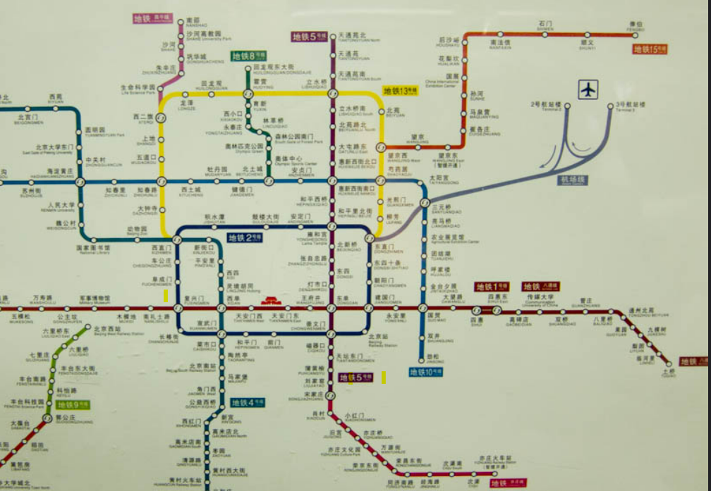
‘Beijing Subway Map’ by Charles Haynes is licensed under CC BY-SA 2.0
Figure 2 – European street signs
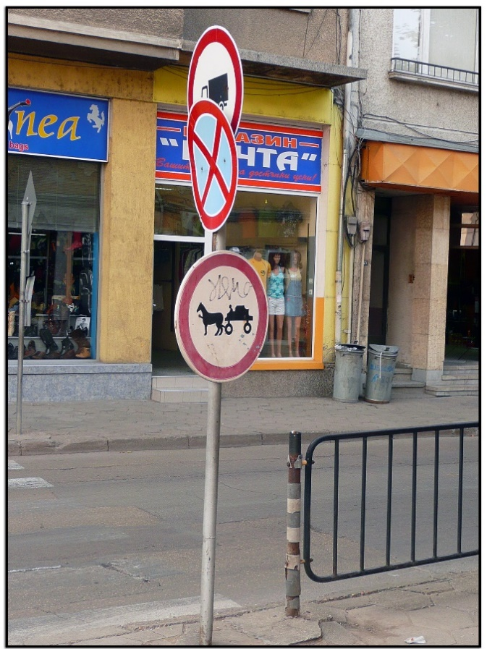
‘Troian’ by abac077 is licensed under CC BY-NC-SA 2.0.
Figure 3 – Austrian no parking sign
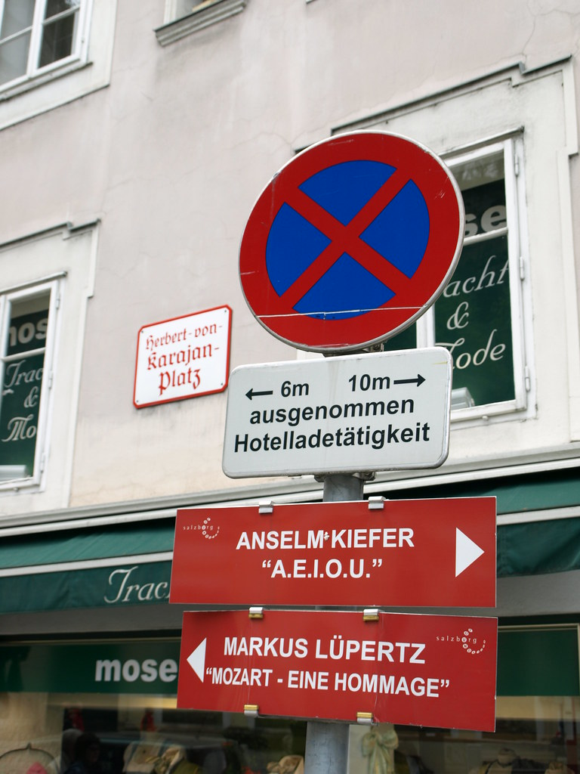
‘And Sometimes “Y” – Salzburg, Austria by g Tarded is licensed under CC BY-NC-ND 2.0

Phase 1, resource 2 – digitally altered photographs
Figure 4 – photograph before adding sun
‘Before Adding sun in photoshop’ by PSDESIRE is licensed under CC0 1.0
Figure 5 – photograph after adding sun
‘After Adding Sun in photoshop’ by PSDESIRE is licensed under CC0 1.0

Phase 1, activity 3 – questions for consideration
Examine the provided digitally altered photographs. Consider your responses to the following questions and prepare to explore your responses in a class discussion.
- Why were the photographs altered? (possible answers include: to make the subject seem powerful, to make the photograph more aesthetically pleasing, creative satisfaction for the artist/composer)
- What is the effect of the alteration? (it is no longer an accurate representation of the truth, manipulates and evokes a sense of peace, changes history)
- Where do you encounter altered photographs? (possible answers include: advertising, social media, the use of filters on smart phone cameras)
- Is it unethical to digitally alter photographs? Why/why not?

Phase 1, resource 3 – metalanguage of visual texts
Teacher note: it may be appropriate to provide students with the following table for a reference, or to use it to create a spaghetti match activity. The third column provides some examples of how this table can be modified to provide further support to EAL/D learners. Students and/or teacher can provide further annotated examples as required.
Student note: metalanguage is the technical term used to describe and discuss how language and texts function. Using metalanguage adds sophistication to your writing through the expansion of technical vocabulary.
Table 5 – visual language features and definitions
Visual language features | Definition | Example
Layout | The placement and arrangement of elements in a visual text. | [teacher or student to provide annotated example for differentiation]
Foreground | The part of the image that appears closest to the viewer. | Figure 6 – digitally altered photograph illustration foreground  In the digitally altered photo in figure 5, the man on the rock is in the foreground.
Background | The area furthest from the viewer, behind the subject, or in the distance. | Figure 7 – digitally altered photograph illustrating background  In the digitally altered photo in figure 5, the sun is in the background.
Juxtaposition | Placing things side by side or close together, often to emphasise similarity or difference. | [teacher or student to provide annotated example for differentiation]
Framing | The use of the camera to incorporate aspects of the action in a scene. This provides social distance in a visual text. Example: close-up, medium, and long shot | [teacher or student to provide annotated example for differentiation]
Salience | Importance given to particular elements. Example: The size, expression and foreground position of an object demands the viewer’s attention first. | Figure 8 – photograph illustrating salience  In figure 4, the man on the rock is the salient feature because he is positioned in the top left corner and in the foreground of the frame.  Figure 9 – digitally altered photograph illustrating salience  In figure 5, the sun is the salient feature because it is placed in the centre of the frame and the bright yellow contrasts with the softer colours
Symbolism | A word or concrete object that represents something else, especially an object representing something that is abstract. | [teacher or student to provide annotated example for differentiation]
Reading path | The movement of a viewer’s gaze around the visual text. This movement can be demonstrated by lines of sight, or vectors. | [teacher or student to provide annotated example for differentiation]
Colour palette | Range of colours often used deliberately in visual texts for symbolic meaning. | [teacher or student to provide annotated example for differentiation]
Contrast | To consider similarities and differences between (features of) texts. Diagrams are useful for planning texts that require compare and contrast. | [teacher or student to provide annotated example for differentiation]
Vectors | Lines, real or implied, which direct a viewer’s attention to a focal point in a visual text. Example: Some vectors are invisible (as in a glance between people), but others are real, and draw the viewer’s eye directly. | [teacher or student to provide annotated example for differentiation]
Motif | An element that is repeated in a text. It may also be repeated and woven throughout the text, such as a colour motif (‘Literary Terms: a practical glossary’, Moon 2005). | [teacher or student to provide annotated example for differentiation]

Core text 1 – Mirror by Jeannie Baker
For extracts from core text 1, Mirror by Jeannie Baker, see the core texts booklet.

Phase 1, resource 4 – sentence structure revision
Key
Bold text: verb
Blue text: conjunction
Underlined text: simple sentence
Simple sentence
A simple sentence has one verb and one idea – also called an independent clause because it makes sense on its own.
- Mirror is a picture book.
Compound sentence
A compound sentence has two or more verbs. It is made up of 2 simple sentences joined by a conjunction or joining word.
- Mirror is a picture book, and it explores different life experiences.
Complex sentence
A complex sentence has at least one simple sentence and at least one dependent clause.
- Although Mirror explores different life experiences, it emphasises the similarities between humans across the world.
A dependent clause has a verb but is an incomplete idea.
- Although Mirror explores different life experiences…

Phase 1, resource 5 – review of Mirror by Jeannie Baker
Teacher note: some vocabulary may require explicit teaching as a pre-reading activity, particularly to support EAL/D learners. For example: illustrate, concept, otherness, clever, construction, simultaneously, collage, commonality, belonging, instigates, initial, appreciation.
Review of Mirror by Jeannie Baker
Mirror, written and illustrated by Australian children’s book author, Jeannie Baker, explores the concept of otherness through visual literacy. The book uses a comparative form to show the similarities and differences between the lives of two young boys, one from Sydney, Australia and the other from Morocco, North Africa.
The clever use of a two-sided construction allows the reader to experience the two contrasting lives simultaneously. Through the use of images, collages created through mixed media, a day in the lives of both boys is experienced and the reader can clearly identify with the commonalities of family, community and belonging.
By introducing younger readers to the concept of otherness, the author instigates an initial understanding that although all people are different, they are still the same. The children’s storybook Mirror encourages acceptance and appreciation of human societies, wherever they are in the world.

Phase 1, activity 4 – complex sentences in action
- Match the correct subordinating conjunction to join the main and dependent clauses.
Table 6 – complex sentences activity 1
Main clause | Subordinating conjunction | Dependent clause (an incomplete idea)
The actor was happy he got a part in the movie | that | it was a small one.
I need to finish my assignment | although | was in the freezer?
I love puppies | by | the due date.
Where is the ice cream | because | they are so cute.
- The order of complex sentences can be changed to create more interesting sentence starters. Match the clauses starting with a subordinating conjunction.
Table 7 – complex sentences activity 2
Subordinating conjunction | Dependent clause (an incomplete idea) | Main clause
If | Roger sneezed all over the cake, | I had a detention.
Because | you watch television, | you must finish your homework.
After | I forgot my homework, | I will allow it.
Before | you can give me two good reasons, | I didn’t want to eat it.
- Inserting phrases can add further complexity to complex sentences. Identify the phrases in these complex sentences from the book review of Mirror:
- Mirror, written and illustrated by Australian children’s book author, Jeannie Baker, explores the concept of otherness through visual literacy.
- The book uses a comparative form to show the similarities and differences between the lives of two young boys, one from Sydney, Australia and the other from Morocco, North Africa
- Through the use of images, collages created through mixed media, a day in the lives of both boys is experienced…
- The children’s storybook Mirror encourages acceptance and appreciation of human societies, wherever they are in the world.
- When creating complex sentences, be wary of creating sentence fragments. This means the sentence does not make complete sense. To check, put the words ‘It is clear that …’ in front of the possible fragment. Does it make sense? If so, it is a complete sentence.
Identify which of the following are sentence fragments:
- Children are open to accepting others.
- Doomed society.
- Through the use of images, collages created through mixed media.
- Visual imagery shows Tom.
- With unity, we can save the world.
- The book uses a comparative form to show the similarities and differences.
- When I read the book.
- The vectors draw the reader’s eyes to the text.

Phase 1, resource 6 – complex sentences in action answers
- Match the correct subordinating conjunction to join the main and dependent clauses.
In this model example, the subordinating conjunctions have been matched appropriately with the main clauses and dependent clauses to create accurate complex sentences.
Table 8 – complex sentences activity 1 answers
Main clause | Subordinating conjunction | Dependent clause (an incomplete idea)
The actor was happy he got a part in the movie | although | it was a small one.
I need to finish my assignment | by | the due date.
I love puppies | because | they are so cute.
Where is the ice cream | that | was in the freezer?
- The order of complex sentences can be changed to create more interesting sentence starters. Match the clauses starting with a subordinating conjunction.
The model responses demonstrate appropriate matching of clauses with conjunctions to create accurate complex sentences that start with a subordinating conjunction. Note that the dependent clause is followed by a comma when it is used at the front of a sentence.
Table 9 – sentence activity – complex sentences activity 2 answers
Subordinating conjunction | Dependent clause (an incomplete idea) | Main clause
If | you can give me two good reasons, | I will allow it.
Because | I forgot my homework, | I got detention.
After | Roger sneezed all over the cake, | I didn’t want to eat it.
Before | you watch television, | you must finish your homework.
- Identify the phrases in these complex sentences from the book review of Mirror. The correct responses are below.
- Adjectival phrase – written and illustrated by Australian children’s book author
- Adjectival phrase – one from Sydney, Australia and the other from Morocco, North Africa.
- Adjectival phrase – collages created through mixed media
- Adjectival phrase – wherever they are in the world
- Identify which of the following are sentence fragments. The responses in bold are the sentence fragments – they do not make sense on their own.
- Children are open to accepting others.
- Doomed society
- Through the use of images, collages created through mixed media
- Visual imagery shows Tom.
- With unity, we can save the world.
- The book uses a comparative form to show the similarities and differences.
- When I read the book.
- The vectors draw the reader’s eyes to the text.

Phase 1, activity 5 – exploring etymology
Teacher note: explore the etymology of metalanguage vocabulary with students to develop word consciousness. Use the online etymology dictionary to understand the origins of the word and use Word Roots to find more examples of words that begin with the word roots and its variations. This will support students to understand the language device and to become ‘word detectives’ as they use their understanding when encountering unfamiliar vocabulary (for example ‘contrary’, ‘contradict’, ‘counter-clockwise’)
To the student: etymology is the study of the origins of, and changes to, words in relation to meaning. It explores words derived from earlier or other languages, place names, people's names or coinages. Word roots are the building blocks of words that can help you make sense of unfamiliar words. A prefix is a bound morpheme made up of letters that appear before a base word to make a new word. A suffix is a letter or group of letters that attach to the end of a base word to make a new word.
- For each of the word roots below, identify its meaning and origin using the online etymology dictionary Identify derivatives of that root word using Word Roots and write a definition for each word. Gather the information into the table below or in an appropriate Frayer diagram. The first row has been done as an example.
- Complete the table with the relevant information and provide examples of derivatives and their meanings.
Table 10 – exploring etymology activity
Visual language device | Word root | Meaning | Origin | Derivate word | Derivative meaning
Contrast | contra | ‘to set in opposition with a view to show the differences’ | French –‘contraster’  Italian – ‘contrastare’ – ‘stand out against’  Latin – ‘contra’ – ‘against’ | Contradict  Contrary | Speak against  Having the habit of often going against what others do
Foreground | fore | [insert in here what the word means] | [insert in here the origin of the word] | [insert derivative word here] | [insert in here what the word means]
Juxtaposition | juxta | [insert in here what the word means] | [insert in here the origin of the word] | [insert derivative word here] | [insert in here what the word means]
Salience | sal | [insert in here what the word means] | [insert in here the origin of the word] | [insert derivative word here] | [insert in here what the word means]
Symbol | sym | [insert in here what the word means] | [insert in here the origin of the word] | [insert derivative word here] | [insert in here what the word means]

Using the Frayer model
The Frayer model is a graphic organiser that can help us unpack unfamiliar vocabulary we encounter in texts. To use the Frayer model, we complete the following steps:
- Place the target word – the word you would like to understand – in the middle square of the diagram. Look up the definition of the target word in a dictionary. Choose the most appropriate definition and re-write it in your own words.
- Next, look at the ‘characteristics’ section of the diagram. In this section, write down words or phrases that you have come across in the dictionary definition that give us more of an idea of the target word.
- To consolidate your understanding of the word, use it in a sentence.
- To consolidate understanding, look for non-examples (antonyms) to include in the last section of the table.
Figure 10 – blank Frayer model
Phase 1, activity 7 – comparing register
- Read the emails below. These have both been sent by students to Kobra Moradi who wrote the memoir ‘My Mother, My Hero’ that we read last term.
Table 11 – student emails to Kobra Moradi
Email 1 | Email 2
Hi Kobra.  I’m Sam. I read your story about your mum. It was in my English class. It was a good story. You talked about your mum and how strong she was. And how strong you were.  I wanted to write to you. I wanted to tell you that I liked the story. They way you told it was really good. The words you used like ‘being a victim of poverty and racism, and a witness of historical persecution’ were really good words to use. They made me feel sad for you. I also thought you were very brave.  Thanks heaps for writing what you wrote. I reckon that if other people read it they might know a bit more about what other people in the world go through.  From  Sam | Dear Ms Moradi,  My name is Sam. In my Year 7 English class last term, I was lucky enough to read your incredibly moving story about your mother and your own resilience.  I felt compelled to write to you to tell you that although I have not personally experienced the immense challenges that you have faced and overcome, I felt connected to the story that you told. The emotive language that you used to describe your experience of ‘being a victim of poverty and racism, and a witness of historical persecution’ was extremely powerful and as I read these words, I could feel empathy for your struggle while also admiring your courage.  Thank you for sharing your story. Your words have the potential to help readers understand the hardship that many people across the world fight to overcome.  Kind regards,  Sam
- Complete the following table by providing examples from the emails for each of the language features that create register.
Table 12 – comparing register table
Feature of language | Email 1 | Email 2
Informal/formal language examples | [Type examples here] | [Type examples here]
Nouns/noun groups | [Type examples here] | [Type examples here]
Sentence structures (simple, compound and complex sentences) | [Type examples here] | [Type examples here]
Vocabulary | [Type examples here] | [Type examples here]

Phase 1, resource 7 – sample email to Jeannie Baker
Student note: when writing to someone with whom you do not have a close relationship, it is important to keep your register formal. The email below is from a student who has never met Jeannie Baker. Revise and edit this email to create a more formal and academic register.
Sample email
Hi Jeannie.
I’m Sam. I saw your book Mirror in my English class. It was good. I like the colours that you used. It made it look bright and cheerful. It was good how you had two stories. The stories were the same. They were also different.
My favourite page was the one where the families were having dinner. It showed that lots of families are together at dinner. That was shown by the dinner table. The thing that stood out most on this page was the two boys.
The book made me think about how some things are different in different parts of the world. It also showed that some things are the same. It was good that there were no words. It made the pictures more important.
Thanks for making a great book.
From Sam

Core formative task 1 – exploring how visual texts impact the way we tell and receive stories
Writing an email to the author, Jeannie Baker
- Write an email to the composer of Mirror sharing with her your personal response to the text. Describe how the text impacted you. Refer to the way Baker used visual language in an effective way to tell the story.
You may like to consider:
- what you liked about the text
- what surprised you about the text
- what you have learned about visual language through engaging with the text
- your thoughts about the story being told in the text
- any questions you may have for the composer about the choices she made when composing the text
- When writing an email always have in mind:
- audience – who are you writing to?
- aim – why are you writing to them, what impact do you desire?
- additional information (attachments and hyperlinks) – is there any additional information you would like to share?
Teacher note: the following table could be completed together as a class. The third column can be included as an option to support EAL/D learners.
- Use the checklist below to plan your email.
Table 13 – email planning checklist
Before you write | Planning ideas | Suggestions for students requiring further support
What is the purpose of this email? | [Type your ideas here] | To give an opinion.  To communicate your response to the text.
Who are you going to send this to? | [Type your ideas here] | Jeannie Baker, the composer of Mirror.
What is your relationship to the recipient? What register will be appropriate? Have you included a variety of sentence structures including at least one complex sentence? | [Type your ideas here] | We have not met. Jeannie Baker is older and a well-known writer. Formal register is appropriate.
What are the main points you are trying to communicate? Sometimes it is easier to write if you prepare the conclusion. | [Type your ideas here] | I liked the book – especially the way that it used pictures to tell a story. I would like to know why she decided to include no words at all. The way that there were two different stories being told made it very unique.
- Write out your email in your book and use the self-editing checklist to reflect and refine your response.
Table 14 – self-editing email checklist
Once you write | Reflection and refinement
Do you address your audience appropriately and accurately?  Do you have a clear subject line? This will help the audience understand your purpose. | [Type your reflection and refinement here]
Is there a clear structure?  Greeting, introduction, body, conclusion, action and sign-off | [Type your reflection and refinement here]
Is there any unnecessary or repeated information that should be cut out?  Is there any information that would be better incorporated via a hyperlink or attachment?  Keep mobile users in mind and avoid multiple or lengthy attachments. | [Type your reflection and refinement here]
Has it been proofread? | [Type your reflection and refinement here]

Phase 2 – unpacking and engaging with the conceptual focus
This phase is focused on student engagement with the key conceptual focus of the program. Through ‘unpacking and engaging with the conceptual focus’, students develop from their initial engagement with the power and uniqueness of visual texts to consider the layers of meaning behind the key textual concepts of the program. Students will consider how an appreciation of representation signals that images do more than just ‘show’ us the world. Students examine the codes and conventions of several types of media texts. They are introduced to the role of connotation, imagery and symbol. Through interactions with stimulus texts they begin to consider the interplay of language and visuals in guiding the reader experience of texts that may be both informative and persuasive.
Students will be challenged to consider the nature of representation in focusing on the conscious work of composers as text creators who intentionally ‘re-present’ people, events and issues. This is especially relevant for visual texts that purport to be transparent, such as in the news media. Students will explore how the composers of visual texts employ a range of textual and visual features to guide the responses of responders according to their purpose, the codes and conventions of the form and the context in which they are working.
Note the teaching and learning activities in this phase focus on student discovery and personal response to key textual and language features. Analysis and critical response are developed in the following phases.
The teacher recognises students’ prior understanding of the characteristics of several types of media text, including news reports and social media posts.
Students practise writing the individual textual features of informative news reports, focusing on codes and conventions such as passive voice and the structure of opening sentences.

Phase 2, resource 1 – teaching approaches
The following strategies have been used within the teaching and learning activities in this phase. See Phase 2, resource 4 – critical and creative thinking for more information about the critical thinking cues suggested below.

Analogies and metaphors
Both ACARA (2020) and the OECD (Vincent-Lancrin et al 2019) suggest asking students to formulate analogies or metaphors in order to encapsulate their thinking about a concept. Both the process of coming up with an analogy or figurative description, and the sharing of ideas around the class, are powerful ways to support higher-order and creative thinking.

Convergent versus divergent questions
According to Quigley (2020:172), convergent thinking questions seek to ‘explain and convey relationships/cause and effect’ while divergent thinking routines focus on ‘questions that hypothesise, predict and infer.’

REAL goals
Quigley (2020) emphasises the importance of establishing a ‘why’ for reading each time students are asked to read. The intention is to establish both metacognitive awareness and an element of self-control to their classroom reading. REAL goals (you may like to co-create a classroom poster) can help establish routines.
- R – retrieve – reading to retrieve specific information (such as examples of context)
- E – enjoy – reading simply to enjoy
- A – analyse – reading to dig into layers
- L – link – reading to connect or corroborate

Core text 2 – news article from website
Hermidale reaps a tonne of learning with crop’s harvest (Jones 2022)
See the Core texts booklet for the full text of this article.

Phase 2, activity 1a – teacher facing adjusted activities
Teacher note: the following strategies offer differentiation options for activities from within this phase. Note that a vocabulary list and accompanying visuals to support access to the text would benefit most students for every activity.
Reading the core text ‘Hermidale reaps a tonne of learning with crop’s harvest.
The teacher may choose to read this article to the class, pausing where appropriate for vocabulary discussion and to stress key words to signpost key ideas.
The ‘F’ pattern for screen reading
The teacher could provide a cut out template of the ‘F’ pattern for students to place over the page. Students are asked to highlight the key words, phrases or images that match those identified in the previous numbering activity. Do they match up or link? What information in the ‘F’ pattern links to the image? Discuss.
Objectivity in news report language
The teacher could present an extract from the Hermidale news report where the same event or issue is referred to objectively and then with more emotion, or subjectivity. For example, the ‘project’ is both an:
- ‘85-hectare wheat crop [that] was harvested’ – objective language focused on the technical activity, and something
- ‘that has gone from strength to strength’ – subjective language that expresses the writer’s perspective in an emotive or evaluative way.
Students could classify a teacher-chosen range of sentences in this way and be supported to add examples from their chosen article.
Reading the news report aloud in the style of a television news anchor
Students could be supported to participate in this activity if the teacher can print sections of the news report text as large-sized font on large cards. These can then be held up to students like a teleprompter. Students and teacher can also make use of an online cueprompter.
Extension work for evaluative language
Evaluative questions support the reader to respond based on their informed opinion. This style of question invites the responder to make a judgement and to explain the backing for that claim. The teacher could model and discuss the construction of this type of question and ask students to design a list that can be adapted for the class activity.
Evaluative question examples:
- What changes would you recommend to make this…more…?
- Why do you think the composer has…?
- Which are the most effective ways the composer has…?
- To extend these, students may be supported to consider the specific context of evaluation, in this case, visuals used to evoke emotion. What specific vocabulary choices could help with an evaluation in that context?
- For example, from ‘Which colours are the best to promote this brand?’ to ‘What is the impact of the contrast between bright and sombre colours?’

Phase 2, activity 1b – student facing adjusted activities
Student note: complete the sequence activity or activities your teacher has assigned you.
Reading the core text ‘Hermidale reaps a tonne of learning with crop’s harvest
As the teacher reads the article to you, listen for and write down key words. Following the reading, you will create a word bank glossary with the help of your teacher.
The ‘F’ pattern for screen reading
The teacher has provided you with a cut out template of the ‘F’ pattern for reading. Place it over your printout page of the article and highlight the key words, phrases or images that match those identified as the teacher read the article. Do they match up or link? What information in the ‘F’ pattern links to the image? Discuss as a class.
Objectivity in news report language
Teacher note: you will need to prepare extracts from the news report for this activity where the same event or issue is referred to objectively and then with more emotion, or subjectivity. For example, the ‘project’ is both an ‘85-hectare wheat crop [that] was harvested’ – objective language focused on the technical activity, and something ‘that has gone from strength to strength’ – subjective language that expresses the writer’s perspective in an emotive or evaluative way.
You should also explicitly revise the difference between objective and subjective language. Students could then select sentences from the text and change the language to make them either objective or subjective.
- The teacher has provided you with extracts from the article. Categorise each pair of extracts into either subjective or objective statements.
- Discuss your choices with a partner.
- Select 2 sentences from the text and change them from either objective to subjective or vice versa.
Reading the news report aloud in the style of a television news anchor
Have you ever wanted to be a news reporter? Put on your best news reporter voice and deliver the news article as though you are on television. Use either printed cue cards or an online cueprompter.
Extension work for evaluative language
Student note: evaluative questions support the reader to respond based on their informed opinion. This style of question invites the responder to make a judgement and to explain the backing for that claim.
- Consider the following questions with reference to the text and write a response:
- What changes would you recommend to make this article more interesting?
- Why do you think the composer has used quotes in the article?
- Which are the most effective ways the composer has engaged the responder with the topic?
- Extension questions:
- What specific vocabulary choices evoke emotions as represented in the visuals used in the article? What is the impact of the contrast between bright and sombre colours in the article’s image?

Phase 2, activity 2 – extension and independent analysis
Teacher note: the links within the following table are to articles from within the Department of Education website. For each one there is a suggested focus for guided student analysis, as well as suggested metalanguage that could be introduced as relevant for that article and image. You may need to scaffold learning by pre-teaching metalanguage or treat as a pre-test of knowledge and insert on a needs basis. Student groups could take responsibility for ‘teaching’ the class about the metalanguage when they report back. This is an excellent opportunity to revisit the 7 Strips activity.
Student activity:
- Your teacher has assigned you one of the news articles to analyse.
- In your assigned pair or group, use the guiding conceptual questions to focus your work. You can also develop your own conceptual questions for your article.
- Identify examples of suggested metalanguage for your article.
- Use critical thinking or divergent questions such as ‘What would change if the image had been taken from a high angle instead?’
- Deliver a focus report back to the class on the article and the features of the image that add meaning to the written text. Justify how the image does or does not do more than just ‘show’ content from the article.
Table 15 – web news articles and guiding questions
Article name and link | Conceptual questions to guide responses and discussion | Metalanguage
Students learn the bear facts about conservation | - Does the low angle shot impact emotionally on the responder?  - How does the symbolism of parent and child add to the article? | Low and high angle  Symbolism
Show time strengthens community ties | - Why has the photographer included all the elements in the shot?  - Has the motif been chosen for a particular reason? | Framing  Layout  Motif
Raising the volume on the voice of youth | - How many different symbols can you identify? (table, smiles, sunlight, tree, wall and windows)  - What do the symbols add to our reactions to this article? | Symbolism  Foreground, background
Safety the focus of new fire program | - How does the subjects’ gaze, body language and gesture impact on the responder?  - Does the image only ‘show’ us, or does it add to the article or create new meanings for the viewer? | Vectors  Gaze  Body language, gesture and facial expression
Teacher note: for more information on metalanguage linked to visual literacy, for example ‘framing’, see the glossary for the ACARA National Curriculum and the entries such as ‘gesture’ in the English K–10 Glossary (NESA 2022). Within the National Literacy Learning Progression (NLLP), do a ctrl + f to search for specific metalanguage.

Phase 2, resource 2 – news websites
Potential starting points for student exploration of a range of news websites include the following. Teachers are advised to check appropriacy for class context:
- News.com.au
- ABC news
- Sky news Australia
- Kids News (Newscorp) has age-appropriate coverage and the ability to set reading levels.

Phase 2, resource 3 – passive and active voice
This activity is adapted from the LEAD approach developed by Myhill (2018) on the ways that teaching grammar can be integrated into the writing classroom, with a particular focus on grammar teaching in the context of authentic use. Metalinguistic knowledge is taught in the context of writing lessons so that students see the connections between language and its impact on the reader.
- L – link – make a link between the grammar or language feature and its function in making meaning.
- E – examples – explain the grammar or feature through examples.
- A – authenticity – give examples of how the grammar or feature works in authentic texts.
- D – discussion – build in high quality discussions around language choices.
In this specific activity, we are adapting these principles for use with the distinction between the passive and the active voice. For example, in the second paragraph of the Hermidale news report:
- Link – the way in which a passive construction such as ‘crop was harvested’ puts the focus on the process and creates a more technical or objective ‘feel’ to the writing appropriate for the informative news report form.
- Examples – explore further examples of passive and active voice and its impact on the effectiveness of the type of text.
- Authenticity – check the use of passive voice in other forms and compare.
- Discussion – for example, ‘What is the impact of changing a sentence from passive to active or vice versa?’
Teacher note: for further information on this aspect of grammar, see the Grammar Guide (sharepoint.com) from the Writing in Secondary resource hub, and the glossaries for English in the Australian Curriculum and in the English K-10 syllabus (NESA 2022).
Teacher-led example for the classroom – I do, we do, you do. Use the following or create your own to complete the activity. Students then practise using examples drawn from the news reports:
- The flowers are watered every day – I watered the flowers every day.
- My first trip to Uluru will always be remembered – I will always remember my first trip to Uluru.
- The dinner was made by mum – Mum made dinner.

Phase 2, resource 4 – critical and creative thinking strategies
ACARA (2020) – general capability:
- Inquiring – develop questions; identify, process and evaluate information
- Generating – create possibilities; consider alternatives; put ideas into action
- Analysing – interpret concepts and problems; draw conclusions and provide reasons; evaluate actions and outcomes
- Reflecting – think about thinking; transfer knowledge
The OECD (Vincent-Lancrin et al 2019) report suggests the following to encourage critical and creative thinking:
- create interest, need to learn, integrate perspectives
- be challenging
- develop clear domain knowledge
- include development of a product
- ensure students co-design part of product
- leave room for unexpected
- include time for reflection and feedback

Phase 2, resource 5 – advertising campaigns, social media and websites
Teacher note: the links to TV advertising campaigns, social media campaigns and persuasive websites in the table below are a suggestion only. While students are to be encouraged to research and explore, the teacher may well want to curate a selection of choices to ensure that content is age appropriate. Note that there are other ads included in the linked sites, and that there is an extensive discussion available on these websites to guide discussion of the emotive impact of these visual texts.
Table 16 – example persuasive visual texts
Organisation | Link | Key features
NRMA Bear meets eagle on fire (TV advertising campaign) | Mumbrella.com.au – best campaigns of 2022 | - Tracking and panning shots  - Telling a story  - Sound and image (over text)  - Striking visual imagery
Telstra – time for a chat (TV advertising campaign) | Talkwalker – best marketing campaigns in Australia | - Telling a story  - Visual devices used to guide audience expectation
#EmpowerMoves – United Nations Women Australia  ‘Meet our family’ – Symbio Wildlife Park  ‘Dumb Ways to Die’ – MetroTrains (Social media campaigns) | Brafton – 7 of the Best Australian Social media Campaigns | - Features aimed at clear target audience  - Visuals used to evoke emotion  - Emotionally compelling content
World Wildlife Fund (WWF) (website) | WWF website. See also its Public Service Advertisements page. | - Use of colour, contrast, symbolism for persuasive impact  - Codes and conventions of a website
WIRES (website) | WIRES website | - Informative versus persuasive text and visual features  - Codes and conventions of website  - Emotive intent of images chosen
Teacher note: reading in the role of a specific occupation is adapted from the work of Quigley (2020:88–90). The aim is for students to read actively and with a specific purpose so that their attention is focused. According to Quigley, such role-playing ‘boosts comprehension and memory’ (Quigley 2020:158). Whether the teacher assigns different roles within a group, or students choose their roles, the key appears to be the active decision-making and focus brought about by such role-playing.
Reading or viewing like a historian might lead to questions like – what events in history are used to try and convince the responder? What evidence is used and how strong is it?
Reading or viewing like a travel agent might lead to questions like – what kinds of landscapes are we shown? How effective are images of beautiful places?

Phase 2, resource 6 – codes and conventions of persuasive visual texts
The following table showcases some of the most familiar codes and conventions of visually persuasive texts such as social media marketing campaigns and television advertising. For further discussion and examples see a resource such as the Visme blog on Advertising Techniques in Visual Marketing.
Teacher note: to prepare this table as a resource for students, the teacher may choose to add a ‘visual example’ column for each code and convention.
Table 17 – codes and conventions of persuasive visual texts
Code and convention | Definition and example
Use of colour | Colour is seen to send a message through emotional associations we hold. White coats, for example for purity or scientific professionalism.
Gaze – direct or indirect, and body language | The direct gaze of the figure in the visuals (straight into the eyes of the viewer) is said to suggest power or an invitation. The body in general can suggest or symbolise many emotions: relaxation, energy or attractiveness. See the Toy Story 3 billboard on the Visme blogpost. What does Buzz Lightyear’s body language and gaze direction suggest?
Composition, focal point (salience) and reading path | A design suggestion for layout is for a focal point then 2 other points, connected through the reading path. This is often a Z or an F shape and will usually be arranged according to ‘vectors’.
Rule of thirds | Another design suggestion is that each image be divided into 3 columns and 2 rows. Placing important elements at the ‘crossroads’ emphasizes them.
Emotional appeal (and story-telling) | The way the visual elements are arranged to make the viewer feel like they can relate to the product
Celebrity endorsement | Client case studies, influencers and celebrities endorse the product and influence through the associations viewers have with them, for example trust.
Font | The shape, colour and size of the typography. Its relationship to the image. The importance of the message but also the emotional appeal of the way it is stated.
Symbolism and association | Viewers create associations between visuals and feelings, ideas places and memories. These are used to sell products, for example an expensive wristwatch associated with a luxury apartment. Symbolism (and visual metaphors) make subtle comparisons, for example between a perfume bottle and love.
Anthropomorphism | The use of a character to invite viewer emotional attachment. This may involve turning an inanimate object (see for example this advertisement for M&M’s [YouTube (0:29)]) into a creature.

Phase 2, resource 7 – best practice in assessment procedures
This is a brief overview drawn from the acknowledged resources. Teachers should familiarise themselves with best practice in this area and evaluate practices on an ongoing basis.
- Notice the key sections in the sample assessment task for Term 2 Year 7, accompanying this resource, and ensure all sections are written in student-friendly language appropriate to your context.
- Ensure that practices focus on establishing where students ‘are in their learning so that teaching can be differentiated, and further learning progress can be monitored over time’ (CESE 2020a:24).
- Build in explicit opportunities for peer and teacher feedback, both during task preparation and after return of the assessed task (CESE 2020a; Hattie and Timperley 2007).
- Create clear marking rubrics, explain the place of the task in the learning context, and set up consistent and objective marking practices (CESE 2020b; NESA 2021).
- Support the students’ writing process through the task preparation stage by explicitly scheduling brainstorming, planning, drafting, editing and redrafting time. See for example, The process writing approach: A meta-analysis (Graham and Sandmel 2011).

Phase 2, activity 3 – exploring the assessment notification
You have examined the assessment notification and it is time to reflect on your initial thoughts, questions and queries and identify where and how your thinking has changed. You may have new questions, thoughts and queries as you progress through the program and prepare for the assessment.
- Reflect on your initial thoughts, questions and queries and identify where and how your thinking has changed. You may have new questions, thoughts and queries. Record your thoughts, questions and queries.
- Thoughts
- Questions
- Queries
- Consult your teacher and record the answer to those questions or useful information. This means you can refer to this later as you are composing your multimodal report.
- Answers to your questions
- Additional useful information

Phase 2, resource 8 – introducing the fictional task context
Teacher note: the clips below could be used in a fun and interactive way to bring students into the fictional context for this task. It is important that they see that the fictional setting is just a way to ensure that their work has a purpose and context. Turn the captions on where possible or provide students with a transcript to support their engagement with each text.
Table 18 – links for introducing the fictional task context
Text and link | Annotation
Steven Spielberg discusses films to show aliens | Spielberg and the host discuss which films they would and would not show to aliens if they arrived on Earth. Which films show the best and worst of humanity?
Kang and Kodos from The Simpsons | Animated comic scenes showing these 2 alien characters interacting with humans. The aliens often discuss what they would like to do to Earth and why.
Key scenes from films where aliens reflect on humanity may be appropriate. Men in Black (classified PG) or E.T (classified PG) | If students are having trouble with the idea of aliens discussing the pros and cons of planet Earth, they may need extra support from well-known films.

Core formative task 2 – writing in response to stimulus
This task will give you an opportunity to compose an informative news article about something relevant and interesting to your school experience. This writing task will allow you to experiment with some of the text features and codes and conventions that you have been exploring in this unit.
- Use the ‘model’ text of an ‘informative’ news report in the style of Core text 2 – news article from website (NSW Department of Education) as a stimulus text for a news report about a school activity to go onto the school website.
- Write between 100 and 200 words and choose an appropriate supporting image for your article.
In your writing you may wish to try:
- using the passive voice to describe a processes
- organising the content and layout with the typical reading path of an online news report in mind
- opening your first paragraph with a who, what, when, where, why sentence
- writing an attention-grabbing headline
- using objective informative language (as opposed to subjective, emotive or evaluative language).

Phase 2, resource 9 – process writing
The composition of a piece of writing intended for others to read usually follows a step-by-step process:
- Planning – brainstorming, selecting and organising ideas on the basis of audience, intention and form.
- Drafting – composing a first draft with a focus on engaging the reader in ideas and story.
- Revising – engaging in feedback from teacher, mentor or peers in order to improve the writing.
- Editing – proofreading and polishing to prepare for publication. Focus on spelling, punctuation, clarity and textual features.
- Publication – final preparation of the piece with a focus on layout and style.
This summary is adapted from Graves (1994) and Calkins (1994). It is a foundation of contemporary practice, for example Graham, MacArthur and Fitzgerald (2013) and appears in Sedita’s (2022) adaptation of the reading rope idea into the writing rope.

Phase 3 – discovering and engaging analytically with core texts
In the ‘discovering and engaging analytically with core texts’ phase, students will move through a process of reading and viewing to develop a deep understanding of the connections between an original written text and a visual adaptation of it. Students will respond personally and critically to a poem by Robert Adamson, then explore how Paul Kelly’s song version and, in particular an accompanying music video, create new layers of meaning. Students analyse how the visual text emotionally impacts the viewer and provokes new considerations of the original text because of the unique emotive power of visual texts.
Students will engage in structured reading and viewing activities designed to refine understanding, responding and comprehension skills. Students will deepen their conceptual understanding through critical and creative thinking strategies designed to provoke deep understanding and an informed response. They will experiment with informative and analytical writing structures to express their deepening awareness of the ways visual texts impact on the audience.

Phase 3, resource 1 – descriptive caption
Example student planning (with 2 sentence description in the caption above the image): the image of a dog below was chosen to represent the idea of dogs being adorable and slightly goofy.
Figure 11 – this image of a dog shows the warm browns of the dog's coat and the soft ears flopping around the face in an endearing way. The dog is sitting in a way dogs often do when they have done something cute (or naughty).
‘yellow Labrador retriever biting yellow tulip flower’ by Richard Brutyo is licensed through the Unsplash creative commons licence.

Phase 3, activity 1a – teacher facing adjusted activities
The following strategies can be used to adjust activities in this phase for a diverse range of students.
Sentence starters for a descriptive caption
Students can be guided to use the following (types of) sentence starters in creating their descriptions:
- The image of the…shows…
- The [animal] is [gerund form of verb] in the way they do when…
- We can see the [adjective + colour] of the animal’s [specific physical feature]
- The [animal] is often seen…[gerund form of verb] when…
Using images to support students with vocabulary preparation for a new text
To support students (in particular EAL/D learners) to access the poem, the teacher could create a PechaKucha with images representing each word. Students could then agree on the order of difficulty and teacher could publish an image only PechaKucha. Students can be guided to experiment with this process later in the program with other texts.
Word banks for low stakes experimental writing
The teacher can supply or co-develop with the class several groups of words which can then be used by students in their writing. It is important to clarify what the intention is with each group, for example, to make the poem more threatening.
- Making ‘looks out’ more threatening – stares, peers, scans, inspects
- Making ‘on black cast iron’ (preposition + adjective + adjective + noun) funnier – on sticky bubble gum; in a melted ice-cream puddle
- Changing the location to change the mood – from ‘On the low arch’ (preposition + article + adjective + noun) to ‘Under a concrete bridge’.

Phase 3, activity 1b – student facing adjusted activities
Teacher note: the following strategies can be used to adjust activities in this phase for a diverse range of students.
Student note: complete the sequence activity or activities your teacher has assigned you.
Sentence starters for a descriptive caption
- Choose an animal with which you feel a personal connection.
- Research and choose an image of that animal that represents a significant idea about the animal (for example the majesty of a lion).
- Write a 2-sentence description including at least one key physical feature and one characteristic action. You can use the following sentence starters to help you:
- The image of the…shows…
- The [animal] is [verb] in the way they do when…
- We can see the [adjective + colour] of the animal’s [specific physical feature]
- The [animal] is often seen [ verb] when…
Using images to support students with vocabulary preparation for a new text
- Look at the teacher’s pechakucha with images representing each word.
- Decide on the order of difficulty for each word and contribute your ideas to put the images in order from easiest to hardest.
Word banks for low stakes experimental writing
- Create a word bank that you can use in your writing.
- Brainstorm a list of words into the first column of the table.
- Complete the table with synonyms that match your words – some examples have been provided for you.
- Use these more interesting words in your writing.
Table 19 – vocabulary word bank
Brainstorm word | Synonyms | High modal words | Comparative words (er, est, more)
looks at (verb) | stares  scans | peers | [Type here]
dark (adjective) | black  unlit | gloomy | gloomier  darkest
scary (adjective) | alarming | spine-chilling  petrifying | scariest  most petrifying
[Add extra rows for extra terms] | [Type here] | [Type here] | [Type here]

Phase 3, activity 2 – sketch to stretch
Student note: a ‘sketch to stretch’ is a comprehension activity which supports you to visualise and summarise a text so that you can demonstrate your understanding and interpretation of it. It does this by having you draw or ‘sketch’ your understanding of a text in response to a question. As you sketch, you continue to add to your image and ‘stretch’ your understanding as you respond to the question. A ‘sketch to stretch’ can be used in any subject at school and with any text, including scientific, historic or creative texts.
While a ‘sketch to stretch’ requires you to draw, the quality of your drawings is not the focus of the activity. Rather, it is the interpretation and quality of your thinking that is the focus. As such, when you draw, focus your attention on what you are drawing and not on how well you are drawing it. To help with this, choose one pen or pencil to use. Do not use multiple colours as you are drawing as this will shift your thinking away from the interpretation of the information and place it on the artistic qualities of your work.
- The focus question for this ‘sketch to stretch’ is ‘What do you think are the 3 most important moments in ‘Eurydice and the Tawny Frogmouth’ by Robert Adamson?
In responding to this question, you will sketch the 3 moments that you believe are the most important. You may choose they moments as the most important because:
- they are the most powerful emotionally
- they made to you think about something personally
- these moments are most important to the story
- they provide the most detail.
Use the space below to brainstorm your thoughts and decide on your 3 moments.
Table 20 – sketch to stretch brainstorm
Moment one | Moment 2 | Moment 3
[Type here] | [Type here] | [Type here]
- Draw your sketch in the left-hand column of table 21 – sketch to stretch. Remember that the artistic quality of your drawings is not important.
- Write an explanation for your sketch in the right-hand column. You might like to explain:
- why you chose that moment
- what that moment made you think, feel, do (or want to do)
- your choice of visuals to represent your thoughts and feelings.
Table 21 – sketch to stretch
Sketch | Explanation
Moment one is… | I chose this moment because…  This moment made me feel/think about…  I chose the visual…
Moment 2 is… | I chose this moment because…  This moment made me feel/think about…  I chose the visual…
Moment 3 is… | I chose this moment because…  This moment made me feel/think about…  I chose the visual…
- Reflect upon your initial thoughts, questions and queries and identify where and how your thinking has changed. You may have new questions, thoughts and queries. Record your thoughts, questions and queries.

- Thoughts
- Questions
- Queries

Core text 3a – ‘Eurydice and the Tawny Frogmouth’ by Robert Adamson
For the full text of the poem ‘Eurydice and the Tawny Frogmouth’ (Adamson 2009), see the Core texts booklet.

Phase 3, resource 2 – allusion to Eurydice
The following summary (for teacher background) is adapted from the Eurydice entry on the greekmythology.com website.
In Greek mythology, the nymph Eurydice was married to Orpheus the famed poet and musician. She died when she was bitten by a snake as she tried to evade the pursuit of another man.
Grieving Orpheus created such beautiful and mournful music that the gods advised him to go to the Underworld and bring her back. He passed through to the Other Side and so affected the God of the Underworld, Hades, and his wife Persephone, with his mournful melodies, that they allowed him to lead Eurydice back to the surface. On one condition: that he walk in front of her and not look back until they reach the surface. Worried that he had been tricked, Orpheus reached daylight and could not resist turning around to look, but because Eurydice was still in darkness she was immediately sent back to the Underworld.

Phase 3, activity 3 – parts of speech
Use the table below to find examples of each part of speech from the poem. Consult the glossary for the English K–10 Syllabus (NESA 2022) or the grammar guide (Sharepoint.com) from the Writing in Secondary hub to assist you if required.
Table 22 – parts of speech activity including definitions
Part of speech | Definition | Example | Student examples
Nouns | refer to a person, place or thing | arch | [space for student answers]
Verbs | refer to the actions of the subject of the sentence | looks out | [space for student answers]
Adjectives | enrich a sentence by describing nouns | low | [space for student answers]
Adverbs | embellish meaning by modifying a verb, adjective or another adverb | ? | [space for student answers]
Prepositions | help to set out a position, place or time | on | [space for student answers]
Pronoun | replace a noun | he | [space for student answers]
Conjunction | link words or groups of words together | and | [space for student answers]
Teacher note: the poet’s use of ‘more…’ in this context can be described as either a phrasal preposition (more than) or an adverb that is missing the adverb it is modifying, such as ‘heavily’. This is a note of interest for the teacher as it is beyond the scope of Stage 4 grammar.
Differentiation options
- Include an explicit instruction literacy lesson on parts of speech. Explain and give examples then ask students to match the definition from the table to the correct term. Reduce the number of terms to class need and capability. Extend the number of examples and the opportunities for students to find further examples using signs around the school for example.
- Extend understanding for HPGE students by asking them to further research and then classify the words from the text into more specific groups such as transitive and intransitive verbs.

Phase 3, activity 4 – analytical writing
Teacher note: there are 3 analytical writing skills that could be the focus of explicit instruction, guided practice and then independent student experimentation in the following activities. For each one, the teacher is advised to show examples from the texts explored in class, then provide an opportunity for students to practise constructing their own versions.
- The timeless present tense
Teacher preparation: the timeless present tense (‘the composer shows’) is used as a convention of student analytical writing. The teacher could differentiate this from the past tense (‘the composer showed’) making the point that even though this event happened in the past, what the student is writing is not a narrative, but an analysis. It is also a good way to stress the idea of conventions. They may not seem logical, but they are our agreed way of doing things.
Student activities for the timeless present:
- Use this as a checklist item for peer-editing – has your partner consistently used the timeless present when analysing the composer’s work?
- Practise transforming a paragraph in and out of the timeless present – what happens if you write about the composer in the past tense?
- Local cohesion
Teacher preparation: use the following paragraph (taken from the sample student response for the assessment task) to explore internal cohesion. This refers to the ways in which ideas are linked together by pronouns, signpost words and synonyms.
‘Humans are different and they come from different backgrounds. They speak different languages and believe in different things and act differently. But they all accept each other which helps them build strong communities. Picture 1 is from a short film named Visible. In this picture there are visual features such as salience, long shot, and symbolism.’
Student activities for local cohesion:
- Colour code or circle and link nouns (for example ‘humans’) and referring words (‘they’). Guide students to noticing how they link within and across sentences.
- Brainstorm alternatives where there is not enough variety. This is an opportunity to explicitly model looking for appropriate synonyms, and their job in providing variety and connection. For example, ‘these creatures/people/beings…speak different languages…’ Using ‘image’ instead of ‘picture’ in the last sentence would work.
- Compile a list of referring words from a student-chosen text. Compile the synonyms the composer has used for key words in the text. Note that this is an example of reading to retrieve – the R in REAL goals (Quigley 2020).
- Engage in peer-editing where students annotate for internal cohesion in a partner’s work.
- The 3-part sentence for discussing visual devices
Teacher preparation: the 3-part sentence is a way of supporting students to include the important detail in one sentence, for the sake of brevity and increasing the depth of analysis by linking the student’s personal explanation to both metalanguage and an example in the one sentence. The 3-part sentence involves:
Language feature + example + explanation (informed personal analysis).
For example:
- The alliteration of ‘fringe of feathers’ emphasises the seriousness of the owl, but it also suggests its human-like qualities.
Student activities for the 3-part sentence:
- Practise this way of writing for each of the stills from the music video in Phase 3, activity 5 – visual devices in the music video below.
- Work with a partner to check your own writing: can you join sentences together so that your ideas are more succinct? Can a 3-part sentence help you to do this?
- For extension: one of the keys to good analytical writing is the choice of verb, highlighted in bold in the example above. You could experiment with the effect of changing this verb (to highlights, suggests or intensifies), as well as consider the impact of reducing its intensity to ‘shows’. What happens if you add adverbs such as ‘powerfully’?

Phase 3, activity 5 – visual imagery and emotions
Use the table below to categorise the words from the brainstorm, then link words to specific moments in the visual text.
Table 23 – visual imagery and emotions
Task | Thoughts | Feelings | Verbs | Nouns | Other
Brainstorm words | [Students answer in this space.] | [Example: freedom] | [Students answer in this space.] | [Students answer in this space.] | [Students answer in this space.]
Moments from the visual text | [Students answer in this space.] | [Example: the mid and long shots of the bird figure dancing.] | [Students answer in this space.] | [Students answer in this space.] | [Students answer in this space.]
Teacher note: for differentiation, the class could co-develop their brainstorm list and discuss several examples before students work in pairs to complete the categorisation and choice of scene. The teacher may also provide the scenes for students, in pairs, to match them to the appropriate words.

Core text 3b – Phase 3, activity 6 – visual devices in the music video
Teacher note: using or adapting the following table, the teacher could support understanding, or develop awareness of, metalanguage and the ways in which film or visual devices may be seen to impact on the viewer.
Teacher preparation: the following table provides stills from the music video, as well as potential teaching points related to visual devices. In each row there is a suggestion provided for an analysis of how devices create meaning. The teacher may choose to scaffold this activity by removing some suggested points. Note also that the images are available in the accompanying Core texts booklet.
Students may:
- fill in the gaps in the table as instructed by the teacher
- add rows including new images, visual devices and effects
- use the information in one row to practise analytical sentences.
Table 24 – stills and visual devices from the core text
Still | Devices and (suggested) effects
Figure 12 – still 3, close up of hand | - Close up  - symbolism (of the hand)  …emphasise the gracefulness of the bird.
Figure 13 – still 4, close up of eyes with light from rear  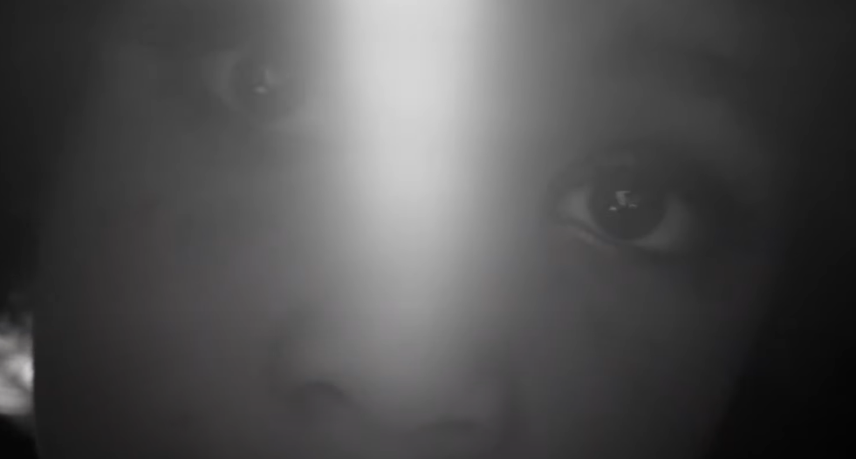 | - Symbolism (eyes)  - Direct gaze  - Light from background  …(the first 2 devices) could be said to challenge the viewer and suggest the power and independence of the bird.
Figure 14 – still 5, gesture with hands  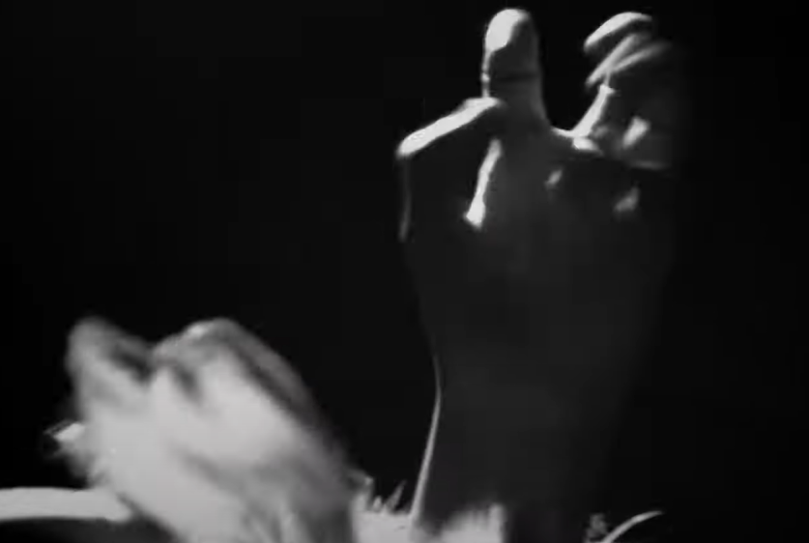 | - Body language and gesture  …connect the visual text with the poem (the bird ‘clenched’ and ‘unclenched’) but the close up intensifies the aggression of the movement.
Figure 15 – still 6, zoom to close up and out of focus shot  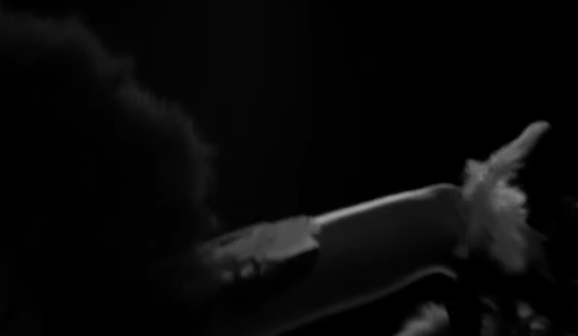 | - Zoom in and out  - Out of focus  …emphasise the sudden movement of the bird and suggest its freedom and independence. It is out of human control.
Figure 16 – still 7, light and shade in mid shot  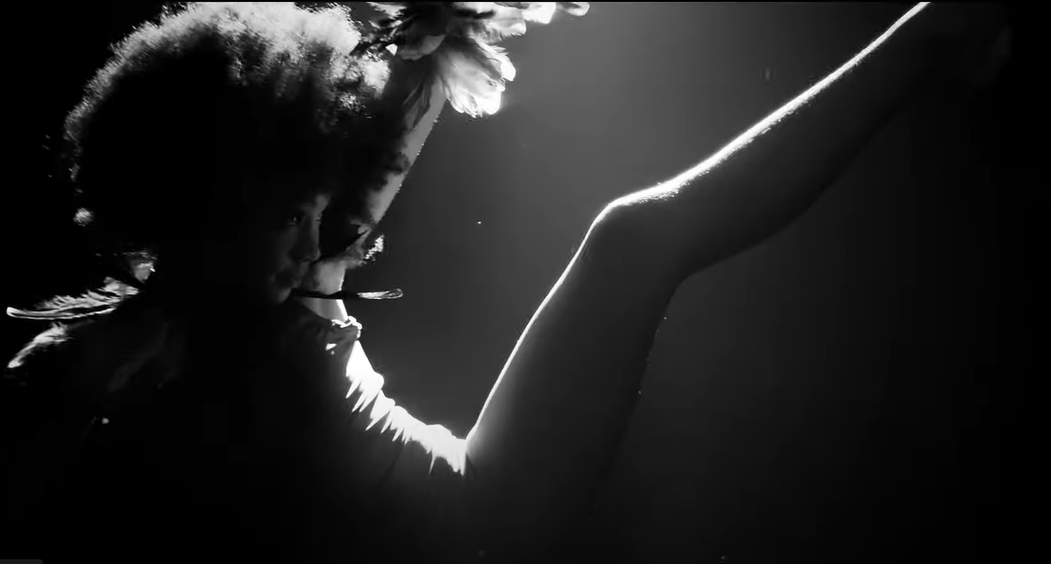 | - Mid shot  - Use of light and shade, as well as colour  …this focus on the flow of movement focuses our attention on the freedom and joy of movement.
Figure 17 – still 8, framing and editing  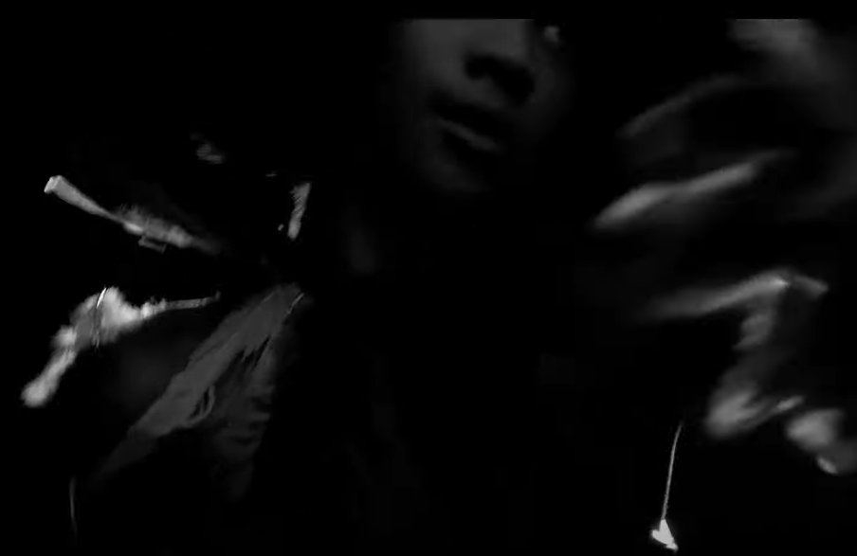 | - Framing (parts of body deliberately cut off)  - Editing (quick and sudden)  …both support the out of focus zooming and create a jerky feel that suggests the bird’s freedom, power and joy.
All images in this sequence – Paul Kelly (2022). ‘Eurydice and the Tawny Frogmouth’ (3:25), stills from YouTube video (dir, Sian Darling). Sony Music Publishing/Golvan Arts Management. Reproduced and made available for copying and communication by NSW Department of Education for its educational purposes with the permission of One Louder on behalf of Paul Kelly.

Phase 3, activity 7 – critical and creative thinking
Activity 1 – seeking and investigating patterns
Teacher note: the following table can be adapted for use with pairs or to guide whole class discussion. Students are guided through the 2 examples, then supported to find other examples before a further class plenary.
- Look at the 2 examples in the table for the music video. Notice how the evidence has been used for each column point.
- Find 2 examples of your own and complete the table.
Table 25 – patterns in the music video
Pattern | Visual devices | Discussion
The bird figure dances wildly over the lines ‘flying with you’ from the song | Mid and long shots, quick cuts, out of focus shots and use of light and shade | In contrast to the close ups on face and hands, these sections of the music video suggest intensity, freedom and playfulness, perhaps evoking the joy of the relationship.
The bird figure opens and closes her eyes at key moments | Close up shots and symbolism of eyes | There is a tension in the poem between ‘looks out’ and ‘waiting’ on the one hand, and the ‘hunting’ that is about to happen. The eyes open suggest an intensity of focus while the closed eyes are more calming and dreamy.
[Students add further examples] | [Students add further visual devices] | [Students add further discussion]
[Students add further examples] | [Students add further visual devices] | [Students add further discussion]
Activity 2 – prioritising and making judgements
- The teacher has provided you with a list of words or phrases from the poem and a slide show of stills from the music video.
- Match the correct phrases with the images.
- Decide on your favourite pair and justify in a class discussion using evidence.
Activity 3 – established and dynamic associations
Teacher note: the table below can be used again as a stimulus for student exploration. Teacher guides the discussion of the examples provided, then supports students to find other examples and return to the whole class plenary for discussion before the analytical writing activity which follows. The teacher will use the discussion to clarify terminology. Established associations refer here to existing connotations and symbolism, such as the wisdom of owls. Dynamic associations could be seen to refer to changing or personal or adapted meanings that arise from viewing and thinking about the new text. While dynamic associations can exist within a text, the focus of this phase is on how the new visual adaptation leads to new associations.
- The teacher will discuss with you the examples of established and dynamic associations.
- Can you find your own example?
Table 26 – established and dynamic associations
Established associations (examples and suggestions only) | Dynamic associations
The symbolism of the owl as wise | The speed of cuts, shadows, blurring of focus and out of frame shots all suggest the speed, power, urgency and panic of the hunt. This is stronger in the visual text.
The gate as symbol of the entryway to the family home | The human dancer brings the focus more onto the bird. The sense that the bird is a symbol of ‘our’ home and that the poet is flying with ‘you’ is less present in the music video. We are more captured by the action and experiences of the bird.
The connotations of ‘black’ and ‘cast iron’ are of strength and mystery | Perhaps these connotations are intensified in the music video?
The connotations of ‘clenched’ as powerful or tense | Also evident in the music video. The powerful and defiant gaze of the figure at the viewer intensifies this feeling.
The symbolism of flying as freedom | The lightness implied by ‘weighed no more’ is extended and adjusted by the interpretive dance of the figure. Freedom is suggested by the moves, as is joy and mystery and power. Perhaps the poem focuses on ‘flying with you’ while the visual text is more individualistic?
Using this information, write an analytical response to one of the following questions:
- How have the new ideas sparked by visual features added to your enjoyment and understanding of the poem?
- Why do you think it is important (or do you think it is unnecessary), to know the poem in order to enjoy and understand the music video?
Teacher note: teaching and learning activities in this phase draw on the following resources and pedagogies. For the difference between critical thinking (analysing and assessing) and creative thinking (generating and applying new ideas) see the general capability of critical and creative thinking within the ACARA National Curriculum. The dimension of Intellectual Quality within the Quality Teaching Model contains the element of higher-order thinking. Here teachers are encouraged to provide students with opportunities to classify, explain, explore and create, as well as put elements together to consider and create new patterns. Bloom’s revised taxonomy (Anderson & Krathwohl 2001) scaffolds the learning from ‘remember’ and ‘understand’ towards the higher complexity of ‘apply…analyse…evaluate…create’.

Core formative task 3 – informative writing: explain how you will make a music video
Student note: this task will give you an opportunity to compose an informative text in the style of the assessment task you will be completing. You will therefore have the chance to show the teacher your developing ideas and get feedback without having to worry about marks. This writing task will allow you to keep experimenting with some of the text features and codes and conventions that you have been exploring in this unit. In particular, use it to write within a fictional scenario so you can ask any questions you have about how to do this well.
Fictional task context – you are a cinematographer in a film production company. Your boss, the Director, has to persuade a famous singer or band to let your company make the music video for one of their songs. She has tasked you, the cinematographer, with explaining how you will use 2 visual devices to make a video that will represent the song in fresh and interesting ways. Write a 100–200-word explanation of what you would do.
Additional advice for this task. You might like to:
- choose a song you like and are familiar with but does not have an existing music video
- include images or visual texts in your explanation to help you explain.

Phase 4 – deepening connections between texts and concepts
In the ‘deepening connections between texts and concepts’ phase, students explore a range of visual texts that are connected by the exploration of a similar theme. The focus of this section is on examining the interplay of images and written text and how this is used to position responders and achieve a specific purpose.
The teacher recognises students’ prior understanding of code and conventions of visual texts and their experiences of engaging with picture books and film.
A deepening awareness of the ways in which the textual features of visual texts are used by composers to impact on the audience, also underpins this phase. Students deepen their understanding of the difference between the narrative and theme of a text and how connotation, imagery and symbol are used to represent specific themes in visual texts.
Students practise analysis and critical thinking as they make connections between texts in preparation for the summative assessment task.
They analyse a range of visual texts, including revisiting some engaged with in Phase 1 and then develop increasingly well-organised analytical writing to express their informed personal responses.

Phase 4, activity 1 – scaffolding peer discussion
Teacher note: to support the development of critical thinking skills, use:
- convergent questioning – questions that explain and convey relationships/cause and effect
- divergent questioning – questions that hypothesise, predict and infer
- evaluative questioning – questions that develop arguments and defend and justify points (Quigley 2020).
Student note: after you read your selection of texts, you were asked to categorise them into 2–4 groups. Consider your responses to the following questions then discuss these questions with another group about their choice of text categories.
- What are the similarities between the texts in your collection? What are the differences?
- How would the collection of texts be different if they were all the same text type?
- Which of the texts in the collection is the most powerful?

Phase 4, activity 2 – audience and purpose quadrant analysis
Student note: use the prompts in the table to determine the purpose and audience of your text.
Text title: __________________________________________________________
Table 27 – audience and purpose quadrant analysis
Audience and purpose quadrant analysis | Audience and purpose quadrant analysis
Purpose  Does it inform, persuade or entertain?  What type of text is this? | Audience  For whom is this composed?
Vocabulary  Vocabulary evidence of purpose and audience. | Subject matter  What is the text about?

Phase 4, resource 1 – Aboriginal iconography: glossary
Student note: the following vocabulary list should help you to understand the informative text ‘Aboriginal and/or Torres Strait Islander Art symbols’.
Definitions
Arnhem Land – vast portion of land in northeast Northern Territory. It is home to the Yolngu people and people must have a permit to visit.
Clan – a group of people related by kinship or family connections.
Elders – someone who is acknowledged as a custodian of local knowledge and beliefs.
First Nations people – refers to the traditional landowners of Australia – the distinct groups of Aboriginal and Torres Strait Islander peoples.
Iconography – the use of images or symbols to relate a cultural, religious or historical meaning.
Identity – the combination of factors that make someone who they are.
Intriguing – interesting or fascinating.
Ochre – an earthy pigment/colour that varies from yellow to brown.
Oral communication – the exchange of ideas through spoken word.
Protocols – set of rules or processes that should be followed.
Visual communication – using visual images to send a message.

Phase 4, resource 2 – Aboriginal iconography: informative text
Aboriginal and/or Torres Strait Islander Art symbols
Historically, Aboriginal and Torres Strait Islander peoples did not have their own written language. Instead, stories were generally told through oral communication. A more formal way of recording language and stories was through the use of symbols – otherwise known as iconography. Iconography was included in artworks, and in visual communications left in sacred areas.
Although iconography can be interpreted as simple designs, this is not the case. Each symbol has a different level of meaning depending on the audience. Some symbols are for the exclusive use of elders and others are governed by strict gender protocols or for only viewing within a single community. As a result, it is inappropriate for non-Aboriginal and/or Torres Strait Islander peoples to create symbolic artworks.
Whilst each language group has its own symbols, they can look similar to those from other groups. It is important to note that these similar symbols could have very different meanings. For example, some clans in Arnhem Land have sophisticated designs to represent their individual identities. These designs are called ‘miny’tji’ and use fine lines and ochre colours.
There are, however, some symbols common to most Aboriginal and/or Torres Strait Islander language groups.
People are represented by a curved U shape. It symbolises the shape left in the sand when someone has been sitting on it cross-legged. A circle generally represents a meeting place, campsite or waterhole, whereas straight lines represent the track that should be taken to get from one place to another. Finally, animals are represented by the tracks they leave behind them. It is this combination of both common and individual symbolic visual language that makes Aboriginal and/or Torres Strait Islander languages so intriguing.
Adapted from Aboriginal Art Symbols - Iconography | Kate Owen Gallery

Phase 4, activity 3 – cause and effect sentences
Student note: cause is the reason why something happened, and effect is the result or outcome of what happened. When we use appropriate connectives, we can link these ideas cohesively and clearly.
- Use this table as a ‘bank’ of cause and effect transition words and phrases. Add cause and effect transition words and phrases used in the text ‘Aboriginal and/or Torres Strait Islander Art symbols’ to the third column.
Table 28 – cause and effect sentences
Examples of cause and effect words | Examples of cause and effect phrases | Cause and effect words and phrases in the text
So  Thereby  Due to  Since  Because  Thus  Similarly  Whereas  Consequently  Therefore  Hence  Otherwise | As a result  On account of  Which means  The reason for  As a consequence of  Resulting in  In order to  The reason  Instead | [Students add words here.]
Teacher note: examples from the text are – instead, otherwise, although, depending on, as a result, whilst, however, whereas, that makes.
Teaching cause and effect sentences using Pearson and Gallagher’s (1983) Gradual Release of Responsibility
- Teacher model: ‘My Country’ by Barbara Weir is an acrylic on linen artwork that viewers can see features meeting places because of the use of circles in the text.
- Student and teacher model: The acrylic on linen artwork ‘My Country’ by Barbara Weir uses straight lines… [finish this sentence]
- Construct your own cause and effect sentence using the ‘Aboriginal and/or Torres Strait Islander Art symbols’ text and suggested cause and effect words and phrases for support. Suggested artworks to explore:
- Awelye Atnwengerrp (Barbara Weir in Kate Owen Gallery: Contemporary aboriginal art, 2023)
- Kalaya Tjukurpa (Emu Dreaming) (Jimmy Baker in Kate Owen Gallery: Contemporary aboriginal art, 2023)
- Tjala Tjukurrpa (Honey Ant Dreaming) (Yaritji Young in Kate Owen Gallery: Contemporary aboriginal art, 2023)
- Untitled (Yinarupa Nangala in Kate Owen Gallery: Contemporary aboriginal art, 2023)
- Wananooroo (Jack Britten in Kate Owen Gallery: Contemporary aboriginal art, 2023)
Teacher note: the activity above should be used to also demonstrate to students the use of captions in a gallery. This understanding will be required for part of the summative assessment task, and this is an opportune time to draw attention to the information that is included in an art gallery caption. It should also allow students to practice locating the title and composer of a text and how to include this information fluently in a sentence. Students could also use a 5 senses graphic organiser to collate their ideas prior to writing their captions.

Phase 4, resource 3 – protocols for teaching Aboriginal and/or Torres Strait Islander texts
To the teacher: the following checklist could support a deeper understanding and engagement with an Aboriginal and/or Torres Strait Islander text. Many of the points below can be represented in more than one focus.
Table 29 – protocols for teaching Aboriginal and/or Torres Strait Islander texts
Number | Focus | Reasoning
1 | Content warnings and classroom support | Teachers to engage with local Aboriginal and/or Torres Strait Islander staff and/or local AECG, Local Land Councils (LALC) for support on content such as Passing, Stolen Generation, colonisation and law atrocities, other difficulties and spiritual knowledge that could include Connections to Country.  Teachers should allocate time for prior discussions of content that is suitable for all parties. Remuneration to local experts for their time should be considered
2 | Authenticity | Research whether the author is of Aboriginal and/or Torres Strait Islander background.  Is the author writing from their cultural perspective?  Has the book been endorsed by the author’s community or other Aboriginal and/or Torres Strait Islander organisations, for example, the AECG?
3 | Representation | Has the book shown a respectful perspective of on-Country, Peoples, Culture and/or History?  Is content authentic and goes beyond stereotypes?  Is the representation of On Country authentic?
4 | Language | If the author uses language other than English, who can translate or verify translations to be used in class?  Can information in the book be translated into local Aboriginal and/or Torres Strait Islander language with verification of correctness?
5 | Classroom preparation | Teacher to engage with Aboriginal and/or Torres Strait Islander Peoples to collaborate on:  - Beginning or introduction to topic  - cultural sensitivities and comparisons  - language use  - confirmation activities of understanding especially of On Country activities.
6 | Follow up | What activities are used to confirm knowledge in collaboration with local community?  Thank them for their knowledge, connections, time and support for student/schools, invite community to a celebration of cultural learning with student-led displays.

Core text 4 – Open Your Heart to Country by Jasmine Seymour
Annotated extracts (Powerpoint slide deck) from the Core text – Open Your Heart to Country by Jasmine Seymour are available to support teachers and students in their exploration of this text. Extracts are also included in the Core texts booklet.

Phase 4, activity 4 – exploring vocabulary
Teacher note: it may be useful to assign the following 2 activities for homework if school culture and policy permit.
- Read a review of Jasmine Seymour’s Open Your Heart to Country.
- Create vocabulary bookmarks by highlighting key vocabulary. Work with your teacher and/or peers to create categories for the vocabulary in the review. Examples may include:
- unfamiliar words
- language of opinion
- topic specific words
- challenging words.
- For the highlighted words, identify the category, record a definition, find synonyms and use each word in a sentence. The first row has been completed as an example.
Table 30 – exploring vocabulary
Category | Word | Definition | Synonym(s) | Sentence
Language of opinion | mellifluous | pleasantly smooth and easy to listen to | melodious | She spoke to me in mellifluous tones.
[enter category] | [Add your response here] | [Add your response here] | [Add your response here] | [Add your response here]
[enter category] | [Add your response here] | [Add your response here] | [Add your response here] | [Add your response here]
[enter category] | [Add your response here] | [Add your response here] | [Add your response here] | [Add your response here]
[enter category] | [Add your response here] | [Add your response here] | [Add your response here] | [Add your response here]
[enter category] | [Add your response here] | [Add your response here] | [Add your response here] | [Add your response here]

Phase 4, activity 5 – exploring word meaning of ‘values’
- Complete the following activities to explore the origins and meaning of the word ‘values’. Use Word Roots and a dictionary to assist you.
Table 31 – exploring word meaning
Word | Values
Root word and meaning | [Students add response here]
Definition as a verb | [Students add response here]
Definition as a noun | [Students add response here]
Explanation of the difference between the verb and noun meanings. | [Students add response here]

Phase 4, activity 6 – Aboriginal and/or Torres Strait Islander languages
Teacher note: students should be reminded that Australia’s First Nations peoples have more than 250 separate languages and 800 dialects. The language in the text is just one of many Aboriginal and/or Torres Strait Islander languages. You may like to explore local languages on the Gambay – First Languages Map with your class before completing this activity. There are also several online language dictionaries available. This would also be a good opportunity to invite AECG or LALC members to share local language with your class.
- Identify words from your own local Aboriginal and/or Torres Strait Islander language group to translate the traditional language in the text. If you cannot access words from your own area, try a different language group.
- How similar or different is the language?
- In the extract from the text in which the Dharug language is used, identify one visual feature that reflects or enhances your understanding of the written text. The first row of the table has been completed for you as an example.
Table 32 – language comparison table
Words in the text | Meaning | Word in local language | Identify one visual language feature that reflects or enhances your understanding of the written text
Ngiyini Ngurrawa | You are on Country. | [Students add response here] | Symbol of the black cockatoo which is a totem connected to Dharug Country
Walama ngurragu | Return home. | [Students add response here] | [Type text your response here]
Warami. Budyari naady’unya | Where are you from? | [Students add response here] | [Type text your response here]
Dabuwamilyi Ngurragu | Paint up for Country. | [Students add response here] | [Type text your response here]

Phase 4, activity 7 – figurative language in the core text
Teacher note: after reading the text, students should be asked to identify examples of figurative language. This may be a good time to revisit figurative language devices studied in Program 1.
- The text uses figurative language in combination with visual images to tell a story. Identify examples of each device in the Device, Evidence, Effect (DEE) table and the effect of using the example.
Table 33 – DEE table to support analysis
Device | Evidence | Effect
Alliteration – repetition of consonant sound | [Students add response here] | [Students add response here]
Personification – a human quality is given to a thing | [Students add response here] | [Students add response here]
Allegory – hidden meaning | [Students add response here] | [Students add response here]
Symbolism – when one thing represents another | [Students add response here] | [Students add response here]

Phase 4, resource 4 – figurative language responses
Teacher note: the following table provides suggested answers for Phase 4, activity 7 – figurative language in the core text. It can also be used to create a modified version of the activity. Provide students with a table with some cells pre-filled for learners requiring further support.
Table 34 – figurative language responses
Device | Evidence | Effect
Alliteration – repetition of consonant sound | Far from | The repetition of the ‘f’ sound alludes to the fact that it is a long way away from the current place. That many Aboriginal and/or Torres Strait Islander peoples were taken far away from their traditional lands during the Stolen Generations period. It could also signify that reconciliation is still a long way off.
Alliteration – repetition of consonant sound | Listen. Love. Learn. | Here, an atmosphere of peace is created through the lulling effect of the repetition of the ‘l’ sound. It implies that reconnecting and being on-Country will bring peace to the individual.
Personification – a human quality is given to a thing | Let place soothe | This use of personification reiterates the importance of being On Country to Aboriginal and/or Torres Strait Islander Peoples and that it brings healing.
Personification – a human quality is given to a thing | Lonely feet | The concept that feet can be lonely reinforces the idea of Aboriginal and/or Torres Strait Islander Peoples being taken away from where they traditionally connect with the land (where they once stood) and this has left a feeling of loneliness and isolation. It can also mean that no matter where your journey takes you, the connection to home will always soothe you.
Personification – a human quality is given to a thing | Land singing you back home | Singing is a term often symbolic of happiness and celebration. The analogy of the land singing in welcome demonstrates the reciprocal connection between Country and Aboriginal and/or Torres Strait Islander Peoples.
Personification – a human quality is given to a thing | Skin might have many names | This is referencing how the different groups of Aboriginal and/or Torres Strait Islander Peoples could have a connection. Skin names or Skin Groups are a reference to Kinship of both maternal and paternal family lines. This also references the different Country peoples may align themselves to.
Personification – a human quality is given to a thing | Long ago stories will cover you | This is a reference to Dreamtime stories connecting you to Country. It can also be a connection to identity and how the Dreamtime stories are an indication of where you come from and your place within Kinship. Therefore, reconnecting with traditional stories brings Lore, Respect of Country, Connection to peoples through families, and an understanding of an individual's place in time.
Allegory – hidden meaning | Welcome home lost children | This line indicates the hidden message of what happened during the Stolen Generations and the impact of returning to traditional land, language, culture and knowledge.
Symbolism – when one thing represents another | The overlapping layers of images | Represents the ongoing connections between past and present.

Phase 4, resource 5 – annotated extracts from the core text
Annotated extracts of the Core text 4 – Open Your Heart to Country by Jasmine Seymour are available to support the exploration of this text.

Core text 5 – Visible by Genevieve Clay-Smith
The short film Visible (3:00) by Genevieve Clay-Smith can be accessed on the Department of Education’s website.

Phase 4, activity 8 – three level guide for Visible
Teacher note: the three level guide comprehension strategy is useful to teach students to use evidence to support an argument. Sometimes known as ‘here, hidden and head’, the first 3 questions should be literal (here), the next 3 questions should be inferential (hidden) and the last question should be evaluative (head).
What it is: levelled reading is a way to comprehend, interpret and apply difficult texts by working at the literal, interpretive and applied levels.
What it does: levelled reading helps readers to go beyond the surface of a text in a step-by-step way.
- After viewing the short film Visible, you must decide whether the following statements about the film are true or false or if there is not enough information given (there will only be one of these). You must provide evidence from the film to support your argument. Some of these statements can be either true or false. Your use of evidence from the text is what is important.
Female protagonist: Audrey
- Audrey is unhappy at school.
- The other students do not notice Audrey.
- The girls in the bathroom are kind to Audrey.
- Audrey is happy at home.
- Audrey is brave.
- Audrey achieves her goal with her plan.
- Audrey’s parents approve of her plan.
- The 3 characters will remain friends for a long time.

Phase 4, activity 9 – film metalanguage information gap activity
Teacher note: information gap activities are particularly effective for EAL/D learners because of the communicative demands. They involve each of the learners having different information from each other and using oral communication skills and listening skills to complete a task.
In this activity, partners have different sets of images from the core text Visible. These should be laid out in front of them and there should be a barrier separating the partners so that they cannot see their partner has the explanation of the film device. Students take turns to read a definition or description of the film device while their partner finds the matching frame from the film.
Student note: the aim of this activity is for you to match the correct film device with an example from Visible. Your partner has the definitions of the film devices that match the frames from the film that you have been allocated. Listen carefully as your partner reads a definition and find the frame that you think is being described. You will then read a definition from the list that you have been given and your partner will try to match that to one of the frames that they have been given.
Information gap activity
- You have been given the description of 5 film devices. Your partner has the example from the film that matches your description.
- Read the description of the film device to your partner. Your partner must find the frame from the film that matches the description.
- Your partner will read to you a description of a film device that they have been given. You need to find the frame from the film on your sheet that matches the description that your partner has read.
- Continue this process until you have matched each of the descriptions with a frame from the film.

Table 35 – information gap activity set A
Frame from Visible | Film device
Figure 18 – frame 1 from Visible  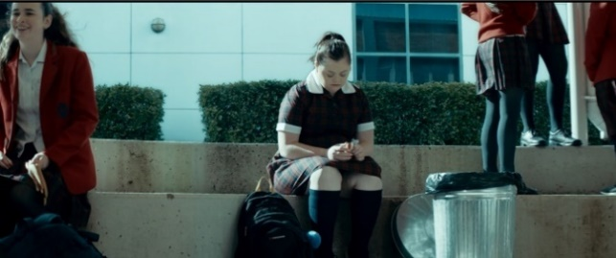 | Mid shot – a shot that is approximately half-filled with the subject. Usually these are ‘regular’ shots and are very common for character conversations/interactions or showing a select area or object within an area (a desk, chair and so on).
Figure 19 – frame 2 from Visible  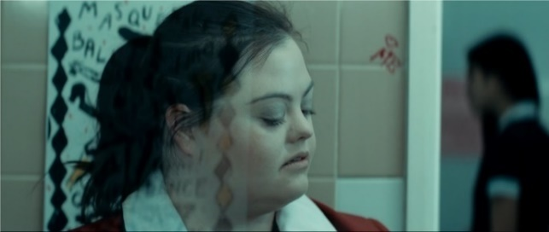 | Contrast – placing things that are considered opposite close to each other. Contrasts can be between colours (black and white), sizes (large and small), textures (rough and smooth), etcetera. to create interest and complexity. One small contrasting colour/size/shape in an image is also usually highly salient because it stands out.
Figure 20 – frame 3 from Visible  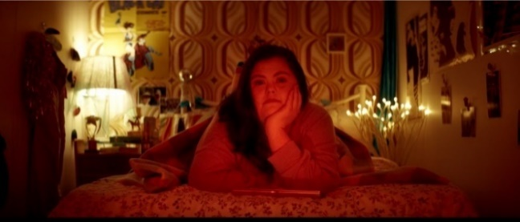 | Shallow focus – the device that keeps one part of an image in focus while the rest is out of focus. It helps emphasise one part of the image over another to draw the viewer's eye to a particular area of the frame or subject.
Figure 21 – frame 4 from Visible  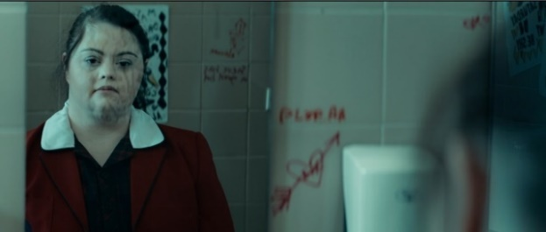 | Long shot – a shot that is made up of a large landscape, cityscape or another kind of scene. Generally, these are used to get across lots of information at once, such as the layout of a room, the location of an event, the number of people around.
Figure 22 – frame 5 from Visible  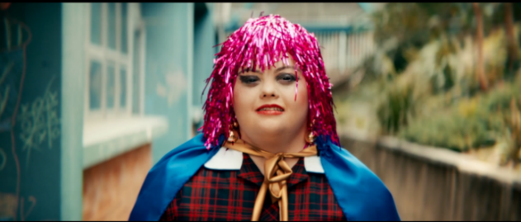 | Background – the area furthest from the viewer, behind the subject or in the distance. The setting or context of an image.
Table 36 – information gap activity set B
Frame from Visible | Film device
Figure 23 – frame 6 from Visible  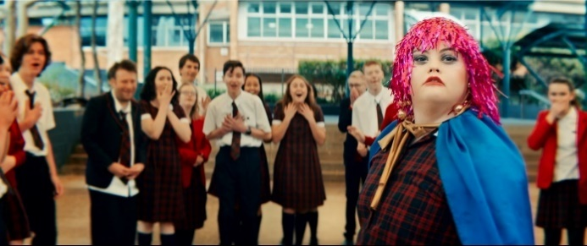 | Deep focus – device of photography which permits the whole frame to remain clearly in focus, from close-up range to infinity.
Figure 24 – frame 7 from Visible  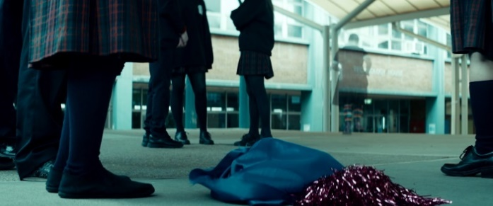 | Costuming – the clothes, makeup, hairstyles, accessories and so on. Designed to be worn by characters to represent their personality, status, heritage, culture and so on. Colour symbolism often comes into play here (a character wearing earthy colours may be associated with gardening, plants and nature).
Figure 25 – frame 8 from Visible  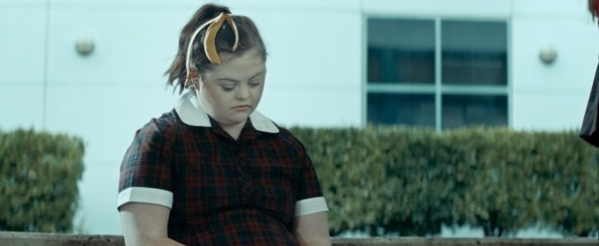 | Lighting – how a shot is lit or not lit. This includes natural lighting (the sun, open windows) and artificial lighting (lamps, torches) as well as feature lighting such as coloured lights, spotlights, moving lights. Lighting has a major impact on the mood and atmosphere of an image (low light is mysterious, harsh light is unnerving, soft light is intimate and so on).
Figure 26 – frame 9 from Visible  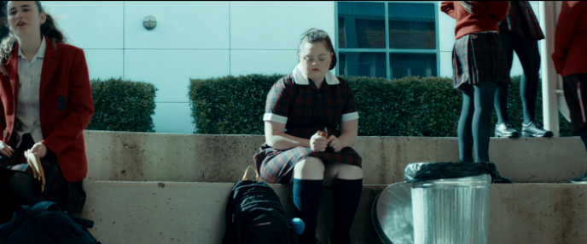 | Close up – when the frame is mostly or entirely filled with a character’s face or an important object. Used to create viewer focus and show that whatever is being shown is important. Often used on characters’ faces in highly emotional images.
Figure 27 – frame 10 from Visible  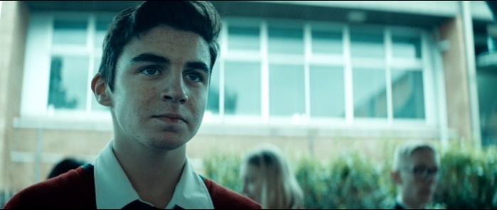 | Positioning/symbolism – where objects and characters have been placed in the shot. What is in the foreground, middle ground and background and why they have been placed there. The use of one image/object to represent an idea or concept that is more complex than it is.

Phase 4, resource 6 – film metalanguage information gap answers
Table 37 – information gap activity set A answers
Frame from Visible | Film device
Figure 28 – frame 1 from Visible  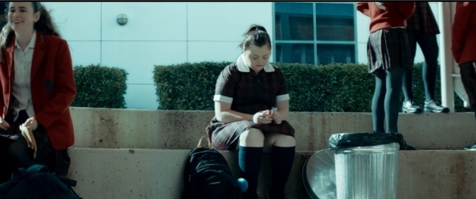 | Deep focus
Figure 29 – frame 2 from Visible  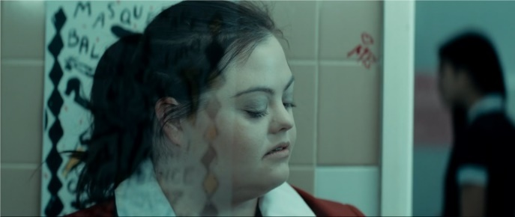 | Close up
Figure 30 – frame 3 from Visible  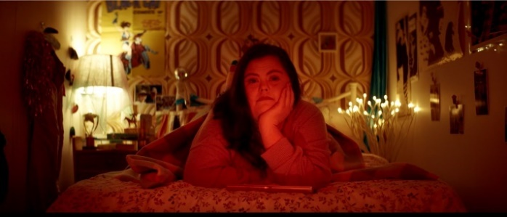 | Lighting
Figure 31 – frame 4 from Visible  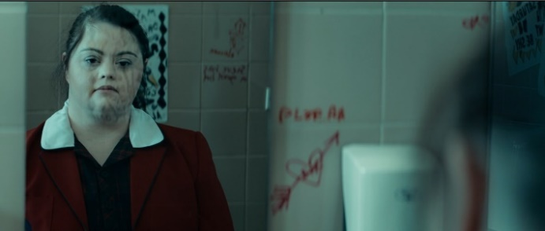 | Positioning and symbolism
Figure 32 – frame 5 from Visible  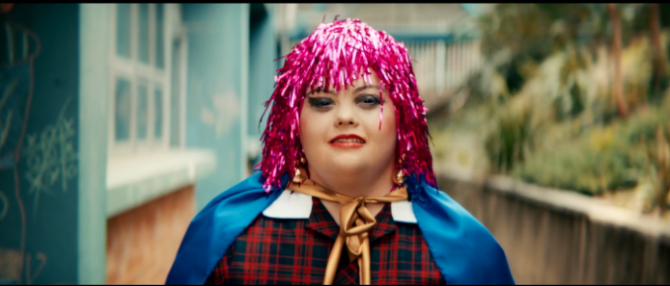 | Costuming

Table 38 – information gap activity set B answers
Frame from Visible | Film device
Figure 33 – frame 6 from Visible | Contrast
Figure 34 – frame 7 from Visible | Background/foreground
Figure 35 – frame 8 from Visible | Mid shot
Figure 36 – frame 9 from Visible | Long shot
Figure 37 – frame 10 from Visible | Shallow focus

Phase 4, activity 10 – theme or plot?
After you have watched the short video on Theme (2:52), consider the core text Visible and indicate whether the following points describe the plot or the themes of the texts:
- Everyone wants to be seen.
- Audrey feels lonely at school.
- Diversity makes the world a better place.
- Connections are crucial to developing identity.
- Audrey changes her clothes to be noticed by her peers.
- Humans search for a place to belong.
- Audrey is mocked and belittled by her peers.
- Courage can lead to personal growth.

Phase 4, activity 11 – connecting texts thematically
In the last activity, you may have noticed that one of the differences between theme and plot is that while plot is specific to one text, a theme can be found in many texts because it communicates social, personal, ethical and/or philosophical ideas and experiences.
In the table below, identify a theme that is shared by both Open Your Heart to Country and Visible. Explain how the codes and conventions of the text types are used to communicate this theme. The first row has been completed as a model. You may use the themes you identified in the previous activity or those that you have identified yourself.
Table 39 – connecting texts thematically
Theme | Open Your Heart to Country | Visible
Connections can be healing. | The connection to Country is healing for Aboriginal peoples. The fern used in the ‘Paint up for Country’ page has medicinal properties and so can be seen as a symbol of healing. | Connections with others helps to heal Audrey in Visible. After she has been humiliated, she forms a connection with one of her peers. The colour palette changes after this connection has been made. The warm, yellow tones replace the cold, blue tones to reflect the healing that has taken place for Audrey.
Diversity makes the world a better place. | [space for student answer] | [space for student answer]
[space for student answer] | [space for student answer] | [space for student answer]

Core formative task 4 – writing analytically about theme
Use the work you have completed on theme to compose an analytical paragraph exploring a theme that is represented in both Open Your Heart to Country by Jasmine Seymour and the short film, Visible. The scaffold below will help you structure your writing.
Table 40 – analytical response scaffold
Scaffold | Student response
Express the theme you are exploring as a sentence. | [space for student answer]
Provide evidence from the first text using the Seldon method sentence structure that supports the theme you have identified. | [space for student answer]
Provide evidence from the second text using the Seldon method sentence structure that supports the theme you have identified. | [space for student answer]
Write a sentence that provides a conclusion about the theme that you have identified. | [space for student answer]

Phase 5 – engaging critically with model texts
In the ‘engaging critically and creatively with model texts’ phase, students examine and respond to models for the textual and language features necessary to complete the formal assessment task. With each model text, students will investigate the ways in which a composer has explained, discussed or reflected on the use of visuals. This includes a digital brochure about a city, a photo essay by a famous photographer and a collector writing a guide to 2 exhibitions. Significantly, each of these model texts is a multimodal text, and students are guided to analyse how the different modes work in concert to achieve the informative and analytical aim of the composer.
By reading, viewing, understanding and responding critically and creatively to these complex texts involving both written and visual modes, students explore the ways in which composers present and organise information that refers to visuals, in order to guide the readers’ experiences. In addition, word, sentence and text level structures, grammar and punctuation are analysed and practised in the context of the purpose, audience and context of the multimodal text.
The complex hybrid multimodal texts examined in this phase are likely to be new forms for the majority of students. Students will need guidance and time to explore each in the framework of its purpose, with time to explore analogous texts of their choosing. The teacher, however, recognises students’ prior understanding of the codes and conventions of visual texts, as well as the structural and language features of moderately complex to complex informative texts. It is not expected that teachers will work through activities related to all 4 model texts; sequences can be combined, model texts can be exchanged and language features reorganised to suit the classroom context.

Phase 5, activity 1 – guided exploration of a multimodal text
Teacher note: this can be applied to a different text of the teacher’s choosing and the table can be adapted to work as a jointly constructed shared online document.
In pairs or groups, use the following table to guide your work in analysing the codes and conventions of the model text. Focus on any 2 images from within the visual text. Complete the table with your own ideas and examples.
Table 41 – exploring images and written text in model text 1
Focus for exploration | Student ideas and examples
Image 1 – how are visual devices used to achieve the composer’s aim? | [space for student answer]
Image 2 – how are visual devices used to achieve the composer’s aim? | [space for student answer]
What are the connections between the written text and image 1? | [space for student answer]
What are the connections between the written text and image 2? | [space for student answer]
What codes and conventions of multimodal texts can you see through the whole blogpost? | [space for student answer]
What are the key nouns and/or noun groups from image 1? | [space for student answer]
What are the key nouns and/or noun groups from image 2? | [space for student answer]
Teacher note: below is an additional worked example for teacher reference.
Figure 38 – Leeds image 3 Henry Moore sculpture
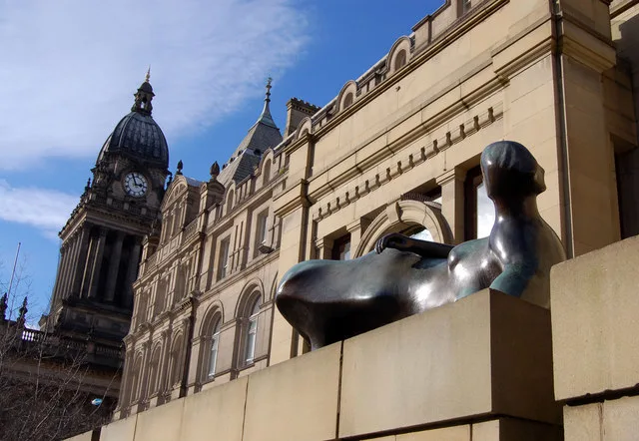
The image below, ‘A Henry Moore reclining figure’ by Malcolm Morris is licensed through Europeana.eu as CC BY-SA.
Accompanying text: ‘In Leeds, the Henry Moore Institute now shows exhibitions as well as holding an extensive research library on Moore and sculpture in general’ (Daley & Murphy 2023:Arts and Culture).
Teacher note: nouns and noun groups to explore:
- ‘institute’ and ‘sculpture’ – subject specific terminology
- ‘extensive research library’ – succinct noun group (adjective + adjective + noun) which contains conceptual detail in one succinct phrase.

Phase 5, resource 1 – the features of multimodal texts
The following resources will support the teacher with the required metalanguage and definitions. Terminology will need to be adjusted for the class context.
- The language of multimodal texts [PDF 208 KB] (University of Michigan)
- Multimodal texts surround us. What are they? How can we use them in our teaching? (Georgina Barton, EduResearch Matters)
- Creating multimodal texts (Victorian Department of Education, Literacy Teaching Toolkit)
Common features of multimodal texts include:
- Headings and sub-headings
- Captions
- Pull quotes, text grabs and feature boxes
- Paragraphs
- Images and graphics
- Layout, salience, proximity and vectors
- Use of font, colour
- Columns
- Bi-line

Phase 5, resource 2 – model multimodal text 2
The second model multimodal text for teacher sharing or projection.
Figure 39 – model multimodal text 2
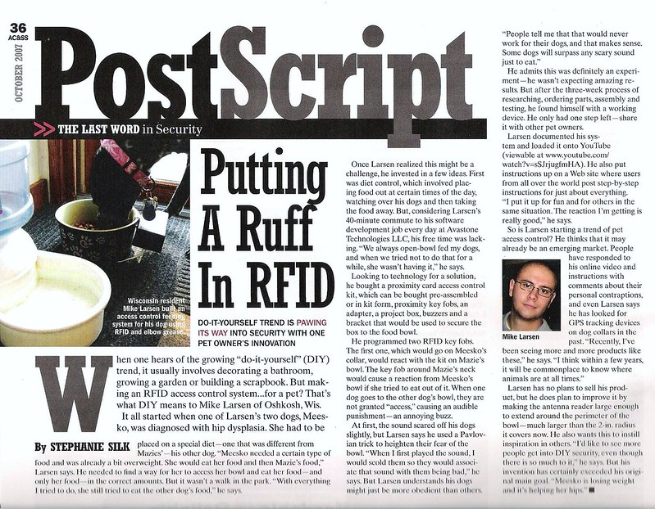
Access control and security systems magazine article by mlarsens is licensed under CC BY-NC-ND 2.0

Phase 5, activity 2 – layout of a multimodal text
Teacher note: the following table has been provided so that students can evaluate the features of a multimodal text in relation to the needs of the specific reader. With this second model text, students are encouraged to consider the effectiveness of the layout, not per se, but in the light of their task in the formal assessment. The specific content, reader and objective should guide the assessment of effectiveness.
Student activity instructions
Use the following table to explore the advantages and disadvantages of each feature of a multimodal text. Think about the advantages and disadvantages in relation to the formal assessment task for this unit. Which of these features would help your target reader (the Minister for Other Planets) understand and use the information you are providing for their upcoming speech?
Table 42 – advantages and disadvantages of multimodal text features for the information report required in the formal assessment task
Feature | Advantage for an informative multimodal report | Disadvantage for an informative multimodal report
Headings and sub-headings | Make it easy to find key sections of the report during a ‘live’ event such as a speech. | [space for student response]
Large font initial letter of a paragraph | [space for student response] | Decorative only so not useful – the report is not being published.
Captions under visual texts | Supply key information about the visual so it makes it easy for the Minister to understand and incorporate. | May over-simplify information?
Colours and a variety of fonts | Colours may draw attention to key features or information. | Colours and font variety may make the overall text too ‘busy’ and distract the reader from key information.
[Students and or class to add rows as necessary] | [space for student response] | [space for student response]

Phase 5, resource 3 – elaboration and description within accompanying written text to an image
The following example image and written text combinations can be used to examine, analyse and respond to key features of multimodal texts.

Model extract 1 – introductory text
‘The paintings were commissioned in the 1830s by Professor David Low, the University of Edinburgh's first-ever chair of agriculture. William Shiels, a portrait and animal painter, was sent all over Britain to paint cattle, horses, sheep, goats, pigs and dogs - spending 8 years on the road doing so’ (Murphy 2023).
Interesting points for analysis and annotation. Note:
- how the dependent clause ‘the University of Edinburgh’s first-ever chair of agriculture’ supplies further information (elaborates) on the independent (or main) clause that comes before it. Notice that it is missing the phrase ‘who was’
- the same structure for ‘a portrait and animal painter’
- the use of the comma in both points above
- the use of the hyphen to introduce the additional information at the end.
- the contextual information about the artist including the adjective ‘first-ever’ which adds important detail.
Model extract 2 – image 1
The painting of image 1 and its accompanying text (below) could be used to explore language structures and expand the range of visual devices discussed. See activity below.
Figure 40 – painting of a bull by Paulus Potter (image 1)
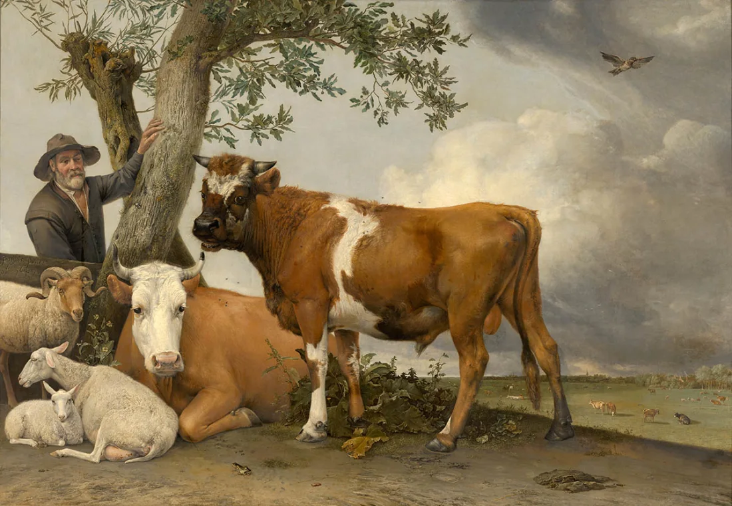
This painting, ‘The Bull’, by Paulus Potter, from europeana.eu is licensed as Public Domain Mark 1.0
Model extract 3 – caption and accompanying text for image 1
‘This portrait of a bull was painted in 1647 by Paulus Potter, who was just 22 years old at the time. It is a vast painting, measuring more than three metres in width and two metres in height.
It is a significant artwork from the 17th century in the Netherlands, made noteworthy by its realism and rustic setting. Bulls were a sign of prosperity and wealth, though had not been painted previously. Although the realistic details in the painting suggest one animal, livestock experts determine that the depiction of the bull's anatomy imply it is a composite of several different animals’ (Murphy 2023).
Interesting points for analysis and annotations. Note:
- The evaluative adjectives ‘significant’ and ‘realistic’.
- The dependent clause ‘who was just 22 years old…’ introduced by the relative pronoun ‘who’. This gives more specific information about the artist.
- The verbs ‘suggest’ and ‘imply’ to introduce the explanation or analysis by the writer.
Model extract 4 – image 2
The painting ‘The New Settlers’ and its accompanying text provide an opportunity to further investigate elaborating through adjectives and after hyphens.
Figure 41 – ‘The New Settlers’, painting by Antanas Gudaiti
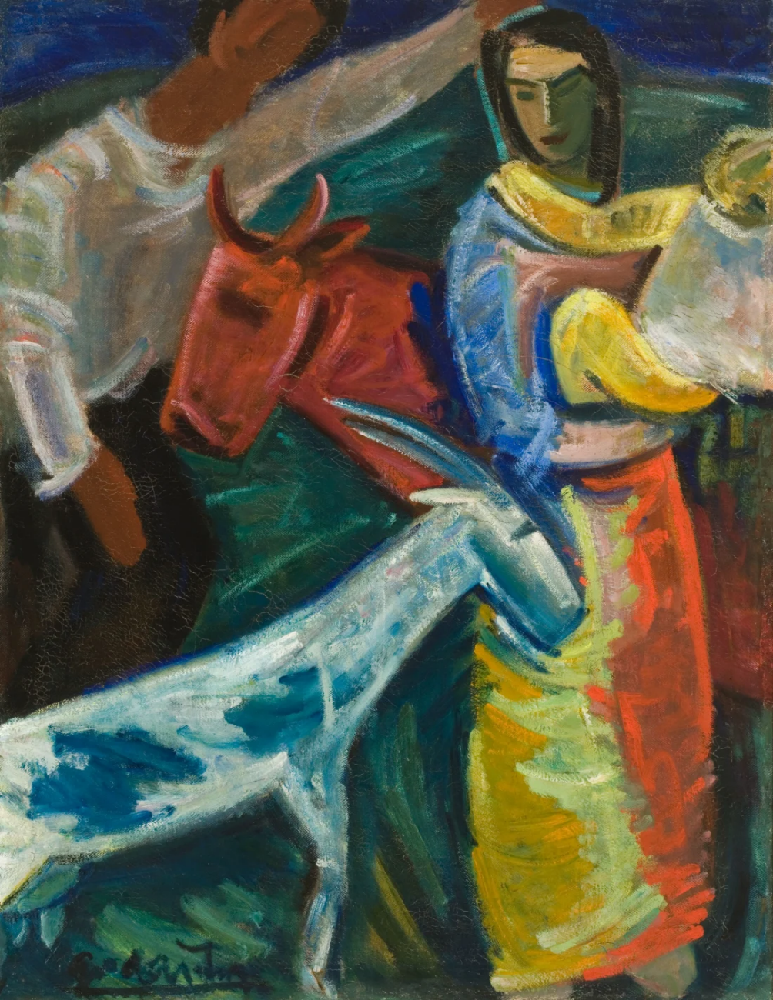
The painting above, ‘The New Settlers’ by Antanas Gudaiti, from europeana.eu is licensed as CC-BY 4.0
Model extract 5 – caption and accompanying text for image 2
‘This painting The New Settlers by Antanas Gudaiti was painted in 1933. In this expressive painting, there are vibrant colour combinations - the goat is blue and the cow is bright red’ (Murphy 2023).
Interesting points for analysis and annotation. Note:
- The evaluative adjectives ‘expressive’, ‘vibrant’ and ‘bright’ which carry the writer’s perspective, but also provide more specific descriptive detail.
- The additional detail after the hyphen. This provides more specific elaboration on the phrase ‘vibrant colour combinations’.
Model extract 6 – image 3
The painting of cattle in image 3, and its accompanying text provide further opportunities for investigating the grammatical codes and conventions of this form of writing.
Figure 42 – painting of cattle by Theodor Philipsen
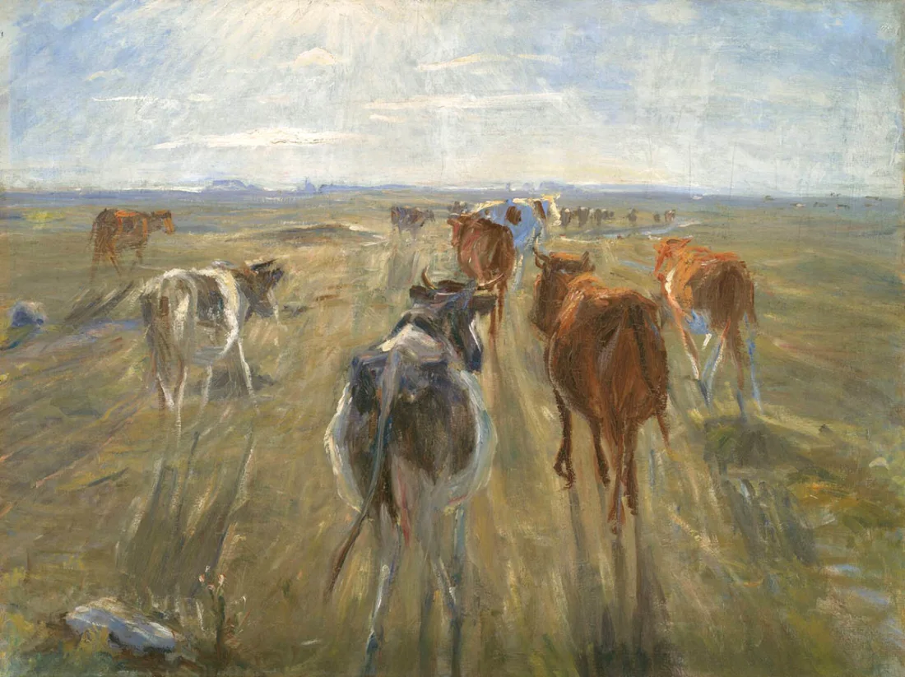
The painting above ‘Long shadows. Cattle on the island of Saltholm’ by Theodor Philipsen, from europeana.eu is licensed as CC0 1.0
Model extract 7 – caption and accompanying text for image 3
‘Danish artist Theodor Philipsen painted this dynamic painting of cattle on the island of Saltholm between 1888 and 1892. Unlike other paintings here, these cattle are running away from the viewer. The short, richly coloured brushstrokes make the picture vibrate with light, colour, and atmosphere… The colour palette used in this painting, as well as the way the shadows reflects from the cattle, shows his priority is more on portraying sunlight and the power of nature’ (Murphy 2023).
Interesting points for analysis and annotation. Note:
- The phrases which analyse the image: ‘Unlike other paintings… cattle are running away… short, richly coloured brushstrokes… colour palette.’
- The evaluative adjectives which carry the writer’s perspective and provide more refined detail: ‘dynamic… richly coloured’ (adverb + adjective)
- The noun group ‘the power of nature’ for creating detail about the subject matter of the image.
- The verbs which introduce an analysis of the image: ‘vibrate…reflects’.

Phase 5, activity 3 – analysing and experimenting
Teacher note: the following activities are designed to extend student work after the peer-teaching activity above. Here they have opportunities for further annotation of codes and conventions as well as ideas for experimenting with the supplied model texts to change key aspects. Students could complete some or all of these activities, but they may need to be scaffolded depending on context. Once the teacher has demonstrated, students should work in a collaborative and guided way, then have time for independent application followed by the core formative task.
Student activity ideas
- Can you sharpen the analysis by adding in some of the technical vocabulary you have been learning this term? Choose one image and add 2–3 metalinguistic phrases to the accompanying text. For example, comment on the layout, symbolism or proximity in order to explain the effect of the image. For example, in image 2: ‘the symbolism of the family is clear with the baby in the mother’s arms – this suggest that the animals are part of the family. The warm colours reinforce the feeling of company and equality’.
- What other features of a multimodal text can you identify? Choose another example of accompanying text from this multimodal blogpost and annotate for the features discussed here: evaluative adjectives, noun groups, punctuation for elaboration and verbs introducing analysis.
- Would you like to see what everyone else has been working on? Display these annotations around the classroom. Pin up images with accompanying text and use coloured string to show connections.
- Can you change these texts to mean the opposite of what they do at the moment? The accompanying text is generally positive. Experiment with changing adjectives and verbs to make the evaluation negative.

Core formative task 5 – informative accompanying text
Student note: this task will give you an opportunity to refine your writing of informative and analytical accompanying text for a visual. This is exactly the type of writing you will need for the formal assessment task you will be completing. This writing task will allow you to keep experimenting with some of the text features and codes and conventions that you have been exploring in this unit. In particular, use it to write an informative description of an image which includes your analysis of the ways in which visual devices have been used to impact the responder.
- Compose the accompanying text for an image included in a multimodal blogpost. You have 2 options:
- Through this unit you have had opportunities to write about images: an animal of your choosing or a photograph of your town or suburb, for example. Use this formative assessment task to return to a piece of writing you have begun and refine it to show your understanding of the word and sentence-level grammar and punctuation you have been learning about.
- Alternatively choose a new image or visual text, for example a news report from the day you were born, or a photograph of your town or suburb from 100 years ago. Imagine that these images are part of a multimodal text similar to those you have explored in Phase 5. Write the accompanying text of between 50 and 150 words focusing on informing the reader about the important features of the image, and what the image reveals about the topic.
Additional advice for this task
You might like to practise using:
- nouns and noun groups to give a clear description of the topic, content or context
- evaluative adjectives to clarify your perspective
- verbs such as ‘suggests’ and ‘reflects’ to introduce your analysis
- punctuation (such as hyphens or semi-colons) to elaborate on your ideas
- metalanguage for analysing the codes and conventions of visual texts.

Phase 6 – preparing the assessment task
In the 'preparing the assessment task' phase, students are supported with a range of strategies to support them in their engagement with the formal assessment task. Students will engage with activities that support them to identify the key words in questions and use these in the formation of a response. Students will also engage with and rehearse responding to short answer questions in timed conditions. The activities provided throughout this phase are not meant to be completed consecutively, nor should they be left until Phases 1–5 are taught in their entirety. They should be introduced as required, to consolidate skill development and run concurrently with the other phases. Some may take a few minutes in a once-off lesson, while others may require an entire lesson. Others will need to be repeated to ensure that each element of analytical skill development has been achieved. All will need to be adapted to the class context.

Phase 6, resource 1a – assessment notification glossary
Teacher note: create a glossary to support student engagement with the assessment notification. Depending on the students, the terms and phrases bolded may need to be defined or replaced with other words. This is not an exhaustive list. It should be modified or edited by the class teacher.
Anahit is the most powerful planet in the Galaxy. The Ministers in the government of Anahit have been watching Earth for many years and are deeply concerned. They have noticed that Earth’s environment is being destroyed and the inhabitants are suffering. The Ministers have decided that the best solution is to destroy planet Earth and start again.
Your boss, the Minister for Other Planets, believes that Earth should be saved. They have one final chance to convince the other Ministers at their next meeting.
The Minister for Other Planets is going to deliver a speech and has asked you, the Senior Advisor, to provide evidence that can be used to support the argument that Earth is worth saving.
You know that visuals are a very effective type of evidence, and you have decided to select 3 powerful and engaging visual texts about Earth. You will create a multimodal report presenting and analysing the visuals. You will include captions to help your boss understand the content and context of the visuals. In addition, you will write the accompanying informative text.
Remember, your job is not to convince anyone. You job is to gather, select and analyse the evidence and write an informative report to support your boss’ argument that Earth should be saved.
Your task – multimodal report
Create a multimodal report your boss can use to support their argument that Earth is worth saving from destruction.
To complete this multimodal report, you must:
- Decide why Earth is worth saving: this will be your thesis.
- Research and select the 3 visual texts that you think will best support the argument that Earth is worth saving (for example: images, paintings, photographs, or extracts from media texts or picture books).
- Write a one sentence caption for each visual stating: what the visual is, who it is by, where it is from and what it shows. The captions are not included in your final word limit.
- Compose a multimodal report of 300–500 words (excluding captions, headings and other multimodal report features) analysing the 3 visual texts. Explain what they communicate about planet Earth (your thesis). In your analysis, focus on the content, construction, and contextual information (where relevant) that will help your boss convince the Anahit government that the Earth should be saved.
Table 43 – assessment glossary
Term | Definition | Image
Galaxy | A collection of billions of stars and other matter held together by gravity.  Our planet Earth and the sun belong to the Milky Way galaxy. They are only tiny parts of this galaxy. | [Insert an appropriate image]
Planet | A large body in outer space that circles around the sun or another star. | [Insert an appropriate image]
Government | The group of people who are responsible for controlling a country or a state. | [Insert an appropriate image]
Minister | A person who is the head of a government department. | [Insert an appropriate image]
Senior Advisor | A senior advisor is someone who gives an idea or opinion to help make a choice or a decision.  This is called giving advice. | [Insert an appropriate image]
Concern | A worried or nervous feeling about something. | [Insert an appropriate image]
Notice | [Insert an appropriate definition] | [Insert an appropriate image]
Environment | [Insert an appropriate definition] | [Insert an appropriate image]
Destroy | [Insert an appropriate definition] | [Insert an appropriate image]
Inhabitant | [Insert an appropriate definition] | [Insert an appropriate image]
Boss | [Insert an appropriate definition] | [Insert an appropriate image]
Save | [Insert an appropriate definition] | [Insert an appropriate image]
Evidence | [Insert an appropriate definition] | [Insert an appropriate image]
Meeting | [Insert an appropriate definition] | [Insert an appropriate image]
Convince | [Insert an appropriate definition] | [Insert an appropriate image]
Engage | [Insert an appropriate definition] | [Insert an appropriate image]
Multimodal | [Insert an appropriate definition] | [Insert an appropriate image]
Report | [Insert an appropriate definition] | [Insert an appropriate image]
Caption | [Insert an appropriate definition] | [Insert an appropriate image]
Content | [Insert an appropriate definition] | [Insert an appropriate image]
Context | [Insert an appropriate definition] | [Insert an appropriate image]
Accompanying | [Insert an appropriate definition] | [Insert an appropriate image]
Informative text | [Insert an appropriate definition] | [Insert an appropriate image]
Gather | [Insert an appropriate definition] | [Insert an appropriate image]
Select | [Insert an appropriate definition] | [Insert an appropriate image]
Analyse | [Insert an appropriate definition] | [Insert an appropriate image]
Support | [Insert an appropriate definition] | [Insert an appropriate image]
Thesis | [Insert an appropriate definition] | [Insert an appropriate image]
Research | [Insert an appropriate definition] | [Insert an appropriate image]
Excluding | [Insert an appropriate definition] | [Insert an appropriate image]
Construct | [Insert an appropriate definition] | [Insert an appropriate image]

Phase 6, activity 1a – crafting a thesis
- Brainstorm as many ideas as you can below about why Earth should be saved. Remember, the Ministers main concerns are that the environment is being destroyed and the inhabitants are suffering. Focus on these first and then explore other ideas.
Figure 43 – thesis ideas brainstorm

- Reflect on your brainstorm, select your 2 strongest arguments, identify these below then ask your teacher for feedback:
- Idea 1:
- Idea 2:
- Teacher feedback:

Phase 6, resource 1b – annotating a text
Figure 44 – sample visual annotation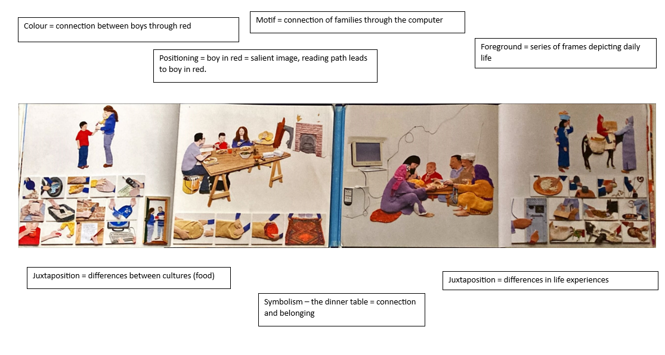

Phase 6, activity 1b – critical thinking for analytical writing
Student note: analytical writing requires you to use evidence to support your ideas. To gather appropriate evidence, it is necessary to develop appropriate note-taking skills. With reference to the annotations you made for Mirror, your teacher has modelled some examples of relevant notes in the first row.
- With a partner, find supporting detail to complete the second row. Complete the final row individually.
Table 44 – critical thinking for analytical writing
Big ideas | Supporting detail
Connection | Use of the colour red  Juxtaposition  Reading path
Universal experiences | [space for student response]
Cultural differences | [space for student response]

Phase 6, activity 1c – Seldon method: bubble theory
- Examine the Seldon method: bubble theory templates below. Consider how this method could assist you in writing complex analytical sentences.
Figure 45 – Seldon method: bubble theory

Figure 46 – Seldon method bubble theory template

Figure 47 – Seldon method bubble theory sample for Mirror

- Using the information gathered in the previous activity, use the Seldon method to create your own complex analytical sentences. Use the example provided in the first row for the use of the colour red as a model.
Table 45 – Seldon method: bubble theory sentence scaffold
This | does that, | doing that, | and doing that.
The composer’s use of the colour red | creates a reading path from the boy in red on the left-hand side of the page to the boy in red on the right-hand side of the page | emphasising the similarities between the 2 boys in the story | and suggesting that human beings across the world have more in common than we might initially think.
[space for student response] | [space for student response] | [space for student response] | [space for student response]
[space for student response] | [space for student response] | [space for student response] | [space for student response]

Phase 6, activity 2 – gathering and selecting texts
Teacher note: before students start writing their report, they need to gather all the information they have about their visuals. This is the first step in their analysis and is the information they will use to compose their report for the boss. Encourage students to be as detailed as possible. This detail will be used by students in their informative analysis and will help the boss convince the Anahit government that the Earth should be saved. Complete a sample of the selected template with the class. Students should complete the template focusing on a variety of visuals.
In this activity you will gather your visual texts and begin your analysis. Three templates have been provided. You will work individually and then in small groups to complete template 1. Then you may choose to continue using template 1 or explore the other options.
- Locate a visual text that represents the selected written text.
- Complete the table below with as much evidence as you can identify.
- Working in small groups, use the table to guide discussion about each group member’s selected image explaining why it is an appropriate choice to accompany the written text.
- As a group, come to a consensus (decide) on which image is the most effective to accompany the written text.
- Extension activity: deliver a short speech to the class as to why the image is effective in representing the written text.

Annotating a text – sample template 1
Table 46 – template for selecting texts
Checklist | Evidence
The visual text achieves its purpose (for example, to persuade, to inspire, to entertain) | [Type your response here]
The visual text is engaging | [Type your response here]
The message of the visual text is clear and is connected to the written text | [Type your response here]
The text uses a range of visual language features | [Type your response here]
There can be more than one interpretation of the visual text | [Type your response here]
The visual text enhances a reader’s understanding of the written text | [Type your response here]

Annotating a text – sample template 2
Teacher note: this is an alternate template designed to assist textual analysis. With the sample template below, students would insert their image at the top of the document (or the other side of their piece of paper) and annotate the text using the prompts provided. Complete a sample of the selected template with the class. Students should complete the template focusing on a variety of visuals.
Space for student selected image: [insert the image]
Using the table below, add notes in each of the quadrants.
Table 47 – annotating a potential visual text table
Add notes in each of the quadrants | Add notes in each of the quadrants
Contextual information | Visual language
Emotional power | How codes and conventions are used
Using the sentence stem below, explain how the visual will support the thesis.
This will support my thesis because…

Annotating a text – sample template 3
Teacher note: this is an alternate template designed to assist textual analysis. With the sample template below, students would insert their image in the centre of the diagram and annotate the text using the prompts provided. Complete a sample of the selected template with the class. Students should complete the template focusing on a variety of visuals.
Figure 48 – text annotation template

Phase 6, resource 2 – assessment task scaffold
Teacher note: this resource contains a number of scaffolds that could be used to support students. It is not expected that all scaffolds would be used. Teachers should select the scaffolds appropriate for their students.
Table 48 – steps to success
Step | Task | Advice
1 | Select a theme and prepare your thesis. | What is your one sentence reason for why planet Earth should be saved?  You may decide to choose a specific theme, such as ‘strong community’, to help you form your thesis.
2 | Research and collect your visual texts. | Collect 4–6 visual texts that may be useful in supporting your thesis.  Narrow your collection down to 3 visual texts that clearly and powerfully support your thesis.  You will need to submit your 3 visual texts with captions along with this task (see step 3).  You may use the following sources to help you research:  - Flickr  - Europeana  - Openphoto  - Bugwood Image Database System  - Openverse  Teacher note: NSW Department of Education recommends using Creative Commons (CC) licensed material to eliminate copyright issues when accessing and using resources created by others. The websites provided in this section of the assessment scaffold have been licensed under Creative Commons (CC) and can be used by our students to find, gather and select their visual texts. Please note that these sites are public domains that may include some inappropriate content.
3 | Caption your collection of visual texts. | Create a 1–2 sentence caption for each visual text in your collection.  Each caption should summarise your interpretation of the visual text and support your thesis.  Your captions may be used to form your subheadings or topic sentences in your report.
4 | Annotate your visual texts. | Annotate 3 of your selected visual texts with specific reference to the following points:  - Emotional power – what emotional response(s) do(es) your visual texts provoke?  - Visual codes and conventions – what are some visual codes and conventions used in each of your visual texts? (For example, colour, connotation, imagery, positioning, salience or symbolism)  - Effect of visual codes and conventions – how do the visual codes and conventions you have identified support your theme or ideas?
5 | Write an informative, analytical report | Your boss already has an argument; the Earth should be saved.  The purpose of your report is to provide evidence to help your boss persuade the Grand Council.  Your report should be informative and analytical. It should provide information about why Earth should be saved and supported by an analysis of your 3 visual texts.  You report must include:  - Introduction (1 paragraph)  - Introduce the thesis of your report.  - Outline the main ideas you will be discussing to support your boss’ argument.  - Introduce your selection of visual texts and explain why they are useful in supporting your thesis.  - Body paragraphs (2–3 paragraphs)  - Create subheadings for the main ideas you will be discussing.  - Discuss each idea in separate paragraphs and support with ONE of your visual texts.  - Provide a brief outline of your ideas.  - Analyse and explain how your visual texts support your ideas.  - Conclusion (1 paragraph)  - Provide a strong closing statement that relates to your theme.  - Summarise the main ideas in your report.  - Explain why your visual texts are appropriate tools to support your thesis or ideas.  - Make a strong closing statement about the approach your boss should take with her argument or presentation.

Phase 6, activity 3 – supporting the thesis
Teacher note: it is very important that students are guided to select images that align with their thesis. The images should clearly support the argument they are making. Guide students to select 2–3 images that support one of the arguments they recorded in Phase 6, activity 1a – crafting a thesis. This is a starting point and then students expand their selection. They should then narrow their selection to the 3 strongest images. Students can use the arguments and ideas they recorded in Phase 6, activity 1a – crafting a thesis.

Argument 1 – exploring 3 visuals
- Complete the scaffold focusing on argument 1 from Phase 6, activity 1a – crafting a thesis. Select 3 images that could be appropriate to support your argument and then compare your analytical evidence. Once you have done this, decide which option is the best to convince the Ministers to save Earth.
[Record your argument here]
Table 49 – argument 1, supporting the thesis with the analysis of visual texts
Image 1 | Image 2 | Image 3
Option 1: [Insert your image] | Option 2: [Insert your image] | Option 3: [Insert your image]
Main visual devices:  - [List the visual devices]  - [List the visual devices]  - [List the visual devices] | Main visual devices:  - [List the visual devices]  - [List the visual devices]  - [List the visual devices] | Main visual devices:  - [List the visual devices]  - [List the visual devices]  - [List the visual devices]
How does this support your argument?  - [Explain how this supports your argument]  - [Explain how this supports your argument]  - [Explain how this supports your argument] | How does this support your argument?  - [Explain how this supports your argument]  - [Explain how this supports your argument]  - [Explain how this supports your argument] | How does this support your argument?  - [Explain how this supports your argument]  - [Explain how this supports your argument]  - [Explain how this supports your argument]
- Final decision, identify which option you have selected and explain the reason you made this decision. State why it is the best option to support your argument.
- I decided on option …
- because…

Argument 2 – exploring 3 visuals
[Record your argument here]
- Complete the scaffold focusing on another argument from Phase 6, activity 1a – crafting a thesis. Once you have done this, decide which option is the best to convince the Ministers to save Earth.
Table 50 – argument 2, supporting the thesis with the analysis of visual texts
Image 1 | Image 2 | Image 3
Option 1: [Insert your image] | Option 2: [Insert your image] | Option 3: [Insert your image]
Main visual devices:  - [List the visual devices]  - [List the visual devices]  - [List the visual devices] | Main visual devices:  - [List the visual devices]  - [List the visual devices]  - [List the visual devices] | Main visual devices:  - [List the visual devices]  - [List the visual devices]  - [List the visual devices]
How does this support your argument?  - [Explain how this supports your argument]  - [Explain how this supports your argument]  - [Explain how this supports your argument] | How does this support your argument?  - [Explain how this supports your argument]  - [Explain how this supports your argument]  - [Explain how this supports your argument] | How does this support your argument?  - [Explain how this supports your argument]  - [Explain how this supports your argument]  - [Explain how this supports your argument]
- Final decision, identify which option you have selected and explain the reason you made this decision. State why it is the best option to support your argument.
- I decided on option …
- because…

Argument 3 – exploring 3 visuals
[Record your argument here]
- Complete the scaffold focusing on another argument from Phase 6, activity 1a – crafting a thesis. Once you have done this, decide which option is the best to convince the Ministers to save Earth.
Table 51 – argument 3, supporting the thesis with the analysis of visual texts
Image 1 | Image 2 | Image 3
Option 1: [Insert your image] | Option 2: [Insert your image] | Option 3: [Insert your image]
Main visual devices:  - [List the visual devices]  - [List the visual devices]  - [List the visual devices] | Main visual devices:  - [List the visual devices]  - [List the visual devices]  - [List the visual devices] | Main visual devices:  - [List the visual devices]  - [List the visual devices]  - [List the visual devices]
How does this support your argument?  - [Explain how this supports your argument]  - [Explain how this supports your argument]  - [Explain how this supports your argument] | How does this support your argument?  - [Explain how this supports your argument]  - [Explain how this supports your argument]  - [Explain how this supports your argument] | How does this support your argument?  - [Explain how this supports your argument]  - [Explain how this supports your argument]  - [Explain how this supports your argument]
- Final decision, identify which option you have selected and explain the reason you made this decision. State why it is the best option to support your argument.
- I decided on option …
- because…

Creating captions – refining ideas and visual analysis
- Complete the table below and use the information gathered to create the captions for each image.

Table 52 – summary of ideas and visual analysis
Summary of key information | Sample | Image 1 | Image 2 | Image 3
Insert a small version of your selected images in each cell. | Figure 49 – frame from 'Visible  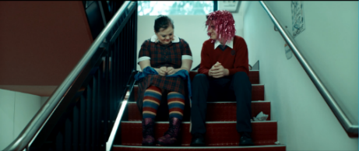 | [space for student response] | [space for student response] | [space for student response]
Content (Briefly describe what the image is showing – what can you see): | The low angle long shot shows 2 characters sitting side by side on a staircase. The positioning of the characters on the same step reflects the equality between them. | [space for student response] | [space for student response] | [space for student response]
Type of Text (Photo, artwork, picture book and so on) | Screen shot from a short film. | [space for student response] | [space for student response] | [space for student response]
Source (Where is it from or where did you find it?)  Created by (Who made it?) | Visible directed by Clay-Smith G. | [space for student response] | [space for student response] | [space for student response]
Connection to thesis  (Briefly say how it supports to your argument) | This shows how humans can accept difference and live in peace. | [space for student response] | [space for student response] | [space for student response]
Caption | This screenshot from the short film called Visible directed by Clay-Smith G shows humans accepting difference and living in peace. | [space for student response] | [space for student response] | [space for student response]

Core formative task 6 – improving student sample response
In the assessment task notification, you have been provided with a sample student response.
- Read the sample student response.
- Read the marking guideline and engage in a class discussion about what each of these descriptions might look like in a response.
- Use the marking guideline and the annotations provided to improve the student sample response.
- Submit the improved response to your teacher for feedback.

Phase 6, resource 3 – informative report for government ministers of Anahit
Teacher note: the following text can be used to support students to understand the structure and features of informative writing. It can also be used to develop understanding of the fictional context of the task. The following text was created using a template accessible on Microsoft Word. This may be an opportune time to explore with students a range of options for the presentation of their summative task.

Sample response – Earth: time to start over

Introduction
It has been clear that for many years, our neighbouring planet – Earth – is in trouble. It is our duty as Anahitans to support our fellow galaxy inhabitants in the way that we conclude is most practical. For this reason, we have sent Anahitan representatives to bring back intelligence about life on Earth so that we can make an informed decision about what to do with this planet. This report is a summary of their findings.

Environmental challenges
Figure 1 – human activity is destroying the environment. This photograph, entitled ‘pollution!’ was taken by Michelle Rivera and illustrates the impact of human activity on the environment.
This photograph is entitled ‘pollution!’ by Michelle Rivera is licensed under CC BY-NC 2.0
Despite countless warnings to change their behaviours, human beings have continued to act in ways that have led to severe environmental destruction. The image in figure 1 clearly represents this degradation. In the background, we can see industrial towers burning fossil fuels and the smoke that is produced creates a vector drawing the viewer’s eye to the car in the foreground. This reading path highlights the connection between big companies and individuals; both are guilty of polluting the environment through their behaviours and are not changing their ways and therefore, Earth has no hope of survival.

“…human beings have continued to act in ways that have led to severe environmental destruction.”

Looking for a connection
Loneliness and disconnection plague the earthlings.
Figure 2 – humans struggle to connect with each other. This frame is taken from a short film called Visible directed by Genevieve Clay-Smith
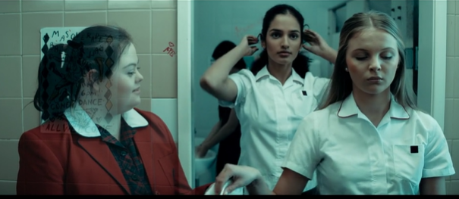
Still from Genevieve Clay-Smith (2022). ‘Visible’ (short film), NSW Department of Education, CApture, accessed 19 June 2023. Reproduced and made available for copying and communication by NSW Department of Education for its educational purposes. This has been made possible as permission has been granted by CApture. This resource is licensed up until May 2026.
In the figure above it is evident that the character on the left side of the frame clearly desires a connection with the other characters; this is revealed through her warm facial expression her gaze towards the girl on the right side of the frame. The desire for connection is unfulfilled though, as the characters on the right do not meet the gaze. Interestingly, there is an evident disconnection between the girls in white who do not meet each other’s gaze either therefore, all characters exist in isolation from each other. The colour palette that has been used is made up of cool tones of predominantly blue and this creates a mood of sadness and metaphorically cold atmosphere, representing Earth as an unappealing place to live.

The price of the pursuit of money
Figure 3 – humans worship money at the cost of a bright future. This extract is from the picture book The Giant and the Sea by Trent Jamieson and Rovina Cai.
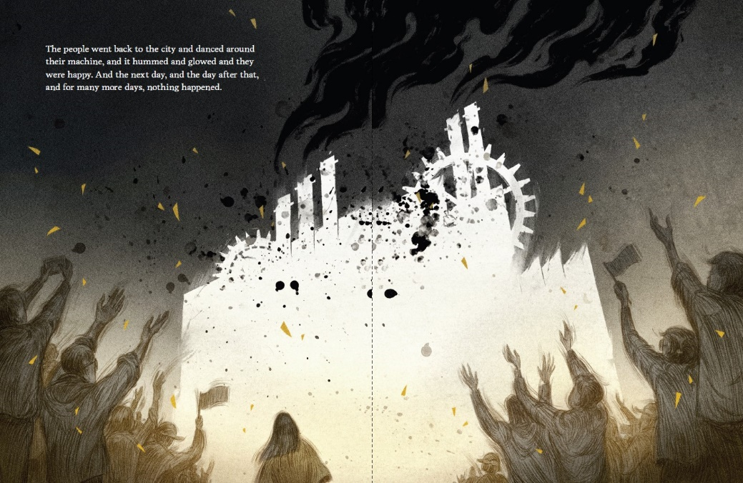
Extract from Jamieson T (2020) The Giant and the Sea (Cai R illus), Hachette Australia, Sydney.
Humans value wealth above almost everything else and this has led to many of the problems that the planet is facing. In figure 3, the adoration that humans feel for money is depicted through the placement of the machinery in the frame. The machine symbolizes money as it represents jobs and a means of producing items that the earthlings can sell and buy. The placement is also symbolic as it is in the centre of the frame; the connotation is that money is at the centre of the existence of humans. It is clear that this will lead to a bleak future for the humans because the colours that are used in this text are dull browns, greys, black and white.

Recommendation
When considering the evidence, it becomes clear that Earth is no longer a viable planet. The environmental challenges, the inability for humans to connect with each other and their relentless pursuit of money regardless of the cost are problems on Earth that are far too difficult to solve. Unfortunately, the most practical course of actions is to bulldoze the planet and start all over again.

Phase 6, activity 4 – features of an informative report jigsaw
Teacher note: Jigsaw is a cooperative learning strategy where students are assigned one aspect of a topic, they then meet with members from other groups who are assigned the same aspect, and after mastering the material, they return to their initial group and teach the material to their group members. It:
- supports educators to differentiate learning
- enables each student to specialise in one aspect of a topic, with each student's part being essential to the completion of the task
- builds students' comprehension, cooperation, communication and problem-solving skills.
Student note: in jigsaw learning, you spend time with group members to understand a concept or part of a text. It is important that group members work together to ensure that all group members are confident in their understanding. The groups are then reformed, and you will be the ‘expert’ for your section of the text. You will share the findings from your original group with the members of the new group and they will share their findings with you.
Student activity for jigsaw learning.
Follow the step-by-step instructions from your teacher to investigate part of a text as an ‘expert’, then share your knowledge with your peers.
- Your teacher will assign you to a group.
- Read your assigned paragraph from Phase 6, resource 3 – informative report for government ministers of Anahit.
- Work with your group to identify the language and structural features of your paragraph and complete the table below. Each group member should complete their own table. The first row of the table has been completed for you to provide you with a model response.
- You will be put in a new group with someone from each of the other paragraph groups. You will be the ‘paragraph expert’ for your paragraph in your new group.
- Your group members will each share the information about their paragraph.
- Add the information about the features of the other paragraphs to your own table.
- You will now have a table of textual evidence for the complete sample report.
Table 53 – features of an informative report activity
Language feature | Example | Effect
Clear topic sentences that introduce an argument or concept | ‘Loneliness and disconnection plague the earthlings’. | Helps to orient the reader and establish the main idea of the paragraph.
Variety of sentence structures | [space for student response] | [space for student response]
Cause and effect sentences | [space for student response] | [space for student response]
Use of the codes and conventions of multimodal texts (for example, images, headings, captions and so on) | [space for student response] | [space for student response]
Metalanguage relevant to visual texts is used | [space for student response] | [space for student response]
Academic register is used | [space for student response] | [space for student response]

Core formative task 7 – analytical paragraph
- Select one of the visual texts and its accompanying caption that you used for your multimodal report
- Add it to the class ‘gallery’. Your teacher will advise you as to what form this will take.
- Explore the work of your peers in the ‘gallery’, engaging with the texts and the captions.
- Select one of the visual texts from the gallery collection and complete an analytical paragraph about it.
- In your response, apply the knowledge and skills you developed in this program.
- Circle yes or no in the checklist below to ensure you have constructed your response accurately.
Table 54 – checklist for analytical paragraph
Features of an analytical paragraph | Present in my work
Clear topic sentence | Yes – No
Topic sentence introduces the main idea of the paragraph | Yes – No
Metalanguage relating to visual texts is used correctly | Yes – No
Evidence from text is integrated fluently to support an argument | Yes – No
Cause and effect sentences are used | Yes – No
Seldon method: bubble theory sentence structure is used | Yes – No

References
This resource contains NSW Curriculum and syllabus content. The NSW Curriculum is developed by the NSW Education Standards Authority. This content is prepared by NESA for and on behalf of the Crown in right of the State of New South Wales. The material is protected by Crown copyright.
Please refer to the NESA Copyright Disclaimer for more information https://educationstandards.nsw.edu.au/wps/portal/nesa/mini-footer/copyright.
NESA holds the only official and up-to-date versions of the NSW Curriculum and syllabus documents. Please visit the NSW Education Standards Authority (NESA) website https://educationstandards.nsw.edu.au/ and the NSW Curriculum website https://curriculum.nsw.edu.au/home.
English K–10 Syllabus © NSW Education Standards Authority (NESA) for and on behalf of the Crown in right of the State of New South Wales, 2022.
ABC News (Australian Broadcasting Corporation) (2023) ABC news [website], accessed 21 June 2023.
ACARA (Australian Curriculum, Assessment and Reporting Authority) (2020) Version 3 of National Literacy and Numeracy Learning Progressions, ACARA website, accessed 12 June 2023.
ACARA (Australian Curriculum, Assessment and Reporting Authority) (2023) Learning area downloads, ACARA website, accessed 21 June 2023.
ACARA (Australian Curriculum, Assessment and Reporting Authority) (2023) Critical and Creative Thinking, ACARA website, accessed 21 June 2023.
Adamson R (2009) ‘Eurydice and the tawny Frogmouth’, The Kingfisher’s Soul, Bloodaxe Books, UK.
Anderson LW, Krathwohl DR, Airasian P, Cruikshank K, Mayer R, Pintrich P, Raths J and Wittrock M (eds) (2001) A Taxonomy for Learning, Teaching, and Assessing: A Revision of Bloom's Taxonomy of Educational Objectives, Addison Wesley Longman, Inc, New York.
Australian News Channel Pty Ltd (2023) Sky News Australia [website], accessed 21 June 2023.
Baker J (2008) Kalaya Tjukurpa (Emu Dreaming) [painting], Kate Owen Gallery website, Kate Owen Gallery, Rozelle, accessed 21 June 2023.
Baker J (2010) Mirror, Walker Books Australia.
Barton G (17 December 2018) ‘Multimodal texts surround us. What are they? How can we use them in our teaching?’, EduResearch Matters, accessed 21 June 2023.
Bispham N (11 January 2023) 7 of the Best Australian Social Media Campaigns We’ve Ever Seen: #EmpowerMoves – United Nations Women Australia’, Brafton, accessed 1 August 2023.
Bispham N (11 January 2023) ‘7 of the Best Australian Social Media Campaigns We’ve Ever Seen: ‘Meet Our Family’ by Symbio Wildlife Park’, Brafton, accessed 21 June 2023.
Bohatko H (24 April 2023) ‘Raising the volume on the voice of youth’, NSW Department of Education, accessed 21 June 2023.
Britten J (1998) ‘Wananooroo’ [painting], Kate Owen Gallery website, Kate Owen Gallery, Rozelle, accessed 21 June 2023.
CESE (Centre for Education Statistics and Evaluation) (2020a) ‘What works best: 2020 update’, CESE, NSW Department of Education, accessed 2 June 2023.
CESE (Centre for Education Statistics and Evaluation) (2020b) ‘What works best in practice’, CESE, NSW Department of Education, accessed 2 June 2023.
Clay-Smith G (2022) ‘Visible’ [short film], CApture, NSW Department of Education website, accessed 19 June 2023.
Daley B and Murphy A (9 February 2023) ‘Celebrating a year of culture in Leeds’, Europeana, accessed 20 June 2023.
Digital Learning Selector (n.d.) ‘5 senses chart’, accessed 21 June 2023.
Doherty L and Horton L (3 May 2023) ‘Students learn the bear facts about conservation’, NSW Department of Education, accessed 21 June 2023.
Everts M (23 March 2023) ‘Through the eyes of Dorothea Lange’, Europeana, accessed 20 June 2023.
Fun With Captain Starlight (4 August 2022) Open Your Heart To Country By Jasmine Seymour (Read Aloud), Fun With Captain Starlight, Bing Videos, accessed 20 June 2023.
Gibbons P (2015). Scaffolding Language Scaffolding Learning: Teaching English Language Learners in the Mainstream Classroom, 2nd edn, Heinemann, Portsmouth, New Hampshire.
Graham S and Sandmel K (2011) ‘The Process Writing Approach: A Meta-analysis’, The Journal of Educational Research, 104(6):396-407, doi:10.1080/00220671.2010.488703.
Graham S, MacArthur CA and Fitzgerald J (eds) (2013) Best practices in writing instruction, 2nd edn, The Guilford Press, New York.
Graves DH (1994) A Fresh Look at Writing, Heinemann, Portsmouth, New Hampshire.
GreekMythology.com (n.d.) Eurydice, GreekMythology.com website, accessed 21 June 2023.
Hattie J and Timperley H (2007) ‘The Power of Feedback’, Review of Educational Research, 77(1):81–112, doi:10.3102/003465430298487.
Jamieson T (2020) The Giant and the Sea (Cai R illus), Hachette Australia, Sydney.
Jones V (19 December 2022) ‘Hermidale reaps a tonne of learning with crop’s harvest’, NSW Department of Education, accessed 13 March 2023.
Kate Owen Gallery (2023), Aboriginal Art Symbols - Iconography, accessed 21 June 2023.
Keys to Literacy (n.d.) Keys to Content Writing, Keys to Literacy website, accessed 26 June 2023.
Maio A (12 December 2019) ‘What is Shallow Focus? How Can it Help Your Cinematography?', Studiobinder, accessed 21 June 2023.
Mapbox Inc, OpenStreetMap and Maxar (n.d.) Gambay – First Languages Map [online map], accessed 21 June 2023.
Membean Inc (2023) Word Roots [website], accessed 21 June 2023.
MetroTrains (2012), ‘Dumb ways to die’, Brafton, accessed 21 June 2023.
Moon B (2001), Literary Terms: a practical glossary 2nd edn, Chalkface Press, Cottesloe.
Murphy A (20 January 2023) ‘How artists have painted cows’, Europeana, accessed 20 June 2023.
Myhill D (2018) ‘Grammar as a meaning-making resource for improving writing’, L1–Educational Studies in Language and Literature, 18(3):1–22, doi:10.17239/L1ESLL-2018.18.04.04.
Nangala Y (n.d.) ‘Untitled’ [painting], Kate Owen Gallery website, Kate Owen Gallery, Rozelle, accessed 21 June 2023.
Nationwide News Pty Ltd (2023) Kids News [website], accessed 21 June 2023.
Nationwide News Pty Ltd (2023) ‘News.com.au [website], accessed 21 June 2023.
NESA (NSW Education Standards Authority) (2021) Assessment Principles, NESA website, accessed 6 March 2023.
NESA (NSW Education Standards Authority) (2023) English K–10 Syllabus: Glossary, NSW Curriculum website, accessed 21 June 2023.
NRMA (2022) Until Then – Bear Meets Eagle On Fire for NRMA Insurance, Mumbrella website, accessed 21 June 2023.
Owen K (2023) Kate Owen Gallery: Contemporary aboriginal art, Kate Owen Gallery website, accessed 20 June 2023.
Paul Kelly (30 July 2021) ‘Paul Kelly with James Ledger, Alice Keath, Seraphim Trio - Eurydice and the Tawny Frogmouth’, Paul Kelly, YouTube, accessed 17 June 2023.
Pearson PD and Gallagher MC (1983) ‘The instruction of reading comprehension’, Contemporary Educational Psychology, 8(3):317–344 doi.org/10.1016/0361-476X(83)90019-X.
PopMov (17 September 2021) ‘Every time Kang & Kodos took over the world on the Simpsons (Almost) - Part 1’, PopMov, YouTube, accessed 21 June 2023.
Pritchard-Owens K (20 April 2023) ‘Safety the focus of new fire program’, NSW Department of Education, accessed 21 June 2023.
Quigley A (2020) Closing the reading gap, Routledge, London.
Scarborough HS (2001) ‘Connecting early language and literacy to later reading (dis)abilities: Evidence, theory, and practice’ in Neuman S and Dickinson D (eds), Handbook for research in early literacy, 1: 97–110, Guildford Press, New York.
Sedita J (2022) The Writing Rope – A Framework for Explicit Writing Instruction in All Subjects, Brookes Publishing Co, Baltimore.
Seymour J (2022) Open Your Heart to Country, Magabala books, Australia.
Sonnenfeld B (director) (1997) ‘Men in Black’ [motion picture], Columbia Pictures, United States of America.
Spielberg S (1982) ‘E.T’ [motion picture], Universal Pictures, United States of America.
State of New South Wales (Department of Education) (n.d.) Grammar Guide, WiS Resource Hub, accessed 21 June 2023.
State of New South Wales (Department of Education) (2008) Quality Teaching Framework, NSW Department of Education website, accessed 21 June 2023.
State of New South Wales (Department of Education) (2020) Sentences, NSW Department of Education website, accessed 21 June 2023.
State of New South Wales (Department of Education) (2022) Literacy in secondary schools, NSW Department of Education website, accessed 5 July 2023.
State of New South Wales (Department of Education) (2023) Comprehension, NSW Department of Education website, accessed 15 March 2023.
State of New South Wales (Department of Education) (2023) Core Concepts: Theme, NSW Department of Education website, accessed 21 June 2023.
State of New South Wales (Department of Education) (2023) Improving reading comprehension Years 3 to 8: A guide to support conversations about evidence-based practice in reading, NSW Department of Education website, accessed 15 March 2023.
State of New South Wales (Department of Education) (2023) Vocabulary, NSW Department of Education website, accessed 16 March 2023.
State of New South Wales (Department of Education) (27 April 2023) ‘Show time strengthens community ties’, NSW Department of Education, accessed 21 June 2023.
State of New South Wales (Department of Education) (19 December 2022) ‘Hermidale reaps a tonne of learning with crop’s harvest’, NSW Department of Education, accessed 13 March 2023.
Talkwalker (2023) Telstra - ‘Time for a chat, Talkwalker website, accessed 21 June 2023.
The Late Show with Stephen Colbert (11 March 2023) ‘What Film Would Steven Spielberg Show to Aliens Visiting Earth?, The Late Show with Stephen Colbert, YouTube, accessed 21 June 2023.
University of Michigan (n.d.) The language of multimodal texts [PDF 208 KB], accessed 21 June 2023.
Velarde O (1 June 2023) ‘20+ Commonly Used Advertising Techniques in Visual Marketing’, Visme, accessed 21 June 2023.
Victoria State Government (Department of Education) (2019) ‘Creating multimodal texts’, Literacy Teaching Toolkit, Victorian Department of Education website, accessed 21 June 2023.
Vincent-Lancrin S, González-Sancho C, Bouckaert M, de Luca F, Fernández-Barrerra M, Jacotin G, and Vidal Q (2019) ‘Fostering Students' Creativity and Critical Thinking: What It Means in School’, Educational Research and Innovation, OECD Publishing, Paris, doi: 10.1787/62212c37-en.
Weir B (2001) Awelye Atnwengerrp [painting], Kate Owen Gallery website, Kate Owen Gallery, Rozelle, accessed 21 June 2023.
WIRES (2023) Wires [website] accessed 21 June 2023.
World Wildlife Fund (WWF) (2023) ‘Public Service Advertisements (PSA), WWF website, accessed 21 June 2023.
Young Y (2023) Tjala Tjukurrpa (Honey Ant Dreaming) [painting], Kate Owen Gallery website, Kate Owen Gallery, Rozelle, accessed 21 June 2023.

© State of New South Wales (Department of Education), 2023
The copyright material published in this resource is subject to the Copyright Act 1968 (Cth) and is owned by the NSW Department of Education or, where indicated, by a party other than the NSW Department of Education (third-party material).
Copyright material available in this resource and owned by the NSW Department of Education is licensed under a Creative Commons Attribution 4.0 International (CC BY 4.0) license.
This licence allows you to share and adapt the material for any purpose, even commercially.
Attribution should be given to © State of New South Wales (Department of Education), 2023.
Material in this resource not available under a Creative Commons licence:
- the NSW Department of Education logo, other logos and trademark-protected material
- material owned by a third party that has been reproduced with permission. You will need to obtain permission from the third party to reuse its material.
Links to third-party material and websites
Please note that the provided (reading/viewing material/list/links/texts) are a suggestion only and implies no endorsement, by the New South Wales Department of Education, of any author, publisher, or book title. School principals and teachers are best placed to assess the suitability of resources that would complement the curriculum and reflect the needs and interests of their students.
If you use the links provided in this document to access a third-party's website, you acknowledge that the terms of use, including licence terms set out on the third-party's website apply to the use which may be made of the materials on that third-party website or where permitted by the Copyright Act 1968 (Cth). The department accepts no responsibility for content on third-party websites.

