Arabic Early Stage 1 – (It’s me!) هذا أنا!

Contents
Unit overview 3
Early Stage 1 outcomes and content to be addressed 4
Learning map 7
Assessment 10
Assessment opportunities 11
Teaching and learning activities 12
Week 1: Greetings and farewells 12
Week 2: What’s your name? 15
Week 3: Numbers 18
Week 4: All about me! 23
Week 5: Assessment criteria and practice task 27
Week 6: Communicative task – Introducing yourself to the new student 31
Week 7: Feedback and goal setting 34
Week 8: Language review 36
Student resources 39
Resource 1: Greetings and farewells flashcards 39
Resource 2: What’s your name? flashcards 40
Resource 3: Arabic number flashcards 41
Resource 4: How old are you? video and transcript 43
Resource 5: My name is – tracing sheet 47
Resource 6: My profile worksheet 49
Resource 7: Student rubric – It’s me! 51
Resource 8: Peer feedback strategy – Two stars and a wish 52
Support and alignment 53
References 56

Unit overview
Stage: Early Stage 1
Title: (It’s me!) هذا أنا!
Description: In this unit, students introduce themselves in Arabic. They answer common questions about themselves and use basic greetings.
Duration: This lesson sequence is designed to be completed over approximately 8 weeks.
Student proficiency levels:
It is assumed that most Early Stage 1 students are beginner learners of Arabic. Some Early Stage 1 students may be Intermediate or Advanced users of Arabic if it is the background language of their family or it is their mother tongue. The assessment tasks in this scope and sequence are aimed at Beginner students. Every classroom will be different and teachers will need to adapt to their context. Many classes may include a combination of Beginner, Intermediate and Advanced students with varying skills and abilities within these proficiency levels. Assessment tasks and opportunities in this unit can be differentiated using the ‘Too hard?’ and ‘Too easy?’ suggestions.
Note: teachers should start each lesson with their typical classroom routine, which may include culturally greeting students, singing songs and reviewing basic language concepts such as colours, numbers and letters in Arabic.

Early Stage 1 outcomes and content to be addressed
The table below outlines the focus area, outcomes and content points for Early Stage 1 students.
Focus area and outcome | Content points
Interacting  A student:  - exchanges meaning through play and actions by reproducing culturally appropriate modelled language MLE-INT-01 | Exchanging meaning in oral interactions in the target language  - Greet and farewell others  - Introduce themselves  - Interact in classroom routines reproducing modelled language with actions and gestures  - Interact in games and imaginative play  Reproducing oral language to interact in the target language  - Reproduce modelled vocabulary and formulaic phrases on familiar themes to interact  - Recognise and reproduce modelled sounds to interact  Reproducing how target language speakers communicate in interactions  - Reproduce verbal and nonverbal communication that is appropriate to cultural practices
Understanding texts  A student:  - responds to information in simple texts in a variety of ways to demonstrate understanding MLE-UND-01 | Understanding and responding to target language texts  - Follow simple instructions  - Use auditory cues, gestures, visuals and other forms of nonverbal communication to understand texts  - Associate vocabulary on familiar themes with known actions, people, places and objects  - Respond to simple texts using actions, drawing and singing in the target language and/or English  - Reproduce vocabulary seen or heard in texts to demonstrate understanding
Creating texts  A student:  - creates simple texts by reproducing culturally appropriate modelled vocabulary MLE-CRT-01 | Creating multimodal texts in the target language  - Create texts reproducing modelled vocabulary with visuals and other forms of nonverbal communication to express meaning  - Represent an idea or information about themselves using modelled vocabulary, formulaic phrases and visuals  Reproducing vocabulary to create texts  - Reproduce modelled vocabulary and formulaic phrases on familiar themes to create texts  - Use modelled sound–symbol correspondences to create written texts  - Reproduce modelled features of the target language writing system to create simple written texts  Reproducing how target language speakers communicate to create texts  - Reproduce language appropriate to cultural practices to create texts
Modern Languages K–10 Syllabus © NSW Education Standards Authority (NESA) for and on behalf of the Crown in right of the State of New South Wales, 2022.

Learning map
The creation of maps for learning is a planning process that incorporates Aboriginal intellectual tradition. Learning maps are a visual pathway of what students will learn.
Share the learning map with your students, briefly explaining the learning that will happen in each lesson. Provide students with a copy of the learning map or display the learning map in the classroom. This learning map can be adapted to Arabic by accessing a copy of Learning map – (It’s me!) !هذا أنا Early Stage 1.
Figure 1 – It’s me! learning map
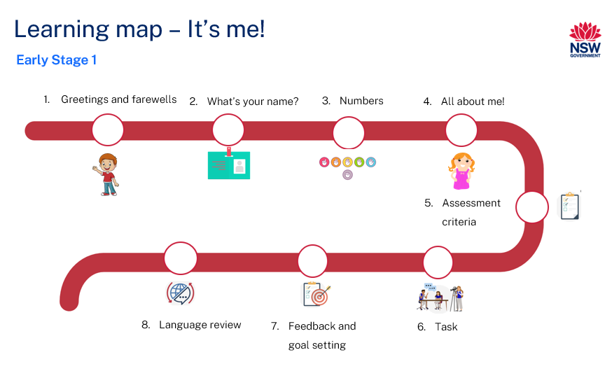
Figure 2 – هذا أنا! learning map
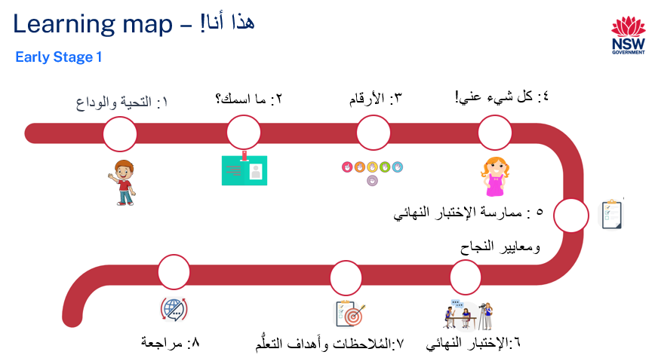

Assessment
Early Stage 1 communicative task: A new student from an Arabic speaking country has joined your class. Introduce yourself to this new student, using appropriate greetings and tell them about yourself, including your name and age.
Too hard?
Student use appropriate greetings and include their names when introducing themselves to a new student.
Too easy?
Students use appropriate greetings and include their name, age and birthday when introducing themselves to a new student.
Context: a new student from an Arabic-speaking country has joined your class
Audience: the new student
Purpose: to introduce yourself to the new student

Assessment opportunities
The table below details assessment opportunities and differentiation ideas.
Assessment opportunities | Too hard? | Too easy?
Week 1: Timed role-play  Students practice Arabic greetings and farewells with their classmates in a timed role-play activity. | Timed role-play  Provide students with a copy of Resource 1: Greetings and farewells flashcards to help support them in saying greetings and farewells to other students. | Timed role-play  Students greet and farewell each other in different situations and times of day.
Week 2: Who’s who?  In pairs, students practice asking and responding to the question ‘What's your name?’ in Arabic. | Who’s who?  Provide students with a copy of Resource 2: What’s your name? flashcards to guide them during this activity. | Who’s who?  Students are to include Arabic greetings and farewells in addition to asking and responding to 'What's your name?’
Week 4: My profile  Students complete Resource 6: My profile worksheet to evaluate their skills in writing their names and ages in Arabic. | My profile  Provide students with their name tags from Week 4: Activity 5. Students can complete the profile in Arabic by simply copying their names and drawing a picture of themselves. | My profile  Students can complete the profile by writing their names in Arabic, their age using Arabic numerals and their birthday.

Teaching and learning activities

Week 1: Greetings and farewells
The table below outlines the learning intention and success criteria of the lesson, and materials that the teacher and students will need to complete the teaching and learning activities.
Learning intention and success criteria | Materials
Students will identify and say greetings and farewells in Arabic.  Students can:  - greet and farewell each other correctly in Arabic. | - Resource 1: Greetings and farewells flashcards  - Interactive whiteboard  - Learning map on A3 poster  - Timer

Vocabulary 1: Greetings
The table below outlines the suggested vocabulary for Activity 2, Activity 3 and Activity 4. It includes the original Arabic script, a Romanised version of the Arabic script and the corresponding English translations.
English | Romanised Arabic/transliterated Arabic | الترجمة الى اللغة العربية
Hello | Marhaban | مرحباً
Good morning | Sabah al-khair | صباح الخير
Good afternoon | Masaa al-khair | مساء الخير
Welcome | Ahlan wa sahlan | أهلاً وسهلاً
Goodbye | Ma'a al-salamah | مع السلامة
Until we meet again | Ila al-liqaa' | إلى اللقاء
Bye | Salam | سلام

Activity 1: Learning map
Show the students the Learning map and break down what they will be learning about each week. Remind students that the Learning map is a plan and some changes may happen along the way.

Activity 2: Introduce vocabulary
To pre-assess students’ vocabulary before teaching new words, display Resource 1: Greetings and farewells flashcards on the board. Tell the students that you will be calling out the greetings and farewells in Arabic. Call out each word on the board in Arabic and ask the students to tell their partners the words they know by saying the English translation.

Activity 3: Say hello and goodbye!
Read Resource 1: Greetings and farewells flashcards to the students and have them repeat each word after you call them out.
Demonstrate a simple exchange of greetings and farewells with a student. Start by saying a greeting in Arabic, such as (hello) مرحباً, then have the student respond with a farewell phrase of their choice, such as (goodbye) مع السلامة. Switch roles with the student and have them greet you first and then you bid them farewell.

Activity 4: Timed role-play
Note: Beginner students may be given a copy of Resource 1: Greetings and farewells flashcards to support them in speaking during this activity.
Tell the students that they will now practice greeting and bidding farewell to each other using the language they have learned. Set a 2-minute timer on the interactive whiteboard and have the students walk around the classroom, interacting with as many classmates as possible within the allocated time.
Evaluation: students can greet and farewell their peers.

Week 2: What’s your name?
The table below outlines the learning intention and success criteria of the lesson, and materials that the teacher and students will need to complete the teaching and learning activities.
Learning intention and success criteria | Materials
Students will learn how to introduce themselves in Arabic by saying their name and age.  Students can:  - identify and pronounce their own name correctly in Arabic  - ask and respond to the question ‘What’s your name?’ in Arabic. | - Resource 2: What’s your name? flashcards  - A marker  - Arabic exercise books  - Blank A4 paper  - Timer  - Writing materials

Vocabulary 2: What’s your name?
The table below outlines the suggested vocabulary for Activity 2, Activity 3 and Activity 4. It includes the original Arabic script, a Romanised version of the Arabic script and the corresponding English translations.
English | Romanised Arabic | الترجمة الى اللغة العربية
What’s your name? – feminine | Ma ismuki? | ما اسمكِ؟
What’s your name? – masculine | Ma ismuka? | ما اسمكَ؟
My name is | Ismi | اسمي

Activity 1: The first letter in my name is…
To pre-assess students’ ability to identify the first sound of their names in Arabic, say the first letter of each student’s name in Arabic. Ask students to stand up if the letter you’ve called out is the beginning letter of their name.

Activity 2: What’s your name?
Display Resource 2: What's your name? flashcards to students. Explain that, in Arabic, there are 2 variations of the question ‘What's your name?’ اسمكَ؟ ما – the masculine form and ما اسمكِ؟ – the feminine form. Call out the questions in both variations and have the students repeat them after you.

Activity 3: My name is…
Demonstrate how to respond to the question ‘What's your name?’ in Arabic by saying (My name is) اسمي followed by your name. Have the entire class repeat the phrase (My name is) اسمي and then ask them to call out their own names. Seat students in a circle and let them know it is now their turn to individually practice responding to the question ‘What's your name?’ using the appropriate gender variation. Display each student’s name on the board as they say their name. Leave students’ names on the board for Activity 5.

Activity 4: Who’s who?
Divide students into pairs. Explain that they will practice asking and responding to ‘What's your name?’ in Arabic. For example:
- Student A: Asks (What's your name?) using the appropriate gender – ‘ما اسمكِ؟’ (feminine) ‘ما اسمكَ؟’ (masculine).
- Student B: Responds with (My name is...) ‘اسمي...’in Arabic, followed by their name.
After one minute, the roles should be reversed. Instruct each pair to find another partner and continue practising asking and responding to the question.
Note: for Beginner students, provide them with a copy of Resource 2: What’s your name? flashcards to support them in their role play.

Activity 5: Write your name
Ask students to copy their name into their Arabic exercise books from the board. Students then draw a picture of themselves below their name in their books.
Evaluation: students identify and write their name correctly.

Week 3: Numbers
The table below outlines the learning intentions and success criteria of the lesson, and materials that the teacher and students will need to complete the teaching and learning activities.
Learning intentions and success criteria | Materials
Students will:  - count from 1–8 in Arabic  - ask someone’s age in Arabic.  Students can:  - count and identify the numbers 1–8 in Arabic  - ask ‘How old are you?’ in Arabic  - say their age in Arabic correctly. | - Resource 3: Arabic number flashcards  - Resource 4: How old are you? video and transcript  - Interactive whiteboard

Vocabulary 3
The table below outlines the suggested vocabulary for Activity 2, Activity 3 and Activity 4. It includes the original Arabic script, a Romanised version of the Arabic script and the corresponding English translations.
English | Romanised Arabic | الترجمة الى اللغة العربية
1 | Wahid | ١
2 | Itnan | ٢
3 | Thalatha | ٣
4 | Arab’a | ٤
5 | Khamsa | ٥
6 | Sitta, | ٦
7 | Sab'a | ٧
8 | Thamaniya | ٨
How old are you? – feminine | Kam umruki? | كم عمرك ِ؟
How old are you? – masculine | Kam umruka? | كم عمركَ؟
I am 4 years old. | Umri arba' sanawat. | عمري أربع سنوات
I am 5 years old. | Umri siit sanawat. | عمري خمس سنوات.
I am 6 years old. | Umri khams sanawat. | عمري ست سنوات.

Activity 1: Number drills
To check what students already know, divide them in pairs, then call out a number in English between one and 8. Ask the students to tell their partner what the number is in Arabic, if they know it. Continue calling out numbers until all numbers between one and 8 have been called.
Using Resource 3: Arabic number flashcards. Call out each number in Arabic while displaying the flashcard and have the students repeat each number after it has been called. Place the cards in the correct order from right to left and then say them aloud again while pointing to each number, then have the students repeat it after you.

Activity 2: Unjumble the numbers!
Note: this activity aims to reinforce the concept that, in Arabic, numbers are written from right to left.
Divide the students into groups and provide each group with a set of Resource 3: Arabic number flashcards. The flashcards should not be in the correct order. Instruct the students to arrange them in the correct order, ensuring the numbers are lined up from right to left on the floor or table.
Note: the words ‘five’ and ‘six’ in Arabic are pronounced as khamsa (خمسة) and sitta (ستة) in isolation. However, when used in a sentence such as ‘I am 5 years old’ or ‘I am 6 years old,’ they become ‘khams’ (خمس) and ‘sitt’ (ست).

Activity 3: How old are you?
- To teach students new vocabulary on how to ask and respond to the question ‘How old are you?’, play the How old are you? (0:33) animated video (Resource 4) on the interactive whiteboard. Play the video at least twice to give students multiple opportunities to hear the language.
- Review the language from How old are you? (0:33) by asking questions in English. Students can respond in English or Arabic. Suggested questions include:
- What question did the teacher ask Nour?
- What question did the teacher ask Samy?
- Do the questions mean the same thing in English?
- Why are they different in Arabic?
- How old is Samy?
- How old is Nour?
- Play How old are you? (0:33) and ask the students to repeat each phrase after each character from the video.
- Split the students into pairs and have them practise asking and responding to the question ‘How old are you?’ with their partners. Give students a few minutes to do this.

Activity 4: Toss the toy!
Have the students sit or stand in a circle. Begin the game by asking the question, ‘How old are you?’ in Arabic, before tossing the soft toy to a student in the circle. That student then responds by answering the question. For example, they might say, ‘I am 5 years old’ ((عمري خمس سنوات. Before throwing the toy to another student in the circle, the student who caught the toy must ask, ‘How old are you?’ in Arabic. Continue playing until every student has had a turn.
Evaluation: students correctly ask and answer their age.

Week 4: All about me!
The table below outlines the learning intentions of the lesson and materials that the teacher and students will need to complete the teaching and learning activities.
Learning intention and success criteria | Materials
Students will review vocabulary relating to greetings, farewells and saying their name and age.  Students can:  - say greetings and farewells correctly in Arabic  - identify and say their name correctly in Arabic  - share their age with the rest of the class correctly in Arabic. | - Resource 5: My name is – tracing sheet  - A3 or A4 papers  - Cardboard  - Laminated self-adhesive sheets  - Safety pins

Activity 1: Pass the parcel of greetings
Note: the parcel could be a ball, a toy or a box. Ensure that the music used for this game is age appropriate.
For suggested vocabulary for this activity, please refer to Vocabulary 1.
Ask the students to stand in a circle and give a parcel to a student. Let them know that they should only pass the parcel to the person sitting next to them. Show them the direction they should pass it around the circle. When the music stops, the student holding the parcel should stand up and say hello or goodbye in Arabic to the class. Keep playing until each student has a turn.

Activity 2: Class book
For suggested vocabulary for this activity, please refer to Vocabulary 2.
Make a class book with the students. Each student will create a page in the book. Provide students with Resource 5: My name is – tracing sheet. Students trace (My name is) اسمي then write their name into the box provided in Arabic. Once students have written their names, they draw a picture of themselves on the page. Suggest that students can also draw things they like to do, such as games they like to play or things they like to eat. Once every student has finished, collect their pages and create a class book by stapling them together. Sit the students on the floor and read the book to the class.

Activity 3: Name tag puzzle
Note: prior to this activity, have each student’s name written in Arabic on a piece of cardboard. Then, cut each name into halves.
Place all the halves of students’ name pieces in the middle of each table, making sure that each table group has only their own names on the table. Ask the students in each group to help each other find the 2 halves of their names and put them together correctly. Once students have completed their names, they stick the halves onto the self-adhesive laminate sheet provided, creating their name tags. After putting together their name tags, help the students pin the tags onto their clothes. Students walk around the room, introducing themselves to their classmates using their name tags.

Activity 4: Jumping numbers
Note: prior to this activity, write down the Arabic numbers from 1–6 on blank A4 or A3 pieces of paper.
For suggested vocabulary for this activity, please refer to Vocabulary 3.
Place the large paper numbers spaced apart in a line on the floor. Each number should have enough space around it for a student to stand or jump onto it. Gather students at the start of the number line. Each student then jumps or walks along the number line, saying each number in Arabic as they land on it, until they reach their age. For example, a five-year-old would move from number one to number 5, saying each number as they go. Once they reach their age, they should say (I am ... years old) ‘عمري ... سنوات.’. Continue this activity until every student has had a chance to move.
Note: ensure that the numbers are securely fixed to the floor to prevent slipping. Also ensure there is enough space for each student to safely move from number to number.

Activity 5: My profile
Show the students Resource 6: My profile worksheet. Explain to the students that they are required to complete their profiles. This includes writing their names in Arabic, their age using Arabic numerals and drawing a picture of themselves.
Note: Advanced students can also write their birthday.
Evaluation: students write their name and age in Arabic.

Week 5: Assessment criteria and practice task
The table below outlines the learning intention and success criteria of the lesson, and materials that the teacher and students will need to complete the teaching and learning activities.
Learning intention and success criteria | Materials
Students will develop an understanding of the requirements of the assessment task.  Students can:  - say what they need to do to be successful in the task  - ask questions if they don't understand the requirements of the assessment task. | - Completed Resource 6: My profile worksheet for each student  - Resource 7: Student rubric – It’s me!  - A3 Learning map  - Interactive whiteboard

Activity 1: Discuss the assessment task
To prepare students for the final task, review the Learning map and discuss the language that has been taught each week. Point out that, according to the learning map, the final task will be completed in Week 6. Explain that students will greet and introduce themselves to a new student who has joined their class from an Arabic-speaking country. A classmate will pretend to be the new student.
Note: some students with Advanced proficiency may be from an Arabic-speaking country. These students can complete the ‘Too easy’ adjustment of the task and include their birthday in addition to introducing themselves.

Activity 2: Success criteria
After you have explained the assessment task, students Think-Pair-Share and suggest appropriate success criteria, such as:
I will be successful if I can:
- greet the new student
- say my name and age
- say words correctly
- say words in the right order.

Activity 3: Discuss the rubric
To help students understand the rubric for the final task, start the lesson by showing them Resource 7: Student rubric – It's me!. It is important to note that this rubric can be adapted if the class has decided on different success criteria. Explain that the rubric has been written using ‘I can’ statements to help students understand each component of the task. Introduce the concept of a thumb signal for each level of achievement. A thumbs up means students have achieved the task completion objectives, while a thumbs sideways signal means they still need to work on it. Go through each component of the rubric and explain what is expected at each level of achievement.

Activity 4: Discuss peer assessment
Note: this may be the first-time students are engaging in peer assessment. As a result, you may need to provide further explanations on why this is important and what students should and should not do while giving and receiving peer assessment.
Explain that, as part of the task, peer feedback will be incorporated. To help with this, use the thumbs up or thumbs sideways strategy as the scale of understanding. Explain that students will use this strategy to provide feedback to the student introducing themselves. A thumbs-up signal means ‘You did it!’, while a sideways thumb signal means ‘Tell me more!’.
Note: print the resource below to have your students read it themselves or explain this strategy verbally to the students.
Figure 3 – Thumbs up and thumbs sideways strategy
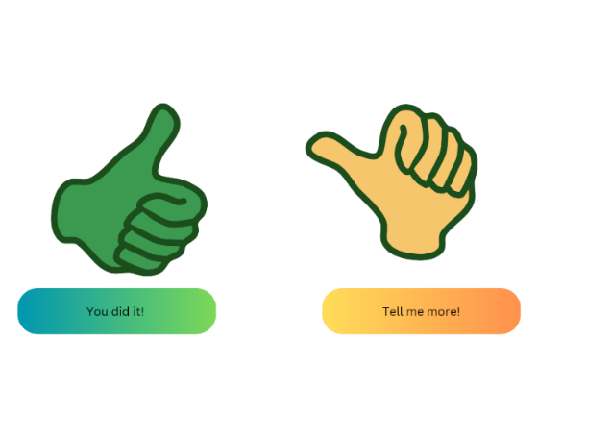
Images sourced from Canva and used in accordance with the Canva Content License Agreement.

Activity 5: Practice task
Tell the students that they are going to do a role-play in pairs. In this activity, students will switch roles between being themselves and pretending to be a new student from an Arabic-speaking country. Start by dividing the class into pairs. Every student will get a chance to act as both the new student from an Arabic-speaking country and as themselves. When students are acting as themselves, they should greet and tell the new student their name and age.
Note: for students with Beginner language proficiency, provide them with a copy of their completed Resource 6: My profile worksheet to help them with introducing themselves.

Week 6: Communicative task – Introducing yourself to the new student
The table below outlines the learning intentions and success criteria of the lesson, and materials that the teacher and students will need to complete the teaching and learning activities.
Learning intentions and success criteria | Materials
Students will role-play introducing themselves including saying their name and age to a new student from an Arabic-speaking country.  Students can:  - greet the new student  - say their name and age  - say words correctly  - say words in the right order. | - Recording device

Activity 1: Set up
Students get into groups of 4. Give groups a few minutes to ensure everybody knows the order in which they will be performing each role. Students then take turns introducing themselves, including saying their name and age, to a new student who has joined their class from an Arabic-speaking country.
Suggested rotations:
- Role-Play 1 – Student 1 – ‘You’, Student 2 – Peer assessor, Student 3 – New student, Student 4 – Camera operator
- Role-Play 2 – Student 1 – Camera operator, Student 2 – ‘You’, Student 3 – Peer assessor, Student 4 – New student
- Role-Play 3 – Student 1 – New student, Student 2 – Camera operator, Student 3 – ‘You’, Student 4 – Peer assessor
- Role-Play 4 – Student 1 – Peer assessor, Student 2 – New student, Student 3 – Camera operator, Student 4 – ‘You’

Activity 2: Task instructions
Note: before recording interactions, check if any students do not have permission to be video recorded. Alternatives to video recording include audio recording or watching the interactions while taking notes and marking the rubric.
For this task, students will work in groups of 4 and take turns in the following roles:
- New student: ask introductory questions to the student who will be introducing themselves, such as ‘What's your name?’ and ‘How old are you?’
- ‘You’: introduce yourself to the new student
- Camera operator: record the interaction
- Peer assessor: give feedback to the student introducing themselves.
The student playing ‘You’ and introducing themselves to the new student is completing the communicative task.
The camera operator will record the student introducing themselves to the new student.

Activity 3: Peer assessment
The student providing the peer assessment will give feedback to the student being the teacher using the thumbs up/thumbs sideways strategy or Resource 8: Peer feedback strategy – Two stars and a wish.

Week 7: Feedback and goal setting
Note: if there is insufficient time to mark the videos before Week 8, Weeks 7 and 8 can be swapped.
The table below outlines the learning intention and success criteria of the lesson, and materials that the teacher and students will need to complete the teaching and learning activities.
Learning intention and success criteria | Materials
Students will reflect on feedback to set suitable learning goals.  Students can:  - reflect on the feedback provided to establish new learning goals. | - Resource 7: Student rubric – It’s me!  - Interactive whiteboard  - Recorded student videos  - Writing materials
Note: prior to this lesson, review each video and make notes on each student to determine whether they have met all the key components required to complete the task successfully. These components include task completion, fluency, grammar, pronunciation and vocabulary.

Activity 1: Self-assessment
Students watch the video of themselves completing the task and use the rubric to self-asses. Students compare their self-assessment rubric with the teacher’s completed rubric.

Activity 2: Set learning goals
Note: this may be the first time students will be setting learning goals. Students will choose a suggested learning goal from the list below by raising their hand.
To foster student ownership of their learning, facilitate a class discussion to help students reflect on their marked rubric, peer and self-assessment and set their own personalised learning goals for the next phase. Use simplified language to ensure that the students can understand and engage with the discussion effectively.
Suggest learning goals, such as:
- I will be confident when saying words in Arabic.
- I will try to say Arabic words in the correct order.
- I will practise saying tricky sounds in Arabic, for example…
Encourage students to raise their hands when they hear a goal that resonates with them. Students record their learning goals.
Evaluation: students set appropriate learning goals based on previous learning goals and/or teacher, peer and self-assessment.

Week 8: Language review
Note: if there is insufficient time to mark the videos before Week 8, Weeks 7 and 8 can be swapped.
The table below outlines the learning intention and success criteria of the lesson, and materials that the teacher and students will need to complete the teaching and learning activities.
Learning intention and success criteria | Materials
Students will review the language learnt during this unit to be able to give class instructions.  Students can:  - ask questions about vocabulary, grammar or pronunciation they have used in this unit  - use the Arabic they have learned to communicate with classmates. | - Resource 1: Greetings and farewells flashcards  - Hand puppets  - Students’ recorded videos
Note: over the course of the unit, gaps in student knowledge, misconceptions and misuse of language will have been identified. These observations are addressed using engaging and interactive activities and strategies. The activities below are examples and will need to be supplemented with activities to address your observations.

Activity 1: Student questions
Remind students of the activities and tasks they have completed over the course of the unit. Give students time to Think-Pair-Share any questions they may have about aspects of the language taught.
Note: set up different language stations for Activities 2–4 that focus on reinforcing word work, grammar, listening and responding. These activities can be adapted to suit students’ needs. After a set time, students rotate in groups to a new station to complete activities with a different focus.

Activity 2: Word work
This station will focus on reviewing learnt vocabulary.
Suggested activity:
Snap it: Provide 2 sets of Resource 1: Greetings and farewells flashcards. Each student takes a turn placing a card face-up on the table and saying aloud the greeting or farewell printed on the card. When a student places a card that matches the top card on the pile (for example, 2 identical greetings or farewells are played in a row), the first student to place their hand on the pile and call out 'Snap' wins the pile.

Activity 3: Grammar
This station will focus on grammar taught during the unit.
Suggested activity:
Hand puppets: In pairs, students practise asking and responding to basic questions about themselves using their puppets.

Activity 4: Listening and responding
This station will focus on strengthening and reviewing listening and responding to texts skills.
Suggested activity:
Students watch videos their classmates have recorded as part of the final task. After watching the videos, students work in pairs to recall and repeat key details from each video, such as the student’s name and age.

Student resources

Resource 1: Greetings and farewells flashcards
صباح الخير  Sabah al-khayr |  | مساء الخير  Masaa al-khair |  | مرحباً  Marhaban |  | أهلاً وسهلاً  Ahlan wa sahlan
 |  | إلى اللقاء  Ila al-liqa' |  | مع السلامة  Ma'a as-salamah |  | سلام  Salam
Images sourced from Canva and used in accordance with the Canva Content License Agreement.

Resource 2: What’s your name? flashcards
What is your name?  مَا اسْمُكَ؟  Ma asmuka? |  | What is your name?  مَا اسْمُكِ؟  Ma asmuki?
Images sourced from Canva and used in accordance with the Canva Content License Agreement.

Resource 3: Arabic number flashcards
Arba'ah  أربعة  Four |  | Thalāthah  ثلاثة  Three |  | Ithnān  اثنان  Two |  | Wāhid  واحد  One
Thamāniyah  ثمانية  Eight |  | Sab'ah  سبعة  Seven |  | Sittah  ستة  Six |  | Khamsah  خمسة  Five
Images sourced from Canva and used in accordance with the Canva Content License Agreement.

Resource 4: How old are you? video and transcript
Access the video How old are you? (0:33).
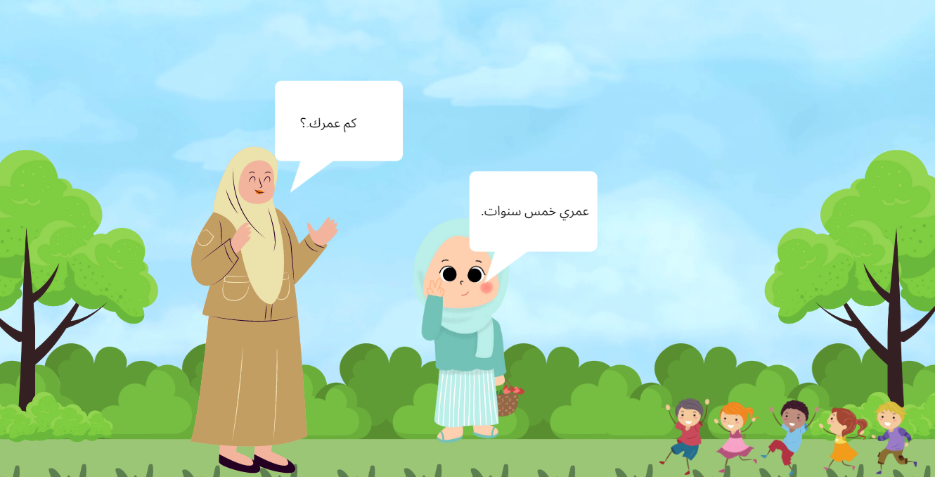
Images sourced from Canva and used in accordance with the Canva Content License Agreement.

Transcript – How old are you?
Teacher
Hello, Nour.
. مرحباً,نور
Nour
Hello, teacher.
. مرحبا بالمعلمة
[Screen shows a teacher and a girl in a playground. Behind them, kids are using a slide.]
Teacher
How old are you?
كم عمرك ِ؟
Nour
I am five years old.
عمري خمس سنوات.
[Screen shows a teacher and a girl standing in a playground. Behind them, kids are standing in a line.]
Teacher
Hello, Samy.
مرحباً ،سامي.
Samy
Hello, teacher.
مرحبا بالمعلمة.
[Screen shows a teacher and a boy in a playground. Behind them, kids are on the climbing equipment.]
Teacher
How old are you?
كم عمركَ؟
Samy
I am six years old.
عمري ست سنوات.
[Screen shows a teacher and a boy standing in a playground. Behind them, 2 kids are on a seesaw.]

Resource 5: My name is – tracing sheet
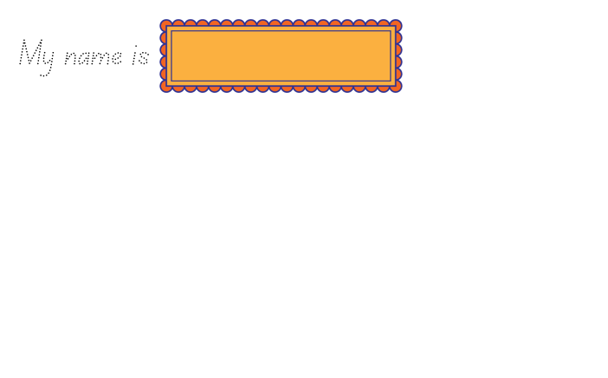

Resource 6: My profile worksheet
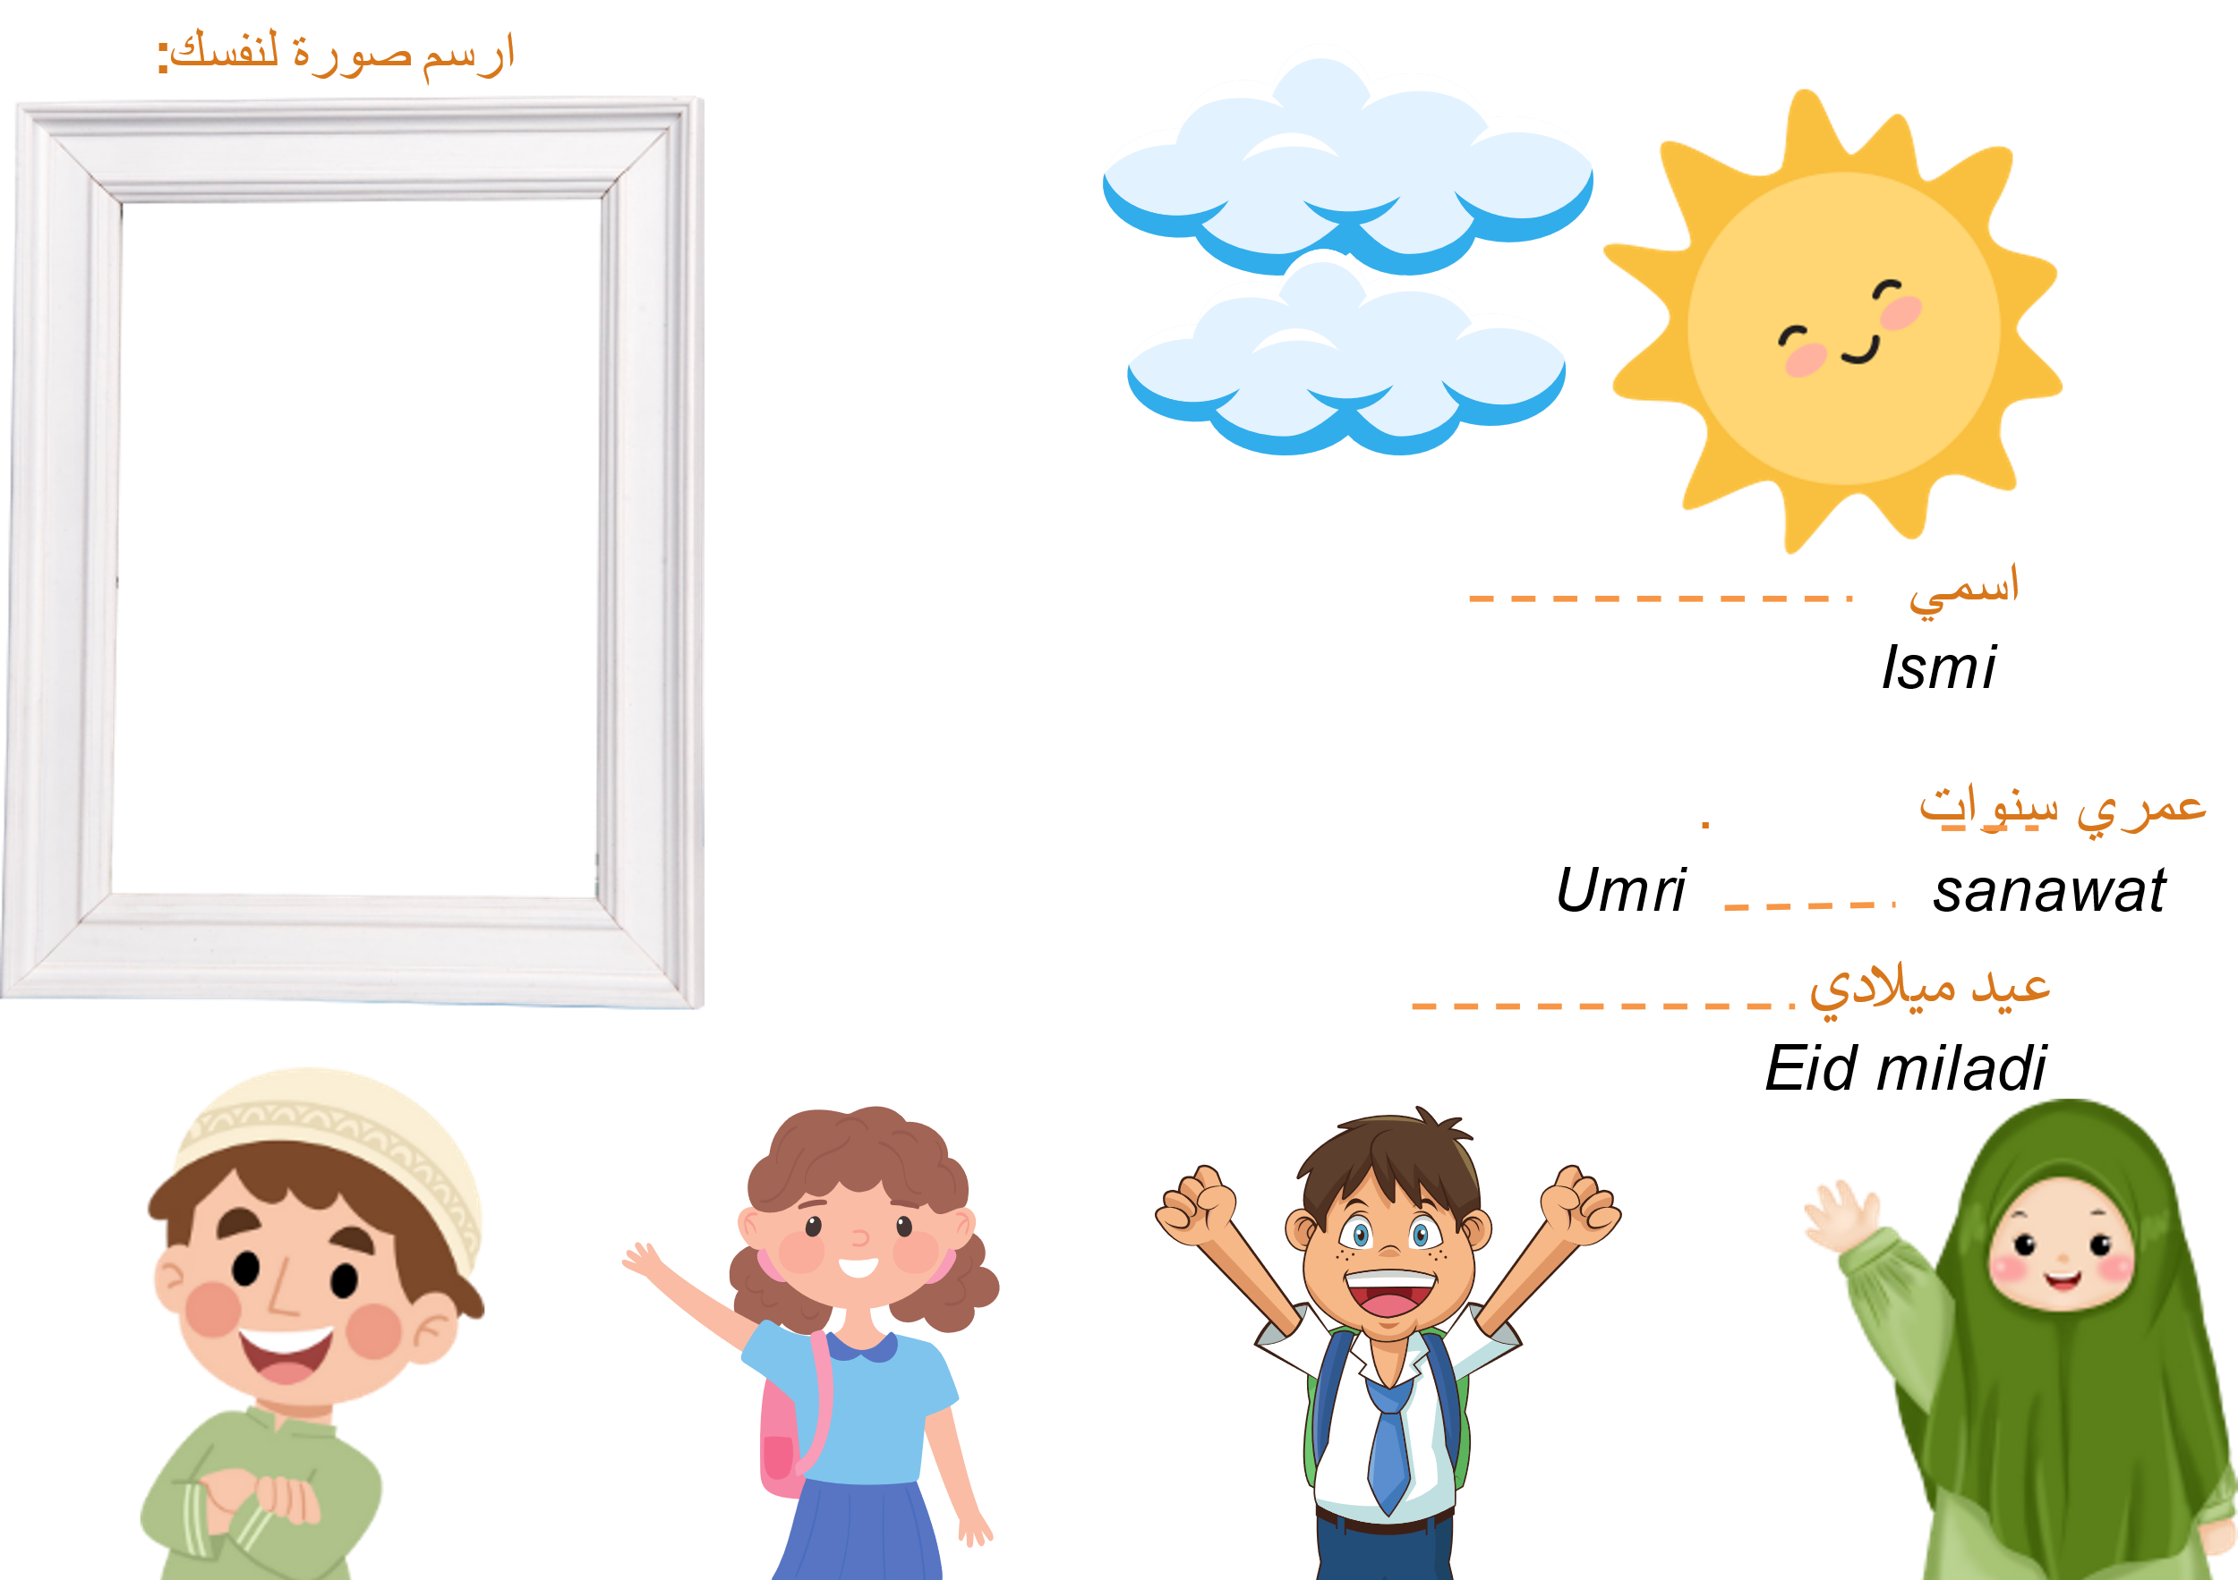
Images sourced from Canva and used in accordance with the Canva Content License Agreement.
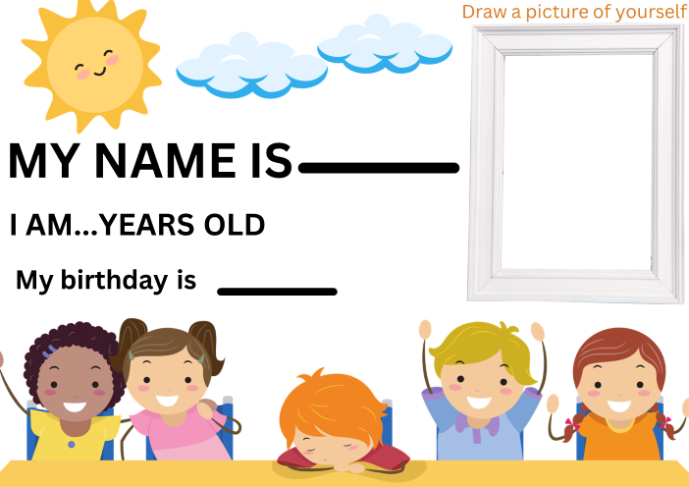
Images sourced from Canva and used in accordance with the Canva Content License Agreement.

Resource 7: Student rubric – It’s me!
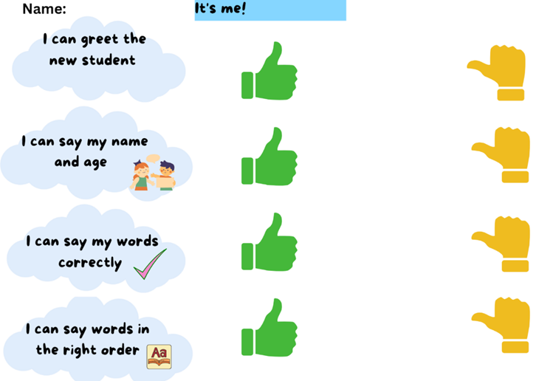
Images sourced from Canva and used in accordance with the Canva Content License Agreement.

Resource 8: Peer feedback strategy – Two stars and a wish
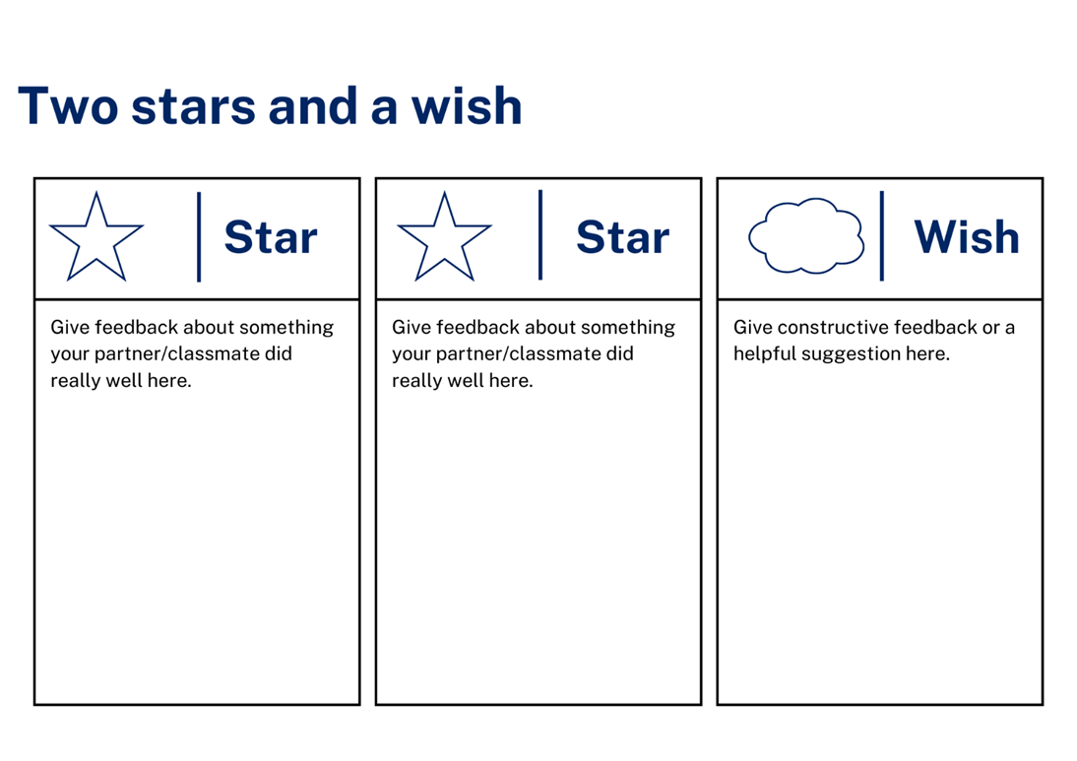

Support and alignment
Resource evaluation and support: all curriculum resources are prepared through a rigorous process. Resources are periodically reviewed as part of our ongoing evaluation plan to ensure currency, relevance and effectiveness. For additional support or advice, contact the Primary Languages team by emailing primlang@det.nsw.edu.au.
Alignment to system priorities and/or needs: School Excellence Policy, School Success Model
Alignment to the School Excellence Framework: this resource supports the School Excellence Framework elements of curriculum (curriculum provision, teaching and learning programs) and effective classroom practice (lesson planning).
Alignment to Australian Professional Teaching Standards: this resource supports teachers to address Australian Professional Teaching Standards 2.2.2, 3.2.2.
Consulted with: Curriculum, Secondary Learners, school-based staff and NESA subject matter experts. Advice from Aboriginal Outcomes and Partnerships, EAL/D, HPGE and Inclusive Education for Modern Languages Stage 3 Italian Mangiare in Ristorante has been considered in preparing this document.
NSW syllabus: Modern Languages K–10 Syllabus
Syllabus outcomes: MLE-INT-01, MLE-UND-01, MLE-CRT-01
Author: Primary Curriculum
Publisher: State of NSW, Department of Education
Resource: Unit
Related resources: further resources to support Early Stage 1 Modern Languages can be found on the Languages K-6 curriculum page.
Professional learning: relevant professional learning is available through Primary Languages Networks on Teams (staff only).
Universal Design for Learning: support the diverse learning needs of students using inclusive teaching and learning strategies. Some students may require more specific adjustments to allow them to participate on the same basis as their peers. For further advice see Inclusive practice resources for primary school.
Differentiation: when using these resources in the classroom, it is important for teachers to consider the needs of all students in their class, including:
- Aboriginal and Torres Strait Islander students. Targeted strategies can be used to achieve outcomes for Aboriginal students in K-12 and increase knowledge and understanding of Aboriginal histories and cultures. Teachers should use students’ Personalised Learning Pathways to support individual student needs and goals.
- EAL/D learners. EAL/D learners may require scaffolding to support them to gain content knowledge, while providing extra time and assistance to master the English language required to engage with texts or complete classroom tasks. View some samples of differentiating through scaffolding.
- Students with additional learning needs. Learning adjustments enable students with disability and additional learning and support needs to access syllabus outcomes and content on the same basis as their peers. Teachers can use a range of adjustments to ensure a personalised approach to student learning.
- High potential and gifted learners. Assessing and identifying high potential and gifted learners will help teachers decide which students may benefit from extension and additional challenge. In addition, the Differentiation Adjustment Tool can be used to support the specific learning needs of high potential and gifted students.
Creation date: 28 March 2023
Rights: © State of New South Wales, Department of Education

References
This resource contains NSW Curriculum and syllabus content. The NSW Curriculum is developed by the NSW Education Standards Authority. This content is prepared by NESA for and on behalf of the Crown in right of the State of New South Wales. The material is protected by Crown copyright.
Please refer to the NESA Copyright Disclaimer for more information https://educationstandards.nsw.edu.au/wps/portal/nesa/mini-footer/copyright.
NESA holds the only official and up-to-date versions of the NSW Curriculum and syllabus documents. Please visit the NSW Education Standards Authority (NESA) website https://educationstandards.nsw.edu.au/ and the NSW Curriculum website https://curriculum.nsw.edu.au/home.
NSW Modern Languages K-10 Syllabus © 2022 NSW Education Standards Authority (NESA) for and on behalf of the Crown in right of the State of New South Wales.
8 Ways (nd) 8 Aboriginal Ways of Learning website, accessed 13 December 2022.
AITSL (Australian Institute for Teaching and School Leadership) (2017) ‘Feedback Factsheet’, AITSL, accessed 21 March 2023.
Brookhart S (2011) How to Assess Higher-Order Thinking Skills in Your Classroom, Hawker Brownlow Education, Victoria.
CESE (Centre for Education Statistics and Evaluation) (2020a) What works best: 2020 update, NSW Department of Education, accessed 10 March 2023.
CESE (2020b) What works best in practice, NSW Department of Education, accessed 10 March 2023.
Conti G (28 September 2015) ‘16 tips for effective grammar teaching in the foreign language classroom’, The Language Gym, accessed 21 March 2023.
Conti G (28 May 2017) From Target Language to Model Language – the mind shift that has transformed my teaching, The Language Gym, accessed 20 March 2023.
Harmer J (2014), The Practice of English Language Teaching, Pearson, United Kingdom.
Henshaw FG and Hawkins MD (2022) Common Ground: Second Language Acquisition Theory Goes to the Classroom, Focus, Indianapolis, accessed 14 March 2023.
Jones J and Wiliam D (2014) Modern Foreign Languages Inside the Black Box: Assessment for Learning in the Modern Foreign Languages Classroom (Black P, Harrison C, Marshall B and Wiliam D, eds), Learning Sciences International, United States.
NESA (NSW Education Standards Authority) (2022) Proficient Teacher: Standard descriptors, The Standards, NESA website, accessed 21 December 2022.
Smith S (2022) Becoming an Outstanding Languages Teacher, 2nd edn, Routledge, United Kingdom.
Wiliam D and Leahy S (2015) Embedding Formative Assessment: Practical Techniques for K–12 Classrooms, Learning Sciences International, United States.

© State of New South Wales (Department of Education), 2023
The copyright material published in this resource is subject to the Copyright Act 1968 (Cth) and is owned by the NSW Department of Education or, where indicated, by a party other than the NSW Department of Education (third-party material).
Copyright material available in this resource and owned by the NSW Department of Education is licensed under a Creative Commons Attribution 4.0 International (CC BY 4.0) license.
This license allows you to share and adapt the material for any purpose, even commercially.
Attribution should be given to © State of New South Wales (Department of Education), 2023.
Material in this resource not available under a Creative Commons license:
- the NSW Department of Education logo, other logos and trademark-protected material
- material owned by a third party that has been reproduced with permission. You will need to obtain permission from the third party to reuse its material.
Links to third-party material and websites
Please note that the provided (reading/viewing material/list/links/texts) are a suggestion only and implies no endorsement, by the New South Wales Department of Education, of any author, publisher, or book title. School principals and teachers are best placed to assess the suitability of resources that would complement the curriculum and reflect the needs and interests of their students.
If you use the links provided in this document to access a third-party's website, you acknowledge that the terms of use, including licence terms set out on the third-party's website apply to the use which may be made of the materials on that third-party website or where permitted by the Copyright Act 1968 (Cth). The department accepts no responsibility for content on third-party websites.

