Modern Languages K–10 Syllabus (2022) – assessment guidelines
Contents
Introduction 2
Syllabus outcomes and content 2
Overview of assessment 6
What is assessment? 6
Formative and summative assessment 7
When to assess 9
What to assess 10
How to assess 12
Backward mapping 15
Step 1 – identify the desired learning goals and outcomes 17
Step 2 – determine measures of success 22
Step 3 – plan instruction 31
Evaluation 35
Conclusion 35
Support and alignment 36
References 38
Note: This document provides advice only. It is the responsibility of individual school executive and teaching staff to ensure assessment processes are compliant with both NSW Education Standards Authority (NESA) and departmental requirements and policies.

Introduction
This document supports teachers of modern languages 7–10 to understand and design relevant and engaging assessment opportunities for students. It provides comprehensive information for teachers in all contexts across NSW public schools, as well as their supervisors and the educational teams who provide universal support to schools. Only read the sections relevant to you, based on your context.
The document provides advice only. Assessment is a school-based decision, aligned with the Curriculum planning and programming, assessing and reporting to parents K-12 policy in NSW public schools. (Note: If the link does not open, you can access via the policy library in the portal.)
For general advice on programming for the Modern Languages K–10 Syllabus, please access the programming guidelines from our Planning, programming and assessing languages 7–10 web page. For support with planning a unit of work, please access the unit of work guidelines and template on the same page.

Syllabus outcomes and content
In the Modern Languages K–10 Syllabus (2022), students apply knowledge of language systems and develop intercultural capability as they communicate across 3 focus areas:
- Interacting
- Understanding texts
- Creating texts.
Each focus area has 3 Stage-based outcomes.
Stage 4
- ML4-INT-01 exchanges information and opinions in a range of familiar contexts by using culturally appropriate language
- ML4-UND-01 interprets and responds to information, opinions and ideas in texts to demonstrate understanding
- ML4-CRT-01 creates a range of texts for familiar communicative purposes by using culturally appropriate language
Stage 5
- ML5-INT-01 exchanges information, ideas and perspectives in a range of contexts by manipulating culturally appropriate language
- ML5-UND-01 analyses and responds to information, ideas and perspectives in a range of texts to demonstrate understanding
- ML5-CRT-01 creates a range of texts for diverse communicative purposes by manipulating culturally appropriate language
The content for each outcome is represented through content groups and dot points, as seen in the figure below.
Figure 1 – syllabus content groups and content
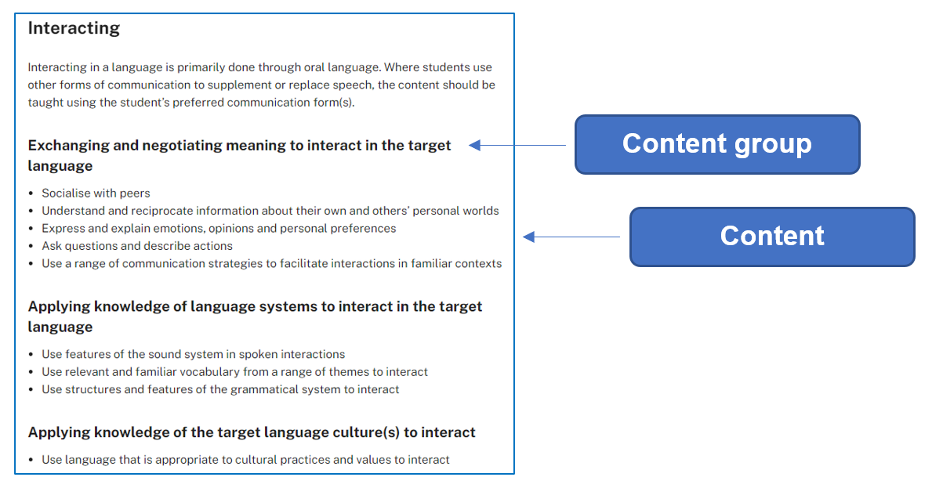
Modern Languages K–10 Syllabus © NSW Education Standards Authority (NESA) for and on behalf of the Crown in right of the State of New South Wales, 2022.
All content is considered essential for students to demonstrate achievement of the outcome.
In the syllabus, content groups are organised by:
- communication skills and function
- knowledge of language systems
- knowledge of culture.
Figure 2 – organisation of content groups
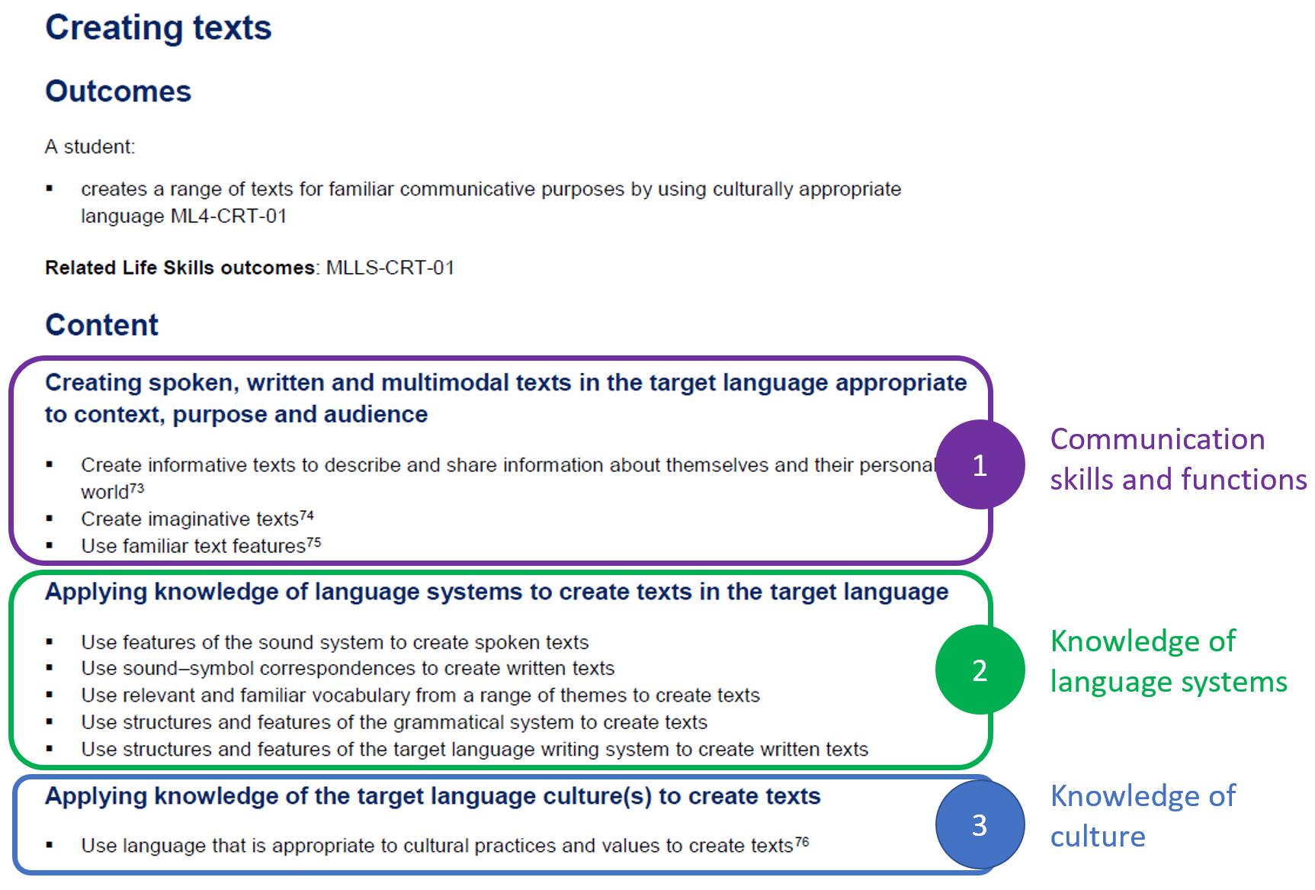
Modern Languages K–10 Syllabus © NSW Education Standards Authority (NESA) for and on behalf of the Crown in right of the State of New South Wales, 2022.

Overview of assessment

What is assessment?
Assessment is the broad name for the collection and evaluation of evidence of a student's learning.
Assessment:
- provides opportunities for teachers to gather evidence about student achievement in relation to syllabus outcomes
- enables students to demonstrate what they know and can do
- clarifies student understanding of concepts and promotes deeper understanding
- provides evidence that current understanding and skills are a suitable basis for future learning.
Source: Assessment Principles (NESA 2022) (accessed 9 August 2023)
In the Modern Languages K–10 Syllabus, the purpose and aspects of assessment are described as:
‘The primary role of assessment is to establish where students are in their learning so that teaching can be differentiated and further learning progress can be monitored over time. It provides information that assists teachers to target their teaching at the point of student need. Assessment is most effective when it is an integral part of teaching and learning programs.
Assessment involves:
- establishing where students are in their learning
- ongoing monitoring
- formative and summative tasks
- providing feedback about student progress.’
Modern Languages K–10 Syllabus © NSW Education Standards Authority (NESA) for and on behalf of the Crown in right of the State of New South Wales, 2022.
Assessment opportunities are required to be inclusive of and accessible for all students. It is important to consider how you will support the needs of all students, for example by:
- providing print and digital options
- allowing students to communicate in their preferred communication mode, including the use of assistive technology
- providing a scaffold
- negotiating a plan to prepare students for assessment tasks.
An equitable assessment allows for demonstration of learning across a range of different contexts – refer to Curriculum planning for every student – advice (opens in a new tab) for more information.

Formative and summative assessment
Effective assessment involves using a range of measures. The use of high impact assessment strategies supports students to become ‘assessment capable learners’. They can understand and respond to the following questions:
- Where am I going?
- How am I going?
- Where to next?

Formative assessment
Formative assessment is an ongoing process which aims to close the gap between where a student is now and where they need to be, in order to successfully demonstrate their achievement of the outcomes.
The goals of formative assessment are to:
- collect evidence of students’ knowledge, understanding and skills in order to inform next steps in teaching
- provide feedback to students about their learning and how to improve
- allow opportunities for student self-reflection and setting learning goals.
Think of formative assessment as a targeted opportunity for students to practise specific language and skills, so you can give them feedback and they can identify areas for focus and plan next steps for their learning. It can occur before, within or between a sequence of lessons.
Formative assessment can take a range of forms – there is no set format. For example, you may use any or all of the following, as formative assessment opportunities:
- activities and quizzes
- exit tickets
- online tools, such as Kahoot!, Plickers or Mentimeter
- mini tasks.
Effective formative assessment is a key contributor to success in summative assessment.

Summative assessment
Summative assessment occurs at the end of a period of learning (such as a unit or term). It measures student achievement at a point in time, allowing teachers to gather evidence of achievement of learning intentions and outcomes against standards. Like formative assessment, it also provides an opportunity to provide feedback to students on their progress.
With communication the central goal of language learning in the syllabus, summative assessment takes the form of real-world or simulated real-world tasks, which articulate the context, purpose and audience of the communicative act.
For example: ‘Imagine you have become separated from your tour group in Indonesia. Ring the tour leader and negotiate where and when you can meet the group to re-join the tour. Your teacher will play the role of the tour leader.’
In this task it is clear the students are conducting a conversation. The context is they are travelling in Indonesia as part of a tour group. The audience is the tour leader and the purpose is to re-join the group and no longer be lost.
The department recommends providing students with a description of the assessment task, with marking guidelines, at the start of each unit. This supports them to see the purpose of all content within the unit. Allow time to discuss the task, and then revisit the task at various points throughout the unit, so students are reminded of why each sequence of learning is relevant.

When to assess
Assessments should provide a balance of progress (formative) and achievement (summative) evidence. With assessment being both at specified points in time and ongoing, it is important to find the balance between using assessment for reporting and using assessment more broadly.
Schools provide parents and/or carers with a formal report on their child's learning at least twice per year. Therefore, we need to ensure we have a clear picture of each student’s ability in relation to syllabus outcomes at these times.
We also need to keep our focus on building students’ language acquisition over time while meeting reporting requirements. For example, if our end-of-unit summative assessment task falls in Week 9 or 10, yet report writing occurs in Week 6, we would need to identify and use alternative assessment approaches, including a greater focus on formative assessment opportunities. However, we would still require students to complete the end-of-unit summative task, as it enables opportunities to:
- demonstrate their achievement of the unit’s learning, as a whole
- provide ongoing monitoring and feedback
- plan next steps in learning
- develop skills that apply to real-world communication.
The summative assessment task can then contribute to the next reporting cycle.

What to assess
Assessment is based on syllabus outcomes. There is no requirement to formally assess all outcomes. However, the department recommends assessing each outcome at least once across a year of learning as this builds a more complete picture of students’ overall achievement.
In the Modern Languages K–10 Syllabus, the outcomes are very broad and the true ‘richness’ of the syllabus lies in the content dot points. For this reason, the department recommends assessing against one or more content dot point(s) aligned to the relevant outcome(s). If you teach a scripted language, the content dot points are also where you find references to the ‘target language writing system’, which should form part of assessment.
The number of content dot points you assess through each task will vary, based on the nature and demands of the task. Be aware that not all content is measurable, so not all content will be assessed. The marking guidelines section will help you identify which one(s) to choose.
While we expect students to demonstrate the macro skills of listening, speaking, reading and/or writing, it is important to remember that the outcomes are not based around the macro skills. Therefore, we do not organise our assessment by these skills.
The syllabus does indicate the relationship between the focus areas (which organise the outcomes) and the macro skills, as seen in the figure below:
Figure 3 – relationship between focus areas and macro skills
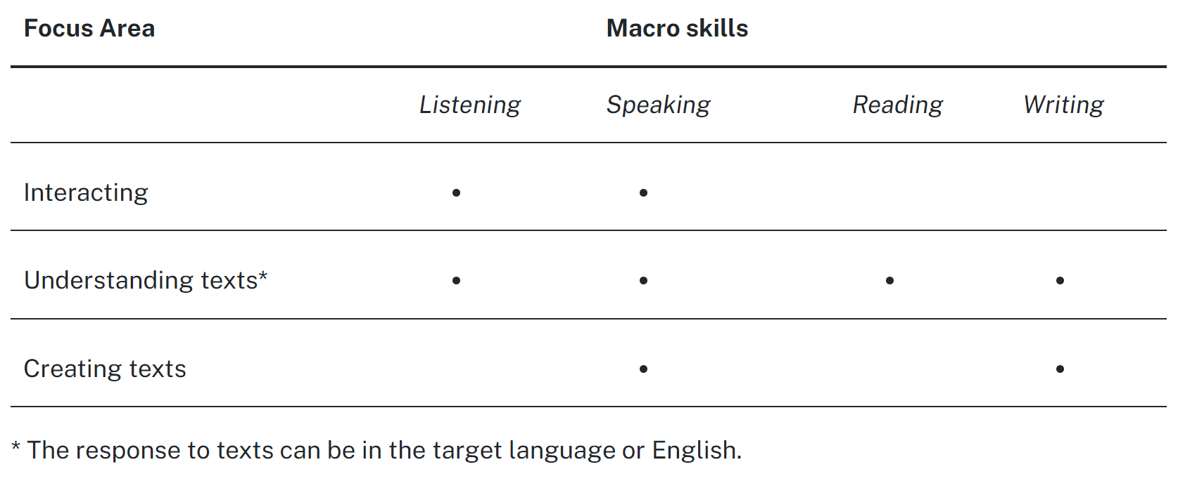
Modern Languages K–10 Syllabus © NSW Education Standards Authority (NESA) for and on behalf of the Crown in right of the State of New South Wales, 2022.
The syllabus outcomes are inclusive in nature, allowing us to embed appropriate adjustments to speaking, listening, reading, writing and communication experiences to support students with disability.
Remember, the syllabus includes a glossary if there is any terminology in the outcomes and content you are unfamiliar with.

How to assess
Ensure you provide students with a range of formative and summative assessment opportunities.
The aim of the Modern Languages K–10 Syllabus is to empower students to become effective communicators in the target language by developing linguistic competence and intercultural capability. In our context, summative assessment takes the form of a real-world or simulated real-world task, which articulates the context, purpose and audience of the communicative act.
With translating and AI tools available to students, it is critical that we assess the student’s own work. Consider if tasks will be completed in class or at home. If students do complete some or all of a task at home, consider:
- a portfolio approach, with a reflection journal
- check-in sessions to discuss the student’s work and progress, including targeted questions
- identifying part(s) to complete at home and part(s) in class, to identify any inconsistencies in achievement
- conducting post-assessment interviews.
If your school has exam periods, you can still design task-based assessment. For example, for a Stage 4 half-yearly written exam, you could use the following:
- Task A – you have just received this email from your future host student, outlining what they generally eat for dinner, and their favourite foods, with reasons. Demonstrate your understanding of the information by answering questions about the text in English. Then, determine if you think you will have any concerns (or not) with the food during the homestay, with 3 references to the text.
- Task B – write back to your future host student. In your reply, include your name, age, at least 2 of your favourite foods, one food you do not like (with reason) and what you generally eat for dinner.
Choose the approach which works best for you and your students – remember, ‘assessment can enhance student engagement and motivation, particularly when it incorporates interaction with teachers, other students and a range of resources’.
Source: Assessment Principles (NESA 2022) (accessed 25 August 2023)

Assessing content through different outcomes
In any given task, we can assess outcomes individually, or we can combine outcomes. For example, you can have a receptive component assessing ‘Understanding texts’, combined with a related productive component, assessing ‘Interacting’ or ‘Creating texts’.
To support you to assess in a range of ways, take a look at the sample ideas below, which show ways to assess the same topic of ‘Festivals’, using different outcomes.

Understanding texts (ML4-UND-01)
You are on exchange in [country]. Look at the event timetable for a cultural festival coming up in your town which includes a brief outline of what is on offer. Complete these tasks:
- Answer questions about the flyer, with reference to the text, in English.
- Choose 2 activities to do at the festival and give a reason why you have chosen each one, in [language].
Adapted from Stage 4 Japanese.

Creating texts (ML4-CRT-01)
You are planning an upcoming festival for [language] speakers. Create a poster or infographic to advertise the festival. Include:
- an engaging format, to encourage your audience to attend the festival, with relevant image(s)
- the name of the festival
- when (day, date and time) and where the festival takes place
- at least 2 activities which will occur at the festival
- at least 4 foods and drinks which will be available.

Interacting (ML4-INT-01)
Provide students with a flyer for an upcoming event, with various activities. Have a conversation in pairs, in [language], about the event. One student takes the role of an Australian exchange student and one takes the role of a [language-speaking] friend. In your conversation, each person presents their 2 activity choices, including why they are of interest. Then discuss the options and decide on one activity to attend together and when to go.
Include:
- each person’s 2 activity choices and why they are preferred and reasons for your preferences
- a negotiation to identify one activity to attend together, with reason(s)
- a plan to go to the event including location and day.
Adapted from Stage 4 Japanese.
An extra note about assessing ‘Interacting’:
- Many of us find the ‘Interacting’ outcome the most challenging to assess, as interacting requires a level of spontaneity indicated through the outcome’s related content group of ‘Exchanging and negotiating meaning to interact in the target language’. Assessing large numbers of students adds another layer of complexity to this outcome.
- The sample summative task for Term 2 in our Stage 4 French scope and sequence provides ideas and marking guidelines which support assessing large numbers of students, while maintaining validity and reliability.

Backward mapping
The department recommends a ‘backward mapping’ approach to assessment and unit design for modern languages.
By designing our summative assessment task first, then backward mapping our teaching, learning and formative assessment opportunities, we are supporting our students to develop the skills required for effective communication. Teaching and learning activities should be specifically designed to prepare students with the necessary skills, knowledge and understanding to succeed in the planned assessments.
A backward mapping approach has 3 key steps, as outlined below. We will explore each step in detail.
Figure 4 – 3 steps for backward mapping
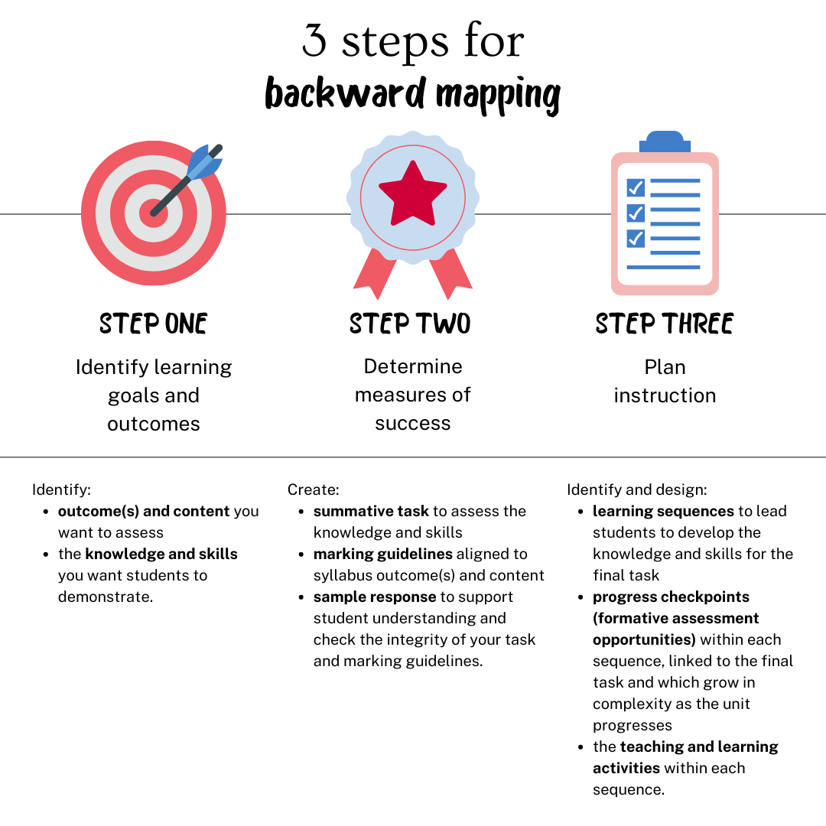

Step 1 – identify the desired learning goals and outcomes
There are 2 key questions to consider in this step:
- By the end of this unit of work, what do I want my students to be able to know, understand and do?
- How will I get them to demonstrate this?
For the purpose of this document, we are planning a Stage 4 unit called ‘All about me’. By the end of the unit, we would like students to be able to:
- express their name, age and nationality
- express who is in their family
- describe personalities
- express likes and dislikes
- join sentences using and, but.
In order to design our task, we will first need to decide which outcome(s) and related content we want to assess.
The Stage 4 outcomes are:
- ML4-INT-01 exchanges information and opinions in a range of familiar contexts by using culturally appropriate language
- ML4-UND-01 interprets and responds to information, opinions and ideas in texts to demonstrate understanding
- ML4-CRT-01 creates a range of texts for familiar communicative purposes by using culturally appropriate language
We can assess outcomes individually, or we can also assess a combination of outcomes, depending on the task we create. Keep in mind that, across a year or Stage of learning, it is good practice to assess a range of outcomes and content. This builds a more complete picture of students’ overall achievement.
For our context, we decide to focus on assessing student achievement against the ‘Creating texts’ and ‘Understanding texts’ outcomes.
Our plan is for students to:
- create a profile of themselves to send to a sister school
- read a range of student profiles from the sister school, and choose 2 students they would like to correspond with and one they would not like to correspond with, providing reasons for their choices (in English).
In assessing ‘Creating texts’ and ‘Understanding texts’, we do not need to assess every content heading and dot point. In fact, some content dot points are not designed with assessment in mind; rather they support student learning.
Below are all the content dot points for the 2 outcomes we have chosen. Read the dot points carefully and choose the one(s) relevant to what students will be demonstrating through our task.
When choosing the dot points, consider:
- are the dot points measurable across a range of ability levels A–E?
- are they relevant to the task?
(In brackets, you will find some possible thinking about whether to assess this content, or not, in relation to the task. This information has been provided for illustrative purposes only – you choose the content dot point(s), based on the assessment you design.)

Creating texts
ML4-CRT-01 creates a range of texts for familiar communicative purposes by using culturally appropriate language
Creating spoken, written and multimodal texts in the target language appropriate to context, purpose and audience
- Create informative texts to describe and share information about themselves and their personal world (Definitely assessed – students are creating an informative task, and this is a measurable skill against grades A–E.)
- Create imaginative texts (Not assessed – while some students may choose to create a fictional student profile, you are not assessing the accuracy of the information, but rather the amount of information they are providing using accurate language, which is covered by the dot point above.)
- Use familiar text features (May or may not be assessed, depending on context – students are creating a student profile, which has specific text features. If you want to assess the textual features and format of a student profile, be explicit in identifying what you want students to include so you can describe achievement against grades A–E in your marking guidelines. Alternatively, consider allowing students to choose how they present their information, which allows the opportunity for student choice. If allowing students to choose, you are focusing on the language students use, not the format, and this dot point would not be assessed.)
Applying knowledge of language systems to create texts in the target language
- Use features of the sound system to create spoken texts (Not assessed.)
- Use sound–symbol correspondences to create written texts (May or may not be assessed, depending on context – if students have been learning script and you want to specifically assess their achievement, you may consider assessing. However, for most contexts, the last content dot point in this section would be sufficient.)
- Use relevant and familiar vocabulary from a range of themes to create texts (Definitely assessed – students are being assessed on their ability to use the vocabulary learnt during the unit.)
- Use structures and features of the grammatical system to create texts (Definitely assessed – students are being assessed on their ability to use grammatically correct language learnt during the unit.)
- Use structures and features of the target language writing system to create written texts (Likely to be assessed, for scripted languages. If assessing, consider handwritten script versus input method with technology.)
Applying knowledge of the target language culture(s) to create texts
- Use language that is appropriate to cultural practices and values to create texts (Not assessed.)

Understanding texts
ML4-UND-01 interprets and responds to information, opinions and ideas in texts to demonstrate understanding
Understanding and responding to spoken, written and multimodal target language texts
- Listen to, read and view information, opinions and ideas in a range of predictable texts on familiar themes (Not assessed – while this is what students will be doing, this is not a measurable skill in the context of the task.)
- Develop and use comprehension strategies to interpret information, opinions and ideas in texts (Not assessed – while this is what students will be doing, this is not a measurable skill in the context of the task.)
- Respond appropriately in the target language and/or English to main ideas and supporting details in texts by interpreting information, opinions and ideas (Definitely assessed – students will be able to demonstrate their degree of understanding, across grades A–E.)
- Demonstrate understanding of the context, purpose and audience in predictable texts (Not assessed – students are being assessed on the content of the student profile, not their understanding of the purpose, context or audience of the text.)
Applying knowledge of language systems to understand and respond to target language texts
- Use knowledge of features of the sound system to understand texts (Not assessed.)
- Use knowledge of sound–symbol correspondences to understand and respond to texts (Not assessed – while students are using their knowledge of sound–symbol correspondences to understand the text, it is not assessable across grades A–E in this context. It may be assessable across A–E for some scripted languages, depending on context.)
- Use knowledge of appropriate and familiar vocabulary from a range of themes to understand and respond to texts (Definitely assessed – students are using their knowledge of the learnt vocabulary to understand and respond to texts.)
- Use knowledge of structures and features of the grammatical system to understand and respond to texts (May or may not be assessed, depending on context – understanding likes and dislikes, with reasons, may be complex in some languages.)
- Recognise and use structures and features of the target language writing system to understand and respond to texts (May be assessed, for scripted languages.)
- Use familiar metalanguage to compare target language structures and features with English (Not assessed.)
Developing intercultural understanding through target language texts
- Respond to texts by reflecting on how language is connected with cultural practices and values, and how this is evident in their own language(s), culture(s) and identity (Not assessed.)

Outcomes and dot points to be assessed
After consideration, we decide to assess the following content dot points for each outcome.
Creating texts (ML4-CRT-01)
- Create informative texts to describe and share information about themselves and their personal world
- Use relevant and familiar vocabulary from a range of themes to create texts
- Use structures and features of the grammatical system to create texts
- Use structures and features of the target language writing system to create written texts (for scripted languages only)
Understanding texts (ML4-UND-01)
- Respond appropriately in the target language and/or English to main ideas and supporting details in texts by interpreting information, opinions and ideas
- Use knowledge of appropriate and familiar vocabulary from a range of themes to understand and respond to texts

Step 2 – determine measures of success
Measures of success are determined though creating:
- your summative task, in detail
- the related marking guidelines
- a sample student response at A grade level.

Designing your summative task in detail
Consider what information students need to succeed in the task. Here is our planned task:
- create a profile of themselves to send to a sister school
- read a range of student profiles from the sister school, and choose 2 students they would like to correspond with and one they would not like to correspond with, providing reasons for their choices (in English).
Let’s unpack this for students, to set them up for success. For example:
Part A
You will create a profile of yourself to send to a sister school. You may choose the format of your profile, for example a social media post, a Google Slides or PowerPoint presentation, a poster or a video (with captions). In your profile, include:
- your name, age and nationality
- at least 2 descriptions of your personality
- one thing you like and one thing you don’t like
- who is in your family
- a description of at least one family member.
Use a range of vocabulary and structures we have learnt through the unit, including:
- correct personal pronouns and verb forms
- a range of adjectives
- and, but to join sentences.
Part B
You will be given 5 student profiles from students at your sister school. In each profile, the student says their name, age and nationality. They also describe themselves and their families, including likes and dislikes.
Read each profile, and answer a range of questions in English, to demonstrate your understanding. Then choose 2 students you would like to correspond with and one you would not like to correspond with, providing reasons for your choices (in English).

Developing marking guidelines
Marking guidelines describe student achievement against standards, across a range of grades or marks. Achievement standards have 2 important components – what students are expected to learn and how well they have demonstrated this learning. In our context, the ‘what’ is the syllabus outcome(s) and related content dot point(s). The ‘how well’ is the A–E grade scale.
Explicit marking guidelines support equity and transparency in assessment. They clearly communicate to students what is expected of them at each grade level.
Marking guidelines can be developed in a range of ways and have a range of formats. What is essential is that there is a clear link between your marking guidelines and the syllabus. In deciding on your approach, consider your school requirements and context. Marking guidelines may also be co-designed with students and, when used in conjunction with student work samples, facilitate collaborative discussions about 'what a good one looks like' (WAGOLL). This engages students in the task and develops them as ‘assessment capable’ learners.
Marking guidelines may be analytic or holistic. Analytic guidelines involve assessing different aspects of student achievement individually. Holistic guidelines support an overall assessment, considering all aspects simultaneously.
In its support for the Modern Languages K–10 Syllabus, the department has developed analytic marking guidelines, with the descriptions of student achievement aligned to one or more syllabus content dot points. This approach enables students to better identify what they know and can do, as well as any areas for improvement.
The dot points we identified in Step 1 of this document will form the basis of our marking guidelines.
We now need to describe what ‘A’ achievement looks like for each dot point. This is based on the description of the task provided to students. Below is a sample. You can see some dot points are standalone, and others have been grouped. Consider what works best, in the context of the tasks you design.
Table 1 – creating marking guidelines for achievement at ‘A’ level
Outcome(s) and dot point(s) | A – extensive achievement
ML4-CRT-01  - Create informative texts to describe and share information about themselves and their personal world | Creates a detailed text with a high level of accuracy that includes:  - name, age and nationality  - at least 2 descriptions of their personality  - one thing they like and one thing they don’t like  - who is in their family  - a description of at least one family member.
- Use relevant and familiar vocabulary from a range of themes to create texts  - Use structures and features of the grammatical system to create texts | Uses:  - correct personal pronouns and verb forms  - a range of adjectives  - and, but to join sentences  with minimal errors.
- Use structures and features of the target language writing system to create written texts (for scripted languages only – sample provided for Japanese) | Composes Japanese script with a high level of accuracy, appropriately using hiragana and katakana.  Selects correct input method and rōmaji to accurately type in Japanese.
ML4-UND-01  - Respond appropriately in the target language and/or English to main ideas and supporting details in texts by interpreting information, opinions and ideas | Responds in English to the text, accurately identifying key details.  Provides extensive justification, with detailed reference to the text, for choosing 2 students and not choosing one student.
Next, we describe achievement across grades B–E. Use language which students will understand, and which makes clear the distinction between each level of achievement.
To access a range of marking guidelines with descriptions of achievement across A–E, view the department’s sample units of work. You will find the summative assessment task (with related marking guidelines) in Appendix A of each document. The codes in brackets below indicate the outcomes being assessed.
- Stage 4 French (ML4-UND-01 and ML4-CRT-01)
- Stage 5 French (ML5-CRT-01)
- Stage 4 Japanese (ML4-INT-01 and ML4-UND-01)
- Stage 5 Japanese (ML5-CRT-01)
Even if you do not teach the language(s) listed, we encourage you to explore the range of assessment tasks and marking guidelines, as they are written in English.
In place of grades, you may prefer to use mark ranges on your marking guidelines. For example, in a task worth 20 marks, you may consider:
- 18–20, in place of A
- 15–17 in place of B, and so on.
The benefit of mark ranges is that they support us to rank our students, if required.

Developing a sample response
The department recommends writing a sample response. This allows us to:
- understand exactly what is required to complete the task
- identify the language and skills needed
- evaluate if the task design, description and marking guidelines work, so you can make refinements where necessary
- identify how to adjust and/or scaffold the task to support success for all learners.
With the Modern Languages K–10 Syllabus providing a framework for all modern languages, sample responses can also support consistent teacher judgement.
We can develop a sample response in the target language or in English. We can use the sample response in a range of ways, including:
- showing it to students at the start of the unit, in the target language, to illustrate to students what they will be able to know and do by the end of the unit
- using it to co-design marking guidelines, allowing students to see how their learning is applied within the context of the unit
- using it during the unit, to explore ‘what a good one looks like’ (WAGOLL), for students to identify key language they still need support with
- providing it, in English, with the summative task notification, as a scaffold.
As with all advice, use the approaches which work best for you and your context, meeting the needs of your students. If showing the sample in the target language, consider strategies to prevent students copying the response, such as ensuring devices are packed away.

Sample response
Figure 5 – sample response
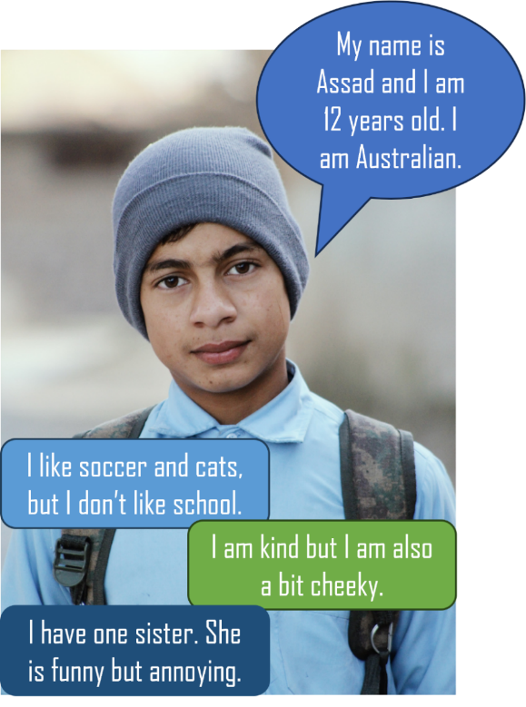
Image licensed under Unsplash License.
Having the sample response in front of us supports us to identify a range of options to support students with disability to complete the task, for example providing:
- a preparation schedule (‘steps to success’)
- a scaffold
- sentence starters
- a cloze version, with options
- a vocabulary chart.
These are sample ideas only. Make adjustments based on the needs of the students in your class. The task has options for how students present their work, so discuss these with your students too.

Task notifications
We provide assessment notifications to students for summative assessment tasks, so they understand what is required. Schools often have their own formats or templates for notifications.
Task notifications include:
- adequate written notification in advance of the task (typically, 2 weeks)
- details of the task, including
- task number and weighting (from the related course assessment schedule)
- outcome(s) assessed
- description of the task
- marking criteria (‘You will be assessed on your ability to…’)
- feedback, including how this will be given to students
- marking guidelines.
Notifications use student-friendly language, allowing all students to access and understand task requirements.

Step 3 – plan instruction
Now it is time to identify and design:
- the learning sequences which will support student success in the summative assessment task
- ‘mini task – progress checkpoints’ within each sequence, to ensure students are on track with their learning
- the teaching and learning activities (with related resources) within each sequence.

Learning sequences and related mini tasks
The department recommends organising teaching and learning activities into ‘chunks’ or short learning sequences. The duration of each ‘chunk’ or learning sequence will vary, depending on the content. Generally, they are 2–4 weeks in length.
This structured approach enables more explicit teaching and fosters deeper student understanding. Each ‘chunk’ represents a particular aspect of the content, with related:
- learning intentions and success criteria
- vocabulary, language structures and/or grammar
- script, where relevant
- formative assessment opportunities, including a ‘mini task – progress checkpoint’ which links directly to the summative task.
‘Mini task – progress checkpoints’ ideally occur towards the end of a ‘chunk’ or learning sequence. Mini tasks are designed to assess student progress towards the summative (end-of-unit) assessment task. There should be a clear link between each mini task and the summative task.
Let’s go back to what we would like our students to be able to do by the end of our Stage 4 unit, ‘All about me’:
- express their name, age and nationality
- express who is in their family
- describe personalities
- express likes and dislikes
- join sentences using and, but.
And our planned summative assessment task requires students to:
- create a profile of themselves to send to a sister school
- read a range of student profiles from the sister school, and choose 2 students they would like to correspond with and one they would not like to correspond with, providing reasons for their choices (in English).
Our possible ‘chunks’ or learning sequences, with related ‘mini task – progress checkpoints’ may be:

Chunk 1
- Introducing self and others
- Numbers 0–20 and saying how old you are
- Discussing nationality
- Mini task: It’s your first day at your sister school in [country]. In pairs, introduce yourself to another student in [language], exchanging names, ages and nationalities. (ML4-INT-01)

Chunk 2
- Expressing who is in your family
- Describing personalities and appearances
- Mini task: Your host family wants to learn more about you. Create a text (real or imagined) about you and your family, including
- an image and 3 adjectives to describe yourself
- an image of your family, identifying each family member
- a description of at least one other family member. (ML4-CRT-01)

Chunk 3
- Saying what you like and do not like
- Mini task: You receive a message from your host brother about what he likes and doesn’t like. In English, explain to a friend if you think you will get along, with at least 2 references to the text. (ML4-UND-01)
You can see the 3 mini tasks:
- relate directly to the summative task, in terms of both language and skills
- increase in complexity, in language and/or skills.
This sets students up for success in meeting the requirements of the summative assessment task.
As part of each mini task, include:
- an opportunity for feedback (by peers or the teacher)
- student self-reflection – this enables students to recognise areas for development and plan their next steps
- time to review future teaching – seeing how students demonstrate their learning through the mini task allows us to refine what we have planned next. If students are not yet demonstrating mastery of key language and skills, we may need to include additional activities to what we planned, or if students are confident, we may be able to move more quickly through content.
While mini tasks are designed for formative assessment, they can be adapted for use as summative assessment. This may be required if your unit is for a full term, yet report writing occurs mid term, or if you need to modify the timing of your unit to meet student needs. The number of ‘chunks’ or learning sequences, with related mini tasks, will vary depending on your context and the needs of your students.
Activities and tools for providing feedback are available on the department’s Digital Learning Selector. Advice on providing effective feedback is available through our ‘Effective feedback in languages’ microlearning.

Teaching and learning activities (with related resources)
Availability of resources varies from school to school. In addition, some teachers may prefer using a textbook, while other teachers may prefer designing their own activities.
Whether you use a textbook or not, only source or choose activities which are relevant to the summative assessment task. While it is important for students to learn vocabulary, the central goal in language learning is communicating in the target language. This requires a strong focus on using the vocabulary in a range of structures, recycling and building on these structures within and across units. This also supports students to communicate about their personal worlds, aligning with syllabus content.

Evaluation
After implementing a summative assessment task, it is important to evaluate it. Consider the following reflection questions and, where possible, work collaboratively with colleagues.
- Were the marking guidelines applied consistently?
- Was effective feedback provided?
- Did the task effectively assess the outcome(s)?
- What changes need to be made in future assessments?
It is important to also evaluate the formative assessment opportunities, including mini tasks, to ensure they effectively built the knowledge and skills required to complete the summative assessment task.

Conclusion
In conclusion, the following steps support quality assessment design. The order in which you do the steps may vary – what is important is that all steps are addressed, rather than the order in which you address them. You may also do 2 or more steps simultaneously.
- identify outcome(s) and content to be assessed – what skills and knowledge are you assessing?
- Design the task – what to you want students to do? Is it engaging for students? Does it have a context, purpose and audience?
- Design the marking guidelines – what does achievement look like? Are the marking guidelines clearly expressed for students?
- Draft a sample response – do the task and marking guidelines work, or do you need to make adjustments?
- Consider differentiation adjustments – how will you make the task accessible and engaging for the range of students in your class?

Support and alignment
Resource evaluation and support: All curriculum resources are prepared through a rigorous process. Resources are periodically reviewed as part of our ongoing evaluation plan to ensure currency, relevance, and effectiveness. For additional support or advice, contact the Languages and Culture team by emailing languagesnsw@det.nsw.edu.au.
Alignment to system priorities and/or needs: Curriculum Planning and Programming, Assessing and Reporting to Parents K-12 Policy
Alignment to the School Excellence Framework: This resource supports the School Excellence Framework elements of curriculum (teaching and learning programs).
Alignment to Australian Professional Standards for Teachers: This resource supports teachers to address Australian Professional Standards for Teachers 2.2.2, 2.3.2, 3.2.2.
Consulted with: Curriculum and Reform and subject matter experts
NSW syllabus: Modern Languages K–10 Syllabus
Author: Languages and Culture
Publisher: State of NSW, Department of Education
Resource: Assessment guidelines
Related resources: Further resources to support Modern Languages can be found on the Languages curriculum page.
Professional learning: Relevant professional learning is available through the Languages statewide staffroom (entry survey link for staff only).
Creation date: 1 September 2023
Rights: © State of New South Wales, Department of Education

References
This resource contains NSW Curriculum and syllabus content. The NSW Curriculum is developed by the NSW Education Standards Authority. This content is prepared by NESA for and on behalf of the Crown in right of the State of New South Wales. The material is protected by Crown copyright.
Please refer to the NESA Copyright Disclaimer for more information https://educationstandards.nsw.edu.au/wps/portal/nesa/mini-footer/copyright.
NESA holds the only official and up-to-date versions of the NSW Curriculum and syllabus documents. Please visit the NSW Education Standards Authority (NESA) website https://educationstandards.nsw.edu.au/ and the NSW Curriculum website https://curriculum.nsw.edu.au/home.
Modern Languages K–10 Syllabus © NSW Education Standards Authority (NESA) for and on behalf of the Crown in right of the State of New South Wales, 2022.
NESA (NSW Education Standards Authority) (2022) ‘Assessment Principles’, Assessment, NESA website, accessed 25 August 2023.
© State of New South Wales (Department of Education), 2023
The copyright material published in this resource is subject to the Copyright Act 1968 (Cth) and is owned by the NSW Department of Education or, where indicated, by a party other than the NSW Department of Education (third-party material).
Copyright material available in this resource and owned by the NSW Department of Education is licensed under a Creative Commons Attribution 4.0 International (CC BY 4.0) license.
This license allows you to share and adapt the material for any purpose, even commercially.
Attribution should be given to © State of New South Wales (Department of Education), 2023.
Material in this resource not available under a Creative Commons license:
- the NSW Department of Education logo, other logos and trademark-protected material
- material owned by a third party that has been reproduced with permission. You will need to obtain permission from the third party to reuse its material.
Links to third-party material and websites
Please note that the provided (reading/viewing material/list/links/texts) are a suggestion only and implies no endorsement, by the New South Wales Department of Education, of any author, publisher, or book title. School principals and teachers are best placed to assess the suitability of resources that would complement the curriculum and reflect the needs and interests of their students.
If you use the links provided in this document to access a third-party's website, you acknowledge that the terms of use, including licence terms set out on the third-party's website apply to the use which may be made of the materials on that third-party website or where permitted by the Copyright Act 1968 (Cth). The department accepts no responsibility for content on third-party websites.

Teacher to provide text.
To ensure the task is valid and reliable, students who wish to create a video would not be assessed on their spoken language, as this changes the content dot point being assessed. Instead, they would include written text in their video.

