Modern Greek Stage 1 – Η Νυσταγμένη Αρκούδα (The Sleepy Bear)
Contents
Unit overview 3
Stage 1 outcomes and content to be addressed 4
Learning map 7
Assessment 10
Assessment opportunities 11
Teaching and learning activities 12
Week 1: Introduction to book 12
Week 2: Foods 19
Week 3: Let’s revise colours and numbers 23
Week 4: Building sentences 26
Week 5: Assessment criteria 30
Week 6: Communicative task – write the last page of Η Νυσταγμένη Αρκούδα 32
Week 7: Feedback and goal setting 34
Week 8: Language review 36
Student resources 39
Resource 1: Colours 39
Resource 2: Bingo mat 40
Resource 3: Days of the week 41
Resource 4: Days of the week flashcards 42
Resource 5: Matching pairs 44
Resource 6: What do bears eat? 45
Resource 7: Memory game 47
Resource 8: Nouns and adjectives 49
Resource 9: Greek foods 50
Resource 10: Peer feedback strategy – Two stars and a wish 51
Resource 11: Visual rubric 52
Support and alignment 53
References 56

Unit overview
Stage: 1
Title: Η Νυσταγμένη Αρκούδα (The Sleepy Bear)
Description: In this unit, students read the incomplete book, The Sleepy Bear. Students use simple food vocabulary, numbers and colours to write the last page of the book.
Duration: This lesson sequence is designed to be completed over approximately 8 weeks.
Student proficiency levels: It is assumed that most Stage 1 students have been learning Modern Greek since Kindergarten and their proficiency level will still be Beginner. This unit is aimed at Beginner students. Every classroom will be different and teachers will need to adapt to their context. Many classes may include a combination of Beginner, Intermediate and Advanced students with varying skills and abilities within these proficiency levels. Assessment tasks and opportunities in this unit can be differentiated by using the ‘Too hard?’ and ‘Too easy?’ suggestions.

Stage 1 outcomes and content to be addressed
The table below outlines the focus area, outcomes and content points for Stage 1 students.
Focus area and outcome | Content points
Understanding texts  A student:  - recognises and responds to information in simple texts to demonstrate understanding ML1-UND-01 | Understanding and responding to target language texts  - Listen to, read and/or view simple texts such as stories, songs, charts, rhymes or lists on familiar themes  - Recognise information in simple texts and respond to simple questions in the target language and/or English to show understanding of texts  - Demonstrate understanding when responding to texts using actions, drawing, singing or simple exchanges in the target language and/or English  Applying knowledge of language systems to understand and respond to target language texts  - Recognise and use sounds of modelled vocabulary and phrases to understand and respond to texts  - Recognise sound–symbol correspondences in modelled words and phrases to understand and respond to texts  - Recognise and use knowledge of modelled vocabulary, high-frequency words and formulaic phrases on familiar themes to understand and respond to texts  - Use simple grammar patterns to understand and respond to texts  - Recognise that the target language has features that may be similar to or different from English  - Recognise and reproduce symbols or modelled vocabulary and phrases of the writing system to understand and respond to texts  Developing intercultural understanding through target language texts  - Notice that language is used in ways that reflect cultural practices and reflect on students’ own language and cultural practices
Creating texts  A student:  - creates simple texts by selecting culturally appropriate modelled language ML1-CRT-01 | Creating spoken, written and multimodal texts in the target language  - Create texts using familiar vocabulary, phrases and visuals to express meaning  - Label or describe objects and images  Applying knowledge of language systems to create texts in the target language  - Use pronunciation patterns to create spoken texts  - Use familiar sound–symbol correspondences to create written texts  - Use familiar vocabulary and formulaic phrases to create texts  - Use simple modelled sentence structures to create texts  - Reproduce modelled features of the target language writing system to create written texts  Reproducing how target language speakers communicate to create texts  - Reproduce language appropriate to cultural practices to create texts
Interacting  A student:  - exchanges meaning by selecting culturally appropriate modelled language ML1-INT-01 | Exchanging meaning in oral interactions in the target language  - Exchange greetings, farewells and simple information to describe people or objects  - Express simple emotions and preferences  - Interact in classroom routines using familiar language  Reproducing oral language to interact in the target language  - Recognise and reproduce modelled sounds, including pronunciation and intonation patterns to interact  - Reproduce familiar vocabulary and short formulaic phrases to interact  Applying knowledge of the target language culture(s) to interact  - Use familiar verbal and nonverbal communication that is appropriate to cultural practices
Modern Languages K–10 Syllabus © NSW Education Standards Authority (NESA) for and on behalf of the Crown in right of the State of New South Wales, 2022.

Learning map
The creation of maps for learning is a planning process that incorporates Aboriginal intellectual tradition. Learning maps are a visual pathway of what students will learn.
Share the learning map with your students, briefly explaining the learning that will happen in each lesson. Provide students with a copy of the learning map or display the learning map in the classroom. This learning map can be adapted to Modern Greek by accessing a copy of Learning map – Η Νυσταγμένη Αρκούδα (The Sleepy Bear) Stage 1.
Figure 1 – The Sleepy Bear learning map
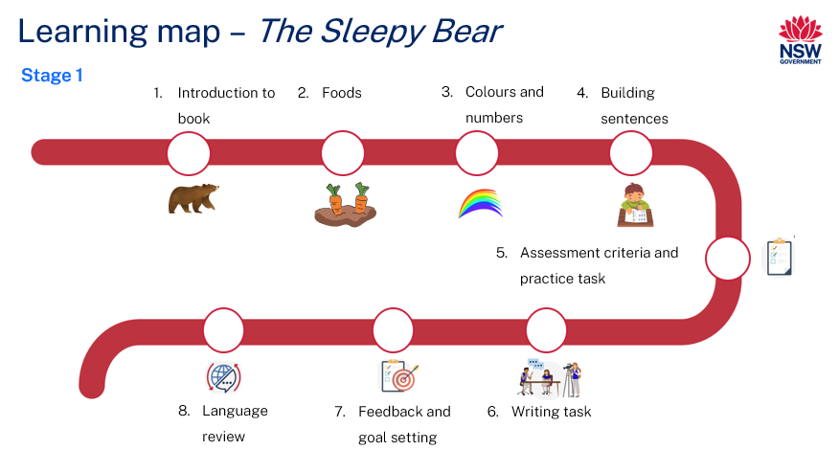
Figure 2 – Η Νυσταγμένη Αρκούδα learning map
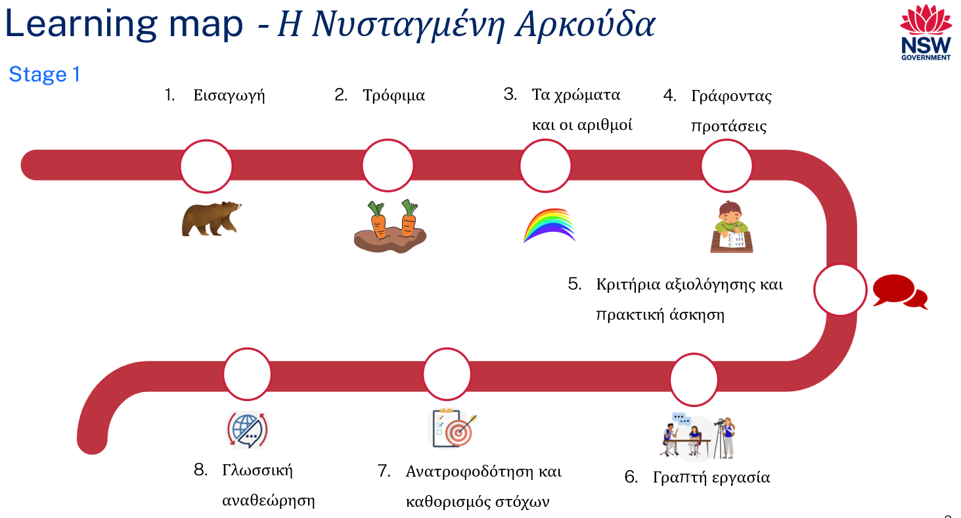

Assessment
Stage 1 communicative task: You are reading the book The Sleepy Bear and discover that the end of the story is missing. Complete the story by adding the ending to the book on the last page.
Too hard?
Use a scaffold to write a simple sentence to complete The Sleepy Bear.
Too easy?
Write a second page to end The Sleepy Bear story telling where Bruno goes to sleep during the winter.
Context: you are reading a book and the end is missing
Audience: readers of the book
Purpose: to complete the book

Assessment opportunities
The table below details assessment opportunities and differentiation ideas.
Assessment opportunities | Too hard? | Too easy?
Week 2: Letter scramble  Students are given words where the letters are all scrambled. Students must unscramble them to make the names of words for foods that a bear eats. | Letter scramble  Students are given a list of the scrambled words to use as a guide to help them unscramble the words. | Letter scramble  Students research some more foods that bears eat and scramble them up. They give these to a peer to unscramble.
Week 3: Memory game  Students play a card game to match up pictures with their corresponding names in Modern Greek. | Memory game  Provide students with cards that have both the Modern Greek and English words to match up with the pictures. | Memory game  Before playing, students make matching cards to add to the set of cards they already have.
Week 4: Building sentences  Students are provided with sentence builders and from this must produce a simple sentence about the book. | Building sentences  Model writing a simple sentence for students to record in their book. | Building sentences  Students write a more detailed sentence which includes adjectives that are the correct gender and plural if needed.

Teaching and learning activities

Week 1: Introduction to book
The table below outlines the learning intention and success criteria of the lesson and materials that the teacher and students will need to complete the teaching and learning activities.
Learning intention and success criteria | Materials
Students will revise the colours in Modern Greek and numbers from 1–20.  Students can:  - recognise and say all the colours in Modern Greek  - count from 1–20 in Modern Greek. | - Η Νυσταγμένη Αρκούδα (Modern Greek)  - The Sleepy Bear (English)  - Resource 1: Colours  - Resource 2: Bingo mat  - Learning map  - Counters  - Coloured pencils

Vocabulary 1: Colours
The table below outlines the suggested vocabulary for Activity 2, Activity 3 and Activity 4. It includes the original Modern Greek script, a Romanised version of the Modern Greek script, and the corresponding English translations.
English | Romanised Modern Greek | Modern Greek
red | kόkkino | κόκκινο
yellow | kítrino | κίτρινο
pink | roz | ροζ
green | prásino | πράσινο
purple | mov | μωβ
orange | portokalí | πορτοκαλί
blue | ble | μπλε
black | mávro | μαύρο
brown | kafé | καφέ
grey | gri | γκρι
silver | asimí | ασημí
gold | chrysό | χρυσό
white | áspro | άσπρο

Vocabulary 2: Numbers
English | Romanised Modern Greek | Modern Greek
one | éna | ένα
two | dío | δύο
three | tría | τρία
four | téssera | τέσσερα
five | pénte | πέντε
six | éxi | έξι
seven | eptá | επτά
eight | oktό | οκτώ
nine | ennéa | εννέα
ten | déka | δέκα
eleven | énteka | έντεκα
twelve | dόdeka | δώδεκα
thirteen | dekatría | δεκατρία
fourteen | dekatéssera | δεκατέσσερα
fifteen | dekapénte | δεκαπέντε
sixteen | dekaéxi | δεκαέξι
seventeen | dekaeptá | δεκαεπτά
eighteen | dekaoktό | δεκαοκτώ
nineteen | dekaennéa | δεκαεννέα
twenty | eíkosi | είκοσι

Activity 1: Learning map
Show the students the Learning map and break down what they will be learning about each week. Remind students that the learning map is a plan and some changes may happen along the way.

Activity 2: Reading The Sleepy Bear
Have students sit on the floor and read The Sleepy Bear. Ask the following questions to assess students’ prior knowledge:
- Can you tell me what this story is about?
- Do you know any of the words?
- In Modern Greek, can you tell me what colour the grass is? What colour the sun is? Whisper to a partner any other colours you recognise.
- In Modern Greek, can you tell me how many fish, carrots and strawberries Bruno eats?
Note: explain that bears need to hibernate during winter. In autumn, bears enter a period of excessive eating that lasts for several weeks. Bears need to put on a lot of weight before they enter a state of hibernation where they will survive entirely off their fat stores. They enter their dens and do not eat or drink for the entire winter period.

Activity 3: Colours
- Model and drill the Modern Greek words for colours to ensure students have the correct pronunciation.
- Play a communicative language learning game such as ‘Bingo!’ to practise using colours.
- Display Resource 1: Colours and have students create their own bingo mat by colouring all the squares on Resource 2: Bingo mat in different colours of their choice. The same colour can be used in more than one square.
- Provide a handful of counters to each student and each time a colour is called out in Modern Greek a counter must be placed on that colour. The winner is the first person to get a whole row of counters.
- All students take turns at being the bingo caller drawing the words from a hat or a bowl. The words are read aloud to the class until someone wins. Some students may need teacher assistance with pronunciation.

Activity 4: Buzz off hairy legs
- As a class, revise the numbers from 1–20 in Modern Greek. This can be done by singing a song or rhyme, or by getting students to repeat every number after saying it aloud.
- Have students stand up and form one circle, or a number of smaller circles, to play ‘Buzz off hairy legs.’ The objective of the game is to be the last one standing.
- Begin with one student saying the number one in Modern Greek. Each student in the circle must continue the counting sequence. If a student gets their number wrong they must sit down and the next person must then say the correct number.
- The counting continues until it gets to 20. Then the sequence continues with next 4 students saying aloud ‘Buzz off hairy legs.’ The student that says ‘legs’ is out and the counting starts again until there is one student left.

Week 2: Foods
The table below outlines the learning intention and success criteria of the lesson and materials that the teacher and students will need to complete the teaching and learning activities.
Learning intention and success criteria | Materials
Students will learn the days of the week and identify what kinds of food Bruno the bear eats.  Students can:  - say the days of the week in Modern Greek  - say the different food Bruno the bear eats. | - Η Νυσταγμένη Αρκούδα (Modern Greek)  - Resource 3: Days of the week  - Resource 4: Days of the week flashcards  - Resource 5: Matching pairs  - Resource 6: What do bears eat?  - Writing materials

Vocabulary 3: Days of the week
The table below outlines the suggested vocabulary for Activity 1, Activity 2 and Activity 3. It includes the original Modern Greek script, a Romanised version of the Modern Greek script, and the corresponding English translations.
English | Romanised Modern Greek | Modern Greek
Monday | Deftéra | Δευτέρα
Tuesday | Trίti | Τρíτη
Wednesday | Tetárti | Τετάρτη
Thursday | Pémpti | Πέμπτη
Friday | Paraskevί | Παρασκευή
Saturday | Sávvato | Σάββατο
Sunday | Kyriakί | Κυριακή

Vocabulary 4: Food
English | Romanised Modern Greek | Modern Greek
honey | méli | μέλι
carrots | karota | καρότα
fish | psária | ψάρια
strawberries | fráoules | φράουλες
nuts | karίthia | καρύδια
roots | rίzes | ρίζες
grasses | chόrta | χόρτα
fruit | froúta | φρούτα

Activity 1: Introduce vocabulary
- To pre-assess students' vocabulary before teaching new words, ask students to turn to a partner and tell them any days of the week that they know in Modern Greek. Pairs share their knowledge with the class.
- Display Resource 3: Days of the week on the board. Call out each word on the board and ask students to raise their hand or put their thumbs up at their chest when they are familiar with a day of the week.
- Read aloud the Greek days of the week using Resource 4: Days of the week flashcards and have students repeat each word after you call them out.
- Ask students to look for any similarities between the words for the days of the week in English and in Modern Greek.
- If students have a language background other than Modern Greek or English, ask if they can see any similarities in their background language as well.

Activity 2: What do bears eat?
- Re-read The Sleepy Bear and talk about the different foods a bear would feast on before it goes into hibernation. For example, fruit, nuts, carrots, strawberries, honey, roots, grass and fish.
- As you read through the book, ask students to point out any of the foods they know the names of.
- Pre-assess students’ ability to identify any of the foods in the text using Resource 5: Matching pairs, where students match the picture of the food with its corresponding name by drawing a line connecting the 2.
- As an extension, students can draw some extra foods they know and write their names in Modern Greek.

Activity 3: Letter scramble
- Display Resource 6: What do bears eat? and explain that each of these words are a food that a bear would eat. Explain that the letters are all jumbled up. The words in order are μέλι (honey), καρότα (carrots), ψάρι (fish), φρόυτα (fruit), χόρτα (grasses), ρίζες (roots), καρύδια (nuts) and φράουλες (strawberries).
- Students are given one word each. The letters of these jumbled words are cut up and rearranged into a food that a bear eats.
- Once students unjumble the letters and form the word of a food, students have a peer check the new word. The word is then stuck into a workbook where a picture can be drawn to match.

Week 3: Let’s revise colours and numbers
The table below outlines the learning intention and success criteria of the lesson and materials that the teacher and students will need to complete the teaching and learning activities.
Learning intention and success criteria | Materials
Students will revise the colours and numbers from 1–20 and familiarise themselves with the sentences from The Sleepy Bear.  Students can:  - say all the colours  - count from 1–20  - recognise whether sentences in The Sleepy Bear book are correct or incorrect. | - Η Νυσταγμένη Αρκούδα (Modern Greek)  - Resource 7: Memory game  - 6-sided dice (one for each student pair)

Activity 1: Numbers
- Students sit in a circle. Two selected players roll a 6-sided die.
- The first student to add the numbers correctly and call out the correct answer in Modern Greek is the winner.
- The winner competes against the next student. If any student wins 4 in a row, they retire undefeated.
- As a class, count on from 1–20 to review the numbers.

Activity 2: Memory game
- In pairs or small groups, students are given a set of cards from Resource 7: Memory game. Shuffle the cards and lay them face down.
- Each set consists of a card with the picture and a card with its description. For example, a picture of 5 red strawberries will have a corresponding card with the phrase ‘5 red strawberries.’
- Each student takes a turn to flip 2 cards at a time. The goal of the game is for students to collect as many matching sets as they can. Students alternate taking turns. If a player flips over a matching set, they get to keep it. If they do not find a match, they must turn the cards back over and let the other player take their turn.
- At the end of the game the player with the most pairs of cards wins.

Activity 3: True or false
- Read through The Sleepy Bear again and discuss what the bear eats every day.
- Tell students that you will now say some sentences aloud and students must put a thumbs up if they think it’s correct, or a thumbs down if they think it is incorrect. Some suggestions include:
- On Monday Bruno finds 2 carrots.
- On Wednesday Bruno finds one pot of honey.
- On Friday Bruno finds 3 silver fish.
- On Tuesday Bruno finds 2 carrots.
- On Thursday Bruno finds 4 strawberries.
- Ask students to explain why each sentence is correct or incorrect. Students discuss with a partner, then provide feedback to the class.

Week 4: Building sentences
The table below outlines the learning intention and success criteria of the lesson and materials that the teacher and students will need to complete the teaching and learning activities.
Learning intention and success criteria | Materials
Students will learn to write a simple sentence about The Sleepy Bear and learn about differences in gender with nouns.  Students can:  - write simple sentences using a sentence builder  - recognise that Modern Greek nouns have masculine, feminine and neuter genders. | - Η Νυσταγμένη Αρκούδα (Modern Greek)  - Resource 8: Nouns and adjectives  - Resource 9: Greek foods  - Writing materials

Activity 1: Greek nouns
- Explain to students that, unlike the English language, every noun in the Modern Greek language belongs to one of 3 groups. The groups are masculine (ο), feminine (η) or neuter (το) and there is no way of telling which family the nouns belong to from their meaning. For example, the coffee – ο καφές, the salad – η σαλάτα, the fish – το ψάρι.
- Nouns from the same group also follow rules when they are plural. See table below for plurals.
Table 1 – Plurals
Singular | Plural
the coffee / Ο καφές (masculine) | coffees / Οι καφέδες
the salad / Η σαλάτα (feminine) | salads / Οι σαλάτες
the fish / Το ψάρι (neuter) | fish(many) / Τα ψάρια
Note: there are 5 words for ‘the’ in this table, based on gender and number. Students in Stage 1 should be able to use Ο, Η, Το, Οι and Τα in interactions and be able recognise them in texts.
- Go through the picture book The Sleepy Bear and ask students if they notice any differences between the masculine, feminine and neuter nouns (food) and plurals (numbers and colours).
- Display Resource 8: Nouns and adjectives and explain that these sentences show both the singular and plural forms. Go through each sentence individually.
- Provide a copy of Resource 8: Nouns and adjectives to each student and have them highlight the differences by underlining or using a coloured highlighter.

Activity 2: Building sentences
- Read through The Sleepy Bear and have a look at each sentence carefully.
- Ask students if they can identify any patterns on each page. Anticipated responses include days of the week, different foods, numbers, and colours.
- Explain that in each sentence, there is a description of the different foods that Bruno finds. For example, ‘On Tuesday Bruno finds 2 orange carrots’. In this sentence the carrots are being described as ‘orange’. Explain that the words for colours (for example, orange), are adjectives and they describe nouns, such as carrots.
- Ask students for other words to describe the food in the story. Students can answer in English or in Modern Greek. Examples include ‘big’, ‘small’ and ‘delicious’.
- Have students build sentences from the following table. Using the picture book, they must begin saying or writing a day of the week and then pick appropriate adjectives and nouns. Pay special attention to the different endings that correspond to masculine/feminine and singular/plural.
Table 2 – Sentence builders
On | Day of the week | Bruno finds | Number | Colour | Food
Τη (On) | Δευτέρα (Monday)  Τρίτη (Tuesday)  Τετάρτη (Wednesday)  Πέμπτη (Thursday)  Παρασκευή (Friday) | ο Μπρούνο βρίσκει (Bruno finds) | ένα (one)  δύο (two)  τρία (three)  τέσσερις (four)  πέντε (five)  έξι (six) | κόκκινο (red)  πορτοκαλί (orange)  πράσινο (green)  μπλέ (blue)  χρυσό (gold)  ασημένια (silver) | ψάρι (fish)  καρότα (carrots)  μέλι (honey)  φράουλες (strawberries)

Activity 3: Greek food
- Revise food words. Have a conversation about what kinds of food students would find if they visited Greece.
- Ask students if they have ever been to Greece or to a Greek restaurant. Ask what food those students ate. For those that have not been to Greece or a Greek restaurant, ask what they know about Greek food.
- Talk about the different foods students could order if they were in Greece or at a Greek restaurant. Answers may include souvlaki, yeeros, spanakopita, olives, taramasalata, Greek salad and so on.
- Display and hand out a copy of Resource 9: Greek foods to each student. Model and drill the name of each food and talk about them in some detail. Suggest that Bruno may want to have some Greek food before he hibernates.
- Write the name of each food on the board and have students copy each word under the correct picture.

Week 5: Assessment criteria
The table below outlines the learning intention and success criteria of the lesson and materials that the teacher and students will need to complete the teaching and learning activities.
Learning intention and success criteria | Materials
Students will develop an understanding of the requirements of the assessment task.  Students can:  - say what they need to do to be successful in the task  - ask questions if they don't understand the requirements of the assessment task. | - Η Νυσταγμένη Αρκούδα (Modern Greek)  - Laptop or iPad – one per student  - Learning map  - Writing materials

Activity 1: Discuss the assessment task
To prepare students for the final task, review the Learning map and discuss the language that has been taught each week. Point out that, according to the learning map, the final task will be completed in Week 6. Explain to students they will be writing the end of the story of The Sleepy Bear by creating the last page in the book. Explain that, following the pattern of the story, Bruno must find one more thing to eat before he goes into hibernation. Tell students that he will find a food from Greece.

Activity 2: Success criteria
After looking at the assessment task, students Think-Pair-Share and suggest appropriate success criteria, such as:
I will be successful if I can:
- write the ending of the book The Sleepy Bear
- use correct grammar when writing my sentence in Modern Greek
- include one colour, one day of the week and one type of food in my Modern Greek sentence.

Activity 3: Practice task – jumbled up modelled sentence
- Write each of the words in the following sentences on card:
- On Saturday, he finds eight pink fish – Το Σάββατο, αυτός βρίσκει οκτώ ροζ ψάρια.
- On Sunday, he finds nine white nuts – Την Κυριακή, αυτή βρίσκει εννιά άσπρα καρύδια.
- Using one example, mix the words up on the board and put the sentence back together as a class.
- Students put the other sentences together in pairs.
- Students write their own sentence and share with a classmate.

Week 6: Communicative task – write the last page of Η Νυσταγμένη Αρκούδα
The table below outlines the learning intention and success criteria of the lesson and materials that the teacher and students will need to complete the teaching and learning activities.
Learning intention and success criteria | Materials
Students will write the ending to The Sleepy Bear.  Students can:  - write a simple sentence using 2 adjectives and a noun  - correctly use Modern Greek grammar related to gender and plurals. | - Resource 10: Peer feedback strategy – Two stars and a wish  - Laptop or iPad  - Writing materials

Activity 1: Hangman
- Play a game of hangman as a warm-up. The game will also review the Greek alphabet and set the scene for the task.
- Set up the board for hangman with gaps marked out for the letters in the words, for example, ‘πέντε καφέ σουβλάκια’ – ‘five brown souvlakia’. Give students the clue ‘Greek food’.
- Display the Greek alphabet.
- Students are invited to guess a letter in the words. When a letter is guessed it is crossed out from the displayed alphabet.
- If a letter is guessed correctly it is written in the appropriate gaps. When letters are incorrectly guessed, a stick figure is slowly drawn with each incorrect guess. The class can have 6 incorrect guesses – one for the head, one for the body, 2 for the arms and 2 for the legs. Additional guesses can be allowed by adding hands and feet.
- The class will win if they can fill all the gaps before the body is drawn.

Activity 2: Written task
- Students access, create or are provided with an image of Greek food, for example – πέντε καφέ σουβλάκια – five brown souvlakia, that Bruno finds on his last day before he goes into hibernation.
- Before writing, remind students that when writing their sentence, they need to follow the pattern set out in the book The Sleepy Bear. This includes a day of the week, a colour, a number, and a food.
- Students neatly write their sentence on a page with the picture of the food they have chosen.
- When they have written their sentence, remind students to check their work for spelling and grammar errors.

Activity 3: Peer assessment
Students will pair up and give each other feedback on their ending to The Sleepy Bear using the ‘thumbs up thumbs sideways’ strategy or Resource 10: Peer feedback strategy – Two stars and a wish.

Week 7: Feedback and goal setting
The table below outlines the learning intention and success criteria of the lesson and materials that the teacher and students will need to complete the teaching and learning activities.
Learning intention and success criteria | Materials
Students will reflect on feedback to set suitable learning goals.  Students can:  - use the feedback slip to choose a learning goal for themselves. | - Resource 11: Visual rubric  - Interactive whiteboard  - Writing materials
Note: prior to this lesson, read and mark each student’s ending to The Sleepy Bear using the visual rubric to determine whether they have met the key components required to complete the task successfully. These components include task completion, grammar, and vocabulary.

Activity 1: Self-assessment
Students have a look at their task and mark themselves using Resource 11: Visual rubric.
Students then compare both the teacher marked rubric and the one they completed.

Activity 2: Set learning goals
- To foster student ownership of their learning, facilitate a class discussion to help students reflect on their marked rubric, peer- and self-assessment and set their own personalised learning goals for the next phase. During the discussion, provide age-appropriate suggestions for learning goals, such as improving their ability to speak the language, adding more detail or creativity to their instructions, or building confidence in their abilities. Use simplified language to ensure that the students can understand and engage with the discussion effectively.
- Teacher suggested learning goals include:
- I will be confident when saying words in Modern Greek
- I will try to say Modern Greek words in the correct order and using masculine, feminine or neuter families
- I will practise saying tricky sounds in Modern Greek, for example…
- I will practise writing Modern Greek letters, especially…
- Present these suggestions and encourage students to raise their hands when they hear a goal that resonates with them. By doing so, students will understand their options and select a learning goal that is most relevant and suitable for their needs.
- Students record their learning goals.
Evaluation: students set appropriate learning goals.

Week 8: Language review
The table below outlines the learning intention and success criteria of the lesson and materials that the teacher and students will need to complete the teaching and learning activities.
Learning intention and success criteria | Materials
Students will reflect on and ask questions about the language taught in this unit.  Students can:  - ask questions about vocabulary, grammar, or pronunciation they have used in this unit  - use Modern Greek words and phrases they have learned to communicate with classmates. | - Η Νυσταγμένη Αρκούδα (Modern Greek)  - Writing materials
Note: over the course of the unit, gaps in student knowledge, misconceptions and misuse of language will have been identified. These observations are addressed using engaging and interactive activities and strategies. The activities below are examples and will need to be supplemented with activities to address your observations.

Activity 1: Student questions
Remind students about the activities and tasks they have completed over the course of the unit. Give students time to Think-Pair-Share any questions they may have about any aspect of the language taught.

Activity 2: Oral gap reading
Read the book The Sleepy Bear again and engage in an oral gap activity with the students. Read the first half of each sentence and have the students complete the second half. For example, say ‘On Tuesday Bruno found…’ and students say ‘ένα χρυσό δοχείο μέλι’ (one golden pot of honey)’ or say ‘open your…’ and students say ‘book’ (βιβλίο).
Students take turns at leading oral gap reading in small groups.

Activity 3: Language review – days of the week and food
- Introduce the phrase ‘I eat’- ‘τρώω’. Write it on the board and model and drill with students to ensure correct pronunciation.
- As an example sentence, say ‘On Monday, I eat strawberries’ – ‘Την Δευτέρα, τρώω φράουλες’.
- Students form circles in groups of 5 to 7. The first student says ‘On (day) I eat (food)’ and gently tosses a bean bag to a student in the circle. The student with the bean bag says ‘On (different day) I eat (different food)’ before gently tossing the bean bag to a classmate.
- The activity can be repeated with different groups.

Activity 4: Language review – colours and numbers
- Remind students about and display vocabulary from previous units, for example, related to toys or classroom objects.
- Students draw a picture of several objects and use the same colour to colour them.
- They label their drawing in Modern Greek, for example ‘Two red pencils’. (Δύο κόκκινα μολύβια)

Student resources

Resource 1: Colours
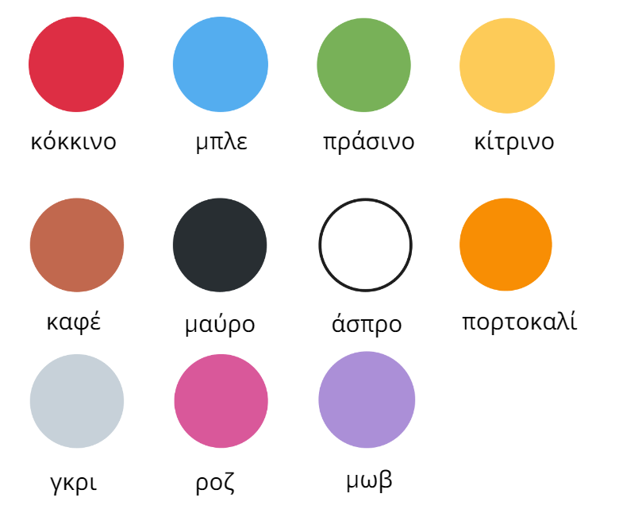

Resource 2: Bingo mat

Resource 3: Days of the week
Κυριακή | Πέμπτη
Δευτέρα | Παρασκευή
Τρίτη | Σάββατο
Τετάρτη

Resource 4: Days of the week flashcards
Sunday  Κυριακή | Monday  Δευτέρα
Tuesday  Τρίτη | Wednesday  Τετάρτη
Thursday  Πέμπτη | Friday  Παρασκευή
Saturday
Σάββατο

Resource 5: Matching pairs
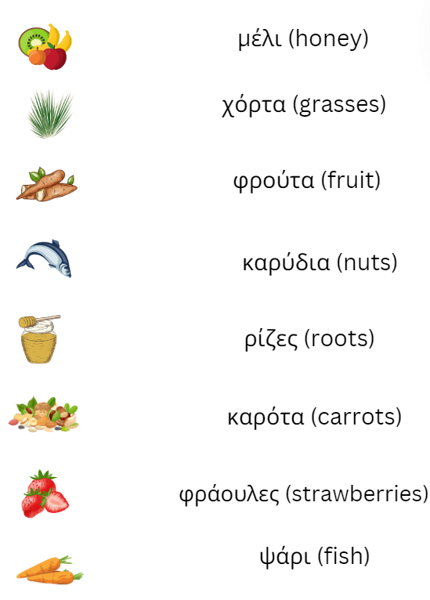

Resource 6: What do bears eat?
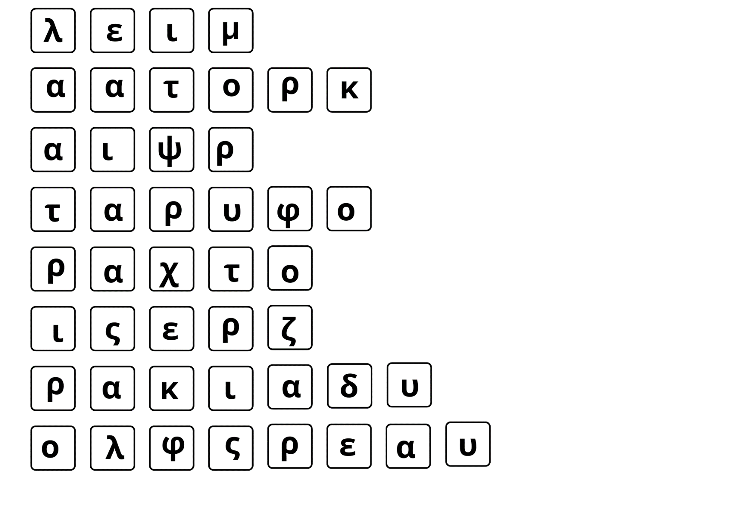
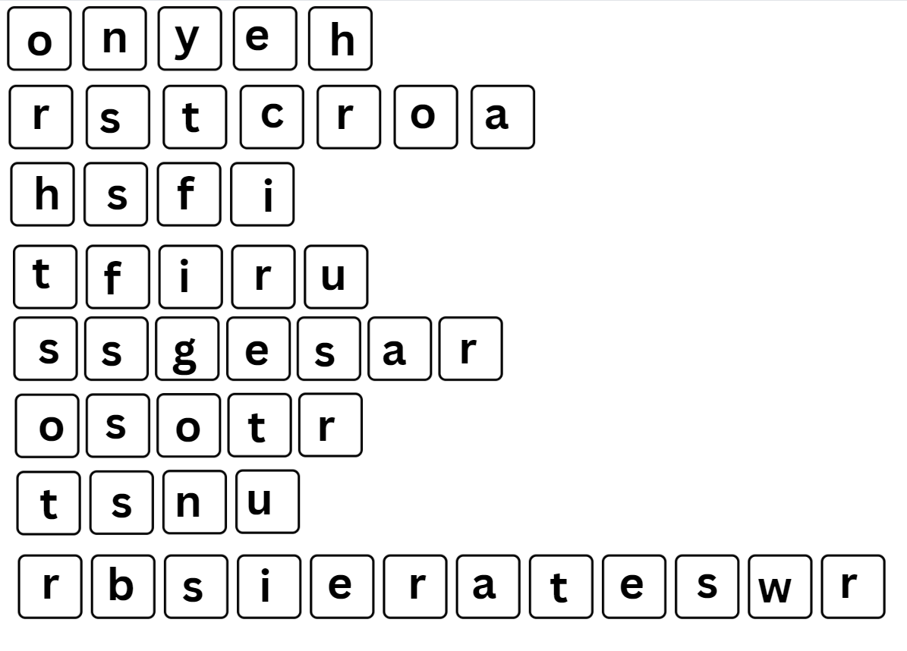

Resource 7: Memory game
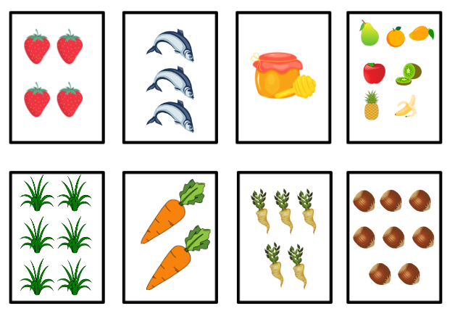
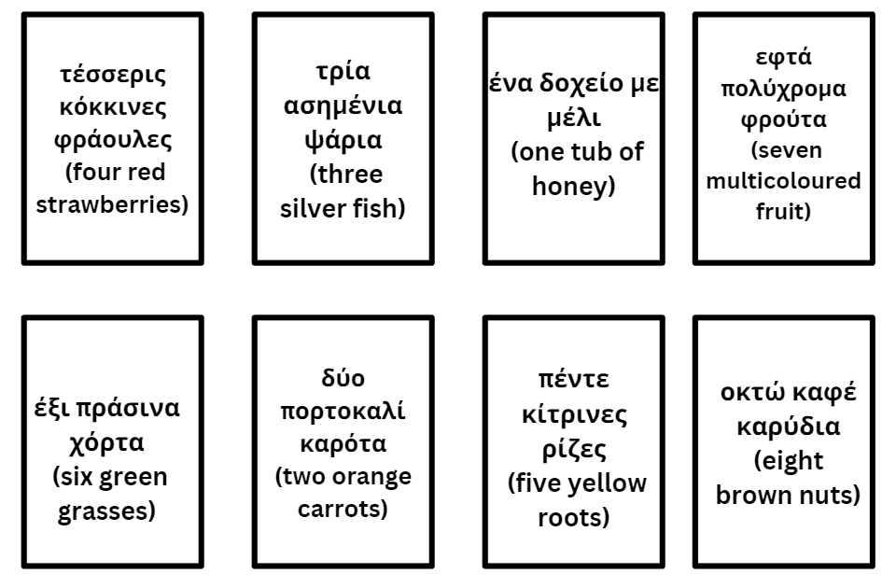

Resource 8: Nouns and adjectives
Singular | Plural
One gold jar of honey – Ένα χρυσό δοχείο μέλι | Many gold jars of honey – Πολλά χρυσά δοχεία μέλι
One orange carrot – Ένα πορτοκαλί καρότο | Two orange carrots – Δύο πορτοκαλί καρότα
One silver fish – Ένα ασημένιο ψάρι | Three silver fish – Τρία ασημένια ψάρια
One red strawberry – Μία κόκκινη φράουλα | Four red strawberries – Τέσσερις κόκκινες φράουλες

Resource 9: Greek foods
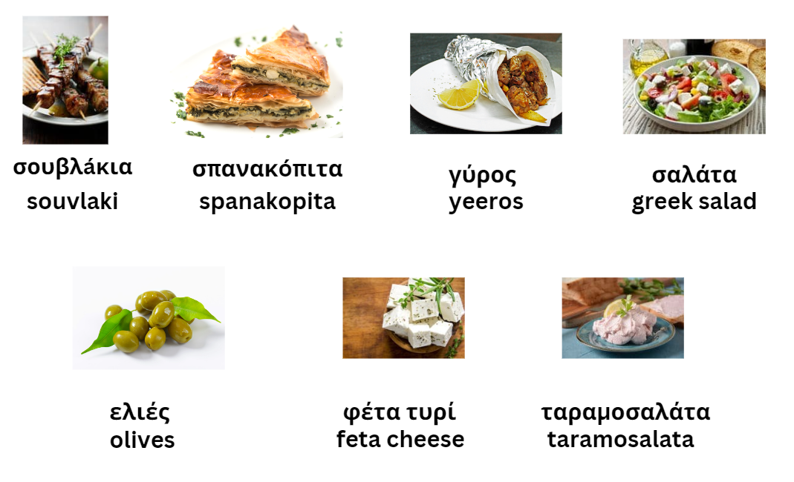

Resource 10: Peer feedback strategy – Two stars and a wish
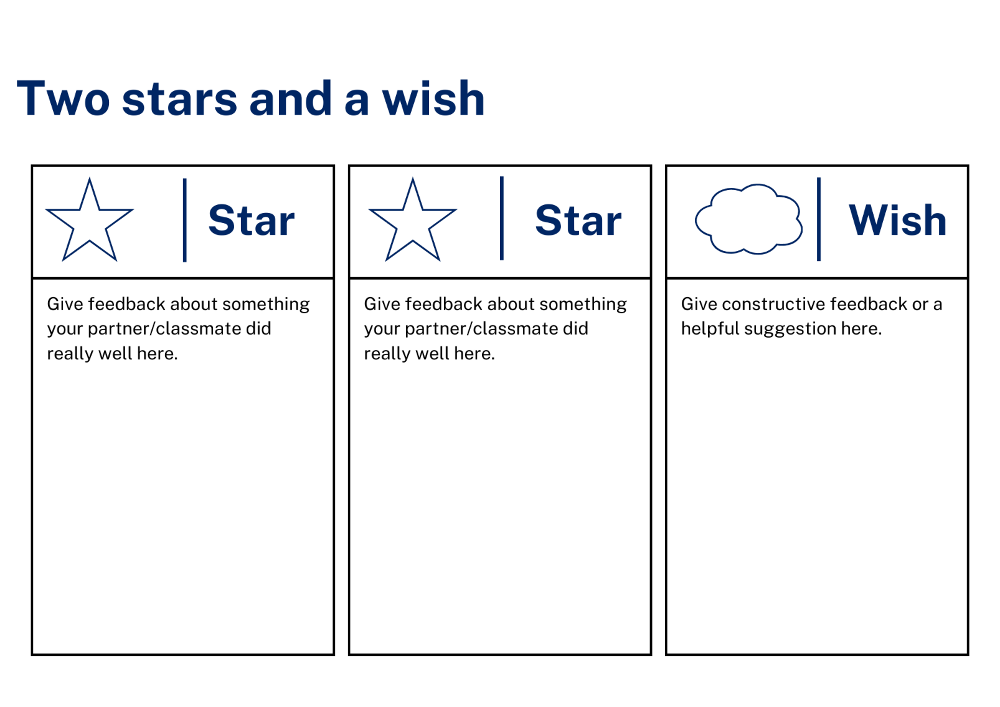

Resource 11: Visual rubric
Name: | The Sleepy Bear

I can write a simple sentence.
In my sentences I include adjectives and a noun.
I write Modern Greek nouns with the correct gender.
I can say and write the words for colours, numbers and foods in Modern Greek.

Support and alignment
Resource evaluation and support: all curriculum resources are prepared through a rigorous process. Resources are periodically reviewed as part of our ongoing evaluation plan to ensure currency, relevance, and effectiveness. For additional support or advice, contact the Primary Languages team by emailing primlang@det.nsw.edu.au.
Alignment to system priorities and/or needs: School Excellence Policy, School Success Model
Alignment to the School Excellence Framework: this resource supports the School Excellence Framework elements of curriculum (curriculum provision, teaching and learning programs) and effective classroom practice (lesson planning).
Alignment to Australian Professional Teaching Standards: this resource supports teachers to address Australian Professional Teaching Standards 2.2.2, 3.2.2.
Consulted with: Curriculum, Secondary Learners, school-based staff and NESA subject matter experts. Advice from Aboriginal Outcomes and Partnerships, EAL/D, HPGE and Inclusive Education for Modern Languages Stage 3 Italian Mangiare in Ristorante has been considered in preparing this document.
NSW syllabus: Modern Languages K–10 Syllabus
Syllabus outcomes: ML1-INT-01, ML1-UND-01, ML1-CRT-01
Author: Primary Curriculum
Publisher: State of NSW, Department of Education
Resource: Unit
Related resources: further resources to support Stage 1 Modern Languages can be found on the Languages K-6 curriculum page.
Professional learning: relevant professional learning is available through Primary Languages Networks on Teams (staff only).
Universal Design for Learning: support the diverse learning needs of students using inclusive teaching and learning strategies. Some students may require more specific adjustments to allow them to participate on the same basis as their peers. For further advice see Inclusive practice resources for primary school.
Differentiation: when using these resources in the classroom, it is important for teachers to consider the needs of all students in their class, including:
- Aboriginal and Torres Strait Islander students. Targeted strategies can be used to achieve outcomes for Aboriginal students in K-12 and increase knowledge and understanding of Aboriginal histories and cultures. Teachers should use students’ Personalised Learning Pathways to support individual student needs and goals.
- EAL/D learners. EAL/D learners may require scaffolding to support them to gain content knowledge, while providing extra time and assistance to master the English language required to engage with texts or complete classroom tasks. View some samples of differentiating through scaffolding.
- Students with additional learning needs. Learning adjustments enable students with disability and additional learning and support needs to access syllabus outcomes and content on the same basis as their peers. Teachers can use a range of adjustments to ensure a personalised approach to student learning.
- High potential and gifted learners. Assessing and identifying high potential and gifted learners will help teachers decide which students may benefit from extension and additional challenge. In addition, the Differentiation Adjustment Tool can be used to support the specific learning needs of high potential and gifted students.
Creation date: 28 March 2023
Rights: © State of New South Wales, Department of Education

References
This resource contains NSW Curriculum and syllabus content. The NSW Curriculum is developed by the NSW Education Standards Authority. This content is prepared by NESA for and on behalf of the Crown in right of the State of New South Wales. The material is protected by Crown copyright.
Please refer to the NESA Copyright Disclaimer for more information https://educationstandards.nsw.edu.au/wps/portal/nesa/mini-footer/copyright.
NESA holds the only official and up-to-date versions of the NSW Curriculum and syllabus documents. Please visit the NSW Education Standards Authority (NESA) website https://educationstandards.nsw.edu.au/ and the NSW Curriculum website https://curriculum.nsw.edu.au/home.
Modern Languages K–10 Syllabus © NSW Education Standards Authority (NESA) for and on behalf of the Crown in right of the State of New South Wales, 2022.
8 Ways (n.d.) 8 Aboriginal Ways of Learning [website], accessed 13 December 2022.
AITSL (Australian Institute for Teaching and School Leadership (2017) ‘Feedback Factsheet’, AITSL, accessed 7 August 2023.
Brookhart SM (2011) How to Assess Higher-Order Thinking Skills in Your Classroom, Hawker Brownlow Education, Victoria.
CESE (Centre for Education Statistics and Evaluation) (2020a) What works best: 2020 update, NSW Department of Education, accessed 7 August 2023.
CESE (Centre for Education Statistics and Evaluation) (2020b) What works best in practice, NSW Department of Education, accessed 7 August 2023.
Conti G (28 May 2017) ‘From Target Language to Model Language – the mind shift that has transformed my teaching’, The Language Gym, accessed 7 August 2023.
Conti G (28 September 2015) ‘16 tips for effective grammar teaching in the foreign language classroom’, The Language Gym, accessed 7 August 2023.
Harmer J (2014) The Practice of English Language Teaching, Pearson, United Kingdom, accessed 21 March 2023.
Henshaw FG and Hawkins MD (2022) Common Ground: Second Language Acquisition Theory Goes to the Classroom, Focus, Indianapolis, accessed 7 August 2023.
Jones J and Wiliam D (2014) Modern Foreign Languages Inside the Black Box: Assessment for Learning in the Modern Foreign Languages Classroom (Black P, Harrison C, Marshall B and Wiliam D, eds), Learning Sciences International, United States.
NESA (NSW Education Standards Authority) (2020) Nurturing Wonder and Igniting Passion, designs for a new school curriculum: NSW Curriculum Review [PDF 1.12 MB], NESA, accessed 7 August 2023.
NESA (NSW Education Standards Authority) (2022) ‘Proficient Teacher: Standard descriptors’, The Standards, NESA website, accessed 21 December 2022.
Smith S (2022) Becoming an Outstanding Languages Teacher, 2nd edn, Routledge, United Kingdom.
Wisniewski B, Zierer K and Hattie J (2020) ‘The Power of Feedback Revisited: A Meta-Analysis of Educational Feedback Research’, Frontiers In Psychology, 10(3087), doi:10.3389/fpsyg.2019.03087, accessed 7 August 2023.
Wiliam D (2017) Embedded Formative Assessment, 2nd ed, Solution Tree Press, Indiana.

© State of New South Wales (Department of Education), 2023
The copyright material published in this resource is subject to the Copyright Act 1968 (Cth) and is owned by the NSW Department of Education or, where indicated, by a party other than the NSW Department of Education (third-party material).
Copyright material available in this resource and owned by the NSW Department of Education is licensed under a Creative Commons Attribution 4.0 International (CC BY 4.0) licence.
This licence allows you to share and adapt the material for any purpose, even commercially. Attribution should be given to © State of New South Wales (Department of Education), 2023.
Material in this resource not available under a Creative Commons licence:
- the NSW Department of Education logo, other logos and trademark-protected material
- material owned by a third party that has been reproduced with permission. You will need to obtain permission from the third party to reuse its material.
Links to third-party material and websites
Please note that the provided (reading/viewing material/list/links/texts) are a suggestion only and implies no endorsement, by the New South Wales Department of Education, of any author, publisher, or book title. School principals and teachers are best placed to assess the suitability of resources that would complement the curriculum and reflect the needs and interests of their students.
If you use the links provided in this document to access a third-party's website, you acknowledge that the terms of use, including licence terms set out on the third-party's website apply to the use which may be made of the materials on that third-party website or where permitted by the Copyright Act 1968 (Cth). The department accepts no responsibility for content on third-party websites.

