[Language] Stage 1 – School canteen
Contents
Unit overview 3
Stage 1 outcomes and content to be addressed 4
Learning map 7
Assessment 9
Assessment opportunities 10
Teaching and learning activities 12
Week 1: Food 12
Week 2: Make a bilingual poster for the canteen 16
Week 3: Likes and dislikes 18
Week 4: Language games 21
Week 5: Assessment criteria and practice task 24
Week 6: Communicative task – Buy food from the canteen 28
Week 7: Feedback and goal setting 31
Week 8: Language review 33
Student resources 37
Resource 1: School canteen flashcards 37
Resource 2: Visual rubric – School canteen 38
Resource 3: Peer feedback strategy – Two stars and a wish 39
Resource 4: Stepping stones 40
Support and alignment 42
References 45

Unit overview
Stage: 1
Title: School canteen
Description: In this unit, students will make a bilingual poster about food available from the school canteen. They will discuss likes and dislikes before ordering food from the canteen in a role-play.
Duration: This lesson sequence is designed to be completed over approximately 8 weeks.
Student proficiency levels: It is assumed that most Stage 1 students have been learning the language since Kindergarten and their proficiency level will still be Beginner. This unit is aimed at beginner students. Every classroom will be different and teachers will need to adapt to their context. Many classes may include a combination of Beginner, Intermediate and Advanced students with varying skills and abilities within these proficiency levels. Assessment tasks and opportunities in this unit can be differentiated by using the ‘Too hard?’ and ‘Too easy?’ suggestions.

Stage 1 outcomes and content to be addressed
The table below outlines the focus area, outcomes and content points for Stage 1 students addressed in this unit.
Focus area and outcome | Content points
Interacting  A student:  - exchanges meaning by selecting culturally appropriate modelled language ML1-INT-01 | Exchanging meaning in oral interactions in the target language  - Exchange greetings, farewells and simple information to describe people or objects  - Express simple emotions and preferences  - Interact in classroom routines using familiar language  Reproducing oral language to interact in the target language  - Recognise and reproduce modelled sounds, including pronunciation and intonation patterns to interact  - Reproduce familiar vocabulary and short formulaic phrases to interact  Applying knowledge of the target language culture(s) to interact  - Use familiar verbal and nonverbal communication that is appropriate to cultural practices
Understanding texts  A student:  - recognises and responds to information in simple texts to demonstrate understanding ML1-UND-01 | Understanding and responding to target language texts  - Recognise information in simple texts and respond to simple questions in the target language and/or English to show understanding of texts  - Demonstrate understanding when responding to texts using actions, drawing, singing or simple exchanges in the target language and/or English  Applying knowledge of language systems to understand and respond to target language texts  - Recognise and use sounds of modelled vocabulary and phrases to understand and respond to texts  - Recognise sound–symbol correspondences in modelled words and phrases to understand and respond to texts  - Recognise and use knowledge of modelled vocabulary, high-frequency words and formulaic phrases on familiar themes to understand and respond to texts  - Use simple grammar patterns to understand and respond to texts  - Recognise and reproduce symbols or modelled vocabulary and phrases of the writing system to understand and respond to texts  Developing intercultural understanding through target language texts  - Notice that language is used in ways that reflect cultural practices and reflect on their own language and cultural practices
Creating texts  A student:  - creates simple texts by selecting culturally appropriate modelled language ML1-CRT-01 | Creating spoken, written and multimodal texts in the target language  - Create texts using familiar vocabulary, phrases and visuals to express meaning  - Label or describe objects and images  Applying knowledge of language systems to create texts in the target language  - Use pronunciation patterns to create spoken texts  - Use familiar sound–symbol correspondences to create written texts  - Use familiar vocabulary and formulaic phrases to create texts  - Use simple modelled sentence structures to create texts  - Reproduce modelled features of the target language writing system to create written texts  Reproducing how target language speakers communicate to create texts  - Reproduce language appropriate to cultural practices to create texts
Modern Languages K–10 Syllabus © NSW Education Standards Authority (NESA) for and on behalf of the Crown in right of the State of New South Wales, 2022.

Learning map
The creation of maps for learning is a planning process that incorporates Aboriginal intellectual tradition. Learning maps are a visual pathway of what students will learn.
Share the learning map with your students, briefly explaining the learning that will happen in each lesson. Provide students with a copy of the learning map or display the learning map in the classroom. This learning map can be adapted to [Language] by accessing a copy of Learning map – School canteen (Stage 1).
Figure 1 – School canteen learning map
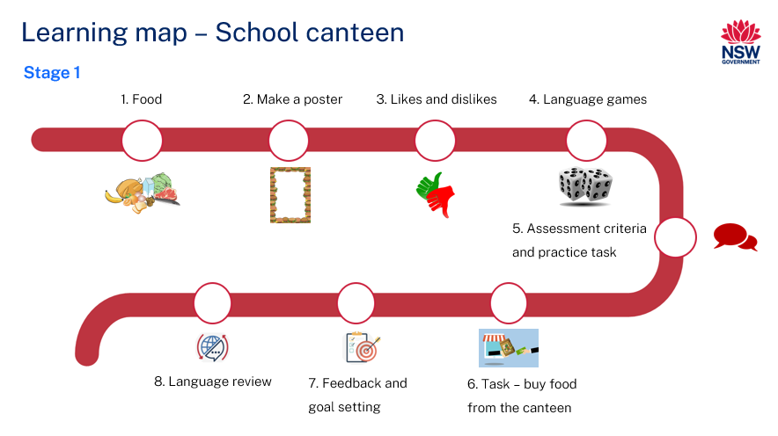

Assessment
Stage 1 communicative task: You would like to get something for lunch from the canteen menu. Tell the [Nationality] parent at the canteen some things you like and some things you don’t like before deciding on what to buy.
Too hard?
Tell the [Nationality] parent at the canteen some things you like before deciding on something to buy.
Too easy?
You and a friend would like to get lunch from the menu. Discuss the options on the menu with your friend. Then order the food for you and your friend from the [Nationality] parent at the canteen.
Context: choosing food from the canteen menu
Audience: [Nationality] parent helper
Purpose: to decide what to buy

Assessment opportunities
The table below details assessment opportunities and differentiation ideas.
Assessment opportunities | Too hard? | Too easy?
Week 1: Introduce food vocabulary  Pre-assessment of vocabulary knowledge. | If most of the students know only a few of the words, reduce the number and complexity of the words and phrases taught. | If most of the students know all of the words, introduce more complex vocabulary.
Week 2: Create bilingual poster  Create a poster with images of the food on the canteen menu and the names of the food written in English and [Language]. | Each student contributes one image with its accompanying language to a group poster. | Additional information such as prices and ingredients can be included in the poster.
Week 3: Pre-assessment of new language  Pre-assessment: Students accurately use the phrases ‘I like’ and ‘I don’t like’. | If most students are unable to accurately use the phrases ‘I like’ and ‘I don’t like’, simplify the task to focus on ‘I like’ only. | If most of the class is already able to use both phrases, teach synonyms such as ‘enjoy’ and ‘love’, and adverbs, such as ‘really’.
Week 4: Jumbled sentences  Students put the sentences together with the correct word order. | Students put simple sentences together, for example, ‘I like...’ or ‘I don’t like...’ | Students put sentences together for a conversation where they buy something for themselves and a friend.

Teaching and learning activities

Week 1: Food
The table below outlines the learning intention and success criteria of the lesson, and materials that the teacher and students will need to complete the teaching and learning activities.
Learning intention and success criteria | Materials
Students will use known and new language in a variety of interactive activities.  Students can:  - tell a partner words they already know in [Language]  - say and write words in [Language]. | - Resource 1: School canteen flash cards  - Writing and drawing materials  - Language exercise books  - Intentional observation checklist

Activity 1: Learning map
Explain and display the Learning map to give students a more detailed breakdown of lessons during the unit. Point out that the learning map is a plan that may need to change.
Note: the task may need to be adapted if there is no canteen to meet the context of the school. You may need to explain the concept of a school canteen to some students.

Activity 2: Introduce food vocabulary
- Introduce vocabulary related to food that can be bought from school canteens.
Suggested vocabulary includes: apple, banana, orange, sandwich, sushi, pasta, rice, lollies, cake, ice cream, food from [Culture].
- Display images of food that can be bought from the canteen on one side of the board, such as those on Resource 1: School canteen flashcards. Children call out the names of the food in English as they are placed on the board.
- On the other side of the board, put the written [Language] words for the food one at a time in a random order. Model the pronunciation of each food and have students imitate the pronunciation.
- Pre-assessment: Students look at the pictures of food and cards with [Language] words for food. Ask students to identify how many they think they know by answering the following questions, showing thumbs up at their chests:
- Do you know all of the words?
- Do you know most of them?
- Do you know some of them?
- Do you know none of them?
- Students Think-Pair-Share and tell their partners the words they know and report back to class.
- Whole class activity: Ask children to match words to their corresponding picture one at a time. After each match, model and drill the correct pronunciation of vocabulary.
Note: adapt Resource 1: School canteen flashcards for your language and how you are teaching this unit. Print the cards so that they can be displayed on the board.

Activity 3: Bingo!
- Play a communicative language learning game such as ‘Bingo!’ to practice using food vocabulary.
- Have each student create a bingo card by choosing approximately 6 types of food. Students draw or include an image of the food with the [Language] word for the food.
- Lead a whole class game to demonstrate the activity before students split into groups.
- All students take turns at being the bingo caller, drawing the language words from a hat or bowl. Students read the words aloud to their group of 5 or 6 students. Some students may need teacher assistance with pronunciation.
- The students playing the game listen to the words being called. If the word called is on their bingo card, they cover or mark the word. The winner of each round is the student who marks or covers all their words and pictures first.

Activity 4: Hotseat
- If time permits, play a different communicative language learning game such as ‘Hotseat’ to practice using food vocabulary.
- Divide the class into 2 teams. One player per team has their back to the board. Write a word related to food in [Language] on the board.
- Students give clues to their teammate without saying the word, for example, ‘It is a long, yellow fruit’. The first student on the chairs to say the word for ‘banana’ in [Language] earns a point for their team. Intermediate or advanced students can give clues in [Language].
- After each round, model and drill correct pronunciation of vocabulary, displaying the words on the board or wall.
Evaluation: students demonstrate sound knowledge of the vocabulary needed to participate in the games.

Activity 5: Recording new language
Students record food vocabulary in their language exercise books.

Week 2: Make a bilingual poster for the canteen
The table below outlines the learning intention and success criteria of the lesson, and materials that the teacher and students will need to complete the teaching and learning activities.
Learning intention and success criteria | Materials
Students will make and present a bilingual poster for the canteen.  Students can:  - make a poster with images in [Language] and in English  - spell words correctly  - say the [Language] words correctly when presenting the poster. | - Language exercise books  - Materials to create a poster

Activity 1: Setting the scene – Why does the canteen need a bilingual poster?
Tell students they will create a poster with images of the food for sale at the school canteen with the words written in English and [Language].
Explain the need for this poster, being [Nationality] students at your school find it difficult to understand the canteen menu. This may or may not be a real situation at your school. If it is not a real situation, have the class pretend that this is the case. The audience of the poster will be students at your school. The communicative purpose for making the poster is to help [Nationality] students understand the menu.

Activity 2: Create bilingual poster
Students plan and start creating a bilingual poster with images of the food on sale at the school canteen. Images can be drawn or cut and pasted from other resources.
Ask students to choose the food they wish to include in the poster and to ensure they write the words correctly in [Language] and in English by referring to the images still displayed on the wall.
Evaluation: students complete their posters with images labelled accurately.

Activity 3: Share poster
Students present their posters in English to a group of classmates, with food vocabulary in [Language].
Evaluation: students use appropriate pronunciation, grammar and vocabulary when presenting their poster.

Week 3: Likes and dislikes
The table below outlines the learning intention and success criteria of the lesson, and materials that the teacher and students will need to complete the teaching and learning activities.
Learning intention and success criteria | Materials
Students express likes and dislikes.  Students can:  - say and write sentences with ‘I like’ and ‘I don’t like’ in [Language]. | - Resource 1: School canteen flash cards  - Language exercise books

Activity 1: Pre-assessment of new language
To pre-assess student knowledge of the language required to complete the task, elicit the phrases ‘I like’ and ‘I don’t like’. One way this can be done is to show an image of a type of food, for example, ‘banana’, and use gesture or facial expressions to indicate if you like or dislike the food. Asks students what they should say in [Language]. Students quietly speak to their partner and, if they are familiar with this structure, say ‘I like banana’ or ‘I don’t like banana’ in [Language].

Activity 2: Communicative card game to practise new language
Note: adapt Resource 1: School canteen flash cards to make a card game in your language.
- In small groups, students take turns at turning over 2 physical or digital cards with pictures of food.
- When a student turns over the first card, they say ‘I like (food)’.
- With the second card, the student says ‘I don’t like (food)’.
- If a student turns over 2 cards with the same picture, they say ‘I really like (food)’ and keep the cards.
- The winner is the player with the most cards at the end of the game.
Evaluation: students accurately use the phrases ‘I like’ and ‘I don’t like’.

Activity 3: Communicative game to practise new language
- Demonstrate a game to the class, in which students list food they like and don’t like.
- To begin the game, say for example, ‘I like bananas’.
- The first student says ‘I like bananas and ice cream’.
- The next student says ‘I like bananas, ice cream and pasta’, and so on until the list gets to approximately 6 items.
- Repeat the process, this time starting the sentences with ‘I don’t like…’.
- Students can refer to the words and images on the Resource 1: School canteen flashcards displayed on the wall, if necessary.
- Students play both versions of the game a few times in groups of approximately 6 students.
Evaluation: students use appropriate pronunciation, grammar and vocabulary.

Activity 4: Recording new language
Students record the phrases ‘I like...’ and ‘I don’t like...’ in their language exercise books or preferred means of recording.
Evaluation: students accurately record language.

Week 4: Language games
The table below outlines the learning intention and success criteria of the lesson, and materials that the teacher and students will need to complete the teaching and learning activities.
Learning intention and success criteria | Materials
Students will use language required for the task in communicative activities.  Students can:  - say ‘I like’ and ‘I don’t like’ in unplanned sentences. | - Language exercise books  - Intentional observation checklist  - Cards with jumbled-up sentences  - Bean bag

Activity 1: Communicative game to practise likes and dislikes
Students form one or 2 circles, depending on numbers. Begin by saying ‘I like (food)’ and gently toss a bean bag to a student in the circle. The student with the bean bag says ‘I like (different food)’ before gently tossing the bean bag to a classmate. When everyone has said a food they like, the process is repeated with students saying ‘I don’t like (food)’.

Activity 2: Modelling and drilling likes and dislikes
- Model ‘I like ice cream, but I don’t like cake’ by repeating the sentence several times. Then drill the phrase, as a whole and in chunks, by asking students to repeat as a class and in smaller groups, for example, ‘boys’, or ‘this table’.
- After drilling the example sentence as a whole and in chunks, say only ‘bananas’ and ‘apples’ using gestures such as thumbs up and down to indicate likes and dislikes. Students say, ‘I like bananas, but I don’t like apples.’ If necessary, explain these expectations to students in English. Then say ‘cake’ and ‘ice cream’, again using gestures such as thumbs up and down to indicate likes and dislikes.
- In small groups or pairs, students say types of food with thumbs up and down to prompt classmates to say, ‘I like…, but I don’t like…’.
Evaluation: students use a range of vocabulary in the small group activity.

Activity 3: Additional language required to complete task
- Model the phrases ‘Can I please have...?’ and ‘You can have…or...’ by repeating the phrases several times.
- Drill the phrases, as a whole and in chunks, by asking students to repeat as a class and in smaller groups.
- Display the phrases in the classroom and have students record the phrases.
- Students practise using the phrases in conversation with a partner.

Activity 4: Jumbled sentences
- Write each of the words in the following sentences on cards:
- I like (apples), but I don’t like (bananas)…
- How can I help you?
- Can I have some (pasta) please?
- Include cards with the food vocabulary introduced in Week 1.
- Using one example, mix the words up on the board and put the sentence back together as a class.
- Students put the other sentences together in pairs or small groups.
- Students record their own sentence(s) and share with a classmate.
Evaluation: students put the sentences together with the correct word order.

Activity 5: Exit ticket
Stick images of the food near the door. To assess student understanding of likes and dislikes and their ability to use [Language] in unplanned situations, tell students they must tap one picture of a food and say ‘I like (food)’ or ‘I don’t like (food)’ as they leave. Make notes in the Intentional observation checklist.
Evaluation: students can use ‘I like’ and ‘I don’t like’ in unplanned sentences.

Week 5: Assessment criteria and practice task
The table below outlines the learning intention and success criteria of the lesson, and materials that the teacher and students will need to complete the teaching and learning activities.
Learning intention and success criteria | Materials
Students will develop a clear understanding of the requirements of the assessment task, prepare for and practise the task.  Students can:  - say what they need to do to be successful in the task. | - Resource 3: Peer feedback strategy – Two stars and a wish

Activity 1: How can I help you?
Split the class in half. One half will ask questions and the other will answer. The first person to ask 4 people ‘How can I help you?’ and listen carefully to the answer, ‘Can I have some (food) please?’ will be the winner. Students will then swap roles.

Activity 2: Introduce the assessment task
Explain the following task to the class:
- You would like to buy something from the canteen but aren’t sure what to get.
- After greeting the [Nationality] parent at the canteen, tell them something you like and something you don’t like. The [Nationality] parent will refer to the bilingual menu poster to make some suggestions before you decide what to buy. Tell the parent what you would like to buy. Say thank you and goodbye.
- Point out that:
- the context of the task is that you would like to buy something but aren’t sure what to get
- the audience of the communication will be the [Nationality] parent at the canteen
- the communicative purpose or reason is to get some food.

Activity 3: Success criteria
After looking at the assessment task, students Think-Pair-Share and suggest appropriate success criteria. See below for an example.
I will be successful if I can:
- tell the [Nationality] parent a type of food I like and a type of food I don’t like
- use phrases such as ‘I like …, but I don’t like…’, ‘you can have…or…’ and ‘can I please have...?’ correctly
- say the words correctly
- speak in a well-paced manner without long pauses
- use greetings to start and end the conversation.

Activity 4: Peer assessment
Note: this may be the first time students are engaging in peer assessment. As a result, teachers may need to provide further explanations on why this is important and what students should and should not do while giving and receiving peer assessment.
Peer feedback will be provided after completing the task in Week 6. Confirm which peer feedback strategy will be used, for example, Two stars and a wish (Resource 3).
Students give examples of what stars and wishes would sound like for this task.
Evaluation: students Think-Pair-Share examples of appropriate peer feedback.

Activity 5: Task groups
Students will use the same groups for the practice task and the actual task.
Organise students into groups of 3 and give them a few minutes to ensure everybody knows the order in which they will perform each role. ‘You’ is the student who is completing the assessed communicative task.

Suggested rotations:
- Role-play 1: Student 1 – ‘You’, Student 2 – Peer assessor/Camera operator, Student 3 – Parent helper
- Role-play 2: Student 1 – Parent helper, Student 2 – ‘You’, Student 3 – Peer assessor/Camera operator
- Role-play 3: Student 1 – Peer assessor/Camera operator, Student 2 – Parent helper, Student 3 – ‘You’

Activity 6: Practice task
Choose one or 2 students to model the example interaction with.
Groups practise the task, with each student getting a chance to play each role. Encourage students to use as many different types of food as they can in the practice conversation.
Example interaction:
- Parent helper: Hello, how can I help you?
- You: (thinking aloud) I like sushi, but I don’t like pasta.
- You: (to parent) Can I have some sushi please?
- Parent helper: Sure, here you are.
- You: Thank you, bye!

Week 6: Communicative task – Buy food from the canteen
The table below outlines the learning intention and success criteria of the lesson, and materials that the teacher and students will need to complete the teaching and learning activities.
Learning intention and success criteria | Materials
Students will participate in a role-play at a school canteen and order food from a menu.  Students can:  - tell the [Nationality] parent a type of food they like and a type of food they don’t like  - use phrases such as ‘I like …, but I don’t like…’, ‘You can have…or…’ and ‘Can I please have...?’ correctly  - say the words correctly  - speak in a well-paced manner without long pauses  - use greetings to start and end the conversation. | - Resource 3: Peer feedback strategy – Two stars and a wish  - Recording device  - Tripod and microphones (if possible)

Note: if there is a [Nationality] parent helper at your school’s canteen, ask them to play the role. By asking the parent to serve your students at the canteen, this task will be a genuinely authentic communicative task.
If this is the case, tasks will need to be completed one at a time.
This unit will assume that the communicative task will be a simulated conversation with a student playing the role of parent helper.

Activity 1: Task set-up
Students get into the groups decided in the previous lesson. Groups are given a few minutes to ensure everybody knows the order in which they will perform each role. ‘You’ is the student who will be completing the assessed communicative task.
Suggested rotations:
- Role-play 1: Student 1 – ‘You’, Student 2 – Peer assessor/Camera operator, Student 3 – Parent helper
- Role-play 2: Student 1 – Parent helper, Student 2 – ‘You’, Student 3 – Peer assessor/Camera operator
- Role-play 3: Student 1 – Peer assessor/Camera operator, Student 2 – Parent helper, Student 3 – ‘You’

Activity 2: Communicative task – Buy something from the school canteen
Students get into groups of 3 and complete the task.
Note: make sure to space students apart when filming. Demonstrate how to film using recording device. Use microphones, if possible, to maximise sound quality. Highlight the importance of holding the recording device still by using a tripod or resting it on a table.
Example interaction:
- Parent helper: Hello, how can I help you?
- You: (thinking aloud) I like sushi, but I don’t like pasta.
- You: (to parent) Can I have some sushi please?
- Parent helper: Sure, here you are.
- You: Thank you, bye!
Note: before recording interactions, check if any students do not have permission to be filmed. Alternatives to video recording include audio recording or the teacher watching the interactions while taking notes and marking the rubric.

Activity 3: Peer feedback
Each student will provide and receive feedback to the student who was ‘you’ when they had the role of peer assessor/camera operator. Peer feedback is provided verbally and may be followed up with a completed peer feedback slip.

Week 7: Feedback and goal setting
Note: if there is insufficient time to mark the videos before Week 8, Weeks 7 and 8 can be swapped.
The table below outlines the learning intention and success criteria of the lesson, and materials that the teacher and students will need to complete the teaching and learning activities.
Learning intention and success criteria | Materials
Students will reflect on feedback to set suitable learning goals.  Students can:  - understand the feedback received  - reflect on the feedback provided to establish new learning goals. | - Resource 2: Visual rubric – School canteen  - Recording device  - Teacher marked rubric (one per student)  - Language exercise books
Note: prior to this lesson, the teacher views each video and marks each student according to the criteria on Resource 2: Visual rubric – School canteen.

Activity 1: Self-assessment
Students watch the video of themselves completing the task and mark themselves using Resource 2: Visual rubric – School canteen. Students then compare both the teacher completed rubric and the one they completed.

Activity 2: Set learning goals
To foster student ownership of their learning, facilitate a class discussion to help students reflect on their marked rubric, peer- and self-assessment, and set their own personalised learning goals for the next phase. Use simplified language to ensure that the students can understand and engage with the discussion effectively.
Suggest learning goals, such as:
- I will be confident when saying words in [Language]
- I will try to say [Language] words in the correct order
- I will practise saying tricky sounds in [Language], for example…
Present suggestions like the above and others appropriate to the context of your class. Encourage students to raise their hands when they hear a goal that resonates with them. By doing so, students will understand their options and select a learning goal that is most relevant and suitable for their needs. Students record their learning goals.
Evaluation: students set appropriate learning goals based on previous learning goals and teacher, peer- and self-assessment.

Week 8: Language review
Note: if there is insufficient time to mark the videos before Week 8, Weeks 7 and 8 can be swapped.
The table below outlines the learning intention and success criteria of the lesson, and materials that the teacher and students will need to complete the teaching and learning activities.
Learning intention and success criteria | Materials
Students will reflect on and ask questions about the language taught in this unit.  Students can:  - ask questions about vocabulary, grammar, or pronunciation they have used in this unit  - use [Language] they have learned to communicate with classmates. | - Resource 4: Stepping stones  - Mini whiteboards  - Markers
Note: over the course of the unit, gaps in student knowledge, misconceptions and misuse of language will have been identified. These observations are addressed using engaging and interactive activities and strategies.

Activity 1: Student questions
Remind students of the activities and tasks they have completed over the course of the unit. Give students time to Think-Pair-Share any questions they may have about any aspect of the language taught.

Activity 2: Language review – Food
- Play an engaging communicative language game such as a drawing game. Model how to play the game by drawing a word on the board and asking students to guess what it is.
- Play as a whole class with 2 teams using the whiteboard, or in smaller groups using mini whiteboards.
Note: point out game-playing strategies, such as taking time to draw the picture so that teammates can work out what you’re trying to draw. Explain that students should also avoid spending too much time on drawing their picture as the first person to guess is the winner.
- One student per team is nominated as a ‘drawer’ and is given a word or image of food vocabulary taught during the unit. As the student draws images of the food type, their teammate(s) work out what is being drawn. The first team with a non-drawing member to say the word or phrase correctly will win a point.
- After each round or at the end of the game, drill the vocabulary again with the students.

Activity 3: Language review – Likes and dislikes ‘stepping stones’
Students use Resource 4: Stepping stones to create 5 sentences. Students read their sentences to a partner before recording their sentences.
Example sentences include:
- I like apples.
- I don’t like sushi and bananas.
- You like ice-cream
Figure 2 – Stepping stones I
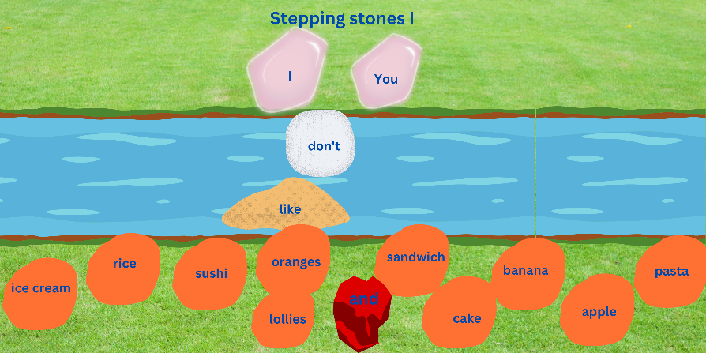
Images sourced from Canva and used in accordance with the Canva Content License Agreement.
Students who completed the ‘Too easy’ task create and record sentences using ‘Stepping stones II’.
Figure 3 – Stepping stones II
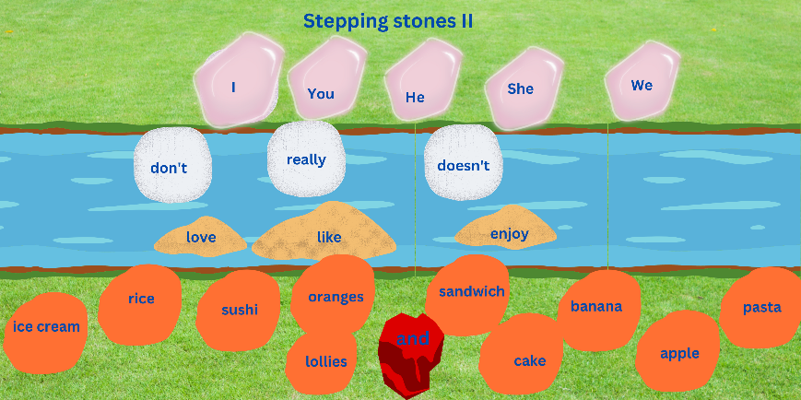
Images sourced from Canva and used in accordance with the Canva Content License Agreement.
Note: adapt Resource 4: Stepping stones to your language.

Student resources

Resource 1: School canteen flashcards
This resource can be adapted by replacing the text to suit your [Language].
 |  |  |  |  |  | 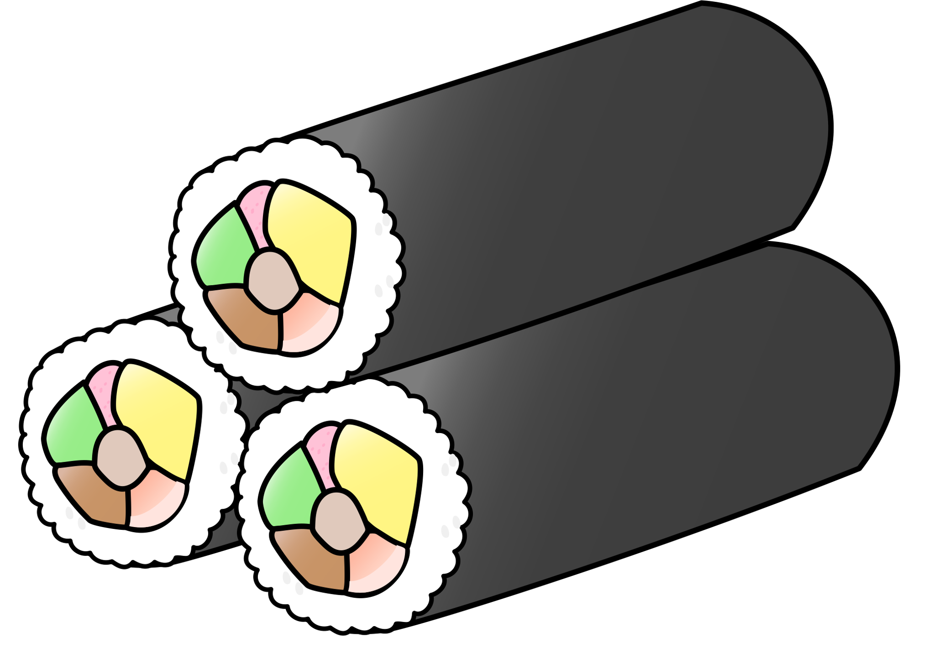
banana |  | orange |  | apple |  | sushi |  | sandwich
pasta |  | rice |  | cake |  | lollies |  | ice cream
Images sourced from Canva and used in accordance with the Canva Content License Agreement.

Resource 2: Visual rubric – School canteen
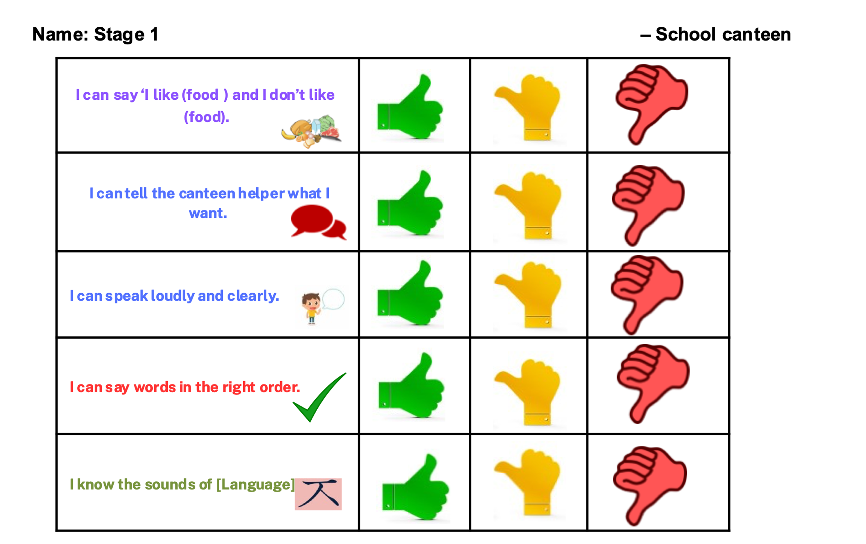
Images sourced from Canva and used in accordance with the Canva Content License Agreement.

Resource 3: Peer feedback strategy – Two stars and a wish
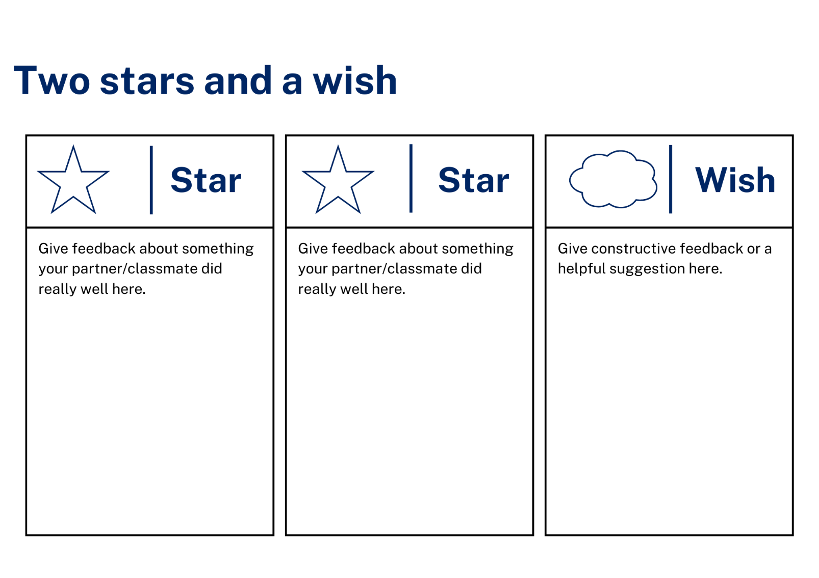

Resource 4: Stepping stones
This resource can be adapted to [Language] by accessing a copy of Stepping stones.
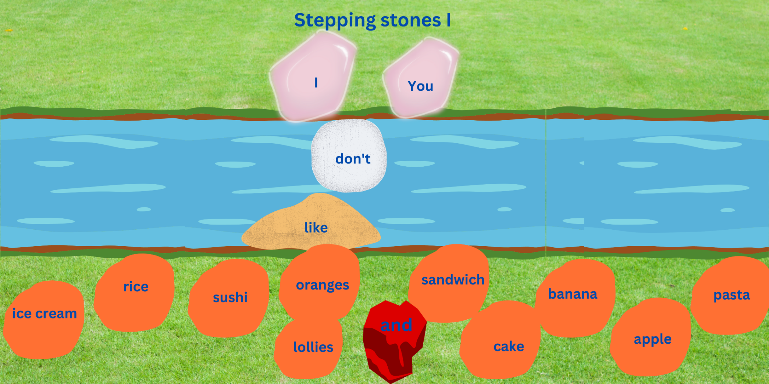
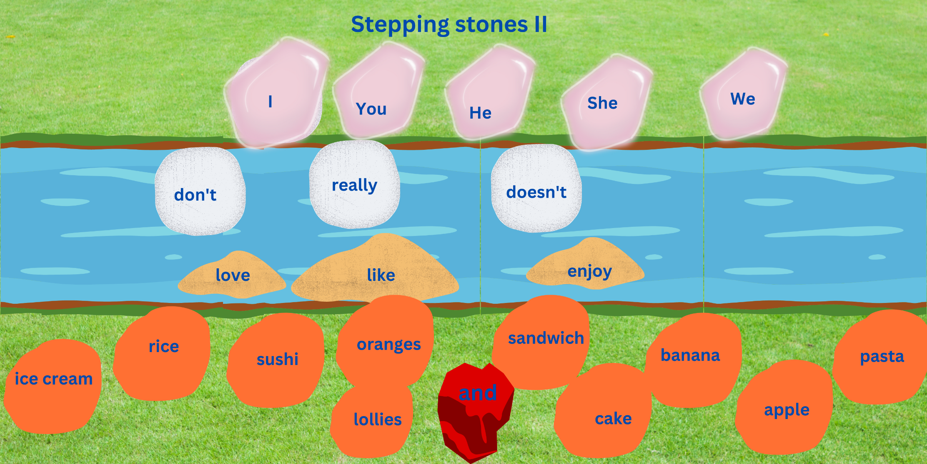
Images sourced from Canva and used in accordance with the Canva Content License Agreement.

Support and alignment
Resource evaluation and support: all curriculum resources are prepared through a rigorous process. Resources are periodically reviewed as part of our ongoing evaluation plan to ensure currency, relevance, and effectiveness. For additional support or advice, contact the Primary Languages team by emailing primlang@det.nsw.edu.au.
Alignment to system priorities and/or needs: School Excellence Policy, School Success Model
Alignment to the School Excellence Framework: this resource supports the School Excellence Framework elements of curriculum (curriculum provision, teaching and learning programs) and effective classroom practice (lesson planning).
Alignment to Australian Professional Teaching Standards: this resource supports teachers to address Australian Professional Teaching Standards 2.2.2, 3.2.2.
Consulted with: Curriculum, Secondary Learners, school-based staff and NESA subject matter experts. Advice from Aboriginal Outcomes and Partnerships, EAL/D, HPGE and Inclusive Education for Modern Languages Stage 3 Italian Mangiare in Ristorante has been considered in preparing this document.
NSW syllabus: Modern Languages K–10 Syllabus
Syllabus outcomes: ML1-INT-01, ML1-UND-01, ML1-CRT-01
Author: Primary Curriculum
Publisher: State of NSW, Department of Education
Resource: Unit
Related resources: further resources to support Stage 1 Modern Languages can be found on the Languages K-6 curriculum page.
Professional learning: relevant professional learning is available through Primary Languages Networks on Teams (staff only).
Universal Design for Learning: support the diverse learning needs of students using inclusive teaching and learning strategies. Some students may require more specific adjustments to allow them to participate on the same basis as their peers. For further advice see Inclusive practice resources for primary school.
Differentiation: when using these resources in the classroom, it is important for teachers to consider the needs of all students in their class, including:
- Aboriginal and Torres Strait Islander students. Targeted strategies can be used to achieve outcomes for Aboriginal students in K-12 and increase knowledge and understanding of Aboriginal histories and cultures. Teachers should use students’ Personalised Learning Pathways to support individual student needs and goals.
- EAL/D learners. EAL/D learners may require scaffolding to support them to gain content knowledge, while providing extra time and assistance to master the English language required to engage with texts or complete classroom tasks. View some samples of differentiating through scaffolding.
- Students with additional learning needs. Learning adjustments enable students with disability and additional learning and support needs to access syllabus outcomes and content on the same basis as their peers. Teachers can use a range of adjustments to ensure a personalised approach to student learning.
- High potential and gifted learners. Assessing and identifying high potential and gifted learners will help teachers decide which students may benefit from extension and additional challenge. In addition, the Differentiation Adjustment Tool can be used to support the specific learning needs of high potential and gifted students.
Creation date: 28 March 2023
Rights: © State of New South Wales, Department of Education

References
This document contains NSW Curriculum and syllabus content. The NSW Curriculum is developed by the NSW Education Standards Authority. This content is prepared by NESA for and on behalf of the Crown in right of the State of New South Wales. The material is protected by Crown copyright.
Please refer to the NESA Copyright Disclaimer for more information. https://educationstandards.nsw.edu.au/wps/portal/nesa/mini-footer/copyright
NESA holds the only official and up-to-date versions of the NSW Curriculum and syllabus documents. Please visit the NSW Education Standards Authority (NESA) website https://educationstandards.nsw.edu.au/ and the NSW Curriculum website https://curriculum.nsw.edu.au/home.
Modern Languages K–10 Syllabus © NSW Education Standards Authority (NESA) for and on behalf of the Crown in right of the State of New South Wales, 2022.
8 Ways (n.d.) 8 Aboriginal Ways of Learning [website], accessed 13 December 2022.
AITSL (Australian Institute for Teaching and School Leadership) (n.d) ‘Feedback Factsheet’, AITSL, accessed 21 March 2023.
Brookhart SM (2011) How to Assess Higher-Order Thinking Skills in Your Classroom, Hawker Brownlow Education, Victoria.
CESE (Centre for Education Statistics and Evaluation) (2020a) What works best: 2020 update, NSW Department of Education, accessed 10 March 2023.
CESE (Centre for Education Statistics and Evaluation) (2020b) What works best in practice, NSW Department of Education, accessed 10 March 2023.
Conti G (28 September 2015) ‘16 tips for effective grammar teaching in the foreign language classroom’, The Language Gym, accessed 21 March 2023.
Conti G (28 May 2017) From Target Language to Model Language – the mind shift that has transformed my teaching, The Language Gym, accessed 20 March 2023.
Harmer J (2014) The Practice of English Language Teaching, 5th edn, Pearson Education, United Kingdom, accessed 21 March 2023
Henshaw FG and Hawkins MD (2022) Common Ground: Second Language Acquisition Theory Goes to the Classroom, Focus, Indianapolis, accessed 14 March 2023.
Jones J and Wiliam D (2014) Modern Foreign Languages Inside the Black Box: Assessment for Learning in the Modern Foreign Languages Classroom (Black P, Harrison C, Marshall B and Wiliam D, eds), Learning Sciences International, United States, accessed 14 March 2023
NESA (NSW Education Standards Authority) (2022) ‘Proficient Teacher: Standard descriptors’, The Standards, NESA website, accessed 21 December 2022.
Smith S (2022) Becoming an Outstanding Languages Teacher, 2nd edn, Routledge, United Kingdom.
Wiliam D and Leahy S (2015) Embedding Formative Assessment: Practical Techniques for K–12 Classrooms, Learning Sciences International, United States, accessed 14 March 2023.

© State of New South Wales (Department of Education), 2023
The copyright material published in this resource is subject to the Copyright Act 1968 (Cth) and is owned by the NSW Department of Education or, where indicated, by a party other than the NSW Department of Education (third-party material).
Copyright material available in this resource and owned by the NSW Department of Education is licensed under a Creative Commons Attribution 4.0 International (CC BY 4.0) licence.
This licence allows you to share and adapt the material for any purpose, even commercially. Attribution should be given to © State of New South Wales (Department of Education), 2023.
Material in this resource not available under a Creative Commons licence:
- the NSW Department of Education logo, other logos and trademark-protected material
- material owned by a third party that has been reproduced with permission. You will need to obtain permission from the third party to reuse its material.
Links to third-party material and websites
Please note that the provided (reading/viewing material/list/links/texts) are a suggestion only and implies no endorsement, by the New South Wales Department of Education, of any author, publisher, or book title. School principals and teachers are best placed to assess the suitability of resources that would complement the curriculum and reflect the needs and interests of their students.
If you use the links provided in this document to access a third-party's website, you acknowledge that the terms of use, including licence terms set out on the third-party's website apply to the use which may be made of the materials on that third-party website or where permitted by the Copyright Act 1968 (Cth). The department accepts no responsibility for content on third-party websites.

