Modern Greek Stage 2
Στη λαϊκή αγορά (At the markets)
Contents
Unit overview 6
Stage 2 outcomes and content to be addressed 7
Learning map 11
Assessment 14
Assessment opportunities 15
Teaching and learning activities 17
Week 1 – fruit 17
Vocabulary 1 – fruit 18
Activity 1 – Learning map 19
Activity 2 – fruit – pre-assessment of vocabulary 19
Activity 3 – concentration game 20
Activity 4 – singular and plural 20
Activity 5 – creating a mind map 21
Week 2 – vegetables 23
Vocabulary 2 – vegetables 24
Vocabulary 3 – shopping phrases 25
Vocabulary 4 – numbers 1–5 25
Activity 1 – pre-assessment 26
Activity 2 – Bingo! 27
Activity 3 – going to the market song 27
Activity 4 – buying fruit and vegetables at the market 28
Week 3 – numbers and weight 31
Vocabulary 5 – numbers 6–20 32
Vocabulary 6 – numbers 10–100 33
Activity 1 – pre-assessment – ‘Buzz off’ 34
Activity 2 – counting game 35
Activity 3 – dice game – recording numbers in Modern Greek 36
Activity 4 – weighing in kilos 37
Week 4 – the euro 38
Vocabulary 7 – currency 38
Activity 1 – buying fruit and vegetables 39
Activity 2 – Greek currency – euro 40
Activity 3 – Battleship 41
Activity 4 – recording sentences 42
Week 5 – assessment criteria and practice task 43
Activity 1 – assessment task 43
Activity 2 – success criteria 43
Activity 3 – discuss the rubric 44
Activity 4 – peer assessment 45
Activity 5 – practice task 45
Week 6 – communicative task – buy fruit and vegetables at the market 46
Activity 1 – going to the market song 47
Activity 2 – task set-up 47
Activity 3 – communicative task – buy fruit and vegetables at the market 47
Activity 4 – peer assessment 49
Week 7 – feedback and goal setting 50
Activity 1 – draw and guess 51
Activity 2 – self-assessment 51
Activity 3 – set learning goals 51
Week 8 – language review 52
Activity 1 – student questions 53
Activity 2 – language review 53
Activity 3 – grammar review 54
Student resources 55
Resource 1 – fruit flashcards 55
Resource 2 – plurals 61
Resource 3 – fruit help sheet 62
Resource 4 – vegetables help sheet 65
Resource 5 – vegetables flashcards 67
Resource 6 – vegetable names flashcards 71
Resource 7 – market song lyrics 73
Resource 8 – cloze passage song 74
Resource 9 – market shopping phrases 75
Resource 10 – number chart 76
Resource 11 – euro worksheet 77
Resource 12 – Battleship shopping game 78
Resource 13 – assessment task – At the markets 79
Outcomes 79
Task 79
Learning intention 80
Success criteria 80
Resource 14 – rubric – At the markets 82
Resource 15 – peer feedback strategy – Two stars and a wish 85
Resource 16 – dialogue cards 86
Resource 17 – sentence reordering 88
Support and alignment 89
References 92

Unit overview
Stage: 2
Title: Στη λαϊκή αγορά (At the markets)
Description: In this unit, students will ask and respond to questions with their peers to buy fruit and vegetables in Modern Greek. Students interact with peers using familiar vocabulary, formulaic phrases and questions, adjectives and nouns to buy fruit and vegetables.
Duration: This lesson sequence is designed to be completed over approximately 8 weeks.
Student proficiency levels:
It is assumed that many Stage 2 students have been learning Modern Greek since Kindergarten and for many, their proficiency level will be Intermediate although some students will still be at the Beginner level. This unit is aimed at Intermediate students. Every classroom will be different, and teachers will need to adapt to their context. Many Stage 2 classes may include a combination of Beginner, Intermediate and Advanced students. Assessment tasks and opportunities in this unit can be differentiated using the ‘Too hard?’ and ‘Too easy?’ suggestions.

Stage 2 outcomes and content to be addressed
The table below outlines the focus area, outcomes and content points for Stage 2 students.
Focus area and outcome | Content points
Interacting  A student:  - exchanges information in familiar contexts by selecting culturally appropriate modelled language ML2-INT-01 | Exchanging meaning in oral interactions in the target language  - Share information about themselves to describe their personal world  - Ask and answer modelled questions in a guided conversation  - Express emotions and preferences  - Interact in conversation with teacher and peers in familiar social contexts  Applying knowledge of language systems to interact in the target language  - Recognise and use modelled sounds, including pronunciation and intonation patterns and/or rhythms to interact  - Select familiar vocabulary and formulaic phrases to interact  - Use modelled sentence structures to interact  Applying knowledge of the target language culture(s) to interact  - Use modelled language structures and nonverbal communication that are appropriate to cultural practices
Understanding texts  A student:  - identifies and responds to information in texts to demonstrate understanding ML2-UND-01 | Understanding and responding to target language texts  - Listen to, read and view information in texts on familiar themes  - Use strategies to locate, organise, classify and sort information in texts for a range of purposes  - Respond to questions about specific information in texts on familiar themes, using modelled target language sentence structures and/or English  - Respond to texts through actions, visuals, written or spoken responses in the target language and/or English to demonstrate understanding and convey meaning  Applying knowledge of language systems to understand and respond to target language texts  - Identify and use the sounds of familiar vocabulary and phrases in the target language to understand and respond to texts  - Recognise and use sound–symbol correspondences to understand and respond to texts  - Identify and use knowledge of vocabulary and formulaic phrases from familiar themes to understand and respond to texts  - Identify and use elements of grammar in familiar language patterns  - Recognise modelled target language features and compare them with English features  - Recognise and use modelled structures and features of the target language writing system to understand and respond to texts  Developing intercultural understanding through target language texts  - Respond to texts and identify connections between language and cultural practices and reflect on their own language(s) and culture(s)
Creating texts  A student:  - creates texts for familiar communicative purposes by selecting culturally appropriate modelled language ML2-CRT-01 | Creating spoken, written and multimodal texts in the target language  - Create informative texts appropriate to context, purpose and audience describing themselves and their personal world  - Create imaginative texts appropriate to context, purpose and audience using a series of modelled sentence structures and visuals to add meaning  Applying knowledge of language systems to create texts in the target language  - Use pronunciation and intonation patterns to create spoken texts  - Use sound–symbol correspondence to create written texts  - Use vocabulary, formulaic expressions or modelled phrases from familiar themes to create texts  - Use elements of simple grammar patterns in modelled sentence structures to create texts  - Use modelled structures and features of the target language writing system to create written texts  Applying knowledge of the target language culture(s) to create texts  - Select language appropriate to cultural practices to create texts
Modern Languages K–10 Syllabus © NSW Education Standards Authority (NESA) for and on behalf of the Crown in right of the State of New South Wales, 2022.

Learning map
The creation of maps for learning is a planning process that incorporates Aboriginal intellectual tradition. Learning maps are a visual pathway of what students will learn.
Share the learning map with your students, briefly explaining the learning that will happen in each lesson. Provide students with a copy of the learning map or display the learning map in the classroom. This learning map can be adapted to Modern Greek by accessing a copy of Learning map – At the Markets (Stage 2).
Figure 1 – At the markets learning map
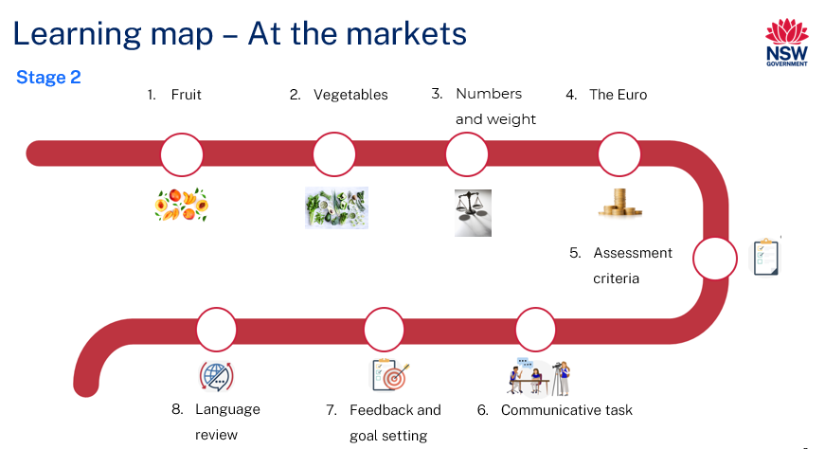
Figure 2 – Στη λαϊκή αγορά learning map
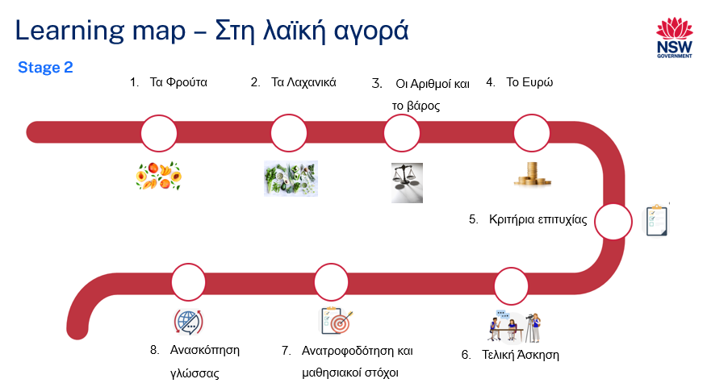

Assessment
Stage 2 communicative task: You are at a market in Greece. Buy some fruit and vegetables.
Too hard?
Purchase only one item from the market using simple phrases.
Too easy?
Purchase 3 or more items from the market using a variety of phrases.
Context: at a fruit and vegetable market in Greece
Audience: shopkeeper
Purpose: to buy fruit and vegetables

Assessment opportunities
The table below details assessment opportunities and differentiation ideas.
Assessment opportunities | Too hard? | Too easy?
Week 1 – creating a mind map  Students create a mind map to write the names of as many words for fruit that they know. | Creating a mind map  Students choose 2 of their favourite fruits to create their mind map. They can include 2 fruits in Modern Greek, English and a drawing. Then they can add a few more just in English and a drawing and add Greek as the unit progresses. | Creating a mind map  Students create a mind map and include the singular and plural forms of each type of fruit.
Week 2 – buying fruit and vegetables at the market  Students complete Resource 8 – cloze passage song based on Resource 7 – market song lyrics. | Going to the market song  Give students the fruit and vegetables flashcards. Students copy each one by reading, saying and writing the words using correct pronunciation and script. | Going to the market song  Students complete the cloze passage without access to the lyrics or flashcards.
Week 3 – weighing in kilos  Students use a kitchen scale to weigh classroom items. They record results in kilos and grams in a table and practise saying the numbers in Greek and κιλό/α (kilo/kilos), using the correct intonation and pronunciation. | Weighing in kilos and grams  Students are given a partially completed table. | Weighing in kilos and grams  Students write full sentences about the weight of each classroom item. For example, ‘Tο τετράδιο ζυγύζει/είναι δύο κιλά’ (The book weighs 2 kilos).

Teaching and learning activities

Week 1 – fruit
The table below outlines the learning intention and success criteria of the lesson, and materials that the teacher and students will need to complete the teaching and learning activities.
Learning intention and success criteria | Materials
Students will use both familiar and new vocabulary to talk about fruit in Modern Greek.  Students can:  - say names of different fruit in Modern Greek  - pronounce words correctly  - spell the names of fruit correctly. | - Resource 1 – fruit flashcards  - Resource 2 – plurals  - Resource 3 – fruit help sheet  - A trip to the markets PowerPoint book (English version)  - A trip to the markets PowerPoint book (Modern Greek version)  - ICT device  - Greek workbooks  - Writing materials

Vocabulary 1 – fruit
The table below outlines suggested vocabulary for Week 1 – fruit. It includes the original Modern Greek script, a Romanised version of the Modern Greek script, and the corresponding English translations.
English | Romanised Modern Greek | Modern Greek
apple/apples | milo/mila | μήλο/μήλα
pear/pears | ahladi/ahladia | αχλάδι/αχλάδια
strawberry/strawberries | fraoula/fraoules | φράουλα/φράουλες
plum/plums | damaskino/damaskina | δαμάσκηνο/δαμάσκηνα
orange/oranges | portokali/portokalia | πορτοκάλι/πορτοκάλια
grape/grapes | stafili/stafilia | σταφύλι/σταφύλια
banana/bananas | banana/bananes | μπανάνα/ μπανάνες
watermelon/watermelons | karpouzi/karpoozia | καρπούζι/καρπούζια

Activity 1 – Learning map
Explain and display the Learning map to give students a more detailed breakdown of lessons during the unit. Point out that the learning map is a plan that may need to change.
Display the learning map in the classroom for students to refer to throughout the term.

Activity 2 – fruit – pre-assessment of vocabulary
- Display Resource 1 – fruit flashcards or images of fruit on the board.
- Say the names of the fruit and point to each image and ask students to use the thumbs up and thumbs down strategy to show words they know and do not know.
- Students show the teacher thumbs up when they know the word, and thumbs down when they do not know the word.
- Students use the Think-Pair-Share strategy to tell their partner the Modern Greek words for each type of fruit.
- Model and drill the correct pronunciation of each word.
- Hand out flashcards of fruit, see Resource 1 – fruit flashcards.
- Students pair up and take turns telling their partner the names of various fruits in English and Modern Greek using their flashcards.
- Walk around the room and listen to each student.

Activity 3 – concentration game
- Give students Resource 3 – fruit help sheet to glue in their workbooks and/or display in the classroom. Students can refer to the help sheet if needed.
- Play a communicative language learning game, such as concentration, using the flashcards to practise fruit vocabulary.
- Hand out Resource 1 – fruit flashcards. Ask students to pair up.
- Students place flashcards face down and take turns turning cards over and saying the relevant word until they find a matching pair. To keep the cards, students must name the fruit correctly in Modern Greek.
- The winner is the student that collects the most pairs of cards.

Activity 4 – singular and plural
- Read A trip to the market PowerPoint book to students.
- Students clap when they hear the name of a fruit mentioned in the book, such as μήλο (apple), αχλάδι (pear), φράουλα (strawberry), δαμάσκηνο (plum), πορτοκάλι (orange).
- Hand out flashcards with pictures and Greek names of fruit, see Resource 1 – fruit flashcards.
- Students locate flashcards with the names of the fruit mentioned in the book and practise reading and saying aloud the names of the fruit and their plurals.
- Use the Think-Pair-Share strategy to determine spelling rules used for plurals in English.
- Explain to students that when making an English noun plural the following rule is applied:
- an -s or -es is usually added to the end of the word.
- there are exceptions, for example: mouse-mice, ox-oxen, moose-moose.
- When making a Modern Greek word plural, it requires knowing both the gender of the word and the letters with which it ends. Display Resource 2 – plurals and explicitly teach the rules applied when changing a noun into a plural.
- Point out that for most fruit the gender is neuter with some exceptions of feminine.
- Give each student Resource 2 – plurals and have them change each fruit into a plural using the rules. Students write all the fruit names along with their corresponding plurals in their workbooks.
Note: when handing out the flashcards point out to students the singular and plural forms of the fruit.

Activity 5 – creating a mind map
- Students create a mind map to write the names of fruit using an online app/website or in their workbooks.
- Ask students to write the word φρούτο (fruit) in the centre and draw a circle around it.
- Students draw lines out from the circle and write the names of each fruit in syllables, the words in Modern Greek and a drawing or picture to go with each fruit (see Figure 3).
Figure 3 – mind map example
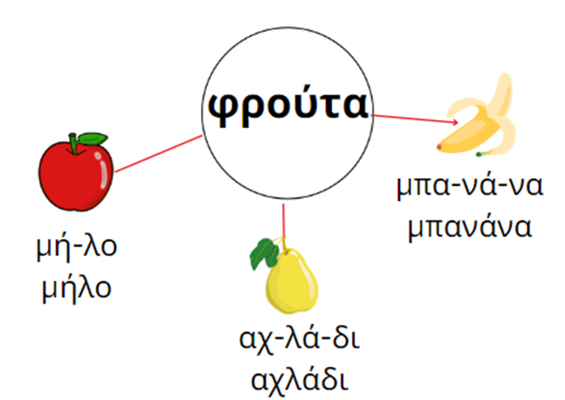
Evaluation: monitor whether the class already has a sound knowledge of the suggested vocabulary and adjust if necessary. Students can add the plurals to the mind map.

Week 2 – vegetables
The table below outlines the learning intention and success criteria of the lesson, and materials that the teacher and students will need to complete the teaching and learning activities.
Learning intention and success criteria | Materials
Students will learn Modern Greek words for vegetables and phrases used when buying fruit and vegetables.  Students can:  - say and write the names of different vegetables in Modern Greek  - say the names of different fruits in Modern Greek  - say and write phrases to buy fruit and vegetables. | - Resource 4 – vegetables help sheet  - Resource 5 – vegetables flashcards  - Resource 6 – vegetable names flashcards  - Resource 7 – market song lyrics  - Resource 8 – cloze passage song  - Resource 9 – market shopping phrases  - ICT devices  - Individual whiteboards  - Greek workbooks  - Writing materials

Vocabulary 2 – vegetables
The table below outlines suggested vocabulary for Week 2 – vegetables. It includes the original Modern Greek script, a Romanised version of the Modern Greek script, and the corresponding English translations.
English | Romanised Modern Greek | Modern Greek
cucumber/cucumbers | aggouri/aggouria, | αγγούρι/αγγούρια
carrot/carrots | karoto/karota | καρότο/καρότα
onion/onions | kremmidi/kremmidia | κρεμμύδι/κρεμμύδια
corn | kalamboki/kalambokia | καλαμπόκι/καλαμπόκια
broccoli | brokola/brokola | μπρόκολο/μπρόκολα
tomato/tomatoes | domata/domates | ντομάτα/ντομάτες
capsicum/capsicums | piperia/piperies | πιπεριά/πιπεριές
mushroom/mushrooms | manitári/manitária | μανιτάρι/μανιτάρια

Vocabulary 3 – shopping phrases
The table below outlines suggested vocabulary for Week 2 – vegetables. It includes the original Modern Greek script, a Romanised version of the Modern Greek script, and the corresponding English translations.
English | Romanised Modern Greek | Modern Greek
When I go to the market, Miss... | Otan tha pao kira mou sti laiki... | Όταν θα πάω κυρά μου στη λαϊκή...
I want to buy... | Thelo na agoraso... | Θέλω να αγοράσω...
How much does it cost? | Poso kani? | Πόσο κάνει;

Vocabulary 4 – numbers 1–5
The table below outlines suggested vocabulary for Week 2 – vegetables. It includes the original Modern Greek script, a Romanised version of the Modern Greek script, and the corresponding English translations.
English | Romanised Modern Greek | Modern Greek
one | ena | ένα
two | thio | δύο
three | tria | τρία
four | tessera | τέσσερα
five | pente | πέντε

Activity 1 – pre-assessment
- Show students a poster with images of various vegetables Resource 4 – vegetables help sheet..
- Ask students to identify how many words they think they know by showing thumbs up at their chests in response to the following questions:
- Do you know all the words for these pictures in Modern Greek?
- Do you know most of them? (thumbs up)
- Do you know some of them? (thumbs to the side)
- Do you know none of them? (thumbs down)
- In pairs, students use Resource 5 – vegetables flashcards and Resource 6 – vegetables names flashcards to match words to pictures.
- Read out the names of the vegetables in Modern Greek one at a time. Students repeat to practise correct pronunciation of each word.
- Model and drill the pronunciation of the new vocabulary with different groups of students, so you can listen to each student a number of times.
Evaluation: are students able to pronounce the words correctly? Which words and sounds are they having trouble with?

Activity 2 – Bingo!
- Display Resource 4 – vegetables help sheet in the classroom. Explain to students that they will be using this resource to play a game of Bingo.
- Demonstrate the game and play as a whole class first.
- Divide students into groups.
- Students use their workbooks or individual whiteboards to write the names of 6 vegetables.
- One student from each group calls out the names of the vegetables and the other students cross out the word mentioned. The student who crosses out all the words calls out ‘Bingo!’. The first student to call out ‘Bingo!’ is the winner.
- Students record the vocabulary in their Greek workbooks or on a device.

Activity 3 – going to the market song
- Display Resource 7 – market song lyrics sung to the tune, Όταν θα πάω κυρά μου στo παζάρι (1:59) (‘When I go to the market, Miss’).
- Students listen to the song twice and answer the question:
- What fruit is mentioned in the song?
- Break the song up by singing one line at a time and allow students to work out the meaning of each line.
- Students practise singing the song, ensuring they are using correct pronunciation.
- Drill the phrases or lyrics, as a whole and in chunks, by asking smaller groups to repeat.
- Students complete a cloze passage of the song, see Resource 8 – cloze passage song.
Note: the song can be adapted to include the names of the fruit learned in the previous week or to include new vocabulary of other fruit and vegetables.

Activity 4 – buying fruit and vegetables at the market
- Model and drill the phrases from the song, ‘When I go to the market Miss’, Θέλω να αγοράσω....ένα μήλο/δύο αχλάδια. (I would like to buy...one apple/two pears.), Πόσο κάνει; (How much is this?) by repeating the phrases several times.
- Separate students into 2 groups.
- Give one group of students cards of learned vocabulary of fruit and vegetables, see Resource 1 – fruit flashcards and Resource 5 – vegetables flashcards.
- Give the other group cards of the phrases:
- Θέλω να αγοράσω....ένα μήλο/δύο αχλάδια. (I would like to buy...one apple/two pears.)
- Πόσο κάνει; (How much is this?)
- Πόσο κάνει ένα μήλο; (How much for one apple?), see Resource 9 – market shopping phrases.
- Students pair up and practise saying the phrases, ensuring each student has a turn.
- Students can extend each phrase by using vocabulary previously learned. For example, students can greet the other person first and say ‘thank you’ and ‘you are welcome’.
Example interaction:
- Γειά σου/Καλήμέρα/Καλό απόγευμα. (Hello/Good morning/Good afternoon.)
- Θέλω να αγοράσω ένα μήλο. (I would like to buy one apple.)
- Πόσο κοστíζει; (How much does it cost?)
- Αυτό κοστíζει 1 ευρώ. (This costs 1 euro.)
- Ευχαριστώ! (Thank you!)
- Παρακαλώ! (You are welcome!)
- Play Greek whispers with students.
- Ask students to sit in a circle or a number of smaller circles.
- One student whispers a phrase, for example, «Θέλω να αγοράσω ένα μήλο σε παρακαλώ.» (I would like to buy an apple please).
- Each subsequent student continues to whisper the phrase until it gets to the end of the circle.
- The last student reveals the phrase.
Note: the phrases taught are found in the song, Όταν θα πάω κυρά μου στη λαϊκή (When I go to the market, Miss).
Evaluation: monitor whether the class already has a sound knowledge of the suggested vocabulary and adjust if necessary.

Week 3 – numbers and weight
The table below outlines the learning intentions and success criteria of the lesson, and materials that the teacher and students will need to complete the teaching and learning activities.
Learning intentions and success criteria | Materials
Students will:  - use Modern Greek language to recall numbers  - use the term kilos in Modern Greek.  Students can:  - count to 20 in Modern Greek  - count on the decade to 100 in Modern Greek  - use the term kilos  - write the vocabulary correctly  - pronounce words correctly. | - Resource 10 – number chart  - Classroom items  - Dice  - Individual whiteboards  - Kitchen scales × 6  - Greek workbooks  - Writing materials

Vocabulary 5 – numbers 6–20
The table below outlines suggested vocabulary for Week 3 – numbers and weight. It includes the original Modern Greek script, a Romanised version of the Modern Greek script, and the corresponding English translations.
English | Romanised Modern Greek | Modern Greek
six | exi | έξι
seven | efta | επτά
eight | ohto | οχτώ
nine | ennea | εννέα
ten | deka | δέκα
eleven | enteka | έντεκα
twelve | dodeka | δώδεκα
thirteen | dekatria | δεκατρία
fourteen | dekatessera | δεκατέσσερα
fifteen | dekapente | δεκαπέντε
sixteen | dekaexi | δεκαέξι
seventeen | dekaefta | δεκαεπτά
eighteen | dekaohto | δεκαοχτώ
nineteen | dekaennea | δεκαεννέα
twenty | ikosi | είκοσι

Vocabulary 6 – numbers 10–100
The table below outlines suggested vocabulary for Week 3 – numbers and weight. It includes the original Modern Greek script, a Romanised version of the Modern Greek script, and the corresponding English translations.
English | Romanised Modern Greek | Modern Greek
ten | theka | δέκα
twenty | ikosi | είκοσι
thirty | trianta | τριάντα
forty | saranta | σαράντα
fifty | peninta | πενήντα
sixty | exinta | εξήντα
seventy | evthominda | εβδομήντα
eighty | ogthonda | ογδόντα
ninety | eneninta | ενενήντα
one hundred | ekato | εκατό

Activity 1 – pre-assessment – ‘Buzz off’
- Have students stand up and form a circle to play ‘Buzz off hairy legs’. The objective of the game is to be the last one standing.
- Begin with one student saying the number one in Greek. Each student in the circle must continue the counting sequence. If a student gets their number wrong, they must sit down and the next person must then say the correct number.
- The counting continues until it gets to 10. Then the sequence continues with the next 4 students each saying one word from the phrase ‘Buzz off hairy legs’. The student who says ‘legs’ is out and the counting starts again until there is one student left.
- Play the game for a few rounds so students can refamiliarize themselves with the game and numbers.
- Once students have had some practise increase the numbers so that they go from 1–20.
- Observe students carefully and record students who are familiar or unfamiliar with numbers in Modern Greek.
Note: Stage 2 students should be familiar with numbers 1–10. Some students will be familiar with numbers 11–20.

Activity 2 – counting game
- Display Resource 10 – number chart.
- Revise numbers on the decade in Modern Greek with students.
- Ask students to form a circle.
- Choose a number to start, for example εξήντα (sixty) and write it on the board.
- Choose a student to start the game with the number δέκα (ten). The game goes up to 100, counting on the decade.
- The next student says the number 20 then the next students says 30, and so on until 60, where the student must clap instead of saying the number. If they do not clap or accidentally say 60, the student stands up and helps the teacher. If a student says a number incorrectly or is out of order, they are also out. The next student starts counting from the beginning.
- The last student remaining wins the game.
- The game can be modified to work with any set of numbers you choose.

Activity 3 – dice game – recording numbers in Modern Greek
- Display Resource 10 – number chart on the board as a scaffold for students in need of extra support.
- In pairs, students use 2 dice to record numbers in Modern Greek.
- Explain to students that when forming numbers in Modern Greek the same process is used as when forming numbers in English. When counting numbers off the decade you say the name of the decade first and then the number from 1–9.
- Students roll the dice one at a time and record the numbers in words in their workbook or mini whiteboards. For example, if student A rolls a 2 first and then a 3, they record 23 in words in their workbook. For example, 23-είκοσι τρία. Student B rolls a 1 and then a 2, they record 12-δώδεκα.
- Students practise saying the numbers using correct intonation and pronunciation.
- The student with the highest number receives a point. Students continue playing and keep score.
- The first student to get 10 points is the winner.
- Adapt the game by asking students to add, subtract or multiply the numbers together or include more dice to create bigger numbers.
Note: show students that, when writing Modern Greek numbers 1–20 in words, the number is written in one word. For numbers 20–100, the numbers are written in 2 words, for example 15 is δεκαπέντε and 25 is είκοσι πέντε.

Activity 4 – weighing in kilos
Note: introduce the terms κιλό and κιλά for kilo and kilos as well as γραμμάρι and γραμμάρια for gram and grams.
- Split students into groups of 4.
- Students practise saying the numbers in Modern Greek and the term κιλό/κιλά (kilo/kilos), using the correct intonation and pronunciation, for example ένα κιλό/πέντε κιλά.
- Give each group a kitchen scale and classroom items to weigh. Ensure that each group knows how to use the scale and can read the weight of each item.
- Students weigh each classroom item and record results in kilos and grams in their Greek workbooks.
Evaluation: assess whether the class already has a sound knowledge of vocabulary related to classroom items. Lead a communicative activity to revise if necessary.

Week 4 – the euro
The table below outlines the learning intention and success criteria of the lesson, and materials that the teacher and students will need to complete the teaching and learning activities.
Learning intention and success criteria | Materials
Students will use known and new language to recall numbers and money in Modern Greek.  Students can:  - use the terms, ευρώ/λεπτά (euro and cents) correctly  - ask a question about cost  - respond with positive and negative answers to questions about cost. | - Resource 11 – euro worksheet  - Resource 12 – Battleship shopping game  - ICT device  - Greek workbooks  - Pencils

Vocabulary 7 – currency
The table below outlines suggested vocabulary for Week 4 – the euro. It includes the original Modern Greek script, a Romanised version of the Modern Greek script, and the corresponding English translations.
English | Romanised Modern Greek | Modern Greek
euro | evro | ευρώ
cents | lepta | λεπτά
yes | ne | ναι
no | ohi | όχι
two hundred | thiakosia | διακόσια
five hundred | pentakosia | πεντακόσια
The [name of fruit] costs [one] euro and [10] cents. | To [frouto] kostizi [ena] evro ke [theka] lepta. | Το [φρούτο] κοστίζει [ένα] ευρώ και [δέκα] λεπτά.

Activity 1 – buying fruit and vegetables
- Give each student a copy of Resource 11 – euro worksheet and have them complete it.
- Mark as a whole class and record student responses.
- Put phrases on the board and ask students to translate them in English using the Think-Pair-Share strategy, for example:
- Συγνώμη αλλά πόσο κοστίζει το καρότο; (Excuse me, how much does this carrot cost?)
- Το καρότο κοστίζει ένα ευρώ. (The carrot costs one euro.)
- Ευχαριστώ. (Thank you.)
- Παρακαλώ. (You’re welcome.)
Evaluation: use student responses to the euro worksheet to assess their understanding of numbers from Week 3.

Activity 2 – Greek currency – euro
- Discuss with students the history of the currency used in Greece, the euro and the symbol €. Explain that the euro is used in a total of 20 different European countries including Cyprus, Italy, Spain and France.
- Display Resource 11 – euro worksheet, discussing the appearance and value of each one.
- Model correct way of saying each number then drill each phrase as a whole and in chunks by asking students to repeat as a whole class and in smaller groups.
- Students glue the worksheet in their workbooks.
- Practise saying new vocabulary with a partner.

Activity 3 – Battleship
- Play ‘Battleship shopping game’ with fruit and vegetables.
- Give each student a copy of the Resource 12 – Battleship shopping game.
- Students form groups of 4, with 2 students on each team.
- Write down the location of 7 ‘fruit and vegetable battleships’ on a piece of paper. Do not show the paper to students.
- Each empty square could be the location of one fruit and vegetable battleship.
- Each team has a turn at guessing where you have hidden the battleships.
- Students create sentences like:
- Tο καρότο κοστίζει ένα ευρώ και δέκα λεπτά; (Does the carrot cost one euro and 10 cents?)
- Ναι, το καρότο κοστίζει ένα ευρώ. (Yes, the carrot costs one euro)
- Όχι, το καρότο δεν κοστίζει ένα ευρώ. (No, the carrot does not cost one euro).
- If there is a fruit and vegetable battleship in this location, students get to put their team mark on that spot. If there is not a battleship, all the students mark an ‘x’ in that place. Continue playing the game until one team finds the 7 ships. The winner of the game is the first team to locate all the ships.

Activity 4 – recording sentences
Revise new vocabulary learned and students record phrases in their workbooks or on a device and draw a picture to match each phrase.
Evaluation: pair up students to work together if a student is unfamiliar with the vocabulary.

Week 5 – assessment criteria and practice task
The table below outlines the learning intention and success criteria of the lesson, and materials that the teacher and students will need to complete the teaching and learning activities.
Learning intention and success criteria | Materials
Students will develop a clear understanding of the requirements of the assessment task.  Students can:  - suggest appropriate success criteria  - explain what they need to do to be successful in the task. | - Resource 13 – assessment task – At the markets  - Resource 14 – rubric – At the markets!  - Resource 15 – peer feedback strategy – Two stars and a wish

Activity 1 – assessment task
Share Resource 13 – assessment task – At the markets with the students and lead the class in reading it.

Activity 2 – success criteria
After looking at the assessment task, students Think-Pair-Share and suggest appropriate success criteria, such as:
I will be successful if I can:
- ask the shopkeeper for fruit and vegetables
- ask the shopkeeper the cost of fruit and vegetables
- use correct sentences with correct grammar
- pronounce the words correctly
- speak in a well-paced manner without long pauses
- start and end the conversation in an appropriate way, for example, ‘Γεια σου, ευχαριστώ πολύ, αντίο!’ (Hello, thank you very much, goodbye).

Activity 3 – discuss the rubric
- Show students an unmarked rubric Resource 14 – rubric – At the markets. This may need to be adapted if the class has decided on different success criteria.
- Explain metalanguage, such as fluency, accuracy, pronunciation and vocabulary.
- Students read and then discuss the ‘excellent’ column of the rubric in pairs. Students then share their understanding of what is needed to be successful.
- Point out and provide examples, if possible, of what ‘excellent’ and ‘sort of’ samples of task completion, fluency, accuracy, pronunciation and vocabulary look and sound like.

Activity 4 – peer assessment
Peer feedback will be incorporated into the task, see Resource 15 – peer feedback strategy – Two stars and a wish. Confirm which peer feedback strategy will be used, for example, ‘Two stars and a wish’ and discuss with students.
Evaluation: students give examples of what stars and wishes would look like for this task.

Activity 5 – practice task
Students get into groups of 3 and take turns at playing ‘You’ – the buyer, the shop keeper and a peer-assessor/camera operator.
Suggested rotations:
- Role-play/Presentation 1: Student 1 – buyer, Student 2 – peer-assessor/camera operator, Student 3 – shopkeeper
- Role-play/Presentation 2: Student 1 – camera operator, Student 2 – buyer, Student 3 – peer-assessor/Camera operator
- Role-play/Presentation 3: Student 1 – peer-assessor/camera operator, Student 2 – shopkeeper, Student 3 – buyer.

Week 6 – communicative task – buy fruit and vegetables at the market
The table below outlines the learning intention and success criteria of the lesson, and materials that the teacher and students will need to complete the teaching and learning activities.
Learning intention and success criteria | Materials
Students will participate in a role-play at a Greek market and buy fruit and vegetables.  Students can:  - ask the shopkeeper for fruit and vegetables  - ask the shopkeeper the cost of fruit and vegetables  - use correct sentences with correct grammar  - pronounce the words correctly  - speak in a well-paced manner without long pauses  - start and end the conversation in an appropriate way, for example, ‘Γεια σου, ευχαριστώ πολύ, αντίο!’ (Hello, thank you very much, goodbye). | - Resource 13 – assessment task – At the markets  - Resource 14 – rubric – At the markets  - Resource 15 – peer feedback strategy – Two stars and a wish  - Tablets or other recording devices

Activity 1 – going to the market song
Sing Όταν θα πάω κυρά μου στo παζάρι (1:59) (‘When I go to the market, Miss’) once again as a class.
Check students’ understanding of the language in the song.

Activity 2 – task set-up
Divide students into groups of 3. Give students a few minutes to ensure everybody knows the order in which they will be performing each role. The buyer is the student who is completing the assessed communicative task.
Hand out the rubric and peer feedback worksheets to each student.
Suggested rotations:
- Role-play/Presentation 1: Student 1 – buyer, Student 2 – peer-assessor/camera operator, Student 3 – shopkeeper
- Role-play/Presentation 2: Student 1 – camera operator, Student 2 – buyer, Student 3 – peer-assessor/camera operator
- Role-play/Presentation 3: Student 1 – peer-assessor/camera operator, Student 2 – shopkeeper, Student 3 – buyer.

Activity 3 – communicative task – buy fruit and vegetables at the market
Note: before recording the interactions/presentations, check if any students do not have permission to be filmed. Alternatives to video recording include audio recording or watching the interactions while taking notes and marking the rubric.
You are in Greece, visiting the local market. Buy some fruit and vegetables.
Example interaction:
- You: Καλημέρα! (Good morning!)
- Shopkeeper: Γειά σας! (Hello!)
- You: Θέλω τρία μήλα, σε παρακαλώ. (I would like three apples please.)
- Shopkeeper: Εντάξει. (Ok.)
- You: Πόσο κοστίζει; /Πόσο κάνει; (How much does it cost?)
- Shopkeeper: Δύο ευρώ. (Two euros.)
- You: Ευχαριστώ, αντίο! (Thank you, goodbye!)
- Shopkeeper: Aντίο! (Goodbye!)
Note: make sure to space students apart when filming. Demonstrate how to film using a recording device. Use microphones, if possible, to maximise sound quality. Highlight the importance of holding the recording device still by using a tripod or resting it on a table.
One student records the interaction between the shopkeeper and the buyer. The camera operator will provide peer-assessment to the buyer after the interaction using the ‘Two stars and a wish’ strategy.

Activity 4 – peer assessment
Students provide peer feedback verbally and follow up by completing Resource 15 – peer feedback strategy – Two stars and a wish.

Week 7 – feedback and goal setting
Note: if there is insufficient time to mark the videos before Week 8, Weeks 7 and 8 can be swapped.
The table below outlines the learning intention and success criteria of the lesson, and materials that the teacher and students will need to complete the teaching and learning activities.
Learning intention and success criteria | Materials
Students will reflect on their task recordings to assess performance and set learning goals.  Students can:  - accurately self-assess how they completed the task  - set appropriate learning goals based on previous learning goals as well as teacher, peer and self-assessment. | - Resource 1 – fruit flashcards  - Resource 5 – vegetables flash cards  - Resource 14 – rubric – At the markets  - Greek workbooks  - Tablets or other recording devices
Note: prior to the lesson, view all material and mark rubrics for each student.

Activity 1 – draw and guess
Note: prepare flashcards without the images of fruit and vegetables for the below activity. Use Resource 1 – fruit flashcards and Resource 6 – vegetable names flashcards. Alternatively, write words in Modern Greek on paper.
Split the class into small groups and have one student from a team come to the whiteboard. Ask the student to draw an image from the flash cards. Set a timer for one minute and the student draws an image of the word on the flashcard. The team members try to guess the word within the set time. If they guess the word, the team wins a point. If not, the next team gets a chance to guess the word.

Activity 2 – self-assessment
Students watch the video of themselves completing the task and mark themselves using the rubric. Students then compare both the teacher completed rubric and the one they completed.

Activity 3 – set learning goals
Students reflect on the teacher, peer and self-evaluation to set learning goals for the next phase of learning. Example learning goals could be ‘I will not be worried about making a mistake when speaking Greek. Students write their learning goals in their Greek workbooks.
Evaluation: students set appropriate learning goals based on previous learning goals and teacher, peer and self-assessment.

Week 8 – language review
Note: if there is insufficient time to mark the videos before Week 8, Weeks 7 and 8 can be swapped.
The table below outlines the learning intention and success criteria of the lesson, and materials that the teacher and students will need to complete the teaching and learning activities.
Learning intention and success criteria | Materials
Students will reflect on and ask questions about the language taught in this unit.  Students can:  - ask questions about vocabulary, grammar or pronunciation they have used in this unit  - use the language they have learned to communicate with classmates in Modern Greek. | - Resource 1 – fruit flashcards  - Resource 5 – vegetables flashcards  - Resource 7 – market song lyrics  - Resource 16 – dialogue cards  - Resource 17 – sentence re-ordering  - Devices  - Greek workbooks  - Pencils
Note: over the course of the unit, gaps in student knowledge, misconceptions and misuse of language will have been identified. These observations are addressed using engaging and interactive activities and strategies. The activities below are examples and will need to be supplemented with activities to address your observations.

Activity 1 – student questions
Remind students of the activities and tasks they have completed over the course of the unit. Give students time to Think-Pair-Share any questions they may have about any aspect of the language taught.
Notes: set up different language stations that will focus on reinforcing word work, grammar, listening and responding. These activities can be adapted to suit students’ needs. Students rotate in groups after a set timer to a different station to complete the activities with a different focus.

Activity 2 – language review
The stations will review the unit’s learned vocabulary.
Suggested activities:
- Bingo: students record 6 words in their workbooks. Call out words from the suggested vocabulary. Students cross out words on their list. First student to cross all words out on their list calls out ‘Bingo!’ and they are the winner.
- Concentration: use Resource 1 – fruit flashcards and Resource 5 – vegetables flashcards to play a game of memory. Mix the cards and put them face down on the desk or floor. Students take turns to turn 2 cards face-up and read the word aloud. When students have a matching pair, they keep it. The student with the most pairs when all the cards are matched is the winner.
- Memory: place 10 or more flashcards in a basket. Ask students to look at the flashcards for 30 seconds. Cover the flashcards. Students recall as many flashcards as possible. The winner is the student who can recall the most words.
- Reading corner: hand out A trip to the market PowerPoint book and Resource 7 – market song lyrics. Students sit in a circle and read one line each until complete.

Activity 3 – grammar review
- Dialogue cards: prepare a set of cards with English sentences to be translated into Greek, see Resource 16 – dialogue cards. Students take turns in picking a card and translating it to the teacher. Students keep the card if they get it correct. The winner is the student with the most cards.
- Fruit and vegetables plurals: students take turns picking a card and reading the fruit or vegetable and then saying the plural. Students keep the card if they get it correct. The winner is the student with the most cards.
- Sentences re-ordering: use sentences students have learned in this unit, see Resource 17 – sentence re-ordering. The words in a sentence are randomly and incorrectly arranged. Students rearrange the words to make a sentence with the correct sentence structure and record it in their workbooks or device.

Student resources

Resource 1 – fruit flashcards
apple |  | pear |  | strawberry |  | plum
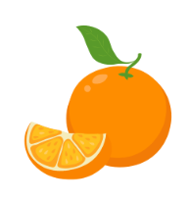
orange |  | grapes |  | banana |  | watermelon

μήλο |  | αχλάδι |  | φράουλα |  | δαμάσκηνο
πορτοκάλι |  | σταφύλι |  | μπανάνα |  | καρπούζι
This resource can be adapted by replacing the text to suit your language.

 |  | 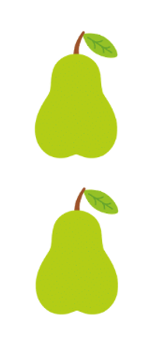 |  |  |  | 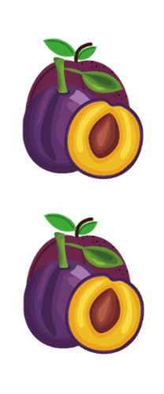
μήλα |  | αχλάδια |  | φράουλες |  | δαμάσκηνα

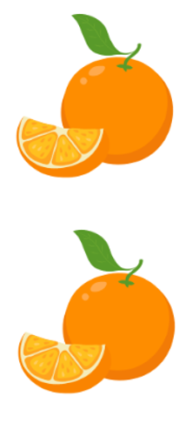
πορτοκάλια |  | σταφύλια |  | μπανάνες |  | καρπούζια
This resource can be adapted by replacing the text to suit your language.

apples |  | pears |  | strawberries |  | plums

oranges |  | grapes |  | bananas |  | watermelons

Resource 2 – plurals
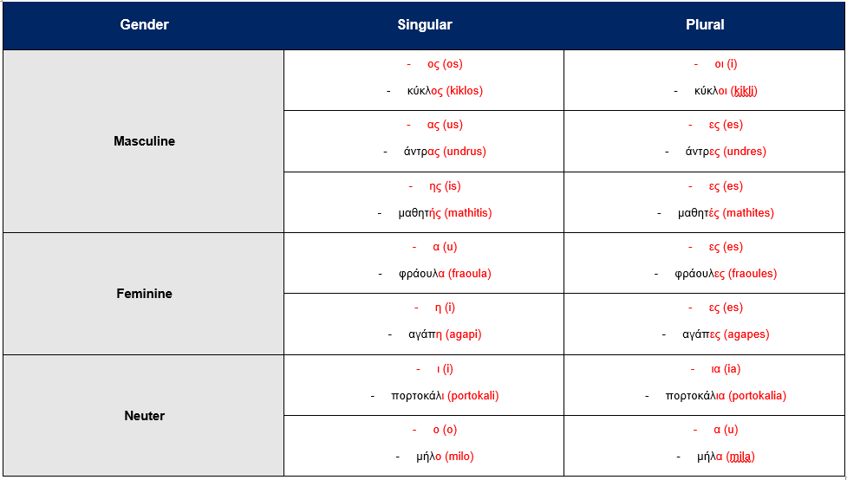

Resource 3 – fruit help sheet
μήλο (milo)  apple |  | αχλάδι (ahladi)  pear |  | φράουλα (fraoula)  strawberry |  | δαμάσκηνο (damaskino)  plum
πορτοκάλι (portokali)  orange |  | σταφύλι (stafili)  grapes |  | μπανάνα (banana)  banana |  | καρπούζι (karpouzi)  watermelon
This resource can be adapted by replacing the text to suit your language.
μήλα (milα)  αpples |  | αχλάδια (ahlathia)  pears |  | φράουλες (fraoules)  strawberries |  | δαμάσκηνα (thamaskina)  plums

πορτοκάλια (portokalia)  οranges |  | σταφύλια (stafilia)  grapes |  | μπανάνες (bananes)  bananas |  | καρπούζια (karpoozia)  watermelons
This resource can be adapted by replacing the text to suit your language.

Resource 4 – vegetables help sheet
 |  | 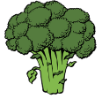
κρεμμύδι (kremmithi)  onion |  | μπρόκολο (brokola)  broccoli |  | μανιτάρι (manitari)  mushroom |  | καρότο (karoto)  carrot

 |  | 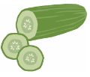
καλαμπόκι (kalamboki)  corn |  | αγγούρι (aggouri)  cucumber |  | πιπεριά (piperia)  capsicum |  | ντομάτα (ntomata)  tomato
This resource can be adapted by replacing the text to suit your language.
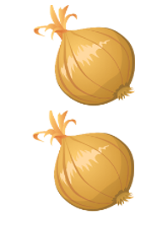 |  | 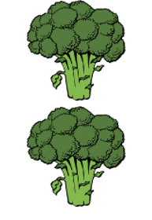
κρεμμύδια (kremidia)  onions |  | μπρόκολα (brokola)  broccoli |  | μανιτάρια (manitaria)  mushrooms |  | καρότα (karota)  carrots
 |  | 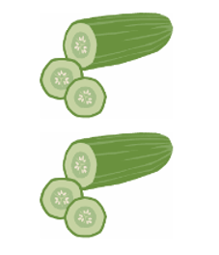 |  | 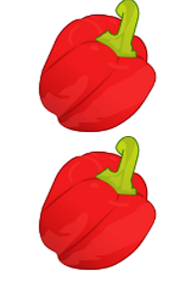 |  | 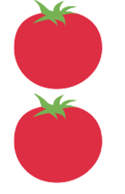
καλαμπόκια (kalambokia)  corn |  | αγγούρια (aggouria)  cucumbers |  | πιπεριές (piperies)  capsicums |  | ντομάτες (domates)  tomatoes

Resource 5 – vegetables flashcards
κρεμμύδι |  | μπρόκολο |  | μανιτάρι |  | καρότο

καλαμπόκι |  | αγγούρι |  | πιπεριά |  | ντομάτα
This resource can be adapted by replacing the text to suit your language.
onion |  | broccoli |  | mushroom |  | carrot

corn |  | cucumber |  | capsicum |  | tomato

κρεμμύδια |  | μπρόκολα |  | μανιτάρια |  | καρότα
καλαμπόκια |  | αγγούρια |  | πιπεριές |  | ντομάτες
This resource can be adapted by replacing the text to suit your language.
onions |  | broccoli |  | mushrooms |  | carrots
corn |  | cucumbers |  | capsicums |  | tomatoes

Resource 6 – vegetable names flashcards
This resource can be adapted by replacing the text to suit your language.
κρεμμύδι |  | μπρόκολο |  | μανιτάρι |  | καρότο
καλαμπόκι |  | αγγούρι |  | πιπεριά |  | ντομάτα

κρεμμύδια |  | μπρόκολα |  | μανιτάρια |  | καρότα
καλαμπόκια |  | αγγούρια |  | πιπεριές |  | ντομάτες

Resource 7 – market song lyrics
Όταν θα πάω κυρά μου στη λαϊκή (When I go to the markets Miss)
(sung to the tune of Όταν θα πάω κυρά μου στo παζάρι)
Όταν θα πάω κυρά μου στη λαϊκή, (When I go to the markets Miss)
Θέλω να αγοράσω ένα μήλο.(I want to buy one apple)
Ένα μήλο, πόσο κάνει; (One apple how much?)
Πόσο κάνει ένα μήλο; (How much for one apple?)
Η λαϊκή είναι τόσο ωραία. Χ2 (The market is so great × 2)
Όταν θα πάω κυρά μου στη λαϊκή, (When I go to the markets Miss)
Θέλω να αγοράσω ένα αχλάδι. (I want to buy one pear)
Ένα αχλάδι, πόσο κάνει; (One pear how much?)
Πόσο κάνει ένα αχλάδι; (How much for one pear?)
Η λαϊκή είναι τόσο ωραία. Χ2 (The market is so great × 2)

Resource 8 – cloze passage song
Όταν θα πάω κυρά μου στη λαϊκή
(sung to the tune of Όταν θα πάω κυρά μου στo παζάρι)
Όταν θα πάω κυρά μου στη ______,
Θέλω να αγοράσω ένα ______.
Ένα μήλο, ______ κάνει;
Πόσο ______ ένα μήλο;
Η ______ είναι τόσο ωραία. ×2
Όταν θα πάω κυρά μου ______ λαϊκή,
Θέλω να ______ ένα ______.
______ ______, πόσο κάνει;
______ ______ ένα αχλάδι;
Η λαϊκή ______ τόσο ωραία. ×2

Resource 9 – market shopping phrases
This resource can be adapted by replacing the text to suit your Language.
Πόσο κάνει;  Ή  Πόσο κοστíζει;  (How much is it? or How much does this cost?) |  | Πόσο κάνει;  Ή  Πόσο κοστíζει;  (How much is it? or How much does this cost?) |  | Πόσο κάνει;  Ή  Πόσο κοστíζει;  (How much is it? or How much does this cost?) |  | Πόσο κάνει;  Ή  Πόσο κοστíζει;  (How much is it? or How much does this cost?)
Θέλω να αγοράσω _______.  (I would like to buy) |  | Θέλω να αγοράσω _______.  (I would like to buy) |  | Θέλω να αγοράσω _______.  (I would like to buy) |  | Θέλω να αγοράσω _______.  (I would like to buy)

Resource 10 – number chart
Τhe numbers 1–20
1  ένα  ena | 2  δύο  thio | 3  τρία  tria | 4  τέσσερα  tessera | 5  πέντε  pente | 6  έξι  exi | 7  επτά  epta | 8  οχτώ  ohto | 9  εννέα  ennea | 10  δέκα  theka
11  έντεκα  enteka | 12  δώδεκα  thotheka | 13  δεκατρία  thekatria | 14  δεκατέσσερα  thekatessera | 15  δεκαπέντε  thekapente | 16  δεκαέξι  thekaexi | 17  δεκαεπτά  thekaepta | 18  δεκαοχτώ  thekaohto | 19  δεκαεννέα  thekaennea | 20  είκοσι  ikosi
The numbers by the decade 10–100
10  δέκα  theka | 20  είκοσι  ikosi | 30  τριάντα  trianta | 40  σαράντα  saranta | 50  πενήντα  peninta | 60  εξήντα  exinta | 70  εβδομήντα  evthominta | 80  ογδόντα  ogthonta | 90  ενενήντα  eneninta | 100  εκατό  ekato

Resource 11 – euro worksheet
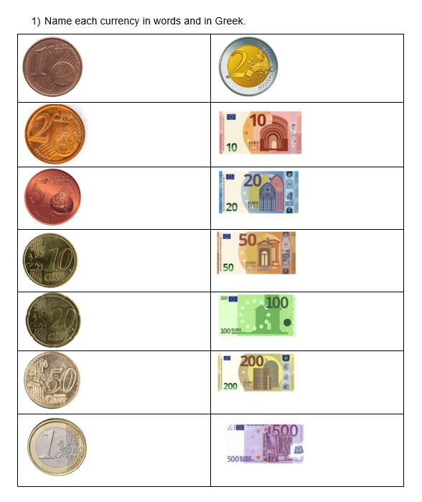

Resource 12 – Battleship shopping game
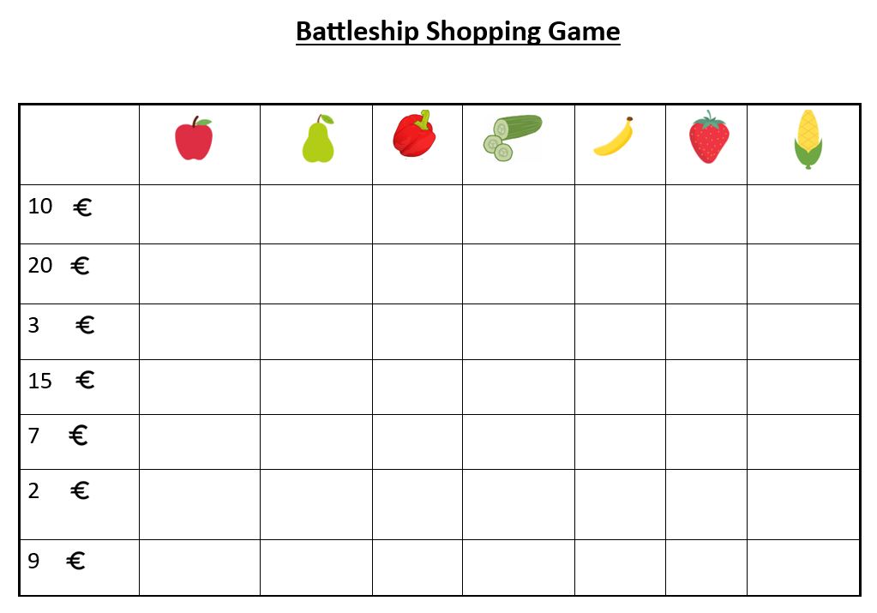

Resource 13 – assessment task – At the markets

Outcomes
You will be assessed on how well you:
- ask and answer modelled questions in a guided conversation
- select familiar vocabulary and formulaic phrases to interact
- recognise and use modelled sounds, including pronunciation and intonation patterns and/or rhythms to interact.

Task
You are at a market in Greece and want to buy fruit and vegetables. You will be interacting with the shopkeeper using familiar vocabulary, formulaic phrases and questions, adjectives and nouns to buy fruit and vegetables. This includes what kind of fruit or vegetables, how many of each and how much it will cost in euros.
Too hard? | Too easy?
Purchase only one item from the market using simple phrases. | Purchase 3 or more items from the market using a variety of phrases.

Learning intention
Students will interact with a shop keeper to buy fruit and vegetables.

Success criteria
You will interact with a shopkeeper.
You will be successful if you can:
- ask the shopkeeper for fruit and vegetables
- ask the shopkeeper the cost of fruit and vegetables
- use correct sentences with correct grammar
- pronounce the words correctly
- speak in a well-paced manner without long pauses
- start and end the conversation in an appropriate way, for example, ‘Γεια σου, ευχαριστώ πολύ, αντίο!, Σε παρακαλώ’. (Hello, thank you very much, goodbye).

Task instructions
- This task will be completed in groups of 3. Each student will take turns at all 3 roles:
- the person buying the fruit and vegetables
- the shopkeeper (peer feedback)
- camera operator.
- The person buying the fruit from the shop is completing the communicative task, so you will only be assessed for task completion while performing this role. You will be assessed on all other criteria in the rubric while performing all roles except for camera operator.
- The shopkeeper will provide feedback to the person buying fruit and vegetables. This feedback will take the form of ‘Two stars and a wish’.
- Following the task, you will watch a recording of yourself completing the task. You can self-assess by marking yourself on Resource 14 – rubric – At the markets. Then compare the self-assessed rubric and the teacher marked rubric.
- Reflect on your performance and identify areas for improvement. Use this information to set a learning goal for the next stage of learning.

Resource 14 – rubric – At the markets
Name:
Table 1 – rubric – At the markets
Criteria | Excellent | Got it | Sort of | Not yet | Limited
Communication | Your audience, the shopkeeper, clearly understands what you want to communicate.  Successfully and thoroughly complete all of the following aspects of the task:  - start the conversation in an appropriate way, for example, καλημέρα (good morning)  - ask the shopkeeper for items they would like to buy  - use correct language to order more than one fruit and vegetable  - ask the shopkeeper for the cost  - end the conversation in an appropriate way, for example, ευχαριστώ, αντίο (thank you, goodbye). | Your audience, the shopkeeper, can understand what you want to communicate.  Successfully complete all of the following aspects of the task:  - start the conversation in an appropriate way  - ask the shopkeeper what they would like to order  - use correct language to order fruit and vegetables  - ask the shopkeeper for the cost  - end the conversation in an appropriate way, for example, ευχαριστώ, αντίο (thank you, goodbye). | Your audience, the shopkeeper, can mostly understand what you want to communicate.  Successfully complete most of the following aspects of the task:  - start the conversation in an appropriate way  - ask the shopkeeper what they would like to order  - use correct language to order fruit and vegetables  - ask the shopkeeper for the cost  - end the conversation in an appropriate way, for example, ευχαριστώ, αντίο (thank you, goodbye). | Your audience, the shopkeeper, struggles to understand what you want to communicate. However, communication is successful.  Do not complete all aspects of the task. | Your audience, the shopkeeper, is unable to understand what you want to communicate.  Unable to complete any aspect of the task.
Fluency | Speak with ease in a well-paced manner without long pauses. | Speak confidently with appropriate speed and expression. | Usually speak confidently with appropriate speed and expression. | Don’t speak confidently. | Unable to be understood.
Grammar | Always say words in the correct order when speaking. | Usually say words in the correct order when speaking. | Make some grammar mistakes when speaking. | Rarely make sense when speaking. | Unable to be understood.
Pronunciation | Pronounce all words correctly. | Pronounce most words correctly. | Consistently make pronunciation errors. | Pronounce only a few words correctly. | Unable to be understood.
Vocabulary | Use expected vocabulary correctly and add interesting vocabulary to dialogue. | Use expected vocabulary in dialogue correctly. | Make some mistakes when trying to use expected vocabulary. | Make many mistakes when trying to use expected vocabulary. | Unable to use vocabulary in appropriate context.

Resource 15 – peer feedback strategy – Two stars and a wish
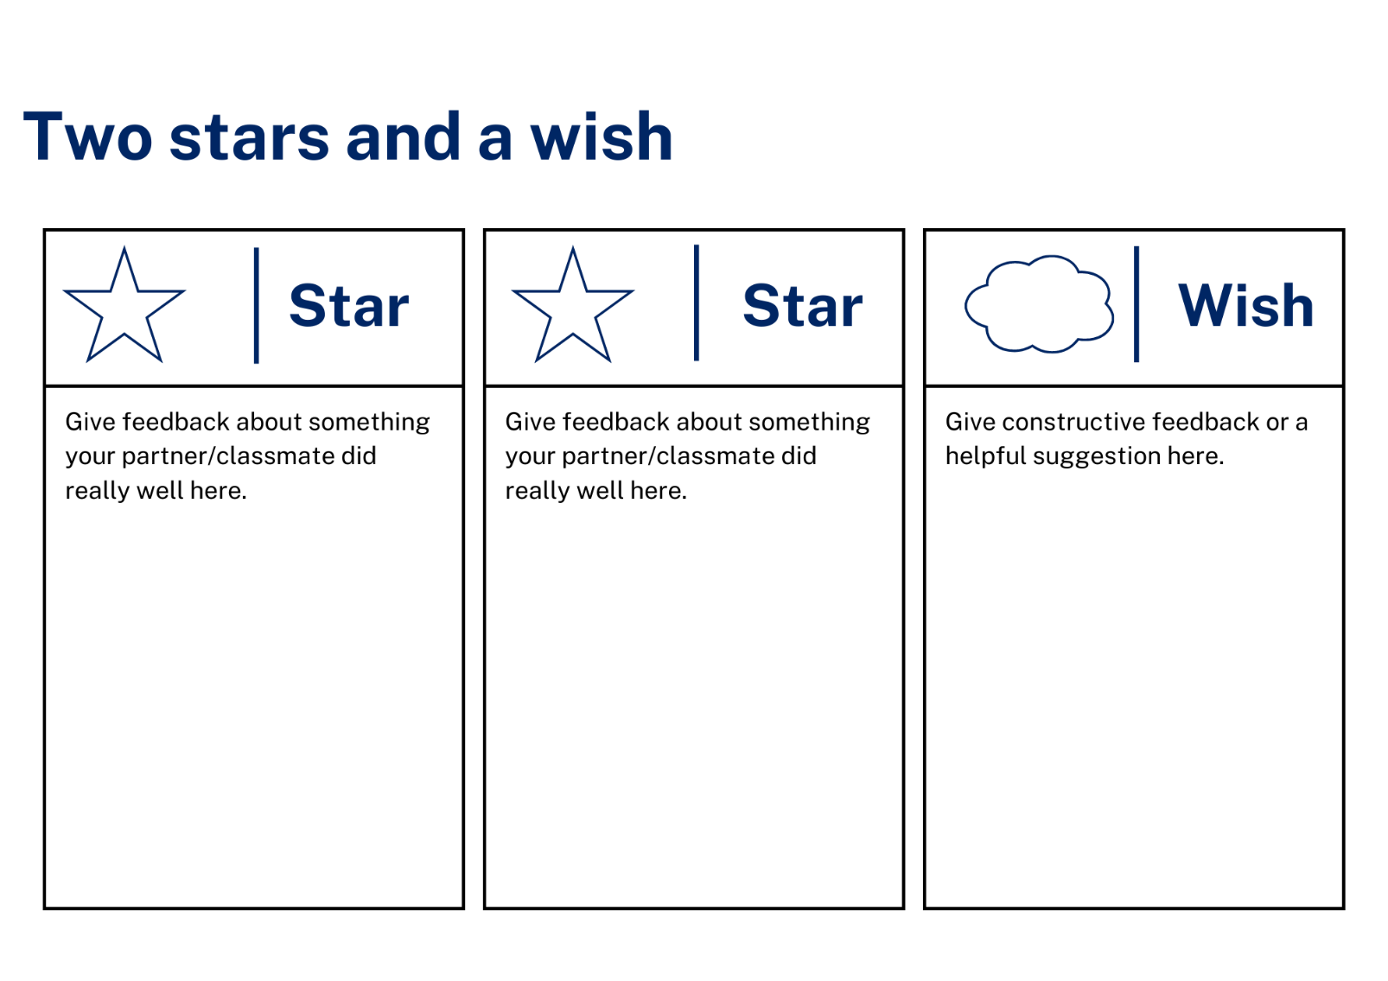

Resource 16 – dialogue cards
This resource can be adapted by replacing the text to suit your Language.
Πόσο κάνει;  (How much is this?) |  | Πόσο κοστíζει;  (How much does this cost?) |  | Πόσο κοστíζει ένα μηλο;  (How much does one apple cost?) |  | Πόσο κάνει ένα αγγούρι;  (How much for one cucumber?)
Θέλω να αγοράσω ένα μήλο.  (I would like to buy one apple.) |  | Κοστíζει ένα ευρώ και πενήντα λεπτά.  (It costs one euro and fifty cents.) |  | Το μήλο κοστíζει δύο ευρώ και εíκοσι λεπτά.  (The apple costs two euros and twenty cents.) |  | Ναι, το καρότο κοστíζει δέκα λεπτά.  (Yes, the carrot costs ten cents.)

Θέλω εννέα κιλά αγγούρια.  (I would like nine kilos of cucumbers.) |  | Θέλω δύο κιλά πατάτες σε παρακαλώ!  (I would like two kilos of potatoes please.) |  | Ευχαριστώ!  (Thank you!) |  | Ευχαριστώ πολύ!  (Thank you very much!)
Θέλω να αγοράσω έξι πιπεριές.  (I would like to buy six capsicums.) |  | Η ντομάτα κοστíζει ένα ευρώ και πενήντα λεπτά.  (The tomato costs one euro and fifty cents.) |  | Το καλαμπόκι κοστíζει τρíα ευρώ και εíκοσι πέντε λεπτά.  (The corn costs three euros and twenty cents.) |  | Όχι, το καρότο δεν κοστíζει δέκα ευρώ.  (No, the carrot does not cost ten euros.)

Resource 17 – sentence reordering
- κάνει; Πόσο (much? How)
- ένα κοστίζει μήλο; Πόσο (one costs apple? How much does)
- μήλο δύο και κοστίζει είκοσι Το λεπτά. ευρώ (apple two euros and costs twenty The cents. εuro)
- έξι να Θέλω πιπεριές. αγοράσω (six Ι want to capsicums. buy)
- παρακαλώ δύο σε κιλά πατάτες! Θέλω (please two of kilos potatoes. I want)
- πάω Θα λαϊκή. στη (going I am markets. to the)
- το δέκα Όχι, δεν ευρώ. καρότο κοστίζει (the ten No, doesn’t euros. carrot cost)
- και σταφύλια λεπτά. δύο κοστίζουν Τα ευρώ είκοσι (and grapes cents. two cost The euros twenty)

Support and alignment
Resource evaluation and support: all curriculum resources are prepared through a rigorous process. Resources are periodically reviewed as part of our ongoing evaluation plan to ensure currency, relevance, and effectiveness. For additional support or advice, contact the Primary Languages team by emailing primlang@det.nsw.edu.au.
Alignment to system priorities and/or needs: School Excellence Policy
Alignment to the School Excellence Framework: this resource supports the School Excellence Framework elements of curriculum (curriculum provision, teaching and learning programs) and effective classroom practice (lesson planning).
Alignment to Australian Professional Teaching Standards: this resource supports teachers to address Australian Professional Teaching Standards 2.2.2, 3.2.2.
Consulted with: Curriculum, Secondary Learners, school-based staff and NESA subject matter experts. Advice from Aboriginal Outcomes and Partnerships, EAL/D, HPGE and Inclusive Education for Modern Languages Stage 3 Italian Mangiare in Ristorante has been considered in preparing this document.
NSW syllabus: Modern Languages K–10 Syllabus
Syllabus outcomes: ML2-INT-01, ML2-UND-01, ML2-CRT-01
Author: Primary Curriculum
Publisher: State of NSW, Department of Education
Resource: Unit
Related resources: further resources to support Stage 2 Modern Languages can be found on the Languages K-6 curriculum page.
Professional learning: relevant professional learning is available through Primary Languages Networks on Teams (staff only).
Universal Design for Learning: support the diverse learning needs of students using inclusive teaching and learning strategies. Some students may require more specific adjustments to allow them to participate on the same basis as their peers. For further advice see Inclusive practice resources for primary school.
Differentiation: when using these resources in the classroom, it is important for teachers to consider the needs of all students in their class, including:
- Aboriginal and Torres Strait Islander students. Targeted strategies can be used to achieve outcomes for Aboriginal students in K–12 and increase knowledge and understanding of Aboriginal histories and cultures. Teachers should use students’ Personalised Learning Pathways to support individual student needs and goals.
- EAL/D learners. EAL/D learners may require scaffolding to support them to gain content knowledge, while providing extra time and assistance to master the English language required to engage with texts or complete classroom tasks. View some samples of differentiating through scaffolding.
- Students with additional learning needs. Learning adjustments enable students with disability and additional learning and support needs to access syllabus outcomes and content on the same basis as their peers. Teachers can use a range of adjustments to ensure a personalised approach to student learning.
- High potential and gifted learners. Assessing and identifying high potential and gifted learners will help teachers decide which students may benefit from extension and additional challenge. In addition, the Differentiation Adjustment Tool can be used to support the specific learning needs of high potential and gifted students.
Creation date: 24 October 2023
Rights: © State of New South Wales, Department of Education

References
This resource contains NSW Curriculum and syllabus content. The NSW Curriculum is developed by the NSW Education Standards Authority. This content is prepared by NESA for and on behalf of the Crown in right of the State of New South Wales. The material is protected by Crown copyright.
Please refer to the NESA Copyright Disclaimer for more information https://educationstandards.nsw.edu.au/wps/portal/nesa/mini-footer/copyright.
NESA holds the only official and up-to-date versions of the NSW Curriculum and syllabus documents. Please visit the NSW Education Standards Authority (NESA) website https://educationstandards.nsw.edu.au/ and the NSW Curriculum website https://curriculum.nsw.edu.au/home.
Modern Languages K–10 Syllabus © NSW Education Standards Authority (NESA) for and on behalf of the Crown in right of the State of New South Wales, 2022.
8 Ways (n.d.) 8 Aboriginal Ways of Learning [website], accessed 13 December 2022.
AITSL (Australian Institute for Teaching and School Leadership (2017) ‘Feedback Factsheet’, AITSL, accessed 13 December 2022.
Brookhart SM (2011) How to Assess Higher-Order Thinking Skills in Your Classroom, Hawker Brownlow Education, Victoria.
CESE (Centre for Education Statistics and Evaluation) (2020a) What works best: 2020 update, NSW Department of Education, accessed 13 December 2022.
CESE (Centre for Education Statistics and Evaluation) (2020b) What works best in practice, NSW Department of Education, accessed 13 December 2022.
Conti G (28 September 2015) ‘16 tips for effective grammar teaching in the foreign language classroom’, The Language Gym, accessed 13 December 2022.
Conti G (28 May 2017) From Target Language to Model Language – the mind shift that has transformed my teaching, The Language Gym, accessed 13 December 2022.
Henshaw FG and Hawkins MD (2022) Common Ground: Second Language Acquisition Theory Goes to the Classroom, Focus, Indianapolis, accessed 13 December 2022.
Jones J and Wiliam D (2014) Modern Foreign Languages Inside the Black Box: Assessment for Learning in the Modern Foreign Languages Classroom (Black P, Harrison C, Marshall B and Wiliam D, eds), Learning Sciences International, United States.
NESA (NSW Education Standards Authority) (2020) ‘NSW Curriculum Review – final report’, NESA, accessed 13 December 2022.
Rosenshine B (2012) ‘Principles of Instruction: Research-Based Strategies That All Teachers Should Know’, American Educator, 36(1):12–19, 39, accessed 13 December 2022.
Smith S (2022) Becoming an Outstanding Languages Teacher, 2nd edn, Routledge, United Kingdom.
Wisniewski B, Zierer K and Hattie J (2020) ‘The Power of Feedback Revisited: A Meta-Analysis of Educational Feedback Research’, Frontiers In Psychology, 10(3087), doi:10.3389/fpsyg.2019.03087, accessed 13 December 2022.
Wiliam D (2013) ‘Assessment: The Bridge between Teaching and Learning’, Voices from the Middle, 21(2):15–20, accessed 13 December 2022.
Wiliam D and Leahy S (2015) Embedding Formative Assessment: Practical Techniques for K–12 Classrooms, Learning Sciences International, United States.

© State of New South Wales (Department of Education), 2023
The copyright material published in this resource is subject to the Copyright Act 1968 (Cth) and is owned by the NSW Department of Education or, where indicated, by a party other than the NSW Department of Education (third-party material).
Copyright material available in this resource and owned by the NSW Department of Education is licensed under a Creative Commons Attribution 4.0 International (CC BY 4.0) license.
This license allows you to share and adapt the material for any purpose, even commercially. Attribution should be given to © State of New South Wales (Department of Education), 2023.
Material in this resource not available under a Creative Commons license:
- the NSW Department of Education logo, other logos and trademark-protected material
- material owned by a third party that has been reproduced with permission. You will need to obtain permission from the third party to reuse its material.
Links to third-party material and websites
Please note that the provided (reading/viewing material/list/links/texts) are a suggestion only and implies no endorsement, by the New South Wales Department of Education, of any author, publisher, or book title. School principals and teachers are best placed to assess the suitability of resources that would complement the curriculum and reflect the needs and interests of their students.
If you use the links provided in this document to access a third-party's website, you acknowledge that the terms of use, including licence terms set out on the third-party's website apply to the use which may be made of the materials on that third-party website or where permitted by the Copyright Act 1968 (Cth). The department accepts no responsibility for content on third-party websites.

