Hindi Stage 2: व्यंजन मेला (Food fair)
Contents
Unit overview 3
Stage 2 outcomes and content to be addressed 4
Learning map 8
Assessment 11
Assessment opportunities 12
Teaching and learning activities 13
Week 1: Food 13
Week 2: Temporal connectives 20
Week 3: Recipe cards 25
Week 4: What’s your recipe? 31
Week 5: Assessment criteria 34
Week 6: Communicative task 37
Week 7: Feedback and goal setting 39
Week 8: Language review 41
Student resources 45
Resource 1: Common ingredients and equipment flashcards 45
Resource 2: Imperative verbs flashcards 47
Resource 3: Indian street food poster 48
Resource 4: Recipe of bhelpuri 49
Resource 5: Temporal connective flashcards 50
Resource 6: Memory game flashcards 51
Resource 7: Word mat 57
Resource 8: Annotated recipe of bhelpuri 59
Resource 9: Understanding the recipe 60
Resource 10: Mango lassi step-by-step cards 61
Resource 11: Recipe template 63
Resource 12: Bhelpuri recipe presentation 64
Resource 13: Assessment task – Food fair 68
Resource 14: Rubric – Food fair 71
Resource 15: Peer feedback strategy – Two stars and a wish 75
Support and alignment 76
References 79

Unit overview
Stage: 2
Title: व्यंजन मेला (Food fair)
Description: In this unit, students record a video of a recipe in Hindi. They use imperative verbs, temporal connectives, and modelled sentence structures to compose the text.
Duration: This lesson sequence is designed to be completed over approximately 8 weeks.
Student proficiency levels: It is assumed that many Stage 2 students have been learning Hindi since Kindergarten and their proficiency level will be Intermediate, although some students will still be at the Beginner level. This unit is aimed at Intermediate students. Every classroom will be different, and teachers will need to adapt to their context. Many Stage 2 classes may include a combination of Beginner, Intermediate and Advanced students. Assessment tasks and opportunities in this unit can be differentiated using the ‘Too hard?’ and ‘Too easy?’ suggestions.

Stage 2 outcomes and content to be addressed
The table below outlines the focus area, outcomes and content points for Stage 2 students.
Focus area and outcome | Content points
Interacting  A student:  - exchanges information in familiar contexts by selecting culturally appropriate modelled language ML2-INT-01 | Exchanging meaning in oral interactions in the target language  - Share information about themselves to describe their personal world  - Ask and answer modelled questions in a guided conversation  - Express emotions and preferences  - Interact in conversation with teacher and peers in familiar social contexts  Applying knowledge of language systems to interact in the target language  - Recognise and use modelled sounds, including pronunciation and intonation patterns and/or rhythms to interact  - Select familiar vocabulary and formulaic phrases to interact  - Use modelled sentence structures to interact  Applying knowledge of the target language culture(s) to interact  - Use modelled language structures and nonverbal communication that are appropriate to cultural practices
Understanding texts  A student:  - identifies and responds to information in texts to demonstrate understanding ML2-UND-01 | Understanding and responding to target language texts  - Listen to, read and view information in texts on familiar themes  - Use strategies to locate, organise, classify and sort information in texts for a range of purposes  - Respond to questions about specific information in texts on familiar themes, using modelled target language sentence structures and/or English  - Respond to texts through actions, visuals, written or spoken responses in the target language and/or English to demonstrate understanding and convey meaning  Applying knowledge of language systems to understand and respond to target language texts  - Identify and use the sounds of familiar vocabulary and phrases in the target language to understand and respond to texts  - Recognise and use sound–symbol correspondences to understand and respond to texts  - Identify and use knowledge of vocabulary and formulaic phrases from familiar themes to understand and respond to texts  - Identify and use elements of grammar in familiar language patterns  - Recognise modelled target language features and compare them with English features  - Recognise and use modelled structures and features of the target language writing system to understand and respond to texts  Developing intercultural understanding through target language texts  - Respond to texts and identify connections between language and cultural practices and reflect on their own language(s) and culture(s)
Creating texts  A student:  - creates texts for familiar communicative purposes by selecting culturally appropriate modelled language ML2-CRT-01 | Creating spoken, written and multimodal texts in the target language  - Create informative texts appropriate to context, purpose and audience describing themselves and their personal world  - Create imaginative texts appropriate to context, purpose and audience using a series of modelled sentence structures and visuals to add meaning  Applying knowledge of language systems to create texts in the target language  - Use pronunciation and intonation patterns to create spoken texts  - Use sound–symbol correspondence to create written texts  - Use vocabulary, formulaic expressions or modelled phrases from familiar themes to create texts  - Use elements of simple grammar patterns in modelled sentence structures to create texts  - Use modelled structures and features of the target language writing system to create written texts  Applying knowledge of the target language culture(s) to create texts  - Select language appropriate to cultural practices to create texts
Modern Languages K–10 Syllabus © NSW Education Standards Authority (NESA) for and on behalf of the Crown in right of the State of New South Wales, 2022.

Learning map
The creation of maps for learning is a planning process that incorporates Aboriginal intellectual tradition. Learning maps are a visual pathway of what students will learn.
Share the learning map with your students, briefly explaining the learning that will happen in each lesson. Provide students with a copy of the learning map or display the learning map in the classroom. This learning map can be adapted to your language from the English version in Learning map – व्यंजन मेला (Food Fair) Stage 2.
Figure 1 – Food fair learning map
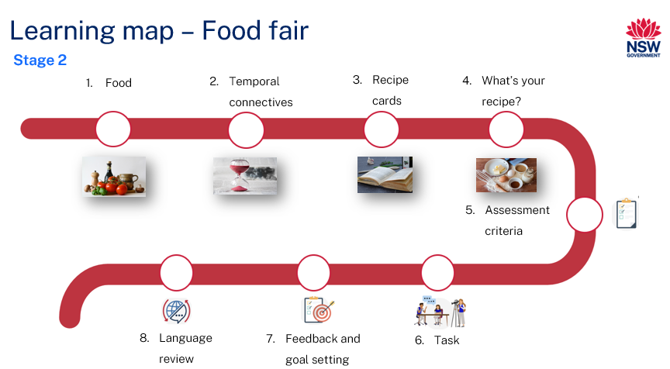

Figure 2 – व्यंजन मेला learning map
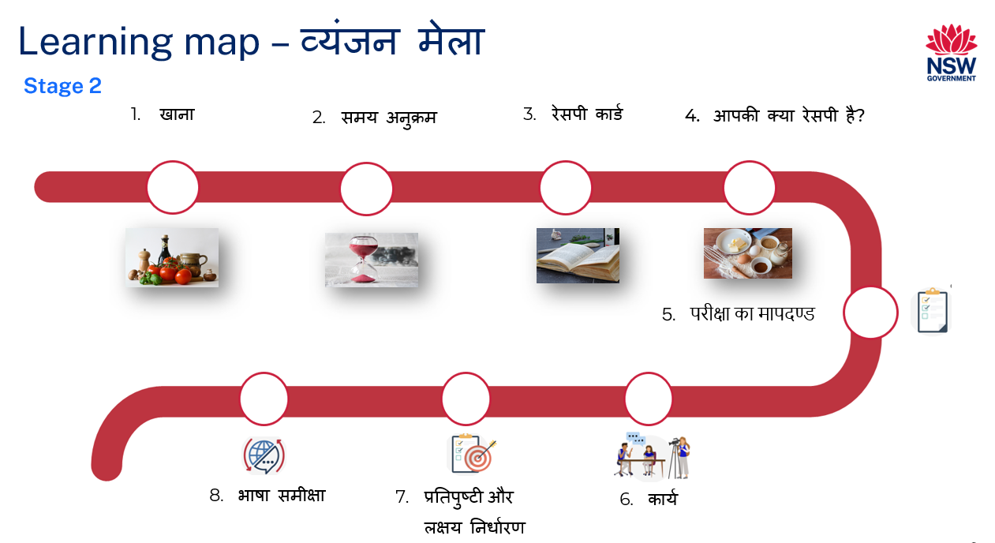

Assessment
Stage 2 communicative task: The local council is organising a multicultural food festival at a park near your school. Create a video demonstrating how to prepare a culturally relevant recipe that you have written in Hindi. You will send this video to the organisers to show them what you plan to cook at the festival.
Too hard?
Create a video in Hindi demonstrating how to prepare a culturally relevant recipe that is readily available.
Too easy?
Include a brief history and a fun fact about the cultural food in the video.
Context: multicultural food festival
Audience: organisers of the festival
Purpose: to inform the organisers of what you’ll cook at the festival

Assessment opportunities
The table below details assessment opportunities and differentiation ideas.
Assessment opportunities | Too hard? | Too easy?
Week 2: Recipe race  Students play a game to reinforce the concept of temporal connective and imperative verbs. | Use flash cards with images only. | Call out a multi-step instruction that includes 2 temporal connectives and 2 imperative verbs.
Week 3: Active listening  To assess students’ comprehension skills, students read the text and identify the errors. | Read the sentence with one focus at a time. Students listen for imperative verbs for the first few questions. | Students call out true and false questions for the class.
Week 4: What’s your recipe?  Students choose a no cook Indian recipe of their choice for the food fair. They write a recipe for the chosen food using a scaffold. | Students write simple sentences that match the images of a readily available recipe. | Students write a recipe without a scaffold.

Teaching and learning activities

Week 1: Food
The table below outlines the learning intentions and success criteria of the lesson and materials that the teacher and students will need to complete the teaching and learning activities.
Learning intentions and success criteria | Materials
Students will:  - communicate words and phrases related to food in Hindi  - learn imperative verbs.  Students can:  - say and write food vocabulary correctly in Hindi  - identify imperative verbs in sentences in Hindi  - use imperative verbs to give clear instructions in Hindi. | - Resource 1: Common ingredients and equipment flashcards  - Resource 2: Imperative verbs flashcards  - Video: Bhelpuri recipe (1:30)  - Hindi exercise books

Activity 1: Learning map
Explain and display the Learning map to give students a more detailed breakdown of lessons during the unit. Point out that the learning map is a plan that may need to change.

Vocabulary 1: Common ingredients and equipment
The below table outlines the suggested vocabulary for Activity 2. It includes original Hindi script, a Romanised version of Hindi script and the corresponding English translations.
हिन्दी | Romanised Hindi | English
प्याज़ | pyaaz | onion
टमाटर | tamaatar | tomato
दूध | doodh | milk
चीनी | cheeni | sugar
नमक | namak | salt
चावल | chawal | rice
आटा | aata | flour
पानी | paani | water
ब्रेड | bread | bread
कप | cup | cup
चम्मच | chammach | spoon
कटोरा | katora | bowl
सामग्री | samagri | ingredients

Activity 2: Pre-assessment
- Pre-assessment: Show students the images in Resource 1: Common ingredients and equipment flashcards. Ask them to identify how many words they think they know by answering the following questions and showing thumbs up at their chests:
- Do you know all the words for these pictures in Hindi?
- Do you know most of them?
- Do you know some of them?
- Do you know none of them?
- In pairs, students then Think-Pair-Share and tell their partners the words they know.
- Continue the pre-assessment by showing the video: Bhelpuri recipe (1:30). Students listen for the ingredients of bhelpuri. In pairs, they answer the following questions:
- Do you know more words now after watching the video than when you looked at the flashcards?
- Which words do you now know?
- As a whole class, match the words to the pictures one at a time. After each match, model and drill the correct pronunciation of vocabulary.
Note: display vocabulary on the wall. Add new and known words in Hindi as required.

Vocabulary 2: Imperative verbs
The table below outlines the suggested vocabulary for Activity 3 and Activity 4. It includes the original Hindi script, a Romanised version of the Hindi script, and the corresponding English translations.
हिन्दी | Romanised Hindi | English
फैंटैं | phaintay | whisk
उबालें | ubale | boil
कांटें | kaantay | cut
गूँदें | goonday | knead
छिड़कें | chidkay | sprinkle
मिलाएं | milaye | mix
डालें | daalay | pour/add
परोसें | parosay | serve

Activity 3: Imperative verbs
Note: in this unit, students will learn how to use imperative verbs, which tell someone to do something. They are standalone phrases with a subject, noun, or pronoun.
- Hindi has 3 imperative forms which correspond to the 3 forms of the second person singular personal pronoun. They are तू too (you-intimate), तुम tum (you-familiar) and आप aap (you-formal).
- The formal imperative form of pronoun is used when writing recipes.
- The formal imperative, आप (you), is formed by adding the suffix- iye/ay to the verb stem. For example, आप खाएं aap khaaye (eat), लाएं laaye (get), डालें daale (put), मिलाएं milaye (mix).
- Pre assessment: Show students the video: Bhelpuri recipe (1:30). Ask students what verbs they heard or saw either in English or in Hindi. In pairs, students Think-Pair-Share and tell their partners the words they know and report back to the class.
- Provide Hindi translations to the English words. Show pictures of Resource 2: Imperative verbs flashcards and model saying the vocabulary words in Hindi. Students repeat the words. Model and drill the correct pronunciation of vocabulary. Display pictures and imperative verbs on a piece of butcher’s paper.
- Display images from Resource 2: Imperative verbs flashcards one at a time. As a whole class, brainstorm cooking actions that students can mime for imperative verbs.
Suggested actions include:
- whisk – wrist action for whisk
- boil – wriggling of fingers
- knead – making a fist and moving wrists.
- Say an imperative verb and students mime the action. Repeat the activity with all the other verbs. Flip the activity with you miming the action and students guessing the verb in Hindi. After a few rounds, have students repeat the activity in pairs, taking turns at miming and guessing the actions.
- Compare Hindi words relating to cooking activities with their English equivalents, as well as discussing cultural differences related to the ways in which different people prepare their food. For example, in many cultures, bread is made using flour and water. Sometimes, seasoning is added for additional taste. Discuss breads in different cultures such as damper, naan, and pizza base. Ask how these types of bread are similar or different to Indian roti/chapatti.
- Students copy the words into their Hindi exercise books.
Note: it may be a good opportunity for students to make roti, with your supervision, to immerse themselves in the language and culture. Check if you have access to your school’s kitchen for this activity.
Evaluation: students accurately use the correct pronunciation to pronounce the vocabulary words.

Activity 4: Simon says
Split the class into groups. In each group, every student takes a turn at being ‘Simon’ and gives their classmates at least 2 imperative verbs to mime in Hindi. For example, if Simon says ‘whisk’, students mime whisking action using their wrists. However, if the student playing Simon instructs without saying, ‘Simon says’, then any student who follows that instruction given sits out. After each student has a turn being ‘Simon’ in the group, the game is complete.

Week 2: Temporal connectives
The table below outlines the learning intention and success criteria of the lesson and materials that the teacher and students will need to complete the teaching and learning activities.
Learning intention and success criteria | Materials
Students will learn to use temporal connective in a recipe.  Students can:  - understand the purpose of temporal connective in a recipe  - say and write temporal connective in Hindi  - use temporal connective in a recipe in Hindi. | - Resource 2: Imperative verbs flashcards  - Resource 3: Indian street food poster  - Resource 4: Recipe of bhelpuri  - Resource 5: Temporal connective flashcards  - Resource 6: Memory game flash cards  - Resource 7: Word mat  - Video: Bhelpuri recipe (1:30)  - Butchers paper  - Hindi exercise books  - Google Earth

Vocabulary 3: Food and taste
The table below outlines the suggested vocabulary for Activity 1. It includes the original Hindi script, a Romanised version of the Hindi script, and the corresponding English translations.
हिन्दी | Romanised Hindi | English
स्वादिष्ट | swaadisht | delicious
मीठा | meetha | sweet
खट्टा | khatta | sour
नमकीन | namkeen | salty
कड़वा | garam | hot
ठंडा | thanda | cold

Activity 1: Taste buds
Note: if time and facilities permit, cook the dish with the class and have students to try the food. However, check students’ health and religious limitations before having students try bhelpuri.
- Show students the video: Bhelpuri recipe (1:30). Brainstorm what ingredients are used in the recipe and what imperative words they can hear. Show the video again and have students complete the worksheet to record the ingredients, equipment and procedure used by the cook. This can be done in English or in Hindi. Recall and list vocabulary related to ingredients, numbers, equipment, and the procedure in Hindi.
- Show Resource 3: Indian street food poster and ask students the following questions:
- What is bhelpuri? (Bhelpuri is a sweet and sour crunchy snack which is a popular street food of Mumbai.)
- What does bhelpuri taste like? (Sweet and sour.)
- How would you describe different foods on the poster? (Delicious, sweet, sour, salty, spicy, hot, cold.)
- Discuss the cultural significance of street food in India by showing pictures of different types of street food in Resource 3: Indian street food poster. Use Google Earth to show street food stalls near Juhu Beach, Mumbai and ‘Little India’ in Harris Park. Ask students what street food is found in Australia.
- Students write vocabulary words in their Hindi exercise books.

Vocabulary 4: Temporal connectives
Note: a temporal connective is a word or phrase that indicates when something is happening. For example, first, next, finally, before, after, then. Temporal connectives are also known as adverbs of time.
The table below outlines the suggested vocabulary for Activity 2, Activity 3 and Activity 4. It includes the original Hindi script, a Romanised version of the Hindi script, and the corresponding English translations.
हिन्दी | Romanised Hindi | English
पहले | pehle | first
फिर | phir | then/next
उसके बाद | uske baad | after that
अंत में | ant mein | finally

Activity 2: Temporal connectives
- Display large chart paper or use a whiteboard to create a mind map of temporal connectives. Ask students what an adverb of time or a temporal connective is. Ask them to suggest temporal connectives they know and encourage them to think about words that help indicate the order of steps or actions. Discuss the meaning of each temporal connective and emphasise their role in indicating time or sequence.
- Watch the video: Bhelpuri recipe (1:30) again. Ask students to identify temporal connectives and have them share their responses.
- As a whole class, discuss the impact of using temporal connectives in making the recipe instructions clear and easy to understand.
- Cut the strips of Resource 4: Recipe of bhelpuri and jumble them in an envelope. Split the class in small groups of 3 and hand out the envelopes for students to reorder strips of sentences to assemble the recipe.
- Students write temporal connectives in Hindi in their Hindi exercise books.

Activity 3: Recipe race
- Revise Imperative verbs from the previous lesson.
- Split the class in groups of 4 and distribute Resource 2: Imperative verbs flashcards and Resource 5: Temporal connective flashcards to each team. Explain that it is time for a fun race to reinforce the concept of temporal connective and imperative verbs. Students take turns calling out a specific temporal connective and an imperative verb. For example, पहले (pehle/first), छीलें (cheelay/peel).
- Each team finds the announced temporal connective and imperative verb from the flash cards. One person from the team races to the front of the room and sticks them on the board. The team that displays the correct combination first wins a point. Repeat the process with different temporal connectives and imperative verbs until all teams have had a chance to participate.

Activity 4: Memory game
Split the class in groups of 4 and hand out Resource 6: Memory game flashcards to play a memory game with images of the food, verbs and temporal connectives from the vocabulary lists, along with the corresponding Hindi words. Students mix the flash cards and put them face down on the desk or floor. Students alternate turning 2 cards over and reading the word aloud. When students have a matching pair, they keep it (however, they do not get another turn, so that all students have an opportunity to participate). The winner has the most pairs when all the cards are matched. Students can have Resource 7: Word mat to refer to.

Week 3: Recipe cards
The table below outlines the learning intention and success criteria of the lesson and materials that the teacher and students will need to complete the teaching and learning activities.
Learning intention and success criteria | Materials
Students will understand the features of a recipe.  Students can:  - identify the key components of a recipe such as title, ingredients and instructions  - say and write ingredients used in a recipe in Hindi  - say and write imperative verbs used in a recipe in Hindi  - say and write temporal connectives used in a recipe in Hindi  - say, write and understand the sentences in Hindi. | - Resource 4: Recipe of bhelpuri  - Resource 8: Annotated recipe of bhelpuri  - Resource 9: Understanding the recipe  - Die (with pockets)  - Hindi exercise books  - Sticky notes
Note: use this lesson as an opportunity to teach correct sentence structure by modelling and highlighting appropriate vocabulary and grammar to students. It is important that students receive explicit support using scaffolds as they learn to create texts in the target language.

Activity 1: Deconstruct the recipe
For suggested vocabulary for this activity, refer to Vocabulary 1, Vocabulary 2 and Vocabulary 4.
- Show Resource 4: Recipe of bhelpuri as a text. Show students features of a recipe. Explain that a recipe contains a title, numbered instructions, imperative verbs, temporal connective, ingredients, and quantities. Show Resource 8: Annotated recipe of bhelpuri. Highlight different parts of the recipe. Deconstruct the text as you read it aloud clearly and slowly. Ask questions, such as:
- How do you say tomatoes in Hindi?
- How do you say onions in Hindi? Repeat with other vocabulary.
- Where is imperative verb in the first, second and third step?
Note: if time and learner proficiency permit, ask these questions in Hindi.
- Hand out Resource 4: Recipe of bhelpuri to students. Ask students to use different colours to highlight temporal connectives, imperative verbs and ingredients. Emphasise that the imperative verbs are at the end of a sentence when giving instructions in Hindi and that the correct order of words when giving instructions is temporal connective, equipment/ingredients, imperative verbs.
- Annotate a sentence on the board, for example:
Figure 3 – Annotated sample sentence
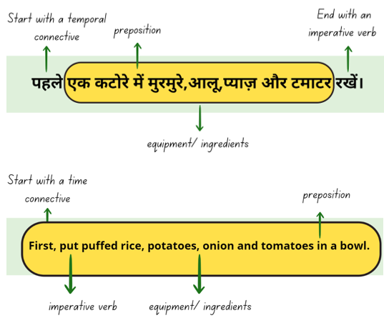
Images sourced from Canva and used in accordance with the Canva Content License Agreement.
- Use Resource 9: Understanding the recipe to write ingredients, temporal connectives and imperative verbs in Hindi using the recipe.

Activity 2: Active listening
Read the text from Resource 8: Annotated recipe of bhelpuri again, but this time with a few errors. Ask students to spot the mistake. For example, change the verb at the beginning of the sentence or read the steps in a different order. Students respond with thumbs up if the statement is true and thumbs down if the statement is false.
Using Resource 4: Recipe of bhelpuri, ask students to quiz their partner on the text in English while their partner responds in Hindi. Set a timer of 2 minutes for this activity. Students switch roles after 2 minutes. Set another timer of 2 minutes to complete the activity. For example:
- Student A: How do you say onions in Hindi?
- Student B: प्याज़ (pyaaz/onions)
- Student A: How many potatoes do you need to make bhelpuri?
- Student B: दो (do/two)
- Student A: What imperative verb is used in the first step?
- Student B: रखें (rakhay/put)

Activity 2: Is it in a sequence?
Note: keep each step of the recipe in a different envelope so the words don’t get mixed up. Create your own jumbled up sentences using the steps in the recipe of bhelpuri.
In pairs, students unjumble the words in a sentence using Resource 5: Recipe of bhelpuri for the steps of the recipe. For example:
- Jumbled up words: रखें। आलू, टमाटर, पहले प्याज़, मुरमुरे और पहले
- Unjumbled/correct sentence: पहले एक कटोरे में प्याज़, टमाटर, मुरमुरे और आलू रखें। (First, put puffed rice, potatoes, onion, and tomatoes in a bowl).

Activity 3: The rolling effect
Prepare 3 dice with names or images of ingredients, imperative verbs and temporal connective. Split the class in small groups of 4. Students roll 3 die simultaneously and make a statement using the images or words. For example, the 3 die show the words next, tomato and mix. Students will say the sentence: फिर, टमाटर मिलाएं। (Next, mix the tomatoes).

Activity 4: Exit ticket
To assess students’ understanding of sentence structure, divide the board into 3 sections and ask students to write the temporal connective, ingredient/equipment and imperative verb on sticky notes. As students leave the class, they stick their notes in the correct order to make a simple sentence on the board. For example, Next, cut the onions. फिर प्याज़ कांटे।
Figure 4 – Exit ticket example
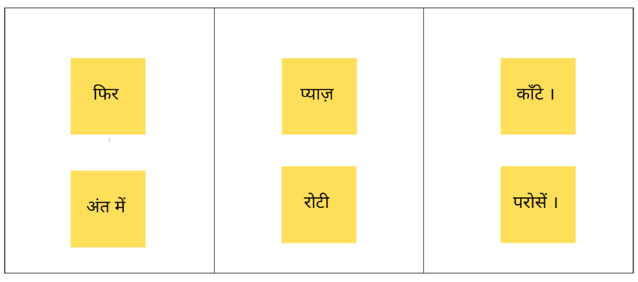

Week 4: What’s your recipe?
The table below outlines the learning intention and success criteria of the lesson and materials that the teacher and students will need to complete the teaching and learning activities.
Learning intention and success criteria | Materials
Students will create their own recipe card.  Students can:  - correctly list all ingredients required for the recipe in Hindi  - correctly use imperative verbs in Hindi to provide step-by-step instructions  - use appropriate temporal connective to organise instructions in a sequence in Hindi. | - Resource 7: Word mat  - Resource 10: Mango lassi- step-by-step cards  - Resource 11: Recipe template  - Resource 12: Bhelpuri recipe presentation  - Materials for recipe  - Sticky notes for peer feedback

Activity 1: Working with images
Note: the steps written under the images for Resource 10: Mango lassi step-by-step cards are for teacher reference to jointly construct the sentences. Delete or remove the sentences before handing out to students.
- Display Resource 10: Mango lassi step-by-step cards on a screen. Ask students what ingredients they think are used to make mango lassi. As a whole class, jointly co-construct sentences that match with the images.
- See the below table for possible sentences for the recipe of mango lassi.
Image number | Hindi | Romanised Hindi | English
1 | पहले आम, दही, दूध और चीनी को blender में २ minute के लिए ब्लेन्ड करें। | Pehle aam, dahi, doodh aur cheeni ko blender mein 2 minute ke liye blend kare. | First, put mango, milk and sugar in a blender and blend for 2 minutes.
2 | फिर, mango lassi को गिलास में डालें। | Phir, mango lassi ko glass mei daale. | Then, pour mango lassi in a glass.
3 | उसके बाद, एक चुटकी इलायची छिड़कें। | Uske baad, ek chutki ilaychi chidke. | After that, sprinkle a pinch of cardamom powder on mango lassi.
4 | अंत में, ठंडा परोसें। | Unt mein, Thanda parose. | Finally, serve the mango lassi cold.
- Hand out Resource 10: Mango lassi step-by-step cards. In pairs, students write a recipe using the images and jointly constructed sentences as a scaffold. Provide students with Resource 7: Word mat and a dictionary to help them with learnt and new vocabulary.
- Peer Assessment: Students provide feedback to each other by writing ‘Two Stars and a Wish’ on a sticky note.

Activity 2: What’s your recipe?
- Ask students to choose a no cook recipe for an Indian dish of their choice for the food fair. Suggested recipes include आम की लस्सी (mango lassi), नींबू पानी (lemonade), नारियल के लड्डू (coconut laadoo), गुलाब दूध (rose milk), रायता (raita), चाट (chaat) and so on.
- Provide students with Resource 11: Recipe template as a scaffold for them to write the recipe. Students write the recipe on the template or in their Hindi exercise books.
- Once completed, students make a presentation using PowerPoint or Canva matching the recipe that they have created. Students may refer to the Bhelpuri recipe presentation. If needed, refer to the guides provided on PowerPoint or Canva to support students in exporting their presentations to complete the task.

Week 5: Assessment criteria
The table below outlines the learning intention and success criteria of the lesson and materials that the teacher and students will need to complete the teaching and learning activities.
Learning intention and success criteria | Materials
Students will develop a clear understanding of the requirements of the assessment task.  Students can:  - suggest appropriate success criteria  - explain what they need to do to be successful in the task. | - Resource 13: Assessment task – Food fair  - Resource 14: Rubric – Food fair  - Resource 15: Peer feedback strategy – Two stars and a wish  - Completed recipe  - Hindi exercise books  - Laptops or devices for creating presentation

Activity 1: Communication of the assessment task
Ensure students have enough time to create their own recipe and record and narrate a presentation on PowerPoint or Canva.

Activity 2: Assessment task
Hand out Resource 13: Assessment task – Food fair and lead the class in reading it.

Activity 3: Success criteria
After looking at the assessment task, students Think-Pair-Share and suggest appropriate success criteria, such as:
I will be successful if I can:
- create a recipe using appropriate ingredients and quantities
- give instructions in a recipe using imperative verbs
- sequence the steps in a recipe using temporal connective
- include a short description of the food that includes taste and cultural significance
- use correct sentences with correct grammar
- use nouns with the correct gender
- use the correct order of words
- pronounce the words correctly
- speak in a well-paced manner without long pauses.

Activity 4: Discuss the rubric
- Show students an unmarked rubric Resource 14: Rubric – Food fair. This may need to be adapted if the class has decided on different success criteria.
- Explain the metalanguage such as fluency, accuracy, pronunciation and vocabulary.
- Students read and then discuss the ‘Got it’ column of the rubric in pairs. They then share their understanding of what is needed to be successful.
- Point out and provide examples of what ‘got it’ and ‘sort of’ samples of task completion, fluency, accuracy, pronunciation and vocabulary look and sound like.

Activity 5: Peer assessment
Peer feedback will be incorporated into the task (see Resource 15: Peer feedback strategy – Two stars and a wish. Confirm which peer feedback strategy will be used, for example, Two stars and a wish, and discuss with students.
Evaluation: students give examples of what stars and wishes would sound like for this task.

Activity 6: Practice task
Students create their own recipe and record and narrate a presentation on PowerPoint or Canva. If needed, refer to the guides provided on PowerPoint or Canva to support students in exporting their presentations to complete the task.

Week 6: Communicative task
The table below outlines the learning intention and success criteria of the lesson and materials that the teacher and students will need to complete the teaching and learning activities.
Learning intention and success criteria | Materials
Students will record a video demonstrating how to prepare a culturally relevant recipe that they have written in Hindi.  Students can:  - create a recipe using appropriate ingredients and quantities  - give instructions in a recipe using imperative verbs  - sequence the steps in a recipe using temporal connective  - include a short description of the food that includes taste and cultural significance  - use correct sentences with correct grammar  - use nouns with the correct gender  - use the correct order of words  - pronounce the words correctly  - speak in a well-paced manner without long pauses. | - Bhelpuri recipe presentation  - Resource 13: Assessment task – Food fair  - Resource 14: Rubric – Food fair  - Resource 15: Peer feedback strategy – Two stars and a wish  - Completed recipe card  - Microphones (if possible)  - Tablets or laptops

Activity 1: Task preparation
If required, ensure students have enough time to finish writing their recipe. Students then complete their presentation and record their voice over the slides.

Activity 2: Communicative task
This task will be completed individually. Each student creates their own recipe and a matching presentation using PowerPoint or Canva. Students will narrate their presentation in a video that meets the success criteria. Students may refer to the Bhelpuri recipe presentation. If needed, refer to the guides provided on PowerPoint or Canva to support students in exporting their presentations to complete the task.

Activity 3: Peer feedback
- Hand out Resource 13: Assessment task – Food fair and Resource 14: Rubric – Food fair.
- Make sure to space students apart, using microphones if possible, to maximise sound quality.
- Divide students into pairs. Students take turns providing peer assessment to the presenter using the ‘Two stars and a wish’ strategy.
- Students provide peer feedback verbally and follow up with the completed Resource 15: Peer feedback strategy – Two stars and a wish.

Week 7: Feedback and goal setting
Note: if there is insufficient time to mark the videos before Week 8, Weeks 7 and 8 can be swapped.
The table below outlines the learning intention and success criteria of the lesson and materials that the teacher and students will need to complete the teaching and learning activities.
Learning intention and success criteria | Materials
Students will reflect on their task recordings to assess performance and set learning goals.  Students can:  - self-assess their completion of the task  - set suitable learning goals based on previous learning goals and teacher, peer- and self-assessment. | - Resource 14: Rubric – Food fair (one teacher-completed copy per student)  - Resource 14: Rubric – Food fair (one per student for self-assessment)  - Hindi exercise books  - Tablets or other recording devices

Teacher preparation
Note: prior to this lesson, view each video and mark each student according to the criteria on Resource 14: Rubric – Food fair.

Activity 1: Self-assessment
Students watch the video of themselves completing the task and use the rubric to self-assess. Students compare their self-assessment rubric with the teacher’s completed rubric.

Activity 2: Set learning goals
Students reflect on the teacher, peer and self-evaluation to set goals for the next phase of learning. For example, ‘I will not be worried about making a mistake when speaking Hindi’ and ‘I will try to say (a particular sound) correctly’. Students write their learning goals in their language notebooks.
Evaluation: students set appropriate learning goals based on teacher, peer- and self-assessment.

Week 8: Language review
Note: if there is insufficient time to mark the videos before Week 8, Weeks 7 and 8 can be swapped.
The table below outlines the learning intention and success criteria of the lesson and materials that the teacher and students will need to complete the teaching and learning activities.
Learning intention and success criteria | Materials
Students will reflect on and ask questions about the language taught in this unit.  Students can:  - ask questions about vocabulary, grammar, or pronunciation they have used in this unit  - use the language they have learned to communicate with classmates in Hindi. | - Resource 6: Memory game flashcards  - Resource 7: Word mat  - Resource 9: Understanding the recipe  - Resource 10: Mango lassi step-by-step cards  - Cut up recipe cards with images and steps  - Dominos cards (teacher prepared)  - Jumbled up words (teacher created)  - Hindi exercise books  - Recipes for bhelpuri and mango lassi (recorded by teacher)
Note: over the course of the unit, gaps in student knowledge, misconceptions and misuse of language will have been identified. These observations are addressed using engaging and interactive activities and strategies. The activities below are examples and will need to be supplemented with activities to address your observations.

Activity 1: Student questions
Remind students of the activities and tasks over the course of the unit. Students are given time to Think-Pair-Share any questions they may have about any aspect of the language taught.
Note: set up different language stations for Activities 2–4 that will focus on reinforcing word work, grammar, listening and responding. These activities can be adapted to suit students’ needs. Students rotate in groups after a set timer to a different station to complete the activities with a different focus.

Activity 2: Word work
This station will focus on reviewing learnt vocabulary.
Suggested activities:
- Simon says: students play a game of ‘Simon says’ in their group. Every student takes a turn at being Simon and gives their classmates at least 2 imperative verbs to mime in Hindi. For example, if Simon says ‘whisk’, students mime whisking action using their wrists. However, if the student playing Simon instructs without saying, ‘Simon says’, then any student who follows that instruction given sits out. After each student has a turn being Simon in the group, the game is complete. Use Resource 7: Word mat.
- Dominos: make domino cards with vocabulary words, images, and their English translation. Provide students with a set of dominoes and play with a time limit.
- Memory: use Resource 6: Memory game flashcards to play a game of memory. Mix the cards and put them face down on the desk or floor. Students take turns to turn 2 cards face up and read the word aloud. When students have a matching pair, they keep it. The winner has most pairs when all the cards are matched. Students may have Resource 7: Word mat to refer to.

Activity 3: Grammar
This station will focus on strengthening and reviewing grammar skills.
Suggested activities:
- Cue cards: prepare a deck of cards with English sentences to translate to Hindi. Students take turns in picking a card and translating. Students take turns to be the referee. Students score a point for the correct translation.
Note: have an answer sheet available for students to check their response.
- Picture task: create recipe cards with images. Students write steps for a dish in Hindi that match with the images. See Resource 10: Mango lassi step-by-step cards for a sample recipe.
- Sentence re-ordering: the words in a sentence are randomly and incorrectly arranged. Students rearrange the words to make a sentence with the correct sentence structure.

Activity 4: Listening and responding
This station will focus on strengthening and reviewing listening and responding to texts skills.
Suggested activities:
- Gap fill activity: students listen to the recipe for mango lassi or bhelpuri recorded by the teacher or read aloud by another student. Students fill the gaps with the words they hear. Compare and discuss the completed gap fill sheet with a partner.
- Q&A: students listen to an audio recording of a recipe. In pairs, students write approximately 5 comprehension questions for a partner to respond. Questions and answers are written in English.
- Sort it out: students listen to the recipe recorded by the teacher, or another student reads aloud their recipe. Categorise the text in Resource 9: Understanding the recipe to find ingredients, imperative verbs and temporal connective used in the recipe.

Student resources

Resource 1: Common ingredients and equipment flashcards
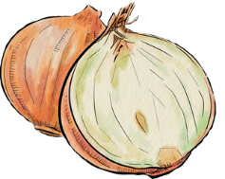
प्याज़ |  | टमाटर |  | दूध |  | चीनी
नमक |  | पानी |  | ब्रेड |  | आटा

कप |  | कटोरा |  | चम्मच |  | बेलन
चाकू |  | तवा |  | थाली |  | करछी
Images sourced from Canva and used in accordance with the Canva Content License Agreement.

Resource 2: Imperative verbs flashcards
फैंटें |  | उबालें |  | गूँदें |  | छिड़कें
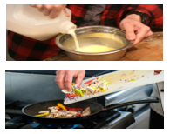
डालें |  | कांटें |  | मिलाएं |  | परोसें
Images sourced from Canva and used in accordance with the Canva Content License Agreement.

Resource 3: Indian street food poster
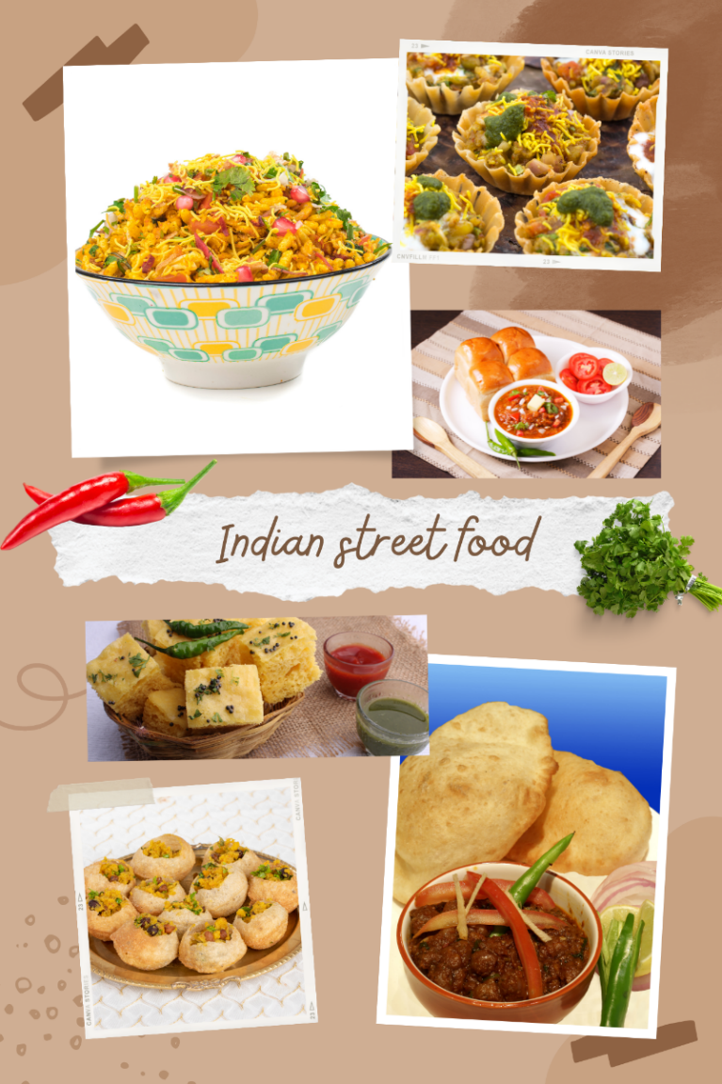
Images sourced from Canva and used in accordance with the Canva Content License Agreement.

Resource 4: Recipe of bhelpuri
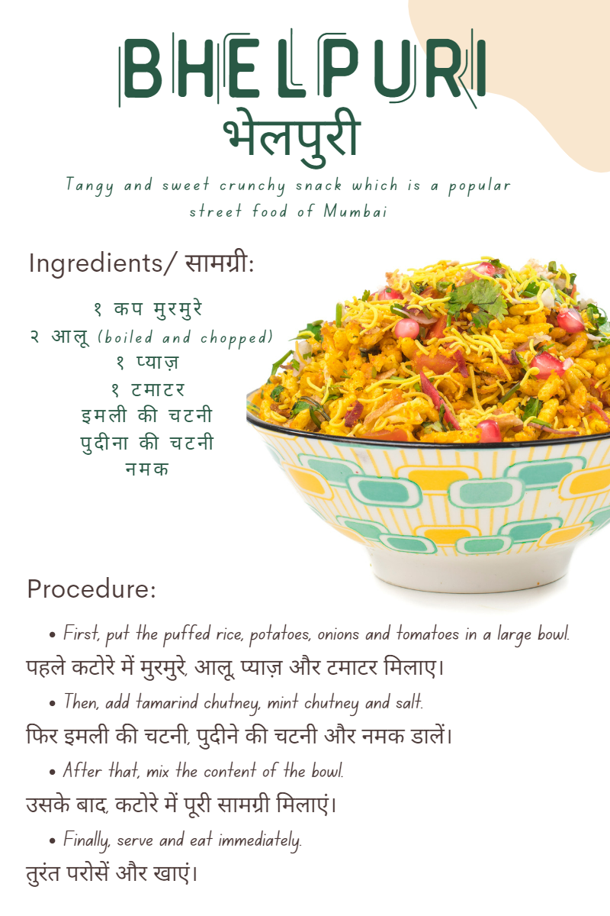
Images sourced from Canva and used in accordance with the Canva Content License Agreement.

Resource 5: Temporal connective flashcards
पहले |  | फिर |  | उसके बाद |  | अंत में
Images sourced from Canva and used in accordance with the Canva Content License Agreement.

Resource 6: Memory game flashcards

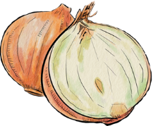

Images sourced from Canva and used in accordance with the Canva Content License Agreement.
फैंटें |  | उबालें |  | गूँदे |  | छिड़कें
डालें |  | कांटे |  | मिलाएं |  | परोसें

पहले |  | फिर |  | उसके  बाद |  | अंत में
प्याज़ |  | टमाटर |  | नमक |  | दूध

ब्रेड |  | चीनी |  | आटा |  | कटोरा
तवा |  | चम्मच |  | बेलन |  | चाकू

Resource 7: Word mat
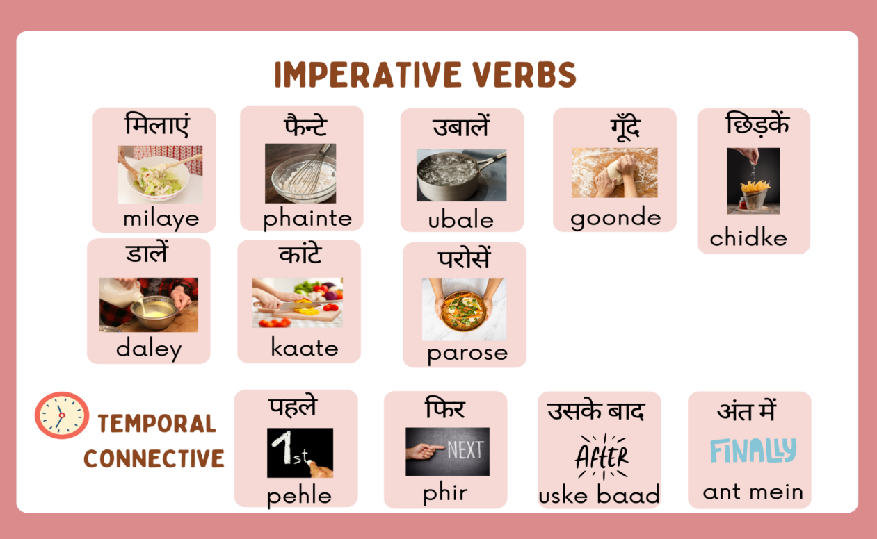
Images sourced from Canva and used in accordance with the Canva Content License Agreement.
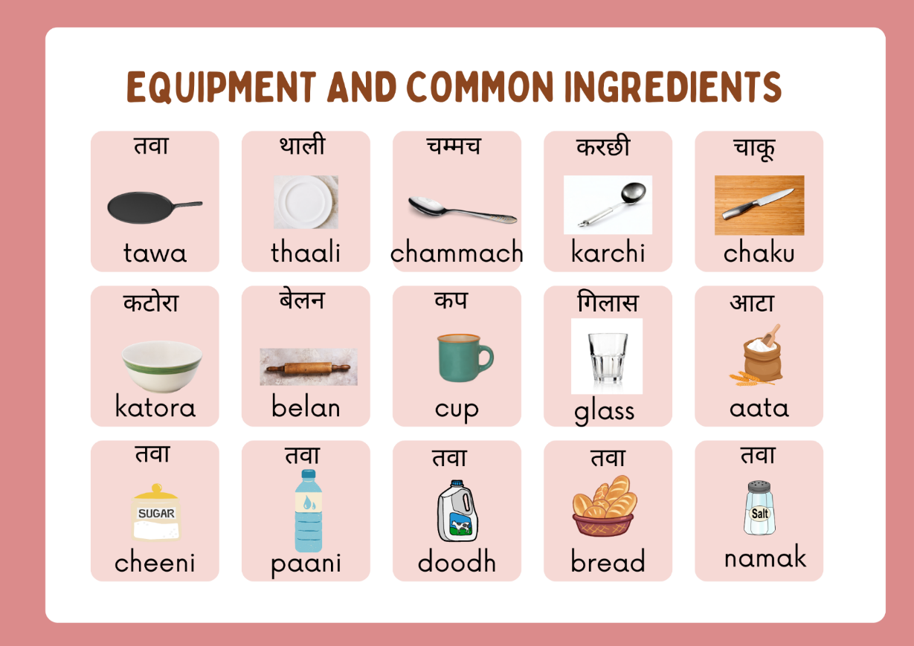
Images sourced from Canva and used in accordance with the Canva Content License Agreement.

Resource 8: Annotated recipe of bhelpuri
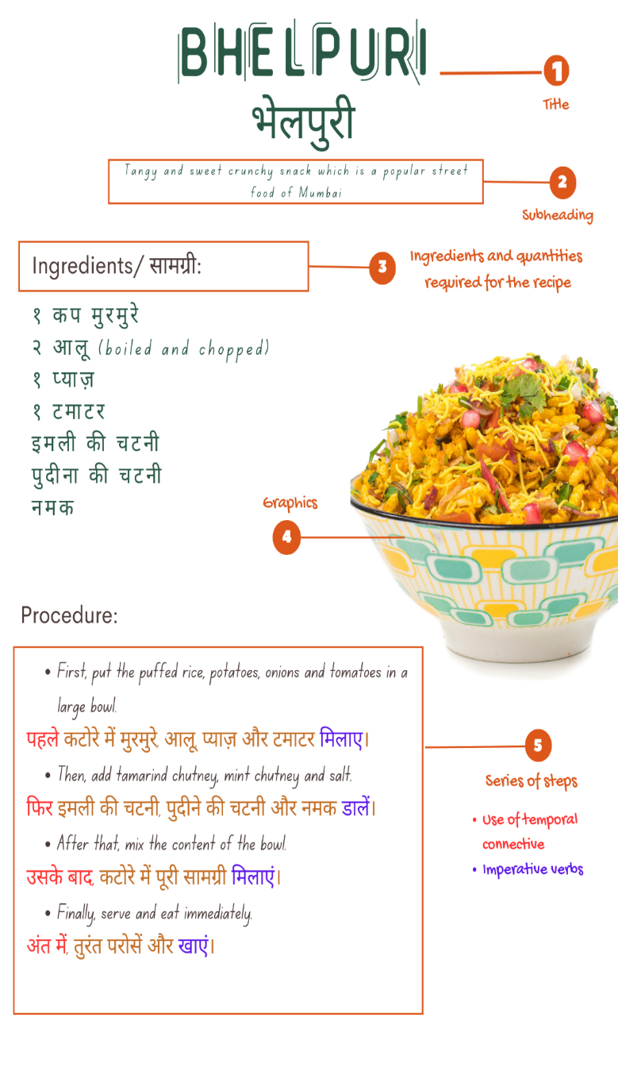
Images sourced from Canva and used in accordance with the Canva Content License Agreement.

Resource 9: Understanding the recipe
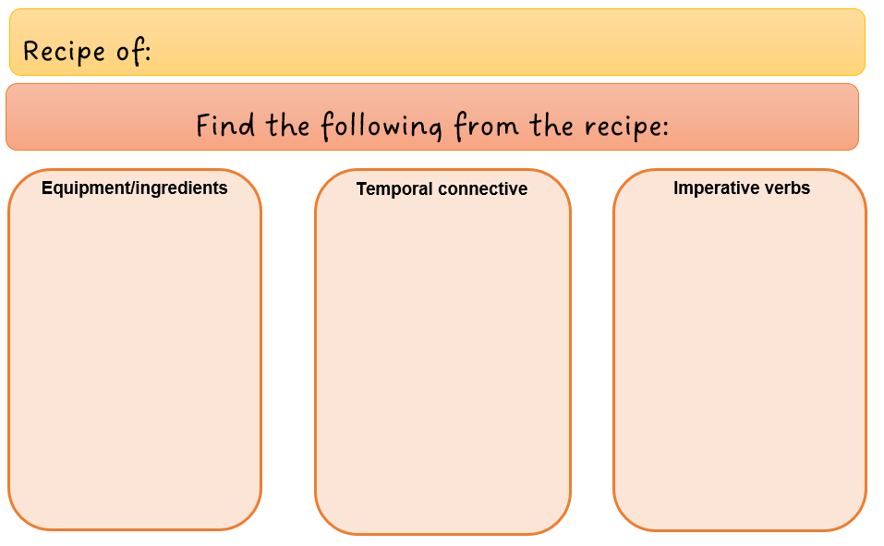

Resource 10: Mango lassi step-by-step cards
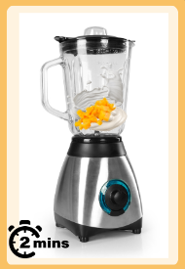 |  |  |  | 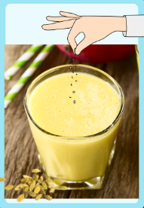 |  | 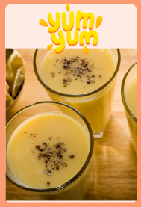
पहले आम, दही, दूध और चीनी को blender में २ minute के लिए ब्लेन्ड करें। |  | फिर, mango lassi को गिलास में डालें। |  | उसके बाद, एक चुटकी इलायची छिड़कें। |  | अंत में, ठंडा परोसें।
First, blend mango, yogurt, milk and sugar in a blender for 2 minutes. |  | Then, pour mango lassi in a glass. |  | After that, sprinkle one pinch of cardamom powder. |  | Finally, serve cold.
Images sourced from Canva and used in accordance with the Canva Content License Agreement.

Resource 11: Recipe template
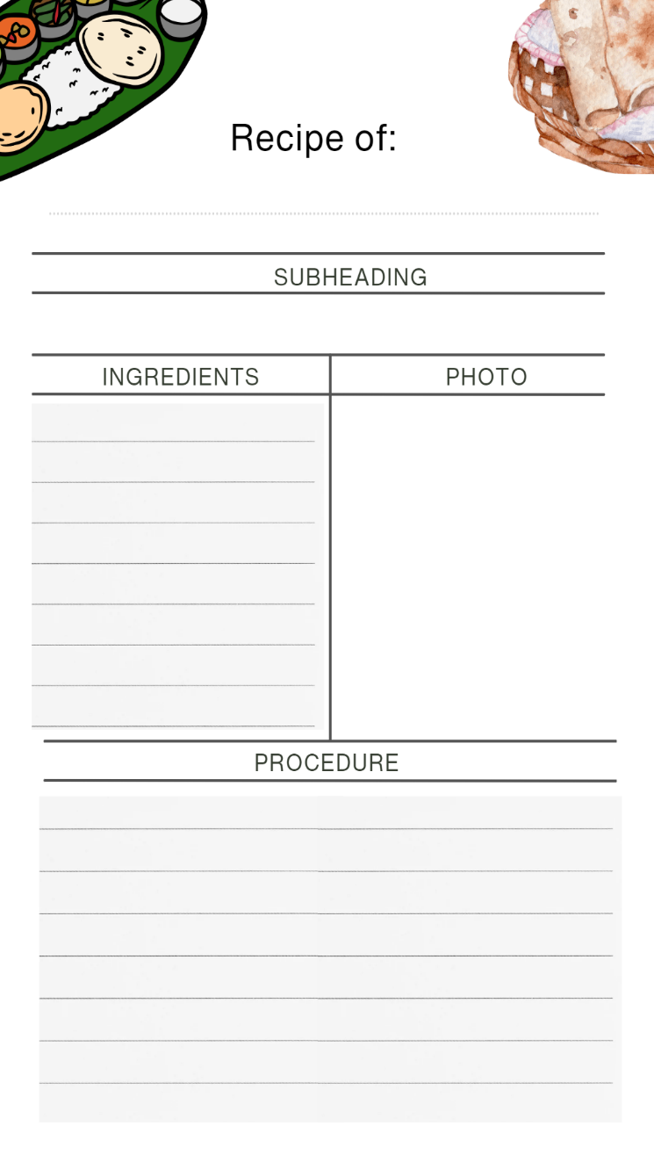
Images sourced from Canva and used in accordance with the Canva Content License Agreement.

Resource 12: Bhelpuri recipe presentation
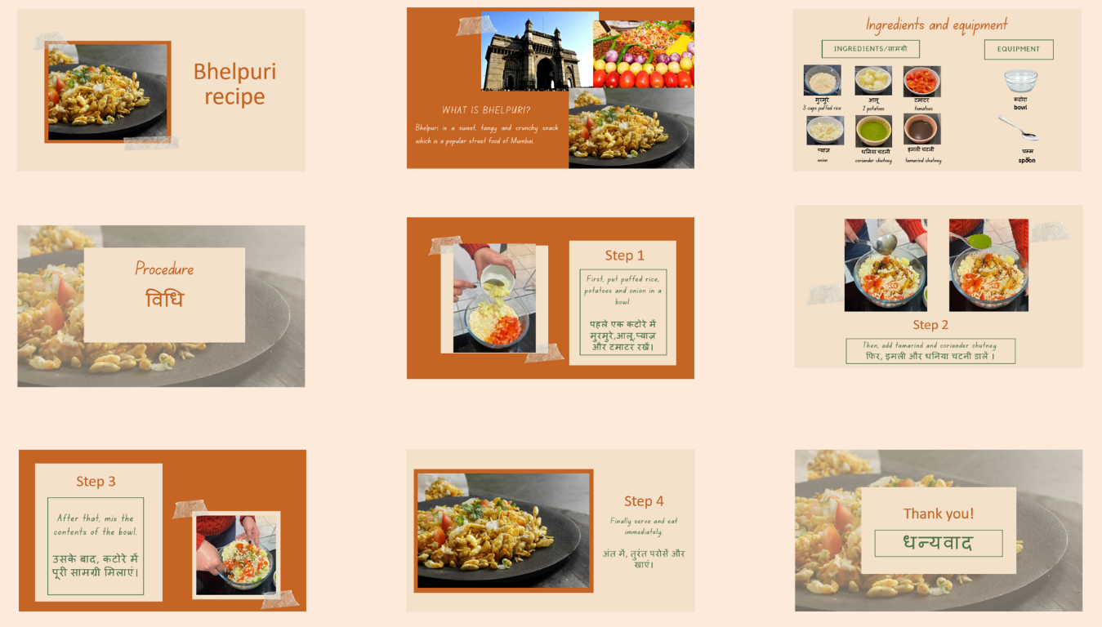
Images sourced from Canva and used in accordance with the Canva Content License Agreement.

Transcript and translation of the presentation
Slide 1
Narrator: नमस्ते बच्चों! आज मैं आपको भेलपुरी बनाने की विधि बताऊँगी। लेकिन उससे पहले, भेलपुरी क्या है?
Narrator: Namaste kids! Today I will tell you the procedure of making bhelpuri. But before that, what is bhelpuri?
[Screen shows an image of bhelpuri and the words bhelpuri recipe].
Slide 2
Narrator: भेलपुरी एक स्वादिष्ट खट्टा और मीठा snack है। यह Mumbai का एक लोकप्रिय street food भी है।
Narrator: Bhelpuri is a delicious sweet and sour snack. It is Mumbai’s popular street food.
[Screen shows pictures of Gateway of India, street food with onions, tomatoes, potatoes and chillies and a plate of bhelpuri. The words what is bhelpuri and its description is on the screen.
Slide 3
Narrator: भेलपुरी बनाने के लिए आपको यह सामग्री चाहिए – ३ कप मुरमुरे, २ आलू टमाटर, प्याज़, धनिया चटनी और इमली चटनी । भेलपुरी बनाने के लिए आपको एक कटोरे और एक चम्मच की जरूरत पड़ेगी।
Narrator: You need the following ingredients to make bhelpuri: 3 cups puffed rice, 2 potatoes, tomatoes, onion, coriander chutney and tamarind chutney. You would also need a bowl and a spoon.
[Screen shows images of all the ingredients and equipment required for the recipe of bhelpuri. These images are labelled in English and Hindi].
Slide 4
Narrator: भेलपुरी बनाने की विधि।
Narrator: Here’s the procedure to make bhelpuri.
[Screen shows a words procedure written in English and Hindi].
Slide 5
Narrator: पहले एक कटोरे में मुरमुरे,आलू,प्याज़ और टमाटर रखें।
Narrator: First put puffed rice, potatoes and onion in a bowl.
[Screen shows an image of putting all ingredients in a bowl. The first step of the procedure is written in English and Hindi].
Slide 6
Narrator: फिर, इमली और धनिया चटनी डालें ।
Narrator: Then, add tamarind and coriander chutney.
[Screen shows 2 images. In the first image, tamarind chutney is poured in the bowl. In the second image, coriander chutney is poured. The second step of the procedure is written in English and Hindi].
Slide 7
Narrator: उसके बाद, कटोरे में पूरी सामग्री मिलाएं।
Narrator: After that, mix the contents of the bowl.
[Screen shows a picture of mixing all the ingredients. The third step of the procedure is written in English and Hindi].
Slide 8
Narrator: अंत में, भेलपुरी तुरंत परोसें और खाएं। आपकी भेलपुरी अब तैयार है।
Narrator: Finally, serve and eat immediately. Bhelpuri is now ready.
[Screen shows a picture of plated bhelpuri. The fourth step of the procedure is written in English and Hindi].
Slide 9
Narrator: सुनने के लिए धन्यवाद।
Narrator: Thank you for listening.
[Screen shows the word thank you in English and Hindi. End of transcript].

Resource 13: Assessment task – Food fair

Outcomes
You will be assessed on how well you:
- create texts for familiar communicative purposes by selecting culturally appropriate modelled language.

Task
The local council is organising a multicultural food festival at a park near your school. Create a video demonstrating how to prepare a culturally relevant recipe that you have written in Hindi. You will send this video to the organisers to show them what you plan to cook at the festival.
Too hard? | Too easy?
Create a video in Hindi demonstrating how to prepare a culturally relevant recipe that is readily available. | In the video, include a brief history and fun fact about the cultural food.

Learning intention
Students will be able to create a video demonstrating the process of preparing a culturally relevant recipe that they have written in Hindi, which they will later cook at the festival.
Advanced learners
Students will be able to include a brief history and fun fact about the cultural food in the video.

Success criteria
You will record a video going through the steps of a recipe of a culturally relevant Indian dish in Hindi for the multicultural food festival.
You will be successful if you can:
- create a recipe using appropriate ingredients and quantities
- give instructions in a recipe using imperative verbs
- sequence the steps in a recipe using temporal connective
- include a short description of the food that includes taste and cultural significance
- use correct sentences with correct grammar
- use nouns with the correct gender
- use the correct order of words
- pronounce the words correctly
- speak in a well-paced manner without long pauses.

Task instructions
- This task will be completed individually. You will create a recipe of your choice and a matching presentation using PowerPoint or Canva. You will also make an audio recording of your presentation and create a video that meets the success criteria. Refer to the video and presentation for bhelpuri to help you complete the task. You will be assessed on all the criteria in the rubric.
- Following the task, you will watch a recording of yourself completing the task. You can self-assess by marking yourself on the ‘Food fair! assessment rubric’. Then compare the self-assessed rubric and the teacher marked rubric.
- Reflect on your performance and identify areas for improvement. Use this information to set a learning goal for the next stage of your learning journey.

Resource 14: Rubric – Food fair
Name:
Rubric for ‘Food fair’
Table 1 – Marking criteria
Criteria | Excellent | Got it | Sort of | Getting there | Not yet
Communication | Your audience, the organisers of the festival, clearly understands what you want to communicate.  Successfully and thoroughly complete all the following aspects of the task:  - create a recipe using appropriate ingredients and quantities  - give instructions in a recipe using imperative verbs  - sequence the steps in a recipe using temporal connective  - include a short description of the food that includes taste and cultural significance | Your audience, the organisers of the festival, can understand what you want to communicate.  Successfully complete most of the following aspects of the task:  - create a recipe using appropriate ingredients and quantities  - give instructions in a recipe using imperative verbs  - sequence the steps in a recipe using temporal connective  - include a short description of the food that includes taste and cultural significance | Your audience, the organisers of the festival, can mostly understand what you want to communicate.  Successfully complete most of the following aspects of the task:  - create a recipe using appropriate ingredients and quantities  - give instructions in a recipe using imperative verbs  - sequence the steps in a recipe using temporal connective  - include a short description of the food that includes taste and cultural significance | Your audience, the organisers of the festival, can rarely understand what you want to communicate.  Do not complete all aspects of the task. | Your audience, the organisers of the festival, struggles to understand what you want to communicate.  Unable to complete any aspect of the task.
Grammar | Always say Hindi words in the correct order when speaking:  - use nouns with the correct gender  - use formal form of imperative verbs for example. | Usually say Hindi words in the correct order and when speaking:  - use nouns with the correct gender  - use formal form of imperative verbs. | Make some of the following grammar mistakes when speaking in Hindi:  - use nouns with the correct gender  - use formal form of imperative verbs. | Rarely make sense when speaking in Hindi. | Unable to be understood.
Pronunciation | Pronounce the words correctly. | Pronounce most words correctly. | Consistently make pronunciation errors. | Pronounce only a few words correctly. | Unable to be understood.
Fluency | Speak Hindi with ease, in a well-paced manner without long pauses. | Speak confidently with appropriate speed and expression. | Usually speak confidently with appropriate speed and expression. | Don’t speak confidently. | Unable to be understood.
Vocabulary | Use full range of vocabulary correctly and use relevant words to expand on the topic. | Use expected vocabulary correctly to complete the task. | Make some mistakes when trying to use expected vocabulary. | Make many mistakes when trying to use expected vocabulary. | Unable to use vocabulary in appropriate context.

Resource 15: Peer feedback strategy – Two stars and a wish
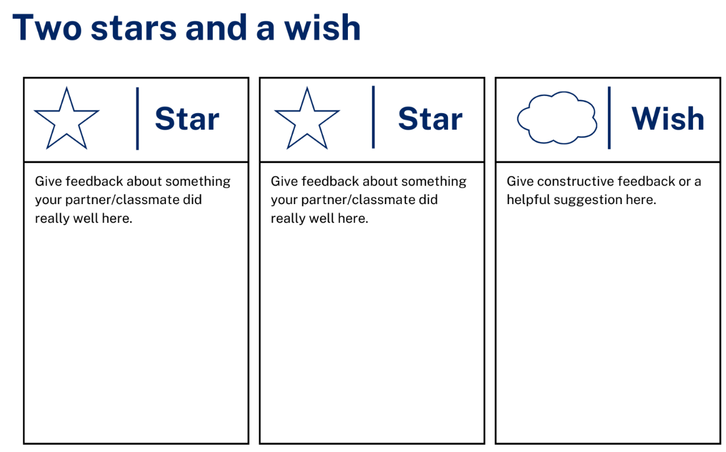

Support and alignment
Resource evaluation and support: all curriculum resources are prepared through a rigorous process. Resources are periodically reviewed as part of our ongoing evaluation plan to ensure currency, relevance, and effectiveness. For additional support or advice, contact the Primary Languages team by emailing primlang@det.nsw.edu.au.
Alignment to system priorities and/or needs: School Excellence Policy, School Success Model
Alignment to the School Excellence Framework: this resource supports the School Excellence Framework elements of curriculum (curriculum provision, teaching and learning programs) and effective classroom practice (lesson planning).
Alignment to Australian Professional Teaching Standards: this resource supports teachers to address Australian Professional Teaching Standards 2.2.2, 3.2.2.
Consulted with: Curriculum, Secondary Learners, school-based staff and NESA subject matter experts. Advice from Aboriginal Outcomes and Partnerships, EAL/D, HPGE and Inclusive Education for Modern Languages – Stage 3 – Italian – Mangiare in Ristorante has been considered in preparing this document.
NSW syllabus: Modern Languages K–10 Syllabus
Syllabus outcomes: ML2-INT-01, ML2-UND-01, ML2-CRT-01
Author: Primary Curriculum
Publisher: State of NSW, Department of Education
Resource: Unit
Related resources: further resources to support Stage 2 Modern Languages can be found on the Languages K-6 curriculum page.
Professional learning: relevant professional learning is available through Primary Languages Networks on Teams (staff only).
Universal Design for Learning: support the diverse learning needs of students using inclusive teaching and learning strategies. Some students may require more specific adjustments to allow them to participate on the same basis as their peers. For further advice see Inclusive practice resources for primary school.
Differentiation: when using these resources in the classroom, it is important for teachers to consider the needs of all students in their class, including:
- Aboriginal and Torres Strait Islander students. Targeted strategies can be used to achieve outcomes for Aboriginal students in K-12 and increase knowledge and understanding of Aboriginal histories and cultures. Teachers should use students’ Personalised Learning Pathways to support individual student needs and goals.
- EAL/D learners. EAL/D learners may require scaffolding to support them to gain content knowledge, while providing extra time and assistance to master the English language required to engage with texts or complete classroom tasks. View some samples of differentiating through scaffolding.
- Students with additional learning needs. Learning adjustments enable students with disability and additional learning and support needs to access syllabus outcomes and content on the same basis as their peers. Teachers can use a range of adjustments to ensure a personalised approach to student learning.
High potential and gifted learners. Assessing and identifying high potential and gifted learners will help teachers decide which students may benefit from extension and additional challenge. In addition, the Differentiation Adjustment Tool can be used to support the specific learning needs of high potential and gifted students.
Creation date: 28 March 2023
Rights: © State of New South Wales, Department of Education

References
This resource contains NSW Curriculum and syllabus content. The NSW Curriculum is developed by the NSW Education Standards Authority. This content is prepared by NESA for and on behalf of the Crown in right of the State of New South Wales. The material is protected by Crown copyright.
Please refer to the NESA Copyright Disclaimer for more information https://educationstandards.nsw.edu.au/wps/portal/nesa/mini-footer/copyright.
NESA holds the only official and up-to-date versions of the NSW Curriculum and syllabus documents. Please visit the NSW Education Standards Authority (NESA) website https://educationstandards.nsw.edu.au/ and the NSW Curriculum website https://curriculum.nsw.edu.au/home.
Modern Languages K-10 Syllabus © 2022 NSW Education Standards Authority (NESA) for and on behalf of the Crown in right of the State of New South Wales.
8 Ways (n.d.) 8 Aboriginal Ways of Learning [website], accessed 13 December 2022.
AITSL (Australian Institute for Teaching and School Leadership (2017) ‘Feedback Factsheet’, AITSL, accessed 21 March 2023.
Brookhart S (2011) How to Assess Higher-Order Thinking Skills in Your Classroom, Hawker Brownlow Education, Victoria.
CESE (Centre for Education Statistics and Evaluation) (2020) What works best: 2020 update, NSW Department of Education, accessed 10 March 2023.
CESE (Centre for Education Statistics and Evaluation) (2020) What works best in practice, NSW Department of Education, accessed 10 March 2023.
Conti G (28 September 2015) ’16 tips for effective grammar teaching in the foreign language classroom’, The Language Gym, accessed 21 March 2023.
Conti G (28 May 2017) From Target Language to Model Language – the mind shift that has transformed my teaching, The Language Gym, accessed 20 March 2023.
Harmer J (2014), The Practice of English Language Teaching, Pearson, United Kingdom.
Henshaw FG and Hawkins MD (2022) Common Ground: Second Language Acquisition Theory Goes to the Classroom, Focus, Indianapolis, accessed 14 March 2023.
Jones J and Wiliam D (2014) Modern Foreign Languages Inside the Black Box: Assessment for Learning in the Modern Foreign Languages Classroom (Black P, Harrison C, Marshall B and Wiliam D, eds), Learning Sciences International, United States.
NESA (NSW Education Standards Authority) (2022) ‘Proficient Teacher: Standard descriptors’, The Standards, NESA website, accessed 21 December 2022.
Smith S (2022) Becoming an Outstanding Languages Teacher, 2nd edn, Routledge, United Kingdom.
Wiliam D and Leahy S (2015) Embedding Formative Assessment: Practical Techniques for K–12 Classrooms, Learning Sciences International, United States.
© State of New South Wales (Department of Education), 2023
The copyright material published in this resource is subject to the Copyright Act 1968 (Cth) and is owned by the NSW Department of Education or, where indicated, by a party other than the NSW Department of Education (third-party material).
Copyright material available in this resource and owned by the NSW Department of Education is licensed under a Creative Commons Attribution 4.0 International (CC BY 4.0) license.
This licence allows you to share and adapt the material for any purpose, even commercially. Attribution should be given to © State of New South Wales (Department of Education), 2023.
Material in this resource not available under a Creative Commons licence:
- the NSW Department of Education logo, other logos and trademark-protected material
- material owned by a third party that has been reproduced with permission. You will need to obtain permission from the third party to reuse its material.
Links to third-party material and websites
Please note that the provided (reading/viewing material/list/links/texts) are a suggestion only and implies no endorsement, by the New South Wales Department of Education, of any author, publisher, or book title. School principals and teachers are best placed to assess the suitability of resources that would complement the curriculum and reflect the needs and interests of their students.
If you use the links provided in this document to access a third-party's website, you acknowledge that the terms of use, including licence terms set out on the third-party's website apply to the use which may be made of the materials on that third-party website or where permitted by the Copyright Act 1968 (Cth). The department accepts no responsibility for content on third-party websites.

