[Language] Stage 3 – Welcome to my home!
Contents
Unit overview 3
Stage 3 outcomes and content to be addressed 4
Learning map 8
Assessment 10
Assessment opportunities 11
Teaching and learning activities 14
Week 1: Rooms 14
Week 2: Objects in a home 18
Week 3: Where in the home? 22
Week 4: Describe the room 27
Week 5: Assessment criteria and practice task 30
Week 6: Communicative task – Record a video describing your home 33
Week 7: Feedback and goal setting 36
Week 8: Language review 38
Student resources 41
Resource 1: Rooms 41
Resource 2: Household items flashcards 43
Resource 3: Rooms vocabulary 47
Resource 4: Outline of a home 48
Resource 5: What do you see? 49
Resource 6: Sentence builders 51
Resource 7: Red and green cards 54
Resource 8: Assessment task – Welcome to my home! 55
Resource 9: Rubric – Welcome to my home! 58
Resource 10: Peer feedback strategy – Two stars and a wish 62
Support and alignment 63
References 66

Unit overview
Stage: 3
Title: Welcome to my home!
Description: In this unit, students respond to information about a home by labelling rooms and objects using familiar and new vocabulary. They create a video for a cousin using modelled descriptive language, prepositions and adjectives to describe their home. Students also share their favourite place in the home in the video.
Duration: This lesson sequence is designed to be completed over approximately 8 weeks.
Student proficiency levels: It is assumed that most Stage 3 students have been learning [Language] since Kindergarten and their proficiency level will be Intermediate. This unit is aimed at intermediate students. Every classroom will be different and teachers will need to adapt to their context. Many classes may include a combination of Beginner, Intermediate and Advanced students. Assessment tasks and opportunities in this unit can be differentiated using the ‘Too hard?’ and ‘Too easy?’ suggestions.

Stage 3 outcomes and content to be addressed
The table below outlines the focus area, outcomes and content points for Stage 3 students.
Focus area and outcome | Content points
Interacting  A student:  - exchanges information and opinions in familiar contexts by using culturally appropriate rehearsed language ML3-INT-01 | Exchanging meaning in oral interactions in the target language  - Understand and share information about themselves and their personal world  - Ask and answer questions with familiar structures  - Ask for clarification or repeat information to facilitate understanding in familiar interactions  Applying knowledge of language systems to interact in the target language  - Use key features of the sound system including pronunciation, intonation patterns, stress and/or rhythms to interact  - Use familiar vocabulary to interact  - Use modelled grammatical structures to interact  Applying knowledge of the target language culture(s) to interact  - Use language and nonverbal communication that are appropriate to cultural practices
Understanding texts  A student:  - identifies and responds to information and opinions in texts to demonstrate understanding ML3-UND-01 | Understanding and responding to target language texts  - Listen to, read and view information and opinions in a range of texts on familiar themes  - Use comprehension strategies to process information and opinions in texts  - Respond in the target language and/or English to main points and specific information in familiar texts to explain understanding and express opinions  Applying knowledge of language systems to understand and respond to target language texts  - Identify and use the sounds of the target language to understand and respond to texts  - Identify and use sound–symbol correspondences to understand and respond to texts  - Use knowledge of vocabulary and phrases from familiar themes to understand and respond to texts  - Use modelled sentence structures and grammar patterns to understand and respond to texts  - Use familiar metalanguage to compare some target language structures and features with English  - Recognise and use familiar structures and features of the target language writing system to understand and respond to texts  Developing intercultural understanding through target language texts  - Respond to texts and consider how language is connected with cultural practices and compare how this is evident in their own language(s), culture(s) and identity
Creating texts  A student:  - creates a range of texts for familiar communicative purposes by using culturally appropriate rehearsed language ML3-CRT-01 | Creating spoken, written and multimodal texts in the target language  - Create imaginative texts appropriate to context, purpose and audience using a series of sequenced sentences and visuals to express ideas on familiar themes  Applying knowledge of language systems to create texts in the target language  - Use pronunciation, intonation patterns, stress and/or rhythms to create spoken texts  - Use sound–symbol correspondences to create written texts  - Use relevant vocabulary, formulaic expressions or modelled phrases from familiar themes to create texts  - Use a range of modelled sentence and grammatical structures to create texts  - Select structures and features of the target language writing system to create written texts  Applying knowledge of the target language culture(s) to create texts  - Use language appropriate to cultural practices to create texts
Modern Languages K–10 Syllabus © NSW Education Standards Authority (NESA) for and on behalf of the Crown in right of the State of New South Wales, 2022.

Learning map
The creation of maps for learning is a planning process that incorporates Aboriginal intellectual tradition. Learning maps are a visual pathway of what students will learn.
Share the learning map with your students, briefly explaining the learning that will happen in each lesson. Provide students with a copy of the learning map or display the learning map in the classroom. This learning map can be adapted to [Language] by accessing a copy of Learning map – Welcome to my home! (Stage 3).
Figure 1 – Welcome to my home! learning map
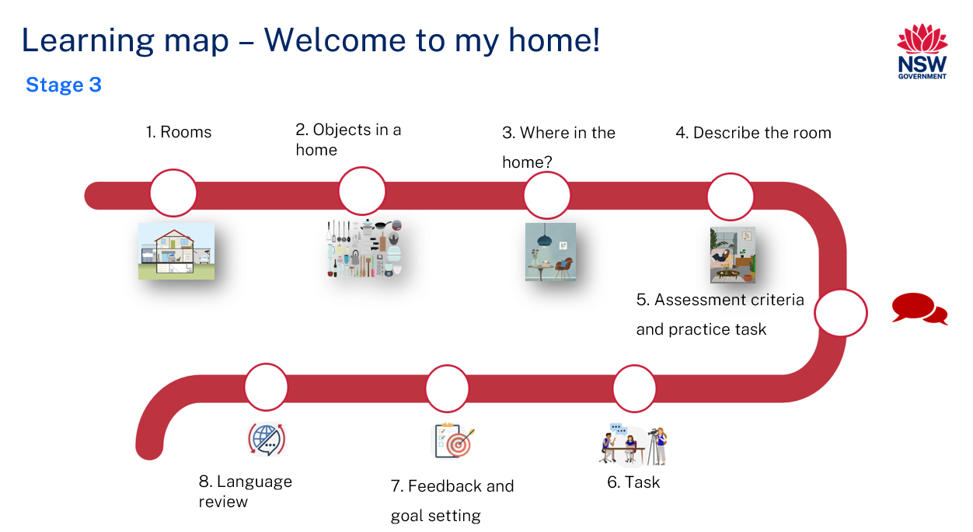

Assessment
Stage 3 communicative task: Your cousin is coming to stay with you from [Country]. They would like to know about your home before they come. Draw a labelled diagram of your home. Record a video describing your home to your cousin. In your video, include different rooms, objects in your home and their location.
Too hard?
Draw a labelled diagram of your bedroom and record a video describing your bedroom to your cousin. Name the different objects and their location in your room.
Too easy?
In the video, also mention your favourite place in your home and explain why it is your favourite place.
Context: cousin coming from overseas
Audience: cousin
Purpose: to describe your home to your cousin

Assessment opportunities
The table below details assessment opportunities and differentiation ideas.
Assessment opportunities | Too hard? | Too easy?
Week 2: Where in the room?  Split the class into small groups. Give each group some pictures of objects in the home. Assign a room in the home to each group and have students cut out and stick pictures of 5 objects that are found in that room. For example, for a living room poster, students could glue pictures of a sofa, TV, rug, coffee table, lamp, fan, and so on. Provide about 5 minutes for this activity. Students label the pictures on the poster using a picture dictionary or bilingual dictionaries. Check if all pictures are labelled correctly. | Reduce the number of labelled objects to 3. For example, chair, table, TV. | Write the names of objects in [Language] without a dictionary.
Week 3: Let’s put it together!  Hand out pictures of different rooms and jumbled-up sentences to groups of students. In their groups, students use the graphic organiser to put the jumbled-up words together to make a sentence describing the picture. Each group reports back to the class and describes the room using the sentences. | Students unjumble the words to make a simple sentence for one room. | After unjumbling, students write a sentence to describe each room in [Language].
Week 4: Red and green cards  Display a series of pictures and read a compound sentence describing each picture. The sentences may or may not contain deliberate mistakes. Students vote on whether each sentence is correct (using a green card with a tick) or incorrect (using a red card with a cross). Ask students who vote red what is wrong with the sentence. Make the change and have the class vote again. | Include simple sentences to describe a picture.  For example, ‘There is a blue fridge. It is next to the cupboard.’ | Include complex sentences to describe a picture.  For example, ‘There is a green plant that is next to the sofa in the living room.’

Teaching and learning activities

Week 1: Rooms
The table below outlines the learning intention and success criteria of the lesson, and materials that the teacher and students will need to complete the teaching and learning activities.
Learning intention and success criteria | Materials
Students will name different rooms in a home in [Language].  Students can:  - say and write words for rooms in a home in [Language] correctly. | - My home! PowerPoint book  - Resource 1: Rooms (class and student copies)  - Resource 2: Household items flashcards  - Resource 3: Rooms vocabulary (per student group)  - Resource 4: Outline of a home (enlarged copy)  - Bean bag

Activity 1: Learning map
Explain and display the Learning map to give students a more detailed breakdown of lessons during the unit. Point out that the learning map is a plan that may need to change.

Activity 2: Vocabulary
Vocabulary to be included: home, home, apartment, walls, window, roof, stairs, garden, living room, kitchen, bedroom, bathroom, laundry.
- Pre-assessment: Show students Resource 1: Rooms and Resource 2: Household items flashcards in [Language]. Ask students to identify how many words they think they know by showing a thumbs up at their chests in response to the following questions:
- Do you know all the words for these pictures in [Language]?
- Do you know most of them?
- Do you know some of them?
- Do you know none of them?
- In pairs, students then Think-Pair-Share the words they know and report back to class. As a whole class, ask students to match the words to the pictures one at a time. After each match, model and drill the correct pronunciation of vocabulary.
- Brainstorm vocabulary words related to a home in [Language]. As students say different vocabulary words, co-construct a word cloud using those words. Split the students into groups of 4. Give each group a set of Resource 3: Rooms vocabulary flashcards. Display a picture of different household items using Resource 2: Household items flashcards. For example, display a picture of a bed and have students hold up a flashcard with ‘bedroom’ written on it. The first group to hold up the flash card with the correct name gets a point.
- Play a game of ‘Hot potato’. Demonstrate with a small group of students. A student throws a bean bag and says the name of a room in [Language]. The student who catches the bean bag says the name of another room or vocabulary word from the list quickly and passes the bean bag on to another student in the group. If a student drops the bean bag or is unable to say a word in [Language], they must sit down. Continue the game until there is one student left standing in the group. Students play the game in small groups.
Note: print and display the word cloud. Add new and known words in [Language] to the cloud as required.

Activity 3: Rooms
- Show pictures of different types of homes in Australia and [Country]. Discuss the similarities and differences between students’ homes and homes in [Country].
- Display the My home! PowerPoint book and show parts of and rooms in a home. Elicit the phrases ‘There is/are…’ and ‘This is…’. Model a number of sentences such as ‘There are 2 bedrooms’ in [Language]. Students repeat the sentences.
- Show students images from Resource 1: Rooms. Hold the ‘living room’ picture and ask students what picture this is. Students say ‘This is a living room’ in [Language]. Repeat the activity with the other pictures, teaching the name of the room and phrases every time. Point to a room, then ask what room it is and how many are there.
Example interaction:
- Teacher (hold the picture of a living room): What is this?
- Student (responds in [Language]): This is a living room.
- Teacher: How many living rooms are there?
- Student (responds in [Language]): There is one living room.
Repeat with other rooms in a home.
- Hand out images from Resource 1: Rooms. In pairs, students take turns asking and responding to the questions.
Evaluation: students accurately use the phrases ‘This is…’ and ‘There is/are…’.

Activity 4: Online book
Note: students create an online book using PowerPoint, Canva or any other software of their choice. In every lesson, students add a page to the online book. The final book will be used as a stimulus or script to complete the assessment task.
Display Resource 4: Outline of a home. Say the name of each room and have students repeat with correct pronunciation. Students create and label the outline of a home using PowerPoint, Canva or any other software of their choice.

Activity 5: Where are my socks?
Make up a story called ‘Where are my socks?’, one word at a time. Model this activity with a small group of students. For example, ‘I can’t find my socks. I looked for them in the living room and I can’t find my socks.’ Another student repeats the phrase using the previous room and adds on another room. For example, ‘I looked for them in the living room and kitchen and I can’t find my socks.’ The next student adds on again, for example, ‘I looked for them in the living room, kitchen and bathroom and I can’t find my socks.’ All students complete the activity in groups of 4 or 5.

Week 2: Objects in a home
The table below outlines the learning intention and success criteria of the lesson, and materials that the teacher and students will need to complete the teaching and learning activities.
Learning intention and success criteria | Materials
Students will name the different objects in the home in [Language].  Students can:  - name household objects in [Language]  - accurately say and write ‘This is a…’ in [Language]. | - My home! PowerPoint book  - Resource 3: Rooms vocabulary (per student group)  - A3 paper  - Butcher’s paper  - Language exercise books  - Sticky notes

Activity 1: Vocabulary
- Revise names of colours and numbers up to 10 in [Language].
- Ask students to write 10 words from the word cloud, including words from the previous lesson in English. Students then pass their list to a partner to translate. Students check their partner’s translation with the vocabulary list of colours, numbers and rooms in the home.
- Pre-assessment: Display the names of different rooms on butcher’s paper. For example, living room, kitchen, bedroom, bathroom and laundry. Students think of as many household items as they can in each of the rooms. Set a timer for approximately 5 minutes and have students write the names of objects in [Language] on a sticky note along with their name. Students stick the note on the correct room.

Activity 2: Colourful lie detector
Read the My home! PowerPoint book and refer to the colours of different household items. Revise ‘There is/are…’ from the last lesson. Display the images from the My home! PowerPoint book on the screen as you say a statement about the image, focusing on colours. Students respond with a thumbs up if the statement is true and a thumbs down if the statement is false.
Note: this activity can also be done as an online quiz.
Suggested statements:
- There is a big red door
- There are 2 blue windows
- There is an orange roof.
- There is a green wall in the kitchen.
- There are yellow flowers.
- There is a big blue door.
Note: point to objects to support students if required.
In pairs, students play the game of ‘Lie detector’. Using the pictures from the My home! PowerPoint book, pairs make up true or false statements. Student A makes up a statement and Student B says whether it is true or false. Students swap roles with their partners halfway through the game.

Activity 3: Household items
Read the My home! PowerPoint book. Refer to the pictures and vocabulary of household items and rooms.
While reading the text, model and drill the correct pronunciation of vocabulary of household items. Say a word and ask students to repeat. Say the next word and have students repeat the previous word(s) and the new word. For example, if you say ‘blanket’ in [Language], students repeat ‘blanket’ in [Language]. Then, if you say ‘bed’ in [Language], students say ‘blanket’ and ‘bed’ in [Language]. Repeat the activity by revising ‘There is/are…’ and ‘This is…’. For example:
- Teacher: This is a kitchen. There is a fridge.
- Students (repeat): This is a kitchen. There is a fridge.
- Teacher: This is a kitchen. There are pots and pans.
- Students (repeat and add on): This is a kitchen. There is a fridge and pots and pans.
- Teacher: This is a kitchen. There is a microwave.
- Students (repeat and add on): This is a kitchen. There is a fridge, pots and pans and a microwave.
- Repeat the same for the other rooms.
Refer to the My home! PowerPoint book and ask students ‘Which of these objects do you have in your own home? What similarities are there between your home and the home shown in the My home! PowerPoint book?’
Evaluation: students use appropriate pronunciation, grammar and vocabulary.

Activity 4: Where in the room?
Split the class into small groups of 4. Each group gets a copy of Resource 3: Rooms vocabulary. Assign each group a room in a home and give them A3 paper to make a poster. Ask students to cut out and stick on or draw pictures of the objects that are found in that room. For example, a living room poster might contain pictures of a sofa, TV, rug, coffee table, lamp, fan and so on. Provide 5 minutes for this activity. Students label the pictures in the poster using a picture dictionary or bilingual dictionaries. Check all pictures are labelled correctly. Display the posters in the room for future reference.

Activity 5: Online book
Students add another page or slide to the online book from the last lesson based on the poster they made.

Activity 6: Race to the front
Spread pictures of different household items at the back of the room. Split students into groups of 4. One student from each group comes forward. Call out the name of one of the household items in [Language]. Students race and bring the picture of that item to the front of the class. The first student to get the picture gets a point. The game continues until everyone has had a turn.

Week 3: Where in the home?
The table below outlines the learning intention and success criteria of the lesson, and materials that the teacher and students will need to complete the teaching and learning activities.
Learning intention and success criteria | Materials
Students will describe the position of objects in a home in [Language].  Students can:  - use appropriate prepositions in [Language]  - accurately say and write a simple sentence describing the position of an object in a room. | - My home! PowerPoint book  - Resource 5: What do you see? (one per student)  - Pictures of different rooms from the My home! PowerPoint book  - Jumbled-up sentences to match each room created by the teacher (one set per group)  - Language exercise books  - Sticky notes

Activity 1: Solve the sentence!
Note: use this lesson as an opportunity to teach correct sentence structure using appropriate vocabulary and grammar to students. It is important that students receive explicit support using scaffolds as they learn to create texts in the target language.
- Before revising prepositions with students, briefly explain what prepositions are and give some examples in English. Elicit different prepositions by asking the position of a book in different places. For example, next to, in, between, on, behind and so on. Place a book on a table and ask students where it is. Students respond by saying ‘The book is on the table’ in [Language]. Then, place the book next to a chair and ask students where it is now. Students respond by saying, ‘The book is next to the chair’ in [Language]. Repeat with different prepositions in [Language]. Students record the prepositions in their language exercise books.
- Read aloud sentences from the My home! PowerPoint book as pictures are displayed. During reading, students complete a table in Resource 5: What do you see? by writing information about one or more of the objects shown, including its colour and position.
Note: this activity can be differentiated so that students with Advanced proficiency can write the names of all objects in [Language] and students with Beginner and Intermediate proficiency can choose between 2–4 objects to write in English. Once students have completed the table, revise and display the phrases such as ‘There is/are…’ and ‘This is…’ on the board for students to refer to. The final table should look like the one below.
Room/Picture | Colour | Object | Position/Location
- Kitchen  - Living room | - Blue  - Black  - Pink  - Green | - Fridge  - TV  - Lamp  - Plant | - Next to the cupboard  - On the green wall  - Next to the sofa  - In the pot
- After students have completed the table, they work in pairs to review and compare their responses. As a whole class, review the pictures and have students add any information they missed to the table.
- Demonstrate how to make simple ‘silly sentences’ in [Language] using correct structure. Using the table in Resource 5: What do you see?, students pick one item from one (or more) heading(s) to make a silly sentence using the correct sentence structure. For example:
- The (colour) (object 1) is (preposition) the (object 2).
- The blue fridge is on the cupboard.
- There is a (colour) (object 1) (preposition) the (place/object 2).
- There is a black TV in the bathroom.
- There is a pink fridge next to the sofa.
- In groups of 4, students take turns to practise constructing silly sentences.
- Using the completed table in Resource 5: What do you see?, co-construct sentences using the correct sentence structure that matches the pictures. For example:
- This is a kitchen. There is a blue fridge.
- The blue fridge is next to the cupboard.
- This is a living room. It has a black TV.
- The black TV is on the green wall.

Activity 2: Let’s put it together!
Split students into groups of 4 and hand out pictures of different rooms and jumbled-up sentences to each group. Using the Resource 5: What do you see? worksheet, students put the jumbled-up words together to make a sentence describing the picture. As an extension activity, each student can write a sentence of their choice to describe the room on the poster. Each group reports back to the class and describes the room using the sentences. Display the poster in the room for future reference.
Note: create your own jumbled-up words to match the pictures.

Activity 3: Online book
Students add another page or slide to the online book from the last lesson describing the position of objects in one of the rooms.

Activity 4: Exit ticket
To assess students’ understanding of sentence structure, divide the board into 4 sections and ask students to write the phrase, colour, object, and its position on sticky notes. As students leave the class, have them stick their note in the correct order to make a simple sentence on the board. For example, ‘There is a blue fridge next to the cupboard.’
Figure 1 – Exit ticket example
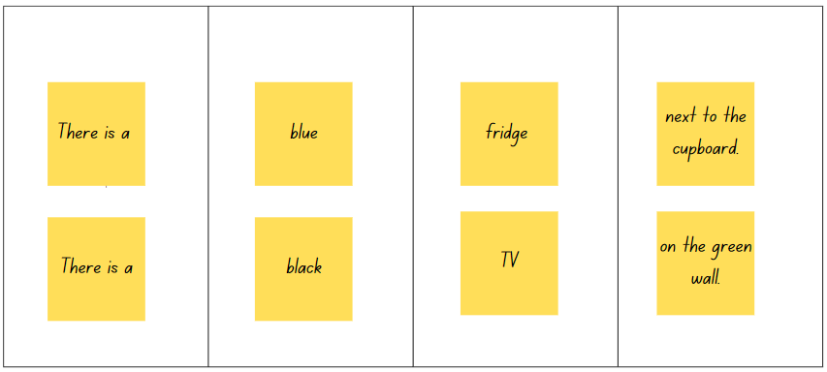

Week 4: Describe the room
The table below outlines the learning intention and success criteria of the lesson, and materials that the teacher and students will need to complete the teaching and learning activities.
Learning intention and success criteria | Materials
Students will describe a room in [Language].  Students can:  - use adjectives to describe the objects in a room  - say where an object is in a room  - correctly write a simple sentence in [Language] describing a room. | - Resource 6: Sentence builders  - Resource 7: Red and green cards  - Pictures of various rooms from the My home! PowerPoint book  - Sticky notes  - Timer

Activity 1: Sentence builders
Note: introduce and explain how to use sentence builders at the beginning of the lesson.
Show a picture of a room and co-construct a few sentences about the room using the correct sentence structure, colours, household objects and their position from the previous lesson. Choose words and phrases from sentence builders to make meaningful sentences. Use the scaffold or questions to write sentences. For example:
- What room is it? This is my room.
- What is the size of the room? My room is small.
- Describe the objects in the room using adjectives (colour and size). There is a bed and a mattress. There is one red pillow. There is a big chair and a yellow desk.
- Where are the objects? The red pillow is on my bed. There is a lamp next to my desk.
Note: extend this activity for students with Advanced proficiency levels by asking what they like to do in the room. Students may choose from the options in Resource 6: Sentence builders. Students may also respond by saying, for example, ‘I like to relax in my room.’
Split the class into groups of 4. Show a picture of a room from the My home! PowerPoint book and ask students to come up with 10 sentences about the room in 5 minutes using Resource 6: Sentence builders. Set a timer. The first group to make 10 sentences gets a point. Repeat the game for 3 rounds.

Activity 2: Red and green cards
Hand out Resource 7: Red and green cards. Display a series of pictures from the My home! PowerPoint book and read a sentence describing each picture. The sentence may or may not contain deliberate mistakes. Students vote whether a sentence is correct (using a green card with a tick) or incorrect (using a red card with a cross). Ask students who vote red what is wrong with the sentence. Make the change and have the class vote again.
Note: this activity can also be done as ‘thumbs up’ and ‘thumbs down’ if red and green cards aren’t available.

Activity 3: Speed dating – Two truths and a lie
Spread out the pictures of different rooms from the My home! PowerPoint book at different stations. In pairs, students play a game of ‘Two truths and one lie’. Using the pictures, one student says 2 statements describing the pictures that are true, and one statement that is a lie. The other student must detect the lie. Students swap roles with their partner and repeat the activity until the timer goes off. When the timer goes off, students move to a different station with a different room. When groups reach the last station, they write a paragraph describing the room using the sentence builder.
Peer assessment: Students provide feedback to each other by writing ‘Two stars and a wish’ on a sticky note.

Activity 4: Online book
Students add more pages or slides to the online book from the previous lesson describing different rooms in their home.

Week 5: Assessment criteria and practice task
The table below outlines the learning intention and success criteria of the lesson, and materials that the teacher and students will need to complete the teaching and learning activities.
Learning intention and success criteria | Materials
Students will develop a clear understanding of the requirements of the assessment task.  Students can:  - suggest appropriate success criteria  - explain what they need to do to be successful in the task. | - Resource 8: Assessment task – Welcome to my home!  - Resource 9: Rubric – Welcome to my home!  - Resource 10: Peer feedback strategy – Two stars and a wish  - Completed online book  - Language exercise books  - Materials for creating a 2D or 3D model of the home

Activity 1: Communication of the assessment task
Ensure students are provided with time to complete the online book or script for the video, and if time permits, create a 2D or 3D model of the home. Students may choose to create a 2D or 3D model and write a script for the video or complete the online book with sentences and illustrations matching the success criteria.

Activity 2: Assessment task
Hand out Resource 8: Assessment task – Welcome to my home! and lead the class in reading it.

Activity 3: Success criteria
After looking at the assessment task, students Think-Pair-Share and suggest appropriate success criteria, such as:
I will be successful if I can:
- draw a labelled diagram or 3D model of a home
- identify and describe different rooms in the home
- identify and describe different objects in the home using adjectives
- describe the position of different objects in the home
- express my personal preference about the home
- use correct grammar in my sentences
- use phrases, such as ‘this is’, ‘there is’, ‘there are’ or ‘I like’ to begin sentences
- pronounce the words correctly
- speak in a well-paced manner without long pauses
- end the video in an appropriate way, for example, ‘I hope you like my home. I can’t wait to see you’.

Activity 4: Discuss the rubric
- Show students an unmarked rubric, Resource 9: Rubric – Welcome to my home! This may need to be adapted if the class has decided on different success criteria.
- Explain the metalanguage, such as fluency, accuracy, pronunciation and vocabulary.
- In pairs, students read and then discuss the ‘Got it’ column of the rubric. Students then share their understanding of what is needed to be successful.
- Point out and provide examples of ‘excellent’ and ‘sort of’ task completion, fluency, accuracy, pronunciation and vocabulary.

Activity 5: Peer assessment
Peer feedback will be incorporated into the task (see Resource 10: Peer feedback strategy – Two stars and a wish). Confirm which peer feedback strategy will be used, for example, ‘Two stars and a wish’, and discuss with students.
Evaluation: students give examples of what stars and wishes would sound like for this task.

Activity 6: Practice task
Students get into groups of 3 and take turns being the presenter, cousin from overseas and camera operator.

Week 6: Communicative task – Record a video describing your home
The table below outlines the learning intention and success criteria of the lesson, and materials that the teacher and students will need to complete the teaching and learning activities.
Learning intention and success criteria | Materials
Students will record a video describing their home for a cousin who is coming from overseas.  Students can:  - draw a labelled diagram or 3D model of a home  - identify and describe different rooms in the home  - identify and describe different objects in the home using adjectives  - describe the position of different objects in the home  - express their personal preference about the home  - use correct grammar in sentences  - use phrases, such as ‘this is’, ‘there is’, ‘there are’ or ‘I like’ to begin sentences  - pronounce the words correctly  - speak in a well-paced manner without long pauses  - end the video in an appropriate way, for example, ‘I hope you like my home. I can’t wait to see you’. | - Resource 9: Rubric – Welcome to my home!  - Resource 10: Peer feedback strategy – Two stars and a wish  - Completed online book or 2D model of the home  - Tablets or other recording devices  - Tripod and microphones (if possible)

Activity 1: Task preparation – Record a video describing your home
Ensure students are provided with time to create a 2D model of the home or that they have completed the online book for the video.
Note: students can choose to create a 3D model of the home if time permits. Students write a script for the video or complete the online book with sentences and illustrations matching the success criteria. The final book will be used as a stimulus or script to complete the assessment task.

Activity 2: Task set-up
Students get in groups of 3. Give students a few minutes to ensure everybody knows the order in which they will be performing each role. The student who is describing the home is completing the assessed communicative task.

Suggested rotations:
- Presentation 1: Student 1 – Cousin from overseas/Peer assessor, Student 2 – Camera operator, Student 3 – Presenter
- Presentation 2: Student 1 – Presenter, Student 2 – Cousin from overseas/Peer assessor, Student 3 – Camera operator
- Presentation 3: Student 1 – Camera operator, Student 2 – Presenter, Student 3 – Cousin from overseas/Peer assessor

Activity 3: Communicative task and peer feedback
Note: before recording the presentation, check if any students do not have permission to be filmed. Alternatives to video recording include audio recording or the teacher watching the presentation while taking notes and marking the rubric.
- Hand out Resource 9: Rubric – Welcome to my home!
- Make sure to spread students out, using microphones if possible, to maximise sound quality. Highlight the importance of holding the recording device still, using a tripod or resting it on a table. Demonstrate how to film using the selected device.
- Students get into groups of 3. The camera operator records the presenter. The cousin will provide peer assessment to the presenter after the recording using the Resource 10: Peer feedback strategy – Two stars and a wish strategy.
- Students provide peer feedback verbally and follow up with the completed Resource 10: Peer feedback strategy – Two stars and a wish.

Week 7: Feedback and goal setting
Note: if there is insufficient time to mark the videos before Week 8, Weeks 7 and 8 can be swapped.
The table below outlines the learning intention and success criteria of the lesson, and materials that the teacher and students will need to complete the teaching and learning activities.
Learning intention and success criteria | Materials
Students will reflect on recordings of themselves completing the task to assess how well they completed the task and to set learning goals.  Students can:  - accurately self-assess their completion of the task  - set appropriate learning goals based on previous learning goals and teacher, peer- and self-assessment. | - Teacher completed copy of Resource 9: Rubric – Welcome to my home! (one per student)  - Blank Resource 9: Rubric – Welcome to my home! for self-assessment (one per student)  - Language exercise books  - Tablets or other recording devices

Teacher preparation
Note: prior to this lesson, view each video and mark each student according to the criteria on the rubric for communicative language tasks.

Activity 1: Self-assessment
Students watch the video of themselves completing the task and mark themselves using the Resource 9: Rubric – Welcome to my home!. Students then compare both the teacher completed Resource 9: Rubric – Welcome to my home! and the one they have completed.

Activity 2: Set learning goals
Students reflect on the teacher, peer- and self-evaluation to set learning goals for the next phase of learning. Example learning goals could be ‘I will not be worried about making a mistake when speaking language’ or ‘I will try to say (a particular sound) correctly’. Students write their learning goals in their language exercise books.
Evaluation: students set appropriate learning goals based on previous learning goals and teacher, peer- and self-assessment.

Week 8: Language review
Note: if there is insufficient time to mark the videos before Week 8, Weeks 7 and 8 can be swapped.
The table below outlines the learning intention and success criteria of the lesson, and materials that the teacher and students will need to complete the teaching and learning activities.
Learning intention and success criteria | Materials
Students will reflect on and ask questions about the language taught in this unit.  Students can:  - ask questions about vocabulary, grammar or pronunciation they have used in this unit  - use [Language] they have learned to communicate with classmates. | - Pictures of various rooms from the My home! PowerPoint book  - Copies of Resource 6: Sentence builders  - Language exercise books  - Swatters  - Teacher created jumbled-up sentences  - Text describing rooms recorded by teacher
Note: over the course of the unit, gaps in student knowledge, misconceptions and misuse of language will have been identified. These observations are addressed using engaging and interactive activities and strategies.

Activity 1: Student questions
Remind students of the activities and tasks they have completed over the course of the unit. Students are given time to Think-Pair-Share any questions they may have about any aspect of the language taught.
Note: set up different language stations for activities 2–4 that focus on reinforcing word work, grammar, listening and responding. These activities can be adapted to suit students’ needs. After a set time, students rotate in groups to different stations to complete activities with a different focus.

Activity 2: Word work
This station will focus on reviewing learnt vocabulary. Suggested activities include:
- Word bingo: Students write 10 words from the vocabulary taught throughout the unit. Students take turns at being the caller and call out the word from the list. The first student to tick off all words is the winner.
- Swat it: Write 10 words from the vocabulary list. Take turns to call out words. The first student to swat the word that is called out keeps the word.

Activity 3: Grammar
This station will focus on grammar taught during the unit. Suggested activities include:
- Resource 6: Sentence builders: In pairs, students give each other sentences in English to translate into [Language].
- My home! PowerPoint book picture task: Students write a description of a room in a picture in [Language] using sentence builders.
- Sentence re-ordering: The words in a sentence are randomly and incorrectly arranged. Students rearrange the words to make a sentence with the correct sentence structure.

Activity 4: Listening and responding
This station will focus on strengthening and reviewing students’ listening and responding to texts skills. Suggested activities include:
- Gap fill activity: Students listen to a description of a room read or recorded by the teacher. Alternatively, have another student read a text aloud. Students fill the gaps with the words they hear.
- Comprehension activity: Students listen to the description of a room. In pairs, students write 5 comprehension questions for a partner to answer. Questions and answers are written in English.
- Lie detector: In pairs, students make up true or false statements using pictures of one of the rooms. Student A makes up a statement and Student B says whether it is true or false. Change the game halfway where Student A makes up false statements for Student B to correct.

Student resources

Resource 1: Rooms
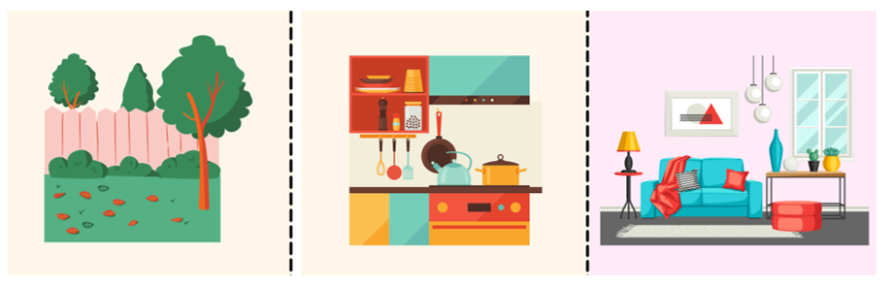
Images sourced from Canva and used in accordance with the Canva Content License Agreement.
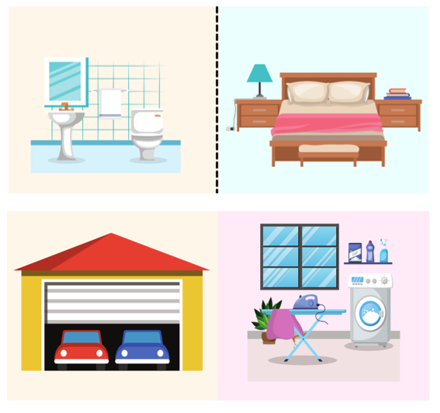
Images sourced from Canva and used in accordance with the Canva Content License Agreement.

Resource 2: Household items flashcards
This resource can be adapted by replacing the text to suit your [Language].
 |  | 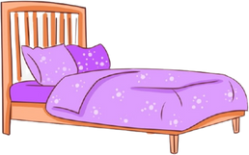 |  | 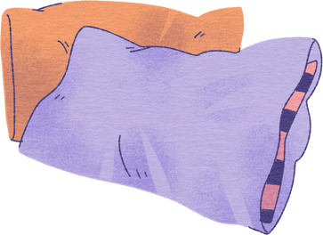
blanket |  | bed |  | pillow |  | painting
 |  |  |  | 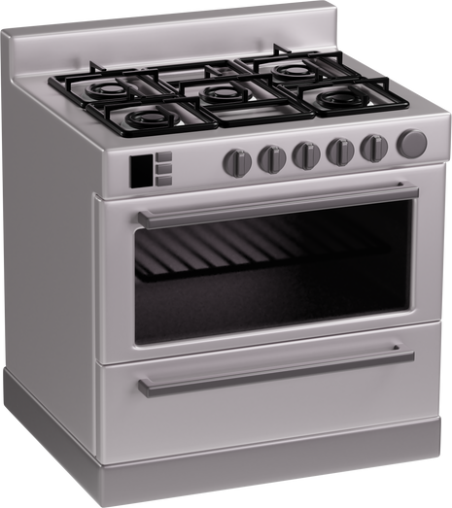
clothes |  | fridge |  | cooktop |  | dustbin
Images sourced from Canva and used in accordance with the Canva Content License Agreement.
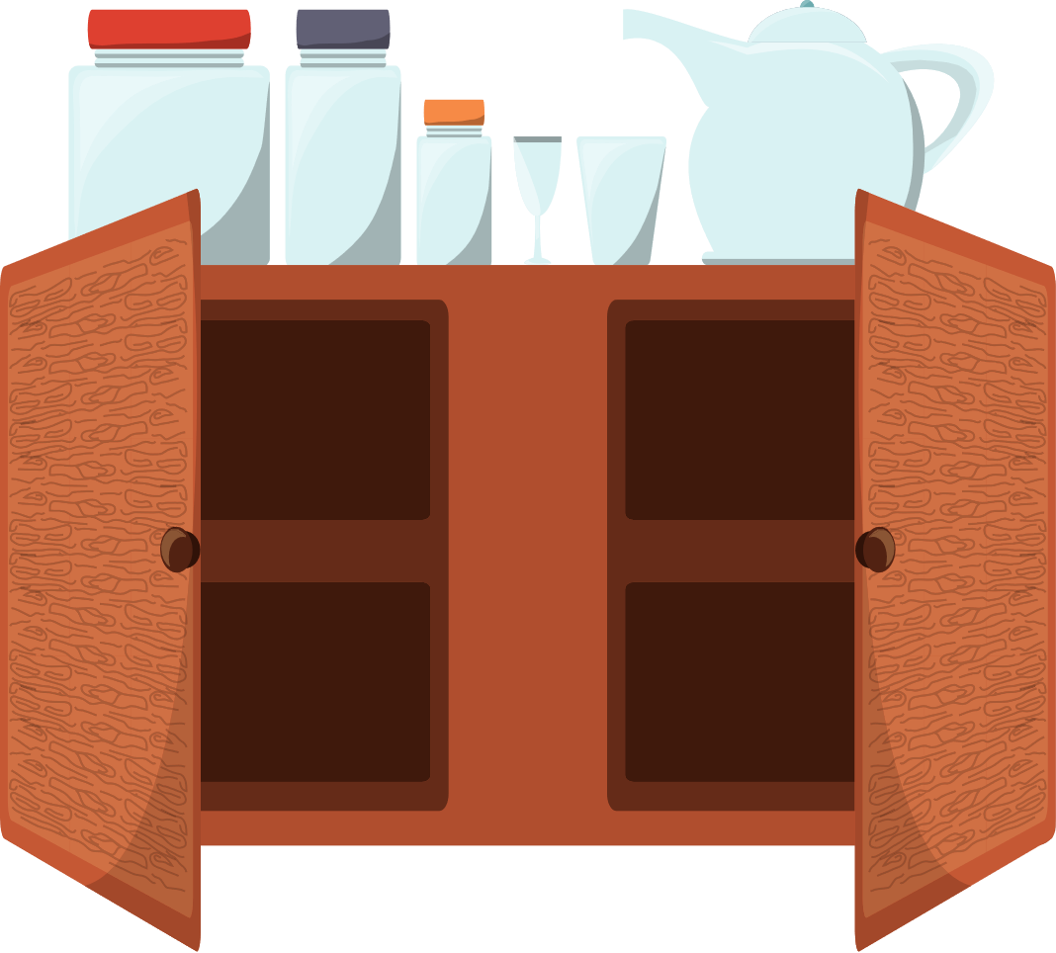 |  |  |  |  |  | 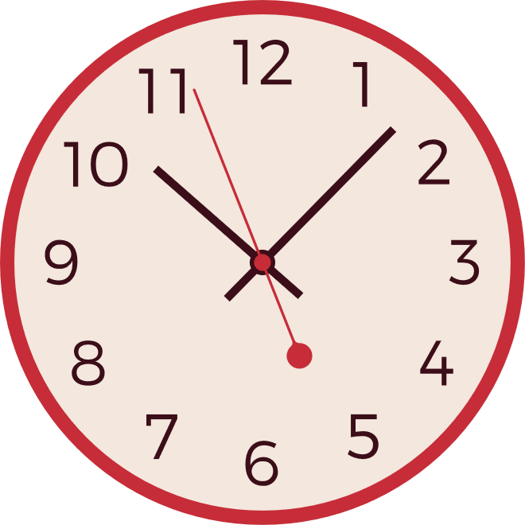
cupboard |  | utensils |  | TV |  | clock
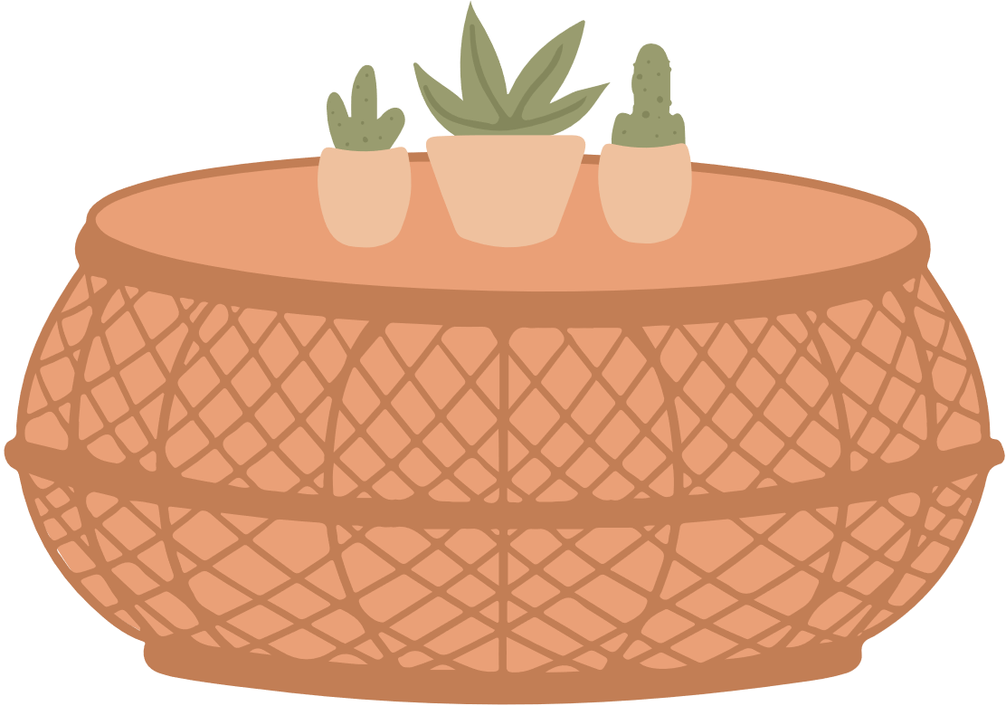 |  | 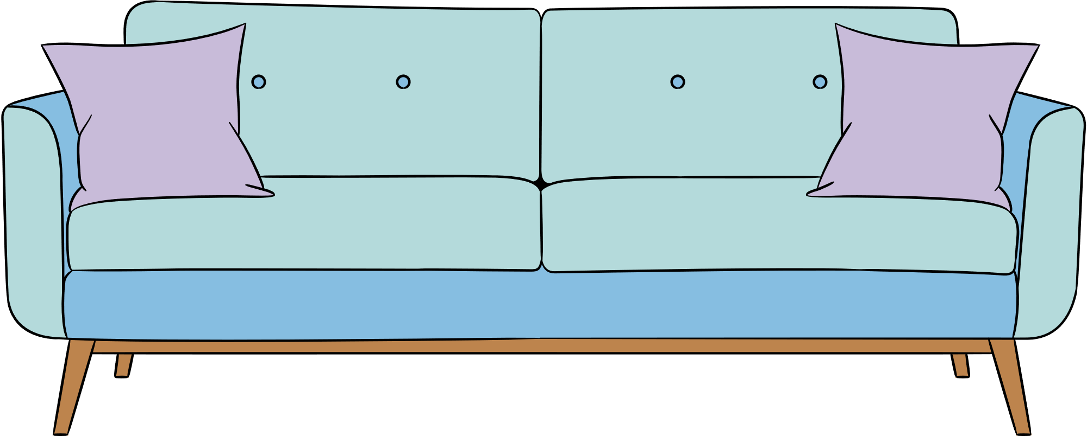
table |  | sofa |  | mirror |  | lamp
Images sourced from Canva and used in accordance with the Canva Content License Agreement.
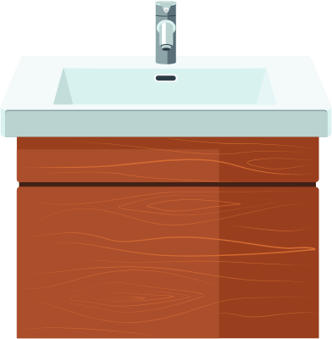
sink |  | toilet |  | shower |  | towel
 |  | 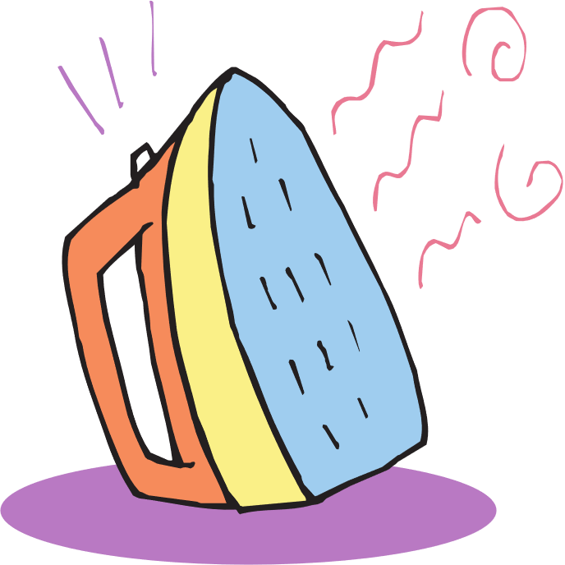
soap |  | iron |  | basket |  | washing machine
Images sourced from Canva and used in accordance with the Canva Content License Agreement.
 |  | 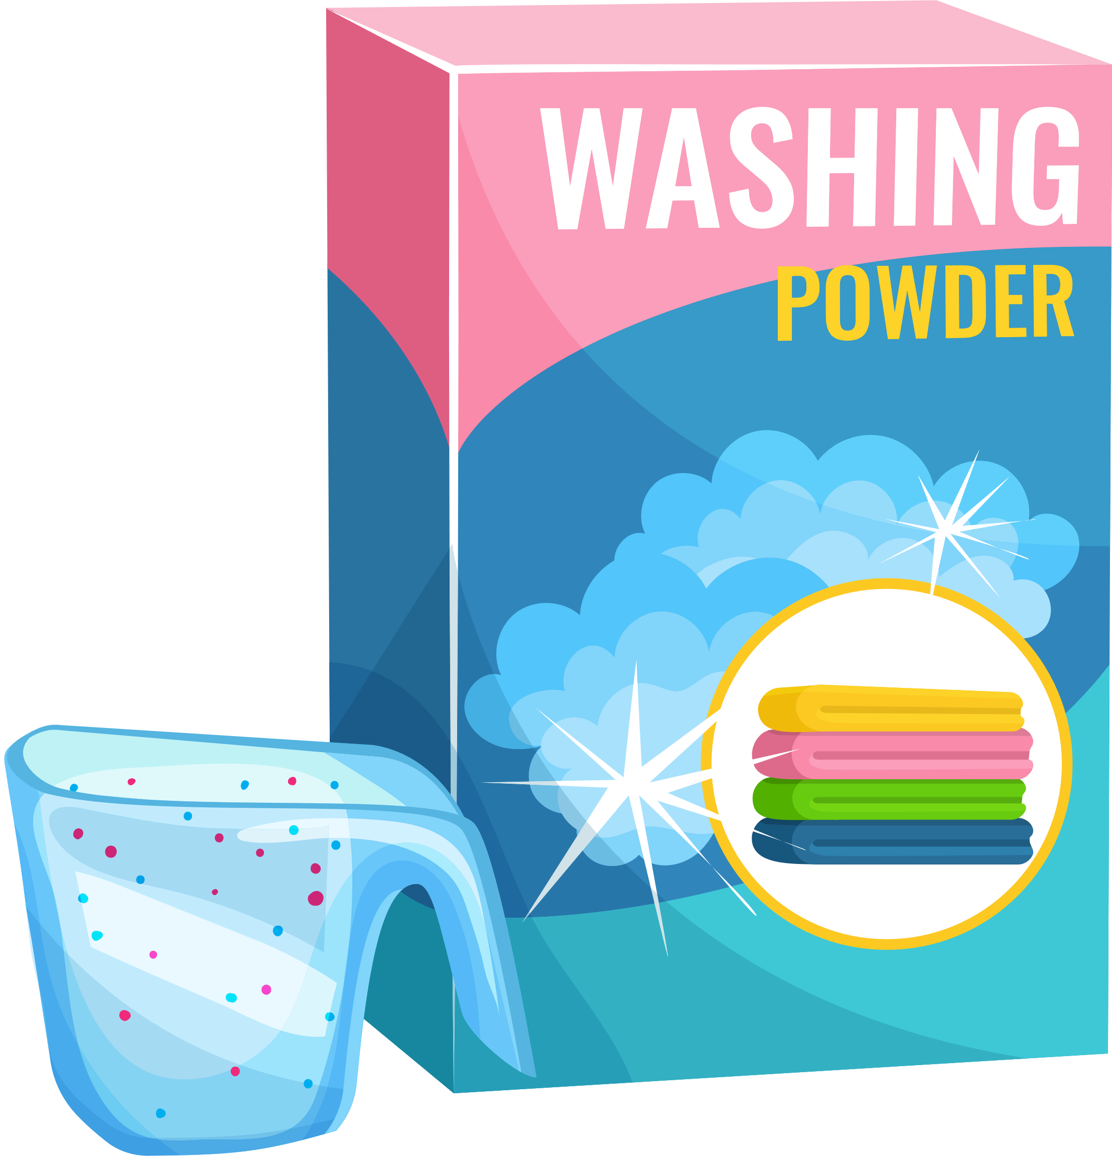
broom |  | washing powder |  | tools |  | car
bicycle |  | ladder |  | dustpan
Images sourced from Canva and used in accordance with the Canva Content License Agreement.

Resource 3: Rooms vocabulary
This resource can be adapted by replacing the text to suit your [Language].
bedroom |  | garage
kitchen |  | garden
bathroom |  | stairs
laundry |  | living room

Resource 4: Outline of a home
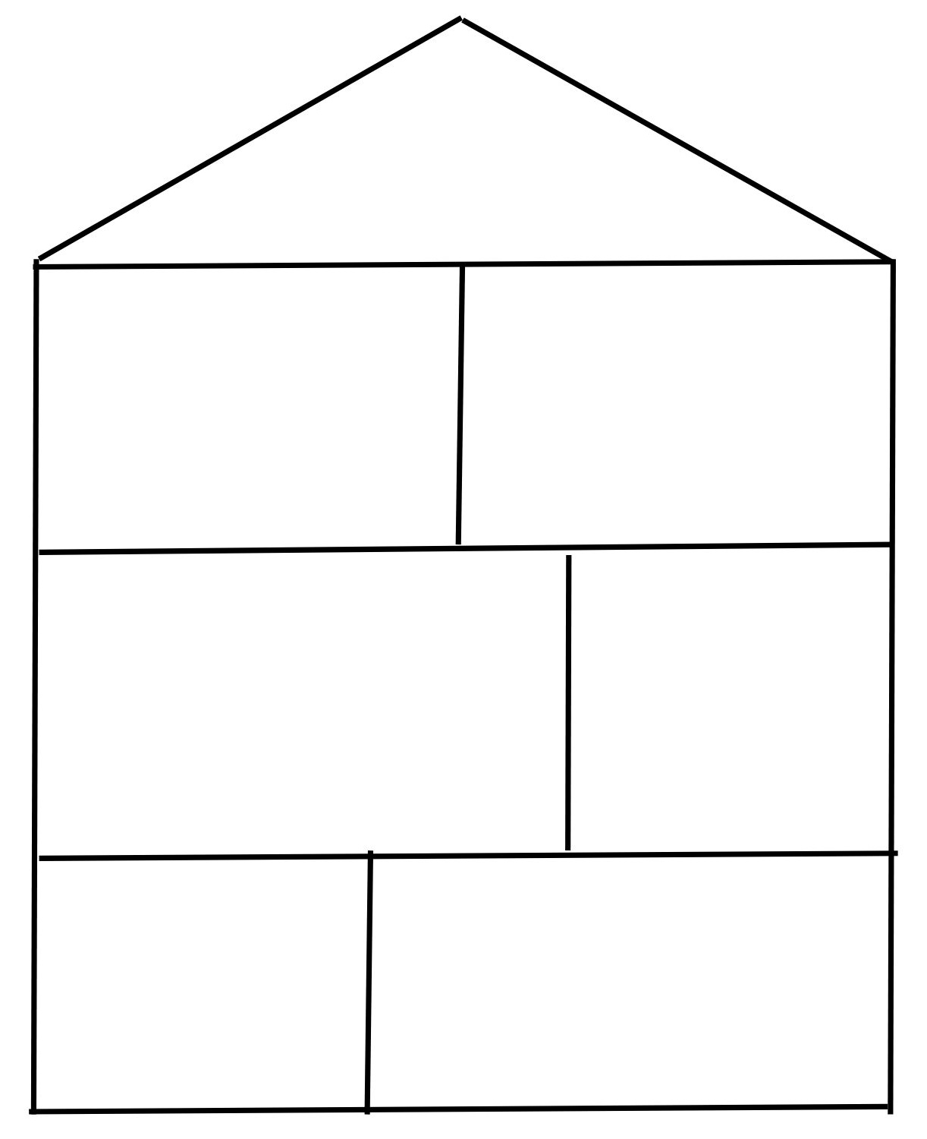

Resource 5: What do you see?
Room/Picture | Colour | Object | Position/Location
For example: Kitchen | Blue | Fridge | Next to the cupboard
Living room
Bedroom
Laundry
Bathroom

Resource 6: Sentence builders

Sentence one
Sentence stem | Helping verb | Number | Room
In my home | - there is  - there are  - this is | - one  - two  - three  - four  - five  - six  - seven  - eight  - nine  - ten | - living room  - kitchen  - bathroom(s)  - bedroom(s)
 | - there is also |  | - garage

Sentence 2
Sentence stem | Room | Conjunction | Verb | Activity
- My favourite room is  - I like | - my room  - living room  - kitchen  - laundry  - bathroom  - bedroom | - because | - I like | - to read  - to relax  - to cook  - to listen to music  - to eat (dinner)  - to do my homework  - to spend time with my family/friends  - to shower  - to wash clothes  - to wash dishes  - to watch TV  - to play (video games)  - to play (with my toys)

Sentence builder scaffold

(sentence stem) |  | (helping verb) |  | (number) |  | (room)

(sentence stem) |  | (helping verb) |  | (number) |  | (room)

(sentence stem) |  | (room) |  | (conjunction) |  | (verb) |  | (activity)

Resource 7: Red and green cards

Resource 8: Assessment task – Welcome to my home!

Outcomes
You will be assessed on how well you:
- identify and respond to information in texts to demonstrate understanding
- create texts for familiar communicative purposes by selecting culturally appropriate modelled language.

Task
Your cousin is coming to stay with you from [Country]. They would like to know about your home before they come. Draw a labelled diagram of your home. Record a video describing the home to your cousin. In your video, include different rooms, objects in your home and their location.
The table below outlines the communicative task students will need to complete.
Too hard? | Too easy?
In the video, include information about one room in the home. | Draw a labelled diagram of your bedroom and record a video describing your bedroom to your cousin. Name the different objects and their location in your room.

Learning intention
Students will be able to record a video about their home for a cousin who is coming from overseas.
Advanced learners
Students will be able to include information about their favourite part of the home in the video.

Success criteria
You will record a video about your home for a cousin who is coming from overseas. You will be successful if you can:
- draw a labelled diagram or 3D model of a home
- identify and describe different rooms in the home
- identify and describe different objects in the home using adjectives
- describe the position of different objects in the home
- express your personal preference about the home
- use correct grammar in your sentences
- use phrases such as ‘this is’, ‘there is’, ‘there are’ or ‘I like’ to begin sentences and express opinions.
- pronounce the words correctly
- speak in a well-paced manner without long pauses
- end the video in an appropriate way, for example, ‘I hope you like my home. I can’t wait to see you’.

Task instructions
- This task will be completed in groups of 3. Each student will take turns in all 3 roles:
- the presenter
- the cousin (peer feedback)
- camera operator.
- The person presenting the model or online book of their home is completing the communicative task, so you will only be assessed for task completion while performing this role. You will be assessed on all other criteria in the rubric while performing all roles except for camera operator.
Intermediate or Advanced students should also include information about their favourite part of the home and express their personal preference on any one of the rooms. When you are the camera operator, you will record the presenter presenting their model of the home or the online book.
- The cousin will provide feedback to the person presenting their home. This feedback will take the form of ‘Two stars and a wish’.
- Following the task, you will watch a recording of yourself completing the task. You can self-assess by marking yourself on the Resource 9: Rubric – Welcome to my home!. Then compare your self-assessed rubric with the teacher-marked rubric.
- Reflect on your performance and identify areas for improvement. Use this information to set a learning goal for the next stage of learning.

Resource 9: Rubric – Welcome to my home!
Name:
Table 1 – Rubric for ‘Welcome to my home!’
Criteria | Excellent | Got it | Sort of | Getting there | Not yet
Communication | Your audience, the cousin from overseas, clearly understands what you want to communicate.  Successfully and thoroughly complete all the following aspects of the task:  - Draw a labelled diagram of the home.  - Identify and describe different rooms in the home.  - Identify and describe different objects in the home using adjectives.  - Describe the position of different objects in the home.  - Express my personal preference about the home.  - End the video in an appropriate way, for example, ‘I hope you like my home. I can’t wait to see you’. | Your audience, the cousin from overseas, can understand what you want to communicate.  Successfully complete most of the following aspects of the task:  - Draw a labelled diagram of the home.  - Identify and describe different rooms in the home.  - Identify and describe different objects in the home using adjectives.  - Describe the position of different objects in the home.  - End the video in an appropriate way, for example, ‘I hope you like my home. I can’t wait to see you’. | Your audience, the cousin from overseas, can mostly understand what you want to communicate.  Complete most of the following aspects of the task:  - Draw a labelled diagram of the home.  - Identify and describe different rooms in the home.  - Identify and describe different objects in the home using adjectives.  - Describe the position of different objects in the home.  - End the video in an appropriate way, for example, ‘I hope you like my home. I can’t wait to see you’. | Your audience, the cousin from overseas, struggles to understand what you want to communicate. However, communication is successful.  Rely on non-linguistic resources such as image, gesture and facial expression to communicate. | Your audience, the cousin from overseas, is unable to understand what you want to communicate.  Unable to complete any aspect of the task.
Grammar | Always say [Language] words in the correct order when speaking [Language]. | Usually say [Language] words in the correct order when speaking [Language]. | Make some grammar mistakes when speaking [Language]. | Rarely make sense when speaking [Language]. | Unable to be understood.
Pronunciation | Pronounce the words correctly. | Pronounce most words correctly. | Consistently make pronunciation errors. | Pronounce only a few words correctly. | Unable to be understood.
Fluency | Speak [Language] with ease, in a well-paced manner without long pauses. | Speak confidently with appropriate speed and expression. | Usually speak confidently with appropriate speed and expression. | Don’t speak confidently. | Unable to be understood.
Vocabulary | Use full range of vocabulary correctly and uses relevant words to expand on the topic. | Use expected vocabulary correctly to complete the task. | Make some mistakes when trying to use expected vocabulary. | Make many mistakes when trying to use expected vocabulary. | Unable to use vocabulary in appropriate context.

Resource 10: Peer feedback strategy – Two stars and a wish
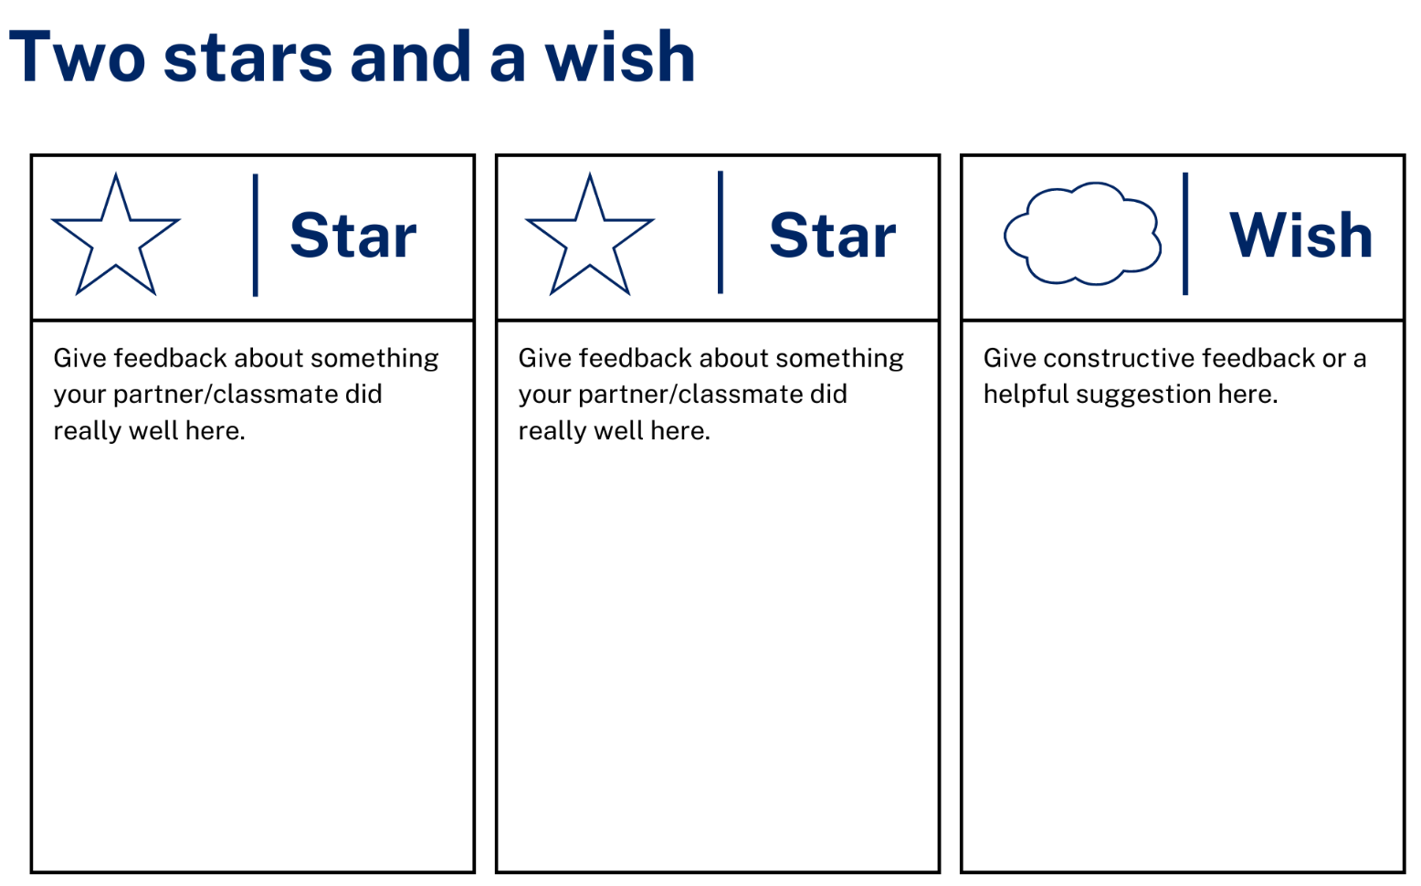

Support and alignment
Resource evaluation and support: all curriculum resources are prepared through a rigorous process. Resources are periodically reviewed as part of our ongoing evaluation plan to ensure currency, relevance, and effectiveness. For additional support or advice, contact the Primary Languages team by emailing primlang@det.nsw.edu.au.
Alignment to system priorities and/or needs: School Excellence Policy, School Success Model
Alignment to the School Excellence Framework: this resource supports the School Excellence Framework elements of curriculum (curriculum provision, teaching and learning programs) and effective classroom practice (lesson planning).
Alignment to Australian Professional Teaching Standards: this resource supports teachers to address Australian Professional Teaching Standards 2.2.2, 3.2.2.
Consulted with: Curriculum, Secondary Learners, school-based staff and NESA subject matter experts. Advice from Aboriginal Outcomes and Partnerships, EAL/D, HPGE and Inclusive Education for Modern Languages Stage 3 Italian Mangiare in Ristorante has been considered in preparing this document.
NSW syllabus: Modern Languages K–10 Syllabus
Syllabus outcomes: ML3-INT-01, ML3-UND-01, ML3-CRT-01
Author: Primary Curriculum
Publisher: State of NSW, Department of Education
Resource: Unit
Related resources: further resources to support Stage 3 Modern Languages can be found on the Languages K-6 curriculum page.
Professional learning: relevant professional learning is available through Primary Languages Networks on Teams (staff only).
Universal Design for Learning: support the diverse learning needs of students using inclusive teaching and learning strategies. Some students may require more specific adjustments to allow them to participate on the same basis as their peers. For further advice see Inclusive practice resources for primary school.
Differentiation: when using these resources in the classroom, it is important for teachers to consider the needs of all students in their class, including:
- Aboriginal and Torres Strait Islander students. Targeted strategies can be used to achieve outcomes for Aboriginal students in K-12 and increase knowledge and understanding of Aboriginal histories and cultures. Teachers should use students’ Personalised Learning Pathways to support individual student needs and goals.
- EAL/D learners. EAL/D learners may require scaffolding to support them to gain content knowledge, while providing extra time and assistance to master the English language required to engage with texts or complete classroom tasks. View some samples of differentiating through scaffolding.
- Students with additional learning needs. Learning adjustments enable students with disability and additional learning and support needs to access syllabus outcomes and content on the same basis as their peers. Teachers can use a range of adjustments to ensure a personalised approach to student learning.
- High potential and gifted learners. Assessing and identifying high potential and gifted learners will help teachers decide which students may benefit from extension and additional challenge. In addition, the Differentiation Adjustment Tool can be used to support the specific learning needs of high potential and gifted students.
Creation date: 28 March 2023
Rights: © State of New South Wales, Department of Education

References
This document contains NSW Curriculum and syllabus content. The NSW Curriculum is developed by the NSW Education Standards Authority. This content is prepared by NESA for and on behalf of the Crown in right of the State of New South Wales. The material is protected by Crown copyright.
Please refer to the NESA Copyright Disclaimer for more information. https://educationstandards.nsw.edu.au/wps/portal/nesa/mini-footer/copyright
NESA holds the only official and up-to-date versions of the NSW Curriculum and syllabus documents. Please visit the NSW Education Standards Authority (NESA) website https://educationstandards.nsw.edu.au/ and the NSW Curriculum website https://curriculum.nsw.edu.au/home.
NSW Modern Languages K-10 Syllabus © 2022 NSW Education Standards Authority (NESA) for and on behalf of the Crown in right of the State of New South Wales.
8 Ways (n.d.) 8 Aboriginal Ways of Learning [website], accessed 13 December 2022.
AITSL (Australian Institute for Teaching and School Leadership) (n.d.) ‘Feedback Factsheet’, AITSL, accessed 21 March 2023.
Brookhart SM (2011) How to Assess Higher-Order Thinking Skills in Your Classroom, Hawker Brownlow Education, Victoria.
CESE (Centre for Education Statistics and Evaluation) (2020a) What works best: 2020 update, NSW Department of Education, accessed 10 March 2023.
CESE (Centre for Education Statistics and Evaluation) (2020b) What works best in practice, NSW Department of Education, accessed 10 March 2023.
Conti G (28 September 2015) ‘16 tips for effective grammar teaching in the foreign language classroom’, The Language Gym, accessed 21 March 2023.
Conti G (28 May 2017) From Target Language to Model Language – the mind shift that has transformed my teaching, The Language Gym, accessed 20 March 2023.
Harmer J (2014) The Practice of English Language Teaching, 5th edn, Pearson Education, United Kingdom, accessed 21 March 2023.
Henshaw FG and Hawkins MD (2022) Common Ground: Second Language Acquisition Theory Goes to the Classroom, Focus, Indianapolis, accessed 14 March 2023.
Jones J and Wiliam D (2014) Modern Foreign Languages Inside the Black Box: Assessment for Learning in the Modern Foreign Languages Classroom (Black P, Harrison C, Marshall B and Wiliam D, eds), Learning Sciences International, United States, accessed 14 March 2023.
NESA (NSW Education Standards Authority) (2021) ‘Proficient Teacher: Standard descriptors’, The Standards, NESA website, accessed 21 December 2022.
Smith S (2022) Becoming an Outstanding Languages Teacher, 2nd edn, Routledge, United Kingdom.
Wiliam D and Leahy S (2015) Embedding Formative Assessment: Practical Techniques for K–12 Classrooms, Learning Sciences International, United States, accessed 14 March 2023.

© State of New South Wales (Department of Education), 2023
The copyright material published in this resource is subject to the Copyright Act 1968 (Cth) and is owned by the NSW Department of Education or, where indicated, by a party other than the NSW Department of Education (third-party material).
Copyright material available in this resource and owned by the NSW Department of Education is licensed under a Creative Commons Attribution 4.0 International (CC BY 4.0) licence.
This licence allows you to share and adapt the material for any purpose, even commercially.
Attribution should be given to © State of New South Wales (Department of Education), 2023.
Material in this resource not available under a Creative Commons licence:
- the NSW Department of Education logo, other logos and trademark-protected material
- material owned by a third party that has been reproduced with permission. You will need to obtain permission from the third party to reuse its material.
Links to third-party material and websites
Please note that the provided (reading/viewing material/list/links/texts) are a suggestion only and implies no endorsement, by the New South Wales Department of Education, of any author, publisher, or book title. School principals and teachers are best placed to assess the suitability of resources that would complement the curriculum and reflect the needs and interests of their students.
If you use the links provided in this document to access a third-party's website, you acknowledge that the terms of use, including licence terms set out on the third-party's website apply to the use which may be made of the materials on that third-party website or where permitted by the Copyright Act 1968 (Cth). The department accepts no responsibility for content on third-party websites.

