Country names in Chinese

Introduction
Read the Chinese names for countries and see if you can work out what they are in English. In the table below, write the English name in the English column. You may work in pairs or small groups to work them out. You do not need to learn all of these countries! Be sure to know China and Australia and any that are relevant to you. You may add to the list with countries relevant or of interest to you.
Chinese | English
中国
澳大利亚
英国
印度
新西兰
美国
南非
希腊
日本
印度尼西亚
意大利

A deeper look
- 人 means person. What do you think it means if you put it after the name of a country?
- How would you write the Chinese nationality?
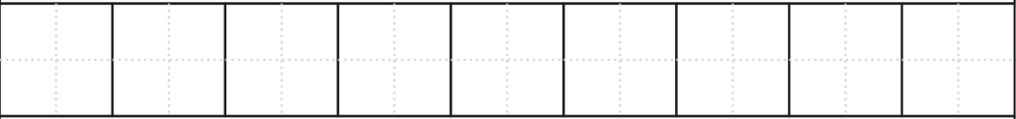
- Write a sentence in Chinese saying what nationality you are, starting with ‘I am …’.
- How do you ask someone ‘Are you Italian?’ in Chinese?
- How do you write ‘I am also Italian’ in Chinese?
- How do you write ‘I am not Australian’ in Chinese?

Hanzi practice
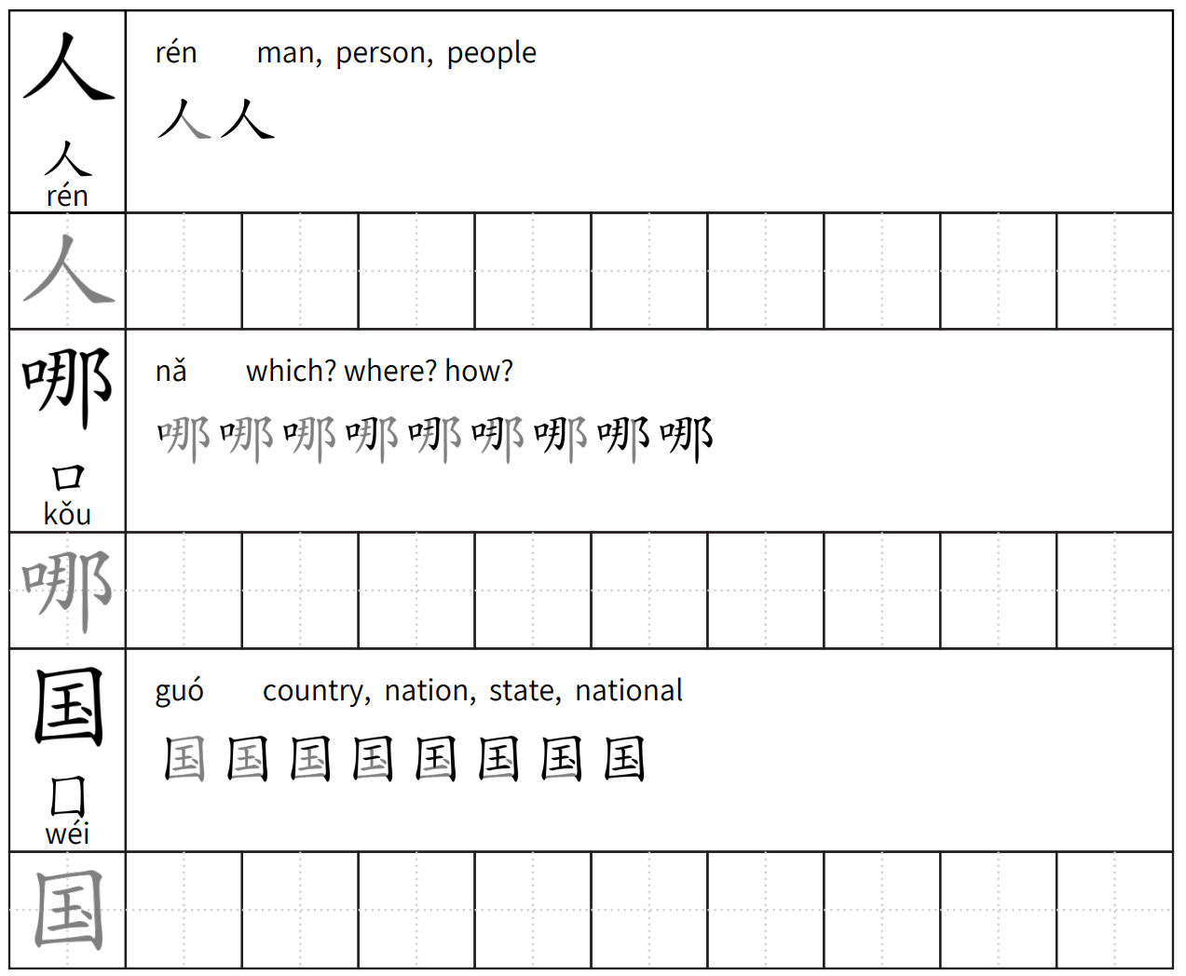

For the teacher

Introduction
Chinese | English
中国 | China
澳大利亚 | Australia
英国 | Great Britain
印度 | India
新西兰 | New Zealand
美国 | United States of America
南非 | South Africa
希腊 | Greece
日本 | Japan
印度尼西亚 | Indonesia
意大利 | Italy

A deeper look
- 人 means person, what do you think it means if you put it after the name of a country?
It means nationality, [country] person.
- How would you say Chinese nationality?
中国人。
- Write a sentence in Chinese saying what nationality you are, starting with ‘I am …’.
For example, 我是澳大利亚人。
- How do you ask someone ‘Are you Italian?’ in Chinese?
你是意大利人吗？
- How do you write ‘I am also Italian’ in Chinese?
我也是意大利人。
- How do you write ‘I am not Australian’ in Chinese?
我不是澳大利亚人。

© State of New South Wales (Department of Education), 2023
The copyright material published in this resource is subject to the Copyright Act 1968 (Cth) and is owned by the NSW Department of Education or, where indicated, by a party other than the NSW Department of Education (third-party material).
Copyright material available in this resource and owned by the NSW Department of Education is licensed under a Creative Commons Attribution 4.0 International (CC BY 4.0) license.
This license allows you to share and adapt the material for any purpose, even commercially.
Attribution should be given to © State of New South Wales (Department of Education), 2023.
Material in this resource not available under a Creative Commons license:
- the NSW Department of Education logo, other logos and trademark-protected material
- material owned by a third party that has been reproduced with permission. You will need to obtain permission from the third party to reuse its material.
Links to third-party material and websites
Please note that the provided (reading/viewing material/list/links/texts) are a suggestion only and implies no endorsement, by the New South Wales Department of Education, of any author, publisher, or book title. School principals and teachers are best placed to assess the suitability of resources that would complement the curriculum and reflect the needs and interests of their students.
If you use the links provided in this document to access a third-party's website, you acknowledge that the terms of use, including licence terms set out on the third-party's website apply to the use which may be made of the materials on that third-party website or where permitted by the Copyright Act 1968 (Cth). The department accepts no responsibility for content on third-party websites.

