Find someone who …?
Your teacher will give each student a different identity card. By asking questions to other students, complete the table below.
First, translate these questions into Chinese.
- What is your name?
- How old are you?
- What do you like?
- What don’t you like?
- What nationality are you?
- Where do you live?
- What language(s) do you speak?
When you’re ready, walk around the room, finding out who fits the criteria in the table below, and write their name in the ‘Identity’ column. You might find more than one person meets each criteria.
Criteria | Identity
Is 13 years old
Is 15 years old
Is 17 years old
Is 62 years old
Is Chinese
Is Australian
Is Italian
Is Indonesian
Is Japanese
Speaks Chinese
Speaks English
Speaks Italian
Speaks Indonesian
Speaks Japanese
Lives in Newcastle
Lives in Rome
Lives in Sydney
Lives in Nara
Lives in Bali
Lives in Beijing
Likes basketball
Likes swimming
Likes sport
Likes pizza
Likes chocolate
Doesn’t like cappuccino
Doesn’t like basketball
Doesn’t like soccer
Doesn’t like swimming
Doesn’t like sport

For the teacher
Check students have the correct questions before commencing the activity.
- What is your name? 你叫什么名字？
- How old are you? 你几岁了？
- What do you like? 你喜欢什么？
- What don’t you like? 你不喜欢什么？
- What nationality are you? 你是哪国人？
- Where do you live? 你住在哪？
- What language(s) do you speak? 你会说什么？
Provide each student with an identity card. There are 15 cards, so some students will have the same card, but this does not affect the activity.

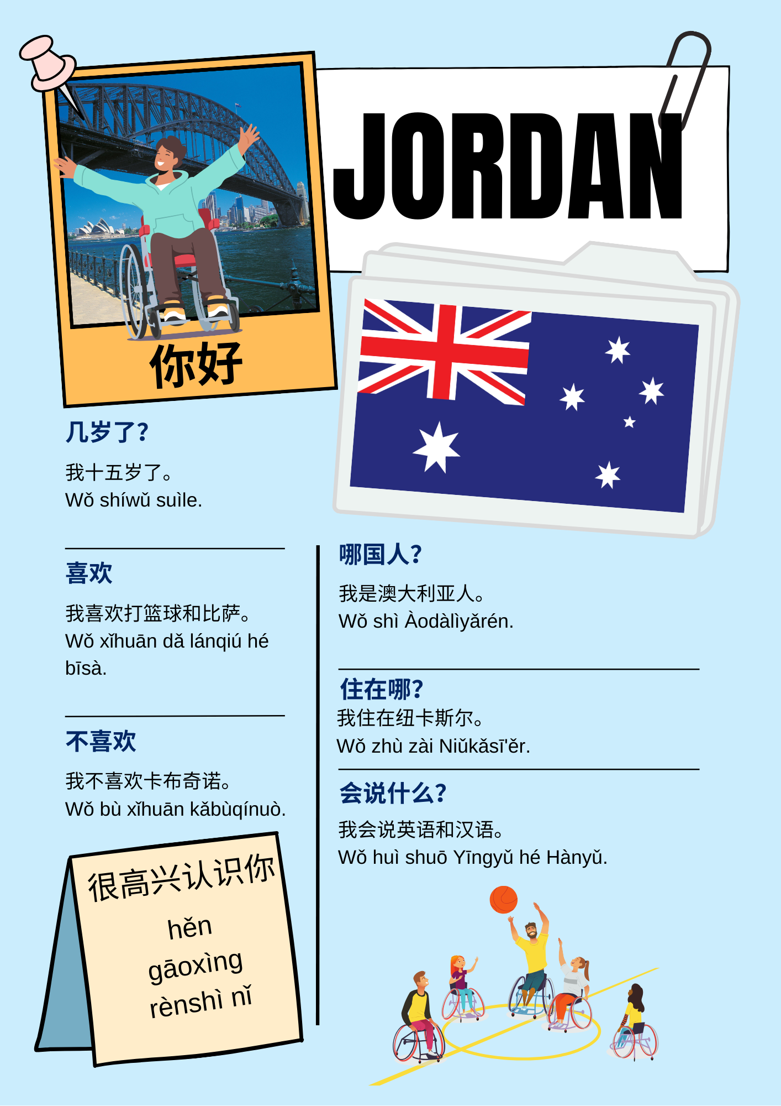 | 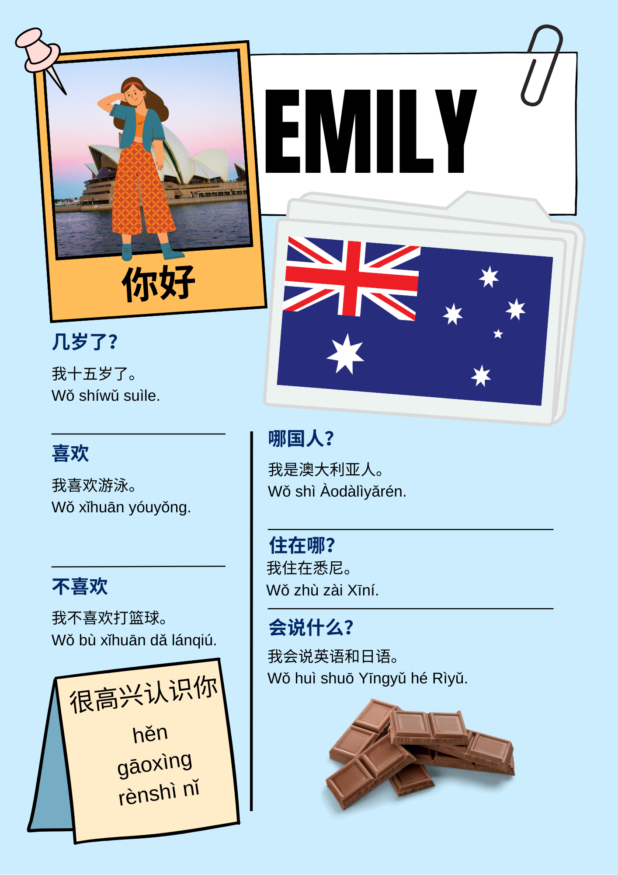
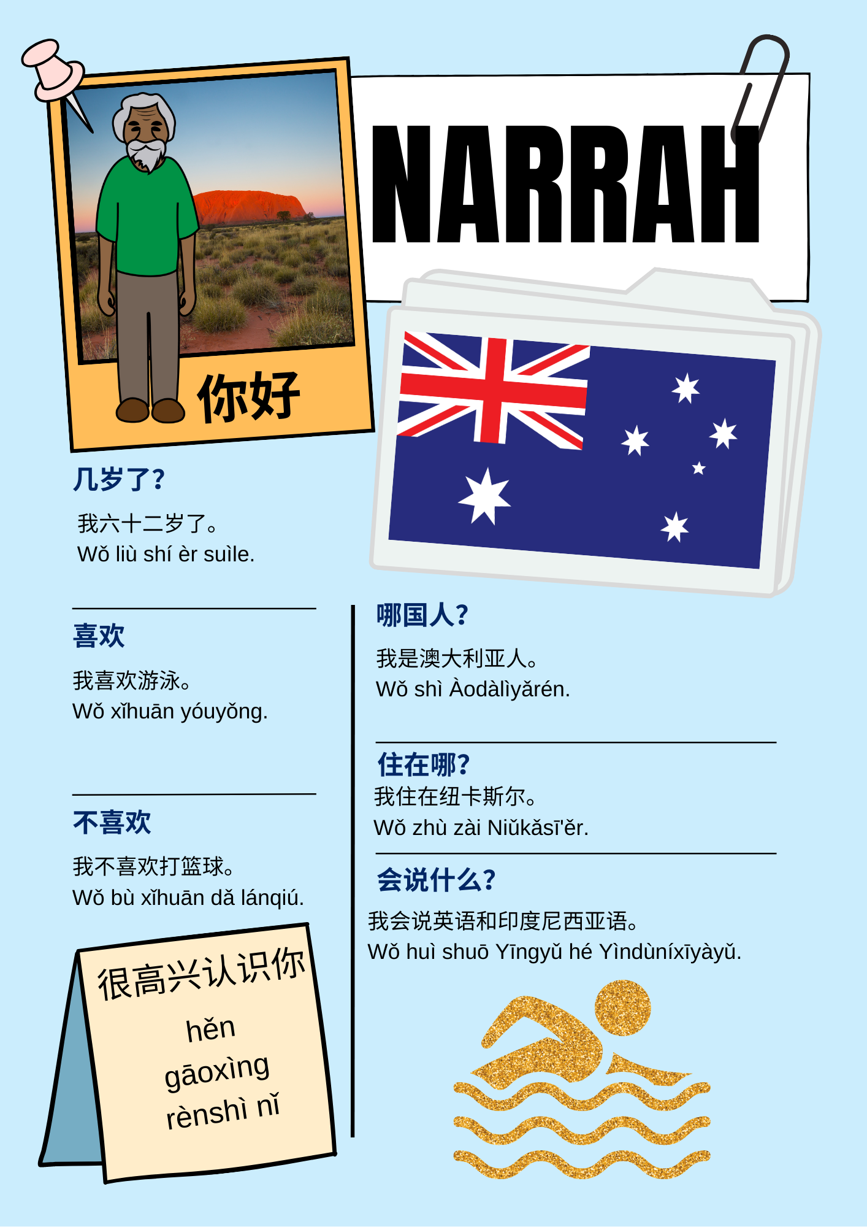 | 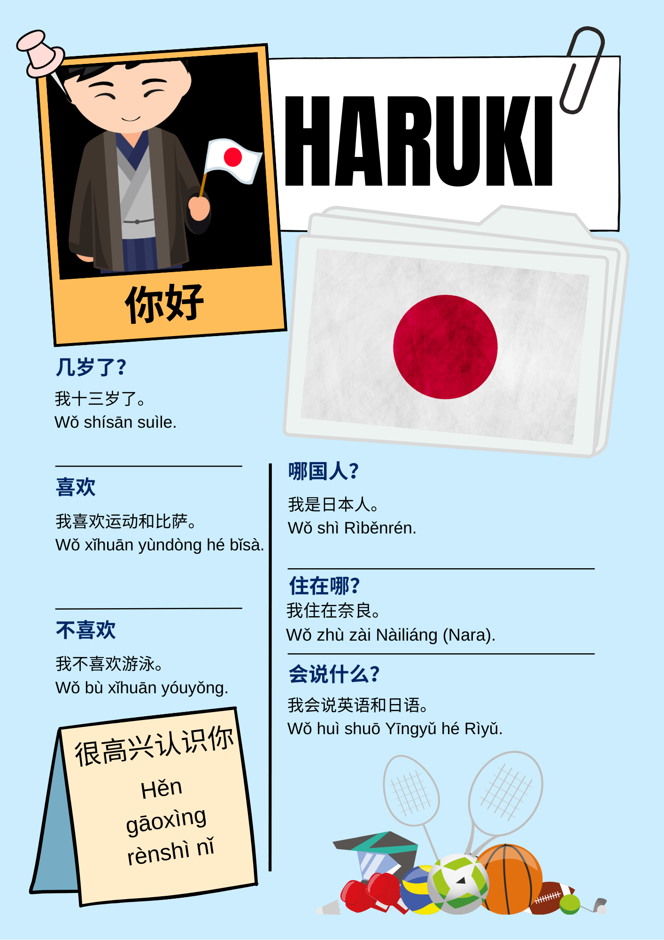
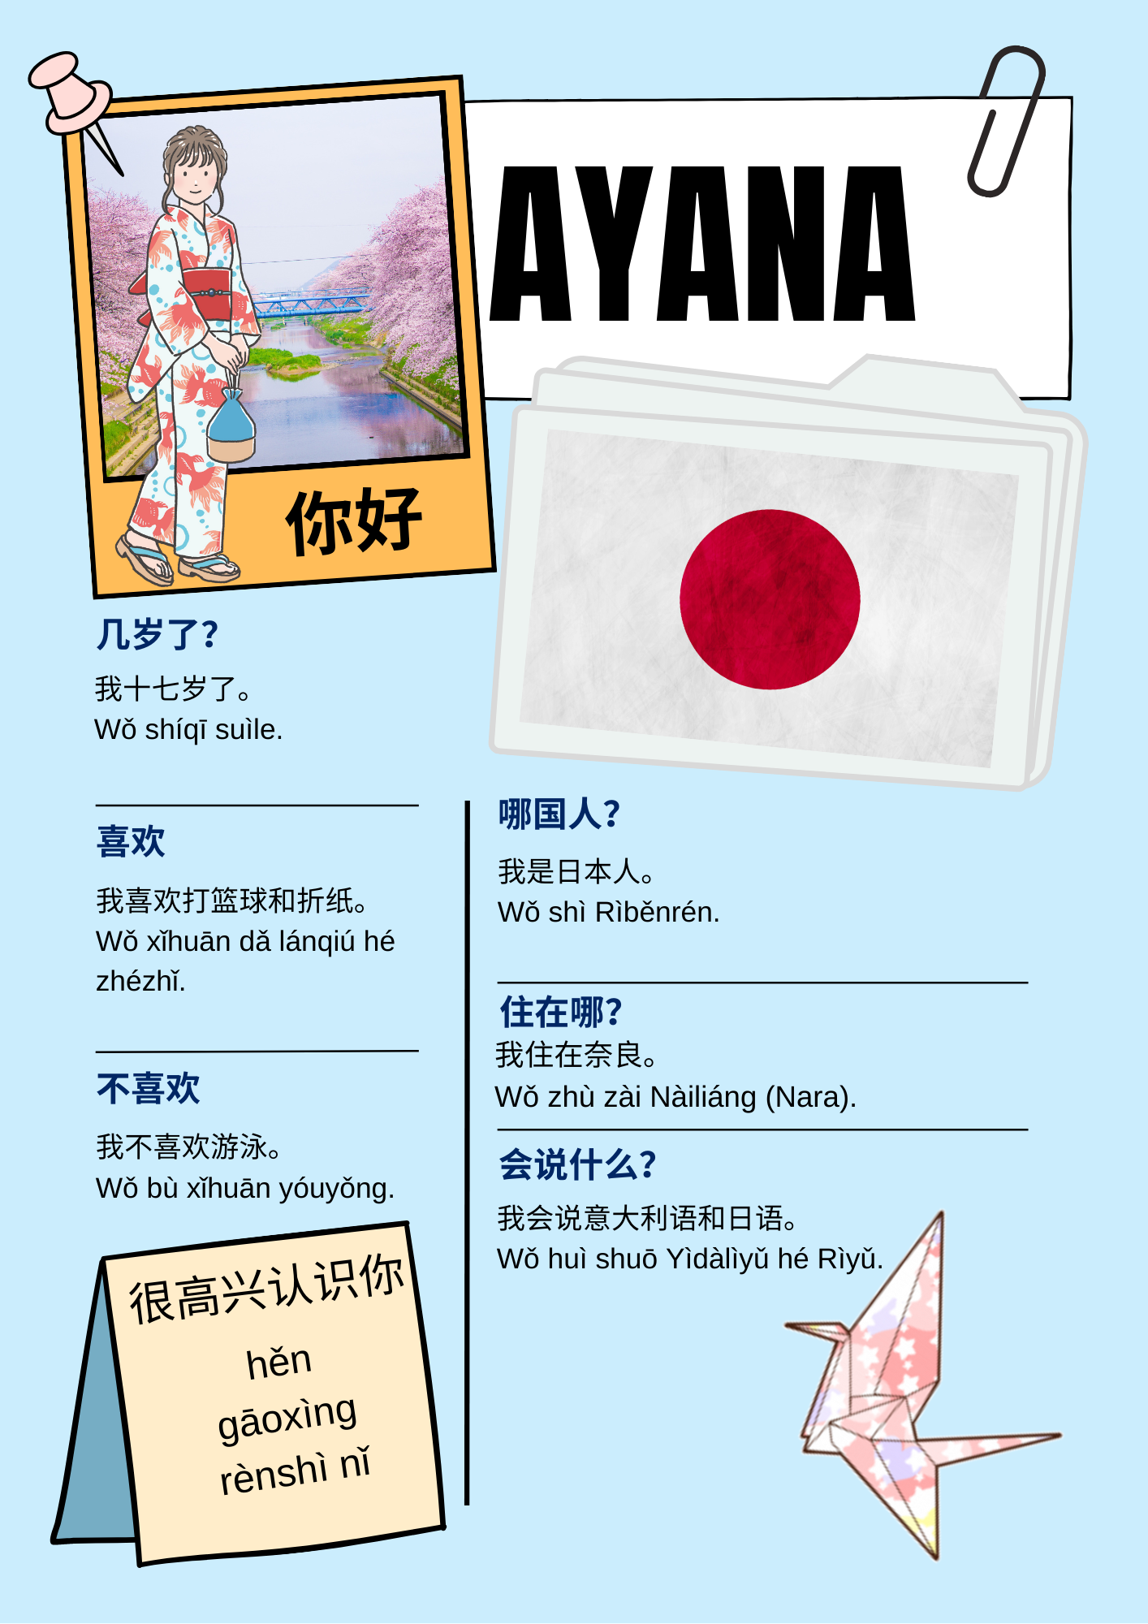 | 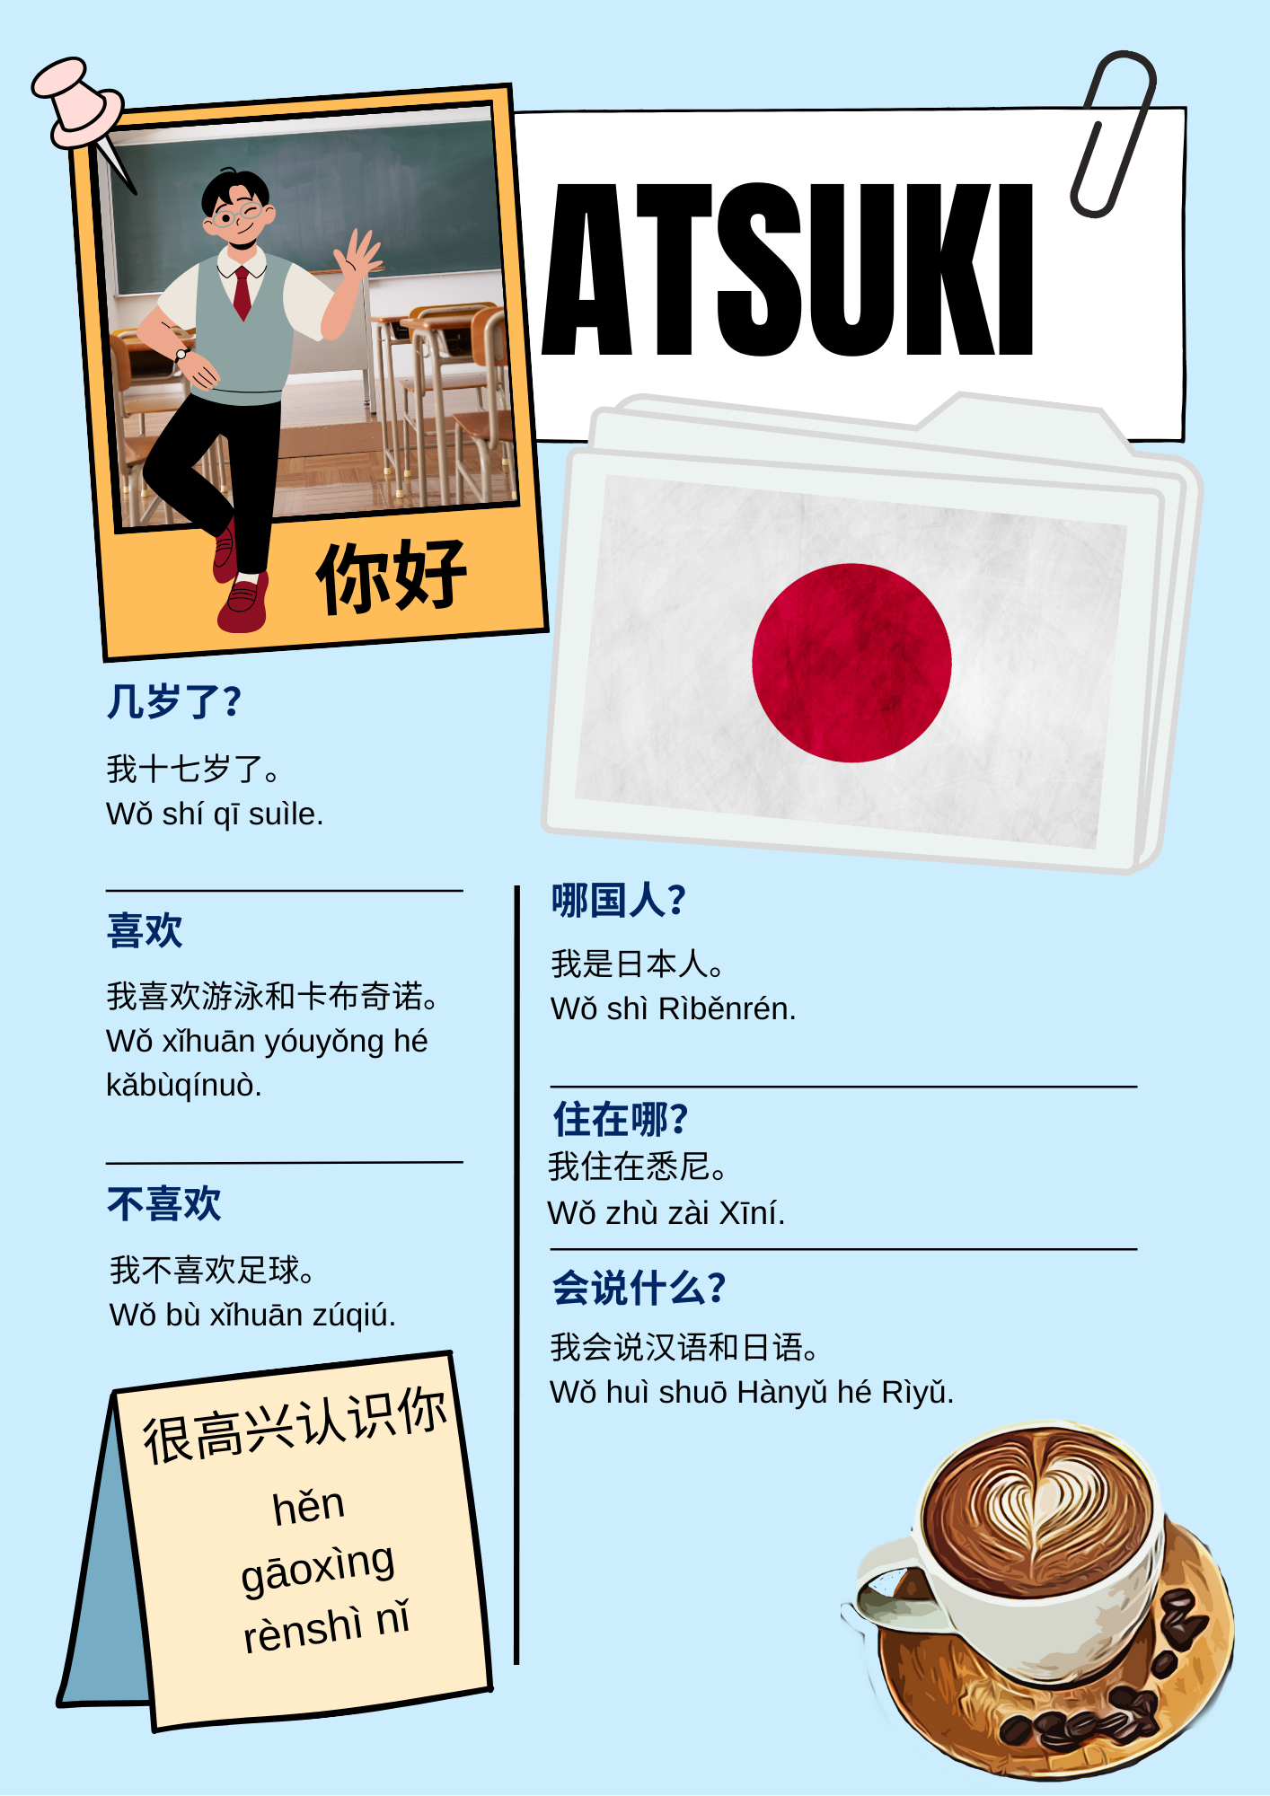
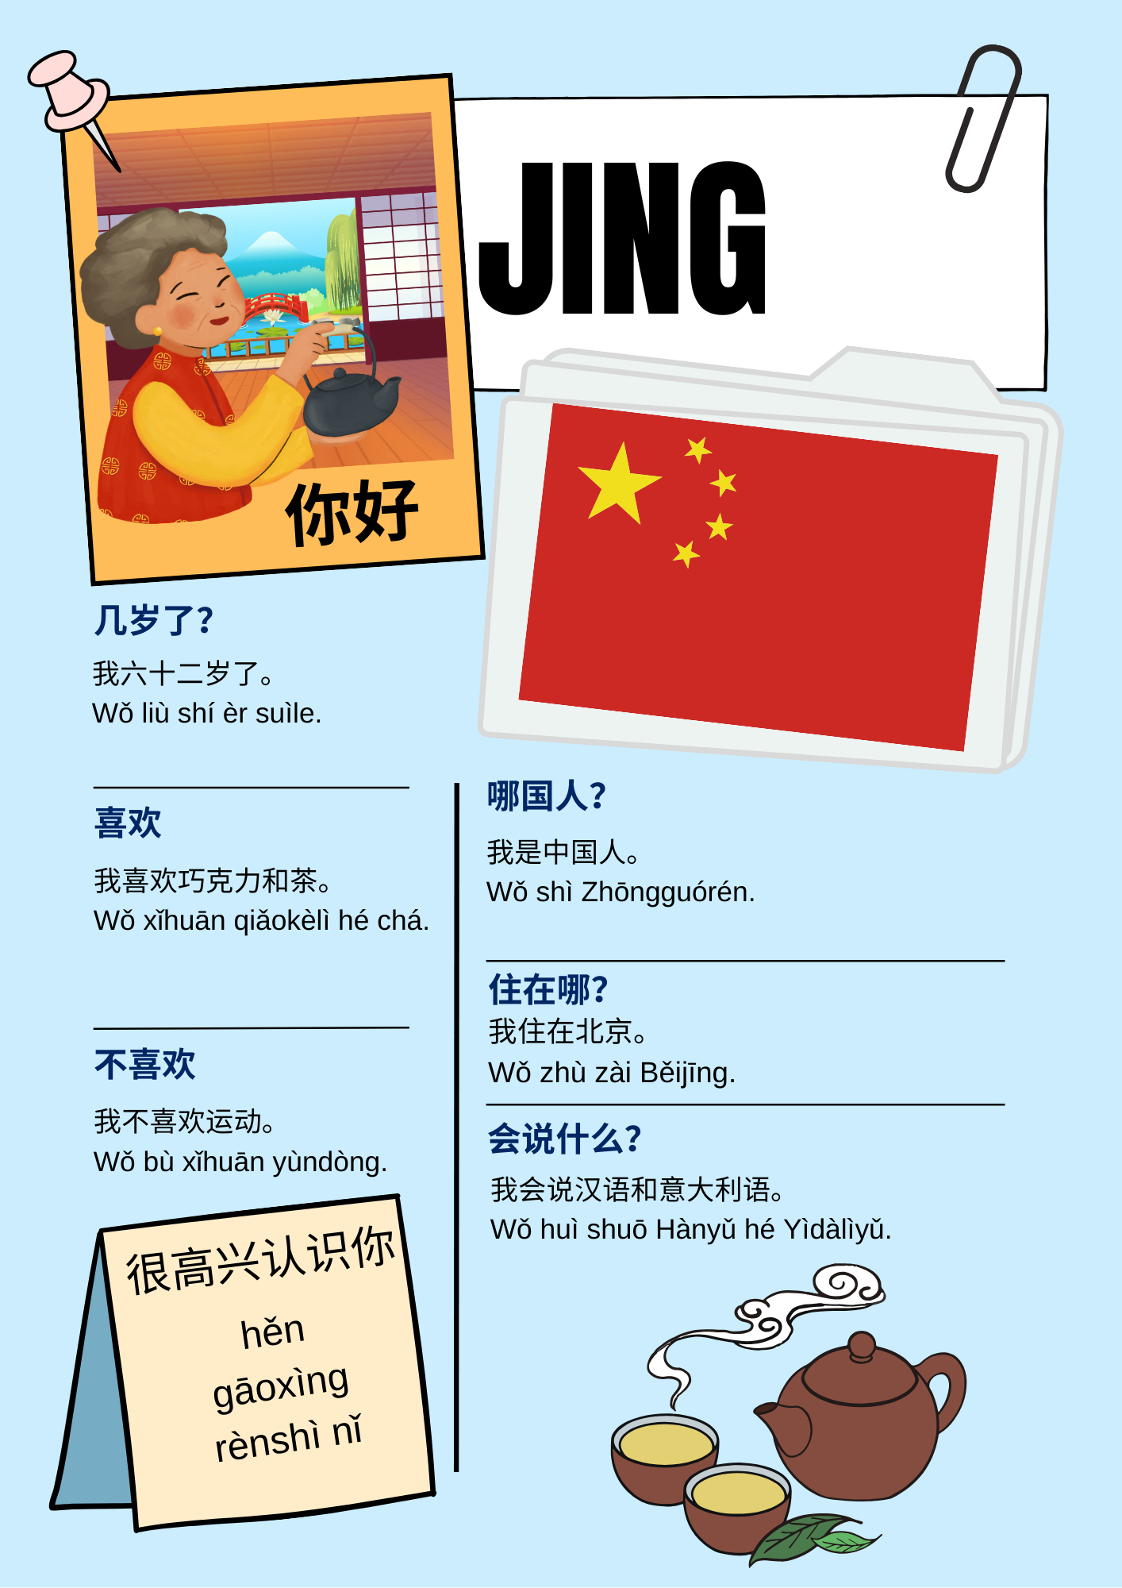 | 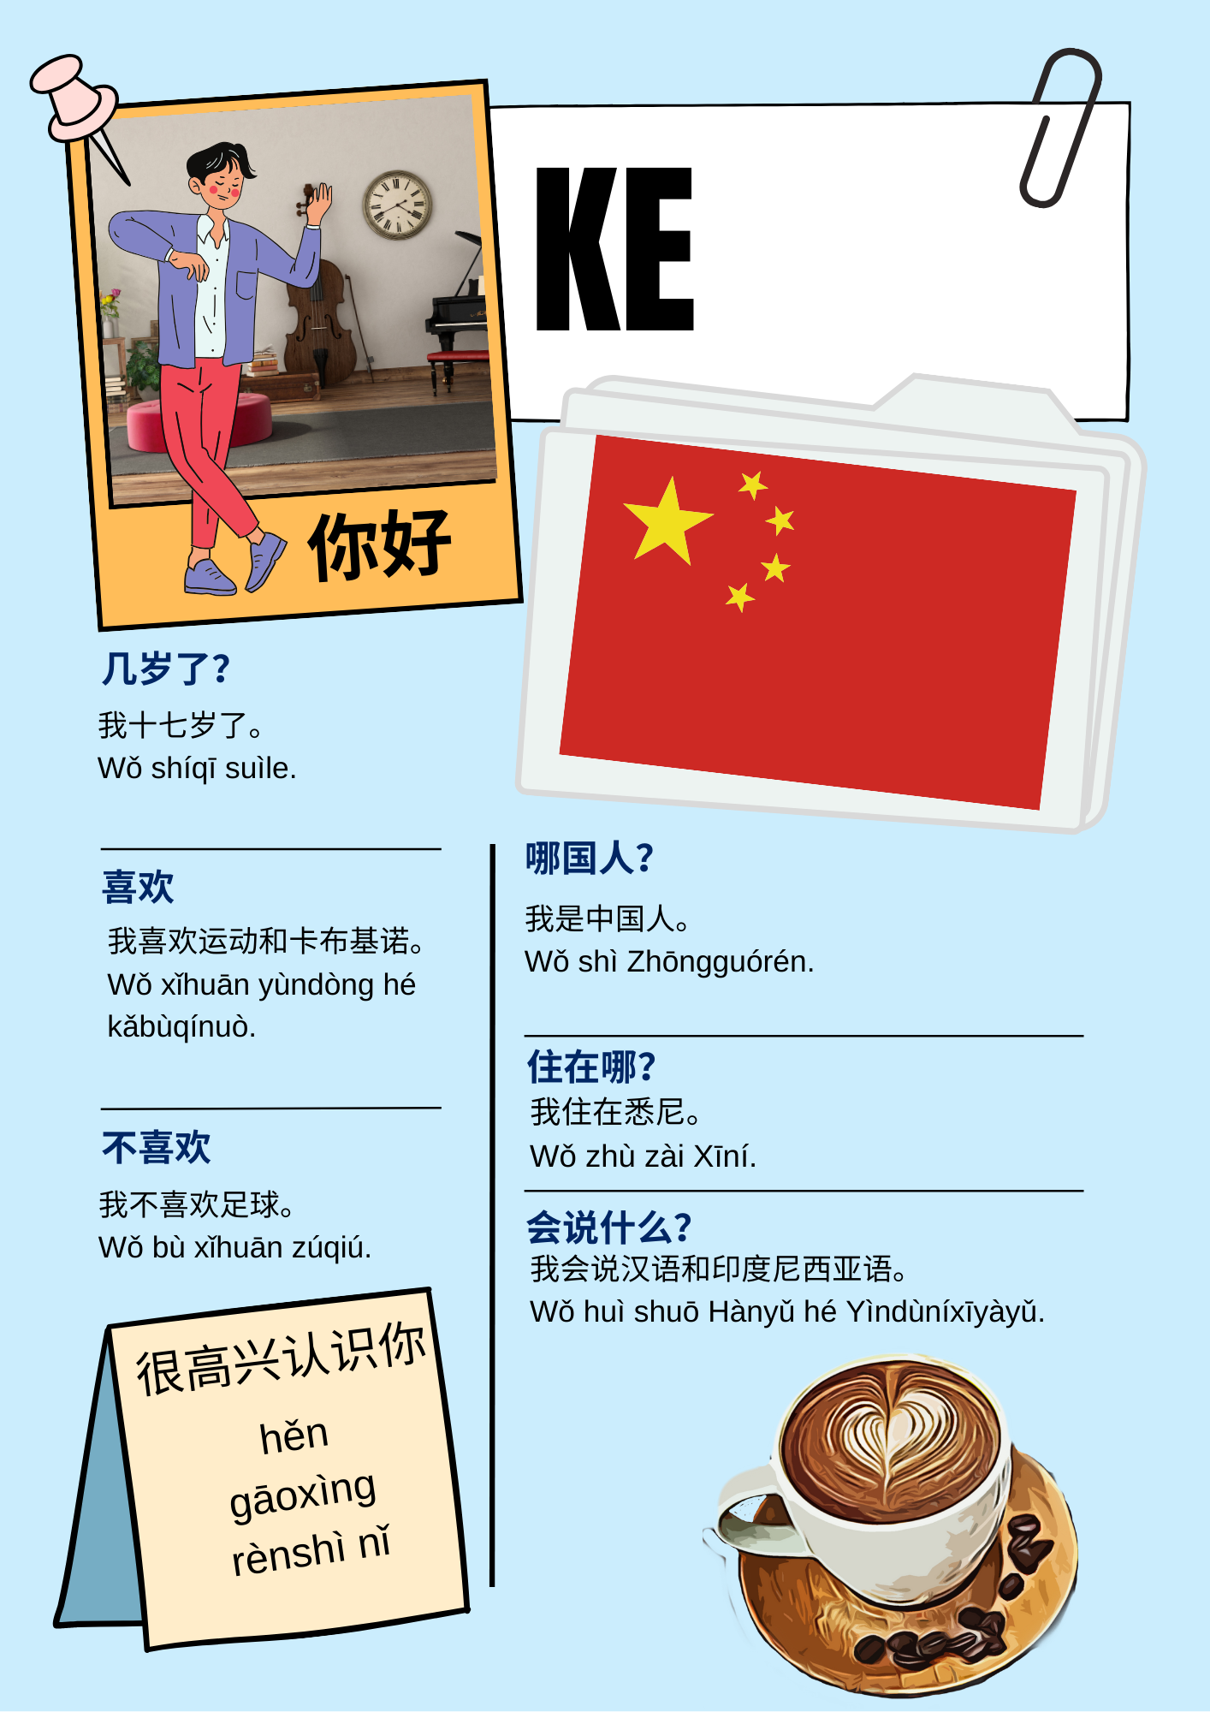
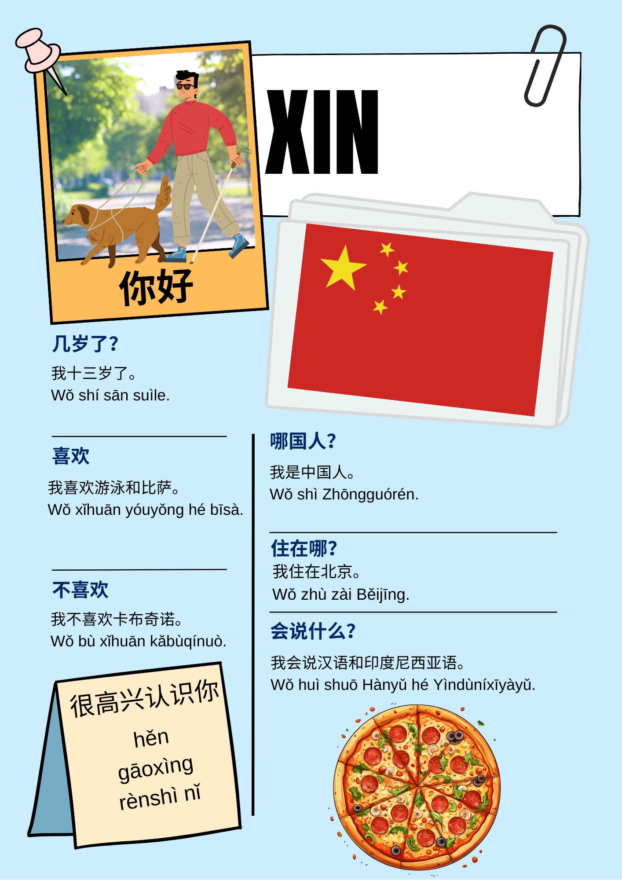 | 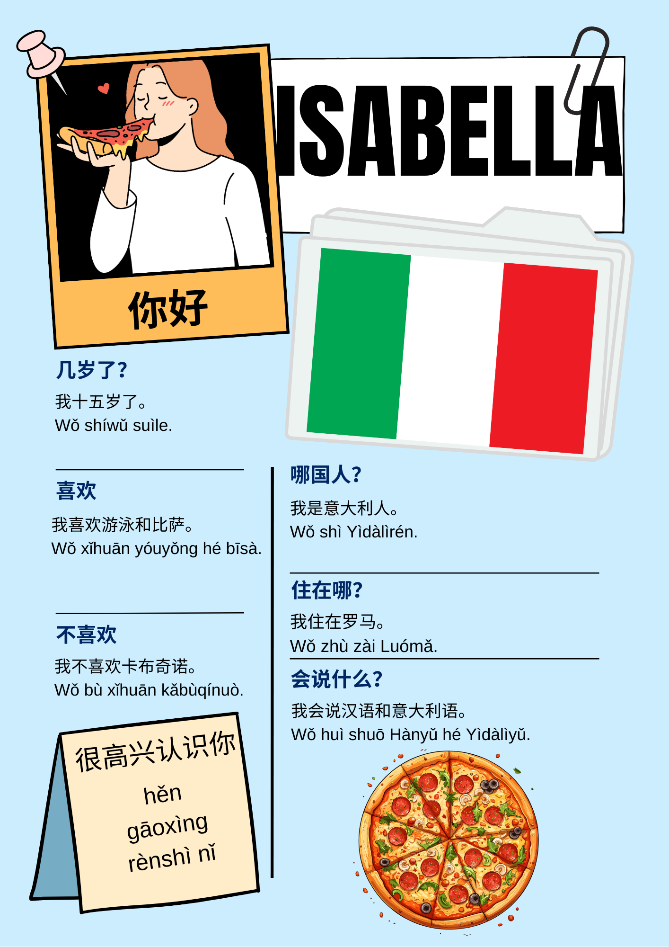
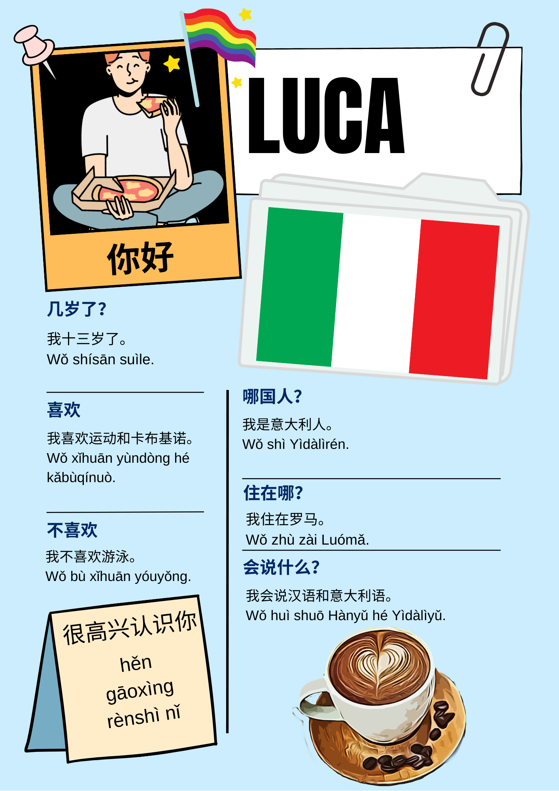 | 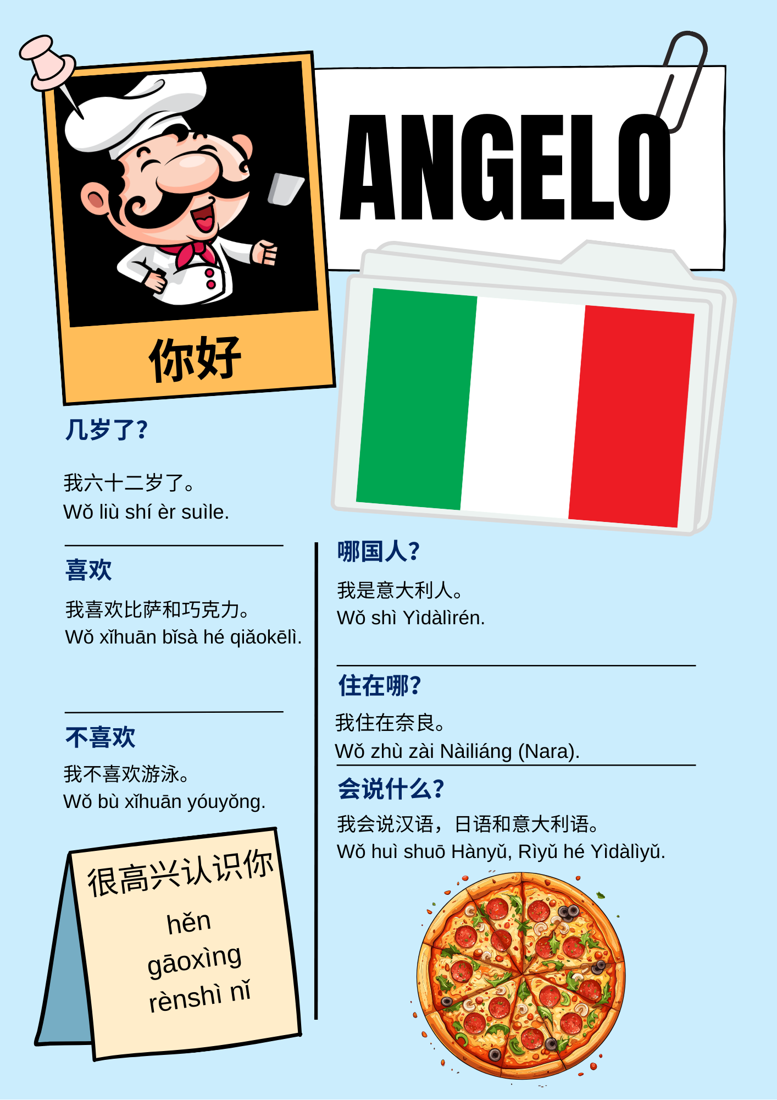
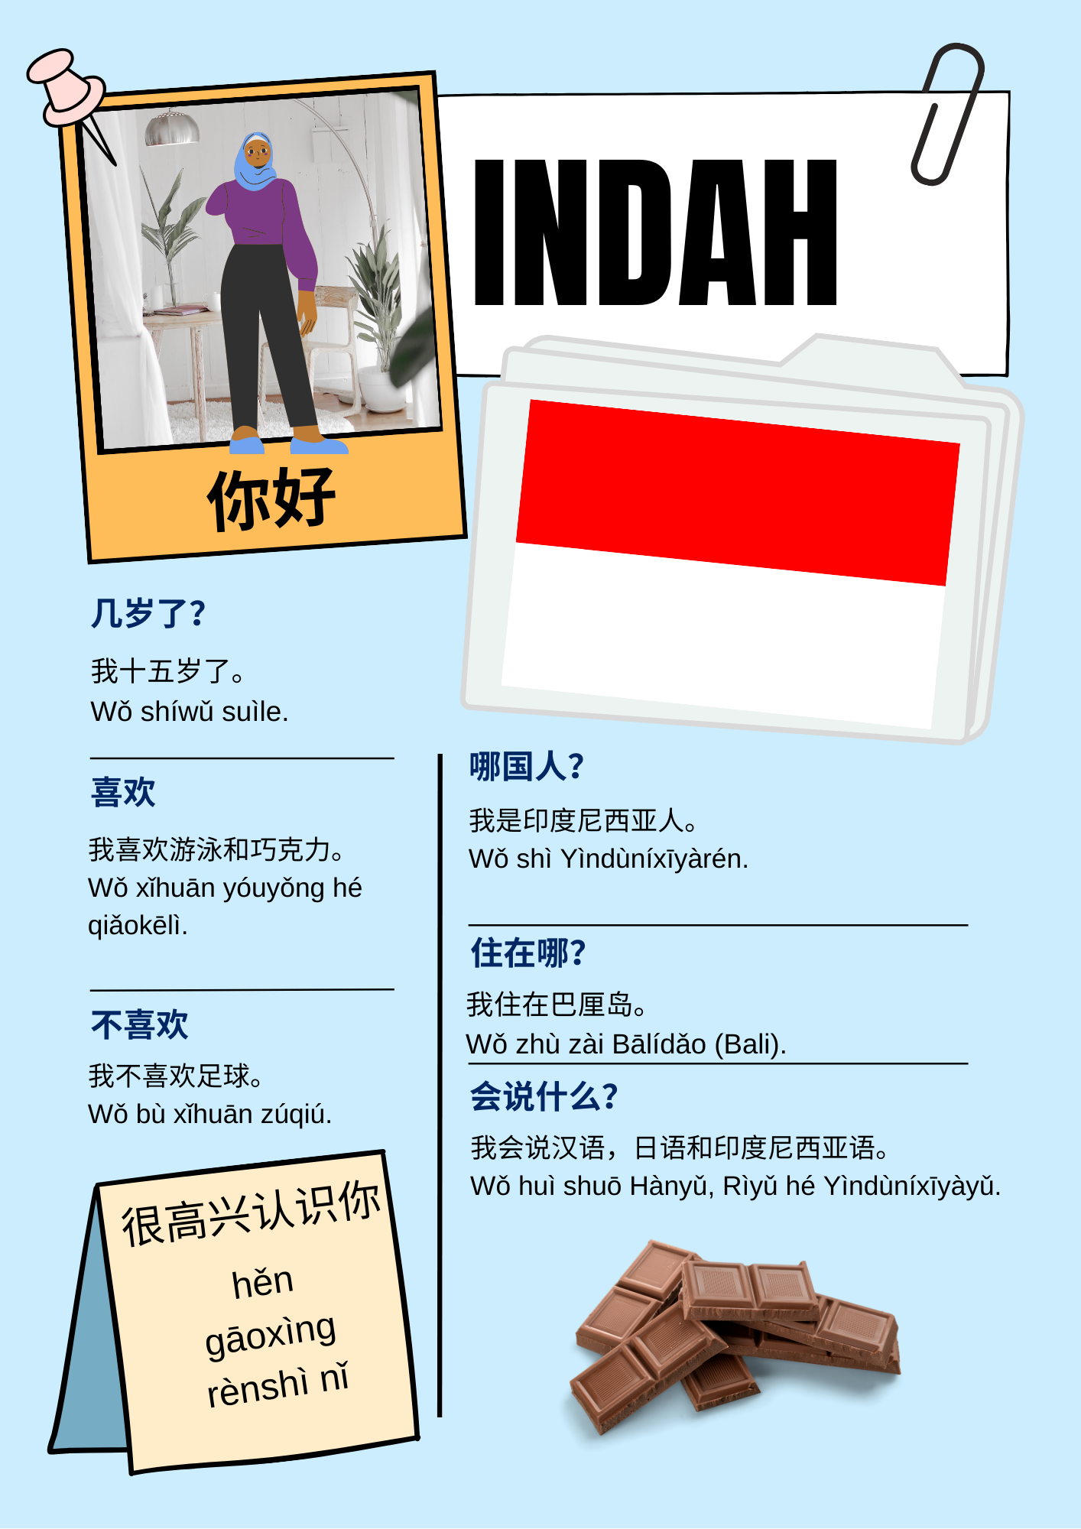 | 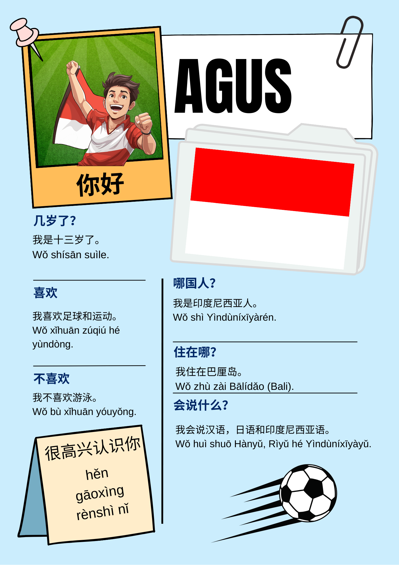
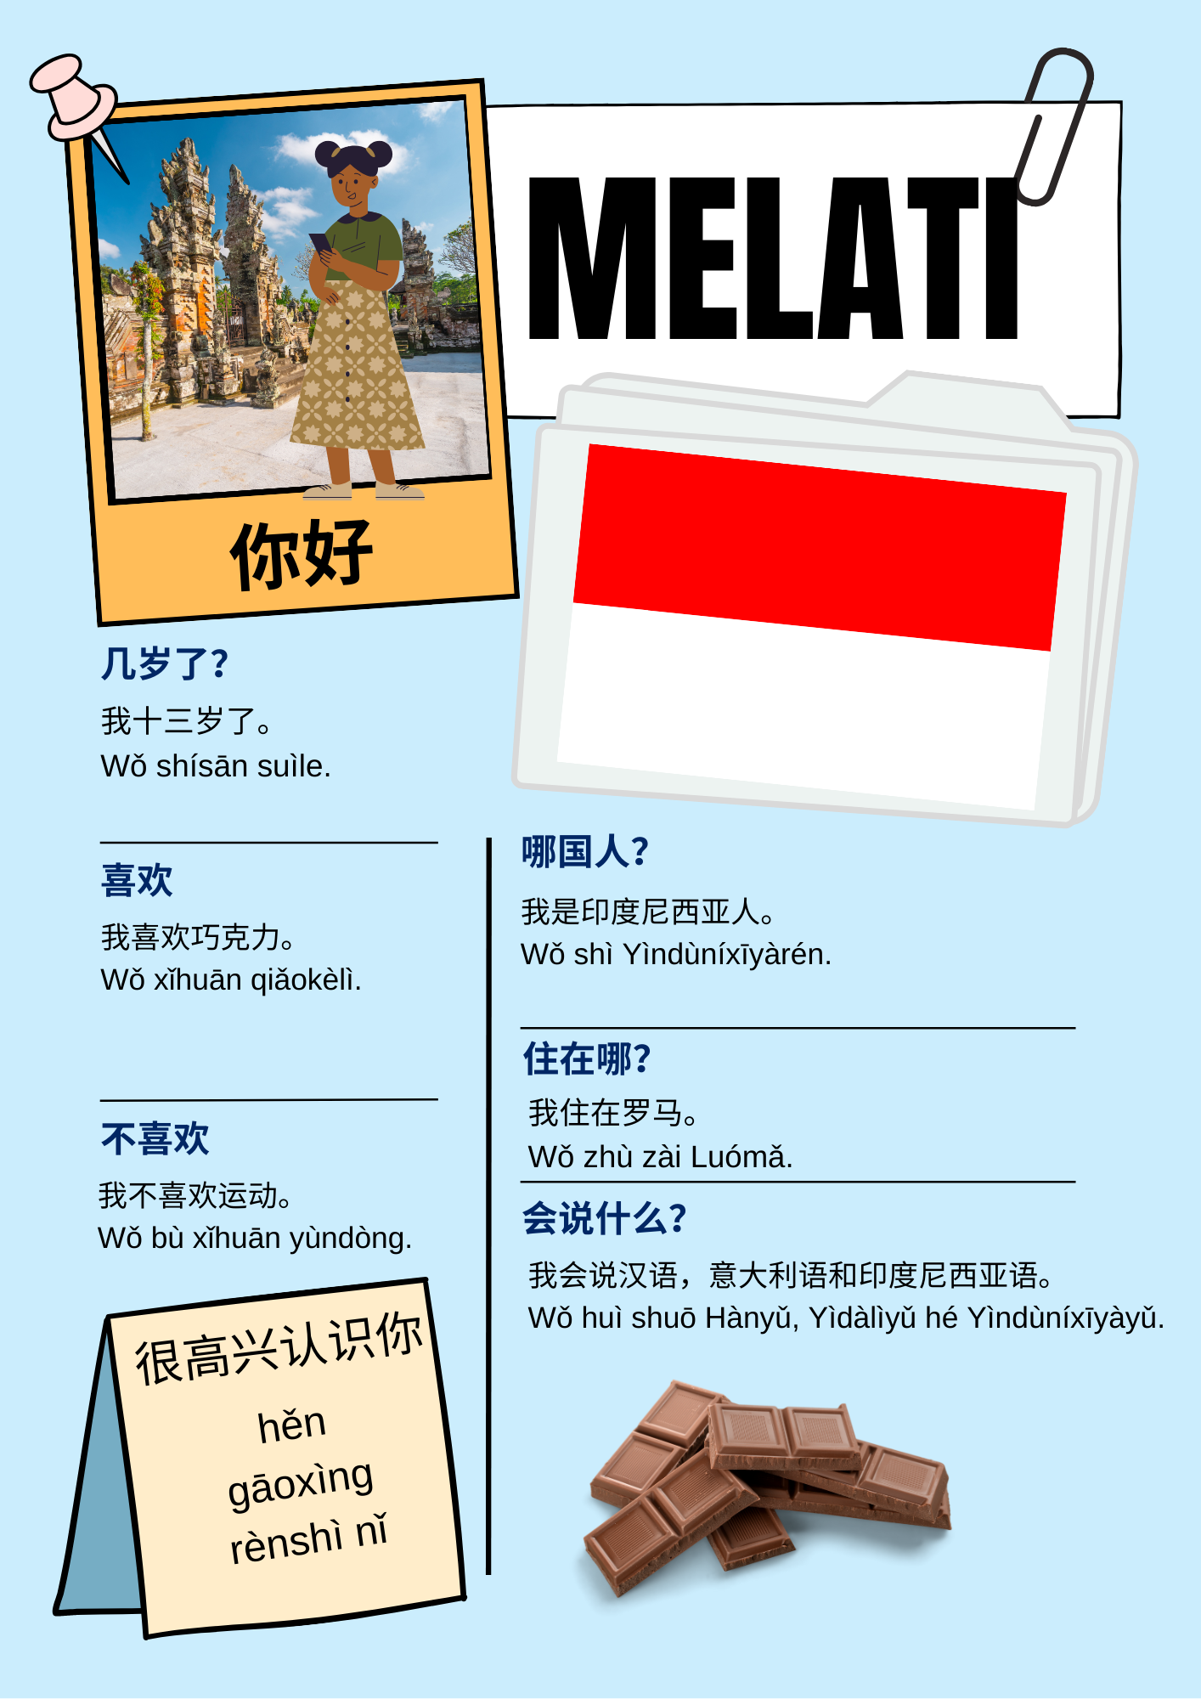

Suggested solution
These are the possible matches students might find.
Criteria | Identity
Is 13 years old | Haruki, Xin, Luca, Agus, Melati
Is 15 years old | Jordan, Emily, Isabella, Indah
Is 17 years old | Ayana, Atsuki, Ke
Is 62 years old | Narrah, Jing, Angelo
Is Chinese | Ke, Jing, Xin
Is Australian | Jordan, Emily, Narrah
Is Italian | Isabella, Luca, Angela
Is Indonesian | Indah, Agus, Melati
Is Japanese | Haruki, Atsuki, Ayana
Speaks Chinese | Melati, Jordan, Angelo, Indah, Atsuki, Isabella, Agus, Luca, Ke, Jing, Xin
Speaks English | Jordan, Emily, Narrah, Haruki
Speaks Italian | Ayana, Jing, Isabella, Melati, Angelo, Luca
Speaks Indonesian | Melati, Indah, Agus, Xin, Ke, Narrah
Speaks Japanese | Emily, Haruki, Atsuki, Ayana, Indah, Agus
Lives in Newcastle | Jordan, Narrah
Lives in Rome | Isabella, Luca, Melati
Lives in Sydney | Emily, Atsuki, Ke
Lives in Nara | Haruki, Ayana, Angelo
Lives in Bali | Indah, Agus
Lives in Beijing | Jing, Xin
Likes basketball | Jordan, Ayana
Likes swimming | Emily, Narrah, Indah, Isabella, Atsuki, Xin
Likes sport | Haruki, Ke, Luca, Agus
Likes pizza | Jordan, Haruki, Angelo, Xin, Isabella
Likes chocolate | Emily, Jing, Angelo, Melati, Indah
Doesn’t like cappuccino | Jordan, Xin, Isabella
Doesn’t like basketball | Emily, Narrah
Doesn’t like soccer | Atsuki, Ke, Indah
Doesn’t like swimming | Haruki, Ayana, Luca, Agus, Angelo
Doesn’t like sport | Jing, Melati

© State of New South Wales (Department of Education), 2023
The copyright material published in this resource is subject to the Copyright Act 1968 (Cth) and is owned by the NSW Department of Education or, where indicated, by a party other than the NSW Department of Education (third-party material).
Copyright material available in this resource and owned by the NSW Department of Education is licensed under a Creative Commons Attribution 4.0 International (CC BY 4.0) license.
This license allows you to share and adapt the material for any purpose, even commercially.
Attribution should be given to © State of New South Wales (Department of Education), 2023.
Material in this resource not available under a Creative Commons license:
- the NSW Department of Education logo, other logos and trademark-protected material
- material owned by a third party that has been reproduced with permission. You will need to obtain permission from the third party to reuse its material.
Links to third-party material and websites
Please note that the provided (reading/viewing material/list/links/texts) are a suggestion only and implies no endorsement, by the New South Wales Department of Education, of any author, publisher, or book title. School principals and teachers are best placed to assess the suitability of resources that would complement the curriculum and reflect the needs and interests of their students.
If you use the links provided in this document to access a third-party's website, you acknowledge that the terms of use, including licence terms set out on the third-party's website apply to the use which may be made of the materials on that third-party website or where permitted by the Copyright Act 1968 (Cth). The department accepts no responsibility for content on third-party websites.

