Asking for directions

For the teacher
Print the cards on different coloured paper. Use one colour for the gender of the passer-by, one colour for the destination, and one colour for the directions.
Distribute the cards to each pair or group of 3, in 3 piles, face down.
Students use the cards from the separate piles as cues to participate in a conversation to ask for and give directions to a passer-by.
Demonstrate with a volunteer student how to create the dialogue using the cards as a guide. You may consider adding or omitting destinations, based on your context.
Both students draw a gender card to determine the gender of both speakers.
Student 1 greets the passer-by using the appropriate title:
- Excusez-moi monsieur/madame/mademoiselle ?
Student 2 responds:
- Oui, monsieur/madame/mademoiselle.
Student 1 draws a card from the destination pile and asks the question:
- Pour aller à [location] s’il vous plait ?
Student 2 draws a card from the directions pile and responds according to the instructions given – for example:
- Allez tout droit/prenez la deuxième à gauche/continuez tout droit.
Student 1 thanks Student 2 using the appropriate title:
- Merci monsieur/madame/mademoiselle.
Student 2 responds by saying you’re welcome and goodbye:
- Je vous en prie/de rien/avec plaisir. Au revoir/salut.
If the partners both agree that the cards were accurately represented in their conversation, they keep their card(s). If they have made an error, the card must be returned to the bottom of the pile. Students can then switch roles or partners.

sir | sir
madam | madam
miss | miss
sir | sir
madam | madam
miss | sir
sir | madam
the cinema | the hospital
the post office | the supermarket
sporting field | the pharmacy
the pool | the bakery
the school | the church
the train station | the cheese shop
the shop | the chocolate shop
 | 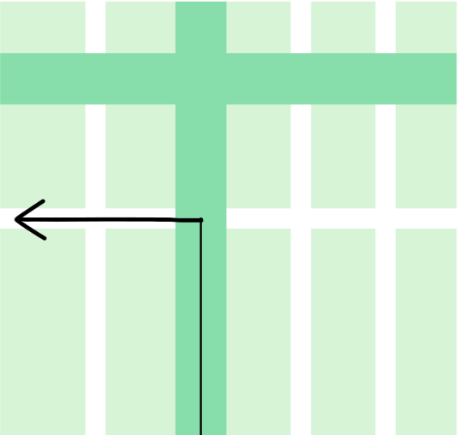
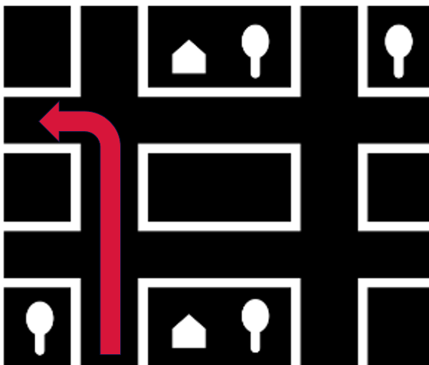
 | 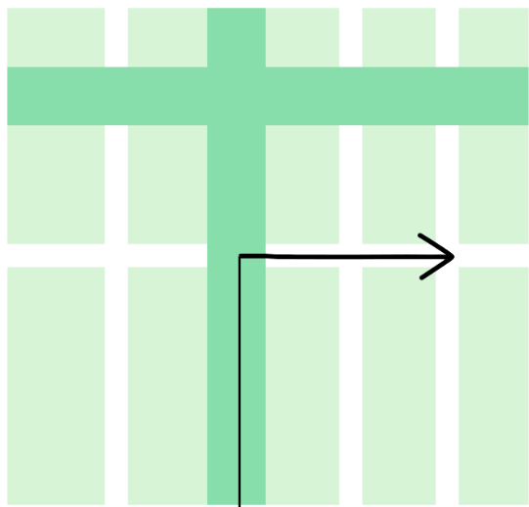
Images sourced from Canva and used in accordance with the Canva Content License Agreement.
© State of New South Wales (Department of Education), 2023
The copyright material published in this resource is subject to the Copyright Act 1968 (Cth) and is owned by the NSW Department of Education or, where indicated, by a party other than the NSW Department of Education (third-party material).
Copyright material available in this resource and owned by the NSW Department of Education is licensed under a Creative Commons Attribution 4.0 International (CC BY 4.0) license.
This license allows you to share and adapt the material for any purpose, even commercially.
Attribution should be given to © State of New South Wales (Department of Education), 2023.
Material in this resource not available under a Creative Commons license:
- the NSW Department of Education logo, other logos and trademark-protected material
- material owned by a third party that has been reproduced with permission. You will need to obtain permission from the third party to reuse its material.
Links to third-party material and websites
Please note that the provided (reading/viewing material/list/links/texts) are a suggestion only and implies no endorsement, by the New South Wales Department of Education, of any author, publisher, or book title. School principals and teachers are best placed to assess the suitability of resources that would complement the curriculum and reflect the needs and interests of their students.
If you use the links provided in this document to access a third-party's website, you acknowledge that the terms of use, including licence terms set out on the third-party's website apply to the use which may be made of the materials on that third-party website or where permitted by the Copyright Act 1968 (Cth). The department accepts no responsibility for content on third-party websites.

