Describing a home – card game

Instructions for students
Your teacher will give you and your partner a set of cards. Place the cards face down on the desk, organised into 4 piles based on colour categories.
You and your partner will take turns to ask and answer questions about the features of your ‘home’.
Take turns to choose one card from each pile and lay them face up in front of you.
Your partner will then ask the following questions:
- C’est une maison ou un appartement ?
- Elle/il est comment ?
- Il y a combien de chambres ?
- Il y a combien de salles de bains ?
Answer the 4 questions, based on the 4 cards you have selected.

For the teacher
Print the cards on coloured paper (based on the categories provided under each heading). You will need enough sets for one set between 2 students.
Student A: C’est une maison ou un appartement ?
Student B: C’est une maison. La maison est à deux étages. OR C’est un appartement. L’appartement est au deuxième étage.
Distribute them to each pair or group. Students use the cards to describe various aspects of a home.
Student A: C’est une maison ou un appartement ?
Student B: C’est une maison. La maison est à deux étages. OR C’est un appartement. L’appartement est au deuxième étage.
Student A: Elle/il est comment ?
Student B: Elle/il est modern mais pas confortable.
Student A: Il y a combien de chambres ?
Student B: Il y a trois chambres.
Student A: Il y a combien de salles de bains ?
Student B: Il y a deux salles de bains.
Once all the cards have been used, students can shuffle them and begin again to ensure a variety of combinations.

Alternative play
Categories can be removed or added as desired, according to the context and Stage of learning. For example, to begin with you may provide each pair the ‘C’est une maison ou un appartement ?’ cards only, gradually adding the other categories.
Students play with one deck of cards only, with all categories mixed together. Students take turns to draw a card. Prompted by the picture, they must ask the relevant question and then hand the card to their partner for them to provide the answer.

C’est une maison ou un appartement ?
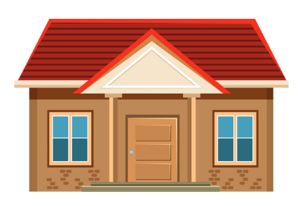  one storey | 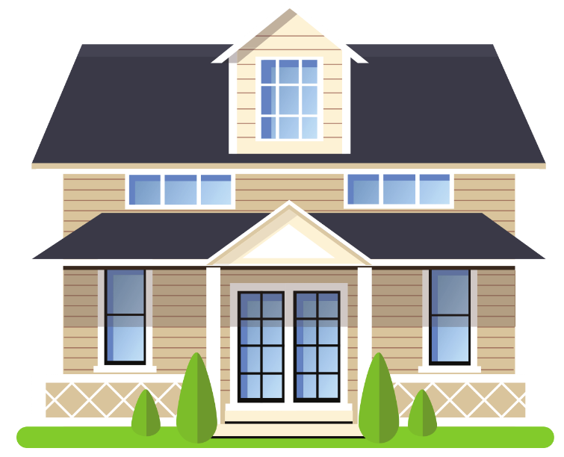  2 storeys
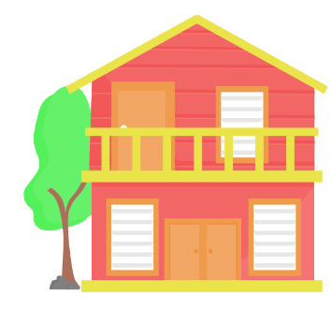  2 storeys | 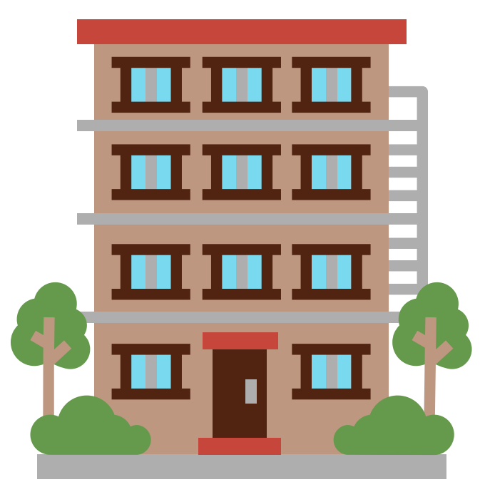  on the first floor
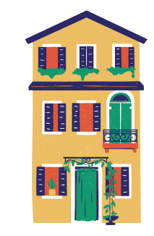  on the ground floor | on the second floor
on the third floor | one storey
Images sourced from Canva and used in accordance with the Canva Content License Agreement,

Elle/il est comment ?
small and very comfortable | big and very modern
big but not old | nice but too modern
historic and very pretty | pretty but not big
beautiful and quite big | old but too small

Il y a combien de chambres ?
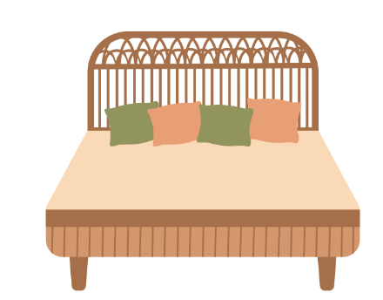x 2 | x 4
x 3 | x 2
x 1 | x 2
x 2 | x 3
Images sourced from Canva and used in accordance with the Canva Content License Agreement,

Il y a combien de salles de bains ?
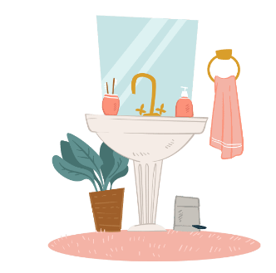x 1 | x 3
x 2 | x 1
x 1 | x 1
x 1 | x 1
Images sourced from Canva and used in accordance with the Canva Content License Agreement.
© State of New South Wales (Department of Education), 2023
The copyright material published in this resource is subject to the Copyright Act 1968 (Cth) and is owned by the NSW Department of Education or, where indicated, by a party other than the NSW Department of Education (third-party material).
Copyright material available in this resource and owned by the NSW Department of Education is licensed under a Creative Commons Attribution 4.0 International (CC BY 4.0) license.
This license allows you to share and adapt the material for any purpose, even commercially.
Attribution should be given to © State of New South Wales (Department of Education), 2023.
Material in this resource not available under a Creative Commons license:
- the NSW Department of Education logo, other logos and trademark-protected material
- material owned by a third party that has been reproduced with permission. You will need to obtain permission from the third party to reuse its material.
Links to third-party material and websites
Please note that the provided (reading/viewing material/list/links/texts) are a suggestion only and implies no endorsement, by the New South Wales Department of Education, of any author, publisher, or book title. School principals and teachers are best placed to assess the suitability of resources that would complement the curriculum and reflect the needs and interests of their students.
If you use the links provided in this document to access a third-party's website, you acknowledge that the terms of use, including licence terms set out on the third-party's website apply to the use which may be made of the materials on that third-party website or where permitted by the Copyright Act 1968 (Cth). The department accepts no responsibility for content on third-party websites.

