Describing homes

Activity 1
Look at the scaffold below. ‘Il y a’ means ‘there is’ or ‘there are’.
Singular/masculine | Il y a | un balcon. | Le balcon | est | grand.
Singular/feminine | Il y a | une porte. | La porte | est | bleue.
Plural | Il y a | des volets. | Les volets | sont | verts.
Now use the scaffold to answer the questions below.
- How do you say ‘a’ for masculine words?
- How do you say ‘the’ for masculine words?
- How do you say ‘a’ for feminine words?
- How do you say ‘the’ for feminine words?
- How do you say ‘the’ for plural nouns, for example ‘the shutters’?
- What do you think ‘des’ means?

Activity 2
Match the sentences below to the correct image in the table, by writing the sentence next to the correct image.
- Il y a un garage.
- Il y a une porte-fenêtre.
- Il y a des volets.
- Il y a une porte.
- Il y a une terrasse.
- Il y a un balcon.
- Il y a un appartement.
- Il y a une maison près de la mer.
House | Description
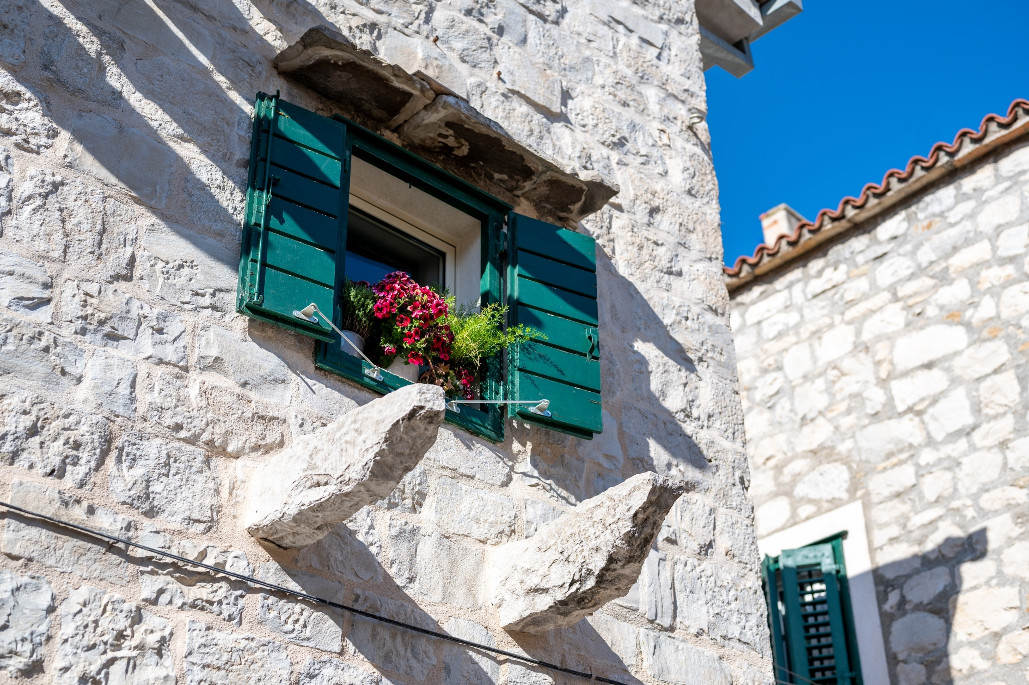
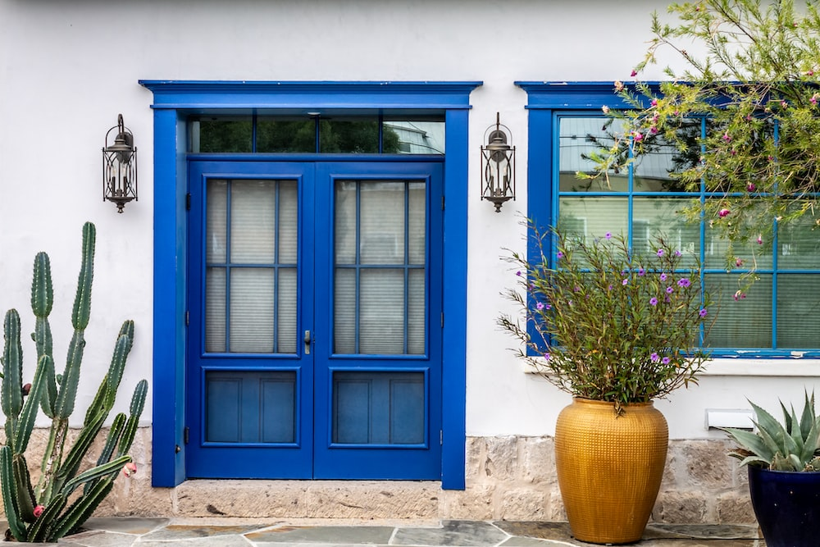
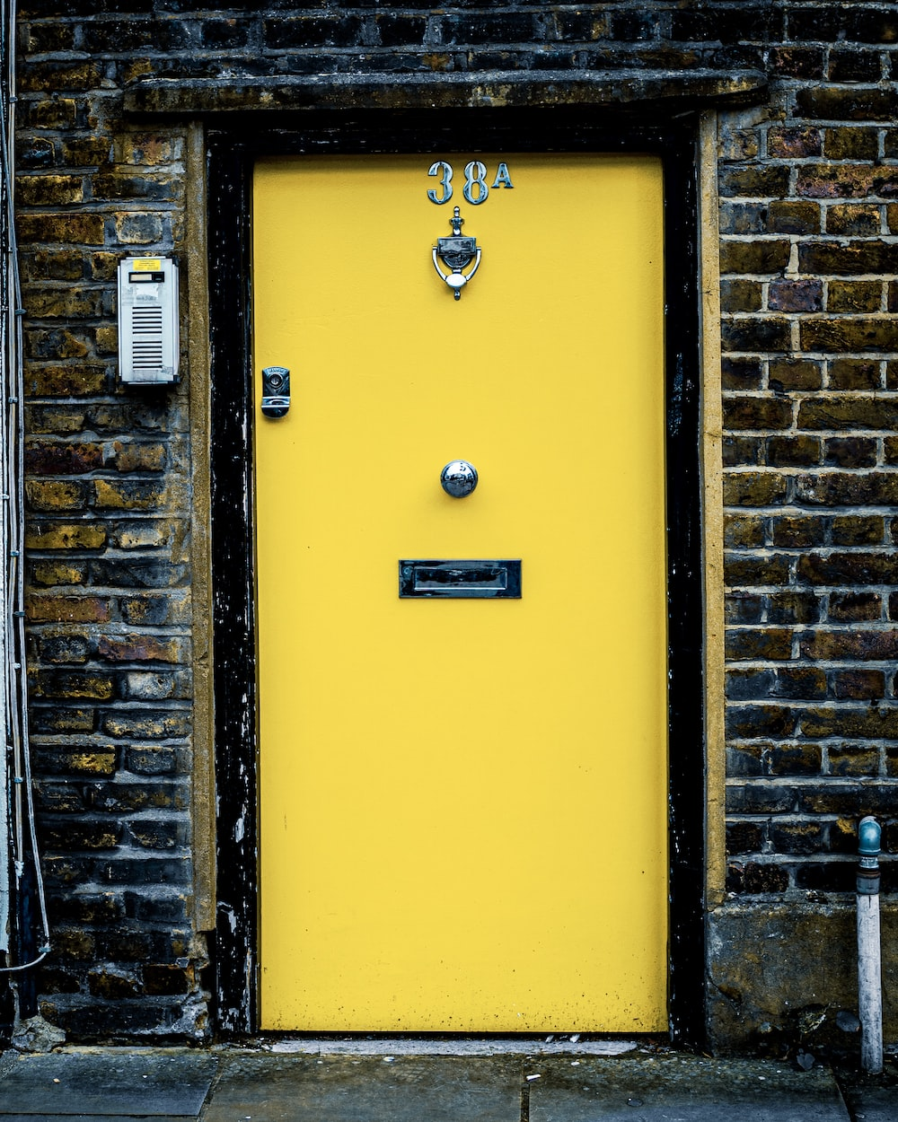
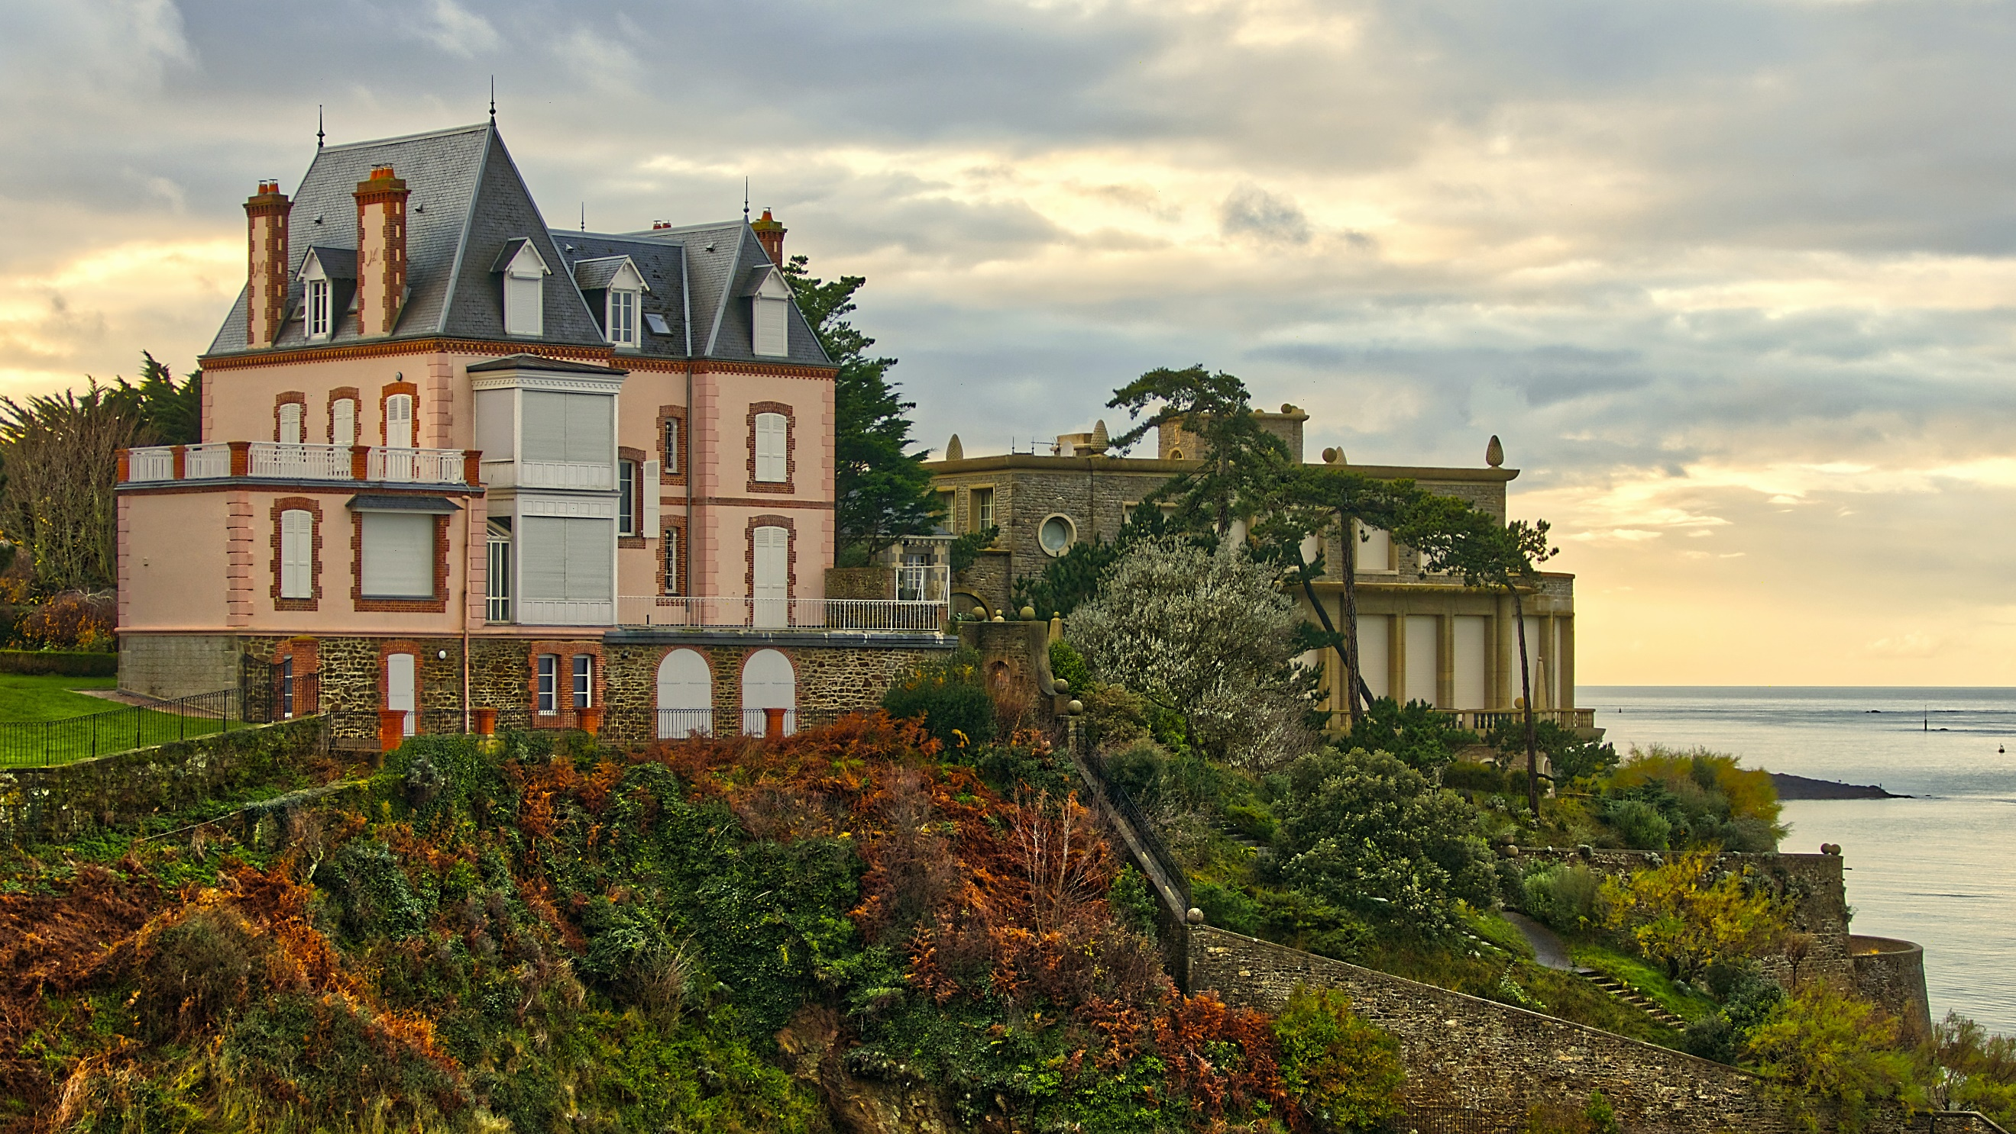
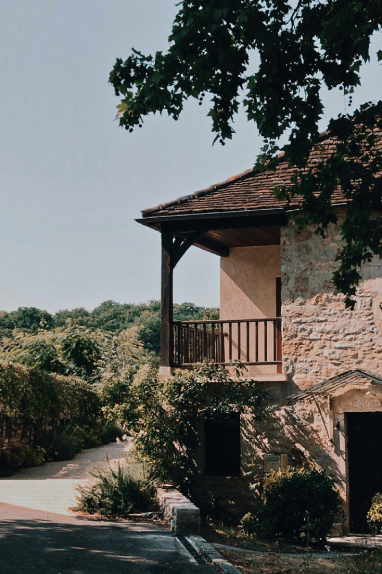
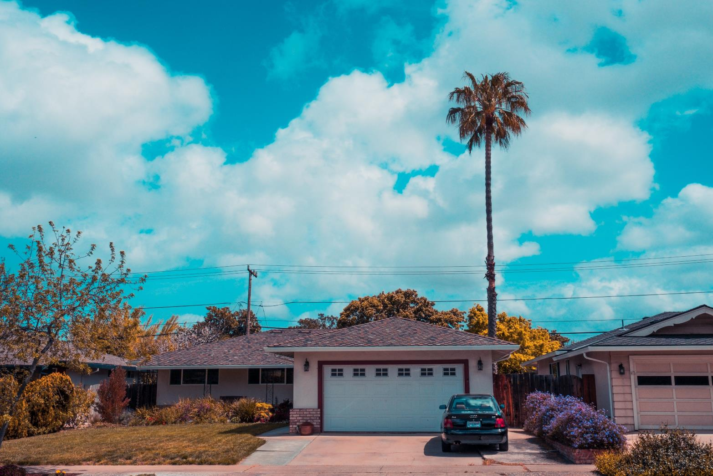
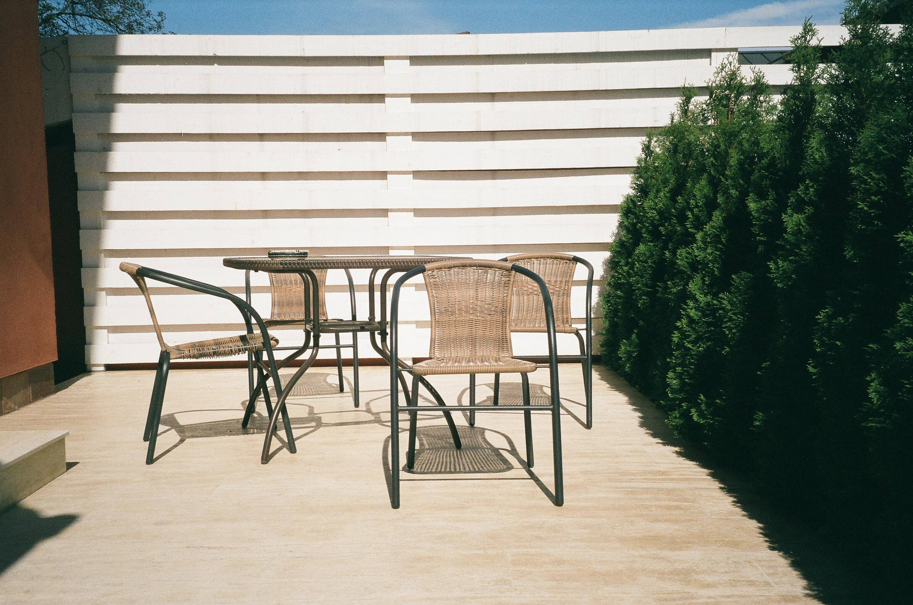
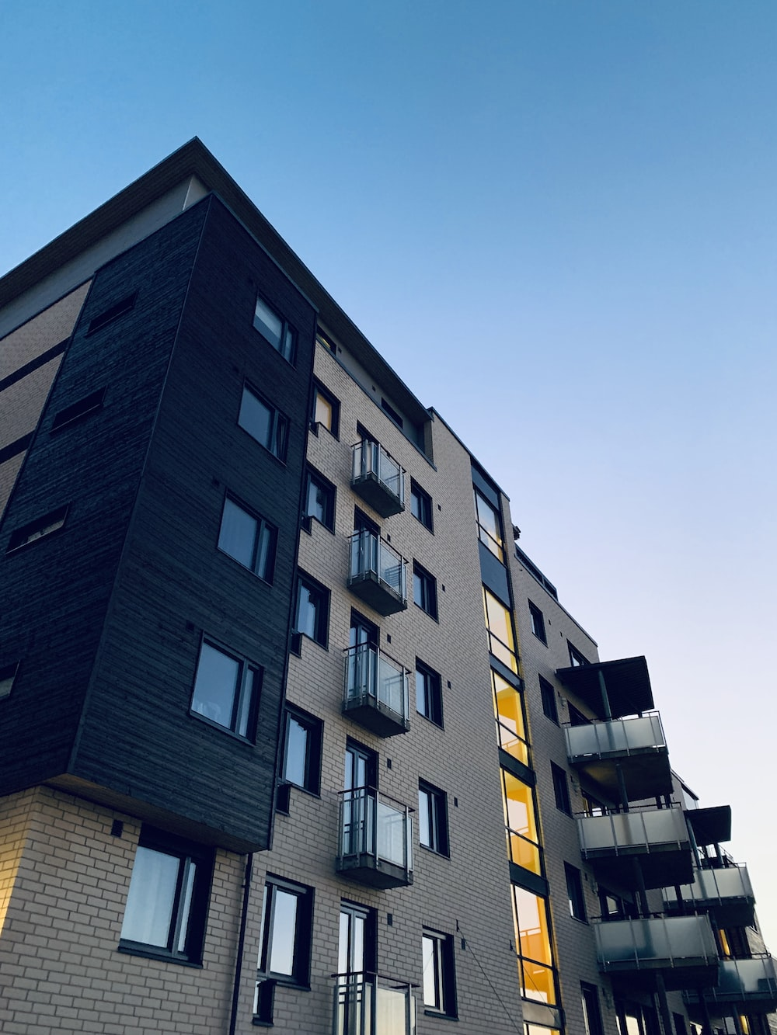
Images licensed under Unsplash License.

Activity 3
In French, adjectives (describing words) agree with the nouns (things) they are describing.
Look at these examples in the table below:
Describing a masculine, singular noun | Describing a feminine, singular noun | Describing a masculine, plural noun | Describing a feminine, plural noun
Le balcon est petit. | La maison est petite. | Le balcons sont petits. | Le maisons sont petites.
Work with a partner to translate the following sentences into French (be careful with the adjective!) and then write each sentence in the table in Activity 2, next to the matching picture:
- The apartment is modern.
- The French door is blue.
- The shutters are green.
- The garage is big.
- The terrace is nice.
- The door is yellow.
- The house is big.
- The balcony is small.

Activity 4
Choose 3 of the homes and write a sentence next to it to say if you like it, or not, and why.
For example:
J’aime la maison parce que la terrasse est grande.
Je déteste la maison parce que le balcon est petit.

For the teacher
House | Description
Il y a des volets.
Les volets sont verts.
Il y a une porte-fenêtre.
La porte-fenêtre est bleue.
Il y a une porte.
La porte est jaune.
Il y a une maison près de la mer.
La maison est grande.
Il y a un balcon.
Le balcon est petit.
Il y a un garage.
Le garage est grand.
Il y a une terrasse.
La terrasse est agréable.
Il y a un appartement.
L’appartement est moderne.
Images licensed under Unsplash License.

© State of New South Wales (Department of Education), 2023
The copyright material published in this resource is subject to the Copyright Act 1968 (Cth) and is owned by the NSW Department of Education or, where indicated, by a party other than the NSW Department of Education (third-party material).
Copyright material available in this resource and owned by the NSW Department of Education is licensed under a Creative Commons Attribution 4.0 International (CC BY 4.0) license.
This license allows you to share and adapt the material for any purpose, even commercially.
Attribution should be given to © State of New South Wales (Department of Education), 2023.
Material in this resource not available under a Creative Commons license:
- the NSW Department of Education logo, other logos and trademark-protected material
- material owned by a third party that has been reproduced with permission. You will need to obtain permission from the third party to reuse its material.
Links to third-party material and websites
Please note that the provided (reading/viewing material/list/links/texts) are a suggestion only and implies no endorsement, by the New South Wales Department of Education, of any author, publisher, or book title. School principals and teachers are best placed to assess the suitability of resources that would complement the curriculum and reflect the needs and interests of their students.
If you use the links provided in this document to access a third-party's website, you acknowledge that the terms of use, including licence terms set out on the third-party's website apply to the use which may be made of the materials on that third-party website or where permitted by the Copyright Act 1968 (Cth). The department accepts no responsibility for content on third-party websites.

