# *Elle est comment ta maison ?*

## Activity 1

Look at the features of each home and write a description in French.

The first one has been done for you.

### Numéro 1

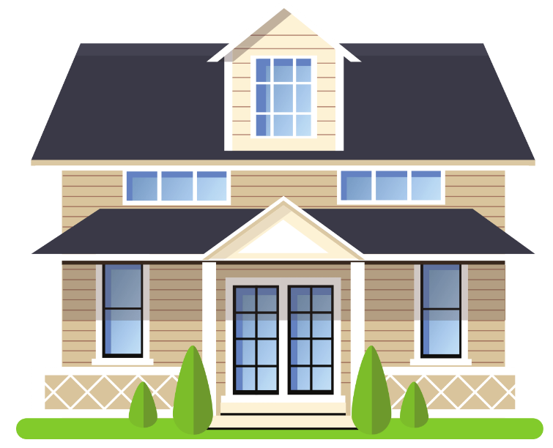 (big and modern)

a bathroom x 2 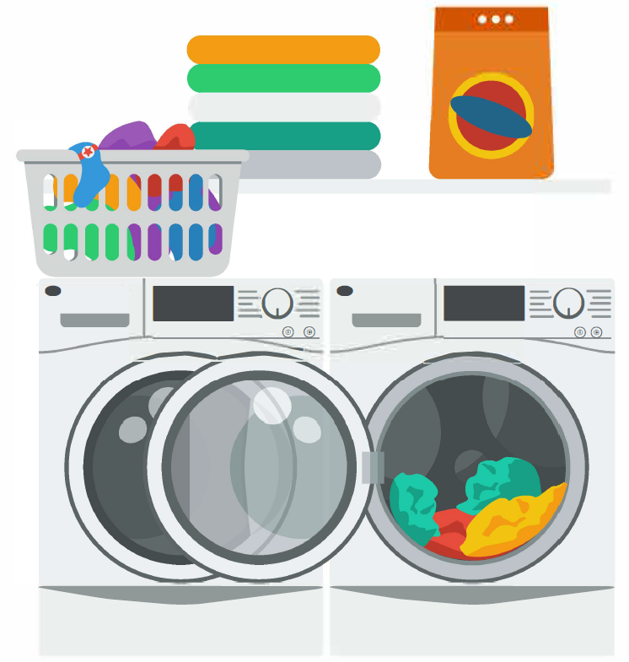 a bedroom x 4

a dining room 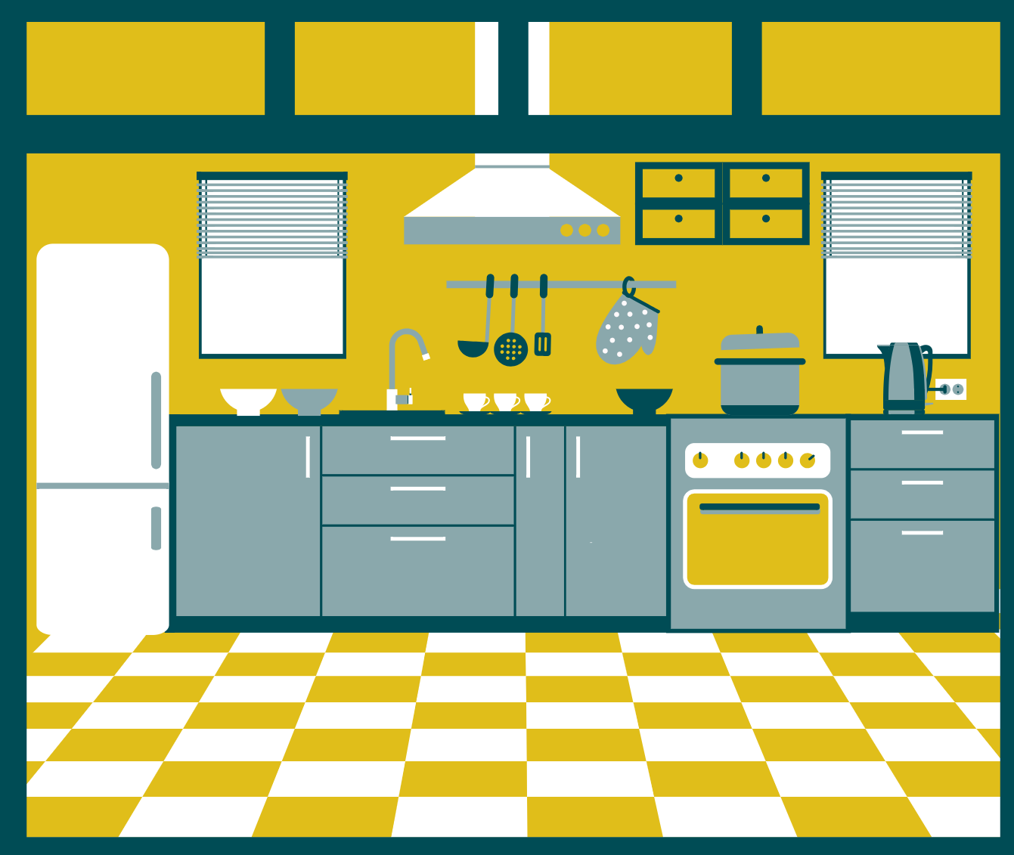 a 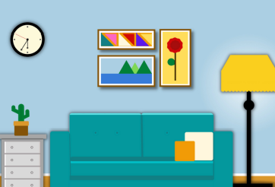 x 2 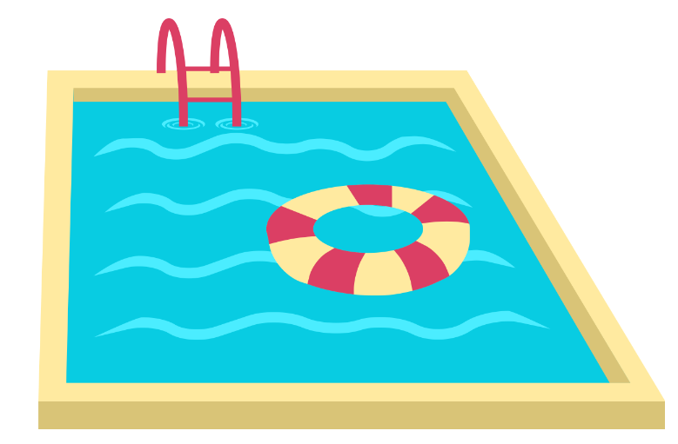

*Ma maison est grande et moderne. Il y a deux étages, deux salles de bains, une buanderie, quatre chambres, une salle à manger, une cuisine, deux salons et une piscine.*

### Numéro 2

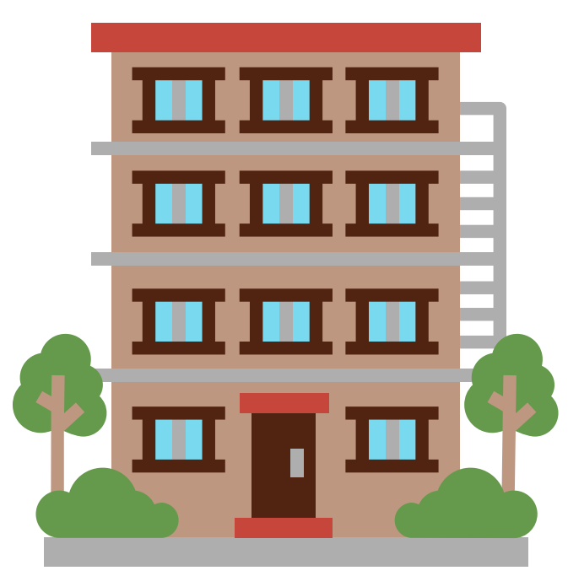 (small and nice)

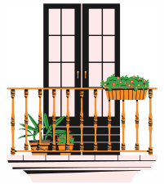 a bathroom a bedroom x 2  

### Numéro 3

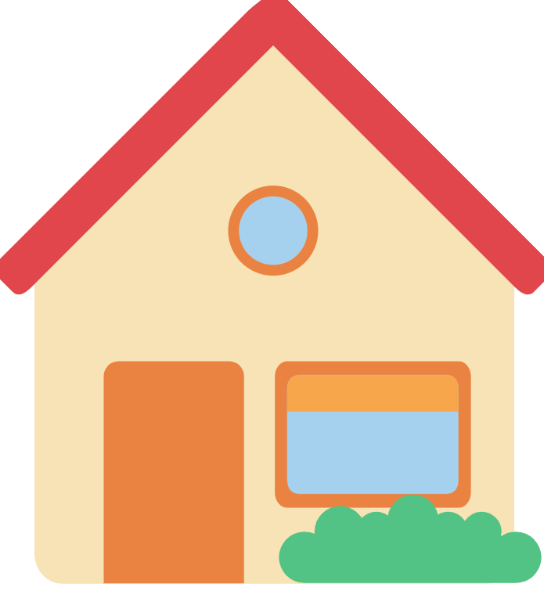 (small and pretty)

a bathroom  a bedroom x 3

a dining room   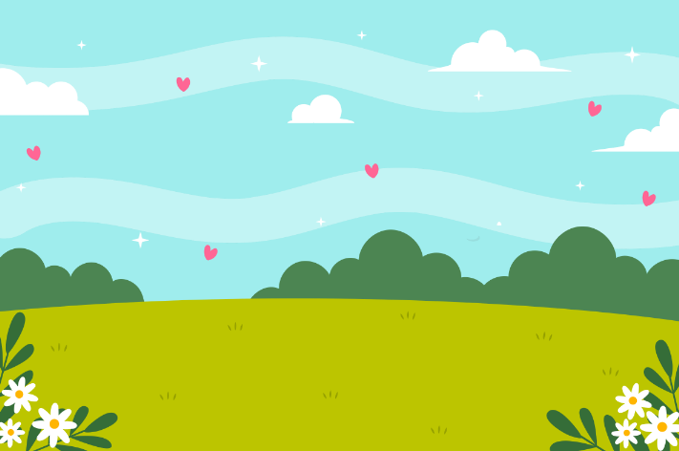

### Numéro 4

 (old and beautiful)

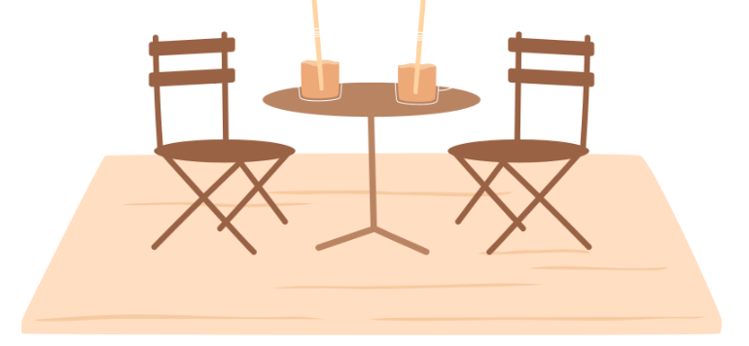 a bathroom a bedroom x 3   

### Numéro 5

 (historic and comfortable)

a bathroom x 2  a bedroom x 4

a dining room   x 2  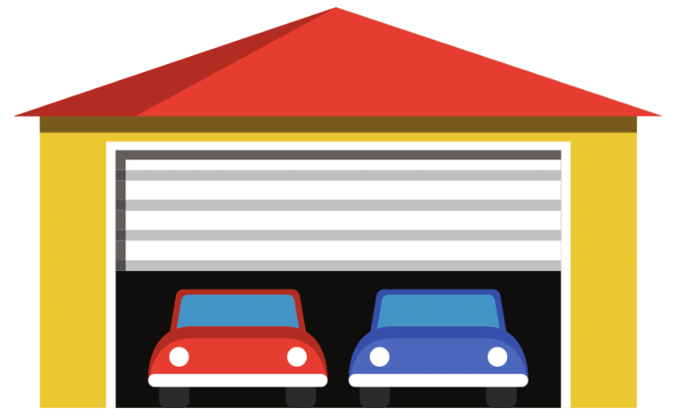

Images sourced from [Canva](https://aus01.safelinks.protection.outlook.com/?url=https%3A%2F%2Fwww.canva.com%2F&data=05%7C01%7CElisabeth.Robertson%40det.nsw.edu.au%7C7dc9e0b7775f404296e208db49d05a01%7C05a0e69a418a47c19c259387261bf991%7C0%7C0%7C638184931429489225%7CUnknown%7CTWFpbGZsb3d8eyJWIjoiMC4wLjAwMDAiLCJQIjoiV2luMzIiLCJBTiI6Ik1haWwiLCJXVCI6Mn0%3D%7C3000%7C%7C%7C&sdata=8ibsmLaJaBnkUpJw7h0eqmGRLzj7azBMCXxEZck%2BpS8%3D&reserved=0) and used in accordance with the [Canva Content License Agreement](https://aus01.safelinks.protection.outlook.com/?url=https%3A%2F%2Fwww.canva.com%2Fpolicies%2Fcontent-license-agreement%2F&data=05%7C01%7CElisabeth.Robertson%40det.nsw.edu.au%7C7dc9e0b7775f404296e208db49d05a01%7C05a0e69a418a47c19c259387261bf991%7C0%7C0%7C638184931429645439%7CUnknown%7CTWFpbGZsb3d8eyJWIjoiMC4wLjAwMDAiLCJQIjoiV2luMzIiLCJBTiI6Ik1haWwiLCJXVCI6Mn0%3D%7C3000%7C%7C%7C&sdata=exKdQz7VwUd5o1xqqDJ1soEOV0nS9yczzzdf5qbIT7E%3D&reserved=0).

## Activity 2

Write which home you prefer, using the structure ***Je préfère…parce que il y a…***

## Activity 3

Write a description of your home (or your dream home) in French. Include at least 2 adjectives and the rooms your home has.

## Activity 4

Ask 4 classmates *Elle est comment ta maison ?*

Fill in the table in English, based on what they say. Listen carefully for adjectives to describe the home, and the rooms the home has, including the number of rooms (where relevant).

Then tell them about your home.

|  |  |
| --- | --- |
| Name | Write the features of the home (in English) |
|  |  |
|  |  |
|  |  |
|  |  |

## ****For the teacher****

### Numéro 2

*Mon appartement est petit et agréable. Il y a un balcon, une salle de bains, deux chambres, une cuisine et un salon.*

### Numéro 3

*Ma maison est petite et jolie. Il y a une salle de bain, une buanderie, trois chambres, une salle à manger, une cuisine, un salon et un jardin.*

### Numéro 4

*Mon appartement est vieux et beau. Il y a une terrasse, une salle de bain, trois chambres, une cuisine, un salon et une buanderie.*

### Numéro 5

*Ma maison est historique et confortable. Il y a deux salles de bain, une buanderie, quatre chambres, une salle à manger, une cuisine, deux salons, un jardin et un garage.*

**© State of New South Wales (Department of Education), 2023**

The copyright material published in this resource is subject to the *Copyright Act 1968* (Cth) and is owned by the NSW Department of Education or, where indicated, by a party other than the NSW Department of Education (third-party material).

Copyright material available in this resource and owned by the NSW Department of Education is licensed under a [Creative Commons Attribution 4.0 International (CC BY 4.0) license](https://creativecommons.org/licenses/by/4.0/).

[](https://creativecommons.org/licenses/by/4.0/)

This license allows you to share and adapt the material for any purpose, even commercially.

Attribution should be given to © State of New South Wales (Department of Education), 2023.

Material in this resource not available under a Creative Commons license:

* the NSW Department of Education logo, other logos and trademark-protected material
* material owned by a third party that has been reproduced with permission. You will need to obtain permission from the third party to reuse its material.

**Links to third-party material and websites**

Please note that the provided (reading/viewing material/list/links/texts) are a suggestion only and implies no endorsement, by the New South Wales Department of Education, of any author, publisher, or book title. School principals and teachers are best placed to assess the suitability of resources that would complement the curriculum and reflect the needs and interests of their students.

If you use the links provided in this document to access a third-party's website, you acknowledge that the terms of use, including licence terms set out on the third-party's website apply to the use which may be made of the materials on that third-party website or where permitted by the *Copyright Act 1968* (Cth). The department accepts no responsibility for content on third-party websites.