Placement of adjectives

Activity 1
Decide which BAGS category each adjective belongs to. Write the adjective in the correct category in the table below.
bon, petit, grand, mauvais (bad), beau, vieux, joli
 | Category | Adjectives
B | beauty
A | age
G | goodness
S | size

Activity 2
Decide if the adjective goes before or after the noun it describes. Write the adjective in the correct column in the table below.
historique, moderne, bon, petit, grand, mauvais, beau, vieux, confortable, joli, agréable, colour words
Before | After

Activity 3
Next to each image in the table below is a sentence in French, describing each home. Using the ‘BAGS’ rule, write a new sentence saying you live in each home. The first one has been done for you. Take care with the position of each adjective!
House | Description
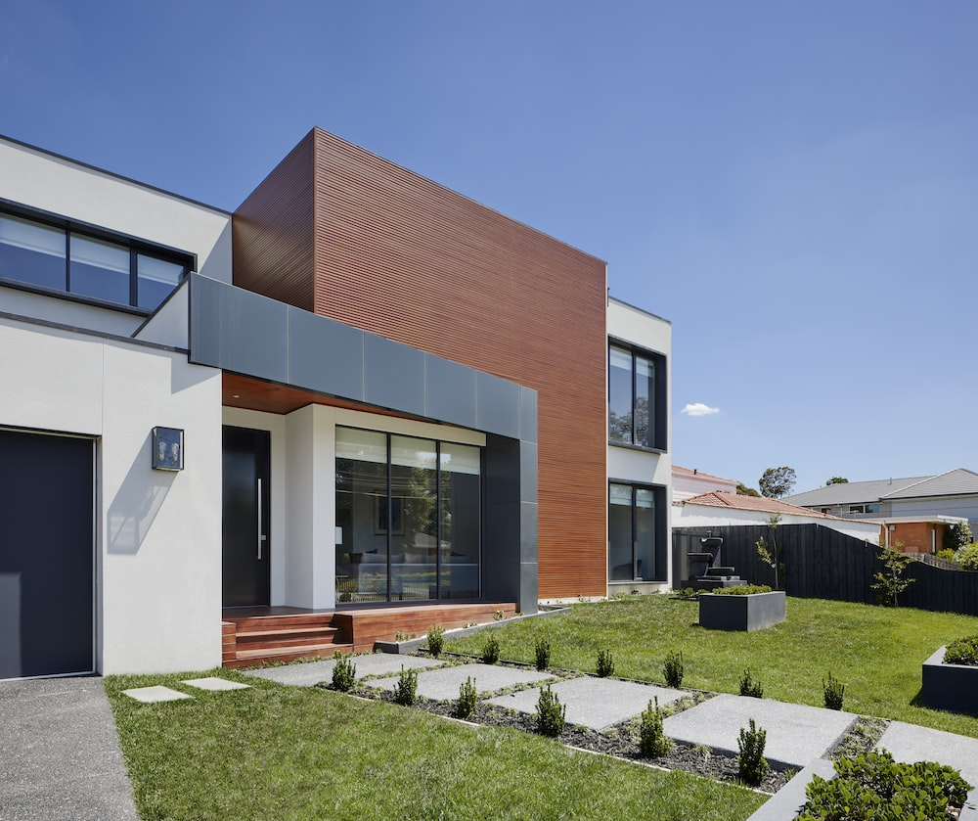 | La maison est grande et moderne.  J’habite dans la grande maison moderne.
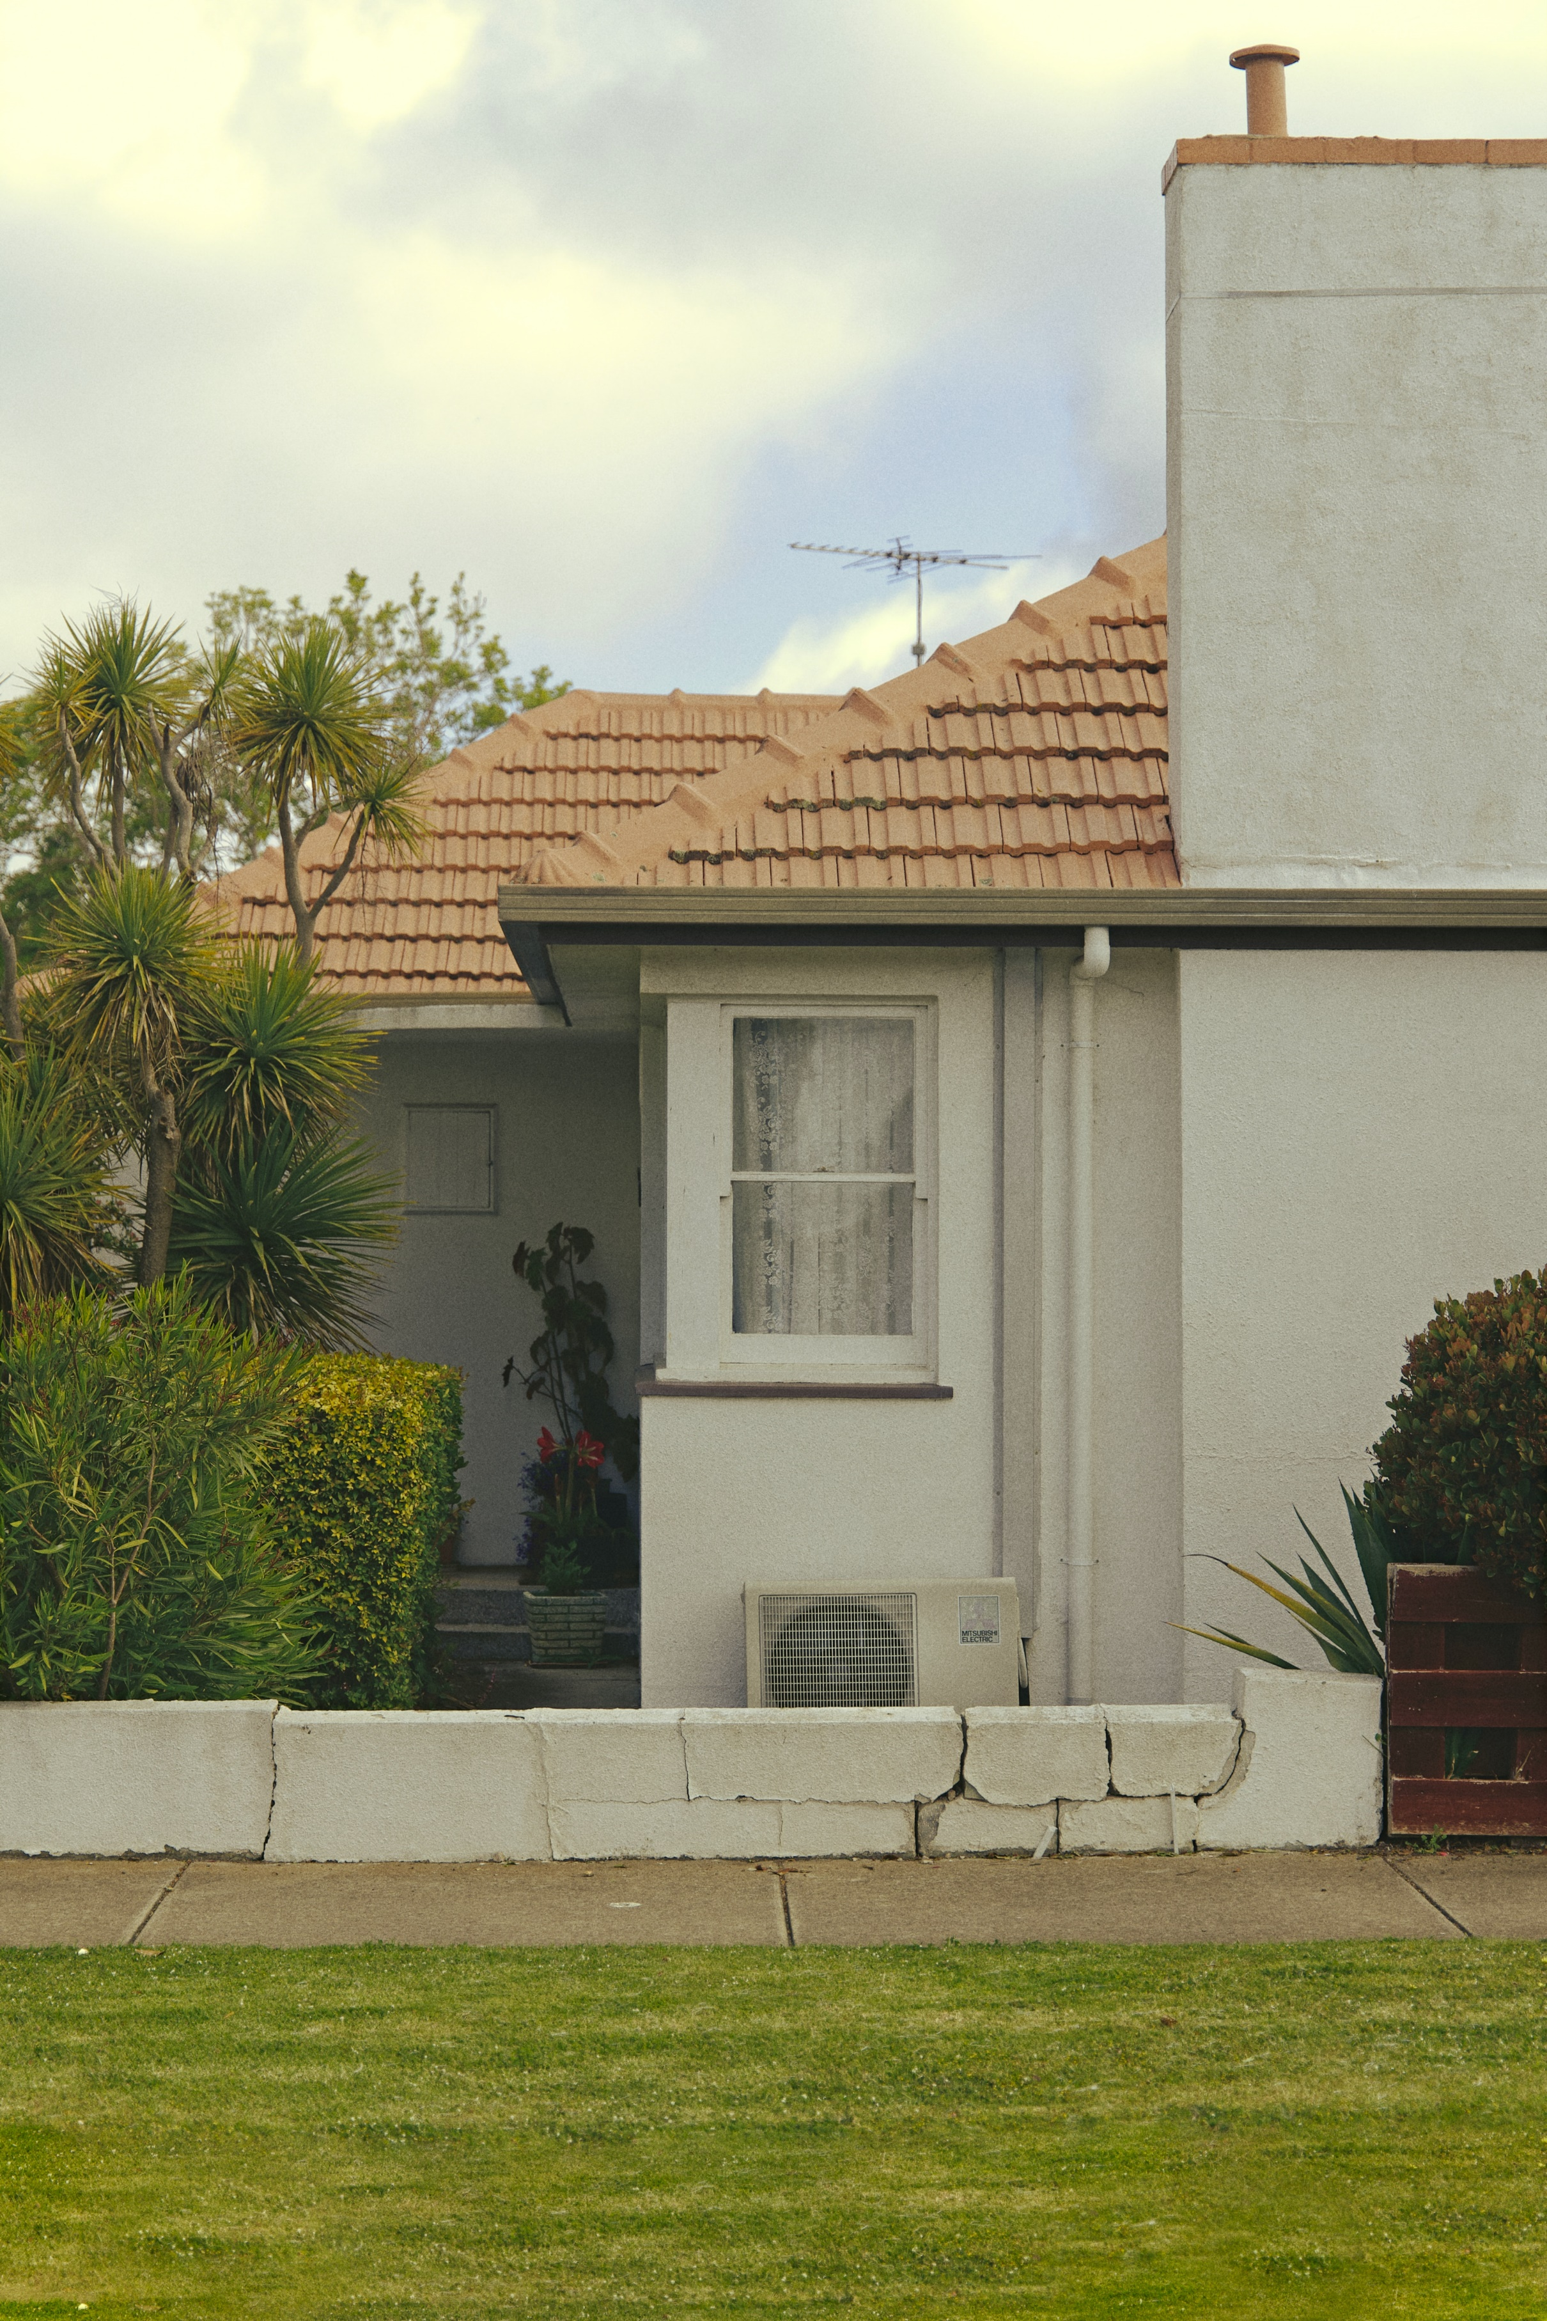 | La maison est vieille et blanche.
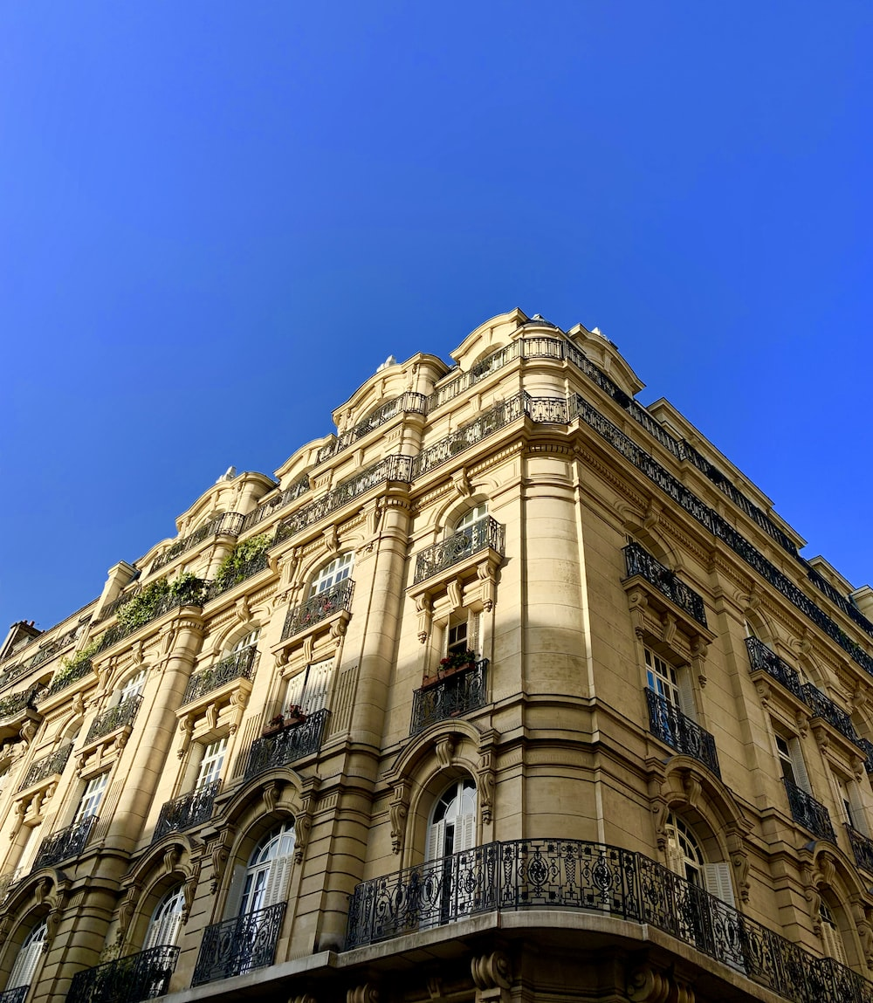 | L’appartement est joli et historique.
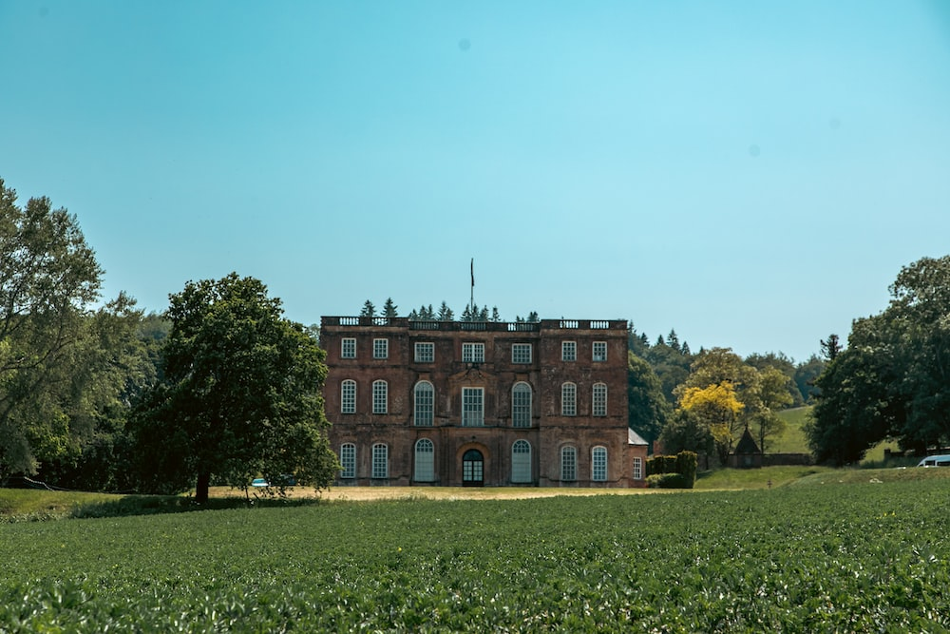 | La maison est belle et historique.
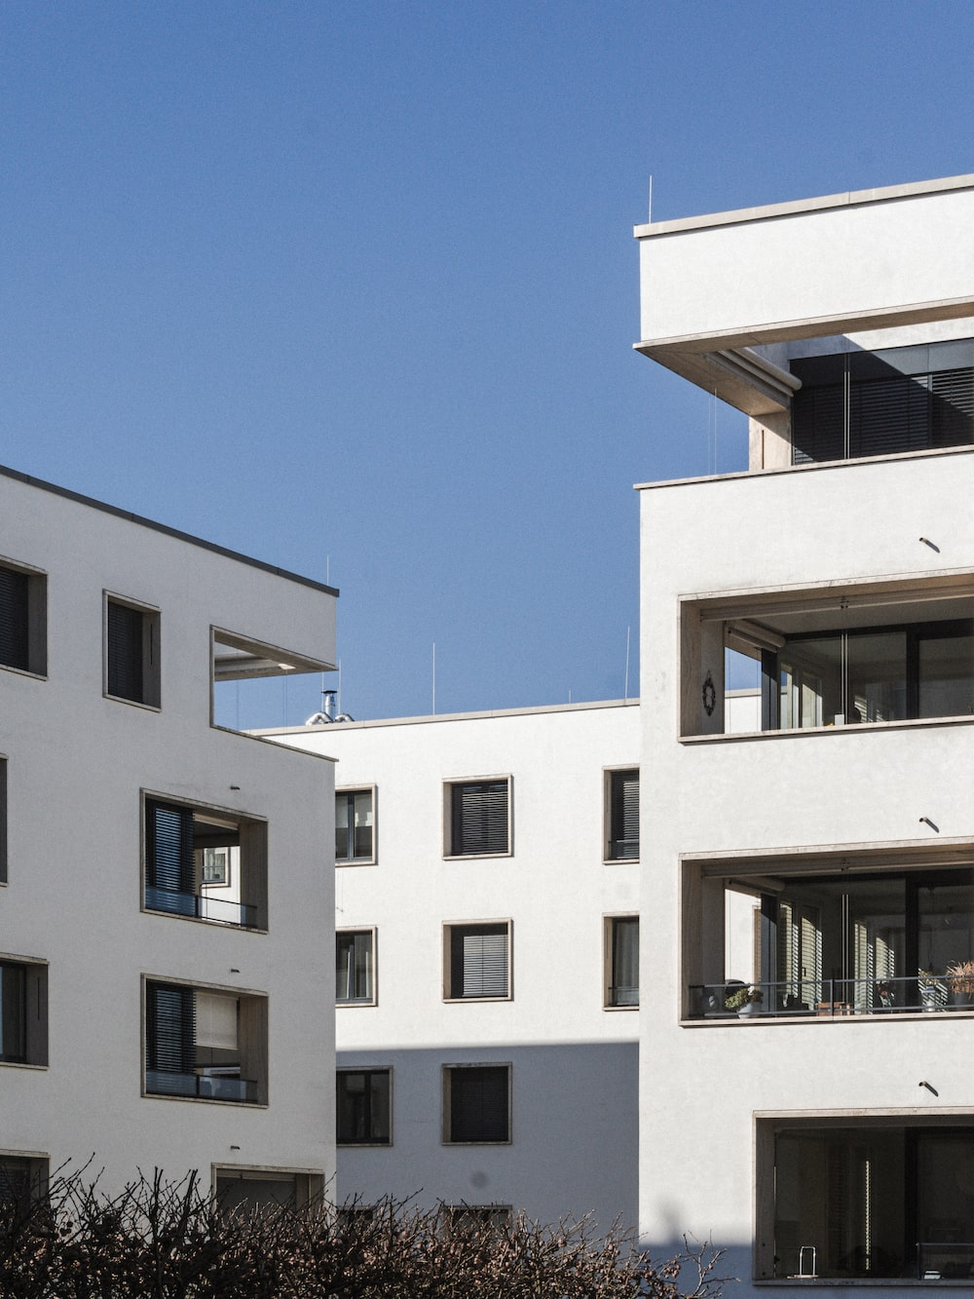 | L’appartement est moderne et agréable.
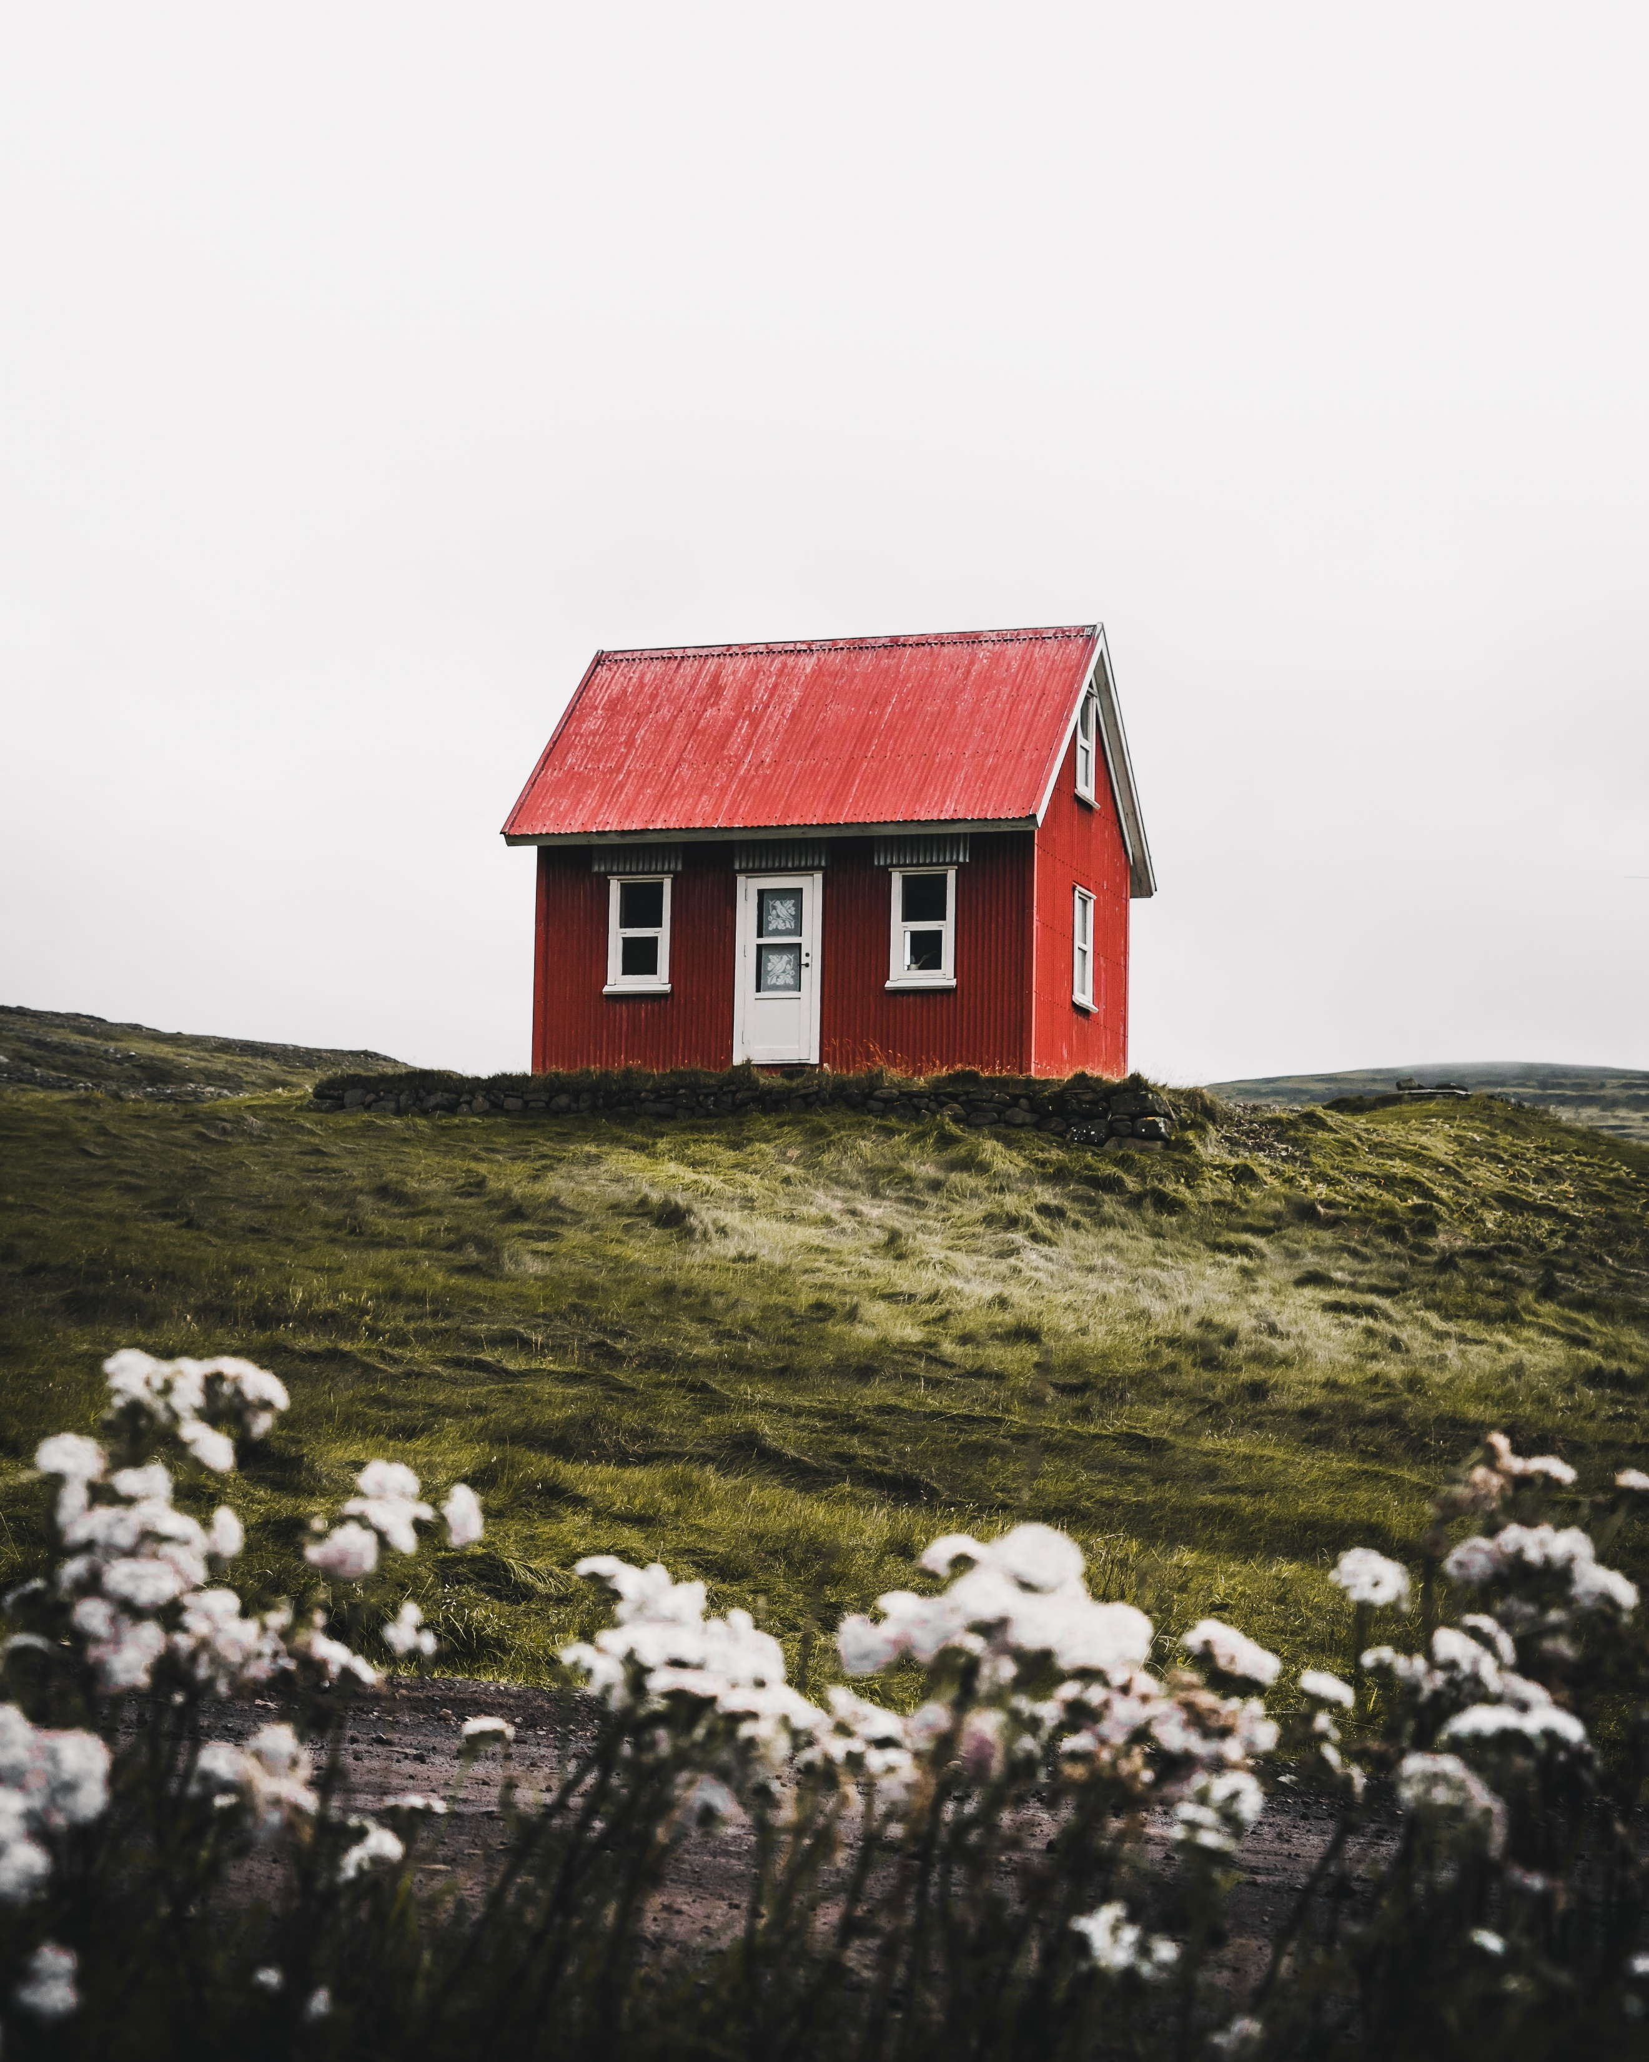 | La maison est petite et rouge.
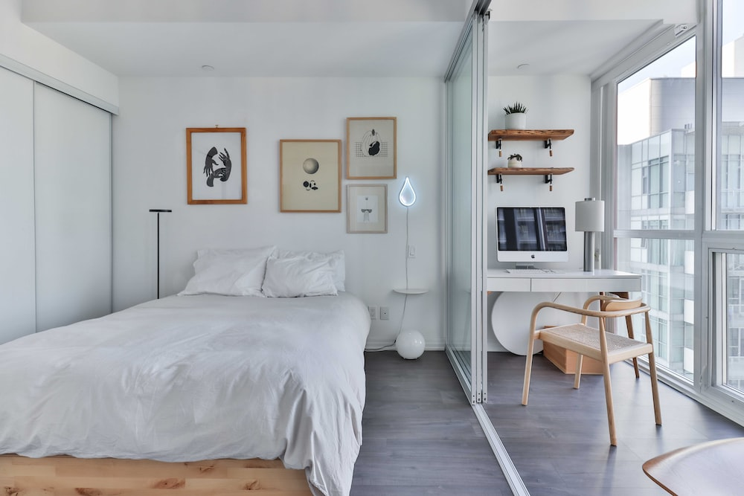 | L’appartement est petit et confortable.
Images licensed under Unsplash License.

Activity 4
Complete the sentence with a description of where you live.
J’habite dans

For the teacher

Activity 1
 | Category | Adjectives
B | beauty | beau, joli
A | age | vieux
G | goodness | bon, mauvais
S | size | petit, grand

Activity 2
Before | After
bon, petit, grand, beau, vieux, joli, mauvais | moderne, historique, confortable, agréable, colour words

Activity 3
Other options are possible.
House | Description
La maison est grande et moderne.
J’habite dans la grande maison moderne.
La maison est vieille et blanche.
J’habite dans la vieille maison blanche.
L’appartement est jolie et historique.
J’habite dans le joli appartement historique.
La maison est belle et historique.
J’habite dans la belle maison historique.
L’appartement est moderne et agréable.
J’habite dans l’appartement moderne et agréable.
La maison est petite et rouge.
J’habite dans la petite maison rouge.
L’appartement est petit et confortable.
J’habite dans le petit appartement confortable.
Images licensed under Unsplash License.

© State of New South Wales (Department of Education), 2023
The copyright material published in this resource is subject to the Copyright Act 1968 (Cth) and is owned by the NSW Department of Education or, where indicated, by a party other than the NSW Department of Education (third-party material).
Copyright material available in this resource and owned by the NSW Department of Education is licensed under a Creative Commons Attribution 4.0 International (CC BY 4.0) license.
This license allows you to share and adapt the material for any purpose, even commercially.
Attribution should be given to © State of New South Wales (Department of Education), 2023.
Material in this resource not available under a Creative Commons license:
- the NSW Department of Education logo, other logos and trademark-protected material
- material owned by a third party that has been reproduced with permission. You will need to obtain permission from the third party to reuse its material.
Links to third-party material and websites
Please note that the provided (reading/viewing material/list/links/texts) are a suggestion only and implies no endorsement, by the New South Wales Department of Education, of any author, publisher, or book title. School principals and teachers are best placed to assess the suitability of resources that would complement the curriculum and reflect the needs and interests of their students.
If you use the links provided in this document to access a third-party's website, you acknowledge that the terms of use, including licence terms set out on the third-party's website apply to the use which may be made of the materials on that third-party website or where permitted by the Copyright Act 1968 (Cth). The department accepts no responsibility for content on third-party websites.

