Japanese – Stage 4 – How do Japanese homes measure up?

Introduction
This resource provides an example of how numeracy can be embedded into teaching and learning programs in a meaningful, stage-appropriate way. It can be modified to suit your context, including the needs of your students.

Syllabus outcomes
ML4-UND-01 interprets and responds to information, opinions and ideas in texts to demonstrate understanding
Modern Languages K–10 Syllabus © NSW Education Standards Authority (NESA) for and on behalf of the Crown in right of the State of New South Wales, 2022.

Language structures
- What is a __________? (__________ は何ですか。)
- How many metres is it? How many tatami is it?
(何メートルですか。/何畳ですか。)
- It is __________ metres. It is __________ tatami.
(__________ メートルです。/__________ 畳です。)

Numeracy skills

Understanding units of measurement
Students:
- investigate and determine the different standard measurements used in Japanese floorplans, comparing tatami measurements to metres/centimetres (UuM6)
- calculate the area of the rooms to compare size (UuM8)
- make conversions between units of measurements (UuM8).

Positioning and locating
Students create a floor plan of their own home or dream home using tatami measurements (PoL5).

Further numeracy resources
- Designing a vegetable garden
- Laying floor tiles
- Understanding area
- Design a park [PDF 170 KB]

Student worksheet

Japanese homes and rooms – how do they measure up?
Read through the blog post about Japanese homes.
Then, review the floor plan below and then answer the questions.
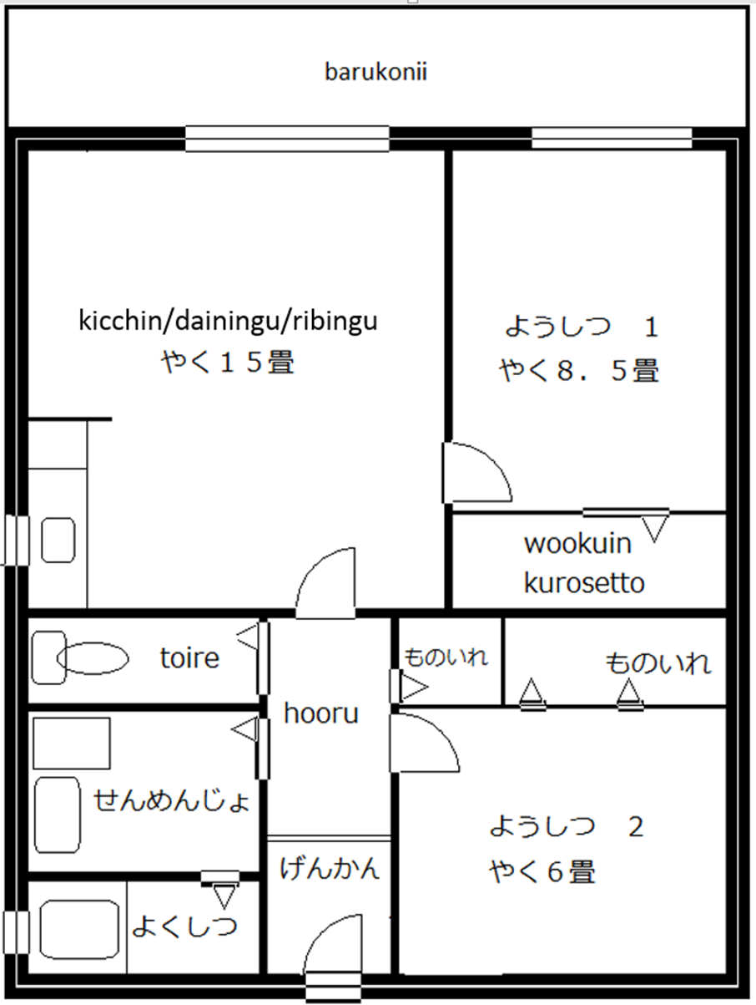

Questions
Answer the following questions in the language specified.
- In English, describe what you noticed about the way the size of the rooms is measured.
- 畳は何メートルですか。Answer in English.
- What are these called in Japanese? Answer in Japanese.
- [entrance]は何ですか。
- [balcony]は何ですか。
- [toilet]は何ですか。
- [bathroom]は何ですか。
- What are these called in English? Answer in English.
- ようしつは何ですか。
- げんかんは何ですか。
- wookuin kurosettoは何ですか。
- kicchin/dainingu/ribinguは何ですか。
- Answer the following questions using the standard tatami measurement. Show calculations.
- ようしつ (1) は何メートルですか。
- ようしつ (2) は何メートルですか。
- kicchin/dainingu/ribunguは何メートルですか。

- Create a floor plan of your own home or dream home using tatami (畳) as the measurement. Label each room in Japanese (hiragana/romaji).

References
This resource contains NSW Curriculum and syllabus content. The NSW Curriculum is developed by the NSW Education Standards Authority. This content is prepared by NESA for and on behalf of the Crown in right of the State of New South Wales. The material is protected by Crown copyright.
Please refer to the NESA Copyright Disclaimer for more information https://educationstandards.nsw.edu.au/wps/portal/nesa/mini-footer/copyright.
NESA holds the only official and up-to-date versions of the NSW Curriculum and syllabus documents. Please visit the NSW Education Standards Authority (NESA) website https://educationstandards.nsw.edu.au/ and the NSW Curriculum website https://curriculum.nsw.edu.au/home.
Modern Languages K–10 Syllabus © NSW Education Standards Authority (NESA) for and on behalf of the Crown in right of the State of New South Wales, 2022.

© State of New South Wales (Department of Education), 2023
The copyright material published in this resource is subject to the Copyright Act 1968 (Cth) and is owned by the NSW Department of Education or, where indicated, by a party other than the NSW Department of Education (third-party material).
Copyright material available in this resource and owned by the NSW Department of Education is licensed under a Creative Commons Attribution 4.0 International (CC BY 4.0) license.
This license allows you to share and adapt the material for any purpose, even commercially.
Attribution should be given to © State of New South Wales (Department of Education), 2023.
Material in this resource not available under a Creative Commons license:
- the NSW Department of Education logo, other logos and trademark-protected material
- material owned by a third party that has been reproduced with permission. You will need to obtain permission from the third party to reuse its material.
Links to third-party material and websites
Please note that the provided (reading/viewing material/list/links/texts) are a suggestion only and implies no endorsement, by the New South Wales Department of Education, of any author, publisher, or book title. School principals and teachers are best placed to assess the suitability of resources that would complement the curriculum and reflect the needs and interests of their students.
If you use the links provided in this document to access a third-party's website, you acknowledge that the terms of use, including licence terms set out on the third-party's website apply to the use which may be made of the materials on that third-party website or where permitted by the Copyright Act 1968 (Cth). The department accepts no responsibility for content on third-party websites.

